Statement of Significance: Former Mutual Store Ltd (later Maples Pty Ltd) complex (part 112-118 Millswyn Street, South Yarra), February 2023

Heritage Place: | Former Mutual Store Ltd (later Maples Pty Ltd) complex | PS ref no: | HO1406
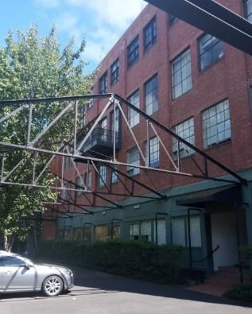  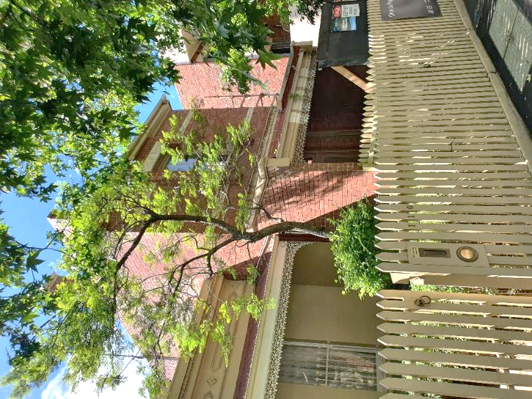  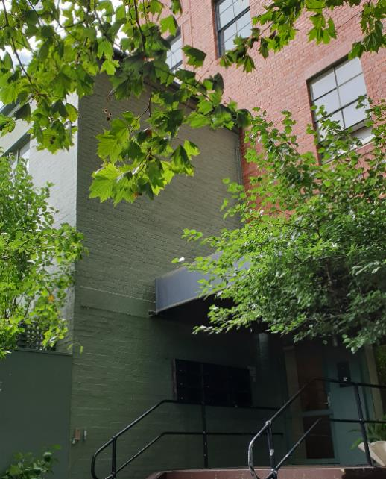  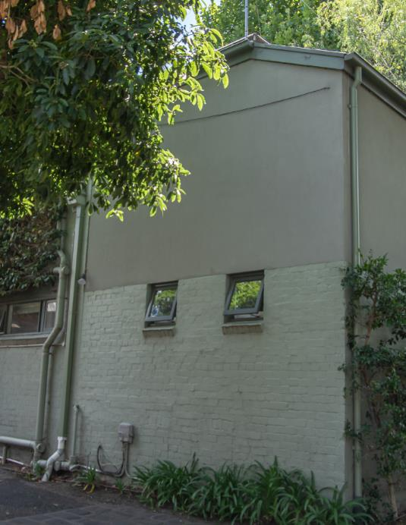  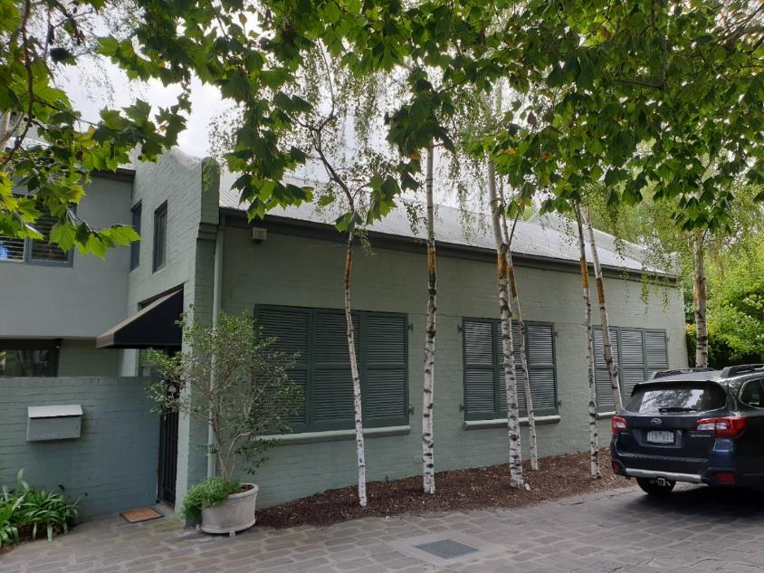 | 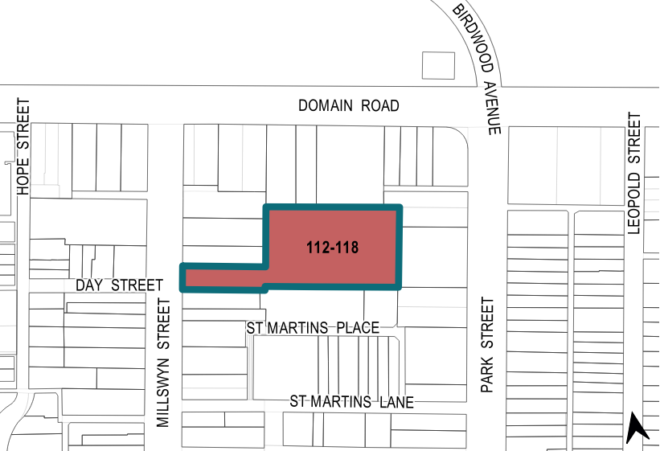

What is significant?
Former Mutual Store Ltd (later Maples Pty Ltd) complex at part of 112–118 Millswyn Street, South Yarra, built in c1889 and 1922–23 for the Mutual Store Ltd, is significant.
Elements that contribute to the significance of the place include (but are not limited to) the:
- 1922 former storage building’s original four-storey form (Figure 1: Number 4) with a stairwell and face red brick finishes, and its high level of integrity to its original design including the decorative brick detailing to the stairwell, as well as its pattern and size of original fenestration
- remnant painted signs dating from the Maples Pty Ltd era on the south and east elevations of the 1922 former storage building (Figure 1: Number 4)
- surviving original face brick walls and pattern of openings of the c1889 former grain store (Number 2), c1889 former toilet block (Figure 1: Number 3) and 1923 engineers’ workshop (Number 6)
- 1889 store foreman’s residence at 114 Millswyn Street (Figure 1: Number 2) and the access way to the south of the residence
- steel roof trusses and brick walls on the northern and southern property boundaries, which are remnants of the loading areas and associated structures (Figure 1: Number 5)
- bluestone pitchers predating the 1922 redevelopment.
The changes introduced by the 1978 residential conversion also contribute to the significance of the place. More recent alterations and additions are not significant.
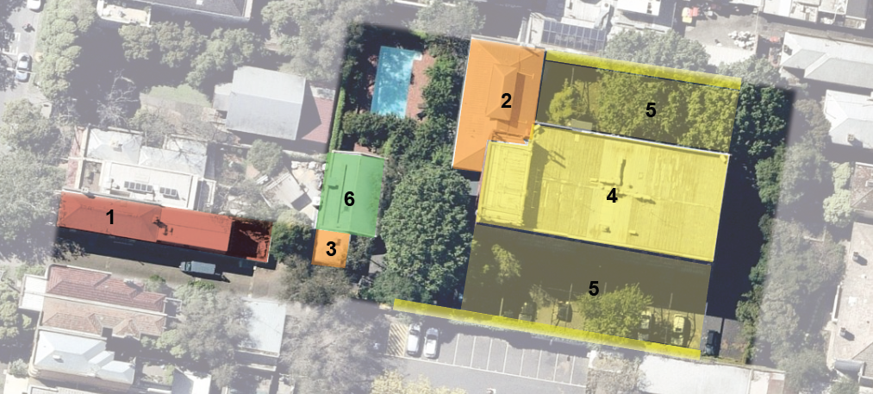
Legend
1 | Former foreman’s residence at 114 Millswyn Street (1889) | 4 | Former storage building (1922)
2 | Former shed, later used as grain store (c1889) | 5 | Remnant loading area structures (1922) and associated brick walls (c1889–1922)
3 | Former toilet block, later used as kerosene store (c1889) | 6 | Former engineers’ workshop (1923)
Figure 1. Aerial photograph of the subject site, showing the key elements that contribute to the significance. (Source: Nearmap 2022 with GML overlay)

How is it significant?
Former Mutual Store Ltd (later Maples Pty Ltd) complex at part of 112–118 Millswyn Street, South Yarra, is of local historical and representative significance to the City of Melbourne.

Why is it significant?
The former Mutual Store Ltd (later Maples Pty Ltd) complex at part of 112–118 Millswyn Street, South Yarra, is historically significant as an atypical example of an industrial place in the South Yarra area of the City of Melbourne, which is otherwise a predominantly residential area. The complex is also significant for its long-term association with Mutual Store Ltd, which established Melbourne’s first department store in Flinders Street, Melbourne. The existing former stable complex and warehouse were erected c1889 (Figure 1: Number 1, Number 2 and Number 3) and 1922–23 (Figure 1: Number 4, Number 5 and Number 6) respectively for the Mutual Store. Established in 1889 to house the company’s livery yard and later incorporating the delivery plants by the beginning of the 1920s, the complex was renewed as a delivery depot and warehouse complex in 1922–23. The complex demonstrates the growth in retailing and manufacturing that was part of the buoyant new economy in early twentieth century Melbourne following the subdued period of World War I and the strong tariff protection in the 1920s. The complex also demonstrates the evolution of the transportation and logistics system of a major retailing business over time. Acquired by the Melbourne furniture manufacturers, Maples, the site continued its industrial operation as a warehouse and manufacturing complex between 1963 and 1978. (Criterion A)
The subject complex, today known as Millswyn, is also of historical interest as the first major residential conversion of an industrial building in Melbourne, and one of the first in Australia. The residential development in 1978 was led by the Largga Partnership, partners of which kept units in the complex. The partnership was formed by Andrew Reed, Len Hayball, and Graeme Gunn, the principals of the architectural firms Andrew Reed and Associates and Gunn Hayball Pty Ltd, as well as Ross Ramus, architect, Jean Miller, investor, and Grazia Gunn, curator. (Criterion A)
Incorporating structures from 1889 and 1922–23 built for Mutual Store Ltd and later converted for Maples Pty Ltd, the complex is important as a representative example of a relatively intact cluster of residential and industrial buildings developed for a single primary occupant. The complex retains the 1889 foreman’s residence designed by Reed, Henderson and Smart (Figure 1: Number 1); c1889 former grain store (Figure 1: Number 2) and former kerosene store (Figure 1: Number 3) predating the 1922 former storage building designed by Ballantyne and Hare (Figure 1: Number 4), as well as a 1923 workshop building (Figure 1: Number 6). The original built form, roofline, face brick surfaces (partly overpainted) and industrial buildings with utilitarian designs provide tangible evidence of the warehousing associated with a major retail business in this part of the City of Melbourne. The 1922 main building is also of importance, being a representative example of an interwar warehouse building, characterised with the steel-framed concrete structure and masonry external walls, the use of vertical bays with large window openings divided by pilasters, and the use of restrained decorative detailing. (Criterion D)

Primary source
South Yarra Heritage Review 2022 (GML Heritage)

