Statement of Significance: Kia Ora (447–453 St Kilda Road, Melbourne), February 2023

Heritage Place: | Kia Ora | PS ref no: | HO1412
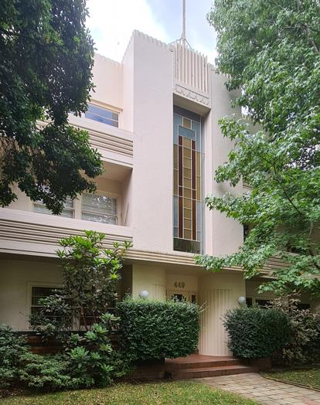  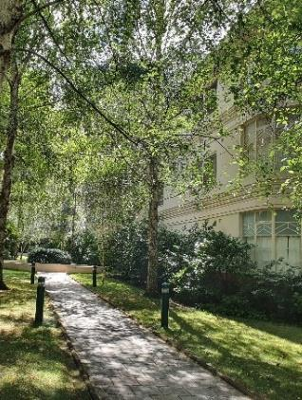 | 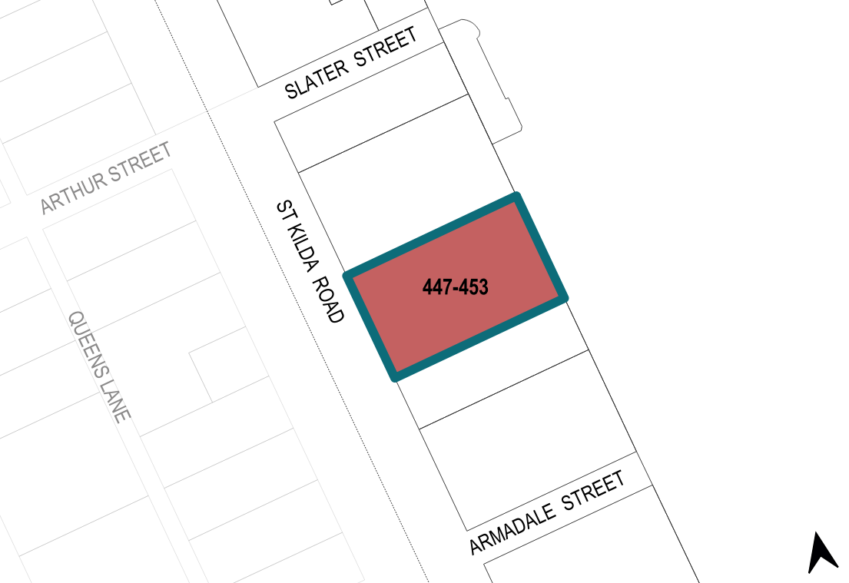

What is significant?
Kia Ora at 447–453 St Kilda Road, Melbourne, built in 1936, is significant.
Elements that contribute to the significance of the place include (but are not limited to) the:
- original built form, wrapping around the central courtyard, paths and garden
- rendered bi-chromatic face-brick foundations, rendered brickwork upper walls, and original fenestrations
- shallow hipped roof
- original Moderne elements and detailing, including the vertical towers at the front entrances, face-brick secondary entrances, curved-cornered balconies and corner windows, strong vertical and horizontal compositional emphasis and detailing, and geometric Moderne detailing to windows and doors
- original bi-chromatic face-brick front fence on St Kilda Road, including integrated garden beds and letter boxes
- path and garden layout, and garden setting, in the central courtyard.
More recent changes, including replacement windows and plantings, are not significant.
More recent tree plantings contribute to the garden setting of the place but are not significant in their own right.

How is it significant?
Kia Ora at 447–453 St Kilda Road, Melbourne, is of local historical, representative, aesthetic and associative significance to the City of Melbourne.

Why is it significant?
Kia Ora is historically significant as an early surviving example of luxury flat complexes designed in the Moderne style in the interwar period. Designed in 1936 by Lewis Levy for Kia-Ora Investments, the complex of flats, comprising two mirrored blocks of 30 flats each, joined at the rear and wrapping around a central courtyard, was the largest block in Melbourne at the time of its construction. It is notable as an example of a new typology that emerged in the interwar period in Melbourne—the low-rise flat complex with incorporated courtyard areas. It is also notable for its siting within the St Kilda Road corridor, highlighting the prestige associated with a St Kilda Road address at the time. Kia Ora is a remaining example reflecting a key period in the development of high-density living in Melbourne before the emergence of high-rise apartment construction. (Criterion A)
Kia Ora has representative significance as a highly intact well-designed and well-appointed luxury low-rise flat complex from the interwar period. The gardens, carparking and generous floorplans are key identifying features of such complexes. The integration of the courtyard and built elements demonstrate emerging interwar design ambitions to maximise light to individual flats. This reflects the growing social awareness of the health benefits of sunshine in the 1930s. Kia Ora is also notable for its ongoing use as residential flats. (Criterion D)
Kia Ora is significant aesthetically for its integrated planning of built form and landscaping, its strong three-dimensional composition which counterpoints horizontal and vertical massing and elements and refined use of Moderne detailing. Key Moderne details include the dominant entrance towers, curved-cornered balconies, and detailing on walls and windows (such as horizontal glazing). The cream rendered walls and banded bi-chromatic brick fence and matching foundations are also significant. Decorative geometric Moderne details to doors and windows further enhance the design. (Criterion E)
Kia Ora is significant for its association with the Dixon family of Kia-Ora Investments, a major cordial and food processing company, which is also the building’s namesake. (Criterion H)

Primary source
South Yarra Heritage Review 2022 (GML Heritage)

