Statement of Significance: Melbourne Hebrew Congregation Synagogue (2W–8W Toorak Road, South Yarra), February 2023

Heritage Place: | Melbourne Hebrew Congregation Synagogue | PS ref no: | HO1416
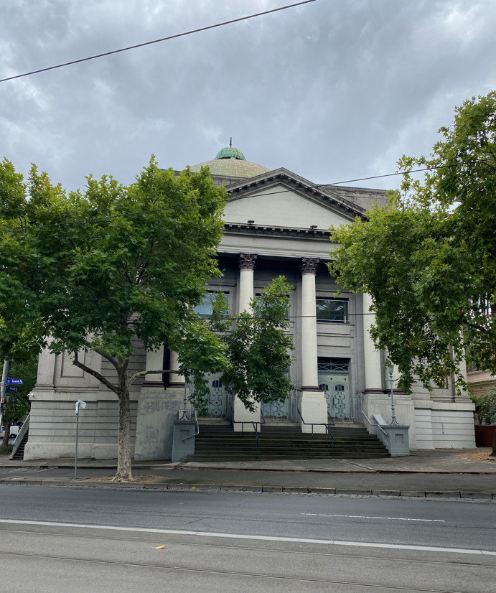  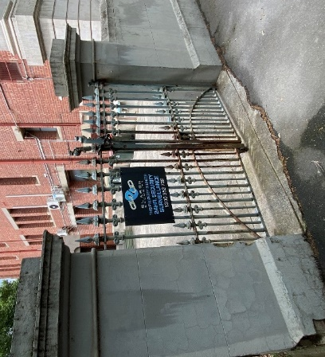  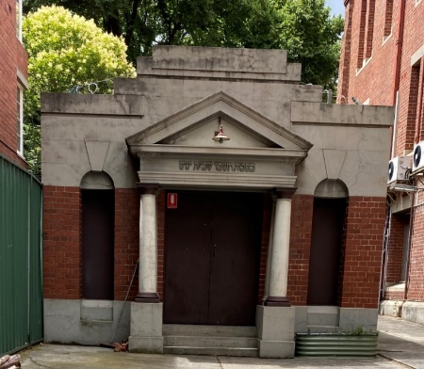 | 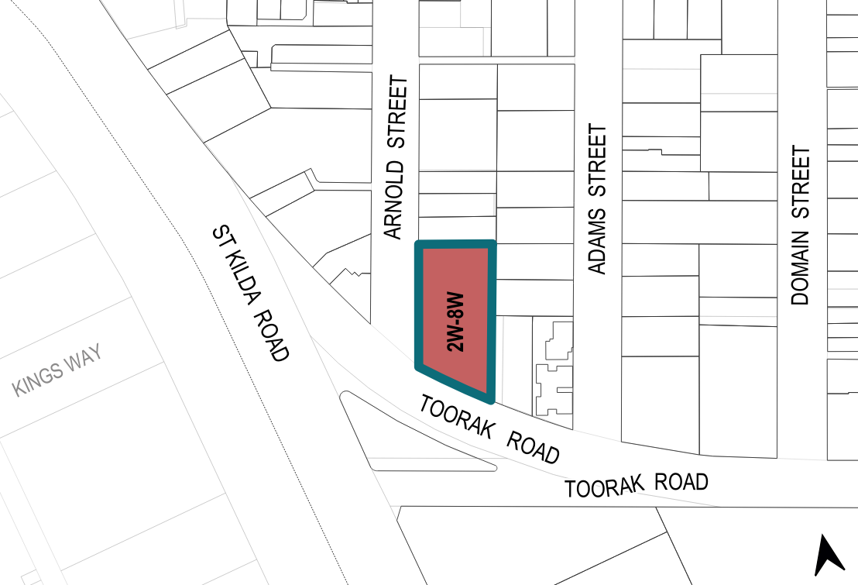

What is significant?
The Melbourne Hebrew Congregation Synagogue at 2W–8W Toorak Road, South Yarra, built in 1930, is significant.

Elements that contribute to the significance of the place include (but are not limited to) the:
- building’s original external form, including prominent dome
- building’s integrity to the original design by Nahum Barnet
- buildings materiality, including concrete render, walls left in face brick and copper cladding to the dome
- front portico, including pediment, columns on pedestals and associated detailing
- entire detailing to externals walls, including parapets, balustrading, pilasters and other decoration expressed in concrete render
- external detailing to the drum of the dome
- original pattern of fenestration
- stairs accessing both the Toorak Road and Arnold Street elevations, including associated balustrading
- concrete rendered brick perimeter wall on the Arnold Street frontage, including Victorian gate removed from the congregation’s original site on Bourke Street in Melbourne
- sukkah building located to the rear of the synagogue building fronting Arnold Street, with front façade including portico, niches and pediments, as well as the retracting nature of the roof and the walls
- stained-glass windows
- highly intact interior of the building, including the internal moulded detailing (columns, cornices, stringcourses, rosettes, pediments and panels); its carved timberwork (including Arks, bimahs, seats, friezes and fittings); its scagliola surface treatments, tiled and parquetry flooring, original doors and windows, barrel vaulted and dome ceilings
- memorial objects in the foyer area, including memorial boards, plaques, and commemorative items
- triangular forecourt and mature Canary Island Date Palm (Phoenix canariensis).
More recent additions, including the security gates on the Arnold Street elevation, and the fire escape to the eastern elevation, are not significant.

How is it significant?
The Melbourne Hebrew Congregation Synagogue at 2W–8W Toorak Road, South Yarra, is of local historical, representative, aesthetic and social significance to the City of Melbourne.

Why is it significant?
The Melbourne Hebrew Congregation Synagogue at 2W–8W Toorak Road, South Yarra, is of historical significance to the City of Melbourne, as the principal place of worship for the oldest Jewish congregation in Victoria. The Melbourne Hebrew Congregation was formed in 1841, and was originally housed at a site on Bourke Street in Melbourne. The congregation chose to move to the subject site in order to provide a larger place of worship closer to where many of its congregants had settled. The erection of a substantial and highly ornate synagogue on in a prestigious location is indicative of the growth of the Melbourne Hebrew Congregation and its increased social prominence since its formation in 1841. (Criterion A)
The Melbourne Hebrew Congregation Synagogue at 2W–8W Toorak Road, South Yarra, is of

representative significance as a synagogue designed in a classically inspired architectural style, typical of the pre-World War II synagogues in Victoria. The characteristics of a synagogue that used references to classical styles include external elements such as porticos, pilasters and gable ends styled to represent pediments, as well as interior decorative elements. The former site of the Melbourne Hebrew Congregation, on Bourke Street in Melbourne, had also been built in the classical style, and was directly referenced in the design of the subject site. (Criterion D)
The Melbourne Hebrew Congregation Synagogue is of aesthetic significance as a highly decorative, architecturally refined interpretation of classical architecture in the interwar period. The synagogue is significant for its prestigious siting and striking visual prominence of the dome that have contributed to it being a landmark building in the area. The building’s exterior is characterised by its ornate detailing and sophisticated composition, including its large, classical portico, concrete render moulding, carved Hebrew lettering and Greek key pattern tiles. The interior of the building is aesthetically significant for its equally refined decorative elements, surfaces, and internal fittings. Significant features of the interior include the treatment of the underside of the dome, the decorative colonnaded screen housing the Ark with refined scagliola work, and the use of columns, friezes and cornices. Additionally, the horseshoe shaped balcony, tiled surfaces of the foyer, and barrel-vaulted ceiling of the function room are also important to the aesthetic value of the building. Significant fixtures and fittings include interior light fittings, staircase balustrading, timber seats contemporary with the building, and the stained-glass windows. The extensive finely crafted Tasmanian blackwood carving to the bimah is an outstanding example of ornate timberwork. The fine quality of the timberwork brought from the original synagogue on Bourke Street, Melbourne, including wooden seats and the original bimah, further enhance the aesthetic character of the interior. The triangular forecourt setting and mature Canary Island Date Palm (Phoenix canariensis) contribute to and enhance the overall integrity and aesthetic significance of the place. (Criterion E)
The synagogue at 2W–8W Toorak Road, South Yarra is socially significant to the City of Melbourne. As the second synagogue belonging to the Melbourne Hebrew Congregation, which was formed in 1841, The Melbourne Hebrew Congregation is thus the oldest surviving Jewish congregation in the State of Victoria, and has remained an active community. The congregation moved to the current site in 1930 in order to provide a larger place of worship and closer to the suburbs in which the community had begun to settle. The Architect of the synagogue, Nahum Barnet, chose to design the new building with direct references to the old Bourke Street synagogue, as it was considered to be important in the history of the congregation. These direct references can be seen in the choice of the classical style architecture and use of a dominant front portico with Corinthian columns. Further enhancing the ongoing connection of the congregation to both sites, is the presence of materials brought to the new synagogue from Bourke Street, in 1930. These include Victorian gates and carved wooden seats, and the bimah, which has been placed in the minor synagogue at the subject site. The Synagogue also continues to connect with the community through its memorial objects (memorial boards, plaques, and commemorative items in the foyer). The synagogue provides tangible links to previous generations, including the congregation and community more broadly. The Melbourne Hebrew Congregation continues to use the site as their place of worship and social gatherings and events. (Criterion G)

Primary source

South Yarra Heritage Review 2022 (GML Heritage)

