Statement of Significance: Pasley Street and Park Place Precinct, February 2023

Heritage Place: | Pasley Street and Park Place Precinct | PS ref no: | HO1419
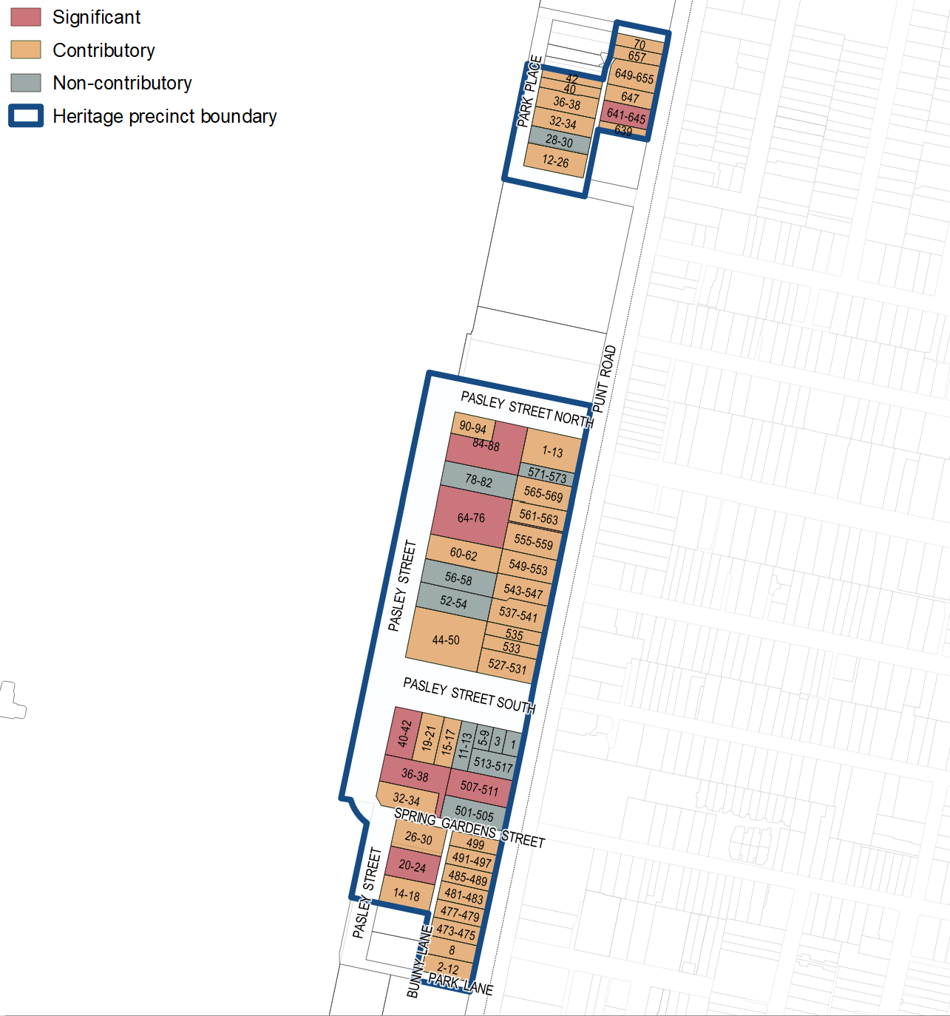

What is significant?
Pasley Street and Park Place Precinct, including 8 Bunny Lane, 2–12 Park Lane, 12–42 Park Place, 14–94 Pasley Street, 1–13 Pasley Street North, 1–21 Pasley Street South, 473–573 and 639–657 Punt Road, South Yarra, developed from 1865 to 1961, is significant.
Elements that contribute to the significance of the precinct include (but are not limited to) the:
- low-scale external form of buildings developed pre-World War I (typically one to three storeys), featuring original hipped and gabled roof forms (sometimes with parapets) and intact early chimneys, timber and masonry construction and finishes (some painted and rendered), pattern and size of original fenestration, stylistic detailing and early iron palisade fences on stone plinths
- low-scale external form of buildings developed from 1918 to 1961 (typically one to four storeys), featuring masonry or concrete construction and finishes (some painted and rendered), original hipped and flat roof forms (sometimes with parapets), intact early chimneys, and the pattern and size of original fenestration, stylistic detailing, and early low masonry fences
- significant buildings’ high level of integrity to their original design
- early subdivision patterns, including the size of allotments, the setbacks of park-fronting properties and the views to and from Fawkner Park
- public space elements, including the street trees, widths and shape of the asphalted footpaths and bluestone gutters in Pasley Street, Pasley Street North, Pasley Street South and Park Place.
Early intact fences at 507–511 Punt Road, 565–569 Punt Road, 641–645 Punt Road and 649–655 Punt Road also contribute to the significance.
More recent alterations and addition to significant and contributory places, including replacement fences, verandah or windows, are not significant.
Post-1961 developments and other extensively altered properties are not significant.

How is it significant?
Pasley Street and Park Place Precinct, including 8 Bunny Lane, 2–12 Park Lane, 12–42 Park Place, 14–94 Pasley Street, 1–13 Pasley Street North, 1–21 Pasley Street South, 473–573 and 639–657 Punt Road, South Yarra, is of local historical and aesthetic significance to the City of Melbourne.

Why is it significant?
The Pasley Street and Park Place Precinct is historically significant for its representation of the early subdivision pattern that resulted from an 1865 sale of Crown land, which was the last Crown land released for sale in the City of Melbourne. This sale of land was associated with a significant conflict in the City of Melbourne in the 1860s that ensued following the breaking up of areas reserved as public parkland for private development. The precinct is also important for its retention of the early pattern of development from the subsequent residential subdivisions from 1869 (Pasley Street) and 1885 (Park Place) that led to the formation of dog-legged Pasley Street and laneways connecting to Punt Road, as well as Park Place. The 1885 sale of the Park Place allotments was claimed to be the last subdivision of Crown land within the City of Melbourne. The area’s particular association with speculative building and owner-builders reflect the politicised nature of the subdivision at a time of a

public debate about the retention of public parkland versus revenue-raising by the government and private development. (Criterion A)
The historical development pattern of the mixed-era precinct represents the key phases of residential development in the City of Melbourne. The residential development of the precinct was initially slow, with few examples constructed in the 1870s, including the intact semidetached two-storey villa at 64–76 Pasley Street designed by architects Crouch & Wilson. After slow development in the 1870s, the Pasley Street pocket saw intensive building during the boom period of the 1880s and the beginning of the 1890s. The sale of the Park Place pocket in 1885 and development of the cluster of Victorian buildings between 1886 and 1891 also coincided with the land boom of the Victorian period that continued until 1892. Following economic recovery in the early twentieth century, the vacant land remaining in the Park Place pocket was taken up for further residential development. Throughout the interwar and postwar period, a number of houses and blocks of flats were erected on new allotments, representing subdivided former gardens of Victorian-era properties, or replacing earlier houses. Astor at 641–645 Punt Road, with its Mediterranean-influenced façade, is an example of a Victorian residence converted to flats in the 1920s, reflecting a pattern of development that was common in South Yarra during the interwar period. The postwar flats in this precinct reflect the changing urban landscape seen in much of inner city Melbourne, brought about by waves of postwar European migrants who valued high-density European-inspired city living. (Criterion A)
Aesthetically, the mixed-era precinct is significant for the contribution of the well-preserved masonry houses in a concentrated area. The diverse building stock ranges from Victorian-era workers’ cottages and two-storey villas, to twentieth century residences and flats. The places of aesthetic importance include a finely detailed Victorian residence with Dutch gables at 20–24 Pasley Street, and highly refined Italianate style examples at 36–38 Pasley Street, 64–76 Pasley Street, 84–88 Pasley Street and 507–511 Punt Road. A postwar block of flats at 40–42 Pasley Street, designed by prominent architect Yuncken Freeman Bros, is also of aesthetic importance. The views and vistas into and out of Fawkner Park to the residential areas and along Pasley Street are part of the important elements of the precinct. (Criterion E)

Primary source
South Yarra Heritage Review 2022 (GML Heritage)

