Statement of Significance: Melbourne Girls Grammar School (Part 62-108 Anderson Street, South Yarra), February 2023
Heritage Place: | Melbourne Girls Grammar School | PS ref no: | HO1401
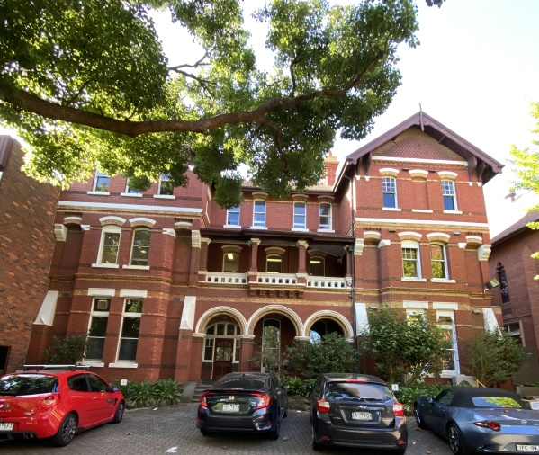  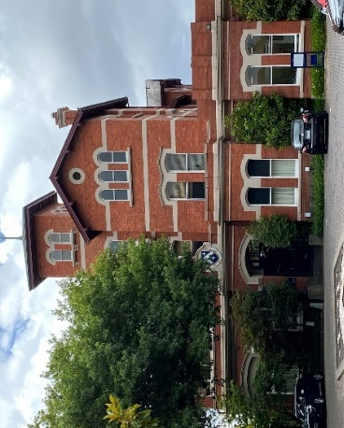  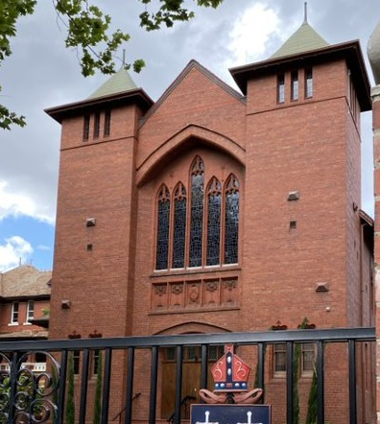  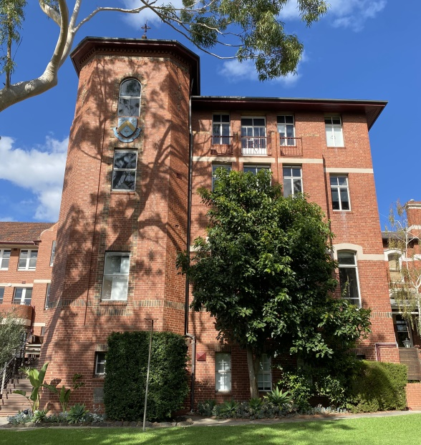  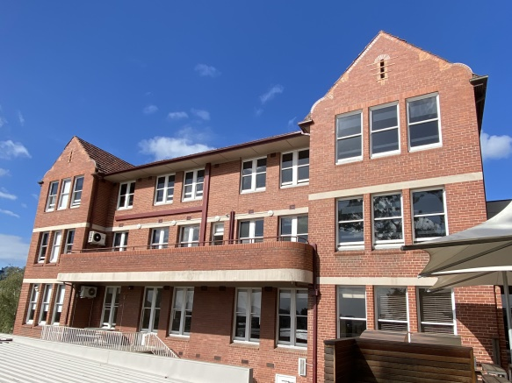  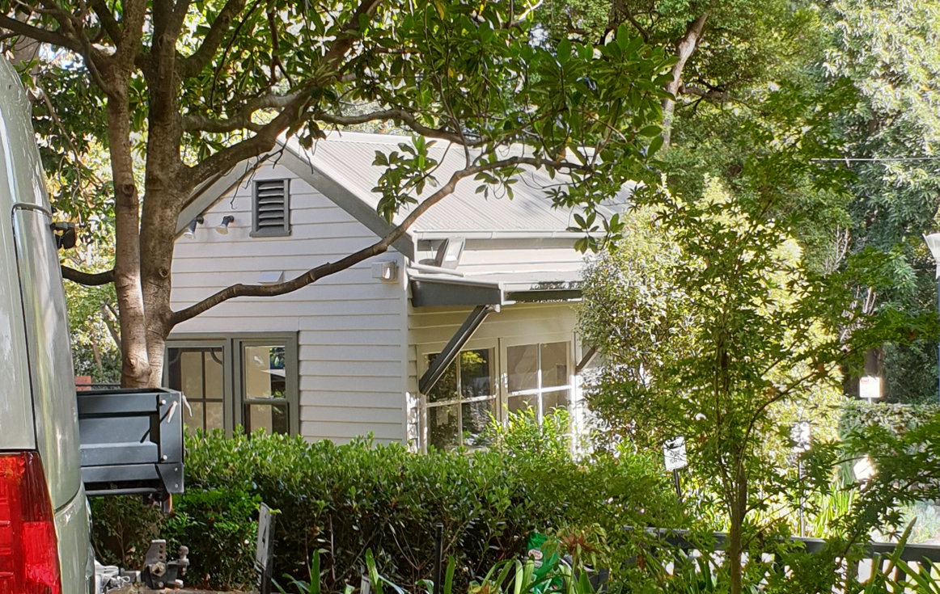 |  | 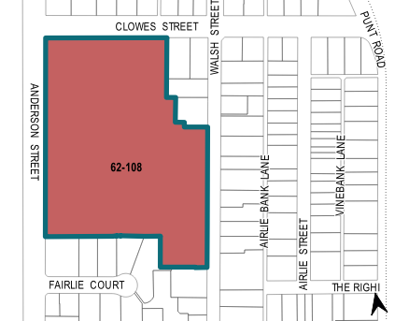

What is significant?
Melbourne Girls Grammar School at part of 62–108 Anderson Street, South Yarra, developed from 1881 onwards, is significant.
Elements that contribute to the significance of the place include (but are not limited to) the:
- form, materiality and detailing of the Merton Hall building with rear wing (Figure 1: Number 1)
- form, materiality and detailing of the Chapel of St Luke building (Figure 1: Number 2)
- form, materiality and detailing of Phelia Grimwade House (Figure 1: Number 3)
- form, materiality and detailing of the 1930 Phelia Grimwade House extension (Figure 1: Number 4)
- form, materiality and detailing of Gilman Jones Hall (Figure 1: Number 5)
- form, materiality and detailing of the former nursery building (Figure 1: Number 6)
- fencing and retaining walls around much of the site, built in a combination of red brick, sandstone and bluestone
- early wrought iron gates
- school’s garden setting, particularly in the northwest corner of the site surrounding Phelia Grimwade House
- mature collection of trees including evergreen and deciduous exotic and Australian native specimens (established by c1945) within the gardens along Clowes Street and Anderson Street (Figure 2: Numbers 1–12)
- school’s continuous use of red and polychromatic brickwork, terracotta and render across the site
- school’s siting within its domestic streetscape, opposite the Royal Botanic Gardens.
More recent alterations and additions (Figure 1: Number 7–13), are not significant. The two c1930s residences fronting Walsh Street (Figure 1: Number 14) are not significant to the subject site.

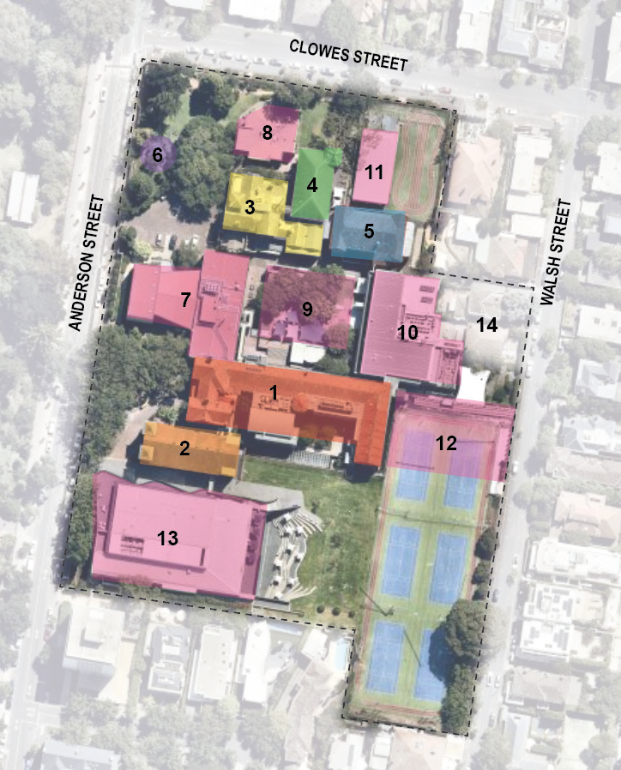
Legend
1 | Merton Hall (1900) and rear extension (1919, after 1938) | 8 | Jessie Bage House (1979)
2 | Chapel of St Luke (former Assembly Hall) (1917) | 9 | Nina Crone Library (1987, 2006)
3 | Phelia Grimwade House (former Yarra House) (1881–82) | 10 | Christine Briggs Building (2004)
4 | Phelia Grimwade House extension (1930) | 11 | Hub (c2010s)
5 | Gilman Jones Hall (1937) | 12 | Wildfell Centre (2010)
6 | Former Nursery (c1940) | 13 | Artemis Centre (2014–17)
7 | Ross Hall and Edith Mountain Centre (c1970–80s) | 14 | Two c1930s residences known as 281 and 285 Walsh Street (incorporated as part of the complex in the late twentieth century)
Figure 1. Aerial photograph of 62–108 Anderson Street, South Yarra (dashed outline), showing the key elements that contribute to the significance (Numbers 1–6). Purpose-built school buildings shaded in pink (Numbers 7–13) and Number 14 are late twentieth century additions to the complex that are not significant. (Source: Nearmap 2022 with GML overlay)

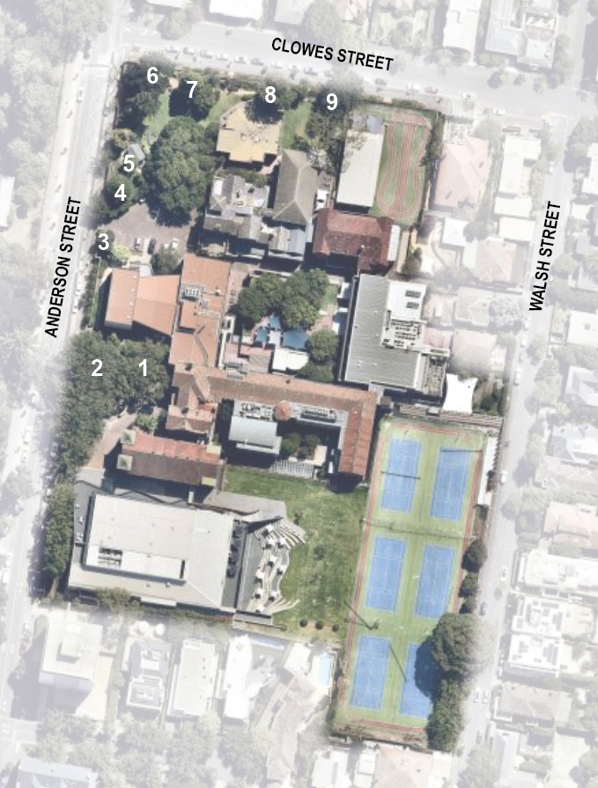
Legend
1 | Red Ash (Fraxinus pennsylvanica) | 6 | English Elm (Ulmus procera)
2 | Row of seven London Plane (Platanus x acerifolius) | 7 | Likely Monterey Cypress (Cupressus sp.)
3 | Red-flowering Gum (Corymbia ficifolia) | 8 | Silky Oak (Grevillea robusta)
4 | Monterey Cypress (Cupressus macrocarpa) | 9 | English Elm (Ulmus procera)
5 | Kurrajong (Brachychiton populneus)
Figure 2. Aerial photograph of the subject site with mature trees that contribute to the significance. (Source: Nearmap 2022 with GML overlay)

How is it significant?
Melbourne Girls Grammar School at part of 62–108 Anderson Street, South Yarra, developed from 1881 onwards, is of local historical, aesthetic and social significance to the City of Melbourne.

Why is it significant?
Melbourne Girls Grammar School at part of 62–108 Anderson Street, South Yarra, is of local historical significance as a long-established girls school in South Yarra. The secondary education of girls in the nineteenth century had been provided by private tutors and by small private schools, which often operated in the homes of their owners. Originally opened as Merton Hall, Melbourne Girls Grammar School began as one of these schools in 1893. Merton Hall gained such popularity, likely due to the quality of teaching provided by its original Cambridge-educated proprietors, that it commissioned a large purpose-built schoolhouse. The large student numbers and fine campus would have cemented the school’s prominence. (Criterion A)
The school is of historical significance as the first girls’ school in Victoria that was officially affiliated with the Anglican Church. Despite other Christian denominations gradually providing for girls’ education in the nineteenth century, the Anglican Church did not provide such measures, and Anglican families instead relied upon small girls’ schools whose owners had Anglican leanings. Due to connections between the school’s second owner and the Anglican Church, the school was eventually granted permission to use the name of Melbourne Church of England Girls Grammar School, and was shortly afterwards acquired by the Anglican Church. The Anglican Church has since opened further girls’ schools in Victoria, and is a major provider of private education in Victoria. (Criterion A)
Melbourne Girls Grammar School is of aesthetic significance for its fine collection of architect-designed buildings, enhanced by its garden setting and location opposite the Botanic Gardens. The site is characterised by its continuous use of red brick buildings, enlivened by render, polychromatic brickwork, terracotta, and tiled roofs. The Merton Hall building, designed by Percy Oakden, is a finely designed building, with ornate brickwork and intact original detailing. The former assembly hall features highly refined use of terracotta Art Nouveau decorative detailing. Phelia Grimwade House is a highly refined example of an asymmetrical, early 1880s house, that is greatly enhanced by its remnant garden setting including mature trees (evergreen and deciduous exotic and Australian native specimens) established by c1945. Further additions, including the Phelia Grimwade House extension and Gilman Jones Hall, exhibit fine detailing and conscious integration with existing buildings. (Criterion E)
Melbourne Girls Grammar School is socially significant to the City of Melbourne, having been continually used as a place of education for over 160 years. It is especially significant to the community of women who have been educated there, and those who have been associated with the school, such as teachers, benefactors and administrators. The school community’s connection with the site is especially evident in the Chapel of St Luke, where the Old Collegians’ Association has been responsible for the donation of multiple stained glass memorial windows. The Chapel continues to be used by members of the community as their principal place of worship, and for major life events such as weddings and funerals. (Criterion G)

Primary source
South Yarra Heritage Review 2022 (GML Heritage)

