Statement of Significance: Sheridan Close (485-491 St Kilda Road, Melbourne), February 2023

Heritage Place: | Sheridan Close | PS ref no: | HO1413
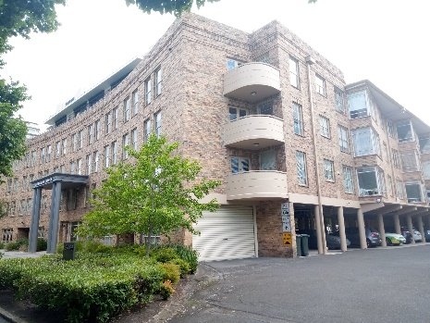  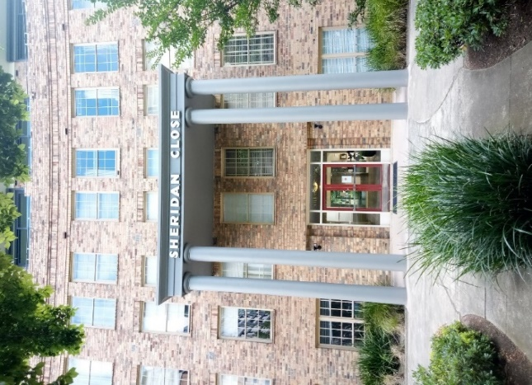 | 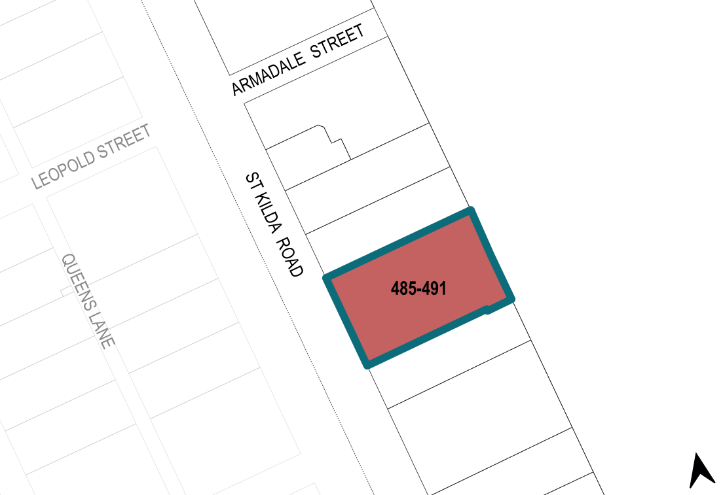

What is significant?
Sheridan Close at 485–491 St Kilda Road, Melbourne, built in 1951–53 and designed by Sir Bernard Evans, is significant.
Elements that contribute to the significance of the place include (but are not limited to) the:
- original built form surrounding an enclosed trapezoidal courtyard garden
- open access galleries and protruding stairwell towers on the internal sides
- face oatmeal brick construction, concave western façade, serrated northern and southern façades, and inner façades facing into the courtyard
- terracotta tiled hipped roof to north, south and east sections of the building, accessible terraces to the west section of the building
- pillars and ground floor undercroft parking
- complex’s original materials as well as its detailing

- complex’s high level of integrity to its original design representative of Postwar Modernist architecture, including influences of earlier styles such as Georgian Revival and the Moderne;
- pattern and size of original Georgian Revival style fenestration on the western façade
- Modernist style fenestration with asymmetrical glazing maximising light on the northern and southern sides
- other original elements including timber and aluminium window frames
- original or early volcanic rock edging, garden beds and layout of the central courtyard garden
- lamps and stepping stones within the courtyard garden.
More recent changes, including window, balustrading and door replacements, are not significant.
The tree plantings contribute to the setting of the place but are not significant in their own right.

How is it significant?
Sheridan Close at 485–491 St Kilda Road, Melbourne, is of local historical, representative, aesthetic and associative significance to the City of Melbourne.

Why is it significant?
Sheridan Close is historically significant as an early example of an Own-Your-Own (OYO) flat complex in Melbourne, a forerunner to strata-title legislation which was introduced in 1967. It pioneered a new typology of luxury, purpose-built, high-density living. It was the largest block of OYO flats built in Melbourne when it was completed in 1953. It is significant for its capacity to demonstrate a period of residential growth along the St Kilda Road corridor. The high quality and grandeur of Sheridan Close is indicative of the prestige of a St Kilda Road address at that time. The integration of car parking within the building reflects the expectation of individual car ownership. It is also notable for its ongoing use as residential flats. (Criterion A)
Sheridan Close is aesthetically significant for its grandeur, scale and unusual stylistically hybridised design. The arrangement of the complex around an enclosed trapezoidal courtyard illustrates the exclusivity of the complex and harks to back to the planning model of European piazzas. The complex is stylistically transitional. It is characterised by its juxtaposition of Modernist design principles with earlier styles such as Georgian and Moderne that were popular in the interwar era. These earlier styles would have been familiar to and popular with the wealthy demographic at which the complex was marketed and were commensurate with its prestigious address. Modernist design principles are at work, however, in the raising of the north and south sections of the building on pillars to create undercroft car parking areas and in the environmental considerations evidenced in the serrated profile of these wings to provide individual dwellings with light and views.
The visual dominance and concavity of the main St Kilda Road façade with its simple yet refined detailing contributes to the building’s aesthetic significance and makes a notable contribution to the St Kilda Road streetscape. The oatmeal-coloured face brickwork construction is uncommon in this area and visually striking. (Criterion E)
Sheridan Close is significant for its association with architect Sir Bernard Evans who was a key proponent of the Own Your Own movement. Evans is also notable for his public contribution and advocacy in support of taller residential city buildings with greater open space and setbacks from the street in Melbourne. This was achieved through service on several council committees and roles as the Lord Mayor of Melbourne (1959–61) and a commissioner of the Melbourne and Metropolitan Board of Works (1956–73). As well as Sheridan Close, Bernard Evans, through his architectural practice, built many buildings of different uses and styles including Emerald Hill Court, South Melbourne; AMPOL House, Carlton; the CRA building, 99 Collins Street; and the Legal and General Assurance building, St Kilda Road. (Criterion H)

Primary source
South Yarra Heritage Review 2022 (GML Heritage)

