Statement of Significance: South Yarra Precinct, February 2023

Heritage Place: | South Yarra Precinct | PS ref no: | HO6
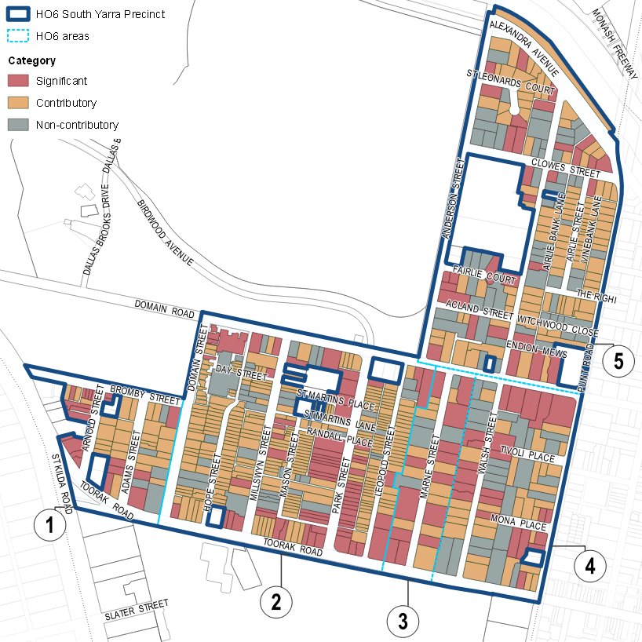

What is significant?
The South Yarra Precinct, South Yarra, incorporating an area in the Parish of Melbourne South developed from the 1840s, is significant.
Elements that contribute to the significance of the precinct include (but are not limited to):
- Area 1, including
- early pattern of subdivision of the land comprising 14 allotments (Crown Sections 3 and 4), fronting Adams Street, Arnold Street and Bromby Street, sold in 1864
- early pattern of subdivision of the land comprising seven allotments (Crown Section 5),

bounded by Bromby Street, St Kilda Road and Arnold Street, sold in 1865.
- mixed-era residential buildings, predominantly interwar and postwar blocks of flats interspersed with nineteenth century building stock
- early twentieth century commercial and industrial buildings in St Kilda Road and Arnold Steet, including those that reflect the emergence of motor-related businesses along the major thoroughfare on the St Kilda Road and a former private hospital
- Area 2, including
- early pattern of subdivision of the land comprising four 9 ½-acre allotments (Crown Allotments 15, 16, 17 and 18) sold in 1849. Residential subdivision by 1850 created wider principal streets (Millswyn Street and Park Street) with large villa blocks. Smaller blocks for workers’ houses were created by mid-Victorian subdivisions in narrower street such as St Martins Lane, Little Park Street and Hope Street (including former Montpelier Place), and similar 1880s subdivisions of Mason Street and Leopold Street
- mixed-era residential buildings including a high concentration of refined architect-designed buildings, particularly evident along Park Street, and represented in other streets such as Millswyn Street, Domain Road and Toorak Road
- early suburban subdivisions and nineteenth century building stock, especially with consistent pre-1901 streetscapes in Domain Street, Hope Street, Mason Street and Leopold Street
- nineteenth and early twentieth century commercial buildings in the intersection of Domain Road and Park Street, and along Millswyn Street
- Area 3, including
- early pattern of subdivision of the land comprising a 9 ½-acre allotment (Crown Allotment 19) sold in 1849. Allotment 19 was the site of a mansion 'Maritimo' until the early twentieth century. The Maritimo Estate was subdivided in 1912–16 into allotments fronting Domain Road and a new street named Marne Street
- a high concentration of refined architect-designed blocks of flats representing the popularity of flat development that continued into the postwar period
- high quality interwar building stock, representative of almost every interwar architectural style (including Arts and Crafts, Georgian Revival, Old English, Moderne, Mediterranean and Spanish Mission) and the work of some of Melbourne’s most prominent architects practising in the period
- Area 4, including
- early pattern of subdivision of the land comprising two 9 ½-acre allotments (Crown Allotments 20 and 21), sold in 1849. Formed in the 1850s, spacious villa allotments fronting Walsh Street, Mona Place and Tivoli Place were among the earliest residential subdivisions in South Yarra
- mixed-era residential buildings representing the phase of active flat development following demolition and subdivision of nineteenth century estates
- a number of early houses (such as those at 98–110 Walsh Street and 107–111 and 113–117 Walsh Street and 249 Domain Road and 255 Domain Road) which reinforce the traces of the earliest layer of residential development in this area
- Area 5, including
- early pattern of subdivision of the land comprising three 10-acre allotments (Crown Allotments 8, 9 and 10), and a smaller allotment (Crown Allotment 5), sold in 1845-46. These allotments were developed with a number of houses in the 1840s and 1850s. Further residential subdivisions occurred from the 1880s, creating allotments fronting Walsh Street, Domain Road and Clowes Street, and newly formed streets of Airlie Street and The Righi
- early pattern of subdivision comprising reclaimed land (part of a former lagoon) on Crown Allotment Y, bounded by Clowes Street, Punt Road and Alexandra Avenue, subdivided in 1910-13
- mixed-era residential building stock characterised by eclectic range of interwar styles and influences, including Arts and Crafts, Georgian Revival, Old English, Moderne, Mediterranean and Spanish Mission
- a cluster of intact 1920s–30s Georgian Revival style buildings in St Leonards Court
- consistent pre-1901 streetscapes in Airlie Street
- a varying topography with land sloping down towards the river
- the low-scale external form of buildings developed pre-World War I (typically one to three storeys); featuring original hipped and gabled roof forms (sometimes with parapets); early chimneys; timber and masonry construction and finishes (some painted and rendered); the pattern and size of original fenestration; stylistic detailing; and early iron palisade fences on stone plinths or retaining walls
- the low-scale external form of buildings from 1918–45 (typically one to four storeys) featuring masonry construction and finishes (some painted and rendered), original hipped, gabled and flat roof forms (sometimes with parapets); intact early chimneys; the pattern and size of original fenestration; stylistic detailing; and early low masonry fences (some with integrated letter boxes and garden beds)
- the typical external form of post-1945 buildings (with varying heights); which have masonry and concrete construction and finishes; original hipped, gabled and flat roof forms (sometimes with parapets); early chimneys; the pattern and size of original fenestration; stylistic detailing; and early fences and landscaping (including masonry or stone fences, garden edging, garden beds or retaining walls)
- early subdivision patterns as evidenced in the hierarchy of principal and secondary streets and lanes (including the layout and width of streets), allotment sizes, and setbacks from property boundaries
- public space elements including:
- the Golden Wych Elm (Ulmus glabra ‘Lutescens’) at 2 Clowes Street
- street trees, especially mature London Plane trees (Platanus x acerifolia) planted along Arnold Street and Adams Street and in a verge along Bromby Street
- a group of mature trees planted on the stretch of reserve along the Yarra River (opposite 1–45 Alexandra Avenue), including two Canary Island Date Palms (Phoenix canariensi), Washingtonia (Washingtonia robusta), Schinus Peppercorn Tree (Schinus areira) and Eucalyptus Bangalay (Eucalyptus botryoides)
- two mature Moreton Bay Figs (Ficus macrophylla) at the triangular traffic island at the corner of Toorak Road and St Kilda Road
- extant street lamp (55 Bromby Street) and street lamp bases (outside 1–9 and 19 Park Street,

at the corner Park Street and Mason Street, at the corner Toorak Road and Park Street, and outside 1 Walsh Street)
- asphalted footpaths, bluestone kerbs and gutters, and the lanes with bluestone pitchers and central drains
- views into and out of the adjoining parks and gardens.
Early fences and landscaping contribute to the significance of the precinct.
More recent (post-1980s) alterations and additions to significant and contributory buildings are not significant.

How is it significant?
South Yarra Precinct, South Yarra, is of local historical and aesthetic significance to the City of Melbourne.

Why is it significant?
South Yarra Precinct is historically significant for its demonstration of a predominantly residential development pattern that spans from the 1840s through to the postwar period. The concentration of high-quality building stock in the precinct demonstrates the significant influence of wealth and privilege in this part of Melbourne. This is reflected in the prestigious location and desirability of the area associated with its elevated position, proximity to the river and pleasant parkland setting. Area 2 retains most housing stock from the Victorian period. Substantial terraces and detached villas developed by prominent property owners are interspersed with smaller working-class houses built for their servants and those who worked in trades. Several boarding houses, guesthouses and private hotels were established in Park Street. Occupying elevated land and in close proximity to the city centre, merchants, professionals and wealthy speculators were drawn to the area. Owing to the social cachet of the area, graziers established town houses here from the mid nineteenth century or later retired to the area. Subsequent suburban subdivisions and nineteenth-century building stock are well represented across the South Yarra Precinct, especially with consistent Victorian streetscapes in Domain Street, Hope Street, Mason Street, Leopold Street (Area 2) and Airlie Street (Area 5). (Criterion A)
Throughout the twentieth century, remaining vacant lots were taken up for further residential development. From the interwar period, South Yarra became a focus for flat development in Melbourne where low-rise blocks of flats became a lucrative form of investment in the aftermath of the stock market crash of 1929 and subsequent Depression. This is particularly evidenced by the interwar streetscapes in Marne Street (on the site of the Maritimo estate, in Area 3), developed over a short period 1928–40. The popularity of flat development continued into the postwar period. Area 3 is distinguished for its collection of a high number of architecturally designed, mostly interwar, luxury blocks of flats and houses. Fairlie Court and St Leonards Court (the former Fairlie and St Leonards estates, in Area 5) represent similar concentration of interwar development at smaller scale. Area 1 is predominantly characterised by interwar and postwar flats interspersed with Victorian-era building stock. Area 4 also had a similar phase of active flat development following demolition and subdivision of Victorian era properties such as Salisbury (42–66 Walsh Street), Riahnva (at the corner of Toorak Road and Punt Road) and Fairholm (55–77 Walsh Street). The South Yarra Precinct is distinguished for its array of mixed-era development. This resulted in the area having a rich combined architectural and streetscape character. (Criterion A)
The South Yarra Precinct is also significant for its retention of nineteenth and early twentieth century commercial and industrial buildings in St Kilda Road (Area 1), Millswyn Street and the intersection of Domain Road and Park Street (Area 2). The latter was the location of one of the earliest commercial developments in the suburb, and was substantially renewed around the time of the electrification of tram lines in 1927. The emergence of automobile-related businesses in the 1910s and 1920s in St Kilda Road (Area 1) and St Martins Lane (Area 2) is evidence of relatively early car ownership in the area. (Criterion A)
The South Yarra Precinct is of aesthetic significance primarily as a prestigious residential area of mixed character that has developed and evolved from the 1840s through to the present day. This layering of development has resulted in the area having a rich combined architectural and streetscape character. This mixed character is unified by a general consistency in building quality, height, setback, form, and a pattern of fenestration and materiality that harmonises buildings of different historical eras and architectural styles within a cohesive urban setting. The precinct’s character is enriched by its public realm elements, which include a mix of wide and finer grade streets that have mature and semi-mature deciduous and evergreen trees, bluestone kerbs and guttering, asphalt footpaths and a network of bluestone lanes (the latter are a particular feature of Areas 2 and 5). Throughout the precinct oblique views are possible due to the generous side setbacks of many buildings. This allows buildings to be viewed three-dimensionally, including roofscapes of hip and gable roof forms clad with slate or terracotta combined with chimneys and parapets. The aesthetic quality of the precinct is further enhanced by its proximity to parklands; it is bound by Fawkner Park to its south, and the Royal Botanic Gardens, and Yarra River to its north. (Criterion E)
Within the precinct there are streets that have a particularly high uniformity that demonstrate subsequent subdivision patterns. These include the intact Victorian streetscapes along Hope Street, Mason Street, Park Street and much of Leopold Street (Area 2) and Airlie Street (Area 5) which retain a large proportion of Italianate style houses. It includes interwar streetscapes of Marne Street (Area 3), St Leonards Court (Area 5) and (to a lesser degree) Fairlie Court (Area 5). These are characterised by an eclectic range of interwar styles and influences, including Arts and Crafts, Georgian Revival, Old English, Moderne, Mediterranean and Spanish Mission. Of note is the large number of interwar Georgian Revival residences, particularly in St Leonards Court and Fairlie Court (Area 5). Area 2 retains a group of intact interwar shops at the corner of Domain Road and Park Street. Early commercial development can also be observed along Millswyn Street (although all buildings are now used for residential purposes). (Criterion E)
The precinct is distinguished by its high concentration of refined architect-designed buildings. This is particularly evident along Park Street, Domain Road and Toorak Road (Area 2) and Marne Street (Area 3) for Victorian and interwar architecture respectively, however such places are not confined to any one section of the precinct nor to any one development period. This, coupled with the general high quality of architectural design and materiality, provides an unusually rich aesthetic quality to the streetscapes across the entire area. (Criterion E)
The precinct contains a large number of blocks of residential flats from the interwar and postwar periods. While those from the interwar period tend to be large luxury flats, the later postwar flats reflect the changing urban landscape seen in much of inner city Melbourne. Through its high
concentration of refined architect-designed building stock the precinct demonstrates the influence of the many middle and upper-middle class arbiters of taste who chose to live in the area. The poswar buildings themselves sit comfortably side by side with earlier development due to their scale, form and materiality. (Criterion E)

Primary source
South Yarra Heritage Review 2022 (GML Heritage)

