Statement of Significance: South Yarra Primary School (585-601 Punt Road, South Yarra), February 2023

Heritage Place: | South Yarra Primary School | PS ref no: | HO1408
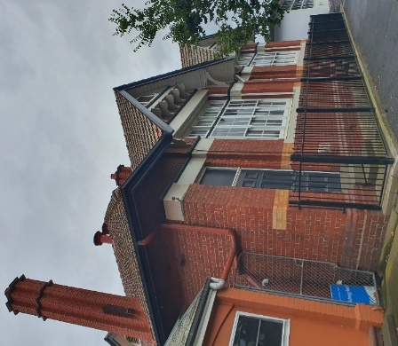  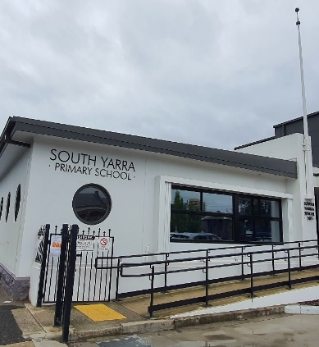  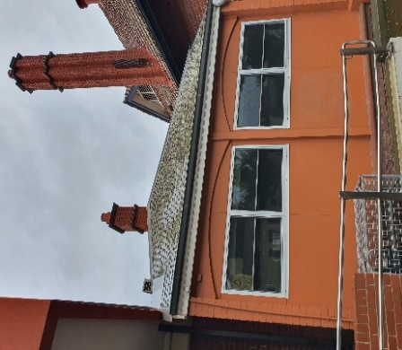  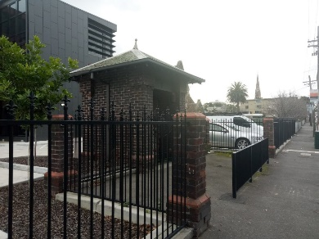 | 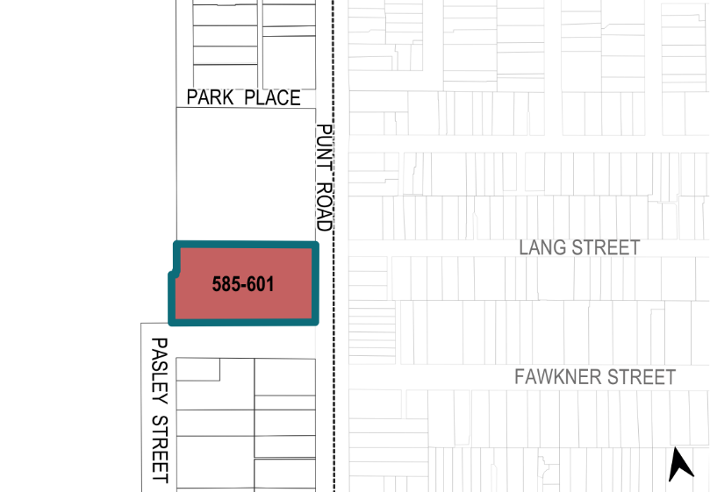

What is significant?
South Yarra Primary School at 585–601 Punt Road, South Yarra, built in 1877, 1906, 1923–24,
1948–50, is significant.
Elements that contribute to the significance of the place include (but are not limited to) the:
- original external form, materials and details of the 1906–07 red brick infants school building (Figure 1: Number 1) and the 1953 school bell hung at the rear of the building
- remaining side (south) elevation and front (east) elevation up to the flagpole of the 1948–50 main school building (Figure 1: Number 5), including its form, fenestrations, flagpole, and Moderne style lettering reading ‘South Yarra Primary School’ on the front (east) of the building under the flagpole.
- remaining bluestone foundations of the 1877 school building (Figure 1: part of Number 5)
- 1924 war memorial gateway and honour roll, and brick fence posts (Figure 1: Number 4)
- form, remaining fabric and composition of the 1906 former caretaker’s cottage (Figure 1: Number 2).
The 1923–24 skillion roof extension to the east of the infants school building (Figure 1: Number 3) is of historical interest however its form has been compromised by incremental change.
More recent alterations and additions, including contemporary buildings dating from c2009 to 2020 (Figure 1: numbers 6–10), fencing, paved areas, play equipment and furniture are not significant in their own right but contribute to the ongoing use of the site as a primary school.

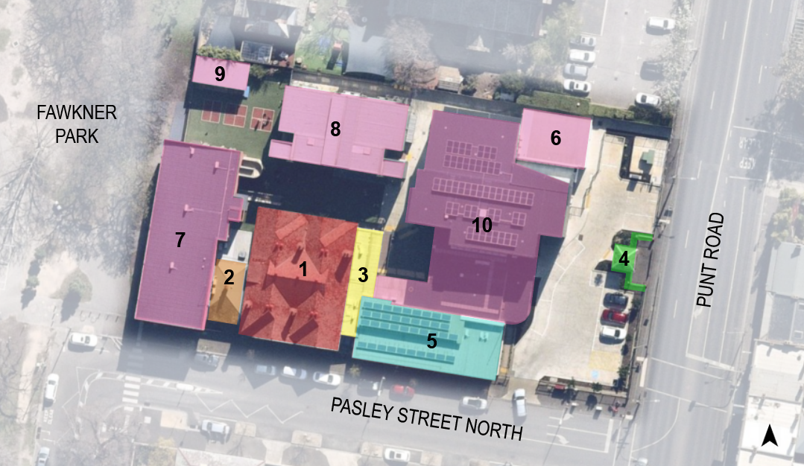
Legend
1 | Infants’ school (1906–07, 1923) | 6 | Contemporary building (c2009)
2 | Former caretaker’s cottage (1906–07) | 7 | Classrooms and multimedia room (2010)
3 | Hat and cloakroom extension (1923) | 8 | New building (2015–16)
4 | Memorial gateway and fence (1924) | 9 | Contemporary building (2017)
5 | Main school building (originally built 1887 and rebuilt and renovated 1948–50) | 10 | Learning Centre and entrance wing (2019–20
Figure 1. Aerial photograph of 585–601 Punt Road, South Yarra, showing the key buildings and later structures. Purpose-built school buildings shaded in pink (Numbers 6–10) are additions constructed from the 2000s onwards that are not significant. (Source: Nearmap 2020 with GML overlay)

How is it significant?
South Yarra Primary School at 585–601 Punt Road, South Yarra, is of local historical, representative and social significance to the City of Melbourne.

Why is it significant?
The site of the South Yarra Primary School at 585–601 Punt Road, South Yarra, has historical significance as a place where Aboriginal people camped in the c1850s and 1860s; this was most likely a use that had been ongoing for a long period of time prior to British colonisation. A mature River Red Gum in the school yard, which no longer survives, marked the site of the camping place. This tree was revered for many years by the school community on account of its historical connection. When the tree died, a piece of wood was retained by the school as a souvenir (Criterion A)
South Yarra Primary School, established as a Presbyterian school in 1854, taken over by the Education Department as a State School in 1873, and added to in 1877, 1906, 1923–24 and 1948–50, is historically significant as the oldest school operating on the same site in the City of Melbourne. The school's history follows its development as an early denominational school (attached to a church) in 1854, its incorporation under the Common School system from 1862, and its adoption as a State School in 1873. Its close proximity to the surviving South Yarra Presbyterian Church (1865), with which it was associated historically, enhances its historical significance. The introduction of free, compulsory and secular education in Victoria in 1873, increased the demand for government school buildings and sparked the need for producing attractive and functional standard school designs. The South Yarra Primary School is an example of one of these designs. Since then, the school building has undergone a number of changes, with significant additions in 1906, 1923–24 and 1948–50, which reflect key periods of development of the school to accommodate the changing needs of the contemporaneous school community. (Criterion A)
Elements of the South Yarra Primary School have representative significance as they are typologically representative of key periods of state school design since the introduction of government schools. These periods and elements include: the late nineteenth century (remaining bluestone foundations of the 1877 school building); early part of the twentieth century (the 1906–07 infants school and 1906 caretaker’s cottage; interwar period (the 1924 memorial gateway including the honour roll and fenceposts); and postwar period (the remaining portion of the 1948–50 main school building and 1953 school bell hung at the rear of the infants school building). The elements demonstrate spatial arrangements and typical stylistic aspects of such building typologies. The side (south) elevation and front (east) elevation (up to the flagpole) of the postwar building designed by the Public Works Department (Figure 1: Number 5) represent the remaining portion of the main school building (1948–50), which was possibly the only postwar primary school building in the City of Melbourne. It demonstrates chief architect of the Public Works Department 1934–53, Percy Everett's, tendency to favour the Moderne style in public buildings, including schools. The red brick infants’ school building (Figure 1: Number 1) is notable for its intactness, and is a strong example of a Federation-era infants school building design by the Public Works Department district architect J B Cohen. (Criterion D)
The South Yarra Primary School is socially significant to the City of Melbourne. It has had a long and continuing role as a government school in the City of Melbourne since 1854. The Church has been a focus for the local community, and has been part of the lives of generations of school children. The 1924 memorial gateway and honour roll (Figure 1: Number 4) is socially significant as a visual tangible link to previous generations of students who lost their lives in World War I. (Criterion G)

Primary source
South Yarra Heritage Review 2022 (GML Heritage)

