Statement of Significance: South Yarra Telephone Exchange (737-743 Punt Road, South Yarra), February 2023

Heritage Place: | South Yarra Telephone Exchange | PS ref no: | HO1411
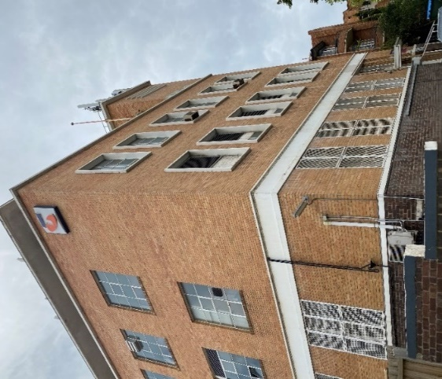 | 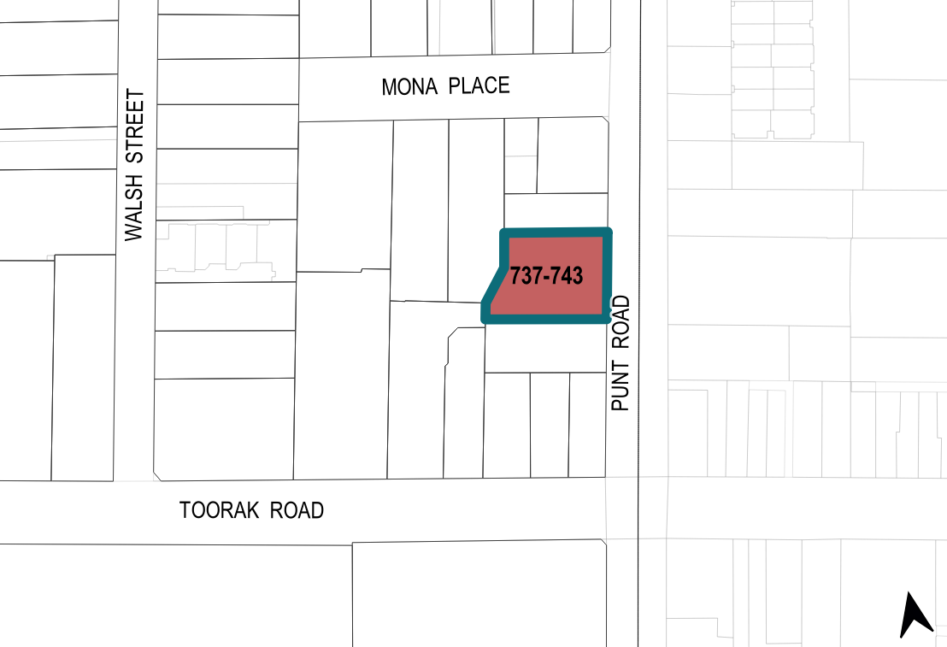

What is significant?
The South Yarra Telephone Exchange at 737–743 Punt Road, South Yarra, built in 1950 for the Postmaster-General’s Department is significant.
Elements that contribute to the significance of the place include (but are not limited to) the:
- building’s original 1950 external form, materials and detailing
- building’s high level of integrity to its original design, including the composition of the primary; street-facing elevation
- pattern and size of original window and door openings
- other original detailing including bichromatic brickwork, cement banding, projecting window surrounds and mullions, tower grill detailing and metal building numbers next to the entrance.
The original dark brown brick garden wall on the Punt Road façade also contributes to the significance of the place. Plant and aerials located on the roof are not significant.

How is it significant?
The South Yarra Telephone Exchange at 737–743 Punt Road, South Yarra, is of local historical and representative significance to the City of Melbourne.

Why is it significant?
The South Yarra Telephone Exchange at 737–743 Punt Road, South Yarra, is of local historical significance to the City of Melbourne as an example of a telephone exchange built to serve the needs of local residents. Built in 1950 to a design by John McMahon Keane of the Commonwealth Works Department, the exchange building demonstrates the increased demand for automated telecommunication infrastructure in suburban Melbourne from the 1940s and into the postwar period, reflecting the growing number of telephone subscribers. The subject building is significant as an early postwar Commonwealth Department of Works designed purpose-built telephone exchange building. The subject site was acquired by the Postmaster-General’s Department for the purpose of an automatic telephone exchange in 1946. (Criterion A)
The South Yarra Telephone Exchange is significant as a highly intact example of a Commonwealth Department of Works designed telecommunications building. It reflects the application of Modernist design principles of rationality and functionality for Government Infrastructure in the early postwar era. The building’s solid massing, geometric form, interplay between horizontal and vertical elements, use of simple, contrasting materials and pared back detailing also reflect Modernist design principles. The main section of the building is characterised by its bichromatic brickwork, painted cement render banding, mullion and grill details and horizontal array of regular sized openings. Key elements also include the five-storey tower to the northeast corner of the building and the floating horizontal plane created by the deep eaves of the inset fourth-floor level of the building. The Commonwealth Department of Works was responsible for a number of high quality major public buildings during the postwar period, particularly for telecommunication infrastructure. The South Yarra exchange demonstrates a commitment by the Commonwealth Department of Works to high quality architectural design for major public building and the expansion of this specific typology after World War II. (Criterion D)

Primary source
South Yarra Heritage Review 2022 (GML Heritage)

