Statement of Significance: South Yarra Presbyterian Church complex (603-627 Punt Road, South Yarra), February 2023

Heritage Place: | South Yarra Presbyterian Church complex | PS ref no: | HO1409
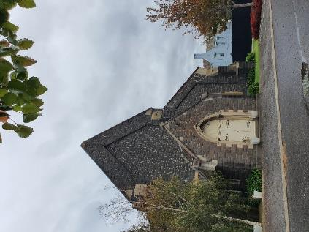  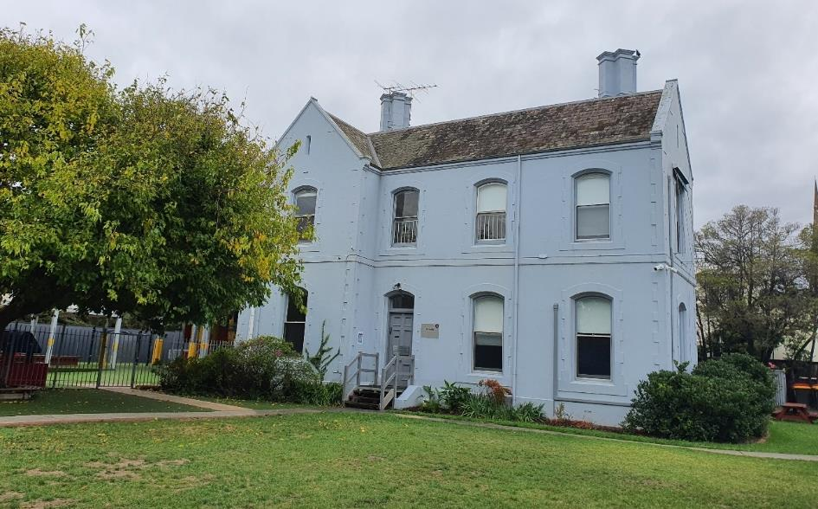  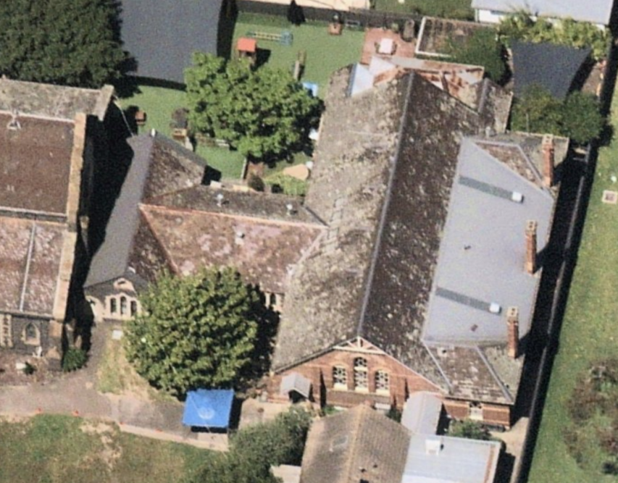  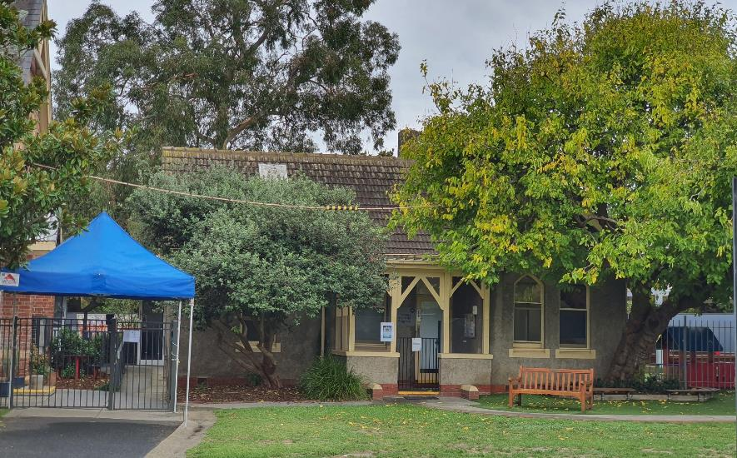 | 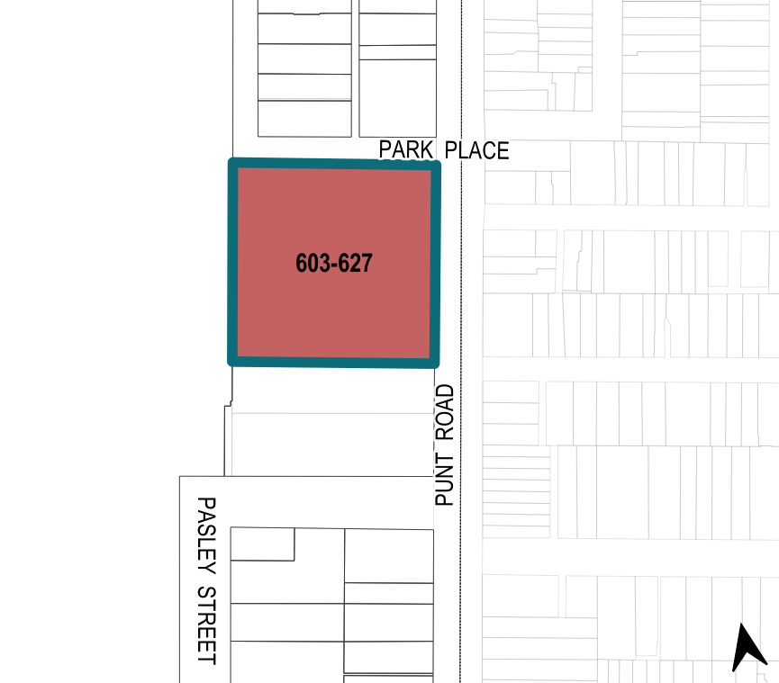

What is significant?
The South Yarra Presbyterian Church complex at 603–627 Punt Road, South Yarra, established in 1854 and built in stages from 1866 to 1925, is significant.
Elements that contribute to the significance of the place include (but are not limited to) the:
- 1866 church (Figure 1: Number 1) and its original external form with slated gable roof, bluestone construction with sandstone (Barrabool Hills freestone) dressing and Gothic Revival style detailing; its high level of integrity to its original design; pattern and size of original fenestration and other decorative details; and the 1920 porch (Figure 1: Number 5)
- 1874 vestry and school wing’s original T-shaped form with slate roof, bluestone construction and cement moulding; its high level of integrity to its original design; pattern and size of original fenestration and other Gothic Revival style decorative details (Figure 1: Number 3)
- 1884 Sunday school’s original external form, polychrome face brickwork and bluestone foundation; its high level of integrity to its original design; pattern and size of original fenestration and other decorative details (Figure 1: Number 4)
- 1873 manse’s original external form with additions from c1890, ruled render finish over masonry (now overpainted) and detailing; its high level of integrity to its original design; pattern and size of original fenestration and other decorative details influenced by domestic Gothic style (Figure 1: Number 2)
- 1925 caretaker’s cottage’s original external form with a gable roof and a projecting gabled wing, rough cast render finish and face brick base; its high level of integrity to its original design; pattern and size of original fenestration and other decorative details influenced by domestic Gothic style (Figure 1: Number 6).
More recent alterations and additions, including rear extension to the caretaker’s cottage from 1992 and refurbishment from 1992 and 1993, are not significant.
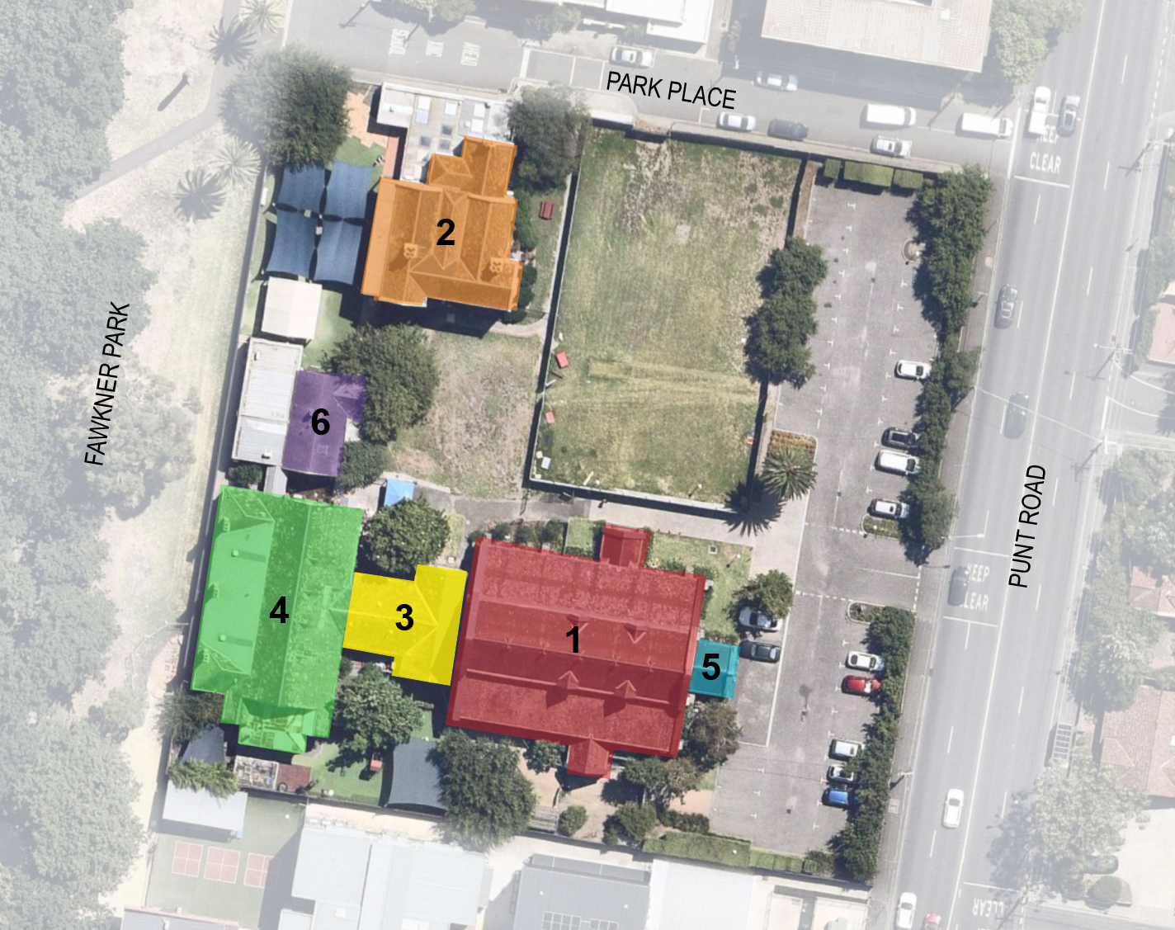
Legend
1 | Presbyterian Church (1866) | 4 | Former Sunday school (1884)
2 | Former manse (1873 and c1890) | 5 | Porch (1920)
3 | Vestry and school wing (1874) | 6 | Former Caretaker’s cottage (1925)
Figure 1. Aerial photograph of 603–627 Punt Road, South Yarra, showing the key elements that contribute to the significance. (Source: Nearmap 2021 with GML overlay)

How is it significant?
The South Yarra Presbyterian Church complex at 603–627 Punt Road, South Yarra, is of local historical, representative and social significance to the City of Melbourne.

Why is it significant?
The South Yarra Presbyterian Church at 603–627 Punt Road, South Yarra, established in 1854, is historically significant as an example of a local Presbyterian church built as part of the early suburban development of Melbourne. It is significant as it occupies one of the four Crown reserves granted for use in the mid–1850s by four major Christian denominations along the same section of Punt Road. Replacing an earlier 1854 timber church building, the 1866 church building (Figure 1: Number 1) stands as a key element in the extensive complex of buildings on the site that was developed through the nineteenth century and into the twentieth century. The South Yarra Presbyterian Church complex provides important tangible evidence of this early phase of suburban expansion within the City of Melbourne outside of the central city. (Criterion A)

The South Yarra Presbyterian Church complex is of representative significance to the City of Melbourne, for its representation of an early church complex comprising an 1866 church building and other buildings associated with the operation of the church, developed between 1874 and 1925. These buildings are also significant for their designs influenced by the Gothic Revival style. Designed by prominent Melbourne architect Lloyd Tayler, the subject church (Figure 1: Number 1) retains key stylistic elements that exemplify Gothic Revival style churches, including the use of bluestone with contrasting dressings and detailing, slated high-pitched gable roof, dormer windows and openings on the clerestory level, buttresses, tracery stained-glass, and pointed arched windows and doors. The adjoining 1874 vestry and school wing (Figure 1: Number 3) matches the bluestone construction of the church and contrasting quoining detailing. The 1884 Sunday school building (Figure 1: Number 4) features elements of the Gothic Revival style including narrow pointed arched windows and timber fretwork to the gable ends. The two residential buildings (Figure 1: Number 2 and Number 6) represent domestic versions of Gothic Revival architecture, through their decorative timberwork, gabled roofs (both), quoining to the openings (manse) and narrow pointed arched windows (caretaker's cottage). (Criterion D)
The South Yarra Presbyterian Church complex is socially significant to the City of Melbourne. Serving the Presbyterian congregation on the site since 1854, and retaining that affiliation following the formation of the Uniting Church in Australia, the South Yarra Presbyterian Church demonstrates the dominance of the early Scots Presbyterian immigrants in the local area and their continued influence. The South Yarra Presbyterian Church is important to the Presbyterian community of South Yarra as a place of family gatherings and important occasions such as christenings, wedding and funerals for over 150 years. (Criterion G)

Primary source
South Yarra Heritage Review 2022 (GML Heritage)

