Statement of Significance: St Martins Youth Arts Centre complex (24-32 and 40-46 St Martins Lane, 20-36 St Martins Place and 120-122 Millswyn Street, South Yarra), February 2023

Heritage Place: | St Martins Youth Arts Centre complex | PS ref no: | HO1417
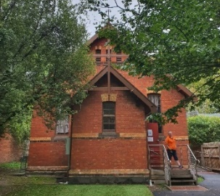  120 – 122 Millswyn Street  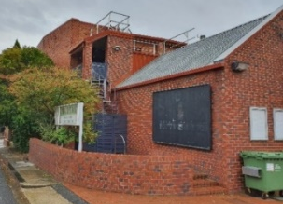  40–46 St Martins Lane  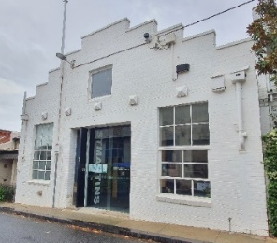  24–32 St Martins Lane  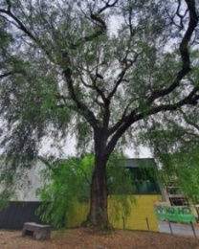  20–36 St Martins Place | 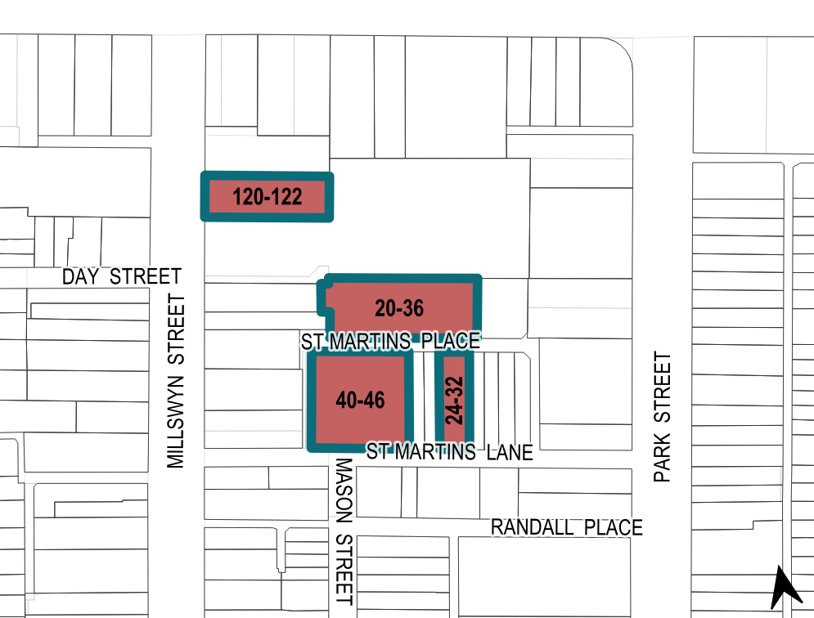

What is significant?
The St Martins Youth Arts Centre complex, comprising 24–32 and 40–46 St Martins Lane, 20–36 St Martins Place, and 120- 122 Millswyn Street, South Yarra, built between 1889 and 1982, is significant.
Elements that contribute to the significance of the place include (but are not limited to) the:
- original external form of the 1956 building (Figure 1: Number 3) at 40–46 St Martins Lane, its red face brick materials and extruded brick detailing and fenestration
- original external form of the 1982 addition (Figure 1: Number 4) to the 1956 building, its red face brick materials, entrance canopy and fenestration
- high level of integrity of the 1956 building and 1982 addition (Figure 1: Number 3 and Number 4) to its original designs
- original external form of the former warehouse (Figure 1: Number 2) built in 1930 at 24–32 St Martins Lane, its stepped parapet, and pattern and size of fenestration and steel bosses
- original external form of the former church hall (Figure 1: Number 1) built in 1889 at 120-122 Millswyn Street, its face brick materials, enclosed porch, buttresses, polychromatic detailing, the pattern and size of fenestration, and timber window joinery
- high level of integrity of the former church hall (Figure 1: Number 1) to its original design
- Peppercorn tree (Schinus areira) and Irene Mitchell commemorative plaque and bench and garden bed area (Figure 1: Number 5) at 20–36 St Martins Place.
More recent alterations and additions, including modified windows and entrance door at 24–32 St Martins Lane; the entrance steps and handrail and the rear extension at 120–122 Millswyn Street; and the carpark at 20–36 St Martins Place are not significant.
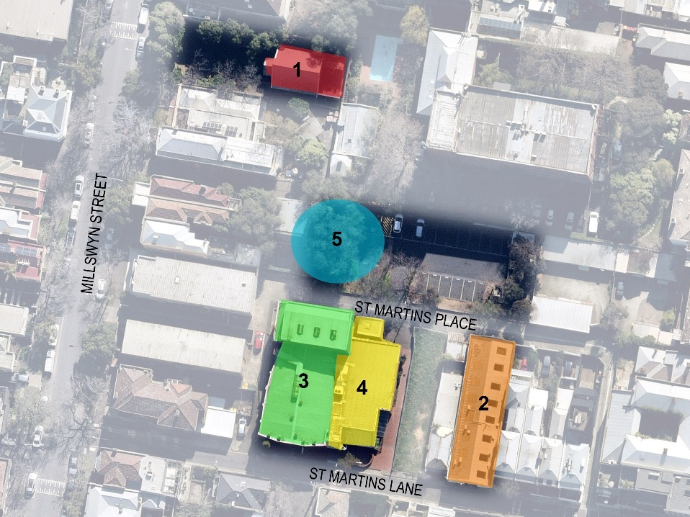
Legend
1 | 120–122 Millswyn Street (1889) | 4 | Additions to 40–46 St Martins Lane (1982)
2 | 24–32 St Martins Lane (1930) | 5 | Peppercorn (Schinus areira) at 20–36 St Martins Place (c1870s)
3 | 40–46 St Martins Lane (1956)
Figure 1. Aerial photograph showing the elements across four discrete sites that contribute to the significance. (Source: Nearmap 2021 with GML overlay)

How is it significant?
The St Martins Youth Arts Centre complex, comprising 24–32 and 40–46 St Martins Lane, 20–36 St Martins Place, and 120–122 Millswyn Street, South Yarra, is of local historical, representative, social and associative significance to the City of Melbourne.

Why is it significant?
The site of the St Martins Youth Arts Centre at 40–46 St Martins Lane is historically significant for its connection with Melbourne Little Theatre Company (renamed St Martin’s Theatre Company in 1962). The company is historically important for the significant role it has played in the development of local theatre in Melbourne. Melbourne Little Theatre Company was established in 1931 during the Great Depression at a time when local theatre productions increased in number as Melbourne’s commercial theatres experienced a demise. Melbourne Little Theatre was accommodated in the former St Chad’s Chapel at 40–46 St Martins Lane (demolished) from 1934, rehearsing and performing Australian plays at a time when performance of local productions was financially difficult. The chapel was replaced in 1956 with a purpose-built theatre building (Figure 1: Number 3). Additions were made to the theatre building in 1982 (Figure 1: Number 4). The theatre and its ancillary buildings at 24–32 St Martins Lane
and 120 Millswyn Street continued to offer a platform for emerging local actors, directors, writers and designers to develop and present their skills in an intimate and progressive environment. The construction of the purpose-built 1956 theatre represents the expansion of St Martin’s Theatre and the popularity of New Wave local theatre in the postwar period. The complex of buildings has provided, and continues to provide, a place to support emerging and professional actors, writers, directors and designers. (Criterion A)
The former church hall (Figure 1: Number 1) at 120–122 Millswyn Street, South Yarra, is of historical significance as an example of a Wesleyan mission hall built in 1889 as an ancillary place of worship to the South Yarra Wesleyan Church on Punt Road. This was designed as a mission church, to serve the needs of the poorer members of the Wesleyan congregation, many of whom resided in the working-class neighbourhood that was in close proximity to the site (Criterion A).
The St Martins Youth Arts Centre complex is of representative significance, as it provides physical evidence of the evolution of an amateur theatre complex in the inner suburbs that made use of converted and adapted buildings. Owing to the financial constraints that many amateur theatre companies experienced, local theatres typically occupied spaces in buildings originally designed for a different use and located in suburban areas where rent was more affordable. Melbourne Little Theatre Company occupied the former St Chad’s Chapel (demolished) from 1934 to 1956 when a new purpose built theatre replaced the chapel, and acquired other pre-existing properties in the vicinity (Figure 1: Number 1 and Number 2) to provide more space for rehearsing and administration. Melbourne Little Theatre Company’s conversion of these structures as performance spaces reflects the adaptive and progressive approach of independent theatres in Melbourne that were typically community-centric, artist-run organisations. (Criterion D)
St Martin’s Theatre building (Figure 1: Number 3) is of representative significance as an example of a postwar brick theatre building with a voluminous structure finished with large expanses of unbroken face brick wall planes enclosing the 1956 Randall Theatre. The building is one of the first theatres in Melbourne to be designed in the modern ‘Continental style’ with entrance to seating at each side and no intermediate aisles. It was designed by the architect Gordon Murphy of Cowper, Murphy and Appleford architects, who were responsible for the design of many theatres in Victoria from the 1930s to the 1950s. The 1982 additions (Number 4), comprising an external stairwell with roof access and railing, the kiosk and foyer and the Irene Mitchell Studio, is also important as a complementary extension that represents the building’s continued as a theatre. (Criterion D)
The former church hall (Figure 1: Number 1) is significant as a representative architectural example of the type of small-scale church halls that were commonplace in the inner suburbs in the late nineteenth century. Its single-storey built form, gable roof, symmetrical arrangement, central entrance porch, polychromatic brickwork, buttresses and segmentally arched windows are typical of suburban church halls. The building was designed by Samuel Charles Brittingham, chief architect of the Public Works Department (1914–22). Brittingham designed many schools and community buildings during his 47-year employment with the Public Works Department. (Criterion D)
The St Martins Theatre complex (now St Martins Youth Arts centre complex is socially significant to the city of Melbourne. It is an important cultural institution that has had a longstanding and continuing presence and influence in Melbourne's theatre industry since 1934. It has social significance for the role it has played as an inclusive and independent theatre that has supported emerging talent for over 80 years. The theatre is socially significant, providing a regular program of affordable productions to
the South Yarra and wider Victorian communities. St Martins Youth Arts Centre is also socially significant for the role it has played in nurturing young talent and promoting diversity in the arts. Since its inception in 1982, St Martins Youth Arts Centre has provided theatre training and performance opportunities to children. The Youth Centre focuses on inclusivity and offers scholarships to support children who may experience barriers to entering the arts industry based on disability, neurodiversity, learning challenges, cultural and linguistic difference or financial difficulty. (Criterion G)
St Martin’s Theatre has supported and fostered the talents of thousands of amateur and professional actors, writers, directors and designers for over 80 years. It has associations with internationally award-winning Australian playwrights, directors and actors including Brett Randall, who founded the company and Irene Mitchell, who was director and teacher at the theatre for over 30 years. St Martin’s Theatre was influential in Melbourne's theatre industry as a place that brought together emerging artists, many who later entered the industry through working for professional theatre organisations. Notable alumni who trained at St Martin’s include actress Sheila Florance; actor George Fairfax; designer, festival director and cultural activist John Truscott; and costume designer Graham Bennett. The Peppercorn tree (Schinus areira) and the Irene Mitchell commemorative plaque and bench at 20–36 St Martins Place has associative significance as a memorial to its former theatre director. (Criterion H)

Primary source
South Yarra Heritage Review 2022 (GML Heritage)

