Statement of Significance: Wesley College (part 567-581 St Kilda Road, Melbourne), February 2023

Heritage Place: | Wesley College | PS ref no: | HO1415
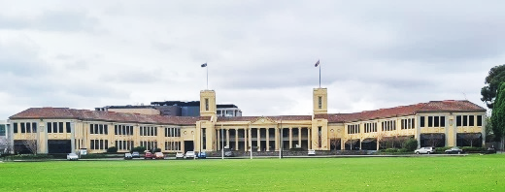  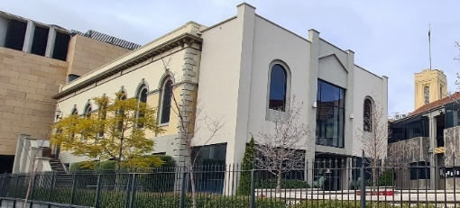  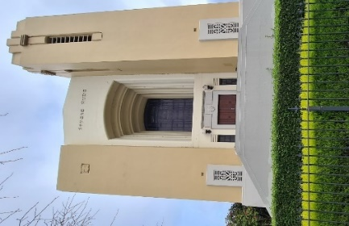  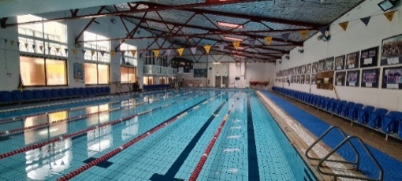  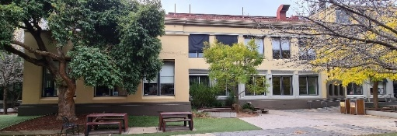  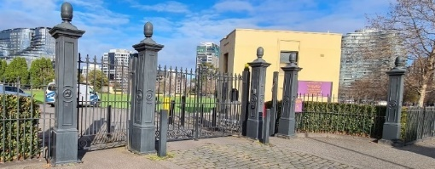 | 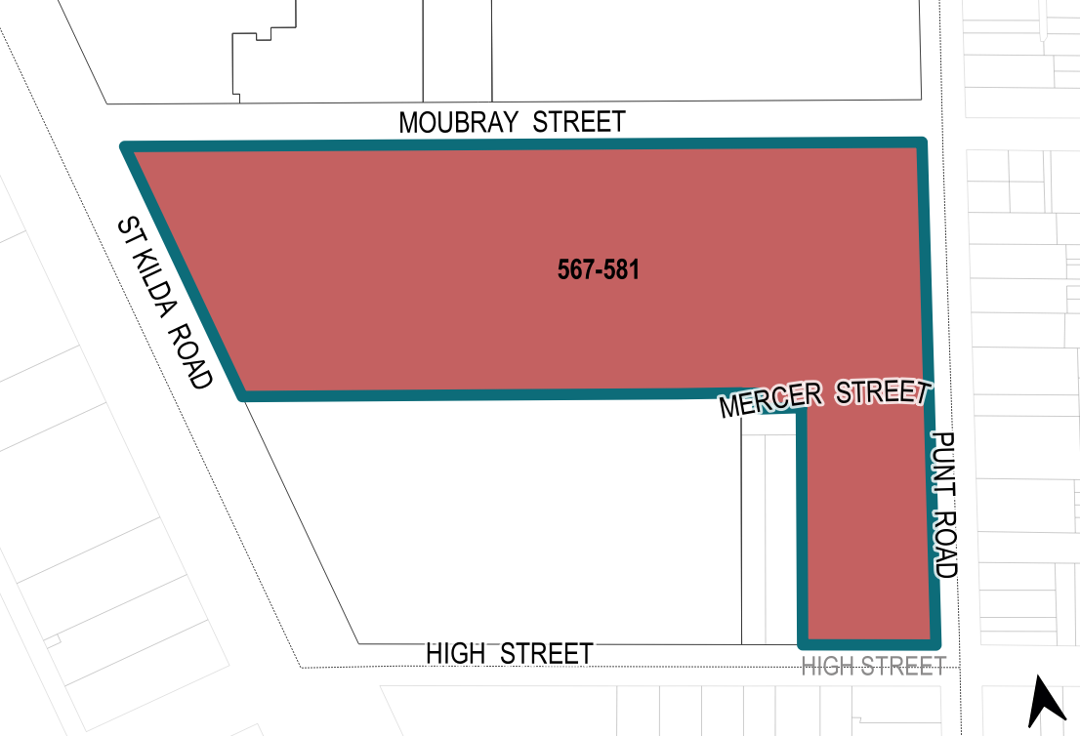

What is significant?
Wesley College at part of 567–581 St Kilda Road, Melbourne, developed from 1866 onwards, is significant.
Elements that contribute to the significance of the place (Figure 1) include (but are not limited to) the:
- form, materiality and detailing of the 1908 Adamson Hall (Figure 1: Number 4) and the 1918 stairwell additions, memorial plaques and detailing
- 1866–1878 form of the main building (Figure 1: Number 1) and scale and siting of buildings fronting the Nye Quadrangle
- form, composition, materiality, detailing and original pattern of fenestration of the 1934 Menzies and Holt Wings (Figure 1: Number 2 and Number 3) and the composition, materiality and detailing of the 1934 main building façade
- remaining 1930s windows and bluestone foundations of the North Wing (Figure 1: Number 5)
- original window frames and moulded door surrounds on the West Wing (Figure 1: Number 7)
- the form, materiality and detailing of the chapel (Figure 1: Number 14), including the corner tower, pattern of fenestration, stained glass windows, and Art Deco grooved and moulded decorative elements
- the form, materiality and detailing of the 1935 Senior School faculty building (Figure 1: Number 16), and its original pattern of fenestration and remaining original multi-paned windows and entrance door
- roof structure and exposed trusswork of the 1935 indoor swimming pool and gymnasium (Figure 1: Number 15)
- original and early doggy boxes, score board and baseball pitch in the Front Turf (Figure 1: Number 19)
- original and early iron picket fencing and Percy Lane memorial gates (Figure 1: Number 21)
- use of hipped terracotta tiled roofs and rendered brick across the site
- school’s siting and uninterrupted views of the main building from St Kilda Road.
More recent alterations and additions, including the 1980s modifications to the Swimming pool and gymnasium building (Figure 1: Number 15), Senior School resource building (Figure 1: Number 17) and sports hall (Figure 1: Number 18) demonstrate a later wave of development and contribute to the significance of the place. The 1990s reconstructed and refurbished façades of the north, fronting the Nye Quadrangle also contribute to the significance for representing the form and materiality of the 1930s buildings.
The performing arts building (Figure 1: Number 10), Middle School campus infill, and recent scorebox are not significant.
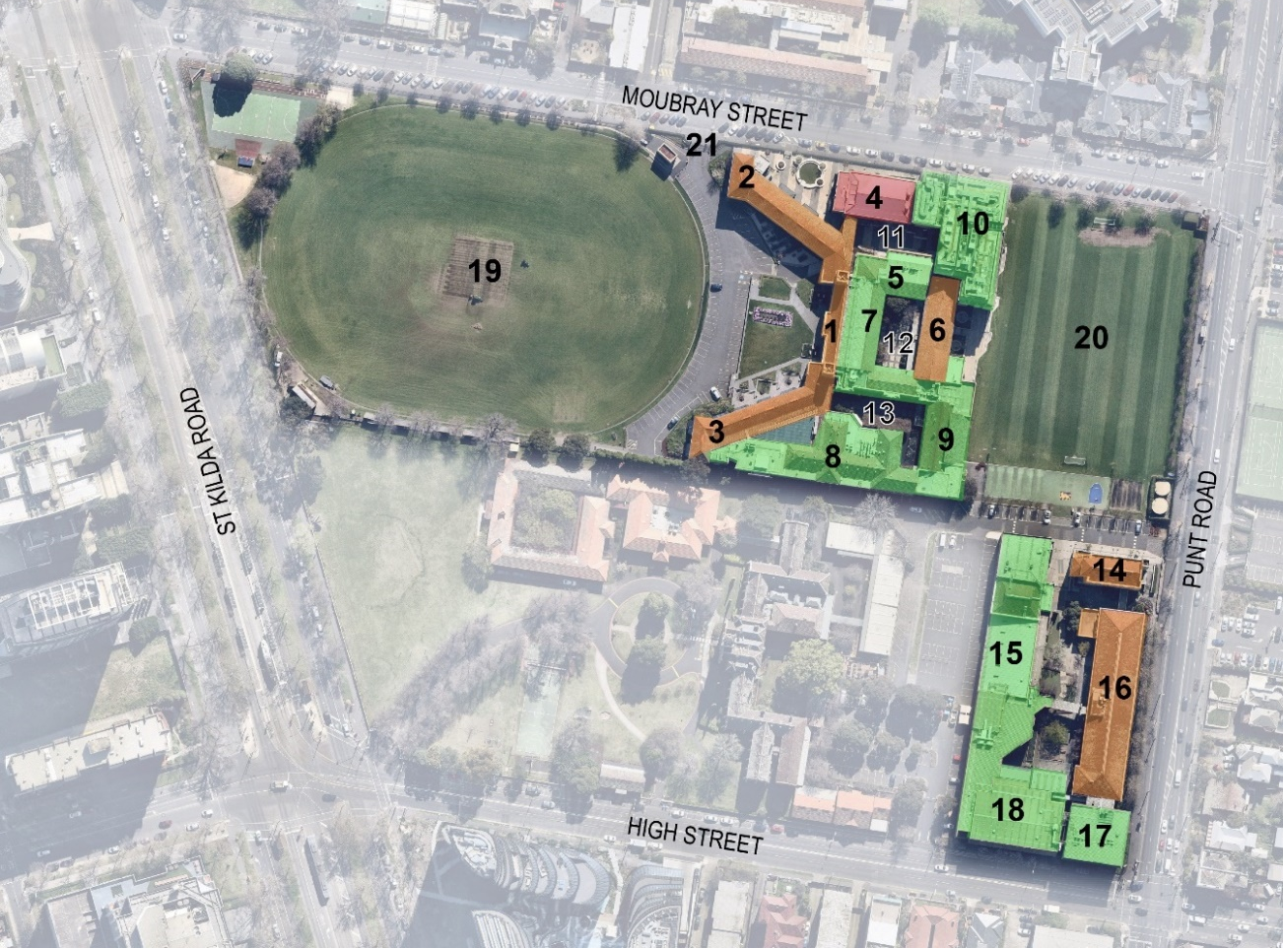
Legend
Middle School |  | Senior School (former Junior School)
1 | Main building (1866, 1934) | 14 | Chapel (1936)
2 | Menzies wing (1934) | 15 | Swimming pool and gymnasium (1935, c1982)
3 | Holt Wing (1934) | 16 | Senior School faculty building (1935)
4 | Adamson Hall (1908, 1918, 2012) | 17 | Senior School resource building (1984)
5 | North Wing (former Library) (reconstructed 1990) | 18 | Sports hall (1982)
6 | East Wing (former Cato building) (1934, 1990) | Grounds
7 | West Wing (c1866–1878; 1934; 1990) | 19 | Front Turf
8 | Science block (c1866–1878; 1934; 1980s) | 20 | Back Turf
9 | Sports Directorate | 21 | Percy Lane memorial gates
10 | Performing arts building (2013)
11 | Hattam Quadrangle
12 | Nye Quadrangle
13 | Gwillim Quadrangle

Figure 1. Aerial photograph of the subject site, showing the key buildings and later structures. The red indicates the 1908 period of development; the orange overlay indicates structures added or altered in 1933–37 and the green overlay denotes structures substantially modified or constructed from the 1970s onwards. (Source: Nearmap 2022 with GML overlay)

How is it significant?
Wesley College at part of 567–581 St Kilda Road, Melbourne, developed from 1866 onwards, is of local historical, aesthetic and social significance to the City of Melbourne.

Why is it significant?
Wesley College at part of 567–581 St Kilda Road, Melbourne, is of local historical significance as the first school registered in Victoria and one of six private ‘grammar’ schools in Victoria allocated a Crown reserve in the 1850s. As one of Victoria’s oldest private schools and one of the original six ‘public schools’ that comprised the Associated Public Schools of Victoria, it represents efforts to establish the English public school model in Victoria. Wesley College has occupied the site since the construction of the main building in 1866. It is one of Melbourne’s most distinguished and long-established private schools that drew students from the local area as well as further afield, and provided boarding facilities until 1982. Wesley College has been a leading exemplar of progressive and liberal education in Melbourne, demonstrated by its tolerance in matters of religious faith and introduction of co-education in 1978. (Criterion A).
Wesley College is historically significant for its military associations. In 1867 the school established a Cadet Corps, which operated until 1975. During World War II the campus was occupied by the Land Headquarters Inspection Division which undertook military operations between 1942 and1944. The school’s military associations are represented in the many war memorials and plaques located in the buildings and grounds that commemorate alumni who served in both world wars. (Criterion A)
The influence Wesley College has had on Victoria and Australia as a whole is seen in the list of its celebrated graduates, including Samuel Alexander OM, philosopher and the first Jewish fellow of an Oxbridge College, and Sir Robert Menzies and Harold Holt, who were both former Australian prime ministers. Thirteen Rhodes Scholars were educated at Wesley as well as many nationally recognised names in the arts, sports and politics. The memorial marble lions, replica Italian wellhead, the memorial stairs on the Adamson building and the honour board in the chapel are of particular historical significance for their association with Wesley College alumni who served in the armed forces during World War I. (Criterion A)
Aesthetically, Wesley College is significant as an important example of a private school expanded and developed over 18 decades. The school is picturesquely sited behind a large oval overlooking St Kilda Road. The school’s revivalist architecture style, site placing and adopting of quadrangles reflect the conservative architectural expression typically applied to Victorian schools with links to the English public school model. The college’s main building with prominent pediment, the splayed wings and towers, have a strong aesthetic impact viewed from St Kilda Road and Moubray Street. While individual buildings have varying degrees of intactness the site retains consistency in terms of its main elements and planning. The consistent use of rendered brick surfaces, terracotta tiled roofs, and decorative detailing—including the use of engaged pilasters, vertical grooving and uniform fenestration patterns—are applied to the 1930s buildings, creating a sense of visual unity. The main building, including the Menzies Wing and Holt Wing, and Senior School Faculty Building show elements of the Neo-Classical style. The school chapel reflects a more modern approach, evident in the use of its asymmetrical composition with prominent corner tower, Art Deco detailing and parapet roof. Finely moulded representations of the college’s symbols and motifs are embedded into the

façades of the main building, the Menzies and Holt wings, chapel and the Senior School building. The aesthetic importance of Wesley is reflected in the consistent use of materials, fine detailing and modern interpretation of historicist elements, such as pilasters and towers. The school architecture is greatly enhanced by its grounds and setting, including the expansive ovals, memorials and artworks, early spectating booths and scoring box, iron picket fencing and memorial gates. (Criterion E)
Wesley College is socially significant to the City of Melbourne. It has been used continuously as a school for over 150 years (except for the period of military occupation from 1942 to 1944),and holds close associations with the alumni community. The social value of the place connects to many among the wider Wesley College community who resonate with the strong ongoing activity and membership of the Old Wesley Collegians’ Association and the Wesley College Foundation. Wesley College’s numerous war memorials are also important to the alumni and veteran community, and to the families of the alumni they commemorate. Examples of memorials include the Percy Lane Memorial Gates, Italian wellhead copy and marble lions, both located at the main building forecourt; two memorial stairwells and Alan Kerr memorial doors on Adamson Hall. (Criterion G)
Wesley College, Melbourne, is of associative significance for its links to the people that were most instrumental in shaping the school: Lawrence Arthur Adamson, principal of Wesley College (1902–1932) was instrumental in expanding the Wesley College campus on St Kilda Road, and helped shape the vision for its built form. His crucial role in financially supporting the built development of the school, and in recognising and supporting the school’s military associations is commemorated by Adamson Hall. (Criterion H)
Architect Harry Norris (1888–1967) was a distinguished architect whose name is synonymous with the 1930s Moderne style. The suite of buildings he designed for Wesley College was a substantial commission and reflects Norris’s prominence as an architect in the peak of his career. The refined quality of the designs, their close proximity to one another and their visual prominence when viewed from St Kilda Road and Punt Road, make this collection of buildings an important example of Norris’s designs. The buildings of Wesley College are distinguished for their thematic and stylistic coherence and interwar construction. As a group, they represent Norris’s capability across a range of styles, including stripped back Neo-Classical and Moderne styles. Several of Norris’ finest works, including the Nicholas Building and Wesley College, were commissioned by the Nicholas family, the subject site therefore represents an important line of patronage in the architect’s work. (Criterion H)

Primary source
South Yarra Heritage Review 2022 (GML Heritage)

