Statement of Significance: Yarra Boathouses Precinct, February 2023

Heritage Place: | Yarra Boathouses Precinct | PS ref no: | HO1418
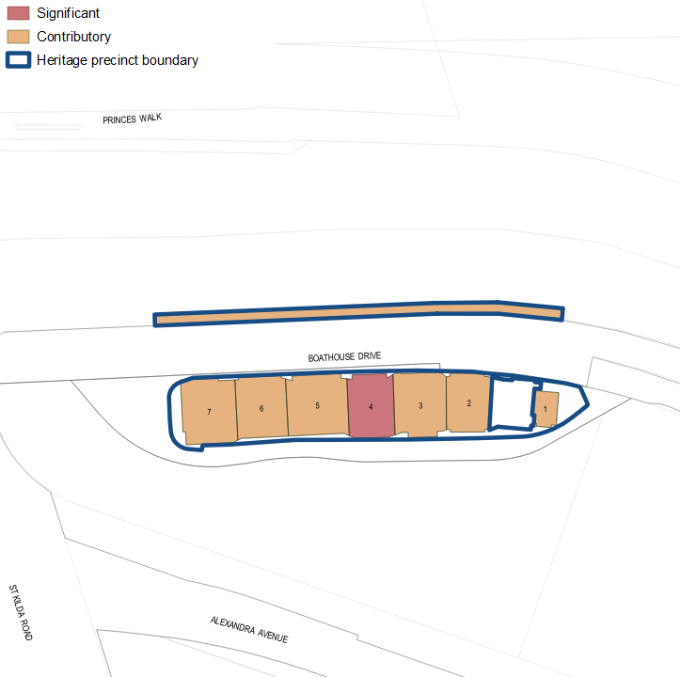

What is significant?
The Yarra Boathouses Precinct, comprising 1–7 Boathouse Drive, Melbourne, is significant.
Elements that contribute to the significance of the precinct (Figure 1) include (but are not limited to) the:

- boathouses’ original external form of two or three storeys, original roof form and verandahs, construction materials and finishes, pattern and size of original fenestration, and stylistic detailing
- buildings’ high level of integrity to their original design
- siting and spacing of the boathouses
- lack of fencing and open space between the boathouses
- boathouses’ prospect to, and views along, the Yarra River
- public space elements including boat ramp, trees, the shape and width of the pedestrian and bicycle path and the street lights.
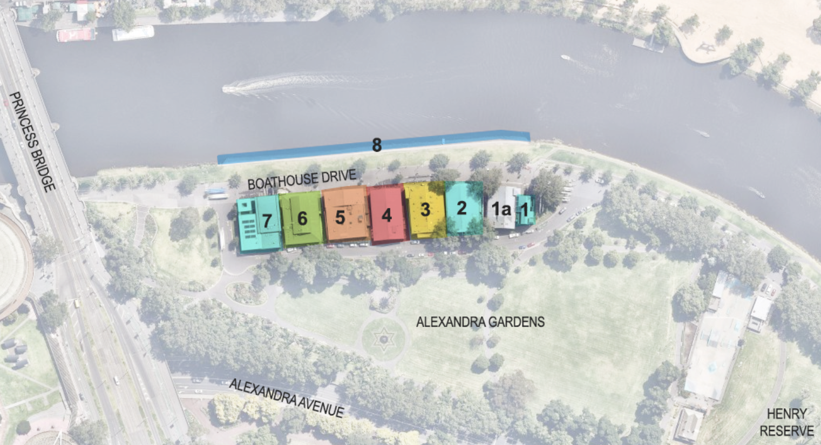
Legend |  | Location
1 | Additions (2012) to Melbourne University Boathouse | 1 Boathouse Drive
1a | Melbourne University Boathouse (1908, 1978) | 1 Boathouse Drive
2 | Yarra Yarra Rowing Club (2005) | 2 Boathouse Drive
3 | Banks Rowing Club (1981) | 3 Boathouse Drive
4 | Melbourne Grammar School Boathouse (1953) | 4 Boathouse Drive
5 | Mercantile Rowing Club (1973) | 5 Boathouse Drive
6 | Melbourne Rowing Club (c1993) | 6 Boathouse Drive
7 | Richmond Rowing Club (1973, 2014) | 7 Boathouse Drive
8 | Boat ramp | Opposite 1–7 Boathouse Drive
Figure 1. Aerial photograph of the subject precinct showing the key elements that contribute to the significance. (Source: Nearmap 2022 with GML overlay)

How is it significant?
Yarra Boathouses Precinct is of local historical, representative, social and associative significance to the City of Melbourne.

Why is it significant?
The Yarra Boathouses Precinct is historically significant as it provides physical evidence of the development of recreational and professional rowing on the Yarra River. Rowing and sculling have been popular recreational activities in Melbourne since the city’s formation. Some of Victoria’s oldest rowing clubs have occupied premises at the subject site for over 100 years and continue to do so. The subject precinct includes the purpose-built boathouses of seven Yarra River rowing clubs established in the nineteenth century, including: Melbourne University Rowing Club (established in 1859, Figure 1: Number 1 and Number 1a), Yarra Yarra Rowing Club (1871, Figure 1: Number 2), Banks Rowing Club (1866, Figure 1: Number 3), Melbourne Grammar School Rowing Club (c1868, Figure 1: Number 4), Mercantile Rowing Club (1880, Figure 1: Number 5), Melbourne Rowing Club (1862, Figure 1: Number 6), and Richmond Rowing Club (1863, Figure 1: Number 7). The site of the Yarra Boathouses Precinct is also important for its direct and indirect association with the Victorian Rowers Association, the oldest rowing association in the world, which was formed by members of the Yarra River rowing clubs. The development of the Henley-on-Yarra regatta in 1904 contributed to the popularity of rowing in Victoria as a spectator sport. The annual regatta became a popular event in Melbourne that drew crowds of up to 300,000 in the twentieth century. Rowing events influenced the passive recreational use of the area, as demonstrated by the development of Henley Reserve as a spectator area and the formation of Alexandra Avenue. Membership of rowing clubs grew significantly when women were permitted to apply as members from the 1980s. The clubs continue to train, race and host events at the boathouses. (Criterion A)
The Yarra Boathouses precinct is of significance for the number of boatsheds it has and the varied periods of development they represent. From as early as the 1850s, clubs established in this part of Yarra River were initially accommodated in early boatbuilders’ boathouses before the 1880s since when they could apply for Crown occupation licences, which allowed the development of purpose-built club boathouses. The club boathouses have been rebuilt or altered to recover from multiple fire damages and to accommodate the needs of contemporary club operations and activities. The extant boathouses in the precinct have been developed at varying dates, replacing or extending the pre-existing structures. The precinct today comprises: The 2012 addition (Figure 1: Number 1) to the 1908 Melbourne University Boathouse with 1978 additions (Figure 1: Numbers 1a); the Yarra Yarra Rowing Club boathouse rebuilt in 2008 (Figure 1: Number 2); Banks Rowing Club boathouse rebuilt in 1981 (Figure 1: Number 3); Melbourne Grammar School Rowing Club boathouse rebuilt in 1953 (Figure 1: Number 4), Mercantile Rowing Club boathouse rebuilt c1973 (Figure 1: Number 5), Melbourne Rowing Club rebuilt c1993 (Figure 1: Number 6); and Richmond Rowing Club rebuilt in 1973 and extended 2014 (Figure 1: Number 7). (Criterion A)
The grouping of boathouses is significant as a representative example of the boathouse typology. The functionally driven form of this typology is evident in the spatial arrangement of each boathouse, with the ground level being used for the storage of boats and the upper levels used for social activities and viewing. Prevailing characteristics of the boathouse typology are demonstrated by the subject buildings, including horizontal massing, low pitched gable roofs, double width openings to the ground floor, and glazing and verandahs on the upper level. The siting of boathouses on riverbanks within a public reserve area is also a common setting for club boathouses. Public realm elements, which include the prospect to the river, parkland setting, recreational street furniture and the shared pedestrian and bicycle path, contribute to the character of the precinct. Associated elements including ‘landing stages’ or boat ramps are frequently located nearby. The boathouses have been a feature of this area since the late 1850s and contribute to the recreational amenity and appearance of the Alexandra Gardens. The Yarra Boathouses structures and boat ramp reflect different periods of construction but present as a coherent collection based on these shared characteristics. Melbourne Grammar School boathouse (built 1953) is significant as highly intact postwar boathouse design (Criterion D).
The Yarra Boathouses Precinct is of social significance for its direct associations with seven rowing clubs that have occupied boathouses at 1–7 Boathouse Drive for over 100 years, and for its association with the rowing community through the presence of the clubs and the competitions held in this part of the Yarra River. The clubs affiliated with the Yarra Boathouses have hosted, and continue to host, a range of annual social and sporting events that are attended by members and other \rowing clubs as well as the broader public. The Yarra boathouses were constructed to serve the recreational needs of the public and have social significance to rowing club members, the broader rowing community, and spectators for their continued use. Rowing is part of a long-standing tradition of recreational boating activity on the Yarra. The ongoing popularity of rowing and sculling in Melbourne is evidenced by the many rowers on the river, and the continued presence and activity of the clubs and their ongoing membership basis. (Criterion G)
The boathouses are significant for their historical associations with successful international sportsmen and women including the 1956 Olympic Men's Eight rowing team, who won a bronze medal, and the Oarsome Foursome, who won gold medals at the 1992 and 1996 Olympic Games. (Criterion H)

Primary source
South Yarra Heritage Review 2022 (GML Heritage)

