Planning and Environment Act 1987

MELBOURNE PLANNING SCHEME

Notice of the preparation of Amendment C426melb

Melbourne City Council has prepared Amendment C426 South Yarra Heritage Review to the Melbourne Planning Scheme.

The amendment applies to the land shaded grey in Figure 1 below.

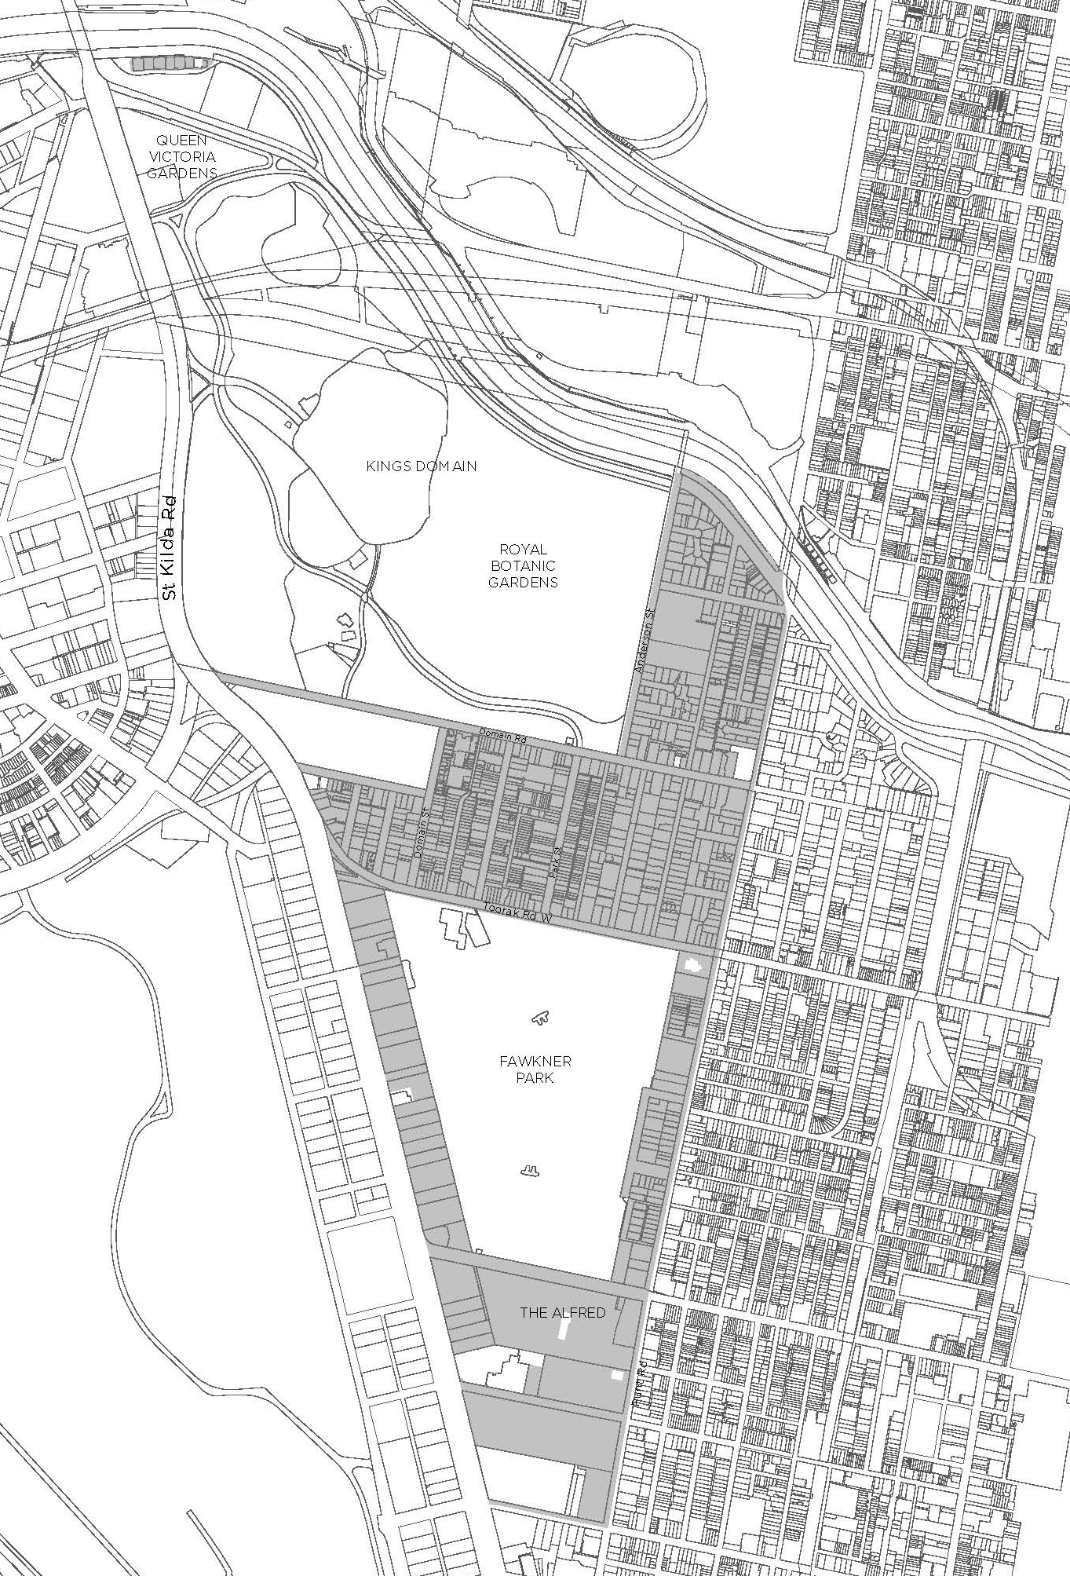

Figure 1. Land affected by the Amendment (shown in grey shading).
Amendment C426 proposes to:
- Apply individual Heritage Overlays and add Statements of Significance to sixteen (16) places:
  - HO1401 (Melbourne Girls Grammar School, part 62-108 Anderson Street)
  - HO1402 (Fairlie flats, 54-60 Anderson Street)
  - HO1403 (St Thomas Aquinas Catholic Church, 39-45 Bromby Street)
  - HO1404 (Domain Park, 191-201 Domain Road)
  - HO1405 (Former Fawkner Club Hotel, 2-14 Hope Street)
  - HO1406 (Former Mutual Store Ltd complex, part 112-118 Millswyn Street)
  - HO1407 (Former Wesleyan Church, 431-439 Punt Road)
  - HO1408 (South Yarra Primary School, 585-601 Punt Road)
  - HO1409 (South Yarra Presbyterian Church, 603-627 Punt Road)
  - HO1410 (Christ Church vicarage, and Memorial Hall and school building, 663-681 Punt Road)
  - HO1411 (South Yarra Telephone Exchange, 737-743 Punt Road)
  - HO1412 (Kia Ora, 447-453 St Kilda Road)
  - HO1413 (Sheridan Close, 485-491 St Kilda Road)
  - HO1414 (Former Chevron Hotel, 519-539 St Kilda Road)
  - HO1415 (Wesley College, part 567-581 St Kilda Road)
  - HO1416 (Melbourne Hebrew Congregation Synagogue, 2W-8W Toorak Road)
- Apply a serial Heritage Overlay and add a Statement of Significance to one (1) place:
  - HO1417 (St Martins Youth Arts Centre complex, 24-32 and 40-46 St Martins Lane, 20-36 St Martins Place, 120-122 Millswyn Street)
- Amend the boundary and Statement of Significance for the existing South Yarra Precinct HO6.
- Revise the boundary and add a Statement of Significance for HO421 (Hoddle Bridge).
- Apply two heritage overlay precincts and add Statements of Significance:
  - HO1418 (Yarra Boathouses Precinct).
  - HO1419 (Pasley Street and Park Place Precinct).
- Amend the existing incorporated document titled Heritage Places Inventory March 2022 (Amended February 2023), to change building heritage categories, significant streetscape categories and make address corrections for 351 properties.
- Delete 34 existing individual Heritage Overlays and include within HO6 South Yarra Precinct
- Amend the existing Heritage Overlay maps to reflect the above changes.

You may inspect the amendment, all documents that support the amendment including the explanatory report, free of charge, at the following locations:
- The City of Melbourne website: http://participate.melbourne.vic.gov.au/amendment-c426
- The Department of Transport and Planning website: www.planning.vic.gov.au/schemes-and-amendments/amending-a-planning-scheme/planning-documents-on-exhibition
- During office hours, at the office of the planning authority:
City of Melbourne
Customer Service Counter, Ground Floor
Melbourne Town Hall Administration Building
120 Swanston Street
MELBOURNE VIC 3000

Any person who may be affected by the amendment may make a submission to the planning authority (the City of Melbourne) about the amendment. Submissions must be made in writing, providing the submitter’s name and contact address, and clearly stating the grounds on which the amendment is supported or opposed and indicating what changes (if any) the submitter is seeking.
Name and contact details of submitters are required for council to consider submissions and to notify submitters of the opportunity to attend council meetings and any public hearing held to consider submissions. The closing date for submissions is Monday 24 April 2023.
A submission must be addressed to the Manager Heritage Strategy and lodged via one of the following:
- online at participate.melbourne.vic.gov.au/amendment-c426
- by email to heritage@melbourne.vic.gov.au
- by mail to the City of Melbourne, GPO Box 1603, Melbourne VIC 3001 and marked to the attention of the Manager Heritage Strategy.
The planning authority must make a copy of every submission available at its office and/or on its website for any person to inspect free of charge for two months after the amendment comes into operation or lapses.

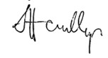
Sophie Handley
Director City Strategy
CoM reference DM: 16185684

