Planning and Environment Act 1987

melbourne PLANNING SCHEME

AMENDMENT C379melb

EXPLANATORY REPORT

Who is the planning authority?

The amendment has been prepared by the City of Melbourne, who is the planning authority for this amendment.

Land affected by the amendment

The amendment applies to numerous properties throughout the municipality as shown on the map below:

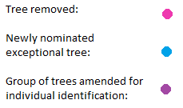
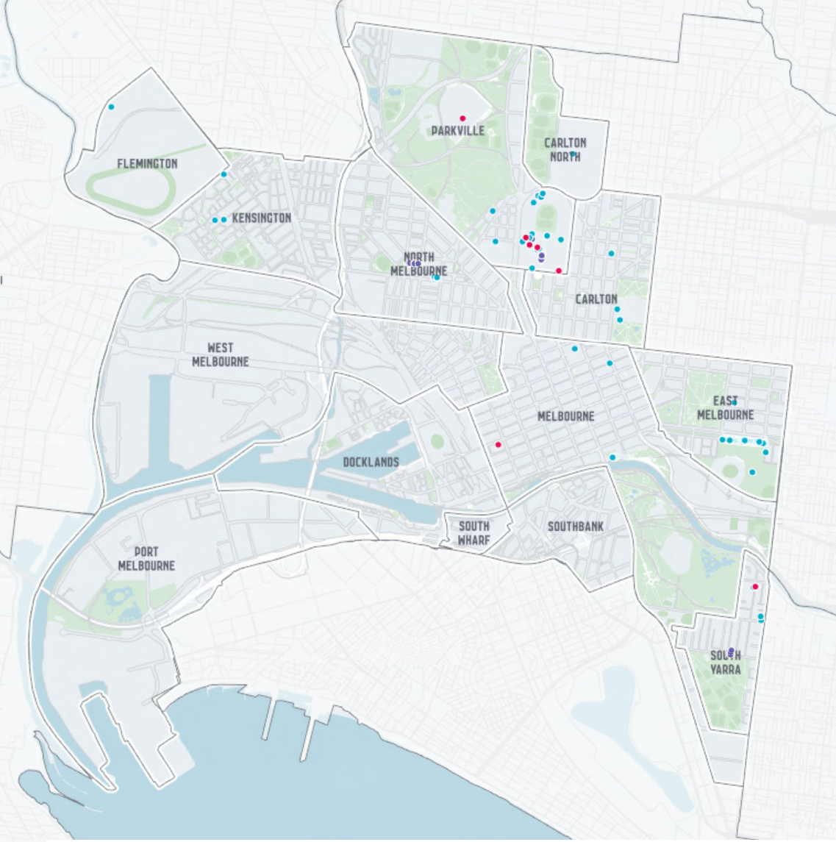

Exceptional trees proposed for protection in this amendment are located in East Melbourne, North Melbourne, Kensington, Flemington, Parkville, University of Melbourne Parkville Campus, Carlton, South Yarra, East Melbourne and Melbourne CBD. A mapping reference table is attached at Attachment 1 to this Explanatory Report which lists all sites affected by the amendment.

What the amendment does

Amendment C379 proposes to implement the Exceptional Tree Register 2019 by:

Expanding the Schedule 2 to the Environmental Significance Overlay (ESO2) to include and protect an additional 119 exceptional trees located on privately owned or privately managed land across the municipality,

Amending ESO2 by expanding the existing tree groups No’s 96, 98 ,121 and 133 to individually list the already protected exceptional trees within these groups to allow for a tree protection zone radius to be specified for each tree,

Amending the ESO2 schedule by deleting the listing for 7 trees which have been removed due to poor physical health, deleting Tree Group 12 (Trees No’s 133/1-133/11)due to an approved planning permit allowing the removal of five of the eleven trees subsequently diminishing the exceptional value of the entire row of trees and making minor listing corrections,
- Updating the ESO2 Maps No 4 & 5 to extend the Tree Protection Zone to the east and west of Plane Tree Way, removing 287-293 Exhibition Street Melbourne from the Tree Protection Zone for Tree No 171 and removing 128W-130W Toorak Road South Yarra from the Tree Protection for Tree No’s 133/1-133/11 and

Listing the Exceptional Tree Register 2019 as a background document which has been updated to include the additional 119 exceptional trees resulting from successful round 2 public nominations.

Specifically, the amendment:
      - Amends Schedule 2 to the Clause 42.01 (Environmental Significance Overlay) (Exceptional Trees) on a permanent basis to:
        - Include an additional 119 trees across the municipality, expand the existing tree groups No’s 96, 98, 121 and 133 to individually list already protected exceptional trees,
        - Delete 7 trees that no longer require protection under the overlay, and delete Tree Group 12 (Trees No’s 133/1-133/11)
        - Make minor listing corrections and consequential changes to comply with the Ministerial Direction on the Form and Content of Planning Schemes
        - Delete redundant background documents.
      - Amends the schedule to Clause 72.08 to reference the Exceptional Tree Register 2019 as a background document.
      - Updates the Planning Scheme Maps Nos. 3ESO, 4ESO, 5ESO, 8ESO, 9ESO and 11ESO,to reflect the inclusion and deletion of trees on a permanent basis.

Strategic assessment of the amendment

Why is the amendment required?
The Exceptional Tree Register (ETR) was first endorsed by the City of Melbourne in 2012 to identify significant trees as part of a holistic vision for the future urban forest. The register recognises and celebrates exceptional trees on any land that is listed in the Melbourne Planning Scheme, with the exception of land that is owned or managed by the City of Melbourne or located in the Royal Botanic Gardens. Land owned or managed by the City of Melbourne is subject to Council’s Tree Retention and Removal Policy (2012) and therefore excluded from the register.
For trees to be classified as ‘exceptional’, they are required to meet a minimum of one of the following exceptional criteria: aboriginal association; aesthetic value; curious growth form; environmental/micro-climate services; historical value; horticultural value; location or context; outstanding example of species; outstanding habitat value; outstanding size; particularly old; rare or localised; or social, cultural or spiritual significance. The register is consequently made up only of trees that provide a truly exceptional contribution to the community.
Amendment C212 implemented the Round 1 recommendations from the Exceptional Tree Register (2012) by applying Schedule 2 to the Environmental Significance Overlay (ESO2) to identified trees in the municipality. This amendment was gazetted in the Melbourne Planning Scheme on 30 April 2015.
In 2019, Council called for a second round of nominations to expand upon the list of exceptional trees. Council has reviewed the Round 2 nominations and a total of 119 trees meet the relevant criteria. Amendment C379 is required to introduce permanent controls to protect the additional 119 trees via Schedule 2 to the Environmental Significance Overlay (ESO2). On 29 April 2021, the Minister for Planning approved Amendment C378 which protects the 119 exceptional trees on an interim basis. This interim protection expires on 27 April 2023.
The Amendment also proposes to amend the ESO2 by expanding four existing tree groups to list each tree with an individual tree protection zone, removing the listing for 7 trees which have been removed due to poor physical health and making minor listing corrections. The recently updated Exceptional Tree Register 2019 is also proposed to be listed as a background document.

How does the Amendment implement the objectives of planning in Victoria?
The amendment is consistent with the objectives of planning in Victoria by implementing the objectives detailed in Section 4 (1) of the Planning and Environment Act 1987 which state:
“to provide for the protection of natural and man-made resources and the maintenance of ecological processes and genetic diversity;
to secure a pleasant, efficient and safe working, living and recreational environment for all Victorians and visitors to Victoria; and
to conserve and enhance those buildings, areas or other places which are of scientific, aesthetic, architectural or historical interest, or otherwise of special cultural value.”
The amendment implements these objectives through the protection of the exceptional trees via their inclusion within Schedule 2 to the Environmental Significance Overlay (ESO2). Owners of properties where exceptional trees are located play an important role caring for a valuable natural community asset. Not only do urban trees provide substantial environmental and community benefits, they can also help to reduce energy costs and provide aesthetic and amenity value.

How does the Amendment address any environmental, social and economic effects?
Environmental Effects
The amendment will have many positive environmental effects. The protection of exceptional trees throughout the municipality enhances ecological diversity, fauna habitat, aesthetics and landscape character. Protecting trees increases the longevity of tree life and canopy coverage which therefore brings about further environmental benefits including: lowering air pollution, increasing carbon storage and sequestration, capture and reuse of stormwater, reducing energy expenditure during periods of extreme heat and mitigating the urban heat island effect.

Social Effects
The amendment will have social benefits by protecting valuable trees which contribute to a sense of place and to the health and wellbeing of the community and visitors to the city.

Economic Effects

The amendment is expected to support economic prosperity through the positive environmental and social effects leading to a healthier and attractive city.
Does the amendment address relevant bushfire risk?
The amendment affects land within inner metropolitan Melbourne which is not a bushfire prone area.
Does the amendment comply with the requirements of any Minister’s Direction applicable to the amendment?
The amendment is consistent with the Ministerial Direction on the Form and Content of Planning Schemes as identified at Section 7 (5) of the Planning and Environment Act 1987.
The amendment has been prepared having regard to Ministerial Direction No.9 – Metropolitan Strategy which requires a Planning Authority to have regard to the Metropolitan Strategy (Plan Melbourne 2030). Specifically, the amendment is consistent with Policy 5.1: Development will respond to its surroundings, such as urban character, cultural heritage, natural features and climate by ensuring that valuable trees are protected from being removed or significantly lopped for future generations to enjoy.
The amendment is consistent with Minister’s Direction No. 11 - Strategic Assessment of Amendment with the explanatory report providing a strategic assessment of the planning scheme amendment.
The amendment has been prepared having regard to Planning Practice Note No 7 by following the guidance on how to assess the significance of vegetation in urban areas and how to protect significant vegetation through the planning scheme. The significance of all nominated trees has been assessed against a set of criteria established by a panel of experts with the successful trees being protected in the planning scheme via the ESO2.
The amendment complies with the Planning Practice Note No 15 Assessing an Application for One or More Dwellings in a Residential Zone. The ESO2 triggers the need for a planning permit to build or carry out works within the area of tree protection zone or to significantly prune, lop or remove the exceptional tree. The assessment of the works by the planning authority will that ensure the tree and the root zone around the tree is protected.
How does the amendment support or implement the Planning Policy Framework and any adopted State policy?
The amendment will assist in supporting the following strategies:
Clause 12 Environment and landscape values
Clause 12.01-1S (Protection of biodiversity)
Strategy: to assist in the identification, protection and management of important areas of biodiversity.
Clause 15 (Built Environment and Heritage).
Clause 15.01-5S Neighbourhood Character
Strategy: Ensure development responds to its context and reinforces a sense of place and the valued features and characteristics of the local environment and place by respecting the underlying natural landscape character and significant vegetation.
The amendment implements these strategies through the protection of the exceptional trees via their inclusion within Schedule 2 to the Environmental Significance Overlay (ESO2). Council along with the owners of properties where exceptional trees are located play an important role caring for a valuable natural community asset. Not only do urban trees provide substantial environmental and community benefits, they can also help to reduce energy costs and provide aesthetic and amenity value.
The amendment will result in the protection of exceptional trees from being removed from the private environment to ensure that future generations benefit from the enjoyment of the trees.
How does the amendment support or implement the Municipal Planning Strategy?
The Amendment does not seek to change the strategic directions of the MPS. The proposal to protect an additional 119 exceptional trees is consistent with the current strategic directions at Clause 02.03-2 Environment and landscape values “to protect flora and fauna ecologies and recognise that land use and development activities can undermine the health and biodiversity of its flora and fauna ecologies” and Clause 02.03-4 Built environment and heritage which “recognises that the City’s landscape features combine to give the municipality its unique appearance and feeling” and “new development must respect this character and add to the overall quality of the urban environment”.

Does the Amendment make proper use of the Victoria Planning Provisions?
The amendment makes proper use of the Victoria Planning Provisions by applying the Environmental Significance Overlay (ESO) to protect trees identified as being exceptional. The ESO provision has been applied to trees included on the existing Exceptional Trees Register 2019 and is the most appropriate VPP tool to be used. The ESO applies a Tree Protection Zone (TPZ) to each tree based on Australian Standard – Protection of Trees on Development Sites, AS 4970 (2009). The amendment seeks to expand the ESO2 to provide protection to an additional 119 additional trees identified in the register.

Inclusion of a tree in ESO2 will introduce a requirement for a planning permit to remove, significantly prune or lop the exceptional tree, or to do any works within the Tree Protection Zone (TPZ), which is the area where a tree’s root system could be detrimentally damaged by development. The need for a planning permit does not mean that no works are allowed, however the proposed buildings works will be assessed at the planning permit application stage to ensure the exceptional tree and its root system is protected.

The ESO map for all trees to be included through this amendment, applies only to the TPZ. The ESO2 schedule also specifies the Tree Protection Zone dimensions specifically for each tree. For newly planted or establishing trees within an avenue, a predicted TPZ is provided which is the expected mature TPZ of a newly planted or establishing tree based on the average of the mature trees within the avenue.

Many of the additional 119 exceptional trees are located in the Melbourne University campus site in Parkville (shown on Map at Attachment 2). The amendment is proposing to individually list the trees located within the Melbourne University Parkville Campus in the updated ESO2 schedule but given that the entire campus site is already affected by an ESO, no changes are required to the planning scheme maps.

How does the Amendment address the views of any relevant agency?
Property owners and all public land managers have been consulted with in the preparation of the City of Melbourne Exceptional Tree Register 2019.
All relevant stakeholders and agencies will be notified and their views will be sought as part of amendment exhibition process.
Does the Amendment address relevant requirements of the Transport Integration Act 2010?
The amendment is not relevant to any requirements in the Act.
Resource and administrative costs
What impact will the new planning provisions have on the resource and administrative costs of the responsible authority?
The inclusion of trees in the Environmental Significance Overlay may contribute to a minor increase in the number of planning permit applications on an annual basis. However this increase can be accommodated within existing resources.
Where you may inspect this amendment
The Amendment is available for public inspection, free of charge at Participate Melbourne, the City of Melbourne’s online engagement hub: https://participate.melbourne.vic.gov.au/amendment-c379

The Amendment can also be inspected free of charge at the Department of Environment, Land, Water and Planning website at: www.planning.vic.gov.au/public-inspection

Panel hearing dates
In accordance with clause 4(2) of Ministerial Direction No.15 the following panel hearing dates have been set for this amendment:

Directions Hearing: In the week commencing 17 October 2022
Panel hearing: In the week commencing 21 November 2022

Melbourne Planning Scheme Amendment C379

ATTACHMENT 1 Amendment C379 Affected Sites
ETR | Property Address | Affected Properties | Amended Tree Protection Zone for currently protected trees | Map Sheet amended
96/1-2 | 156 Grattan Street PARKVILLE | University of Melbourne 156-290 Grattan Street PARKVILLE | ☑
98 /1-11 | 156 Grattan Street PARKVILLE | University of Melbourne 156-290 Grattan Street PARKVILLE | ☑
121 /1-20 | Plane Tree Way  92-132 O'Shanassy Street NORTH MELBOURNE | Plane Tree Way, 92-132 O'Shanassy Street NORTH MELBOURNE VIC 3051 | ☑ | Maps 4 and 5 - change
133 /1-11 |  |  | ☑
133 /1-11 |  |  | ☑
139 | 156 Grattan Street PARKVILLE | University of Melbourne 156-290 Grattan Street PARKVILLE VIC 3010
140 | 156 Grattan Street PARKVILLE | University of Melbourne 156-290 Grattan Street PARKVILLE VIC 3010
141 | 156 Grattan Street PARKVILLE | University of Melbourne 156-290 Grattan Street PARKVILLE VIC 3010
142 | 156 Grattan Street PARKVILLE | University of Melbourne 156-290 Grattan Street PARKVILLE VIC 3010
143 | 156 Grattan Street PARKVILLE | University of Melbourne 156-290 Grattan Street PARKVILLE VIC 3010
144 | 156 Grattan Street PARKVILLE | University of Melbourne 156-290 Grattan Street PARKVILLE VIC 3010
145 | 156 Grattan Street PARKVILLE | University of Melbourne 156-290 Grattan Street PARKVILLE VIC 3010
146 | 156 Grattan Street PARKVILLE | University of Melbourne 156-290 Grattan Street PARKVILLE VIC 3010
147 | 62 Anderson Street SOUTH YARRA | 289-291 Walsh Street SOUTH YARRA VIC 3141 |  | Map 11
147 |  | 62-108 Anderson Street SOUTH YARRA VIC 3141
148 | 98 Vale Street EAST MELBOURNE | 98-108 Vale Street EAST MELBOURNE VIC 3002 |  | Map 9
149 | 8 Howlett Street KENSINGTON | 8-32 Howlett Street KENSINGTON VIC 3031 |  | Map 4
149 |  | Reserve 113-115 Epsom Road KENSINGTON VIC 3031
150 | 276 Epsom Road FLEMINGTON | Melbourne Showgrounds 276-318 Epsom Road FLEMINGTON VIC 3032 |  | Map 3
151 | 14 Flockhart Street KENSINGTON | 18-22 Flockhart Street KENSINGTON VIC 3031 |  | Map 4
151 |  | 97-99 Bayswater Road KENSINGTON VIC 3031
151 |  | 14-16 Flockhart Street KENSINGTON VIC 3031
153 | 94 Bayswater Road KENSINGTON | 94 Bayswater Road KENSINGTON VIC 3031 |  | Map 4
154 | 63 O'Shanassy Street NORTH MELBOURNE | 63-69 O'Shanassy Street NORTH MELBOURNE VIC 3051 |  | Map 5
154 |  | 55-61 O'Shanassy Street NORTH MELBOURNE VIC 3051 |  | Map 5
155 | 63 O'Shanassy Street NORTH MELBOURNE | 55-61 O'Shanassy Street NORTH MELBOURNE VIC 3051 |  | Map 5
155 |  | 63-69 O'Shanassy Street NORTH MELBOURNE VIC
156 /1-5 | 63 O'Shanassy Street NORTH MELBOURNE | 71-77 O'Shanassy Street NORTH MELBOURNE VIC 3051 |  | Map 5
156 /1-5 |  | 63-69 O'Shanassy Street NORTH MELBOURNE VIC 3051
157 | 63 O'Shanassy Street NORTH MELBOURNE | 71-77 O'Shanassy Street NORTH MELBOURNE VIC 3051 |  | Map 5
157 |  | 63-69 O'Shanassy Street NORTH MELBOURNE VIC 3051
158 | Lygon Street CARLTON NORTH | Melbourne General Cemetery Lygon Street CARLTON NORTH VIC 3054 |  | Map 5
159 | 140 Gatehouse Street PARKVILLE | 140-142 Gatehouse Street PARKVILLE VIC 3052 |  | Map 5
159 |  | 144 Gatehouse Street PARKVILLE VIC 3052
159 |  | 136-138 Gatehouse Street PARKVILLE VIC 3052
160 | 29 College Crescent PARKVILLE | Ormond College 29-55 College Crescent PARKVILLE VIC 3052 |  | Map 5
161 | 29 College Crescent PARKVILLE | Ormond College 29-55 College Crescent PARKVILLE VIC 3052 |  | Map 5
162 /1-3 | 29 College Crescent PARKVILLE | Ormond College 29-55 College Crescent PARKVILLE VIC 3052 |  | Map 5
163 | 9 Nicholson Street CARLTON | Exhibition Building & Melbourne Museum 9-11 Nicholson Street CARLTON VIC 3053 |  | Map 5
164 | 9 Nicholson Street CARLTON | Exhibition Building & Melbourne Museum 9-11 Nicholson Street CARLTON VIC 3053 |  | Map 5
165 | 156 Grattan Street PARKVILLE | University of Melbourne 156-290 Grattan Street PARKVILLE VIC 3010
166 | 156 Grattan Street PARKVILLE | University of Melbourne 156-290 Grattan Street PARKVILLE VIC 3010
167 | 254 Domain Road SOUTH YARRA | Airlie Police College 254-260 Domain Road SOUTH YARRA VIC 3141 |  | Map 11
168 | 254 Domain Road SOUTH YARRA | Airlie Police College 254-260 Domain Road SOUTH YARRA VIC 3141 |  | Map 11
168 |  | 252 Domain Road SOUTH YARRA VIC 3141
169 | 154 Faraday Street CARLTON | 320-322 Drummond Street CARLTON VIC 3053 |  | Map 5
169 |  | 156 Faraday Street CARLTON VIC 3053
169 |  | 154 Faraday Street CARLTON VIC 3053
169 |  | 158 Faraday Street CARLTON VIC 3053
169 |  | 152 Faraday Street CARLTON VIC 3053
169 |  | Unit 4, 320 Drummond Street CARLTON
169 |  | Unit 3, 320 Drummond Street CARLTON
170 | 100 La Trobe Street MELBOURNE | RMIT University 100-186 La Trobe Street MELBOURNE VIC 3000 |  | Map 8
171 | 275 Exhibition Street MELBOURNE |  |  | Map 8
171 |  | 275-285 Exhibition Street MELBOURNE VIC 3000
172 | 77 Story Street PARKVILLE | University High School 77 Story Street PARKVILLE VIC 3052 |  | Map 5
173 /1-4 | 2 Swanston Street MELBOURNE | Federation Square 2 Swanston Street MELBOURNE VIC 3000 |  | Map 8
174 | 174 Hotham Street EAST MELBOURNE | 174-188 Hotham Street EAST MELBOURNE VIC 3002 |  | Map 9
174 |  | 181-189 Gipps Street EAST MELBOURNE VIC 3002
174 |  | 191-195 Gipps Street EAST MELBOURNE
175 /1-74 | Brunton Avenue EAST MELBOURNE | Yarra Park Brunton Avenue EAST MELBOURNE VIC 3002 |  | Map 9
176 | Brunton Avenue EAST MELBOURNE | Yarra Park Brunton Avenue EAST MELBOURNE VIC 3002 |  | Map 9

Attachment 2 Map of Exceptional Trees in the Melbourne University Parkville Campus
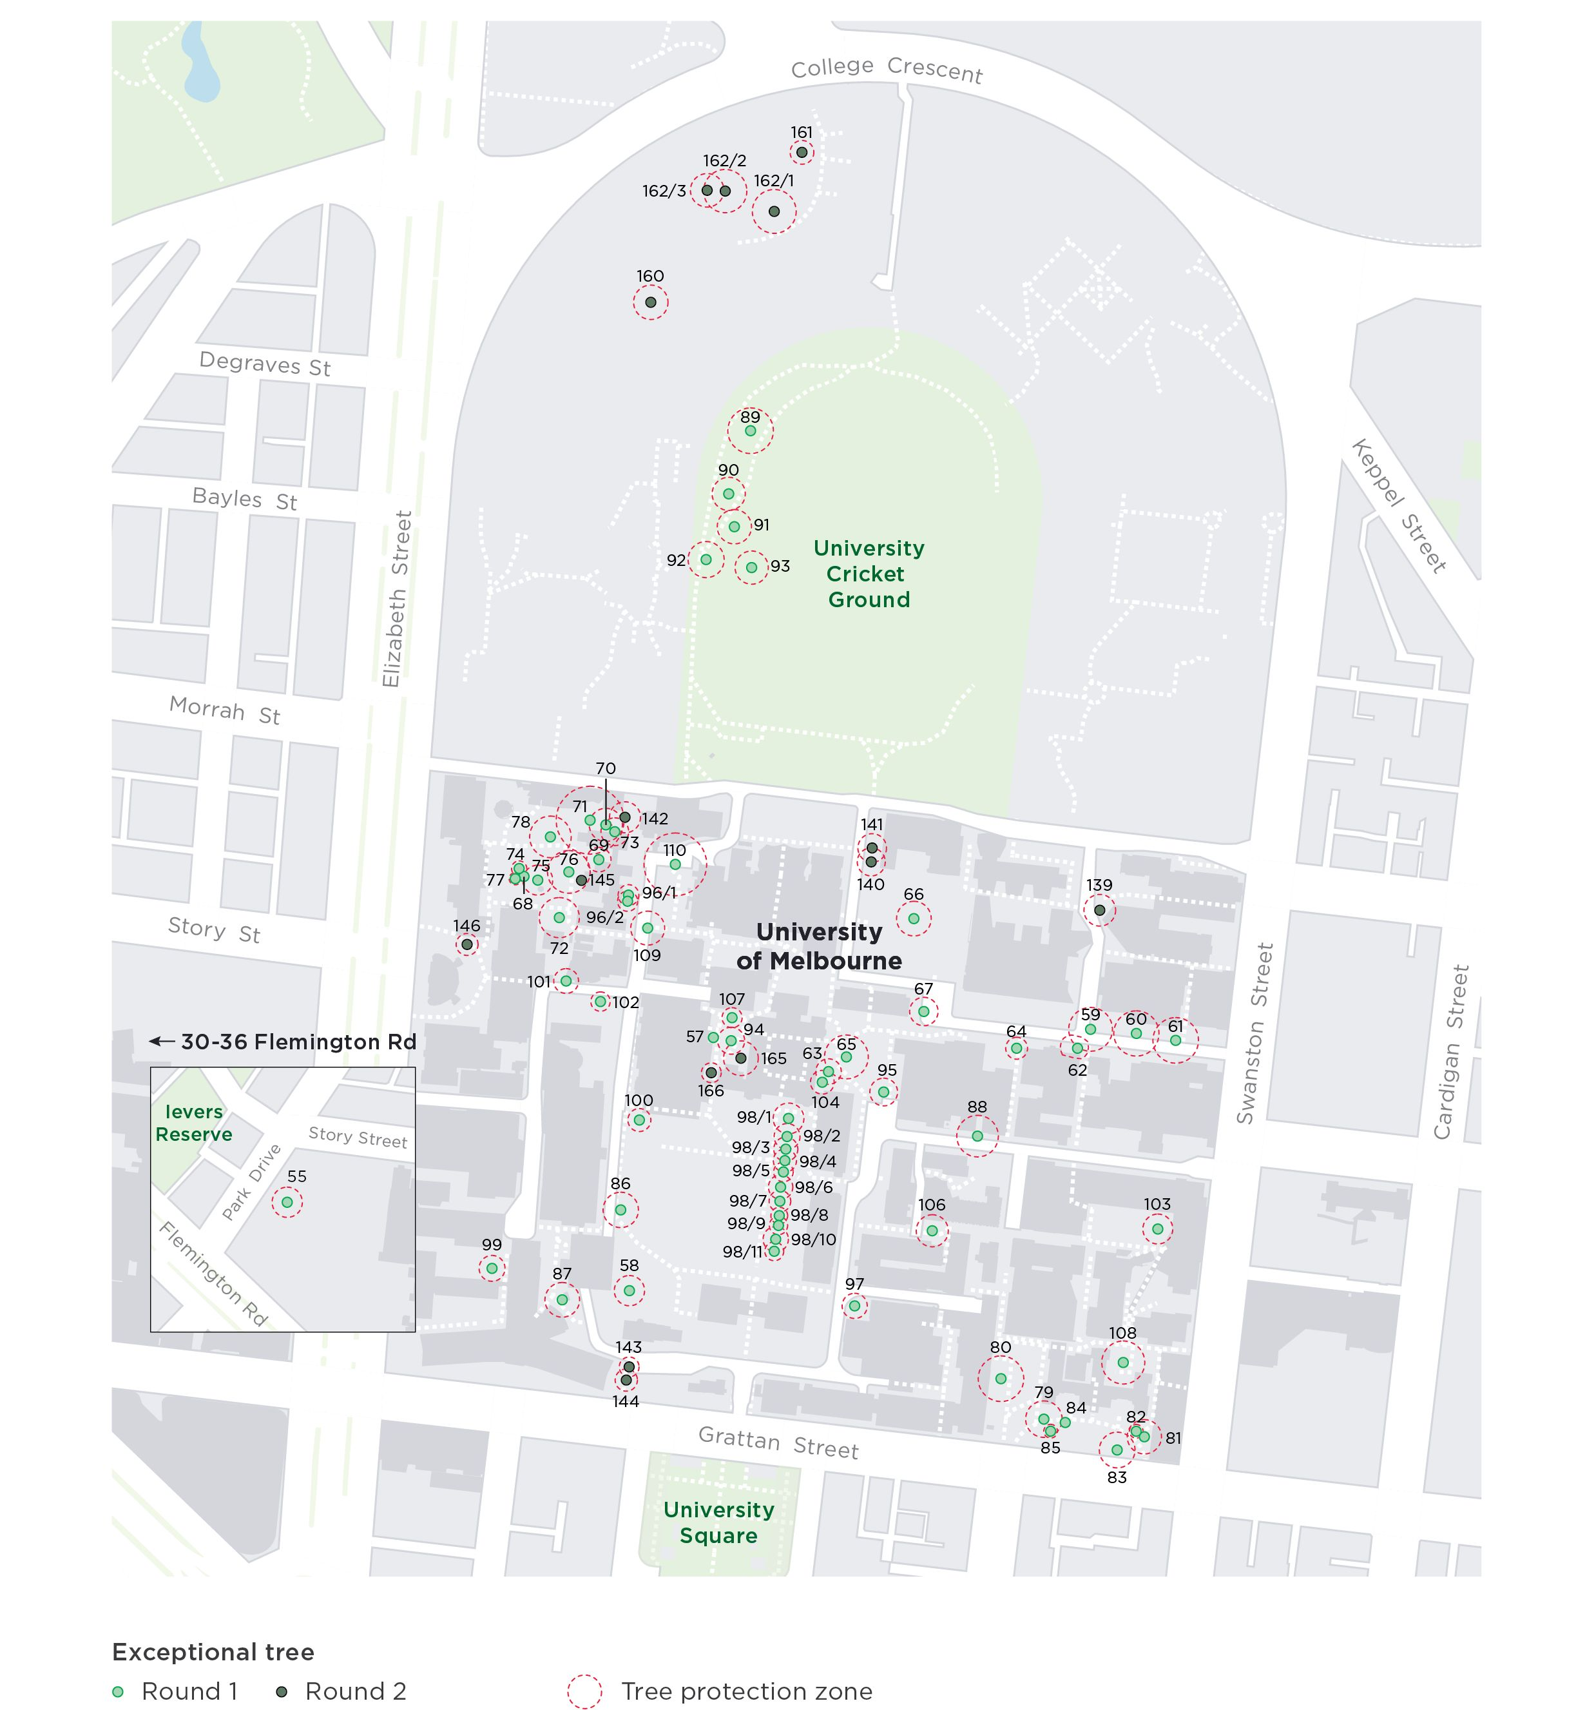

Note: Round 1 Trees currently protected and Round 2 trees proposed for protection

