Heat Safe City

Analysis of Community Engagement Results

May 2023

Project Background
Due to climate change, Melbourne is experiencing more hot weather and heat wave events than ever before. In Melbourne, we currently average 11 days greater than 35 degrees and expect this to rise to 16 days by 2050.
City of Melbourne is committed to reducing the threat of extreme urban heat for all, particularly vulnerable people. Our goal is that the city provides places of respite for residents, workers and visitors during extreme heat events.
To achieve this goal and build a heat safe city, we wanted to better understand the issues our community faces during an extreme heat event.

Community engagement
A project overview was provided on Participate Melbourne including details about about why we need a Heat Safe City and how we can create one.
Between 24 February 2023 and 7 April 2023, we asked the community to provide feedback via an online survey and ‘hot spots’ map. We also completed in-person engagement activities and stakeholder meetings with:
- Senior citizens in South Yarra
- Families with young children in Docklands
- Public housing residents in Kensington
- West Melbourne residents at Future Melbourne Committee Meeting
- Council to Homeless Persons Peer Education and Support Program members.
The purpose of the engagement was to:
- To communicate the City’s vision for a heat safe city
- To encourage the community to provide feedback on their heat health priorities and locations that need cooling
During the engagement period, 650 individual visitors accessed the Participate Melbourne project pages, 137 online surveys were received, 44 pins marked on the ‘hot spots’ map and 50 individuals engaged through face-to-face engagement activities and stakeholder meetings.

Survey respondents
Age of survey respondents
15-19 years of age | 20-29 years of age | 30-39 years of age | 40-49 years of age | 50-59 years of age | 60-69 years of age | 70-79 years of age | 80-89 years of age | Prefer not to say
1 | 9 | 30 | 25 | 26 | 32 | 9 | 1 | 4

Survey respondents' connection to the project
Resident | Worker | Business owner | Student | Visitor | Prefer not to say | Other
105 | 12 | 3 | 3 | 8 | 1 | 5
Where survey respondents live
Carlton | CBD | Docklands | East Melbourne | Kensington | North Melbourne | Parkville | Southbank | South Yarra | West Melbourne | Fishermans Bend | Other
11 | 30 | 17 | 10 | 11 | 17 | 3 | 15 | 2 | 12 | 1 | 7

Survey responses
Please indicate level of concern with the following statements:
Health risks that heat pose to me
Not concerned | Mildly concerned | Concerned | Strongly concerned | Require further information
23% | 23% | 23% | 29% | 2%

Health risks that heat pose to others in my community
Not concerned | Mildly concerned | Concerned | Strongly concerned | Require further information
7% | 13% | 23% | 56% | 1%

Thinking about the last extreme heat day, where did you receive information from about the high heat day?
Website or app | 61%
News | 51%
Social media | 18%
Family/friend | 12%
Other | 7%
Neighbour/Word of mouth | 6%
I wasn’t aware it was going to be a hot day | 5%

On a hot day which of these did you do?
Close blinds and curtains during the day | 78%
Stay indoors | 77%
Use an air conditioner | 67%
Fans/other cooling | 49%
Cancel plans to avoid exposure to hot spaces | 49%
Use external window shades or awnings to block the sun | 39%
Visit a public building with air conditioning | 21%
Change my work hours and commute | 19%
Check on your family and neighbours | 19%
Keep yourself cool by applying wet towels etc. | 15%
Swimming pool/beach | 15%
Other | 7%
Visit a friend of family that has air conditioning | 2%

Other actions people take include:
- Drink more water and carry water around
- Seek shade when walking
- Seek shade under trees and at local parks
Does your home have features which keep it cooler on hot days?
Air conditioning | 81%
Awnings or blinds | 72%
Working windows and doors | 64%
Insulation | 48%
Ceiling fans | 23%
I do not have any cool features | 6%
I go to public spaces and facilities on hot days | 5%

Which factors do you consider when deciding to use or not use the cooling features in your home?
Energy bills | 81%
The physical wellbeing and comfort of others in my household | 72%
Mental Wellbeing | 64%
Other | 48%
My physical wellbeing and comfort | 23%

Other factors considered when deciding to use or not use cooling features in homes:
- Emissions generated from energy use
- The inability to install cooling features due to renting rather than owning the property
- The comfort of pets

What cooling solutions would you like to see more of in the city?
Survey respondents ranked the following cooling solutions as their most preferred:
- Trees
- Cool green corridors such as linear streetscapes of trees, vegetation and water bodies
- Shade structures
- Green walls, roofs and facades
- Garden beds and raingardens
- Water bodies such as water features, fountains and ponds
- Cool and light coloured pavement
- Misting and water play
- Permeable pavement
Survey respondents also raised the following suggestions for cooling solutions in the city:
- Shading and misting along pedestrian corridors and shopping strips
- Expanding green space and replacing asphalt with greenery and light coloured paving
- Reducing cars and parking spaces in the CBD
- Water play and swimmable waterways
- Incentives and guidelines for greening on private property
- Building standards to increase greening and the use of light coloured materials

What services and facilities could the council offer to help you stay cool during hot days?
Survey respondents ranked the following services and facilities as their most preferred:
- Parks and gardens
- Cooling centres I.e. libraries and community hubs
- Pools
- Warnings and notifications
- Community education materials and seminars
Survey respondents also raised the following suggestions for services and facilities the council could offer:
- Improving accessibility of cool community centres that provide respite areas for vulnerable communities
- Indoor play and water play facilities
- Services like heat kits, drink vouchers, shuttle buses to take people to cool places and appointments
- Programs and subsidies to improve energy efficiency of homes
- More shade along shopping strips, bus stops and tram stops
- Environmental monitoring and community education

Hot spots map
Users were asked to drop a pin on a map to identify local ‘hot spots’ and leave comments about that location. Respondents identified 44 hot spots across the municipality (see Figure 1).
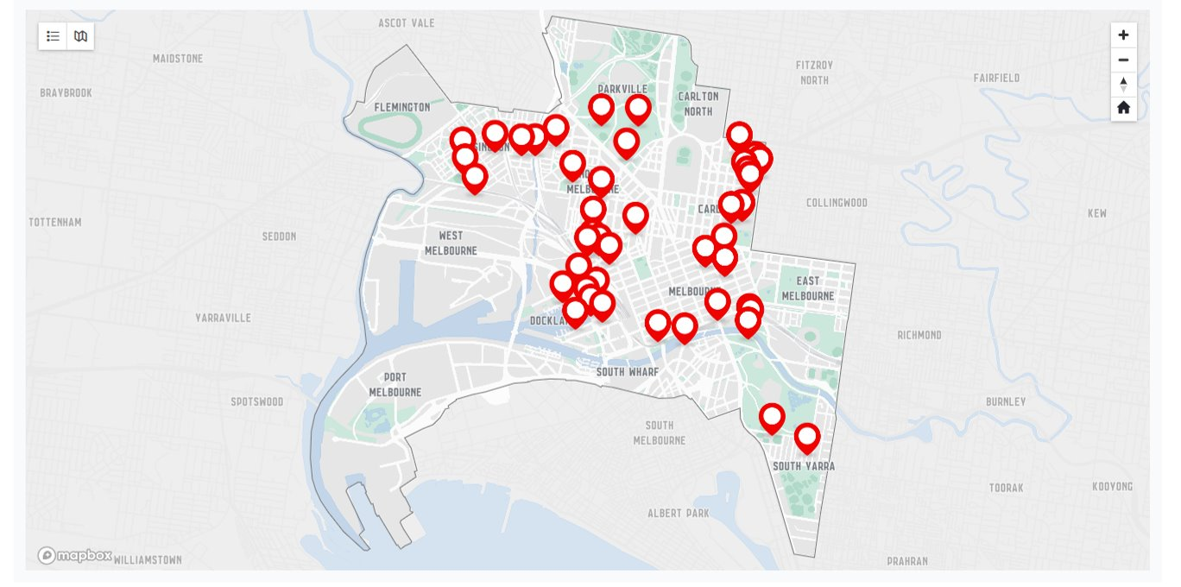
Figure 1: Local ‘hot spots’ map
Respondents suggested the following types of locations for cooling intervention:
Type of location | Location examples | Comments
Intersections, walkways and promenades | Flinders Street Station intersection | ‘This entire intersection, especially the south side (Flinders Station and Fed Square sides) is sooo hot.’
 | Harbour Esplanade, Docklands | ‘The entire foreshore of the Harbour Esplanade facing Victoria Harbour at Docklands is very hot and offers no real shade other than the odd small tree. The distance between them is massive. Even so, the immediate water's edge area for tourists offers no respite from the heat with amazingly no seating options either.’  ‘Walking between West Melbourne and docklands is very exposed and gets very hot at times. The new trees are a welcome addition and might help in a few years but the walk across the bridge and along Harbour esplanade is so exposed and hot.’
 | Marvel Stadium | ‘All around Marvel stadium. So much concrete and no or very little greenery.’
Plazas | Royal Exhibition Building and Melbourne Museum Forecourt | ‘The area between the Museum and REB (where the summer play was) is incredibly hot, glary and heat affected.’  ‘The paths either side of the Exhibition Building and the museum are heat traps with zero shade. This could be easily fixed with some strategic plantings.’
 | Southbank | The area in front of the little cement stadium is such a sun trap and hot spot. Even though this area is for entertainment the heat generated from the sun in this immediate area could cause health problems. The distance from tree-to-tree cover in this area is quite large. Shade is not existent in full sun days.
Playgrounds and picnic areas | Royal Park Nature Play Playground | ‘Lack of shade over playground and picnic areas.’
 | Station Street Park, Carlton | ‘Little shade over the play equipment.’
Public transport stations, platforms and shelters | Macaulay Station and rail corridor | ‘The absence of any trees around Macaulay Station or for that matter along the rail corridor and adjacent bike trail means this area suffers from a lot of radiant heat.’
 | South Kensington Station | ‘South Kensington station. Narrow platforms. Limited services. Hardly any shelter. Heard of people experiencing heat stroke here on hot days waiting for train.’
Wide streets, median strips and linear parks | Victoria Street, North Melbourne | ‘For most of Victoria St there's limited shade, and because there are very few nature strips in North Melbourne, it's all hot hard surfaces.’
 | Arden Street, North Melbourne | ‘The full southern side of Arden st is exposed to full sun creating a source of considerable radiant heat that lasts long after the sun has set making this and the adjoining areas very hot.’  ‘Most of the streets between Arden and Spencer St have very few to nothing in the way of street trees and even less on private property with few exceptions. The result is very solid hot zone.’
 | Macaulay Road, North Melbourne | ‘Macaulay Road has limited shade, which is under threat from development, with some street trees having recently been removed, and two large trees on private land proposed to be removed as part of a current development application.’
 | Hawke Street, West Melbourne | ‘I look forward to the two Hawke Street parks joining up to form one long Hawke Street strip park, as the CoM has described as being on the agenda. More green space required in good ol' industrial West Melbourne. Hawke Street has a green median strip in places, but more required please.’
Paved streets surrounded by high density development | Little Lonsdale and Little Bourke Streets | ‘On 30 degree plus, the pavement and walls in Little Bourke Street between Russell and Exhibition Street absorb then radiate unbearably hot conditions.’

Face-to-face engagement
We met with community members and stakeholder groups in Kensington, South Yarra, CBD, West Melbourne and Docklands.
Feedback we heard from all groups:
- Accessible community facilities and services are needed for those in low quality housing.
- Practical resources like welfare kits for vulnerable community members would be valuable.
- Community service organisations knowledge of the available resources to share with community members could be expanded.
- There is a lack of community facilities in Docklands that cater for respite. The current location of the Community Hub and Library is difficult to walk to from the other side of the harbour.
- There is concern for the amount of greenery that is getting lost with the construction that is occurring across the city.
- Community members would like to see more greening included in new developments.
- Programs that support installation and efficient use of air conditioning would be useful.
- It is difficult for public housing residents to make modifications to their housing. Further support for residents in public housing to access cooling infrastructure and make modifications to apartments.
The Council to Homeless Persons Peer Education and Support Program members specifically raised the following:
- Increased support for those experiencing homelessness and sleeping rough is required. This could include:
  - Improved access to clean water, toilets, showers, power and charging devices.
  - Increased opening hours of facilities such as pools
  - Storage facilities for medication
  - Grab-and-go welfare kits
  - Drop-in centres to provide resources and information

How feedback will be used
Heat Safe City principles and advocacy positions
Insights from this survey will inform the development of Heat Safe City principles that will guide heat action at the City of Melbourne and provide focus for advocacy positions to address extreme heat issues for our community which are not within City of Melbourne’s remit.
Heat Safe City projects
The insights gained through these consultation activities will provide an understanding of key ideas and opportunities for heat safe city projects that have the greatest community support. It will inform the prioritisation of heat safe city projects for next and future summers.

