Parking and Kerbside Management Plan
Community Engagement Report

Acknowledgement of Traditional Owners
The City of Melbourne respectfully acknowledges the Traditional Owners of the land we govern, the Wurundjeri Woi-wurrung and Bunurong Boon Wurrung peoples of the Eastern Kulin and pays respect to their Elders past, present and emerging.
We acknowledge and honour the unbroken spiritual, cultural and political connection the Wurundjeri, Bunurong, Dja Dja Wurrung, Taungurung and Wadawurrung peoples of the Eastern Kulin have to this unique place for more than 2000 generations.
We are committed to our reconciliation journey, because at its heart, reconciliation is about strengthening relationships between Aboriginal and non-Aboriginal peoples, for the benefit of all Victorians.
Contents
1. Introduction 4
2. Community engagement methodology 4
2.1 How we engaged and who we reached 4
2.2 How we analysed the feedback 5
3. Summary of feedback received on the Parking and Kerbside Management Plan 5
3.1 Participate Melbourne survey questions 5
3.2 Analysis of Participate Melbourne open text questions and other submissions 7
4. Key stakeholder engagement workshop report 18
5. Demographic and travel information of Participate Melbourne contributors 20
5.1 How often respondents usually travel to or within the City of Melbourne and usual mode of travel 20
5.2 Respondents and their relationship to the City of Melbourne 21
How to contact us 23

1. Introduction
The Draft Parking and Kerbside Management Plan (PKMP) has been developed by the City of Melbourne to inform the management of parking and kerbside space in the municipality.
This report provides an overview of the community engagement undertaken on the Draft PKMP, analysis of the feedback received on the plan and who was reached through the engagement process.

2. Community engagement methodology
Future Melbourne Committee endorsed the release of the Draft PKMP for community engagement on 21 March 2023.
The formal community engagement period ran from 22 March to 19 April 2023 (four weeks). Pre-draft engagement occurred in October 2022 to inform the draft PKMP.

2.1 How we engaged and who we reached
Community engagement on the PKMP consisted of:
- Participate Melbourne (online portal) - the main channel for engagement and collection of feedback from the general public on the PKMP. The Participate Melbourne survey was completed by 371 people.
- Key stakeholder workshops – were coordinated by an independent facilitator – Movement & Place Consulting. Workshops were held in October 2022 and April 2023. A total of 36 participants attended the workshops and included a mix of businesses, residents and transport stakeholders.
- Briefing sessions with key stakeholder groups – this included: Motorcycles Consultative Forum, Disability Advisory Committee, Department of Transport and Planning, Victoria Walks, Bus Association Victoria, RACV, Parking Australia (seven engagement sessions).
- Individual conversations with interested parties – Phone conversations and meetings with city businesses and commercial car parking operators (seven engagements)
- Surveys – phone survey research of parking customers (971 people) was conducted; focussed email survey of key stakeholders (16 stakeholders).
- Other submissions – Future Melbourne Committee submissions (four submitters), written submissions (three) and customer contact via email and phone (five customer enquiries).
Engagement on the PKMP was promoted via the City of Melbourne’s communications channels including social media, website, electronic direct mail and other stakeholder networks.
In total, 439 individuals or organisations provided direct input into and feedback on the PKMP, in addition to the 971 people who were surveyed in relation to their experience of parking in the city to support the development of the draft plan.

2.2 How we analysed the feedback
All written or verbal feedback (including open text comments on Participate Melbourne) was synthesised into individual sub-comments, categorised by issue or idea. For example one written submission or survey response may have four separate points which were categorised individually.
Sub-comments were categorised and analysed by theme. A City of Melbourne response by theme – including whether changes were recommended to be made to the PKMP – is provided in this report.

3. Summary of feedback received on the Parking and Kerbside Management Plan
Overall, there was a high level of support for the direction of the PKMP and alignment between the feedback provided and the policy and intent of the plan.

3.1 Participate Melbourne survey questions
People were asked to nominate the most important strategic challenges to be addressed in the PKMP. The top responses were:
- “There are competing needs for access to limited city space” (57.8% of respondents selected this challenge)
- “Drivers can have difficulty finding available on-street car parking space” (47.5%)
- “Parking rules and complex parking signage can be confusing” (42%)
- “There is a large supply of off-street parking in the city but it is underutilised (37%)
People were asked to select the words which best described what well-functioning kerbside space looks like in the City of Melbourne. Results showed that ‘Safe’, ‘Pedestrian-friendly’, ‘Available’, ‘Functional’, ‘Accessible’ and ‘Affordable’ were the highest ranked.
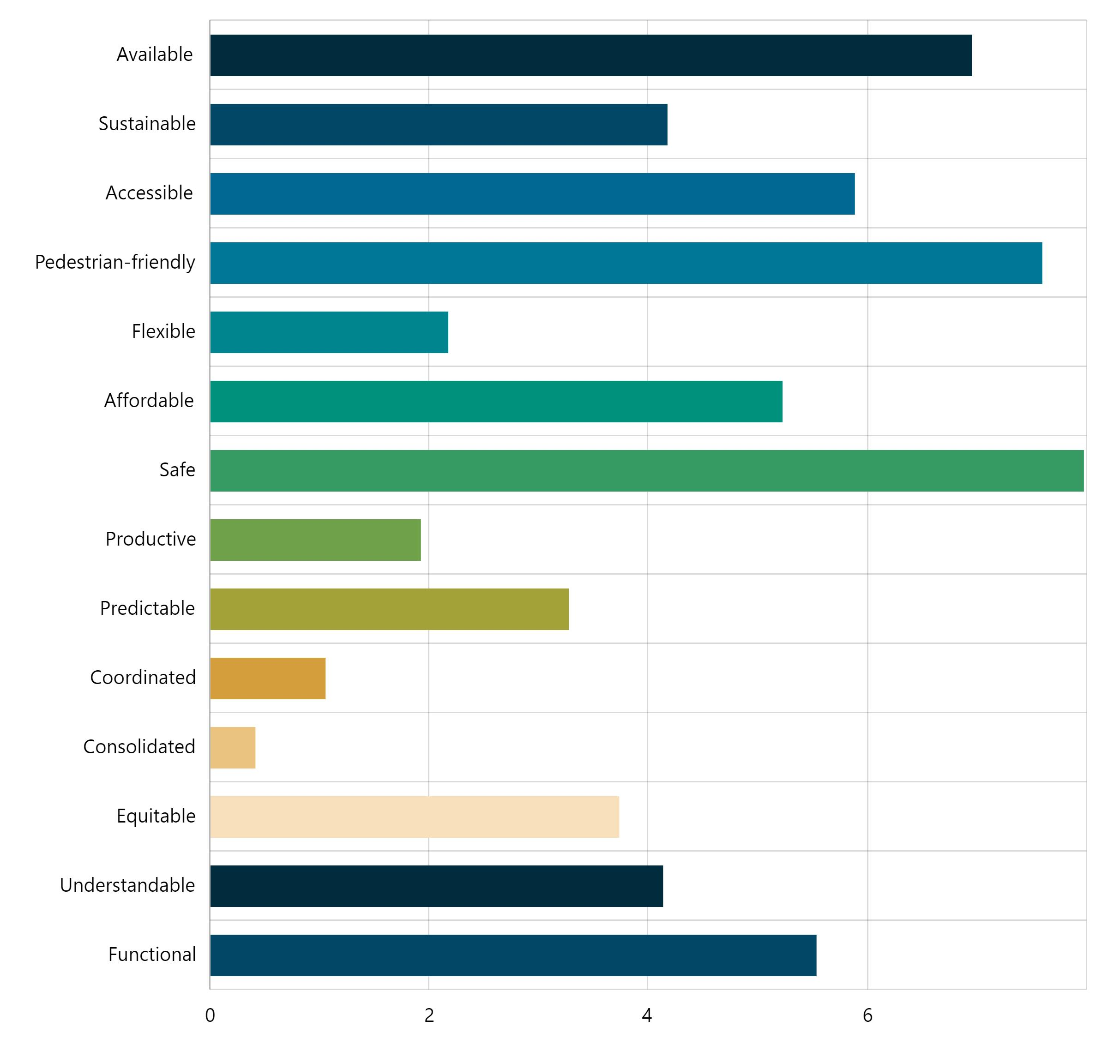
Above: Factors most important to achieving well-functioning kerbside space, as ranked by respondents (n = 374)
People were asked to consider the seven strategic directions in the PKMP and their level of support or opposition to what is proposed. The results show that the majority of people either ‘strongly support’ or ‘support’ all directions in the PKMP.
Highest level of support was provided for ‘kerbside space functionality is regularly reviewed’ at 83 per cent. The highest level of opposition was indicated for ‘drivers consider alternatives to limited on-street parking’ at 20 per cent. Opposition to the strategic directions represented a small proportion of respondents relative to the total number of people contributing feedback.
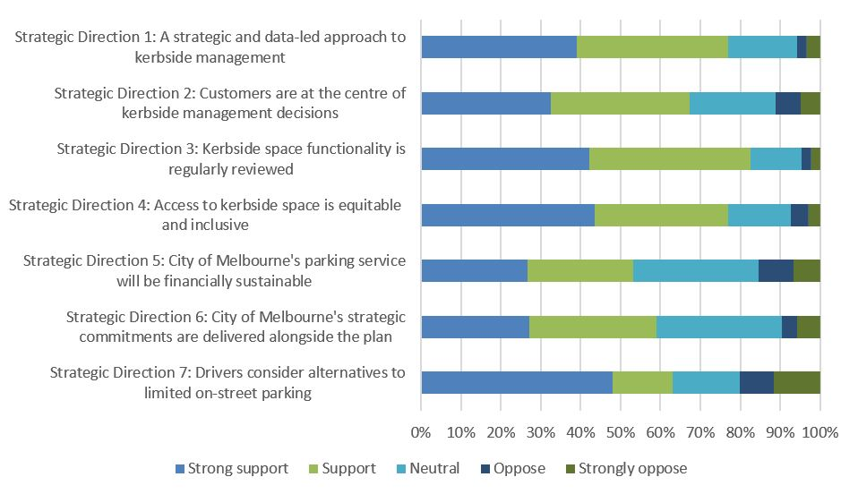
Above: Level of support for or opposition to the Strategic Directions in the Draft Parking and Kerbside Management Plan (n = 383)

3.2 Analysis of Participate Melbourne open text questions and other submissions
Of the people who completed the Participate Melbourne survey, 65 per cent provided open text comments. Comments have been themed and the sentiment summarised for this report. A response to each theme was prepared by the project team, including where a change is proposed for the PKMP.
Accessibility – 10 comments
Summary: People said that disabled spaces can be hard to find, there are not enough bays that meet disability standards, clearer linemarking is needed to support compliance of disabled bays, controls can be confusing for people with a disability, barriers on footpaths need to be removed and there was some suggestion that parking be free for people with a disability.
"As a person with a disability, my experiences have been very difficult, stressful and anxiety-inducing when trying to park in Melbourne City." |  | “There are not enough disabled parking spaces in the city of Melbourne.”

City of Melbourne response: These points are acknowledged and have been included in the PKMP. They are consistent with points raised by the City of Melbourne Disability Advisory Committee. It is a priority of the PKMP to improve the experience for people with a disability travelling into and within our city.
Car share – 2 comments
Summary: Support allocation of more car share spaces using data.
"It is important to use a data-led approach to providing a demand-responsive carshare network. More on-street space should be allocated in areas where demand is high for carsharing services."

City of Melbourne response: City of Melbourne is developing a Low Emissions Vehicles Plan which will include a new policy on car share. The PKMP acknowledges this and will allow for the allocation of space based on data and application of kerbside management tools to support car share as per the new car share policy.
City space allocation – remove bike lanes and reinstate parking – 25 comments
Summary: Many car parking spaces have been removed for bike lanes. This is a bad outcome for the city as it limits the number of people who can park in the city and impacts on traffic flow.
"The bike lanes installed has also taken parking spots away. I live 30 mins drive away. I can’t ride in. I don’t want to catch the train. I want to drive and know I can get a park. It’s not too much to ask." |  | "Bring back kerbside parking with reasonable parking limits and get rid of bike lanes. At my age I am not riding a bike." |  | "Bike lanes as protected zones should only be available for certain hours during the day. Should then be converted to vehicle use to assist flow for balance of days and nights."

City of Melbourne response: Strategic allocation of space for transport and other public infrastructure is determined outside the PKMP (e.g. Transport Strategy 2030, Urban Forest Strategy). However, the sentiment regarding loss of parking space is acknowledged and feedback regarding the design of bike lanes has been provided to councilors and the appropriate team internally. The PKMP, if implemented, will support optimising the use of all available kerbside space through reallocation of underutilised space and multipurpose spaces - which may result in a net increase in general parking spaces in the city.
City space allocation – remove parking for public infrastructure and green space – 73 comments
Summary: City of Melbourne should be stronger on removal of car parking and reallocating space to city greening, open space, footpath widenings, bike lanes, outdoor dining and other public infrastructure to improve city amenity and safety
"Strategy needs to be stronger on replacing car parking with bike lanes, footpaths, trees, etc. Needs specific targets like cities in Europe to remove X% of on-street car parking per year, perhaps starting small and increasing gradually over time." |  | "Too many drivers in the city cruising for parks, I support more space for cycling and walking. Since the La Trobe and William St cycling lanes were improved I've started cycling everyday. If there were more protected bike lanes, I believe more people would cycle daily too." |  | "Space in the city, especially within the Hoddle Grid, is at a premium. The volume of people using very limited footpath space far exceeds the number of people parking in high-value parking spaces. This is especially the case on the little streets, with overcrowded footpaths and an abundance of off-street parking."

City of Melbourne response: Strategic allocation of space for transport and other public infrastructure is determined outside the PKMP (e.g. Transport Strategy 2030, Urban Forest Strategy). However, the sentiment in support of the reallocation of parking space to other uses and the encouragement to continue removing more parking to support such projects is acknowledged. It has been shared with councilors and the appropriate teams internally. The PKMP, if implemented, will support the reallocation of parking space to other uses when there is determined to be a strategic need for that space which offers a higher benefit to the city. This is made possible by the policies in this plan which ensure remaining kerbside space within a precinct is appropriately managed and needs for kerbside space are adequately accommodated to support the functionality of the city.
Concern that goals for a people-focussed city are compromised – 27 comments
Summary: Concern that the PKMP will encourage driving to the city. People reinforced the importance of people space, public transport to the success of a capital city and businesses - drawing on global exemplars.
"Too many people are driving in the city out of convenience, not need. As someone from Europe, the idea that cars dominate the CBD, over public transport users and pedestrians feels very very out-of-date." |  | "I am disappointed that this plan focuses so much on drivers and car parking. Kerbside space is some of the most valuable real estate in the city and we continue to waste it on creating more space for cars. This comes at a huge cost to all the other great things we could be doing with it. As a general principle, CoM should be pushing to limit private car trips and parking within the city."

City of Melbourne response: The City of Melbourne Transport Strategy 2030 seeks 'Fewer non-essential vehicles in the municipality' (Outcome 4). Key to achieving this outcome is reducing through traffic and trips made by car which could have been taken by another mode. The Transport Strategy also includes actions including the development of a Kerbside Management Plan and investigating a demand based parking pricing pilot. Both of these actions are being delivered under the PKMP and will support the City of Melbourne delivering on its strategic commitments to a liveable, prosperous and sustainable city for people.
Congestion charge – 2 comments
Summary: support for a city congestion charge to address vehicle congestion.
"There should be congestion charges for cars and motorcycles with more emphasis on public transport and walking."

City of Melbourne response: City of Melbourne's Transport Strategy 2030 supports the introduction of road user pricing.
Construction – 3 comments
Summary: Impact of construction needs to be reviewed including through appropriate planning, charging, permits and enforcement.
"Residents and Traders in Southbank consistently complain that throughout building construction both trucks delivering to sites and workers on sites ignore parking restrictions causing traffic management issues at a local level. This necessitates repeated reporting of breaches to Council. Enforcement and their interventions are often too little and too late."

City of Melbourne response: There is more to do to improve the impact of construction. An adjustment to the PKMP will be made to more explicitly call this out as part of the scope for review of parking permits. Further investigation of opportunities to improve enforcement in relation to construction zones is underway.
Deliveries and Loading Zones – 17 comments
Summary: Strong support for allocating enough space for loading activities in the city and using technology and enforcement to support the logistics industry operate efficiently. General support for conversion of loading zones to parking after hours.
"Consider enforcing or incentivising night-time deliveries to businesses. London did this in 2012 Olympics and it was a win-win for businesses and delivery firms, as well as private citizens. Reduced congestion and reduced emissions." |  | "More loading zones that are patrolled so others don’t abuse them by parking illegally." |  | "Provide real-time and prediction information regarding the availability of loading zones. This would reduce unnecessary travel by freight vehicles searching for suitable bays to stop and deliver goods in the CBD."

City of Melbourne response: City of Melbourne's Transport Strategy 2030 supports strategic initiatives which enable the efficient movement of goods in and out of the city. This includes a freight consolidation centre. The PKMP aligns with this policy and proposes the next level of detail to achieve the strategic outcomes at an operational level. Opportunities to improve the operation of loading zones - via kerbside management tools, technology and enforcement - is a priority initiative and will be reinforced in the plan. Examples for how this can be achieved - received from logistics industry, transport workers and academics will be included in the Plan.
Electric vehicles – 9 comments
Summary: Electric vehicles policy is not adequately addressed in the Plan. Consider policy to install on-street charging infrastructure and using kerbside management tools (e.g. price) to encourage electric vehicle use.
"Missing from the Parking and Kerbside Plan is how the Council uses its street parking assets to foster the use of Battery Electric Vehicles (BEV) in the Melbourne City." |  | "Electric cars should be free of parking fees."

City of Melbourne response: Electric vehicles (EV) is a new policy area for the City of Melbourne. Significant research to develop CoM's policy position on electric vehicles is required and therefore any implications for kerbside management policy, could not be included in the PKMP at this time. CoM's EV policy will sit within the Low Emissions Vehicles Plan under development. PKMP and LEV teams have been working closely to ensure the Plans are complementary. Once the LEV Plan is completed (and if endorsed by Council) the PKMP will be reviewed and updated as appropriate.
Enforcement – 9 comments
Summary: Timeliness of enforcement needs to be addressed, particularly outside CBD. Parking officers can sometimes be (or perceived to be) overzealous. The value of parking fines is too low to have an impact
"Fine regimes need to be reviewed with the State Government particularly in the Capital City Zone area to optimise the use of parking space" |  | "Amongst the issues I saw in one day at court were confusing signage and meters (payment points next to parking they don't pay for), app delays resulting in fines, no standing areas that meant people couldn't move house, construction taking away permit areas 24/7 across a whole block."

City of Melbourne response: Observations and enforcement data shows that for many people the fine value does not act as a deterrent. We will call out the need to more thoroughly investigate this in the plan and if appropriate advocate for change. Processes relating to responsiveness to urgent enforcement matters will be reviewed and called out more explicitly in the plan.
Off-street parking – 24 comments
Summary: Acknowledgement that the significant off-street parking capacity should be better utilised, however concerns were raised including that it is expensive, sometimes unsafe or dirty, can have poor accessibility and can be hard to understand pricing and availability. Suggestions include: CoM should own more off-street parking; work with off-street providers to improve parking and encourage use of pre-booking or other technology to support finding parking.
"Off-street parking is surely the answer! Private operators need to stop ripping off customers; then we should ALL be parking off the street at reasonable rates." |  | "Just like other councils have large affordable parking spaces near train station and markets, the city of Melbourne should aim to provide multi storeyed parking that are not for profit." |  | "I used to spend ages searching for on street parking, but pre-booking off street parking has been cheaper, quicker, and more relaxing."

City of Melbourne response: Feedback in relation to off-street parking reinforced the need for City of Melbourne to better engage with the off-street parking providers to develop initiatives to support better use of the parking capacity, improve awareness of options relating to availability and pricing, consider discount or parking validation schemes and to improve the overall customer experience. Further examples to highlight the types of solutions put forward have been added to the Plan. Suggestions that City of Melbourne should own or manage more off-street parking are valid. An initiative to investigate the City of Melbourne's future role in off-street parking ownership has been added to the Plan.
On-street parking availability – 12 comments
Summary: Difficult to find an available space when needed which is impacting the experience of visiting the city for those that drive. Suggestions that more parking could solve this problem.
"I travel to the city for personal appointments or for social events a few times a month. I find it frustrating the number of limited on street parking available." |  | "There are continued issues with doing business in the city as a result of the lack of available on street parking. Much of this is highlighted in the report that has been tabled."

City of Melbourne response: Improving availability of parking within the city is a key principle of the PKMP and reinforced through the feedback. Using kerbside management tools more strategically - including space allocation, parking controls, pricing and enforcement - will help improve availability. Demand based pricing is an important lever which is proposed to be introduced in two years. Ongoing review and refresh of kerbside space will ensure every available space is being used as optimally as possible - and may result in more parking supply in certain locations.
On-street parking controls and signage – 12 comments
Summary: Most people suggested that 1 hour time limits (or less) are too short to be useful and that 2P was a preferred time control for on-street.
"In an effort to 'share the love', the city's 1 hour spots are almost useless if you are going to the doctor or another appointment. Often 2hr spots are too far away." |  | "On each visit I like to have about 2 hours of parking. Enough for the family to eat and do some shopping. There is limited 2 hour parking available."

City of Melbourne response: Our own research has shown where time restrictions in the CBD were increased from 1/2P to 1P and 1P to 2P, parking occupancy and compliance indicators improved. Appropriate time limits which allow for people to do what they need during a short stay is important. It can encourage additional visits/spend per trip, reduces anxiety and the risk of getting a fine. Further clarification on finding the balance between turnover and utility of a space when setting time restrictions has been included in the Plan.
On-street parking pricing – 21 comments
Summary: Some people propose on-street parking should be cheaper, while others suggest CoM has priced on-street parking too low. Clear and simple communication about pricing is important.
“At present ratepayers essentially heavily subsidise the use of public land for the storing of private vehicles, at substantial cost and without considering the most effective use of the space. I believe Council should consider increasing the price of on-street parking, particularly in high-demand to reflect the cost of using the space and to encourage more informed parking decisions.” |  | "The hourly parking rate of $7 is unaffordable/ very expensive for some people wanting to use metered parking in and around the city." |  | "Support demand responsive and time of day based fees however real time costs and availability of spaces should be easily accessible via app etc to inform driver behaviour and avoid cruising."

City of Melbourne response: The PKMP includes clear policy for CoM to follow in relation to the use of price as a tool for managing parking demand. Pricing parking based on data to ensure availability represents best practice parking management. Based on feedback, additional clarity around the importance of effectively communicating price to customers under a demand based pricing model has been added.
Residential parking – 16 comments
Summary: High demand for parking in residential areas means it is difficult to find a car park near home for many. Feedback included solutions to improve availability of residential parking and permits.
"We live in West Melbourne, our home is a single dwelling with no off street parking. During business hours and the football it is impossible for us to park near our home." |  | "Please make all spaces resident permit optional to stop residents unnecessarily circling for parks clogging up the roads and polluting the air." |  | "On-street parking is increasingly inaccessible to resident permit holders in the City of Melbourne as a direct result of Council approving developments with carpark waivers, and residents of those developments then buying/ requiring/ registering cars with nowhere to park them."

Technology – 6 comments
Summary: Use technology to better communicate with customers about parking availability, type and location and as a tool to support the simplification of parking. However, ensure that use of technology does not exclude members of the public
"I believe the City of Melbourne is on the right track with the draft strategy. I strongly believe that there is technology that can assist the City of Melbourne by using MaaS and Parking technology to provide multiple options for people travelling to the city." |  | "Consideration of stakeholder ability to engage with technology, and the retention of more “traditional” methods of interaction are important for those who do not have the skills or accessibility to technology."

City of Melbourne response: The PKMP outlines the City of Melbourne's next steps in terms of technology use and investment. It is important that technology supports the solving of problems and improved kerbside management outcomes. Feedback in relation to maintaining traditional methods of sharing information for those without access to technology has been added to the plan.
Tradesperson and service vehicles – 3 comments
Summary: Need to give consideration to the needs of tradespeople (and the residents and businesses they service) to facilitate convenient access to properties.
"I’d like to see a permit introduced to enable service providers additional time. E.g. A plumber attends a leaking pipe and has to park a block away and the only available car park is 1/2 hour, by the time they inspect the job it’s time to move the vehicle, thus adding to traffic congestion when they are required to drive around the block looking for another parking space." |  | "There needs to be better access for residents to obtain occasional parking for tradespeople."

City of Melbourne response: The issue of access for tradespeople is acknowledged. The PKMP includes a key initiative to undertake a strategic review of CoM's parking permit schemes. The needs of tradespeople and people who service buildings in the city will be considered as part of this review.
Two-wheeled vehicle parking – 9 comments
Summary: E-scooters are impacting safety for pedestrians. Strong support for moving two-wheeled vehicles off footpaths on to dedicated on-street parking.
"Parking motorcycles and other motorised vehicles on the footpath is dangerous (they ride up onto the path suddenly near pedestrians) and makes accessibility an issue as they are rarely parked to provide enough space for pedestrian traffic." |  | "Revise Policy 6.13 to make provision of on-street parking for two-wheeled devices the norm rather than the exception."

City of Melbourne response: There is agreement from key stakeholders - motorcycle representative bodies, Victoria Walks and Lime - on the need to accommodate two-wheeled parking on-street to support improved public realm amenity and safety for pedestrians and operations of shared schemes. Plan will be updated to reflect the desire of stakeholders to see more proactive planning and accommodation of shared micromobility scheme parking on-street.
Other comments – 17 comments
Summary: other comments and opinions included: public transport, development planning, style and presentation of the plan and survey plus other feedback not directly related to the subject area.

4. Key stakeholder engagement workshop report
A workshop was held with 16 key stakeholders on 6 April 2023 with representation from city traders, residents, government and the transport sector. The session was facilitated by Movement & Place Consulting. Follow up conversations and a survey informed next steps on the PKMP.
An overview of the Draft Parking and Kerbside Management Plan was presented and discussed. Key points raised by participants can be summarised as:
- General support for the strategic directions in the PKMP and proposed approach to managing kerbside space.
- Prioritise the allocation and management of on-street kerbside space for loading zones, pick up / drop off activities and people with a disability.
- Encourage alternatives to on-street parking through improvements to off-street parking including financial incentives and promotion of park and ride, public transport and cycling options
- Support for making parking simpler for customers with education on available options
- Support for the annual review and adjustment process with an emphasis on improved communications about parking.
- A mixture of views on bicycle lanes. Some views included a need to review the impact bicycle lanes have had on parking and traffic flow and consider adjustments or removing. Opposing views were to encourage removing parking spaces to create more well-defined and attractive spaces in the CBD, including bicycle lanes.
Alternatives to on-street parking
Discussion focussed on use of underutilised off-street parking capacity, to take pressure off on-street parking demand. However there was concern privately owned commercial parking can be perceived as unsafe and expensive, reducing the attractiveness of the CBD. A range of ideas were raised including collaboration between City of Melbourne, traders and commercial parking operators to provide incentives or parking discounts following CBD spend. Parking hubs located around the CBD edges could also be promoted, leveraging the Free Tram Zone. Additionally, there was the suggestion that council investigate ownership of additional off-street parking.
Loading and servicing
There was general agreement that difficulties with servicing and loading need to be addressed, including availability of spaces in close proximity to businesses and improved management of service laneways. There were mixed opinions on fees for loading zones. The issue of taxi and rideshare services blocking carriageways or stopping unsafely to pick up/drop off passengers was raised. There was general agreement that dedicated pick up/drop off zones for passengers could improve conditions for all.
Simplicity and reliability
The stakeholder group agreed that simplification of parking signage is necessary, and real-time information about on-street parking availability should be provided to customers. Better information about parking options, pricing, and availability should be provided to give people travelling to the city greater choice. An education campaign could also be investigated with the aim of improving customer awareness of various controls and parking availability. Finally, attendees acknowledged the need for clarity around "No Parking" signage for pick up / drop off and agreed supplementary signage could be used to indicate these spaces are permitted passenger pick up /drop off zones.
Street layout
It was widely agreed that all CBD streets should follow a standardised layout, with some flexibility to accommodate specific land uses or needs. Attendees agreed that on-street parking should be designed to better accommodate disability permit parking and ensure these spaces are positioned in safe and convenient locations. Participants also agreed that "pick-up/drop-off" zones should be located at the beginning of each block for convenience and efficiency.

5. Demographic and travel information of Participate Melbourne contributors
Participate Melbourne respondents were asked to indicate demographic and travel information in their survey response to build a picture of who was engaged.

5.1 How often respondents usually travel to or within the City of Melbourne and usual mode of travel
Most respondents travelled frequently within or to the City of Melbourne with 45 per cent noting they travel in the municipality every day. Respondents predominantly travelled by public transport or private vehicle as their usual mode of travel to the city. With 30 percent of respondents using private vehicle as their main mode of travel, this indicates a strong level of feedback from people who rely on vehicle access to the City of Melbourne.
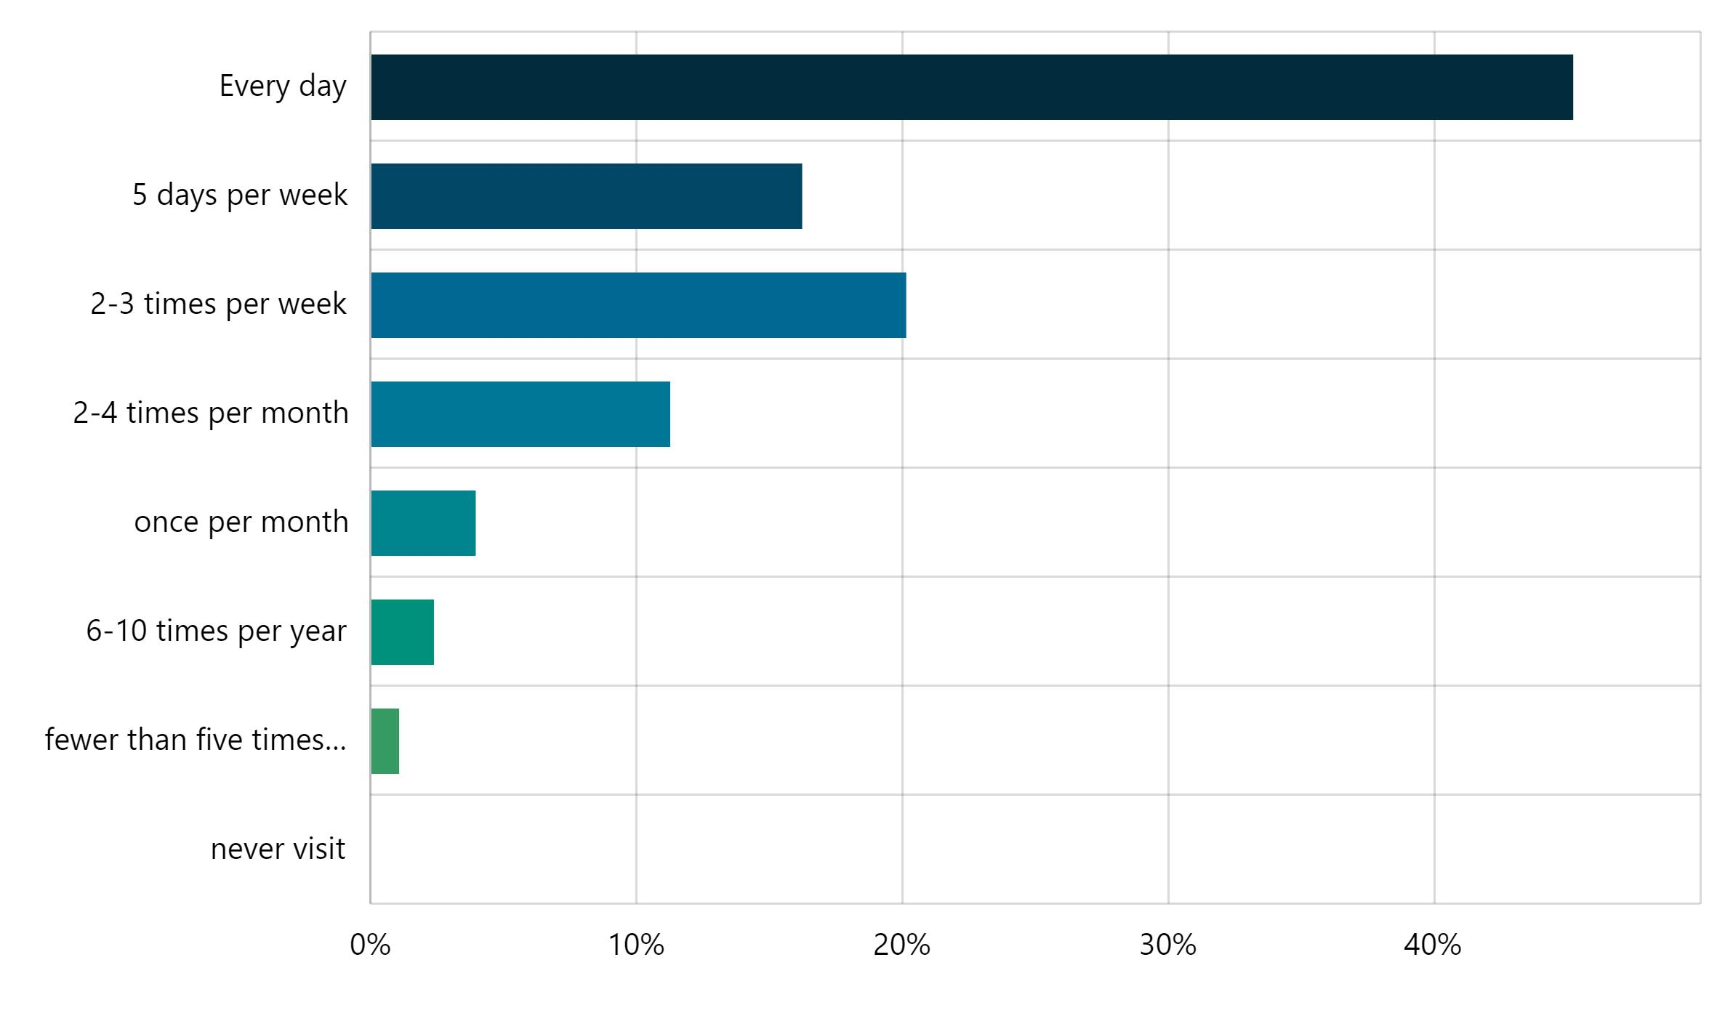
Above: How often respondents travel to or within the City of Melbourne (n = 383)
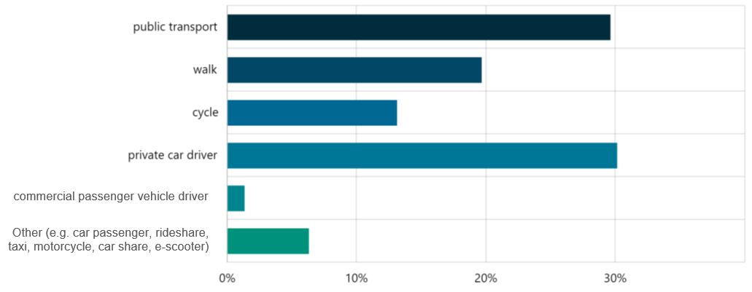
Above: Usual mode of travel to or within the City of Melbourne (n = 382)

5.2 Respondents and their relationship to the City of Melbourne
People who responded to the survey were more likely to be men (52 per cent), under 50 years of age (61.5 per cent) and a City of Melbourne resident (52.88 per cent).
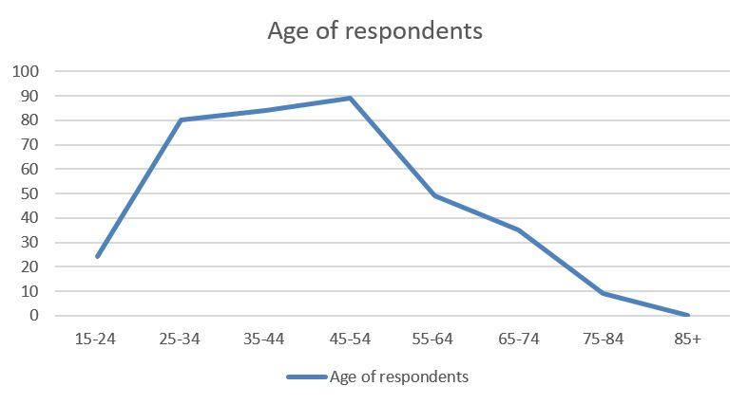
Above: Age of respondents (n = 377)
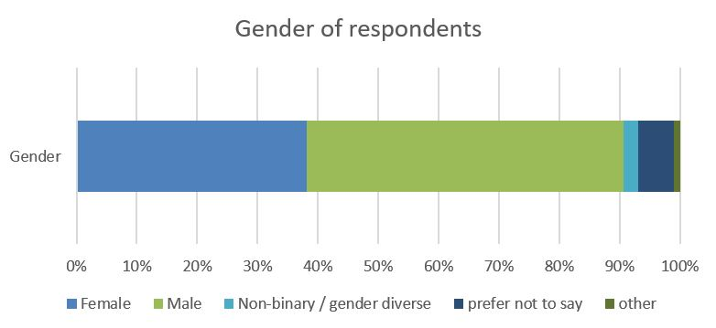
Above: Gender of respondents (n = 375)
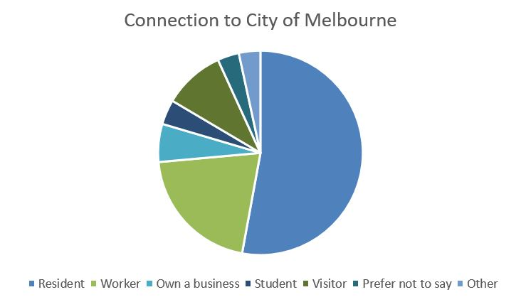
Above: Connection to City of Melbourne (n = 382)

How to contact us
Online:  melbourne.vic.gov.au  In Person:  Melbourne Town Hall – Administration Building  120 Swanston Street, Melbourne  Business Hours, Monday to Friday  (Public holidays excluded)  Telephone:  03 9658 9658  Business Hours, Monday to Friday  (Public holidays excluded)  Fax:  03 9645 4854  In writing:  City of Melbourne  GPO Box 1603  Melbourne VIC 3001  Australia  melbourne.vic.gov.au | Interpreter Services  We cater for people of all backgrounds  Please call 03 9280 0726  03 9280 0717 Cantonese (廣束話)  03 9280 0719 Indonesian (Bahasa Indonesia)  03 9280 0720 Italian (Italiano)  03 9280 0721 Mandarin (普通话)  03 9280 0722 Somali (Soomaali)  03 9280 0723 Spanish (Español)  03 9280 0725 Vietnamese (Việt-ngữ)  03 9280 0726 Arabic (عربي)  03 9280 0726 Korean (한국이)  03 9280 0726 Hindi (हिन्दी)  03 9280 0726 All other languages  National Relay Service:  If you are deaf, hearing impaired or speech-impaired, call us via the National Relay Service: Teletypewriter (TTY) users phone 1300 555 727 then ask for 03 9658 9658 9am to 5pm, Monday to Friday (public holidays excluded)

