Parking and Kerbside Management Plan
Contents
1. Introduction 4
2. Purpose of this plan 6
3. Vision 6
4. Context 7
5. Strategic directions 18
6. Policies 23
7. References 40

Acknowledgement of Traditional Owners
The City of Melbourne respectfully acknowledges the Traditional Owners of the land we govern, the Wurundjeri Woi-wurrung and Bunurong Boon Wurrung peoples of the Eastern Kulin and pays respect to their Elders past, present and emerging. We acknowledge and honour the unbroken spiritual, cultural and political connection the Wurundjeri, Bunurong, Dja Dja Wurrung, Taungurung and Wadawurrung peoples of the Eastern Kulin have to this unique place for more than 2000 generations. We are committed to our reconciliation journey, because at its heart, reconciliation is about strengthening relationships between Aboriginal and non-Aboriginal peoples, for the benefit of all Victorians.

1. Introduction
Melbourne is renowned for its high-quality public places, spaces and streets. The way that our city space functions, and how people use and experience this space is key to the city’s reputation as a desirable place to live, work, visit and do business. However, public space in a busy capital city is limited and in high demand. The city continues to grow and change and the way we use our streets and spaces continues to evolve. The challenge for the City of Melbourne is to ensure that as the city changes, we are able to manage the varied and sometimes conflicting demands on our valuable kerbside space to ensure it is functioning as optimally as possible for the benefit of our businesses, residents and visitors.

  - What is kerbside space?
Kerbside space is the very useful and high demand road space, typically located immediately adjacent to a footpath*.
*Sometimes car parking and kerbside functions are accommodated away from the kerb – for example, to accommodate mobility such as bus lanes, clearways and protected bike lanes. In some locations we also allocate the centre-of-road space of streets for car parking. For the purposes of this plan, these types of parking and kerbside functions have been included.
It is an important transfer point for people and goods into and out of our city. Approximately 4 per cent of all road space in the city is classified as parking and kerbside space (source: Analysis of Transport Space GIS Mapping Study, City of Melbourne 2017). It is particularly important because it is needed to accommodate functions that keep our city operating. This includes direct, safe and convenient access to the footpath for loading and unloading of goods, for inclusive access for people with a disability and for people being picked up or dropped off by car, taxi, rideshare or public transport. Kerbside space is therefore essential for the productivity of Melbourne’s economy.

Infographic: Title ‘Analysis of street space allocation across Melbourne municipality’
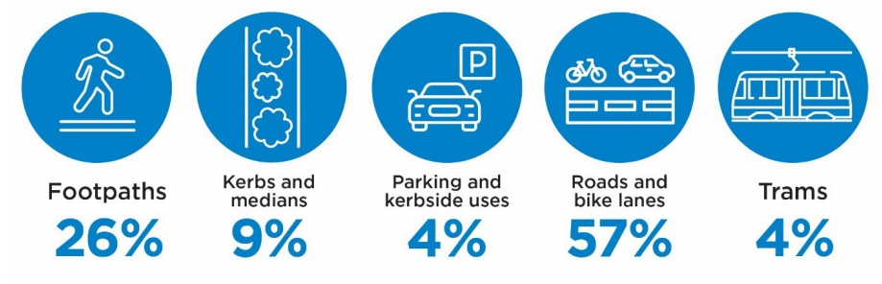
Text alternative for infographic: This infographic shows that public space in a busy capital city is limited and in high demand. Footpaths account for 26% of space, kerbs and medians account for 9%, parking and kerbside uses account for 4%, roads and bike lanes account for 57%, and trams account for 4%.

Kerbside space is also used for parking – the storage of vehicles such as cars, bikes and motorbikes. Across the municipality we have approximately 23,000 kerbside spaces, of which 17,000 are allocated for on-street car parking. They are used for short-term parking in places such as the CBD, busy activity strips and near particular land uses such as schools. Longer-term and all-day car parking is typically provided in residential areas, near parks, within industrial areas and growth areas. Kerbside space is also in demand for other important city uses – for tree planting, for activation such as outdoor dining and to facilitate construction. In some locations, an expansion of parkland, footpath space, public transport space, a traffic clearway or other infrastructure is required, which can result in the removal of parking and space for kerbside uses. When kerbside space is managed well, it accommodates a variety of city demands.

Infographic: Title ‘Examples of how kerbside space is used in the City of Melbourne’
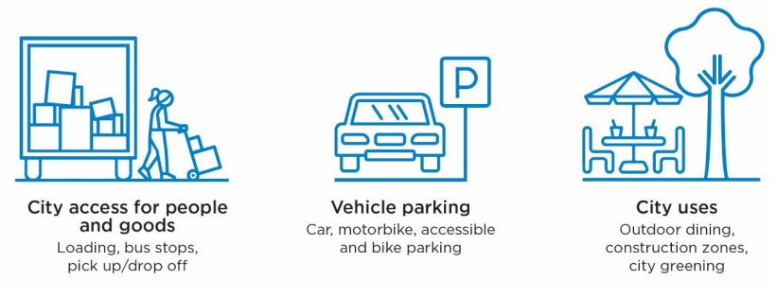
Text alternative for infographic: This infographic shows three examples of how kerbside space is used in the City of Melbourne:
- City access for people and goods (including loading, bus stops, pick up/drop off)
- Vehicle parking (including car, motorbike, accessible and bike parking)
- City uses (including outdoor dining, construction zones, city greening)

  - How is kerbside space managed?
Global cities use a range of tools to manage kerbside space. In Melbourne we:
- line mark parking spaces in areas of high demand, to get more efficient parking outcomes
- dedicate space to specific uses (such as accessible parking, loading zones and bus stops)
- implement parking controls to manage demand and facilitate reliable access (such as using time limits and fees)
- give priority to certain users in specific locations (such as customer parking in retail areas and residential parking where off-street parking options are unavailable)
- provide for temporary access needs (such as exclusive use of spaces for construction, film production and events)
- enforce the parking controls in place to ensure compliance (such as issuing fines)
- use technology to implement our parking controls, capture data and support the enforcement of rules (for example, parking meters and parking sensors).

Text box: The history of parking management
In 1870, the city of Washington DC began planting shade trees and creating ‘walks, enclosed with curb stones, not exceeding one-half the width of any and all avenues and streets’. Fifty years later, this convenient kerbside area became the place where people put their newly invented motor cars. By the 1920’s, the term ‘parking’ had come to mean the area next to the kerb where motor vehicles were stored.
As motor vehicle ownership and use grew, the space to park cars was overwhelmed. In the USA in 1935, the first parking meters were installed in commercial areas to regulate access to the kerb. This mechanical roadpricing system supported by penalty notices issued to non-compliant users, restored reliable access by keeping a proportion of bays vacant and discouraging long stays. Another advantage of the system was that it provided local governments with a source of revenue.
The first parking meters were installed in Melbourne ahead of the 1956 Olympic Games. In many places, including in our municipality today, this mechanical and manual parking control system is still in use. Coins are still placed in meters, tyres are ‘chalked’ and paper infringement notices issued to ensure that non-payment and ‘overstays’ are minimised. In recent years, mechanical systems have given way to digital processes, and technology has created opportunities for improved data to inform strategic parking management and an enhanced customer experience.
Images: Two decorative images omitted of parked cars and an example of a City of Melbourne parking sign, circa 1956-65.

2. Purpose of this plan
This plan supports the City of Melbourne in our role as manager of the city’s kerbside space. It will be used to guide our decisions around parking supply, to inform how we manage demand for kerbside space and how we optimise access to this important space. This plan will also outline actions and policies to help us transition towards a fairer and more transparent, best practice approach to managing the city’s kerbside space. At its heart, the supply of parking and its management is about resource allocation. This plan helps us achieve that fairly, 2efficiently and with the end user in mind.

3. Vision
The City of Melbourne applies best practice kerbside management to ensure our limited kerbside space is:
- reliable for all users
- used efficiently to positively contribute to and support our local economy
- allocated fairly to all users who need it
- easy to access with a seamless customer experience.
We use policy, data and technology to enable this and provide a commitment to transparent decision making. The result is a service which provides reliable parking access to meet the needs of our businesses, community and visitors in a manner that supports a productive city economy.

4. Context
In developing this plan, we have considered relevant policy and current parking, travel and stakeholder data. This has enabled us to identify the key challenges and opportunities to be addressed in this plan.

  - Policy context
We manage on-street parking and kerbside space on local and arterial roads across the municipality. We design, make decisions, manage and enforce use of this space within the context of City of Melbourne policies and Victorian legislation, regulations and policies:
City of Melbourne strategies, plans and policies:
- Future Melbourne 2026
- Council Plan 2021 – 2025
- Transport Strategy 2030
- Economic Development Strategy 2031
- Climate Change Mitigation Strategy 2018
- Climate Change Adaptation Strategy 2017
- Urban Forest Strategy 2014
- Central City Urban Forest Precinct Plan 2013 – 2023
- Central Melbourne Design Guide 2018
- Inclusive Melbourne Strategy 2022 – 2032
- Disability Access and Inclusion Plan 2020 – 2024
- Road Management Plan 2021
- Code of Practice for Building, Construction and Works 2022.
Victorian Government legislation, regulations and policies:
- Transport Integration Act 2010
- Road Management Act 2004
- Road Safety Road Rules 2017
- Road Safety Act 1986
- Infringements Act 2006
- Victoria’s Infrastructure Strategy 2021 – 2051
- Victorian Freight Plan 2018.

  - Kerbside space and its use in Melbourne
    - How much kerbside space do we have?
Within the municipality, we have approximately 23,000 on-street kerbside spaces. City of Melbourne Census of Land Use and Employment (CLUE) data shows that there is a significant supply of off-street parking in the city. In total there are around 217,000 spaces across the municipality, with almost 90 per cent of these spaces in off-street parking facilities. On-street paid parking makes up less than 5 per cent of the total parking capacity in the municipality.
Graph: Title ‘Total parking spaces in the City of Melbourne: Breakdown of on-street and off-street parking capacity (2022)’
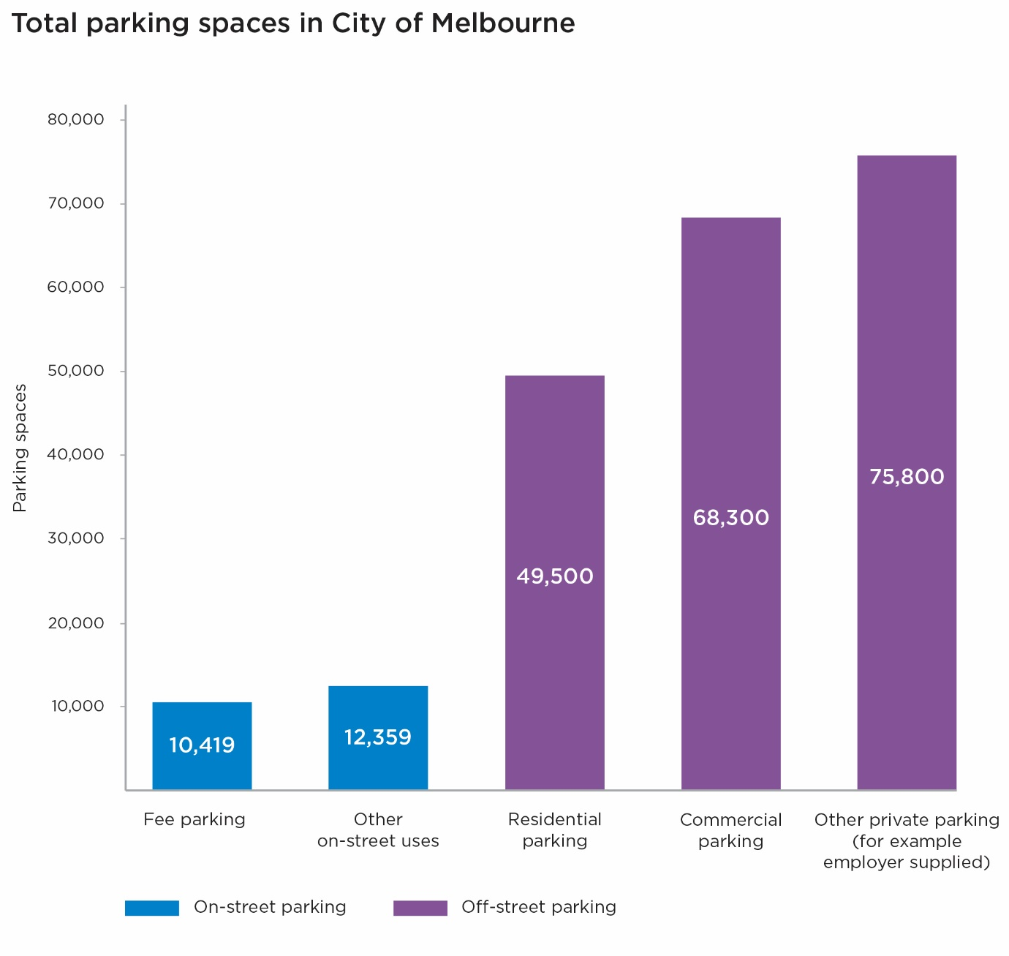
Text alternative for graph: This graph shows that in the City of Melbourne we have:
- 10,419 on-street parking spaces that require a fee to be paid
- 12,359 on-street parking spaces designated for other uses (for example, loading zones)
- 49,500 off-street residential parking spaces
- 68,300 off-street commercial parking spaces
- 75,800 other off-street private parking spaces (for example, employer supplied parking).

Graph: Title ‘Breakdown of 23,000 on-street spaces (2022)’

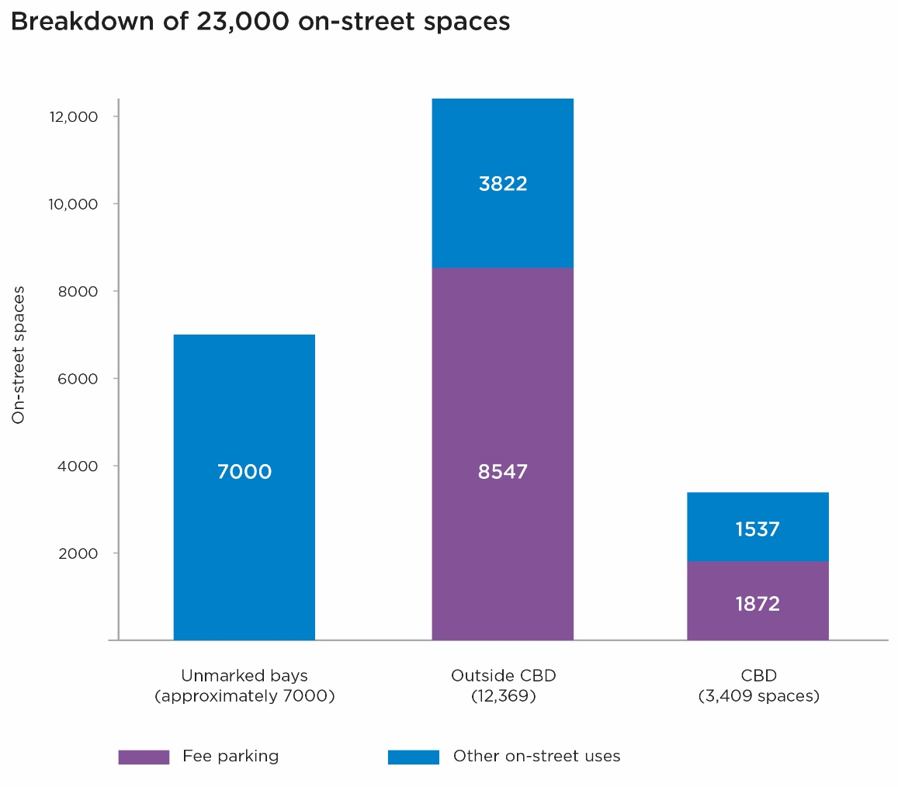
Text alternative for graph: This graph shows that:
- Outside the CBD there are 12,369 spaces. Of these:
  - 8,547 spaces are fee parking
  - 3,822spaces are for other on-street uses
- Within the CBD there are 3,409 spaces. Of these:
  - 1,872 spaces are fee parking
  - 1,537 spaces are for other on-street uses
- There are approximately 7,000 additional bays that are unmarked.

Within the CBD, kerbside space is in high demand for many important city functions such as loading, parking for people with a disability, picking up/dropping off goods and people, and for temporary uses such as construction zones. Once these uses are accommodated, the remainder of available kerbside space in the CBD – approximately 55 per cent – has been allocated for short stay parking. The supply of on-street parking has reduced over recent decades and will continue to reduce as our city grows. Important strategic changes to our public realm – such as for streetscape and amenity improvements, sustainable transport and economic opportunities – will only be possible by making adjustments to our streets and kerbside space.

    - How is our space being used?
According to the Victorian Integrated Survey of Travel and Activity (VISTA) the Melbourne municipality is the top destination in metropolitan Melbourne for social and hospitality trips and fourth most popular for shopping trips (source: Victorian Integrated Survey of Travel and Activity, 2018). Approximately three-quarters of travel to the City of Melbourne for these purposes does not rely on car parking – unusual in the context of metropolitan Melbourne, where the majority of trips are by car and result in parking.
Based on VISTA travel survey data, only 14 per cent of trips made to the municipality with the purpose to ‘buy something’ (shopping) involved driving a car and parking on-street. A further 21 per cent drove a car into the city and used off-street parking. Most people who travelled to the city to shop – 63 per cent – arrived by non-car mode.
Similarly, for ‘social’ trips (including hospitality) across the municipality, 63 per cent were by non-car means, while 15 per cent used on-street parking and 19 per cent parked off-street.
Trip types most reliant on on-street kerbside space were pick-ups and deliveries of goods and people.
VISTA shows that of the 760,000 individual vehicle trips into and within the city on an average day, most of these trips are for work and social purposes and most trips end in off-street parking.

Graph: Title ‘Mode share of trips to the City of Melbourne by purpose (VISTA, 2018)’
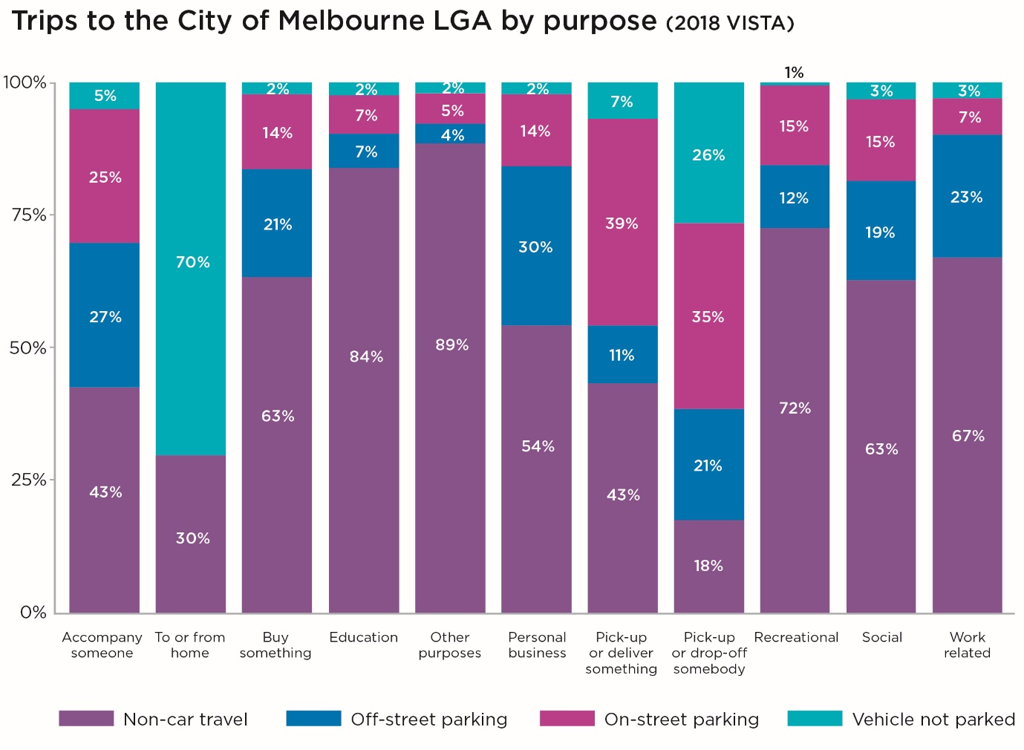
Text alternative for graph: This graph shows the travel/parking choices made by those travelling into the City of Melbourne for the following reasons:
- To accompany someone: 43% did not travel by car, 27% travelled by car and parked off-street, 25% travelled by car and parked on-street, 5% travelled by car but did not park their vehicle.
- To travel to or from home: 30% did not travel by car, 70% travelled by car but did not park their vehicle.
- To buy something: 63% did not travel by car, 21% travelled by car and parked off-street, 14% travelled by car and parked on-street, 2% travelled by car but did not park their vehicle.
- For education purposes: 84% did not travel by car, 7% travelled by car and parked off-street, 7% travelled by car and parked on-street, 2% travelled by car but did not park their vehicle.
- For personal business: 54% did not travel by car, 30% travelled by car and parked off-street, 14% travelled by car and parked on-street, 2% travelled by car but did not park their vehicle.
- To pick up or deliver something: 43% did not travel by car, 11% travelled by car and parked off-street, 39% travelled by car and parked on-street, 7% travelled by car but did not park their vehicle.
- To pick up or drop off somebody: 18% did not travel by car, 21% travelled by car and parked off-street, 35% travelled by car and parked on-street, 26% travelled by car but did not park their vehicle.
- For recreational purposes: 72% did not travel by car, 12% travelled by car and parked off-street, 15% travelled by car and parked on-street, 1% travelled by car but did not park their vehicle.
- For social purposes: 63% did not travel by car, 19% travelled by car and parked off-street, 15% travelled by car and parked on-street, 3% travelled by car but did not park their vehicle.
- For work related purposes: 67% did not travel by car, 23% travelled by car and parked off-street, 7% travelled by car and parked on-street, 3% travelled by car but did not park their vehicle.
- For other purposes: 89% did not travel by car, 4% travelled by car and parked off-street, 5% travelled by car and parked on-street, 2% travelled by car but did not park their vehicle.

Graph: Title ‘Private vehicle trips to the City of Melbourne by purpose (VISTA, 2018)’
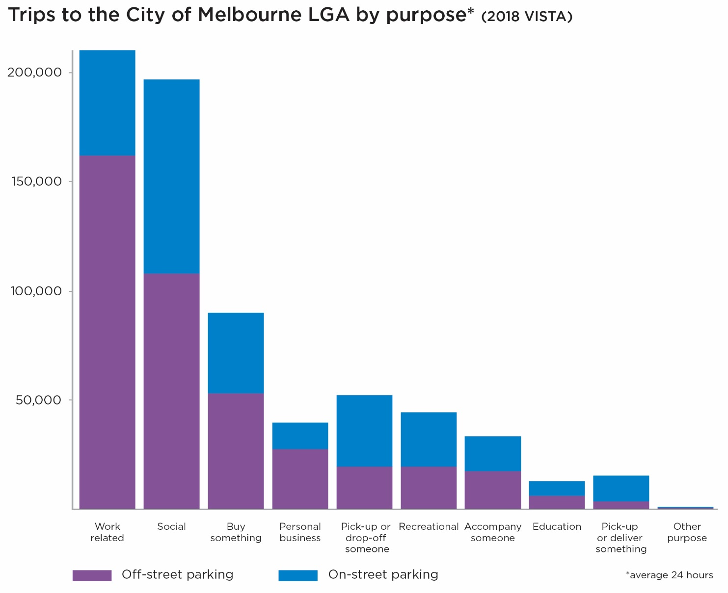
Text alternative for graph: This graph shows the number of drivers travelling to the City of Melbourne on an average day by trip purpose – broken down by on and off street parking:
- Work related purposes: 162,138 parked off-street, 48,237 parked on-street
- For social purposes: 107,913 parked off-street, 88,951 parked on-street
- To buy something: 53,117 parked off-street, 36,868 parked on-street
- For personal business: 27,454 parked off-street, 12,248 parked on-street
- To pick up or drop off someone: 19,665 parked off-street, 32,635 parked on-street
- For recreational purposes:19,615 parked off-street, 24,563 parked on-street
- To accompany someone: 17,257 parked off-street, 16,063 parked on-street
- For education purposes: 5,988 parked off-street, 6,652 parked on-street
- To pick up or deliver something: 3,378 parked off-street, 12,047 parked on-street
- For other purposes:479 parked off-street, 731 parked on-street

    - What are our stakeholders’ needs?
The City of Melbourne has many stakeholders that rely on kerbside space. The needs of these stakeholders are varying and must be prioritised against the space available to accommodate them.
Table: Title ‘Kerbside space stakeholders and their needs’
Stakeholder | Their needs
People with a disability | Safe, accessible and readily available spaces close to their destination.  Parking controls that are fair and inclusive to accommodate diverse needs.
Businesses | Reliable access for goods to be picked up or delivered on time.  Customers able to access their business via parking, pick up/drop off, public transport or other means.  Option to use parking space to support business (for example, outdoor dining parklets).
Residents | Space to park their vehicle or visitor’s vehicle near home (where off-street parking is not available).  Vehicles not blocking property access or causing amenity issues.  Option to use parking space for other public uses (for example green space or temporary social use).
Delivery companies | Easy, reliable access to loading zones within proximity of their destination.  Adequate time to complete deliveries.
Car share operators and users | Vehicles visible and accessible to support existing users and attract new users.  Vehicles available when and where people want to use them.
People driving and parking a car | Space available that meets their needs, in terms of cost, location and convenience.  A simple, fair and seamless on-street parking experience.
People picking up or dropping off passengers (including CPVs and tourist buses) | Space that is easy and safe to access and positioned in areas where there is high demand for pick up/drop off.
People riding motorbikes or bicycles | Space to park that is located convenient to their destination and allows their bike to be stored safely.
Tradespeople | Reliable access to parking space within proximity of their job.
Emergency and public service (including police, postal) | Guaranteed access to space in specific locations to support operations.
Public transport operators and users | Stops that are well located and sized according to need
Temporary users of space (events, construction etc) | Access to vacant kerbside space to enable timely, convenient temporary use.

Text box: What we’ve heard from our stakeholders so far?
Pre-draft engagement occurred with our key stakeholders and parking customers in late 2022 to inform the development of the Plan.
A half-day stakeholder workshop with business, resident and transport operator representatives was held to better understand the conflicting needs of the various users of kerbside space. Key findings were:
- Priority use of space should be provided for disability access first, followed by loading and pick up/drop off activities. Any remaining space should be allocated to other uses, including paid parking.
- The majority of workshop participants suggested parking be paid for by the user rather than rate payer.
- The vision for parking in the city was described by workshop participants as: available, productive, sustainable, pedestrian friendly, flexible and affordable.
- The top idea for parking customers was: better utilise the city’s off-street parking capacity and encourage visitors to park outside the CBD and travel in by tram, train or other mode (source: Parking and Kerbside Management Stakeholder Engagement Report, Movement & Place Consulting 2022).
A survey of approximately 1,000 car parking customers was conducted to better understand their current experience and expectations of parking in the city. Key findings were
- 95 per cent of parking customers that needed to find a car park during their last trip to the city looked for an on-street space when they arrived. Only five per cent went straight to off-street parking.
- Of those customers that looked for an on-street parking space, 82 per cent found it difficult or very difficult to find an available space. Of those searching, 36 per cent ended up in off-street car parking.
- 97.5 per cent of customers expect to pay for parking in the city.
- 65 per cent of customers said they would like peak and off-peak parking pricing.
- 53 per cent of customers said they would pay more for a higher chance of getting a car park close to their destination (source: Melbourne Parking Survey, Redbridge Group, 2022).
The Draft Plan was put to the community for feedback in March – April 2023. Around 440 individuals and organisations engaged with us on the Plan. Community, businesses and other stakeholders told us they want:
- A data led approach to decision making
- Regular reviews and engagement with the community on parking
- Improvements to on-street parking availability, simple signage and fair pricing
- Off-street parking to be better used, but also accessible, affordable and safe
- Loading, pick up / drop off and disability access prioritised
- Eagerness for Council to make immediate improvements to parking

Infographic: Title ‘Key insights from Parking Customer Sentiment Survey, October 2022’.
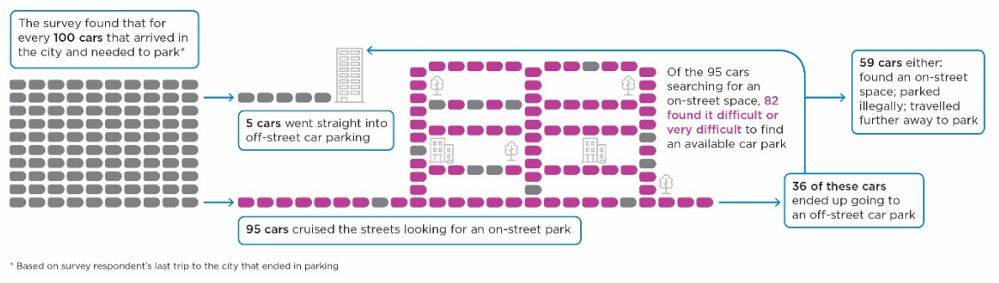
Text alternative for infographic: This infographic shows that for every 100 cars that arrived in the city and needed to park:
- 5 cars went straight into off-street car parking
- 95 cars cruised the streets looking for an on-street park.
  - Of these 95 cars, 82 found it difficult of very difficult to find an available car park.
  - Of these 95 cars, 59 either found an on-street space, parked illegally or travelled further away to park, and 36 cars ended up going to an off-street car park.
These results are based on survey respondent’s last trip to the city that ended in parking.

  - Challenges
There are many challenges – sometimes conflicting – that we face in managing kerbside space.
- Competing demand for limited city space:
We have a finite amount of space to accommodate critical city functions including: loading, vehicle storage, traffic clearways, property access, waste collection, bicycle and bus lanes, bus and tram stops, parking for people with a disability, bicycle and motorcycle parking, car share vehicles, taxi zones, emergency vehicle parking, temporary construction zones, residential parking and reserved spaces for events or filming. We also convert parking spaces to other important city needs such as footpath widenings, greening and parklets.
- Congested parking, low turnover and circulating vehicles:
In some parts of the city or at certain times, it can be difficult for drivers to find an on-street parking space that suits their needs. In these situations, we typically see very high occupancy, lower turnover of vehicles and vehicles cruising around streets searching for a space. This adds to traffic congestion in the city, an increase in vehicle kilometres travelled and vehicle emissions – which all impact city amenity. In addition, the lack of parking reliability creates frustration for drivers and can lead to unsafe driving or illegal parking, diminishing the sense that the city is easy to access.
- People’s experience of parking in the city can be poor and the signage confusing:
A driver must overcome many barriers to find a parking space in the city. Available spaces can sometimes be hard to find. It’s not always clear where to look. When an available space is found, the parking controls may not allow for as long as a driver needs, so they keep searching. Drivers may not know the price of parking before they arrive at the meter. In some areas today, drivers pay a different price depending on the side of the street they park. Once a customer finds a suitable parking space the controls in place may be complex which makes the signage confusing and difficult to interpret. Approximately 10 per cent of the requests we receive for an infringement review are linked to confusing signage or complex settings.
Image: A decorative image of a complex parking sign on Lonsdale Street with seven panels communicating different parking restrictions has been omitted.
- Loading zones are not functioning optimally:
Loading zones appear to be in high demand in certain locations and at certain times of the day. Observations and reports revealed a range of issues, including vehicles parking in loading zones all day and accepting a fine as a ‘cost of doing business’ and delivery vehicles parking in metered parking spaces, bike lanes or in no stopping areas due to loading zones being occupied or difficult to find. We’ve also found that there is a lower need for loading zones in the afternoons. Inefficient loading zones reduce productivity of nearby businesses and undermine the city economy.
- Demand for pick up / drop off space is growing:
While approximately 20 per cent of kerbside space in the CBD can be used for picking up and dropping off passengers and goods, there appears to be ongoing challenges with quick access to the kerb for short durations (under two minutes). This can be due to insufficient quick access space in high demand locations, drivers being unaware of the spaces they are legally allowed to use (for example, anyone can legally use No Parking spaces when picking up or dropping off) or the nature of ride sharing trips where customers seek the most convenient start and end points for their trips, whether kerbside space is available or not.
- Parking for people with a disability is not meeting all needs:
There are more than 400 accessible parking bays for disability parking permit holders across the municipality. Almost 7 per cent of all car parking in the CBD is allocated to accessible parking, which is relatively high. However, the majority do not meet current accessibility standards due to difficulty accommodating the dimensions in spatially constrained areas such as the CBD. Community feedback focuses on the network of accessible spaces as being inadequate in terms of supply, location and management of demand. Holders of a disability parking permit can also park in general parking spaces for double the signed time if displaying their valid permit, however it’s unclear how well known this rule is. The City Access Permit, introduced by the City of Melbourne in the 1980s before accessible parking bays were legislated in Victoria, is still in use today, however its value and impact are not clearly understood.
- The large supply of off-street parking in the city is underutilised:
In the City of Melbourne there are close to 200,000 off-street parking spaces. However, our research shows that approximately 95 per cent of visitors arriving to the city and needing a car park will look for an on-street parking space first rather than travel directly to off-street parking. The difference in price between on-street parking and commercial off-street parking can be significant. This exacerbates the driver preference for on-street parking. The price differential does not reflect that on-street parking is a premium product and the price of off-street parking increases demand for the limited spaces that are available.
- The value of kerbside space is not well understood:
Research shows we subsidise the cost of parking in the central city by up to 135 per cent, providing below market value parking and some free parking (source: Valuing on-street parking space, Movement & Place Consulting 2021). In some areas the total construction and maintenance bill for parking is effectively subsidised for a small number of users. The value of the space is therefore not accurately represented in Council’s finances, nor is it included in the way we set customer prices. This distorts the wider community’s understanding of the true value and importance of kerbside space. In a city with up to one million people living, working or visiting per day, the single car space outside a key destination is likely to be of high value to many people. Our parking fees are not currently used to effectively manage demand or encourage use of the significant off-street capacity.
- Permits are issued without consideration to parking supply and exclude a range of potential uses:
There are many residential parking permit schemes operating across the municipality – introduced or adjusted at different times responding to local issues. The number of residential parking permits allowed per property varies depending on the area, with eligibility typically tied to the property type and construction date, rather than the nearby parking supply on- and off-street. We also issue permits for people with a disability, tradespeople, medical practitioners, businesses in vehicle restricted areas (such as Bourke Street Mall) and special events or users. When there are a high number of permits issued in a high demand area, reliability of access to a space becomes a significant issue, even for permit holders. Our permits do not allow for temporary access to space for other potential uses such as social activity, play, trader expansion, open space or bike parking.
- Parking enforcement is essential, but fines do not equal success:
Our parking officers play a critical role in making our parking service reliable, keeping the city moving and ensuring fair access for everyone. However, there is a perception that the role of enforcement is purely to raise revenue. When a parking fine is issued it can feel like we are being punitive or trying to ‘catch people out’ – particularly if it relates to a genuine mistake or confusing sign. The number of fines issued is not a measure of success, but rather an indication that we may not have provided reliable and easy parking options and communicated these options to drivers clearly. The role of enforcement is to promote compliance, so that the rules achieve their objective. There is a balance to using enforcement to ensure safe and efficient use of space and enforcement that results from confusion or genuine unavoidable mistakes.

Text box: Parking myths
- Myth 1: Cheap parking will improve the customer experience
Free or cheap parking creates additional demand for the space. The number of spaces available in the city remains the same, so when demand increases, it generally becomes harder for people to find an available space. When availability is low, this creates frustrated cruising as drives search for a low-cost space. An unreliable service that does not meet expectations is always worse for a driver than paying for a service that meets their needs.
- Myth 2: Relaxed parking controls can support business and city reactivation
When parking is not controlled, turnover of space is lower. This means that fewer people can access parking in that area. When parking was largely uncontrolled during COVID-19 lockdowns, there were only 10 arrivals per bay per day in Russell Street, compared to an average of 23 when parking controls were in place (source: City of Melbourne Independent Transport Review, Deloitte 2021). If this was replicated across the CBD, it would equate to approximately $1.9 million in potential lost spend each day.
- Myth 3: Councils charge fees for parking and issue fines just to raise revenue
Fees are an important tool for managing parking demand. Fees set at the right price can maximise occupancy while ensuring availability for people that need access. Research found that on-street parking in Melbourne is valued and priced well below what the private market would charge for an off-street space in the same location (source: Valuing on-street parking space, Movement & Place Consulting 2022). This subsidy is borne by ratepayers but typically benefits non-ratepayers who drive in from other municipalities. While we recoup the cost of parking provision and maintenance in some areas, this is not the case in most areas. A significant proportion of on-street spaces in the municipality are free to user. Any additional revenue from parking funds essential community services and infrastructure and directly reduces rates for ratepayers.
- Myth 4: City retailers rely on parking for customers
Only 14 per cent of people shopping in the municipality drive and park a car on-street, while 60 per cent arrive by non-car modes (source: Victorian Integrated Survey of Travel and Activity, Victorian Government 2018). There is a perception that retail is dependent on parking, but the evidence shows otherwise. A study in London confirmed that more parking does not equate to greater commercial success. This and other surveys in Melbourne show that people overestimate the proportion of customers that arrive by car – in some cases by up to 400 per cent. A good mix of shops and services and a quality environment were found to be more important factors for attracting visitors to commercial centres (source: Review of the relevance of parking to the success of urban centres, London Councils 2012).
- Myth 5: Car drivers spend more money than people who walk, cycle or catch public transport
A study in Carlton found that space converted to bike parking returned five times more retail spend as on-street car parking. Following this study, several Lygon Street traders found their revenue improved if more bicycle parking was located near their business (source: Recognising the economic role of bikes: Sharing parking in Lygon Street, Carlton, Lee and March 2010). In London, a study found car drivers spend more on a single trip, while people who walk or arrive by bus visit more frequently and spend more over a week or month.

5. Strategic directions
We commit to the following strategic directions to improve the management of kerbside space:

  - Adopt a strategic and data-led approach to kerbside management
Outcome | 1. Kerbside space is actively managed to optimise its use and productivity
Description | Every piece of kerbside space is being used efficiently, turnover of space is optimised and demand is being managed to facilitate availability of space for those that need access to it. The benefit to our economy and city productivity is maximised.
Indicators of success | Availability of parking is between 5-15 per cent, measured over each 50-100 spaces.  Loading zones are available where and when needed, while not being unoccupied for more than 40 per cent of their operational time period.

To deliver on the vision and outcomes of this plan, we commit to transitioning to a best practice ‘kerbside management approach’ to manage our limited on-street space. This approach provides a fairer, more transparent and equitable approach to managing on-street parking and kerbside space. This means:
    - We will use a data-led, strategic approach to making changes to kerbside space and controls at a precinct level – in line with the new policies in this plan. This work will be led by a Kerbside Manager.
    - We will not ‘set and forget’ on-street parking restrictions or make ad-hoc changes without appropriate evidence.
    - We commit to regular, proactive engagement in local areas, sharing the data that underpins our decision making and making strategic decisions to ensure the use of space is optimised and the competing needs for kerbside space are balanced. This will be delivered in line with the policies in this plan including clear roles and responsibilities for all decision makers, and clear delineation between those making decisions about objectives and targets, and those deciding how the targets and objectives can best be achieved.
    - We will continue to investigate, pilot and invest in technology that will support improved kerbside management outcomes. Technology in parking management has evolved rapidly over the last decade and will play an important role in enhancing the customer experience, enabling our data-led decision making, improving the efficiency of enforcement and in solving problems that are difficult to address with traditional kerbside management tools.
    - We will review and refresh our enforcement to ensure it is proactive, responsive and proportionate in approach and guided by data. Enforcement data will also inform parking management decisions. We will investigate whether the value of infringement notices adequately supports compliance and is achieving behaviour change. If appropriate we will advocate for parking infringement reform to ensure our enforcement activity contributes effectively to kerbside management.

Infographic: Title ‘The Kerbside Management Approach’
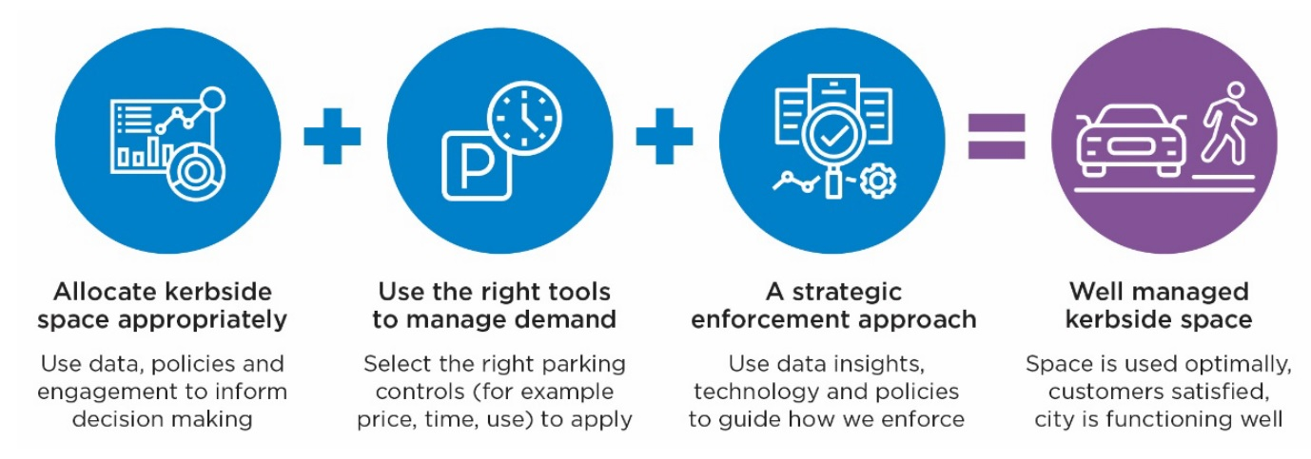
Text alternative for infographic: This infographic depicts the Kerbside Management Approach whereby allocating kerbside space appropriately (using data, policies and engagement to inform decision making), plus using the right tools to manage demand (selecting the right parking controls – for example price, time use), plus adopting a strategic enforcement approach (using data insights, technology and policies to guide how we enforce) should result in well managed kerbside space (where space is used optimally, customers are satisfied and the city is functioning well).

  - Put customers at the centre of kerbside management decisions
Outcome | 2. Customer experience is enhanced through reliable availability of space, simplified controls, intuitive kerbside layouts and seamless payment options
Description | Drivers can find a space that suits their needs, at any time. Parking controls and signage are simple and easy to understand – improving the driver experience and compliance. Payment is easy and offers some flexibility. The layout of kerbside controls within a street is intuitive. Information about parking can be easily accessed and understood. The controls and our approach to enforcement keep the customer in mind.
Indicators of success | Increased customer satisfaction with the location of on-street parking space used.  Fewer customer complaints about parking signage/controls.  Fewer fines issued.

Our customers are all users of kerbside space – for example people with a disability, delivery drivers, motorcyclists, car share users or drivers looking to pick up or drop off passengers or park a vehicle. We will deliver kerbside management and on-street parking services with our customers at the centre of all decisions. This means:
    - We will use the tools at our disposal to better understand our customers and their needs.
    - We will publish information about restrictions and pricing openly.
    - As an immediate first step, we will refresh our parking controls and signage to ensure they are standardised, simple, and intuitive and reflect the parking needs of the area. Where possible we will seek consistency across all days of the week to make signage easier to understand.
    - We want the experience of accessing on-street space in the municipality to be as seamless as possible. To achieve this, we will introduce a demand-based pricing model for parking in the next two years. This means using data to understand the impact of price on parking demand. Over time, regular reviews of parking data will consider how demand changes by time of day, day of the week and seasonally throughout the year. This will lead to lower prices at off-peak times. A maximum incremental price increase will be agreed prior to commencing. We will only price parking if demand needs to be reduced and will remove or reduce prices if parking availability in an area is too high. We will review and refresh our parking enforcement approach to ensure we are educating our customers, encouraging voluntary compliance and supporting customers who need assistance.
    - We will review and refresh our parking enforcement approach to ensure we are educating our customers, encouraging voluntary compliance and supporting customers who need assistance.
    - We will investigate the appropriateness of applying a price to other kerbside space uses where demand for highly sought after space exceeds supply in busy locations (for example, to manage demand for access to very high use loading zones) or where kerbside space is dedicated to benefit a specific user (for example, valet parking).

  - Review how kerbside space is functioning across the municipality
Outcome | 3. Community expectations are improved through established, proactive parking management practices, strategic communications and engagement
Description | We have clear policy settings and evidence that inform our kerbside management actions. Our decisions are transparent and effective at meeting policy goals. We undertake regular engagement with community members to discuss data and how we can meet the agreed objectives and our policy settings. We proactively communicate with the community about kerbside management and how changes are determined.
Indicators of success | General community sentiment about our parking service is improved.  A systematic approach to reviewing controls each year is applied.  Fewer customer complaints about parking restrictions and requests to change them.

In order to assess how our kerbside space is functioning:
    - As a first step, we will undertake a Parking Precinct Review in each neighbourhood. These reviews will use a data driven evidence base to set a baseline and understand existing needs in each area. They will propose updated allocation of kerbside space and parking controls in response to the needs of each area. A key objective of the reviews is to ensure adequate space has been provided for important uses in busy areas – such as loading, pick up / drop off, disability access and car share – in line with our policies on hierarchy of kerbside space use (Policy 6.1) and standard street layouts (Policy 6.4).
    - Reviews will then be completed regularly across the whole municipality.
    - We will develop and deliver a strategic communications approach for parking so that our customers understand how we manage parking, when we will engage with them and can access the information they need about parking in the City of Melbourne.

  - Provide access to kerbside space that is equitable and inclusive
Outcome | 4. Access to kerbside space is equitable and inclusive with clear and consistently applied policies
Description | The way we allocate space, apply restrictions and pricing is fair, transparent and equitable. People with a disability who are driving or being driven by others are able to find a parking space or pick up/drop off space that suits their needs within a convenient distance of their destination. Information assisting customers is easy for all to access and interpret. Parking pricing is fair.
Indicators of success | Increase in the number of accessible bays that meet accessibility standards.  Network of accessible bays within 200 metres of all major destinations.  5-15 per cent of accessible bays available at all times.  Reduced complaints about accessible parking bays.

We will provide kerbside space which is equitable and inclusive. This means:
    - We will set user restrictions based on the agreed hierarchy of kerbside space use (Policy 6.1) until the needs of each group are met in priority order.
    - The price of parking will always be set at the lowest possible price to manage demand in each area.
    - Information about how and where to find parking that suits the needs of all community members will be readily available.
    - Accessible parking will be reviewed to ensure we have the right number of spaces in the right locations. We want to ensure they are consistently positioned within streets to ensure they can be found intuitively in line with our standard street layouts (Policy 6.4).
    - We will find innovative solutions to delivering more compliant accessible parking bays or making significant improvements to accessibility of bays and will relocate bays if required due to space constraints.
    - We will investigate opportunities for clearer signage and line marking of accessible parking spaces to support ease of identification for people with a disability and to improve compliant use of accessible spaces.
    - We will ensure footpath obstacles nearby to accessible parking spaces are removed.

  - Deliver a financially sustainable parking service
Outcome | 5. Kerbside management is financially sustainable
Description | The value of kerbside space and the cost of maintaining car parking is understood by our community and priced appropriately to manage demand. Revenue from parking covers the cost of providing the service and maintaining parking assets. Businesses and the community understand that users are willing to pay for reliable parking services in premium locations and revenue from parking reduces rates.
Indicators of success | Parking subsidies are reduced.  Parking fees reflect the value of the space to the user.  Parking fees cover the cost of delivering and maintaining the parking service and infrastructure.  Reduction in operating costs.

We will deliver kerbside management with ratepayers in mind. This means:
    - We will ensure parking fees reflect the value of the space to the user, and cover maintenance costs.
    - We will allocate additional parking fee revenue to projects that improve the public realm, such as improvements to pedestrian connections to support walking to parking across wider areas and help even out parking demand.
    - We will use the policies in this plan, data and technology to create efficiencies and reduce operating costs (for example, simplified standard signage will reduce the time and costs associated with sign replacement).
    - We will be transparent about parking subsidies provided for by ratepayers.

  - Deliver on our city’s strategic commitments to environmental sustainability, liveability, our unique city identity and a prosperous economy
Outcome | 6. Kerbside management supports City of Melbourne to realise its broader strategic commitments
Description | The City of Melbourne’s important strategic commitments are being delivered, supported by an improved approach to kerbside management. This includes reduced vehicle emissions, mode shift to sustainable transport and providing space to improve Melbourne’s unique place and identity through public realm improvements, new parks and urban forest canopy and opportunities for economic activity.
Indicators of success | Increase in car share spaces.  Reduced reliance on parking.  Reduced vehicle cruising for on-street parking.  Improved urban amenity.

Our strategic commitments are supported through an improved approach to kerbside management and the implementation of this plan. This means:
    - We will release car parking spaces for other needs including shared services, new public spaces and parks, urban forest growth, sustainable transport and economic activity.
    - We will support emissions reduction policies by managing parking to enable direct and efficient access to available parking space and to encourage mode shift to sustainable transport.
    - We will prioritise public realm projects which contribute to safety and amenity improvement above the retention of parking, as these projects are more critical to the economic success of businesses within a precinct.
    - Where on-street parking is required within a precinct, it must be managed according to kerbside management principles to ensure it achieves optimal occupancy and turnover to benefit the businesses and community of that precinct.
    - We will develop an overarching Parking Permit Policy which will incorporate a review of all existing permit schemes, categories and eligibility and impact assessment criteria and process. This will complement the work already underway to transition the City of Melbourne to digital permits. It will also investigate permitting other types of uses for parking spaces.
    - We will investigate ways to encourage our community to consider how the kerbside space around them is programmed and used.

  - Encourage drivers to consider alternatives to on-street parking
Outcome | 7. Off-street parking is the preferred option for most drivers
Description | Drivers always consider off-street options when opting to drive and park in the city. This is enabled through better engagement with commercial stakeholders, improved communications and better management of the on-street parking demand.
Indicators of success | Off-street parking occupancy increases.  Off-street parking fees decrease relative to on-street fees.  Reduced vehicle cruising for on-street parking.

Our on-street metered parking makes up only 5 per cent of the total parking capacity in the City of Melbourne. This means:
    - We will continue to support and encourage people to consider their transport options, including off-street parking, park and ride, public transport, walking, cycling, car share and other new mobility options as they emerge.
    - We will manage our parking aligned with best practice kerbside management principles to provide conditions for more competitive rates in the commercial off-street market.
    - We will work with off-street parking providers, city businesses and other key stakeholders to promote off-street parking to our customers. We will support innovative solutions to facilitate better use of the existing off-street capacity – including investigating opportunities such as valet parking, a parking validation scheme, apps or other technology.
    - We will investigate the City of Melbourne’s future role in the ownership and management of off-street parking.

6. Policies
The following policies will guide our decision making in implementing this plan and managing kerbside space going forward:

  - Allocating and prioritising kerbside space
Our policy: We will use a hierarchy of kerbside space uses to support our decision making and ensure that we prioritise kerbside uses consistently.
Details:
- We have created a hierarchy of kerbside space by use, to help us prioritise the allocation of space when multiple kerbside uses have been determined as being required in an area. We will accommodate higher priority uses as required before the lower priority uses, and implement the hierarchy through parking controls and kerbside restrictions.
Table: Title ‘Hierarchy of kerbside space by use’
Priority and kerbside use | Definition
Priority 1: Safety | Clearance provided for safety reasons (such as sight distance and regulatory requirements) and to ensure safe pedestrian and vehicle movement
Priority 2: Public transport | Space required for picking up and dropping off people using transit including clearance for vehicle access and egress
Priority 3: Accessible parking | Parking bays dedicated for the use of people with disabilities that are placed in convenient locations close to a wide range of facilities
Priority 4: Construction permit zones | Parking bays located adjacent to construction sites that are dedicated for the use of construction vehicles to facilitate medium or long term building works
Priority 5: Loading zones | Enable delivery of goods where off-street loading is not available
Priority 6: Pick up / drop off | Space required for quick access pick up and set down activities such as ‘No parking’
Priority 7:Two-wheeled vehicle parking | Parking areas dedicated for the use of motorcycles and bicycles to support high demand in key areas and reduce clutter on footpaths
Priority 8: Short term parking | Car parking areas, typically provided for up to two hours. Payment may be required in high demand areas
Priority 9: Car share services | Parking dedicated for the use of car share vehicles where membership and demand justify the allocation of bays
Priority 10: Reserved parking | Parking bays that are reserved for and paid by individuals or businesses to facilitate access that is essential to their activities such as emergency vehicles, medical practitioners, events, film crews, weddings, removalists and building maintenance
Priority 11: Medium term parking | Car parking areas, typically provided for three to four hours. Payment may be required in high demand areas
Priority 12: Resident priority parking | Parking areas that can be used by holders of a valid residential parking permit including ‘resident parking permit excepted’ or dedicated ‘resident parking permit’
Priority 13: Long term parking | Car parking areas, typically provided all day

- For example, we will prioritise installing an accessible parking bay for people with a disability (if there is a requirement for one), before we would consider installing short stay parking in that space, as per the hierarchy.
- The hierarchy relates to the intended restriction of space, not the actual use. For example, emergency vehicles can park anywhere if required in an emergency (even on the footpath or in a traffic lane). The hierarchy only relates to how exclusive restrictions will be applied.
- Note: Decisions about the allocation of street space for movement (for example, bus lanes and clearways) and city place functions (for example, street trees and footpath widening) are determined outside of this hierarchy and plan. Once the space for kerbside and parking functions in a street has been determined, decisions about the allocation of kerbside space will be informed by this hierarchy of use.

  - Applying the right kerbside management tools
Our policy: In any location where parking availability is low, we will use a range of kerbside management tools to increase availability and reliability of the parking service. Council will play an important role in setting the objectives and goals for parking in the city. The specific kerbside management tools to be applied (including fee-based controls) will be determined by officers in order to meet the objectives and goals as set by Council. The application of kerbside management tools on a day-to-day basis is a logical process based on evidence.
Details:
- It is important that the right tools are applied in the correct order and circumstances. The parking control intervention thresholds below will be used as a framework to guide our use of kerbside management tools.

Infographic: Title ‘Parking control intervention thresholds’
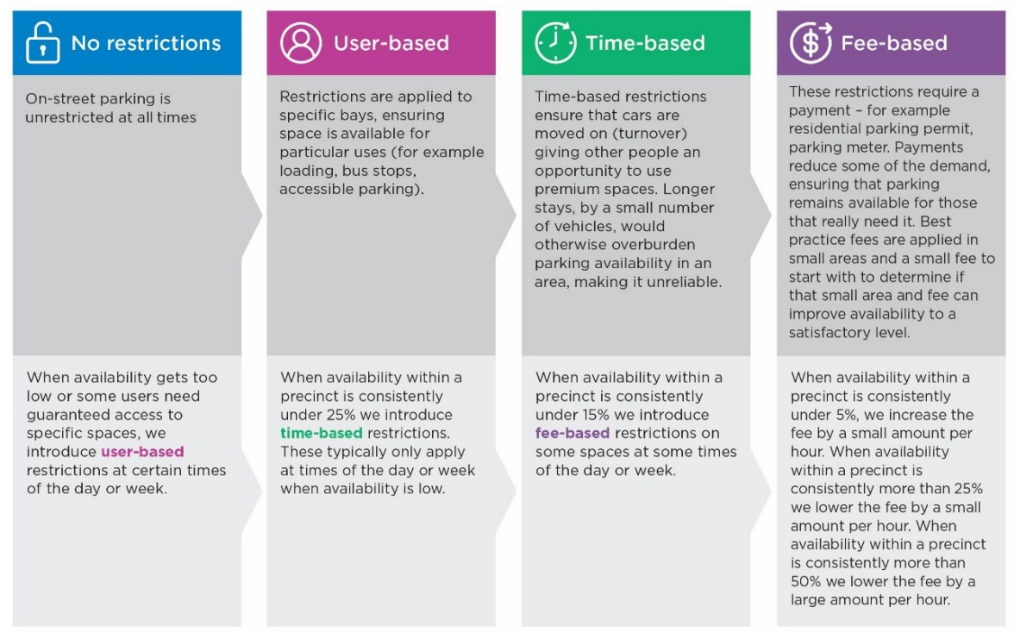
Text alternative for infographic: This infographic explains the parking control intervention thresholds (in order of intervention):
- No restrictions:
  - Where on-street parking is unrestricted at all times.
  - When availability gets too low or some users need guaranteed access to specific spaces, we introduce user-based restrictions at certain times of the day or week.
- User-based restrictions:
  - Where restrictions are applied to specific bays, ensuring space is available for particular uses (for example, loading, bus stops, accessible parking).
  - When availability within a precinct is consistently under 25% we introduce time-based restrictions. These typically only apply at times of the day or week when availability is low.
- Time-based restrictions:
  - Where time-based restrictions ensure that cars are moved on (turnover) giving other people an opportunity to use premium spaces. Longer stays, by a small number of vehicles, would otherwise overburden parking availability in an area, making it unreliable.
  - When availability within a precinct is consistently under 15% we introduce fee-based restrictions on some spaces at some times of the day or week.
- Fee-based restrictions:
  - These restrictions require a payment – for example, via a residential parking permit or a parking meter. Payments reduce some of the demand, ensuring that parking remains available for those that really need it. Best practice fees are applied in small areas and a small fee to start with, to determine if that small area and fee can improve availability to a satisfactory level.
  - When availability within a precinct is consistently under 5%, we increase the fee by a small amount per hour. When availability within a precinct is consistently more than 25% we lower the fee by a small amount per hour. When availability within a precinct is consistently more than 50% we lower the fee by a large amount per hour.

- The framework ensures that areas with high parking availability have fewer controls, while areas that have low availability will have controls applied to ensure there are spaces available.
- The application of controls is focused on ensuring the parking service is reliable for customers. For example, very short time-based restrictions can support high turnover of spaces, but may only be useful to a small number of people or trip types. This is an inefficient use of space. Time restrictions must provide adequate time to meet the needs particular to a precinct. In high demand areas, the combination of an adequate time based restriction and price based restriction is needed to achieve utility and turnover.
- Note that as restrictions are applied, they are applied to specific time periods at certain times of the week. Typically, most spaces remain unrestricted at times of low demand, such as overnight.

  - Converting car parking spaces to other uses
Our policy: We support the conversion of car parking spaces to be used for another function where there is a strategic need to do so. Car parking spaces could be used to facilitate important city infrastructure (such as street trees, footpath widenings, tram stops, dining areas and additional open space) or different types of vehicle parking (like motorcycles, scooters or bicycles) that are being moved to the kerbside to alleviate congestion on cluttered footpaths.
Details:
- As our city continues to grow and change, our streets will continue to evolve to meet community needs.
- Recognising that land use and demand in every area is constantly changing, we will regularly review and adjust our parking management settings, based on evidence and stakeholder consultation, to ensure that on-street parking in every precinct is managed to meet our policy objectives and optimise value to the community.
- Footpath congestion may also prompt us to review the use of nearby kerbside space and consider changes. For example, if we observe a section of footpath experiencing high demand for motorcycle parking and this location has become congested, we may proactively convert a car parking space to accommodate motorcycle parking. Any proposed changes would be based on an assessment of footpath widths, existing footpath furniture, pedestrian data, modal usage data and our observations.

  - Standardising street layouts
Our policy: We will use standard street typologies to guide how we lay out kerbside uses within a street, to create consistency and a more intuitive experience for drivers looking for a parking space.
Details:
- Essentially, this is an agreed standard layout of kerbside uses in any given street, which can be replicated in similar streets. It is most relevant in the CBD where there is a diverse mix of uses and high demand for space, however the principles can be applied in mixed use areas across the municipality too.
- Note that spaces for each type of kerbside use will not always be provided in every street, and this locational priority is used to provide a consistent, simple arrangement that customers can become familiar with.
- The following design rules will be the starting position for the layout of kerbside uses within a typical street in the CBD (or busy mixed-use area):
  - Pick up/drop off space – signed ‘No Parking – 2 minute limit’ – will be positioned immediately after an intersection for vehicles to briefly pull into to pick up or drop off passengers. This placement will also allow people with a disability easy access to a kerbside ramp when being picked up or dropped off.
  - Loading zones – positioned immediately in front of the pick up/drop off space allow for ease of access for delivery vehicles.
  - Accessible parking space for disability parking permit holders – positioned in the last space on the approach to an intersection or adjacent to a mid-block crossing point, to allow for the shortest travel distance to a kerbside ramp and signalised intersection – especially in locations where space constraints mean that accessibility standards cannot be fully met.
  - Car share parking space (when allocated in a street) – typically positioned immediately behind the accessible parking space or within close proximity to pedestrian network access points, such as near intersections or pedestrian laneways. Car share bays should be grouped together where possible.
  - Two-wheeled vehicles parking – will be positioned in the part of the street which encourages the highest level of use by two-wheeled vehicles as an alternative to parking on the footpaths.
  - The remaining car spaces – unallocated once higher order priorities from the hierarchy of kerbside use (Policy 6.1) have been met – will be allocated to short-stay general visitor car parking. There will not be any long-stay resident or employee parking provided in the CBD or in other high-demand activity areas outside the CBD.
  - Space available in the centre of the road between traffic lanes will typically be considered for other uses such as urban forest restoration, but can otherwise be a location for general parking and accessible parking for disability parking permit holders in the spaces nearest to intersections.

Infographic: Title ‘Typical standard street layout for the CBD or high-demand activity areas’
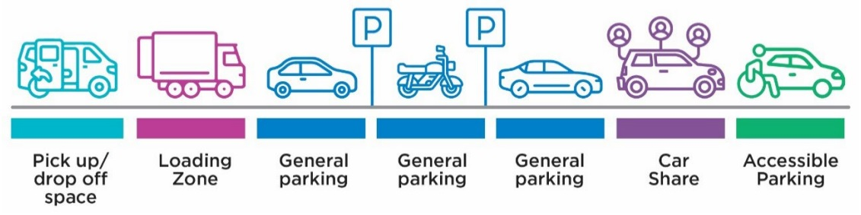
Text alternative for infographic: This infographic depicts a typical standard street layout for the CBD or mixed use areas, showing one pick up/drop off space, followed by one loading zone, followed by three general parking spaces, followed by one car share space, followed by one accessible parking space.

- While standard street typologies provide a clear rationale for the placement and mix of uses within a street, some exceptions will apply as a result of space constraints, land use and precinct-specific needs. Exceptions will include:
  - Pick up/drop off space for hotels and major city destinations – where deemed appropriate to be positioned within proximity to the land use it serves. It should provide enough space to accommodate tourist buses and commercial passenger vehicles, and be signed to enable flexibility.
  - Short term parking or pick up /drop off for specific land uses (for example, childcare) – where there is a need to provide for quick access, ‘No parking’ or short term parking can be provided within proximity of that land use.
  - Taxi zones – can be provided in a limited manner at key transport interchanges to support accessibility and convenient connections to sustainable transport and other high demand locations.
- This consistent approach will:
  - provide streets with a balanced mix of space which meets diverse stakeholder needs
  - ensure parking is located with regard to typical customer needs
  - create predictability for drivers looking for a specific type of space
  - use consistent time boundaries for restrictions that simplify messaging
  - simplify parking signage so that it is easier to understand
  - create efficiencies in the management of kerbside space.
- It is appropriate that decisions about the allocation and positioning of kerbside uses within a street are in the best interests of the broader precinct within which it sits. Individual requests to reallocate space are one input that will be considered, alongside all other data and evidence as per allocation principles in Policy 6.1 and Policy 6.5. When contrary views are expressed, robust data and evidence will hold the most weight.

  - Reviewing and revising parking controls
Our policy: A wide range of evidence – particularly data and land use information – will be used when prioritising and conducting Parking Precinct Reviews to ensure management decisions are well informed. We will set up a process that enables the public to easily highlight areas of low availability or where restrictions do not meet specific needs. Changes will be consistent with the principles outlined in this plan, informed by the data available and will always aim to meet our objectives and better utilise existing spaces in a fair way that meets customer needs.
Details:
- The following information will help us determine how often to review each precinct, and will be key considerations during the review:
  - Professional assessments of safety and parking reliability that highlight urgent needs
  - Community stakeholder inputs including photos, ideas and general feedback
  - City of Melbourne data including parking surveys, sensor and meter data, parking infringement data, parking officer observations and patrol data which indicate issues such as very high or low occupancy, levels of compliance or poor kerbside functionality within an area
  - Planned or known major changes in an area such as large-scale developments, infrastructure or strategic plans and masterplans that are being delivered.
- Following each revision, a three month ‘pulse check’ will seek to identify any teething issues or unintended outcomes and address them where possible.
- Each precinct will be assessed annually at a minimum, and more frequently if the data shows more rapid changes in demand (up or down) within specific precincts.
- Minor changes will be possible: Requests for ad hoc, smaller scale changes will always arise such as for temporary construction permits. We’ll consider these on a case-by-case basis, using the information and data available to us at the time. However, to ensure fairness and consistency for all precincts and their communities, we will generally hold non-urgent, minor and strategic improvements over until the next annual review period.

  - Engaging with the community about changes to kerbside space
Our policy: We will conduct ongoing stakeholder engagement in relation to parking and kerbside management. This will focus on:
- explaining the evidence for decisions before changes are made
- explaining new restrictions and raising awareness during each transition period
- taking feedback on board and responding to queries after changes are made and prior to the next review.
Details:
- Our stakeholder engagement will:
  - proactively engage stakeholders and keep them informed with timely updates
  - provide transparent data in a manner that is easily understood
  - provide a range of easily accessible methods of providing feedback and insight
  - communicate clearly, with transparent data in a manner that manages expectations
  - seek to include culturally and linguistically diverse communities and people with specific needs
  - be safe for children to attend and share their views
  - respond within a reasonable timeframe to concerns that are raised with clear steps about how the issue will be investigated.
- We consider stakeholders to be occupiers of residential properties, business operators, service providers and owners or managers of other land uses (for example, medical, education and aged care) or organisations located or invested in the area.
- We will also consider customers who might not otherwise be considered stakeholders, such as people with a disability visiting from anywhere else in Australia.
- It is rare for all stakeholders and the community to agree about how a specific space should be restricted. We will focus on managing parking in line with the objectives outlined in this plan, using the best information and data available to us at the time. We will always prepare a detailed rationale for our decision making.
- The following table outlines the level of engagement we commit to undertaking based on the type of change.

Table: Title ‘Level of engagement with community based on type of parking change’
Type of change | Level of consultation required prior to changes made
Major change  (for example, Parking Precinct Reviews) | We will consult with stakeholders via a combination of in-person, online and postal methods to seek initial input to feed into the review, advise of any proposed changes and provide an opportunity for feedback before changes are made. For example, this could include face-to-face meetings, surveys, mail outs and interviews.
Minor change – not urgent  (for example, an adjustment within a street following the implementation of a Parking Precinct Review) | We will consult with stakeholders via mail out to advise of any proposed changes and provide an opportunity for feedback before changes are made.
Minor change – urgent  (for example, an urgent change to resolve a safety concern) | None – particularly if we have a duty of care to respond to safety matters and responsibility under the Road Management Act and Road Safety Act.

  - Simplifying parking signage
Our policy: Parking signs should be as simple and as consistent as possible, so that controls can be easily communicated and understood. Signage should use the simplest form of control compliant with the Victorian Road Safety Road Rules. Controls should use consistent time periods and be the same for the majority of the week if possible while still providing a reliable service. The number of parking control panels on a single pole should be as few as possible – in most cases no more than two – to reduce complexity. Bespoke or custom signs will be avoided as they have lower customer recognition and require extra time and resources to install and maintain.
Details:
- Simpler, standard parking controls applied to a broader area will assist drivers in better understanding the parking restrictions and increasing compliance across the municipality. It should also reduce footpath clutter caused by poles and signs within each street.

Text box: Case Study – Simplified parking signage in Brisbane
In 2015, the Brisbane City Council implemented consistent, simplified parking controls and signage. Signage which graphically represented the parking controls helped customers interpret the rules.
The simple signs were found to reduce parking fines issued in some areas by up to 60 per cent and keep the city moving due to drivers being able to more quickly interpret the signage.

  - Using parking pricing to help manage demand
Our policy: Paid parking is an effective way to manage the demand for parking. The setting of fees for paid parking in an area will be determined by the demand for parking in the area and by time of day. Any changes made to parking prices and the way these are determined throughout the municipality must be transparent, based on up-to-date empirical evidence of parking demand patterns in each area and be communicated effectively to all customers.
Details:
- Paid parking is introduced or adjusted within an area based on the parking intervention thresholds as per Policy 6.2.
- We will set fees based on the principles of area and time demand for parking to ensure a reliable parking service and maintenance of parking availability.
- Parking pricing information – including changes to price – must be communicated effectively to customers. The information must be easy to access and up-to-date.
- A formal transition to demand-based pricing will occur in the future. A framework with clear parameters for how this model will operate in the City of Melbourne will be developed for future adoption by Council. It will be based on the following established, best practice model:
  - Demand-based pricing involves setting the price of parking at the lowest price that keeps a few spaces available within a defined area.
  - It requires setting an availability target and undertaking regular reviews of parking occupancy in an area and adjusting the fees to achieve that target.
  - Our goal is to maintain an average of 5-15 per cent availability as much as possible.
  - Decision making will be transparent and the data which has informed decisions will be made public.
Infographic: Title ‘How a demand-based pricing model works’
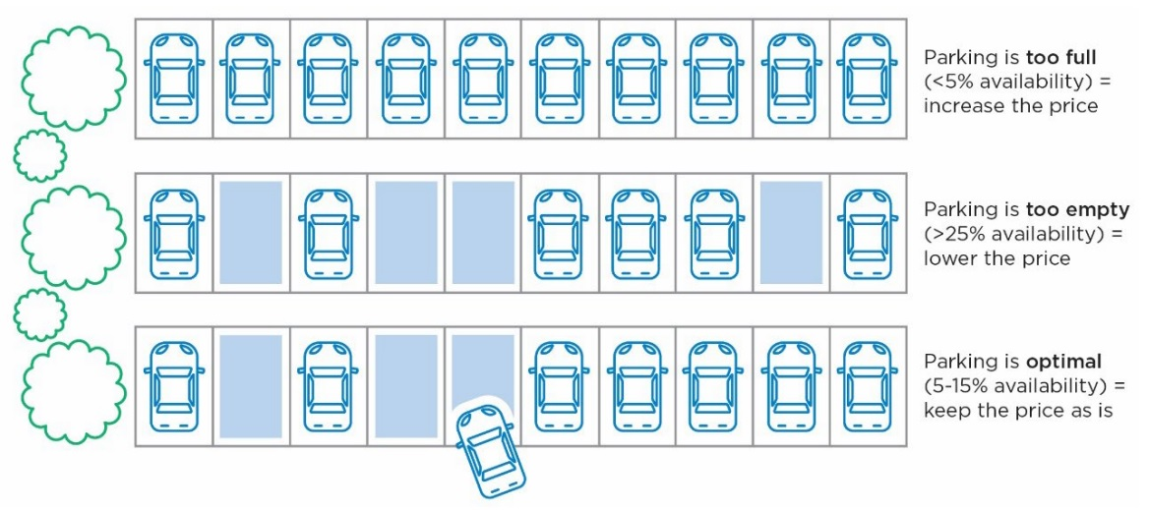
Text alternative for infographic: This infographic depicts:
- an area where parking bays are too full (<5% availability), therefore the price of parking would need to be increased here
- an area where parking bays are too empty (>25% availability), therefore the price of parking would need to be lowered here
- an area where parking is optimal (5-15% availability), therefore the price would remain as is.

Text box: Case Study: San Francisco demand-based pricing (SFpark)
From 2011 to 2013, the SFpark pilot demonstrated how demand-responsive pricing can increase parking availability. Instead of charging the same hourly rate all day, every day, prices per block were incrementally adjusted to achieve occupancy between 60 – 80 per cent during each pricing period. Rates were restricted to between US$0.25 and $6 per hour and updated monthly. Some time limits were increased or removed. Demand-based pricing has since been rolled out to all local government-managed paid parking in San Francisco.
The outcomes of the SFpark pilot were:
- Increased sales for local businesses. Sales tax revenue grew by more than 35 per cent in SFpark areas compared to less than 20 per cent in other areas
- Lower on-street parking prices. A 4 per cent decline was seen in pilot areas
- Decreased parking search time. A 43 per cent reduction was experienced in pilot areas
- Decreased vehicle kilometers travelled. Reduced cruising for parking led to a 30 per cent decrease in total kilometers travelled in SFpark areas
- Fewer parking fines issued. There was a 23 per cent reduction in SFpark areas (source: San Francisco Municipal Transport Agency, 2017).
Since the success of SFpark, many cities around the world have introduced demand-based pricing to better manage on-street parking, including: New York, Los Angeles, Seattle, Boston, Baltimore Washington DC, Vancouver, Calgary, Rotterdam, Madrid, Moscow and Auckland.

  - Using technology to enhance our parking service
We have been using technology to help us manage parking for many decades. As parking technology develops, there are opportunities to improve customer experience, management efficiency and gather data to that can improve wayfinding and decision making. The policies below will guide our use of technology and priorities into the future:
    - Parking meters
Our policy: ‘Smart meters’ should replace all ticket machines and older parking meters to improve customer payment options. Cashless meters should be used unless the number of payments by coin are very high.
Details:
- Smart meters, which allow drivers to pay via credit card and digital wallets, capture parking transactions digitally and provide important data about how our parking is being used.
- Smart meters are more efficient to operate and maintain. Being more compact, and applying to several bays at once, they reduce physical and visual clutter on our footpaths.
- All new parking meter technology must comply with accessibility standards. Newer meters are more accessible for all users, including people in a wheelchair.
- Ticket machines will be replaced by smart meters. This is because they require additional maintenance (for example to accommodate printer and paper rolls) and are less convenient for customers (requires an additional trip back to the vehicle).
- Cashless meters will become commonplace as fewer people are carrying coins to pay for parking. COVID-19 has accelerated the move towards a cashless society. In the City of Melbourne, coin payments make up only six per cent of all parking payments. Cashless meters do not require coin collection services, typically need less maintenance and are less prone to vandalism and faults - reducing the cost of the parking service to ratepayers and improving the reliability for customers
    - Pay-by-phone option
Our policy: Pay-by-phone (for example, payment via a parking app on a smart phone or mobile device) is our preferred payment option and will be expanded as appropriate.
Details:
- Pay-by-phone provides customers with maximum flexibility and convenience. It enables a parking session to be started, ended or extended remotely.
- As a payment system it is easier for all people to use, including those with a disability as it eliminates the need to travel to and operate a parking meter.
- Popularity of pay-by-phone has increased in recent years and now makes up more than half of all parking payment transactions. Global trends are showing a reduction in the need for physical parking meters in streets due to the growth in use of pay-by-phone.
- Pay-by-phone apps can provide on-street parking availability and support informing or guiding customers to off-street parking when appropriate.
- We will investigate providing competition and choice for customers through authorising multiple pay-by-phone service providers and trialling pay-by-phone only in appropriate areas.
- We will continue to monitor technology developments such as automated in-vehicle payments.
    - Pay-by-plate (vehicle registration number) option
Our policy: Pay-by-plate is another a payment option worth investigating due to benefits such as improved customer experience and operational efficiencies.
Details:
- This could be useful in specific areas, or for specific user groups such as residential permit parking.
- It reduces the potential for errors entering bay ID numbers, simplifies parking road markings, and offers a range of customer experience enhancements.
- Pay-by-plate aligns with the City of Melbourne’s Digital Permits project and creates efficiencies for parking management.
- It is not fit for every purpose, and will be considered in appropriate locations.
    - Parking sensors
Our policy: Sensors are an important tool and should continue to be used in as many parking spaces as possible to collect data and inform decision making on a permanent or temporary basis as appropriate.
Details:
- Parking sensors are an important tool to support enforcement of parking time controls and encourage turnover of spaces. We have had parking sensors installed in high use spaces across the city for a decade, and currently have approximately 5,500 sensors installed.
- They are a critical source of data, helping us to quickly and easily view parking availability in an area and identify service reliability issues. Sensors in loading zones will improve our understanding of usage patterns and can be used to improve customer information and turnover.
- As technology improves, we will explore the potential to book on-street space to further improve parking reliability.
- It is not currently cost effective or necessary to install sensors in every parking space. Sensors will be placed in locations where they provide the most valuable data and best support an improved customer experience.
    - Camera technology including License Plate Recognition (LPR)
Our policy: LPR is a valuable tool that is used to increase compliance with parking restrictions.
Details:
- Mobile and stationary LPR technology is used to support enforcement activities such as safety around school zones, compliance with parking controls across large neighbourhood areas, to monitor activity in key locations, or address specific compliance problems (such as stopping or parking in bicycle lanes).
- As digital permits are phased in, LPR will be used to confirm vehicles have digital permits.
    - Digital signage
Our policy: We will continue to pilot and adopt various digital signage and customer communication methods taking into account customer benefits, wider community benefits (such as reduced traffic congestion) and installation and maintenance costs.
Details:
- Digital signage can improve customer experience through simplified communication of restrictions and supplementary information such as countdown timers on loading zones.
- It could better communicate temporary parking changes that are made to facilitate activities such as events and bookable bays.
- The technology can provide operational efficiencies and reduce the cost to ratepayers over the life of the sign.
- They may however, have a more significant environmental impact than the alternatives. We will therefore take a whole life-cycle approach to understanding the benefits and costs of digital signage.
- Digital signage is being trialled in cities across Australia and is legally enforceable provided it presents a reasonable likeness to the standard regulatory signage.
    - Parking information
Our policy: Technology can help us improve how we share information about parking to our customers and users of our kerbside space.
Details:
- We have led the adoption of open data systems that enable onstreet parking information to be shared via third-party apps.
- Improved communication of parking information via web or app-based platforms, can provide real time information about parking availability, pricing, location of specific parking spaces (such as motorcycle parking) and temporary changes to local parking conditions.
- Better information supports decision making and gives all customers better choice of how they travel and where they park.
- With improved parking data, we can provide people with a disability with better information to support their travel decision making. This includes up-to-date, mapbased information about location and type of accessible parking bays, restrictions, street gradients, and location of pick up/drop off spaces, taxi ranks and off-street accessible parking options. We will investigate providing real time information (from parking sensors) about accessible parking bay availability.
- Use of technology to support the sharing of customer information will not exclude people without access to technology or who prefer to engage in traditional channels.

    - Technology partners
Our policy: Forming strategic partnerships with key stakeholders (such as the Victorian Government, universities and the private sector) will enable us to trial new and emerging parking and kerbside management technology.
Details:
- We can achieve our strategic goals by preferencing trials and investment in technology solutions which address our kerbside management challenges (including those listed at section 4.3 of this Plan), or which support more efficient management of kerbside space. For example, we could trial using pay-by-phone as the only payment option in an area to reduce the number of meters.
- Focusing on strategic partners we can help to solve their pressing needs, while piloting new ways of managing parking and new technology tools.
- Identifying customers willing to participate in “beta-testing” will form part of our approach to understanding how technology can improve customer experiences.

  - Developing a Strategic Parking Permit Policy
Our policy: Our Strategic Parking Permit Policy will be developed using a consistent set of principles and a wide range of data and information. Existing Parking Permit Policies will be reviewed with the aim to better utilise existing space in an equitable manner that considers the needs of all potential users.
Details:
- A parking permit (typically daily, weekly or yearly) provides an exception from a parking restriction enabling the permit holder to use a wider range of spaces. Common permit types are used for construction, residents, film crews and people with a disability.
- Permits are used to make general restrictions simple, while ensuring people with a genuine need to access parking can do so.
- The overarching Parking Permit Policy will be guided by the following principles:
  - Parking permits should be limited to the highest priority users that have needs which may not be catered for by general parking restrictions
  - All permits should be priced equitably to manage demand and reflect the value provided by the parking spaces
  - The supply of parking spaces in an area should be a key consideration when setting or reviewing permit policies to ensure the availability needs of all users is balanced
  - The process of assessing permit applications and their impact within an area and enforcing permit conditions must be clearly defined and consistent to ensure the successful and fair application of the permit scheme.
  - Permits will be specific to a vehicle registration and will always include a specific expiry date. In future, digital permits should enable multiple vehicles to be attached to a single permit, provided that only one vehicle is parked within the permit area at a time
  - Permit costs are not covered by other Council rates or charges
  - Ratepayers that do not own a car, or that park in off-street locations are subsidising the maintenance of on-street car parking in residential locations that is used under the residential parking permit scheme
  - Parking permit policy should be designed to support growth in car share use and other sustainable transport modes.
- We will amend or phase out permits that do not align with these key principles.
- A transition to digital permits is underway. This will provide customers with a streamlined approach to applying, paying for and renewing permits. It will mean physical permits and vouchers will be phased out and replaced with digital permits, which will be integrated into the parking enforcement system.

  - Refreshing our parking enforcement approach
Our policy: Our parking enforcement approach will be customer-focused and prioritise voluntary compliance. It will focus on ensuring the safe and efficient use of our streets for all road users and ensure equitable and reliable access to our kerbside space can be achieved. Revenue from enforcement activities will cover operational costs and surplus revenue will be used to improve customer awareness, the overall parking experience and parking options (including through improving pedestrian connections to parking locations or improving awareness of off-street parking options).
Details:
- We aim to maximise voluntary compliance by having parking restrictions which are equitable, simple, easy to understand, transparent and accepted by the community.
- When we need to enforce the restrictions, we will do so with the aim of achieving behaviour change and a reasonable level of compliance.
- If appropriate we will issue warnings. We will develop an internal policy to guide the circumstances under which warnings are appropriate.
- Our enforcement patrols will prioritise safety related issues (such as vehicles parking in No Stopping areas, obstructing access to crossings, driveways or laneways or unauthorised parking in accessible parking bays) and parking that obstructs the smooth operation of city streets (such as unauthorised parking in a loading zone or double parking).
- Our parking enforcement officers provide valuable insights into how the city’s streets are functioning. Officer insights will be captured formally and be an input into decisions about future parking restrictions. Officer assessments and increased complaints may indicate the need to increase enforcement in an area or make adjustments to parking controls.
- We do not view infringement numbers as a measure of success, but rather an indicator that we may not have provided adequate parking management and controls, information or understanding of the restrictions. This does not relieve the driver or responsibility to park properly or pay a fine. However, each infringement provides an opportunity for us to consider if the existing restrictions and communication processes are working for customers.
- An increase in infringements tends to indicate an issue with the parking settings, which prompts us to review restrictions in areas with high levels of infringements per officer patrol.

  - Prioritising access for shared and commercial transport
The below outlines our policy positions on some key shared and commercial transport modes and the important role they play in keeping our busy city functioning:
    - Public transport
Our policy: Public transport is critical to ensuring access to and around the municipality for a wide range of people including people with a disability. Public transport stops have a very high priority for kerbside space due to the range of users, equity considerations and volume of users that public transport attracts.
Details:
- Public transport stops need to be in locations that are appropriate for both customers and operators to ensure the street can be used safely.
- In some locations it will be appropriate to have a kerb outstand (into the existing parking bays) and then allow public transport (buses or trams) to stop or park at the new kerb.
- Public transport kerbside access is a priority. However it is generally desirable to locate termini outside the central city, as per our Transport Strategy 2030. We will work with the Victorian Government to minimise terminus space and consolidate or relocate stops and routes where appropriate through network planning.
    - Delivery vehicles
Our policy: It is important that an adequate number of loading zones are available for delivery vehicles at key locations and times of day. We will monitor the demand for loading zones (like all other parking needs) and will manage supply and demand to ensure availability is maintained.
Details:
- Loading zones are critical to the city’s businesses, residents and visitors, as they enable delivery vehicles to efficiently transfer goods into and out of the city.
- People making deliveries need adequate time to complete their work. Loading zones with a 30 minute time restriction are preferred in the CBD as they offer the best balance between providing adequate time for delivery while ensuring turnover so that others can use the space.
- Once a delivery driver arrives at a loading zone, we prefer that they are able to make multiple deliveries from that space, rather than be required to leave and find another space nearby.
- Loading zone supply and allocation will be informed by data. This includes sensor data on length of use and turnover of space, land use data to determine intensity of freight generated by street or precinct, business and logistics industry data, enforcement data and other surveys to understand use and delivery patterns. Review of loading zone supply and controls will occur as part of the regular Precinct Parking Reviews.
- We will continue to work with the Victorian Government and private sector to explore opportunities for a freight consolidation centre for Melbourne with the aim of reducing the number of delivery vehicles entering the CBD each day.
- We will deliver clearer communications to the logistics industry so that delivery drivers know where to find these spaces. Given that other vehicles (such as licenced taxis and buses) can legally use loading zones, we will work to ensure their needs are met either in alternative designated areas or through additional loading zones.
- With demand for loading zones the highest in the morning, we will adjust controls on some of these spaces to enable general parking later in the day to reflect the drop in demand.
- Opportunities to encourage the uptake of cargo bikes for deliveries through the allocation of on-street space will be investigated.
- We will also investigate opportunities for technology (for example, booking systems for loading zones and real time availability and prediction information) and pricing at specific times or in areas of high demand to help us improve availability and turnover of loading zones.
    - Commercial Passenger Vehicles
Our policy: Commercial Passenger Vehicles (CPVs) provide an important transport service for customers travelling to from and within the city. Adequate space must be available in specific locations for quick access and turnover, while ensuring premium kerbside space is used efficiently.
Details:
- CPVs (which include taxis and app-based rideshare providers like Uber, Shebah and Didi) require kerbside space to pick up and drop off passengers, and we provide more than 200 ‘No Parking’ spaces across the city for this purpose. ‘No Parking’ signs allow any vehicle to use the space for two minutes (unless otherwise signed) and the driver must remain within three meters of the vehicle.
- This Victorian Road Rule may not be commonly understood by drivers or the general public, and ‘No Parking’ signs may even appear to be counterintuitive. We will investigate options for supplementary signage and improved communications to ensure drivers who are picking up or dropping off passengers preference using ‘No Parking’ spaces.
- Licenced taxis are also legally able to use loading zones, however our preference is that CPVs use the provided ‘No Parking’ spaces to free up loading zones which are already in high demand for goods delivery.
- Although taxi zone usage across the city has varied since app-based providers have entered the market and following COVID-19, taxis fill an important gap in the transport network by providing accessible transport for people with a disability and convenient connections at transport interchanges.
- We will continue to work with the sector to find the balance between customers having convenient access to CPVs in the city versus an oversupply of vehicles waiting for a job, adding to congestion on streets and in kerbside space.
    - Car share services
Our policy: We will allocate space for car share vehicles. This will be based on data within each precinct, including demographics, land use, car ownership levels, population density, current availability of car share vehicles in an area and their level of use. Where existing car share vehicles are being used more than six hours per day, this is an indication that demand for car share in this location is high and additional space for car share may be provided. We will proactively plan the car share network and offer spaces to service providers through an open market process.
Details:
- Car share services have been operating in the municipality since the late 1990s. They offer an important service, providing short-term access to a vehicle for a fee. In a busy inner city context, car share offers residents and businesses a cheap and convenient alternative to owning a car (which would sit unused for much of the time). Research has shown that each car share vehicle can remove up to nine private vehicles from parking on our city streets. This means allocating kerbside space for car share vehicles creates more parking spaces for those who need them.
- Car share service providers are charged a fee for exclusive use of the allocated kerbside space and to cover the cost of managing the service.
- Our policy for car share is being updated as part of a separate Low-emissions Vehicles Plan
    - Commercial coaches
Our policy: We will continue to provide kerbside space across the city to facilitate the pick-up and drop-off of commercial bus passengers. Space for bus and coach layover will not be accommodated in areas with high-demand for on-street parking in the municipality.
Details:
- Tourist and charter buses operate across the city and provide benefits to our city’s businesses and visitors.
- To ensure the utilisation of our municipality’s limited kerbside space is optimised, we will typically provide ‘No Parking, Buses Excepted’ signed spaces in key locations across the city to accommodate bus pick up/drop off functions. This is due to charter and tourist buses being less frequent or regular users of space and therefore allocating full-time dedicated Bus Zone spaces in high demand areas would not be an efficient use of space.
- Outside the hours of typical bus use, these spaces may be converted to general parking to maximise their use.
- Space for bus and coach layover will be accommodated outside of the CBD and other high-demand areas and communicated with the industry.

  - Managing two-wheeled vehicle parking
Our policy: On-street parking for two-wheeled vehicles – such as motorcycles, motor scooters, bicycles including multi-wheeled cargo bikes for deliveries and various forms of micro-mobility – will be provided to reduce demand for parking such vehicles on the footpath. In general, this parking policy is intended to only apply to on-street kerbside space, however in some specific circumstances (by exception) it could be applied to parking spaces that are on the footpath.
Details:
- When demand for footpath parking becomes too high, it creates safety issues, pedestrian congestion, accessibility issues, reduced amenity and negative impacts on the city’s economy.
- We will proactively plan for and allocate kerbside space to accommodate the expected growth in micromobility. In particular, for shared schemes such as e-scooter and e-bikes which can be supported by user in-app guidance to allocated parking areas
- Regular surveys of footpath parking will identify when there is a need to reduce footpath congestion in an area. This can typically be achieved by moving some footpath obstructions to the kerbside or by widening the footpath.
- When it is determined that on-street space is required for two-wheeled vehicle parking, the hierarchy of use, intervention thresholds and policies in this plan will be applied to manage availability and ensure reliability of the parking service.

  - Managing parking in parks and gardens
Our policy: Parking within parks and gardens should be minimised, providing only essential access for users of that park or garden.
Details:
- From time to time, master planning of a park may determine that it is appropriate to convert an amount of car parking space within a park or garden to a higher and better park use, to better derive a net benefit to the park and its users. In these instances, a review of parking supply within the broader precinct is appropriate.
- On-street parking located on the perimeter or within the immediate surrounds of a park or garden must be managed to prioritise access for park users as a priority (and neighbouring properties, where applicable). This means setting controls that accommodate the average length of stay for park use and allow for adequate turnover so as many people can utilise the parking as possible.
- Parking controls should deter long-term commuter parking in locations where demand for access to a park or garden is high during weekdays.

7. References
- Analysis of Transport Space - GIS Mapping Study, City of Melbourne 2017
- Better parking for better places, Committee for Sydney 2022
- Census of Land Use and Employment, City of Melbourne, 2022
- City of Melbourne Independent Transport Review, Deloitte 2021
- Lee, A & March, A ‘Recognising the economic role of bikes: Sharing parking in Lygon Street, Carlton in Australian Planner, Volume 47, 2010 - Issue 2
- Melbourne Parking Survey, Redbridge Group 2022
- Parking and Kerbside Management Plan Stakeholder Engagement Report, Movement & Place Consulting, 2022
- Reclaim the kerb: The future of parking and kerbside management in London, Centre for London 2020.
- Review of the relevance of parking to the success of urban centres, London Councils 2012
- Jose, B 2017, ‘San Francisco adopts demand-responsive pricing program to make parking easier’ San Francisco Municipal Transport Agency website, accessed on 6 February 2023: www.sfmta.com
- Transport Strategy 2030, City of Melbourne 2019
- Transport Strategy Refresh Background Paper: Car Parking, RMIT 2018
- Transport Strategy Refresh Background Paper: City Space, UB-Lab 2018
- Valuing on-street parking space, Movement & Place Consulting 2021
- Victorian Integrated Survey of Travel and Activity, Victorian Government 2018

How to contact us
Online:
www.melbourne.vic.gov.au
In person:
Melbourne Town Hall – Administration Building
120 Swanston Street, Melbourne
Business hours, Monday to Friday (Public holidays excluded)
Telephone:
03 9658 9658
Business hours, Monday to Friday (Public holidays excluded)
Fax:
03 9654 4854
In writing:
City of Melbourne
GPO Box 1603
Melbourne VIC 3001
Australia
Interpreter services:
We cater for people of all backgrounds. Please call 03 9280 0726.
National Relay Service:
If you are deaf, hearing impaired or speech-impaired, call us via the National Relay Service: Teletypewriter (TTY) users phone 1300 555 727 then ask for 03 9658 9658
9am to 5pm, Monday to Friday (Public holidays excluded).

