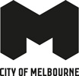
The Greenline Project
Draft Master Plan
August 2023
‘The Birrarung is a river of mists and shadows – the river and its environs are a living, breathing entity that follows Wurundjeri songlines and forms a central part of the Dreaming of the Wurundjeri.’
Nhanbu narrun ba ngargunin twarn Birrarung – Ancient spirit and lore of the Yarra, Wurundjeri input into Yarra Strategic Plan.

Acknowledgement of Traditional Owners
The City of Melbourne respectfully acknowledges the Traditional Owners of the land, the Wurundjeri Woi-wurrung and Bunurong Boon Wurrung peoples of the Eastern Kulin and pays respect to their Elders past, present and emerging.
We acknowledge and honour the unbroken spiritual, cultural and political connection the Wurundjeri, Bunurong, Dja Dja Wurrung, Taungurung and Wadawurrung peoples of the greater Kulin have to this unique place for more than 2000 generations.
We are committed to our reconciliation journey, because, at its heart, reconciliation is about strengthening relationships between Aboriginal and non-Aboriginal peoples, for the benefit of all Victorians.
The City of Melbourne acknowledges that the Greenline Project area along the north bank of the Birrarung is located on the lands and waterways of the Wurundjeri Woi-wurrung people.
Contents
Acknowledgement of Traditional Owners 2
Foreword from Wurundjeri Woi-wurrung 7
Foreword from the Lord Mayor 7
Executive Summary 9
Introduction 9
Introduction 9
Vision 9
The Greenline Project Opportunity Statement 10
Document purpose 11
Strategic context and documents 11
Master plan structure 12
Community and stakeholder engagement summary 13
Engagement approach 13
Engagement Outcomes 13
The case for investment and value creation 15
Business case 15
Project Budget 16
Benefit - Cost Ratio (BCR) 16
Master Plan goals 16
Triple bottom line and Traditional Owner Engagement 16
Sustainable Development Goals 17
The Greenline Project as an urban green space connector 18
The Greenline Project as a cultural connector 19
Site description and project extents 20
Existing site conditions 21
Birrarung Marr precinct 21
The Falls precinct 23
River Park precinct 24
Maritime precinct 25
Salt Water Wharf precinct 26
Key site values and planning framework 27
Land management and status 28
Health and wellbeing of Country 29
Engagement with Wurundjeri Woi-wurrung 29
Health and wellbeing of Country framework 32
Indigenous ecosystems return 33
Healthier waterways 34
Connection to Country and culture 34
Self-determined 34
Take responsibility 34
Master plan overview 35
Master Plan Vision – the woven line 35
The woven line – big spatial moves 36
Ecology 37
Culture 38
Place 39
Connection 39
Illustrative master plan 40
Spatial master plan 40
Spatial master plan – design elements 41
Ecology – river as a living entity 41
Culture – authentic stories and experiences 41
Place – Melbourne’s unique character and place 42
Connection – a connected vibrant waterfront 42
Precincts 42
Birrarung Marr precinct 43
Master Plan actions 44
Birrarung Marr Precinct Spatial Master Plan 46
Birrarung Marr Precinct Illustrative Master Plan 46
Birrarung Marr Precinct – Site 1 (Greenline Promenade) 47
Birrarung Marr Precinct – Site 1 (Fig Tree Boardwalk) 48
Birrarung Marr Precinct – Federation Wharf 49
Birrarung Marr Precinct – Flinders Walk 50
The Falls precinct 51
Master Plan actions 52
The Falls Precinct Spatial Master Plan 54
The Falls Precinct Illustrative Master Plan 54
The Falls Precinct – Sandridge Bridge 55
The Falls Precinct – Banana Alley vaults 56
The Falls Precinct – Customs Square and Enterprize Park 57
The Falls Precinct – the Turning Basin and Enterprize Park 58
River Park precinct 59
Master Plan actions 59
River Park Precinct Spatial Master Plan 61
River Park Precinct Illustrative Master Plan 62
River Park Precinct – Batman Park 62
Maritime precinct 63
Master Plan actions 64
Maritime Precinct Spatial Master Plan 65
Maritime Precinct Illustrative Master Plan 66
Maritime Precinct – World Trade Centre and Crowne Plaza 67
Maritime Precinct – Seafarers Rest frontage 67
Salt Water Wharf Precinct 68
Master Plan actions 69
Salt Water Wharf Precinct Spatial Master Plan 70
Salt Water Wharf Precinct Illustrative Master Plan 71
Salt Water Wharf Precinct – Collins Street river frontage 72
Salt Water Wharf Precinct – North Wharf Road River Frontage 72
Salt Water Wharf Precinct – Collins Wharf Park 73
Woven Line threads 74
Planting and ecology 75
Integrated water management and flood mitigation 76
Resilience and climate change 77
Wurundjeri Woi-wurrung culture and identity 78
Melbourne’s history 79
Creative strategy 79
Wayfinding and interpretation 80
Open space and park network 81
Events and programming 82
Lighting 82
Built form 83
Safety and inclusion 84
Safety and inclusion – main user groups to consider 85
Women 85
Families with Young Children 85
Young people 85
Older people and people with a disability 85
Digital strategy 86
Digital twin opportunities for the Greenline Project 86
Economic Activity and Value Creation 90
A generous promenade 91
Pedestrian links and active transport 91
Water-based uses 93
Sustainability 93
Furniture and materials 95
Community consultation 96
Maintenance and land management 96
Master plan implementation 96
Next steps and stakeholder engagement 96
Next steps 96
Stakeholder engagement 97
Phasing 97
Appendices 97
Appendix A – Birrarung Marr Precinct Site 1 97
Endorsed concept plan 98
Endorsed concept design 99
Appendix B – Gehl Report 99
The Greenline Project health check and design recommendations 99
The Greenline Project health check and design recommendations - desktop research and amenities tool 101
The Greenline Project health check and design recommendations - waterfront access and movement 102
Design recommendations - design for the Greenline Project’s diverse user profiles and social dynamics (people) 103
Design recommendations - consolidate and integrate the Greenline Project’s into its wider public space network 104
Design recommendations - encourage active mobility both on and by the river (mobility) 105
Design recommendations - provide sprinklings of everyday activities across the Greenline Project (the journey) 106
Design recommendations - encourage active mobility both on and by the river (mobility) 107
Design recommendations - provide sprinklings of everyday activities across the Greenline Project (the journey) 108
Appendix C – Supporting documents and reports 112
Reports 112

Foreword from Wurundjeri Woi-wurrung
Wurundjeri Woi-wurrung and Aboriginal embodiment into Melbourne’s Greenline Project.
Historically, our people’s rights to the management of waterways, have been excluded from legislation, planning, management policies and programs.
Nhanbu narrun ba ngargunin twarn Birrarung (Ancient Spirit and Lore of Yarra) outlines our aspiration for the Birrarung and this policy sets out our future plans for the social, cultural, economic, and environmental and heritage outcomes for the Birrarung. It is an evolving policy and process.
With our recognition in the Wilip gin Birrarung murron (Yarra River Protection) Act 2017 our people also gained a legislative mechanism and a formal process through which to engage with responsible public entities, work collaboratively and oversee the governance of the Birrarung and its lands as one living entity.
Our inclusion in the Act was highly significant because for the first time a legislative mechanism included a placed-based approach to the management of a waterway – pairing right Country with the right people – our people. Our future work regarding waterway and land management on our Country will also be founded on bespoke placed based legislation which articulates our role.
Within the context of this significant governance reform, the Yarra Collaboration Committee, through the implementation of the Yarra Strategic Plan has committed to embedding our continued inclusion in formal, resourced, and self-determined partnerships for culturally appropriate management of the Birrarung and its lands.
Through supporting our aspirations for water justice, the granting of unencumbered water rights and embedding our active participation in management of the Birrarung and its lands, we believe that the Yarra Strategic Plan will deliver the necessary changed need to realise boarder reforms (Burndap Birrarung Burndap Umarkoo, Yarra Strategic Plan 2022).
The Greenline Project is an extension of this plan and an exciting opportunity for engagement of this sort. We look forward to working with our partners to see the Greenline Project fulfil the Yarra Strategic Plan, bring to life a continued shared commitment to enhancing the Birrarung.
Wurundjeri Woi-wurrung Community

Foreword from the Lord Mayor
The Yarra River - Birrarung is the greatest culturally and environmentally significant landmark in Melbourne.
To the Wurundjeri Woi-wurrung people it has always been a place of spiritual and cultural importance, a life source and meeting place. Today, the Yarra River - Birrarung and its surrounds continue to be a place for all people. It is integral to Melbourne’s sustainability, prosperity and liveability.
We have an opportunity to transform the north bank of the Yarra River - Birrarung. Reconnecting the land and water through the heart of our city will bring significant environmental, social and economic benefits.
The Greenline Project will create a 4-kilometre promenade of connected parks, open spaces, cultural activations and environmental renewal between Birrarung Marr and the Bolte Bridge. It will unlock a world-class river precinct, which will attract more visitors and investment to our city.
The Greenline Project Master Plan will guide our work as we deliver one of the biggest city-shaping projects in Melbourne’s history. This master plan has been developed together with a design consortium led by landscape architects ASPECT x TCL. It builds on the work of our Greenline Implementation Plan, released in December 2021. It has been informed and refined through extensive community and stakeholder engagement, including with the Traditional Owners of the land, the Wurundjeri Woi-wurrung people. Aboriginal connection to Country is central to our master plan, while the themes of ecology, culture, place and connection are strong drivers of the design.
Conceptually, the Greenline Project is a ‘Woven Line’ in the form of a continuous walkable riverside journey, an enriched ecological corridor and a sequence of riverside destinations that are inclusive, safe and accessible.
Our master plan outlines concepts for five interconnected precincts that make up the Greenline Project – Birrarung Marr, The Falls, River Park, Maritime and Salt Water Wharf – each named to reflect its cultural and historical significance. The precincts will be delivered in stages, with each presented to the public for consultation before we commence work.
A city-shaping project of this undertaking requires collaboration and investment from many stakeholders. We look forward to working with them to deliver this truly transformational project for our city.
Lord Mayor
Sally Capp

Executive Summary
The Greenline Project aims to reposition the Yarra River - Birrarung as the focal point of Melbourne’s culture, economy and liveability.
Through the Greenline Project, we will revitalise the river’s north bank, transforming it into an inspiring and rejuvenated public waterfront. A 4-kilometre pathway will connect vibrant riverside destinations, stretching from Birrarung Marr to the Bolte Bridge in Docklands. It will integrate Aboriginal culture and engagement at every stage of the design and delivery process.
The Greenline Project will present contemporary Melbourne culture and celebrate the history of the area. It will include efforts to restore the river and its surrounding environment as an ecological corridor.
The Yarra River - Birrarung holds immense spiritual, cultural and historical significance for the Wurundjeri Woi-wurrung. It has played a central role in the city’s evolution, serving as a maritime port, a focus of metropolitan rail networks and, recently, a hub for arts and leisure.
Currently, the north bank suffers from limited pedestrian and cyclist navigation, with narrow and poorly connected paths, steep slopes, uneven pavements and inadequate amenities. It lacks cultural diversity, ecological value and sustained social and civic engagement. However, we have an opportunity to reconnect disparate spaces through a clear navigable pathway, allowing for underutilised spaces to become new hubs of activity, culture and commerce.
The Greenline Project expresses and celebrates the layers of history in our city, creating compelling journeys and enhancing opportunities to connect with the water. The project seeks to benefit residents and visitors by establishing connected spaces that embrace the river, prioritise safety and inclusion, provide opportunities for public activities and improve health and wellbeing. It will address environmental and climate-related challenges, focusing on improving river health, increasing tree canopy and reintroducing riparian vegetation to support biodiversity and environmental education.
This master plan develops the Greenline Project as a series of interconnected spaces along the north bank of the Yarra River - Birrarung. We introduce the idea of a ‘woven line’ to guide the big-picture changes and themes that establish the ecological, cultural, connectivity and place-based aspirations of the project. We then detail the vision and design actions across five precincts. We elaborate on the implementation plan’s objectives through a series of Woven Line threads – project-wide strategies that provide an additional dimension of detail about what will continue to be explored in later stages of the project.
An extensive six week stakeholder and community engagement program was held during April – May 2023 with input received from 756 participants across a range of activities. Feedback from the engagement program has been organised into the four project themes, ecology, culture, place and connection. This feedback has been incorporated into this master plan and will be used to develop and refine future precinct plans and concept designs in collaboration with stakeholders and the community.
Finally, we provide supporting information as appendices, including the Birrarung Marr Precinct Site 1 endorsed plans and an urban design recommendations summary report.Introduction

Introduction

Introduction

Vision
The Greenline Project will transform the river’s north bank into a reinvigorated and inspiring public waterfront. A 4-kilometre pathway will connect diverse, vibrant riverside destinations.
It will celebrate Aboriginal and contemporary cultures and the history of the area. The river and its surrounding environment will be re-established as an ecological corridor.
Today, the north bank has narrow and poorly connected paths, steep slopes, uneven pavements and poor amenity – all of which limit walking and cycling. It offers little diversity of cultural expression, limited ecological value and few opportunities for social and civic engagement.
Yet this is a place of spiritual, cultural and historical significance. It continues to be Wurundjeri Woi-wurrung Country, as it was long before Melbourne existed. This place has also played a central role in Melbourne’s evolution: as a maritime port, the focus of metropolitan rail networks and, more recently, as an elite arts and leisure precinct.
The Greenline Project will express and celebrate these layers of history along the north bank, creating compelling journeys and opportunities to connect with the water. All Melbourne residents and visitors will benefit from connected spaces. These spaces will embrace the river, prioritise safety and inclusion and provide opportunities for public activities that improve health and wellbeing. The Greenline Project will also address environmental and climate-related challenges. It will focus on improving river health, increasing tree canopy and reintroducing riparian vegetation to support biodiversity and environmental education.

The Greenline Project Opportunity Statement
The original opportunity statement was prepared in 2021. It was workshopped and updated as follows during the engagement process from April to May 2023.
‘The Greenline Project presents a significant and timely opportunity to revitalise the north bank of the Yarra River - Birrarung, creating a captivating landmark and destination that reflects the unique identity of Melbourne as a liveable city with a rich cultural heritage and a deep connection to the natural environment. A primary objective is the seamless integration of the riverfront to the water itself, and connection to the city. The Greenline Project will enhance accessibility to the river and encourage movement along the corridor, prioritising walking and recreational cycling and connections to public transport.
The Greenline Project will be distinctly Melbourne, representing its rich Aboriginal and maritime history. It will honour Aboriginal heritage and the layered histories and cultural values of the place. Focal points along the north bank and activities on the water will celebrate the Yarra River - Birrarung’s distinctive role in the city, providing valuable opportunities for the public to learn about and experience the culture and history of the site.
Importantly, the ecology of the river and its surrounds will be carefully considered and will inform how the Greenline Project is designed and evolves. This aligns with the Victorian Government’s Yarra Strategic Plan (Burndap Birrarung burndap umarkoo) 2022–32. An integrated water management approach with environmentally sustainable design enhances the climate resilience of the site, encouraging connection with water, increasing urban biodiversity and improving the health of the river.
The Greenline Project aims to create an inclusive space for all users, offering a wide range of experiences, activities and opportunities. It will be designed to ensure all feel welcome and safe. Public spaces are to be accessible and connect linking surrounding sites, particularly other significant landmarks and key areas of interest along both the north and south banks. This is intended to create stronger linkages between sites along the Greenline Project and strengthen a sense of belonging for both the residents and the visitors to the city.
The Greenline Project is to be portrayed as an attractive destination and landmark of Melbourne. The Greenline Project will play an important role as Melbourne recovers from the COVID-19 pandemic, supporting enhanced tourism and the city’s visitor economy. The project will bring new energy to the city and attract both local and international visitors to the river and nearby businesses, revitalising the Melbourne CBD.
Over time, the Greenline Project will evolve to meet the changing needs of Melbourne’s growing population, cooling the city and providing valuable open space. This will contribute to the health of the river and its environment and to human wellbeing, building the city’s resilience to climate change.
Successful delivery of the Greenline Project will be realised through collaboration and investment by a range of partners. Coordination of multiple landowners and managers will be essential, especially in interfacing with large, strategic initiatives led by government and the private sector. This will enable the Greenline Project to plan for and integrate with adjacent infrastructure and precincts, ensuring a cohesive and future-focused outcome for the city.
This transformation will redefine our connection with the Yarra River - Birrarung, embracing and nurturing the river and promoting community health and wellbeing. The Greenline Project will allow new memories to be made, unique to Melbourne and of this place.’

Document purpose
Building on City of Melbourne’s Yarra River - Birrarung Strategy (2019), Greenline Implementation Plan (2021), and the Birrarung Marr Precinct Site 1 Concept (2023), the Greenline Project Master Plan will:
- provide an overarching design framework for the Greenline Project to support a coordinated approach to the staged delivery of projects
- guide design consistency and quality across the delivery of all projects
- outline key design moves and spatial layouts that lay the foundations for the design development of each precinct through future stages
- illustrate the vision, themes and actions that support design and implementation.

Strategic context and documents
This master plan has been informed by key City of Melbourne strategies as well as Victorian Government legislation and documents such as the Yarra River Protection (Wilip-gin Birrarung murron) Act 2017 and the Wurundjeri Woi-wurrung Birrarung water policy.

Yarra River - Birrarung Strategy, December 2019
The Yarra River - Birrarung Strategy guides planning for the inner city reach of the river. It outlines strategic directions and opportunities over the next 15 years to improve the way we use our river and its edges.

Greenline Implementation Plan, December 2021
The Greenline Implementation Plan builds on the Yarra River – Birrarung Strategy, outlining the scope, projects, key actions and milestones for the project.

Burndap Birrarung burndap umarkoo, Yarra Strategic Plan 2022-2032
Developed in collaboration with the Wurunndjeri Woi-wurrung Cultural Heritage Aboriginal Corporation, the Bunurong Land Council Aboriginal Corporation, and state and local government authorities this strategy guides planning to protect and enhance the Yarra River – Birraung, managing the river and adjoining open spaces ‘without borders’ as ‘one living and integrated natural entity.’

Burndap Birrarung burndap umarkoo, Yarra Strategic Plan Implementation Plan 2022
The Greenline Project will implement the actions and land-use directions in the plan to support the community vision for the river including but not limited to ‘Enterprize Park upgrade’, ‘Greenline northbank’ and ‘Seafarers Rest Park.’
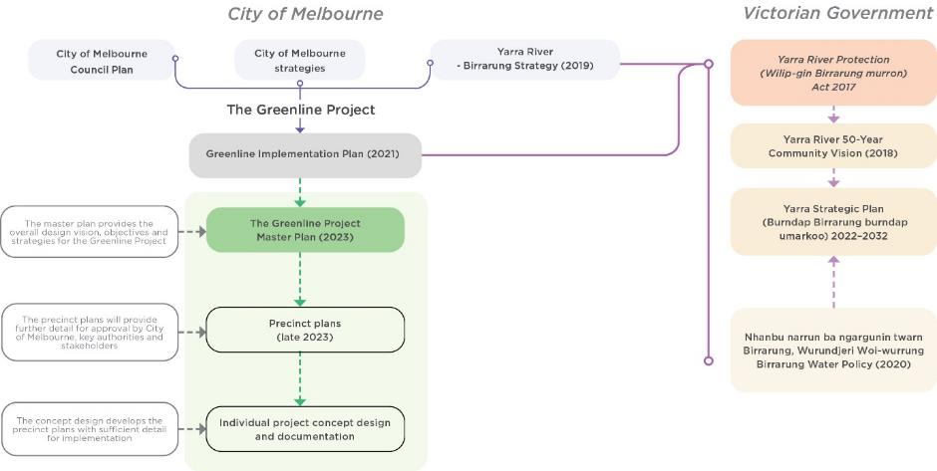

Master plan structure
The master plan builds upon the Greenline Implementation Plan (2021) and sets out the proposed design vision, themes and threads for the Greenline Project. It provides spatial and illustrative plans and actions for each of the five precincts.
The Greenline Project
Opportunity statement
The project vision and opportunity statement elaborate on the aspirations for the project.
Implementation Plan 2021
Master plan (this document)
Master plan vision - The Woven Line
The master plan vision develops project vision and introduces a woven line as a key concept.
The Woven Line – big spatial moves
- A continuous river journey
- An enriched ecological corridor
- A sequence of river destinations
The Woven Line – big spatial moves capture the three largest design ambitions for the project.
The Woven Line – themes
- Ecology - River as a living entity – creating a living, healthy ecosystem
- Culture - Authentic stories and experiences – a cultural landscape
- Place - Melbourne’s unique character and place – inclusive, safe and accessible
- Connection - A connected and vibrant waterfront – a continuous journey
The woven line builds upon the themes identified in the Implementation Plan.
The Woven Line – threads
The woven line – threads outline the strategies that will be followed to develop the precinct plans and project implementation.
Precinct master plans
- Birrarung Marr precinct
- The Falls precinct
- River Park precinct
- Maritime precinct
- Salt Water Wharf precinct
Precinct master plans are spatial and indicative illustrative plans for each precinct with identified actions.
Next stages
Precinct plans
Precinct plans comprise detailed planning for each of the five precincts.
Concept design and documentation

Community and stakeholder engagement summary

Engagement approach
The master plan has been informed and shaped by detailed community and key stakeholder engagement.
We used both broad and targeted promotion to ensure residents, visitors, relevant stakeholders and others interested in the Greenline Project had a chance to share their ideas and feedback on the precinct images to inform the master plan.
Engagement spanned six weeks from April to May 2023 and included:
- an online survey to gather community feedback, accessible via the Greenline Project Participate Melbourne page and a paper version
- three community workshops, two online and one in person
- targeted stakeholder workshops with:
- precinct businesses, special interest users and resident groups, and with
- Wurundjeri Woi-wurrung, Victorian Government departments and agencies, peak bodies for arts, tourism, parks, business, key precinct businesses and developers
- ten pop-up engagement activities at sites throughout the Greenline Project area
- three walking tours – one targeted to Mandarin-speaking participants, one for general community participants and one for City of Melbourne’s Disability Advisory Committee.

Engagement Outcomes
We received feedback from 756 participants across all engagement activities.
The following summary is grouped according to each of the Greenline Project themes:

Ecology
- Acknowledge the role of the Greenline Project as an important urban habitat to promote biodiversity. Create a more natural habitat for birds and wildlife.
- Reintroduce native plantings. A strong focus is needed on greening throughout the Greenline Project.
- Improve the water quality of the river and protect it from pollutants. Restore wetlands to improve river health.
- Reduce the need to include more concrete.
- Consider the impacts of flooding events and climate change and how to manage those impacts into the future.
- Consider the need for shade provision all year round for weather protection. Trees can provide shade.
- Effectively manage waste and control attraction from mosquitos to the wetlands.

Culture
- Rediscover stories and histories along the Greenline Project. Highlight collective histories and cultural values throughout the project.
- Reflect Melbourne’s character. Differentiate the area from anywhere else, including Southbank and Federation Square.
- Sustainability should be a core focus of the experience; for example, pop-up stalls highlighting creative and environmentally friendly initiatives.
- Elevate the river as a destination for boating, art tourism, education and celebration.
- Highlight Wurundjeri Woi-wurrung, maritime, historical and ecological elements of the experience.
- Ensure a joined-up story is told throughout the Greenline Project.
- More art and signage.
- Make sure that consultation continues to seek input into the development of ideas.

Place
- Revitalise the Greenline Project as a whole.
- Provide spaces for everyone while ensuring clarity of use and variation throughout the spaces, including those that are child-friendly. Provide play spaces to accommodate children of different ages; examples included water play, skate parks and playgrounds.
- Build connections to water while ensuring safety near the water’s edge, particularly for children.
- Collaborate with stakeholders to support economic activation to ensure the sustainability of the night-time economy throughout the Greenline Project. Include retail offerings, bars and places for events.
- Provide ample notice of change to manage any impacts on current activities; for example, for boat and river users and business owners.
- Ensure a safe experience for pedestrian movement as well as for cyclists and e-scooters; for example, via bike lanes.
- Apply measures to ensure people feel safe when moving throughout the Greenline Project, including wide pedestrian access.
Connection
- Strengthen connections between the north and south bank of the river.
- Ensure appropriate wayfinding for ease of connection from the city centre to the river, with clarity on key access points.
- Improve access from the stairs at Flinders Street Station.
- Ensure adequate disability access throughout the Greenline Project.
- Reduce pollution, manage rubbish and any river runoff.
- Ensure adequate lighting (not fluorescent), public toilets, windbreaks and shelter from rain.
- Mitigate crowding in confined spaces.
- Ensure connectivity throughout the Greenline Project.

The case for investment and value creation
Melbourne’s walkability is a critical feature of its appeal. Walking enables people to experience the city’s diversity and contributes to its vibrancy and vitality. There is a direct link between convenience for pedestrians and a city’s economic prosperity and safety. The Greenline Project is a critical part of improving Melbourne’s walkability.

Business case
City of Melbourne commissioned a business case study for the Greenline Project. It found the greatest economic benefits to the community will be through higher visitation and economic and commercial activity. Once completed, the Greenline Project is expected to:
- deliver the greatest net benefit to City of Melbourne over a 20-year operating period
- result in the highest economic impact from visitation and economic activity
- create significant benefits for the many commercial businesses in the precinct due to a higher number of visitors and pedestrians to the river’s north and south banks, bringing more opportunities to spend money in the area.
The construction of new connections, pathways and places between Birrarung Marr and Docklands will help to address the existing lack of attraction, creating experiences that encourage visitors to stop, spend and stay along the Yarra River - Birrarung and surrounding suburbs – Docklands, Southbank and CBD.
In addition, the Greenline Project will:
- provide improved connections to the inner suburbs of Melbourne
- encourage active transport through the city centre
- provide a unique visitor offering by creating new destinations and attractions along the Yarra River - Birrarung
- stimulate jobs and ‘gross value added’ – the value of goods and services produced in the area.
Delivering the Greenline Project would also create greater amenity and more integrated and attractive precincts in a part of the city where growth has fallen behind other areas in recent years. A higher level of overall amenity has the potential to change market conditions, leading to new or increased development and higher gross value added from new employment opportunities.
The Greenline Project would deliver economic benefits and help to support and sustain future development, with the potential to provide spill-over benefits to retail and food and beverage businesses adjacent to the Greenline. Based on an uplift in residential and commercial development within the corridor, by 2042 up to 6400 additional jobs could be created.
Between 410 to 560 direct and indirect jobs would be created during construction of the Greenline, over four years.

Project Budget
Business Case estimated budget - $315.6 million
Maintenance cost per year - $7.9 million

Benefit - Cost Ratio (BCR)
BCR – 3.29
Net Present Value (NPV) over 20-year operating period - $740.1 million

Master Plan goals

Triple bottom line and Traditional Owner Engagement
As a major investment in our public space, the Greenline Project is a chance to be bold in creating a better future for all Melburnians. It gives us an opportunity to consider how the city should evolve as it responds and adapts to a changing climate.
The following four lenses inform the project’s approach to sustainable development. Together with the United Nations’ Sustainable Development Goals, they will help us create positive impacts that reach beyond the scope of the works.

Environmental
The design of the Greenline Project will improve the Yarra River - Birrarung’s ecology, biodiversity and health through:
- recognising the river as a single integrated living entity (as per the Yarra River Protection (Wilip-gin Birrarung murron) Act 2017)
- increasing tree canopy coverage, in line with City of Melbourne’s Urban Forest Strategy
- increasing terrestrial and aquatic native vegetation
- increasing permeability of ground surfaces, promoting cooling through evapotranspiration
- decreasing nitrogen entering waterways.

Social
The design of the Greenline Project will increase public activity, health and cultural wellbeing through:
- meeting the increasing demand for green spaces in the central city
- improving the visibility of Melbourne’s Aboriginal heritage and culture
- improving physical activity and the use of active transport for residents and visitors
- increasing the number of safe, welcoming and inclusive outdoor spaces in the city for people to come together
- promoting universal accessibility and inclusive design principles.

Economic
The design of the Greenline Project will stimulate the local economy by:
- increasing visitor numbers and public transport usage in Melbourne
- increasing local employment and office attendance in the central city
- attracting residential and commercial development in surrounding precincts.

Traditional Owner engagement
The design and delivery of the Greenline Project will be underpinned by recognising the importance of the river and its lands for Traditional Owners and collaborative engagement that works with and integrates traditional knowledge of the Registered Aboriginal Party, the Wurundjeri Woi-wurrung Cultural Heritage Aboriginal Corporation by:
- building and fostering an ongoing working relationship with Wurundjeri Woi-wurrung Cultural Heritage Aboriginal Corporation and fostering a Country-led approach to project design
- establishing a framework for City of Melbourne and its consultants to engage with Wurundjeri Woi-wurrung Cultural Heritage Aboriginal Corporation
- enabling the ongoing involvement of, and benefit to, Wurundjeri Woi-wurrung Cultural Heritage Aboriginal Corporation, in the life of the revitalised riverbank.
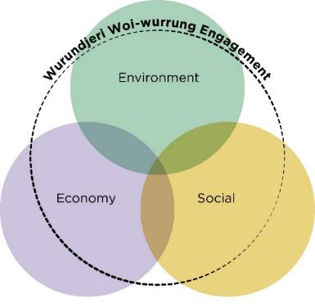

Sustainable Development Goals
The United Nations has identified 17 Sustainable Development Goals (SDGs) which are an urgent call for action by all countries. They aim to improve health and education, reduce inequality and spur economic growth, while building resilience to climate change.
The City of Melbourne reports its progress towards the SDGs. The Greenline Project business case identified that seven of the 17 SDGs are relevant to the scope of its successful delivery and they will continue to influence the ongoing design of the project. These include:
- good health and wellbeing
- decent work and economic growth
- industry, innovation and infrastructure
- reduced inequalities
- sustainable cities and communities
- life below water
- life on land.
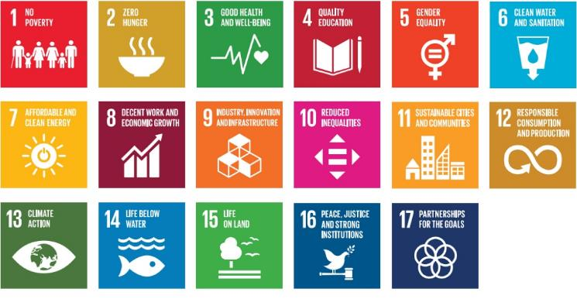

The Greenline Project as an urban green space connector
We have an opportunity to link the network of parks along the Yarra River - Birrarung between Birrarung Marr and Docklands.
The project will provide a recreational and ecological connection between existing parklands and open spaces across the city centre, including the Royal Botanic Gardens and the Domain, Melbourne Park and Yarra Park, Birrarung Marr, Enterprize Park, Batman Park and Docklands Park, and northward to the Moonee Ponds Creek corridor and Royal Park.
The Greenline Project is critical to improving the walkability of Melbourne and is a major step toward the creation of a green loop walk that wraps around the CBD and connects its waterways. It also contributes to the broader objective of the Great Birrarung Parkland, a concept being developed by the Birrarung Council, the statutory body that advises the Victorian Government on protecting and improving the river.
The Greenline Project is also a critical ecological link to larger existing habitat areas upstream at the Domain, as well as to Moonee Ponds Creek and out to the bay.
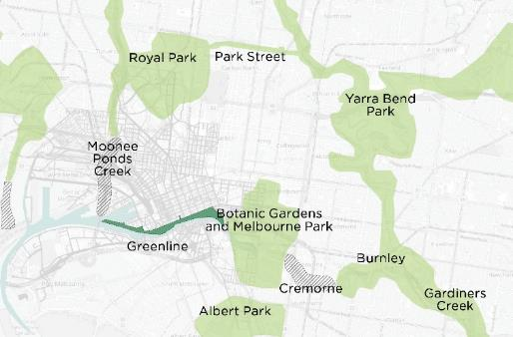
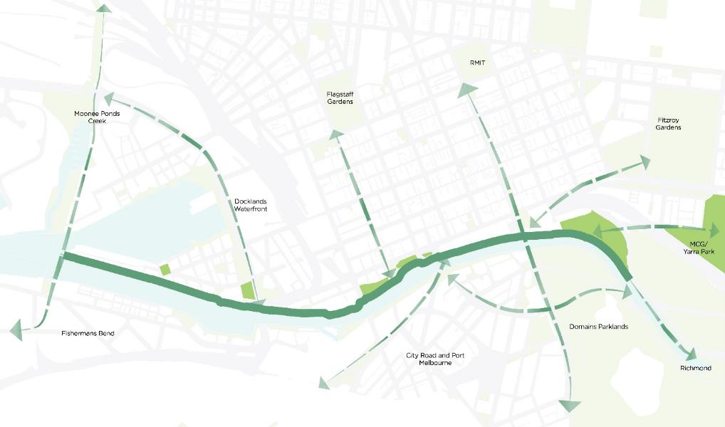

The Greenline Project as a cultural connector
The project will create a more walkable, experiential and physical connection between major cultural places and tourism destinations of inner Melbourne, including:
- Melbourne and Olympic Parks
- The Domain and Royal Botanic Gardens
- Birrarung Marr (major event location)
- Federation Square
- Melbourne Arts precinct
- Melbourne Immigration Museum
- Melbourne Aquarium
- Southbank and Crown Melbourne
- Melbourne Convention and Exhibition Centre and South Wharf
- Docklands Stadium.
The project will also strengthen local connections supporting day-to-day activity for residents and workers in neighbourhoods on both sides of the river.
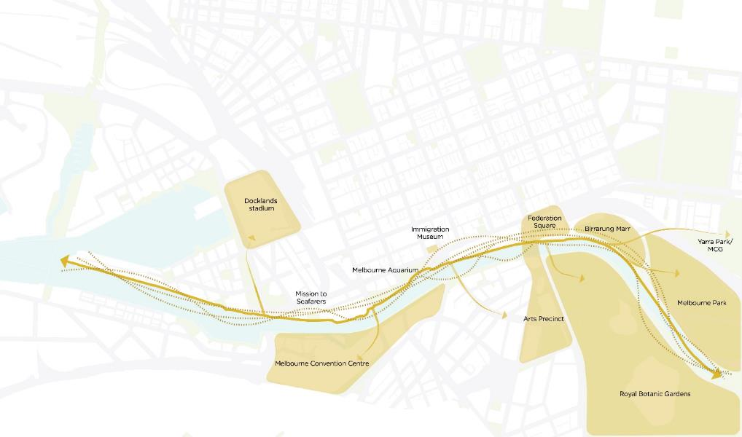

Site description and project extents
The project extends through the heart of Melbourne, covering approximately 4 kilometres of the Yarra River - Birrarung’s north bank.
The Greenline Project Master Plan study area includes several existing public open spaces, parks, heritage buildings, artworks, streets and transport and services infrastructure. At key points, the master plan’s scope extends beyond the river corridor to promote and consider holistic renewal of adjacent open spaces, buildings and streetscapes. The project intersects with six street crossings, five vehicular bridges and four pedestrian bridges.
To support its delivery, we have identified five implementation precincts: Birrarung Marr, The Falls, River Park, Maritime and Salt Water Wharf.
City of Melbourne recognises that the project has a highly variable riverbank and spreads across multiple landowners, management and approval authorities.
We understand that its construction may have impacts on capital works, operations and third-party development. Detailed design issues will be addressed through the development of precinct plans and concept designs subsequent to this master plan.
To realise the project’s significant opportunities and benefits, we will require the highest level of collaboration, coordination, cooperation and integration with all stakeholders.
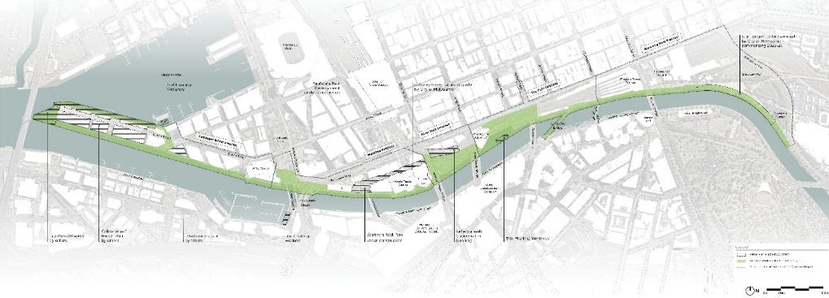

Existing site conditions
The Greenline Project study site is located on the north bank of the Yarra River - Birrarung and extends from the eastern end of Birrarung Marr parkland to the western end of Collins Wharf in Docklands. It contains numerous physical, infrastructure, services, and statutory planning constraints, along with the requirements of stakeholders and approval authorities that inform and regulate what can be designed and implemented.
As part of the master plan and ongoing design stages, we are analysing site conditions, opportunities and constraints to make sure site investigations and liaison with decision-making authorities inform the final detailed design.
Engagement with stakeholders and approval authorities will ensure designs and technical solutions are site responsive, minimise site impacts and coordinate the strategic requirements of these authorities.

Birrarung Marr precinct
The Birrarung Marr precinct currently comprises a narrow pedestrian path along the Yarra River - Birrarung, with limited universal access from Swanston Street and Princes Bridge.
For the Greenline Project, we will need to engage with adjacent landowners and managers on improvements for Federation Wharf and Flinders Walk.
Likewise, we will require ongoing consultation and collaboration with Parks Victoria and Melbourne Water to resolve berthing infrastructure, location, river activities and flood management.
Between Princes Bridge and Elizabeth Street, there are significant services and drainage infrastructure. We will require further assessments to understand specific constraints relating to geotechnical conditions and the Melbourne Metro tunnels.
Opportunities to consider:
- improve access, connection and wayfinding along the river
- address the many trees in poor health
- naturalise the river edge
- address rough sleepers
- manage antisocial behaviour
- reduce conflicts between pedestrians and recreational cyclists at intersections on the existing shared paths
- increase habitat and biodiverse greening along the river
- address flooding risk during high rainfall events
- improve the poor connection to the waterfront from Flinders Street and Princes Bridge
- consider large events and crowds management.
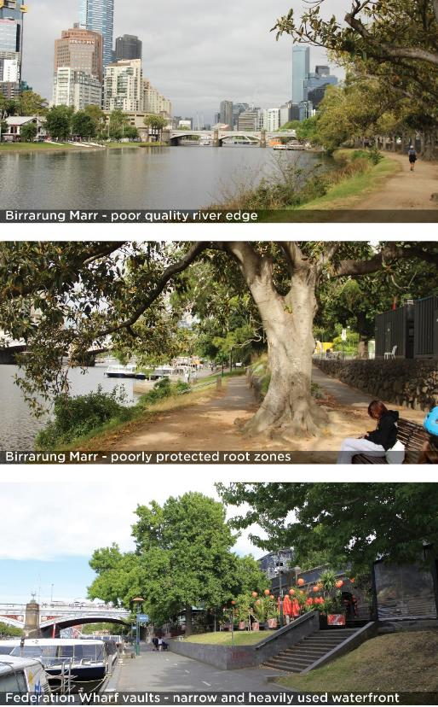
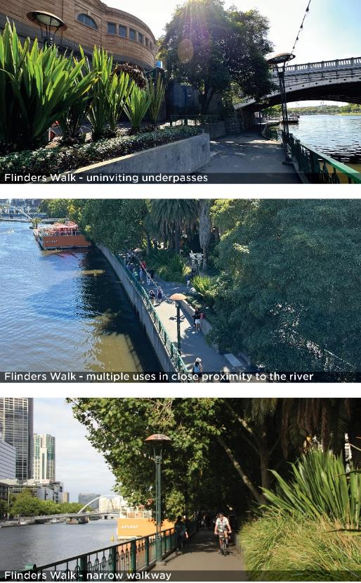

The Falls precinct
In the Falls precinct, pedestrian pathways vary in width and quality, with limited universal access. There are public safety issues associated with the lack of passive surveillance and poor lighting. The precinct is characterised by a complex land ownership and management system. It comprises a range of river edge conditions, alongside noisy rail infrastructure such as the extensive railway viaduct at Enterprize Park. Services and drainage infrastructure will require detailed coordination and integration. Sandridge Bridge has load limitations, which will need further assessment and integration in subsequent design phases. Banana Alley comprises varying river edge conditions and infrastructure quality. We will consult and collaborate with Parks Victoria and Melbourne Water during the planning of berthing infrastructure, river activities and flood management. Prioritising pedestrian connectivity will be balanced with the need for service vehicle access. The proposed removal of the S-bend intersection will require approval from Victorian Government authorities and is subject to feasibility and future consultation. The overall precinct will require further assessments to understand specific constraints relating to geotechnical conditions.
Opportunities to consider:
- improve access, connection and wayfinding along the river
- improve connection across Queens and King Streets
- investigate the removal of the Queens Street Bridge S-bend to increase usable public space
- mitigate noise pollution from the train viaduct and roads
- address narrow promenade and pinch points
- increase habitat and biodiverse greening along the river
- improve footpath surfaces and other hazards
- address flood risk during high rainfall events
- improve passive surveillance and seating opportunities
- improve connection to the waterfront from Flinders Street.
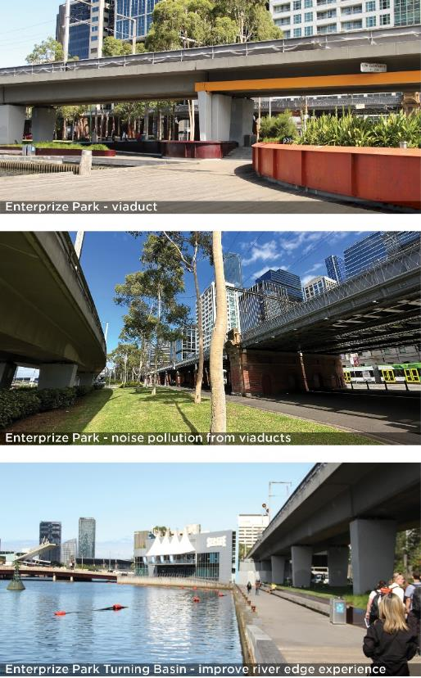

River Park precinct
The River Park precinct features a large open lawn area and scattered trees, flanked by a significant length of railway viaduct. Noise from the viaduct reduces the amenity of the park. Its undercroft is largely managed by other authorities. Throughout the precinct, there is limited universal access and connectivity, with narrow pedestrian paths. There is a population of rough sleepers who need to be considered when planning changes to the park. We will need to liaise and coordinate with a range of authorities regarding the extensive services and drainage infrastructure. To reduce impacts of localised flooding, we will need the input of Melbourne Water as we resolve the park design and river interface.
Opportunities to consider:
- mitigate noise pollution from the train viaduct and roads
- improve connection across King and Spencer Streets
- naturalise the river edge
- increase habitat and biodiverse greening along the river
- address flood risk during high rainfall events
- address rough sleepers
- manage antisocial behaviour
- activate the space under the viaducts.
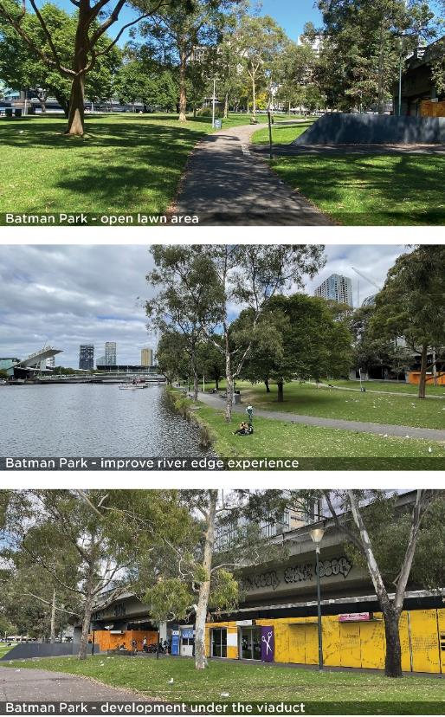

Maritime precinct
The Maritime precinct contains a range of river edge conditions and adjacent land uses. The connection to this precinct from Spencer Street, next to the Crowne Plaza Hotel, is very narrow with poor sightlines. The overall pedestrian experience is poor with a varying sequence and widths of wharves, ramps and pathways. The North Wharf and Mission to Seafarers are important heritage elements, listed on the Victorian Heritage register, which will require appropriate integration. Further assessment of wharf conditions and load ratings will be needed to determine the potential for public realm improvements such as extensions, stairs and ramps.
Opportunities to consider:
- improve access, connection and wayfinding
- increase tree canopy coverage
- improve pedestrian and cyclist navigation at intersections on existing shared paths
- increase habitat and biodiverse greening along the river
- activate ground level business and residential frontages
- improve connection from the waterfront to Docklands Park South
- improve the visibility of Wurundjeri Woi-wurrung culture.
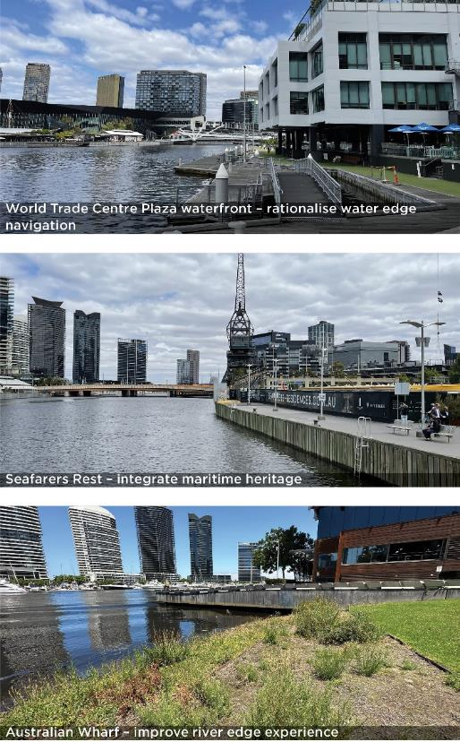

Salt Water Wharf precinct
This precinct comprises a long narrow section of wharf edge, adjacent to the Victoria Harbour Docklands development. There is pedestrian access along the Yarra River - Birrarung, extending from Docklands Park to the Bourke Street extension, with a planned overwater promenade as part of the future development of the precinct. The existing undeveloped water edge along Collins Wharf offers opportunities for the adaptive reuse of some materials and elements. Further consultation with adjacent developers and appropriate authorities will be required in this precinct for further resolution and planning.
Opportunities to consider:
- improve access, connection and wayfinding
- celebrate and integrate historical infrastructure
- increase habitat and biodiverse greening along the river
- increase tree canopy coverage
- improve passive surveillance and safety at night
- activate ground level business and residential frontages
- Improve the visibility of Wurundjeri Woi-wurrung culture.
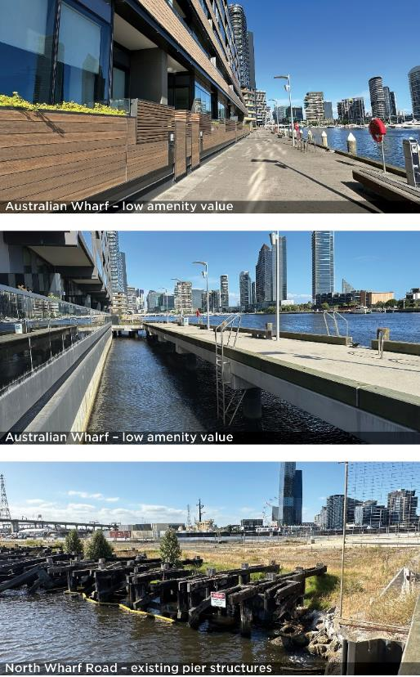

Key site values and planning framework
The Greenline Project study area contains sites of Aboriginal and non-Aboriginal cultural heritage, ecology and critical transport and services infrastructure. It is covered by 44 planning overlays, in addition to land-use zoning, with numerous planning permit and development approvals triggers involving a wide range of stakeholders.
The City of Melbourne is working with key project stakeholders to establish a planning pathway that provides agencies, authorities, decision-makers and the public with surety in approving works while allowing the master plan to evolve. The master plan provides a general contextual response to planning matters, noting that it is intended that the planning pathway will be developed in greater detail in subsequent phases of the Greenline Project.
Significant partnership, engagement and consultation with stakeholders and authorities will be required to obtain necessary approvals. All partnerships must consider the Yarra River Protection (Wilip-gin Birrarung murron) Act 2017 and City of Melbourne’s Yarra River - Birrarung Strategy (2019).
The master plan must consider a number of key site values and planning issues, including:
Aboriginal cultural heritage (tangible and intangible), non-Aboriginal cultural heritage (built form and archaeological)
- flood management and drainage
- land management and urban planning
- maritime operations and commercial leasing
- ecological values of existing flora and fauna
- rail, road and transport infrastructure and operations
- services operations and maintenance.
The map shown identifies key spatial and built-form constraints, including:
- land subject to inundation through flooding
- known Victorian and local government heritage protection sites
- areas of Aboriginal cultural sensitivity
- key drains and waterways
- navigable waterway zones.
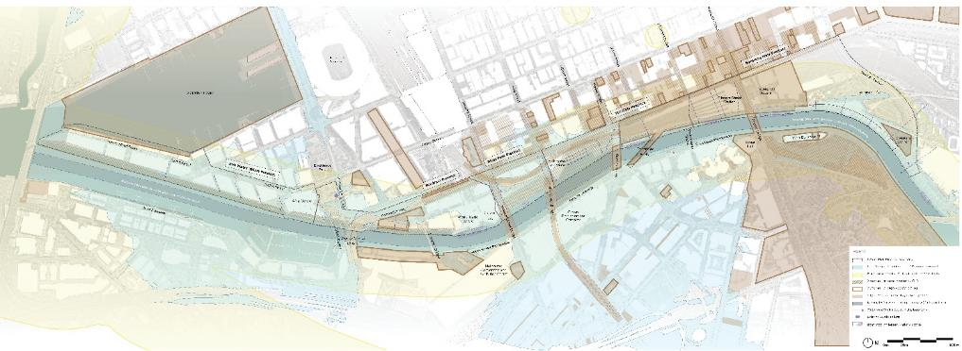

Land management and status
Land within the Greenline Project boundary is owned and managed by a range of stakeholders, including the City of Melbourne.
As a major city-shaping project, the Greenline Project will rely upon partnerships with all relevant stakeholders, including but not limited to:
- Wurundjeri Woi-wurrung Cultural Heritage Aboriginal Corporation
- Victorian and Australian Governments
- government agencies and authorities, such as Development Victoria, Parks Victoria, Melbourne Water, VicTrack and Melbourne Arts Precinct Corporation
- private property owners
- community members
- local businesses.
The map shown identifies key land owners, managers and responsible authorities, as well as the Registered Aboriginal Party for the area.
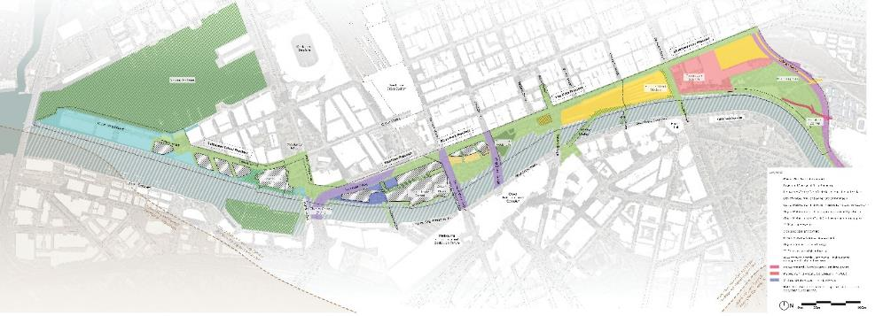

Health and wellbeing of Country

Engagement with Wurundjeri Woi-wurrung
The City of Melbourne has developed strong partnership with the Wurundjeri Woi-wurrung Cultural Heritage Aboriginal Corporation, the Registered Aboriginal Party for the Greenline Project area. This commitment to raising awareness and promoting Melbourne’s Aboriginal heritage and culture are major initiatives of the Council Plan 2021–25 and the Innovate Reconciliation Action Plan 2021–23.
Authentic and ongoing engagement is central to all aspects of the Greenline Project and supports City of Melbourne’s commitment to the Reconciliation Action Plan and vision to ensure that Aboriginal cultures are central to Melbourne’s identity. The Yarra River – Birrarung will be acknowledged as a ‘living entity,’ as required by the Yarra River Protection (Wilipgin Birrarung murron) Act, reinforcing the connection between the city and the river as an Aboriginal place.
The ongoing Aboriginal Melbourne mapping project undertaken by City of Melbourne in partnership with Traditional Owners is building our shared understanding of this Country. It identifies a variety of cultural themes connected with the river and the north bank. The project exemplifies City of Melbourne’s commitment to promoting Aboriginal culture, which will continue on the Greenline Project.
The use and inclusion of cultural knowledge in the project will be subject to the approval of Wurundjeri Woi-wurrung and other relevant knowledge holders and follow Aboriginal Cultural Intellectual Property (ICIP) protocols.
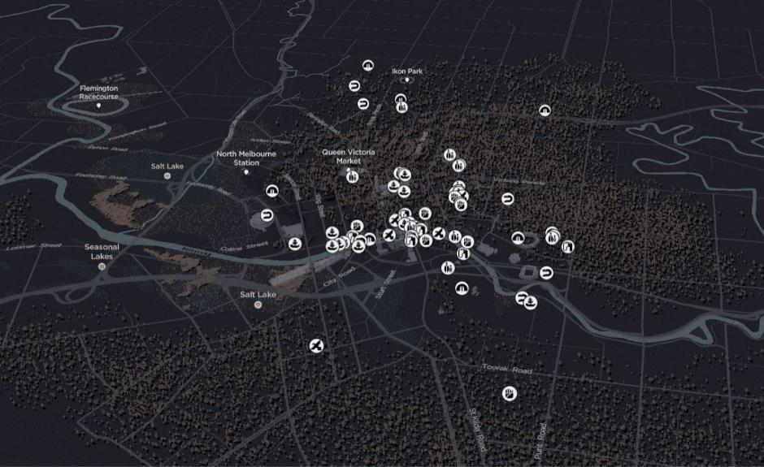
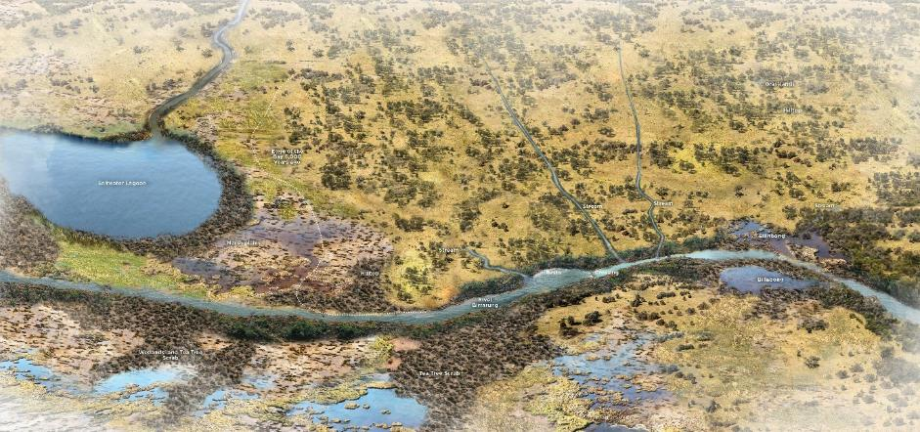
‘The Birrarung is a river of mists and shadows – the river and its environs are a living, breathing entity that follows Wurundjeri Woi-wurrung songlines and forms a central part of the Dreaming of the Wurundjeri. A Dreaming that links the billabongs, wetlands and swamps in the upstream forests, across the meandering plains and out to the salt water. We the Wurundjeri are connected to the Birrarung through spirit, culture and nature.’
Nhanbu narrun ba ngargunin twarn Birrarung – Ancient spirit and lore of the Yarra, Wurundjeri input into Yarra Strategic Plan.
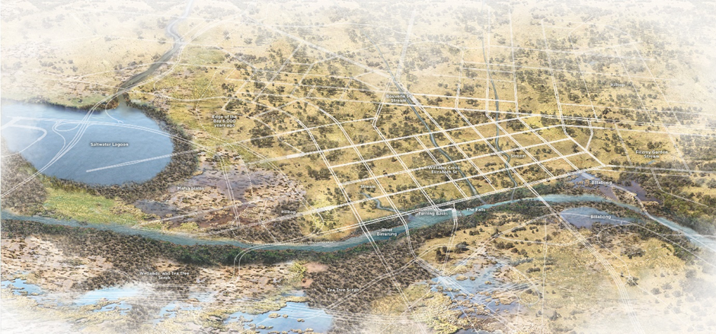
‘The City of Melbourne grew out from the banks of the Birrarung – the river has allowed it to become the vibrant city it is today, but this has come at great expense to the Wurundjeri.’
Nhanbu narrun ba ngargunin twarn Birrarung – Ancient spirit and lore of the Yarra, Wurundjeri input into Yarra Strategic Plan.
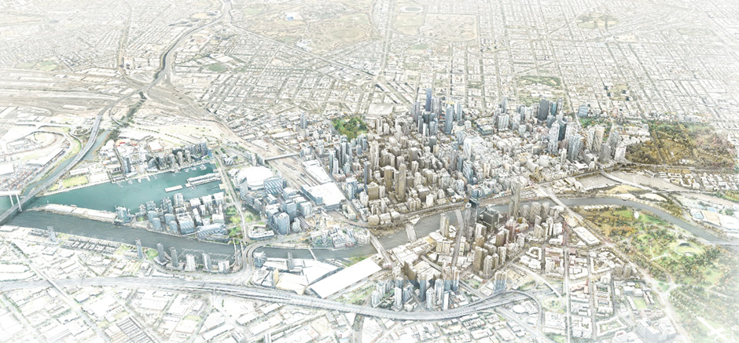
‘The Wurundjeri have lived with and known the Birrarung since the beginning. The Birrarung is now shared by many Victorians, who value the river and its surrounds for what they bring to the beauty of our city.’
Nhanbu narrun ba ngargunin twarn Birrarung – Ancient spirit and lore of the Yarra, Wurundjeri input into Yarra Strategic Plan.
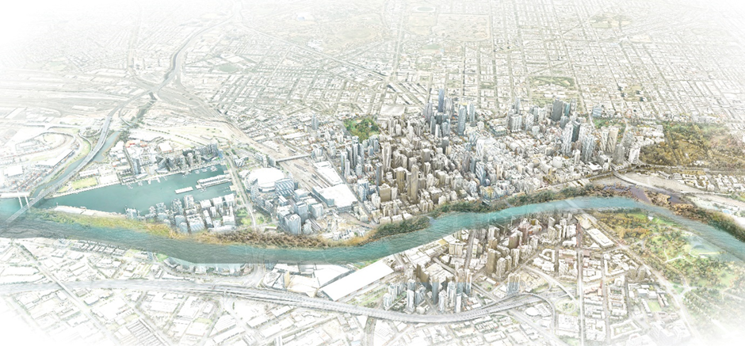
‘Wurundjeri invites all people to see the Birrarung through our eyes, to talk with us to understand our values, and to partner with us to re-energise the river as we fulfil our cultural duty in bringing the Birrarung back to environmental, cultural, ceremonial and spiritual health.’
Nhanbu narrun ba ngargunin twarn Birrarung – Ancient spirit and lore of the Yarra, Wurundjeri input into Yarra Strategic Plan.

Health and wellbeing of Country framework
The values, rights and lore of Country should guide decision-making for the project. We have established a framework that recasts the brief through a Wurundjeri Woi-wurrung lens.
It has been created by drawing from the extensive work undertaken to date by Wurundjeri Woi-wurrung, City of Melbourne, Aboriginal Melbourne and ongoing work by the Aboriginal Design and Partnerships team, integrated within the master plan team. It will evolve as the project develops.
We aspire that the project improves the health and wellbeing of Country. As such, the framework identifies five principles:

Indigenous ecosystems return
Re-establish habitat for fauna related to this part of Country by reintroducing ecologies and designing urban environments that allow humans and non-humans to thrive together.

Healthier waterways
Rebuild a relationship of care between humans and the river by improving water quality and habitat for water-based fauna, and by telling the stories of the waterways as an integrated living entity.

Connection to Country and Culture
Reveal the markers, stories, truths and practices of Country in place to strengthen everyone’s connection to Wurundjeri Woi-wurrung Country and culture.

Self-determined
Ensure that the process of designing and delivering the Greenline Project respects, and is guided by, Wurundjeri Woi-wurrung cultural protocols, processes and opportunities.

Take Responsibility
Understand that built environment processes of the past have caused harm to Country, culture and community and that it is the responsibility of all involved in the project to learn from the past, cause no more harm and design for future generations, both human and non-human.
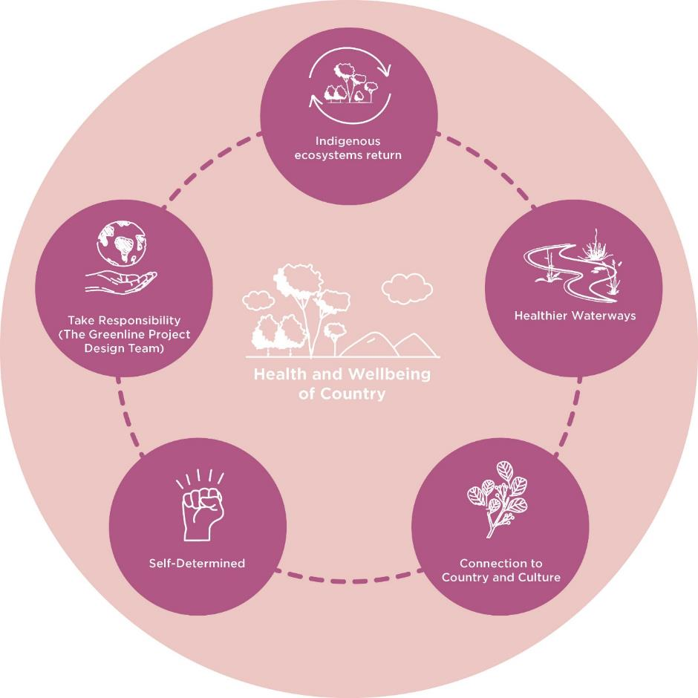

Indigenous ecosystems return
Objectives

Re-establish habitat
Identify locations for indigenous species and understand their habitat, life cycle requirements and suitable conditions.

Strengthen the ecological corridor
Find suitable plant species based on realistic opportunities, understanding their vertical and horizontal connections.

No new barriers
Establish design principles for selecting materials and forms that are friendly to habitat, and detail elements that align with the objectives.

Healthier waterways
Objectives

Increase aquatic vegetation
Plan land-water access, wetlands and riparian vegetation with Indigenous species. Consider ephemeral planting.

Cleaner water entering the river
Identify water sources (local versus major catchment), plan integrated water management and develop water cleaning strategies.

Make evident the confluence of waterways and drains
Narrate river functions based on form and location, craft educational stories and commemorate the confluence of water.

Connection to Country and culture

Read Country
Understand the layers of Country and where they can be revealed and returned through the tangible and intangible markers of Country. This includes materiality, language, stories of place, seasons and natural systems. Engage with Wurundjeri Woi-wurrung decision-makers to understand and embed their histories the way they need to be told.

Understand cultural practice
Design for gatherings, ceremonies and education at key locations, co-locating where possible. Prioritise culturally safe practices. Identify management and operational approaches that do not create barriers to connection. Review and resolve physical and systemic barriers that may prevent genuine connections to Country.

Resources for cultural practice
Engage with Wurundjeri Woi-wurrung to understand plant species relevant to cultural practices and incorporate them throughout the project, more densely adjacent to cultural nodes. Understand the shared histories of place and identify where and how these stories can be told, leaving space for the future.

Self-determined

Cultural authority
Engage with Wurundjeri Woi-wurrung decision-makers on cultural interpretation and Country.

Caring for Country
Understand and integrate Wurundjeri Woi-wurrung land management and caring for Country practices into the design.

Prioritise economic opportunity
Prioritise opportunities for Wurundjeri Woi-wurrung and other Victorian Aboriginal and Torres Strait Islander businesses in the project.

Take responsibility

Past
Respectfully reveal the histories of Country, reflecting on Aboriginal perspectives and truthfully conveying the complete story.

Present
Apply past lessons, prioritise no further harm and work to restore and celebrate Country, culture and community.

Future
Take a multi-generational approach to design decision-making, accounting for the impact on Country, Wurundjeri Woi-wurrung and the community.

Master plan overview

Master Plan Vision – the woven line
The woven line is a design approach for the north bank of the Yarra River - Birrarung that brings together multiple stories, cultures, ecologies, connections and places into one cohesive project vision. It represents a transformative shift in the way people will relate to the city and its river. It acknowledges how – for millennia – Wurundjeri Woi-wurrung people, along with their neighbouring Kulin nations, have had a reciprocal relationship with this Country.
The woven line plans for a bold, continuous and generous riverside journey along the north bank of the Yarra River - Birrarung, interweaving and revealing new narratives, experiences and destinations.
It defines new places where a city and its people come together to embrace the beauty, history, culture and biodiversity of the river.
It will deliver significant value for Melbourne, contributing to the city’s economy, environment, tourism, health, wellbeing and overall resilience. The project will deliver direct economic benefits such as jobs, investment and visitation, and create opportunities for increased commercial activity.

Weaving with Country
The master plan is based on designing with Country and listening to the river. Informed through respectful engagement with Traditional Owners, the Greenline Project recognises the natural and cultural values of its setting and establishes strategies for ongoing recognition, repair and celebration.

Weaving Ecologies
The master plan recognises the Yarra River - Birrarung as a living entity, with environmental strategies that seek to improve habitat value, ecological connectivity and increase biodiversity to contribute to the overall health of the river and Country.

Weaving Connections
The master plan identifies a generous and continuous 4-kilometre pathway that re-connects people to the Yarra River - Birrarung and its adjacent precincts. It creates an unfolding journey, responsive to the distinctive opportunities of each precinct, with place-generated, people-oriented spaces that are active, welcoming and safe.

Weaving Opportunities
The Greenline Project represents tangible and intangible opportunities along the proposed 4-kilometre journey and its adjacent precincts. These include significant economic benefits, visitation and enriched social and cultural experiences.

Weaving Visitation
New destinations, landscapes, journeys and experiences will significantly increase visitation to the river and the city. The project unlocks physical and cultural access to the river, which will draw local workers, communities, school children, interstate and international visitors.
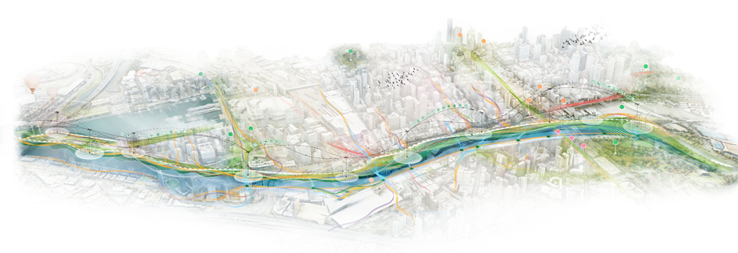

The woven line – big spatial moves
The master plan proposes three ‘big spatial moves’ to deliver a world-class, contemporary waterfront for the north bank of the Yarra River - Birrarung.

Weaving connections - a continuous river journey
The Yarra River - Birrarung will be connected by a striking, generous, public walkway along its length.
This will be achieved through:
- a continuous promenade experience that links seamlessly to its city context
- a generous 6-metre width (nominal) that prioritises safe and inclusive access for all users
- a pathway designed to unfold and reveal a sequence of views and river experiences
- a hierarchy of path connections that cater for large visitor numbers as well as places for more intimate exploration and discovery
- a diversity of walking experiences, from urban promenades and grand canopy walks, to boardwalks and more informal connections
- connecting visitors to a range of river and park experiences
- catering primarily for pedestrians and low-speed, active transport modes
- facilitating generous and intuitive connections between the promenade, the city and Southbank.

Weaving ecologies - an enriched ecological corridor
The Yarra River - Birrarung will be recognised as a living entity and enhanced as an ecological corridor.
This will be achieved through:
- increasing naturalisation and revitalisation of the river’s riparian edge to improve biodiversity and build resilience
- integrating water quality and management strategies to improve the health of the river and mitigate the effects of climate change
- creating a diversity of indigenous planting outcomes that respond to the river’s distinct settings and foster rich habitat and biodiversity outcomes
- connecting visitors to a range of diverse landscape experiences, including floating gardens, water edge ecologies, riparian planting, wetland habitat, curated indigenous gardens and canopy tree plantings
- promoting a range of interpretation and education opportunities at key public interfaces.

Weaving opportunities - a sequence of river destinations
The Yarra River - Birrarung will be enriched with diverse and exciting river experiences, cultural connections and public activities.
This will be achieved through:
- acknowledging and celebrating contemporary Aboriginal culture and heritage in the public open space, events and activities along the north bank
- creating experiences and destinations that reflect the distinctive spaces along the river
- creating safe, inclusive and welcoming spaces and activities that encourage use by all genders, sexualities, ages, abilities and cultural backgrounds
- connecting visitors to the rich layers of heritage and culture of the Yarra River - Birrarung and the city
- establishing cultural meeting places that express Melbourne’s diverse history and contemporary culture
- establishing education hubs where visitors are encouraged to interact and learn about the river and its ecologies
- fostering habitat, public activities and enjoyment at the river edge
- improving connections with existing destinations and attractions, such as bars and restaurants
- facilitating different ways for people to connect with the river, from the grand to the intimate.
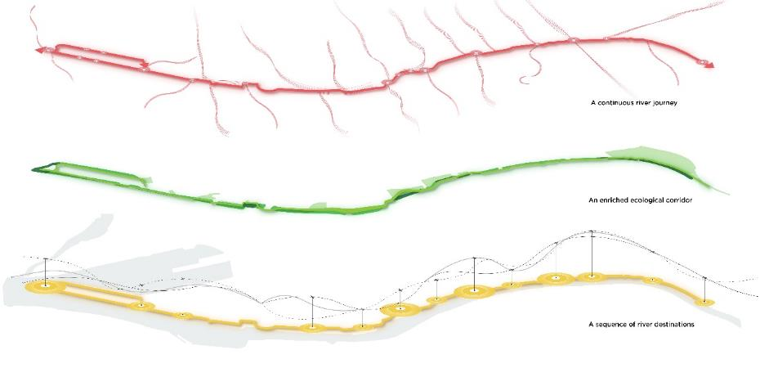

Ecology
River as a living entity – creating a living, healthy ecosystem
The Yarra River Protection (Wilip-gin Birrarung murron) Act 2017 recognises the Yarra River – Birrarung as a living entity. As custodians of the living river, we are focused on caring for its health and improving its function as an ecological corridor.

Woven Line threads
Planting and ecology - Create a biodiverse riverfront that reflects the character and qualities of the river’s indigenous landscape.
Integrated water management and flood mitigation - Safeguard the river’s health by processing water on-site and improving its ability to withstand floods.
Resilience and climate change - Design to be more resilient by adapting to climate change impacts, becoming energy efficient and developing a circular economy.
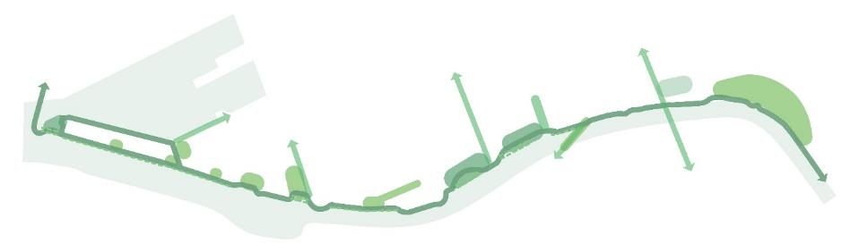

Culture
Authentic stories and experiences – a cultural landscape
The north bank of the river is a special place, layered with heritage and culture. We will tell stories of the diverse cultures and histories of the Yarra River - Birrarung.
Truth-telling and reconciliation are central to the cultural role of the Greenline Project: acknowledging and sharing the history of this place and people, and reckoning with the history of the city to continue Melbourne’s reconciliation journey.
Other important cultural threads are Melbourne’s rich urban, maritime and ecological history as well as a thriving creative, sport and entertainment culture.

Woven Line threads
Wurundjeri Woi-wurrung culture and identity - Create and celebrate meaningful places and connections for a range of cultural activities.
Melbourne’s history - Acknowledge culturally significant sites and showcase Melbourne’s distinctive identity.
Creative strategy - Realise a suite of compelling public artworks and experiences.
Wayfinding and interpretation - Integrate wayfinding and interpretation methods to enhance the visitor experience.
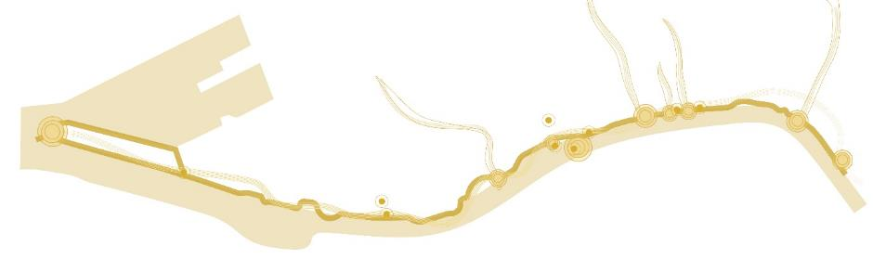

Place
Melbourne’s unique character and place – inclusive, safe and accessible
The Yarra River - Birrarung has flowed for thousands of years. Over its recent past, the character of the north bank has been shaped by the built form of the city, urban infrastructure and changing land uses.
As the population of the city continues to grow, so does the need for high-quality public open space. A better north bank will provide a better public realm and more accessible open space.

Woven Line threads
Open space and park network - Define a series of inviting, public, open riverfront spaces.
Events and programming - Create a welcoming environment through a diversity of events and programs.
Lighting - Create a 24-hour, safe and engaging night time experience.
Built form - Reconsider the built form’s relationship to the river.
Digital strategy - Improve the quality of open space and elevate visitors’ experiences with spatially embedded digital infrastructure.
Safety and inclusivity - Create an inclusive, accessible riverfront.
Value creation - Identify opportunities to create value for existing and future businesses.
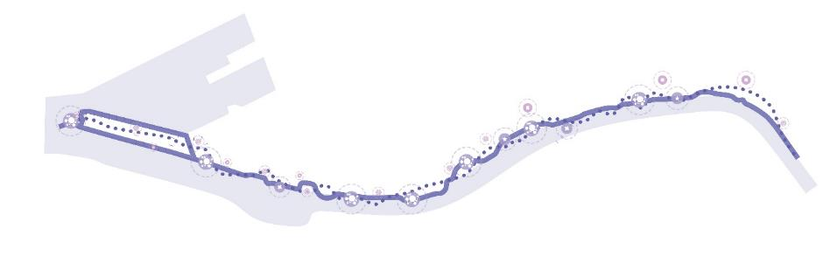

Connection
A connected and vibrant waterfront – a continuous journey
As the closest point of access to water from the CBD, the north bank connects visitors with the river and other destinations. The Greenline Project prioritises the safety and inclusive accessibility of these links. It presents a vibrant waterfront, connected both along its length and to its city context.

Woven Line threads
A generous promenade - Create a clear, navigable and uninterrupted journey along the river.
Pedestrian links and active transport - Connect the riverfront seamlessly with the city and prioritise a pedestrian-focused shared path along the Greenline.
Water-based uses - Promote a diversity of uses on and along the river.
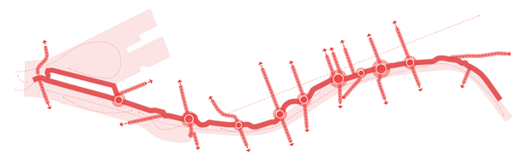

Illustrative master plan
The Greenline Project illustrative master plan is an ambitious vision of what the project could be. Detailed and tested designs will be developed in the precinct planning and subsequent concept design phases.
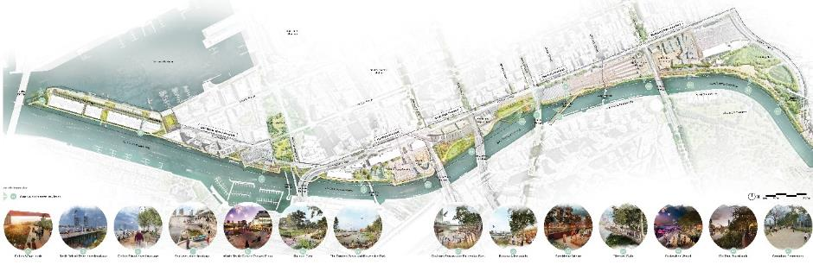

Spatial master plan
The spatial master plan outlines the project’s proposed key activities, experiences and opportunities.
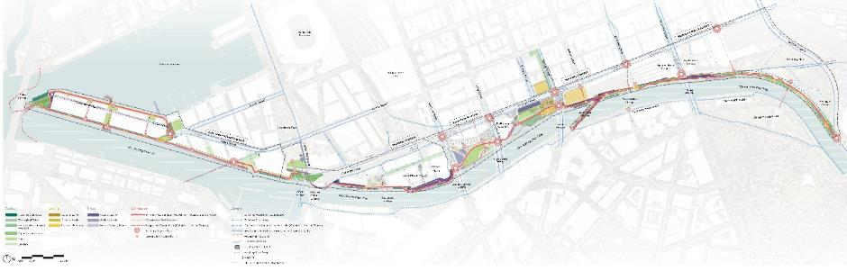

Spatial master plan – design elements
The spatial master plan provides a framework for the design of each precinct, demonstrating how the woven line themes and threads can be applied to form spatial outcomes across all locations.
The spatial master plan for each precinct is partnered with an illustrative master plan, which gives an indication of how the final design may evolve. Following the Greenline Project Master Plan, each precinct will undergo a separate and more rigorous precinct planning and concept design process where these plans will be further tested, developed and finalised.

Ecology – river as a living entity
A series of green spaces and ecological interventions that encompass both aquatic and terrestrial environments.

Floating wetlands
Any floating structures supporting vegetation that treats water and provides habitat. City of Melbourne is conducting trials of these structures.

Ecological edge
Various kinds of planted or constructed ecological zones along the water’s edge, which may be partly or fully submerged at times and will tolerate salt. This may be constructed elements such as river edge walls for fish and aquatic habitat, or ecological planting along the river’s edge.

Biodiversity-focused wetlands
Areas of planting and water environments that support habitat and increase biodiversity.

Riparian landscape
Planted areas adjacent to the river. Plant selection is based on what historically occurred and species that will thrive in an urban environment. May need to include plants that tolerate saltwater inundation.

Park
Formal parkland, including lawn areas and trees.

Garden
Areas with more garden beds and a horticultural focus on curated native and indigenous plant species.

Culture – authentic stories and experiences
Cultural spaces and buildings along the Greenline will include significant places for Wurundjeri Woi-wurrung and other communities.

Cultural zone
Large design areas that focus on place, culture and history.

Cultural node
Points that focus on place, culture and history; for example, through seating, public art, or interpretation.

Cultural building
Existing buildings that have Victorian or local heritage significance and provide important programming or facilities. Many buildings lie outside the project area, but can be connected with the Greenline Project.

Place – Melbourne’s unique character and place
Meaningful places of activity and life, whether large, small or on the water.

Activity zone
Large areas that focus on recreation, education or tourism.

Activity node
Smaller places that focus on recreation, education or tourism.

Water activity node
Places where people may access the water’s edge directly; for example, boating wharfs, floating pontoons, steps and rock edges.

Connection – a connected vibrant waterfront
Connecting people to the river and along its length via easily navigable entry points and journeys..

Primary circulation – pedestrian-focused shared path
The Greenline Project promenade, nominally 6 metres wide.

Secondary circulation – pedestrian-focused shared path
Secondary paths of varying widths, including floating structures and boardwalks.

Proposed connection
Proposed pedestrian-focused connections to the Greenline Project, both inside and outside the project boundary; for example, important crossings over Flinders Street.

Primary access point
Major entries to the Greenline Project, typically located at major roads and intersections.

Secondary access point
Minor entries to the Greenline Project.

Precincts
The Greenline Project’s precincts reflect different land management, activities and characteristics. They guide the planning and implementation of key improvements, coordination and advocacy along the north bank of the Yarra River - Birrarung.

Birrarung Marr Precinct
A gateway to the Greenline Project, boldly celebrating Aboriginal culture and the river’s unique ecology.

The Falls Precinct
The location of the former waterfall and river crossing holds significant cultural value to the Wurundjeri Woi-wurrung and the broader Eastern Kulin Nation, as well as historical links with the founding location of Melbourne.

River Park Precinct
An important open space next to the river, which will become a place of respite and excitement.

Maritime Precinct
A place to interpret the rich seafaring history of the city.

Salt Water Wharf Precinct
A site for river and harbour experiences, with a new proposed public park at the end of North Wharf.
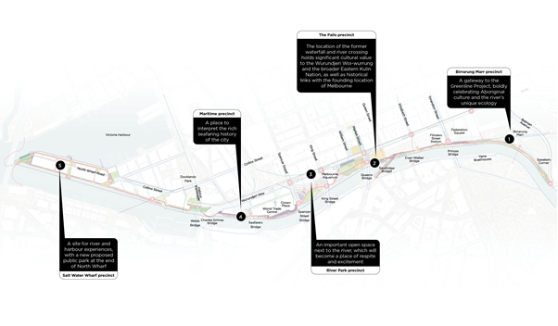

Birrarung Marr precinct
This civic and cultural precinct will be a gateway to the Greenline Project, boldly celebrating Aboriginal culture and Melbourne’s ecology. Adjacent to Federation Square and Flinders Street Station, a re-imagined waterside edge will provide an activated river frontage. It will promote this section of the river as an informal amphitheatre for events and celebrations.
The master plan proposes a revitalised river interface at Birrarung Marr, comprising a rich indigenous planted landscape, an accessible water’s edge and a clear network of paths while retaining Birrarung Marr’s role as an outdoor events space. We will showcase stories about Melbourne, including Wurundjeri Woi-wurrung knowledge and narratives of the river as a living entity.
A rationalised promenade at Federation Wharf will provide a wider, safer environment for pedestrians and better outdoor dining. Proposed terraced seating along the river edge will offer opportunities for informal gatherings while catering for large cultural events and performances. Secondary links will provide continued access for watercraft and unlock space for better habitat.
Flinders Walk has been reimagined to free up more space for people and nature. A new elevated walkway will provide dramatic riverside strolling, socialising and viewing while improving safety and accessibility. Riverside hospitality venues and activation will be integrated into measures to improve ecology, paths and wayfinding.
These proposals will invite greater use of the north bank and improve access to the river and opportunities for tourism and cultural experiences. Increased visitation will stimulate local jobs and activate the local economy. The revitalised spaces will provide safer and more attractive connections to the sports and entertainment precinct.

Master Plan actions

River as a living entity – creating a living, healthy ecosystem
Birrarung Marr
- Improve the ecological values of the existing freshwater rain garden at Birrarung Marr.
- Improve the ecological and habitat value of the soft river’s edge at Birrarung Marr through the use of riparian planting. Design to be climate resilient including considerations for future impacts of flooding, sea level rise, extreme heat, drought and severe storms.
Federation Wharf
- Improve the ecological and habitat value of the river’s edge near Federation Wharf through the use of riparian planting.
Flinders Walk
- Improve the ecological value of the Flinders Walk embankment through the use of riparian and indigenous planting supported by appropriate river edge infrastructure.
Overall
- strengthen and improve the ecological value of the river corridor
- endeavour to retain existing healthy and high-quality trees, and allow for a tree succession plan that fosters the planting of more indigenous species
- use innovative materials with low embodied carbon and high recycled content
- consider the robustness of infrastructure and maintenance requirements for elements that are designed to be inundated without creating new barriers to the movement of aquatic and terrestrial animals and systems.

Authentic stories and experiences– a cultural landscape
Birrarung Marr
- Create a cultural node and potential ceremonial place near the southern entry to Birrarung Marr and Speakers Corner, at the beginning of the Greenline Project.
Flinders Walk
- Open views to the historic facade of the Federation Wharf vaults.
- Celebrate historic tributaries where they connect to the river along Flinders Walk through designed experience and interpretation.
- Incorporate a cultural node to celebrate Williams Creek at its drainage confluence beneath Flinders Walk. Review the opportunity for a wider platform at this location to incorporate seating and interpretation.
Overall
- coordinate with the City of Melbourne public art program and management of existing public artworks
- work with Traditional Owners to ensure cultural values, narratives and resources for cultural practice are embedded into the project outcomes
- understand the layers of Country and where they can be revealed and nurtured through markers of Country, including materiality, language, stories of place, seasons and natural systems.

Melbourne’s unique character and place – inclusive, safe and accessible
Birrarung Marr
- Create pause points along the primary and secondary links, with seating and other amenities to provide opportunities for respite, learning and connecting to country.
- Retain toilet in its current location.
Federation Wharf
- Work with existing boat operators and Parks Victoria to improve systems for boarding and disembarking and resolve constraints such as river waterway depths, flooding, boat corridor dimensions and access to services.
- Create terraced steps for casual use, large events and water edge activity along the Federation Wharf.
- Enhance riverside hospitality, bars and dining along the Flinders Wharf vaults while sensitively integrating the historic built fabric.
- Improve lighting along Federation Square’s southern facades. Ensure that light pollution does not affect the daily cycles of animal species. Activate this precinct with activities to mediate the level change to Princes Walk, outside the Greenline Project extent of works.
Flinders Walk
- Integrate riverside hospitality and activation into the overall ecological and circulation initiatives along Flinders Walk.
- Work with riverside hospitality venues to improve their relationship with the river.
Overall
- we will provide internet access and include future-proofing digital infrastructure, such as smart nodes.

A connected and vibrant waterfront – a continuous journey
Birrarung Marr
- Encourage commuter cyclists to use nearby bike routes. Explore opportunities to minimise potential conflicts between pedestrians and commuter cyclists at existing pinch points.
- Integrate existing and proposed pedestrian connections from the river to the sports precinct and Batman Avenue.
- Allow for a potential future pedestrian connection from Birrarung Marr to Russell Street and advocate for improved connections between Federation Square and the river.
Federation Wharf
- Rationalise and simplify pedestrian path connections between Princes Walk, Federation Wharf and River Terrace.
- Provide more bike parking and cycle infrastructure along the Federation Square southern facade for visitors travelling by bike (outside the Greenline Project extent of works).
Flinders Walk
- Improve entry, access and wayfinding to the Greenline Project from Flinders Street and Princess Bridge. Improve vertical connections and accessibility across Princes Bridge through new elevated pathways, staircase and public lifts that comply with the Disability Discrimination Act 1992.
- Build a new elevated walkway along Flinders Walk from Flinders Street, offering clear, inclusive and safe access with seating and interpretation spaces.
- Upgrade the Flinders Street Station underpass as a vital pedestrian connection and prominent wayfinding point for the main promenade.
Overall
- create a generous promenade along the length of the precinct, supported by secondary paths
- encourage commuter cyclists to use nearby bike routes keeping the north bank as a pedestrian-focused shared path with recreational cyclists.

Birrarung Marr Precinct Spatial Master Plan
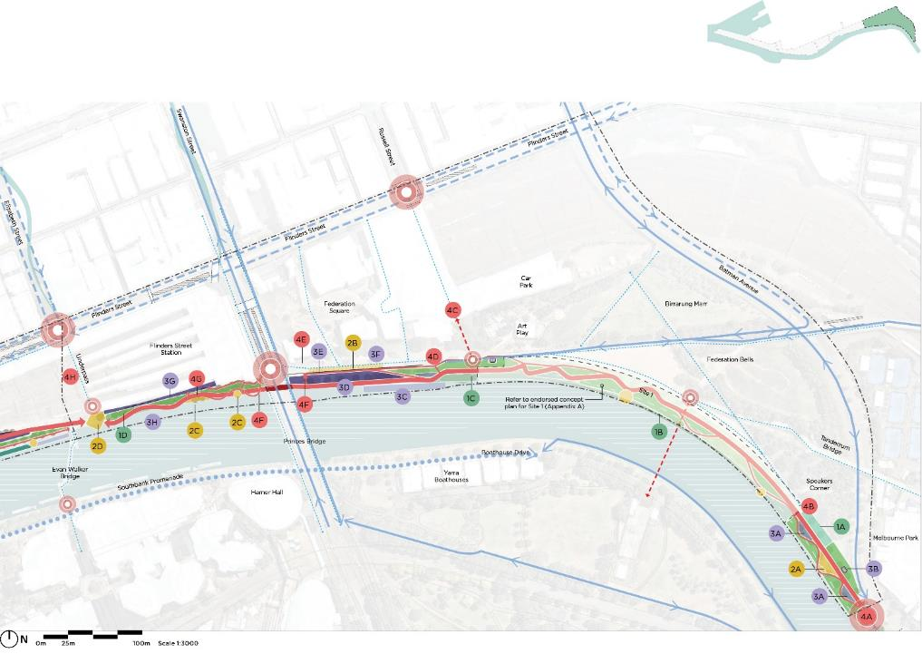

Birrarung Marr Precinct Illustrative Master Plan
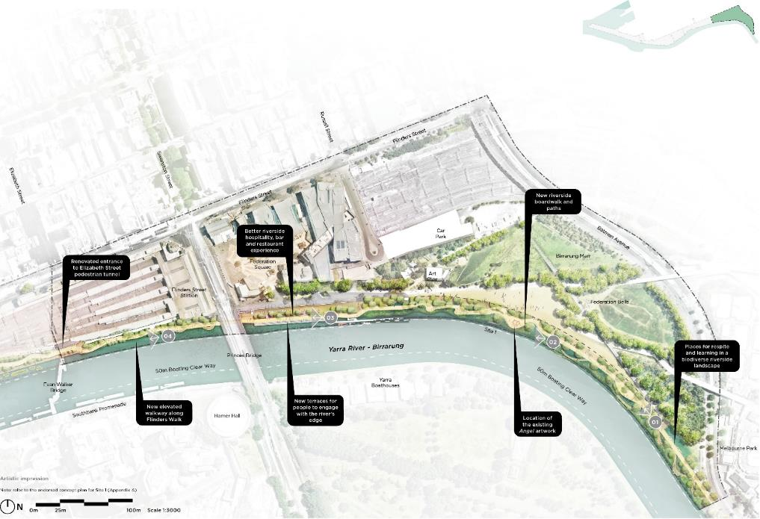

Birrarung Marr Precinct – Site 1 (Greenline Promenade)
This place marks the start of the Greenline Project’s generous promenade experience along the river’s north bank. Entering from the east, visitors can connect with, and stroll along, the river.
An ecological river edge is a place of respite – a place to cool down on hot days. Children and adults of all abilities are immersed in nature through playful moments.
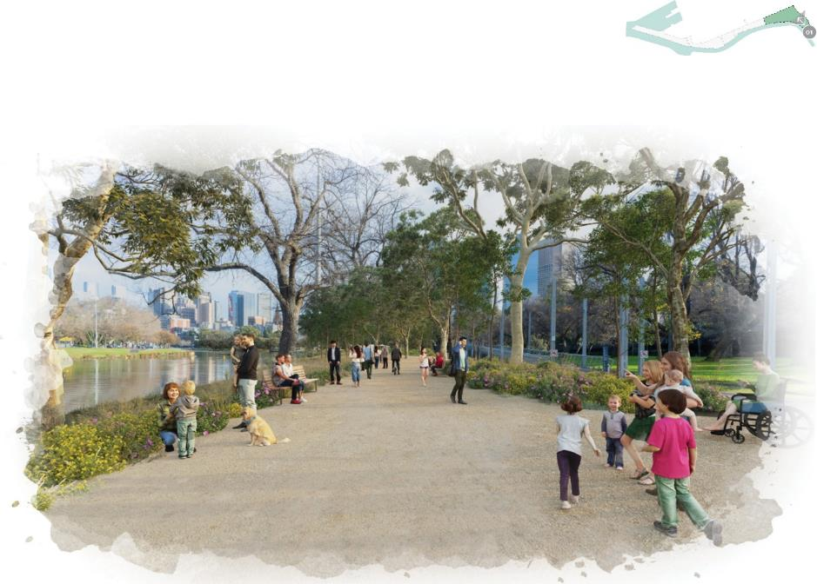

Birrarung Marr Precinct – Site 1 (Fig Tree Boardwalk)
Fig Tree Boardwalk is a pathway to, and respite from, the city; a generous and enticing destination for daily public use. Improved accessibility and seating encourage people to gather or pause beside the river in a cool, shady spot under the trees.
The boardwalk will enhance the impact of existing artworks and strengthen connections to nearby cultural institutions. It will improve the health and growing conditions of the existing fig trees, prolonging their contribution to Melbourne’s waterfront character.
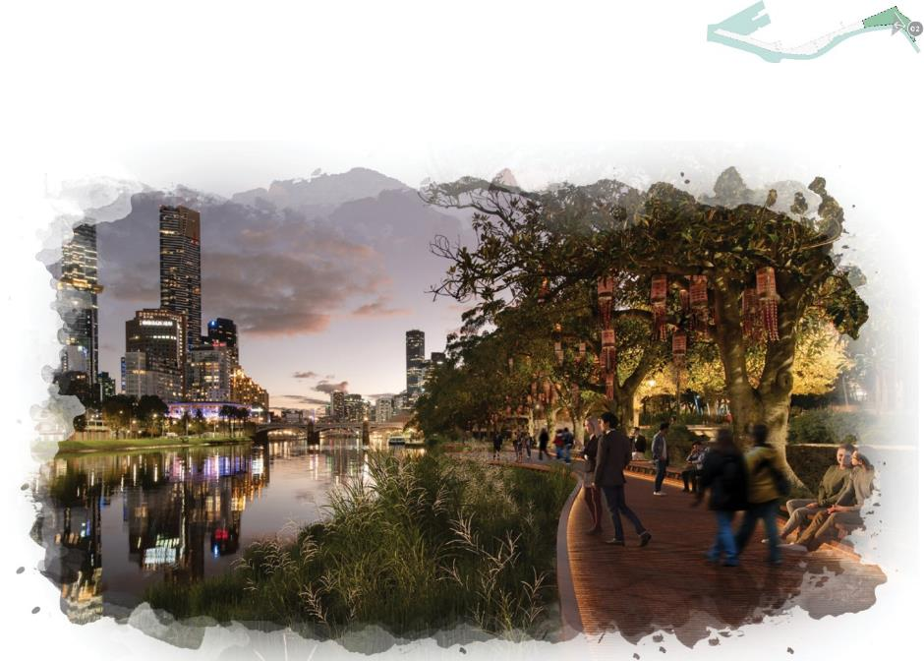

Birrarung Marr Precinct – Federation Wharf
At Federation Wharf, on the doorstep of the city, we will increase the riverfront public space to create an expansive promenade and a range of new experiences. Seating terraces along the river edge will create opportunities for cultural events and performances on the river, as well as outdoor dining. This is a response to the community’s request for event spaces that cater to the local community and visitors and enable interaction with the water.
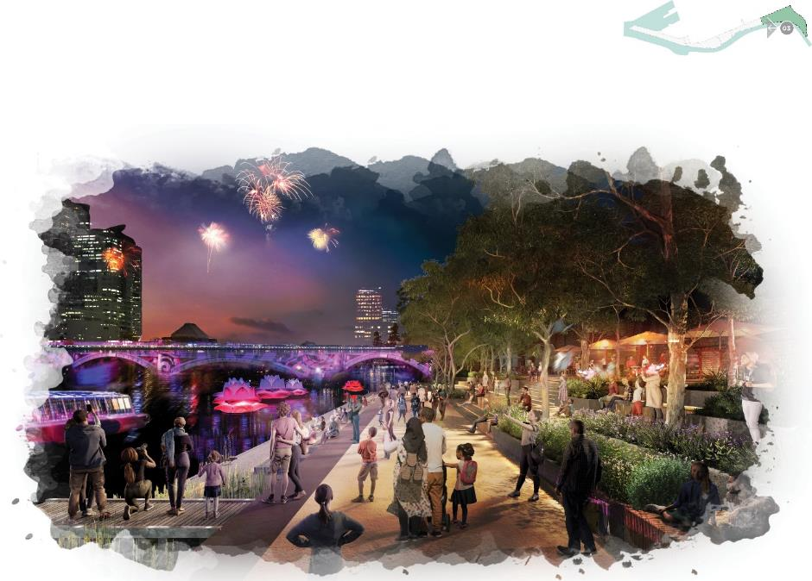

Birrarung Marr Precinct – Flinders Walk
Flinders Walk has been re-imagined to create more space for people and nature. A new elevated walkway will improve safety and accessibility and provide additional room for planting.
The area will continue to be a place for socialising and gathering – whether at destinations or along the walkway looking out across the river. We’ve heard the community’s feedback that increased pedestrian amenity, safety and access are important in this area.
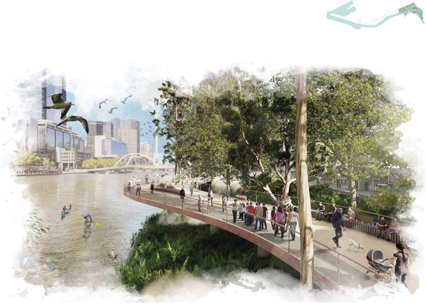

The Falls precinct
This precinct, centred on the former location of the waterfall in the Yarra River - Birrarung, holds significant cultural value for the Wurundjeri Woi-wurrung and Eastern Kulin Nation peoples. The master plan acknowledges the site’s importance and promotes various ways to improve its environmental and cultural qualities.
The waterfall formed a physical boundary between fresh and saltwater river systems. The location was once the primary river crossing for Aboriginal peoples and it also marked the arrival of European colonisers in Melbourne. We propose that Aboriginal, maritime and immigration histories be revealed through physical access to water, improved biodiversity, improved views and vantage points, artistic interpretations and the adaptive re-use of physical assets.
The western edge of Sandridge Bridge, currently inaccessible, will be restored to provide a linear open space with integrated indigenous plantings, social settings and interpretive opportunities to acknowledge Wurundjeri Woi-wurrung culture, local history and nature.
Banana Alley Promenade will be revitalised and broadened with new river connections, habitat creation, public hire boats and small watercraft activities. It will be connected seamlessly to the Turning Basin – the base of the old falls, used by ships returning to sea – via an improved pedestrian crossing at Queens Bridge.
The William Street link to Queens Bridge, also known as the S-bend, will be removed (subject to feasibility and approvals) to create a significant new riverside cultural gathering place, visitor destination and interpretive setting. It will highlight Aboriginal history, settlement, immigration and maritime histories, acknowledging the original configuration of the Turning Basin and providing a stronger civic connection to Customs House, now the Immigration Museum.
Enterprize Park and the Turning Basin will become a major cultural, educational and interpretive hub, with increased river access, a river boardwalk, water management strategies and improved biodiversity. Water access for the public, kayaks for hire and small watercraft will be integrated into a more accessible water’s edge.
Adjoining parks will be upgraded to make them more useable, including for youth recreation kayaks and small rivercraft access.
These initiatives will create new destinations for visitors, providing opportunities to experience and interpret the river and its multi-layered stories, resulting in a significant increase in precinct visitation and flow-on benefits for nearby attractions such as the Immigration Museum.

Master Plan actions

River as a living entity – creating a living, healthy ecosystem.
Flinders Walk / Sandridge Bridge / Banana Alley
- Improve the ecological and habitat value of the river’s edge at Flinders Walk and Banana Alley Wharf.
- Provide greening for Les Erdi Plaza to create an attractive and cooler setting to support existing and additional uses.
- Create a new public setting along the western edge of Sandridge Bridge that incorporates indigenous plantings to increase the habitat and biodiversity values of the precinct.
Enterprize Park and Customs Square
- Design Enterprize Park and Customs Square to adapt to the future impacts of flooding and sea level rise.
- Improve the ecological and habitat value of the shallow river’s edge at the Turning Basin with biodiversity-focussed wetlands to contribute to local interpretation, education and habitat values.
Overall
- endeavour to retain existing healthy and high-quality trees while establishing a tree succession plan that fosters the planting of more indigenous species.

Authentic stories and experiences – a cultural landscape
Flinders Walk / Sandridge Bridge / Banana Alley
- Celebrate the history of Sandridge Bridge with a new public space on its western edge, incorporating seating, meeting areas, and interpretation features.
- Celebrate the history of the Banana Alley vaults.
- Make evident the ecological and cultural value of the Falls, by supporting public connection with the location, alongside interpretation and experiences.
Enterprize Park and Customs Square
- Transform the existing Queens Wharf at Enterprize Park into a large-scale cultural node that fosters Aboriginal cultural practices and ceremonies and serves as a riverside gathering and meeting place for the people of Melbourne.
- Express the Aboriginal and maritime history of the site, including its connection to Customs House (now Immigration Museum).
- Promote ecological awareness through education, interpretation and amenities such as outdoor classrooms, with a focus on children and young people.
- Redevelop the space under the historic viaducts for cultural uses and public programs.
Overall
- Coordinate with the City of Melbourne public art program, and management of existing public artworks
- work with Traditional Owners to ensure cultural values, narratives and resources for cultural practice are embedded into the project outcomes
- understand the layers of Country and where they can be revealed and nurtured through markers of Country. Including materiality, language, stories of place, seasons and natural systems.

Melbourne’s unique character and place – inclusive, safe and accessible
Flinders Walk / Sandridge Bridge / Banana Alley
- Support and manage existing skateboard use and other activities at Les Erdi Plaza. Foster improved connections to the redeveloped western side of Sandridge Bridge. Work with VicTrack to reduce noise from the railway viaduct.
- Upgrade the Banana Alley riverfront by creating a generous tree-lined walkway with better connections to the river’s edge. Improve public amenity while also removing existing carparking. Work with the management of the Banana Alley vaults and existing and future tenants to enable this.
- Work with boat operators and Parks Victoria to improve connections with the river.
- Create a new linear open space along Sandridge Bridge with places for sitting, gathering and activation set amongst a series of biodiverse indigenous gardens.
Enterprize Park and Customs Square
- Coordinate with stakeholders to investigate removing the traffic S-bend at Customs Square to create a significant public open space and meeting place at the river. Review the functionality of the service road as part of the traffic proposal.
- Provide a water access point for small watercraft near Customs Square and Enterprize Park.
- Retain a large lawn for informal recreation and cultural events.
- Include infrastructure recreation activities such as social places, bouldering, basketball, bike hire and other activities.
- Investigate the opportunity to activate and architecturally improve the Melbourne Aquarium frontages facing the river and Enterprize Park by widening the promenade along its edge and investigating the connection to the existing internal café.
Overall
- provide internet access and include future-proofing digital infrastructure, such as smart nodes.

A connected and vibrant waterfront – a continuous journey
Flinders Walk / Sandridge Bridge / Banana Alley
- Review the opportunities to widen the current lower promenade between Evan Walker Bridge and Banana Alley, including under the Sandridge Bridge.
- Review the connection between the Signal building and Banana Alley to improve access.
- Explore floating pontoons in front of Banana Alley to provide over-water experiences and connect to boat moorings.
- Explore future uses of the Banana Alley vaults, including the possibility of a public access link to Flinders Street (in consultation with management and tenants).
Enterprize Park and Customs Square
- Improve and upgrade the crossing at Queens Bridge Street to facilitate connections along the Greenline Project. Review public transport stops and upgrade their amenity and accessibility.
- Strengthen the connection between the Immigration Museum and Customs Square, including public realm improvements that signify the museum’s connection to the river.
- Create an over-water boardwalk at the Turning Basin and Enterprize Park to connect the public with the river and with initiatives to improve biodiversity and habitat.
- Coordinate with Melbourne Aquarium to improve the existing access along Aquarium Drive while supporting the activation of the park.
Overall
- create a generous promenade along the length of the precinct, supported by secondary paths.
- continue the quality of the elevated promenade at Flinders Walk by upgrading the existing elevated walkway to Sandridge Bridge.
- improve the public experience with generous greenery, seating and cultural interpretation.

The Falls Precinct Spatial Master Plan
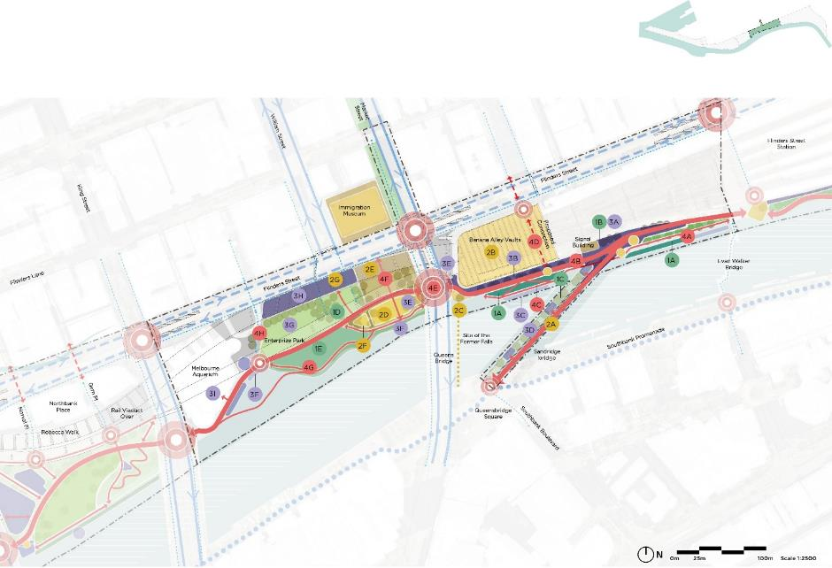

The Falls Precinct Illustrative Master Plan
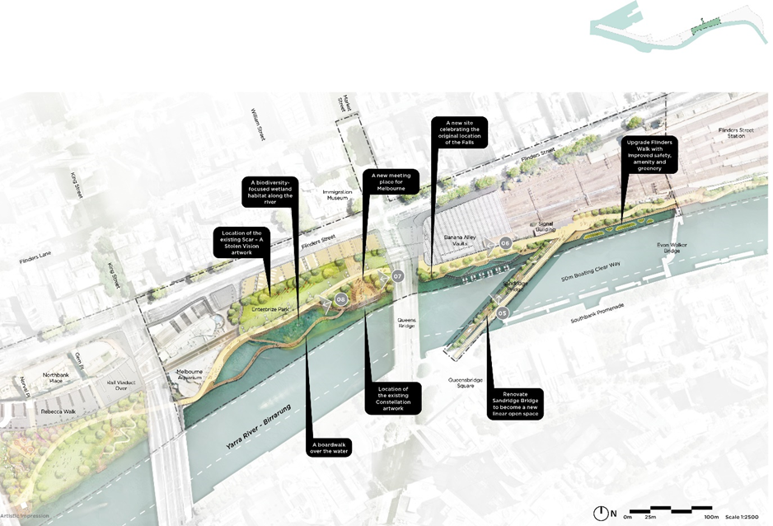

The Falls Precinct – Sandridge Bridge
Currently, only one side of the Sandridge Bridge is publicly accessible. There is an opportunity to transform the bridge into a new public space that strengthens connections between Flinders Street, Southbank and the Greenline Project. Revitalising the underutilised bridge will create a unique, linear open space, complementing other central city public spaces. Through its design, it will elevate the presence of Wurundjeri Woi-wurrung culture as well as local history and nature.
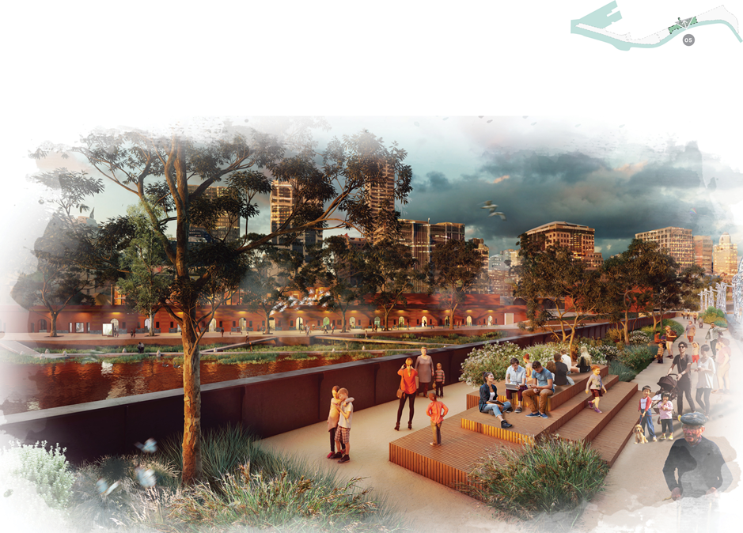

The Falls Precinct – Banana Alley vaults
This location adjacent to the former Falls is a significant cultural site for the Wurundjeri Woi-wurrung and Eastern Kulin Nation peoples.
A generous, tree-lined walkway and riverside plaza can support cultural activities and public art, while a revitalised water’s edge of floating wetlands and pontoons will provide sensitive watercraft access.
The Banana Alley vaults can be both a destination and conduit to the city – complimented by fresh new cultural, commercial and retail opportunities.
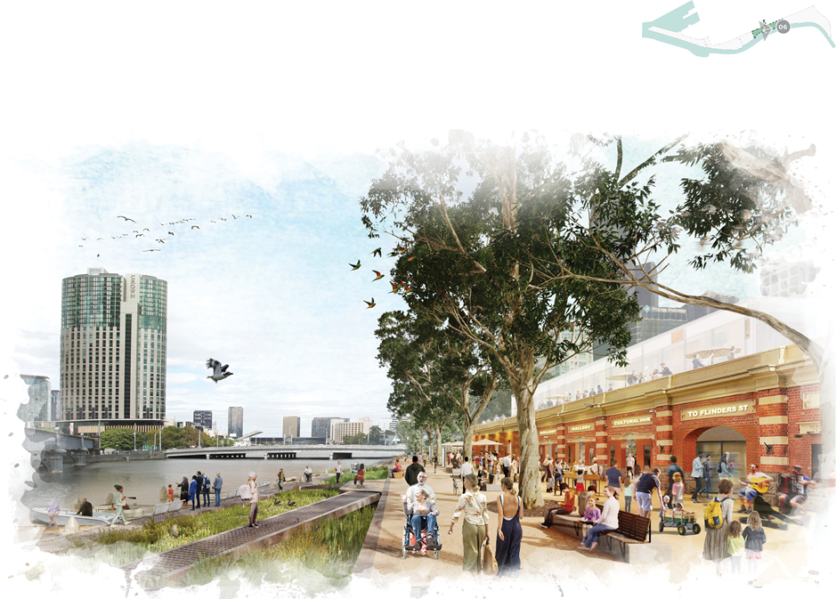

The Falls Precinct – Customs Square and Enterprize Park
The Yarra River - Birrarung has been associated with journeys and gatherings for the Wurundjeri Woi-wurrung for thousands of generations. More recently, it has also been a destination for immigrants and visitors to the city.
This location offers an opportunity for the Greenline Project to create additional, much-needed open space for the city and vastly improved pedestrian connectivity and safety along the river by removing the existing S-bend roadway. In its place, we will realise a new space for gatherings, celebration and historical interpretation that recognises the significant cultural heritage of the area.
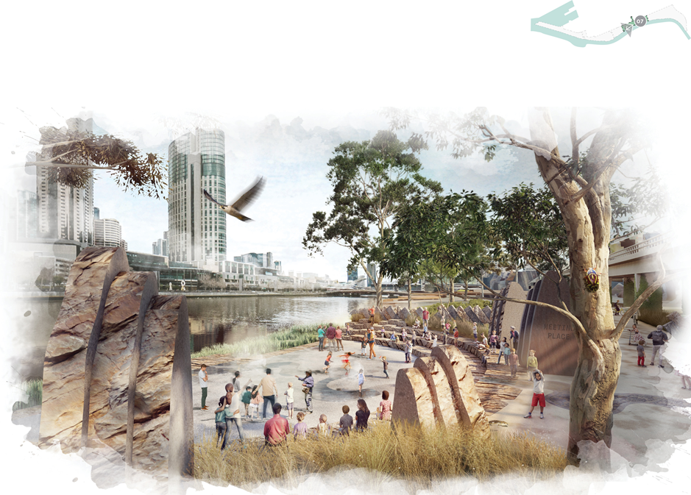

The Falls Precinct – the Turning Basin and Enterprize Park
Enterprize Park adjoins the Turning Basin – what was once a natural widening in the Yarra River - Birrarung. There is an opportunity in this place to increase biodiversity and create a more natural river’s edge: a place where people can connect directly with the river. The introduction of wetland habitat to the Turning Basin, with native Australian planting, boardwalks, and waterfront steps, can provide a location that supports education and teaching about our indigenous landscape, as well as revealing key stories of Melbourne’s rich maritime history.
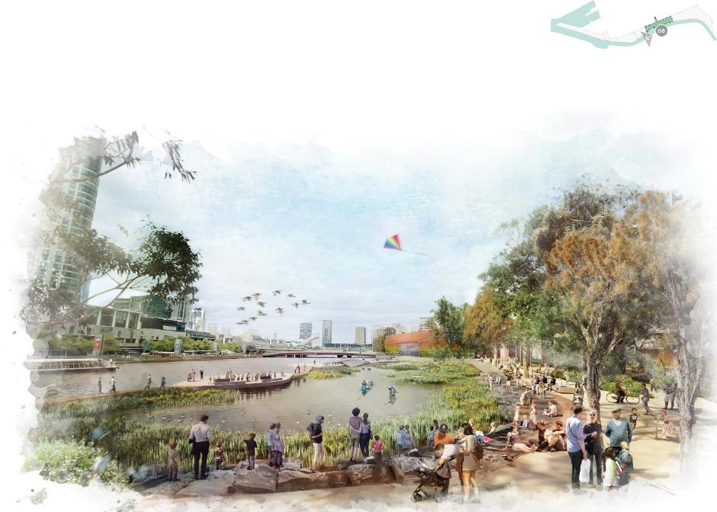

River Park precinct
The re-imagined Batman Park will provide a place of respite, exploration, play and excitement.
This significant open space asset on the river will become a major waterside destination, hosting a range of park activities for residents, city workers and visitors. The park will create opportunities for nature play, informal recreation, indigenous botanical display, exercise, social spaces and a café.
A generous new promenade will connect a variety of activities and provide seamless links to adjacent precincts. A range of secondary paths will guide people to the city beyond.
Batman Park will host a large, immersive ecological site that will improve biodiversity and create habitat, fostering a greater understanding of the local environment for visitors and the local community. A curated indigenous, botanic landscape will provide a beautiful frame for park users and become a valued destination for visitors to experience and interpret the native flora and fauna of Melbourne.
Broad lawn areas will bring the local community to their neighbourhood open space for recreation, while allowing for cultural events and informal and exploratory uses of the revitalised riverbank.
These initiatives will create a destination on the river and a major node of activity for the Greenline Project. It will become a cherished local park for residents and city workers, as well as a major drawcard for visitors to the city and the Yarra River - Birrarung. Increased park use will contribute to rejuvenation of adjacent properties and encourage further investment in the precinct.

Master Plan actions

River as a living entity – creating a living, healthy ecosystem
Batman Park
- Improve the ecological and habitat value of the shallow river’s edge at Batman Park using riparian planting and riverside habitat.
- Host an immersive ecological place to contribute to diversity of park usage, interpretation and ecological values.
Overall
- redesign Batman Park to adapt to the future impacts of climate change through new landscape infrastructure and climate resilient native or indigenous vegetation
- plant a significant curated indigenous garden to create a beautiful frame for park users and a valued destination for visitors
- endeavour to retain existing healthy and high-quality trees while allowing for a tree succession plan that fosters the planting of more indigenous species
- use innovative materials with low embodied carbon and high recycled content. The robustness of infrastructure and maintenance requirements will be considered for elements designed to be inundated, without creating new barriers for the movement of aquatic and terrestrial animals and systems.

Authentic stories and experiences – a cultural landscape
Batman Park
- Integrate the former screen house building into Batman Park’s historic and cultural landscape, noting that the existing helicopter facilities along the riverfront impact the park experience.
Overall
- coordinate with City of Melbourne’s public art program and management of existing public artworks.
- combine art and all ages play elements
- explore opportunities to celebrate Wurundjeri Woi-wurrung culture and the cultural narrative of the river, including supporting ongoing cultural practices.
- communicate with visitors the importance of biodiversity, habitat and native flora
- understand the layers of Country and where they can be revealed and nurtured through markers of Country, including materiality, language, stories of place, seasons and natural systems.

Melbourne’s unique character and place – inclusive, safe and accessible
Batman Park
- Work with VicTrack and Rebecca Walk management on ways to activate the area that can be integrated with park uses, including active public recreation such as bouldering and basketball.
- Provide park amenities.
- Create a dog park in the area – location to be determined.
- Retain a large kickabout lawn for informal recreation.
- Provide an accessible and inclusive destination play space – location to be determined.
- Create areas along the river’s edge for people to connect with the water, including through fishing and boating.
- Explore options for activation at the former screen house.
- Consider the integration of a small café or kiosk to complement park activities and play space.
Overall
- provide internet access and include future-proofing digital infrastructure, such as smart nodes
- work with VicTrack to reduce noise from the railway viaduct
- improve lighting levels around the viaduct for safety and consider artistic experiences to improve amenity and visitor enjoyment in the area, while ensuring the daily cycles of animal species are not altered by light pollution.

A connected and vibrant waterfront – a continuous journey
Batman Park
- Relocate and upgrade the crossing at King Street to improve pedestrian safety and amenity, providing a seamless transition along the promenade between Batman Park and Melbourne Aquarium.
- Connect people with the water and allow for fishing and boating.
- Relocate, improve and upgrade the crossing at Spencer Street and provide a seamless transition between Batman Park and the Crowne Plaza Promenade.
- Integrate the existing Food Hall, Gem Place and Norval Place into the overall design of Batman Park to ensure welcoming gateways to the Greenline Project from Flinders Street.
Overall
- create a generous promenade along the length of the precinct, supported by secondary paths
- locate the promenade on an arc to connect with proposed crossings at King and Spencer Streets
- connect the promenade with a range of park activities on its northern edge and a generous open lawn on its southern side.

River Park Precinct Spatial Master Plan
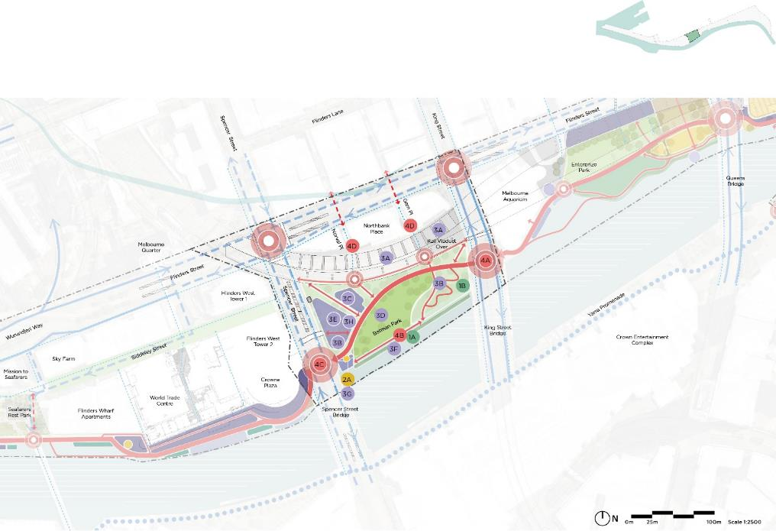

River Park Precinct Illustrative Master Plan
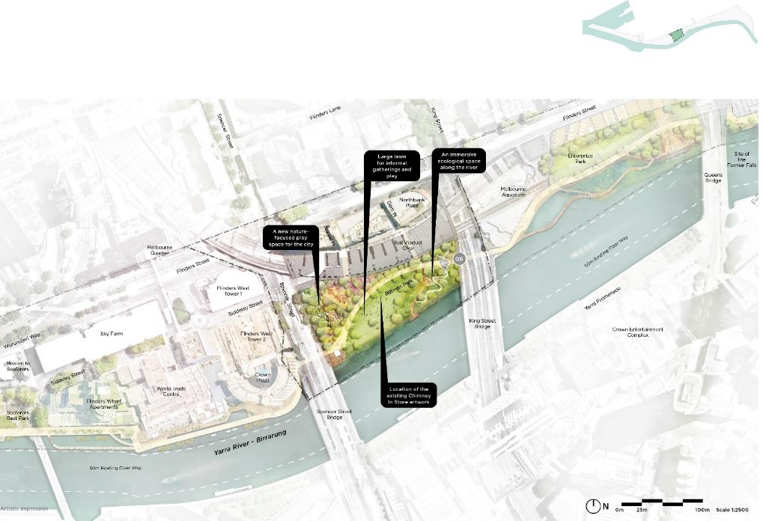

River Park Precinct – Batman Park
Batman Park sits at the south-western corner of the Hoddle Grid and, at present, it lacks amenity and identity. With investment, it will become an important riverside destination for the local community and visitors to Melbourne – full of play, parkland, gardens, wetlands and biodiversity.
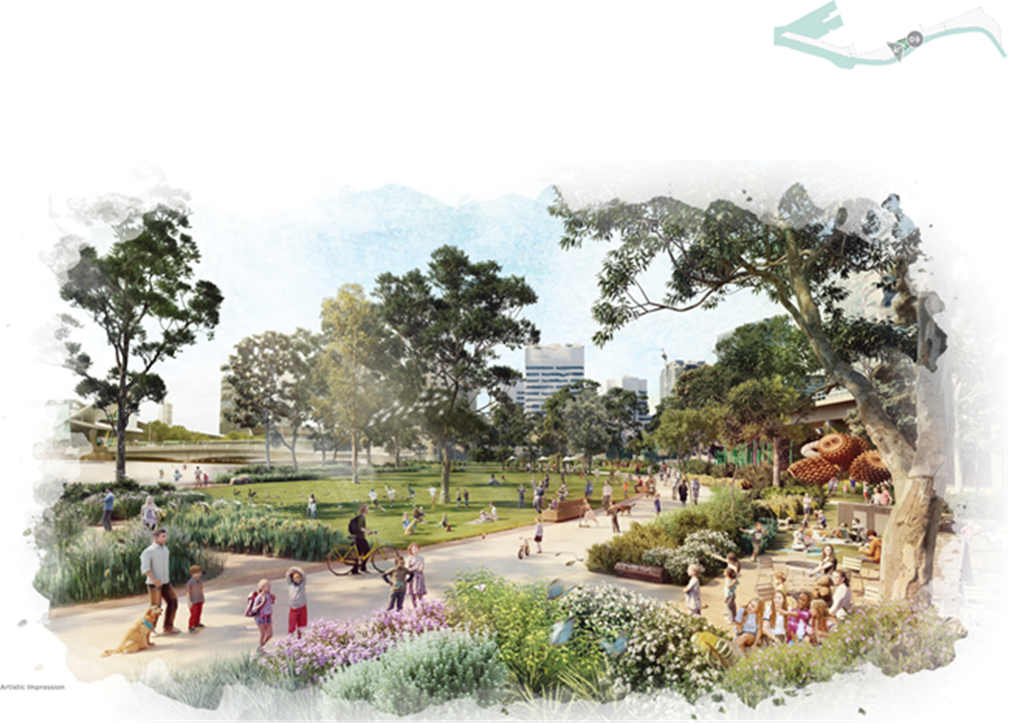

Maritime precinct
This precinct, centred on Crowne Plaza Hotel, World Trade Centre and Seafarers Rest frontage will link the Greenline Project’s central city precincts with Melbourne’s Docklands. The precinct gives us a chance to interpret the city’s rich maritime history.
The wharfs adjacent to the Crowne Plaza and World Trade Centre are underutilised. They will be reconfigured as an integral section of the Greenline Project promenade, providing easier access for people and watercraft, and encouraging activation of restaurants and cafés.
The Greenline Project will strengthen connections between pathways, buildings and open spaces in this precinct, reuniting them as a coherent, maritime-focused promenade experience. Better pedestrian and cycling connections will allow for easier and more enjoyable travel through the precinct and into the CBD, Docklands and Southbank.
Areas of the Greenline Project fronting the future Seafarers Residences will support activated ground-floor retail uses and complement the maritime and industrial history of the area. Seafarers Rest Park provides a new destination and public space at the heart of the precinct, where elements of Melbourne’s maritime heritage and industry are revealed.
Along the promenade, we will identify opportunities for experiences on the water, including detailed interpretation and education nodes. We will shape ecological treatments to the river edge that support river habitat, complimenting new indigenous plantings and floating wetlands along the promenade.
Docklands Park forms an important open space intersection with the Greenline Project, with the opportunity to turn the two parklands into one expanded open space network. The ecological function of Docklands Park and its river interface will be improved through the introduction of estuarine ecology zones. We will explore the introduction of saltwater tolerant plants, such as mangroves, to the former wetland at Docklands Park South.
These initiatives will create a seamless and rich river experience. The public realm, pedestrian connections and ecological encounters will improve people’s interaction with the area’s built form and retail trade. It will increase visitation to the precinct with flow-on benefits for the economic revitalisation of the immediate vicinity and the Siddeley Street precinct more broadly.
The project team will work closely with property owners and managers to realise the master plan vision and Woven Line actions.

Master Plan actions

River as a living entity – creating a living, healthy ecosystem
Maritime Park
- Improve the ecological and habitat value of the hard river’s edge at World Trade Centre Wharf, Flinders Wharf Apartments and Seafarers Residences.
- Enhance existing mangroves and soft river edge adjacent to Webb Bridge.
- Redesign Docklands Park South to adapt to the future impacts of climate change, including the option to introduce a saltwater ecology to the former rain garden.
Overall
- endeavour to retain existing healthy and high-quality trees. Allow for a tree succession plan that fosters the planting of more indigenous species.
- reduce the risks posed by sea level rise and flooding by using design interventions such as flood prevention, innovative materials and surface treatments, without creating new barriers for the movement of aquatic and terrestrial animals and systems.
- explore innovative ecological initiatives to the Greenline Project promenade to enrich local habitat and biodiversity values and help facilitate interpretation opportunities.

Authentic stories and experiences – a cultural landscape
Maritime Park
- Integrate the historic crane into the promenade and surrounding precinct.
- Consider educational installations and playful learning activities on maritime history at Seafarers Rest Park.
Overall
- explore opportunities to tell cultural stories through design and interpretation items.
- recognise, retain and expand on seafarers’ and maritime history throughout the precinct
- coordinate with City of Melbourne’s public art program and management of existing public artworks
- understand the layers of Country and where they can be revealed and nurtured through markers of Country, including materiality, language, stories of place, seasons and natural systems.

Melbourne’s unique character and place – inclusive, safe and accessible
Maritime Park
- Improve the wharf experience at Crowne Plaza Promenade and World Trade Centre Wharf with a focus on new food and beverage and other businesses. Work with the private landowners to improve the safety and amenity in this area.
- Work with the operators of On a Boat and Park Victoria to improve the connection with the river.
- Increase amenity at Flinders Wharf Apartments and to the west of Seafarers Residences.
- Explore options to separate private frontages at Flinders Wharf Apartments
- Integrate the historic facade of Shed 5, Seafarers Residences, into the promenade.
- Build small-scale cantilevered decks over the river for viewing, seating and fishing.
- Provide new amenity in Docklands Park South, supporting the existing playground and wetland area.
- Encourage existing ground floor businesses, such as the fitness centre, to open to the waterfront and park and encourage edge-zone seating for patrons and Greenline Project visitors.
Overall
- provide internet access and include future-proofing digital infrastructure, such as smart nodes.

A connected and vibrant waterfront – a continuous journey
Maritime Park
- Improve the connection between the Crowne Plaza and World Trade Centre Wharf with a new promenade on the water. Coordinate with the Exhibition and Convention Centre to integrate the promenade with Spencer Street footbridge.
- Explore the reconfiguration of the riverfront to create a wide and well-connected promenade.
- Explore the opportunity for an over-water path between Wharf Lane and Seafarers Bridge.
- Integrate the Greenline Project promenade into the existing ambitions of Seafarers Rest Park.
- Improve the connections and crossing to Docklands Link, Navigation Drive and over Charles Grimes Bridge.
- Consider the opportunity to close the southern length of Navigation Drive to motor traffic to connect Docklands Park directly with the Greenline Project (subject to consultation, approvals and traffic management studies).
- Review restrictive cycling signage and provide cycling facilities such as water, air pumps and cycle-network maps.
- Improve the pedestrian and soft mobility crossing conditions at the Batmans Hill Drive intersection to connect Seafarers Rest Park to Docklands.
Overall
- create a generous promenade along the length of the precinct, supported by secondary paths.

Maritime Precinct Spatial Master Plan
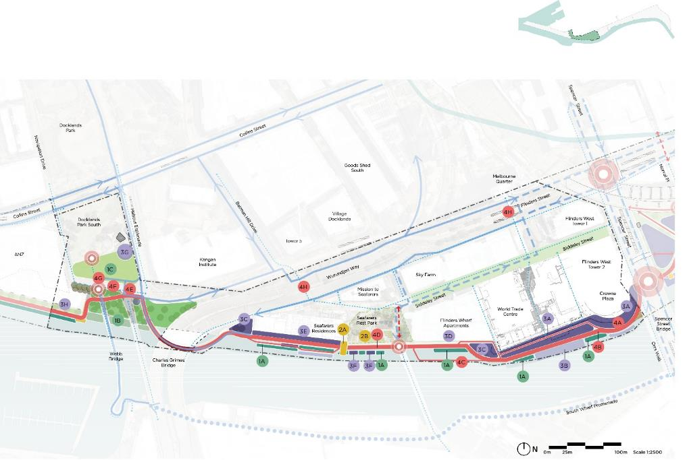

Maritime Precinct Illustrative Master Plan
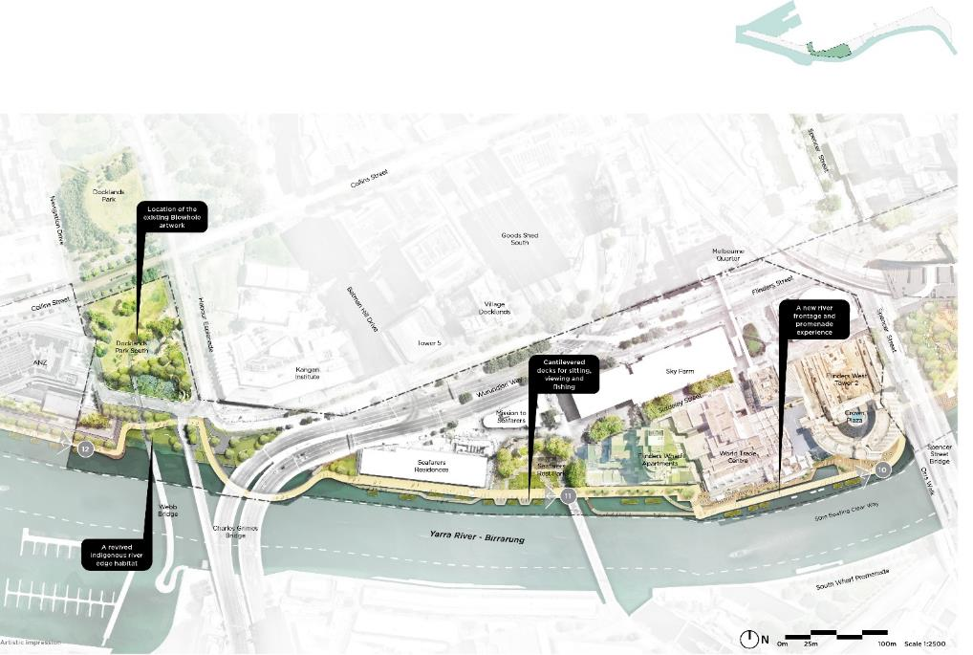
Illustrative plan showing the master plan design and key master plan actions for the Rver Park Precinct.

Maritime Precinct – World Trade Centre and Crowne Plaza
The space along the river at World Trade Centre and the Crowne Plaza Hotel is currently underutilised. We can reconfigure it to be more easily accessible for people and watercraft, which will boost the activation of ground-floor restaurants and cafés.
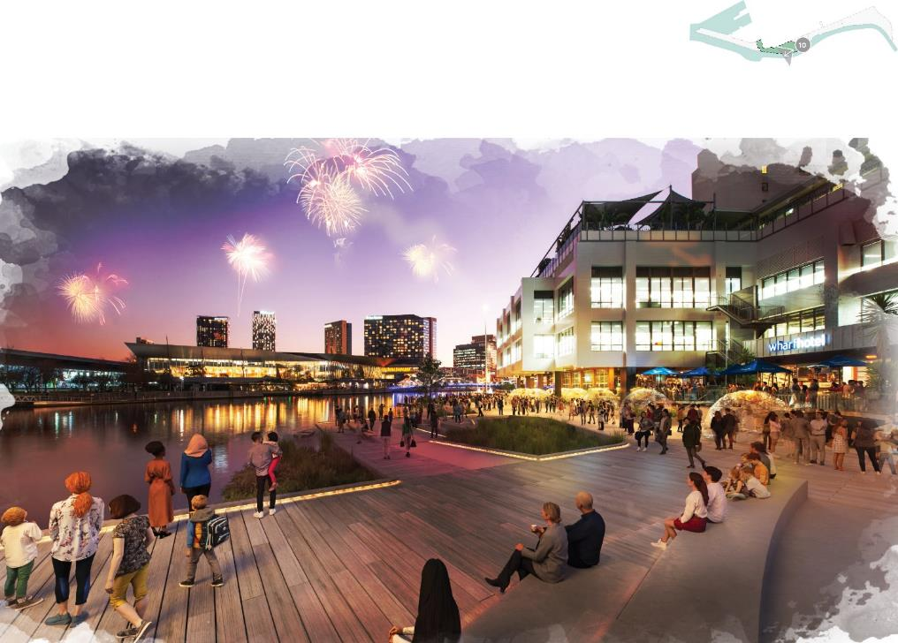

Maritime Precinct – Seafarers Rest frontage
Where the Greenline Project fronts the future Seafarers Residences, it will encourage ground-floor retail outlets and complement the maritime and industrial history of the area. The area will support an active frontage to Shed 5 by connecting with Seafarers Rest Park while improving biodiversity through a new ecologically rich, constructed river edge.
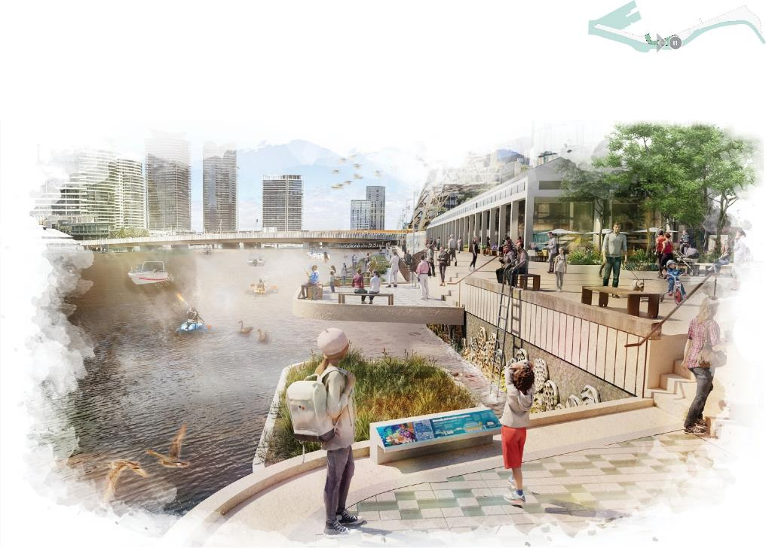

Salt Water Wharf Precinct
This precinct provides unique and contrasting river experiences, with a generous promenade providing views over the broadening waterway, replete with private and commercial boating activities. The promenade will link with the developing Victoria Harbour community and connect Collins Landing with the proposed ecological headland park at the end of North Wharf.
The master plan identifies a series of interventions and improvements to the existing wharf that will enrich people’s experience of the Greenline Project, including improved water interfaces, ecological edges, social spaces and indigenous planted landscapes.
A large portion of the Salt Water Wharf precinct will be designed and delivered by others or has already been completed. We will need ongoing coordination to integrate these elements within the Maritime Precinct.
The river frontage along the Collins Street length of Docklands has a variety of residential and commercial building frontages. The existing promenade presents an opportunity for additional planting, better seating and over-water experiences – creating a sequence of spaces for social interaction along its length. We will explore additional berthing opportunities, along with associated amenities.
The North Wharf frontage is a linear promenade set over the river that suits strolling, jogging, boating and fishing. In this area, we propose new ecological edges to improve the river’s biodiversity.
The junction of the Yarra River - Birrarung at the headland of Victoria Harbour is a majestic setting to view and experience the river. A new ecologically focused park is planned in this location to better connect visitors to the river’s natural ecology and offer environmental education and interpretation. The master plan identifies the potential for a river punt to Fisherman’s Bend, enabled by the proposed boardwalks and seating.
The precinct will connect seamlessly with the developing community at Victoria Harbour. The proposed public park at North Wharf will be valued by residents and workers and will also create a new destination for visitors to Melbourne. Visitors to the precinct will activate the emerging Victoria Harbour and Docklands communities, providing more stability and resilience to local businesses and cafés.
The project team will work closely with property owners, managers, Development Victoria and the developer of Victoria Harbour, to realise the master plan vision and Woven Line actions.

Master Plan actions

River as a living entity – creating a living, healthy ecosystem
Improve the ecological and habitat value of the hard river’s edge at Australian Wharf and North Wharf through a constructed habitat edge using innovative materials. Explore the potential for floating wetlands or other novel solutions to improve the habitat value at this location.
Collins Wharf Park
- Create an ecological restoration zone at Collins Wharf Park that fosters new habitats and biodiversity.
Overall
- adapt the precinct to the future impacts of flooding and sea level rise, extreme heat, drought and severe storms, including with the use of innovative materials and surface treatments and climate-resilient vegetation species, without creating new barriers for the movement of aquatic and terrestrial animals and systems.

Authentic stories and experiences – a cultural landscape
Collins Street River Frontage
- Explore the opportunity for a cultural node adjacent to the park outside 941 Collins Street.
- Identify how the Heritage Fleet can contribute to the historic working waterfront and maritime heritage experience of the project.
Collins Wharf Park
- Explore the interpretation of ecology and history at Collins Wharf park.
- Work with developers in the adaptive reuse of the old Victoria Harbour Shipping Control Tower and its integration into Collins Wharf park.
Overall
- use indigenous plantings and interpretation to tell stories of Wurundjeri Woi-wurrung cultural values throughout the precinct
- integrate adaptive re-use of port infrastructure in the design to celebrate the precinct’s maritime history
- retain the authentic maritime character and qualities of the wharf
- coordinate with City of Melbourne’s public art program and management of existing public artworks
- understand the layers of Country and where they can be revealed and nurtured through markers of Country, including materiality, language, stories of place, seasons and natural systems.

Melbourne’s unique character and place – inclusive, safe and accessible
Work with operators, developers, property owners and Parks Victoria to provide opportunities for boat mooring and enhance the connection with the river.
- Collins Street River Frontage
- Improve the public experience of Australian Wharf, including opportunities for respite and informal recreation.
- Integrate the promenade with the existing open space at Collins Landing.
- Explore opportunities to collaborate with developer at North Wharf and at 907 Collins Street to improve public space and connectivity for all users.
Collins Wharf Park
- Create a new ecologically focused park to better connect visitors to the river and provide a memorable destination for the Greenline Project promenade. Provide park amenities such as toilets, barbecues and seating at Collins Wharf Park.
- Investigate potential future ferry drop off/pick up location.
- Integrate the Greenline Project promenade with the proposed marina to ensure it promotes public benefit and access.
- Provide an access point for small watercraft at Collins Wharf Park.
Overall
- provide internet access and include future-proofing digital infrastructure, such as smart nodes
- integrate promenade with future open spaces – Promenade Park, Community Green and Eco Park.

A connected and vibrant waterfront – a continuous journey
Collins Street River Frontage
- Improve the legibility of the connection to Docklands Link and Navigation Drive from Australian Wharf.
- Consider the integration of a potential tram bridge extension from Collins Street.
- Prohibit motorcycle parking under the trees on the southern facade of 839 Collins Street and replace it with diverse public seating and picnic options. Encourage the restaurant at the southern facade of 839 Collins Street to open to the waterfront and Greenline Project.
- Integrate the Greenline Project with the existing wharf at Victoria Harbour promenade and create clear links with the Library at the Dock and the Community Hub at the Dock.
- Consider additional lighting – while minimising its impact on the daily cycle of wild animals – and signage at Buluk Park lawn edges to support public life, navigation and movement onto the Greenline Project.
Collins Wharf Park
- Explore a potential ferry connection for pedestrian and cycle links to Fishermans Bend and Moonee Ponds Creek.
- Install clear signage and wayfinding to guide commuter cyclists towards nearby designated bike routes, diverting them from the primary promenade.
Overall
- create a generous promenade along the length of the precinct, supported by secondary paths
- create an adaptable design with the capacity for future connections to the south bank of the river, Moonee Ponds Creek and Fishermans Bend.

Salt Water Wharf Precinct Spatial Master Plan
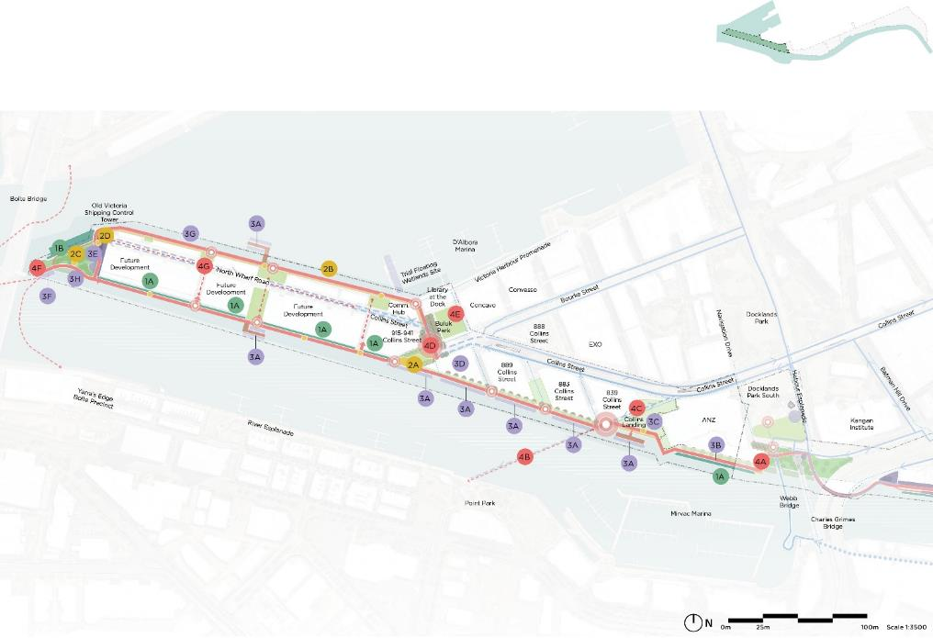

Salt Water Wharf Precinct Illustrative Master Plan
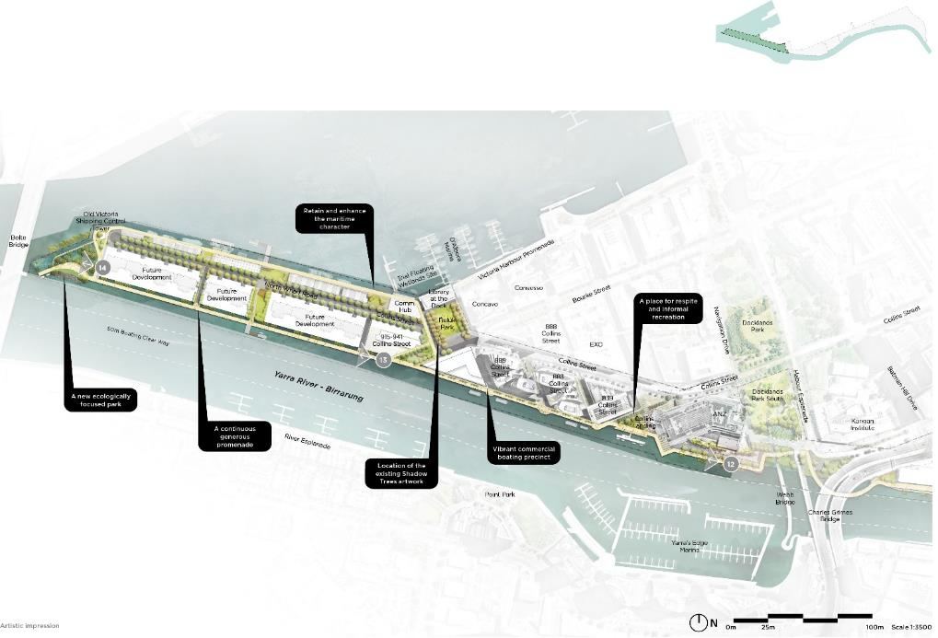

Salt Water Wharf Precinct – Collins Street river frontage
Along the Collins Street length of Docklands, the river has a variety of existing residential and commercial frontages. Additional planting and a better public realm will connect this promenade with the rest of the 4-kilometre north bank journey. We will retain and service commercial berthing facilities and install new public seating and viewing spaces.
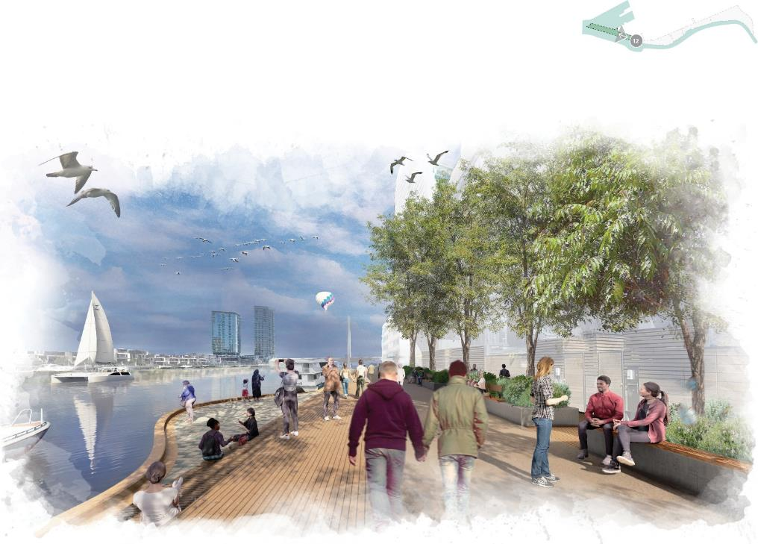

Salt Water Wharf Precinct – North Wharf Road River Frontage
This is an area for existing and future residential development. It can offer a public promenade over the changing river as it merges with the harbour – bringing together the variety of new buildings and public spaces at this end of the north bank.
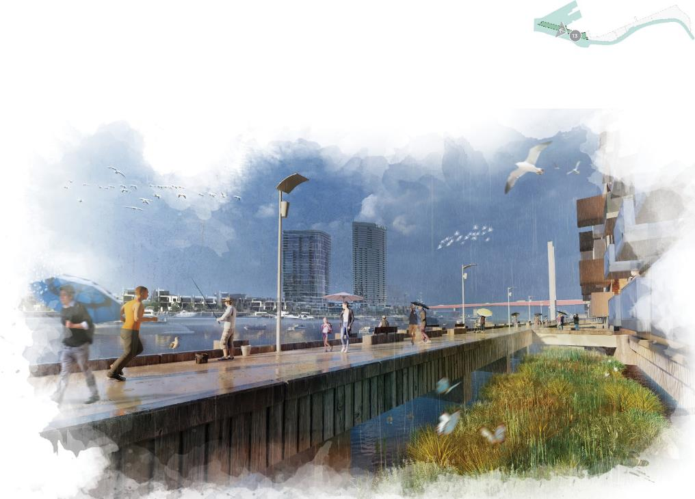

Salt Water Wharf Precinct – Collins Wharf Park
A new public park is planned at the end of the north wharf of Victoria Harbour. It will become a key destination at the city’s edge, celebrating the natural ecology and character of the Yarra River - Birrarung.
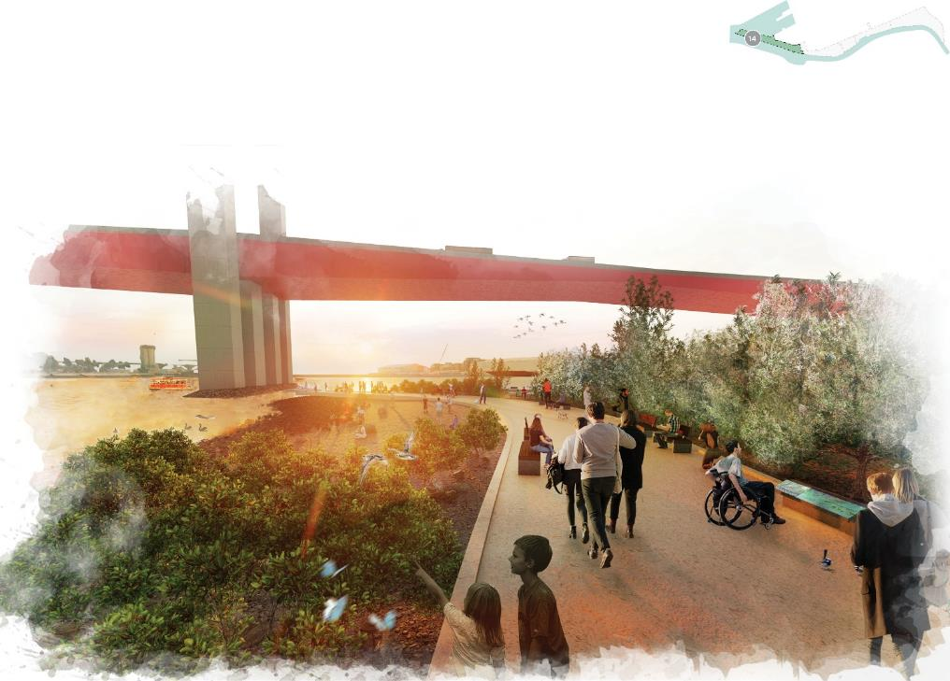

Woven Line threads
With the woven line threads, we highlight strategic details within the themes and designs in previous chapters. The threads are developed from the objectives in the Yarra River - Birrarung Strategy and the Greenline Implementation Plan.
Each thread introduces a key design dimension and lists what the master plan will do and what we will explore in the later stages of the project. The threads are grouped under our four themes: ecology, culture, place and connection.

Ecology - River as a living entity
- Planting and Ecology
- Integrated Water Management
- Resiliency and Climate Change

Culture - Authentic stories and experience
- Wurundjeri Woi-wurrung Culture and Identity
- Melbourne’s History
- Creative Strategy
- Wayfinding and Interpretation

Place - Melbourne’s unique character and place
- Open Space and Park Network
- Events and Programming
- Lighting
- Built Form
- Digital Strategy
- Safety and Inclusion
- Economic Activity and Value Creation

Connection - A connected vibrant waterfront
- A Generous Promenade
- Pedestrian Links and Active Transport
- Water Based Uses

Others - Key topics across all themes
- Consultation and Engagement
- Maintenance and integrated land management
- Furniture and Materials
- Sustainability

Planting and ecology
Create a biodiverse riverfront that reflects the character and qualities of the river’s indigenous landscape.
The Greenline Project will provide a continuous biodiversity corridor through the city, enriching the ecological value of the north bank and increasing habitat for native fauna. Planting will be informed by an understanding of Country and key cultural plant species, as well as local Ecological Vegetation Classes. We will establish measurable targets to ensure we meet our ecological and biodiversity aspirations.
The Greenline Project’s planting and ecological design will:
- increase the health and biodiversity of the river by
- re-establishing native ecosystems and habitat
- strengthen the Yarra River – Birrarung ecological corridor and the experience of being on Wurundjeri Country with culturally significant and indigenous plants, providing opportunities for education and knowledge sharing
- acknowledge, promote and celebrate the ecological and amenity value of all existing trees
- consider the hydrology of the river when choosing plants, including the interaction between fresh water, salt water and the broader stormwater catchment
- explore the potential for floating wetlands to provide habitat and improve biodiversity – informed by the current trial
- consider tree species that are resilient to climate change
- respond to the existing salinity and microclimates of the site
- explore plants that are most suitable for water sensitive urban design.
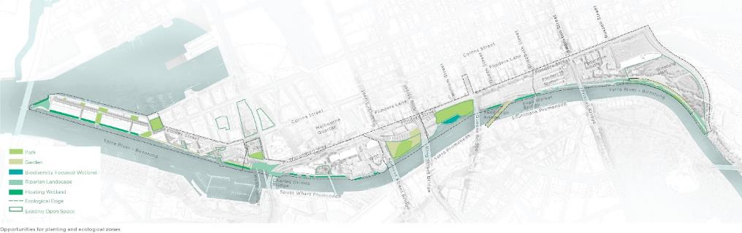

Integrated water management and flood mitigation
Safeguard the river’s health by processing water on site and improving its ability to withstand floods
The impacts of climate change pose significant risks to the health of the Yarra River - Birrarung. Integrated water management and flood mitigation are vital design strategies for its future resilience.
The design of the Greenline Project will:
- incorporate green infrastructure and drainage systems that manage stormwater runoff and reduce the risk of flooding, while improving water quality
- design with the dynamic nature of the river – its tidal variation and capacity to expand during floods
- investigate appropriate flood modelling to demonstrate the site’s ability to manage future flood, storm and tidal surge events
- provide flexible spaces that can be used for different purposes and functions in varying weather conditions
- increase tree canopy coverage, sustainably irrigate green spaces and permeable surfaces where possible to reduce heat absorption, improve air quality and provide shade and respite for people and wildlife
- align with the objectives outlined in City of Melbourne’s Municipal Integrated Water Management Plan
- explore water sensitive urban design initiatives to process stormwater before it is discharged into the Yarra River - Birrarung
- explore processing the city’s stormwater through bioretention systems and then reusing it for irrigation, or other non-potable uses, to create new ecological areas.
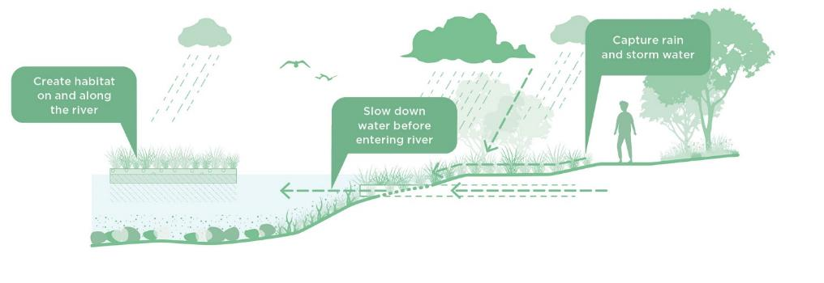
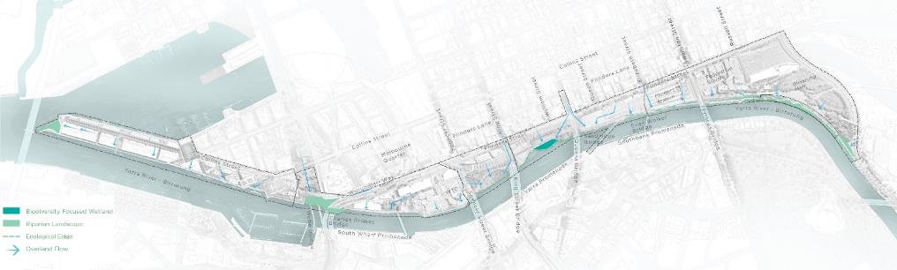

Resilience and climate change
Become more resilient by adapting to climate change impacts, becoming energy efficient and developing a circular economy.
The City of Melbourne’s declaration of a climate and biodiversity emergency in 2019 highlights the urgent need for sustainable and resilient solutions. In response to these pressing challenges, the Greenline Project has a responsibility to integrate community resilience to climate change and ensure adaptability to future extreme weather conditions.
The Greenline Project will:
- specify the most energy-efficient and serviceable options to reduce the energy consumption of infrastructure
- design spaces that consider and address the risks of climate change hazards
- identify building materials with high recycled content that can be used in the Greenline Project
- explore implementing a recycling plan for demolition waste generated during the construction process
- explore how the Greenline Project can help individuals, communities, businesses and institutions to adapt, thrive and survive in a changing climate
- identify materials that have low environmental impact and are suitable for end-of-life recycling or repurposing
- establish a methodology to measure and track embodied carbon footprint throughout the design and construction phase
- explore emerging building products that are manufactured in accordance with circular economy principles
- prioritise sustainable energy practices and minimise carbon emissions, exploring the possibility of becoming a carbon-neutral park
- conduct a climate change risk assessment to support building for extremes throughout the project
- consider the needs of community and emergency responses during heat, storm and flood events.
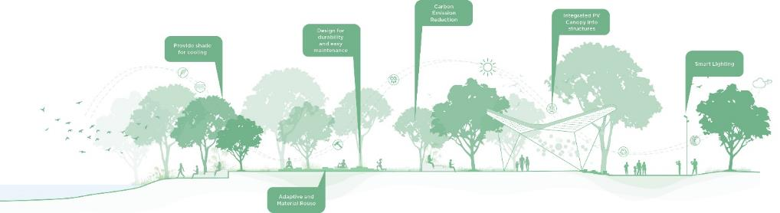

Wurundjeri Woi-wurrung culture and identity
Create and celebrate meaningful connections and places for a range of cultural activities
The Greenline Project has continued the engagement process with Wurundjeri Woi-wurrung Cultural Heritage Aboriginal Corporation as the Registered Aboriginal Party.
As part of the master planning process, we have sought to understand opportunities for celebrating Wurundjeri Woi-wurrung culture and practices, as well as telling the truths of the history of the Yarra River - Birrarung. This includes narratives, stories and places for connection and cultural practice.
The master plan design reflects the framework for improving the health and wellbeing of Country. In partnership with Wurundjeri Woi-wurrung, we will continue to explore these layers of the project in the precinct planning stage.
Opportunities may include:
- increasing understanding of the Yarra River - Birrarung’s Aboriginal heritage while elevating Wurundjeri Woi-wurrung knowledge throughout the project
- understanding the layers of Country and identifying where they can be revealed
- identifying markers of Country that can be retained or re-introduced
- prioritising indigenous plants to re-establish habitat and strengthen the river as an ecological corridor
- creating a healthier waterway through increased aquatic vegetation and other methods
- expressing history and relationships between different places in both tangible and intangible outcomes
- removing barriers that prevent culturally safe practices
- designing spaces to allow for education, gatherings, ceremonies and special occasions at key locations
- including culturally relevant resources within the project, especially the availability of important plant species.
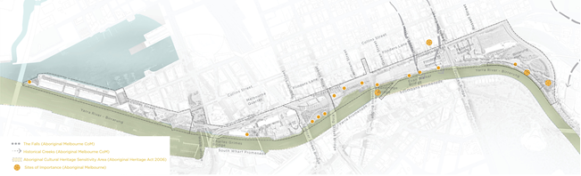

Melbourne’s history
Acknowledge culturally significant sites and showcase Melbourne's distinctive identity
The Greenline Project is on the lands of the Wurundjeri Woi-wurrung peoples and has a deep Aboriginal grounding. The settlement of Melbourne was developed on these unceded lands and itself has an extensive layered history. The project seeks to reveal these diverse cultural histories through different journeys and experiences.
The design of the Greenline Project will:
- establish a key new destination for visitors to Melbourne to experience and understand Wurundjeri Woi-wurrung culture and history
- integrate interpretative design strategies that increase public engagement with heritage places, sites, and elements
- identify and reveal new heritage places, sites, or elements and integrate them into the design
- implement restoration and conservation measures to improve the condition of heritage places, ensuring they are preserved for future generations
- connect heritage places with the wider history of the city and its development, through interpretive signage and storytelling
- create a historical narrative that links the listed places with the surrounding city and showcases their significance to visitors
- integrate both the north and south wharves into the Maritime precinct, creating a cohesive and interconnected maritime heritage experience for visitors
- incorporate Wurundjeri Woi-wurrung history and stories into the maritime theme, highlighting the deep connection between the land, the river and its Traditional Owners
- consider the use of existing and emerging digital technologies where appropriate, such as augmented reality, audio tours, podcasts and QR codes.
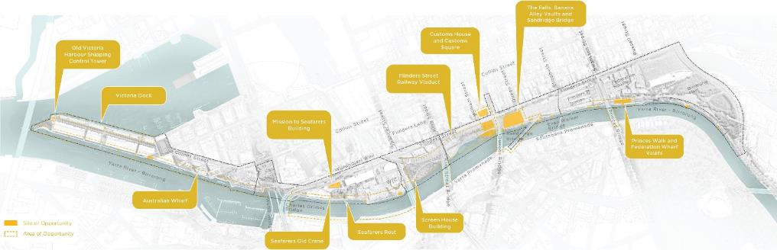

Creative strategy
Realise a suite of compelling public artworks and creative experiences
The Greenline Project will commission a series of integrated, site-responsive public artworks celebrating the character of Melbourne’s north bank and surrounding landscape, and its diverse communities. The public art program will provide avenues for deeper connections to the Yarra River - Birrarung, helping to bridge the cultural and spiritual divide between traditional and contemporary cultures. It will support both active and passive cultural engagement, storytelling and notions of personal responsibility for the river’s care and respectful conduct on Wurundjeri Woi-wurrung land.
The Greenline Project creative strategy program will:
- incorporate the principles of City of Melbourne’s Public Art Framework 2021–31 in the design process
- introduce opportunities for collaborative commissioning to allow artworks to emerge from the design process and, conversely, for the design to be informed by creative inquiry
- retain Aboriginal public art in the open space where possible
- present both permanent and temporary public artworks
- provide programmable platforms to facilitate the development and presentation of temporary art and creative programming
- develop creative solutions that respond to the Greenline Project’s objectives by fostering strong connections to place and respect for Kulin knowledge, tradition and values
- present meaningful engagement opportunities to generate a deep connection to the Yarra River - Birrarung and the broader Greenline Project, and respect for Melbourne’s cultural diversity
- acknowledge existing artwork and continue to deepen the sense of place with an integrated creative strategy.
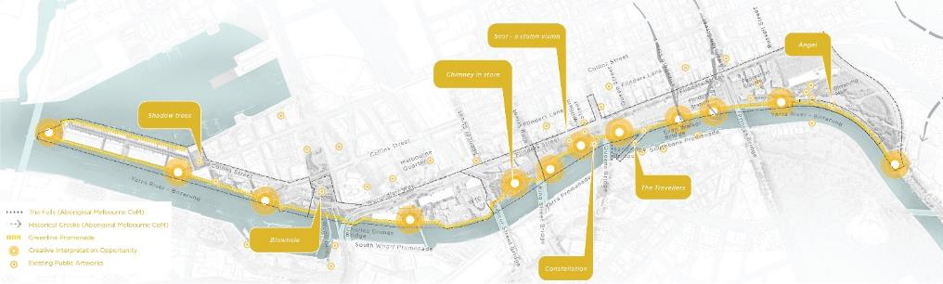

Wayfinding and interpretation
Integrate wayfinding and interpretation methods to enhance the visitor experience
The Greenline Project will deliver consistent wayfinding signage along its full length, building on City of Melbourne’s standard suite of elements, while creating a journey for all visitors.
We will explore opportunities to reveal local history, stories, old and new buildings, cultural spaces, public art, ecological knowledge, education and digital interpretation.
Interpretation strategies for the Greenline Project will include integrated signage, digital and augmented experiences and self-guided and in-person tours that will enhance visitor experiences.
The design of the Greenline Project will:
- incorporate high-level wayfinding and interpretation strategies to facilitate connectivity
- deliver a clear, accessible wayfinding experience for all user groups along its length, enhancing visual and physical connections to adjacent sites and thoroughfares
- elevate the visibility of Aboriginal culture and storytelling
- innovate beyond physical signage with tools such as digital technology to aid navigation for people with a range of abilities, languages and ages
- reflect multiple histories of the river and ways of understanding the site, while supporting multicultural use of the spaces
- provide opportunities for education, especially encouraging exploration along the river’s edge and understanding the natural systems and ecology of the city
- consider dynamic wayfinding to indicate changes due to events or other disruptions, including events, floods or hazards
- explore a range of interpretive narratives by using multi-sensory elements for all user groups
- use intelligent wayfinding measures to encourage city-bound commuter cyclists to take alternative routes.
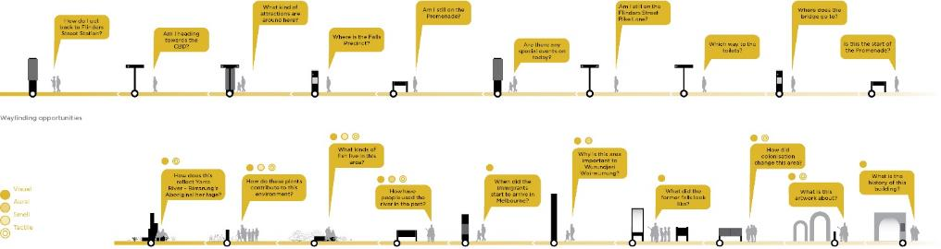

Open space and park network
Define a series of inviting, public and open riverfront spaces
The Greenline Project will play a crucial role in meeting the open space needs of the current and future community of Melbourne.
The parks along the north bank represent the majority of open space in this area of the city; access to these spaces is critical for the health and wellbeing of nearby residents and workers.
The project gives us a chance to improve the existing open space network. We will provide a greater diversity of recreational land and water-based activities for the local community and visitors to enjoy.
The design of the Greenline Project will
- increase the diversity of public open spaces, creating new amenities along the riverfront to encourage greater community use and activation of the river’s north bank
- support more physical activity and the use of active transport along the river
- support better physical and mental health and wellbeing of city residents and workers
- provide open spaces that are comfortable, inclusive, safe and inviting
- result in no net loss of parkland
- avoid introducing encumbrances to open spaces or permanent advertising
- aspire for open spaces to be primarily for public use
- introduce commercial activity within parks only where it enhances the experience of the open space for users
- explore introducing dog off-leash areas to serve the residents in the western end of the CBD
- introduce active and inviting public space interfaces to activate the north bank.
- develop welcoming connections and engagements with the water.
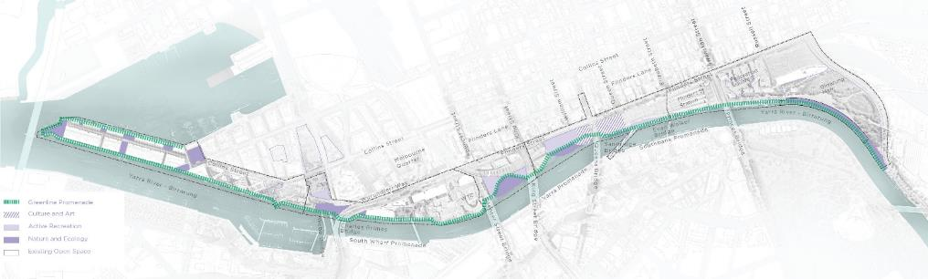

Events and programming
Create a welcoming environment through diverse events and programs
The Greenline Project will activate the north bank, significantly increasing community engagement with the river. It will provide capacity for various activities and events that contribute to the character and function of each open space.
The spatial planning and programming of all open spaces will consider flexibility and crowd capacity and safety during large-scale capital city events, while balancing the day-to-day needs of the local community.
The design of the Greenline Project will:
- support activation that promotes community participation and inclusion
- support seasonal street trading and pop-up sites
- support events and uses that stimulate a night-time economy and twilight trading hours
- acknowledge Aboriginal culture and knowledge
- create spaces that recognise the health of the river
- include fixed infrastructure for events, such as lighting, power and communications
- support large annual events, such as Moomba, New Year’s Eve, RISING, Head of the Yarra and Yirramboi Festival.
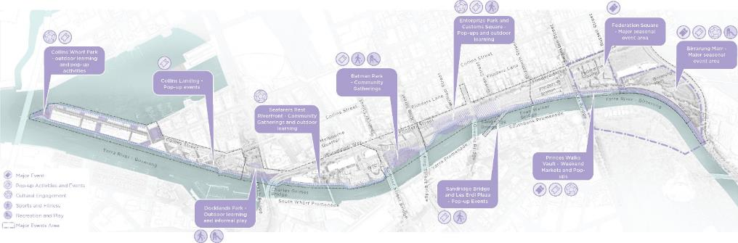

Lighting
Promote 24-hour activity and a safe and engaging night-time experience
The Greenline Project will deliver public lighting that creates a cohesive night time experience, balancing safety and navigation, while being equally mindful of ecological and environmental considerations.
The design of the Greenline Project will:
- adhere to City of Melbourne’s Public Lighting Strategy 2021 and draw from other relevant international standards for best practice in lighting design
- convey a sense of safety at night for all users throughout all precincts
- provide functional lighting to pedestrian and park pathways with areas of higher illumination at key experience zones.
- control lighting so that parklands and other sensitive ecological zones maintain a lower level of lighting
- deliver lighting that is complimentary to wayfinding and navigation aspirations
- consider the need for low-light solutions based on ecological considerations and benefits
- explore feature lighting at key points that will provide moments of wonder and intrigue
- integrate lighting with interpretative design and artistic elements.
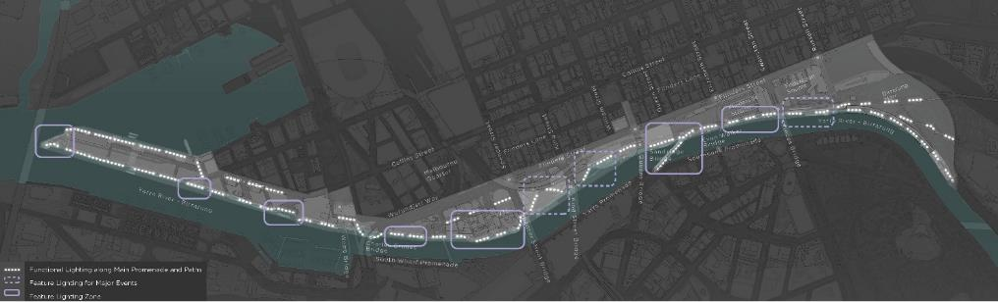

Built form
Reconsider the relationship of the built form to the river
Since European settlement, the development of the Yarra River - Birrarung’s north bank has prioritised transportation infrastructure, creating a barrier between the city and the river. Much of the existing built form has a heavy, infrastructural character, while modern building additions have typically added little to the quality of the riverfront.
The Greenline Project presents a pivotal opportunity to reconsider the relationship of existing buildings to the river. We can explore ways for new built forms to enhance the experience of the river and revitalise the north bank.
The design of the Greenline Project will explore opportunities for:
- refurbishment of heritage buildings and infrastructure through restoration and complimentary new additions
- activation, programming and improved amenity of existing bridges, such as Sandridge Bridge, and new bridge infrastructure
- activation, programming and improved amenity of existing railway viaducts
- new built form to add value to a revitalised north bank and attract long-term anchor tenants
- renewed addresses to existing building interfaces that enhance public amenity, activity and presentation to the river, including existing back-of-houses and service zones fronting public areas adjacent to the river
- small-scale structures and activators such as kiosks, shade pavilions, public amenities and community buildings that support the use of public open spaces
- showcasing adaptive re-use, best practice sustainability, energy efficiency, circular economy and low carbon outcomes
- converting nearby buildings to become potential community hubs.
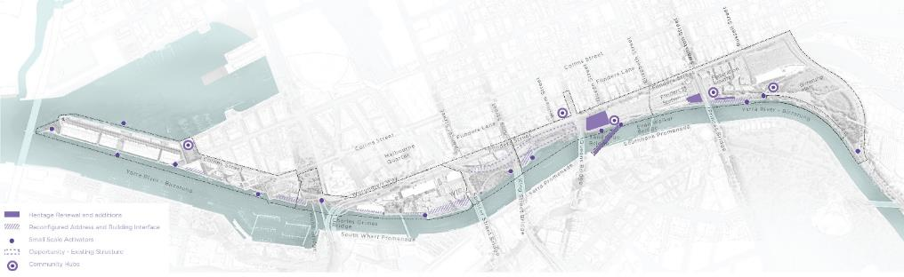

Safety and inclusion
Create an inclusive, accessible riverfront
Poor accessibility is a barrier to the use and enjoyment of spaces along the north bank. In addition, many existing spaces along the river lack a sense of safety, particularly at night, and have limited passive surveillance from adjacent buildings or streets. The Greenline Project is focused on delivering safe, universally accessible, and equitable open spaces for all users.
The design of the Greenline Project will:
- be based on equitable access and inclusivity principles, in line with City of Melbourne’s Inclusive Melbourne Strategy 2022–32 and other international best practice standards
- deliver a generous promenade with a 6-metre nominal width, with access from the city compliant with the Disability Discrimination Act 1992
- deploy signage and wayfinding that caters to the needs of visually and hearing-impaired individuals
- consider crowd management to ensure safety and comfort for all participants during the planning of events and festivals
- cater to the needs of all people, regardless of age, ability, gender or cultural background
- integrate innovative, best practice, universal access design, informed by engagement with relevant user groups to understand their specific needs
- increase safety and perceptions of safety, through environmental design solutions, appropriate security infrastructure and increased passive surveillance and lighting during the day and night, responding to the riverfront location
- provide for safe and effective movement of people including during major events
- plan for toilets and changing places approximately every kilometre
- consider innovative methods that support improved social, health, wellbeing and education outcomes
- undertake Gender Impact Assessments and apply learnings across all aspects of the work, including project processes, engagement, design and ongoing management and activation
- apply an intersectional lens to support equity for the whole community throughout the north bank.
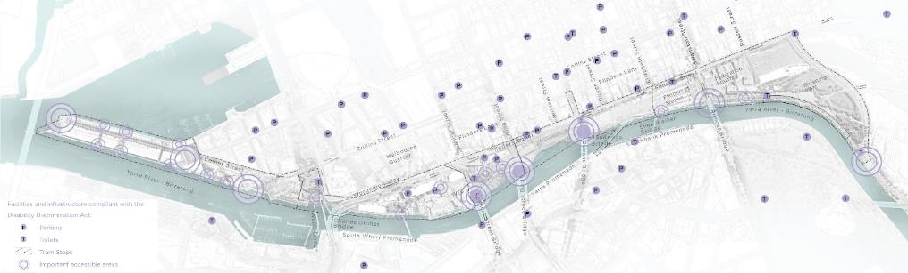

Safety and inclusion – main user groups to consider

Women
Most public spaces along north bank are dominated by male visitors. We need to design new public spaces that cater more to women’s needs. Personal safety from crime and harassement is a key driver for women in deciding whether to spend time in a public space; therefore, it is important to have active zones at the edges of areas, with passive surveillance at all hours, everyday.
The design of the Greenline Project will consider the safety and inclusion of women by designing from the opportunities in the matrix below.

Families with Young Children
Different age groups have different needs:
0-5yrs: Facilities for both caregivers and children are important for this age group.
5yrs +: Larger gathering spaces for children to be active with options to eat, explore, and learn about their city.
The design of the Greenline Project will consider the safety and inclusion of children by designing from the opportunities in the matrix below.

Young people
Large groups of young adults currently visit Enterprize Park. Encourage university and school-based activities to take place along the river front with options for outdoor study, large social gathering spaces, wi-fi access and plug and play, as well as cooking facilities. Unique urban design elements with bold colours are also key attractors.
The design of the Greenline Project will consider the safety and inclusion of young people by designing from the opportunities in the matrix below.

Older people and people with a disability
Commercial and non-commercial edge zones with passive ways to observe public life are already popular with older people along north bank. More opportunities are needed along the riverfront to support and attract older people and people with a disability.
The design of the Greenline Project will consider the safety and inclusion of older people and people with disabilities by designing from the opportunities in the matrix below.

Digital strategy
Improve the quality of open space and visitors’ experiences with spatially embedded digital infrastructure
Urban digital infrastructure and digital technology will play an important role in forming the design, delivery and ongoing management of the Greenline Project. They have the potential to improve the quality of open space and visitors’ experiences and enable forward-thinking design, planning and management of the public realm.
Digital technology and infrastructure can play an important role in the design, development and management of urban environments. City of Melbourne is already at the forefront of local governments across Australia in this field. As a major initiative for the city, the project can demonstrate how digital systems can contribution to sustainability, climate change resilience and cultural life in urban settings. The Greenline Project can demonstrate best practice and create new benchmarks for the city.

What is a digital twin ecosystem?
With the Greenline Project, we aim to develop a Digital Twin model. It will serve as a prototype for the larger city, showcasing the potential and possibilities for future urban development and innovation.
Digital twins can be described as a collection of digital tools that facilitate the finding, visualisation, analysis, simulation and prediction of people, assets and the environment.
A digital twin can:
- find – search and retrieve data from various sources, such as sensors, Internet of Things devices, databases and external systems
- visualise – present and represent the data and information collected from the physical asset or system in a visual format
- analyse – examine and interpret the collected data to derive meaningful insights and make informed decisions
- simulate – replicate the behaviour, characteristics and responses of the physical counterpart in a virtual environment, allowing users to explore different scenarios and test hypotheses
- predict – use historical data and simulation models to forecast or estimate future behaviour, trends or events in the physical asset or system.
Digital twin capabilities:
- Find
- Visualise
- Analyse
- Simulate
- Predict

Digital twin opportunities for the Greenline Project

Engagement
Digital tools can help the community get involved in design decisions, fostering informed and inclusive outcomes. After the project is completed, we can use these tools to gauge community responses. Digital solutions and
initiatives include:
- digital surveys and polls
- virtual reality and 3D modelling
- online platforms.

Placemaking
Digital placemaking uses digital platforms, interactive installations and virtual experiences to engage people, foster community participation and create connections within a place. It transforms public spaces, making them inclusive, interactive and dynamic. Digital solutions and initiatives include:
- virtual and augmented reality
- digital wayfinding
- information kiosks and signage
- public safety.

Sustainability
Our digital strategy furthers the project’s sustainability outcomes by defining measures, seeking efficient data storage and helping effective communication. Digital solutions and initiatives include:
- baseline measures
- feedback metrics
- environmental impacts
- continuous monitoring.

Smart infrastructure
We will use smart infrastructure to help manage the Greenline Project and create transformative experiences for the public. The digital strategy prioritises robust connectivity and the capacity to integrate smart technologies. Digital solutions and initiatives include:
- energy and power supply
- fibre optic, wireless and 5G networks
- sensor deployments
- smart poles
- pit and pipe networks
- physical security.
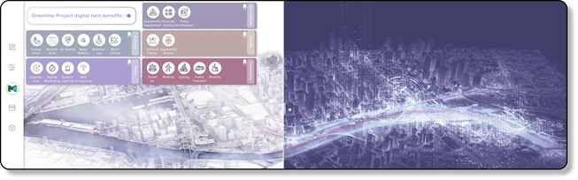

Digital twin capabilities for each project stage
Digital tools, including a digital twin, can be used during planning, design and construction, as well as ongoing management and maintenance. Not all digital tools will be useful at every stage: digital twins are typically most useful when they’re incorporated into the operational phase, as they improve monitoring and maintenance of the project.

Project stages
- Planning and design
- Construction
- Operational (final built form)

Digital twin capabilities
- Data collection
- Federated digital platform
- Design options simulation and assessment
- Community engagement
- Building Information Modelling and documentation
- Construction monitoring
- Data monitoring

Benefits
- Data collected in a federated model can be used to inform the project design and guide its sustainability and environmental benefits
- Digital tools, such as virtual and augmented reality, can support community engagement
- Modelling and monitoring ensure the project’s efficient and sustainable execution
- Real-time monitoring, analysis and optimisation improves management, maintenance, usage and future planning.
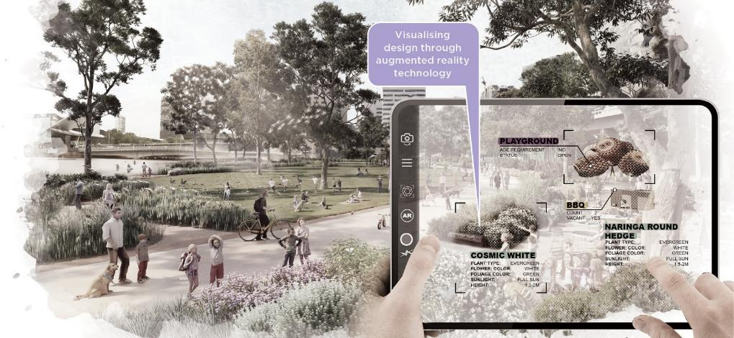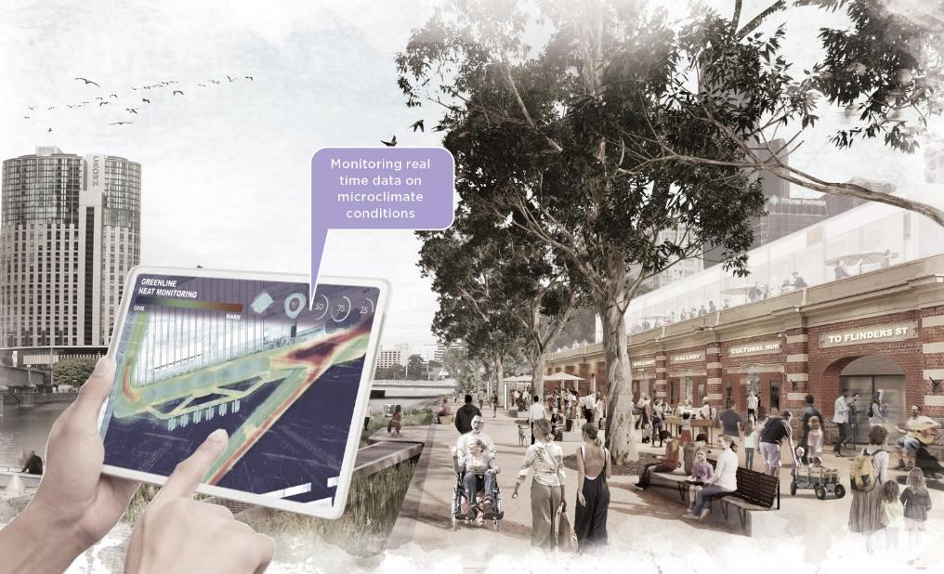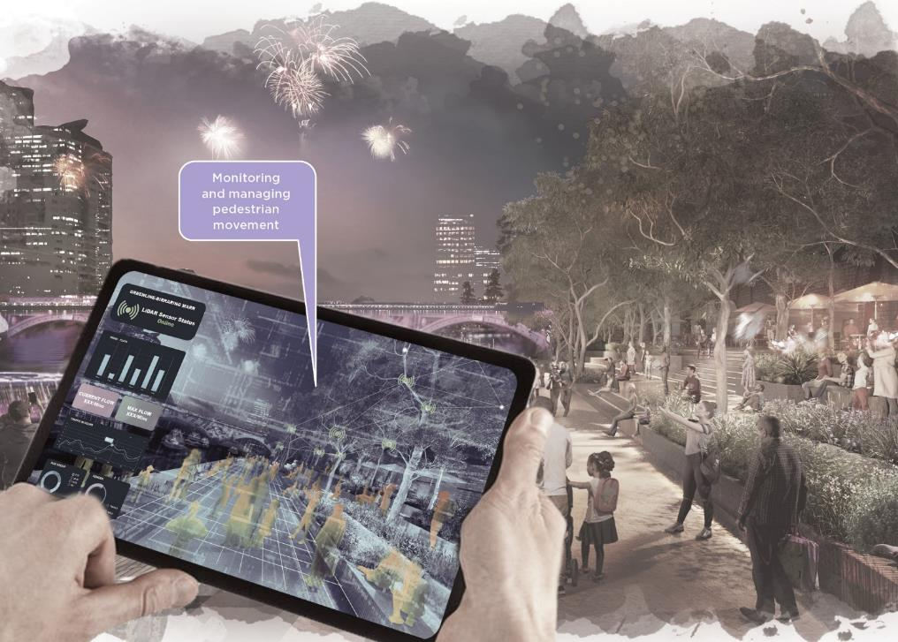

Economic Activity and Value Creation
Identify opportunities to create value and support existing and future businesses
The Greenline Project will have a positive impact on the local economy and adjacent businesses within the Yarra River - Birrarung corridor. The business case for the Greenline Project, released in 2022, confirmed that it has a strong case for investment with every $1 spent resulting in a net benefit of $3.29 to the community. New destinations and a continuous journey along the river will increase footfall and create direct opportunities for existing and new businesses and attract investment in the precinct.
The design of the Greenline Project will support value creation through:
- investing in high-quality open spaces and amenities that will attract both locals and visitors
- exploring social enterprises that encourage Wurundjeri Woi-wurrung and Aboriginal economic participation
- supporting and developing businesses along the riverfront that activate the adjacent open spaces
- improving public transport connections that allow people to easily access the riverfront
- prioritising pedestrian movement along the riverfront
- improving connection along the riverfront that allows people to move easily to establishments
- linking with nearby businesses that may benefit from increased local and visitor numbers
- attracting new residential and commercial developments to the city
- increasing local employment
- creating tourist destinations along the north bank, elevating the overall experience for visitors to the Melbourne Arts precinct and CBD.

A generous promenade
Create a clear, navigable and uninterrupted journey along the river
The Greenline Project will realise a bold and transformative reconnection of the disparate spaces along the northern bank of the Yarra River - Birrarung. It will deliver a generous, 4-kilometre path, with a 6-metre nominal width, from Birrarung Marr to the Bolte Bridge, while also re-establishing the link between the city and the river.
The design of the Greenline Project will:
- create a continuous riverside journey
- provide a series of vibrant and active public spaces that connect the community and city with the river
- link key destinations and provide spaces for recreation, relaxation and social interaction
- ensure safe and inclusive access to the river for all users by providing secondary paths and entries along the main path
- ensure that the promenade is multifunctional and accommodates maintenance and emergency access requirements
- improve crossing points at all intersections along its length
- explore opportunities for small activities along the promenade to ensure an interesting and meandering journey
- diversify opportunities for resting and lingering along the journey
- explore demarcated spaces on the promenade for different traffic speeds to reduce potential conflicts.
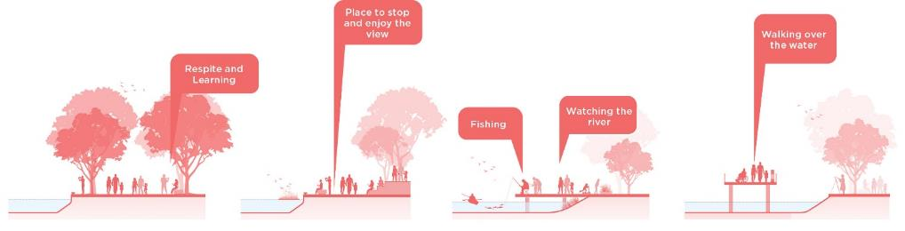
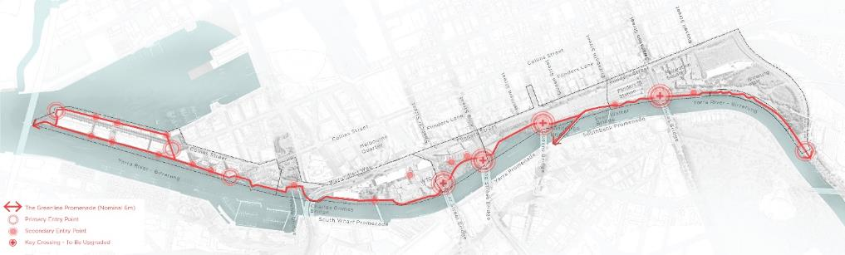

Pedestrian links and active transport
Seamlessly connect the riverfront with the city, prioritising a pedestrian-focused shared path
A key objective of the project is to create safe and clear access to, from, and along the north bank, including connections to the CBD. To balance movement along the promenade with new recreational activities along the river’s edge, we aim to deliver a low-speed environment that is safe for people to walk, ride bikes and use other forms of active transport. The promenade has the potential to become the benchmark for pedestrian-focused shared paths in Melbourne.
The design of the Greenline Project will:
- discourage high-speed cycling and scooter riding and promote alternative routes for commuter cycling that are nearby. The development and ongoing management of the alternative routes are integral to the success of the pedestrian-focused shared path
- minimise conflict between pedestrians and other modes of active transport, including cycling, scooter riding, skateboarding and on-lead dog walking
- encourage the use of public transport infrastructure within the precinct
- support access to water transport and activities and consider future water-based transport options
- integrate intuitive signage, wayfinding and surface material selection that facilitates safe and accessible movement for all users
- provide parking space for cyclists and e-scooter users on the periphery of the project
- consider and adjust to the needs of wildlife
- follow the principles and opportunities relating to cycling in pedestrian-priority shared zones identified in City of Melbourne’s Transport Strategy 2030 and Design and Construction Standards
- prepare a transport and movement strategy that focuses on establishing a safe, low-speed environment for all users.
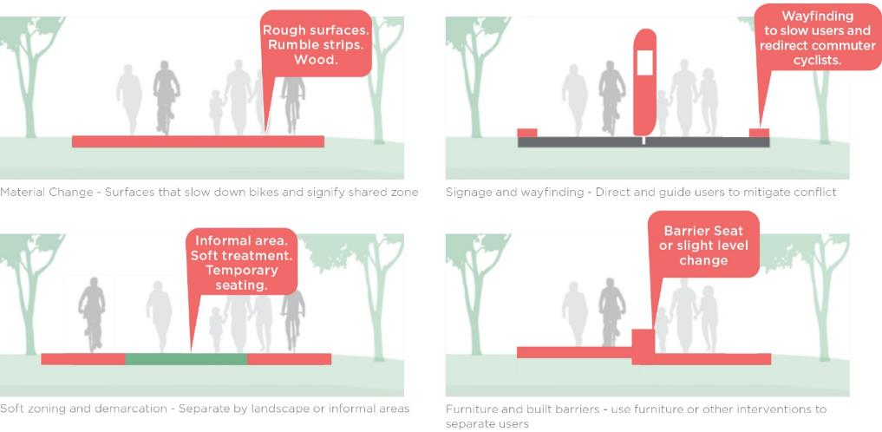
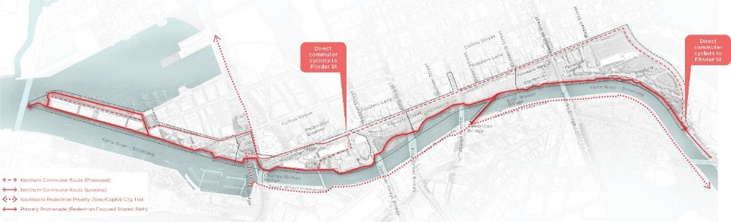

Water-based uses
Promote diverse activities on and along the river
The Greenline Project will consider recreational and commercial water-based functions along the Yarra River - Birrarung corridor. We need to collaborate with Parks Victoria, Melbourne Water and the local boating community to understand current and future needs.
The design of the Greenline Project will:
- consider the needs of recreational and commercial boating
- prepare a waterway operations strategy in collaboration with Parks Victoria, Melbourne Water and the boating community
- review boarding and disembarking and consider relocating and improving commercial berthing infrastructure, in consultation with key stakeholders
- review the projected impacts of sea level rise, sedimentation and increased marine traffic
- review the impact of infrastructure on navigation safety
- minimise litter trapping and look for opportunities to improve litter collection
- provide waterway infrastructure that is secure and visually consistent with the project’s aesthetic
- plan for event infrastructure, including temporary pontoons, gangways, mooring and related promenade infrastructure
- explore opportunities to connect to nearby areas such as Fishermans Bend and Moonee Ponds Creek.
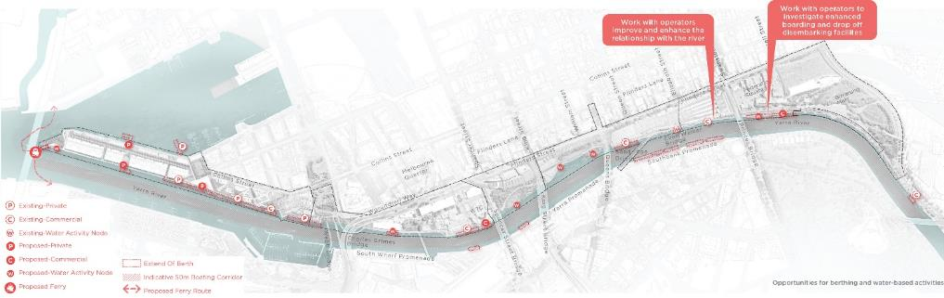

Sustainability
Envision the Greenline Project as a sustainable and resilient public open space
The project can be designed to mitigate and adapt to further climate change impacts, sequester carbon, anticipate future functions with a circular material palette, and prepare for climate change and community shocks and stresses.
The design of the Greenline Project will:

Environmental:
- increase the health and biodiversity of the river by re-establishing native ecosystems and habitat
- increase tree canopy coverage, sustainably irrigate green spaces and use permeable surfaces where possible to provide shade, reduce heat absorption and improve air quality
- explore water sensitive urban design initiatives to process stormwater generated by the project before it is discharged into the Yarra River - Birrarung
- remove carbon from the air through increased planting and tree health
- minimise the use of potable water for irrigation
- explore options for a circular and low embodied carbon material palette

Social:
- be accessible and welcoming to people of all ages, abilities, genders and backgrounds
- create spaces that encourage physical activity and active transportation
- provide opportunities for cultural and artistic expression that reflect the diverse communities of Melbourne
- work with the Traditional Owners to incorporate their perspectives and knowledge
- work with the local community and businesses to integrate their vision.

Economic:
- attract investment and development
- incorporate spaces for events and gatherings that can generate revenue for local businesses
- ensure easy accessibility by public transport to encourage use by visitors to Melbourne
- benefit businesses along and nearby the site
- support a range of events from large to small, pop-ups to seasonal celebrations.
The United Nations Sustainable Development Goals (SDGs) comprise 17 goals, covering a triple bottom line of environmental, social and economic outcomes. They outline an approach to end poverty and protect the planet.
City of Melbourne localised the SDGs by reviewing each goal within our context, developing relevant targets and key indicators of success for each one. The sustainability vision for the Greenline Project incorporates the SDGs. It is an exciting opportunity to demonstrate how individual projects can feed into the bigger picture of sustainability at City of Melbourne.

The project will contribute to a number of SDGs. We have categorised these as:
- priority influence – seven of the most important objectives as highlighted by the Greenline Project business case
- direct influence – how the Greenline Project positively impacts the development, construction and ongoing use, and benefits visitors to the site
- indirect influence – how the Greenline Project positively impacts its immediate surroundings, the city and beyond.
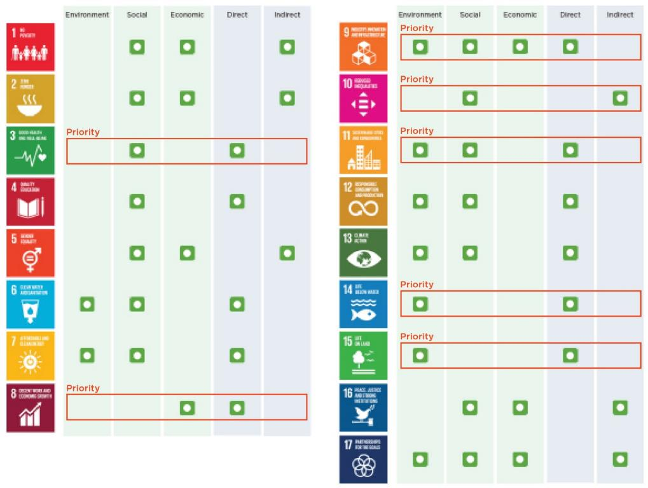

Furniture and materials
The furniture and material palette will give the project a recognisable and legible character, drawing on City of Melbourne’s Design and Construction Standards. Materials and textures should reflect the site’s layered history, geological and hydrological processes, maritime and industrial uses, and contemporary creative elements.
The design of the Greenline Project will:
- incorporate consistent design elements throughout the north bank to create a sense of place
- explore the potential for creating feature elements
- ensure the maintenance and operational needs align with City of Melbourne’s Design and Construction Standards
- investigate furniture and materials that are geographically, historically, culturally and contextually relevant
- investigate furniture and materials that are low embodied carbon, robust, sustainable, and locally sourced, with a high-quality presentation and amenity
- understand where it is appropriate to use City of Melbourne’s standard palette and where it is important to explore alternative feature elements and materials
- explore the use of materials and elements to create low-speed shared zones for cyclists and pedestrians.

Community consultation
Authentic engagement with Melbourne’s diverse resident, worker and business communities is a crucial aspect of the project. City of Melbourne is committed to transparent community consultation processes at all stages of the master planning and design program. Feedback and contributions from the community will continue to shape and inform the development of the Greenline Project to ensure it balances the diverse needs of all users.
We will:
- undertake workshops to involve diverse community groups in the design process to understand their specific needs and perspectives
- consult with the community at critical points to gather feedback, address concerns and make necessary changes to the design
- develop consultation materials that are easy to engage with and understand.

Maintenance and land management
City of Melbourne does not own or manage the full extent of the Greenline Project site. Therefore, the successful delivery of the project will require extensive consultation and cooperation with many landowners and managers. Early in the project, we will need to outline an agreed maintenance strategy that identifies the needs and responsibilities of all parties.
The design of the Greenline Project will:
- identify all landowner and stakeholder interests that need to be considered
- consider the long timeframe of the project and work with an evolving ownership and management environment
- develop a maintenance strategy to clearly set out the responsibility for, and scope of management of, all new and existing spaces
- outline procedures for maintaining and replacing all infrastructure and materials, including end-of-design life plans, in line with circular economy principles
- meet the requirements of City of Melbourne’s Design and Construction Guidelines
- outline planting and softscape maintenance in the short and long term
- reduce litter flows into the river from the local catchment, including with land-based litter collection
- consider ongoing litter management, waste reduction and access for maintenance and litter collection
- include the adequate provision of permanent waste and recycling bins.

Master plan implementation

Next steps and stakeholder engagement

Next steps
The master plan will be implemented over a number of years, beginning with precinct planning and design, then progressing to the delivery of project stages – subject to funding and approvals.
To successfully implement the Greenline Project vision outlined in this master plan, we will need to establish strong partnerships and undertake regular engagement over the course of the program of works.
The key partnerships required to successfully realise the master plan vision include:
- funding
- approvals
- land and asset management and maintenance
- advocacy.

Stakeholder engagement
Our targeted stakeholder consultation and engagement – undertaken prior to and during the development of the master plan – indicates wide-ranging support for the proposed vision.
Successful delivery of the project depends on ongoing consultation at key points. We will undertake broader consultation and community engagement at the concept design stage for each project, prior to delivery.

Phasing
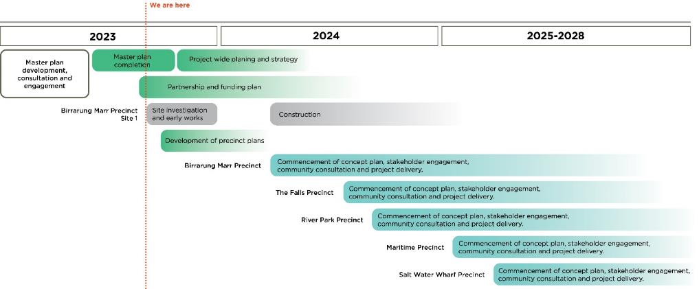

Appendices

Appendix A – Birrarung Marr Precinct Site 1
The City of Melbourne is kickstarting the delivery of the Greenline Project in 2023 with Site 1 of the Birrarung Marr Precinct. A contemporary river edge space will provide unique opportunities for locals and visitors to experience the north bank and the Yarra River - Birrarung. The project will create 450 metres of new boardwalks and a 6-metre wide promenade that will connect native habitats along the river’s edge - a place where Wurundjeri Woi-wurrung Country, knowledge and culture will be celebrated.
Once complete, Birrarung Marr river edge will be the perfect spot to slow down and meander, enjoying views of the river and city from new vantage points. You will also find yourself surrounded by native planting and habitat in the heart of the city.
Birrarung Marr will continue to play host to some of Melbourne’s biggest and best events, facilitating new cultural, creative, and sustainable experiences in a transformed landscape.
With ongoing involvement of Wurundjeri Woi-wurrung informing the Greenline Project development, this vision and draft proposal for Site 1 positions the Yarra River - Birrarung for cultural and environmental education – providing new opportunities for rich cultural learnings led by Traditional Owners.
Early works are expected to begin in 2023, with construction to follow in 2024.
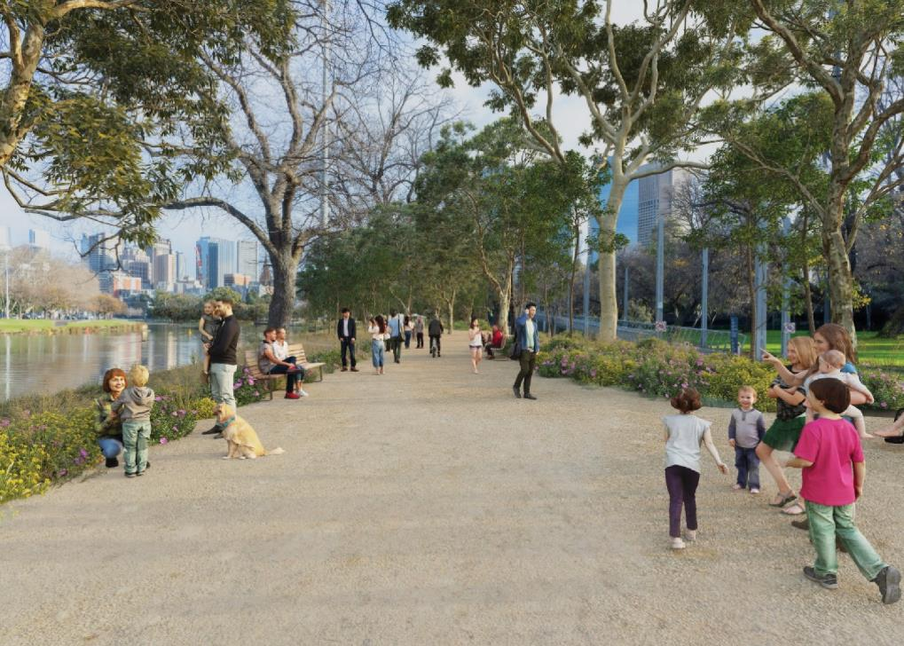

Endorsed concept plan
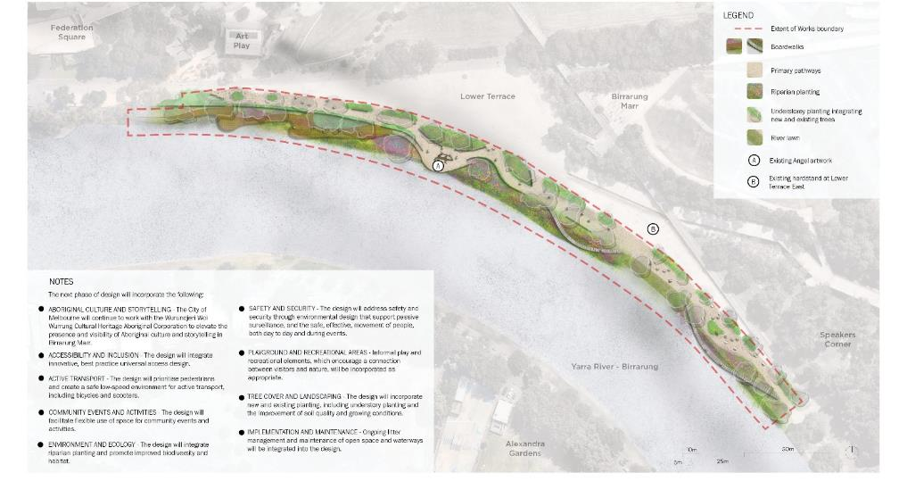

Endorsed concept design
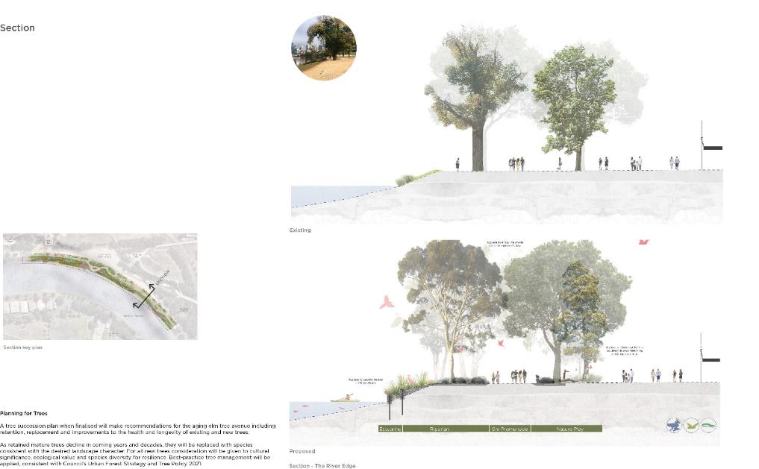

Appendix B – Gehl Report

The Greenline Project health check and design recommendations

Site and Context Analysis “Health Check”
We will add a qualitative layer to existing site analyses by focusing on eye-level observations, challenges, and opportunities, with a particular emphasis on understanding public spaces from a human-centered, user point of view. This includes mapping the following:
- Network of surrounding public spaces
- Connections to /from site and surroundings
- Functions and amenities in the surrounding area
- Analysis of public life and people movement in the area
- Evaluation of public space qualities
- An overall panorama of the Greenline Project’s qualities and trends
- Understanding existing and potential user profiles.

Design Recommendations
Based on the Greenline Health Check analysis, the design recommendations will summarise the key findings and propose actions that can optimise the experience for all users and visitors to Greenline. Specific goals for the design recommendations are:
- Defining existing and future user groups
- Defining key access points and gateways to Greenline
- Defining main outcomes for use, users, activities
- Defining specific recommendations for each precinct
- Defining key opportunities, visions and values
- Setting up suitable benchmark criteria (public life data)
- Highlightling international best practice cases, where relevant
- Providing suggested next steps for future community consultation and digital stream processes.

Gehl Methodology
The Greenline Health Check uses a variety of research methods to create an everyday understanding of the site. The collection of data builds an understanding of public life, public spaces, and buildings within and nearby the site.
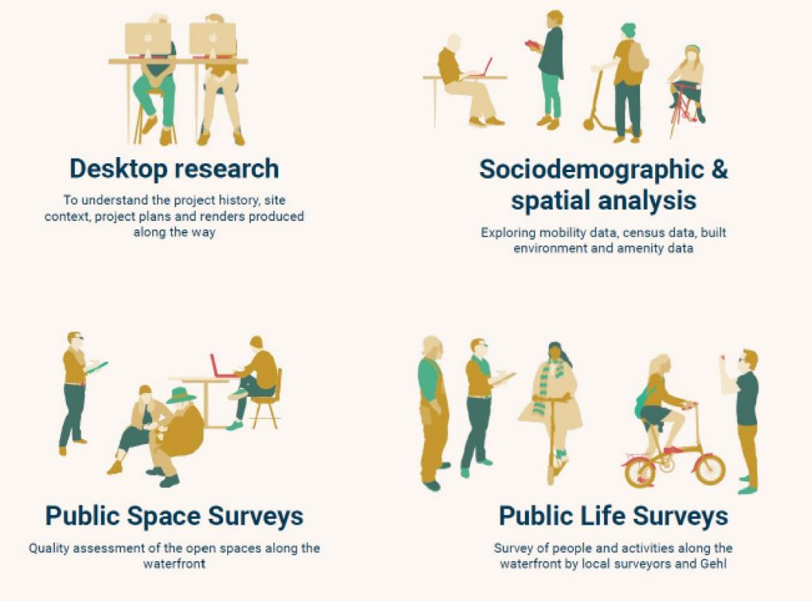

The Greenline Project health check and design recommendations - desktop research and amenities tool
- New working trends since Covid have altered people’s relationship to the city and how they use it
- The Greenline Project’s local residents are still dominated by 25-64 year olds
- The Greenline Project is well supported with supermarkets and minimarts
- Many higher education facilities across project’s’s length, draw young people to the area
- Many cultural and arts facilities, and therefore active edges are located in eastern areas of The Greenline Project
- Many facilities for children are located nearby, but very few play options exist to support this age group
- There are many food and beverage options in the city, but few located on the project site itself
- There is a large concentration of hotels near Spencer Street
- There are many nearby libraries and civic centres, which could beneﬁt from the Greenline Project’s public spaces for their activities
- The Greenline Project has numerous ﬁtness centres nearby which could beneﬁt from its outdoor space.
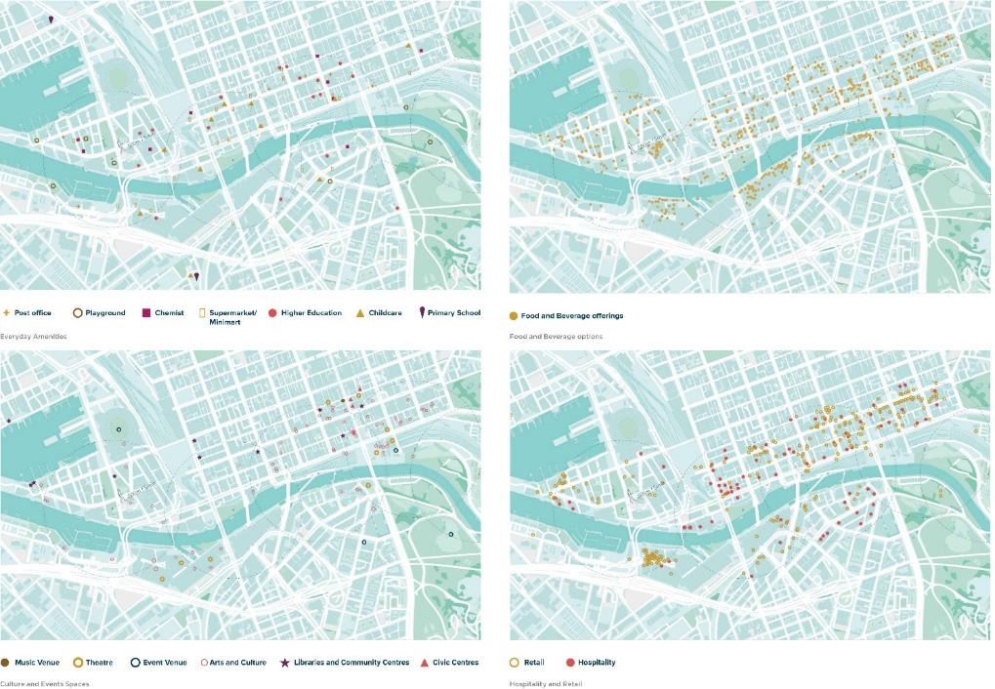

The Greenline Project health check and design recommendations - waterfront access and movement
- Flinders Street is a major barrier between the CBD and the Greenline Project. Long waits at pedestrians crossings are also frustrating
- The site’s feeder streets are of varying quality, but have great potential to support Greenline Project access
- Station access points to the Greenline Project have issues with wayﬁnding and quality
- The site’s narrow sections create conﬂicts between e-scooters, cyclists and pedestrians
- Long stretches of the site are inactive and “impenetrable” with levels issues in the east
- Allocation of space for pedestrians along feeder streets is often inadequate compared to demand
- Access points to the Greenline Project occur at reasonable intervals, however more are needed in some sections
- Activity level increases towards the east, supported by nearby cultural and food and beverage offerings
- The project has the potential to become the benchmark for a pedestrian focused shared path in Melbourne
- The site has fewer teens, young adults and seniors moving through, than the local census spilt.
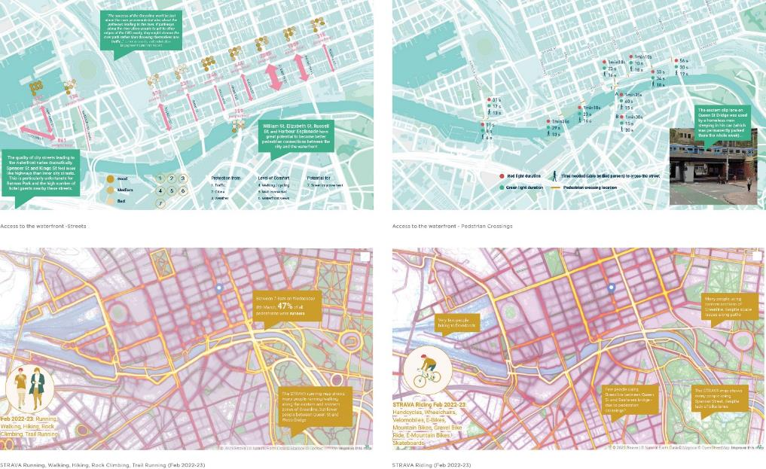

Design recommendations - design for the Greenline Project’s diverse user profiles and social dynamics (people)

Groups and social dynamics
A comparison of stationary groups across the Greenline Project’s sites shows that no larger groups were observed using extremity sites of Birrarung Marr south and Australian Wharf. Federation Square has a high number of small and large groups compared with its square meterage, due to the numerous school groups and large tourist groups visiting. More pairs were recorded nearby Fed Square, where more edge zone activities are found.
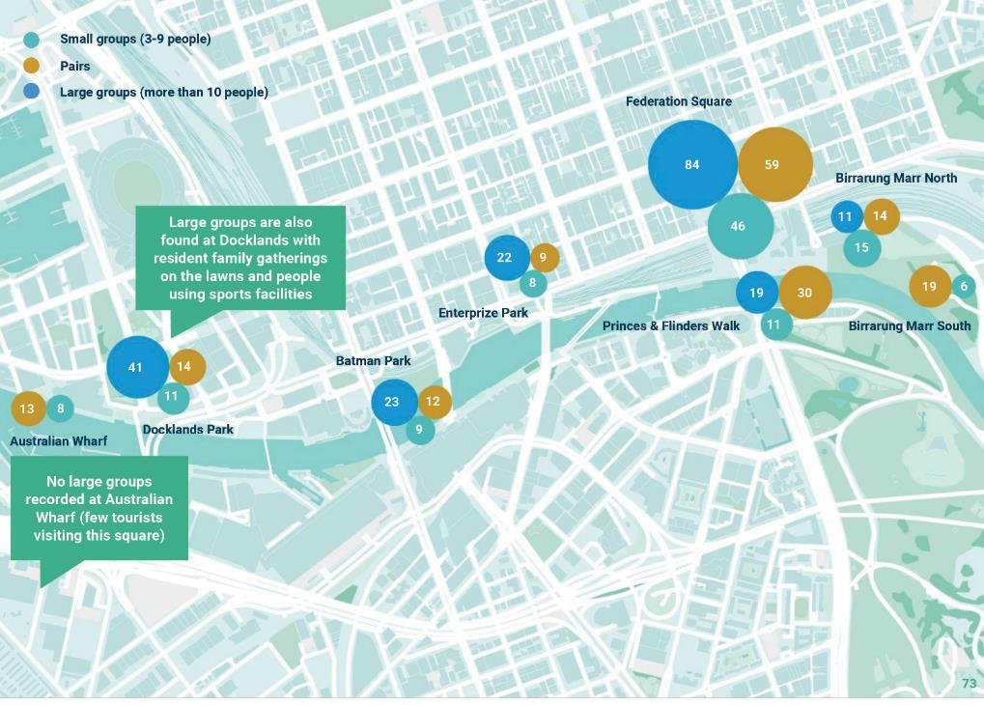

Design recommendations - consolidate and integrate the Greenline Project’s into its wider public space network

The Greenline Project and the city
How can the Greenline Project connect better with its surrounding environment? If the city trend is moving towards a ‘Central Entertainment and Living District’, strengthening comfortable movement for people, water, and urban nature is vital. Greenline’s central location becomes the key east-west connector of Melbourne’s urban ecosystem.
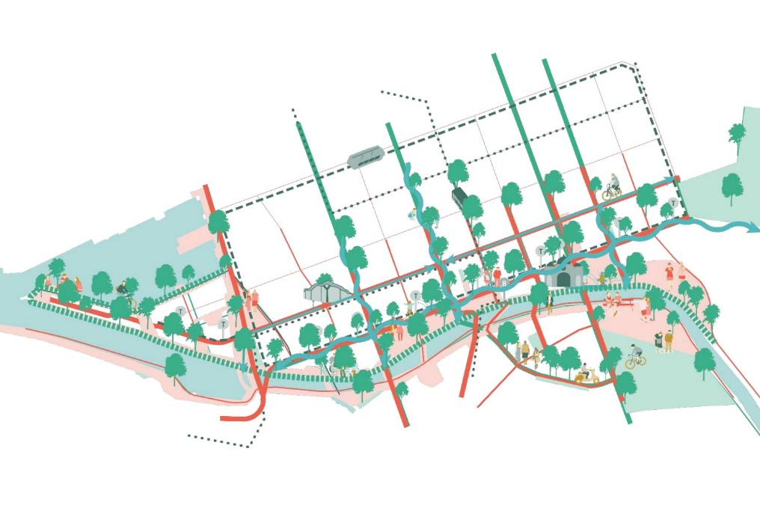

Design recommendations - encourage active mobility both on and by the river (mobility)

Connect Elizabeth Street to Flinders Street Station and waterfront
The current street closure highlights a key opportunity to transform the street into a world class train/tram transport hub. A seamless ‘One Floor’ paving connection to Greenline via the tunnel will help strengthen wayﬁnding to the water considerably. As well as more interactive facades along the tunnel.
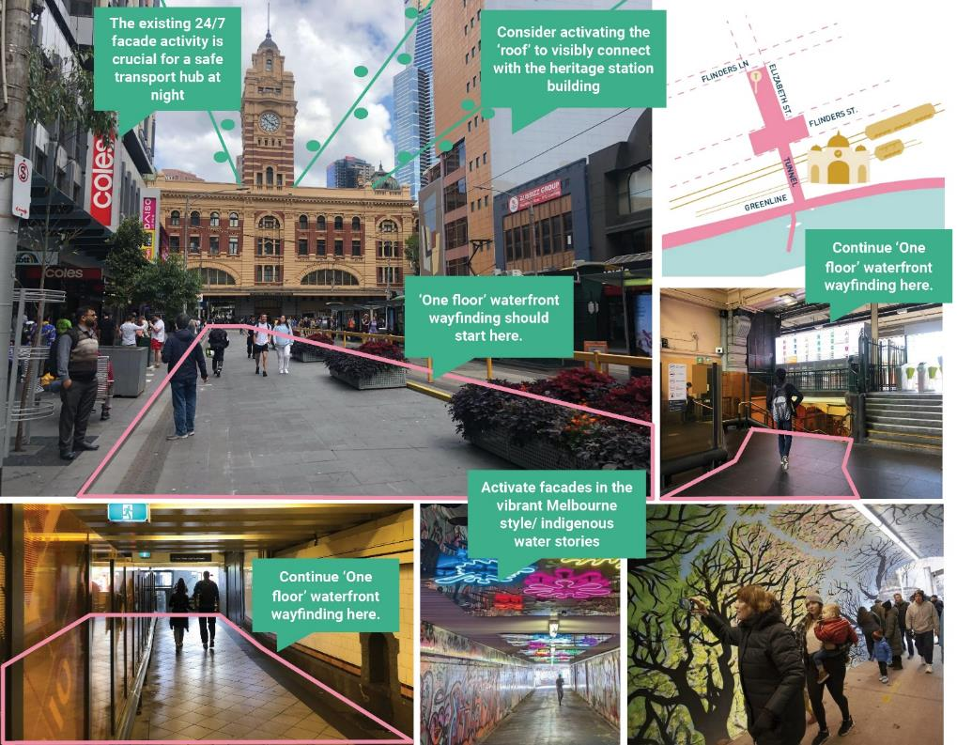

Design recommendations - provide sprinklings of everyday activities across the Greenline Project (the journey)

Many motorised options on the water
There are many motorised ways to experience the water. We will explore options for active mobility on the river and its edges, such as kayak bars, clubs, water bikes, pedal boats and stand up paddle board hire.
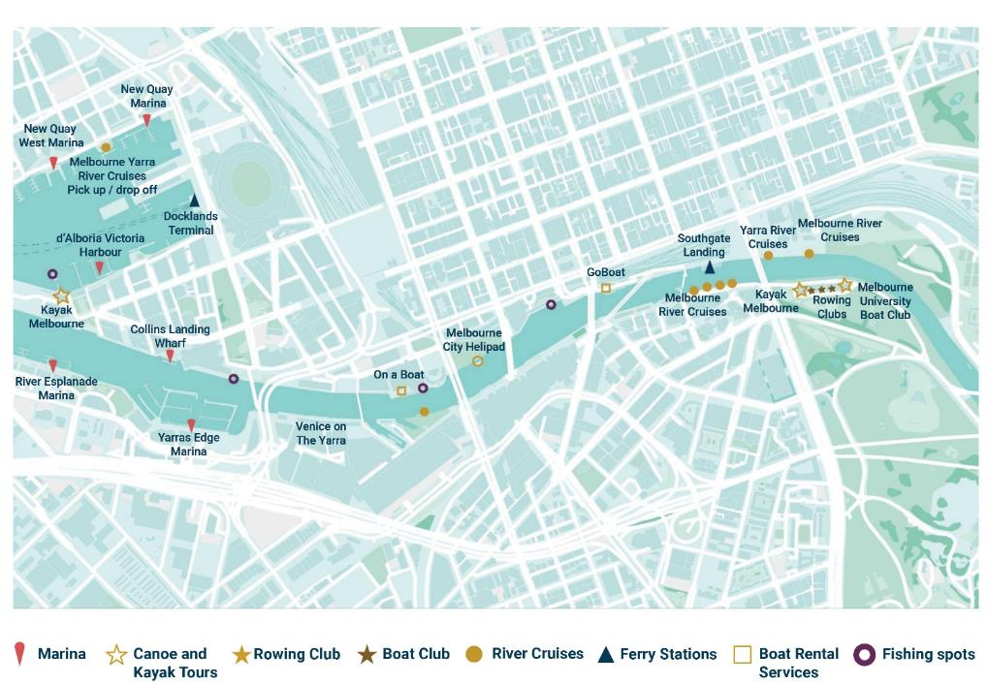

Design recommendations - encourage active mobility both on and by the river (mobility)

Diversity the water’s edge
The waterfront along the Greenline Project is linear and monotonous – it lacks surprises or human-scale details to interest pedestrians. Diverse edges allow for more diverse activities by the waterfront.
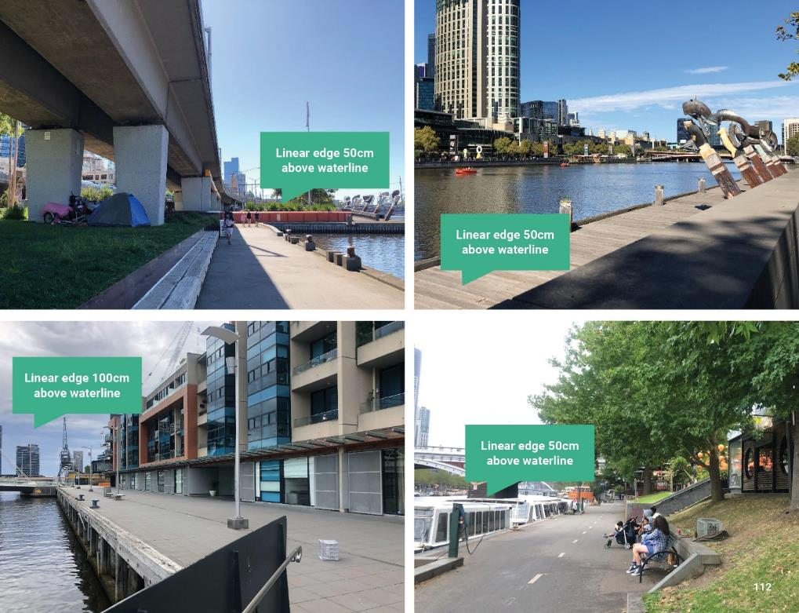

Design recommendations - provide sprinklings of everyday activities across the Greenline Project (the journey)

Comparison of waterfront activities and programming
A quick comparison between a similar 4km stretch of waterfront in Copenhagen, shows the difference in number of activities between the two. Copenhagen has relatively few large buildings or investment spaces, but it offers many small bars, cafes and mini, informal invitations to stay and play along its entire stretch.
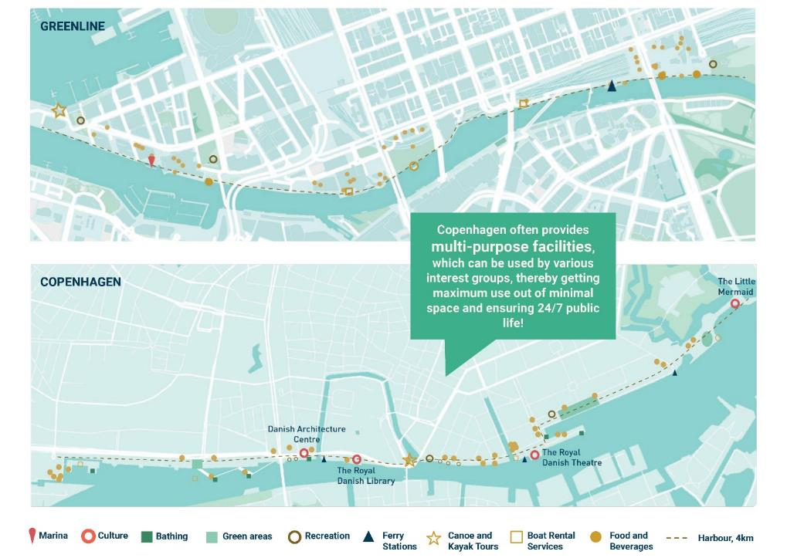

Design recommendations - provide sprinklings of everyday activities across the Greenline Project (the journey)
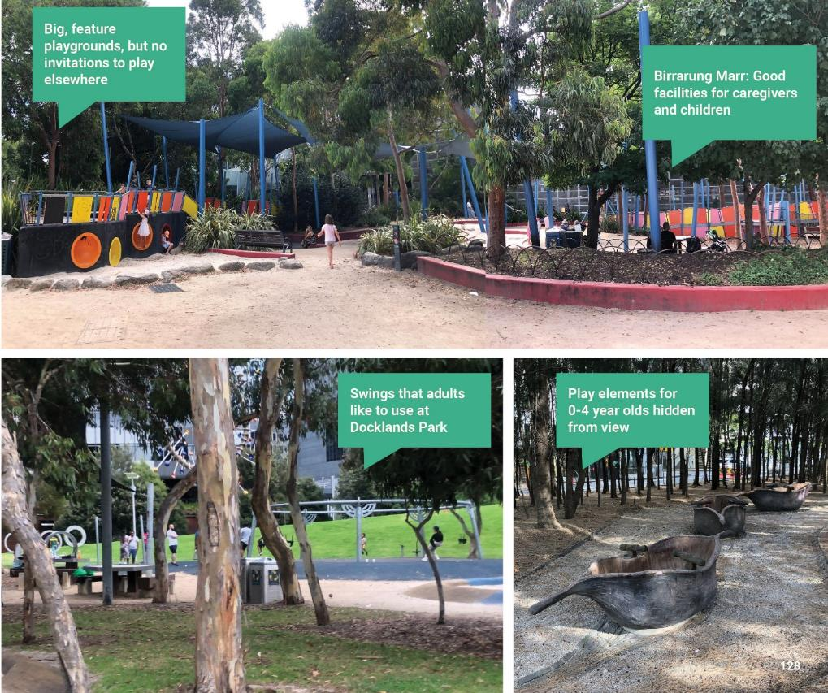

Key site analysis using Gehl’s 12 quality criteria
This analysis highlights the key public spaces that need investment and improvement because baseline needs, such as protection from crime, are not being met. Some public spaces outside the Greenline Project were analysed as baseline public spaces in the area.
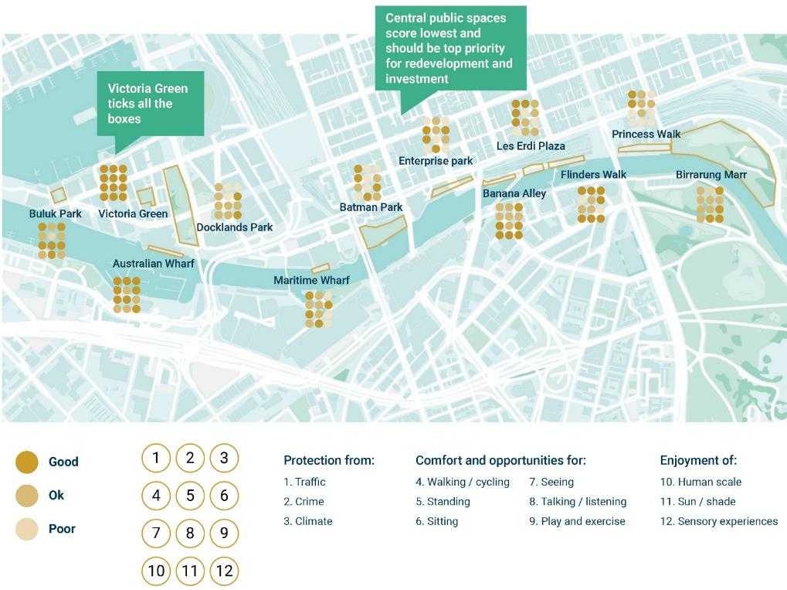

Encourage edge zones
The Maritime precinct facades need a wide, planted residential edge zone to buffer between the private apartments and the public promenade, as well as to enhance the human-scale details along the Greenline Project for visitors.
Banana Alley’s southern facades will also beneﬁt from a small commercial edge zone to inhibit unwanted parked cars, and create a more welcoming entrance for the various tenancies. Vehicular access should be restricted to deliveries only, and regulated via removable bollards if necessary.
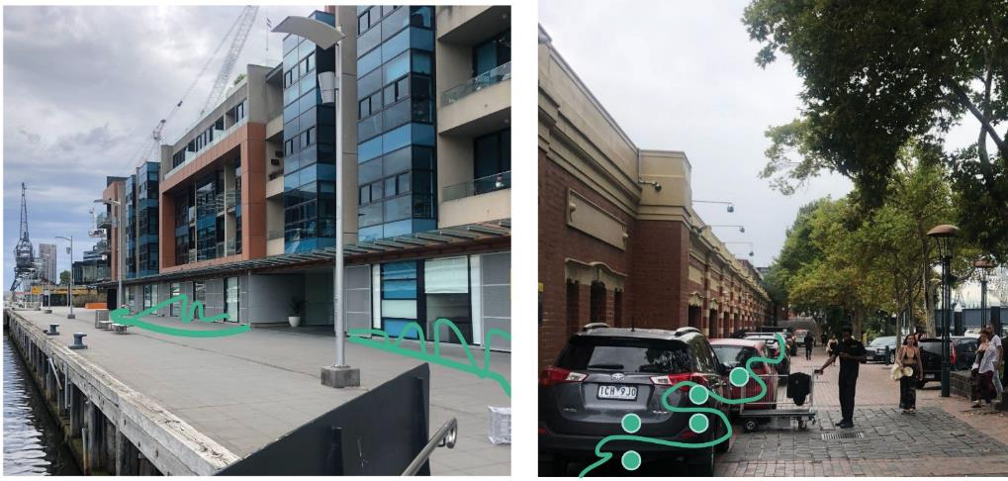

Appendix C – Supporting documents and reports

Reports
- Yarra River - Birrarung Strategy 2019
- Greenline Implementation Plan December 2021
- Greenline Project Business Case Summary Aug 2022
- The Greenline Project - Site 1 - Engagement Findings Report Summary - November 2022
- Burndap Birrarung burndap umarkoo, Yarra Strategic Plan 2022 - 2032
- Burndap Birrarung burndap umarkoo, Yarra Strategic Plan Implementation Plan 2022
- Climate Change Mitigation Strategy to 2050 December 2018
- Greening our City Strategic Action Plan 2017-2021
- Municiple Integrated Water Management Plan - July 2017
- Nature in the City - 2017
- Open Space Strategy - Planning for Future - June 2012
- Co-Designed Catchment Program for the Yarra Catchment - Melbourne Water
- City of Melbourne Reconciliation Action Plan 2015-2018
- Urban Forest Strategy 2012-2032
- Nhanbu narrun ba ngargunin twarn Birrarung - Ancient Spirit and Lore of the Yarra - Wurundjeri Woi-wurrung Birrarung Water Policy
- Yarra River - Rewilding and Ecological Restoration Guide - 2020
- Yarra River 50-year Community Vision Wilip-gin Birrarung murron
- Yarra River Birrarung Cultural Heritage Scoping Study - August 2018
- Yarra River Precinct Five Year Strategic Plan: 2021-2026

