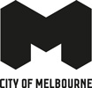
Community Resilience Assessment Southbank community report back
City of Melbourne
February 2023

Contents
Summary 3
2. Context 4
2.1. Major Initiative 52 – Prepare Melbourne 4
2.2. Disasters 4
2.3. Resilience 4
2.4. A focus on community resilience 5
2.5. Southbank 5
3. Community Resilience Assessments 5
3.1 Purpose and objectives 5
3.2 What we heard 6
Community needs 6
Southbank community themes 6
3.4 Emerging community themes and ideas 6
Urban environment 6
Technology 7
Information 7
Community 8
3.5 Idea prioritisation 9
3.6 Before and After 9
Before 9
After 10
3.7 Next Steps 10

Summary
In 2019, City of Melbourne declared a climate and biodiversity emergency, which recognises the serious risks that climate change poses to human health and our lifestyles. This recognition is reflected in the Council Plan 2021-25 and Major Initiative 52, which focuses on building community disaster resilience.
The characteristics, geographies and communities of each neighbourhood across the municipality are unique and diverse. This means a localised approach to building resilience is important.
In November 2022, the City of Melbourne City Resilience & Sustainable Futures team undertook the first of its neighbourhood Community Resilience Assessment workshops in Southbank.
These workshops sought to understand the experiences of people living in Southbank, and where they see the major challenges and opportunities to build better resilience to future shocks and stresses.
We heard that some fundamental human needs to feel prepared for a disaster are that people know: what to do, where to go, who to connect with and how to stay safe. Workshop participants expressed challenges in meeting these needs across a number of theme areas – the urban environment, information at hand, a sense of community within the neighbourhood and functioning technology.
In an ideation workshop, community members identified actions that could be taken at the individual, community and service provider level to improve disaster resilience and preparedness in Southbank.
Participants expressed they’d like to see local activities and events that bring people together in a meaningful way, more communication between building managers and all residents about what to do in a disaster situation such as evacuation procedures, and they want more opportunities to lean in and take an active role in strengthening ties between people living and working in their area.

2. Context

2.1. Major Initiative 52 – Prepare Melbourne
The City of Melbourne is delivering Major Initiative 52 under the Safety & Wellbeing objective in Council Plan 2021-2025. The purpose of this initiative is to 'engage and prepare residents and communities, and enhance their resilience to hazards, disasters and the health impacts of climate change'. It seeks to:
- Understand the current context of disaster likelihood, risk and preparedness.
- Build organisational capacity in disaster preparedness and risk management.
- Enable community preparedness and disaster resilience.

2.2. Disasters
"Disasters are expected to become more complex, more unpredictable, and more difficult to manage... with far-reaching consequences." (Royal Commission into National Natural Disaster Arrangements, 2020).
The term 'disaster' is used to describe the range of natural and human-influenced events that put us in potential danger and that require us to respond and do things differently.
'Disasters' encompasses climate disasters such as heatwaves, floods, fires and hurricanes, as well as more human-level events such as pandemics and acts of terror​.
Disaster risk is a function of hazard, exposure, vulnerability and capacity
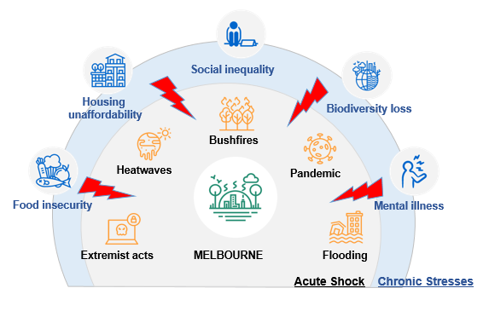

2.3. Resilience
Resilience is the capacity of individuals, communities, institutions, businesses and systems within a city to adapt, survive and thrive, and positively transform as a result.
Disasters are known to have disproportionate impacts on people facing physical, social, economic and environmental barriers. This includes the elderly, people with a disability, people experiencing homelessness, people living public housing and high-rise buildings, people with pre-existing health conditions When we talk about "resilience", we are talking about the capacity to adapt, survive and thrive, and positively transform in response to these sorts of challenges.
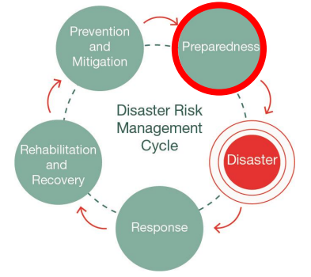
Resilient and prepared communities are more likely to withstand the negative impacts of natural disasters. Likewise, strong social capital correlates to a more effective recovery.

2.4. A focus on community resilience
All the research indicates that communities who are connected are more resilient because people are more likely to look out for the people around them. Our emergency services will not always have the capacity to help everyone during a disaster, and preparing for disasters cannot be the sole domain of government agencies if we are to become truly resilient. The emphasis on building capability within the community to adapt, survive and thrive in response to shocks and stresses, is critical in developing community resilience.
The Community Resilience Assessment is an approach is about looking at the unique experiences, needs and vulnerabilities of the people living in each of our neighbourhoods so we can determine where and how City of Melbourne and its partners can best support.

2.5. Southbank
Southbank has characteristics that make it unique to other neighbourhoods across the City of Melbourne, which means that responses to build community disaster resilience may require different thinking to other parts of the City. Southbank is located along the banks of the Yarra river and is a centre of cultural and business activity. The vast majority of Southbank residents live in apartments. Around 40% of these live alone. Daily foot fall in Southbank far exceeds the resident population of 23,000. Considerations for disaster resilience in Southbank therefore need to include thinking about businesses, hospitality and the urban environment.

3. Community Resilience Assessments

3.1 Purpose and objectives
Purpose. To understand where and how the City of Melbourne and its partners can best support or enable community disaster resilience in Southbank.
Outcomes. This work sought to:
- Explore and validate community needs, experiences and challenges around managing disasters for residents in Southbank
- Seek ideas from the community about how we might solve some existing challenges
- Identify priorities at the individual, community and service provider level
Workshops. The City Resilience & Sustainable Futures team ran two face to face workshops with Southbank residents at the Boyd Community Hub on 8 & 29 November 2022. The first workshop was designed to assess community disaster resilience literacy, awareness and challenges at the neighbourhood level. The second workshop was focused on generating ideas on how the City can build on existing strengths to support disaster resilience.
Participants. More than a dozen Southbank residents attended both community workshops. They were a mix of owner-occupiers, renters and landlords – the majority of whom were long-term residents who lived in residential towers.

3.2 What we heard

Community needs
To feel prepared for a disaster, the community expressed four fundamental needs:
- I am safe
- I know where to go
- I know what to do
- I know who to connect with.

Southbank community themes
Four key strategic themes emerged from the first workshop. These themes identify critical gaps and areas of focus to support and enable resilience in the community.
- Urban environment. The built environment is particularly vulnerable to disaster impacts on Southbank.
- Technology. Network connection and access in Southbank was highlighted as a weak spot in the delivery of information and connection around disasters.
- Information. Information about what to do in the event of a disaster that requires evacuation is not clearly expressed or widely understood.
- Community. There is not a strong sense of community and connection between people who live in Southbank, which can be a lonely experience.

3.4 Emerging community themes and ideas

Urban environment
Given the number of high-rise apartment buildings in Southbank and its proximity to the river, the built environment is particularly vulnerable to disasters, including heatwaves and flooding. Many apartments do not provide adequate space to store supplies for more than a couple of days, and there is a lack of communal spaces for incidental interaction.
This requires strategic thinking about ways to use the build environment in Southbank to support community understanding about what to do in a disaster and signpost places of refuge.
We asked: How might we improve community resilience in the urban environment so that people feel safe navigating disasters?
Your ideas regarding the urban environment
Ensuring that the urban and technological environment is easy to navigate during a disaster
Community
- dedicated and accessible congregation points/places of refuge
- utilising building forecourts as communal spaces for interaction
- utilise existing street signage
- address road and street safety, amenity and permeability
Service Providers
- addressing embedded networks in residential buildings to provide flexibility to invest in solar and other projects
- High-quality public wi-fi
- Use the top of buildings to establish local networks that don't rely on common internet infrastructure

Technology
Poor internet services and phone reception in parts of Southbank are a challenge. A lack of access can increase a sense of vulnerability and isolation amongst residents. This is particularly heightened during a disaster. This requires strategic thinking about our role to deliver support to the community that doesn't rely on mainstream technology.
We asked: ​ How might we address the challenges around technology access during a disaster to reduce vulnerability and isolation?

Information
Participants said they did not know where to look for information on where to go and how to stay safe during an emergency or disaster in Southbank. Delivering information in a language that people understand is important. This requires strategic thinking about sharing intuitive and visible information with the community in a context that makes sense.
We asked: ​How might we best share information within the community about disasters so that people feel clear about what to do and where to go?
Your ideas on how to best share information and raise awareness considering technology barriers
Providing residents and the broader community with visible and universally accessible information about disasters is critical to support awareness and understanding.
Community
- Southbank community billboards
- Pop-up information booths
- NGV exhibition on 'safe in Southbank'
Interpersonal
- building managers communicate with both owners and renters so everyone has access to the right information at the right time.
- run evacuation drills and appoint floor wardens in residential towers
- distribute disaster kits for people in residential towers
Service Providers
- Build service partnerships
- Develop how-to videos and guides

Community
Many workshop participants said they don't know their neighbours or connect to the people around them, due in part to large numbers of short-term rentals and Airbnb accommodation. This has subsequent impacts on personal safety, a sense of belonging and loneliness. In the context of an emergency or disaster it also heightens the chance that people won't check on each other. Although the majority of participants said they were keen to build connections with their community and neighbours, there is a current lack of opportunities or sense of local identity.
This requires strategic thinking about thinking about how we connect people who live in the Southbank community
We asked: ​How might we build better connections between people in Southbank to improve community disaster resilience?
Your ideas to build relationships
Establishing connection between people is often just about providing the opportunities for people to meet and talk.
Creating a sense of community across the neighbourhood and within residential buildings was seen as an important first step to establish the conditions for resilience. Community ideas included:
Community-level
- a calendar of events for Southbank residents that focus on building a local identity and presence – eg community markets, local Christmas events, community helper day
- establishing digital communities and ways for local residents to connect and find common interests
Interpersonal-level
- neighbourhood inductions for new residents
- events to connect people living on the same floor
Your ideas to improve sense of community

Building resilient communities is about providing the conditions for people to contribute, connect and act together.
Community
- Create a shared resources program
- Establish a 'who needs help' register for people facing language, mobility or tech barriers
- Conduct emergency simulations in the neighbourhood so people clear on what to do and where to go in an emergency
Interpersonal
- establish a community shepherd program so members of the community take on active roles to help each other in a disaster
- Create opportunities for resident volunteers to skills share
- Buddy system
Service Providers
- Build service partnerships

3.5 Idea prioritisation
Workshop participants were asked to prioritise concepts and highlight the ideas that felt most pragmatic and impactful. The ideas to generate greatest support were:
- know your floor meet ups and community events
- direct communication with all building residents from building managers on evacuation protocols
- Southbank-specific content from SES
- active resident volunteer programs and buddy systems
- visible signage in the urban environment to support understanding.
As a start, the Southbank Neighbourhood Partner would like to work with the Southbank community on ideas 1 & 2. If you are interested in working on these actions please be in touch with Ash.Lee@melbourne.vic.gov.au.

3.6 Before and After
Workshop participants were surveyed at both the beginning and the end of the workshop series to determine whether their participation in these sessions had given them greater understanding and awareness about disaster resilience in Southbank. The answer was a resounding 'yes'.

Before
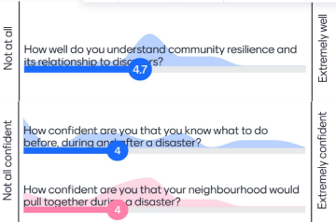

After
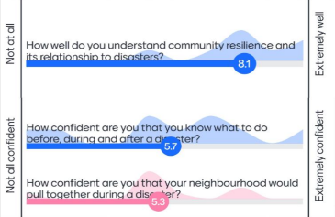
​

3.7 Next Steps
- ​ Share workshop findings community workshop participants
- Add resources and findings to the Southbank Neighbourhood Portal
- Carry out next Community Resilience Assessments with Kensington and Carlton
- Review findings and compare resilience building ideas from each neighbourhood​
- Identify localised action ideas and actions suitable for the municipality
- Include action ideas in Neighbourhood Plans and identify actions for implementation

Thank you to all workshop participants for your input and ideas!

