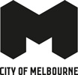
Community Resilience Assessment Kensington community report back
City of Melbourne
April 2023

Contents
Summary 3
2. Context 4
2.1. Major Initiative 52 – Prepare Melbourne 4
2.2. Disasters 4
2.3. Resilience 4
2.4. A focus on community resilience 5
2.5. Kensington 5
3. Community Resilience Assessments 5
3.1 Purpose and objectives 5
3.2 What we heard 6
Resilience 6
Kensington community values 7
3.4 Emerging community themes and ideas 7
Changing urban fabric 8
Information 8
Accessibility 9
Community connection 9
3.5 Idea prioritisation 10
3.6 Before and After 10
Before 10
After 11
Feedback 11
3.7 Next Steps 11
Appendices 12

Summary
In 2019, City of Melbourne declared a climate and biodiversity emergency, which recognises the serious risks that climate change poses to human health and our lifestyles. This recognition is reflected in the Council Plan 2021-25 as one of the six strategic objectives and in the Major Initiative 52, which focuses on building community disaster resilience.
The characteristics, geographies and communities of each neighbourhood across the municipality are unique and diverse. This means a localised approach to building resilience is important.
In March and April 2023, the City of Melbourne City Resilience & Sustainable Futures and Community Development team undertook two Community Resilience Assessment workshops in Kensington.
These workshops sought to understand the experiences of people living in Kensington, and where they see the major vulnerabilities and opportunities to build better resilience to future shocks and stresses.
We heard that some fundamental human needs to feel prepared for a disaster are that people know: what to do, where to go, who to connect with, and how to stay safe. Workshop participants expressed challenges in meeting these needs across several theme areas – the changing urban fabric, information at hand, accessibility for all and community connection within the neighbourhood.
During the second workshop, community members identified actions that could be taken and prioritised at the community level to improve disaster resilience and preparedness in Kensington.
The majority of ideas generated and prioritised by the Kensington workshop participants relate to receiving information about how to be better prepared for disasters ahead of time and opportunities to connect with each other to build stronger community connection. Participants were clear in their suggestion that information developed and shared should be inclusive, intergenerational and culturally diverse.

2. Context

2.1. Major Initiative 52 – Prepare Melbourne
The City of Melbourne is delivering Major Initiative 52 under the Safety & Wellbeing objective in Council Plan 2021-2025. The purpose of this initiative is to 'engage and prepare residents and communities, and enhance their resilience to hazards, disasters and the health impacts of climate change'. It seeks to:
- Understand the current context of disaster likelihood, risk and preparedness.
- Build organisational capacity in disaster preparedness and risk management.
- Enable community preparedness and disaster resilience.

2.2. Disasters
"Disasters are expected to become more complex, more unpredictable, and more difficult to manage... with far-reaching consequences." (Royal Commission into National Natural Disaster Arrangements, 2020).
The term 'disaster' is used to describe the range of natural and human-influenced events that put us in potential danger and that require us to respond and do things differently.
'Disasters' encompasses climate disasters such as heatwaves, floods, fires and hurricanes, as well as more human-level events such as pandemics and acts of terror​.
Disaster risk is a function of hazard, exposure, vulnerability and capacity
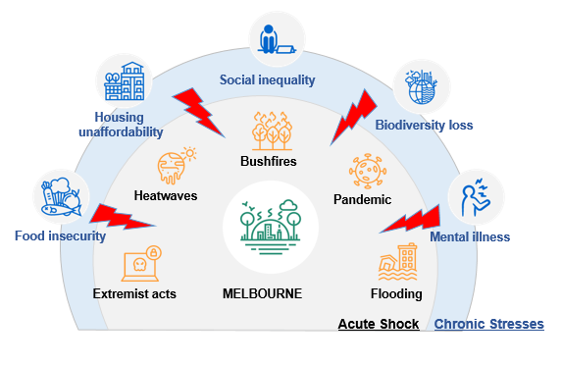

2.3. Resilience
Resilience is the capacity of individuals, communities, institutions, businesses and systems within a city to adapt, survive and thrive, and positively transform as a result.
Disasters are known to have disproportionate impacts on people facing physical, social, economic and environmental barriers. This includes the elderly, people with a disability, people experiencing homelessness, people living public housing and high-rise buildings, people with pre-existing health conditions When we talk about "resilience", we are talking about the capacity to adapt, survive and thrive, and positively transform in response to these sorts of challenges.
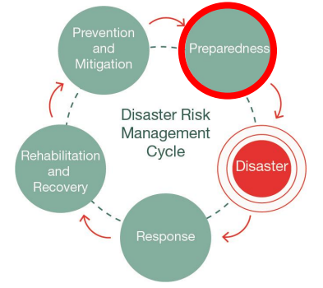
Resilient and prepared communities are more likely to withstand the negative impacts of natural disasters. Likewise, strong social capital correlates to a more effective recovery.

2.4. A focus on community resilience
All the research indicates that communities who are connected are more resilient because people are more likely to look out for the people around them. Our emergency services will not always have the capacity to help everyone during a disaster, and preparing for disasters cannot be the sole domain of government agencies if we are to become truly resilient. The emphasis on building capability within the community to adapt, survive and thrive in response to shocks and stresses, is critical in developing community resilience.
The Community Resilience Assessment is an approach is about looking at the unique experiences, needs and vulnerabilities of the people living in each of our neighbourhoods so we can determine where and how City of Melbourne and its partners can best support.

2.5. Kensington
Kensington is a unique inner suburb of Melbourne approximately 4 km north west of the central city. The neighbourhood features both the Maribyrnong River and Moonee Ponds Creek. Kensington has a distinct heritage character, an active local community and village-like shopping hub around Kensington Station. Housing ranges from small heritage cottages, public housing, and new townhouses in Kensington Banks. There are some industrial and commercial uses in the south east. Kensington includes part of the Macaulay renewal precinct area which is undergoing significant change.

3. Community Resilience Assessments

3.1 Purpose and objectives
Purpose. To understand where and how the City of Melbourne and its partners can best support or enable community disaster resilience in Carlton.
Outcomes. This work seeks to:
- Explore and validate community needs, experiences and challenges around managing disasters for residents in Carlton
- Seek ideas from the community about how we might solve some existing challenges
- Identify priorities relevant to individuals, the community and service providers.
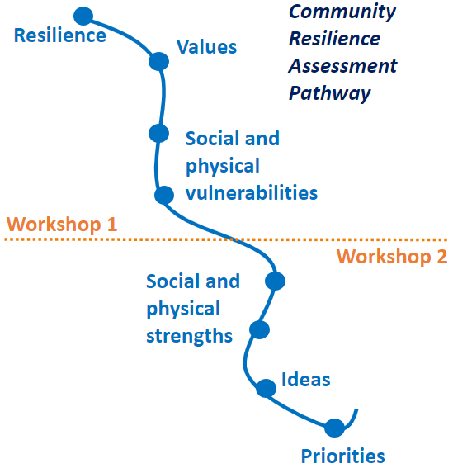
Workshops. The City Resilience & Sustainable Futures team ran two face to face workshops with the Kensington community on March 28 and April 4, 2023. The first workshop was designed to assess community disaster resilience literacy, awareness and challenges at the neighbourhood level. The second workshop was focused on generating ideas on how the City can build on existing strengths to support disaster resilience.
Participants. Fifteen Kensington residents attended both community workshops. Many participants have lived in Kensington for many decades, are actively involved in a range of volunteering activities and some were new residents, both owning and renting in the area.

3.2 What we heard

Resilience
We facilitated an activity where workshop attendees bought to mind a time when they felt resilient. These were some of the words used to describe resilience by the Carlton workshop participants.
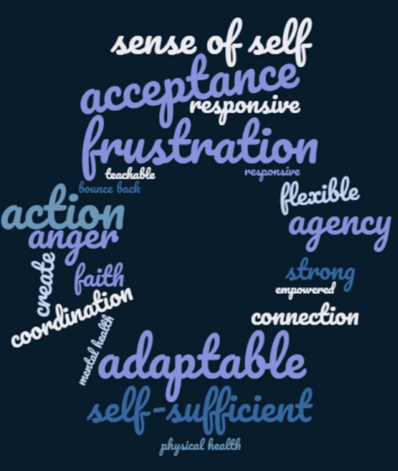

Kensington community values
We asked workshop participants what was important for them and what they valued most in Kensington. The four trends emerged from the extensive conversations.
- Sense of community “People helping People”
- Sense of place/ space with green and open spaces
- The ‘village feel’ and its services
- Quality of Life for all
Complete raw data available in the Appendices. ​

3.4 Emerging community themes and ideas
During the first workshop, we asked participants to identify some of the social and physical vulnerabilities in Kensington that may impact on the community’s ability to deal with a disaster. From the workshop activities, four key themes emerged:
- Changing urban fabric
- Accessibility
- Information
- Community connection
These themes were tested and agreed in the second workshop, with conversations in favour of including 'story telling' within the information theme. The themes were used to identify ideas to help build resilience in the community. Complete raw data available in the Appendices. ​

Changing urban fabric
The built environment in Kensington is changing with an increase in housing density and construction projects, resulting traffic congestion and potential health and safety risks. Participants pointed out that people living in low-quality built homes are and will be the most affected by the changing climate.
We asked: How might we improve community resilience to disasters taking into account the changes occurring to the urban fabric and community demographics?
Your ideas regarding the changing urban fabric
Regarding the changing urban fabric, workshop participants highlighted that they would be in favour of there being:
- A community hub in for Kensington with council presence and information on disaster resilience and climate change
- Better utilisation of the Kensington Town Hall which could serve as an information hub and connection point for the community
- A way to better connect new people moving into Kensington with relevant information and community members (i.e. Neighbourhood Portal, House, Good Karma Network and more)
- Sharing stories of Kensington for new community members to connect with local history to help foster a sense of place, identity and future together
- Information about physical response to emergency (SES sand bags)
- Social events (BBQs etc.) especially for people living in apartments
- Better planning regarding roads and infrastructure to improve traffic flow and access.

Information
Participants said that Kensington was missing an information centre and clear evacuation routes in the event of an emergency or disaster. Participants said that having a physical space to find information would be crucial for people without a smartphone or if the communication technology was not reliable.
We asked: ​How might we best share information so that people feel clear about what to do and where to go in the event of a disaster?
Your ideas on how to best share information
Regarding information, workshop participants suggested:
- All disaster related communications to be in simple languages reflecting the cultural diversity of the Neighbourhood
- Creation of a local information centre/spaces that allows community members to form an ongoing relationship with their neighbourhood, not just for emergencies
- Non-written channels to share information (visual / art)
- Better ways of branding official information to combat misinformation so the community can distinguish the truth
- Developing process to send emergency texts to residents with relevant information and action plans.

Accessibility
Participants raised a range of access issues that could be heightened during a disaster and impact the most vulnerable communities. Participants highlighted issues with access to affordable quality housing, services, evacuation routes, deliveries and the digital divide; with special consideration for people with health and mobility needs, and culturally and linguistically diverse people.
We asked: ​How might we help our most vulnerable/at risk people feel safe navigating disasters and access basic services?
Your ideas to improve accessibility
Regarding accessibility, workshop participants suggested that:
- Community sessions be organised for ‘champions’ to talk about what to do in an emergency
- Central locations like train stations and bus stops in Kensington have a monthly information board with QR code and link to website with trusted information about the local area
- Fridge magnets could be sent to every home with a phone number to ring in case of emergencies
- Communication should be inclusive, understanding that everyone is vulnerable with some people more at risk than others (materials and sites should be provided in range of languages and in plain English, considering older people, CALD, people with disability)
- Emergency section be easy to find on Neighbourhood Portal
- Intergenerational outreach program matching older and younger people to help build skills and connection, especially digital literacy skills.

Community connection
Participants highly value the sense of intergenerational and inclusive community connection. Strong social networks and systems exist to connect and share among the Kensington community. However, disparities also exist in terms of how people feel connected to their community. Isolated members of the population are the most vulnerable to health and disaster risks.
We asked: ​How might we improve community connection to reduce disaster vulnerability and isolation?
Your ideas to improve community connection
Regarding community connection, workshop participants proposed the following actions:
- Having a spokesperson / storyteller at the Kensington Fresh Food Market on regular basis
- Seeking ways to use the Kensington Neighbourhood House as connection point and to connect with people who may be isolated through for example phone calls and visits
- Organising small-scale BBQ gatherings to share information, with council presence
- Providing material and information in key languages identified as most spoken in neighbourhood. Using interpreters to facilitate conversation when needed and ensure all events are inclusive.
- “First Aid Toolkit” for mental illness, in particular for people supporting others suffering from mental illness.

3.5 Idea prioritisation
Across all themes, participants voted for their favourite ideas and the top-rated ideas were: ​
- Train stations and bus stops in Kensington have a monthly information board with QR code and link to website with trusted information about the local area
- Small-scale community BBQ gatherings to share information, with a council presence
- A local information centre or space or hub that allows community members to form an ongoing relationship with their neighbourhood, not just for emergencies
- Better emergency information in real time (i.e. emergency texts to residents with information and action plan)
Overwhelmingly, the vast majority of ideas prioritised were intended to encourage better information sharing across the neighbourhood and community, building on existing networks, council resources and community connections. Information being shared and events being organised should be inclusive, intergenerational and culturally relevant/sensitive.

3.6 Before and After
Workshop participants were surveyed at both the beginning and the end of the workshop series to determine whether their participation in these sessions had been beneficial to them in gaining greater understanding and awareness about community disaster resilience in Kensington.​
It is worth noting that participants felt more confident in their community pulling together during a disaster than knowing what to do individually, and this sentiment was increased after the workshops. The workshop sessions were not designed to provide emergency information but given how much interest emerged from the conversations, a brief Prepare Melbourne resource pack with key emergency links was prepared and shared with the workshop as a first step.​

Before
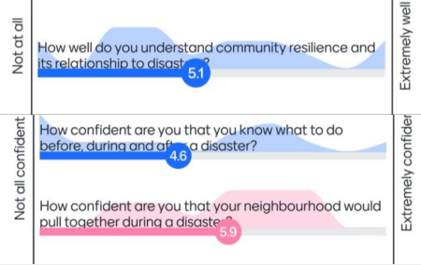

After
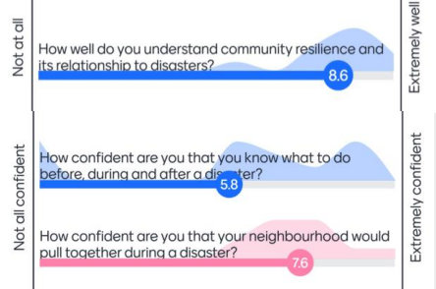

Feedback
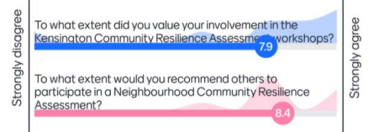
​

3.7 Next Steps
- ​Follow-up conversations in the community: Organise follow-up conversation to share workshop findings with key community members and investigate ways to implement priority actions
- Neighbourhood Portal​: Add resources and findings, from workshops, follow-ups and survey inputs to the project's Participate Melbourne page and Kensington Neighbourhood Portal
- Carry out next Community Resilience Assessment in Carlton
- Review findings and compare resilience building ideas from each neighbourhood​
- Identify localised action ideas and actions suitable for the municipality
- Include action ideas in Neighbourhood Plans and identify actions for implementation
- Continue conversations with community organisations, local community members and other stakeholders and agencies to collaborate on delivering actions.

Thank you to all workshop participants for your input and ideas!

Appendices
Appendix 1. Raw data workshop 1
What is important to people and what do you value about Kensington?​

Sense of community “People helping People”
- Community connections
- People helping People
- Family oriented
- Friendliness
- Caring
- Connection
- Sharing
- Diversity (age + international)
- Inclusion
Green and open spaces = sense of place/space
- Pet Friendly
- Green and open spaces (Banks)
- Moonee Ponds Creek and Maribyrnong River
- Walking trails and views
- ‘Secretness’ of areas (borders of rivers/ creeks)
- Street Treasure
- Quietness
- Quiet Local Streets
Urban fabric: Accessibility – the services it provides
- Public Transport
- Walkability
- Safe
- Closeness to CBD – Small village close to the city
- Density is still low
- Closeness to community services (Hospital & Footscray markets)
- Coffee shops on Bellair
- Different spaces between rail lines
- Having an accessible primary school
Quality of Life
- Food distribution
- Yoga
- Food Forest
- Local living lunches at Public Housing
- Kensington Neighbourhood House
- Citizen engagement
- Community engagement work
- Kensington Good Karma Network and Kensington Actual Good Karma Network

Activity 3a: What are the physical vulnerabilities to disasters in Kensington? ​
Changing urban fabric/built environment
- Construction Density (Holland Estate, Vue Apartments, South Kensington Station)
- Rising sea levels impact on low level housing / industry amenities
- High rises going up
- Low quality builds
- Vulnerable Public Housing Estate
- Construction styles leading to more heat
- Traffic / congestion (Epsom Road, Kensington station, Kensington Road, Macaulay Road, Racecourse Road x Smithfield Road
- Increasing density of Macaulay
- Fire – close proximity of town houses and traffic risk on Epsom Road in case of fire
- Safety (Western Link Road, South Kensington Station)
- Kensington state school proximity to Epson road (student safety)
- Lack of common shelter areas
- Health risks
- Impact of construction – cement toxicity – increased temperature + run off as non-permeable
- Air quality issues
- Coode Island pollution backflow
- Diesel fumes
- Helicopter crash flying over Flemington race course
- Train crash and resulting local trauma, impact on services
- Power gas water long term outages
- Gas main near South Kensington Station
- Big shipping containers – changes
- Damage of the tunnels?
- Old pipes – water coming out of storm water drain
- Flooding (Maribyrnong River, Smithfield Road, Stubb Street, Chelmsford Street)
- 100 year flood line – risk assessment
- Flood water shelter key needs – mitigation and preparedness
- Development happening in what was a flood plain
- Lack of Greening
- Lack of green spaces in certain areas

Activity 3b: What are the social vulnerabilities to disasters in Kensington?​

Community connection
- Local connection
- Affordable housing for close living with others in community
- Social connections and skills
- Lack of social network
- Lack of resilience through lack of life experience – FEAR
Quality of life
- Poor quality housing
- Economic conditions / Cost of living
- Homelessness, Couch surfing
- Food insecurity
- Economic / Financial security of business owners (small businesses)
- Employment
- Family violence
- Availability of info for protection & family violence services
- Judgement – stigma, cultural judgement
- Engagement online which can also lead to community conflict (not facilitated to positively resolved + facilitate resolution)
Information and technology
- Public safety linked to tech safety
- Unreliable reception
- Technology hacking could attack fire management system
- Issue with accessing information for student without a smartphone
- Lack of evacuation or information centre
Accessibility and information
- Distance from fire station in case of emergency
- Public transport disruptions
- Traffic diversion and impact on pedestrians
- Travelling issues
- People with disability not able to evacuate quickly in case of emergency and not connected with
- emergency apps
- Pressure on amenities during a pandemic (parks, dogs)
- Traffic congestion (people, business, deliveries)
- Access issues for deliveries
- Workers passing through – how to connect re a disaster
- More workers / construction workers – how to get home if disaster strikes / isolated
- Difficult access to public transport in case of emergency
- Lack of cars for a lot of residents
- How to connect Kensington Community School on the edge + people come from far away
Health and wellbeing
- Existing Health conditions
- Mental Health
- Aging population – mobility, safety
- Fear of heat and cold in public housing
Appendix 2. Raw data workshop 2
Activity 2: What are the social and physical strengths in Kensington?​
- Connection – community helps each other
- Social norms of caring
- Produce that people grow and share (community gardens and backyard)
- Random acts of kindness – paying when people don’t have money
- Urban form assists community connection
- Good Karma Network (furniture, bedding, welcomes people to the area)
- Rotary Emergency Relief Centre
- Public Transport Excellent (Bus, Trains *3, Tram in walking distance)
- Safety (feel safe)
- Size
- Density
- Places – Stockman’s route, communal green spaces
- History of adversity in area
- Affordability
- Council intervention – Neighbourhood houses and other services
- Swapping / sharing of resources – book libraries
- 87% households have internet connection (2021 census data)
- Free wifi at shops
- Public transport (bus, tram, train)
- Lots of local services distributed well
- No or minimal drug use
- Green spaces are abundant and provide some flood mitigation
- Compact layout + hill provide long lines of sight
- Proximity to local services and alternatives in neighbouring areas
- School and childcare available at multiple ends of Kensington
- One strength is a weakness – how small the population is
- Physically constrained space
  - This contributes to connectedness and knowing neighbours
  - Issues locally that help connect people
  - Active citizens, local people mobilisation
  - History of Spanish fly limited exposure – rich stories
- River – asset not fully explored or realised – transport asset?
- Many trains that run through
- Communication? Opportunity to ramp this up
  - Social media? KGKN very large
- KTH on one side + Kens Comm Rec Centre on other side –
- somewhere in Macaulay needed
- Holland Park designated area
- St Brendans Church + schools for education?
- Very friendly area – people communicating with each other
- Refuge project supporting EM practices
- Local street parties

Activity 3: Ideas and actions to build resilience
​
Changing Urban Fabric – How might improve community resilience to disasters taking into account the changes occurring to the urban fabric and community demographics?
- Connect people moving into Kensington with relevant info (Neighbourhood Portal, House, Good Karma Network)
- Community Hub for Kensington with council presence and information on disaster and climate – 3
- Mould – Health and Safety
- Town Hall underused --> connection point – 3
- Kensington Stories of Past -> help people know the history together to move into the future – 3
- Information about physical response to emergency – SES sand bags – 1
- Money
- Social events (BBQs etc) in the big buildings – 1
- Better planning re roads/ infrastructure to improve traffic flow / access – 3

Accessibility – How might we help our most vulnerable/at risk people feel safe navigating disasters and access basic services?
- Talk about what to do in an emergency – community sessions + champions
- Train stations in Kensington (+ bus stops) have board with QR code (+website) with info about the
- local area for that month providing trusted information – 6
- Knowing who the vulnerable people are
- Fridge magnets to every home, once off with number to ring in emergency – 1
- Have emergency section as part of Kensington Neighbourhood Portal
- Language – Ensure materials / sites in range of languages and in plain English
- Medical / allied health also has basic info + posters (Proportion of families – school connection utilise this to get message out)
- Communication – older people, CALD, people with disability
- Everyone is vulnerable, some more at risk than others
- Digital divide – need to ensure providing info / outreach to tackle this intergenerational program matching older and younger people to build skills and connection

Information – How might we best share information so that people feel clear about what to do and where to go in the event of a disaster?
- Physical placement needs to be accessible (on top of hill can be a problem)
- Language has to be easy to understand and translatable – 2
- Local info centre that allows you to form an ongoing relationship (not just emergencies) – 4
- Non written channels to share information
- Confronting or combating misinformation takes a lot of effort, so better ways of branding official information
- Emergency texts to residents with info and action plan – 4

Community Connection – How might we improve community connection to reduce disaster vulnerability and isolation?
- Spokesperson / storyteller at Fresh Food Market at certain time – 3
- Use the Neighbourhood House as connection point
- Ways to connect the Neighbourhood House for people who may be isolated e.g. phone calls and visits – 1
- Small-scale BBQ gathering to sharing + Importance of council presence – 5
- Guidelines for basic steps to follow, to support mental health illness – “First Aid Toolkit” for mental illness, in particular for people supporting others suffering from mental illness
- Provide material/ information in key languages identified as most spoken in Neighbourhood – use of interprets/agents to facilitate conversation – 2
- Point transversal to all: Make events INCLUSIVE

