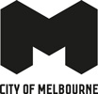
Community Resilience Assessment Carlton community report back
City of Melbourne
May 2023

Contents
Summary 3
2. Context 4
2.1. Major Initiative 52 – Prepare Melbourne 4
2.2. Disasters 4
2.3. Resilience 4
2.4. A focus on community resilience 5
2.5. Carlton 5
3. Community Resilience Assessments 6
3.1 Purpose and objectives 6
3.2 What we heard 6
Resilience 6
Carlton community values 7
3.4 Emerging community themes and ideas 7
Resilient at home 7
Navigating the streets of Carlton​ 8
Community connection 9
Community health and wellbeing 9
3.5 Idea prioritisation 10
3.6 Before and After 10
Before 10
After 11
Feedback 11
3.7 Next Steps 12
Appendices 13

Summary
In 2019, City of Melbourne declared a climate and biodiversity emergency, which recognises the serious risks that climate change poses to human health and our lifestyles. This recognition is reflected in the Council Plan 2021-25 as one of the six strategic objectives and in the Major Initiative 52, which focuses on building community disaster resilience.
The characteristics, geographies and communities of each neighbourhood across the municipality are unique and diverse. This means a localised approach to building resilience is important.
In May 2023, the City of Melbourne City Resilience & Sustainable Futures and Community Development team undertook two Community Resilience Assessment workshops in Carlton.
These workshops sought to understand the experiences of people living in Carlton, and where they see the major vulnerabilities and opportunities to build better resilience to future shocks and stresses. A strong sense of care for their community, culture and resilience emerged from the conversations in Carlton.
We heard that a fundamental human need was to first feel resilient at home, then safe navigating the streets of Carlton, as well as nurturing the community connection and its health and wellbeing.
During the second workshop, community members identified actions that could be taken and prioritised at the community level to improve disaster resilience and preparedness in Carlton. Many ideas emerged from the very engaged Carlton workshop participants.
The majority of the ideas prioritised by the participants aimed to encourage better information sharing across the neighbourhood and community, building on existing community networks and council resources to foster stronger community connections and health and wellbeing. Spaces, information and events should be all be inclusive and culturally sensitive. Ways to make the streets of Carlton safer and more resilient were also strongly encouraged.

2. Context

2.1. Major Initiative 52 – Prepare Melbourne
The City of Melbourne is delivering Major Initiative 52 under the Safety & Wellbeing objective in Council Plan 2021-2025. The purpose of this initiative is to 'engage and prepare residents and communities, and enhance their resilience to hazards, disasters and the health impacts of climate change'. It seeks to:
- Understand the current context of disaster likelihood, risk and preparedness.
- Build organisational capacity in disaster preparedness and risk management.
- Enable community preparedness and disaster resilience.

2.2. Disasters
"Disasters are expected to become more complex, more unpredictable, and more difficult to manage... with far-reaching consequences." (Royal Commission into National Natural Disaster Arrangements, 2020).
The term 'disaster' is used to describe the range of natural and human-influenced events that put us in potential danger and that require us to respond and do things differently.
'Disasters' encompasses climate disasters such as heatwaves, floods, fires and hurricanes, as well as more human-level events such as pandemics and acts of terror​.
Disaster risk is a function of hazard, exposure, vulnerability and capacity
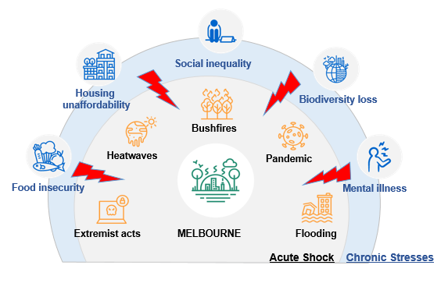

2.3. Resilience
Resilience is the capacity of individuals, communities, institutions, businesses and systems within a city to adapt, survive and thrive, and positively transform as a result.
Disasters are known to have disproportionate impacts on people facing physical, social, economic and environmental barriers. This includes the elderly, people with a disability, people experiencing homelessness, people living public housing and high-rise buildings, people with pre-existing health conditions When we talk about "resilience", we are talking about the capacity to adapt, survive and thrive, and positively transform in response to these sorts of challenges.
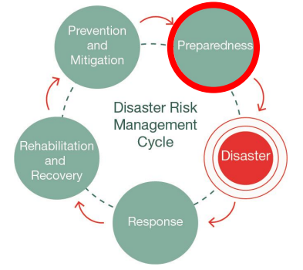
Resilient and prepared communities are more likely to withstand the negative impacts of natural disasters. Likewise, strong social capital correlates to a more effective recovery.

2.4. A focus on community resilience
All the research indicates that communities who are connected are more resilient because people are more likely to look out for the people around them. Our emergency services will not always have the capacity to help everyone during a disaster, and preparing for disasters cannot be the sole domain of government agencies if we are to become truly resilient. The emphasis on building capability within the community to adapt, survive and thrive in response to shocks and stresses, is critical in developing community resilience.
The Community Resilience Assessment is an approach is about looking at the unique experiences, needs and vulnerabilities of the people living in each of our neighbourhoods so we can determine where and how City of Melbourne and its partners can best support.

2.5. Carlton
Carlton is a diverse suburb, well-known for the Italian cafes and restaurants of Lygon Street, its Victorian heritage streets and buildings, and its leafy parks and gardens. 55 per cent of residents were born overseas and 48 per cent speak a language other than English at home. Many of Carlton’s residents are local and international students, who attend the nearby University of Melbourne and RMIT University. The Carlton Public Housing Estate is home to over 3000 residents, 51% of whom were born overseas and 58% speak a language other than English at home.
Carlton takes on a distinct character to the west of Swanston Street in the ‘City North’ precinct, where warehouses mix with larger university and office buildings. As well as entertainment, cultural and leisure activities, Carlton has educational, business, retail and residential facilities. Carlton Gardens contain the contemporary Melbourne Museum and the domed 19th century Royal Exhibition Building that has World Heritage status.

3. Community Resilience Assessments

3.1 Purpose and objectives
Purpose. To understand where and how the City of Melbourne and its partners can best support or enable community disaster resilience in Carlton.
Outcomes. This work seeks to:
- Explore and validate community needs, experiences and challenges around managing disasters for residents in Carlton
- Seek ideas from the community about how we might solve some existing challenges
- Identify priorities relevant to individuals, the community and service providers.
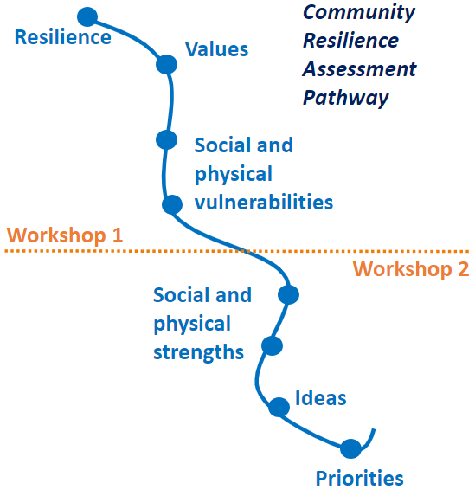
Workshops. The City Resilience & Sustainable Futures team ran two face to face workshops with the Carlton community on May 3 and 17, 2023. The first workshop was designed to assess community disaster resilience literacy, awareness and challenges at the neighbourhood level. The second workshop was focused on generating ideas on how the City can build on existing strengths to support disaster resilience.
Participants. Over twenty Carlton residents attended both community workshops. Some participants have lived in Carlton for many decades, are actively involved in a range of volunteering activities and some were new residents, both owning and renting in the area. Participants from the Carlton public housing estate and international students were well represented.

3.2 What we heard

Resilience
We facilitated an activity where workshop attendees bought to mind a time when they felt resilient. These were some of the words used to describe resilience by the Carlton workshop participants.
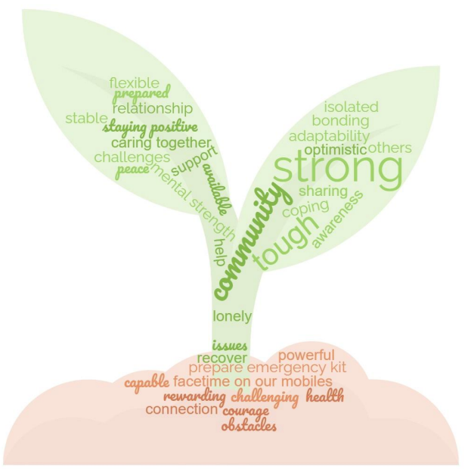

Carlton community values
We asked workshop participants what was important for them and what they valued most in Carlton. The four trends emerged from the extensive conversations.
- Community connection and inclusion, with very supportive neighbours, strong and diverse community groups creating a sense of belonging​
- Access to public services, including transport, medical and dental hospitals, parks and universities
- Neighbourhood safety, where residents always feel safe walking at night
- Culture and vibrancy, through the historic buildings and museums, libraries, restaurants and cafes on Lygon Street, Cinema and the many community events and festivals which residents love. ​
Complete raw data available in the Appendices. ​

3.4 Emerging community themes and ideas
During the first workshop, we asked participants to identify some of the social and physical vulnerabilities in Carlton that may impact on the community’s ability to deal with a disaster. From the workshop activities, four key themes emerged:
- Resilient at home
- Navigating the streets of Carlton
- Community connection
- Community health and wellbeing
These themes were tested and agreed upon in the second workshop, and used to identify ideas to help build resilience in the community. Complete raw data available in the Appendices. ​

Resilient at home
Access to affordable and liveable housing emerged as an essential first condition to feeling safe and resilient at home. ​Community members experiencing homelessness, job instability and living in low-quality accommodation will likely be the most impacted by disasters. ​In the Carlton public housing estate, high rise apartments get very hot in the summer especially in the absence of air conditioning. ​
We asked: ​How might we make our homes more liveable and resilient to disasters?
Your ideas to be more resilient at home
Changes within the built environment to improve the liveability and resilience of residents' homes:​
- Improved services in public housing buildings including air conditioning, heating plus free wifi/internet connection​
- Public housing to include indoor play / creative / recreational areas for children and accessible communal laundry areas. Improved layout in apartments such as separate living spaces – e.g. laundry should be separate from kitchen​
- Having a building manager to support residents with accessing essential services and better building maintenance such as frequent upgrades e.g. carpets + car parks doors should be accessible​
- Improved neighbourhood security such as a police station in every neighbourhood (bring back the police to Carlton, more police patrolling) and security guards for residential areas ​
- Better building evacuation plans shared with residents and easily accessible and education for community members on vandalising, waste management, first aid /mental health training​
- Fundraising at community events and gatherings to strengthen the community connectedness and better information sharing/communication (translated) and campaigns about plans, events, gatherings​​.

Navigating the streets of Carlton​
The streets of Carlton can be challenging to navigate on foot particularly on Elgin and Lygon streets. Heavy fast traffic, limited car parking and frustrated drivers means that local residents find the streets inaccessible at times. ​Participants believe certain streets in Carlton are vulnerable to disasters, particularly heatwaves (with lack of shading at bus stops and shaded sitting areas) plus flooding due to heavy rain (south west corner of Carlton).​
We asked: ​How might we make our streets more accessible and resilient to disasters?​
Your ideas to more safely navigate the streets of Carlton
Ideas to improve the accessibility, amenity and human comfort within Carlton's streetscapes:​
- Changed car parking arrangements and vehicle access to make streets easier to navigate (less fees, longer hours, more parks). This includes trialling vehicle free areas​
- More cycle lanes for bicycles​
- Improved shade and shelter in public areas (particularly public transport stops) to protect from heat and rain with a focus on greening to reduce urban heat island effect​
- Improved safety on the streets by increasing street lights ​
- More permeable surfaces on footpaths, lighter colour surfaces to reduce urban heat island effects, and tram tracks planted up for biodiversity ​benefits​
- Central places for community information sharing such as community billboards ​
- Clean up days organised by community​​
- Community based emergency planning, develop emergency plans and conduct regular drills with local community​.

Community connection
International students and newly arrived migrants can suffer from loneliness and isolation, both culturally and linguistically. ​Access to clear inclusive information and culturally diverse events are seen as key to increase the sense of belonging and companionship, foundational to build community resilience.
We asked: ​How might we improve community connection to reduce disaster risk and isolation?
Your ideas to improve community connection
Connection means different things to newly arrived, migrant, refugee, international students, and workshop participants found it important to connect outside of their immediate community. ​
- A public campaign to encourage people to know their neighbours​
- ‘I love Carlton’ campaign and merchandise to help connect to neighbourhood​
- A list of places/map of community organisations, shops and services to help people connect. To include a list of clubs for people to join (book, sports and online community clubs, U3A for retirees)​
- Safe spaces for people to connect after hours and after-hours event spaces such as schools, library and pools​
- Volunteer groups to improve community togetherness and a buddy system to support each other in disasters​
- Places for information sharing such as swapping club info, inviting people to attend groups ​
- Encourage people to utilise Kathleen Syme, community gardens, community books and veggies swap​
- Community run workshops that are promoted by the library​.

Community health and wellbeing
Community safety was core to the Carlton workshop conversations. ​Discussions highlighted the importance of mental health and social wellbeing, the awareness of vulnerabilities people with disabilities and people suffering from violence at home experience, and that disasters threaten the balancing act of maintaining both physical and mental health. Food security and the ability to access fresh and culturally suitable food in Carlton (beyond Woolworths) were also noted.​
We asked: ​How might we support the health and wellbeing of our community so we can be more resilient to disasters? ​
Your ideas to improve community health and wellbeing
- Encourage activities supporting health and sport, walking groups, exercise groups like Zumba, and men groups and activities​
- Promote more culturally inclusive and affordable food options, with a cheaper supermarket, an affordable basket of fresh food each week, culturally safe groceries e.g. halal butcher, as well as initiatives such as kitchen library and food donations​
- Improve safety and hygiene and raise awareness on subject, with more security guards, better management of pests and infestations and more psychological support for the community​
- A culturally safe, physical space for agencies and community members to connect, with a weekly program to share community services and workshops could be hosted every 3 months​
- Stronger human support with outreach person a residents’ spokesperson working to keep connected with vulnerable and isolated people​
- An online, centralised and shared database of groups and events, existing programs and resources (e.g. neighbourhood portal).

3.5 Idea prioritisation
Across all themes, participants voted for their favourite ideas and the top-rated ideas were: ​
- A list of places/map of community organisations, shops and services to help people connect. Include a list of clubs for people to join (book, sports and online community clubs, U3A for retirees)​
- A culturally safe physical space for agencies to connect, share and host community services and events​
- ‘I love Carlton’ campaign and merchandise to help people feel proud and connected to their community​
- Planting trees for shading and reducing urban heat in public spaces​
- Addressing parking issues (less fees, longer hours, more parks) and trialling vehicle free zones​.
The majority of ideas prioritised aimed to encourage better information sharing across the neighbourhood and community, building on existing networks, council resources to foster stronger community connections and health and wellbeing. ​
Spaces, information and events should be all be inclusive, intergenerational and culturally sensitive.​
Ways to make the streets of Carlton safer and more resilient were also strongly encouraged. ​

3.6 Before and After
Workshop participants were surveyed at both the beginning and the end of the workshop series to determine whether their participation in these sessions had been beneficial to them in gaining greater understanding and awareness about community disaster resilience in Carlton.​
It is worth noting that a brief Prepare Melbourne resource pack with key emergency links was prepared and shared with the workshop participants between the first and second workshops. ​
Based on the evaluation, both understanding of community resilience and confidence in individual and neighbourhood’s capacity to respond to disasters increased after the Community Resilience Assessment workshops. ​

Before
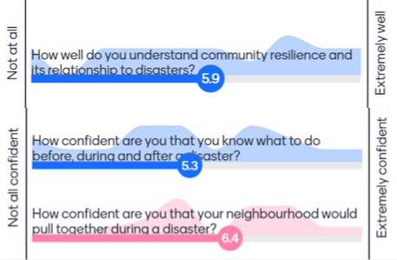

After
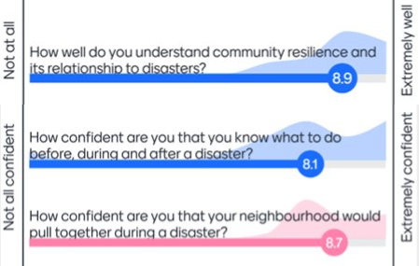

Feedback
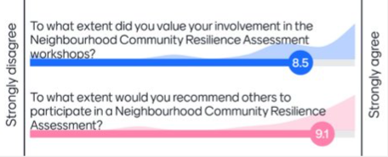

​

3.7 Next Steps
- ​Follow-up conversations in the community: Organise follow-up conversation to share workshop findings with key community members and investigate ways to implement priority actions
- Neighbourhood Portal​: Add resources and findings, from workshops, follow-ups and survey inputs to the project's Participate Melbourne page and Carlton Neighbourhood Portal
- Review findings and compare resilience building ideas from each neighbourhood​
- Identify localised action ideas and actions suitable for the municipality
- Include action ideas in Neighbourhood Plans and identify actions for implementation
- Continue conversations with community organisations, local community members and other stakeholders and agencies to collaborate on delivering actions.

Thank you to all workshop participants for your input and ideas!

Appendices
Appendix 1. Raw data workshop 1
What is important to people and what do you value about Carlton?​

Community connection and inclusion ​
- Community connectedness​
- Diversity x 3 ​
- Diversity and Inclusion ​
- Everyone welcome​
- Student accommodation: free breakfast and catch ups (sense of belonging)​
- Student community​
- Friendly area – easy to meet people​
- People are easy going, can talk to everyone and engage​
- Tight knit community ​
- Public Housing: free food and connection​
- Community lunch every Wednesday​
- Women’s group near cans? Meetings​
- Neighbours are good, very supportive during pandemic as not everyone had family​

Access to public services​
- Accessibility​
- Everything is in walking distance​
- Easy access to everything​
- Close to CBD​
- Support for local businesses -> care for global community​
- Nature and green areas​
- Parks x2 ​
- Royal Park​
- The gardens​
- Close to City Of Melbourne Shopping​
- Convenient location to go shopping to the market​
- Food / shopping​
- Hospitals x 2 ​
- Medical Centre​
- Transport x 4​
- Access to a lot of public transport options (trams and buses) x 2 ​
- Accommodation​
- Rental properties​
- Dental accessibility x 2​
- General public services​
- Good services x 3​
- Public Facility ​
- Closeness to Universities​
- Close to Uni ​
- Uni​

Neighbourhood safety​
- Safer than other neighbourhoods​
- Safety​
- Always feel safe walking at night​
- Good security in Carlton 6pm to 6am in Public Housing​
- Health and Safety​
- Recycling Program​
- Emergency response is great​

Culture and vibrancy ​
- Neighbourhood events and markets​
- Many events and festivals, people love to celebrate everything​
- A city that doesn’t sleep, can come at any time and find it awake and alive​
- Eid Festivals​
- Harmony day​
- Carlton clean day​
- Childcare centres​
- Children activities​
- Lots of young kids activities​
- Melbourne Museum x 3​
- Historic​
- Historical, old beautiful buildings​
- Architecture style​
- Laneways and little streets​
- Entertainment: cinema and cultural experience​
- Cinema Nova​
- Readings​
- Libraries​
- The library and its staff: Kathleen Syme would be an important hub in time of crisis​
- Strong Education + Library – Learning ​
- Hotel where book club meets​
- Student events​
- Restaurants​
- Cafes x 2​
- Good food x 2 ​
- Eating out in Carlton, lots of different restaurants on Lygon streets (unique to Carlton, belongs to all of Melbourne) ​

Activity 3a: What are the physical vulnerabilities to disasters in Carlton? ​
Traffic​
- Lot of traffic on Elgin Street​
- Vicroads: Practicing drivers / L License​
- Lygon Street: too much traffic gridlock ​
- Lygon x Elgin Streets: drive too fast​
- Bad parking creates traffic causing aggression and stress, streets very busy, less traffic would be nice, cycling would be safer​
- Public transport: Myki + Free tram zones too close to the paid zone, students get fines often --> could be extended only 1 or 2 stops away?​
- Parkville, MacArcthur Road x Elliot Avenue: severe traffic, hard to pass through – why not widen this road? ​
Parking​
- Everywhere is bad for parking --> will get worse in emergency​
- Parking is a big issue x underground parking flooding ​
Heat ​
- South west corner of Carlton: Hot​
- High rise vulnerable to heat​
- Public Housing towers get too hot during summer​
- Public Housing Estates ​
  - Heatwave in high rise, no air con (e.g. 480 Lygon Street)​
- Some bus stops don’t have shade​
- Swimming pool used to have trees but were cut down for a gym, shade cloths aren’t as effective​
- Intersection Elgin x Rathdowne Streets: vulnerability of thermal mass: more shade needed​
Health and Safety​
- Carlton gardens risk point​
  - Events​
  - Old Buildings​
  - Storm​
- High rise and Public Housing near Lygon Street x Faraday Street: ​
  - Earthquake​
  - Lifts​
  - No measure for evacuation​
- Public Housing Estates ​
  - Palmerson Street: Safety issues (Health, Security)​
  - Scary big dogs in lift​
- Crime in rising​
- Elgin x Drummond Streets: lack of sitting area, benches near Safeway​
  - Need place to sit that doesn’t involve consuming food or drinks​
- Grattan x Leicester Streets: metro construction generates noise and dust close to student accommodation ​
- South west corner of Carlton: heavy rain causes flooding and street doesn’t drain --> students change route because of flooding, like a river in the streets​
- Princes Park: Enough drinking taps? People don’t leave their dogs on leash​
Access to information ​
- High rise and Public Housing near Lygon Street x Faraday Street: ​
- No measure for evacuation​
- Insufficient physical information: how and where people can get information? How do we let people know where to find information, most info was online, no places to find physical info​
Culture ​
- Lack of culturally safe shops​
- Lack of creativity / arts / galleries – nowhere to express creativity --> mental health ​
Waste​
- Difficulties with people putting green waste in the rubbish ​
- Waste collection could lead to illness​
- Even sorting waste --> recycling / food waste​
- Hard waste collection​
  - Donations – items that are in good condition​
  - Hazardous​
  - Waste on roads – not collected regularly​

Some solutions / ideas​
- Who to call for different emergencies​
- Carlton needs more shade (trees)​
- Foodbank​
- Recycling program needs support​
- Art galleries for community members to feel connected and express themselves​
- Cultural festival – more engagement​
- Public transport: Myki + Free tram zones too close to the paid zone, students get fines often --> could be extended only 1 or 2 stops away?

Activity 3b: What are the social vulnerabilities to disasters in Carlton?​

Living conditions / Liveable infrastructure ​
- Homelessness​
- Accommodation​
- Being misunderstood – people experiencing homelessness​
- Cost of living x 3​
- Housing options that are suitable and sustainable ​
- Affordable, accessible and secure housing​
- Bad architecture is expensive to live in ​
- High utility bills​
- Financial insecurity x 3 ​
- Lack of stable employment ​
- Job options /opportunities​
- Job stability x 2​
- Employment opportunities​
- Low socio-economic ​
- May not be able to work to increase his income​
- Food insecurity x 2​
- Students and young people: Income stability or otherwise – if relying on funding if it stops where would they go​
- Affordable housing maybe too far from Uni + cost more to travel to Uni​
- Increasing homeless population ​
- People experiencing homelessness suffer from climate vulnerability: hot and cold nights, lack of affordable housing​
- Very hot in summer, cold in winter​
- Small business: competition from new businesses moving in, rent rise leading to increase cost of service/product -> affects students​
- Lack of housing​
- Energy poverty and water unaffordability ​
- Support to small businesses (sustaining small businesses during disasters, eg $ during COVID)​
- Aging infrastructure (not so liveable and not so adaptable to changing weather) ​
- No wifi in public housing towers​
Isolation​
- Loneliness and isolation, both culturally and linguistically​
- Loneliness​
- Newly arrived migrants: Isolation – not knowing others and being able to seek help ​
- International students: Isolation from neighbourhood: expenses, access to services, sense of belonging, missing home​
- Community breakdown, isolation​
- Communication + connection – CALD background, non-English speaking​
- Language barriers, sense of belonging, relationship pressures/complications, lack of support, isolation​
- No family in Melbourne​
- Cultural shock​
- Language barrier​
- No family here, not friends with neighbours​
- Not connected to neighbourhood ​
- Lack of companionship​
- Connection to others (international students)​
- Access to clear inclusive information​
Community health and wellbeing ​
- Lack of opportunities to connect with local community / unsure where to find help in connection​
- Public transport difficult to navigate with a disability, very slow​
- Risk of family violence and lack of safety​
- Not tech savvy​
- People with disabilities: Depending on others but not feeling comfortable in asking for help: medical expenses, mobility issues if living in high rises​
- Exposed to aggression​
- Health at risk living on the street ​
- Heath risks and safety ​
- Decrease of bulk billing, access to health care ​
- Community safety ​
- Fear induced by social media​
- Discrimination​
- Shopping Mall ​
- Need to travel to travel to Footscray and Sydney Road for food shopping ​
- Only Woolworths for food / supermarket​
- Balancing Mental and Physical Health Safety (COVID forced isolation for physical health, which impacted the mental health of Public Housing Estate residents) ​
- Mental and social wellbeing​
- Recycling ​
- Drug + alcohol program (opportunity) ​

Appendix 2. Raw data workshop 2
Activity 2: What are the social and physical strengths in Carlton?​
- Transport​
- Proximity to Melbourne CBD​
- Accessibility by foot (doctors, supermarkets, hospitals x 2) for mums with prams​
- Proximity to Fitzroy and Parkville by foot access​
- Lincoln square: safe assembly point to gather at in case of emergency​
- Co-health nearby on Brunswick Street in Fitzroy​
- Accessible Community spaces needed​
- Kathleen Syme Library x3​
- Carlton gardens and Exhibition Building ​
  - Wide parks​
  - Prominent buildings​
- Attractions and Activities e.g. Museum x2​
- Gardens, green spaces​
- Parks​
- Bath​
- Diversity and Inclusion x2​
  - Language​
  - Culture​
  - Skills​
- Food, culture and communities​
- Chinese square dancing at Museum ​
- Farmers market in one of the primary schools​
- Education and research institutions​
- Melbourne Uni x 2​
  - A lot of trams (frequent and accessible)​
  - Great security – builds a sense of safety​
- Schools and Child care​
- Carlton Neighbourhood Learning Centre – more organisations like this needed
- The connection of the Carlton community – many people bring ideas, skills, knowledge, experiences and stories to share​
- Information sharing among people e.g. whatsapp groups​
- Everybody helps each other regardless of where they come from​
- Neighbours providing support and care​
- Friendly on the street​
- The relationship with local coffee shops and restaurant owners that make you feel connected and resilient ​
- Community connectedness – tight-knit ​
- Network of agencies working with community (e.g. Drummond Service, Church of All Nations, Co-Health, Saint Jude’s Church) with range of community services and programs​
- Carlton family camp @ Saint Jude’s​
- Free homework club​
- Sewing groups @ Saint Jude’s​
- Open door sewing group on Wednesday at 480 Lygon Street​
- Community lunches every Wednesday @ Church of All Nations​
- Women’s program @ Church of All Nations​
- Thursday veggies @ Church of All Nations​
- Elderly group meetings​
- Women’s Health sessions by Co-Health ​
- CAN community support ​

Activity 3: Ideas and actions to build resilience
​
Resilient at home – How might we make our homes more liveable and resilient to disasters?​
- Having air conditioning and heating in high rise apartments – design of buildings --> have fundraising + advocating for Planning future developments to consider the below points​
- Indoor play / creative / recreational areas for children / 1​
- More accessible communal laundry area​
- Separate living spaces – eg laundry should be separate from kitchen / 1 ​
- Wifi/internet connection in the home, especially high rise apartments – spaces where free wifi is available​
- Having a building manager in buildings to support residents with accessing services​
- Better maintenance: more frequent upgrades eg carpets + car parks doors should be accessible / 2​
- A police station in every neighbourhood – bring back the police to Carlton / 1, more police patrolling ​
- Security guards of residential areas – landlords, housing commission / 1​
- Affordable/ free residential parking and more parking spaces --> council future planning and community engagement​
- Street lights – more and brighter around streets to increase safety perception, lighting in carparks, a sensor system / 2​
- Better evacuation plans shared with residents and easily accessible --> Education for community members on​
  - Vandalising​
  - Waste management​
  - Evacuations​
  - First aid education – increase the number of first aiders in Carlton​
  - Mental health first aid training ​
- Financial support from government ​
- Fundraising at community events and gatherings / strengthens the community connectedness ​
- Engage more people​
- Better communication and campaigns about plans, events, gatherings​
- Strategy and policy creations should include broader community consultations​
- Better information sharing ​
- translated material distributed to high rise residents – postal/ letter drop​
- hearing from/ consulting with community better/ more often ​
There are many services / opportunities for community to access. Should be extended out to neighbourhood. ​

Community connection – How might we improve community connection to reduce disaster risk and isolation? ​

Connection means different things to newly arrived, migrant, refugee, international students. Good to reach out outside of immediate community. It is hard to find the courage to ‘cold’ intro to neighbours but it is brave and worthwhile. ​
- A public campaign to encourage people to ‘cold’ intro to neighbours, how to, the benefits. Smile at your neighbour and say hello. Neighbour Day could be a good prompt. ​
- ‘I love Carlton’ merchandise to help people feel connected to their community. / 5​
- A list of places or a map of community shops to help people make connections with. 10​
- Need safe spaces for people to connect since schools are closed after hours, e.g. community shops and coffee shops ​
- After-hours event using facilities such as schools, library and swimming pool. Free events like this workshop, food, music, party, drinks, games, sports, cultural diversity, age appropriate events, music for young people @ pool on weekends​
- Volunteer groups to improve community together such as planting and cleaning ​
- A buddy system for people to connect but also check on each other in disasters. One elderly or someone living alone matched with a family or younger couple​
- A list of clubs for people to join / 1 ​
  - The gym and sports club​
  - Book group that meets monthly​
  - Online community groups​
  - U3A for people who have retired​
- Places for information sharing such as swapping club info, inviting people to attend groups etc.​
- Kathleen Syme is a wonderful place for people to connect. Encourage people to join Library and community garden, community books or veggies swap / 1 ​
- Community run workshops that are promoted by the library, book at Laneway Learning ​

Community health and wellbeing – How might we support the health and wellbeing of our community so we can be more resilient to disasters? ​
- Encourage activities supporting health and sport​
  - More training / sessions around health​
  - Walking groups​
  - Exercise groups like Zumba​
  - Men groups and activities – men’s shed type​
- Improving safety and hygiene​
  - Increase security --> more security guards / 1​
  - Hygiene: management of pests and infestations. 10% of happiness regarding state of hygiene in homes.​
  - Safety is an important priority. More awareness on safety issues and ways to easily report on safety issues. / 1​
  - More psychological support for the community: e.g. someone to contact to get support​
- Physical space for agencies to connect / 5​
    - A culturally safe space for all​
    - A safe place to go in the community​
    - Weekly program to share community services ​
    - Host workshops every 3 months​
- Human support​
    - Outreach support working to keep connected with vulnerable people (domestic violence, disability) / 1​
    - Residents spokesperson / champion​
- Online information sharing​
    - A centralised and shared database of groups and events / outreach / 5​
    - Link existing programs and resources on neighbourhood portal / 1​
    - More support for the lonely and isolated – help them connect to existing elderly groups / 1​
    - Ways to overcome technological distraction ​
- Food options​
    - A more affordable supermarket​
    - Culturally safe groceries e.g. halal butcher​
    - Support activities such as kitchen library and food donations at Church of all nations\​
    - Food drives: pay a small amount to get a basket of fresh food each week.

