Acknowledgement of Traditional Owners
The City of Melbourne respectfully acknowledges the Traditional Owners of the land we govern, the Wurundjeri Woi-wurrung
and Bunurong Boon Wurrung peoples of the Eastern Kulin
and pays respect to their Elders past, present and emerging.
We acknowledge and honour the unbroken spiritual, cultural
and political connection the Wurundjeri, Bunurong, Dja Dja Wurrung, Taungurung and Wadawurrung peoples of the Eastern Kulin have to this unique place for more than 2000 generations.
We are committed to our reconciliation journey, because
at its heart, reconciliation is about strengthening relationships between Aboriginal and non-Aboriginal peoples, for the benefit
of all Victorians.

CONTENTS

PROJECT OVERVIEW 4

PANEL SELECTION 6

PARTICIPANT’S ROLE 7

SCOPE OF PROJECT 8

RECOMMENDATIONS 9

ROADMAP 10

MEDIA GUIDELINES 13

FILMING AND PHOTOGRAPHY 13

Meeting times and dates 14

FOOD 16

PAYMENT DETAILS 16

ONLINE PANEL PORTAL 17

10 October 2023

PROJECT OVERVIEW
Everyone deserves a roof over their head, regardless of their financial circumstance. Yet many in our community are finding it increasingly difficult to afford a safe and stable place to call home.
Background
Accessing affordable rental housing is not a new problem, and it’s happening across Australia. Decades of under-investment combined with significant population growth, rising housing costs, and the COVID-19 pandemic means there is a severe shortage of affordable homes for people on very low, low and moderate incomes.
The City of Melbourne wants to change this. We see affordable housing as essential infrastructure that helps Melbourne continue to be a liveable, inclusive and prosperous city. We know it supports our diverse community and keeps our economy productive – research demonstrates that for every $1 invested in affordable housing, the community benefit is $3.
In 2019, it was estimated there was a shortfall of 6,000 affordable homes in the City of Melbourne. By 2036, this shortfall will grow to 23,200 affordable homes.
We are committed to redressing the significant shortage of affordable housing within the municipality, and there is strong support at all levels of government to partner with developers and the community housing sector to deliver solutions for our community. You can read more in our Affordable Housing Strategy.
The community agrees as well, with broad support for affordable housing projects within the city. However, this support reduces when communities consider affordable housing options in their own neighbourhoods.

WHAT IS A PEOPLE’S PANEL?
We are bringing the community together through a People’s Panel. This panel will comprise 40 individuals who are collectively representative of our resident community (based on ABS Census data), to hear from the experts, learn about the benefits of affordable housing to the whole community and explore new and innovative ways to truly make Melbourne a city that everyone can call home.
Purpose
Affordable housing is vital to protect the liveability of our city. It supports the diversity of our community and the productivity of our economy. We have a shortfall of at least 5,500 affordable rental homes in the City of Melbourne. If we do nothing, this will rise to more than 23,000 by 2036.
This is a complex issue and many factors are involved in resolving the issue – council can’t do it alone. The community agrees, with broad support for affordable housing projects within the city. This support reduces when communities consider affordable housing options in their own neighbourhoods. Convening the panel will help community and council work together for meaningful action.
Deliberative Engagement
Deliberative democracy (or deliberative engagement) is all about placing people closer to the affairs of government - putting them at the centre of the issue or decision that affects them. It can lead to new solutions for the most challenging problems we face, improve policy outcomes and build trust.

PANEL SELECTION
The panel selection was based on a random selection of 8500 addresses within the City of Melbourne by an impartial recruiter, Sortition Foundation.
Selection process
Invitations were posted to randomly selected households from the database of City of Melbourne. All individuals at this address over the age of 16 could then register their interest in participating in the panel. This randomisation helps ensure that participants are less likely to share similar interest or favour one demographic.
Participants are then selected from that pool of registered individuals by Sortition Foundation. The selection process matches the key demographics of the community and gives each person the fairest possible chance of selection. The resulting group is more likely to be diverse, balance and representative of the broader community.
Sortition Foundation
The Sortition Foundation offers selection services for deliberative engagement across Australia, USA and UK. They have carried out recruitment and selection work for a wide variety of different local councils, national parliaments, and other organisations.

PARTICIPANT’S ROLE
Your Role
Congratulations! You were selected and confirmed your involvement in the People’s Panel. You will have the opportunity to meet with individuals from all walks of life who live in and around the City of Melbourne. You will hear from engaging speakers, and you will discuss the issues involved in small groups, with facilitators to make sure everyone has their voice heard. You do not need to have any prior knowledge of the topics – all the information you need will be provided during the day. Your role is to attend all deliberative sessions, and to learn, deliberate cooperatively and come to judgement as a group.
Expectations
1.1 Attend all sessions
1.2 Be an active participant
1.3 Ask questions
1.4 Respect and listen to other participants and presenters, keeping an open mind
1.5 Treat everyone with respect
Throughout the Panel sessions a variety of pen and paper and technology will be used to capture yours and the group’s thoughts and ideas. You will need either an iPhone or laptop so do let us know if this will be a challenge for you and we’ll make other arrangements. The facilitators will let you know what you need to bring.

SCOPE OF PROJECT
What the People’s Panel can influence
1.1 How Council and community can work together to deliver more affordable housing.
1.2 What Council can do to support more affordable housing, such as other ideas, strategies, incentives and/or priorities.
1.3 What Council should be advocating for to state and federal Government.

What the People’s Panel cannot influence
2.1 Affordable housing is an essential infrastructure in every neighbourhood. Doing nothing is not an option.
2.2 Commitments outlined in the endorsed Affordable Housing Strategy.
2.3 Committed City of Melbourne budget/funding allocations.
2.4 Who is eligible to access affordable housing as endorsed in the Affordable Housing Strategy.

RECOMMENDATIONS
The highest level of engagement being sought through this process is collaborate (International Association for Public Participation Engagement Spectrum).
Collaborate means we will work together with you to formulate solutions and incorporate your advice and recommendations into the decisions to the maximum extent possible.
Promises
1.1 Listen to what people say
1.2 Document and record all inputs
1.3 Report back on what we have heard
1.4 Work to understand your concerns and priorities
1.5 Incorporate the Panel’s recommendations to the maximum extent possible
1.6 Identify where the Panel’s recommendations have influenced Council’s thinking
1.7 Identify where Council can’t incorporate a recommendation and clearly explain why
1.8 Provide transparent, annual progress updates during implementation
How and When
The City of Melbourne Council has committed to holding a Special Future Melbourne Committee meeting to hear the recommendations of the panel. This will be scheduled for early 2024. At this time and as the recommendations are responded to and implemented the council will be in touch with Panel Participants and the wider community.

ROADMAP
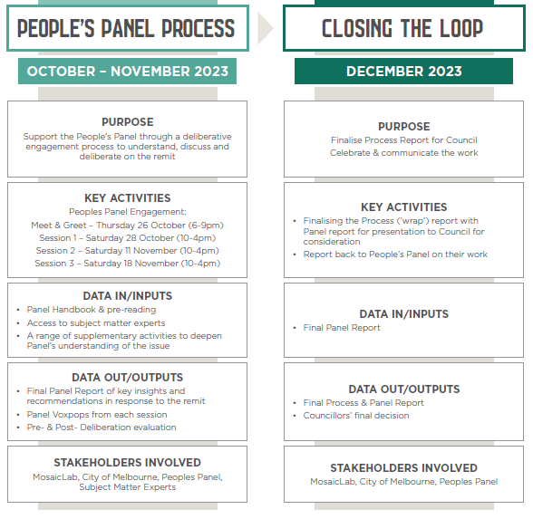

INTRODUCTIONS
The panel will work with a range of individuals and organisations over the course of the four sessions. You can find more information about some of these key groups below.
Facilitators
The sessions will be facilitated by MosaicLab, an experienced team of community engagement consultants who work with many state and local government agencies. MosaicLab is a neutral facilitating group that will plan the process of the panel, lead the group through a range of activities, adjust the panel to meet the needs of the group and intervene as needed to enable the group to resolve any problems. This will ensure the group will achieve its purpose by the end of the panel sessions.
Project Team
The Project Team is made up of City of Melbourne staff from both the Community Engagement and Impact Team and Homes Melbourne. The project team with will support facilitators with all logistics of the session, including accessibility, catering, translation requests and more. These staff members will be on hand during all sessions and will also manage the online participant portal to provide additional resources or answer questions as they arise.
City of Melbourne
The City of Melbourne is the final decision-maker on the issue being considered through the deliberative process. The City of Melbourne commits to using the recommendations decided by the panel to the maximum extent possible. The City of Melbourne will identify where the Panel’s recommendations have influenced Council’s thinking where Council can’t incorporate a recommendation and clearly explain why.
Expert Speakers
The Panel will hear from a range of individuals through the course of the panel. These individual’s will be experts on housing and the issues surrounding affordable housing in a range of ways. Panel participants will also get the opportunity to request specific speakers or topics to be addressed as the panel progresses. The facilitators will outline how this will take place.

OBSERVERS
The group will have sessions that are open and others that are closed, much like a criminal jury. Observers are welcome during the open sessions and will be asked to leave for closed sessions.
Observer Code of Conduct
Observers will be held to a code of conduct while at the sessions. This will be posted in full on the walls in the observer section of the room. Observers will be asked to refrain from interacting with the group members. If observers have any comment or questions to the group, they can place these on the assigned ‘observer message board’ which may or may not be considered by the Panel.
Panel discussion
The panel have control of these sessions and the facilitators will respond to your requests, regarding observers. If you or a group member decide that a previously open session should be closed the facilitators will ask observers to leave. To do this please reach out to any staff on the day.

MEDIA GUIDELINES
The City of Melbourne and its elected representatives are the entrusted media spokespeople should media opportunities arise to talk about the Affordable Housing People’s Panel.
The lead media spokesperson for Housing initiatives is the Lord Mayor. Health, Wellbeing and Belonging portfolio lead Dr Olivia Ball and Deputy Lord Mayor are spokesperson if the Lord Mayor is unavailable.
The Lord Mayor and councillors are the media spokespeople for press conferences, requests from major print, TV and radio outlets.
Social Media Guidelines
Participants are allowed to post on social media regarding their involvement in the panel but are asked to limit phone use during sessions to ensure sessions run smoothly.

FILMING AND PHOTOGRAPHY
Photography and filming will take place throughout the Panel sessions. This content will be shared by City of Melbourne and MosaicLab on various channels. At the end of each session participants will be nominated to film short interview clips regarding various elements of the day and process.
Consent
During the first panel session, photo and video consent forms will be collected from all panel participants in accordance with legal requirements.

Meeting times and dates
Meet and Greet session: Thursday 26th October, 6pm-9pm
Location: Queen Victoria Women’s Centre – see details below
Day Session 1: Saturday 28th October, 10am-4pm
Location: Queen Victoria Women’s Centre – see details below
Day Session 2: Saturday 11th November, 10am-4pm
Drill Hall – see details below
Day Session 3: Saturday 18th November, 10am-4pm
Location: Queen Victoria Women’s Centre – see details below

Queen Victoria Women’s Centre
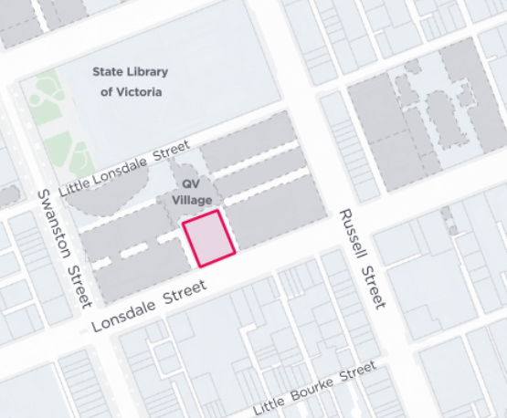
210 Lonsdale St, Melbourne VIC 3000 - please enter through the back of the building in Queen Victoria Village. City of Melbourne staff will be in attendance to guide you.
Wayi Djerring Room (Level 4) at the Queen Victoria Women’s Centre
Trams along Swanston St Stop #8 Melbourne Central Station/Swanston St
Buses run along Lonsdale St to the Swanston St/Lonsdale St stop. Closest train station is Melbourne Central.
Wilson Carpark is located at QV - 180 Lonsdale Street and has rates from $15 per day. Taxi/Uber drop off is available along Lonsdale Street close to the entrance of 210 Lonsdale Street.

Drill hall at Multicultural Hub

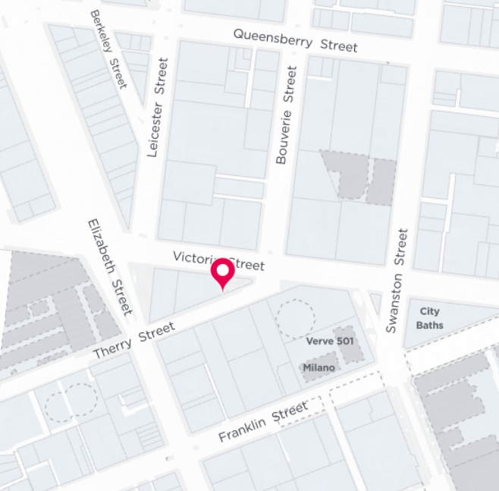

26 Therry St, Melbourne VIC 3000
Trams along Elizabeth St to Stop #7 Queen Victoria Market/Elizabeth St
Closest train station is Melbourne Central and 6-minute walk along Elizabeth St.
Day time parking is available at CBDPark located 3 minutes' walk from Drill Hall and has rates from $12 per day.

FOOD
Catering will be provided to all participants throughout the four sessions. Catering is being provided by Meals with Impact, a work-integrated social enterprise (WISE) that employs women from migrant & refugee backgrounds to co-design and produce culturally appropriate meals tailored for food relief and to the wider community.

PAYMENT DETAILS
Participants that attend all the sessions we be given $500 to thank you for your time. This stipend will be provided by voucher to all participants at the end of the final session on 18 November 2023.
We understand that 'life happens'. If for whatever reason you're unable to attend, we request that you notify the MosaicLab team as soon as you can. A contact number will be provided closer to the first session.

ONLINE PANEL PORTAL
A portal has been created on Participate Melbourne for the dedicated use of Panel Participants.
This portal can be used at all stages of the panel process. It will be used as a platform for participants to ask questions or make suggestions throughout the panel process.
All information in this pack and your Background Report will be available online at any time to refer back to.
Log in
Please go to the following link: https://participate.melbourne.vic.gov.au/affordable-housing
You will be asked to provide a password to enter the Portal.
The password is all lowercase = panelportal
Create an account
To ask questions and interact with fellow participants online you now need to create an account.
Select the Log In button the top right of the screen, and then select “Sign up today”.
Create an account and set your username as FirstnameLastname.

Technical Support
If you have any questions about the portal or need any assistance with setup, please contact Aurora Scott during the Meet and Greet session or via email at Aurora.Scott@melbourne.vic.gov.au

CONTACT DETAILS
Aurora Scott
Project Officer - Community Engagement and Impact
Aurora.Scott@melbourne.vic.gov.au
0479 195 053

Giovina Rocconi
Manager - Community Engagement and Impact
Giovina.Rocconi@melbourne.vic.gov.au
0433 461 357

Jo Cannington
Director Homes Melbourne
Jo.Cannington@melbourne.vic.gov.au

MosaicLab Facilitators
register@mosaiclab.com.au

We hope you enjoy your involvement with the People’s Panel and we look forward to supporting you with the task and receiving you final recommendations at the end of the process.

