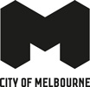
Heritage, People and Place
Discussion Paper 2024

Acknowledgement of Traditional Owners
The City of Melbourne respectfully acknowledges the Traditional Owners of the land we govern, the Wurundjeri Woi-wurrung and Bunurong / Boon Wurrung peoples of the Kulin Nation and pays respect to their Elders past and present. We acknowledge and honour the unbroken spiritual, cultural and political connection they have maintained to this unique place for more than 2000 generations.
We accept the invitation in the Uluru Statement from the Heart and are committed to walking together to build a better future.

Contents
Acknowledgement of Traditional Owners 2
Purpose 5
What is heritage and why is it important? 5
Why are we reviewing the Heritage Strategy? 6
Current challenges and opportunities to be addressed 6
New strategic context 7
Heritage places in the City of Melbourne 7
Developing a people-centred approach 7
What is people-centred heritage? 7
Focus areas 9
Delivering a people-centred approach through our focus areas 9
Focus area 1: reflecting Aboriginal heritage as central to the history of Melbourne 10
Opportunities to take a people-centred approach 10
How could City of Melbourne lead by example? 11
City of Melbourne projects already underway that align with focus area 1 11
Focus area 2: heritage interpretation 12
Sharing our stories and acknowledging the layers of heritage 12
Opportunities to take a people-centred approach 12
How could City of Melbourne lead by example? 13
Focus area 3: heritage, urban change and economic growth 14
Heritage as an enabler of change and growth in Melbourne 14
Opportunities to take a people-centred approach 14
Case study: Abermale Street, Kensington, designed by Fieldwork for Assemble Communities 14
Case study: Quay Quarter, Sydney 15
How could City of Melbourne lead by example? 15
Focus area 4: heritage and climate change 16
Heritage places and our zero-carbon future 16
Opportunities to take a people-centred approach 16
Case study: Willam Ngarrang retrofit, Fitzroy, Kennedy Nolan, Finding Infinity and Wilderness Building Co 16
How could City of Melbourne lead by example? 17
Focus area 5: innovative heritage planning and processes 18
Opportunities to take a people-centred approach 18
Case study: The Holocaust Museum, Elsternwick, designed by Kerstin Thompson Architects 18
Case study: Los Angeles African American Historic Places, Getty Conservation Institute 19
How could City of Melbourne lead by example? 19
Next steps 20
Bibliography 21
How to contact us 23
Online: 23
In person: 23
Telephone: 23
Fax: 23
In writing: 23
Interpreter services: 23
National Relay Service: 23

Purpose
This Discussion Paper is the start of a conversation about how we shape our new Heritage Strategy. We want to understand how we should protect, manage and celebrate heritage in contemporary Melbourne.
The current Heritage Strategy 2013 is an ambitious and innovative strategy that has provided a sound framework to protect and enhance Melbourne’s heritage places. Much has changed since 2013: our city now faces unprecedented pressure for growth and change alongside economic and social challenges and a rapidly escalating climate crisis. Our approaches to heritage places may need to evolve in our changing city.
As we develop a new strategy, we have the opportunity to consider how we can better understand, communicate and interpret people’s heritage values and the buildings, landscapes and other items that carry our stories into the future. This includes acknowledging and celebrating Melbourne’s rich Aboriginal heritage. We are shifting our focus onto why we protect and how we can better acknowledge or celebrate heritage, including heritage that is not well recognised or can’t be protected through the planning scheme.
The ideas and topics in this paper are a prompt for conversation, not an outline of an adopted approach. We want to explore and test them with the diverse voices of the community, business and government. Your feedback will inform the development of our new Heritage Strategy and, therefore, how we connect with our heritage over the next 10 years.

What is heritage and why is it important?
Heritage is our inherited traditions and culture expressed through the layout of the city, including its buildings, objects, collections, landscapes, public parks and gardens, infrastructure, monuments and public art. Some heritage is harder to see, including the city’s archaeology,
our traditions and memories, and Aboriginal intangible heritage, including ceremony, practises, stories, skills, knowledge, dance and song.
Heritage is dynamic and changes with our society over time. It is at the heart of community identity and helps sustain Melbourne’s rich and diverse communities. It is an essential part of the present we live in and the future we will build. It is passed on to us and it is the inheritance we pass on to future generations.

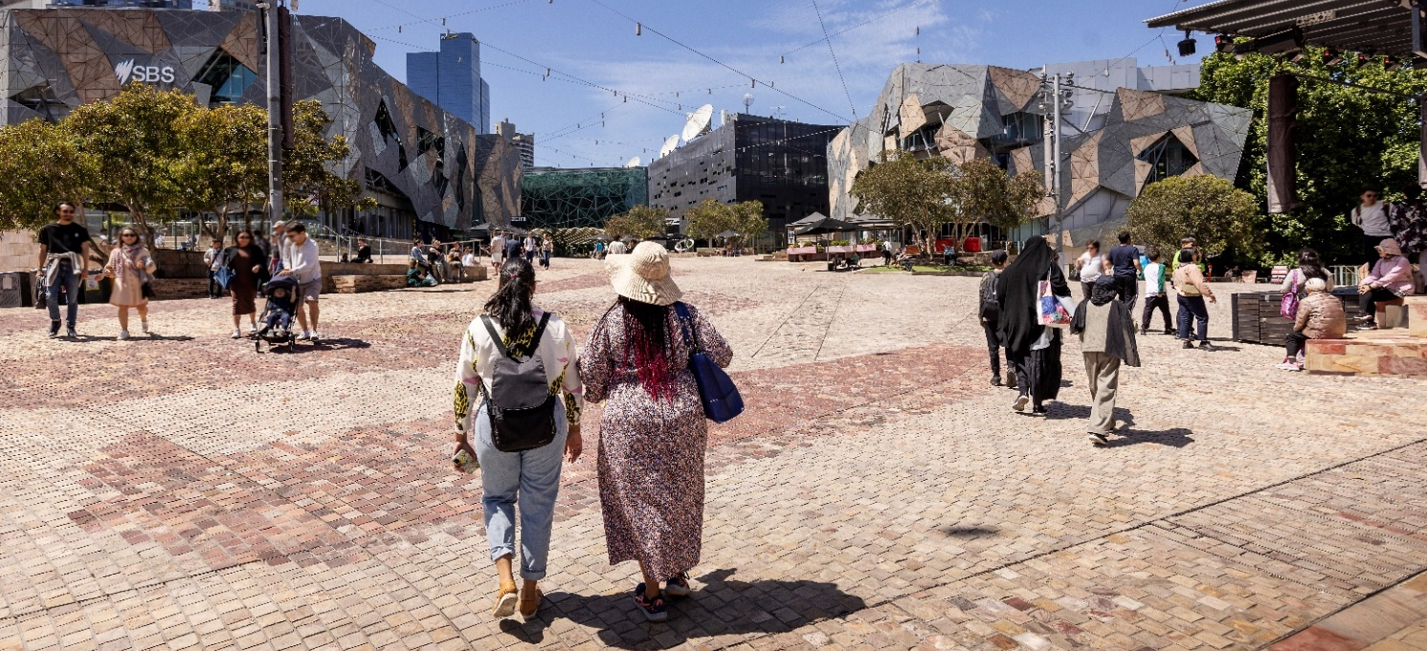
Image 1 People walking through Fed Square

Why are we reviewing the Heritage Strategy?
The current Heritage Strategy 2013 was developed to provide a framework and actions to protect and enhance Melbourne’s heritage. Since then, we have:
- completed seven heritage reviews for individual neighbourhoods and implemented associated Heritage Overlays in the Melbourne Planning Scheme including:
  - City North Heritage Review, 2013
  - West Melbourne Heritage Review, 2016
  - Southbank Heritage Review, 2017
  - Fishermans Bend Heritage Review, 2022
  - Hoddle Grid Heritage Review, 2022
  - Carlton Heritage Review, 2023
  - North Melbourne Heritage Review, 2023
- progressed two further neighbourhood heritage reviews for South Yarra and Parkville
- changed how we categorise heritage buildings, bringing our policies in line with best practice
- renewed our heritage grants program through the Melbourne Heritage Restoration Fund
- improved local heritage policies in the Melbourne Planning Scheme, guiding how heritage places can be developed.
Most existing Aboriginal history and heritage initiatives sit within the Aboriginal Heritage Action Plan 2015-18, the Indigenous Heritage Study Stage 1 and the Reconciliation Action Plan June 2021 – June 2023. Work on many of these actions has progressed.

Current challenges and opportunities to be addressed
Since 2013, Melbourne has experienced rapid population growth and a changing economy. There is immense pressure for more affordable, secure and well-located housing. The municipality’s residential population is over 150,000 and is projected to double in the next 20 years. Greater Melbourne is expected to increase from 5 million to more than 8 million people by 2040. House prices continue to rise as supply is not keeping up with demand.
Heritage places can complement more affordable, high-density housing by playing a role in shaping high quality design and planning of better quality and denser housing. Heritage places also create the character that makes our neighbourhoods more desirable.
Australia and the world are also experiencing a changing climate. Victoria is becoming warmer and drier. City of Melbourne declared a climate and biodiversity emergency in 2019 in recognition of the urgent action required to address climate change.
Heritage places can play an important role in climate change mitigation. Retrofitting existing buildings, rather than demolishing them, improves their efficiency, reduces building waste and conserves their embodied energy. We need further research to determine the most efficient
and sensitive ways of adapting heritage and other existing buildings for climate resilience and lower emissions.

New strategic context
Since the development of the previous Heritage Strategy in 2013, local, state, national and international policy has changed in response to the context we live in. This includes new State heritage and Aboriginal heritage legislation, and updated City of Melbourne plans and strategies.
At an international level, Transforming Our World: the 2030 Agenda for Sustainable Development adopted by all United Nations member states in 2015, introduced 17 Sustainable Development Goals, and in 2020, the International Council on Monuments and Sites (ICOMOS) resolved to promote people-centred approaches to heritage management (ICOMOS Resolution 20GA/19). In this discussion paper, we consider how City of Melbourne could adopt this approach.

Heritage places in the City of Melbourne
The City of Melbourne currently has 1080 listed heritage places that include precincts, buildings, trees and gardens, monuments and bridges. The buildings listed range from dwellings to major sports venues, art galleries, libraries, railway stations, offices and pubs. Most are protected through a local Heritage Overlay, and 331 are included on the Victorian Heritage Register. We have eight places on the National Heritage list and the Royal Exhibition Building and Carlton Gardens are included on the UNESCO World Heritage List.
Melbourne’s history and unique heritage places are a key feature of our identity and distinctiveness.

Developing a people-centred approach
As part of the development of this paper, we commissioned a scoping paper prepared by Dr James Lesh of Heritage Workshop. This explored how a people-centred heritage framework could be implemented and has informed this paper.

What is people-centred heritage?
When a people centred approach is taken, places are considered significant because of people’s relationship with them. This relationship is at the heart of heritage conservation. Social and spiritual values are as important as those directly related to the physical fabric. Other values, such as environmental and economic, should also be considered. People-centred heritage aims to empower the community to help shape cultural heritage.
Under a people-centred approach, the work done by heritage experts evolves through a process of community collaboration. It encourages community involvement wherever practical and promotes varied ways for people’s views to be included without excluding expert knowledge.
There are challenges with taking this approach within the existing system, such as balancing the diverse views of the community and other stakeholders, but these must be considered alongside the significant opportunities that a people-centred approach could present. We know from engagement responses that many people in our communities see heritage as an essential part of the identity of our neighbourhoods and the municipality. We have an opportunity to harness this interest, enabling people to influence how we understand our history and the contribution it makes to our future.
Over the past 10 years, we have received thousands of community comments on heritage in response to hundreds of consultation questions on many projects. A summary of these comments in Table 1 below indicates what heritage means to our community.

Table 1: Community feedback on heritage
Our community
City of Melbourne’s Community Vision shows that the community’s aspirations include.  - We celebrate and protect Melbourne’s unique places.  - Aboriginal cultures are central to Melbourne’s identity.  Understanding the city’s history is also important to visitors, who are often interested in experiencing history through our places and people. Many tourists visit a heritage building, site or monument during their stay. | 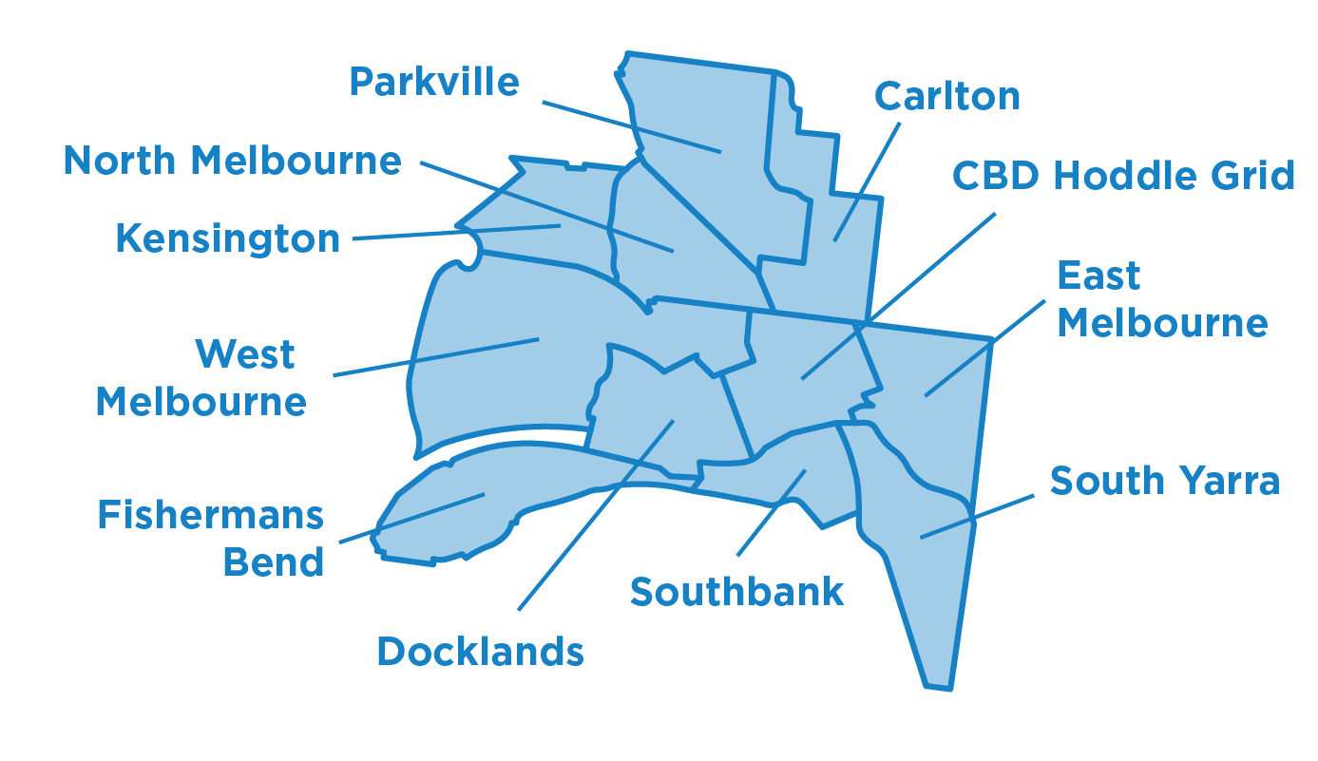
City of Melbourne has six historical societies.
We have 16 other resident and community groups across the municipality.
West Melbourne  The continued liveability and character of West Melbourne rely on future development that produces high-quality, sustainable buildings that respect the neighbourhood’s highly valued and unique heritage. | Melbourne CBD  Residents identified heritage buildings as crucial parts of the city’s character that should be protected.
North Melbourne  The area hosts some of Melbourne’s oldest buildings alongside new developments. Residents believe North Melbourne needs better promotion for its unique character and identity. | Carlton  Many residents have pointed to Carlton’s rich history of multiculturalism, which can be found in the diversity of shops and residences throughout the suburb.
Parkville  Residents highly value the protection and retention of Parkville’s unique character as one of Melbourne’s most intact neighbourhoods. | Docklands  As a newer suburb, Docklands is still developing. There are many projects underway to make the area a connected, activated and welcoming place for visitors and residents.
South Yarra  Residents are seeking greater protection of the eclectic mix of building typologies, as well as Aboriginal culture and stories that are represented in the area. | East Melbourne  As one of Melbourne’s oldest suburbs, East Melbourne is home to many iconic heritage buildings that many residents believe add to its charm, character and village-like feel.
Southbank  There is limited heritage protection in this area. Many residents believe that Aboriginal heritage identification, protection and interpretation should be a key neighbourhood priority. | Kensington  Many residents value the existing heritage homes in the area and hope growth will respect the village-like feel, maintain the green streets and protect views of the city.

Focus areas

Delivering a people-centred approach through our focus areas
We have chosen five focus areas for this Discussion Paper, highlighting key themes or issues that could frame a people-centred approach. By acknowledging the needs and values of the people and communities of Melbourne, we can better plan for heritage places through:
- Reflecting Aboriginal heritage – acknowledging and celebrating the central role of Aboriginal history which links to all other focus areas in this paper.
- Heritage interpretation – better understanding the history of the city, its heritage places and values by creating experiences that connect people with the stories of place.
- Heritage, urban change and the economy – accommodating growth and change while ensuring that Melbourne’s distinctive places remain a prominent feature of its evolution and ongoing economic prosperity.
- Heritage and climate change – adapting to climate change and providing environmentally sustainable heritage buildings and places for people to live, work and enjoy.
- Innovative heritage planning and processes – exploring the future of heritage protection, alternative processes that enable more community involvement, and how the heritage of different parts of our community can be better understood and protected.
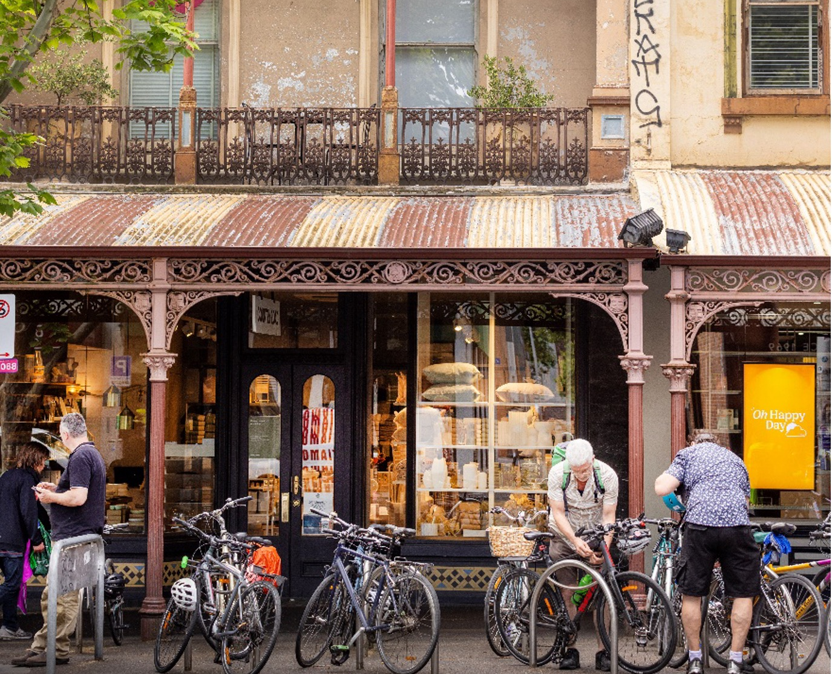
Image 1 People parking bikes at a heritage shopfront on Lygon Street, Carlton

Focus area 1: reflecting Aboriginal heritage as central to the history of Melbourne
As we develop a new strategy, we have an opportunity to acknowledge and celebrate Melbourne as an Aboriginal city. Aboriginal heritage, culture and knowledge are central to Melbourne’s identity. Truth-telling about our heritage is vital as we strive for reconciliation. The places and stories of the Traditional Owners, the Wurundjeri Woi-wurrung and Bunurong Boon Wurrung peoples of the Kulin Nation, as well as people from other Aboriginal communities who have a connection to the city, should be told as part of our living history and identity.
Focus area 1 will enable us to consider developing a framework in consultation with relevant Aboriginal communities and Traditional Owners. This could inform how Aboriginal history and perspectives, and its impact on Melbourne, should be reflected across the entire Strategy. In doing so, Aboriginal culture, heritage and knowledge could become central to Melbourne’s heritage planning and help change our standard approaches.

Opportunities to take a people-centred approach
Aboriginal heritage values are aligned with people-centred heritage in emphasising social and spiritual values.
All heritage places in the City of Melbourne are on Country and may be linked to colonisation. Acknowledging this can inspire new ways of identifying, protecting, understanding and managing places.
This Discussion Paper will be used to start conversations. By creating opportunities to share knowledge about Aboriginal heritage and places with Aboriginal and non-Aboriginal heritage significance, we will help the community connect with our built environment and natural landscapes and better reflect an inclusive and diverse heritage.
Case study: The University of Melbourne student precinct
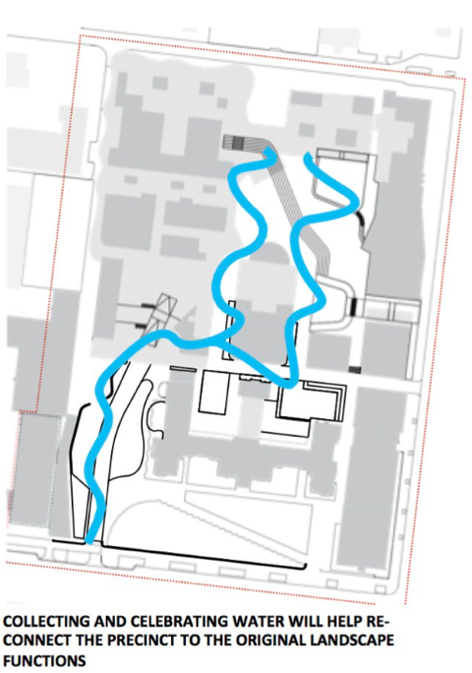  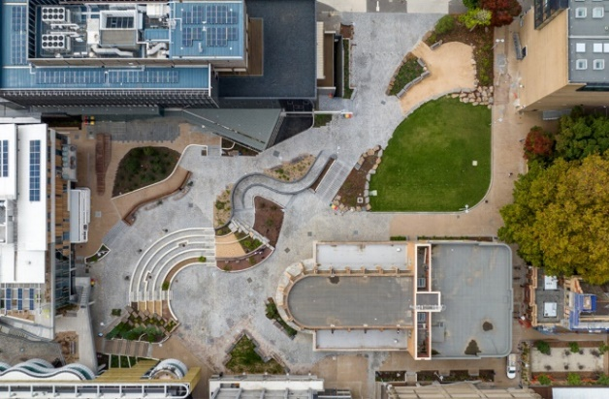  Image 3 Courtesy of kane.com.au | Heritage protection:  Incorporates a significant building (Frank Tate Building) in an individual Heritage Overlay.  New use and scale:  A large, tiered public square for students, staff and the broader public.  Key features:  - Unearths histories and layers of place through the tracing of the now-submerged Bouverie Creek through a public landscape.  - Integrates Aboriginal knowledge into modern design through a design response led by principles of “primacy of Country” and “reveal and remember place”.  - Undertook extensive engagement with 20,000 staff, students and alumni to create a design that encourages connections.  - Led by Indigenous architect, knowledge broker and interpreter Jefa Greenaway. The design is informed through cultural mapping undertaken with Traditional Owners and research into the university’s colonial foundations on site.
Case study: Connecting with Country Framework, Government Architect of NSW (GANSW)
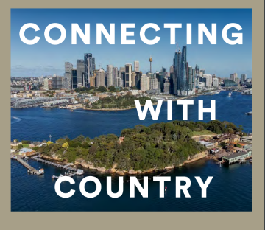  Image 4 Courtesy of planning,nsw.gov,au | Project description:  The Connecting with Country Framework is a guide for good practice to help respond to Country and empower Aboriginal voices when planning, designing and delivering built environment projects.  Key features:  - Outlines a framework that guides and suggests how to connect with Country to guide more sustainable, resilient and culturally responsive development.  - Seeks to reframe the design process using a Country-centred approach, which looks to the connections between people, nature and design and meaningful engagement with local Aboriginal communities.  - Developed in consultation with Aboriginal and Torres Strait Islander people.

How could City of Melbourne lead by example?
We could work with Traditional Owners and the broader Aboriginal community to develop a principles framework for managing and promoting Aboriginal heritage in the municipality, for example with reference to the GANSW Connecting with Country Framework. These principles could guide the delivery of priorities under the other four focus areas.

City of Melbourne projects already underway that align with focus area 1
Image 5 Mapping Aboriginal Melbourne interface | Mapping Aboriginal Melbourne
 | In collaboration with Traditional Owners and Aboriginal communities, City of Melbourne has developed an interactive digital map of places of Aboriginal historical and cultural significance within the municipality. The map can be explored by theme or timeline and reveals something of Aboriginal peoples’ deep connection to this Country and significant events since colonisation. This tool will inform projects across City of Melbourne, including the new Heritage Strategy.

Focus area 2: heritage interpretation

Sharing our stories and acknowledging the layers of heritage
In order for heritage places to remain meaningful and supported by the community, their importance needs to be understood. Heritage interpretation aims to strengthen the relationship between people and heritage places by sharing the stories and connections that a place holds with those who live or work in, or visit the city. It can take many forms, including signage, wayfinding, events, artwork, digital media and building and public realm design.

Opportunities to take a people-centred approach
A people-centred approach would make interpretation a key component of heritage processes. Heritage interpretation helps to reveal and celebrate the different layers of history associated with a place. Sometimes this can include contested or difficult histories that should not be forgotten. Interpretation is not simply about celebration, but also experiences of pain, trauma and loss. Importantly, it can acknowledge experiences of Aboriginal people since colonisation, and their ongoing strength, resilience and survival.
City of Melbourne could look beyond traditional modes of interpretation. This could include exploring how new technologies can be harnessed to create engaging and exciting ways of communicating through place activation or digital media to provide unique and memorable experiences.
Case study: Yalinguth, immersive audio experience
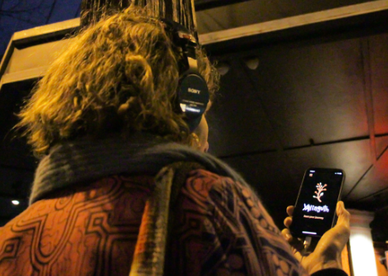  Image 6 Courtesy of yarracity.vic.gov.au | Project description:  Seeks to connect all communities to historical first-hand accounts of place through sharing oral storytelling of Aboriginal and Torres Strait Islander peoples.  Key features:  - Augmented audio experience app.  - Uses geolocated stories and sounds to take the listener on a journey through history.  - Connects the listener to spoken stories, songs, poems and sounds that tell the Aboriginal and Torres Strait Islander history of Gertrude Street, Fitzroy and along the Birrarung/Yarra River.

Case study: Guidelines for hoardings and scaffolding, City of Sydney
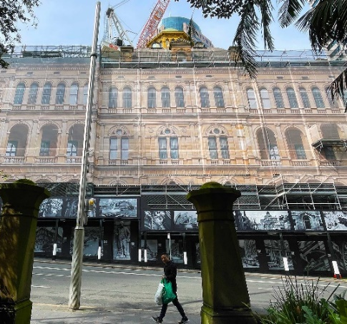  Image 7 Courtesy of cityofsydney.nsw.gov.au | Project description:  The Hoardings and Scaffolding Policy for City of Sydney regulates the design, approval, installation and use of temporary structures on or above roads.  Key features:  - Seeks to reduce the impact of alterations and development on the city’s appearance.  - Requires temporary structures in heritage conservation areas to display high-quality historic images of buildings and streetscapes.  - Works with City of Sydney’s historian to interpret heritage buildings to encourage education and celebration.

How could City of Melbourne lead by example?
- developing an interpretation strategy to inform when and where heritage interpretation should be done, and encourage interpretation to inform the design of new developments
- working with Traditional Owners and the broader Aboriginal community to interpret places and stories in the municipality.
- reviewing the history and placement of the city’s public art and monuments, and ensuring new works reflect our diverse heritage
- implementing a heritage hoardings program using images that show important parts of Melbourne’s history, where appropriate
- instating a city historian to work with developers and the community to find and guide opportunities to share stories, and inform City policies and projects.
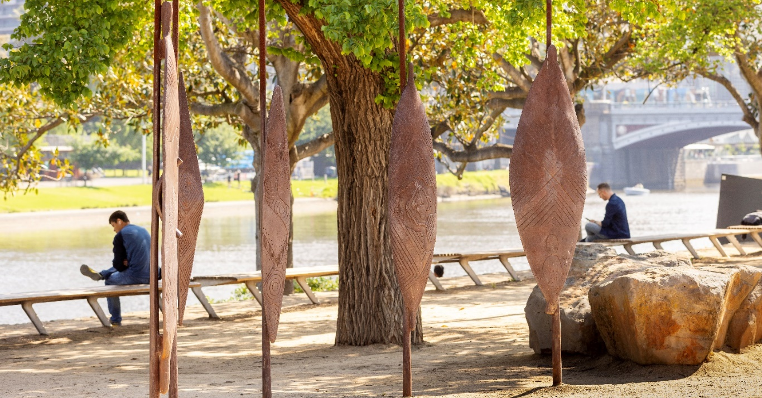
Image 8 Birrarung Wilam (Common Ground) sculpture at Birrarung Marr

Focus area 3: heritage, urban change and economic growth

Heritage as an enabler of change and growth in Melbourne
Melbourne is an economic driver for the metropolitan region, Victoria and Australia. It is a vibrant, multicultural, global city, and its historic precincts, streetscapes and buildings, public spaces, parks and gardens are some of its strongest assets. Previous analysis has shown that heritage conservation in City of Melbourne can lead to:
- net gains in cultural tourism, as heritage values can act as a cultural attractor
- pride in our unique heritage places and stronger connection to place for our residents
- the growth of sought-after heritage skills and trades
- retained residential amenity and liveability.

Opportunities to take a people-centred approach
We have an opportunity to celebrate heritage as an important feature of the sustainable development and economic growth of our city. City of Melbourne’s heritage policies set out how the sensitive evolution of heritage places and neighbourhoods should occur. There can be challenges in delivering the right outcomes, but there are many examples where heritage has facilitated high quality designs.
The public benefit of retaining heritage fabric can far exceed that of demolition. New developments that incorporate heritage buildings or fabric have a stronger sense of distinctiveness and place. Heritage buildings can be adapted and complemented by modern additions, giving places another life and meaning – ensuring they continue to contribute to our city’s culture and story. Their adapted forms often also have better environmental performance and better relate to their local context and the public realm.
Heritage tourism can improve people’s understanding and engagement with heritage, as well as drive economic growth and job creation, ensuring the long-term conservation of heritage places.

Case study: Abermale Street, Kensington, designed by Fieldwork for Assemble Communities
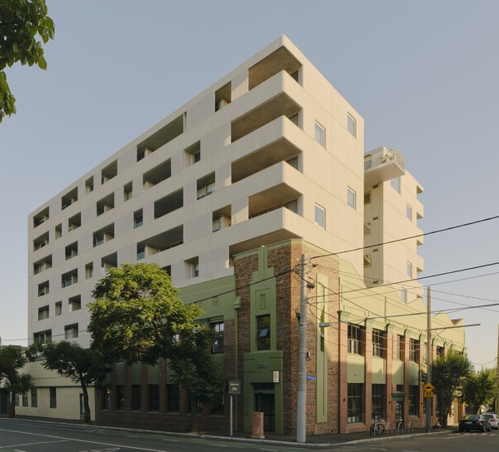  Image 9 Courtesy of archdaily.com | Heritage protection: Significant in Heritage Overlay  New use and scale: High-density residential and zero-waste café.  Key features:  - Renovated wool store and cassette factory.  - Increased affordable housing supply in a build-to-rent-to-own development with one in ten dwellings for key workers at a 20 per cent discount.  - Shared and communal spaces.  - ESD features include retention of building fabric, cross-flow ventilation, reverse-cycle heating and cooling, and new energy-efficient windows.

Case study: Quay Quarter, Sydney
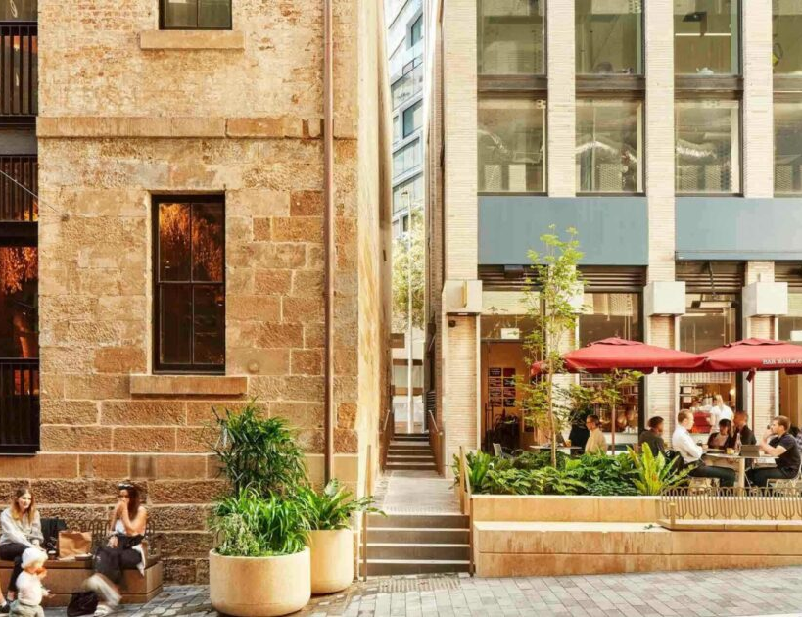  Image 10 Courtesy of aspect-studios.com | Heritage protection: local and state heritage items  New use and scale: Two city blocks incorporating restaurants, office buildings, stores and apartments.  Key features:  - Re-establishes old laneway network of Sydney, with new development complementary to historic sandstone wool stores.  - Public art and interpretive design throughout reveal the legacy of the wool stores and the histories and stories of the Gadigal people.  - Quay Quarter Tower retrofit retained 60 per cent of the existing core structure.

How could City of Melbourne lead by example?
We could demonstrate how heritage can facilitate urban change and growth, by:
- working with Traditional Owners and Aboriginal Communities to develop a principles framework to guide the design and life of a project – see focus area 1
- identify and promote examples where heritage has enabled sustainable development and economic activity
- working with business groups and expert heritage bodies on how heritage can assist in achieving social and economic objectives
- working with Experience Melbourne to leverage the potential of heritage places for visitors
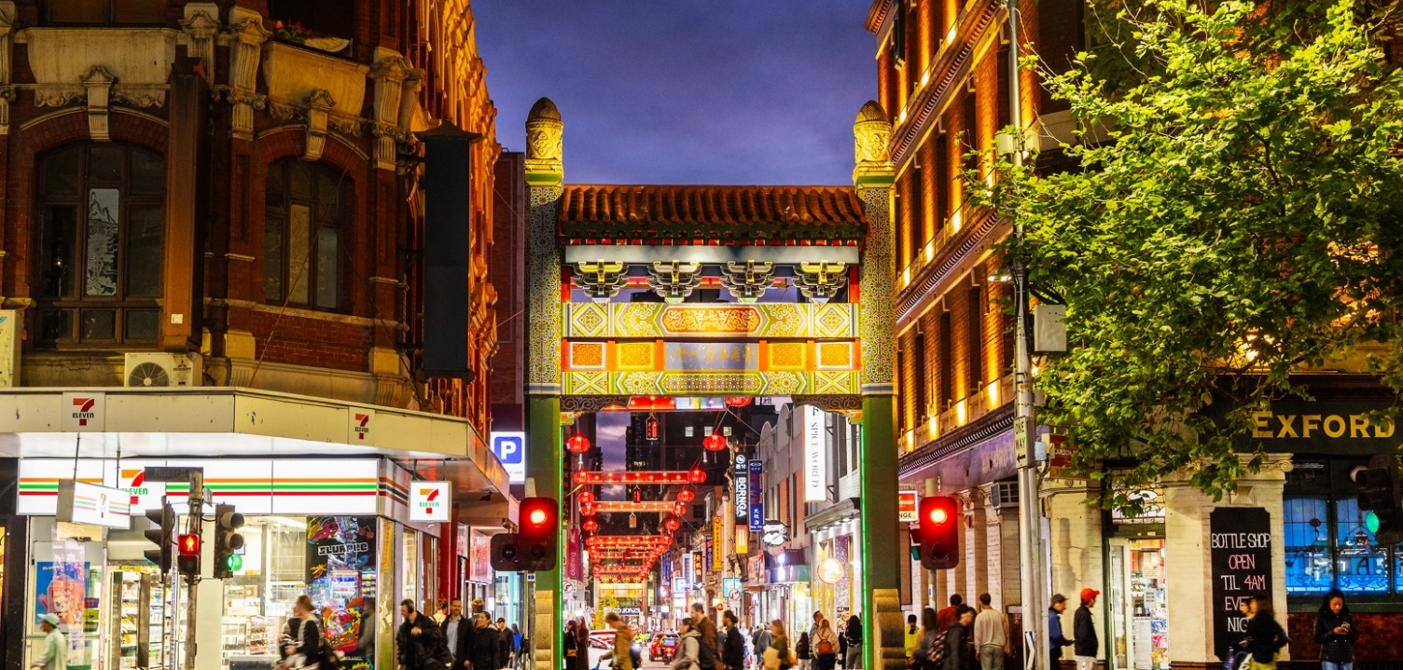
- identifying opportunities to repurpose underutilised heritage buildings to provide housing, such as our Make Room project, which converted a Council-owned heritage building into supported housing.
Image 11 Chinatown, Little Bourke Street

Focus area 4: heritage and climate change

Heritage places and our zero-carbon future
“The greenest building is the one that already exists.”
Carl Elefante – former president of the American Institute of Architects

City of Melbourne is committed to mitigating and adapting to climate change. We aim to achieve net-zero emissions by the year 2040. The construction and operation of buildings account for more than two-thirds of energy consumption and emissions.
Heritage protection is an opportunity to act on climate change by retaining the energy and carbon embodied in heritage building fabric. Retrofitting and adapting heritage buildings causes fewer emissions than a knock down rebuild approach, and can improve their environmental performance and liveability.
We also recognise the risk climate change poses to heritage places through damage from extreme weather events. The Heritage Council of Victoria has prepared principles for climate change risk management for heritage places.

Opportunities to take a people-centred approach
A people-centred approach recognises the critical importance of climate change and its impact on community perceptions of heritage places. We protect heritage for the benefit of future and current generations. We must also face the climate crisis and ensure heritage places are sustainable, efficient and resilient in the future.
The United Kingdom recognises the relationship between heritage and climate change. In many cities, applicants must demonstrate that it is not feasible to retain existing fabric before a permit can be issued for demolition. The City of London has released the Heritage Building Retrofit Toolkit, which provides detailed guidance to property owners about maximising the retention of existing fabric and minimising the environmental impacts of retrofitting a building. City of Melbourne has also developed Retrofit Melbourne, a framework to guide how we support and facilitate investment to retrofit Melbourne’s valued mid-tier commercial buildings to make them zero carbon ready, including those with heritage protection.
Where heritage buildings need improved thermal performance, modest retrofit mechanisms such as improving heating and cooling systems, glazing and insulation can vastly improve their comfort and operational costs, and may not require a planning permit.

Case study: Willam Ngarrang retrofit, Fitzroy, Kennedy Nolan, Finding Infinity and Wilderness Building Co
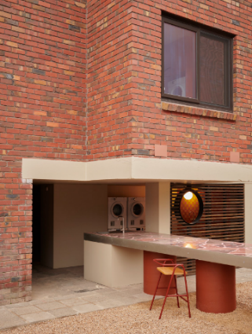  Image 12 Courtesy of kennedynolan.com.au | Heritage protection: Non-contributory in Heritage Overlay.  New use and scale: Medium density residential.  Key features:  - The entire 1970s building was retained, except for windows and doors, which were replaced to improve airtightness – resulting in a large reduction in embodied carbon emissions compared with a new building.  - Net-positive energy output with improved amenity for the tenants – solar systems, efficient water fittings and a heat recovery ventilation unit estimated to provide up to an 80 per cent reduction in bills for tenants.

How could City of Melbourne lead by example?
We could seek to reduce emissions and improve the climate resilience of heritage places by:
- exploring an approach that considers the relationship between people, nature and design to deliver sustainable outcomes – see focus area 1
- exploring flexibility in heritage controls to support building alterations for improved environmental performance, including the installation of visible solar panels without a permit
- reviewing sustainability issues and appropriate policy responses for buildings from particular periods, such as post-war buildings
- considering how landscapes can be adapted for climate resilience by reflecting elements of the original Indigenous landscape
- forming an advisory group to amplify the Retrofit Melbourne plan and to provide education and support to address the specific challenges of retrofitting heritage buildings
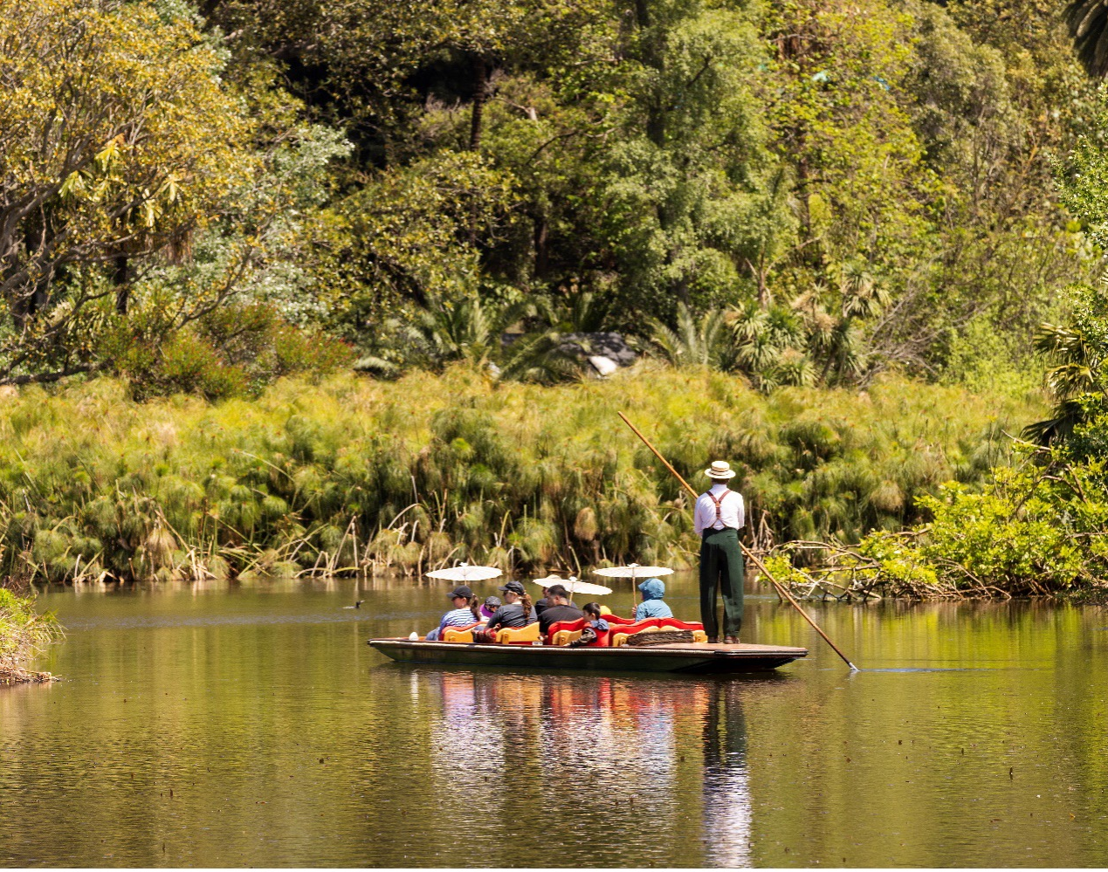
- advocating for the Victorian Government to deliver on its Built Environment Climate Change Adaptation Action Plan 2022-2026, which includes developing policies guiding the sensitive retrofitting of heritage buildings and adaptive reuse as an alternative to new construction.
Image 13 People on a punt at the Royal Botanic Gardens

Focus area 5: innovative heritage planning and processes
Heritage has traditionally been closely linked to statutory heritage planning and authorities’ legislative obligations. There are however many ways that heritage (including unlisted heritage) and its contribution to local character, place and distinctiveness, amenity, and community values can be acknowledged and celebrated.

Opportunities to take a people-centred approach
People-centred heritage enables greater community collaboration that can lead to celebration of more diverse historical themes and eras/ periods.
It could recognise the broader social values and associations of heritage places and important unlisted places, beyond the built fabric. It could engage new and diverse communities while also strengthening relationships with existing heritage stakeholders.
A people-centred approach could lead to greater tolerance for physical changes to a heritage place when it provides community benefit, while retaining the significant parts of a building – particularly when it enables traditional uses to continue.

Case study: The Holocaust Museum, Elsternwick, designed by Kerstin Thompson Architects
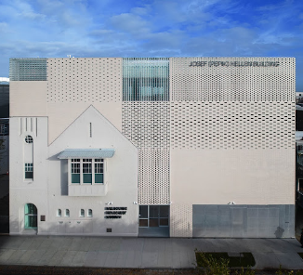  Image 14 Courtesy of mhm.org.au | Heritage protection: Contributory in a Heritage Overlay.  New use and scale: An expanded and renovated museum that houses an extensive collection of sensitive materials relating to the Holocaust.  Key features:  - Incorporates the original heritage fabric in the new design, uniting the past and present into one façade.  - The distinctive heritage façade with an iconic turret is encompassed by glass and clay brick into a new building envelope that improves energy efficiency and welcomes light throughout the interiors.  - The innovative design integrates old and new rather than using the traditional setback approach for additions, creating distance or rebuilding entirely.

Case study: Los Angeles African American Historic Places, Getty Conservation Institute
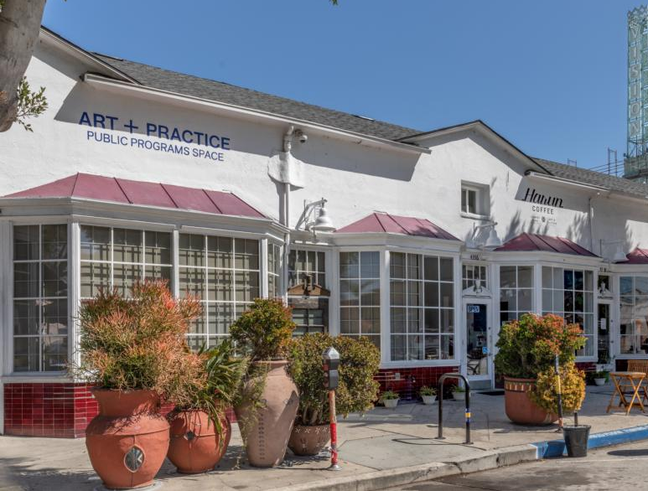  Image 15 Courtesy of getty.edu | Project description: A three-year partnership between the City of Los Angeles and Getty Conservation Institute that seeks to preserve sites that represent Black heritage.  Key features:  - Worked with local communities and cultural institutions to recognise and understand African American experiences in Los Angeles.  - Seeks to examine preservation methods for systemic bias due to the low representation of African-American historic landmarks protected in the city.

How could City of Melbourne lead by example?
We can foster innovation in heritage processes by:
- investigating new ways of engaging with parts of the community whose stories are not told or are underrepresented
- considering the development of a community collaboration approach to make cultural heritage more diverse, accessible and inclusive for all
- considering a municipal-wide review to identify significant places for people and periods that are not well-recognised or represented. This could also include under-explored building interiors, typologies, precincts and historic laneways
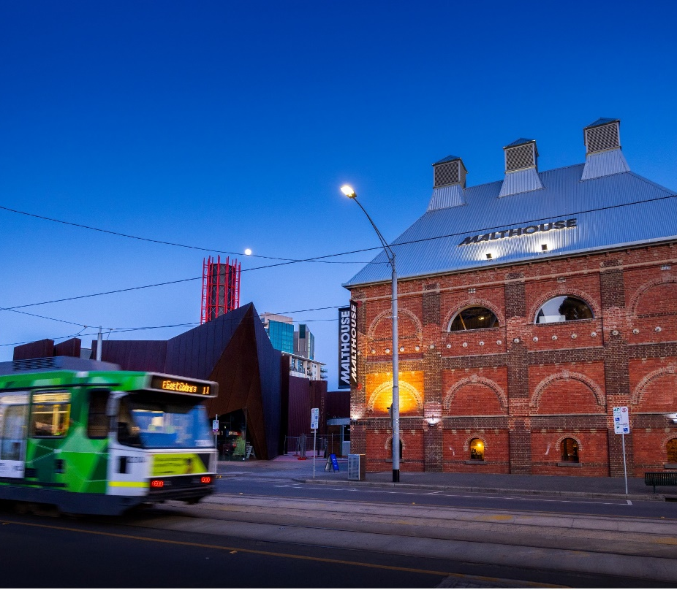
- consider forming an expert panel to review the tolerance for physical material change when cultural significance – and historical or social use – is strengthened by an exemplary development.

Image 16 Tram driving past the Malthouse Theatre, Southbank

Next steps
City of Melbourne will seek to engage with our diverse community, Traditional Owners and other relevant stakeholders as we move through all stages of strategy development.
The first stage is engagement on this Discussion Paper. Feedback will inform the preparation of the Draft Heritage Strategy, which will be considered by the Future Melbourne Committee in 2024.
Further engagement on the Draft Heritage Strategy will lead to the development of the Final Heritage Strategy in 2025, including an implementation plan with agreed actions and timeframes.

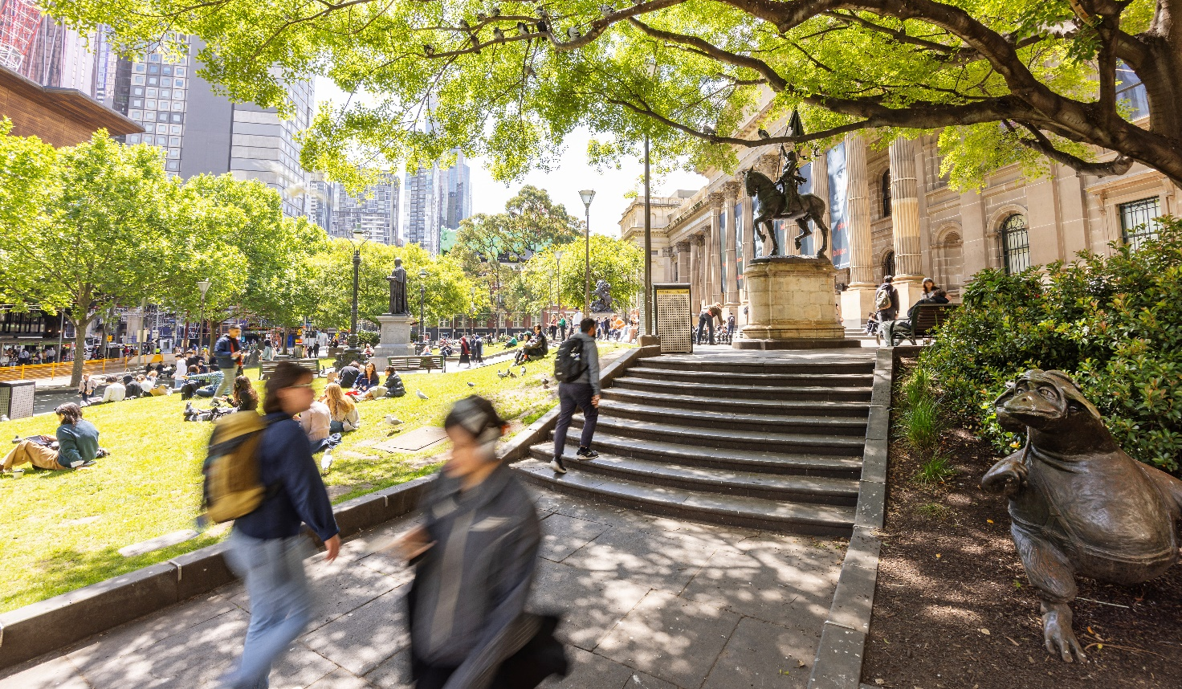
Image 17 People at the front of the State Library, Swanston Street

Bibliography
Aspect Studios, 2021, Quay Quarter Lanes, https://www.aspect-studios.com/au/projects/quay-quarter-loftus-lanes
City of London, Heritage Building Retrofit Toolkit, London. https://www.cityoflondon.gov.uk/assets/Services-Environment/heritage-building-retrofit-toolkit-overview.pdf

City of Melbourne Community Profile 2023, City of Melbourne, viewed 2023, https://profile.id.com.au/melbourne

City of Melbourne, 2023, 'Melbourne Planning Scheme', https://planning-schemes.app.planning.vic.gov.au/Melbourne/ordinance
City of Melbourne, 2023a, Knowledge Bank
City of Melbourne, 2023b, 'Mapping Aboriginal Melbourne', https://aboriginal-map.melbourne.vic.gov.au/
City of Melbourne 2013, Heritage Strategy 2013, Melbourne. https://www.melbourne.vic.gov.au/sitecollectiondocuments/heritage-strategy.pdf

City of Melbourne 2023, Melbourne Planning Scheme, Clause 02.01, Melbourne.
https://participate.melbourne.vic.gov.au/download_file/12657/3481

City of Melbourne 2023, Retrofit Melbourne, Melbourne. https://www.melbourne.vic.gov.au/SiteCollectionDocuments/retrofit-melbourne.pdf

City of Sydney, 2023, Apply historic images to hoardings and scaffolding covers, https://www.cityofsydney.nsw.gov.au/hoardings-temporary-structure-approvals/apply-historic-images-hoardings-scaffolding-covers
City of Yarra 2023, Yalinguth Walk Fitzroy, viewed 2014, https://www.yarracity.vic.gov.au/the-area/visiting-yarra/heritage-walks/yalinguth-walk-fitzroy
Daniels, E 2020, Leimert Park Black Art and Business community, https://www.getty.edu/conservation/our_projects/field_projects/la_african_american_historic_places/
Glas 2020, Collecting and celebrating water will help reconnect the precinct to the original landscape functions, https://www.glasurban.com/work-1/university-of-melbourne-new-student-precinct?itemId=fkv3k37eeuyz54hya4ykx9ussyhdcy
Government Architect New South Wales, 2023, 'Connecting with Country’, https://www.planning.nsw.gov.au/sites/default/files/2023-10/connecting-with-country.pdf
Heritage Council Victoria, 2021, ‘Heritage and Climate Change’,
https://heritagecouncil.vic.gov.au/heritage-protection/heritage-and-climate-change/
ICOMOS 2019, Resolution 20GA/19: People-Centred Approaches to Cultural Heritage.
https://www.icomos.org/images/DOCUMENTS/Secretariat/2021/OCDIRBA/Resolution_20GA19_Peolple_Centred_Approaches_to_Cultural_Heritage.pdf

Kane Constructions, 2020, The University of Melbourne Student Precinct Project, https://www.kane.com.au/project/the-university-of-melbourne-new-student-precinct
Kennedy Nolan Architects, 2023, Willam Ngarrang Retrofit, https://www.kennedynolan.com.au/willam-ngarrang-retrofit
Lesh, J July 2020 ‘The Conversation’ https://theconversation.com/why-heritage-protection-is-about-how-people-use-places-not-just-their-architecture-and-history-138128
Lesh, J 2023, City of Melbourne Heritage Strategy Scoping Paper, Melbourne.
Melbourne Holocaust Museum 2023, Melbourne Holocaust Museum, https://mhm.org.au/
New South Wales Government 2023, Better Placed, Connecting with Country: Issue no. 03, New South Wales. https://www.planning.nsw.gov.au/sites/default/files/2023-10/connecting-with-country.pdf

Ross, T 2023, 38 Albermale Street Residential Building / Fieldwork, https://www.archdaily.com/1008193/38-albermarle-street-residential-building-fieldwork
SGS Economics 2017, The Economics of Heritage Overlays in Melbourne Draft Report, Australia.
Taking bold action on climate change 2023, City of Melbourne, viewed 2023, https://www.melbourne.vic.gov.au/about-council/vision-goals/eco-city/climate-change/Pages/taking-action-climate-change.aspx#:~:text=To%20support%20our%20climate%20and,can%20make%20the%20most%20impact.

The 17 Goals 2023, United Nations, Department of Economic and Social Affairs, viewed 2023,
https://sdgs.un.org/goals

Victoria's Changing Climate 2021, Climate change in Australia, viewed 2023,
https://www.climatechangeinaustralia.gov.au/en/changing-climate/state-climate-statements/victoria/

Victoria State Government 2017, Plan Melbourne 2017-2050, Victoria. https://www.planning.vic.gov.au/__data/assets/pdf_file/0025/654550/Plan_Melbourne_2017-2050_Strategy_.pdf

Victoria State Government 2022, Built Environment Climate Change Adaptation Action Plan 2022-2026, Victoria. https://www.planning.vic.gov.au/__data/assets/pdf_file/0034/635965/Built-Environment-Climate-Change-Adaptation-Action-Plan-2022-2026.pdf

Victoria State Government 2023, Victoria's Housing Statement 2023-2034, Victoria. https://content.vic.gov.au/sites/default/files/2023-09/DTP0424_Housing_Statement_v6_FA_WEB.pdf
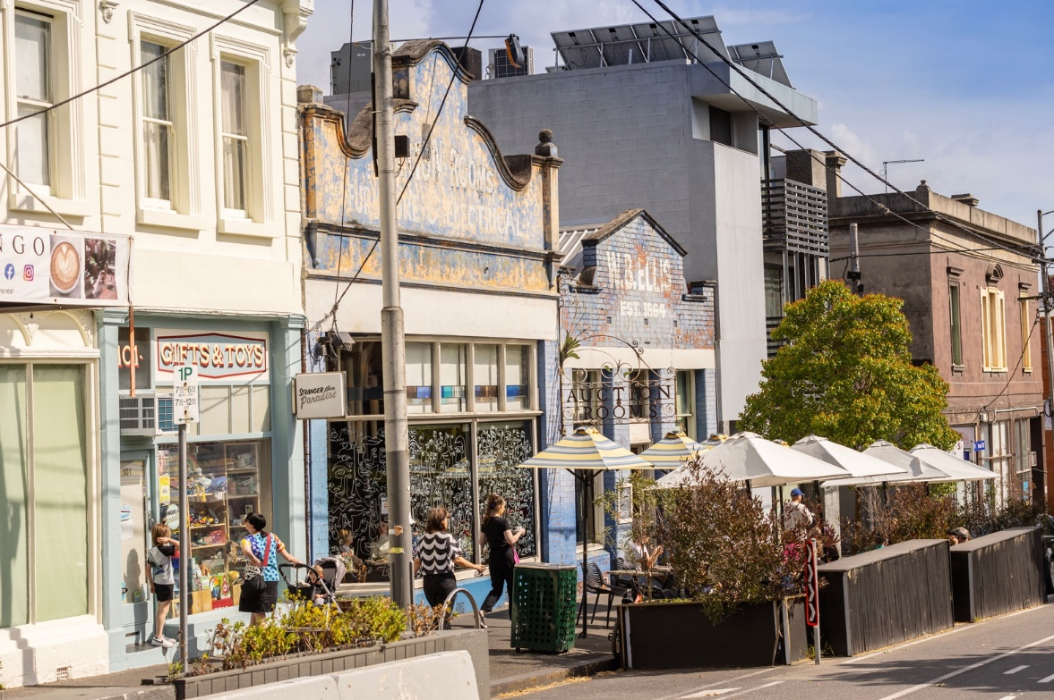
Image 18 People outside heritage buildings on Errol Street, North Melbourne

How to contact us

Online:
melbourne.vic.gov.au

In person:
Melbourne Town Hall – Administration Building
120 Swanston Street, Melbourne
Business hours, Monday to Friday
(Public holidays excluded)

Telephone:
03 9658 9658
Business hours, Monday to Friday
(Public holidays excluded)

Fax:
03 9654 4854

In writing:
City of Melbourne
GPO Box 1503
Melbourne VIC 3001
Australia

Interpreter services:
We cater for people of all backgrounds
Please call 03 9280 0726

National Relay Service:
If you are deaf, hearing impaired or speech-impaired, call us via the National Relay Service: Teletypewriter (TTY) user phone 1300 555 727 then ask for 03 9658 9658 9am to 5pm, Monday to Friday (Public holidays excluded)

