Draft Homelessness Strategy
2024–2030
Updated 6 February 2024
Acknowledgement of Traditional Owners
City of Melbourne respectfully acknowledges the Traditional Owners of the land we govern, the Wurundjeri Woi-wurrung and Bunurong / Boon Wurrung peoples of the Kulin Nation and pays respect to their Elders past and present.
We acknowledge and honour the unbroken spiritual, cultural and political connection they have maintained to this unique place for more than 2000 generations.
We accept the invitation in the Uluru Statement from the Heart and are committed to walking together to build a better future.
Homes Melbourne acknowledges that Aboriginal and Torres Strait Islander peoples continue to live in sacred and spiritual relationships with the land.
We also acknowledge the spiritual homelessness of many people experienced through their separation from traditional land, culture, family and kinship groups.
Melbourne is a city with a conscience: we recognise that sovereignty has never been ceded. It always was, and always will be, Aboriginal land.
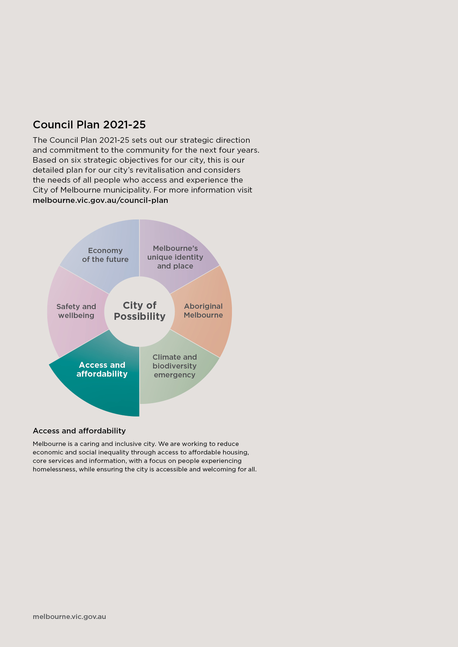
Contents
Foreword 5
Executive summary 5
Guiding principles 6
Our vision 7
Our goal 7
Priorities 7
Priority 1: A city where everyone has a home. 8
Priority 2: A city where no one is left behind 8
Priority 3: A city unified to end homelessness 8
Overview 10
Homelessness in the City of Melbourne 10
Priority cohorts 11
What is causing Melbourne’s homelessness crisis? 20
Housing spectrum 21
Strategic context 22
Australian context: existing roles and responsibilities 24
Relevant City of Melbourne strategies and plans 26
What we heard from the community 27
The Community Vision for Melbourne 29
Priorities for ending homelessness 31
Priority 1. A city where everyone has a home 32
Priority 2. A city where no one is left behind 35
Priority 3. A city unified to end homelessness 37
Appendix A: Homelessness in Australia 40
Appendix B: What has City of Melbourne done so far? 42
Advocacy 42
Outreach 43
Support and partnerships 43
Funding 44
Housing 44
Training and inclusion 45
Bibliography 46

Foreword
[To be prepared by Lord Mayor and Councillor Dr Olivia Ball once community feedback has been received and final report is approved.]
A note on language: Throughout this strategy, we refer to Aboriginal peoples because, in Victoria, Aboriginal peoples are the Traditional Owners. Our use of the term Aboriginal within Victoria reflects cultural protocols that the Victorian Government has also adopted. We refer to Aboriginal and Torres Strait Islander peoples when quoting national populations or statistics, including the Census.
A note on design: The draft strategy is a word document. When the strategy is finalised a designed version will be created with updated graphics and images and formatting.

Executive summary
Homelessness is something that people experience; it is not who they are. Being without secure and affordable accommodation can devastate a person's life, whether it lasts a very short time, several months, or years.
Homelessness affects people from all sections of the community. It can occur when people experience a crisis such as job loss, grief, or family violence, or to those who may have struggled with disadvantage all their lives. Everyone’s experience of homelessness is unique, and it can happen to anyone at any point in their lives.
In our city, we are facing a housing and homelessness crisis, a situation mirrored across Australia and the world. Visible homelessness, people sleeping rough on the streets, is just the tip of the iceberg in our homelessness crisis. Many more women, children and families are part of the hidden problem – sleeping in their cars, on other people’s couches and in severely overcrowded or temporary accommodation.
Homelessness is a community issue with far reaching impacts. We have a responsibility to work together to resolve and reduce the impacts on individuals, families, businesses, and the broader community.
Housing is a fundamental human right – everyone has the right to safe, secure, adequate and affordable housing. We know people can reclaim control of their lives when appropriate housing is available. However, without access to safe, secure housing, people become caught in a loop of homelessness and continue sleeping on our streets.

We cannot do it alone
Everyone has a role to play in tackling this housing and homelessness crisis: all levels of government, the private, property and development sectors, homelessness and health services, community and housing organisations and the broader community.
This strategy acknowledges the different roles that the City of Melbourne and the Victorian Government and Australian Governments play in responding to a variety of homelessness issues. This strategy recognises a collective response is needed and that residents, visitors and businesses all play a role in the success of this strategy.
We are part of the Melbourne Zero Network – an alliance of diverse Melbourne-based businesses, organisations and community groups publicly calling for change to make zero homelessness a reality and taking practical actions to end street homelessness in our city. Melbourne Zero Network is a coalition of what could seem to be unlikely partners, uniting to advocate for real change to end the stigma around street homelessness and position Melbourne as one of the most liveable cities for everyone.

Advocating for action
In addition to direct action and working in partnership, we advocate for others to act. The Victorian and Australian Governments have legislative responsibility for providing public, social and affordable housing and funding specialist housing and homelessness organisations. We will advocate for new and ongoing investment in social, specialist and affordable housing stock. Urgent change is also needed in the complex administrative processes of the housing, homelessness, justice, welfare and health systems

Homelessness in the City of Melbourne
The strategy prioritises Aboriginal peoples and people experiencing chronic homelessness. Both these groups are over-represented in our homeless population. We also prioritise women and young people because they have unique unmet needs within Melbourne’s homelessness system.
Snapshot of homelessness in our city
- 130 people sleeping rough, 1163 people experiencing homelessness in total
- 5 per cent were Aboriginal peoples (Aboriginal peoples only comprise 0.5 per cent of our population)
- 15 per cent were young people aged 15 to 25
- 36 per cent of all people experiencing homelessness were women, and 20 per cent of women were young women aged 20 to 24
Source: Australian Bureau of Statistics (ABS) 2021 Census, released March 2023

Our role
Our community expects us to act. We have an explicit legislative, moral, ethical and leadership responsibility to create a city where every person has a home. We are also responsible for providing support to break the cycle of homelessness.
Adequate housing is a fundamental human right and essential infrastructure critical to health and wellbeing. Over the past two decades, we have invested in housing solutions and coordinated and funded services for people in need. In early 2022, we established Homes Melbourne, recognising that the complexity and extent of the housing crisis needed a comprehensive, targeted response.
Yet despite all our work, the lack of affordable housing in the city undermines our efforts to get people into long-term, safe and secure housing. Without access to safe, appropriate housing, people get caught in a cycle of homelessness.

Consultation and research
Our strategy is underpinned by a robust evidence base and extensive engagement with people who have lived experience of homelessness. We have consulted housing, health and homelessness sector organisations we fund or partner with to deliver services. We also engaged with the broader community – people who operate a business or live, work, study in or visit Melbourne.

Guiding principles
We have developed five principles to inform our approach through research and engaging the community, partners, and experts. These principles underpin our vision, goals and priorities:
- Person-centred approach
- Informed by people with lived experience of homelessness
- People are treated with dignity and respect
- Services are accessible and tailored to the unique needs of each person
- People are empowered to make their own choices (self-determination)
- Health and wellbeing service response
- Trauma-informed
- Culturally safe
- Health-focused
- Adequate housing is a social determinant of health
- Housing is a fundamental human right
- Housing is essential infrastructure
- Everyone has the right to safe, secure, adequate and affordable housing
- Homelessness should be rare, brief and non-recurring
- Housing must be appropriate for individual needs
- Different cohorts may require specialist housing stock
- Government has the primary responsibility to guarantee the right to adequate housing
- Safety and security
- All people have access to our public spaces
- Everyone has a sense of belonging, inclusion, and participation
- The City of Melbourne is a welcoming, accessible, vibrant city
- Measure outcomes and impact
- A qualitative and quantitative data-led approach
- Evaluate impact
- Adapt to improve outcomes
- Open data and transparency.

Our vision
An inclusive city where every person has a home and support to break the cycle of homelessness.

Our goal
To end homelessness in Melbourne by securing sustainable and affordable housing for all.

Priorities
Under three priority areas, we will deliver outcomes to achieve our vision of an inclusive city where every person has a home and gets the support they need to break the cycle of homelessness. Our priorities will be reviewed every two years and updated in response to the changing nature of homelessness and social, political and economic changes. We will develop a costed action plan to implement this strategy. The table below outlines our implementation timeframes. ‘Immediate’ means within the first two years, ‘medium’ means within two to four years, and ‘long-term’ means within the lifetime of the strategy, seven years.

Priority 1: A city where everyone has a home.
We take a person-centred approach, supporting each person on their pathway out of homelessness. People with lived experience of homelessness inform our work. Our priority cohorts are Aboriginal peoples, young people, women, and people experiencing chronic homelessness and sleeping rough.
Outcomes | Our role | Timeframe
1.1 Aboriginal peoples at risk of homelessness have access to culturally safe health, homelessness support and housing services in our city. | Advocate, partner, deliver | Medium
1.2 People experiencing chronic homelessness and sleeping rough are provided with coordinated housing, health and homelessness support services. | Partner and deliver | Medium
1.3 Young people at risk of or experiencing homelessness are supported with prevention, intervention and housing services. | Advocate, partner, deliver | Immediate
1.4 Women at risk of or experiencing homelessness are supported to access secure, affordable homes and services. | Partner and deliver | Medium

Priority 2: A city where no one is left behind
We will create an inclusive city where everyone is supported. We will ensure coordinated services, collaboration and advocacy through partnerships with our communities, governments, corporates and the homelessness sector.
Outcomes | Our role | Timeframe
2.1 Strategic partnerships established through the Melbourne Service Coordination Project will deliver timely and tailored support for people experiencing homelessness. | Partner and deliver | Immediate
2.2 Homelessness and health services in the City of Melbourne meet the needs of our specific homeless community. | Advocate, partner and deliver | Immediate
2.3 Our advocacy will operate effectively across different levels of government and systems to end homelessness. | Advocate | Medium

Priority 3: A city unified to end homelessness
We will support our community to be informed, respectful, empathetic, and united to end homelessness. Our public spaces will be designed and managed to be safe, welcoming and inclusive.
Outcomes | Our role | Timeframe
3.1 Our community is informed and united to create tangible and enduring change to end homelessness. Through collective community initiatives, we will reduce stigma and foster respect, empathy and understanding of homelessness. | Advocate, partner and deliver | Medium
3.2 Our services, programs and public spaces are thoughtfully designed to be safe, accessible and welcoming for everyone. | Partner and deliver | Immediate
3.3 Our organisation supports, trains and equips all staff members to contribute to our shared goal of ending homelessness. | Deliver | Medium
3.4 Our business community and residents can access the support they need to help maintain a safe and welcoming public realm for all. | Partner and deliver | Immediate

Overview

Defining homelessness
City of Melbourne uses the Australian Bureau of Statistics (ABS) definition of homelessness:
“When a person does not have suitable accommodation alternatives, they are considered as experiencing homelessness if their current living arrangement:
- is in a dwelling that is inadequate
- has no tenure, or if their initial tenure is short and not extendable
- does not allow them to have control of and access to space for social relations.”
MacKenzie and Chamberlain’s (1992) cultural definition is also widely used in the homelessness sector and includes three categories of homelessness:
- Primary homelessness is experienced by people without conventional accommodation – sleeping rough or in improvised dwellings.
- Secondary homelessness is experienced by people who frequently move from one temporary shelter to another – emergency accommodation, youth refuges, and couch surfing.
- Tertiary homelessness is experienced by people staying in accommodation that falls below minimum community standards – boarding houses or caravan parks.

The homelessness spectrum
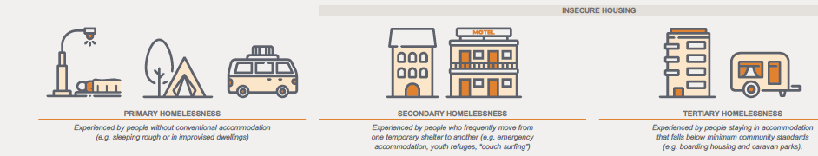

Homelessness in the City of Melbourne
The 2021 Census recorded 1163 people experiencing homelessness in the City of Melbourne out of 169,860 residents. The figure is down from 2016 when the Census recorded 1725 people as experiencing homelessness.
However, as noted above, it was taken during the COVID-19 pandemic, so these patterns do not necessarily indicate ongoing trends. For example, in 2020, before the pandemic, more than 300 people slept rough in the City of Melbourne every night. The Census occurred during COVID-19, and the Victorian Government accommodated people sleeping rough in hotels during this period, which could account for the decrease.
- 130 people sleeping rough
- 5 per cent were Aboriginal peoples (Aboriginal peoples only comprise 0.5 per cent of our population)
- 15 per cent were young people aged 15 to 25
- 36 per cent of all people experiencing homelessness were women, and 20 per cent of women were young women aged 20 to 24
- 1163 people experiencing homelessness in total
Source: ABS 2021 Census, released March 2023

Priority cohorts
This strategy prioritises four cohorts. Our first two priority cohorts are Aboriginal peoples and people experiencing chronic homelessness and sleeping rough. Both these groups are over-represented in our homeless population.
The following two cohorts – women and young people (15 to 25) – have been prioritised because these groups have unique needs not currently met within Melbourne’s homelessness system.
It’s important to note that while we highlight specific cohorts, we are also committed to achieving safe and affordable housing for everyone in our city. Although there is a lack of data relating to homelessness in the LGBTIQA+ communities, this strategy recognises that other groups of people are over-represented.
We also understand the intersectionality of identity – a person experiencing homelessness may hold the identity of many cohorts. This intersectionality needs to be considered when designing policy and service delivery systems. Our work will amplify the voices of LGBTIQA+ communities and other groups who may experience exclusion, including older people, people with a disability and people from multicultural communities.

Aboriginal peoples
Aboriginal peoples are vastly over-represented in Melbourne's overall homelessness population and the chronic homelessness cohort. Despite only 0.5 per cent of the City of Melbourne’s population identifying as Aboriginal, 5 per cent of people experiencing homelessness and 15 per cent experiencing chronic homelessness are Aboriginal peoples (ABS Census 2021, City of Melbourne By Name List, February 2023).
Aboriginal peoples in Victoria experience contact with homelessness services at 10 times the rate of other Victorians (Australian Institute of Health and Welfare, December 2022). Despite Aboriginal peoples representing a high percentage of people experiencing homelessness, there is no Aboriginal-specific access point within Melbourne's CBD or established partnerships with Aboriginal Controlled Community Organisations (ACCOs).

What is an Aboriginal Community Controlled Organisation?
An Aboriginal Community Controlled Organisation is a community-led organisation owned and operated by Aboriginal and Torres Strait Islander peoples in Australia.
ACCOs provide various health, social, and community services tailored to their local community’s needs and cultural requirements.
They strongly emphasise self-determination, community empowerment and cultural safety. They operate on the principle that Aboriginal and Torres Strait Islander peoples should control the design, delivery and evaluation of their community’s health and social services.
ACCOs also prioritise the employment and training of local Aboriginal and Torres Strait Islander staff and are often governed by community-elected boards of directors.
Research to develop a blueprint for an Aboriginal-specific homelessness system reported that Aboriginal peoples often find mainstream services 'cold' and 'scary’ and lack culturally safe environments (Aboriginal Housing Victoria, 2021). Cultural safety means creating an environment where Aboriginal peoples feel safe, respected, and empowered and can access support services that respect and acknowledge their cultural identity, values, and beliefs. Culturally safe environments address the systemic barriers and discrimination that Aboriginal peoples face in the homelessness system.
Despite the Victorian Government’s development of a Cultural Safety Framework in 2019, there are currently no mechanisms to monitor the delivery of culturally safe services across the homelessness system in Melbourne.
Aboriginal peoples have specific cultural and housing needs that are being overlooked. The current homelessness system does not support self-determination. It does not offer choices and options between services or housing choices. There is a call for more Aboriginal staff across the system – including in outreach services and government bodies – to increase representation, understanding, self-determination and participation in decision-making processes.

Jason Russell
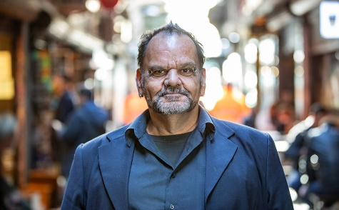

In search of home sweet home
How does a house become a home? It’s a question that Jason Russell still asks himself, years after he put chronic homelessness behind him.
The rituals that helped Jason Russell survive on the streets of inner-city Melbourne for nearly two decades are hard to shake.
“When I first got the keys to the new place, I was terrified. I slept in the lounge room. I didn’t know there was a bedroom. I wouldn’t cook in the kitchen. I was hard wired to living in a squat," Jason said.
In the abandoned inner-city factory where he took shelter for four years, Jason learnt to leave no trace of himself. Nothing that could be linked back to him.
“Now my place is like an Airbnb. I could put my wallet in my pocket and walk out the door and nobody would know it was me living here. Apart from the didgeridoo … that might be a giveaway."
In his former life on the northern coast of NSW, Jason was a firefighter and a family man with a wife and three kids. A proud member of the Birabri Nation.
Things started to unravel when an underlying mental health condition worsened, leading to an honourable discharge from NSW Fire and Rescue.
“As a firefighter we know how to stabilise a body … but an injury to the mind, I didn’t know or understand it. Everything fell to pieces. My career, my world, my family life.”
Jason left his community behind, thinking this would help him escape his “demons”.
After roaming the country for a decade, he eventually found the anonymity he craved in inner-city Melbourne.
Ever since, he’s been unlearning the compound stresses of what he describes as an “18-year bad day”.
While Jason lurched from squat to crisis accommodation to transitional housing and back again, his instincts as a first responder never left him.
“As a firefighter, it was instilled in me to look out for my community.
Jason volunteered at soup kitchens and drop-in centres. He got to know the workers, the agencies. He made friends among those who were also experiencing homelessness.
He started advising the homelessness sector on ways to improve the collection and sharing of data.
“Knowing what it meant to be homeless has made me such a great advocate.”
He has a knack for sharing insights that resonate with first responders. Together, they find ways to better connect with people experiencing homelessness.
“I can walk into a room of firefighters or police, and they’ll respect me. I can tell my story and everyone knows.”
Two years ago, Jason was finally handed the keys to a new house in a suburb that put some distance between him and the squats where demons still lurked.
“I’m housed in a beautiful property. I know that home is where the heart is. I passionately want to make this my home. Is it ‘home sweet home’? Not yet. I’m working on that,” Jason said.

People experiencing chronic homelessness and sleeping rough
Long-term homelessness (12 months or longer) in inner Melbourne was experienced by 70 per cent of people aged between 19 and 24 and 85 per cent of people 25 or older who experienced homelessness.
City of Melbourne and Launch Housing coordinate the Melbourne By Name List, which provides real-time, quality data to inform service planning, service access improvements, decision-making and confirmation of who is moving in and out of homelessness in our municipality. The By Name List identifies 228 people experiencing homelessness, with 112 people reported to be sleeping rough (City of Melbourne, February 2023).
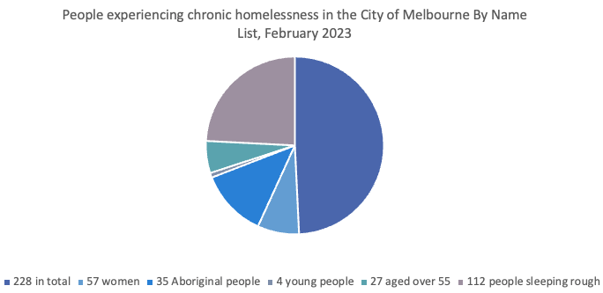
People experiencing long-term homelessness have multiple and complex needs, and many experience mental health difficulties. There are elevated rates of depression, substance abuse and severe mental illness (including psychosis and schizophrenia) in this homeless population. The high prevalence of alcohol and drug use among individuals experiencing chronic homelessness is commonly a consequence of homelessness. It’s a method often used to cope with the dangers, stress and anxiety they face during homelessness.
For people experiencing long-term homelessness, it is now widely understood that housing alone is unlikely to be an adequate or lasting solution. Many who have been sleeping rough for an extended time have experienced deep trauma and violence, have complex needs and require physical and mental health support.
Melbourne’s hospitals provide healthcare for many experiencing chronic homelessness and sleeping rough. Yet our hospitals are under-resourced and not working with homelessness services as effectively as they could. People are still discharged into street homelessness, especially on weekends when most support services are closed. Coordinated discharge planning remains a gap. A less siloed approach is needed to recognise chronic homelessness as a health emergency.
In our city, the homelessness service system is not receiving effective responses from community mental health teams. Catchment area restrictions can limit services’ ability to support people. Given the transient nature of sleeping rough and moving between municipalities, this can mean that people experiencing chronic homelessness fall through the gaps. Catchment area restrictions are one of the most significant challenges service organisations face when supporting people who are unwell and experiencing homelessness. The effect of this is evident in the number of people with untreated mental health issues who are seen by our Daily Support Team in the CBD daily.
People sleeping rough for an extended time usually require specialist housing stock and ongoing support. There is a lack of specialist housing with wraparound support services in Melbourne and nationwide. Without investment in tailored housing solutions for the people who have experienced long-term rough sleeping, the number of people ending up back on the streets will continue to rise.

Helen Matthews
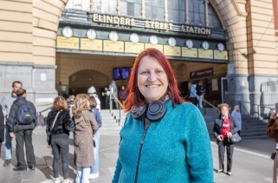

Building bridges
Adjusting to life in a new city took its toll on Helen when she arrived in Melbourne on a whim. It was the first step in a journey to sobriety and stable housing.
Finding your feet in a new city can be a challenge at the best of times, but for Helen Matthews, a spontaneous midlife move to Melbourne quickly turned into sensory overload.
“I burned a lot of bridges in Adelaide. When you’re in the midst of an addiction, you don’t plan ahead. You think a change of scenery will make a difference,” Helen said.
She couch surfed at a friend’s one-bedroom flat. Outside her comfort zone, Helen’s undiagnosed neurodivergence took charge: she got louder, drank more and intensified. She soon wore out her welcome.
“I found myself having nowhere to sleep … so I stayed up all night at Flinders Street Station. What I found there was totally unexpected,” Helen said.
Someone bought her a coffee. Another introduced her to a nearby soup van, offering a warm meal and connection to housing support workers.
Occasionally a bed would come up for Helen in a rooming house, but she'd have to weigh up the risks before saying yes.
Emergency accommodation can be filled with a mix of characters working through their own issues. That can be intimidating, and sometimes threatening, especially for older women who are part of the LGBTIQA+ community. Would she be safe there?
“In one rooming house, a guy I was absolutely terrified of broke in. It took a week to fix the door. In another rooming house, the roof collapsed.”
One thing she could control was her relationship with substances. From a position of early sobriety, she began to address the unseen patterns at play in her life since childhood.
It was an act of bravery for Helen to step into the rooms of a trauma-informed psychologist.
The medical system can be intimidating. Waiting rooms are hectic. The lights are bright. Making it on time to an appointment is stressful. Power imbalances are everywhere.
“When you come from trauma, you’re picking up energy from people. Not just the workers. Everyone in there. It’s how you feel when you walk in the door. Sometimes you walk straight out again.”
And yet she stuck with the psychologist. Grieved the son she’d given up for adoption in Adelaide. And received a proper diagnosis of autism, ADHD and post-traumatic stress.
“Now that I’ve been diagnosed, I've got a bit more understanding of how my brain operates. And tools I can use in times where it’s difficult. And support through the NDIS. That’s made things a lot easier.”
A private rental finally came up in a new complex. Helen has lived in the same place for almost seven years and is firmly in recovery, and she’s gradually extending herself into unfamiliar situations.
“I’ve never really mixed with the LGBTIQA+ community. I’m trying to meet someone.”
“Moving to Melbourne was a blessing in disguise, even though it’s been a journey to get where I've got.”

Women
Women aged 20 to 24 were the largest female age group experiencing homelessness in the City of Melbourne, with 119 people out of 633, or almost 20 per cent (ABS 2021 Census). Across our city, 36 per cent of people recorded as homeless in the 2021 Census were women. The number of women with young children who don’t have anywhere to live has risen dramatically in the past five years. Family violence is the primary cause of homelessness for women and children in Australia (AHURI, October 2022).
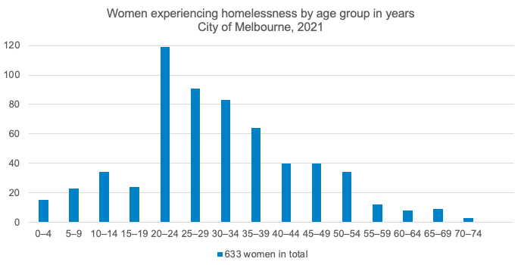
The most recent By Name List data on people sleeping rough in our city shows that a quarter – 57 of 228 are women (February 2023). Yet many more women and children are part of the hidden homelessness problem – sleeping in their cars, on other people’s couches and in severely overcrowded or temporary accommodation.
Women are less likely than men to sleep rough due to safety concerns, reducing their visibility. Women are also more likely to ‘self-manage’ their homelessness through strategies such as moving in with a partner, moving between family and friends, and seeking jobs providing housing such as live-in care work, further decreasing their visibility within the homelessness system.
Women face systemic economic disadvantages when compared with men. Inequalities put women at a greater risk of experiencing homelessness or housing stress as they age. Women, on average, earned $253.70 per week less than men in 2015-2016 (Gender Equity Victoria, 2016). Women-dominated industries such as health care and social assistance are paid significantly less than industries dominated by men. Women are over-represented as part-time workers in low-paid sectors, and 60 per cent of low-income earners are women. Due to these financial inequalities, women have less superannuation and are financially unequal to men at retirement age. In recent years, the gender superannuation gap has been between 22 and 35 per cent (Australians Investing in Women, October 2022).
The risk of experiencing homelessness for older women is directly aligned with inequities in retirement income systems and the fact women are more likely to live alone than men. Forty-five per cent of older women who rent in the private market spend more than 30 per cent of their income on rent, increasing the risk of housing stress or experiencing a period of homelessness (Australians Investing in Women, October 2022).

Jody Letts
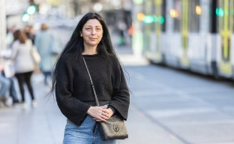

On fragile peace and permanent housing
A home is a hard-won and fragile thing, according to former public servant and military veteran Jody Lett. She spent six months living with her daughter in an old delivery van.
After breaking the cycle of homelessness once before, Jody is motivated to make sure history doesn’t repeat. Some days are easier than others.
“Expenses are hiking. I'm stressing over it,” Jody said.
To help cover the mortgage repayments on her house on the outskirts of Melbourne, Jody has someone to share the rising costs of living.
“If there’s a situation where my companion can’t be in the house anymore – say if they have a car accident, I am doomed. I lose my house. You know what I mean? It's that fragile.”
A decade ago, Jody owned her own home in regional Victoria. She had a job with the federal government.
Jody was also contending with chronic pain from injuries acquired in an earlier life. She spent a decade working in the military, carrying around her weight in personal protective equipment.
Rehabilitation was intensive, but Jody was focused.
“It was like a full-time job, driving back and forward to medical appointments. I’d have to be in Horsham one day … or Heidelberg, or Maryborough. And I didn’t get to choose the days I could attend,” Jody said.
First she ran down her leave entitlements. Then she took leave without pay. When her savings ran out, Jody sold her house and relocated with her teenage daughter to another regional town with cheaper rent, closer to a rehabilitation hub.
When the money ran out, Jody sold her possessions to raise enough cash for an old delivery van.
The van would be home for Jody and daughter for six months. They couch surfed when they could with friends and family. Her daughter quickly fell behind with her remote schoolwork.
“My mental availability wasn’t there to support her. We didn’t have time for [meals]. Not showering today. Wearing the same clothes we wore yesterday. Anything that could buy us more time.”
Jody gravitated towards the CBD for treatment. Here she connected with the homelessness sector and found her way into transitional housing. It was a step up from the van, but the peace was still fragile.
“You’d think you were settled. Then you'd find out you were unable to stay, and the displacement starts again.”
Receiving the permanent disability pension meant Jody could access her superannuation early, and she turned her attention to putting down roots.
“I wanted to be near family and friends, somewhere I could afford to buy. A bus stop out the front. Good health options, access to schooling. A large supermarket for affordable food.”
Finally everything in her house could be modified to support her disability.
Some days she feels a sense of calm and freedom. On hard days, Jody thinks about buying a motor home and hitting the road.
She's also aware that if she decides to run, she could set in motion the cycle of homelessness she’s worked so hard to break.

Young people (15 to 25)
In Melbourne, young people experience high incidences of homelessness – 15 per cent of people (174) who were homelessness in our city were aged 15 to 25 (ABS 2021 Census). Given the high incidence of trauma among young people experiencing homelessness, there is a need to address mental health and wellbeing in young people in a way that differs from other cohorts.
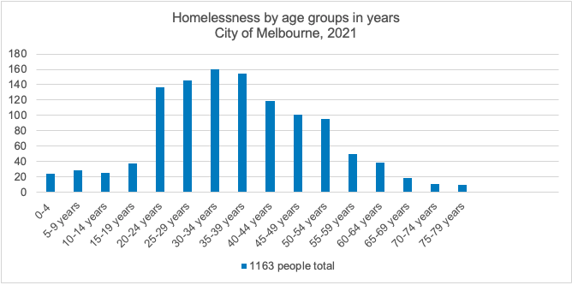
In 2020–21, one in six clients of homelessness services in Melbourne were aged 15 to 24 (AIHW, 2021). Yet the current homelessness system in Melbourne focuses on adults. Young people are caught in this system, and their unique service and housing needs go unmet. The Council to Homeless Persons advocates for a state-wide, youth-specific homelessness strategy to help prevent youth homelessness and to effectively respond to young people without a home (Council to Homeless Persons, CHP, 2022).
Young people need higher touch, specialised and sensitive management and extended support periods. Young people still moving through developmental stages do not have the same skills as many adults. Young people require housing support that teaches them how to live independently, as they may have never lived away from their family and alone. They need housing options with specialist family violence support to enable them to be safe and gain stability.
The existing power imbalance between young people and adults increases dramatically when young people have experienced abuse and trauma. In the current homelessness system, intimidation increases when young people engage with adult-centric services. Research revealed that establishing youth-safe spaces would ensure young people can more comfortably engage with services (AHURI, April 2020).
Research by the Institute of Child Protection Studies also shows that acting early and supporting young people when first at risk of experiencing homelessness reduces long-term entrenchment within the adult system (Barker, 2015). The longer young people experience homelessness, the more likely they are to develop severe health and mental issues and have contact with the justice system.

Joal Presincula
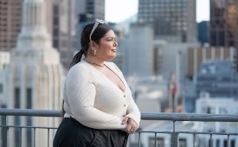

The changing face of homelessness
A fake ID, a savvy older friend and survival instincts were the only things keeping 16-year-old Joal Presincula from the streets when she had nowhere else to go.
Even though she was clubbing all night every night, Joal Presincula still managed to get herself to school most days.
When she fell asleep in class, her friends assumed it was because she’d had a big night.
“My friends had no idea. Nobody had any idea,” Joal said. She avoided going home, where her mum and three growing siblings were jammed into a chaotic two-bedroom unit.
For as long as Joal could remember, her mum had contended with family violence, trauma and clinical depression.
She drifted to the bright lights of the city’s nightlife instead.
“It took a long time for me to realise that couch surfing was homelessness. It’s not just staying at a friend’s house, or at a hotel after the club. It’s actual homelessness.”
It was two years before an older friend urged her to call a homelessness service to help her find a bed in a youth refuge.
She was nearly 19 years old before transitional accommodation came up, and she could talk her way into a private rental.
Life settled down. Joal’s boyfriend moved in. She got pregnant and had a baby at 22, but things unravelled fast when the landlord sold the property.
“So I was experiencing homelessness again, now with a child. I tried to live with the baby’s dad for a bit, but there was family violence. We couch-surfed. We lived with family. We just lived anywhere we could.”
When she came into contact with homelessness workers, she put on a brave face.
“I didn’t spill my guts to anyone. I’d say: ‘I’m great, I just need help with somewhere to live’. And they were like, ‘you’re not bad enough’.”
Joal didn’t know that sharing a fuller picture of her situation with workers would help to prioritise her housing needs on a growing waiting list in metropolitan Melbourne.
Joal’s anxiety escalated to panic attacks. A doctor prepared a mental health care plan, diagnosed her with depression and referred her to a psychologist.
That’s when things started to change for the better.
Joal’s psychologist paired her with a social worker and together they found the language to address Joal’s circumstances to give her the best chance of success in breaking the cycle of homelessness.
As well as advocating to find Joal safe accommodation, the social worker also tended to her other needs: daytime rehab, a weekly playgroup, therapy. Access to a laptop so she could study.
Secure housing finally came up for Joal 11 years ago. She’s still living in the same place.
“Looking back, it’s so funny to me that I only worked with that social worker for three months. But that three months is the reason I’m housed today all these years later.”

What is causing Melbourne’s homelessness crisis?
The causes of homelessness and housing stress are complex. They include poverty, domestic and family violence, rental stress, the gender pay gap, poor health, trauma, job insecurity, and poor availability and supply of housing stock.

Domestic and family violence
Domestic and family violence is the primary reason women, children and young people seek assistance from homelessness services in Melbourne (AHURI, October 2022). Children who experience homelessness are more likely to become homeless when they reach adulthood. There is a strong correlation between homelessness and the following factors: childhood poverty, family breakdown, child protection or out-of-home care, and low levels of education.
When there is violence in the home, there is a higher likelihood of a repeat pattern of behaviour. The young person may imitate the behaviour and become a perpetrator themselves, simultaneously causing the young person to be a perpetrator and victim.
In addition, if the young person is violent, the parent might report them to authorities. Being reported can lead to criminal charges, and it may not be possible for the young person to live legally at home, increasing the chances of homelessness.

Limited funding for support services and shortage of emergency accommodation
The primary challenges within the homelessness system in Melbourne also include a lack of funding for support services and a shortage of emergency accommodations and supported housing options. The Victorian Government has implemented various measures to address these challenges, including funding new housing initiatives and support services. However, more needs to be done, at a quicker pace, by all levels of government to create suitable accommodation and support options in our city.

There are not enough affordable homes in our city
The most significant cause of homelessness is the lack of affordable housing. Affordable housing is for any member of our community who is part of a very low, low or moderate-income household. Affordable housing is not cheap quality. It is fit-for-purpose housing priced reasonably in relation to the income of its occupants.
Affordable housing is a broad term that includes:
- Social housing: a broad term that includes public housing and community housing.
- Public housing: long-term rental housing owned and managed by state governments.
- Community housing: long-term rental housing owned and managed by community housing organisations.
All Melburnians deserve access to safe, secure and affordable housing. Housing is essential infrastructure that is vital to the functioning of our society and economy. Our research shows that for every $1 invested in affordable housing, the community benefits by $3 through worker retention, educational benefits, enhanced human capital, health cost savings, and reduced family violence and crime.
Yet decades of under-investment in social and affordable housing are compounded by several factors, including the COVID-19 pandemic. Our growing population is accelerating house prices and affecting the already stressed rental market. And living costs have risen sharply. In addition, the growth in wages and income support is failing to meet the increasing cost of rent.
Approximately 6000 affordable rental homes were needed in 2016 to meet the current demand in the City of Melbourne (SGS Economics & Planning, 2019). Without intervention, the current affordable housing crisis will worsen. This shortfall could quadruple to more than 23,000 if we do nothing by 2036.
Our city is not alone – there is a vast unmet demand for social housing across the state. The latest Victorian Government figures show that almost 68,000 households are on the Victorian Housing Register (Homes Victoria, March 2023). This application data represents households assessed as meeting eligibility for social housing. It means over 120,000 women, men, and children are facing wait times of several years for social housing.
The lack of social and affordable housing for people with the lowest incomes often leads to people living in severely overcrowded accommodation. Overcrowding mainly occurs in unregistered rooming houses where two or three-bedroom apartments accommodate up to 15 people (CHP, 2019).
Combine this with a lack of affordable housing options, and it is increasingly difficult for people to break the cycle of homelessness and find secure long-term housing.

Housing spectrum
There is a strong relationship between the availability, accessibility and affordability of the different types of housing tenures. Our goal is to end homelessness in Melbourne by securing sustainable and affordable housing for all. Secure long-term housing covers rental and home ownership, as outlined in the housing spectrum image below.
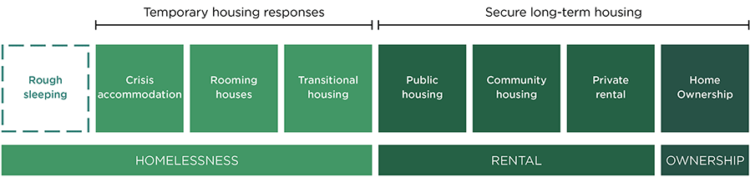
At the far end of the housing spectrum – and worse case outcome – is rough sleeping. Without a supply of secure housing options in inner Melbourne, sleeping rough will remain the only option for many people.

The cycle of homelessness
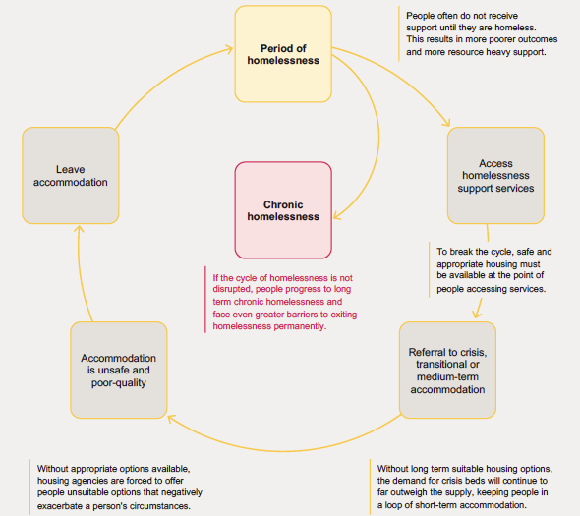

Strategic context
In developing this strategy, we have considered the global, national, state and local context and relevant international, Victorian and local legislation, as outlined below.
In addition to the legislative responsibilities outlined below, our community expects us to act.
The community’s long-term vision for the City of Melbourne is of a ‘city of possibility’ with universal access to housing, safety, and wellbeing.
We have an explicit legislative, moral, ethical and leadership responsibility to create a city where every person has a home and support to break the cycle of homelessness.

Global context: international legislation

International human rights law
The 1948 Universal Declaration of Human Rights formalises the right to adequate housing (Article 25). All UN member countries, including Australia, adopted the declaration at the time.
International human rights law further recognises that every person has the right to an adequate standard of living, including adequate housing (Article 11, International Covenant on Economic, Social and Cultural Rights). Australia ratified this Covenant in 1975.
People experiencing homelessness face violations of a wide range of human rights, such as the right to an adequate standard of living, the right to education, and the right to freedom from discrimination. Several international treaties protect these human rights, particularly the International Covenant on Economic, Social and Cultural Rights, the International Covenant on Civil and Political Rights and the Convention on the Rights of the Child. As a party to all these treaties, Australia is under legal and moral obligations to respect, protect and realise the human rights of all people.
The Sustainable Development Goals
Leaving no one behind is an essential theme of the Sustainable Development Goals, a United Nations framework. City of Melbourne has committed to this framework in its Voluntary Local Review.
The framework consists of 17 goals with specific targets focused on economic growth, social inclusion, and environmental protection. City of Melbourne has embraced the goals to make Melbourne a better place to live, work and visit. The action plan will help us measure progress against the goals over time.
These are the goals that intersect with our approach to ending homelessness:
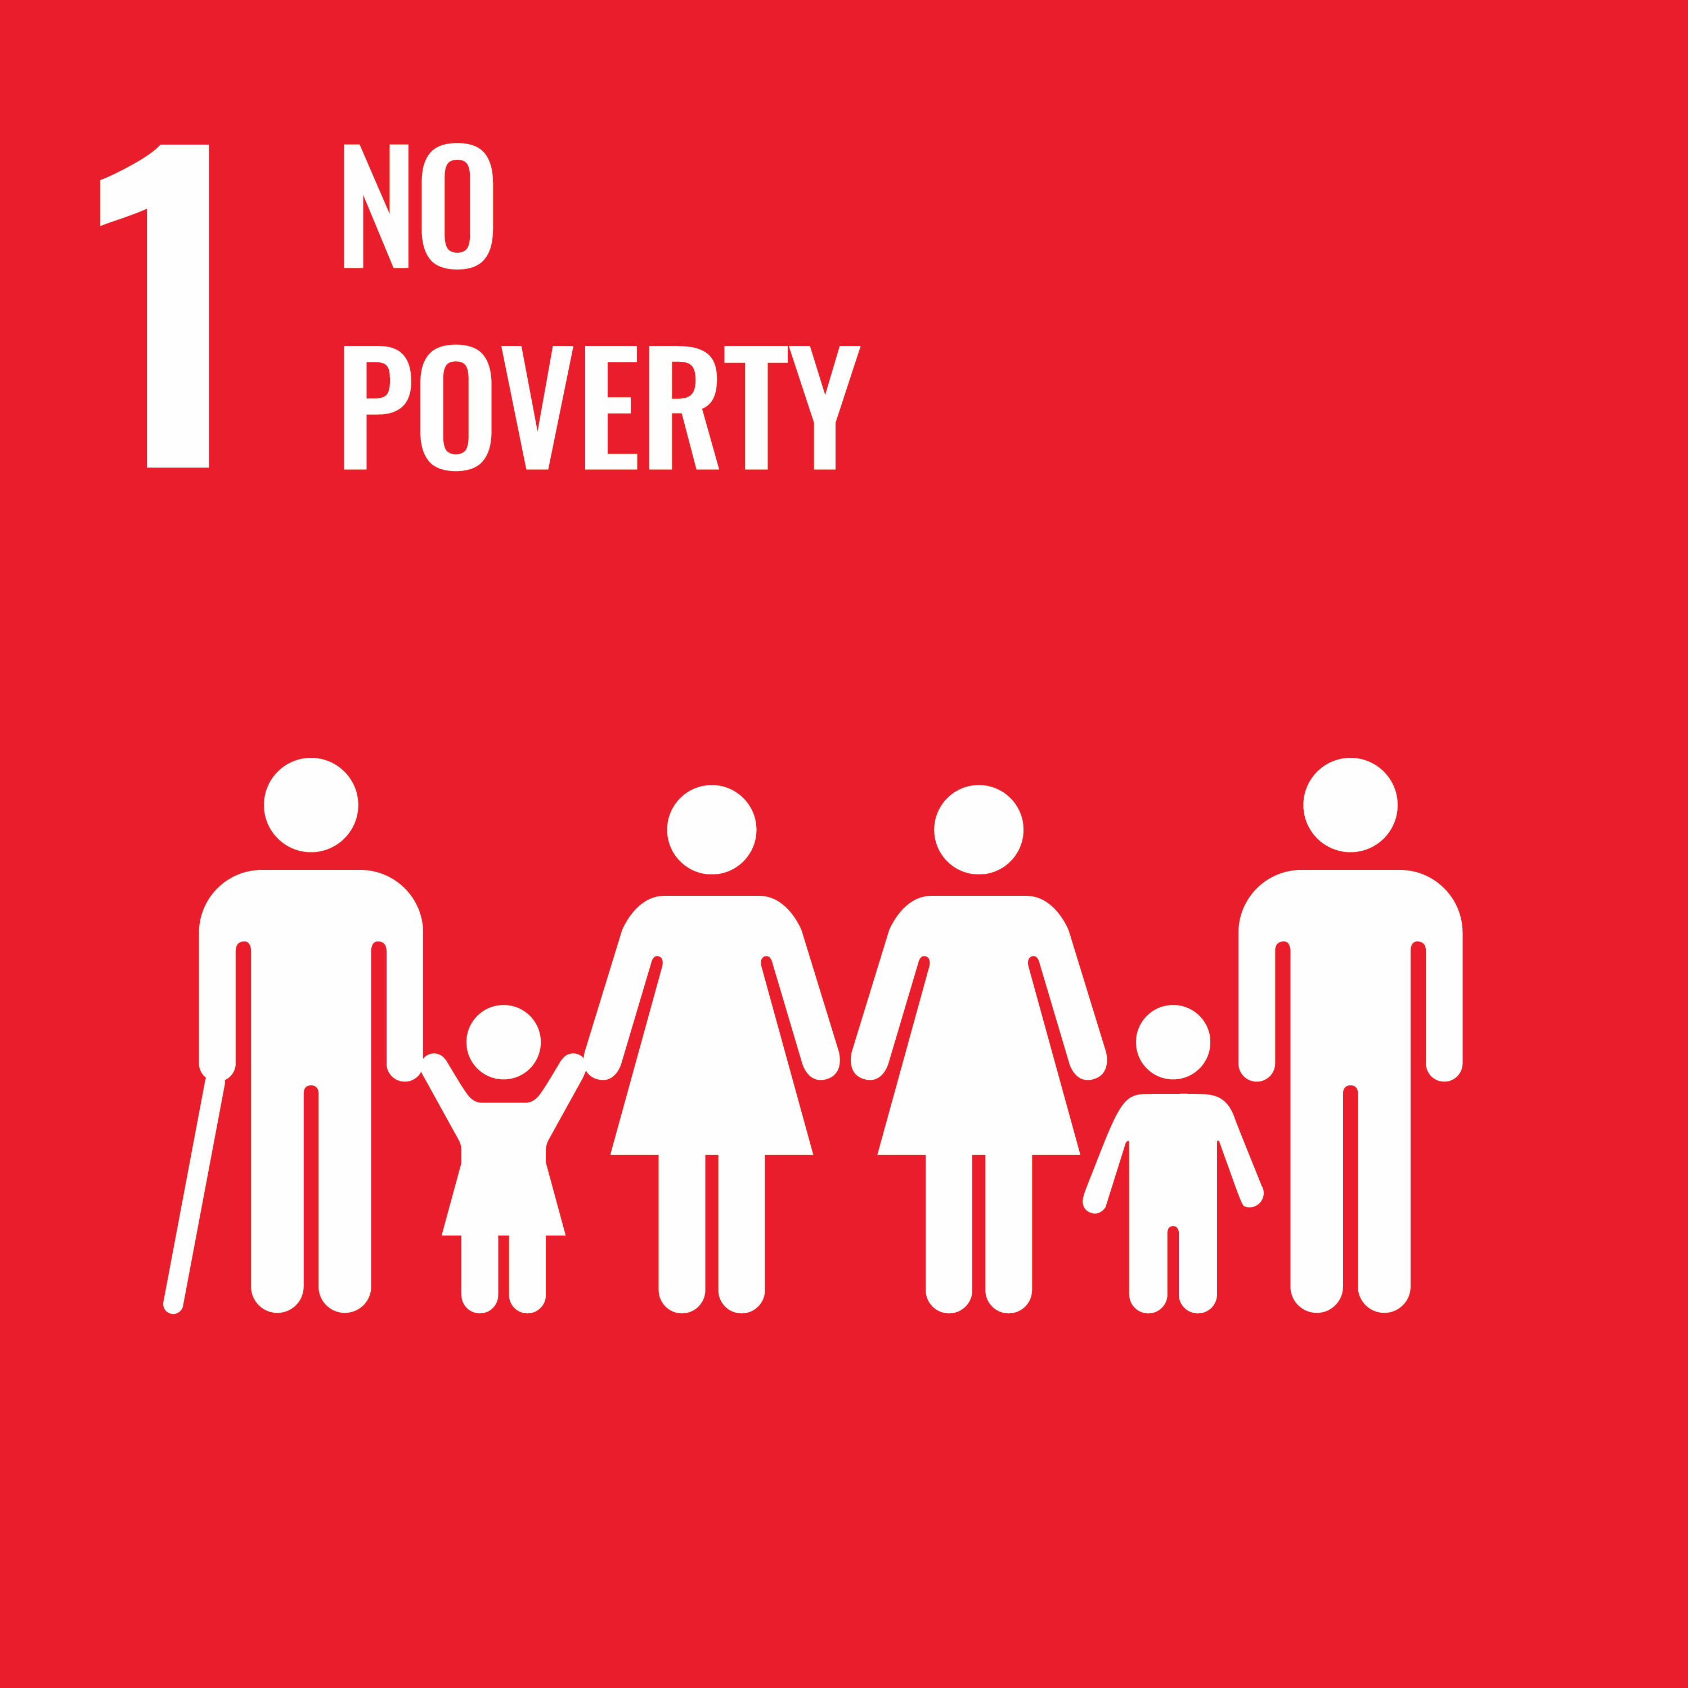 | 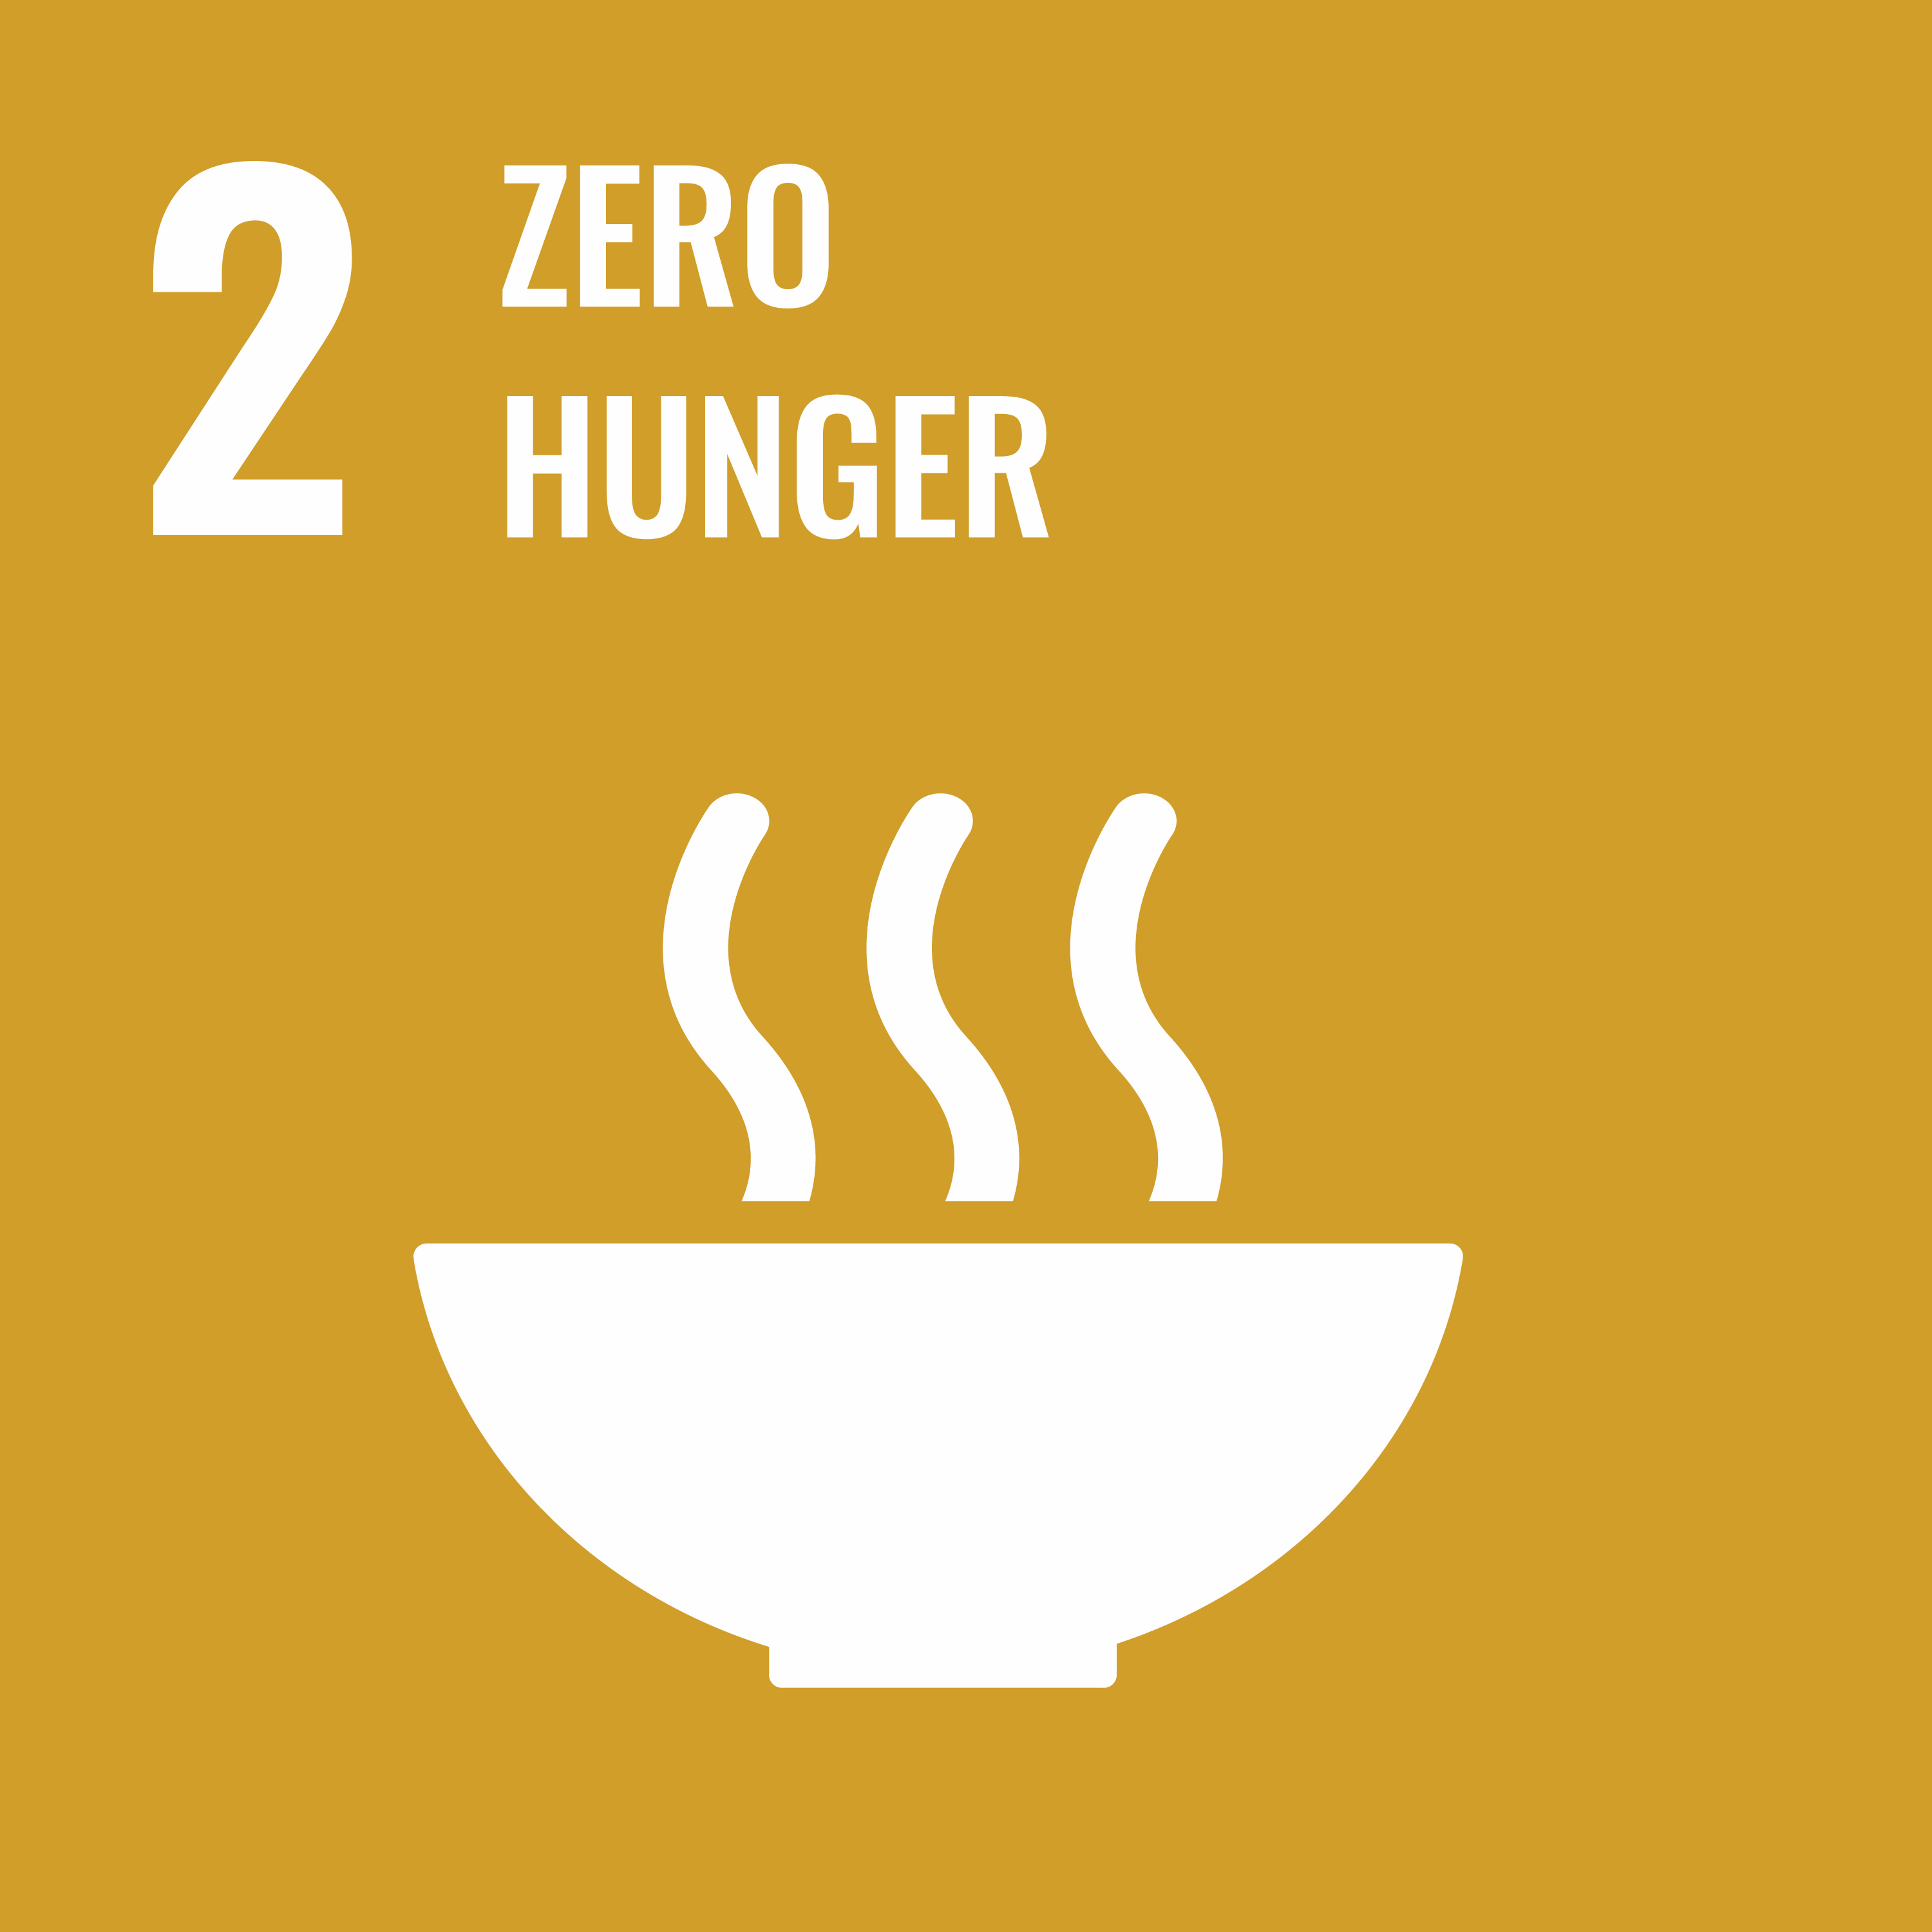 | 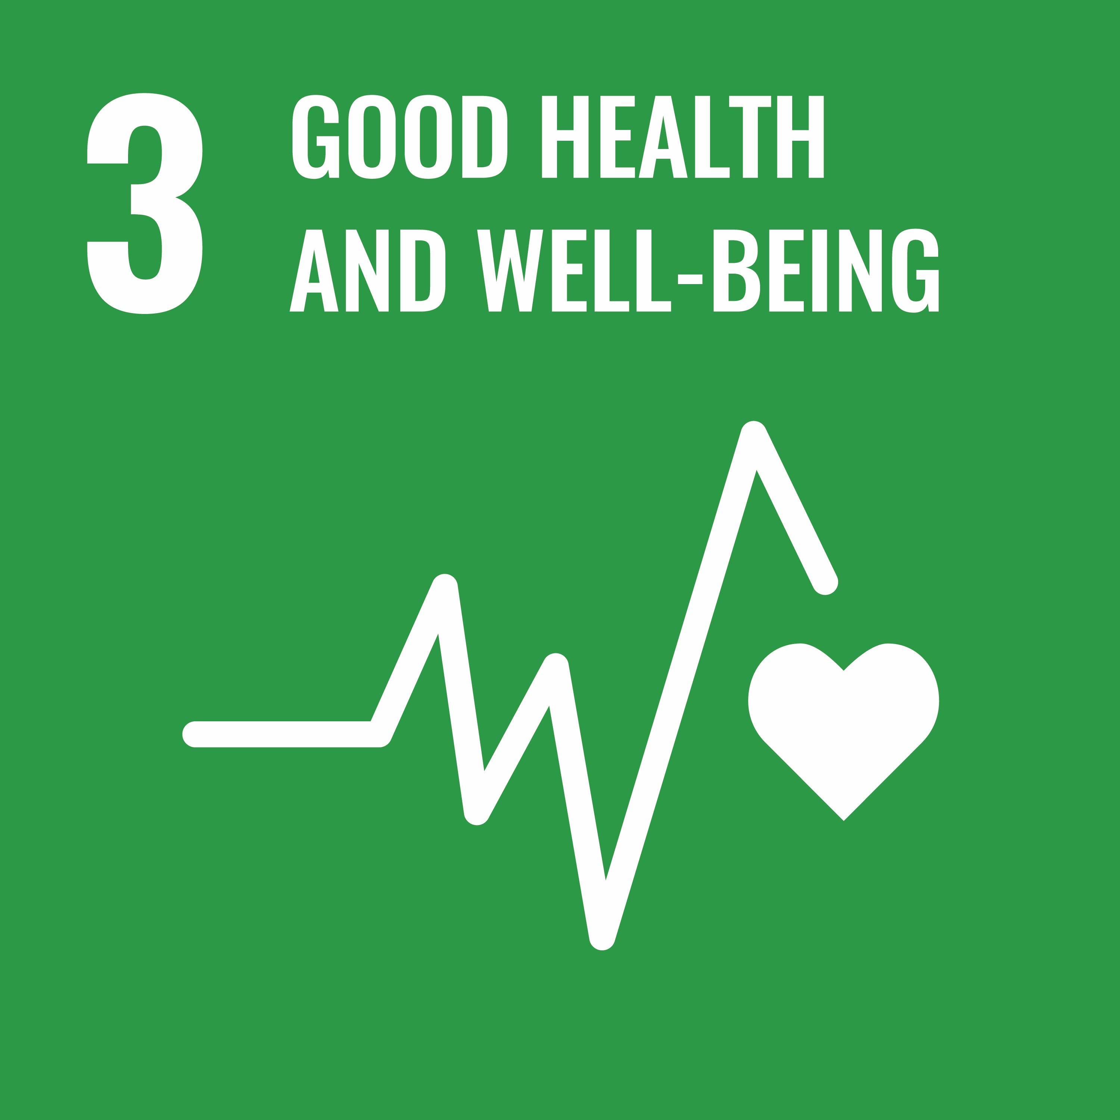 | 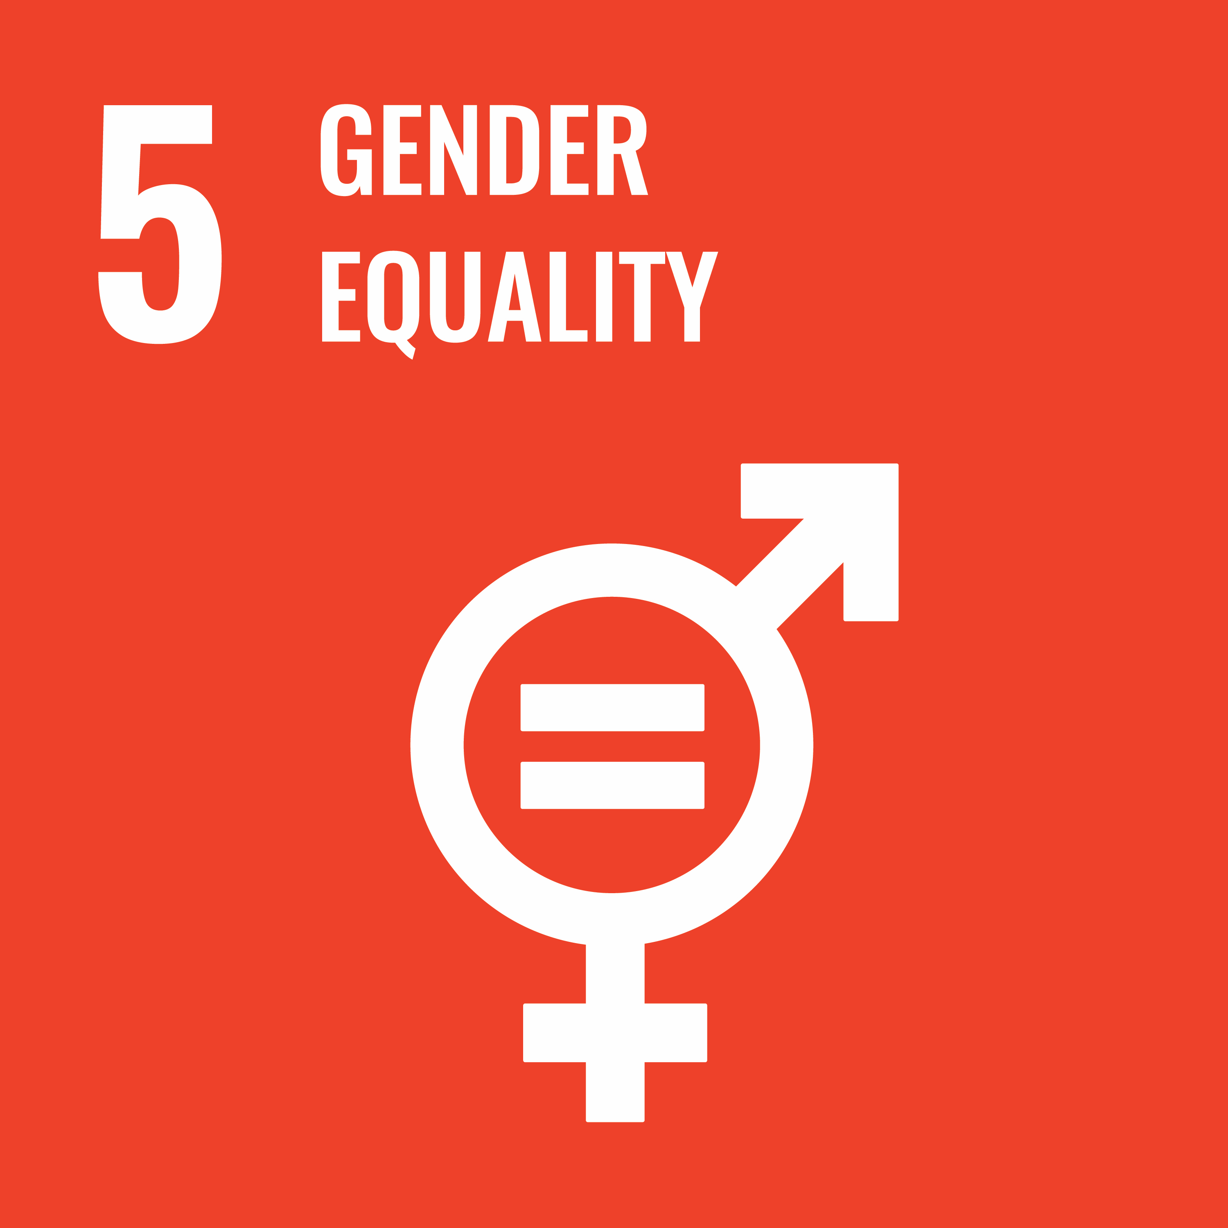
End poverty in all its forms everywhere | End hunger, achieve food security and improved nutrition and promote sustainable agriculture | Good health and wellbeing – ensure healthy lives and promote wellbeing for all at all ages | Gender equality – achieve gender equality and empower all women and girls
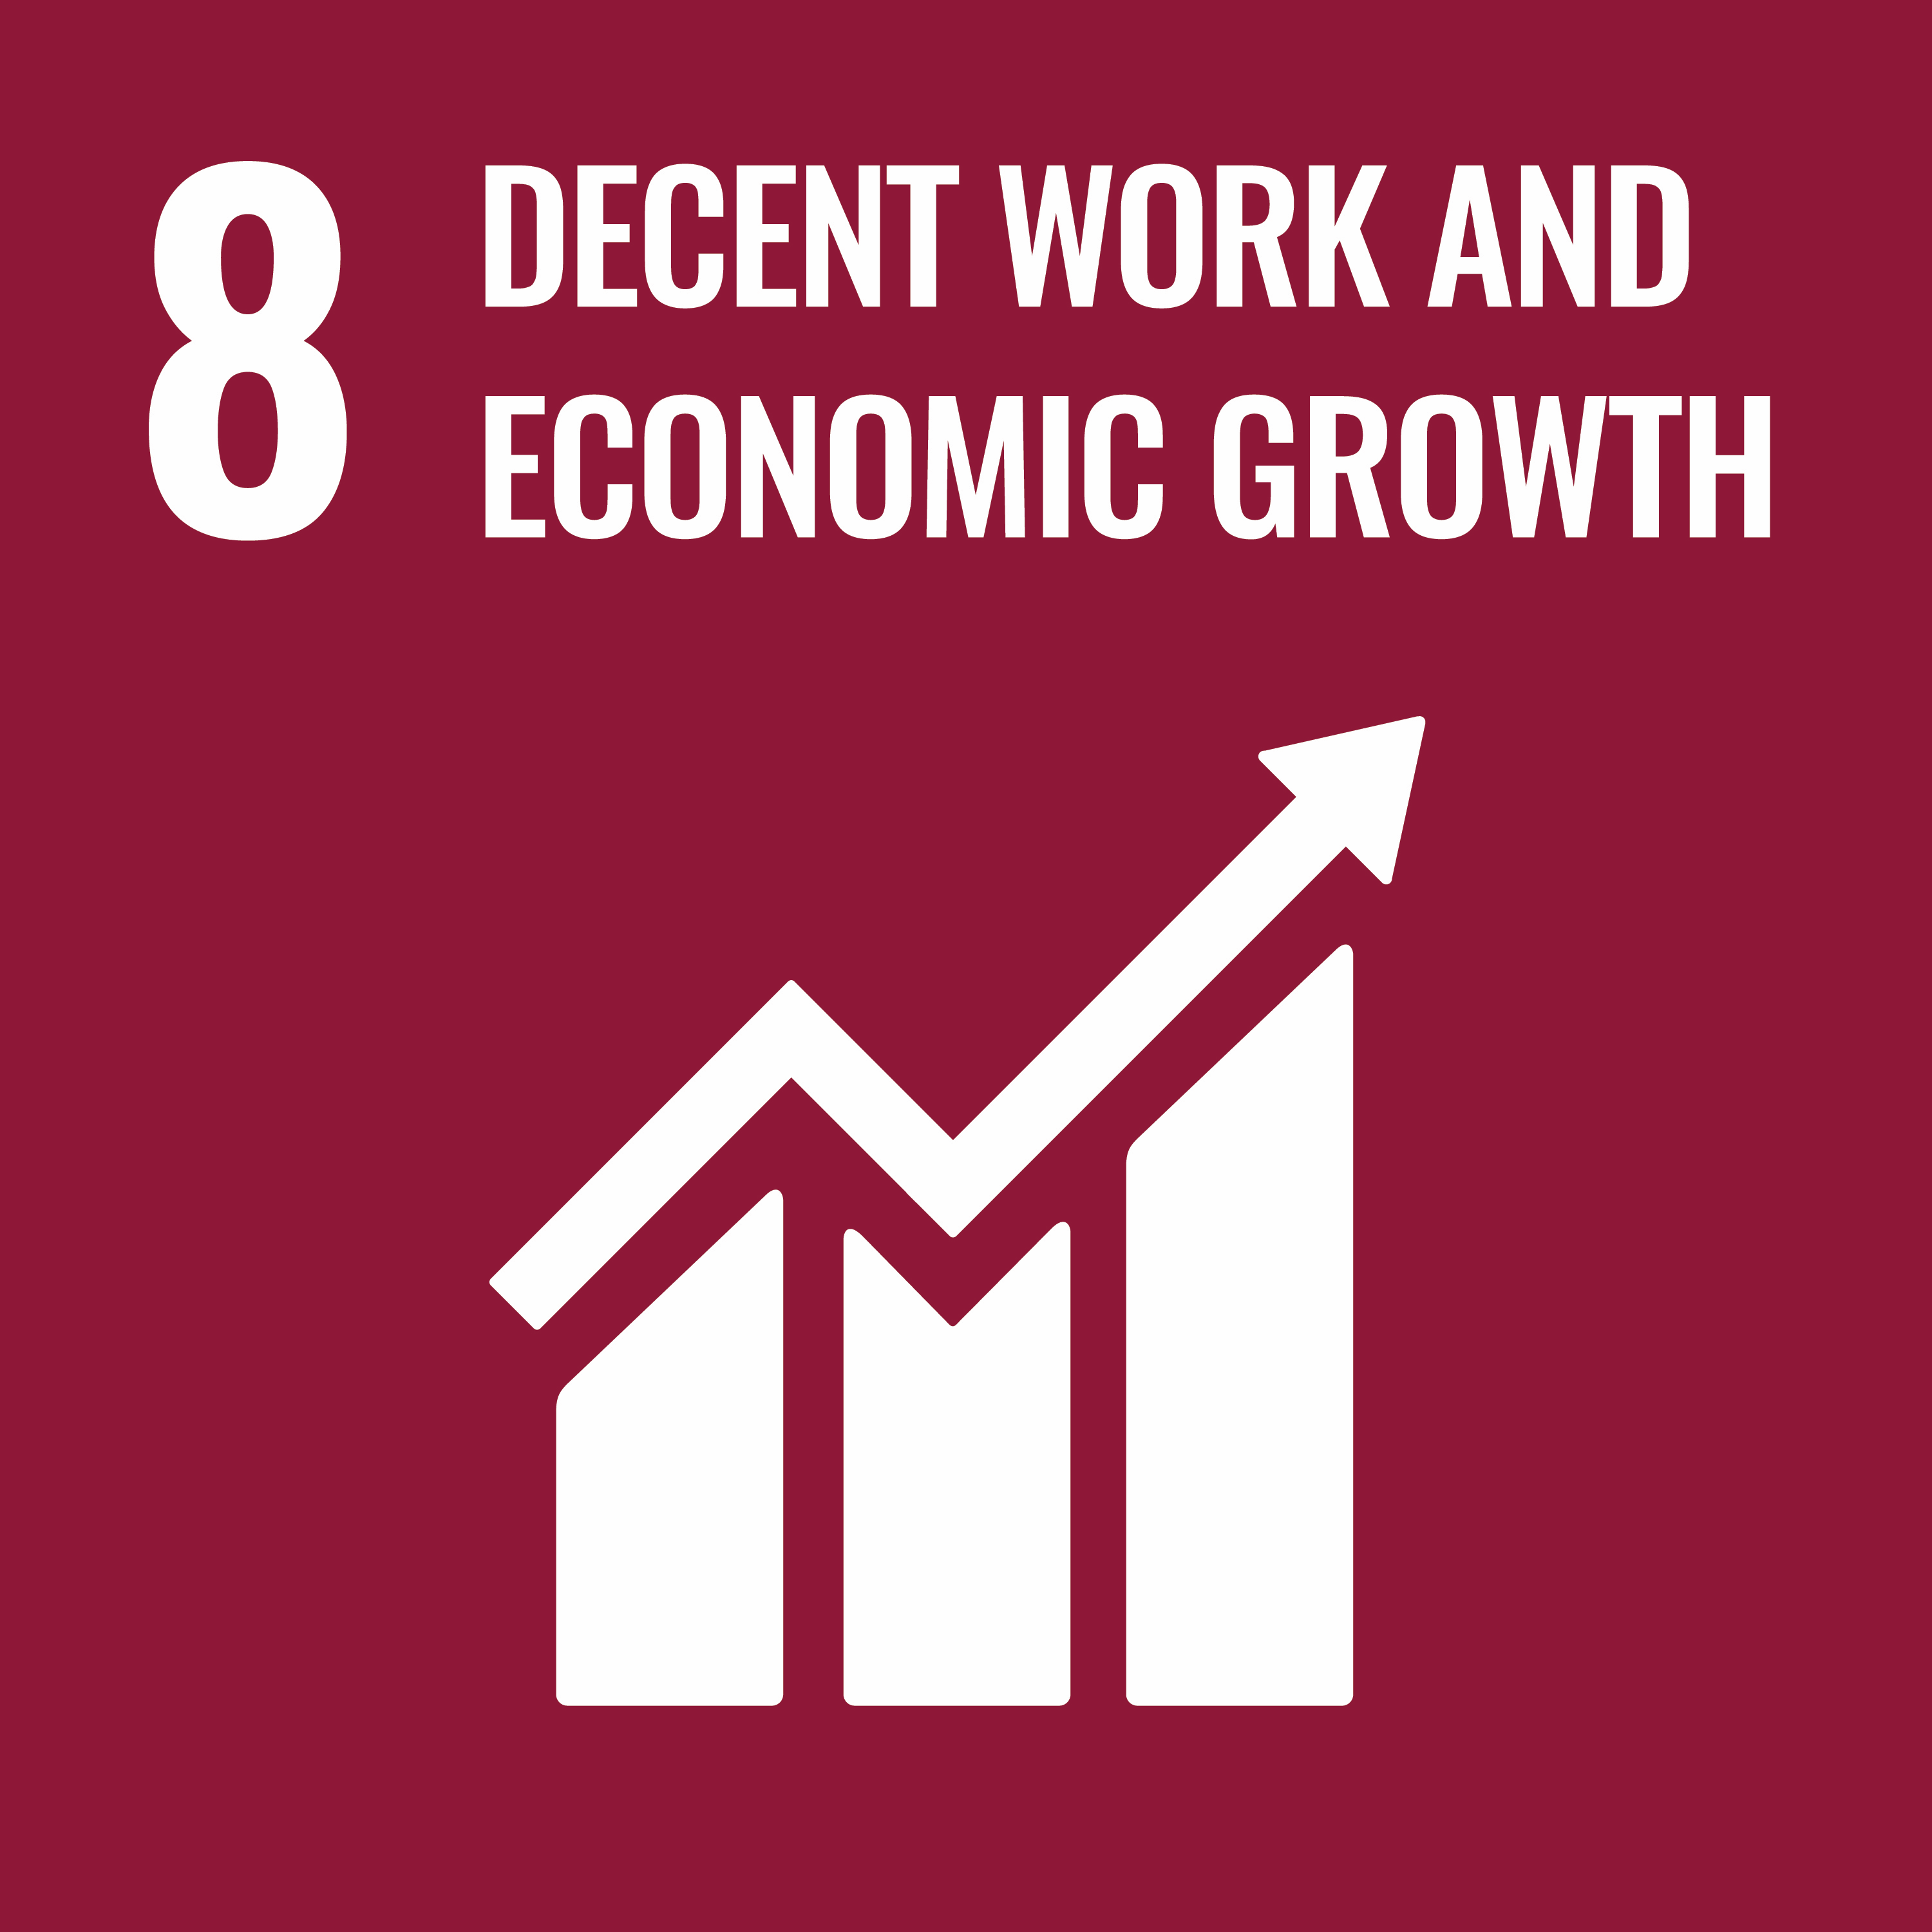 | 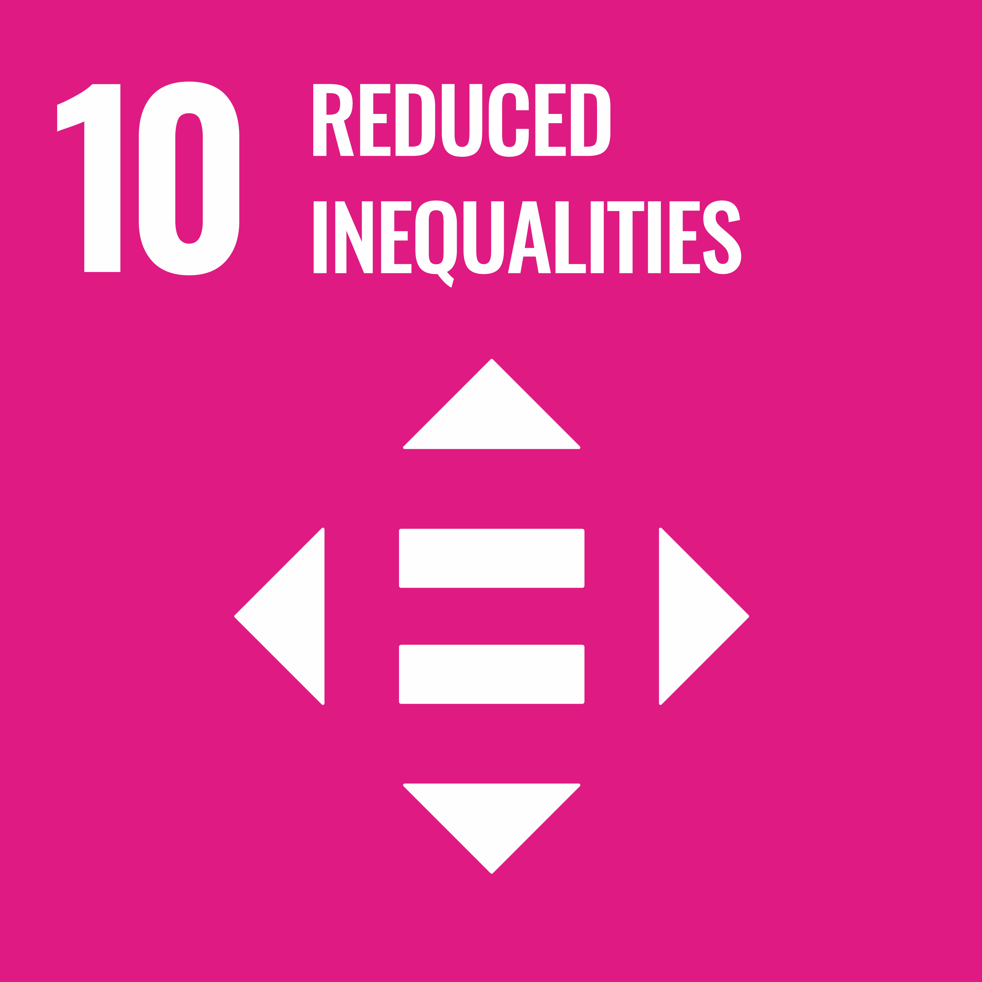 | 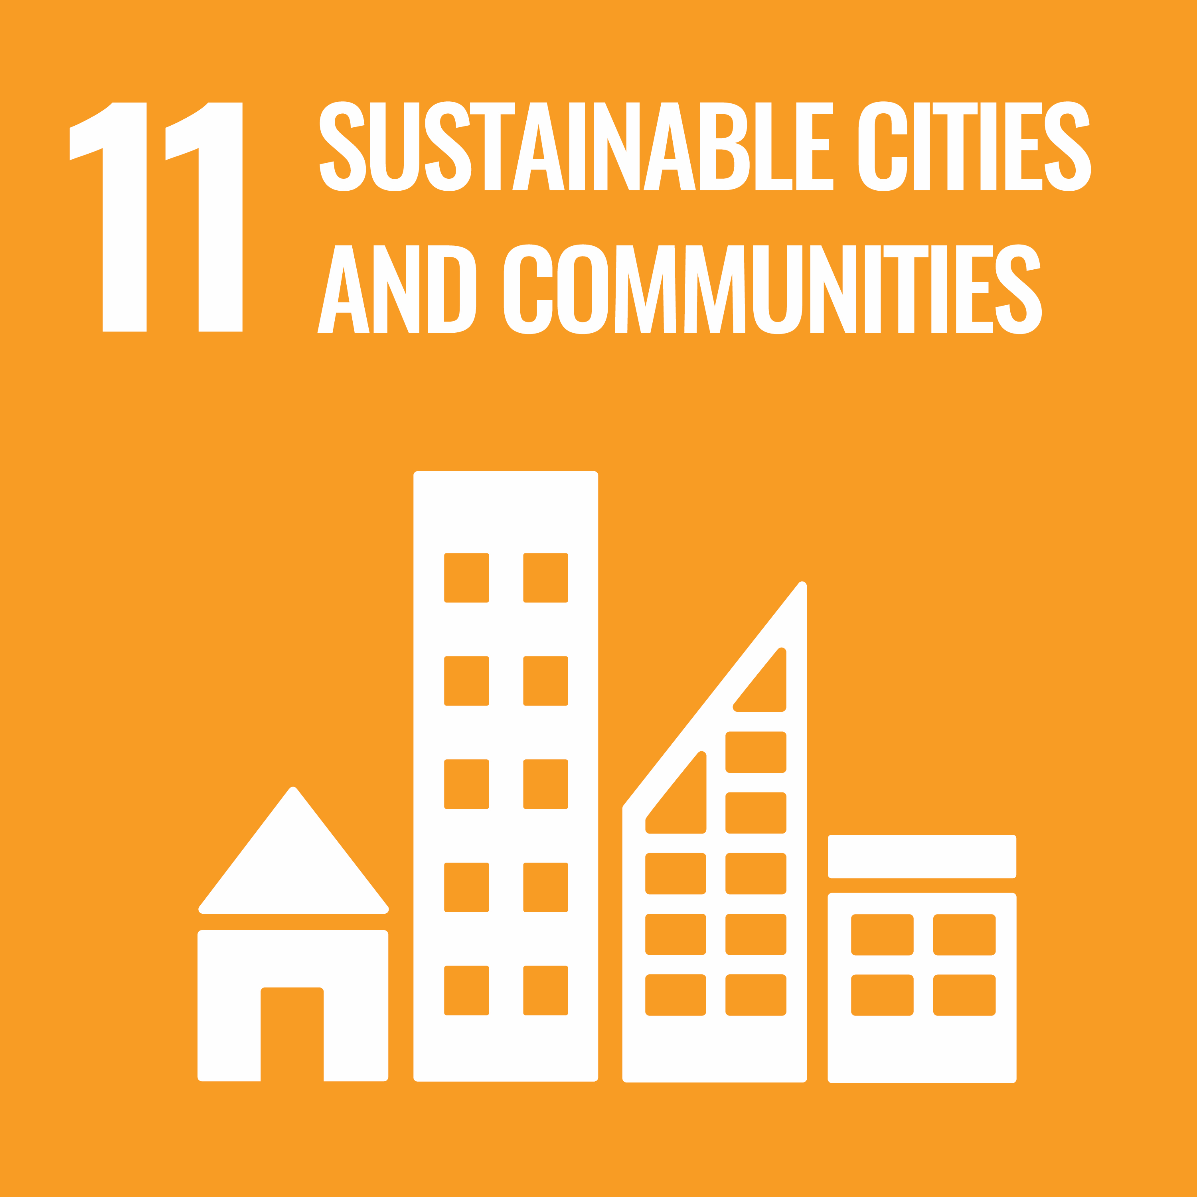 | 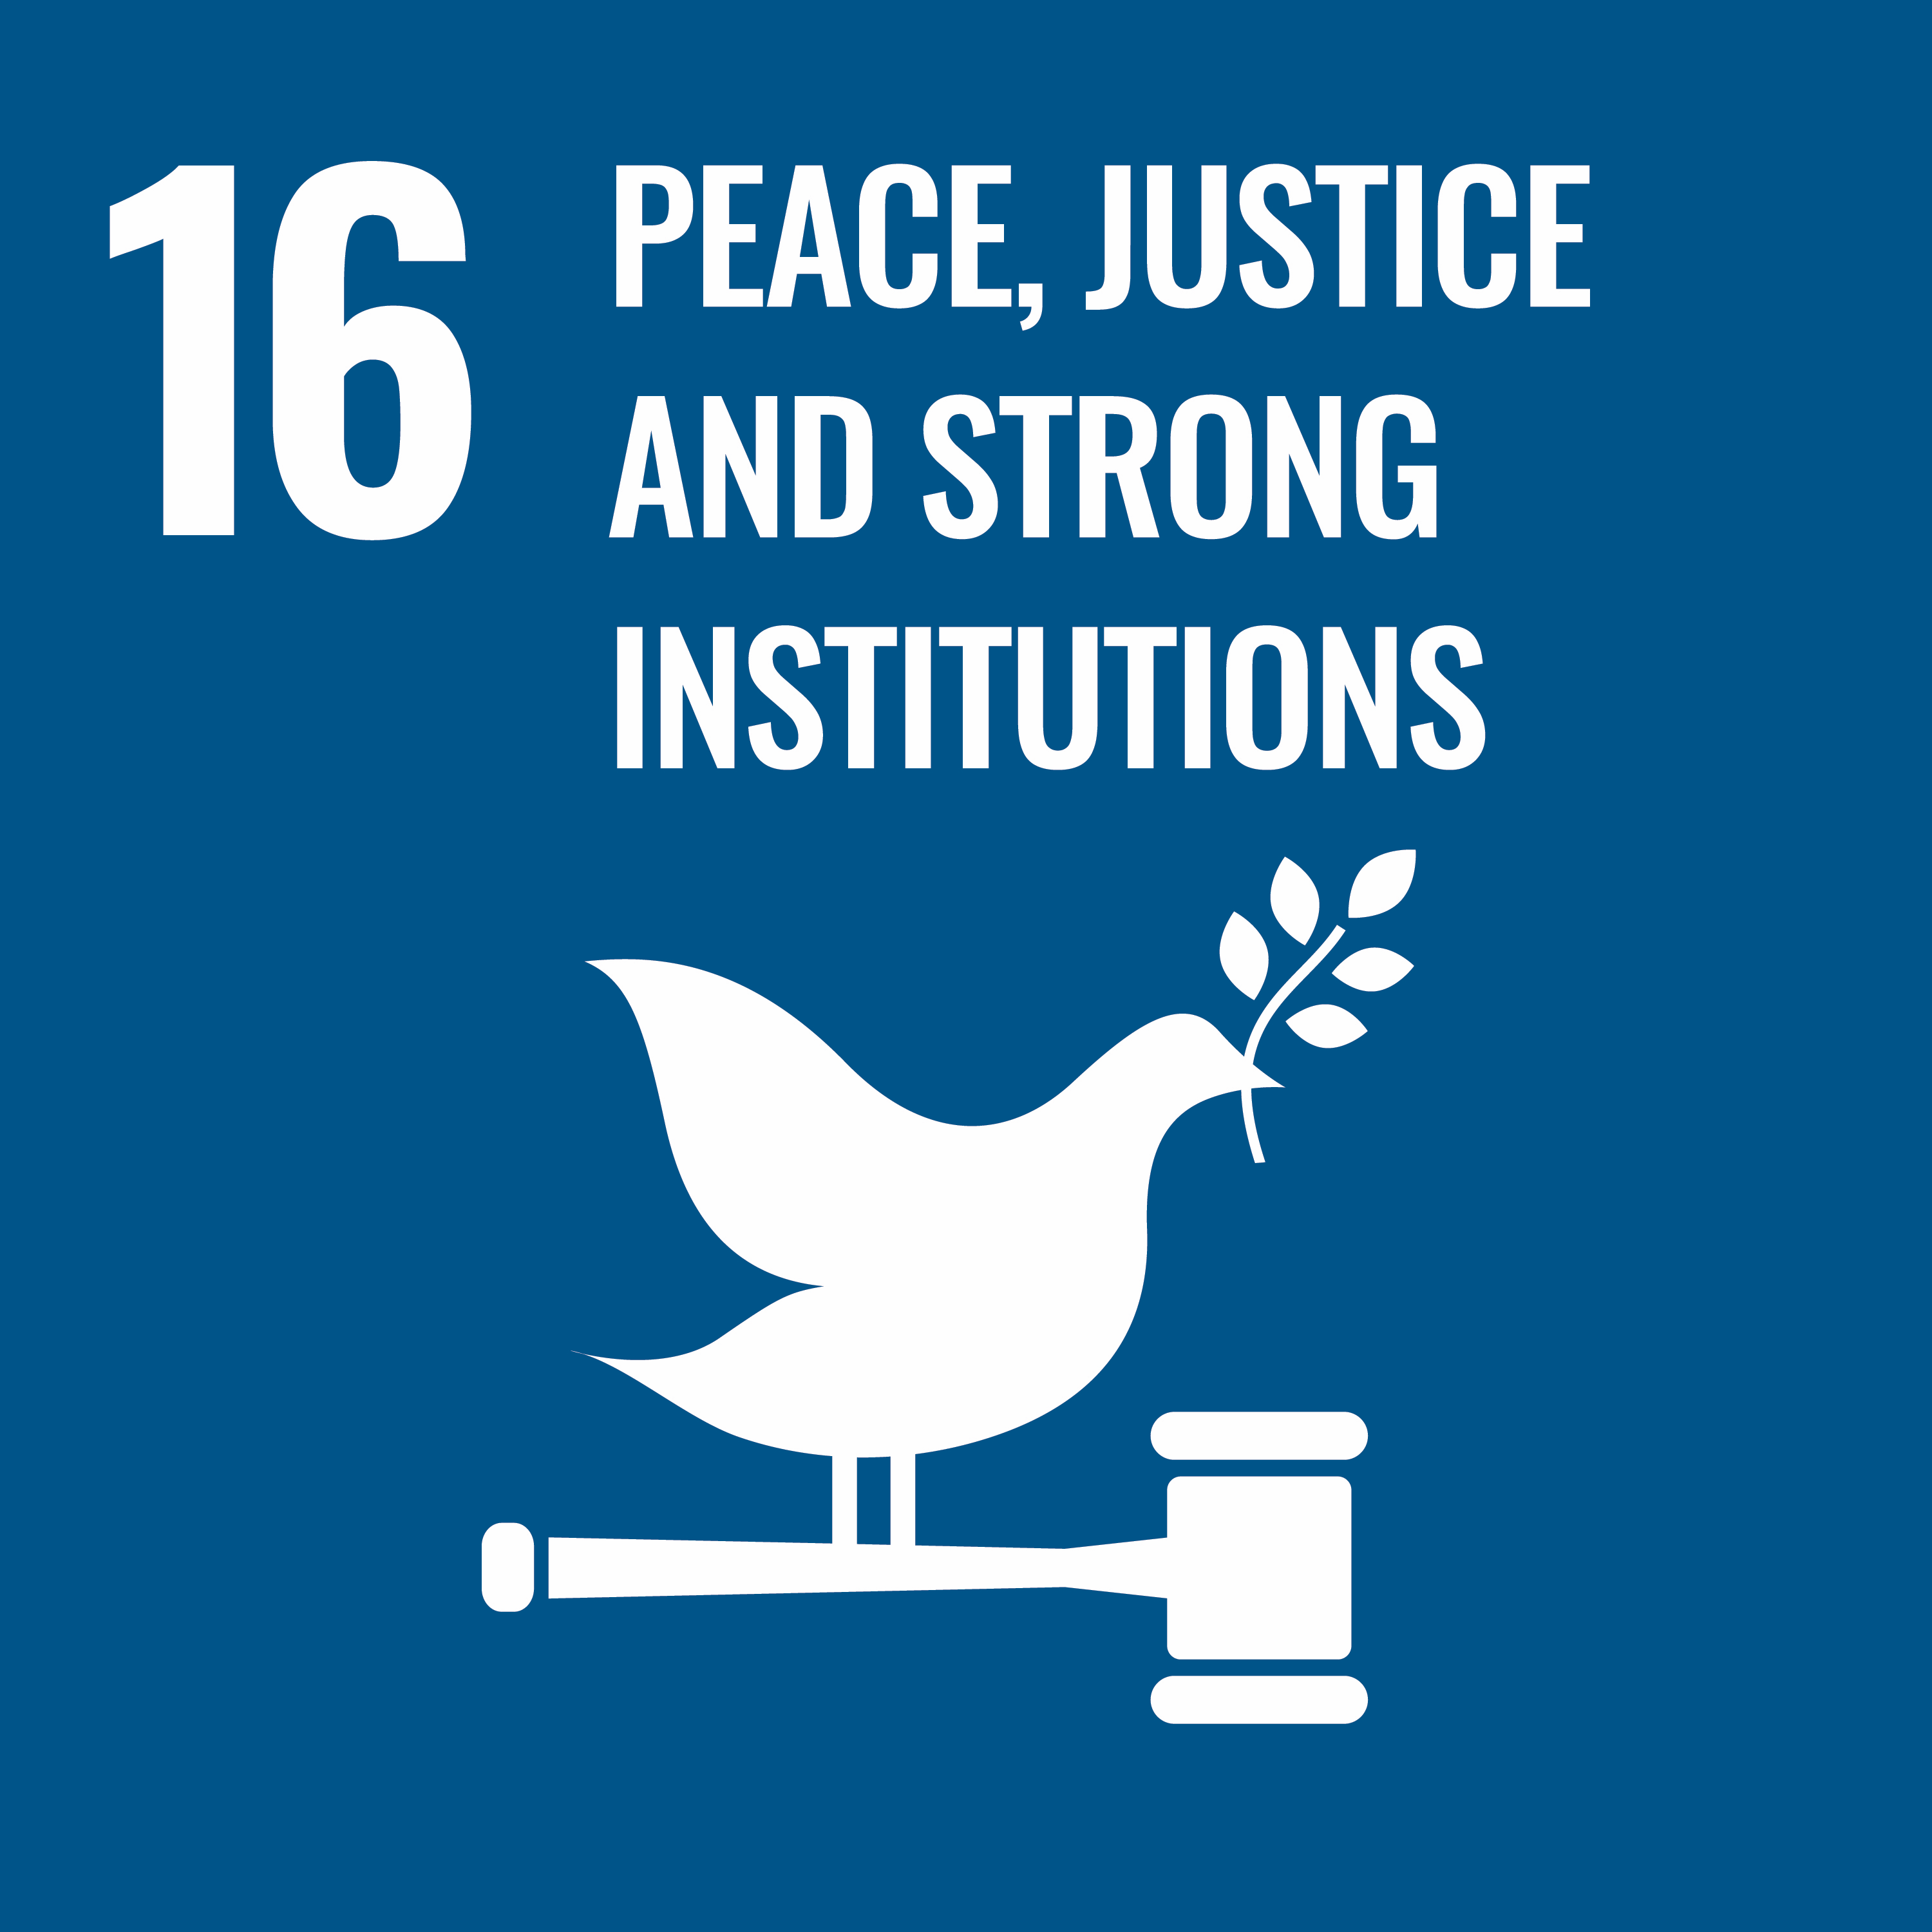
Promote sustained, inclusive, and sustainable economic growth, full and productive employment, and decent work for all | Reduce inequality within the city | Make cities and human settlements inclusive, safe, resilient and sustainable | Promote peaceful and inclusive societies for sustainable development, provide access to justice for all and build effective, accountable, and inclusive institutions at all levels

Australian context: existing roles and responsibilities
Solving the complex problem of homelessness and the lack of housing requires a collaborative effort between all levels of government in Australia, the private, property and development sectors, community and housing organisations and the broader community.
The Victorian and Australian Governments have legislative responsibility for providing social and affordable housing and funding specialist housing and homelessness organisations.

Table 1 – Government roles and responsibilities related to homelessness
Australian Government | State governments | Local governments
The Australian Government provides funding for homelessness initiatives through the Department of Social Services, which administers programs to prevent and respond to homelessness.  These programs include the National Housing and Homelessness Agreement, which provides funding to state and territory governments to deliver homelessness services. | State and territory governments fund homelessness initiatives through various programs and services, including specialist homelessness services, social and affordable housing programs, and homelessness prevention programs. State governments approve planning scheme amendments and control Victoria’s Planning Provisions. | Local governments have a statutory and social responsibility for planning for their local community. They support social and affordable housing outcomes by developing and implementing local planning schemes and designing policies that respond to local homelessness and housing issues.

Table 2 – Relevant Victorian and local legislation
Victorian | Local
Victoria’s Charter of Human Rights and Responsibilities sets out all people’s fundamental rights, freedoms, and responsibilities in Victoria. Local governments must act in a manner compatible with human rights when making decisions under the Charter: freedom, equality, dignity, cultural and property rights, the right to protection of families and children, and the right to participate in public life.  Under Victoria’s Local Government Act 2020, City of Melbourne must act for the benefit and wellbeing of the municipal community. We must achieve the best outcomes for the community, plan for climate change and provide accessible and equitable services responsive to diverse needs.  Local governments support community members in achieving optimal health and wellbeing, as set out in section 24 of the Victorian Public Health and Wellbeing Act 2008.  Victoria’s Gender Equality Act 2020 requires public entities, including councils, to support the identification and elimination of systemic causes of gender inequality in policy, programs and delivery of services in our workplaces and in the communities we serve. City of Melbourne will conduct gender impact assessments on all policies, programs, and services we develop.  The Child Safe Standards were introduced via an amendment to the Child Safety and Wellbeing Act 2005 and are compulsory for all Victorian organisations that provide services or facilities for children. | Local government has a statutory and social responsibility for planning for its local community. We support social and affordable housing outcomes through the planning scheme and by planning and funding infrastructure development. The Melbourne Planning Scheme covers land in our municipality. It contains state and local planning policies, zones, overlays, and other land use and development provisions.  The Activities Local Law 2019 contributes to City of Melbourne’s long-term and responsible approach to the health, vitality, prosperity, security and welfare of residents, businesses and the environment. The Local Law aims to protect public places, provide for safety, control and manage the use of premises and vehicles, and promote a healthy and peaceful physical and social environment. It also specifies our role in addressing rooming houses and squats.  We have a formal operating protocol with Victoria Police to address rough sleeping in the city. The Homelessness Protocol and our ongoing work to end homelessness make it possible to act quickly to protect public safety and amenity while ensuring that the city's most vulnerable people can access the necessary services.  As a member of the Welcoming Cities network, we are committed to creating a place where everyone belongs and participates in our society. The Welcoming Cities Standard sets the national standard for cultural diversity and inclusion policy and practice in local government.

Table 3 – Existing strategies and policies
Australian Government | Victorian Government | City of Melbourne
Australia does not have a national homelessness strategy (as of July 2023). Still, the Australian Government has committed to developing a 10-year National Housing and Homelessness Plan to help more Australians access safe and affordable housing.  Housing Australia Future Fund: The Australian Government has committed to investing $10 billion and spending any earnings, up to $500 million a year, on affordable and social housing projects. Parliament passed the bill in September 2023.  National Housing and Homelessness Agreement: began in July 2018, providing around $1.6 billion yearly to states and territories to improve access to secure and affordable housing across the spectrum.  National Housing Supply and Affordability Council  National Housing Accord 2022 | The Victorian Government announced a ‘Big Housing Build’ in November 2020 – a $5.3 billion investment in more social and affordable housing.  The Social and Affordable Housing Compact is vital to the Victorian Government’s Big Housing Build. The compact outlines a strengthened state and local government partnership. It gives councils a ‘seat at the table’ in identifying priorities for social and affordable housing growth and homelessness in their municipalities.  In September 2023, the Victorian Government released Victoria’s Housing Statement: The Decade Ahead 2024-2034, setting a target to build 800,000 homes in Victoria over the next decade. The statement has a simple proposition: build more homes, and they’ll be more affordable. | Under our Council Plan 2021–25 access and affordability Strategic objective, we will reduce economic and social inequality by ensuring universal access to housing, core services and information.  Our Municipal Public Health and Wellbeing Plan 2021–25 prioritises housing and homelessness, including reducing homelessness and increasing the supply of affordable homes in our municipality.  Our Affordable Housing Strategy 2030  Our 10-year strategy outlines our commitment to planning, advocating for, and delivering more affordable housing in our city.  Our Inclusive Melbourne Strategy 2022–32 helps to advance inclusion and equality in our city. It outlines how we will embrace the diversity of cultures, ages, genders, sexualities, backgrounds, religions and abilities of all who live, work, study and visit the city.

Relevant City of Melbourne strategies and plans
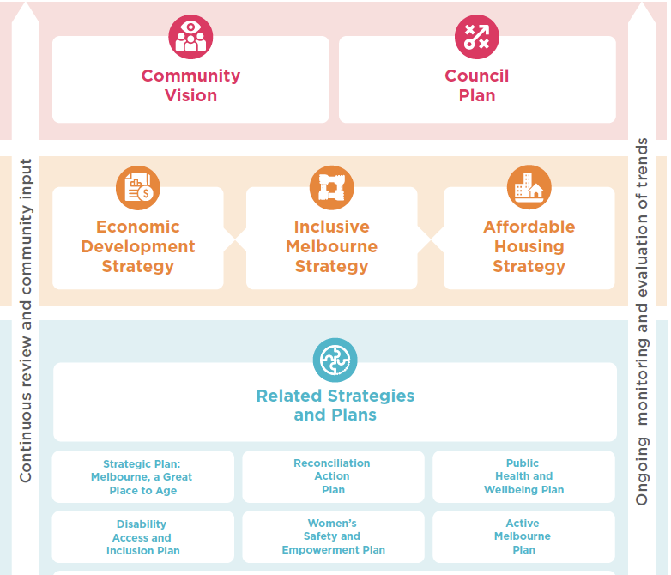
Diagram strategies and goals 1

What we heard from the community
This strategy has been shaped with input from targeted engagement with Homes Melbourne’s Interim Homelessness Advisory Group, direct engagement of people with lived experience of homelessness, and partner agencies.
Throughout our detailed research into the homelessness system, we have engaged with and listened to people with lived experience, businesses and diverse communities across the city. We’ve also involved the community in the four-year Council Plan, Community Vision, and Community Engagement Policy.
During these consultations, we heard that inclusion matters to everyone. For example, almost one in five – 19 per cent – of people said their top priority for the City of Melbourne is to be inclusive, accessible and affordable.
It is clear that our community wants us to act to create an inclusive, welcoming and safe city with sustainable and affordable housing for every person. This feedback has helped shape our vision, goal, guiding principles, priorities and actions.
We used primary and secondary research to build a detailed understanding of the homelessness service system in Melbourne.
Our research included facilitated workshops with frontline workers and people with lived experience of homelessness, 1:1 in-depth interviews with 29 sector experts, a CBD business owner survey and a comprehensive review of existing homelessness research.
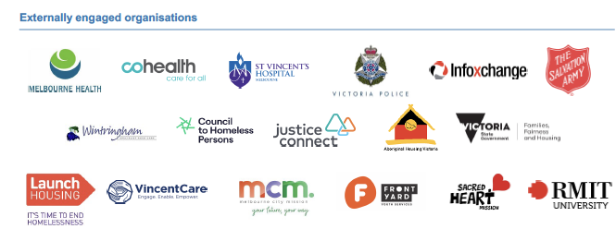

What we heard about the role of our city
We are committed to reducing social exclusion and creating a city in which every member of our community can participate. The community told us how they use and view the city, which will help ensure all people can access and feel safe and secure in our public spaces. It will enable us to create a sense of belonging and inclusion for residents, businesses, workers and visitors, and people experiencing homelessness.

Community insights
What role does the City of Melbourne play for people who visit, live, work and play here?
- A central meeting place
- A place to live
- A place to connect with the community
- A place to access services and businesses in a condensed space (CBD)
- A place to experience urban culture
- A place to experience leisure and enjoyment
What role does the City of Melbourne play for an individual experiencing homelessness?
- A place to seek safety and refuge
- A place to seek support
- A place to seek anonymity when society isolates you
“The city is particularly important for those who come from small communities – the city offers the refuge of anonymity” – People with lived experience workshop
“We’d sleep in the city because the cameras are here and it's safe” – Individual with lived experience
“A lot of people report feeling safe – cameras, well lit, strong community among rough sleepers, essential services – can’t go hungry, if anything, sometimes being over-serviced” – Frontline worker
“Addressing social isolation is important for primary homeless – that’s why people come into the city alongside accessing services” – Sector expert

The Community Vision for Melbourne
The Community Vision was developed through a deliberative engagement process with people who live, work, study, visit, or own a business in Melbourne. It is set out in our Council Plan 2021–25.
The community’s aspirations for our municipality over a 10-year period have helped guide the development of this strategy:
- Melbourne is affordable: our city remains vibrant and diverse by being affordable for everyone.
- The community participates in city decisions: Community members feel empowered to contribute their ideas and knowledge to the decision-making process, finding solutions to complex problems that will work for everyone.
- The design of our city is inclusive: It is made up of safe and accessible places and services where everyone can come together.
- People feel safe in the city: All people who visit, work, and live in the city can do so and feel safe at any time of the day or night.
- Health and wellbeing are prioritised: City of Melbourne’s policies, spaces and services support the community’s physical health and mental wellbeing for the benefit of all.

What we heard from our neighbourhoods
In 2021, we began working with a Neighbourhood Model that focuses on listening to our neighbourhoods to help us plan our services and activities. Our city is a dynamic place made up of unique neighbourhoods: Carlton, Parkville, East Melbourne, West Melbourne, North Melbourne, Kensington, Docklands, South Yarra, Southbank and the CBD Hoddle Grid – all with their own needs, services and priorities.
The communities articulated their priorities in 10 online Neighbourhood Portals. Safety was the number one priority across every neighbourhood, as identified by more than 7000 people in our municipality. Safety and wellbeing issues can be broken down into two themes: safety in the streets and safer roads and bike lanes. On the theme of safety in the streets, priorities include programs to help people connect, better lighting and improved street safety for all users, addressing drug and alcohol use, mental health and aggressive behaviour, and increased police presence (we heard mixed views on this), and more amenities including public toilets, seating, tables and drinking fountains.

What we heard from business owners
Our research team engaged with business owners to understand their sentiments around homelessness in Melbourne, how they want to be involved, and what impacts they perceive homelessness has on their business. A survey was conducted with CBD business owners to gather their input. The survey received fewer than 20 responses, so it is not exhaustive in capturing current sentiment. However, these initial findings will guide further conversations and engagement with businesses in the CBD.

Business owner perceptions of the current state
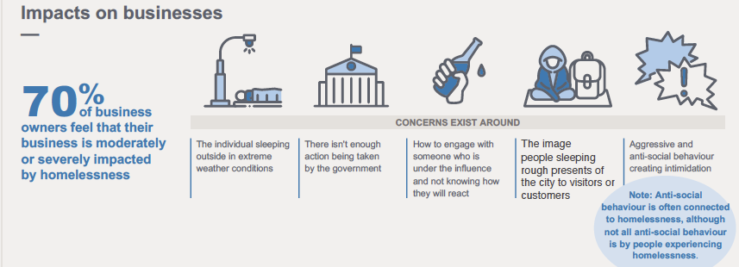

Upcoming community engagement
We will also extensively consult the broader Melbourne community through Participate Melbourne. We will consult visitors and residents on their sentiments around homelessness and opinions on our draft priorities and actions. We will revise and update our draft Ending Homelessness Strategy based on the community's feedback. The final strategy will go to Council for endorsement in mid-2024.

Priorities for ending homelessness
To achieve our vision of an inclusive city where every person has a home and support to break the cycle of homelessness, we are committed to outcomes under three priority areas:
- A city where everyone has a home.
- A city where no one is left behind.
- A city unified to end homelessness.
Everyone has a role to play in tackling the housing crisis: all levels of government, the private, property and development sectors, community and housing organisations and the broader community.
Our three priority areas include outcomes we will deliver directly and where we will work in partnership. The Victorian and Australian Governments have legislative responsibility for providing social and affordable housing and funding specialist housing and homelessness organisations, so our first two priorities also include where we will advocate for other levels of government to act.

Tracking our progress
We have included indicators against each outcome in the priority areas below so that we can monitor our progress. These measures will help track the progress and effectiveness of the strategy in helping to end homelessness in our city.
We have recorded baseline year data and will use qualitative and quantitative analysis from our funded services to report on the trends and our progress. Success indicators will be tracked over the seven years of the strategy, and we will inform the community of our progress yearly.
A costed two-year action plan will be developed to help implement this strategy. We will review the plan and priority areas every two years and update them in response to the changing nature of homelessness and social, political and economic changes. We will undertake periodic, participatory strategy reviews to ensure our outcomes and indicators continue to meet community aspirations.

Priority 1. A city where everyone has a home
We take a person-centred approach, supporting each person on their pathway out of homelessness. People with lived experience of homelessness inform our work. Our priority cohorts are Aboriginal peoples, young people, women, and people experiencing chronic homelessness and sleeping rough.

Challenges and opportunities
People in our priority cohorts have specific housing and support needs. To succeed, the programs we deliver, invest in and coordinate must be accessible and tailored to the needs of each individual. For example, the research uncovered women are less likely to sleep rough due to safety concerns, reducing their visibility. Family violence is the primary cause of homelessness among women and children. Women are more likely to be hidden from the homelessness system, moving between family and friends or looking for jobs that provide them with housing.
People experiencing chronic homelessness have the most complex needs and support requirements. Housing alone cannot support them in housing stability. Ongoing support is crucial for people to remain housed successfully.
Research shows that young people are getting lost in the adult homelessness system and need specialist services. The existing power imbalance between young people and adults increases dramatically when young people experience abuse. Acting early and supporting young people when they are first at risk of experiencing homelessness allows for significantly reducing long-term entrenchment within the adult system.
Given that the longer young people are experiencing homelessness, the more likely they develop serious health and mental issues and have contact with the justice system, there is a need to address mental health and wellbeing in young people differently. To support young people out of homelessness, we will invest in housing options with specialist family violence and mental health programs to enable them to be safe and gain stability.
The lack of housing stock is the biggest blocker for a person trying to break the cycle of homelessness. Rooming houses and other housing options are often unsafe and not located where people want to be. There are long waiting periods for public housing, and temporary accommodation usually has time limits, yet there are no appropriate long-term housing options for people to transition to. The Affordable Housing Strategy 2020–30 outlines our commitment to delivering, planning, and advocating for more affordable housing in Melbourne.

Working with our community and partners
City of Melbourne will partner with the Victorian Government and Aboriginal organisations to ensure that culturally appropriate affordable housing options and homelessness prevention and support services are available. This work will include investigating an Aboriginal-specific housing access point in the city, providing a community place for Aboriginal peoples. We will continue collaborating to develop cultural safety guidelines for housing projects.
We will support prevention work so that young people at risk have every chance of avoiding homelessness, including programs addressing family violence and building life skills for young people to help them navigate the housing market and manage mental health and wellbeing. Together with youth-specific support organisations, we will fund services co-designed with young people and offer housing options with specialist family violence support.
For women at risk of homelessness due to family violence, we will support prevention projects that keep women and children safely housed through integrated legal and social work assistance. These services successfully prevent homelessness and reduce housing insecurity.
People who have experienced chronic homelessness have complex needs and usually require specialist housing and ongoing support. We will work with our health, housing and service partners to ensure that people have specialist housing with wraparound support services, including employment pathways, skills training and alcohol and other drug services.

Advocacy positions
We will advocate for prevention and intervention programs and housing for all individuals, focusing on people of Aboriginal background who are at risk of or experiencing homelessness, young people, women, and people experiencing chronic homelessness and sleeping rough. Given the lack of culturally appropriate housing and high levels of Aboriginal peoples living in severely overcrowded dwellings, we will advocate for culturally relevant housing stock.
City of Melbourne will also advocate for the Victorian and Australian Governments to work directly with Aboriginal Community Controlled Organisations to enable self-determination and flexibility in the use of funding.

Table 4 – Priority 1: A city where everyone has a home
Outcomes | Indicators and Monitoring our progress | Our role | Timeframe
1.1 Aboriginal people at risk of experiencing homelessness have access to culturally safe health, homelessness support and housing services in our city. | Availability of culturally safe housing for Aboriginal people  (baseline date and data to be determined)  Increase from baseline year  Number of Aboriginal people experiencing chronic homelessness or rough sleeping  (baseline date and data to be determined)  Decrease from baseline year | Advocate, partner, deliver | Medium
1.2 People experiencing chronic homelessness and sleeping rough are provided with coordinated housing, health and homelessness support services. | Number of people sleeping rough in our municipality  (baseline date and data to be determined)  Zero  Percentage of individuals experiencing chronic homelessness or rough sleeping placed into Make Room accommodation.  (baseline date to be determined)  Increase from baseline year | Partner, deliver | Medium
1.3 Young people at risk of or experiencing homelessness are supported with prevention, intervention and housing services. | Number of young people at risk of homelessness accessing support services in the City of Melbourne.  (baseline date to be determined from Front Yard Youth Services and Melbourne By Name List)  Increase from baseline year | Advocate, partner, deliver | Immediate
1.4 Women at risk of or experiencing homelessness are supported to access secure, affordable homes and services. | Number of women experiencing chronic homelessness or rough sleeping  (baseline date and data to be determined)  Decrease on baseline year  Number of women accessing support and prevention measures (baseline date and data to be determined)  Increase in the provision of financial assistance, mediation services or legal aid to those at risk (on baseline year) | Partner and deliver | Medium

Priority 2. A city where no one is left behind
We will create an inclusive city where everyone is supported. We will ensure coordinated services, collaboration and advocacy through partnerships with our communities, governments, corporates and the homelessness sector.

Challenges and opportunities
Our research highlighted many problems with the homelessness service system. At present, short-term and unstable funding is causing high staff turnover at service providers. To succeed, funding should be based on people’s needs, not location. In addition, Victorian Government funding boundaries don’t match the transient and episodic nature of homelessness, leaving people to fall through the gaps. We will also advocate for broader changes to reduce unstable and siloed funding across the sector. We also will work to maximise the impact of our investment in services delivered on our behalf.
Timely access to healthcare can drastically improve a person’s circumstances, and mental health support is vital. Yet people experiencing homelessness are turning to Victoria Police, Ambulance Victoria and hospitals to access emergency care. Given this, we will advocate for better integration between the homelessness, housing and health systems.
The research also shows that data gaps restrict Melbourne’s homelessness sector from achieving a lasting impact. Our work will support the sector’s use of data to identify and help at-risk individuals, intervene early, and minimise forced re-sharing of trauma through improved data-sharing practices.

Working with our community and partners
Through the Melbourne Service Coordination Project, we will work with our 17 partners to achieve collaborative case management, implement data-sharing protocols and use data analysis to identify and support at-risk individuals. Our collaborative work will improve individual support by ensuring that services are underpinned by a health and trauma-informed model of care and that people are connected to social services, employment pathways, skills training, mental health, and alcohol and other drug services. This group will also ensure that housing options are suitable and that long-term and ongoing support is provided after an individual is housed.
We will also develop partnerships to increase social and affordable housing and encourage corporate, community and philanthropic contributions. We will join with local, national and international networks, including the Council of Capital City Lord Mayors and the M9 local council group, to ensure we deliver best practices.

Advocacy positions
We will advocate for systemic change, funding and investment to secure appropriate, affordable housing and support people on a pathway out of homelessness. Increased funding and investment from the Victorian and Australian Governments are crucial to enable the construction of safe and suitable housing with wraparound support for all people who are at risk of or experiencing homelessness. The research showed that systemic reform is urgently needed – the homelessness sector has a stretched frontline workforce and high staff turnover.
Our advocacy will also include calls for better coordination between the homelessness and justice systems. People who are in and out of custody are repeatedly arrested for warrants or charges related to their homelessness, mental health, or alcohol or drug presentation. Interactions with Victoria Police and the justice system can also perpetuate trauma and, without addressing the root causes of homelessness, contribute to cycles of poverty and the continuation of homelessness.
We will advocate for state and national investment in early intervention and preventative programs targeted to people as they leave institutions, including hospitals, out-of-home care and prisons.

Table 5 – Priority 2: A city where no one is left behind
Outcomes | Indicators | Monitoring our progress | Our role | Timeframe
2.1 Strategic partnerships established through the Melbourne Service Coordination Project will deliver timely and tailored support for people experiencing homelessness. | Number of instances where housing, health and homelessness support services are coordinated and integrated to provide comprehensive care. (baseline date and data to be determined) | Increase on baseline year | Partner, deliver | Immediate
2.2 Homelessness and health services in the City of Melbourne met the needs of our specific homeless community. | Decrease in overall homelessness in our city (baseline 2021 ABS Census figures, released March 2023) | Increase on baseline year | Advocate, partner, deliver | Medium
2.3 Our advocacy will operate effectively across different levels of government and systems to end homelessness. | Our advocacy positions result in systemic change, increased funding and improved government responses to end homelessness | Increased funding, investment and system coordination | Advocate | Immediate

Priority 3. A city unified to end homelessness
We will support our community to be informed, respectful, empathetic, and united to end homelessness. Our public spaces will be designed and managed to be safe, welcoming and inclusive.

Challenges and opportunities
Across the world, cities offer a wide range of services, but people experiencing homelessness are often stigmatised and marginalised, leading to social exclusion and discrimination. The trauma of street homelessness often creates new problems, making it difficult for people to recover, access, and maintain housing without intensive support.
As a capital city, we need to balance the many voices, experiences and competing needs of people who live, work, own a business, study in or visit the city of Melbourne. Our city is a hub where people access various services and amenities, including education, healthcare, transportation, entertainment, tourism, and cultural experiences. We want Melbourne to be a city where everyone can prosper and feel welcome. Fostering a city that balances the needs of all city users will ensure that everyone feels safe and welcome, including those affected by poverty and homelessness.
We’ve heard from residents and businesses that they have safety concerns, especially at night in the CBD. It is important to note that a common misconception exists that people experiencing homelessness are responsible for anti-social and violent behaviours in the city. Only a small percentage of these behaviours have been linked to homelessness.
Our proposed actions include shifting perceptions and removing the stigma around homelessness through awareness, training and education campaigns. Research shows 91 per cent of Melburnians agree we should do more to end homelessness. The majority (86 per cent) believe it is the government’s responsibility to solve homelessness, and (80 per cent) agree that if we work together, we can end homelessness (Launch Housing Perceptions Research 2022).

What we will do
When designing new open spaces, parks, gardens and buildings, we will create inclusive, easily accessible areas. In addition, we will leverage our social and creative capital, including our arts program, libraries and events funding, to foster inclusion and belonging. By activating public spaces beyond 9 to 5 and ensuring areas are well-lit, we will enhance community safety and specifically, security will be increased for sleeping rough.
To achieve our vision, we will build the capacity of our team. We will implement an organisation-wide approach with processes and systems that enable effective collaboration that benefits our community. We will build on our skills, knowledge and capabilities and deliver human rights training for all our team members to work together to end homelessness in our city.
Our staff training will include understanding the trauma of rough sleeping in our city, responding, and providing referrals to specialist support and partners. Through our maternal and child health, social work, and family support services, we will assess and support women and their children in family violence situations to make informed decisions regarding safety and accommodation.

Working with our community and partners
We are part of the Melbourne Zero Network – an alliance of diverse Melbourne-based businesses, organisations and community groups publicly calling for change to make zero homelessness a reality and taking practical actions to end street homelessness in our city. Melbourne Zero is a coalition of what could seem to be unlikely partners, uniting to advocate for real change to end the stigma around street homelessness and position Melbourne as one of the most liveable cities for everyone. In partnership with Melbourne Zero, we will continue our leadership role to change common attitudes around homelessness and what it means for many people in our community to be without a home.
We will use a co-design approach with people with lived experience and diverse communities in designing facilities, buildings, parks, gardens and other public open spaces. This approach will ensure that the knowledge of people who have experienced the challenges of street homelessness is incorporated to prevent barriers to accessing our assets. We will also continue participatory decision-making processes by including people who have experienced homelessness in our Homelessness Advisory Committee and developing research, strategies, and programs.

Table 6 - Priority 3: A city unified to end homelessness
Outcomes | Indicators | Monitoring our progress | Our role | Timeframe
3.1 Our community is informed and united to create tangible and enduring change to end homelessness. Through collective community initiatives, we will reduce stigma and foster respect, empathy and understanding of homelessness. | Number of community members actively participating in awareness campaigns, events, training and educational activities. | Percentage of individuals who report increased understanding and empathy towards people experiencing homelessness. | Advocate, partner, deliver | Medium
3.2 Our services, programs and public spaces are thoughtfully designed to be safe, accessible and welcoming for everyone. | Number of services programs and public spaces designed with input from people with a lived experience of homelessness and local organisations and groups | Increase on baseline year | Partner and deliver | Immediate
 | Regular assessments and audits, and feedback from users of physical spaces to ensure they are inclusive, safe, accessible and welcoming | User satisfaction surveys
3.3 Our organisation supports, trains and equips all staff members to contribute to our shared goal of ending homelessness. | Percentage of staff members who complete training programs related to homelessness awareness, prevention and support. | Increase on baseline year | Deliver | Medium
3.4 Our business community and residents can access the support they need to help maintain a safe and welcoming public realm for all. | Number of business and residents that participate in programs related to homelessness awareness, prevention and support. | Increase on baseline year | Partner and deliver | Immediate
 | Improved perceptions of safety. | User satisfaction surveys | Partner and deliver | Immediate

Appendix A: Homelessness in Australia
On National Census night in 2021, an estimated 122,494 people were experiencing homelessness. This figure was up 5.2 per cent from the 2016 Census when 116,427 people had no home. This rate of increase was lower than the rate of increase for Australia’s total population (9 per cent), which meant the rate of homelessness fell slightly.
Snapshot of homelessness across Australia
- An estimated 122,494 people across Australia were experiencing homelessness
- Nearly a quarter (23 per cent) were young people aged 12 to 24 years (28,204 people)
- 20 per cent of people experiencing homelessness (24,930) were Aboriginal and Torres Strait Islander peoples
- There was a 10 per cent increase in the number of women experiencing homelessness
Source: ABS 2021 Census, released March 2023.
The ABS released the 2021 Census homelessness data in March 2023. The data has shown several changes in patterns of homelessness since 2016. It is worth noting that these patterns do not necessarily indicate ongoing trends, as the Census occurred during the COVID-19 pandemic and related restrictions (Australian Housing and Urban Research Institute, AHURI, 2023).
The greatest increases in homelessness in 2021 were among children and young people, women and Aboriginal and Torres Strait Islander people (AHURI, 2023).
Aboriginal and Torres Strait Islander people experiencing homelessness saw an increase of more than 6 per cent, with the majority living in severely crowded dwellings. One-third of people living in severely overcrowded dwellings identify as Aboriginal or Torres Strait Islander (Council to Homeless Persons, CHP, 2019). These figures show we desperately need culturally appropriate social housing stock across Australia.
One in five people (20 per cent) experiencing homelessness in Australia are Aboriginal or Torres Strait Islander peoples, despite comprising just 3.2 per cent of the Australian population (ABS 2021 Census).
Almost two out of five (40 per cent) of Aboriginal and Torres Strait Islander peoples experiencing homelessness are under 18.
Aboriginal peoples and communities, particularly women and children, experience disproportionate impacts from family violence. Aboriginal and Torres Strait Islander women were 27 times as likely to be hospitalised for assault as non-Indigenous women between July 2017 and June 2019 (Australian Institute of Health and Welfare, AIHW, 2023).
Children and young people experienced the worst increases in homelessness.
The biggest increases since 2016 in the proportion of people experiencing homelessness were children aged less than 12 – up by 11 per cent, and those aged 12 to 18 – up by 14 per cent. Nearly a quarter (23 per cent) of all people experiencing homelessness were young people aged 12 to 24 years. (AHURI, April 2023).
One in five people (21 per cent) recorded as homeless in 2021 were young adults aged 25 to 34. As was the case in 2016, this group had the highest number of people experiencing homelessness (25,504 people).
Homelessness among women was up significantly, with the youngest women worst affected.
There was a 10 per cent increase in the number of women and a much slower 2 per cent increase in the number of men experiencing homelessness since 2016. However, more than half (56 per cent) of all people experiencing homelessness are men. Women accounted for 81.7 per cent of the 6067 increase of people experiencing homelessness in 2021.
Rates of homelessness for young women aged 12–24 increased from 68 out of every 10,000 in 2016 to 70 out of every 10,000 in 2021. The 2016 Census saw older women become the fastest-growing group of homeless, but in 2021, this rate stabilised at 19 out of every 10,000 women over 55.
In Victoria
Victoria has the second-highest number of people experiencing homelessness in Australia, with over 30,605 people, after New South Wales, which has 34,982 (ABS, 2021 Census).
The statistics show that 25 per cent of Australia’s homeless population lives in Victoria. That’s one in every four people experiencing homelessness.

Table 7 - Homeless operational groups by state, 2021 Census, ABS
State or Territory | People living in improvised dwellings, tents or sleeping out | People in supported accommodation for the homeless | People staying temporarily with other households | People living in boarding houses | People in other temporary lodgings | People living in ‘severely’ crowded dwellings | All people experiencing homelessness
NSW | 956 | 5038 | 4088 | 8839 | 1423 | 14640 | 34,982
VIC | 1022 | 7823 | 2531 | 8578 | 1583 | 9068 | 30,605
QLD | 2051 | 4125 | 4981 | 2972 | 488 | 7839 | 22,444
SA | 323 | 2495 | 1322 | 659 | 255 | 2352 | 7413
WA | 2322 | 1604 | 2150 | 637 | 110 | 2941 | 9757
TAS | 231 | 531 | 588 | 257 | 29 | 709 | 2346
NT | 666 | 1812 | 670 | 67 | 42 | 9904 | 13157
ACT | 59 | 863 | 274 | 134 | 6 | 447 | 1780
Australia | 7636 | 24,291 | 16,597 | 22,137 | 3934 | 47,895 | 122,494

Appendix B: What has City of Melbourne done so far?
City of Melbourne is a national leader in local government responses to homelessness and affordable housing. Over the past two decades, we have invested in housing solutions, worked to address the complex drivers of homelessness, and coordinated and funded services for people in need.
We support the Housing First approach, which prioritises getting people into permanent housing with accompanying support services as the best way to address homelessness. Yet despite all our work over the past 20 years, the lack of housing stock in the city debilitates our efforts to get people into long-term, safe and secure housing.

Homes Melbourne
Homes Melbourne is an entity of City of Melbourne, created to end homelessness and increase safe, secure, and affordable housing in our city. It was established in early 2022, recognising that the complexity and extent of the housing crisis needed a comprehensive, targeted response.
Homes Melbourne leads our approach to ending homelessness and creating lasting change. Our aim is to:
- support the coordination of services for people sleeping rough
- increase pathways out of homelessness and into affordable long-term rental housing
- design and deliver human-centred, trauma-informed, culturally safe homelessness services and programs
- advocate for systemic change to improve multi-sectoral responses to homelessness
- use Council-owned land for specialist transitional housing to support people experiencing persistent homelessness and sleeping rough
- use Council-owned land for affordable, long-term rental housing
- leverage the planning system to facilitate affordable housing with developers
- advocate for systemic change to improve housing outcomes for community members
- attract funding and partnerships to increase social and affordable housing
- work with partners to deliver 6000 affordable homes.

Advocacy

Homelessness Advisory Committee
City of Melbourne’s Homelessness Advisory Committee brings together people with broad and diverse knowledge and experience of issues relating to homelessness. It provides an essential point of contact between the Council and people with personal and professional experience and knowledge of homelessness.

Council of Capital City Lord Mayors
Homes Melbourne chairs the National Housing and Homelessness Working Group for the Council of Capital City Lord Mayors. This group leads the development of the housing and homelessness action plan and advocacy agenda and provides expert advice to capital city CEOs and Lord Mayors.

Research and engagement
Homes Melbourne leads an international network of cities committed to sharing knowledge and approaches to addressing homelessness and undertakes research projects on emerging issues and trends in the city.

Outreach

Operation Protocol
Operation Protocol is a partnership outreach program between City of Melbourne, Victoria Police and the Salvation Army. It aims to balance supporting people experiencing homelessness with maintaining safety and amenity in the city.

Park rangers
As well as keeping parks and public spaces clean and maintained, City of Melbourne’s park rangers have adopted a welfare role, referring people sleeping rough to outreach and homelessness services.

Daily Support Team
The daily support team works with people sleeping rough through referrals to services providing coordinated housing and health intervention. We are the first council in Victoria to have an in-house assertive outreach team.

Support and partnerships

Melbourne Service Coordination Project
The Melbourne Service Coordination Project, in partnership with Homes Victoria, brings together 17 agencies working with people sleeping rough in the CBD. The project provides a platform that helps achieve four outcomes to reduce homelessness: coordinated service delivery, information sharing, housing outcomes and systems-level advocacy. It provides a tailored response for people experiencing homelessness.

By Name List
City of Melbourne and Launch Housing lead the By Name List, which gathers data about homelessness in the municipality. The By Name List is the most accurate, complete and timely list possible of all individuals experiencing rough sleeping in the City of Melbourne. It is an efficient method for monitoring outcomes for people experiencing rough sleeping homelessness. The support services involved in the Service Coordination Project add consenting people to the By Name List and link people to support and provide pathways out of homelessness.

Library Social Worker
In an Australian-first, our dedicated Library Social Worker supports people experiencing homelessness and other complex needs in the municipality. Working across the six City of Melbourne libraries, the Library Social Worker helps library staff understand and respond to homelessness and work with people with multiple and complex needs.

The Helping Out Guide
We publish and distribute the annual Helping Out guide, which provides a comprehensive list of free and low-cost services from organisations in the central city and surrounding suburbs.

Homelessness Support Hubs
This pilot examines homelessness support hub sites where people can access essential support, including food, showers, lockers, information, housing and homelessness advice, and services within the CBD.

Support for grassroots organisations
Many informal, grassroots organisations operating in Melbourne provide mobile support services to people sleeping rough or experiencing homelessness and poverty, including meals, clothing, bedding, showers and laundry facilities. We provide these groups with training and resources to provide the best outcomes for the people they support.

Community grants
We provide annual and two-year grants to fund community connection, social inclusion, access and participation for residents.

Extreme weather planning
Our program provides tailored support and respite options to people experiencing primary homelessness during extreme weather.

Funding
We contract the following organisations to prevent homelessness:
- The Salvation Army Melbourne Project 614 supplies meals, clothing, and counselling to support people at risk of homelessness.
- Melbourne City Mission’s Frontyard Youth Services provides emergency accommodation, case management and support for young people experiencing homelessness.
- Cohealth Central City Community Health is a service for people experiencing homelessness. It provides dietitian services, drug and alcohol counselling, allied health, and mental health services. It is a unique service and one of the only community health services dedicated to helping people experiencing homelessness.
- Justice Connect’s Women’s Homelessness Prevention Project keeps women and children safely housed through integrated legal and social work assistance. It is the only service of its type in Victoria and successfully prevents and reduces housing insecurity.

Housing

Make Room
Make Room is a unique partnership between City of Melbourne, the Victorian Government, housing providers, and corporate and philanthropic organisations. We are converting a Council-owned building at 602 Little Bourke Street – valued at $12 million – into specialist supported accommodation for people experiencing homelessness and sleeping rough. Unison Housing, a registered community housing provider, is refurbishing the property, including up to 50 studio apartments, living areas, wraparound support, and a social enterprise. Residents will stay for up to 12 months or until they are connected with long-term housing.

Affordable Housing Strategy
The Affordable Housing Strategy 2020–30 outlines our commitment to delivering, planning, and advocating for more affordable housing in Melbourne. Affordable housing is essential infrastructure to support Melbourne’s ambition to be a liveable, inclusive and prosperous city.

Drill Hall
In 2001, we provided the Drill Hall building in Victoria Street, Melbourne, to Housing Choices Australia as a long-term lease, allowing 59 housing units to be built for low-income, vulnerable and marginalised people.

Common Ground
City of Melbourne worked with Launch Housing to establish Elizabeth Street Common Ground. It provides permanent, affordable, high-quality housing to 65 people with complex needs who have experienced chronic homelessness, many for more than 10 years. An additional 66 apartments exist for low-income workers and students.

Ending homelessness targets
Our Council Plan 2021–25 commits City of Melbourne to reduce economic and social inequality by ensuring universal access to housing, core services and information. It includes the following homelessness targets:
- The number of people sleeping rough who have not been offered accommodation. Target: zero.
- The number of people supported through a range of accommodation, including long-term supportive housing and affordable housing. Target: 500 (by 2025).

Training and inclusion

Connect Respect training
This free online training program supports businesses to build their understanding and support their response to homelessness in the city. We developed Connect Respect with the Council to Homeless Persons and local businesses to address business concerns about the impact of rough sleeping on their operations and the safety of staff and customers.

Voice of people with lived experience
Consumer participation is a fundamental component of our homelessness response. In partnership with Council to Homeless Persons’ Peer Education and Support Program, we ensure that people with a lived experience of homelessness meaningfully inform the development of policies and initiatives that impact the lives of people without a home.

Cultural safety guidelines
We are developing cultural safety guidelines to inform housing projects. They will support our housing projects to be culturally safe places, with strategic design considerations underpinned by Aboriginal perspectives and the opportunity to celebrate culture and acknowledge the country we are building on.

Bibliography
Aboriginal Housing Victoria, 2020, Mana-na woorn-tyeen maar-takoort Every Aboriginal Person Has a Home, https://www.vahhf.org.au/cms_uploads/docs/victorian-aboriginal-housing-and-homelessness-framework_complete_26_02_20.pdf
Aboriginal Housing Victoria, 2022, Blueprint for an Aboriginal-specific homelessness system in Victoria, https://ahvic.org.au/cms_uploads/docs/aboriginal-housing-vic-4.pdf
Australia Bureau of Statistics (ABS), March 2023, Census 2021, https://www.abs.gov.au/census
Australian Housing and Urban Research Institute (AHURI), 2020, Redesign of a homelessness service system for young people https://www.ahuri.edu.au/sites/default/files/migration/documents/AHURI-Final-Report-327-Redesign-of-a-homelessness-service-system-for-young-people.pdf
AHURI, 2022, Housing, homelessness and domestic and family violence brief, https://www.ahuri.edu.au/analysis/brief/housing-homelessness-and-domestic-and-family-violence
Australian Institute of Health and Welfare, 2021, Specialist Homelessness Services Collection; data cube SHSC demographics
Australian Institute of Health and Welfare, 2022, Specialise homelessness services annual report 2021–2022, https://www.aihw.gov.au/reports/homelessness-services/specialist-homelessness-services-annual-report/contents/clients-services-and-outcomes
Australians Investing in Women (AIIW), October 2022 a Home of One’s Own: Philanthropic & social sector solutions for women’s housing https://percapita.org.au/wp-content/uploads/2022/10/AIIW-Report-A-Home-of-Ones-Own-FINAL-flattened.pdf
Barker, J., Humphries, P., McArthur, M., and Thomson, L., 2015, Literature Review: Effective interventions for working with young people who are homeless or at risk of homelessness, Australian Catholic University for Institute of Child Protection Studies, Canberra
City of Melbourne, 2020, Submission to Parliamentary Inquiry into Homelessness in Victoria, https://new.parliament.vic.gov.au/49f091/contentassets/014058af626043b98135f0213c422318/submission-documents/s296---city-of-melbourne_redacted.pdf
City of Melbourne, 2020, Affordable Housing Strategy 2020–2030, https://www.melbourne.vic.gov.au/sitecollectiondocuments/affordable-housing-strategy.pdf
City of Melbourne, 2022, Inclusive Melbourne Strategy 2022–2032, https://www.melbourne.vic.gov.au/SiteCollectionDocuments/inclusive-melbourne-strategy.pdf
Council to Homeless Persons (CHP), 2022, A plan to end homelessness in Victoria, https://chp.org.au/wp-content/uploads/2022/09/CHP-2022-Victorian-Homelessness-Election-Platform-FINAL.pdf
CHP, 2022, Victorian Aboriginal and Torres Strait Islander Homelessness Fact Sheet, https://chp.org.au/wp-content/uploads/2022/04/Victorian-Aboriginal-and-Torres-Strait-Islander-Homelessness-Factsheet.pdf, Accessed June 2023
CHP, 2022, Homelessness and women Fact Sheet, https://chp.org.au/wp-content/uploads/2022/06/Homelessness-and-women.pdf, Accessed July 2023
Gender Equity Victoria, https://www.genvic.org.au/resources/gender-equity-statistics/, Accessed July 2023
Homes Victoria, Applications on the Victorian Housing Register (VHR), https://www.homes.vic.gov.au/applications-victorian-housing-register-vhr, accessed 27 July 2023.
Housing for the Aged Action Group and Social Ventures Australia, August 2020, At Risk: 405,000 older women risk homelessness without urgent policy reform, https://www.oldertenants.org.au/sites/default/files/at_risk_policy_snapshot_and_key_findings_web.pdf
Guardian.com, 21 May 2022, https://www.theguardian.com/australia-news/2022/may/21/public-housing-waitlist-in-victoria-balloons-by-55-id-never-get-anything-so-why-bother
Justice Connect, 18 May 2021, Fair Matters blog: https://justiceconnect.org.au/fairmatters/opportunity-government-end-cycle-criminalisation-and-homelessness/ Accessed July 2023
Justice Connect, May 2021, Under One Roof Report, https://justiceconnect.org.au/wp-content/uploads/2021/08/Under-One-Roof-12-month-snapshot-May-2021.pdf
Launch Housing, 2022, Public perceptions of homelessness, https://www.launchhousing.org.au/ending-homelessness/research-hub/perceptions-and-attitudes
Launch Housing, 7 June 2023, Myth Busting: Do people experiencing homelessness gravitate to cities? https://www.launchhousing.org.au/myth-busting-do-people-experiencing-homelessness-gravitate-to-cities
Launch Housing, 2016, Housing First: permanent supported accommodation for people with psychosis who have experienced chronic homelessness, https://data.launchhousing.org.au/app/uploads/2017/01/Housing-First-ESCG-full.pdf
MacKenzie, D., Chamberlain, C., 1992, ‘Understanding contemporary homelessness: issues of definition and meaning’, Australian Journal of Social Issues, vol. 27, no. 4: 274– 97.
MacKenzie, D., Flatau, P., Steen, A., and Thielking, M., 2016, The cost of youth homelessness in Australia; Research briefing. Swinburne University Institute for Social Research, the University of Western Australia and Charles Sturt University
Melbourne City Mission, 2022, From Little Things, Big Things Grow Annual Report, https://www.mcm.org.au/-/media/mcm/content-repository-files/mcm-annual-report-2022.pdf
NSW Government, 2020, Achieving collective impact Intersectoral homelessness health strategy 2020-2025 https://www.slhd.nsw.gov.au/sydneyconnect/pdf/publications/Intersectoral-Homelessness-Health-Strategy.pdf
SGS Economics & Planning, 2019, City of Melbourne Housing Needs Analysis, Melbourne, https://s3.ap-southeast-2.amazonaws.com/hdp.au.prod.app.com-participate.files/2715/8318/6221/SGS_Housing_Needs_Analysis_16_July_2019_-_API_2_7.PDF
United Nations, 2009, Fact Sheet No. 21 (Rev.1): The Human Right to Adequate Housing, https://www.ohchr.org/en/publications/fact-sheets/fact-sheet-no-21-rev-1-human-right-adequate-housing
Victorian Government, 2018, Victoria’s homelessness and rough sleeping action plan, https://www.dhhs.vic.gov.au/sites/default/files/documents/201802/Rough%20Sleeping%20Action%20Plan_20180207.pdf
Victorian Government, 2018, Hearts and Homes Public perceptions of homelessness, https://www.dhhs.vic.gov.au/sites/default/files/documents/201808/Hearts%20and%20Homes-Public%20perceptions%20of%20homelessness%20summary%20report.pdf

https://www.ohchr.org/en/instruments-mechanisms/instruments/international-covenant-economic-social-and-cultural-rights
https://www.ohchr.org/en/instruments-mechanisms/instruments/international-covenant-civil-and-political-rights
https://www.ohchr.org/en/instruments-mechanisms/instruments/convention-rights-child
https://www.melbourne.vic.gov.au/about-council/vision-goals/Pages/united-nations-sustainable-development-goals.aspx
https://www.humanrights.vic.gov.au/for-individuals/human-rights/
https://www.localgovernment.vic.gov.au/council-governance/local-government-act-2020
https://www.legislation.vic.gov.au/in-force/acts/public-health-and-wellbeing-act-2008/043
https://www.legislation.vic.gov.au/as-made/acts/gender-equality-act-2020
https://www.legislation.vic.gov.au/in-force/acts/child-wellbeing-and-safety-act-2005/034
https://www.melbourne.vic.gov.au/building-and-development/urban-planning/melbourne-planning-scheme/Pages/melbourne-planning-scheme.aspx
https://www.melbourne.vic.gov.au/SiteCollectionDocuments/activities-local-law-2019.pdf
https://www.melbourne.vic.gov.au/about-council/governance-transparency/acts-local-laws/pages/local-laws-2019.aspx
https://welcomingcities.org.au/
https://www.melbourne.vic.gov.au/about-council/vision-goals/pages/council-plan.aspx
https://www.melbourne.vic.gov.au/community/health-support-services/health-services/Pages/municipal-public-health-and-wellbeing-plan.aspx
https://www.melbourne.vic.gov.au/community/homes-melbourne/affordable-housing/Pages/affordable-housing-strategy.aspx
https://www.melbourne.vic.gov.au/community/strong-communities/pages/inclusive-melbourne-strategy.aspx
https://www.vahhf.org.au/cms_uploads/docs/victorian-aboriginal-housing-and-homelessness-framework_complete_26_02_20.pdf
https://ahvic.org.au/cms_uploads/docs/aboriginal-housing-vic-4.pdf
https://www.abs.gov.au/census
https://www.ahuri.edu.au/sites/default/files/migration/documents/AHURI-Final-Report-327-Redesign-of-a-homelessness-service-system-for-young-people.pdf
https://www.ahuri.edu.au/analysis/brief/housing-homelessness-and-domestic-and-family-violence
https://www.aihw.gov.au/reports/homelessness-services/specialist-homelessness-services-annual-report/contents/clients-services-and-outcomes
https://percapita.org.au/wp-content/uploads/2022/10/AIIW-Report-A-Home-of-Ones-Own-FINAL-flattened.pdf
https://new.parliament.vic.gov.au/49f091/contentassets/014058af626043b98135f0213c422318/submission-documents/s296---city-of-melbourne_redacted.pdf
https://www.melbourne.vic.gov.au/sitecollectiondocuments/affordable-housing-strategy.pdf
https://www.melbourne.vic.gov.au/SiteCollectionDocuments/inclusive-melbourne-strategy.pdf
https://chp.org.au/wp-content/uploads/2022/09/CHP-2022-Victorian-Homelessness-Election-Platform-FINAL.pdf
https://chp.org.au/wp-content/uploads/2022/04/Victorian-Aboriginal-and-Torres-Strait-Islander-Homelessness-Factsheet.pdf
https://chp.org.au/wp-content/uploads/2022/06/Homelessness-and-women.pdf
https://www.genvic.org.au/resources/gender-equity-statistics/
https://www.homes.vic.gov.au/applications-victorian-housing-register-vhr
https://www.oldertenants.org.au/sites/default/files/at_risk_policy_snapshot_and_key_findings_web.pdf
https://www.theguardian.com/australia-news/2022/may/21/public-housing-waitlist-in-victoria-balloons-by-55-id-never-get-anything-so-why-bother
https://justiceconnect.org.au/fairmatters/opportunity-government-end-cycle-criminalisation-and-homelessness/
https://justiceconnect.org.au/wp-content/uploads/2021/08/Under-One-Roof-12-month-snapshot-May-2021.pdf
https://www.launchhousing.org.au/ending-homelessness/research-hub/perceptions-and-attitudes
https://www.launchhousing.org.au/myth-busting-do-people-experiencing-homelessness-gravitate-to-cities
https://data.launchhousing.org.au/app/uploads/2017/01/Housing-First-ESCG-full.pdf
https://www.mcm.org.au/-/media/mcm/content-repository-files/mcm-annual-report-2022.pdf
https://www.slhd.nsw.gov.au/sydneyconnect/pdf/publications/Intersectoral-Homelessness-Health-Strategy.pdf
https://s3.ap-southeast-2.amazonaws.com/hdp.au.prod.app.com-participate.files/2715/8318/6221/SGS_Housing_Needs_Analysis_16_July_2019_-_API_2_7.PDF
https://www.ohchr.org/en/publications/fact-sheets/fact-sheet-no-21-rev-1-human-right-adequate-housing
https://www.dhhs.vic.gov.au/sites/default/files/documents/201802/Rough Sleeping Action Plan_20180207.pdf
https://www.dhhs.vic.gov.au/sites/default/files/documents/201808/Hearts and Homes-Public perceptions of homelessness summary report.pdf

