Affordable Housing Strategy
2020-2030

December 2020

Cover image: Panmile, affordable housing tenant. Photo Credit: Martin Wurt

A City Planning for Growth
Melbourne will be a leader in planning for growth and technological advancement. We will guide and influence the future development of the city for the benefit of all city users and in a way that values and celebrates its historical and cultural identity.

Acknowledgement of Traditional Custodians
The City of Melbourne respectfully acknowledges the traditional custodians of the land, the Bunurong Boon Wurrung and Wurundjeri Woi Wurrung peoples of the Eastern Kulin Nation and pays respect to their Elders past, present and emerging. We are committed to our reconciliation journey, because at its heart, reconciliation is about strengthening relationships between Aboriginal and non-Aboriginal peoples, for the benefit of all Victorians.
Contents
Foreword 7
Executive Summary 8
Introduction 12
Understanding Affordable Housing 13
Who lives in Affordable Housing? 15
What is the problem? 18
COVID-19 and Affordable Housing 20
Why do we need Affordable Housing? 22
How did we get here? 26
What needs to change? 27
Existing Roles and Responsibilities 28
Victoria’s Big Housing Build 31
What has City of Melbourne done so far? 34
How was this strategy developed? 39
Strategic Approach 42
City of Melbourne’s approach 43
Priority 1: Deliver more affordable rental housing on City of Melbourne-owned land 45
Priority 2: Advocate for systemic change and new and ongoing investment for better affordable housing outcomes 47
Priority 3: Facilitate more affordable housing through the planning system 56
Priority 4: Partner with governments, industry, peak bodies and the community to increase affordable rental housing 59
Priority 5: Respond to the COVID-19 crisis with affordable rental housing 61
Implementation 64
Appendix A – Bibliography 67
Appendix B – Glossary 69
Disclaimer
This report is provided for information and it does not purport to be complete. While care has been taken to ensure the content in the report is accurate, we cannot guarantee it is without flaw of any kind. There may be errors and omissions or it may not be wholly appropriate for your particular purposes. In addition, the publication is a snapshot in time based on historic information which is liable to change. City of Melbourne accepts no responsibility and disclaims all liability for any error, loss or other consequence which may arise from you relying on any information contained in this report.
To find out how you can participate in the decision-making process for City of Melbourne’s current and future initiatives, visit melbourne.vic.gov.au/participate

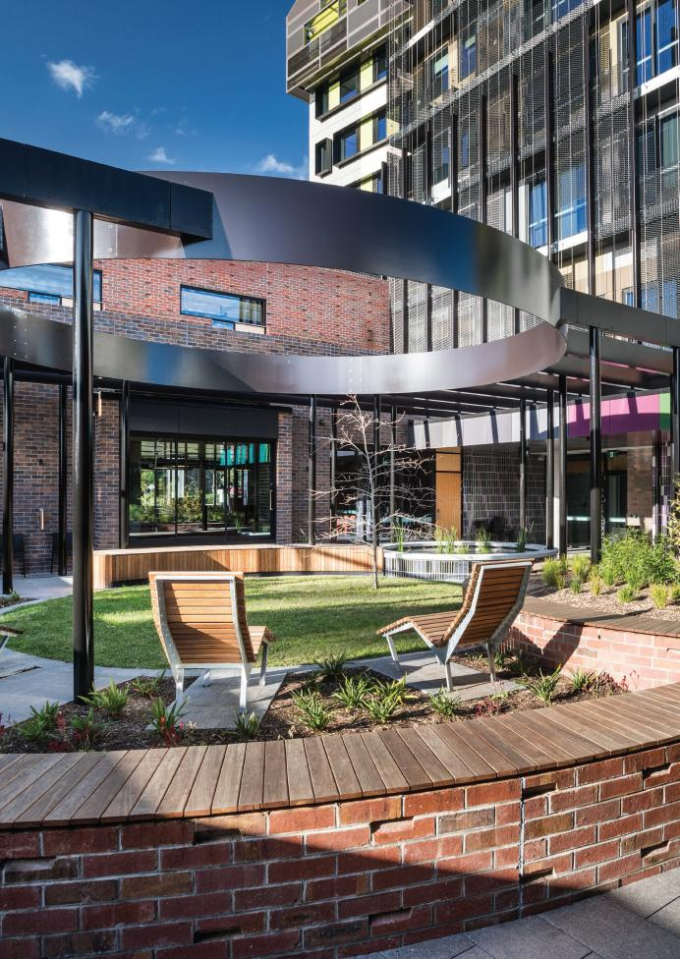
Oznam House, North Melbourne. Photographer:Trevor Meln

Foreword
Affordable Housing Strategy 2030
(To be inserted pending endorsement)
Community housing residents – Image provided by Housing Choices Australia

Executive Summary

We have a significant shortage of affordable housing.
City of Melbourne is in the midst of an affordable housing crisis. There are 1725 people experiencing homelessness including women and children escaping family violence, people with disabilities and pensioners. Pre-COVID-19 we had a short fall of 5500 safe and affordable rental homes and emergency accommodation for people on moderate, low and very low incomes, including those experiencing homelessness.
This shortfall is a result of a range of factors including a rapidly growing population, rents increasing faster than wages and insufficient investment in social and affordable housing over many years.
We know that COVID-19 has increased the need for affordable housing in the short term, and we need to respond now.

Affordable housing is essential infrastructure and improves social and economic resilience.
Affordable housing supports an inclusive and diverse city. We need to ensure that people on very low to moderate incomes have access to a place to live which is safe, secure and appropriate. Access to adequate housing is a fundamental human right.
Anyone can be in need of affordable rental housing during their life. Affordable housing is for anyone in our community who is part of a very low, low or moderate income household (see figure 3, page 12). This can include families, older people, hospitality workers, cleaners and childcare workers.
Affordable housing allows people to participate fully in their community. Numerous studies have proven that a safe home improves physical and mental health, personal relationships and quality of family life, education and employment outcomes.
Housing is essential infrastructure for our city and is vital to the functioning of our society and economy. Affordable housing limits the amount of a household’s income that is needed for rent, leaving money to spend on other necessities. As essential infrastructure, the availability of affordable housing affects our community’s resilience to shocks and major events. To aid in the recovery efforts of this year’s crises and to better prepare for future events, we need a sustained and nationwide increase in affordable housing.

The problem has been developing for many decades.
The current shortage of affordable housing is not the result of a single event or decision. Rather, it is the consequence of decades of successive governments not treating affordable and social housing as essential infrastructure. This has led to long term underinvestment in new housing and inadequate maintenance of existing housing.

Our focus is on affordable rental housing.
The focus of this Strategy is on increasing the supply of affordable rental housing in the municipality of Melbourne which can be developed and managed through registered community housing organisations.
Rental housing is more accessible than ownership for thosein need and can be retained to help others in the long term.The Strategy also outlines how we will focus our advocacy efforts to enable change across the social housing and private rental market.

The COVID-19 crisis necessitates an affordable housing recovery response.
In August 2020, PricewaterhouseCoopers (PwC) determined that demand for affordable housing in the municipality of Melbourne is likely to increase in the immediate to short term due to COVID-19.
Victoria’s Big Housing Build announced in November 2020 committed a historic $5.3 billion to construct more than 12,000 new social and affordable homes across Victoria. In addition to housing thousands of households, this is an important economic stimulus response to COVID-19.
Our research shows that for every $1 invested in affordable housing, the community benefits by $3 due to worker retention, educational benefits, enhanced human capital, health cost savings, reduced family violence and reduced crime. It is an investment in both essential infrastructure and people that compounds over the long term.

The solution to this housing crisis is both simple and complex.
The simple answer is that we need much more affordable housing.
The way we achieve this is more complex. We need to view affordable housing as essential infrastructure for the community. We need all levels of government to support the delivery of new affordable housing by raising and investing more money to deliver this essential infrastructure.
A coordinated response across governments, the private sector, the community housing sector, industry groups and the community is critical. It requires ambitious, bold decisions and an ongoing commitment to housing equity.

We have undertaken extensive research and engagement to develop this strategy.
To inform this strategy we commissioned independent studies and advice and engaged with the community and stakeholders across the housing and development sectors. We have strived to achieve an ambitious, yet balanced approach to increasing affordable rental housing in the municipality of Melbourne.
City of Melbourne is committed to being a city for people. We are inclusive, we care for our most vulnerable and we know that the availability of safe, affordable, quality homes with secure tenure supports the health and well being of our community.
Our Vision: A City that offer quality, affordable and accessible housing to a diverse community.
Our goal: To increase the supply of appropriate, accessible and affordable rental housing in the municipality of Melbourne.

Our Priorities
- Deliver more affordable rental housing on City of Melbourne-owned land
We will use City of Melbourne-owned land to increase the supply of affordable rental housing. We will trial and showcase alternative and innovative housing models and partner with key stakeholders across sectors to achieve the best possible development outcomes.
- Advocate for systemic change and new and ongoing investment for better affordable housing outcomes
We will advocate for fundamental changes to the way affordable housing policy is approached and funded to achieve significantly more housing and better outcomes for everyone.
- Facilitate more affordable rental housing through the planning system
We will facilitate the delivery of more affordable housing through the review and strengthening of planning processes, policy and resources.
- Partner with governments, industry, peak bodies and the community to increase affordable rental housing
We will increase the provision of affordable housing by facilitating strategic partnerships and maintaining ongoing dialogue across different industry sectors, including all levels of government, property developers, community housing organisations and the local community.
- Respond to the COVID-19 crisis with affordable rental housing
We will partner and advocate for affordable housing in the recovery from COVID-19.
“Affordable housing is housing, including social housing, that is appropriate for the housing needs of very low, low, and moderate-income households” Planning and Environment Act 1987.
Priorities | Actions
1. Deliver more affordable rental housing on City of Melbourne-owned land. | 1.1 On land that is owned by the City of Melbourne, up to 25 per cent of all future residential development should be affordable housing, with potential to increase this in urban renewal areas where appropriate.  1.2 Lease a City of Melbourne-owned site to a community housing provider to deliver a longterm affordable rental housing project in the next five years, seeking funding through Victoria’s Big Housing Build.  1.3 Commit a City of Melbourne-owned site for a supported housing project to address homelessness in the next five years.
2. Advocate for systemic change and new and ongoing investment for better affordable housing outcomes. | 2.1 Advocate to the Victorian Government to develop an ambitious 10-year ‘Homes Victoria Strategy’, to support Victoria’s Big Housing Build. This strategy should include clear affordable housing targets and a tangible approach to achieving them.  2.2 Advocate to the Victorian Government for a review of Clause 22.03 Floor area uplift and delivery of public benefits in the Melbourne Planning Scheme and ‘How to Calculate Floor Area Uplifts and Public Benefits, Department of Environment, Land, Water and Planning’.  2.3 Advocate to the Australian Government to deliver a long-term National Housing and Homelessness Strategy. This should commit to systemic change in the housing market and increase funding for affordable housing.  2.4 Advocate for a special agreement for Melbourne on Affordable Housing, such as a City Deal.  2.5 Advocate for the private sector to deliver innovative and diverse affordable housing options.
3. Facilitate more affordable rental housing through the planning system. | 3.1 Develop a corporate policy on affordable housing as it relates to the development of new dwellings on private and public land.  3.2 Strengthen and clarify the City of Melbourne’s position on affordable housing within the Melbourne Planning Scheme.  3.3 Partner with the Victorian Government to deliver a priority planning approval process for affordable housing developments.  3.4 Develop a centralised internal process for recording affordable housing outcomes.
4. Partner with governments, industry, peak bodies and the community to increase affordable rental housing. | 4.1 Partner with the Victorian Government to develop the Social and Affordable Housing Compact, as part of Victoria’s Big Housing Build.  4.2 Investigate a special purpose entity to manage affordable housing contributions, in partnership with other councils and the Victorian Government.  4.3 Continue to work with other local governments to establish opportunities for affordable housing development, including the inter-council affordable housing forum.  4.4 Partner with the development and community housing sectors, peak bodies, governments and the community to deliver more affordable housing.  4.5 Partner with Aboriginal organisations to ensure that appropriate and relevant affordable housing options are available for Aboriginal people in Melbourne.  4.6 Commit staff and budgetary resourcing to the ongoing delivery of affordable housing.
5. Respond to the COVID-19 crisis with affordable rental housing. | 5.1 Advocate for Australian Government stimulus funding for affordable and transitional housing in response to COVID-19  5.2 Work in partnership with the Victorian Government to support the roll out of Big Housing Build, including identifying opportunities for affordable housing projects within the municipality of Melbourne.  5.3 Advocate for further appropriate vacant properties to be head leased by the Victorian Government to transition people into long-term accommodation within the municipality of Melbourne.  5.4 Partner with the Victorian Government to develop a ‘Key Worker 3000’ initiative to secure affordable rental housing for key workers.

Introduction
Affordable housing is essential infrastructure required to support Melbourne’s ambition to be a liveable, inclusive and prosperous city.
In 2019, it was estimated that we had a shortfall of 5,500 affordable homes in the City of Melbourne. By 2036, this shortfall will grow to 23,200 affordable homes.
A sustained increase in the supply of new affordable rental housing is now critical.
“To not have to worry about searching for housing is a massive relief.”
James PhD student and affordable housing tenant

Understanding Affordable Housing

What is affordable housing?
Affordable housing is housing for people on moderate or lower incomes. Affordable housing is not ‘cheap’ or of a poorer standard – it is quality, fit-for purpose housing, priced at a level which is affordable relative to the income of its occupants.
At City of Melbourne, we use the definition of affordable housing provided by Victoria’s Planning and Environment Act 1987, which states that:
“Affordable housing is housing, including social housing,that is appropriate for the housing needs of very low, low, and moderate income households” (Victorian Planning & Environment Act, 1987).
The Act specifies the income range classification for very low to moderate income households. These ranges are updated annually. Figure 3 (page 12) shows these income ranges as of July 2020.
The widely accepted definition of rental stress is when 30 per cent or more of a household’s income is spent on rent (AHURI, 2019). When households on very low to moderate incomes are in rental stress, they are forced to sacrifice necessities of daily life such as food, healthcare or education.
The term ‘affordable housing’ is often confused with ‘social housing’ and ‘community housing’, as these terms overlap. Affordable housing is a broad term that includes:
- Social housing – a broad term that includes public housing and community housing.
  - Public housing – long-term rental housing owned and managed by state governments.
  - Community housing – long-term rental housing owned and/or managed by community housing organisations.
- Subsidised market housing – housing that is provided by the private market through a number of possible
subsidy arrangements. Subsidies may support rental or ownership models.
In some instances, private market housing may qualify as affordable housing if it is affordable for very low to moderate income households. This is largely dependant on price, property type, location and size. However, for a number of reasons, the private market is increasingly unable to provide affordable housing in many neighbourhoods.
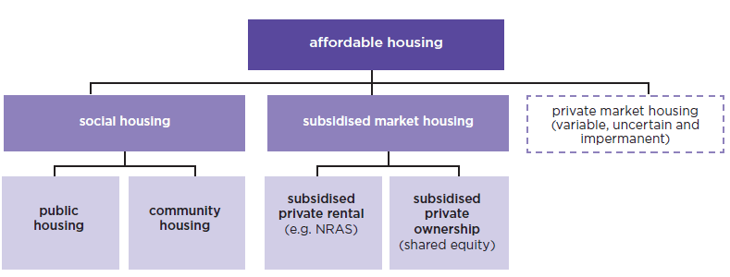
Figure 1: Affordable housing definition diagram

Who is affordable housing for?
A wide range of people may need affordable housing during their life. Affordable housing is for anyone in our community who is part of a very low, low or moderate income household. This can include families, older people, artists, childcare workers, cleaners and healthcare workers.
Some people will need affordable rental housing for the duration of their life, while others will only need it for a short time – for example when their children are young or when an illness prevents them from working full time.
Some examples of very low to moderate income households and their living costs are explored on pages 13 to 15.

Housing Spectrum
There is a strong relationship between the availability, accessibility and affordability of the different types of housing tenures and types, which is explained in the housing spectrum below.
While historically housing affordability may have been considered to only affect low income households, the reality is that it now extends to moderate income household seeking to rent or buy housing.
At the far end of the housing spectrum - and worse case outcome - is rough sleeping. The number of people who are sleeping rough in the City of Melbourne is a great concern; the 2018 StreetCount for the City of Melbourne recorded 279 people sleeping rough.
With more than 100,000 people on the public housing waiting list, including 30,000 children, and a lack of affordable housing options, it is increasingly difficult for people to break the cycle of homelessness and enter secure long term housing.
By improving and increasing affordable housing outcomes, both the likelihood of people re entering homelessness decreases and likelihood of people remaining in stable long term appropriate housing dramatically increases.
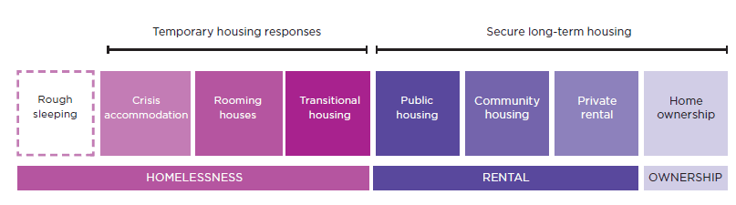
Figure 2: The housing spectrum

Who lives in Affordable Housing?
Kashvi (34) and Zac (31)
Kashvi and Zac live with their 9 and 12 year old children in Carlton. A busy family, Kashvi, Zac and their children enjoy the local park and visiting Zac’s mother on the weekends.
Kashvi works for a hospital caterer with a weekly income of $985. Zac receives a Disability Support Pension of $355 per week.
Without an affordable housing option, Kashvi and Zac rent a three bedroom apartment in Carlton at a weekly cost of $600. This leaves $740 per week for utilities, transport and groceries and other living expenses to support their family.
Kashvi and Zac are classified as a low income family, and meet the criteria for access to affordable housing.
Luke (46)
Luke has a full time job as an office cleaner in the central city. His weekly income after tax is $811. As he works outside of business hours, Luke is able to spend time cycling and assisting his retired parents.
Luke lives close to work, in a one bedroom apartment in Southbank.
Without an affordable housing option, his rent is $360 per week, which leaves him with $451 per week for essentials.
Luke is eligible for affordable housing, as he meets the moderate income single threshold.
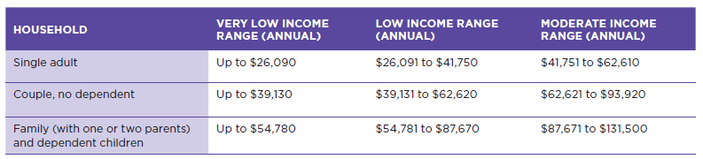
Figure 3: Income ranges for very low, low and moderate income households, July 2020 – Victorian Planning and Environment Act 1987
Ana (72)
Ana is a pensioner with a weekly income of $472. A longtime Kensington resident, Ana volunteers her time at the local community garden, and connects with her friends via a book club each week.
Without an affordable housing option, Ana would be in extreme housing stress. If Ana rents a one bedroom
apartment near to her community in Kensington at an average cost of $345 per week, she would only be left with $127 per week for essentials and all other living expenses. It is extremely unlikely Ana would be able to live in the area.
Ana is eligible for affordable housing, she is classified a very low income single.
Mae (26)
Mae is completing their PhD in Biomedical Sciences at Melbourne University. They receive an income from the university for teaching, which is supplemented with government support. They have a weekly income after tax of $540.
To keep a close eye on their lab and ensure a short commute from teaching class in the evening Mae shares an apartment in the central city. Without an affordable housing option, Mae’s average weekly rent costs $240. This leaves Mae with $300 per week for living expenses.
Mae is eligible for affordable housing, as they meet the low income single threshold.
Natasha (33)
Natasha is a nurse at the Royal Melbourne Hospital and single-parent to two children aged 5 and 7 years. Natasha’s current weekly income is $1000. Natasha rents a two bedroom apartment in Kensington, which is in walking distance to the local primary school and close to her job at the hospital.
Without an affordable housing option, the weekly rent for their apartment is $428. This leaves the family of three $572 per week to pay for essentials including groceries, utilities, clothing and transport; and a small portion put aside to save for an interstate holiday to visit Natasha’s parents next year.
Natasha meets the income criteria for affordable housing and is classified as a low income family.
Without access to affordable housing options, these households spend more than 30 per cent of their income on rent to live in the City of Melbourne, placing them in housing stress.
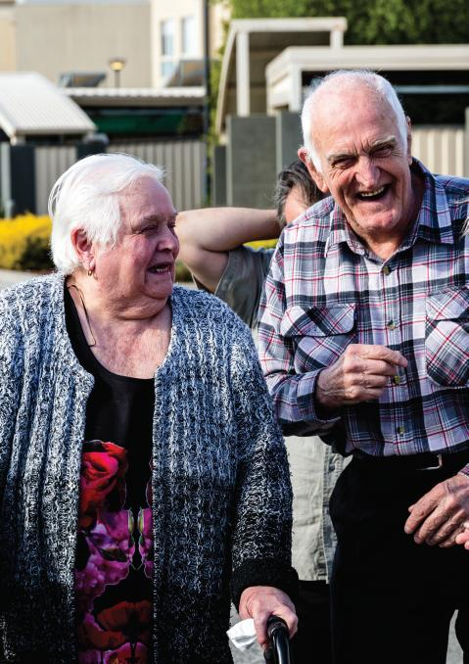
Housing Choices Australia residents – Image provided by Housing Choices Australia

What is the problem?
There is currently a significant shortage of affordable homes in Melbourne.
There isn’t enough social and affordable rental housing in the municipality. City of Melbourne commissioned SGS Economics and Planning to undertake a Housing Needs Analysis in 2019 (SGS Economics & Planning, 2019). The research found that in 2016 there were 9400 households in need of affordable rental homes in the municipality of Melbourne but only 3900 social and affordable homes available – a shortfall of 5500 affordable homes. COVID-19 has increased the need for affordable housing in the short term.
The SGS Economics and Planning research shows that only five per cent of available housing in the municipality of Melbourne is affordable to the lowest 25 per cent of earners. Of this, only one per cent of affordable housing was available in the private market (City of Melbourne, 2014). This means when people on moderate, low or very low incomes choose to live in the municipality, they typically need to spend more than 30 per cent of their gross household income on housing – putting them in housing stress and forcing them to forgo other essential spending, like heating, cooling, food or health care.
The problem has been getting worse. Between 2011 and 2016, median rent increased by 12.5 per cent, while household incomes only grew by 0.15 per cent over the same period (Australian Bureau of Statistics, 2016).
The need for affordable housing is forecast to grow.
Without intervention the current affordable housing crisis will worsen. By 2036 the demand for social and affordable housing is expected to almost triple to approximately 27,100 households.
The need for action is clear and urgent. Approximately one in four new dwellings will need to be social and affordable rental housing to address the shortfall.
This crisis will require all actors within the housing market –Victorian, Australian and local governments, the not-for profit sector, the development industry and the finance and investment industry – to collaborate to deliver a solution.
The recent Victoria’s Big Housing Build announcement will make a significant impact on the supply of housing in Victoria, delivering around 12,000 homes in the next four years. This level of investment will have a significant impact on affordable housing supply, and will require sustained investment to respond to the level of need.
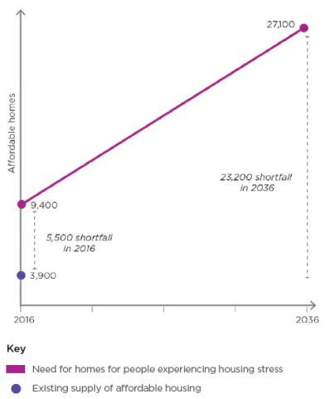
Figure 4: Municipality of Melbourne affordable housing needs projections (2019)
Figure 4: Existing supply and demand and projected demand for affordable housing in the municipality of Melbourne

COVID-19 and Affordable Housing
COVID-19 will bring forward the need for affordable housing.
COVID-19 has had a dramatic impact within Australia and across the world. The economic and social consequences of COVID-19 are yet to be fully understood and will continue to affect us beyond the periods of lock down.
In 2019 the SGS Economics Housing Needs Analysis (SGS Economics & Planning, 2019) determined that there was an unmet demand of around 5500 households in need of affordable housing, which would increase to 23,200 by 2036. Once the COVID-19 pandemic occurred early in 2020, we wanted to understand what impact it was likely to have on the need for affordable housing in our municipality.
We commissioned PricewaterhouseCoopers (PwC) to review the demand forecast in light of COVID-19. We asked them to provide expert commentary on the extent to which the need may have changed and to qualitatively consider some of the impacts of COVID-19 on the demand and supply for affordable housing in the municipality of Melbourne.
The PwC August 2020 Review of Housing Demand Analysis (PwC, 2020) found that the analysis undertaken for our Draft Affordable Housing Strategy “remains relevant and reasonable, based on the information that is currently available” and that demand for affordable housing is expected to increase in the immediate to short term.
Key findings from the review:
- Demand for affordable housing may be pushed forward in the immediate to short term. The economic impact of the virus has seen a rise in unemployment and underemployment, translating to an increased demand for affordable housing. The economic downturn and job losses are anticipated to disproportionately effect those who were already vulnerable before the pandemic.
- Though there has been some decline in rental prices in the city, these prices still remain unaffordable for those on very low, low and most moderate incomes. The drop in prices is also expected to be temporary.
- The 2036 demand for affordable housing may potentially be lower than originally estimated due to a reduction in population caused by reduced immigration. This is currently difficult to estimate.
- High debt taken on by government may compromise payments in the future (pensions, unemployment), increasing the demand for affordable housing.
The medium and long-term implications of COVID-19 are yet to be fully understood and are constantly changing. We will continue to monitor the relevance of the future affordable rental housing demand assumptions. When more concrete information is available, we will revisit the Housing Demand Analysis if further updates are necessary.
Frontline health worker
Affordable housing has a clear role to play in the COVID-19 recovery response.
The Australian Government responded to the pandemic with stimulus measures including JobSeeker and JobKeeper payments. These have provided a vital safety net for millions of Australians.
State governments have also responded rapidly, providing free, emergency accommodation for rough sleepers. In Victoria, emergency accommodation was found for around 95 per cent of people sleeping rough.
However, as unemployment has risen and the virus has exposed existing vulnerabilities within our housing market, permanent affordable rental housing must play a central role in the ongoing recovery response.
Investing in more quality affordable and social housing during the recovery period is a wise investment of public money. Our research shows that for every $1 invested in affordable housing, the community benefits by $3 due to worker retention, educational benefits, enhanced human capital, health cost savings, reduced family violence and reduced crime (SGS, 2019). It is an investment in both essential infrastructure and people that compounds over the long term.
Since the pandemic started, there has been a push for large scale investment in social housing as a stimulus response, which was an important part of Australia’s successful response to the global financial crisis in 2008.
In May 2020 the Construction Union (CFMEU) and peak building industry lobby group (Master Builders Australia) jointly called for a $10 billion social and affordable housing fund to build 30,000 new dwellings. This call has been echoed by housing advocates like National Shelter, Homelessness Australia and the Community Housing Industry Association.
The Victorian Government has recognised the important role social housing should play in recovery. Through the November 2020 Victoria’s Big Housing Build announcement it will invest $5.3 billion in new social and affordable housing construction in Victoria.
Stage 4 restrictions in Melbourne serve as a reminder of the ability of COVID-19 to expose multiple vulnerabilities within our society. Affordable housing has a role to play in reducing disease transmission and alleviating the economic insecurity and hardship likely to be experienced by a growing proportion of the population.
Investing in social housing in response to the pandemic is beneficial to the community and beneficial to the economy.
Older persons awaiting care

Why do we need Affordable Housing?
Affordable housing is essential infrastructure.
Housing is essential infrastructure and is vital to the functioning of our society and economy.
Infrastructure Victoria, the infrastructure advisory group to the Victorian Government, identified investment in affordable housing for vulnerable Victorians as one of its top three priorities in Victoria’s 30 Year-Infrastructure Strategy (2016).
We need to ensure that people on very low to moderate incomes have access to a place to live which is safe, secure and appropriate. Access to adequate housing is a fundamental human right. It allows people to participate fully in their community. Numerous studies have shown that a safe and stable home improves physical and mental health, personal relationships and quality of family life, education and employment outcomes.
Affordable housing reduces the amount of a household’s income that is needed for rent, leaving money to spend on other necessities.
Investing in affordable housing makes economic sense. Our research shows that for every $1 invested in affordable housing, $3 worth of community benefit is provided due to worker retention, educational benefits, enhanced human capital, health cost savings, reduced family violence and reduced crime.
We know affordable housing is essential to the continued success of our cities and regions across Australia. Failure to provide enough affordable housing will have economic and social consequences.
Affordable housing improves social and economic resilience.
The availability of affordable housing directly improves the resilience of our community and our collective ability to respond to major shocks and stresses. In 2020, we have experienced catastrophic bushfires followed by the global COVID-19 pandemic.
Surviving and recovering from these events is contingent on access to safe, secure and affordable housing across all states and territories.
Climate change
Climate change is compounding the housing crisis. The increasing severity and frequency of extreme weather events such as storms, fires, and flooding are destroying people’s homes and leaving them without a place to live. The recent bush fires of the 2020 summer are just one example. These events are expected to continue and worsen.
City of Melbourne has declared a Climate and Biodiversity Emergency. We must prepare to house people displaced by climate change locally, nationally and internationally.
Further, climate change worsens the conditions for people experiencing homelessness and people experiencing housing stress. Heat waves and cold spells are often more acute for those living in financial stress as people are unable to pay for the electricity to run their air conditioning and heating. These weather events heighten physical and mental health conditions. They often result in heat stress-related deaths and rises in mental health issues and domestic violence.
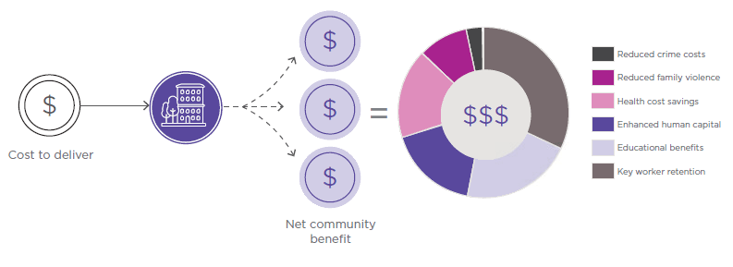
Figure 5: Every $1 spent on affordable housing provides $3 of community benefit
SGES Economics and Planning, 2019
Affordable housing supports an inclusive and diverse city.
A broad spectrum of professionals, students, artists, service and hospitality industry professionals make a significant contribution to our city. They are critical to Melbourne’s liveability and economic prosperity.
Workforce diversity supports economic productivity (Berry, 2003). Cities which lack sufficient affordable housing often see the displacement of low-income workers to outer suburb locations. This can then lead to the loss of industry – as it relocates to be closer to its workforce.
Cities experiencing housing pressure have difficulty attracting quality key workers for their schools, hospitals and other services due to the inability for workers to live close to their employment.
As the affordable housing crisis worsens, some current and future residents, including families, will be excluded from our community.
Our community cares about affordable housing
The City of Melbourne’s vision is for a ‘bold, inspirational and sustainable city’. We strive to represent our community goals and aspirations for the municipality.
We have heard from our community, through numerous forums, events and engagements that they care about affordable housing and want to see increased accessibility and supply of affordable homes. This is a priority identified in both the Future Melbourne 2026 Plan and Council Plan 2017–2021.
For more information on the community engagement process for the Draft Affordable Housing Strategy, see pages 37-38.
Aboriginal Housing
The City of Melbourne acknowledges that Aboriginal and Torres Strait Islander peoples were the First Peoples of this land and have strived to retain their culture and identity through the period of European settlement for over 200 years. We also recognise that European settlement forced the displacement of many Aboriginal people from their traditional lands, including those of the Kulin Nation. Despite the destructive impact of European settlement, Aboriginal culture has endured and is recognised globally as one of the oldest living cultures.
Aboriginal people show enormous resilience and generosity of spirit towards other people with whom their land is now shared. However the echoes of this displacement are still experienced today and Aboriginal people disproportionately experience homelessness and housing insecurity in Australia.
Aboriginal and Torres Strait Islander people continue to experience complex historical disadvantage, including; lower education and training levels, lower incomes and the compounding disadvantage of dispossession of their land. As a consequence, Victorian Aboriginal people face severe housing disadvantage and are 14 times more likely to experience homelessness than non-Aboriginal Victorians.
The City of Melbourne is committed to reconciliation and working in partnership with local Aboriginal organisations to ensure greater housing security for Aboriginal people in our municipality.
As the Victorian Aboriginal Housing and Homelessness Framework states: ‘Aboriginal households are generally more open and often likely to care for elders or be kinship carers and cater for large extended and mobile families. This strength should be acknowledged and supported in considering housing requirements’ (Aboriginal Housing Victoria, 2020).
It is expected that the Victorian Aboriginal and Torres Strait Islander population will grow from 57,782 in 2016 to 95,149 in 2036 and will require an additional 5,085 Aboriginal Housing units by 2036 (Aboriginal Housing Victoria, 2020). Affordable housing should be developed in partnership with the Aboriginal community to support the specific cultural and kinship needs of Aboriginal households. Once developed, the housing should be owned and managed by Aboriginal-led community housing organisations.
Community housing property – Image provided by Housing Choices Australia
Our focus: affordable rental housing
The focus of this Strategy is affordable rental housing. We focus on affordable rental housing rather than affordable ownership for two key reasons:
- affordable rental offers greater certainty that housing remains affordable in perpetuity, and;
- it offers greater flexibility in ensuring that housing is available to people who need it most.
Permanent affordable rental housing protects the retention of affordable housing within the municipality. This is possible with affordable purchase, but becomes more complicated as the affordable housing unit grows in value over time and the owner may choose to sell or rent the property. Without ongoing controls the affordability of the unit can be lost. Affordable rental ensures that the price of housing is affordable long-term.
Affordable rental housing also allows people to transition into and out of a home at different stages of their life. A tenant can move out of an affordable housing unit after beginning a new, higher paying job – allowing someone in need to take their place. Prices can also be adjusted for different income levels (from moderate to very low) offering greater flexibility over time.
We recognise the importance of affordable ownership and the challenge that this presents for many people in Australia, but as a local government it is not our focus. Many of the levers for impacting the private housing market are largely outside of local government control. This includes property and investment taxes, stamp duty, interest rates, wages and major infrastructure. As a local government, we can play a role through advocacy, but our impact on people’s ability to purchase homes is likely to be small.
Community housing residents – image provided by Housing Choices Australia

How did we get here?
The current shortage of affordable housing is not the result of a single event or decision. Rather, it is the consequence of decades of underinvestment in new affordable homes and the inadequate maintenance of existing affordable housing stock.
Underinvestment in affordable housing.
Throughout the 1930s until well after World War II, the Australian and Victorian Governments worked together to build much needed social housing. By 1956, the Housing Commission of Victoria owned and managed 30,170 dwellings.
Towards the end of the 20th century, governments have not prioritised investment in essential community infrastructure and fewer homes have been built.
Australia-wide, construction of public housing stock has declined since the 1970s. The amount of Victorian public housing decreased slightly from 65,310 dwellings in 2001 to 64,241 dwellings in 2016, according to the Australian Productivity Commission. Victoria has the lowest portion of social housing units per capita of all states in Australia - around 3 per cent of total housing stock in Victoria is social housing; compared to 6 per cent in South Australia, 5 per cent NSW; and the national average of 4.5 per cent.
Underinvestment also leads to ageing housing stock. According to the Victorian Auditor-General’s Office (VAGO) in 2017, the average age of Victoria’s public housing stock was 35 years. In total, 60 per cent of public housing stock was more than 30 years old.
Lack of housing stock leaves tens of thousands of households in stress.
The unmet need for affordable housing across Victoria was estimated to be between 75,000 and 100,000 households in 2016. With social housing stock unable to meet the demand, the Victorian Government has prioritized allocation to those in greatest need. This means that tens of thousands of households who qualify for social housing but are not in greatest need aren’t able to access housing and remain in stress. This includes lower income earners and essential workers.
Affordable housing no longer treated as essential infrastructure.
A review of Victorian public housing by the Auditor General in 2017 found that the government was ‘not managing its public housing effectively,’ despite it being valued at around $21 billion in 2016. The absence of a clear long-term direction for public housing was highlighted in the report: ‘at the root of this failure is an asset management framework that is disjointed, poorly communicated and lacking in a comprehensive understanding of asset performance.’
Over reliance on the private market to supply affordable housing.
Supply of housing in the private market is important, but on its own it is not enough to increase the supply of affordable housing.
Demand for housing in Australia is not only motivated by the need for shelter. A lot of new housing is absorbed by investors, rather than owner occupiers. In Australia, home ownership is one of the primary ways to build wealth. As a result much of the new housing supply is absorbed by existing property owners building wealth. Investment property owners will often charge high rents to ensure the property generates a return, or if it is generating strong capital gains it may be left vacant.
In Melbourne the construction of new dwellings has kept pace with population growth (Australian Bureau of Statistics, 2016). Despite the building ‘boom’ in Melbourne, housing costs have continued to increase and a larger proportion of the population is renting. This indicates that despite strong supply, affordability has worsened.

What needs to change?
The solution to this housing crisis is both simple and complex.
The simple answer is that we need much more affordable housing.
The way we achieve this is more complicated. We need to view affordable housing as essential infrastructure for the community. We need all levels of government to support the delivery of new affordable housing by raising and investing more money in this essential infrastructure.
In many international cities the private sector plays a significant role in contributing to affordable housing. However, in Victoria, the absence of policies and levers to require private sector contributions has reduced the overall availability of affordable housing to those who need it.
City of Melbourne recognises that there is no silver bullet to achieve systemic change or investment. The responsibility does not rest with any one industry or government body.
Rather, a coordinated response is required across governments, the private sector, community housing sector, industry groups and the community. It necessitates ambitious, bold decisions and an ongoing commitment to housing equality.
Ensuring well designed housing
Melbourne’s attractiveness to businesses, residents and visitors is in large part derived from the design of its buildings, streets, and open spaces. Cities that invest in high quality design entice people, investment and subsequent economic prosperity. The City of Melbourne has developed a strong reputation for urban quality through ongoing investment in the procurement of capital works projects of high design quality. Equally important is the City’s influence through the planning framework on setting expectations of the quality of development.
Homes for People, City of Melbourne’s 2014- 2018 housing strategy, identified ‘Improving the design quality and environmental performance of new apartments’ as one of its three goals, recognising the importance of living environments on people’s health and well-being. In addition, the City of Melbourne’s Central City Design Guide (2019) alongside progressing a Design Excellence program, demonstrates Council’s commitment to achieving design quality.
City of Melbourne continues to support housing that:
- is responsive and contribute to local context and character
- is built with high quality sustainable materials
- is designed with architectural integrity
- ensures no visible difference between housing tenures in design quality.
- adopts high standards of sustainable building design
- has good space standards and high internal amenity to support the well-being of occupants
- considers how private and public space is delineated and contributes to the development
- offers a diversity of sizes and types of accommodation that is designed to be able to adapt
- activates streets and urban spaces.
We support the Victorian Government’s commitment, as part of the Big Housing Build, for major projects (more than 100 units or 3 storeys) to undergo independent design review by Office of the Victorian Government Architect (OVGA). We encourage this be extended to smaller scale multiple dwelling applications, either through the OVGA or through seeking early urban design input through the Development Planning process.

Existing Roles and Responsibilities
Many different roles and responsibilities influence the affordable housing crisis and its solutions. These range from the regulations, taxes and policies that are controlled by governments, to the management of affordable housing by the community housing sector, and the development of new housing by the private sector.

Governments
The supply of affordable housing is affected by policies of all three tiers of government. To address the housing crisis, a coordinated and sustained approach across all levels of government is needed to ensure effective policy, funding, incentives and governance.
The Australian Government collects approximately 80 per cent of all government taxes and is responsible for allocating the majority of funding into the social housing sector and to other governments (Australian Bureau of Statistics, 2018). It provides financial support for not-for-profit organisations and individuals. It also influences the broader housing market through the use of taxation and regulatory levers to incentivise or disincentivise certain outcomes.
The Victorian Government builds, owns and manages public housing. It provides funding to community housing agencies and sets the rules on how community housing is managed. The Victorian Government also controls the Victorian Planning Provisions and the majority of property taxes, including stamp duty – which significantly affects the housing market.
Local governments collect approximately 3 per cent of all government taxes through rates (Australian Bureau of Statistics, 2018). Increases to rates are capped by the Victorian Government, limiting local government’s financial capacity. Councils use the planning tools within the Victorian Planning Provisions to negotiate development outcomes through the planning permit process. Local government can also use rates concessions to support affordable housing outcomes. Many homelessness services are funded or directly provided by Local Governments. In addition, community infrastructure, such as libraries, often provides support to those experiencing housing stress.

Community housing organisations
Community housing organisations are not-for-profit entities which include registered housing associations and providers. Examples include Housing Choices Australia, Aboriginal Housing Victoria and St Kilda Community Housing. Importantly, they are registered and regulated by the Victorian Government. Their not-for-profit and charitable status attracts a range of funding opportunities and tax benefits.
Community housing organisations build and manage affordable rental properties. Across Australia they are responsible for a portfolio of more than 100,000 affordable rental properties worth more than $30 billion.
Community housing organisations provide different housing types to meet the different housing needs and preferences of their clients. Some community housing organisations specialise in helping specific groups such as people with a disability, women, singles or older people.

The private sector
The provision of affordable housing in private sector developments is currently voluntary in Victoria. As part of the planning permit process, a developer may negotiate the delivery of affordable housing in exchange for other incentives such as additional development rights.
Developers in the property market typically aim to achieve a stable profit margin through the construction and sale of housing. Where incentives and bonuses offset the cost of delivering affordable housing, then affordable housing outcomes will be feasible within their business model.
If the requirements for affordable housing are determined well in advance, developers are able to anticipate the cost and accordingly pay less for land, enabling them to deliver the required housing contribution.

What about build-to-rent?
What is build-to-rent?
Build-to-rent is housing that is purpose-built, retained and managed as long-term rental housing, usually by a single owner. Institutional investors (such as superannuation funds) are often attracted to the model because it can generate a long-term and stable income.
Build-to-rent is commonplace in both the UK and United States (where it is known as multi-family residential housing).
Is build-to-rent affordable?
Build-to-rent is not an affordable housing product in itself, although it can be made affordable if the dwellings are offered at a discount to market rent. To make this possible, the gap between market rent and affordable rent would require subsidising.
Government roles and responsibilities in the Australian housing system
Australian Government | Victorian Government | Local government
Housing demand  - Tax incentives (negative gearing capital gains tax reduction)  - Migration policy  Home ownership  - Capital gains tax reduction  - First home buyer super save scheme  - Home value exclusion from the Age Pension eligibility  Social Housing investment  - National Housing and Homelessness Agreement. (NHHA)  - National Housing Finance and Investment Corporation (NHFIC)  Welfare Support  - Commonwealth rent assistance  Major infrastructure funding  - City Deals  - National Housing Infrastructure Facility(NHIF) | Taxes and duties  - Stamp duty  - Land tax  Public and community housing  - Funding public housing  - Transfer to Community Housing Organisations  Home ownership  - First Home Owner Grants  - Stamp duty exemptions  - Other exemptions  Land release  - Release of public non-residential land  Major Infrastructure funding  - Transport  - Healthcare  - Education | Rates  Minor infrastructure  - Roads and minor infrastructure  - Libraries and community spaces  Planning laws  - Land use zoning  - Inclusionary zoning  - Planning permits and restrictions
Australian Housing and Urban Research Institute 2019
Existing strategies and policies
Australian Government | Victorian Government | Local government
A national housing strategy or policy does not currently exist.  The Australian Government recently established the National Housing and Homelessness Agreement with the states which sets housing supply targets and distributes funding for housing to the states.  The government has also established the National Housing Finance and Investment Corporation to operate an affordable housing bond aggregator to provide long-term, low cost finance for affordable housing providers.  Funding from the Australian Government is also directed through the National Housing Infrastructure Facility to fund critical supporting infrastructure which enables the delivery of new housing. | Homes for Victorians 2017 establishes the government’s response to the housing affordability crisis. It seeks to deliver 6,000 new social housing homes, renew 2,500 public housing residences and help 19,000 people who are homeless or at risk of homelessness.  Legislative amendments were introduced to the Planning and Environment Act 1987 in 2018 to extend the objectives to ‘facilitate affordable housing supply’ and introduce a definition of affordable housing.  Victoria’s Big Housing Build, November 2020 (further details on following page). | Meeting the diverse housing needs of Melbourne’s community is a priority identified in both the Future Melbourne 2026 Plan and Council Plan 2017-2021.  The provision of affordable housing in our municipality also delivers on other goals: A Creative City, A Prosperous City and A Knowledge City.  The City of Melbourne’s current housing Strategy Homes for People: Housing Strategy 2014-18 includes a goal to increase the supply of affordable housing.

Victoria’s Big Housing Build
In November 2020 the Victorian Government announced a historic $5.3 billion multi-year social housing investment. The Big Housing Build has been established in response to the growing shortfall of social and affordable housing in Victoria, and to aid in the ongoing COVID-19 recovery through job creation and economic stimulus. The program includes the establishment of a new Homes Victoria department that will oversee and manage all housing assets, the development of new affordable houses and facility improvements.
The $5.3 billion investment includes:
- $532 million to build 500 new social housing homes and 540 new affordable and market homes on public land, replacing obsolete properties and constructing new homes.
- $948 million on projects already started, or ready to build and spot purchase existing properties; which will deliver 1,600 new social housing properties and 200 new affordable homes
- $1.38 billion in funding for the community housing sector through the Social Housing Growth Fund, for housing projects led by community housing providers
- $2.14 billion in partnerships with the private and community housing sector to build on surplus government owned land sites. This will include partnering with industry, local government, community housing providers and institutional investors to identify new projects. This should deliver up to 5,200 new homes.
In addition to the Big Housing Build, the Victorian Government will commit:
- $498 million to fund new construction, upgrades and maintenance to existing public housing across Victoria, aiming to improve more than 23,000 social housing properties
- $185 million to replace old public housing with new dwellings through the Public Housing Renewal Program, which is already underway.
The Big Housing Build represents the largest ever investment in social and affordable housing in Victoria’s history and will greatly impact the way that social housing is planned for and delivered in the state. The City of Melbourne has been presented with a unique opportunity to leverage the commitment made by the Victorian Government to deliver on the actions outlined in this strategy, and to seek new opportunities as they arise through future Victorian Government initiatives.
In particular, the City of Melbourne has the opportunity to align with the Big Housing Build and Homes Victoria mandate through:
- Partnering with the Victorian Government in developing the ‘Social and Affordable Housing Compact’
- Pursuing strategic partnership projects with Homes Victoria, such as utilising City of Melbourne land that is suitable for new development and shovel-ready projects that could receive funding
- Partnering with the Victorian Government to streamline the City of Melbourne Planning Scheme to facilitate approvals for social and affordable housing discripencies.

The Big Housing Build at a glance
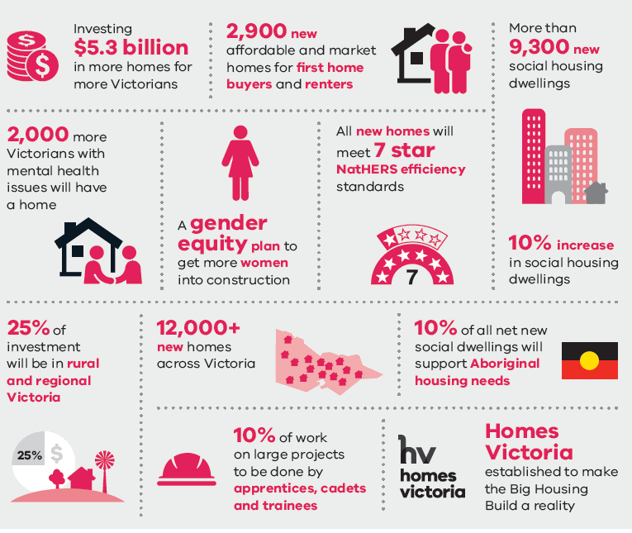
Figure 6: Victoria’s ‘Big Build’ program infographic extract
Victoria’s largest-ever investment in social and fordable housing.
- Investing $5.3 billion in more homes for more Victorians
- 2,900 new affordable and market homes for first home buyers and renters
- 2,000 more Victorians with mental health issues will have a home
- A gender quality plan to get more women into construction
- All new homes will meet 7 star NatHERS efficiency rating
- More than 9,00 new social housing dwellings
- 10% increase in social housing dwellings
- 25% of investment will be in rural and regional Victoria
- 12,000+ new homes across Victoria
- 10% of all new social dwellings will support Aboriginal housing needs
- 10% of work on large projects to be done by apprentices, cades and trainees
- Homes Victoria established to make the Big Housing Build a reality
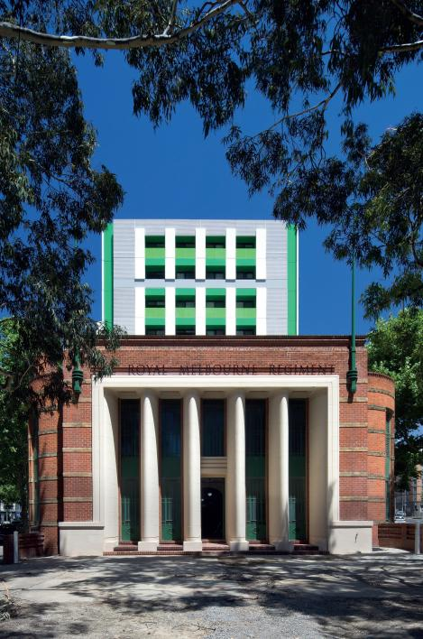
Drill Hall, Melbourne – Community Housing above a multicultural hub

What has City of Melbourne done so far?
City of Melbourne has a long history of involvement in social and affordable housing. Over the past 20 years we have been involved in eight property developments, contributing to the provision of 438 affordable housing units.
We have also been working to address homelessness. In 2019–20, we spent over $1.8 million to build on our response to homelessness. However, despite all our work over the past 20 years, the lack of sufficient affordable housing in the city undermines our efforts to get people into long-term, safe and secure housing.

Homelessness services and support
Housing affordability is inextricably linked to homelessness. Without enough affordable housing, we increase our community’s vulnerability to homelessness. Affordable housing is not exclusively for people experiencing homelessness, but it is needed to transition people out of homelessness. It also helps to prevent people from becoming homeless – by offering people a safe and stable home they can afford.
The number of people experiencing homelessness in greater Melbourne has grown and the central city is disproportionately affected. Transport links and concentration of services lead many people to seek help and shelter in the central city.
City of Melbourne is working to expand and improve homelessness services. This is separate to, but integrated with, our work on affordable housing.

On-street support
City of Melbourne has invested in a range of initiatives to support individuals experiencing homelessness in our city and to resource pathways out of homelessness. Some of these initiatives include:
- Service Coordination Program: The Homelessness Service Coordination Program, is a partnership between City of Melbourne, the Department of Health and Human Services and representatives from agencies who work with people sleeping rough in the central city.
The program streamlines services for people experiencing homelessness, linking with suitable support and ultimately aiming to get them off the streets and into permanent housing. The group is made up of specialist workers from a variety of services who work directly with people experiencing homelessness. The program provides support for housing, health, mental health, alcohol and drug addiction.
- The Daily Support team: a specialised team which works with people sleeping rough in the city, with the aim of finding permanent pathways out of homelessness. We are the first Council in Victoria to have an in-house assertive outreach program for rough sleepers.
- Night Time Safe Spaces: a space open from 11pm to 7am, 364 nights each year. This program provides a welcoming safe and inclusive space for men and women experiencing homelessness in the municipality. It is funded by City of Melbourne. Due to COVID-19 physical distancing restrictions, the space was closed in 2020. Resources and funding were redirected to supporting an on-street outreach service for people who continue to sleep rough on our streets.
- Frontyard Youth Services: provide integrated services in Melbourne’s central city to address the physical, social, emotional and housing needs of young people aged between 12 and 25 years who are at risk of or are experiencing homelessness.
- Libraries Social Support Worker
- Extreme weather program: during extreme heat the City of Melbourne provides swim passes, movie passes and drink bottles to service providers for people experiencing homelessness in the municipality.
- Homelessness Advisory Committee

Transitional accommodation and supported housing
City of Melbourne supports the Housing First approach which focuses on safe and permanent housing as the first priority for people experiencing homelessness. We are currently partnering with health and homelessness services, the Victorian Government and the corporate and philanthropic sectors to create pathways out of homelessness into secure housing.
For more information on how we are working to help people experiencing homelessness and at risk of homelessness, please see the homelessness page at melbourne.vic.gov.au

Long-term affordable housing planning and delivery
City of Melbourne has maintained an active interest in affordable housing over the past twenty years.
A number of different affordable housing initiatives and planning tools have been used in Melbourne. Collectively, however, these are not delivering the scale of new homes required to meet our need. We lack a consistent planning framework and approach to delivering affordable housing. The ad hoc nature of the mechanisms, coupled with the absence of any mandatory planning tools has resulted in too few new affordable homes being delivered.
Figure 7 captures the range of past and existing affordable housing projects, initiatives and planning controls, including uplift incentives, aspirational targets and building on government-owned land. These are discussed in more detail over the following pages.

Building on City of Melbourne-owned land
In our 2014 Housing Strategy we committed to making up to 15 per cent of constructed dwellings available for affordable housing, when we developed on land that we own. This policy has had effect in two current projects:
- The Munro site, as part of the Queen Victoria Market Precinct Renewal, has been approved to provide 48 affordable apartments. An additional six apartments will be owned and managed by the Transport Accident Commission (TAC).
- The Boyd redevelopment in Southbank, which is expected to result in 40 affordable apartments.
There is also an example in the municipality of Melbourne of the Victorian Government using its own land to build new affordable housing. The Inclusionary Housing Pilot at Manningham Street will deliver some social housing on surplus government land, in addition to private housing.
Opportunities to deliver affordable housing on publicly-owned land have been ad hoc and produced limited stock.

Voluntary agreements
The Planning and Environment Act 1987 (the Act) was amended in June 2018, adding an objective to “facilitate the provision of affordable housing in Victoria.” It clarifies that Responsible Authorities – such as City of Melbourne – can enter into a voluntary agreement with a land owner under section 173 of the Act for the provision of affordable housing.

What are the challenges?
Since June 2018, limited voluntary agreements have been entered into with landowners for the delivery of affordable housing in the municipality of Melbourne.
The success of securing affordable housing through section 173 agreements is dependent on Council being able to negotiate with developers at the planning permit stage. To date, these negotiations have had limited success. The main reason is that the agreements are voluntary and there is little to motivate the contribution by developers. Outcomes are also limited by the lack of clarity on preferred outcomes for affordable housing arrangements.
The requirement to enter a section 173 agreement may be required by Council as a condition of a planning permit but if the developer does not agree, the condition is likely to be challenged at the Victorian Civil and Administrative Tribunal (VCAT).
Changes to the Victorian Planning and Environment Act 1987 related to voluntary agreements for affordable housing were a step in the right direction, but have had limited impact on the delivery of affordable housing.

Non-mandatory neighbourhood targets
In the absence of mandatory controls, the Fishermans Bend Framework and the West Melbourne Structure Plan introduced affordable housing requirements for their respective areas (with a 6 per cent target). New developments are expected to include a percentage of affordable housing, unless the proponent can prove that this renders the development unfeasible.

What are the challenges?
Ultimately, these agreements rely on section 173 agreements and are still entirely voluntary. A likely and undesired outcome of this approach is that proponents may consider it financially preferable to argue against provision at VCAT – a time and resource intensive process for all parties which may not result in the desired affordable housing outcomes. A mandatory tool, such as inclusionary zoning, would resolve this problem.
Affordable housing targets for new developments are not being met due to the voluntary nature of affordable housing agreements.
A snapshot of some affordable housing initiatives and controls in the municipality of Melbourne 2000-2020.
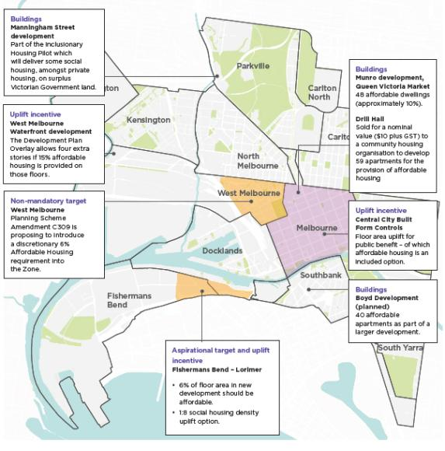
Figure 7: Recent affordable housing initiatives in the municipality of Melbourne

Uplift incentives
An uplift incentive is created by offering additional development rights where affordable housing – or other community benefit – is provided. The Melbourne Planning Scheme offers the provision of affordable housing in exchange for uplift incentives in some areas.

Where do uplift incentives apply?
Central City Built Form controls – Melbourne Planning Scheme Amendment C270 introduced the Central City Built Form controls which included a floor area ratio of 18:1. This was intended to provide a guide for what a reasonable development yield should be within the central city. Development density which exceeds this threshold (floor area uplift), triggers a value sharing contribution towards a public benefit. The public benefit provided must be commensurate with the uplift sought and could include strategically justified uses such as commercial space, publicly accessible areas or affordable housing.
Our two key concerns with the way the uplift mechanism operates in the central city are:
- That the base floor area ratio is very high when benchmarked nationally and internationally. The use of an uplift incentive on top of this ratio further compromises design and density outcomes for the neighbourhood, introducing increased populations who require services and infrastructure locally. A significantly lower floor area ratio would needed to be adopted before an uplift incentive could deliver appropriate outcomes.
- Social housing is identified in the schedule as an option to trigger uplift. Many of the alternative public benefit incentives available under these controls – such as commercial space – are more financially attractive to developers than affordable housing. As a consequence affordable housing is rarely delivered.
West Melbourne Waterfront – a preferred building height of 10 storeys is given in this precinct. A building height of up to 14 storeys may be permitted by City of Melbourne if, amongst other things, 15 per cent of this additional floor area is set aside for affordable housing. This arrangement was agreed to through a site-specific planning scheme amendment.
Fishermans Bend (Lorimer precinct) – in 2018, the Fishermans Bend Framework introduced an affordable housing target of 6 per cent and a 1:8 social housing uplift incentive. The uplift incentive offers an increase of eight dwellings above the ‘as-of-right’ density for each social housing dwelling provided, at the discretion of the responsible authority. As at 2020, the social housing uplift incentive has not been applied to any developments in the Lorimer precinct.
Macaulay (DDO63) – New built form controls were introduced to Macaulay through Design and Development Overlay 63 (DDO63). An uplift incentive was included in the controls allowing developers to exceed the preferred building heights if they can prove their development provides ‘a demonstrable benefit to the broader community.’
However, affordable housing was not explicitly defined as a community benefit. There was also no measurable criteria for assessing how much uplift a community benefit was worth. That is, if affordable housing is offered as a community benefit there is no defined measure to calculate how many affordable housing units and increase in ‘X’ height is worth. This creates uncertainty and confusion for both the developer and the responsible authority.

What are the challenges?
Despite inclusion in the planning scheme, these uplift incentives have delivered limited affordable housing units in the municipality: failing to provide sufficient incentive for developers.
The correlation between the uplift incentive provided and the cost of providing affordable housing is not always clear, and adds risk and cost to developments. The incentives are often insufficient to offset the cost of the affordable housing requirements.
Further, uplift incentives may compromise planned design and density outcomes for a site and the broader neighbourhood. This is particularly relevant when the existing floor area ratios are already maximised.
Current uplift incentives are inconsistent and are not delivering affordable housing.
Uplift incentives may compromise the planned design and density outcomes for individual sites and the broader neighbourhood.

Value capture
Value capture is a means of ‘capturing’ a portion of increased land value. This occurs as a result of government investment or the planning process, such as when land is rezoned to higher value uses or transport infrastructure is provided. The value created and then captured can be contributed towards a community benefit such as affordable housing. This can be done by stating a requirement for the development of affordable housing at the time of rezoning, ensuring that increased land values that result from the rezoning include the cost of delivery of affordable housing.
Although rezoning of land can occur on a site-specific basis, urban renewal areas generally provide the greatest opportunity for value capture. Arden, Macaulay and Dynon and E-Gate are planned future urban renewal sites within the municipality of Melbourne that represent opportunities for value capture.

What are the challenges?
Due to the speculative nature of Melbourne’s housing market, attempts to value capture are often undermined by rises in land values that occur prior to rezoning due to speculation. This occurred recently in Arden where a proposed land sale showed land prices that reflected a speculative residential land use.
Speculation is inherently risky and therefore the implementation of value capture mechanisms should be independent of speculative land prices. Land valuation that does not accurately speculate the inclusion of affordable housing requirements should be regarded as a cost of the risk of speculating and not affect government policy.
This risk can be mitigated by committing to affordable housing requirements early and providing certainty around these requirements. Mandatory Inclusionary Zoning would enable this level of confidence.
Value capture opportunities for affordable housing have been missed when rezoning land in the past. There is a need to commit to affordable housing requirements early and providing certainty around these requirements.

City of Melbourne housing trust
City of Melbourne created the Inner City Social Housing Trust in the late 1990s and contributed $1 million as an initial start-up contribution.
The trust existed for some years and created approximately 300 affordable housing units in central city which still exist. These include Ebsworth House, Guilford Lane, Lion Garden, La Trobe Close, Drill Hall, Common Ground and the Boyd High School Site.
The trust underwent a number of management and organisational changes as it developed and expanded through partnerships and mergers with other similar groups such as Ecumenical Housing to fund development of affordable housing in Melbourne.
The trust became Melbourne Affordable Housing around 2003 and merged with Housing Choices Australia around 2010, a large not-for-profit national affordable housing organisation.

What are the challenges?
Other municipalities have also developed housing trusts in the past including Port Philip and Greater Geelong. This demonstrates that it is possible to use housing trusts to create affordable housing in particular local areas. However it is challenging to scale these organisations up in terms of financial and organisational capacity to expand beyond a certain size.
There are also some issues for local government involvement in trusts due to the National Competition Policy. Councils need to put management, operating and fiduciary guidelines in place to ensure sufficient separation of powers such that the organisation is not operating in a way that prevents competition.
Finally, trusts can sometimes be strict legal entities that may restrict the flexibility of the council to respond to the housing crisis or adapt to future needs.

How was this strategy developed?
To inform this strategy we conducted research, commissioned independent studies and advice and engaged with stakeholders across the housing space, in addition to extensive community engagement. We have strived to achieve an ambitious yet balanced approach to increasing affordable rental housing in the municipality of Melbourne.

Draft Strategy development
Prior to writing the Draft Strategy (released March 2020), City of Melbourne commissioned a Housing Needs Analysis by SGS Economics to determine the current shortfall of social and affordable rental housing in the municipality, and what it is estimated to be in 20 years. This research was peer-reviewed by another independent agency.
An internal opportunities paper was also drafted to establish a clearer understanding of the issues and opportunities relating to affordable housing for the municipality.
City of Melbourne also engaged PwC as an independent advisor to conduct targeted stakeholder engagement on a range of potential mechanisms to address the affordable housing crisis. PwC spoke to senior representatives from the development industry, finance and investment sector, peak bodies, the community housing sector, state governments and the Australian Government.

Community engagement process
The Draft Strategy was endorsed for consultation by the Future Melbourne Committee on 3 March 2020. The public consultation commenced on 4 March and was extended to 5 May due to COVID-19.
The Draft Strategy was promoted on Instagram, Facebook, and LinkedIn and through a series of industry newsletters and emails to stakeholders. By 5 May 2020, the engagement video had reached more than 14,000 people on Facebook, over 7600 people on LinkedIn and was viewed more than 6800 times on Instagram. We also held targeted briefings with key industry and government to discuss the strategy.
By the end of the engagement period, 218 submissions were received:
- 182 online surveys, via Participate Melbourne.
- 30 longer written submissions.
- Six responses via a focus group with people who had experienced homelessness.

Community engagement outcomes
A substantial majority of respondents supported the proposed initiatives contained in the Draft Affordable Housing Strategy, and its underlying intent. Respondents considered provision of affordable housing a serious economic and social issue, and identified that more effective action is required.
Of the priorities, Priority 1: Advocate for Mandatory Inclusionary Zoning received the most mixed response. While 86 per cent of survey respondents were supportive, written submissions presented arguments both for and against this priority. Opposition, though limited, suggested that this approach would not work and/or would be too much of a burden on the development community.
There was overwhelming support for advocacy around increased affordable housing and more funding from the Victorian and Australian Governments. Partnership approaches were also encouraged.

Final Strategy development
The findings from the community engagement directly informed this Affordable Housing Strategy. We also continued to speak to industry stakeholders and government bodies throughout the development of the final strategy.
Key changes in the final strategy in response to feedback and further analysis include more clearly articulating the systemic change required, the shared responsibility to address the crisis, and the way different sectors can leverage their strengths to increase the supply of affordable housing.
The priorities have been reordered to lead with Council’s commitment to use its levers and land assets to deliver affordable housing as well as advocating to the Victorian Government to deliver an even more ambitious Homes Victoria Strategy, including setting targets and investigation of alternative funding approaches. Investigation of an affordable housing levy is proposed. The Strategy defines more clearly what a National Housing Strategy should cover. It includes greater consideration of how existing planning processes could be improved to enable delivery of affordable housing.
In response to changing circumstances brought on by the COVID-19 pandemic, we commissioned an update to the Housing Needs Analysis. Given the ongoing uncertainty around the pandemic and its long-term impacts, we will review data projections when conditions are more stable.
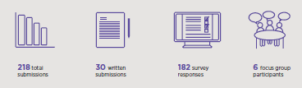
Figure 8: Community engagement on the Draft Affordable Housing Strategy
218 total submissions
30 written submissions
182 survey responses
6 focus group participants

Level of support for draft affordable housing priorities (survey responses):
Priority 1: Advocate for Mandatory Inclusion Zoning – 95% supported
Priority 2: Develop affordable housing on City of Melbourne land – 95% supported
Priority 3: Strengthen City of Melbourne affordable housing processes – 91% supported
Priority 4: Advocate and partner for affordable housing – 92% supported
“The current COVID-19 pandemic is making glaringly obvious the holes in our social safety net....addressing affordable housing has never been more important.” Survey respondent.
“There needs to be greater planning certainty and reduced red tape to encourage the delivery of affordable housing by the private sector.” Real estate group written submission

Top three advocacy areas
(The number of times each area was selected in the top three, from a set of 10).
56% - Build more social housing (Victorian Government)
45% - Change planning mechanisms to increase the supply of affordable housing through private development. E.g. inclusionary zoning. (Victorian Government)
37% - Make more government land available for affordable housing. (Australian Government and Victorian Government)

Strategic Approach
City of Melbourne is committed to working in partnership with the government, development industry and the community housing sector to address the shortfall in affordable housing. This section outlines our five strategic priorities.
“Now I’m very happy to live here, I feel safe. I have freedom, I can do whatever I like. I don’t need to worry about where I have to live, because this is my house.”
Panmile - Hospital food attendant and affordable housing tenant

City of Melbourne’s approach
To address the affordable housing crisis we need more affordable rental housing.
For this to happen, we need to view affordable housing as essential infrastructure for the community. We need all levels of government to support the delivery of new affordable housing by raising and investing more money in this essential infrastructure.
City of Melbourne recognises that there is no silver bullet to achieve this level of systemic change or investment. We also recognise that the responsibility doesn’t rest with any one industry or government body.
A coordinated response is required across governments, the private sector, community housing sector, industry groups and the community. It requires ambition and bold decisions, and an ongoing commitment to housing equity.
Our vision is for a city that offers appropriate, accessible and affordable housing to a diverse community.
Our goal is clear: to increase the supply of appropriate and accessible affordable rental housing in the municipality of Melbourne.
Our Affordable Housing Strategy focuses on what we can do to address this crisis.
- Deliver more affordable housing on City of Melbourne owned land.
- Advocate for systemic change and new and ongoing investment for better affordable housing outcomes.
- Facilitate more affordable housing through the planning system.
- Partner with governments, industry, peak bodies and the community to increase affordable rental housing.
- Respond to the COVID-19 crisis with affordable rental housing.

The scale of opportunity
Collectively, we have the means to make a dramatic change to the delivery of affordable housing both in the municipality of Melbourne and Australia-wide.
Before COVID-19, we had an existing demand for 5500 additional affordable homes in the municipality of Melbourne. This demand was projected to reach 27,100 by 2036, requiring an additional 23,200 affordable homes. COVID-19 has placed additional housing stress on many households and the demand for affordable homes is likely to increase in the immediate to short term.
Victoria’s Big Housing Build will add 12,000 new affordable homes across Victoria. This is the State’s largest ever investment in affordable housing and signals a shift in the way we value this essential infrastructure.
In addition to this vital investment, ongoing commitments are needed across the government and non-government sector to supported the continued growth in the affordable housing supply.
Figure 9 details the potential delivery outcomes of the different priorities and actions of this Strategy over the next 10 years.
There is an opportunity to emerge from the COVID-19 crisis with a stronger and more resilient housing system. This Strategy is intended to contribute to such a change.

Infographic of potential affordable housing outcomes of the actions listed in the Affordable Housing Strategy. These estimates are indicative only and based on pre-COVID-19 expectations of development.
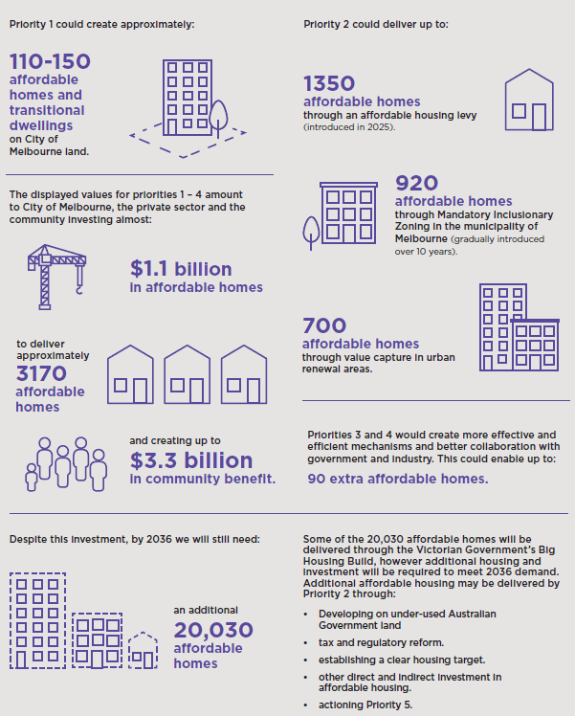
Figure 9: The scale of opportunity for affordable housing (2020–2030 delivery)
Note: The scale of opportunity figures were calculated using pre- COVID-19 data. Adjusted figures are not yet available. Figures presented here should be considered indicative only and subject to change as the impact of COVID-19 becomes realised. Priority 1 was calculated with reference to existing City of Melbourne land holdings and current planning constraints. Priority 2 was calculated with reference to pre-COVID -19 current and forecast development data internal to City of Melbourne, SGS Housing Need Analysis commissioned by City of Melbourne and existing City of Melbourne policy and planning documents.
Priority 3 and 4 calculations apply an efficiency measure with no net impact on total housing outcome and estimates potential lost outcomes that could result from inefficient processes. Priority 5 is calculated using UNSW estimates of national housing need, SQM property data and publicly available industry studies.
Priority1 could create approximately:
- 110-150 affordable homes and transitional dwellings on City of Melbourne land
Priority 2 could deliver upto:
- 1350 affordable homes through an affordable housing levy (introduced in 2025)
- 920 affordable homes through Mandatory Inclusionary Zoning in the municipality of Melbourne (gradually introduced over 10 years)
- 700 affordable homes through value capture in urban renewal areas.
Priorities 3 and 4 would create more effective and efficient mechanisms and better collaboration with government and industry. This could enable up to: 90 extra affordable homes.
The displayed values for priorities 1-4 amount to City of Melbourne, the private sector and the community investing almost:$1.1 billion affordable homes to deliver approximately 3170 affordable homes and creating upto $3.3 billion in community benefit.
Despite this investment, by 2036 we will still need:
- an additional 20,030 affordable homes some of the 20,030 affordable homes will be delivered through the Victorian Government’s Big Housing Build, however additional housing and investment will be required to meet 2036 demand. Additional affordable housing may be delivered by Priority 2 through:
  - Developing on under-used Australian Government land
  - tax and regulatory reform.
  - establishing a clear housing target.
  - other direct and indirect investment in affordable housing.
  - Auctioning Priority 5.

Priority 1: Deliver more affordable rental housing on City of Melbourne-owned land
We will use City of Melbourne-owned land to increase the supply of affordable rental housing. We will trial and showcase alternative and innovative housing models and partner with key stakeholders across sectors to achieve the best possible development outcomes.

What will this priority achieve?
A direct way we can increase the amount of affordablerental housing in the municipality is through the development of affordable housing on our own land.
We recognise that there are many competing interests for City of Melbourne-owned land and that the amount of land we own is relatively small. However, using our land for affordable housing will demonstrate the potential for more widespread use of Victorian Government and Australian Government land to achieve similar outcomes. There are significant Victorian Government land holdings within the municipality of Melbourne that could be leveraged for affordable housing. We will advocate on this issue to other levels of government (see Priority 2).
The three specific actions in this priority demonstrate Council’s leadership role and commitment to increasing the availability of affordable rental housing in the municipality of Melbourne within the next five years. One of the demonstration projects will focus on long-term affordable rental housing . The other project will provide an effective affordable housing model to address the needs of people experiencing homelessness in Melbourne.
This priority also provides an opportunity to trial and showcase alternative and innovative housing models, working in partnership wherever possible.

Leasing government land
Long-term, low-cost leases on government land are preferred over sale of Council land. Leasing means that City of Melbourne retains the benefits of asset ownership and the land is able to continue to deliver community benefit beyond the life of the project.
The use of a lease provides us with greater control over development outcomes.

Development of affordable rental housing on land owned by the City of Melbourne.
1.1 On land that is owned by the City of Melbourne, up to 25 per cent of all future residential development should be affordable housing, with potential to increase this in urban renewal areas where appropriate.
Council’s previous housing strategy made a commitment that up to 15 per cent of housing built on City of Melbourne land would be affordable. This has delivered a small amount affordable housing in the past six years, however given the growing gap in affordable housing availability we believe this target needs to be set at up to 25 per cent. Options that offer this affordable housing to Community Housing Organisations at a discount to market rate will be prioritised. The rate of discount may vary on a site by site basis.
There are other types of development on City of Melbourne land including commercial and community facilities. We commit to considering, as standard practice, the extent to which affordable housing can be incorporated in these developments.
Urban renewal areas present unique opportunities to substantially increase the supply of new affordable housing. This is due to the extent of underused land available in these areas and the opportunity Council has to shape these precincts as they are regenerated. On these sites, consideration will be given to accommodating greater than 25 per cent affordable housing.
There are excellent examples in Melbourne, Sydney, the United Kingdom and elsewhere which demonstrate how affordable housing has been incorporated into the development of community and other public facilities. Well designed and delivered affordable housing incorporated at the development phase of a renewal area helps to create a vibrant, resilient and inclusive community.
In some circumstances, affordable housing projects fail to produce appropriate housing or produce undesirable outcomes. A lease enables contractual enforcement of the use, type and quality of affordable housing. Leasing arrangements are also desirable to some private industry sectors (such as institutional investors) who want to obtain the profits of development and leasing of property without incurring the financial outlay of land acquisition.

Demonstration affordable housing project
1.2 Lease a City of Melbourne-owned site to a community housing provider to deliver a long-term affordable rental housing project in the next five years, seeking funding through Victoria’s Big Housing Build.
As access to land is one of the most significant barriers to the construction of new affordable housing developments, we will lease a Council-owned site for an affordable housing demonstration project in the next five years. We will partner with a community housing provider to deliver the project and seek funding from the Victorian Government through their Big Housing Build initiative.
City of Melbourne is committed to leading by example. Demonstration projects play an important role in showcasing how policies can be implemented and high quality outcomes achieved. Each demonstration project assists in breaking down preconceived notions and expanding boundaries of what can be achieved. They provide confidence to the industry and the community and help to create conditions that support future projects.
The demonstration project will be evaluated on its ability to deliver as much affordable rental housing as possible. We support the inclusion of wrap around services and/or community facilities where appropriate. We will prioritise trialling an innovative model with the potential to be scaled for larger impact.

Supported housing project
1.3 Commit a City of Melbourne-owned site for a supported housing project to address homelessness in the next five years.
In addition to our long-term goal to increase the amount of affordable housing, there is a shared responsibility to deliver supported housing that can transition people with complex needs from homelessness to longer term secure housing. During COVID-19, the mobilisation of hotels as short-term accommodation for people experiencing homelessness provided immediate relief, but an ongoing solution is urgently required.
As part of our commitment to ending homelessness, we will provide a City of Melbourne-owned property for the development of a demonstration supported housing project. The project will illustrate best practice in responding to the needs of people experiencing homelessness. It will incorporate the wrap-around services and care needed to transition people experiencing homelessness into secure, long-term housing.
This priority action provides an opportunity to draw greater community value from City of Melbourne-owned land and to work in partnership to improve outcomes for people experiencing homelessness in Melbourne.

Summary of priority 1 actions:
1.1 On land that is owned by the City of Melbourne, up to 25 per cent of all future residential development should be affordable housing, with potential to increase this in urban renewal areas where appropriate.
1.2 Lease a City of Melbourne-owned site to a community housing provider to deliver a longterm affordable rental housing project in the next five years, seeking funding through Victoria’s Big Housing Build.
1.3. Commit a City of Melbourne-owned site for a supported housing project to address homelessness in the next five years.

Priority 2: Advocate for systemic change and new and ongoing investment for better affordable housing outcomes
We will advocate for fundamental changes to the way affordable housing policy is approached and funded to achieve significantly more housing and better outcomes for everyone.

What does this priority achieve?
City of Melbourne is leading by example by proactively developing affordable housing on our own land, developing a comprehensive affordable housing strategy and reexamining how we can use the planning tools in our control to deliver better affordable housing outcomes.
Now, we are calling on the Victorian and Australian Governments to do the same. By advocating to both levels of government to deliver comprehensive strategies, we believe that the quality and quantity of affordable housing available can be dramatically improved.
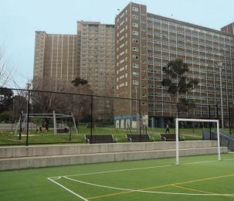
Existing public housing towers in Melbourne

Victorian Government advocacy
2.1 Advocate to the Victorian Government to develop an ambitious 10-year ‘Homes Victoria Strategy’, to support Victoria’s Big Housing Build. This strategy should include clear affordable housing targets and a tangible approach to achieving them.
Homes Victoria Strategy
The Homes Victoria Strategy for social and affordable housing should be developed in consultation with local councils, the industry and community housing sector. We believe the strategy should include a range of new and ambitious policies, including:
- Repositioning affordable housing as essential infrastructure.
- A housing target: provide between 6000 to 10,000 additional dwellings each year for the next ten years.
- A strategic approach to increase ongoing funding for affordable housing, including investigation of an
- Affordable Housing Levy.
- Introduction of statewide Mandatory Inclusionary Zoning across multiple land use types at a rate that can be accommodated in project costs.
- Introduction of a higher affordable housing requirement in all urban renewal precincts when land increases in value due to government intervention, such as rezoning or improved transport infrastructure.
- A commitment to develop underused government owned land for affordable housing.
- The delivery of specialised affordable housing to meet the needs of specific cohorts.
- A commitment to work directly with and resource Aboriginal housing organisations.

Repositioning affordable housing as essential infrastructure.
Our research has demonstrated that there is economic value to investing in affordable housing. However, for decades, successive Australian governments have significantly undervalued and underfunded affordable housing.
Repositioning affordable housing as essential infrastructure is an important step in achieving systemic change. This would see a cultural shift in the way that society and policy makers view affordable housing; meaning that it will be viewed in the same way as other essential infrastructure, such as roads, transport and health care.

A housing target: provide between 6000 to 10,000 additional dwellings each year for the next ten years.
Victoria currently has the lowest proportion of social housing in Australia; only 3.1 per cent of housing is social housing; compared to the national average of 4.5 per cent.
Victoria’s Big Housing Build aims to deliver 12,000 new homes over the next four years, which is a great start. In order for Victoria to meet the national state average for affordable housing, there needs to be ongoing and substantial investment in new housing.
At a minimum, Victoria should build enough new housing to meet the national average. This means, providing an additional 6000 new dwellings each year for the next ten years. A target of 10,000 dwellings per year will bring us closer to meeting the projected demand.
By including a target as part of a Homes for Victorians Strategy Refresh, the Victoria Government will be able to measure and track its performance and have a clear goal to work towards.

A strategic approach to increase ongoing funding for affordable housing, including investigation of an affordable housing levy.
For Victoria to build the new housing that is needed and deliver on affordable housing targets, a lot more funding has to be sourced. Victoria’s Big Housing Build announced a historic amount of funding for new homes. However, to deliver enough housing to meet demand, new funding mechanisms for housing should be considered to introduce a strategic approach that collects funds for affordable housing year-on-year.
We also acknowledge that the solution to the affordable housing crisis doesn’t rest with one industry, government agency or group of people. It is a society-wide crisis that needs a society-wide response.
Following a suggestion from a development industry body, we call on the Victorian Government to investigate an affordable housing levy as a method of collecting significant and ongoing funding. This affordable housing levy could be modelled on the fire services levy, which is applied at a low rate to all businesses and households in Victoria. Housing equity is a society-wide issue and this response acknowledges that we all have a role to play in the solution.
Case study: Victorian Fire Services Property Levy
Following recommendations from the Royal Commission in the 2009 Black Saturday Bush fires, the Victorian government introduced a Fire Services Property Levy.
The levy comprises two parts: a fixed charge and a variable rate, which is based on a property’s classification and capital improved value. There are concessions for pension card holders, and exemptions available.
In the financial year 2018–19 in the municipality of Melbourne, there were 116,393 assessments made.
The levy raised a total of $54.4 million in the municipality and a total of $709 million across the state.
An affordable housing levy
A similar levy for affordable housing could be used to directly fund new builds, or used as an ongoing subsidy for affordable housing.
Using the fire services levy example that raised $709 million, at an average cost of $400,000 per new dwelling; we estimate that the levy could fund around 1700 new dwellings each year.
Alternatively, this levy could be used as an operational subsidy for community housing organisations. After rent has been collected, community housing organisations have to cover a gap of around $20,000 per year per dwelling. An affordable housing levy could potentially subsidise around 35,450 dwellings across the state each year.
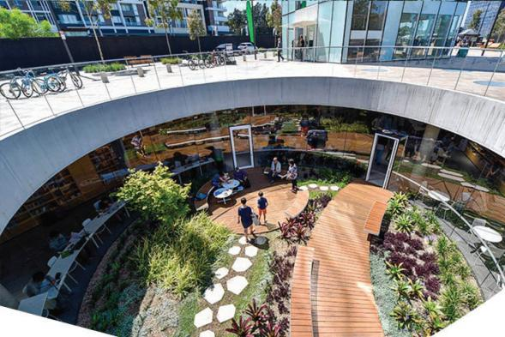
Green Square - Sydney, New South Wales

Inclusive innovation precincts
Over recent decades, Melbourne has built a highly prosperous economy, on the back of investment attraction and its status as a liveable city. Like other global cities, this success has seen rising housing costs and reduced affordability for those on lower incomes.
Melbourne is seeking to further its reputation as an innovative and liveable city with the development of innovation-focused precincts such as Fishermans Bend, Arden, and the Melbourne Innovation District (a collaboration between the University of Melbourne, RMIT and the City of Melbourne).
A study by the Australian Housing and Urban Research Institute in 2020 asserts that “affordable housing implicitly underpins innovation-led employment strategies” (AHURI, 2020, p7). While attracting new businesses, startups and workers contributes to the growth of our economy, care must be taken to ensure these neighbourhoods remain affordable and diverse.
Successful innovation districts require diverse businesses, people and land uses to attract and retain innovative enterprises and talent. A failure to plan for and provide affordable housing can undermine the continued success of an innovation of precinct, as a diverse workforce can no longer afford to live there.
San Francisco is a good example of an innovation precinct which hasn’t prioritised affordable housing and is now an extremely expensive location to live. San Francisco and the Silicon Valley have become synonymous with tech start-ups and innovation. However, housing affordability has also declined significantly since the 1990s. Today it is one of the most expensive cities in the USA to live in, with average monthly rent for a two-bedroom apartment costing US$4690 (AU$7000) (San Francisco Chronicle, 2020). Many professionals – including teachers, police and emergency workers – cannot afford to live in the city they serve and a growing number of families with children are living in housing stress, moving away or experiencing homelessness.
There are more than 8000 people experiencing homelessness in San Francisco. The number of people living in vehicles has jumped by 45 per cent in two years (San Francisco Chronicle, 2020). On an average night there are 1000 people on the waiting list to access one of the typically 30-40 unoccupied shelter beds available. These figures continue to rise despite growing annual funding from the city government to address homelessness – US$360 million in 2019 – and the growing costs borne by charities and not-for-profits to provide for people’s basic needs.
Affordable housing needs to be a bigger part of our innovation precinct and urban renewal planning in Melbourne if we are to avoid the pitfalls of other international innovation precincts.

Introduction of statewide Mandatory Inclusionary Zoning across multiple land use types at a rate that can be accommodated in project costs.
City of Melbourne supports the introduction of state wide Mandatory Inclusionary Zoning (IZ) for affordable housing. This action received strong support in our community engagement process, with 86 per cent of survey respondents supporting this action.
Mandatory IZ is a planning control which triggers an affordable housing contribution upon construction of a new development. The contribution can be made as either a percentage of affordable dwellings provided within the new development or as an equivalent in-kind payment. Our research demonstrated that the cost embeds the cost of providing affordable housing in the cost of the land and provides policy certainty to developers. A state-wide approach also establishes a level playing field for the market.
The introduction of Mandatory IZ should be phased in over a period of time so that the market has adequate time to adjust to the change and at a rate that can be accommodated in project costs. The implementation of Mandatory IZ must be supported by guidance to make decision-making clear and consistent.
As part of the strategy, City of Melbourne commissioned a cost benefit analysis of the Mandatory IZ which balanced costs such as dwelling construction costs, maintenance and operating costs and a reduction in residual land value against the offsetting benefits; including health cost savings, reduced family violence, reduced cost of crime, enhanced human capital, worker retention.
Mandatory IZ is not currently available within the Victorian Planning Provisions, its adoption can only be enabled by the Victorian government.
The City of Melbourne’s position on Mandatory Inclusionary Zoning
- A minimum percentage should be introduced across all of Victoria, with consideration given to mandate higher percentages for urban renewal areas.
- Phased in to allow the property market to adjust and incrementally increased over time.
- Applied to multiple land use types including residential, commercial and some industrial land. Percentages may vary based on land use.
- Calculated as an equivalent percentage of net developable floor area.
- Transferred at minimal cost to a registered housing organisation.
- For dwellings to be designed to be indistinguishable from market housing.

Introduction of a higher affordable housing requirement in all urban renewal precincts when land increases in value due to government intervention, such as rezoning or improved transport infrastructure.
When a site increases in value due to government intervention, such as rezoning or the addition of new transport infrastructure, a portion of the increase in land value may be captured by the government to provide public benefit. Affordable housing is an example of a public benefit.
There have been a series of missed opportunities for the public and government to capture value from large scale planning changes. In Melbourne examples include the rezoning of Fishermans Bend and major planning changes to Southbank and the central city (through planning scheme amendment C270).
To ensure that there is value captured for affordable housing on future sites, we suggest that the government introduce a mandatory affordable housing requirement policy. This can be applied when land increases in value due to direct government intervention, such as a rezoning or the addition of new transport infrastructure. This is similar to an inclusionary zoning tool, but applied specifically to land that experiences a windfall increase in value and set at a higher rate than the state wide inclusionary zoning policy.
Examples of where this could be applied in the future in municipality of Melbourne include the Arden, Dynon and E-Gate precincts.

A commitment to develop underused government-owned land for affordable housing.
City of Melbourne has committed to building affordable housing on our own land. We are calling on the Victorian Government to do the same. We know there is a significant amount of government-owned land that is currently not being used efficiently, and is close to transport, services and employment which makes it well suited to affordable housing.
A 2018 study by the University of Melbourne identified almost 195 hectares of under-utilised government land across greater Melbourne that could be used to deliver more than 30,000 social and affordable homes (Palm, et. al., 2018). It also noted that there were 95 hectares of government land that has already been classified as surplus which could support approximately 2167 homes.
At least 1 per cent of any surplus government land allocated to social housing should be allocated to Aboriginal housing organisations, in line with the Victorian Aboriginal Housing and Homelessness Framework.
We welcome the opportunity to be an active partner in the development or redevelopment of any social or affordable housing in the municipality.

Deliver self determining models of accommodation and care to meet the needs of specific cohorts.
City of Melbourne acknowledges that affordable housing has a crucial role to play in providing people with choice and opportunity. It ensures that cities are diverse, inclusive, sustainable and equitable.
In Victoria, there is a misalignment between the type of social housing we have and the type of social housing we need. Approximately 80 per cent of applicants on the Victorian Housing Register need one or two-bedroom properties, which make up less than 60 per cent of existing public homes. Currently there are more three-bedroom dwellings than any other configuration (VAGO,2017).
The Victorian Government has been seeking to address this issue, in staged redevelopment of housing estates, for example the Atherton Estate in Fitzroy.
We encourage the Victorian Government to consider a mix of housing options that caters for the needs of vulnerable groups. Funding for wrap around services to support needs beyond housing is also critical. Target households should include, but not be limited to:
- people who are older or living with a disability
- people who are impacted by family violence, particularly women and children
- Aboriginal or Torres Strait islander individuals and families
- young people who are leaving foster care or with justice related issues
- single parents with large families.

A commitment to work directly with and resource Aboriginal housing organisations.
Housing equity for Aboriginal Victorians is an important part of reconciliation and self-determination. The Victorian Government has a responsibility to alleviate the disadvantage that many Aboriginal Victorians experience and should work with Aboriginal organisations to realise their housing aspirations.
Organisations, such as Aboriginal Housing Victoria, have established clear targets and pathways towards improved housing security and agency amongst Aboriginal people. This is includes goals to embed Aboriginal housing targets in all relevant mainstream and Aboriginal policies, strategies and programs. It also aims to increase the number of additional social housing units for Aboriginal people by 5000 or more by 2036. We are supportive of these targets and encourage the Victorian Government to incorporate the goals and targets of Aboriginal housing organisations in future housing strategies and budgets.

Review of the Central City Built Form controls
2.2 Advocate to the Victorian Government for a review of Clause 22.03 Floor area uplift and delivery of public benefits in the Melbourne Planning Scheme and ‘How to Calculate Floor Area Uplifts and Public Benefits, Department of Environment, Land, Water and Planning.’
The Central City Built Form controls have not been effective at delivering affordable housing at scale. The intention to provide affordable housing as an uplift is fully supported, but while it competes with options such as commercial office space, it will not be prioritised. Given the need for affordable housing and the availability of commercial space in the central city, the inclusion of commercial space as an uplift incentive is no longer justified. Affordable housing should be prioritised.
Further, the existing floor area ratios are inappropriately high and are delivering compromised built form outcomes. The base FAR needs to be reduced before any uplift incentive can be appropriately applied.
We encourage the Victorian Government to review existing outcomes of the current controls against the aspirations for the central city into the future. We recommend:
- A reduction in the base floor area ratio of 18:1. This should be further reduced if an uplift incentive is available – to ensure high quality built form outcomes can be maintained.
- The removal of commercial space as an acceptable public benefit and greater weighting towards the provision of affordable housing.

Australian Government advocacy
2.3 Advocate to the Australian Government to deliver a long-term National Housing and Homelessness Strategy. This should commit to systemic change in the housing market and increase funding for affordable housing.
National Housing and Homelessness strategy
It is important that efforts to provide affordable housing are coordinated and well informed. The Australian Government has a lead role to play in addressing affordable housing; as a major funder and project partner of state government and the housing sector; and also as the legislator of many of the tax and market settings that influence housing. We call on the Australian Government to deliver a comprehensive National Housing and Homelessness Strategy (National Strategy). This was supported by a number of organisations during the Draft Strategy community engagement.
In a study of four major cities – Melbourne, Vancouver, Toronto and Portland – researchers from the University of Melbourne found that vertical governance that aligned funding and priorities across levels of government was one of the most important aspects of delivering affordable housing (Raynor & Whitzman, 2020).
The creation and release of a National Housing Strategy in Canada has been a game-changing strategy for affordable housing and we are aspiring to a similar outcome in Australia.
A National Strategy should be based on a review and subsequent reforms of the housing market – including the private, social and affordable housing markets. The Strategy should provide long term strategic direction and Australian Government funding for affordable housing.
A National Strategy should include:
- Providing capital and operational funding for CHOs to develop housing and build capacity.
- Substantial ongoing investment to build new public housing and enable different investors to participate in the delivery of affordable housing.
- A review of tax and regulatory structures to address housing inequity.
- Strategic review of Australian Government-owned land to identify underused sites that are appropriate for
affordable housing.
- A commitment to work directly with and resource Aboriginal housing organisations.

Ongoing capital and operational funding for community housing organisations to directly develop and acquire housing and build the sector’s capacity.
Currently the social and affordable housing sector – including state governments and community housing organisations – have limited financial capacity which constrains new development. Greater levels of funding will need to be made available in order to address the significant gap of social and affordable housing in Victoria, and the cost associated with delivering these. Additional funding will be crucial to build the capacity of the sector as a whole.
The Australian Government’s establishment of the National Housing Finance and Investment Corporation (NHFIC) is an important step in providing better financing for community housing organisations. However, for a fundamental shift in the amount of housing being delivered, capital funding is needed. This requires ongoing funding commitment from the Australian Government.

Substantial ongoing investment to build new public housing.
To meet this demand for affordable housing, the Australian Government needs to commit a substantial investment to build new affordable housing. In particular, we call on the Australian Government to increase investment for public housing for the nation’s most vulnerable people.

A review of tax and regulatory structures to address housing inequity and enable different investors to participate in the delivery of affordable housing.
Housing outcomes in Australia are heavily influenced by tax policy settings. It is well documented that tax advantages for housing are inequitably distributed to favour established home-owners and investors (Pawson, et al., 2020). A more equitable direction for housing warrants a holistic review of the tax and regulation policies that influence housing and investment in it. The holistic review should seek to:
- Reduce land and housing speculation and redistribute tax incentives to improve the supply of quality housing for owner-occupiers.
- Increase diversity in the housing market by encouraging a range of public, not-for-profit and other alternative delivery models.
- Consider and evaluate options to encourage institutional investment in affordable housing.

Strategic review of Australian Government-owned land to identify underused sites that are appropriate for affordable housing.
There opportunities to use government-owned land more efficiently. We call on the Australian Government to undertake a strategic review of its own land, and to identify and commit land that is appropriate for the development of affordable housing. Opportunities to develop housing at scale, such as on large government-owned sites, could attract investment from institutions such as superannuation funds.
This proposal has community support. One third of survey respondents selected ‘Make more government land available for affordable housing’ (Australian Government and Victorian Government) as their top advocacy item in the Draft Strategy community engagement.
Additionally, at least 1 per cent of total surplus government land allocated for social housing should be allocated to Aboriginal housing organisations.

A commitment to work directly with and resource Aboriginal housing organisations.
Aboriginal people disproportionately experience homelessness in Australia. The Australian Government has a responsibility to address this inequity and should work with Aboriginal organisations to realise their housing aspirations.
This needs to include the incorporation of housing targets specifically for and owned by Aboriginal people and organisations. The Australian Government should also increase funding for social and affordable housing that meets the cultural needs of Aboriginal people.
Victoria’s Big Housing Build commits to delivering 10 per cent of new dwellings will be targeted to meet the needs of Aboriginal Victorians. We advocate for the National Housing Strategy to make the same commitment at a national level.
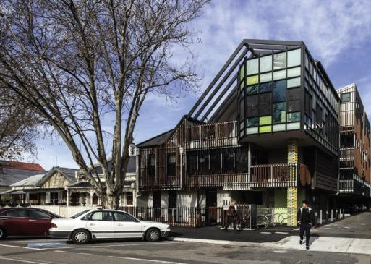
Housing First’s affordable housing in Kymes Place, Port Melbourne

Special agreements
2.4 Advocate for a special agreement on affordable housing for Melbourne, such as a City Deal.
We welcome any opportunity to negotiate a special agreement with the Australian and or Victoria Government on behalf of our city, in order to deliver much needed affordable housing.
Melbourne is Australia’s second biggest city, but Victoria has the lowest portion of social housing units per capita in Australia. A city-specific agreement provides the opportunity to directly address this discrepancy and elevate Melbourne and Victoria’s percentage of social housing up to the national average.
This idea was also proposed by a property industry body during the community engagement process. The agreement could combine funding from the Victorian and Australian Governments, which could be contingent on the delivery of new affordable housing in the city. An example of this kind of agreement is a City Deal, which in the past has been used to deliver other critical infrastructure such as transport in cities around Australia.

The private sector
2.5 Advocate for the private sector to deliver innovative and diverse affordable housing options.
A cooperative and ambitious approach to affordable housing is required across government, private and not-for-profit sectors to increase affordable housing options.
The private sector is an important part of Australia’s housing market and has a key role to play in delivering quality and diverse affordable housing. While private market housing should not displace existing social housing, there are opportunities for government to partner with the private sector to deliver new affordable housing models. The regulation of any affordable housing provided will need to be considered.
Innovative approaches to housing are already part of Melbourne’s housing market. Examples such as Nightingale Housing, the Assembly Model and cooperative housing were frequently cited during the community engagement period and there is clear enthusiasm for these models. While these models do not all qualify as affordable housing, they add much needed diversity to the housing market and there is scope for them to be more affordable in future.
Institutional investors, such as superannuation funds, have the potential to contribute to affordable housing through large scale housing projects. These projects may require additional government support to be feasible for very low to moderate income groups.

Summary of priority 2 actions:
2.1 Advocate to the Victorian Government to develop an ambitious 10-year ‘Homes Victoria Strategy’, to support Victoria’s Big Housing Build. This strategy should include clear affordable housing targets and a tangible approach to achieving them.
2.2 Advocate to the Victorian Government for a review of Clause 22.03 Floor area uplift and delivery of public benefits in the Melbourne Planning Scheme and ‘How to Calculate Floor Area Uplifts and Public Benefits, Department of Environment, Land, Water and Planning.’
2.3 Advocate to the Australian Government to deliver a long-term National Housing and Homelessness Strategy. This should commit to systemic change in the housing market and increase funding for affordable housing.
2.4 Advocate for a special agreement on affordable housing for Melbourne, such as a City Deal.
2.5 Advocate for the private sector to deliver innovative and diverse affordable housing options.

Priority 3: Facilitate more affordable housing through the planning system
We will facilitate the delivery of more affordable housing through the review and strengthening of planning processes, policy and resources.

What does this priority achieve?
An important role of local government is implementing the Planning Scheme. The introduction of Mandatory Inclusionary Zoning remains the most effective means of increasing delivery of affordable housing through the planning system. In the absence of these mandatory controls we are reliant on the existing mechanisms of the planning scheme.
The effectiveness of existing mechanisms to secure affordable housing in the municipality of Melbourne has been limited by a lack of certainty and the voluntary nature of affordable housing contributions.
To improve the delivery of affordable housing, understanding of expectations is needed to ensure developers can deliver the housing stock, community housing organisations are able to manage it and thathousing meets our community’s needs.
There are a number of opportunities to review and strengthen existing mechanisms and process to improve affordable housing outcomes. These improvements relate to:
- how affordable housing contributions are calculated and what the conditions of this contribution will be
- how the provision of affordable housing is incentivised
- how we record and monitor affordable housing outcomes to inform future decisions.

Clarifying our affordable housing planning policy
3.1 Develop a corporate policy on affordable housing as it relates to the development of new dwellings on private and public land.
We will work towards greater consistency across affordable housing mechanisms within our municipality. In the past, Section 173 Agreements have been difficult to negotiate due to unclear expectations about what type of housing is needed, for whom and for how long it will be required.
We also recognise that a number of uplift mechanisms apply across the municipality, with differing calculation approaches and conditions. City of Melbourne is considering the role of uplift incentives and the implications on preferred densities, established floor area ratios and infrastructure planning. Where uplift incentives are considered appropriate, we will seek to clarify and strengthen how they are calculated and how this relates to the cost of providing housing.
The corporate policy will provide a clear understanding of Council’s requirements and require justification to deviate from this position. It will clarify:
- when and where affordable housing is required
- the conditions of uplift incentives as they relate to affordable housing outside of the central city
- the circumstances in which cash-in-lieu of dwelling contributions are acceptable
- the conditions that will be placed on a dwelling transfer, including how long the dwellings are to be retained as affordable housing
It will also clarify how affordable housing contributions are calculated and translated into direct gifting or a discounted sale of equivalent value. This will have a logical relation to the cost of delivering affordable housing.
The development of this corporate policy will involve further engagement with community housing organisations, updates to our website to make information more transparent and accessible, and training where appropriate.

Review of uplift incentives
3.2 Strengthen and clarify City of Melbourne’s position on affordable housing within the Melbourne Planning Scheme.
We will explore options to give greater weight and clarity to our position on affordable housing within the Melbourne Planning Scheme. This may be in part delivered through the planned update to the Municipal Planning Strategy.

Planning process efficiencies
3.3 Partner with the Victorian Government to deliver a priority planning approval process for affordable housing developments.
Victoria’s Big Housing Build is seeking to fast-track planning for social and affordable housing. The City of Melbourne will partner with the Victorian Government to ensure that high standard planning and design outcomes which reflect community needs are upheld by the efficiencies.
Community engagement on the Draft Strategy highlighted an appetite for planning efficiencies to incentivize affordable housing provision.
As part of the COVID-19 recovery response, City of Melbourne is also seeking to review planning processes to increase efficiency. Policy direction will help to make the planning process quicker for projects required to deliver affordable housing. This will provide a clearer understanding of expectations up front, less time negotiating, smoother processes for delivery and monitoring, and reduced time spent deliberating permit applications.

Evaluating the outcomes
3.4 Develop a centralised internal process for recording affordable housing outcomes.
Reviewing the implementation plan against our priority outcomes is critical for the ongoing success of this strategy. We will record the outcomes of affordable housing negotiations, including the amount of housing delivered, conditions of the agreement and dwelling size (including number of bedrooms). This will assist us in assessing the impact of our policy changes to constantly learn and improve as we move forward.

Summary of priority 3 actions:
3.1 Develop a corporate policy on affordable housing as it relates to the development of new dwellings on private and public land.
3.2 Strengthen and clarify City of Melbourne’s position on affordable housing within the Melbourne Planning Scheme.
3.3 Partner with the Victorian Government to deliver a priority planning approval process for affordable housing developments.
3.4 Develop a centralised internal process for recording affordable housing outcomes.
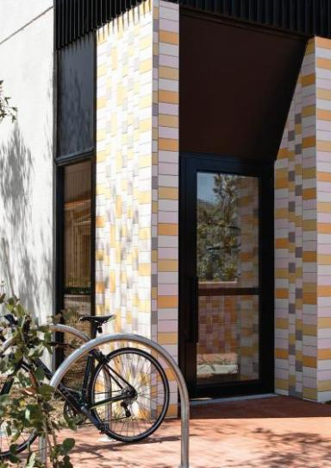
Housing Choices Australia property – Image provided by Housing Choices Australia

Priority 4: Partner with governments, industry, peak bodies and the community to increase affordable rental housing
We will increase the provision of affordable housing by facilitating strategic partnerships and maintaining ongoing dialogue across different industry sectors, including, all levels of government, property developers, community housing organisations and the local community.

What does this priority achieve?
In our role as a capital city we will lead and influence change across government, the community housing sector and development sector. Beyond using our public forums to advocate, we will lead by demonstrating best practice in our own operations.
Other levels of government set policies which impact on the availability of affordable housing in our community. We see many opportunities to enable significant change and increase the supply of affordable housing through advocacy and developing constructive partnerships across the housing industry sector.
This priority provides an outline of the direction and key actions Council will undertake to create conditions and foster connections. We will bring people from different sectors together to collaborate on the delivery of additional affordable housing in inner Melbourne.

Affordable housing contributions
4.1 Partner with the Victorian Government to develop the Social and Affordable Housing Compact, as part of Victoria’s Big Housing Build.
We will work with Homes Victoria to develop a ‘social and affordable housing compact’ – this partnership will include an important role for the City of Melbourne in identifying priorities for our municipality and bringing social housing closer to important infrastructure, such as schools, transport and hospitals.
4.2 Investigate a special purpose entity to manage affordable housing contributions, in partnership with other Councils and the Victoria Government.
How the City of Melbourne manages affordable housing contributions into the future will require further investigation and decisions on:
- who manages or owns the housing
- how we ensure that the housing is retained within the municipality in perpetuity, to ensure the long-term availability of affordable housing
- How funds will be managed and distributed if cash-in-lieu of dwellings is accepted, who will be eligible to receive funds and what type of developments can be funded.
These decisions point to the need for a special purpose entity to manage and distribute housing assets and funds. This entity could take the form of a housing trust, a new community housing organisation or an alternative model. We are not seeking to duplicate existing strengths or capabilities within industry, so the costs, efficiencies and risks of each option will need to be carefully considered prior to Council commitment.
The management of affordable housing contributions is of concern to other local governments and the Victorian Government. We will work together to investigate our options. This may also include investigating ways to share housing contributions across municipal boundaries.

Local government partnerships
4.3 Continue to work with other local governments to establish opportunities for affordable housing development, including the inter-council affordable housing forum.
City of Melbourne has strong and productive relationships with other local governments, community housing organisations and key housing industry stakeholders in the private and not-for-profit sector.
We are committed to continuing to strengthen our work with other local councils to establish opportunities for affordable housing development, share resources and to foster, increased provision of affordable housing projects.

Inter-council affordable housing forum
In 2019, we established the Inter-council affordable housing forum, which has a membership of more than 30 local governments. This has become an effective forum for discussing challenges and sharing learnings.
We will continue to play an active role in this forum.

Land development partnerships
We will identify opportunities to establish formal partnerships with other local governments for the development of affordable housing.
This may include committing to the pooling of resources to investigate innovate housing models or to pilot and build projects. It may also include establishing a local and Victorian Government coalition to assess utilisation of land holdings to accelerate delivery of affordable housing across metro Melbourne.

Cross sector partnerships
4.4 Partner with the development and community housing sectors, peak bodies, governments and the community to deliver more affordable housing.
We recognise how important the development and community housing sectors are to delivering more affordable housing. Partnerships between these sectors, other levels of government and industry bodies are essential to the success of new affordable housing within the municipality of Melbourne.
The community housing sector is committed to providing quality affordable housing for a range of demographics. We will work with community housing organisations to better understand their needs and to involve them in affordable housing processes within Council. We will look for opportunities to actively connect the community housing sector with the development sector and governments.
Alternative and diverse housing models, such as cohousing, cooperative housing and the Nightingale model, were frequently cited in the community engagement for the Draft Affordable Housing Strategy. We value the contribution these models make to housing diversity and affordability and will seek to support opportunities for their establishment within the municipality of Melbourne.

Aboriginal housing partnerships
4.5 Partner with Aboriginal organisations to ensure that appropriate and relevant affordable housing options are available for Aboriginal people in Melbourne.
We are committed to taking a lead role in reconciliation and acknowledge the importance of self-determination in housing. Guided by our Aboriginal Melbourne team, we will continue to develop relationships with Aboriginal organisations to:
- Improve the cultural appropriateness of housing and homelessness services in the municipality of Melbourne.
- Actively include Aboriginal-led housing organisations in conversations and decisions relating to affordable housing contributions.
- Partner with Aboriginal-led housing organisations for opportunities to develop affordable housing for Aboriginal people within the municipality of Melbourne.

Resourcing commitment
4.6 Commit staff and budgetary resourcing to the ongoing delivery of affordable housing.
To successfully deliver more affordable housing in our municipality, we will require new skills and resources within our organisation.
A significant amount of time and skill will be required to assist developers and community housing organisations in negotiating housing agreements. We will provide staff and budgetary resourcing to ensure delivery of affordable housing and provide information, education and resources to develop and maintain internal expertise and support capacity building in the community sector. This will be managed through an internal implementation plan.
Council will commit to creating a single point of contact for delivering affordable housing in line with the Affordable Housing Strategy.
This resource will:
- Broker housing agreements between developers and CHOs and offer a direct point of contact for stakeholders.
- Clarify affordable housing triggers, calculation rates and conditions – through policy and communication channels such as an affordable housing webpage.
- Manage the distribution of housing or cash.
- Providing input to the lease and development of our own land or assets.
- Provide internal support to statutory planners and other areas in the organisation that are part of the affordable housing process.
- Monitor and evaluate affordable housing mechanisms and outcomes.

Summary of priority 4 actions:
4.1 Partner with the Victorian Government to develop the Social and Affordable Housing Compact, as part of Victoria’s Big Housing Build.
4.2 Investigate a special purpose entity to manage affordable housing contributions, in partnership with other Councils and the Victorian Government.
4.3 Continue to work with other local governments to establish opportunities for affordable housing development, including the inter-council affordable housing forum.
4.4 Partner with the development and community housing sectors, peak bodies, governments and the community to deliver more affordable housing.
4.5 Partner with Aboriginal organisations to ensure that appropriate and relevant affordable housing options are available for Aboriginal people in Melbourne.
4.6 Commit staff and budgetary resourcing to the ongoing delivery of affordable housing.

Priority 5: Respond to the COVID-19 crisis with affordable rental housing
We will partner and advocate for affordable housing in the recovery from COVID-19.
The social and economic impacts of COVID-19 are anticipated to be sustained and far reaching. Within all this uncertainty lies an opportunity to increase the social and economic resilience of our community through investment in affordable housing.
Investment in social housing ensures that the outcomes of public investment are maintained in public ownership and continue to be of value in the long term.

Stimulus funding
5.1 Advocate for Australian Government stimulus funding for social and transitional housing in response to COVID-19.
Investing in more affordable and social housing during the recovery period is a wise investment of public money. Social housing delivers a community benefit of $3 for every $1 invested. It is an investment in both essential infrastructure and people that compounds over the long term.
Since the pandemic started, there has been a push for large scale investment in social housing as a stimulus response. This was an important part of Australia’s successful response to the global financial crisis in 2008.
In May 2020 the construction union (CFMEU) and peak building industry lobby group (Master Builders Australia) jointly called for a $10 billion social and affordable housing fund to build 30,000 new dwellings. This call has been echoed by housing advocates including National Shelter, Homelessness Australia and the Community Housing Industry Association.
The Victorian Government has responded to these calls with its $5.3 billion commitment to social and affordable housing under the Victoria’s Big Housing Build program. We encourage the Australian Government to make a similar commitment to housing Victorians.
We welcome any opportunity to negotiate a special agreement with the Australian Government to deliver affordable housing in response to the COVID-19 crisis. At the time of writing (November, 2020), Melbourne has been disproportionately affected by the crisis compared to other cities in Australia. At the same time, Victoria has the lowest percentage of social housing in Australia. The crisis provides an opportunity to address this and strengthen the future resilience of Melbourne.

Victorian government partnership
5.2 Work in partnership with the Victorian Government to support the roll out of Big Housing Build, including identifying opportunities for affordable housing projects within the municipality of Melbourne.
In November 2020 the Victorian Government committed a historic $5.3 billion to construct more than 12,000 new social and affordable homes across Victoria, under the Big Housing Build Program. In addition to the impact this investment will have on thousands of households in need of affordable housing across the State, this is an important economic stimulus response to COVID-19.
We will partner with the Victorian Government to support a timely and efficient roll out of the Big Housing Build. We will work closely with the Victorian government to identify unique opportunities to deliver affordable housing in renewal areas in the municipality, such as Arden.

Vacant property leases
5.3 Advocate for further appropriate vacant properties to be head leased by the Victorian Government to transition people into longterm accommodation within the municipality of Melbourne.
City of Melbourne has experienced an increase in the number of vacant properties following the COVID-19 lockdowns and the current cessation of tourism. At the same time, we still have a large number of people in temporary accommodation awaiting opportunities to transition into permanent affordable housing. While new social housing stock is being built, the Victorian Government can rent or cross-subsidise these properties for use as affordable housing.
There are a number of existing community housing organisations with established not-for-profit property services that the Victorian government could partner with to deliver such an initiative. These include Property Initiatives Real Estate (Women’s Property Initiative) and HomeGround Real Estate (Launch Housing).

Key worker housing
5.4 Partner with the Victorian Government to develop a ‘Key Worker 3000’ initiative to secure affordable rental housing for key workers.
The COVID-19 crisis has highlighted the vital contribution key workers (essential workers) make to our city. We understand that many key workers, such as nurses, hospital attendants and childcare workers, are on moderate incomes, which can make it difficult to rent housing within the municipality of Melbourne. This is of particular concern given the number of hospitals and health facilities in and around our municipality.
We will partner with stakeholders and other levels of government to secure more affordable housing for key workers in our municipality. A Key worker 3000 policy will respond to the crisis and protect the long-term inclusion of key workers in our city into the future.
One way this could work is by the Victorian Government taking out long-term head leases on vacant properties and leasing them to key workers for extended periods. In June, July and August 2020, three times as many properties were vacant as during the same period in 2019. If just half of these additional properties were leased for use as affordable housing in the short-term whilst new housing is built, 2200 new affordable dwellings would be available.

Summary of priority 5 actions:
5.1 Advocate for Australian Government stimulus funding for social and transitional housing in response to COVID-19.
5.2 Work in partnership with the Victorian Government to support the roll out of their ‘Big Housing Build’, including identifying opportunities within the municipality of Melbourne.
5.3 Advocate for vacant property leases to transition people into long-term accommodation.
5.4 Develop a ‘Key worker 3000’ policy to secure affordable rental housing for key workers.
Frontline health workers

Implementation
The Affordable Housing Strategy Implementation Plan outlines how the priority actions will be delivered over the next five years.
A review of the Strategy will occur in 2023 and a report will be provided to council. The implementation plan will also be reviewed and updated at this time.
As outlined throughout this document the implementation of this Strategy will require genuine partnership and advocacy at all levels of government.
The implementation plan includes the indicative costs of each action over five years where L equals projects between $0 and $60,000; M equals projects between $61,000 and $150,000.
Implementation Plan
Action | Role | 2020-21 | 2021-22 | 2022-23 | 2023-24 | 2024-25
Priority 1: Deliver more affordable rental housing on the City of Melbourne owned land
1.1 On land that is owned by City of Melbourne, up to 25 per cent of all future residential development should be affordable housing, with potential to increase this in urban renewal areas where appropriate. | Deliver |  | M | M | M | M
1.2 Lease a City of Melbourne-owned site to a community housing provider to deliver a long-term affordable rental housing project in the next five years, seeking funding through Victoria’s Big Housing Build. | Deliver  Partner | L | L | L | L | L
1.3. Commit a City of Melbourne-owned site for a supported housing project to address homelessness in the next five years. | Deliver  Partner |  | L | L | L
Priority 2: Advocate for systemic change and new and ongoing investment for better affordable housing outcomes
2.1 Advocate to the Victorian Government to develop an ambitious 10-year ‘Homes Victoria Strategy’, to support Victoria’s Big Housing Build. This strategy should include clear affordable housing targets and a tangible approach to achieving them. | Influence | L | L | L | L | L
2.2 Advocate to the Victorian Government for a review of Clause 22.03 Floor area uplift and delivery of public benefits in the Melbourne Planning Scheme and ‘How to Calculate Floor Area Uplifts and Public Benefits, Department of Environment, Land, Water and Planning.’ | Influence | L | L | L | L | L
2.3 Advocate to the Australian Government to deliver a long-term National Housing and Homelessness Strategy. This should commit to systemic change in the housing market and increase funding for affordable housing. | Influence | L | L | L | L | L
2.4 Advocate for a special agreement for Melbourne on Affordable Housing, such as a City Deal. | Influence  Deliver | L | L | L | L | L
2.5 Advocate for the private sector to deliver innovative and diverse affordable housing options. | Influence | L | L | L | L | L
Priority 3: Facilitate more affordable rental housing through the planning system
3.1 Develop a corporate policy on affordable housing as it relates to the development of new dwellings on private and public land. | Deliver | L | L
3.2 Strengthen and clarify City of Melbourne’s position on affordable housing within the Melbourne Planning Scheme. | Deliver |  | L | L
3.3 Partner with the Victorian Government to deliver a priority planning approval process for affordable housing developments. | Deliver |  | L
3.4 Develop a centralised internal process for recording affordable housing outcomes. | Deliver |  | L
Priority 4: Partner with governments, industry, peak bodies and the community to increase affordable rental housing
4.1 Partner with the Victorian Government to develop the Social and Affordable Housing Compact, as part of Victoria’s Big Housing Build. | Partner | L | L | L | L | L
4.2 Investigate a special purpose entity to manage affordable housing contributions, in partnership with other councils and the Victorian Government. | Deliver  Partner | L
4.3 Continue to work with other local governments to establish opportunities for affordable housing development, including the inter-council affordable housing forum. | Partner | L | L | L | L | L
4.4 Partner with the development and community housing sectors, peak bodies, governments and the community to deliver more affordable housing. | Partner |  | L
4.5 Partner with Aboriginal organisations to ensure that appropriate and relevant affordable housing options are available for Aboriginal people in Melbourne. | Partner |  | L | L
4.6 Commit staff and budgetary resourcing to the ongoing delivery of affordable housing. | Deliver |  | M | M | M | M
Priority 5: Respond to the Covid-19 crisis with affordable rental housing
5.1 Advocate for Australian Government stimulus funding for affordable and transitional housing in response to COVID-19 | Influence | L
5.2 Work in partnership with the Victorian Government to support the roll out of Big Housing Build, including identifying opportunities for affordable housing projects within the municipality of Melbourne. | Influence  Deliver | L | L | L | L | L
5.3 Advocate for further appropriate vacant properties to be head leased by the Victorian Government to transition people into long-term accommodation within the municipality of Melbourne. | Influence  Deliver | L | L
5.4 Partner with the Victorian Government to develop a ‘Key Worker 3000’ initiative to secure affordable rental housing for key workers. | Partner  Deliver | L | L

Appendix A – Bibliography
Aboriginal Housing Victoria, 2020, Victorian Aboriginal Housing and Homelessness Framework, Aboriginal Housing Victoria, Melbourne

Australian Bureau of Statistics, 2006, 2011 & 2016, Census Quick Stats: Melbourne City (SA3), Commonwealth of Australia, Canberra

Australian Bureau of Statistics, 2018, Taxation Revenue Australia 2017-18, Commonwealth of Australia, Canberra

AHURI, 2019, Understanding the 30:40 indicator of housing affordability stress, Australian Housing and Urban Research Institute, September 2019 [online]. Available at https://www.ahuri.edu.au/policy/ahuri-briefs/3040-indicator

AHURI, 2020, Glossary, Australian Housing and Urban Research Institute, September 2019 [online]. Available at https://www.ahuri.edu.au/policy/glossary

Australian Productivity Commission, 2019, Report on Government Services 2019 PART G: Housing and
homelessness - State and Territory Government real expenditure on social housing, Commonwealth of Australia, Canberra

Berry, M. 2003, Why is it important to boost the supply of social housing in Australia’. Urban Policy and Research 24(1), 413-435

Community Housing Industry Association, 2018 National Plan for Affordable Housing, Community Housing Industry Association, Melbourne.

Country Fire Authority, 2020, ‘About Black Saturday’, February 2020 [online]. Available at https://www.cfa.vic.
gov.au/about/black-Saturday

City of Melbourne, 2014, Dwelling Stock and Diversity 2006- 2014, City of Melbourne, Melbourne

City of Melbourne, 2015, Homes for People Housing Strategy 2014 - 2018, City of Melbourne, Melbourne

City of Melbourne, 2018, Census of Land Use and Employment, City of Melbourne, Melbourne

City of Melbourne, 2020 - Estimates based on internal data analysis using housing forecasts and development data

City of Sydney, 2019, Green Square affordable housing, City of Sydney, January 2020 [online]. Available at https://www.cityofsydney.nsw.gov.au/affordable-housing-contributions/green-square-affordable-housing-program

City of Vienna - Wienee Wohnen, 2018, Municipal Housing in Vienna. History, facts & figures, January 2020 [online]. Available at https://www.wienerwohnen.at/wienergemeindebau/municipal-housing-in-vienna.html

DELWP, 2019, Victoria in Future 2019: Population Projections 2016 to 2056, State Government of Victoria, Melbourne

DELWP, 2020, Melbourne Planning Scheme, State Government of Victoria, Melbourne

Department of Health and Human Services, 2019, Victorian Housing Register December 2019, State Government of Victoria, Melbourne

Gaetz, S. 2012, The Real Cost of Homelessness: Can we save money by doing the right thing?, Canadian Homelessness Research Network Press, Toronto.

Hanson, S., Richardson, J,. Every, D., Krackowizer, A., Tehan, B., 2016, Climate change, housing and homelessness, RedCross Victoria, Melbourne
Homes Victoria, 2020, Victoria’s Big Housing Build, State Government of Victoria. Available at https://www.vic.gov.au/sites/default/files/2020-11/hv_more_homes_for_more_Victorians_0.pdf

Housing First, 2018, Kyme Place, Port Melbourne, Housing First Ltd, November 2019 [online]. Available at https://housingfirst.org.au/portfolio/developments/104-completed-projects/144-kyme-place

Ministry of Housing, Communities & Local Government, 2018, Households on Local Authority Waiting List, Greater London Authority, December 2019 [online]. Available at https://data.london.gov.uk/dataset/households-localauthority- waiting-list-borough

Palm, M., Raynor, K., Whitzman, C., 2018, Project 30,000: Producing social and affordable housing on government land, University of Melbourne, Melbourne.

Pawson, H, Milligan, V, Yates, J. 2020. Housing Policy in Australia. Palgrave Macmillan.

Planning & Environment Act, 1987, Section 3AA: Meaning of Affordable Housing, State Government of Victoria, Melbourne

PricewaterhouseCoopers, 2020, City of Melbourne Review of Housing Demand Analysis, PricewaterhouseCoopers, Melbourne.

Raynor, K, Palm, M, O’Neil, M and Whitzman, C. 2018. Investigating the costs and benefits of the Melbourne Apartments Project, Transforming Housing, The University of Melbourne, Melbourne.

Raynor, K., & Whitzman, C. 2020. How intersectoral policy networks shape affordable housing outcomes. International Journal of Housing Policy, 1-22. https://www.tandfonline.com/doi/full/10.1080/19491247.2019.1697150

Realestate.com.au, 2019, Suburb profile: Median units rent, REA Group Ltd, Jan 2020 [online]. Available at https://www.realestate.com.au/neighbourhoods

SGS Economics & Planning, 2019, City of Melbourne Housing Needs Analysis, SGS Economics & Planning, Melbourne

Appendix B – Glossary
Affordable housing: “housing, including social housing, that is appropriate for the housing needs of very low, low, and moderate-income households” (Victorian Planning and Environment Act 1987).
Affordable rental housing: rental housing which is affordable (within 30 per cent of income) for households on a very low to moderate income. It includes public housing, community housing and may include some private rental housing.
Inclusionary Zoning: a planning control that requires a percentage of affordable dwellings to be provided within new development.
Housing stress: when people on moderate, low or very low incomes spend more than 30 per cent of their gross household income on rent or mortgage repayments.
Community Housing Organisations: Not-for-profit entities which include registered housing associations and providers. Community housing organisation manage, and may own and develop, affordable housing.

Emergency housing
Rough sleeping: people living on the streets or in parks, sleeping in their car or squatting in derelict buildings for temporary shelter.
Crisis accommodation: short term accommodation, which includes additional support for the resident. It includes women’s refuges, youth refuges and major crisis supported accommodation services.
Provided by: Victorian Government and community housing organisations.
Transitional housing: medium-term accommodation, which often includes support services for residents.
Provided by: Victorian Government and community housing organisations.
Rooming houses: buildings where one or more rooms is available for occupancy by four or more people (in return for the payment of rent). Rooming houses do not offer secure tenancy and residents can be asked to leave with only 24-hours notice. The quality of housing can vary significantly depending on the provider.
Provided by: Private for-profit providers and not-for-profit community housing organisations.

Social housing
Social housing: an umbrella term that includes both public housing (government-owned) and community housing (housing association-owned). This is typically long-term accommodation involving some degree of subsidy. It is for people on very low incomes to moderate incomes.
Public housing: housing owned and managed by the Director of Housing. This is provided to eligible disadvantaged Victorians including those unemployed, on low incomes, with a disability, with a mental illness or at risk of homelessness. Typically households with the highest need for housing assistance are accommodated in public housing. Rents are typically less than 25 per cent of the gross income of very low to low income households.
Provided by: Victorian Government.
Supported housing: long-term accommodation for people with high needs for support/care (people with a disability or older people).
Provided by: Victorian Government and community housing organisations.
Community housing: housing for low income people, including those eligible for public housing. They typically charge up to 75 per cent of market rent for housing and prices are capped at 30 per cent of a household’s income. Community housing organisations are regulated by the Victorian Government.
Provided by: Community housing organisations.

Private market housing
Rental housing: Housing that is available for rent within the private market. It covers a range of housing types.
Property ownership: housing that is privately purchased.
Affordable home ownership: property ownership which is affordable for households on a moderate income or lower. This encompasses alternative models such as housing trusts, shared equity and cooperative housing.
Build-to-rent: housing that is purpose built, retained and managed as long-term rental stock, usually by a single owner. It is not an inherently affordable housing model, but may be designed to offer affordable rents.

How to contact us
Online:
melbourne.vic.gov.au
In person:
Melbourne Town Hall - Administration Building 120 Swanston Street, Melbourne
Business hours, Monday to Friday (Public holidays excluded)
Telephone: 03 9658 9658
Business hours, Monday to Friday (Public holidays excluded)
Fax: 03 9654 4854
In writing:
City of Melbourne GPO Box 1603
Melbourne VIC 3001 Australia
Interpreter services
We cater for people of all backgrounds Please call 03 9280 0726
03 9280 0717 Jiju
03 9280 0719 Bahasa Indonesia
03 9280 0720 Italiano
03 9280 0721 f j
09 280 0722 Soomaali
03 9280 0723 Espanol
03 9280 0725 Viet Ngu
03 9280 0726 All other languages
National Relay Service:
If you are deaf, hearing impaired or speech-impaired, call us via the National Relay Service: Teletypewriter (TTY) users phone 1300 555 727 then ask for 03 9658 9658
9am to 5pm, Monday to Friday (Public holidays excluded)
melbourne.vic.gov.au

