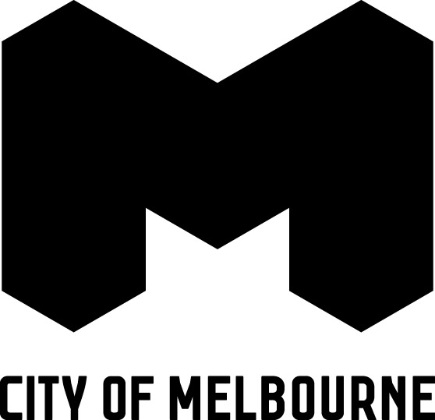
Dear Stakeholder,
The City of Melbourne (CoM) is contacting you as a key stakeholder or as somebody who has provided feedback via Participate Melbourne as part of the community engagement process for the redevelopment of Harbour Esplanade in Docklands.
On 1 December 2014, Places Victoria (PV) lodged the Harbour Esplanade master plan with CoM for a planning permit (ref. TP 2014/1072). CoM has commenced assessment of the master plan and will be preparing a report for CoM’s Future Melbourne Committee in early 2015 (date to be confirmed).
Submissions from the public can be received by Council (either in writing prior to FMC or in person at FMC at Melbourne Town Hall).
CoM will publish the date of the FMC meeting where this master plan will be presented to Council, on its Participate Melbourne website.
Attached is a notification from PV providing an update on the Harbour Esplanade project and outlining elements of the master plan.
For further information refer to:
- PV website for access to the master plan http://www.places.vic.gov.au/news/news-articles/blueprint-for-harbour-esplanade-lodged; and
- PV website for results of the engagement http://www.places.vic.gov.au/precincts-and-development/docklands/building-a-community/harbour-esplanade.
- CoM’s Participate website for FMC meeting date and results of the engagement http://participate.melbourne.vic.gov.au/projects/harbour-esplanade/.
- Visit CoM Planning and Building Branch enquiries counter at Level 3, Council House 2, 240 Little Collins Street Melbourne, where a hardcopy of the master plan can be inspected.
- Contact Rob Moore, Manager Urban Design & Docklands, on 9658 9434 or robert.moore@melbourne.vic.gov.au
Regards
Rob Moore
Manager Urban Design & Docklands

Telephone 03 9658 9434
Facsimile 03 9658 8840
E-mail robert.moore@melbourne.vic.gov.au
Website www.melbourne.vic.gov.au

PLACES VICTORIA HARBOUR ESPLANADE PROJECT UPDATE – DECEMBER 2014

Thank you for taking the time to be part of the conversation about the development of Harbour Esplanade in Docklands earlier this year.
Since July 2014, Places Victoria and the City of Melbourne have worked with multidisciplinary design practice Hassell to refine the Harbour Esplanade Master Plan. Your feedback was presented in workshops and has helped to shape the blueprint for the future development of the Docklands waterfront over the long term.
With your input, we have an ambition for Harbour Esplanade to be a place of increased national significance and one of the great post-industrial waterfronts anywhere in the world.
Harbour Esplanade should be the primary public space in Docklands – a fine boulevard for promenading, providing an opportunity to experience elements of Melbourne’s rich industrial ports heritage and a place to welcome and guide the public through the sub-precincts of Melbourne’s Docklands and central city.
This week, Places Victoria submitted a Planning Permit application to the City of Melbourne, incorporating the Harbour Esplanade Master Plan.
The Harbour Esplanade Master Plan is a blueprint for the future development of a flexible, adaptive and changing event space by the water. It includes an eight-metre wide waterfront promenade spanning the length of Harbour Esplanade and seven key zones:
- An Urban Plaza Zone at the southern end of Harbour Esplanade including a green area and improved east-west connections and crossings for pedestrians.
- An Exhibition and Events Zone, with flexible spaces that can be activated for events and exhibitions. This area will include some buildings and the potential for restored heritage sheds or elements of heritage sheds.
- A Water Transport Zone, making provision for a future ferry terminal.
- A Central Entrance and Service Zone, providing a key entry point to Central Pier and a flexible area for transport services during events.
- A Recreation Zone at the northern end of Harbour Esplanade featuring a water play space for families, a green area and improved east-west connections and crossings for pedestrians. This area will also include some buildings and the potential for restored heritage sheds or elements of heritage sheds, however views from LaTrobe Street to the harbour will be protected.
- A Heritage Vessel Zone, making provision for heritage vessels to be moored in the harbour.
- An Active Street Edge Zone which will see the improvement of the eastern street edge in front of Etihad Stadium.
Feedback gathered during the community engagement process in May / June 2014 reinforced the importance of embracing the water and providing flexible public spaces that can be activated during the day and at night.
The master plan respects the community’s desire for passive, open spaces through the incorporation of green areas along Harbour Esplanade. A redeveloped Harbour Esplanade will include buildings to bring new attractors and activity to the harbour’s edge and may also include restored heritage sheds or elements of heritage sheds. Places Victoria and the City of Melbourne will encourage buildings that integrate public space and make a positive contribution to the street and waterfront through design and innovation.
While Central Pier is an important part of the Docklands waterfront and will ultimately contribute to bringing the area to life, it is not included within the Harbour Esplanade Master Plan. Places Victoria will progress ideas to develop Central Pier in 2015.
We encourage you to visit www.places.vic.gov.au/precincts-and-development/docklands/building-a-community for up to date information about Harbour Esplanade and other Docklands projects.

