

Last Kilometre Freight

Pre-draft community consultation

October 2015

A Connected City

We manage movement in and around our growing city to help people trade, meet, participate and move about safely and easily, enabling our community to access all the services and opportunities the municipality offers.

Contents
Contents 1
Introduction 3
Innovate Freight 5
Participate survey and forum 7
Participate survey 7
Participate forum 7
Social media, meetings and publications 9
Social media 9
Meetings 9
Publication features 9
City of Melbourne publications 9
On-street handouts 11
In-store engagement 11
In-store engagement routes 14
1. Lonsdale Street route 16
2. Collins Street route 16
3. Flinders Street route 17
4. Little Bourke Street route 17
5. A’Beckett Street route 18
Breakfast workshop 19
Submission analysis 21
Comment themes 24
Figure structure 25
Building and street design 25
Alternative and new practices 26
Stakeholders and communication 27
Street management 28
Next steps 29

Issue 2 – Pre-draft Community Engagement, updated for community consultation October 2015
Disclaimer
This report is provided for information and it does not purport to be complete. While care has been taken to ensure the content in the report is accurate, we cannot guarantee is without flaw of any kind. There may be errors and omissions or it may not be wholly appropriate for your particular purposes. In addition, the publication is a snapshot in time based on historic information which is liable to change. The City of Melbourne accepts no responsibility and disclaims all liability for any error, loss or other consequence which may arise from you relying on any information contained in this report.

Introduction
The City of Melbourne is drafting a Last Kilometre Freight Plan to address how freight will be managed in a rapidly growing and changing central city to ensure the things people need and want are delivered into our shops, businesses, homes and workplaces.

To assist the plan’s development, the City of Melbourne engaged the community from 2 March to 31 March 2015.
The consultation was focussed on the issues and opportunities associated with last kilometre freight in the central city.
Three reports were prepared to inform the consultation:
- Background Report
- Issues and Opportunities Report
- Case Studies Report.
The Background Report provided an overview of city growth and development, existing policy and City of Melbourne procedures.
The Issues and Opportunities Report presented our role, the project’s aims and objectives, issues and opportunities identified in an earlier community forum ‘Getting it to your door’ (June 2014) and informal stakeholder engagement.
The Case Studies Report highlighted local and international examples of innovations in last kilometre freight.
Throughout our March engagement the community was encouraged to provide feedback. A number of consultation activities were undertaken to ensure we were engaging with our diverse range of stakeholders. These activities included:
- Participate Melbourne ‘Innovate Freight’ website
- breakfast workshop
- resident and precinct group meetings
- social media.
This was supported by targeted flyer delivery, direct emails and promotion via industry newsletters and publications.
This report details the engagement activities of the pre-draft consultation.

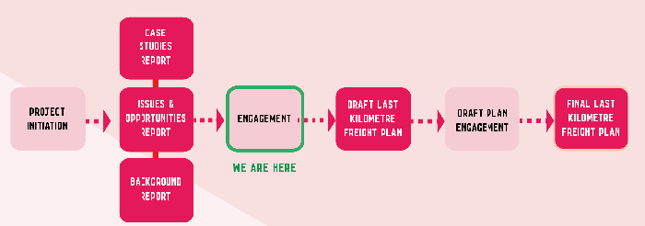
Figure 1: Project timeline.
The project timeline shows six stages in the project process, being (in order): project initiation; case studies report, issues and opportunities report and background report; engagement; draft Last Kilometre Freight Plan; Draft Plan engagement; final Last Kilometre Freight Plan. The engagement stage is highlighted as the current stage of this project.
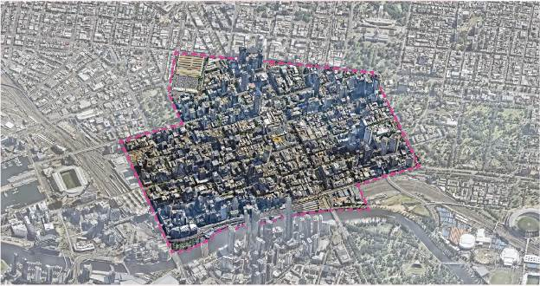
Figure 2: Central city study area
This map highlights the central city study area which is defined by borders along: Spencer Street from the Yarra River to La Trobe Street, La Trobe Street from Spencer Street to William Street, William Street from La Trobe Street to Victoria Street, Victoria Street from William Street to Spring Street, Spring Street from Victoria Street to Flinders Street, Flinders Street from Spring Street to Russell Street, the southern end of Russell Street to the Yarra River and the northern Bank of the Yarra River from Federation Square to Spencer Street.
Participate Melbourne

Innovate Freight
Participate Melbourne is the City of Melbourne’s online engagement platform.
The ‘Innovate Freight’ page was a cornerstone of the pre-draft engagement process, ensuring all information on the project was accessible through the site. This included links to the background, issues and opportunities, case studies reports, a link to Frequently Asked Questions and a link to the breakfast workshop sign up page.
Feedback was encouraged through a survey and forum. An overview of local and international last kilometre freight practices was used to inspire discussion.
Social media posts, features on the project in newsletters, magazines and newspapers, on-street engagement and in-person engagement, such as the Breakfast Workshop, all encouraged and referred people to the ‘Innovate Freight’ page. A total of 2,465 page visits were recorded throughout the March 2015 engagement.
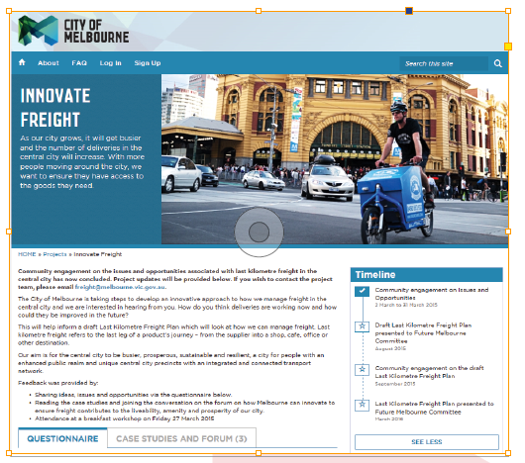
Figure 3: Participate Melbourne ‘Innovate Freight’ home page
Figure 4: Participate Melbourne ‘Innovate Freight’ page statistics
Indicator | Number
Page Visits  Overall Page visits for the duration of the project engagement | 2465
Unique page visits  Number of distinct users visits for the duration of the project engagement | 2203
Informed visits  Number of unique participants that have visited a specific piece of information (i.e. viewing a photo, clicking a link, visiting key dates, viewing a forum question) | 356
Engaged visits  Number of participants that have made a contribution on the page (i.e. making a comment on the forum, filling out a survey) | 48 survey responses  3 forum responses

Participate survey and forum

Participate survey
The issues and opportunities survey was live on ‘Innovate Freight’ throughout the March 2015 engagement.
All project communication encouraged our community to engage through the Participate Melbourne website. This included our face-to-face distribution of flyers promoting the project to delivery drives and businesses throughout the central city.
The survey included the following questions:
- Do you have an issue with freight in the central city?
- Are you aware of some freight ideas and initiatives happening in our city?
- Do you have an idea for an opportunity or innovation to improve the way freight is delivered in the central city?
To assist our analysis of the survey, respondents were also asked to identify whether they were a resident, receiver of freight, delivery driver, etc. and which city precinct they were located in.
A total of 48 survey questionnaires were completed with an additional survey submitted by email in April 2015.

Participate forum
The Participate forum received three submissions in March, each of which could be given a ‘thumbs up’ or ‘thumbs down’ by other site visitors. The submissions were in response to the question ‘What do you think will help us plan for deliveries in a busier city in the future?’. An overview of international and local case studies were used to prompt the forum discussion.
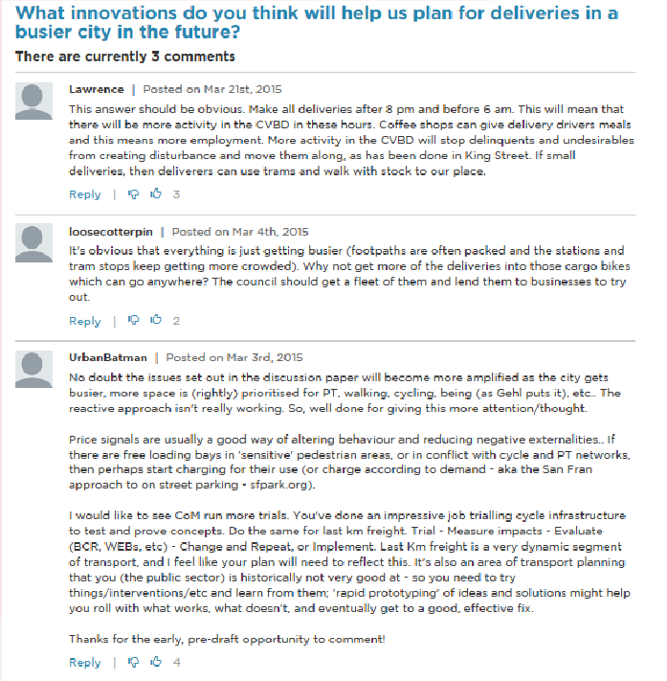
Figure 5: Participate Melbourne forum, at 1 April 2015

Social media, meetings and publications

Social media
Facebook, Twitter and LinkedIn were used to promote the project to a broad audience and to encourage feedback through Participate Melbourne.
Comments received through Facebook posts have been included in the consultation submissions, with the exception of posts tagging other people or using emoticons only.

Meetings
Meetings with stakeholders were held prior to and throughout our March consultation.
Notes from meetings with the Collins Street Precinct Executive and the Eastenders / Residents 3000 Residents Group have been included in the comments for analysis.

Publication features
The Last Kilometre Freight project was featured in the following industry publications:
- the Planning Institute of Australia (Victoria Division) Magazine - 3 April 2015
- an article published on the Bicycle Network website title ‘Logistics by bike’ - 26 March 2015
- the Australian Retailers Association online newsletter - 16 March 2015
- the CBD News - April 2015, Issue 8
- an article published on the ABC media website titled ‘ Melbourne’s bicycle messengers reflect golden age before competing in world championships’ - 26 March 2015.

City of Melbourne publications
The Project was communicated through the following City of Melbourne communication channels:
- City of Melbourne website
- Table Talk (Autumn 2015)
- Enterprise Melbourne website
- Enterprise Melbourne e-newsletter
- On-hold messages.
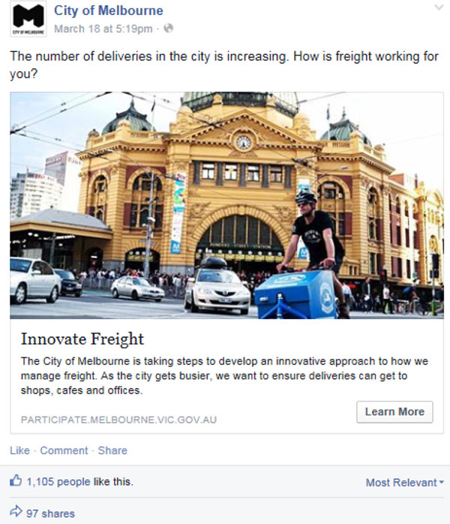
Figure 6: Example of a Facebook post
On-street and in-store engagement
City of Melbourne officer’s walked the streets of the central city communicating with freight drivers and business workers. The purpose of this targeted exercise was to inform our key stakeholders of the project. We wanted to encourage them to find out more about the project and to provide their feedback online through the Participate Melbourne website. Through the online survey and forum stakeholders could share their experiences with, and suggestions for, last kilometre freight in the central city. Our on-street engagement focussed on driving on-line participation. We recognise that stakeholders do not always have time for lengthy discussions or surveys so we wanted to bring to let them know they could engage online at a time convenient to them.

On-street handouts
Participate Melbourne postcards with information on the ‘Innovate Freight’ page were distributed to freight delivery stakeholders on Thursday 12 March 2015 and Monday 16 March 2015. Thirty-two postcards were handed out.
Approximately five additional postcards were handed out to freight drivers during the in-store engagement sessions.
The on-street distribution of the Participate Melbourne postcards is illustrated in Figure 7.

In-store engagement
Visits to 89 stores occurred over two days in March 2015. Each store was given a Participate Melbourne postcard with information on ‘Innovate Freight’ attached and staff were encouraged to engage further online.
The in-store engagement routes were determined after analysing the pedestrian street hierarchy (Walking Plan, 2014), refer Figure 11.
Further details of the in-store engagement and the routes taken are described on the following pages.
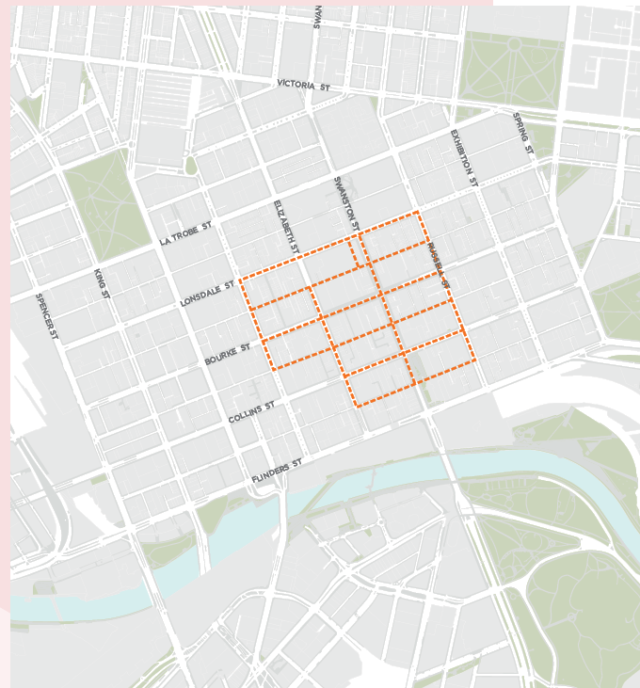
Figure 7: Distribution of Participate Melbourne postcards to freight delivery drivers and stakeholders
This map is of the area covered by the on-street engagement with freight drivers. This included the east-west streets of: Russell, Swanston and Elizabeth streets between Lonsdale Street and Flinders Lane; Queen Street between Lonsdale Street and Little Collins Street; and the north-south streets of Russell, Swanston and Elizabeth streets between Lonsdale Street and Flinders Lane and Queen Street between Lonsdale and Little Collins Street.
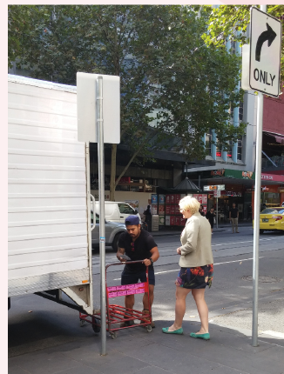
Figure 8: On-street engagement
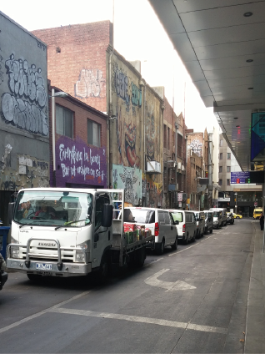
Figure 9: On-street engagement – Caledonian Lane

In-store engagement routes
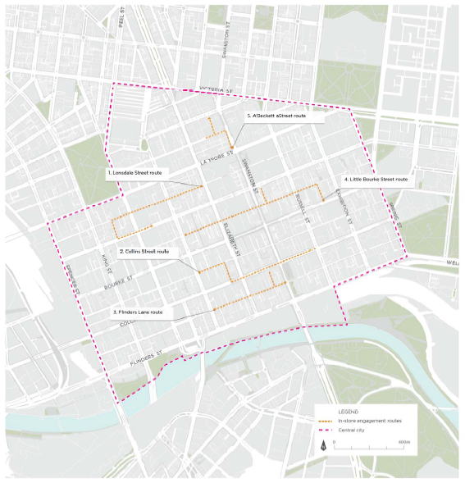
Figure 10: Map of in-store engagement routes
This map shows the in-store engagement routes used by City of Melbourne officers. There are five individual routes. Route 1 is the Lonsdale Street Route. It starts at the intersection of Elizabeth Street and Little Lonsdale Street, running west along Little Lonsdale then turning south at Healeys Lane before turning east along Lonsdale Street and ending just after the intersection with William Street. Route 2 is labelled the Collins Street Route. This route starts at the intersection of Little Collins and Queen Streets and runs east up Little Collins Street before turning south at before turning east again at Equitable Place and continuing up Collins Street until the intersection with Russell Street. Route 3 is the Flinders lane Route; it runs east up Flinders Lane from the corner of Queen Street to Swanston Street, with a detour down Manchester Lane. Route 4 is the Little Bourke Street Route; it being at the intersection of Bourke Street and Market Lane, running north up Market Lane to Little Bourke Street and extending down Little Bourke Street to the intersection with Queen Street. There is a detour down Tattersalls Lane. Route 5 is the A’Beckett Street Route; it starts on the corner of Swanston and La Trobe Streets and runs north before turning west down A’Beckett Street and north again on Stuart Street.

1. Lonsdale Street route
Little Lonsdale Street – Healeys Lane – Lonsdale Street
Key characteristics:
This one way section of Little Lonsdale Street accommodates parking on both sides of the road and a single lane of traffic. The footpaths on either side of the road are very narrow.
There are a number of cafe and restaurants on the first half of the street between Elizabeth and Queen Streets, interspersed with office and business entries. There are also two new residential towers at this end of the street. The rest of the route is predominately office towers until you reach Healeys Lane, where there are a number of cafes and shop fronts.
Businesses visited:
- 1 dry cleaner
- 9 restaurants/cafes
- 1 florist
- 1 tailor
- 1 motorbike store
- 2 hairdressers

2. Collins Street route
Little Collins Street – Equitable Place – Collins Street
Key characteristics:
There is a concentration of small stores and cafes along the selected length of Little Collins Street. Collins Street has fewer cafes, but a larger number of banks and offices. The stretch of Collins Street between Elizabeth and Russell streets is a key retail destination for the city.
Equitable Place also has a high concentration of cafes to service the surrounding offices.
Businesses visited:
- 1 book store
- 5 restaurants/cafes
- 1 chocolate store
- 6 fashion stores
- 1 homeware store
- 1 print store
- 2 shoe stores
- 1 speciality retail store

3. Flinders Street route
Flinders Lane – Manchester Lane - Flinders Lane
Key characteristics:
Between Swanston and Elizabeth streets, Flinders Lane has a high concentration of cafes and small shops. Coupled with its links to Degraves Street and Centre Way, this makes it a very popular destination for tourists, city visitors and office workers.
The area of Flinders Lane between Elizabeth and Queen streets has markedly fewer cafes and stores, however there are still some present. This section of the lane has a single traffic lane and on-street parking on one side, along with offices, hotels and an entrance to the Victoria University city campus.
Manchester Lane is evenly paved with no designated footpaths. The lane houses a small collection of shops including a bar, hairdressers, restaurants and clothing stores.
Businesses visited:
- 1 bakery
- 1 bar
- 11 restaurants/cafes
- 6 fashion stores

4. Little Bourke Street route
Market Lane – Little Bourke Street – Tattersalls – Little Bourke Street
Key characteristics:
Market Lane hosts a small collection of restaurants and bars. This lane has a very narrow footpath resulting in the road space being used by both pedestrians and vehicles.
This stretch of Little Bourke Street is part of the Chinatown Precinct and is densely populated with restaurants, bars and small stores. Compared to the rest of the central city, the building heights along this part of Little Bourke Street are low and there are fewer large office buildings. The street supports a heavy flow of pedestrians and the Walking Plan (CoM, 2014) seeks to investigate its suitability as a Walking Street in the pedestrian street hierarchy.
Businesses visited:
- 1 bakery
- 1 bar
- 1 bottle shop
- 1 Chinese medicine centre
- 1 convenience store
- 2 gift stores
- 3 homeware stores
- 1 hotel
- 2 outdoor stores
- 1 phone store
- 6 restaurants/cafes

5. A’Beckett Street route
Swanston Street – A’Beckett Street – Stuart Street
Key characteristics:
This section of the central city has close ties to RMIT University which has buildings scattered around this route. There is a fast food store on the north western corner of Swanston and La Trobe street and a couple of convenience stores and cafes on the western side of this section of Swanston Street.
There is a new RMIT building on the northern side of A’Beckett Street and a newly constructed building on the southern side. Both of these new developments feature retail spaces at the ground level. There is also a temporary basketball court and barbecue space next to the new RMIT building which has proven very popular amongst students and local residents.
Businesses visited:
- 1 food store
- 5 restaurants/cafes
- 1 pharmacy

Breakfast workshop
A breakfast workshop was held on Friday 27 March from 7 am to 9:30 am at the Melbourne Town Hall.
More than 80 people attended the workshop which brought together a range of freight stakeholders including industry, receivers, residents and state government agencies.
The workshop was designed to gain a greater understanding of the community’s issues and identify opportunities for central city deliveries. The workshop also communicated the transformation of the central city, including rapid population growth and major transport infrastructure investment, and how this will change the way last kilometre freight is managed.
The Breakfast Workshop was in two parts; a presentation and question and answer session, and a brainstorming session.
The presentations and question and answer session allowed participants to hear from local and international expert’s with presentations by:
- David Mayes - Manager Strategic Planning, City of Melbourne.
- Rose McArthur - Technical Director, Integrated Transport Division, Mott MacDonald.
- David Sanders and Scott Hancock - Group Managing Director and Director of Technology, Bestrane.
The second workshop session was focussed on receiving feedback and involved a roaming brainstorming session where attendees identified what is working well, ideas, issues and aspirations for central city deliveries. These were recorded on post-it notes which were then posted to corresponding poster boards. Each poster covered a last kilometre freight topic. The topics were:
- Businesses working together
- Timing and spreading the load
- Project infrastructure
- Buildings and street design
- Vehicle types
- Street access
The workshop allowed attendees to ask questions and explain their key challenges, needs and ideas to the City of Melbourne - feedback which will be considered as we draft the Last Kilometre Freight Plan.
A full workshop report is available on the Participate Melbourne “Innovate Freight’ web page.

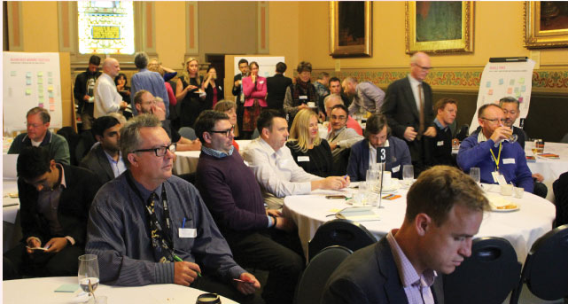
Figure 11: Breakfast Workshop, 27 March 2015

Submission analysis
A total of 60 submissions were received during the March 2015 consultation. These submissions were then separated into individual comments, of which there were 500. On Facebook each post and all of its succeeding comments were classified as one submission.
‘Submission methods (comments)’ (Figure 12) at right details a breakdown by source of the comments received.
Of the 500 comments analysed, 48 were deemed to be not relevant to the last kilometre freight project (Figure 13 ‘comment relevance’). All of these comments, bar one, were made through comments on Facebook. These comments ranged from a love of Melbourne and a sense of pride in the city, to comments about the organisation and Melbourne’s public transport. These comments were considered to be removed from the topic we were consulting on and therefore will not directly inform the development of the Last Kilometre Freight Plan.
A further 32 comments were considered to be outside the scope of the last kilometre freight project. Many of these were comments raised on social media and related to the building of the East West Link. This was very topical at the time of the consultation, with contract discussions taking place. While a connection between the movement of freight and the East West Link was established, this has been deemed not relevant for the development of a Last Kilometre Freight Plan. Further comments were also raised in relation to freight movements or infrastructure investment outside of the central city which is considered outside of scope. Other comments relating to waste programs, freight, service and behaviour of drivers were also considered out of scope.
Comments were also classified by type, according to whether they offered a suggestion, raised an issue, asked a question, praised or supported a project or initiative, or were neutral. This is displayed in ‘comment type’ (Figure 14).

Figure 12: Submissions method
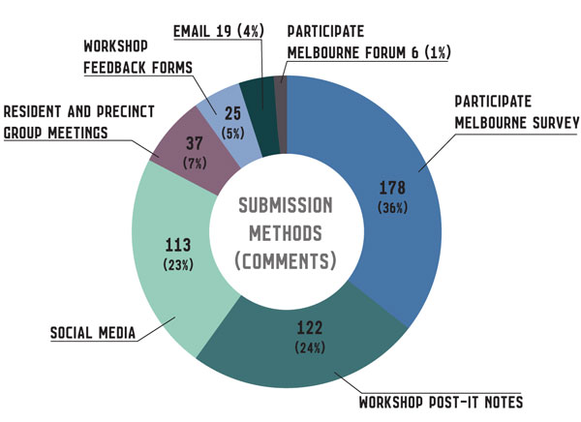
This graph shows the number and percentage of comments received via various submission methods. They are as follows: Participate Melbourne survey 178 (36 per cent), workshop post-it notes 122 (24 per cent), social media 113 (23 per cent), resident and precinct group 37 (7 per cent), workshop feedback forms 25 (5 per cent), email 19 (4 per cent) and Participate Melbourne forum 6 (1 per cent).
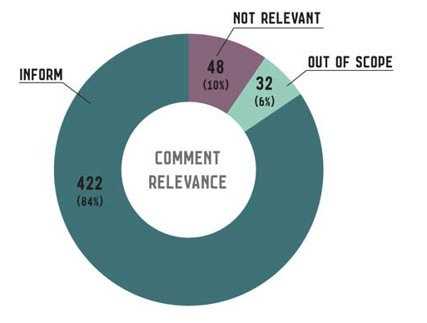
Figure 13: Comment relevance
This graph shows how the comments were classified according to relevance: 422 inform (84 per cent), 48 not relevant (10 per cent), 32 out of scope (6 per cent).
Figure 14: Comment type
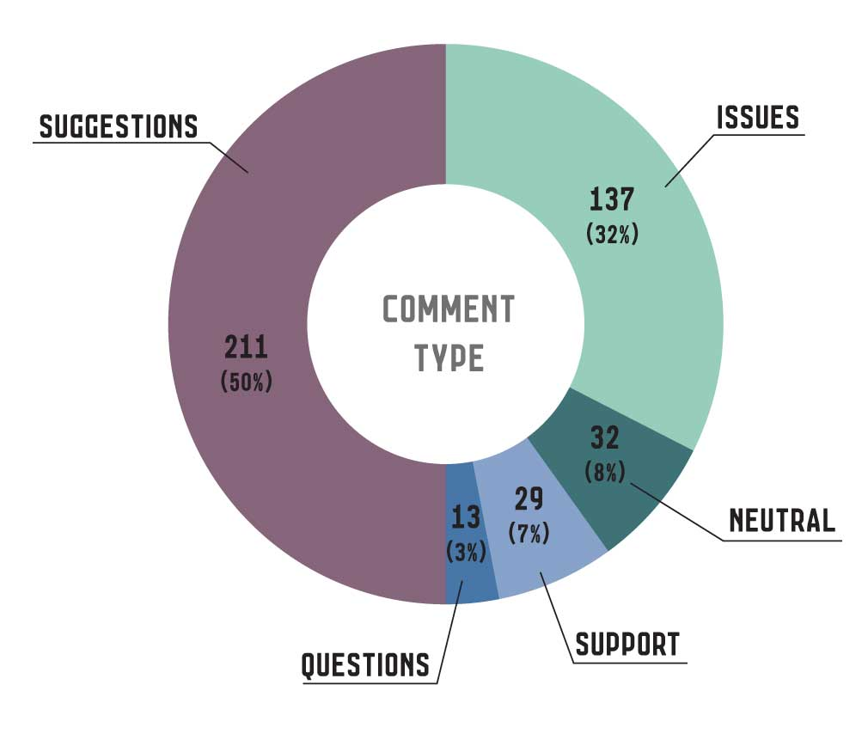
This graph displays the spread of comment types; 211 suggestions (50 per cent), 127 issues (32 per cent), 32 neutral comments (8 per cent), 29 support (7 per cent), 13 questions (3 per cent).

Comment themes
Comments have been classified based on primary and secondary themes. Primary themes refer to the key message of the comment, and secondary themes were used to capture additional information and connections.
For example, the comment ‘trucks are big, noisy and dangerous. They drive too fast and scare pedestrians and people on bikes’ was classified under ‘vehicle size’ for the first theme and ‘safety’ for the second theme.
Themes were then grouped and attributed to overarching themes:
- building and street design;
- stakeholder and communication;
- street management; and
- alternative and new practices.
We found there was a strong appetite for ‘alternative and new practices’ and ‘street management’ (Figure 15).
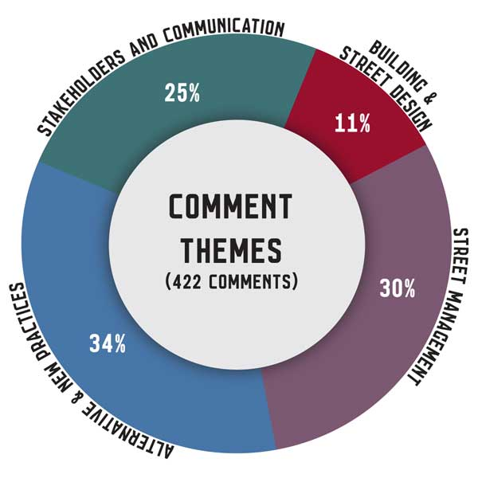
A further breakdown of each overarching theme and its primary and secondary themes is included in the subsequent pages.
Figure 15: Comment themes
This graph displays how the 422 comments have been classified into different themes: 34 per cent alternative and new practices, 25 per cent stakeholders and communication, 11 per cent building and street design, 30 per cent street management.

Figure structure
In Figure 16 below, primary themes are written around the circle, with the overarching theme displayed in the centre. The secondary themes are written alongside, with arrows pointing to the primary theme to which they apply. The bolded secondary themes are those that were mentioned more than once for the relevant primary theme comments.

Building and street design
‘Building and street design’ was the smallest of the overarching themes, representing 11 per cent (47 comments) of relevant comments. Of the primary themes in this group, ‘building and street design’ was the strongest with comment such as “mandatory parcel lockers for CBD buildings” and “encourage/support innovation for quiet delivery docks”.
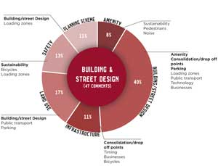
“Use ground floor of big city car parks for service vehicles; mini freight hubs”. – Workshop poster, suggestion, Building and street design (primary), Consolidation and drop off points (secondary)

Figure 16: Building and street design
This graph gives a breakdown of the Building and street design primary themes (47 comments) by percentage and lists the secondary themes that relate to each primary theme. These are as follows: 40 per cent Building and Street Design, secondary themes are amenity, consolidation/drop off points, parking, loading zones, public transport, technology, businesses.11 per cent Infrastructure, secondary themes are consolidation/drop off points, timing, businesses, bicycles. 17 per cent Land use, secondary themes are building/street design, public transport, parking. 13 per cent Safety, secondary themes are; sustainability, bicycles, loading zones. 11 Planning scheme, secondary themes are building/street design, loading zones. 8 per cent Amenity, secondary themes are sustainability, pedestrians, noise.

Alternative and new practices
The largest overarching theme was ‘alternative and new practices’, with 145 comments (34 per cent of all comments received) There was an even number of comments relating to ‘timing changes’ (mostly out-of-hours deliveries), ‘alternative vehicles’, ‘bike deliveries’ and ‘consolidation and drop off points’. ‘Public transport’ for freight deliveries was also a theme identified in the consultation. ‘Bike deliveries’ were often tied to the secondary theme of ‘consolidation and drop off points’ - acknowledging the need for supportive bicycle freight infrastructure.
“A freight hub on the edge of the city and freight is taken into the city on cargo bikes would be great!” – Participate survey, suggestion, bike delivery (primary), consolidation and drop off points (secondary).
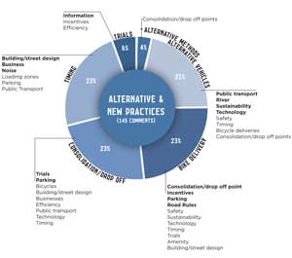
Figure 17: Alternative and new practices
This graph gives a breakdown of the alternative and new practices primary themes (145 comments) by percentage and lists the secondary themes that relate to each primary theme. These are as follows: 21 per cent alternative vehicles, secondary themes are public transport, river, sustainability, technology, safety, timing, bicycle deliveries, consolidation/drop off points. 23 per cent bike delivery, secondary themes are consolidation/drop off points, incentives, parking, road rules, safety, sustainability, technology, timing, trials, amenity, building/street design. 23 per cent consolidation/drop off, secondary themes are trials, parking, bicycles, building/street design, businesses, efficiency, public transport, technology, timing. 23 per cent timing, secondary themes are building/street design, business, noise, loading zones, parking, public transport. 6 per cent trials, secondary themes are information, incentives, trials. 4 per cent alternative methods, secondary theme is consolidation/drop off points.

Stakeholders and communication
‘Stakeholders and communication’ represented 25 per cent of engagement comments (a total of 104 comments). These comments relate to sharing information, better communication and recommendations to improve the freight planning process.
‘Freight plan/projects/process’ was the dominant primary theme (44 per cent). This theme focused on how we approach freight as a city and how we should set priorities, identify opportunities and manage competing demands.
For the primary theme of ‘technology’, ‘communication’ and ‘information’ were consistent secondary themes. These comments reflect an interest in using technology, such as apps, to improve the communication and information sharing process amongst freight receivers and carriers.
“Think of planning for the City of Melbourne as a permanent event”. – Workshop poster, suggestion, freight plan/project/process (primary)
Figure 18: Stakeholders and communication
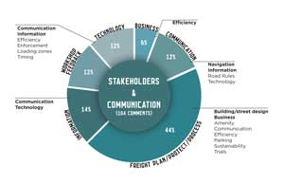
This graph gives a breakdown of the stakeholder and communication primary themes (104 comments) by percentage and lists the secondary themes that relate to each primary theme. These are as follows: 44 per cent freight plan/project/process, secondary themes are building/street design, business, amenity, communication, efficiency, parking, sustainability, trials. 14 per cent Information, secondary themes are communication, technology. 12 per cent workshop feedback, no secondary themes. 12 per cent technology, secondary themes are communication, information, efficiency, enforcement, loading zones, timing. 6 per cent business, secondary themes is efficiency. 12 per cent communication, secondary themes are navigation, information, road rules, technology.

Street management
‘Street management’ received 30 per cent of engagement comments (126 comments) with ‘parking’ the strongest primary theme. The need for more loading bays was echoed in many of the submission comments.
‘Road management’ and ‘congestion’ were equally weighted secondary themes at 27 per cent each. ‘Road management’ comments centred on restricting vehicle access to the central city (alternating between private vehicle and heavy vehicle restrictions).
‘Congestion’ comments mostly related to issues with vehicle congestion in the central city and the strain this can place on freight deliveries.
‘Vehicle size’, though representing a smaller proportion of comments, consistently cited delivery vehicles being too large and posing a threat to safety.
“Swanston Street loading zones - sensor bookable” – Workshop poster, suggestion, parking (primary), technology (secondary)
Figure 19: Street management
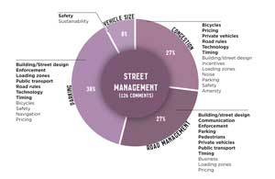
This graph gives a breakdown of the street management primary themes (126 comments) by percentage and lists the secondary themes that relate to each primary theme. These are as follows: 27 per cent congestion, secondary themes are bicycles, pricing, private vehicles, road rules, technology, timing, building/street design, incentives, loading zones, noise, parking, safety, amenity. 27 per cent road management, secondary themes building/street design, communication, enforcement, parking, pedestrians, private vehicles, public transport, timing, business, loading zones, pricing. 38 per cent parking, secondary themes are building/street design, enforcement, loading zones, public transport, road rules, technology, timing, bicycles, safety, navigation, pricing. 8 per cent vehicle size, secondary themes being safety and sustainability.

Next steps
The comments received during the pre-draft community engagement will inform the draft Last Kilometre Freight Plan.
The draft will be presented to the Future Melbourne Committee for consideration in the second half of 2015. If endorsed, community consultation on the draft plan will be undertaken. This will give our community a further opportunity to provide input into the plan before a final plan is prepared and presented for endorsement at the Future Melbourne Committee.

