

Queen Victoria Market Precinct Renewal Master Plan
The Queen Victoria Market Precinct Renewal Master Plan was endorsed by the Melbourne City Council on 28 July 2015.
Contents
Foreword 3
The Queen Victoria Market Precinct Renewal Project 4
Introduction 4
Purpose 4
Key Considerations in Developing the Master Plan 5
Key Findings from Community Engagement 6
Queen Victoria Market as part of Melbourne’s Future 8
The Market We Love 10
Community Feedback 13
Trader Feedback 14
Master Plan 16
Strategic Vision 16
Key Initiatives 17
Outcomes 18
Project Planning Framework 19
Q1 Quarter One 20
Q2 Quarter Two 23
Q3 Quarter Three 26
Q4 Quarter Four 29
Market Cross 31
City Grid 33
Next Steps 36
Project Delivery Timeline 36
Summary of key master plan proposals 38
How to contact us 40

Foreword
The Queen Victoria Market Precinct Renewal Master Plan delivers on our vision to create a world-class ‘market of markets’ and surrounding precinct while celebrating the heritage of the site.
Our commitment to this vision is backed up by the announcements Council made in the 2015/16 Draft Budget. In July, we will make the final payment to complete the purchase of the Corner Queen and Therry streets. Over the next four years Council will allocate more than $130 million of the up to $250 million projected investment required to fund the project.
Council has sought authorisation from the Victorian Planning Minister to prepare and exhibit a planning scheme amendment that recognises the importance of Queen Victoria Market (rezoning to public use zone) and embeds the market as part of the fabric of CBD North.
Previous planning controls created a divide between the market and the city. Our plan is to connect them: better streets, new laneways, improve the public realm, balance the heritage fabric with the right type of new development, taller buildings with setbacks from the street, tower space controls.
Depending on the scope of the projects undertaken, it is estimated that the renewal could generate 9,000 new jobs at the market, 12,000 jobs in the surrounding precinct and thousands of construction industry jobs.
We have applied for National Heritage listing, the necessary precursor to World Heritage listing for the Queen Victoria Market, an acknowledgement that will provide appropriate recognition and protection of this Melbourne icon.
We have consulted, we have listened, we have planned and we have budgeted. This underscores our strong commitment to this project and our ability to deliver it.
Over the next few months we will commence scoping, drawing plans and designing the various projects on the Queen Victoria Market site.
As always, we will continue working with traders and the broader community on this important project.
Robert Doyle
Lord Mayor of Melbourne
Stephen Mayne
Chair, Finance and Governance Portfolio

The Queen Victoria Market Precinct Renewal Project

Introduction
In October 2013, the City of Melbourne announced the largest investment in its history to renew the Queen Victoria Market, and create one of the world’s great market precincts.
Our aim is to preserve the Queen Victoria Market’s heritage and traditional market atmosphere, while allowing the market precinct to evolve and meet the contemporary needs of visitors, traders and our growing city. Improvements to the physical environment will allow a flourishing market to grow and evolve into the future.
We have developed the Queen Victoria Market Precinct Renewal Master Plan to ensure this happens in consultation with the community, market visitors and traders. Central to our thinking is the recognition that prosperous traders are essential to a successful market.
Two milestones have helped shape this Master Plan, opening up a range of exciting opportunities for the market’s renewal: the City of Melbourne’s strategic purchase of a large block of land within the market precinct, Corner Queen and Therry streets, commonly known as the Munro site; and the signing of a formal agreement with the Victorian Government to improve and develop Franklin Street. These achievements have extended our capacity to deliver on our promise – to ensure that the Queen Victoria Market remains part of our city forever.
In the market’s next evolution we are committed to respecting and preserving its diverse heritage. To date, a broad community engagement process, focused consultation with key stakeholders, and a variety of professional investigations into the market’s operation, site and context have been undertaken. Key principles have been established to support this commitment. Community and trader feedback has strongly shaped and supported our vision for renewal.
In developing the Master Plan, the need to review existing development controls became clear to progress the precinct renewal. A separate consultation on a planning scheme amendment was initiated by the City of Melbourne in 2015.
‘Investing now will ensure that the Queen Victoria Market is part of our city forever. We want to preserve and celebrate the market’s iconic features while retaining affordability and ensuring the market is competitive in a changing retail environment.’
Lord Mayor Robert Doyle

Purpose
This Master Plan outlines a wide variety of proposals to revitalise the market precinct with a strong focus on improving the trader, customer and community experience. It outlines options for preserving and celebrating the market’s long history, enhancing facilities for traders and market visitors, providing more open spaces and places for events, eating and meeting, easier access for pedestrians, cyclists and commuters, and better parking.
Community and trader feedback has been included in a Strategic Brief prepared by Queen Victoria Market management. The Strategic Brief describes a vision for the market, outlining the current state of operation and recommending changes to enable the precinct to evolve and thrive for generations to come. It contains detailed assessments and rationales for proposed improvements. It is publicly available on the City of Melbourne website and is referenced throughout this Master Plan.
The Master Plan brings together the detail contained in the Strategic Brief into broad strategic and long term directions for the Queen Victoria Market Precinct Renewal.
The market’s sheer size, complexity of operations, diversity of customers, significance of its heritage and scope of desired improvements mean that this renewal will not occur as a single project, but rather as a collection of many projects, each large and complicated in its own right. The Master Plan therefore aims to provide the framework to coordinate a suite of projects that can be developed with a degree of independence from each other, which also complement each other and contribute to the precinct as a whole.
In the ongoing work that will be required to resolve projects for future works, the detail within the Strategic Brief will be added to, and potentially slightly modified, but the intent is for the Master Plan to provide an enduring framework to guide these projects.
To do this, the Master Plan defines distinct areas, or ‘quarters’ within the market precinct. The quarters reflect the varied trading models in different parts of the market, as well as existing spaces and structures. For each of these quarters, the Master Plan highlights the vision, priorities and key improvements to be delivered. It also identifies key issues to be resolved that have potential impacts beyond their specific location.
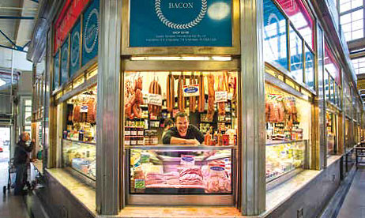

Key Considerations in Developing the Master Plan

Victorian Government Agreement
To support the Queen Victoria Market Precinct Renewal, the Victorian Government and the City of Melbourne have entered into a formal agreement to realign Franklin Street at the south end of the market and transfer some Crown land to the City of Melbourne.
Freehold land will be created as a result of the land transfer, providing opportunities for commercial and residential development to add to the vibrancy and potential of the area. Funds secured through the development of this land will be reinvested into the Queen Victoria Market. The realignment of Franklin Street will improve vehicular movements, deliver economic benefits and create a new route to Docklands.
The land changes will also remove two dangerous roundabouts along Franklin Street, improve pedestrian and traffic connections around the market and improve the amenity of streets around the market.

Key development timing obligations
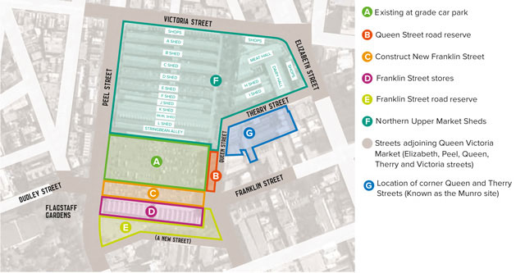
Queen Victoria Market Precinct Location and Staging Plan
- Replace current car spaces within the existing at grade car park elsewhere within the market precinct by 2019, and convert the existing car park to a high quality public space by 2022.
- Construct a new Queen’s Corner building within a portion of the Queen Street road reserve for the Victoria Visitor Centre and new market management facilities by 2026.
- Construct New Franklin Street by 2019.Reconfigure land parcels, including the retained Franklin Street stores and portions of the Franklin Street road reserve to create mixed use development sites by 2026.
- Enhance and renovate northern Upper Market Sheds to support trading and incorporate new market trading services and facilities by 2019.
- Corner Queen and Therry streets (commonly known as the Munro site) – to be referenced in the Victorian Government Agreement.
- Upgrade streetscapes adjoining Queen Victoria Market (Elizabeth, Peel, Queen, Therry and Victoria streets) and public transport infrastructure by 2026.

Key Findings from Community Engagement

Parking
The provision of convenient parking and safe, easy access to the market is a priority for both traders and customers. Access to nearby parking is especially important to traders who must arrive before the commencement of public transport services. The City of Melbourne and Queen Victoria Market management will continue to support the needs of early morning traders into the future.
A car park to replace the existing 720 space open-air parking on the market site will be developed to provide accessible, affordable, safe, family-friendly, short term parking within the precinct. The preferred location for this is at the Corner Queen and Therry streets, although other options are available including the new southern development site in Quarter Three. Arrangements to manage new parking facilities will be developed with input from traders and other users. These will seek to optimise the use of customer parking at different times, accommodating traders at the start and close of each day and allowing for use by others when the market is not trading. Arrangements will be resolved in the next phase of detailed planning.
Many traders’ vehicles are now present within the market sheds during trading hours due to the lack of facilities for delivery and loading of goods and produce. New infrastructure will eliminate this necessity.
Other existing practices including long term parking by general merchandise and fruit and vegetable traders within the market sheds, and the parking of trucks within customer parking areas, will be phased out, in order to remove conflicts between public and service activities.
Our intention is to relocate car parking in order to create the new open space, and at least the current number of spaces from within that area will be accommodated elsewhere in the precinct. Allowances will be investigated for the replacement of parking spaces that are potentially affected by improvements in other areas.

Heritage
The site has been, and continues to be, significant to many people for many reasons. It is an important Aboriginal cultural place, the site of Melbourne’s first cemetery, and has served as the city’s main wholesale food market. It has layers of Victorian, Edwardian and inter-war mercantile architecture, yet not all of the site’s history is visible. In addition to the conservation of heritage buildings, we will celebrate the site’s hidden history through other means such as artworks, signage and landscape features.
Most importantly, this Master Plan aims to preserve the authentic market experience. Queen Victoria Market has served the people of Melbourne continuously since the 1870s – giving it an irreplaceable connection with our past. In the market’s next evolution we are committed to preserving its diverse heritage. As a mark of that commitment, the City of Melbourne has nominated Queen Victoria Market for inclusion on the Australian National Heritage List. This recognition would not only acknowledge the heritage value of the market at a national level, it is a prerequisite for nomination to the World Heritage List.

Opening Hours
Current trading hours at the market are confusing and inconvenient for many shoppers and tourists. Public and trader feedback has indicated strong support for extended opening hours, with parts of the market offering services seven days a week from early morning to late at night. Increasingly, this will mean many spaces in the market having multiple uses across a day and across a week. It does not mean all traders will be working longer hours. Potential benefits include more efficient use of space and facilities at the market, better support for tourism, attraction of new customers, and greater customer convenience.

Public Spaces
Some people come to the Queen Victoria Market only to shop, but for many others, visiting the market involves a break for a casual lunch in the sunshine, or meeting up with friends. Events such as the Night Market are significant attractions in their own right. High quality, useful open space is also increasingly important to meet the needs of the growing residential population around the market.
Improving public spaces in the precinct is therefore a high priority in order to fulfil several aims. These include supporting programmed events that bring people to the market; making pleasant spaces to meet and relax with more greenery, shade and seating; providing opportunities for informal recreation such as tai chi, yoga, and children’s play and providing more generously for walking, cycling and pedestrian activities in streets around the market.
Refer also Capire Consulting Group, Queen Victoria Market Precinct Renewal: Phase 3 Community Engagement Report for City of Melbourne, April 2015.

Queen Victoria Market as part of Melbourne’s Future

Redevelopment Sites
In October 2014, the City of Melbourne announced the purchase of properties within the block bounded by Therry, Queen, and Franklin streets, commonly known as the Munro site, for $76 million. This in combination with the southern site negotiated with the State Government form a strategic set of land holdings that are of importance to the people of Melbourne and the future of the Queen Victoria Market Precinct. The City of Melbourne is confident that the long term value of these two sites will include civic, retail and community benefits alongside a sound financial platform for reinvestment in the market precinct.
These arrangements have opened up new possibilities to better integrate, through the Queen Victoria Market Renewal process, the market with the expanding northern city through the reconfiguration of parking, optimisation of retail and community facilities. They also create opportunities to minimise impacts on the market’s operation during the staged implementation of improvements.
The Munro family’s legacy will be recognised as part of the renewal. The two sites’ redevelopment, combined with a renewed business model for the market, will ensure the market’s future as a much loved authentic trading environment.

Sustainability
The City of Melbourne is committed to becoming one of the world’s most sustainable cities. We know that a successful future depends on understanding the risks that climate change poses, reducing our impact and becoming more resilient.
Projections for Melbourne are for a hotter and drier climate with more frequent and extreme weather events. This is particularly significant for Queen Victoria Market because of the potential vulnerability of its supply chain, as well as impacts to the open-air market and public open spaces.
Through the implementation of this Master Plan we will incorporate renewable energy, waste reduction and recycling, and water use and re-use including stormwater harvesting. We are also considering the role that the precinct can play in building Melbourne’s resilience. It has the opportunity to lead change in the community and help the city tackle its sustainability challenges.

Relocation of the Wholesale Market
Queen Victoria Market is intricately connected with wider trading networks. The new metropolitan Wholesale Market at Epping is expected to open in 2015. The relocation of wholesaling from Footscray to larger premises at Epping offers the potential to increase bulk supply to local businesses. It also represents a significant change for Queen Victoria Market’s fruit and vegetable traders, who rely on the wholesale market for the majority of their produce supply.
The full extent of impacts is not yet known but may affect:
- Future sourcing of produce
- Storage requirements, including the need for refrigeration
- Arrangements for the delivery of fresh produce
- Waste disposal requirements.

A Growing City
Queen Victoria Market is positioned at the heart of Melbourne’s inner north, which has been identified as a growth area for the municipality. Council’s commitment to renew the precinct is timed to respond to this growth. In 2014, our central city grew faster than any other area in Australia. Between 2008 and 2013 the municipality’s residential population increased by almost 30 per cent to about 116,447 people.
Planning for the market needs to take into account the opportunities presented by Melbourne’s growing population of residents, workers, students and visitors. This increased population will create new opportunities and challenges for the market, while also increasing the importance of its open spaces.
Council’s City North Structure Plan 2012, which includes the Queen Victoria Market Precinct, identifies the northern sector of the city as a strategic renewal area that will accommodate more residents and support additional employment through continued intensive redevelopment. Over the past 15 years, the City North area has already seen extensive residential apartment development, both planned and completed, including:
- 3,123 completed apartments
- 2,744 under construction
- 2,266 with planning permit approved
- 3,417 in current planning permit applications.
Of these new households, if each paid one visit per week to Queen Victoria Market this would result in over 600,000 additional visitations per year. Queen Victoria Market is central to this area of intensive development and remains a vital link between the older central city and its northward expansion.

Review of Development Controls
The relationship between the Queen Victoria Market Precinct and the surrounding city have changed over time. What was once a transitional zone between the central city and low-intensity suburbs is now an integral part of the central city and emerging City North growth area. Existing controls over the built form of new development in the precinct have become dated. The City of Melbourne therefore commenced a process of reviewing and updating planning controls over the precinct, including a formal Planning Scheme Amendment process, to better support the precinct’s changing role.

The Market We Love
‘Authenticity and atmosphere that is uniquely Melbourne.’
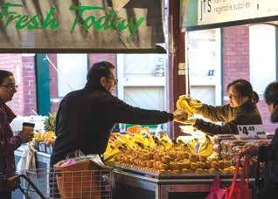
…shopping with favourite fresh produce traders…
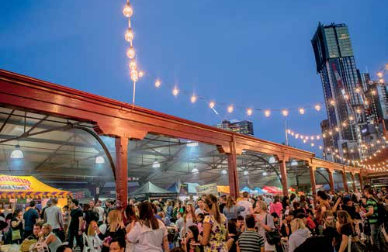
…a unique indoor/outdoor setting for night markets…
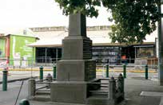
…opportunities to interpret the former cemetery…
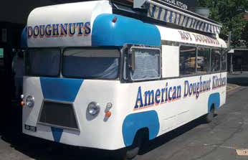
…favourite Melbourne rituals…
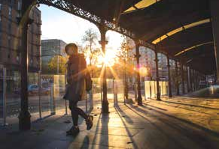
…convenient access on foot, by tram and by car…

…an eclectic mix of specialty shops…
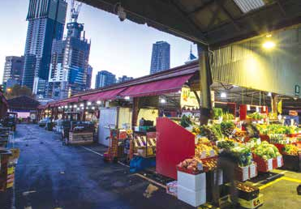
…a touch of chaos and an authentic market atmosphere…
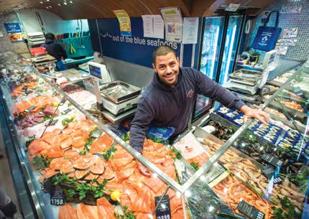
…a diverse mix of meat, fish and deli vendors…
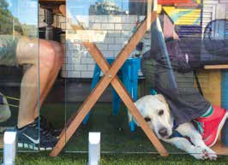
…a place to linger…
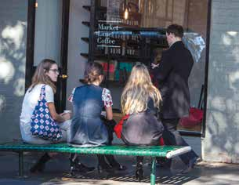
…pedestrian-friendly streets and open spaces…
As we plan for the future of this precinct, we are committed to preserving the core values that have made Queen Victoria Market a favourite with locals and tourists alike. Queen Victoria Market’s trader community is a dedicated and valued group of small business owners who are passionate about the future of the market.

Community Feedback
Thousands of people have shared their views on the Queen Victoria Market Precinct Renewal over four distinct phases of community engagement. The first phase of community engagement was undertaken in November 2013, introducing the concept of renewal and uncovering aspects of the market that people most value. The second phase took place from April to May 2014. We explored the community’s desire to maintain the ‘feel’ of the market by asking people to tell us their ideas on what should be retained and what new ideas they had for the precinct.
The Draft Master Plan was released in early March 2015 and over the following month a third phase of community engagement sought feedback. All market traders were invited to attend discussion groups focussed on their specific trading category. Stakeholder discussion groups were held with members of the Wurundjeri and heritage representatives. Nearly a thousand members of the general public completed surveys. The results indicated broad support for the vision of the Draft Master Plan as a whole and for the directions for improvements as outlined for each of the market’s quarters.
- Opening hours: The majority of traders and public participants support the concept of the market as a destination that provides an ever-changing range of offers.
- Use of the new open space: Both the traders and the public indicated support for programmed markets and events in the proposed new open space.
- Access: While traders said that improved car parking would improve access to the market, public participants said that improved pedestrian amenity and safety would make it easier to access the market.
- Heritage: Traders and public participants said that they supported artwork, signage or landscape features as ways to celebrate the market’s history.
- Market Cross: The most common suggestion to improve the public space was for more public seating.
The Queen Victoria Precinct Renewal Final Draft Master Plan was released to the public between June and July 2015 for a fourth and final stage of community engagement. During this time the Master Plan was available on Participate Melbourne for the community to learn more about the Master Plan and renewal. In addition a series of Queen Victoria Market Trader Forums were held and the Queen Victoria Market Community Hub was opened to the public on Saturday 20 June 2015.

What We Value
- The market experience:
  - ‘The traders treat us as part of their family’, Participate Melbourne, November 2013.
  - ‘Keep the atmosphere of the market, I like the way it is now’, Vox Pop, November 2013.
- Uniquely Melbourne:
  - ‘Authenticity and a great atmosphere that is uniquely Melbourne’, Participate Melbourne, November 2013.
- A diverse community:
  - The market is ‘a community where you can meet and help a lot of people from all walks of life – each day is different and vibrant’, Vox Pop, November 2013.
- Quality, price and variety:
  - ‘Variety, freshness, the great service and support and the friendly, good relationships’, Vox Pop, November 2013.
- Sense of history:
  - ‘The historic feel of the market should be protected – it’s an iconic part of the city’, Vox Pop, November 2013.

What We Want to Improve
- Tell our stories:
  - ‘It is important to the community to know the history of this wonderful market… strengthen the points of interest’, Participate Melbourne, May 2014.
- Look after our historic buildings and sheds:
  - ‘The facades, the open shopping sheds and food halls are central to the market experience’, Participate Melbourne, May 2014.
- Places to meet:
  - ‘A central meeting place with food and chairs and able to have events right in the centre of the market’, Feedback form, May 2014.
- More activities, open longer:
  - ‘The market needs to incorporate a range of uses to ensure it is fully activated and safe at all times of the day’, Participate Melbourne, May 2014.

Trader Feedback
Traders’ success underpins the market’s success. Since the City of Melbourne announced its commitment to the Queen Victoria Market Precinct Renewal, the importance of traders has been emphasised. Traders have been consulted through the community engagement processes, regular meetings between market management and trader representatives, and one-on-one interviews with stallholders. These conversations have provided a deeper understanding of traders’ operational challenges and business requirements, and pressures facing the broader market community. They have also informed Queen Victoria Market’s Strategic Brief, which underpins the Master Plan.
Trader feedback on the Draft Master Plan suggests it is heading in the right direction, confirming the importance of functional improvements across the market, including:
- Precinct-wide infrastructure for power, water, and recycling, with specific provisions in certain areas e.g. for events and alternative market arrangements in Quarter Three.
- Waste management facilities, with emphasis on specific needs in certain areas including fish and meat offal, organics, and packaging.
- Trader amenities with the inclusion of showers, toilets, breakout spaces and storage.
- Facilities for delivery and waste removal including loading docks, off-street loading areas, wash-down services and storage.
- Reducing conflicts between service vehicles, including forklifts, and public access.
The City of Melbourne will continue to work closely with the management of Queen Victoria Market to consult and communicate with traders throughout renewal activities.
The following is some of the feedback received from our traders:
- Sustainability:
  - ‘I would love to see a clear commitment to recycling and waste management’, Feedback form, March 2015.
- Parking:
  - Parking for customers is the most important thing for traders’, Feedback form, March 2015.
- Engagement:
  - ‘I feel feedback has definitely been taken on board since previous meetings which is lovely to feel as though you are being heard and part of the process’, Feedback form, March 2015.
- What kind of place is Queen Victoria Market?
  - ‘It’s a market, it’s an institution, it’s a legacy, it’s a tradition’, Community Engagement Phase 1, Vox Pop.
- Heritage:
  - ‘The sheds should still be open. They need paint and love and electricity, not reconstruction’, Community Engagement Phase 2, Participate Melbourne.
- Facilities:
  - ‘There is no place for people to load – especially for the butchers and fish mongers’, Community Engagement Phase 1, trader discussion group.
  - ‘Queen Street is dangerous due to the number of deliveries’, Community Engagement Phase 1, trader discussion group.
  - ‘Need to modernise amenities and customer comforts’, Community Engagement Phase 1, trader discussion group.
- Attractions:
  - ‘Better trading hours. It opens too early, and closes before anywhere else in the city. Tourists are constantly surprised that the market is already closing and they are just arriving’, Community Engagement Phase 2, Participate Melbourne.
- Minimise disruption:
  - ‘The market must still be able to function during the renewal and continuity of trade with minimum interruption or adequate compensation’, Trader discussion group, November 2013.
- Retail, hospitality and services:
  - ‘Let the market decide. People are wonderfully creative. They will come up with all kinds of things that you can’t believe. Just make it easy for them to do it. And make sure it is not someone’s fifteenth formulaic hospitality outlet’, (Participate Melbourne, work at or for the market (trader / staff).
- Weather protection:
  - ‘Our city is windy and wet most of the time and while we expect and love the feel of an outdoor market, designs should be considered for more protection from the elements for both the traders and the customers’, Participate Melbourne, November 2013.

Master Plan
Queen Victoria Market management developed a Strategic Brief to help inform development of this Master Plan. The Strategic Brief describes the vision for the renewed Queen Victoria Market and the nature of the improvements and new facilities required to enable the market precinct to thrive for generations to come. This is a living document which will be developed over time to inform future detailed design briefs for individual projects.

Strategic Vision
The future vision for Queen Victoria Market is of a thriving and diverse market place that is loved by locals and a must see for tourists.
Three strategic directions will guide the delivery of this vision:

Strategic Direction 1: A market of markets
A place that supports and encourages sustainable market trading in all its varieties
- Upgrade existing facilities
- Welcome people seven days a week
- Support emerging small businesses
- Introduce new markets and attract new customers
- Encourage longer visits

Strategic Direction 2: A Melbourne experience
A place to experience Melbourne’s local character, liveability and identity
- Inspire discovery
- Enhance street life
- Celebrate our heritage
- Become a sustainable environment
- Promote our local produce

Strategic Direction 3: A community meeting place
A place to meet and connect with the diverse and vibrant communities of Melbourne
- Bring people together
- Create shared experiences that encourage social connections
- Look after the locals
- Create a pedestrian heart
- Tell our stories, share our knowledge

Key Initiatives
The renewed Queen Victoria Market will retain its traditional market atmosphere while addressing longstanding issues that constrain its potential.
Despite attracting up to 10 million annual visits, much of the market does not meet contemporary standards for a public market environment. Parts of the market can become highly congested and the historic open-air sheds have never been adapted to meet current or future retail trading requirements.
Throughout the market precinct there is an opportunity to improve safety and amenity for visitors and traders. While customers speak positively of the atmosphere, the market struggles to provide a consistent high-quality experience and market offering throughout the year. Addressing this will entail targeted improvements of specific operational, amenity, and infrastructure issues.
The renewal will include relocation of the existing customer car park. This part of the site will become a new public open space that acknowledges the site’s history as Melbourne’s first cemetery.
Key initiatives to achieve the vision include:
- Heritage conservation:
Greater recognition of the heritage site and interpretation of historically significant parts of the market.
- Functionality:
Create dedicated back-of-house areas for each of the market’s three major trading areas.
- Infrastructure:
Upgrades to the market’s heritage buildings and open-air sheds.
- Trader facilities:
Significant improvements to trading and operations infrastructure and facilities.
- Public places:
Establish a network of quality public spaces throughout the precinct.
- Customer amenities:
New and enhanced customer amenities and facilities.
- Visitor services:
New visitor centre and associated visitor services.
- Community infrastructure:
Develop local community infrastructure such as childcare services.
- Education:
Develop dedicated facilities to support expanded education programs.
- Parking:
Ensure customers continue to have convenient access to car parking within the precinct.
- Commercial viability:
Commercially successful market for traders and the city.
- Equity of access:
Improve access and inclusion for people of all abilities.
- Sustainability and design quality:
Work with partners, including the C40 Climate Leadership Group (C40), Green Building Council of Australia and Office of the Victorian Government Architect, to review development proposals and deliver a thriving and diverse marketplace and surrounding precinct that demonstrates world leadership in design and sustainability.

Outcomes
Customers will experience:
- Greater choice, with parts of the market trading every day, from early morning to late at night.
- Improved access to retail services.
- A brighter, lighter, cleaner, greener and more pleasant environment that is clearly historic, yet subtly contemporary.
- Improved weather protection and climate control to increase people’s comfort within the market.
- A pedestrian friendly precinct that is easy and safe to access and traverse.
- Hundreds of market traders and a rich, diverse form of traditional retailing supported by modern infrastructure.
- A clearly defined and interesting precinct with retail and services along the market’s edges and an open and flexible inner area.
- Sounds, sights and smells that will instil a love of markets in future generations.
- Enhanced customer amenities, including an information centre.
Traders will experience:
- More options and greater choice about when and where to trade within the market, in fixed (with in situ storage) or flexible (set-up and pack-down daily) locations and across a greater number of available hours.
- Better informed customers.
- Improved work-place facilities.
- Better circulation and customer flow.
- Infrastructure improvements to increase efficiency, cleanliness and displays.
- Greater opportunities to run vibrant businesses.
The community will experience:
- Appropriate acknowledgement of the land’s original owners on which the market stands.
- Artworks, signage and landscape features that increase awareness of and interpret the site’s history and heritage.
- A vibrant residential and commercial neighbourhood surrounding the market.
- Improved local community facilities, including childcare, and activities for children and families.
A sustainable market precinct will be:
- Guided by a sustainable precinct plan.
- Rated and communicated through the use of the Green Star – Communities rating tool.
- Zero carbon – maximising energy efficiency, embedded renewable energy sources and investment in off-site renewable energy.
- Climate resilient – cooling the precinct and enhancing biodiversity by integrating green infrastructure, stormwater harvesting, re-use and water sensitive design.
- Resource efficient – through sustainable procurement and resource recovery systems and infrastructure.
- Zero waste – maximising opportunities for waste reduction and recycling in design, construction and operation.
- Economically sustainable – encourage opportunities for business diversity, innovation and economic development with a focus on activities which foster the commercial viability of the Queen Victoria Market.
- Socially sustainable – providing enhanced community opportunities that are accessible and create local employment and acknowledge culture, heritage and identity.

Project Planning Framework
In this Master Plan, the market has been divided into four quarters, each linked to each other by a market cross of public spaces within the heart of the precinct. It is connected to the rest of the city by the grid of surrounding city streets. The division reflects:
- Varied building types and characters
- Different market trading models
- Different types of goods being sold.
The intent is to coordinate a suite of projects that can be developed with a degree of independence from each other, which also complement each other and contribute to the precinct as a whole. It also enables targeted consultation and stakeholder input, in-depth investigations, exploration of options, and detailed resolution of proposals that can be delivered in stages.
For each of these quarters, the Master Plan sets out the preferred vision for the future of that part of the market, priorities identified through the community and trader engagement process, and key proposals for improvements. All of these improvements will require further elaboration and development, and as planning and design work progresses, each quarter is likely to be further divided into a number of projects to facilitate staged implementation.
We have also identified ‘issues to be resolved’, which are of strategic importance because they may have impacts on other parts of the market.
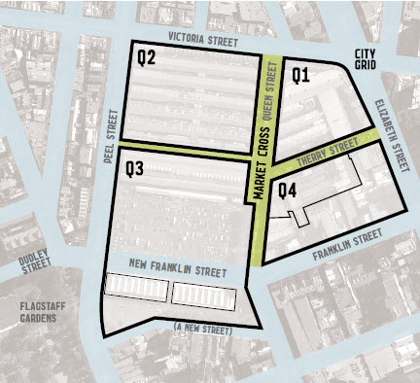
Queen Victoria Market Precinct Renewal - Project Planning Framework

Q1 Quarter One
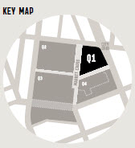

Vision – Future State
Shopfront trading in market halls and street-oriented terraces.
Queen Victoria Market’s diverse mix of fresh food, meat, fish and specialty food vendors continue to animate one of Melbourne’s most intriguing and enduring retail destinations. Shops fronting onto the surrounding streets welcome visitors with hospitality establishments and retail that showcase market produce, making a special destination at any time of day, every day.

Priorities
- Resolve conflicts between service vehicles and public access.
- Improve access for delivery including off-street loading and set-up areas, wash-down service and storage facilities.
- Improve trader facilities including showers, toilets, breakout spaces and storage.
- Improve waste management and recycling facilities for meat and fish offal, organics and packaging.
- Develop sustainable precinct-wide infrastructure for power, waste management and recycling.
- Improve adaptability of trading spaces.

Key Improvements
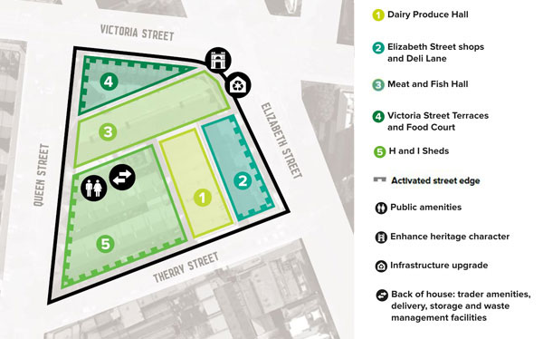
Queen Victoria Market Precinct Renewal - Quarter 1 Plan
- Dairy Produce Hall (see section A2 in the Strategic Brief for details)
  - Extend times of public access through the Hall.
  - Activate the adjoining street space seven days a week.
- Elizabeth Street shops and Deli Lane (see section A3 in the Strategic Brief for details)
  - Focus on cafe and hospitality uses.
  - Support outdoor dining in Elizabeth Street.
  - Make active seven days a week and in evenings.
  - Improve separation of public access and service areas.
- Meat and Fish Hall (see section A4 in the Strategic Brief for details)
  - Focus on food offer.
  - Improve separation of public access and service areas.
  - Activate the adjoining street space.
  - Enhance the Elizabeth Street facade lighting.
- Victoria Street Terraces and Food Court (See section A5 in the Strategic Brief for details)
  - Focus on cafe and hospitality uses.
  - Integrate with trading opportunities in Victoria Street.
  - Make active seven days a week and in evenings.
- H and I Sheds (seen sections A6 and C3 in the Strategic Brief for details)
  - Focus on food offer complementing remainder of Q1.
  - Improve weather protection.
  - Improve trader infrastructure.
  - Activate the adjoining street space seven days a week.
- Back-of-house: trader amenities, delivery, storage and waste management facilities (see sections A1, D1 and D4 in the Strategic Brief for details)
  - Provide dedicated back-of-house facilities for this quarter.
  - Resolve conflicts between service vehicle movements and public access.
  - Improve access for delivery and waste removal including new loading dock, off-street loading areas, wash-down and storage.
  - Improve trader facilities including showers, toilets, breakout space and storage.
  - Improve waste management facilities including fish offal freezing room.
- Public amenities (see section E2 in the Strategic Brief for details)
  - Provide accessible public amenities for this quarter (separate from traders’) with baby/adult change facilities.
- Enhance heritage character
  - Conserve and restore heritage building fabric including Meat and Fish Hall, Dairy Produce Hall and Victoria Street and Elizabeth Street shops.
  - Recognise the market’s history with artwork and signage.
- Infrastructure upgrade (see section D3 in the Strategic Brief for details)
  - Improve sustainable precinct-wide infrastructure including power, water, waste management and recycling systems.
  - Improve ventilation and climate control.
  - Improve lighting and directional signage.
- Activated street edge
  - Investigate opportunities for uses within existing structures and new buildings to make adjoining streets more active and safe.

Issues to be Resolved
- Options for adaptation of H and I Sheds, existing loading facilities and toilets, or more extensive rebuilding potentially including basement service areas.
- Finalise retail mix.

Q2 Quarter Two
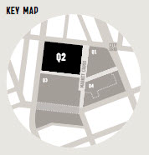

Vision – Future State
Fixed trading stalls in open sheds, sheltered in a structured perimeter to surrounding streets
The experience of shopping with favourite fresh produce and general merchandise traders in the Victorian sheds is sustained with modern infrastructure that ensures the market’s viability and reduces the intrusion of service vehicles into public areas. A built perimeter comprising the Victoria Street shops, F Shed and the old cemetery wall, and new buildings along Peel and Queen streets shelters the open sheds and provides activity onto surrounding streets.

Priorities
- Resolve conflicts between forklift and other service vehicles and public access
- Improve access for delivery including off-street loading and break-down areas, wash-down service and storage facilities.
- Create high quality fixed stalls.
- Improve trader facilities including showers, toilets, breakout spaces and storage.
- Improve waste management facilities with a focus on organic waste.
- Develop sustainable precinct-wide infrastructure.

Key Improvements
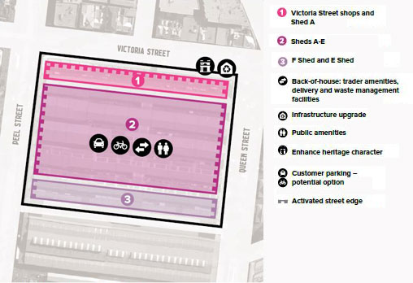
Queen Victoria Market Precinct Renewal - Quarter 2 Plan
- Victoria Street shops and Shed A (see section B2 of the Strategic Brief for details)
  - Improve separation of public access and service areas.
  - Activate the adjoining street spaces seven days a week.
  - Improve opportunities for street trading.
  - More flexible and viable shop spaces.
- Sheds A-E (see sections B3, B4 and B7 of the Strategic Brief for details)
  - Focus on food offer including fruit and vegetables, with complementary mix of non-food offers.
  - Maintain open-air atmosphere while providing adaptable weather protection.
  - Improve facilities for fixed trading stalls in open sheds including convenient access to refrigerated storage, and reticulated utilities.
  - Allow for servicing but minimise the presence of vehicles during public access hours.
  - Make street edges and other key pedestrian routes active seven days per week.
- F Shed and E Shed (see section B5 of the Strategic Brief for details)
  - Develop an integrated treatment of Sheds E and F as a pedestrian thoroughfare linking Peel Street and Queen Street.
  - Provide for seven days per week activation with retail spaces and licensed areas.
  - Provide seasonal weather protection.
- Back-of-house: trader amenities, delivery and waste management facilities (see sections D1, D2 and D4 of the Strategic Brief for details)
  - Provide dedicated back-of-house facilities for this quarter.
  - Resolve conflicts between forklift and other service vehicle movements and public access.
  - Improve access for delivery including off-street loading and break-down areas, wash-down and storage.
  - Improve trader facilities including showers, toilets, breakout space and storage.
  - Improve waste management facilities especially focusing on green waste.
- Infrastructure upgrade (see section D3 of the Strategic Brief for details)
  - Improve sustainable precinct-wide infrastructure including power (such as photovoltaic panels on shed roofs), water, waste and recycling systems.
  - Improve lighting and directional signage.
- Public amenities (see section E2 of the Strategic Brief for details)
  - Provide accessible public amenities for this quarter (separate from traders’ amenities) with baby/adult change facilities.
- Enhance heritage character
  - Respect the former cemetery, including the remnant cemetery wall and Aboriginal section near F Shed.
  - Minimise excavation and potential disturbance of remaining burials.
  - Recognise the market’s history with artwork and signage.
- Customer parking – potential option (see section E1 of the Strategic Brief for details)
- Activated street edge
  - Investigate opportunities for uses within existing structures and new buildings to make adjoining streets more active and safe.

Issues to be Resolved
- Potential to scale up fruit and vegetable distribution to local businesses.
- Options for service and storage facilities, including above or below ground (in areas outside the former cemetery).
- Options to include customer and other parking as an alternative or supplement to parking on the Corner Queen and Therry streets in Q4.
- Options to improve weather protection and street activation along edges of open sheds.
- Sustainable options for climate control in open sheds.
- Finalise the retail mix.

Q3 Quarter Three
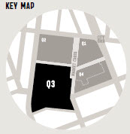

Vision – Future State
Changing – daily, weekly, seasonally – markets and events in open-air sheds and plaza
Market sheds and a new public open space in combination are a unique indoor/outdoor setting for day and night markets, seasonal markets, specialty markets and other public events in a varied program of activity. This makes for a continuously changing Queen Victoria Market – a destination for special occasions as well as for everyday shopping. A new Queen’s Corner building helps to activate the new open space, and provides a home for visitor services.

Priorities
- Develop specialist back-of-house amenities.
- Upgrade infrastructure to support events including alternative market operations and arrangements.
- Upgrade waste management facilities.
- Develop sustainable precinct-wide infrastructure.

Key Improvements
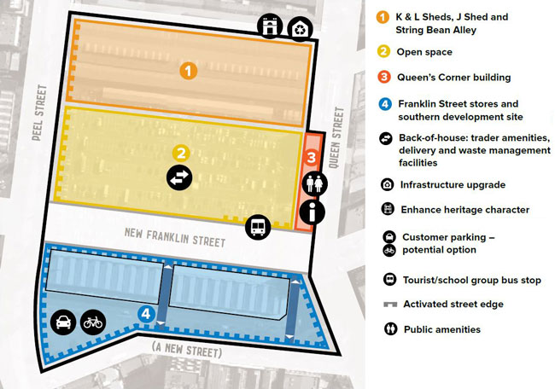
Queen Victoria Market Precinct Renewal - Quarter 3 Plan
- K & L Sheds, J Shed and String Bean Alley (see sections B6, B8 of the Strategic Brief for details)
  - Enhance J Shed as a pedestrian connection and continue to support flexible market trading.
  - Enhance K & L Sheds as a large, flexible, market and event space.
  - Create an interface with the open space that supports indoor/ outdoor activities.
  - Provide for loading and unloading for traders and events but no permanent parking.
  - Provide weather protection and a buffer to traffic along Peel Street.
  - Activate the adjoining street spaces seven days a week.
- Open space (see sections C4, F1, G1 of the Strategic Brief for details)
  - Support large-scale programmed markets and events with appropriately scaled open space.
  - Create spill-out areas and outdoor facilities for uses in the Queen’s Corner building.
  - Provide recreational opportunities that complement Flagstaff Gardens and cater to market patrons and the local community, including students and families with children.
  - Provide spaces for health and wellbeing activities, informal recreation and casual use, with public seating and shade.
  - Develop an integrated design for the new open space and New Franklin Street.
  - Support environmental objectives including management of stormwater runoff, and increased tree canopy cover and shading.
- Queen’s Corner building (see sections D5, E2, F1, G1, H4, H5 of the Strategic Brief for details)
  - Accommodate a Victoria Visitor Centre, with potential for a range of other services.
  - Provide active retail street edge, and hospitality to support use of the new open space.
  - Provide accessible public amenities for this quarter (separate from traders) with baby/adult change facilities.
- Franklin Street stores and southern development site (see section H2 of the Strategic Brief for details)
  - Retain and adaptively re-use the Franklin Street stores.
  - Undertake a mixed use development, guided by the City of Melbourne’s Housing Strategy, with public and private sector organisations.
  - Create active frontages to all streets.
  - Create new public pedestrian links through the block.
- Back-of-house: trader amenities, delivery and waste management facilities (see sections D1, D4 of the Strategic Brief for details)
  - Provide dedicated back-of-house facilities for this quarter and the wider market, focused on support for market events, changing facilities, shower rooms, trader storage, and events furniture storage.
  - Upgrade infrastructure to support various alternative market operations and arrangements, and events.
  - Upgrade waste management facilities with a focus on requirements for food vendors, events and night markets.
- Infrastructure upgrade (see section D3 of the Strategic Brief for details)
  - Improve sustainable precinct-wide infrastructure including power, water, waste and recycling systems.
  - Improve lighting and directional signage.
- Enhance heritage character
  - Improve the presentation of the former cemetery wall.
  - Minimise excavation and potential disturbance of remaining burials in the area of the former cemetery.
  - Recognise the site’s history with artwork, signage and landscape features.
- Customer parking – potential option (see section E1 of the Strategic Brief for details)
- Tourist/school group bus stop
- Activated street edge
  - Investigate opportunities for uses within existing structures and new buildings to make adjoining streets more active and safe.
- Public amenities

Issues to be Resolved
- Options for uses of the new open space.
- Options for adaptive re-use of the Franklin Street stores.
- Options for uses and activities within the Queen’s Corner building.
- Options to include customer and or other parking in the southern development site as an alternative or supplement to parking on the Corner Queen and Therry streets in Q4.

Q4 Quarter Four
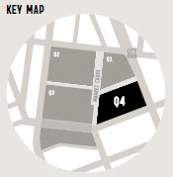

Vision – Future State
Mixed-use development, fine-grained retail, hospitality and community facilities complementary to Queen Victoria Market
Unique specialty shops, high quality cafes and other hospitality services add to the Queen Victoria Market Precinct’s retail offer, while community facilities, apartments and offices bring life to the neighbourhood.

Priorities
- Provide customer car parking to replace existing spaces in the open-air car park.
- Create active frontages complementing market activities.
- Create childcare facility and family hub.
- Enhance the character of Therry Street as a part of the market heritage precinct.
- Respond to the pedestrian scale of the market environment.

Key Improvements
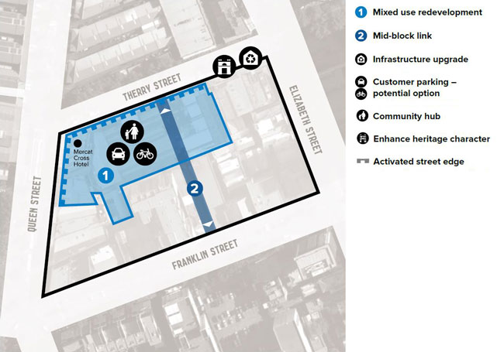
Queen Victoria Market Precinct Renewal - Quarter 4 Plan
- Area 1: Mixed use redevelopment
  - Create active frontages to all streets including ground level up to level five, potentially with accessible balcony verandahs.
  - Accommodate hospitality and retail tenancies that complement the market.
  - Undertake a mixed use development, guided by the City of Melbourne’s Housing Strategy, with public and private sector organisations.
  - Accommodate community uses potentially including childcare, family hub, civic meeting places, galleries and studio spaces.
  - Provide car parking spaces for Queen Victoria Market customers.
  - Incorporate environmental initiatives such as vertical and roof gardens.
  - Integrate the Mercat Cross Hotel and other heritage structures as appropriate into the redevelopment of the site.
  - Recognise the legacy of the Munro family.
- Area 2: Mid-block link
  - Create a new mid-block public pedestrian link from Franklin Street to Therry Street, activated by retail frontages.
- Infrastructure upgrade (see section D3 of the Strategic Brief for details)
  - Improve sustainable precinct-wide infrastructure including power, water, waste and recycling systems.
  - Improve lighting and directional signage.
- Customer parking – potential option (see section E1 of the Strategic Brief for details)
- Community hub
- Enhance heritage character
- Activated street edge
  - Investigate opportunities for uses within existing structures and new buildings to make adjoining streets more active and safe.

Issues to be Resolved
- Access and egress arrangements for the car park and for servicing and waste management.
- Capacity for on-site car parking.
- Options for community uses within the new development.

Market Cross
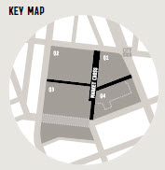

Vision – Future State
One of Melbourne’s great public and local places.
Welcoming and full of urban life, Queen Victoria Market’s public spaces encapsulate qualities that make our city liveable – year in, year out – within a variety of pedestrian-friendly streets and plazas. These open spaces interconnect, help to define, and add value to the different trading areas of the market while providing for a growing community.

Priorities
- Provide improved pedestrian access and safety.
- Resolve conflicts between service vehicles and public access.
- Improve amenity and provide public seating and respite spaces.

Key Improvements
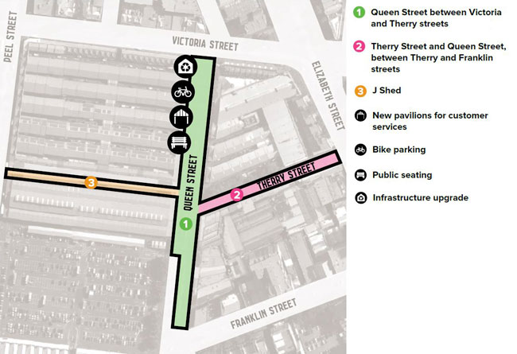
Queen Victoria Market Precinct Renewal – Market Cross Plan
- Queen Street between Victoria and Therry streets (see section C2 of the Strategic Brief for details)
  - Enhance as a public space for casual use with opportunities to gather, eat and relax.
  - Accommodate temporary market stalls and programmed events.
  - Remove parking and vehicular traffic.
  - Separate service vehicle operation from public activity.
  - Increase shade and public seating.
- Therry Street and Queen Street, between Therry and Franklin streets (see sections C1 and C3 of the Strategic Brief for details))
  - Enhance as a public space for casual use and small scale programmed events with opportunities to gather, sit, eat and relax.
  - Minimise vehicular traffic, eliminate through traffic, and increase pedestrian space.
  - Separate service vehicle operation from public activity.
  - Increase shade and public seating.
  - Remove the existing toilet building (to be replaced elsewhere).
  - Provide bicycle parking.
- J Shed
  - Enhance J Shed as a pedestrian connection and continue to support flexible market trading.
- New pavilions for customer services (see sections E3 and E4 of the Strategic Brief for details)
- Bike parking
- Public seating
- Infrastructure upgrade
  - Improve sustainable precinct-wide infrastructure including power, water, waste and recycling systems.
  - Improve lighting and directional signage.

City Grid
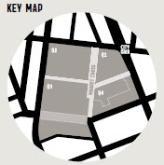

Vision – Future State
The best of Melbourne’s city streets.
Queen Victoria Market connects seamlessly into the surrounding city with its tree-lined streets. Streets prioritise different modes of transport – walking, public transport, cycling and cars – with space allocated accordingly to these priorities. Pedestrian capacity and amenity is increased throughout the precinct, supporting higher density development and access to the market. All streets are attractive public places enriched by adjoining land uses.

Priorities
- Remove unsafe roundabouts.
- Improve accessibility to the market by tram.
- Increase provision of space for walking and pedestrian activity throughout the precinct.
- Improve provision for cycling including on-street paths and parking facilities.
- Improve streetscape amenity and greening.

Key Improvements
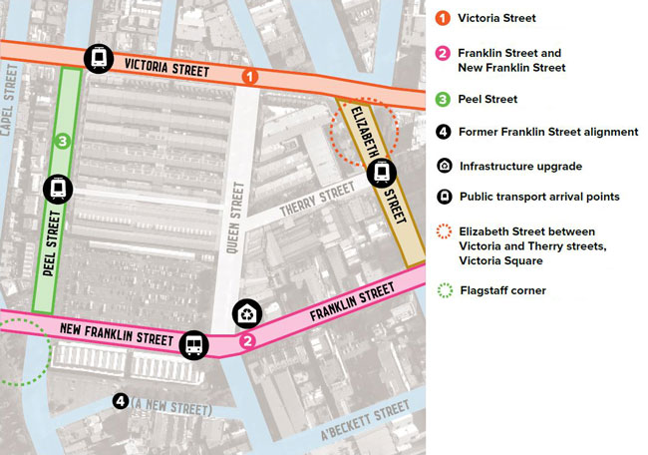
Queen Victoria Market Precinct Renewal - City Grid Plan
- Public transport arrival points
  - Improve tram stops near the market to support universal access, with ample space to avoid congestion.
  - Locate tram stops in response to combined aims for access, traffic management, and creation of pedestrian activity areas.
- Elizabeth Street between Victoria and Therry streets, Victoria Square (see section H3 of the Strategic Brief for details)
  - Minimise through traffic and expand the pedestrian space.
  - Create opportunities for al fresco dining and encourage cafes and restaurants in adjoining buildings to create a unique hospitality destination.
- Flagstaff corner
  - Create a compact, signalised intersection replacing the roundabout.
  - Investigate the potential to create additional public open space linked to Flagstaff Gardens on the site of the tram spur.
- Victoria Street
  - Prioritise public transport and pedestrian movement.
  - Widen footpaths.
  - Encourage evolution of the street into an activity spine for City North, linking Errol Street, Queen Victoria Market and the CUB site.
- Franklin Street and New Franklin Street (see section E7 of the Strategic Brief for details)
  - Prioritise local traffic distribution, pedestrian and cycle movement.
  - Develop an integrated design for New Franklin Street, the adjoining development site and open space.
  - Provide a generous pedestrian frontage to the Franklin Street stores for street trading.
  - Widen footpaths beyond the market and reduce space allocated to centre of road parking.
  - Accommodate public bus services re-routed from the existing alignment of Franklin Street, including stops and passenger waiting facilities.
  - Provide bus passenger facilities for school and tour groups near Queen’s Corner building.
- Peel Street
  - Enhance formal boulevard quality.
- Former Franklin Street alignment
  - Redesign as a 10m wide one-way local access street on the model of other ‘little streets’ of the Hoddle Grid.
- William Street, Queen Street and Elizabeth Street (see section C5 of the Strategic Brief for details)
  - Improve pedestrian links southward from the market, including to Flagstaff Station.
- Infrastructure upgrade
  - Improve sustainable precinct-wide infrastructure including power, water, waste and recycling systems.
- General streetscape improvements
  - Significantly increase street tree plantings and other greening.
  - Upgrade pavements, street furniture and lighting to standards appropriate for high-priority pedestrian precincts in the central city.
  - Support environmental objectives including management of stormwater runoff, and increased tree canopy cover to shade paved surfaces.
  - Provide bicycle parking.

Issues to be Resolved
- Potential for relocation of tram stops and resolution of their design to improve accessibility.
- Tram shunting spur removal at the corner of Flagstaff Gardens.
- Provision for on-street bike lanes.

Next Steps

Project Delivery Timeline
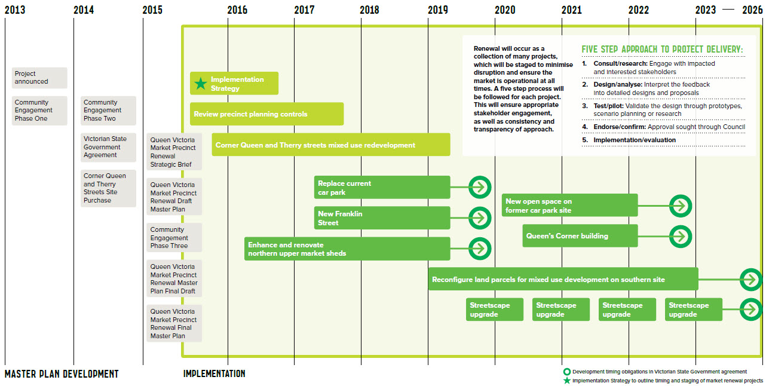
Master Plan Development
- 2013: Project announced, Community Engagement Phase One
- 2014: Community Engagement Phase Two, Victorian State Government Agreement, Corner Queen and Therry Streets Site Purchase
- 2015: Queen Victoria Market Precinct Renewal Strategic Brief, Queen Victoria Market Precinct Renewal Draft Master Plan, Community Engagement Phase Three, Queen Victoria Market Precinct Renewal Master Plan Final Draft, Queen Victoria Market Precinct Renewal Final Master Plan
Implementation
- Mid-2015 to 2016: Implementation Strategy (outlines timing and staging of market renewal projects)
- Mid-2015 to 2017: Review precinct planning controls
- End 2015 to 2019: Corner Queen and Therry Streets mixed use redevelopment
Development timing obligations in Victorian State Government agreement
- 2016 to 2019: Enhance and renovate northern upper market sheds
- 2017 to 2019: Replace current car park and new Franlin Street
- 2019 to 2023: Reconfigure land parcels for mixed use development on southern site
- 2020 to 2022: New open space on former car park site and Queen's corner building
- Queen’s Corner building
- 2020 to 2026: Streetscape upgrade
Renewal will occur as a collection of many projects, which will be staged to minimise disruption and ensure the market is operational at all times. A five step process will be followed for each project. This will ensure appropriate stakeholder engagement, as well as consistency and transparency of approach.
Five Step Approach to Project Delivery:
- Consult/research: Engage with impacted and interested stakeholders
- Design/analyse: Interpret the feedback into detailed designs and proposals
- Test/pilot: Validate the design through prototypes, scenario planning or research
- Endorse/confirm: Approval sought through Council
- Implementation/evaluation

Summary of key master plan proposals
Queen Victoria Market will be a ‘market of markets,’ a true Melbourne experience, and community meeting place. Its main trading quarters, with a distinctive offer and experience in each, will be interlinked by a network of attractive public spaces and connected to the surrounding city by high quality streetscapes.
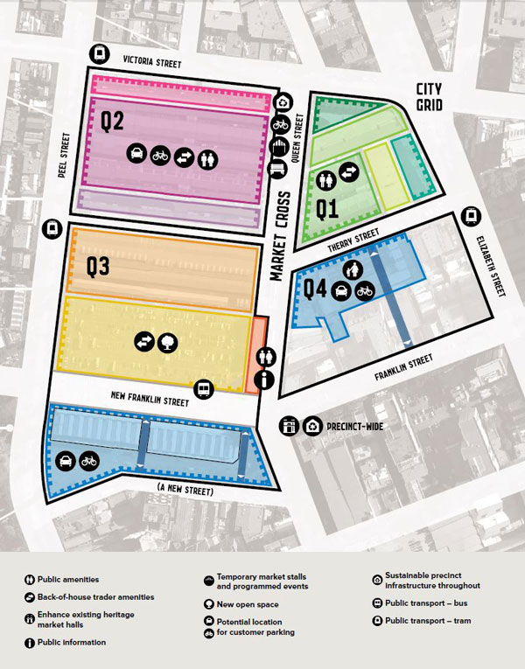
- Q1
The market halls will continue to focus on food and hospitality including meat, fish and specialty food vendors. Shops facing surrounding streets will welcome visitors to the precinct with high quality retail and hospitality establishments and make the market a special destination at all times. Improvements will include modern trader facilities, storage, waste management, and other infrastructure.
- Q2
The open-air heritage sheds will accommodate fixed trading with a focus on fruit and vegetables and a high quality non-food offer. New trader facilities, storage, waste management and other infrastructure will reduce servicing intrusions in public areas. The Victoria Street shops, F Shed and improvements along the Peel Street edge will shelter the sheds and activate the streets.
- Q3
The area south of the old cemetery wall will accommodate changing markets and events. A new open space and enhancements to the existing sheds will create a unique indoor/outdoor facility and a new public place for City North. New trader amenities, storage and other infrastructure will support this approach. A new Queen’s Corner building will accommodate visitor and customer services. The market’s old Franklin Street stores will be re-used within a mixed use development south of New Franklin Street.
- Q4
A new mixed use development will accommodate retail, hospitality and community uses complementing Queen Victoria Market. It will also include the market’s main customer car park, a new mid-block pedestrian laneway or arcade linking Franklin Street to Therry Street, and facilities to support the growing local community.
- Market Cross
The open spaces central to Queen Victoria Market will offer a variety of pedestrian-friendly streets and plazas. Improvements will increase pedestrian priority and create greener spaces for sitting, eating and relaxation.
- City Grid
Queen Victoria Market will be linked into the city via treelined spaces and surrounded by active neighbourhoods with good public transport and pedestrian access. Improvements will include New Franklin Street, removal of dangerous roundabouts, enhanced pedestrian space in Victoria and Franklin streets, and tram and bus passenger facilities.

How to contact us
Online: City of Melbourne
In person:
Melbourne Town Hall - Administration Building
120 Swanston Street, Melbourne
7.30am to 5pm, Monday to Friday
(Public holidays excluded)
Telephone: 03 9658 9658
7.30am to 6pm, Monday to Friday
(Public holidays excluded)
In writing:
City of Melbourne
GPO Box 1603
Melbourne VIC 3001
Australia
Fax: 03 9654 4854
Translation services:
03 9280 0716 Amharic
03 9280 0717 廣東話
03 9280 0718 Ελληνικά
03 9280 0719 Bahasa Indonesia
03 9280 0720 Italiano
03 9280 0721 普通话
03 9280 0722 Soomaali
03 9280 0723 Español
03 9280 0724 Türkçe
03 9280 0725 Việt Ngú
03 9280 0726 All other languages
National Relay Service: If you are deaf, hearing impaired or speech-impaired, call us via the National Relay Service: Teletypewriter (TTY) users phone 1300 555 727 then ask for 03 9658 9658
9am to 5pm, Monday to Friday (Public holidays excluded).

http://www.melbourne.vic.gov.au

