

Report on Future Melbourne 2008 Plan

22 January 2015

Version Control

date | Edoc version | comments | approved | Approval ref
25/01/2016 | 6 | Circulate to councillors under a briefing paper | Kate Vinot  David Mayes | #9663219

Contents
1. Introduction 5
1.1 About this report 5
1.2 Future Melbourne refresh 6
2. A city for people 7
Overview 7
2.1 A great place to live 8
2.2 Inclusive community 10
2.3 A healthy community 11
2.4 Designed for people 11
2.5 An affordable place to live 12
2.6 Quality public space 13
2.7 Community facilities and services meet growth 13
3. A creative city 15
Overview 15
3.1 Creative risk taking 15
3.2 Vibrant, creative community 16
3.3 Celebrating diversity 16
3.4 Prosperity through creativity 17
4. A prosperous city 19
Overview 19
4.1 A global city 20
4.2 A stimulating and safe 24 hour city 21
4.3 Attractive for new businesses 22
4.4 Supportive of business 22
4.5 An events city 23
4.6 A great place to visit 23
4.7 A philanthropic culture 24
5. A knowledge city 27
Overview 27
5.1 Generating innovation from knowledge 28
5.2 Synergies between the city and universities 29
5.3 Learning city 29
5.4 Online city 30
6. An eco-city 31
Overview 31
6.1 Zero net emissions 32
6.2 The city as a catchment 33
6.3 Resource efficient 34
6.4 Adapted for climate change 34
6.5 Living and working in a dense urban centre 35
7. A connected city 37
Overview 37
7.1 Effective and integrated public transport 38
7.2 Cycling city 39
7.3 Walking city 39
7.4 Innovative urban freight logistics 40
7.5 Smart city driving 40
7.6 Regional and global transport connections 41
8. 10 Headline targets 43
8.1 All visitors and residents feel welcome, safe and engaged in the city 43
8.2 All residents, businesses and visitors easily and affordably access the internet 43
8.3 The municipality is home to at least 140,000 people 43
8.4 At least 20 per cent of new housing is affordable or social housing 44
8.5 City employment exceeds 400,000 44
8.6 Per capita greenhouse gas emissions by 2020 have reduced by 35 per cent per resident and 59 per cent per worker from 2006 levels 45
8.7 Per capita drinking water use by 2020 has reduced by 40 per cent per resident and 50 per cent per worker compared to 2000 levels 45
8.8 Melbourne will be one of the world's top five university cities 45
8.9 Melbourne will be in the top 10 most innovative global cities 46
8.10 At least 90 per cent of people walk, cycle or take public transport to work in the municipality 46
Appendix A - Summary of the Future Melbourne 2008 goals. 47
Appendix B - Council strategies to achieve goals 53
Appendix C - Example of the nesting of the three tiers of related goals. 55
References 57

Introduction
In 2007, the Melbourne City Council (Council) invited the community to share its long–term aspirations for the municipality, focusing on the social, environmental, cultural and economic dimensions of life in the city.
Through a comprehensive consultation process during 2007–08 the community brought these aspirations together as the Future Melbourne plan (referred to as Future Melbourne 2008 in this report).
Future Melbourne is the community’s long-term plan for guiding the future direction of all aspects of city life. It presents a shared vision for the city to 2020 and beyond which envisages Melbourne to be a bold, inspirational and sustainable global city.
In 2008, the City Council endorsed Future Melbourne 2008 as the community’s plan and as a resource for the incoming Council. The 2009–13 and 2013–16 Councils drew on the plan to develop their respective four-year Council Plans.
Future Melbourne 2008 proposed specific directions to achieve its aims with a framework of three tiers of nested goals:
- Six primary goals
  - a city for people
  - a creative city
  - a prosperous city
  - a knowledge city
  - an eco-city
  - a connected city.
Beneath these primary goals, there are 33 secondary goals and 152 tertiary goals–ideas. Appendix A contains a list of all the goals. Appendix B outlines City of Melbourne actions to contribute towards achieving 137 (89 per cent) of the 152 tertiary goals of Future Melbourne 2008. This response may have been a strategic or policy initiative or a new program or partnership. Appendix C shows an example of the nest three tiers of goals.
So is 2015 how it was imagined when the community looked forward in 2008? Which Future Melbourne 2008 goals have wholly or partially been achieved? Which goals are still relevant for looking forward another decade? Which of the trends, challenges and changes identified in Future Melbourne 2008 are still relevant? What has emerged that was unforeseen in 2008?

About this report
This report sets out success in achieving the aspirations and goals of Future Melbourne 2008.
The City of Melbourne reports its actions to the community each year in its annual report, and this report generally aligns with the reporting approach of our annual reports.
The Council has generally organised itself as outlined in Future Melbourne 2008 by creating portfolios that reflect the six primary goals, with councillors appointed to a particular portfolio(s).
Implementing the respective Council plans to achieve several outcomes under each of the six primary goals has enabled success to be measured in achieving Future Melbourne 2008 goals. The City of Melbourne continues to this under its current Council Plan 2013–17.
This report highlights that Future Melbourne 2008 has been highly influential in key areas of city planning. It provides a valuable framework for institutions and individuals with an interest in the future of the municipality to coordinate their collective actions to achieve common goals. The City of Melbourne is one key institution that drives achievement of some Future Melbourne goals, while some of these are more appropriately delivered by others.
In most instances, the Council’s and organisation’s actions don’t necessarily align directly with the tertiary-level goals of Future Melbourne 2008, and are best understood as responses to the higher-level aspirations set out in its 33 secondary goals.
These are set out in this report, grouped under each of the six primary Future Melbourne 2008 goals. The actual wording of the goals in Future Melbourne 2008 is provided beneath each heading.
The report then sets out how the City of Melbourne has made a significant contribution to achieving these 33 Future Melbourne 2008 secondary goals.
The report concludes with an account of progress in the municipality against the 10 Future Melbourne 2008 headline targets. These were targets set to be achieved by 2020. The targets relate to multiple goals, which together give an overall picture of the success of Future Melbourne 2008. The report also outlines how the city was tracking in 2015 towards achieving those 2020 targets.
The City of Melbourne has learnt some constructive lessons from the experience of Future Melbourne 2008. In particular, there is scope for the City of Melbourne to communicate better with the community about the nexus between the Future Melbourne plan and respective Council Plans. The refresh of Future Melbourne 2008 will also consider how the City of Melbourne can better monitor, measure and report on its performance and the results it achieves.

Future Melbourne refresh
This report will inform a refresh of the Future Melbourne Plan in 2016. The refreshed plan will be known as Future Melbourne 2026.
Future Melbourne 2008 was prepared at a particular point in time, and the City of Melbourne operates within a dynamic global economy where unanticipated events that directly impact it can occur. In addition, initiatives of the Australian and Victorian Governments can impact City of Melbourne operations. Flexibility in the policy approach is required to underpin the community’s goal of Melbourne being a bold, inspirational and sustainable city.
For example, a key development that has occurred since Future Melbourne 2008 was published is the significant increase in the number of people visiting and living in the municipality. These people continue to create new ways of living, learning and doing business. The rapid innovation and adoption of new technologies has opened opportunities, brought disruption, and shaped new expectations. As the population grows it is vital to protect the essential liveability of Melbourne, and respond to key issues such as reducing greenhouse gas emissions and mitigating projected climate change impacts.
Future Melbourne 2026 will:
- help ensure Melbourne’s future prosperity and status as the world’s most liveable city, attracting and nurturing talent
- bring Future Melbourne up to date and beyond with the significant global changes that have occurred since 2008
- bring Future Melbourne up to date with Melbourne’s rapidly evolving community
- harness the recent and current thinking about Melbourne’s future within the city’s extensive network of organisations, institutions and thought leaders.
A draft Future Melbourne 2026 Project Plan has been developed and a group of six community ambassadors have been appointed to lead and guide the Future Melbourne 2026 project.
These ambassadors are helping to ensure that community engagement is inclusive widely accessible and interactive and that Future Melbourne 2026 is developed and completed as a rich and authentic expression of the community’s collective plan for the future of Melbourne.
Future Melbourne 2026 is expected to be complete in August 2016.

A city for people
A city for people welcomes all. It is accessible, inclusive, safe and engaging and promotes health and wellbeing, participation and social justice. A city for people has political, religious and intellectual freedom that nurtures a rich and dynamic culture. It respects, celebrates, and embraces human diversity. People of all ages and abilities feel secure and empowered in a city for people. Streets, buildings and open spaces are alive with people.
Future Melbourne 2008

Overview
In 2015, Melbourne was ranked the world’s most liveable city for the fifth consecutive year by the Economist Intelligence Unit (EIU). The EIU’s Global Liveability Index ranks 140 cities and in 2015 Melbourne received a score of 100 in healthcare, education and infrastructure, culture, environment and sport. No other city has ranked as the most liveable city for as many consecutive years as Melbourne since the rankings were first published in 2002.
In 2000, Melbourne became the first capital city in the southern hemisphere to be recognised as an International Safe Community by the World Health Organisation Collaborating Centre on Community Safety Promotion. Melbourne is the only Australian capital city to be a member of this wide-reaching network of almost 300 members from 30 different countries. This status was redesignated in 2006 and 2014.
In 2008, the City of Melbourne published Melbourne’s Policy for the 24 Hour City. In recognising the need to challenge the existing behaviours and culture that can impact safety in the city, especially at night, the strategy for a Safer City and Melbourne’s Policy for the 24 Hour City were merged into a single strategic plan, Beyond the Safe City 2014–17.
The City of Melbourne plays an important role in making sure our city remains a great place for people from all walks of life, whether they come to live, enjoy, work or study, and whether they intend to stay long term or just a short while. We plan and design for our growing city, including safe, healthy and high-quality public spaces.
As the following charts display, Melbourne is living up to its reputation as a great place to work, visit, socialise and reside. From 2008 to 2014, there was a 16.2 per cent growth in the daily population using the city. It is expected this growth will continue as long as our planning and long-term thinking to accommodate an average daily population of more than 1 million people expected by 2030 keeps pace. On average, residents are mostly (about 77 per cent) happy / satisfied with their quality of life.
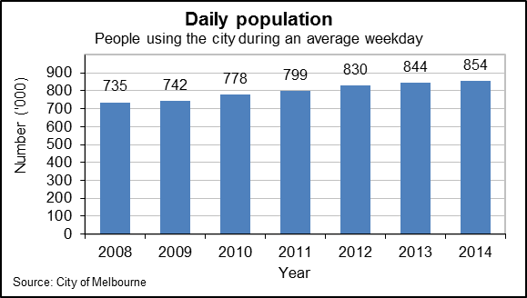
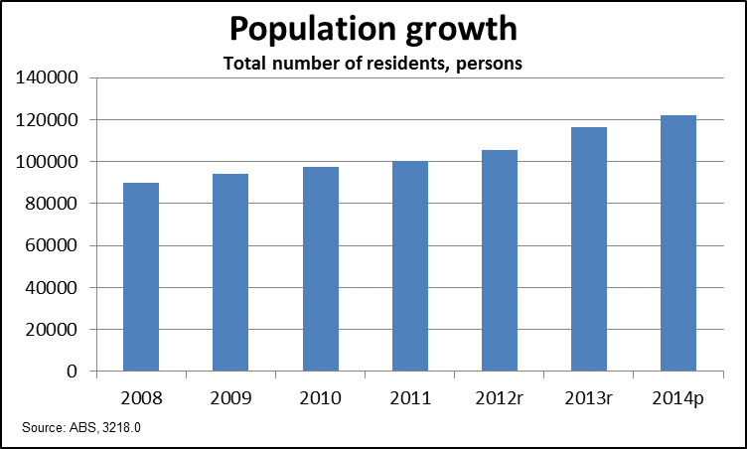
Notes: r = revised (12 months after initial release, but not final); p = preliminary figure (to be revised in 12 months time and then again after the next census).

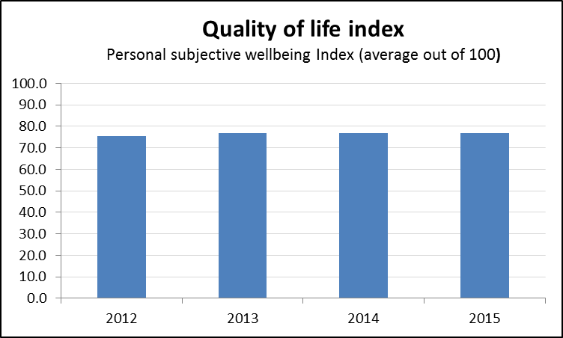
There is an opportunity for the City of Melbourne to engage with the Australian Government and specifically with its Cities and the Built Environment portfolio. The definition of a productive, sustainable and liveable city must be agreed across all levels of government. New ways of communicating and collaborating across government also need to be explored.
The municipality’s growing population with a signifiant proportion of ageing people presents significant policy challenges for all levels of government.
Comprehensive and collaborating planning is vital for maintaining the living and quality of life in Melbourne.

A great place to live
As a city for people, Melbourne will be a great place to live, with a strong sense of community and a welcoming, supportive atmosphere. Melbourne will prosper because our municipality is a great place to live. We will take up local job and business opportunities and will make use of local recreational and cultural facilities. Sustainability will be part of our everyday lives.
Future Melbourne 2008
The City of Melbourne's residential population grew substantially (36 per cent) from 2008 to 2015. According to the current forecast (Geografia 2015), the number of people living in the municipality is likely to exceed the Future Melbourne 2008 target of 140,000 in 2020, by around 6,500 residents. The proportion of the daytime population who live in the municipality has remained fairly stable since 2007. The proportion of residents who also work in the municipality also remained stable from 2001 to 2011.
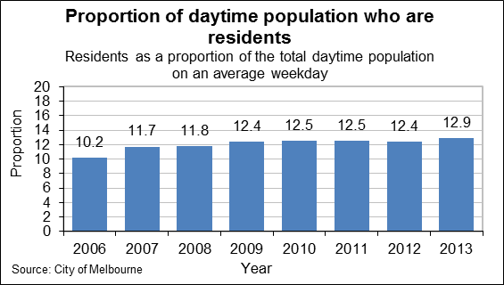
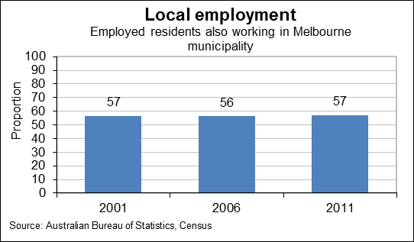
City of Melbourne actions and initiatives to make the municipality a great place to live include:
- We launched the Beyond the Safe City Strategy 2014–17, marking an innovative step in the City of Melbourne’s community safety journey. This strategy addresses the underlying causes of safety issues, not just management of their impact. It merged the previous Strategy for a Safer City and Melbourne’s Policy for the 24 Hour City.
- We are partners in a whole-of-government strategy for delivery of initiatives in and around Docklands to improve its liveability that is now underway.
- The City of Melbourne manages more than 500 hectares of open space (almost 15 per cent of the municipality’s total area) and this space plays an important role in what makes Melbourne so liveable.
- The City of Melbourne Grants and Sponsorship Program puts power back into the hands of the community to enliven the municipality with diverse arts and cultural activities. It encourages physical activity and improved life for our community.
- We developed a streetscape evaluation framework (2010–11) to prioritise streetscape renewal projects across the municipality. The framework balances the streetscape infrastructure needs of private vehicles, public transport, bicycles, motorbikes and pedestrians. A revised Asset Management Policy and Asset Management Strategy (2010–11) were also developed to support this framework.
- The City of Melbourne adopted new commercial waste standards in December 2009. This assists in achieving a cleaner, more welcoming city. All waste companies now meet their legal requirements. Enforcement of the updated waste laws began on 1 July 2010.
- On 28 July 2015, the Council endorsed The Queen Victoria Market Precinct Renewal Master Plan that sets out a plan and vision for its revitalisation. It identifies a range of priority improvements with a strong focus on improving the trader, customer and community experience. The next step in the renewal project will be development of an implementation plan, with first works expected to start in mid-2016.

Inclusive community
As a city for people, Melbourne will be an inclusive community that responds to different voices, needs, priorities and rights. The contributions and potential of Melburnians and visitors is realised and all community members have access to the city's services, facilities, events and activities. In a city for people, individuals with diverse backgrounds, ages and abilities can participate freely and respectful consideration for others is a way of life.
Future Melbourne 2008
According to the 2015 City of Melbourne social indicators survey, the municipality’s population sees the value of celebrating diverse cultures.
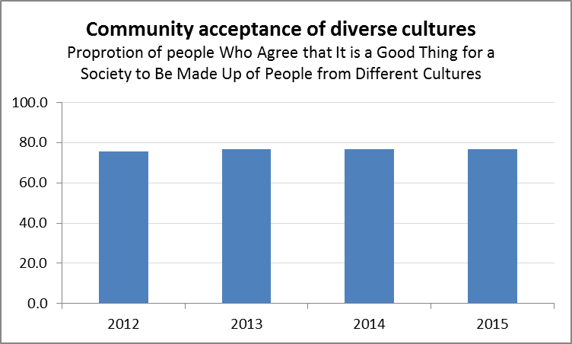
City of Melbourne actions and initiatives to build an inclusive community include:
- We developed and implemented the Melbourne for All People 2014–17 strategy that consolidates and progresses four previous plans:
  - Our Melbourne, Disability Action Plan 2010–13
  - The Children’s Plan, My City and Me – Children’s Voices 2010–13
  - Empowering Young People, The Young People’s Policy 2010–13
  - Lifelong Melbourne, City of Melbourne’s Positive Ageing Strategy 2006–16.
- We delivered physical recreation programs and services targeting under-represented groups and those with low physical activity, and conducted a gender-equity audit of selected City of Melbourne facilities.
- We implemented the Disability Action Plan 2010–13, to lead the systemic removal of barriers in the physical, attitudinal and informational environments and provide a truly just and inclusive community for all.
- We provided funding to organisations that support people experiencing homelessness, ranging from those that provide meals to young homeless people to those that provide a centralised support service.
- We launched the Your City Your Space online forum designed by and for young people. This forum ran for 6 weeks and had over 2400 unique visits. Five priority issues and solutions identified by young people were delivered by the City of Melbourne from 2010 to 2012.
- We developed the new Pathways: Homelessness Strategy 2014–17 which underscores our commitment to working with key partners to provide support services and create pathways to improve employment and training opportunities, access to health services and supported, secure housing.
- We Implemented a number of priorities in our Reconciliation Action Plan 2015–18 and Indigenous Heritage Action Plan 2015-18, including the Tunnerminnerwait and Maulboyheenner monument.
- A high proportion (89%) of City of Melbourne customers surveyed in 2014–15 who participated in our programs (including planned activities, child care services, recreation and leisure centres, student programs and parent support) reported they felt more a part of their community (excluding those who responded ‘don’t know’), which is a stable result compared with previous years.

A healthy community
As a city for people, Melbourne will make health a priority. Improving the physical and mental health of our people is important, and we will give particular attention to those in our city who are disadvantaged and vulnerable.
Future Melbourne 2008
Just over 60 per cent of residents who participated in the 2015City of Melbourne survey considered themselves healthy (their health was ‘excellent’ or ‘very good’). No clear trend can be observed based on data collected since 2012.
City of Melbourne actions and initiatives to build a healthy community include:
- Our Active Melbourne program encourages all residents, city workers and visitors to be active regardless of age, gender, culture or ability. The City of Melbourne’s North Melbourne Recreation Centre and Melbourne City Baths were accredited as two of the ten Lifesaving Victoria platinum pools in 2015.
- The municipality is rich with local community facilities including the North Melbourne Community Centre, the Kensington Community Recreation Centre and the Carlton Senior Citizens. These centres are home to community activities such as soccer, community groups and children’s activities.
- The Green Light Eat Right program helps food outlets (including vending machines) improve the nutritional value of their menus and enable better food choices. The program was piloted in 2014–15 at the Queen Victoria centre and was adapted and applied at the North Melbourne pool, Carlton Baths and the Kensington Community Recreation Centre.
- The 10-hectare JJ Holland Park in Kensington has transformed over the past five years with more space, new trees, the world’s first AFL-Cricket Australia-standard synthetic sports field, a refurbished pavilion, new paths, jogging track and an upgraded BMX track.
- We updated sporting facilities at Flemington Road Oval in Royal Park and Princes Park in 2013. A reconstructed playing field has reopened at the Flemington Road Oval and a new pavilion and sports lighting will be added to enable year-round use. The Princes Park sports area reopened for winter and now has seven soccer fields and four cricket pitches with sports lighting.
- The unveiling in March 2015 of reinstated parkland on the site of the former Royal Children’s Hospital marked a new lease of life for Royal Park, Melbourne’s largest inner-city park. Complementing the surrounding native Australian landscape is a new children’s nature-based play area, with indigenous-themed plant and park structures representing the seven Wurundjeri seasons.
- In 2014, almost all (96 per cent) of the municipality’s population lived within a 300-metre radius of public open spaces and publicly-accessible private outdoor space.
- A high proportion (89%) of customers who participated in the 2015 City of Melbourne survey reported the information they received helped them lead a healthier lifestyle and 95 per cent reported the support they received helped them lead a healthier lifestyle.

Designed for people
A Melbourne designed for people will be a municipality designed at a human scale. In Melbourne, we will be protected and will feel welcome. We will want to walk – and stay – in Melbourne because it delights us.
Future Melbourne 2008
According to the quality of life index in the three annual City of Melbourne surveys (2012–2015), the average level of life satisfaction remains high at over 75.
City of Melbourne actions and initiatives to achieve a city designed for people include:
- Our District Precinct Program supports the work of local business associations to market their special part of Melbourne. Through partnership with the Victorian Government, the District Precinct Program has generated investment in new infrastructure to celebrate Melbourne’s Chinatown around Little Bourke Street, the Greek precinct in Lonsdale Street and Italian influences in Lygon Street.
- Major infrastructure initiatives completed over the last three years include:
  - The Carlton Baths Community Centre and Carlton Family Resource Centre were revitalised.
  - The Kensington Town Hall opened to the public in February 2015 after a substantial reconstruction to provide community meeting space, function rooms and training spaces.
  - The new Kathleen Syme Library and Community Centre opened in Carlton in July 2015.
  - The Queen Victoria Market Master Plan engagement process was finalised in 2015.
  - The Library at the Dock opened in 2014 and the new Docklands Community Boating Hub and Family Services Centre will open in early 2016.
- The population living within a 20-minute walk or 800-metre radius of community facilities has been maintained since 2008 and the population living within a 300-metre radius of open spaces, including parks and reserves, sports fields and outdoor recreation areas, squares and publicly-accessible private outdoor space has remained stable at 96 per cent.

An affordable place to live
As an affordable place to live, Melbourne will provide affordable accommodation, food and services. Our municipality will offer a mix of housing and facilities, reflecting and supporting our diverse and inclusive community.
Future Melbourne 2008
The proportion of flats and apartments in the municipality increased from 78 per cent of all housing in 2002 to 83 per cent in 2010. The proportion of renters and mortgagees paying less than 30 per cent of their income on housing in the municipality declined from 2001 to 2011, down from almost 61 per cent (2001) to an estimated 53.5 per cent (City of Melbourne, Trends and Melbourne, 2015). This indicates it is becoming more expensive to live in the municipality.
City of Melbourne actions initiatives and outcomes that have helped provide affordable housing include:
- Develop and implement the Housing Strategy, Homes for People 2014–18. The strategy has three key goals:
  - Contribute to providing at least 1721 affordable homes (subsidised) for low and moderate income earners.
  - Improve the design quality and environmental performance of new apartments.
  - Foster a high level of awareness and knowledge around good housing outcomes.
- The Council is also exploring the proposal to require that 15 per cent of dwellings constructed on land that it owns is made available as affordable housing, and is managed by a registered Affordable Housing Provider.

Quality public space
As a city for people, Melbourne's public spaces will be of a high quality. Our public spaces will be welcoming and secure, generating a sense of place and belonging. Through quality design, our public spaces will encourage connections between people and with nature. We will include sustainable design features in our public spaces and they will be easy to get to and move around in.
Future Melbourne 2008
With growing numbers of people coming to the city to live, work and visit, the ratio of people per hectare of open space is increasing. The City of Melbourne manages more than 500 hectares of open space. This represents almost 15 per cent of the total area of the municipality.
City of Melbourne actions initiatives that have provided more quality open space include:
- The Urban Forest Strategy (2011) will increase the city’s tree canopy cover from 22 per cent to 40 per cent, cultivating an urban forest that will comprise no more than 5 per cent of an individual tree species and achieving a tree population that is 90 per cent healthy by 2040. To increase canopy cover, the City of Melbourne is planting 3000 trees each year.
- The first Open Space Strategy (2012) was developed to meet the needs of the growing and changing residential and worker population and address open space planning and development in the city for the next 15 years. The strategy identifies areas for the creation of an additional 24 hectares of open space. A further key initiative is to develop Melbourne’s open space network where people can be within easy walking distance (300 metres) to public space, particularly in the areas experiencing population growth. New public open spaces include Errol Street Park in North Melbourne which has added over 4500 square metres of green space to the neighbourhood.
- In May 2015, the Council submitted Planning Scheme Amendment C209 to the Victorian Minister for Planning for approval. This amendment sets contribution rates of 5 per cent and 7.06 per cent for new developments, as either a percentage of the site value, a land contribution or a combination of these.
- Southbank Boulevard and Dodds Street will transform as traffic is shifted to create 2.5 hectares of public space. The first phase of community engagement for Transforming Southbank Boulevard occurred in November and December 2015.

Community facilities and services meet growth
Melbourne will provide the facilities and services needed to ensure our community is a strong one. Our facilities and services are assets that contribute to our health and happiness, encouraging people to meet, collaborate and participate. Melbourne's facilities and services will reflect our commitment to sustainability, and will keep pace with a growing population.
Future Melbourne 2008
Melbourne’s population is growing quickly and the City of Melbourne’s challenge is to ensure that appropriate community infrastructure is funded and delivered to accommodate community needs.
City of Melbourne actions and initiatives to provide more community facilities and services include:
- New generation community facilities were developed that integrate a range of services into a single local hub, including the:
  - Library at the Dock and new family services hub in Docklands (2015)
  - Boyd Library and Community Hub in Southbank (2014)
  - Kathleen Syme Library and Community Centre in Carlton (2013)
  - Carlton Baths Family Resource Centre in Carlton (2013)
  - Kensington Town Hall in Kensington (2015).
New facilities are being located in or near the high-growth areas of the municipality.

A creative city
A creative city allows for and encourages risk taking and initiative. It embraces Indigenous history and culture, builds on its heritage and its freedom, and allows people to experiment and innovate. It is bold and inspirational, fostering uniqueness and invention, and demonstrating leadership.
Future Melbourne 2008

Overview
Melbourne's creative industry is vibrant, and ranges from state-of-the-art film studios at Docklands to fashion design, record labels, songwriters and web designers. In 2012, there were 251 businesses and organisations in the creative industries sector and they provided 4,892 jobs. The sector has total output of $2.06 billion and contributes $988 million in Gross Local Product to the municipality’s economy.
The City of Melbourne encourages and facilitates participation in artistic expression and supports experimentation to inspire innovation and a sense of wonder. Importantly, we celebrate our rich Aboriginal and Torres Strait Islander history and culture and protect and respond to our city’s heritage.
There is high participation in arts and cultural activities in the City of Melbourne.
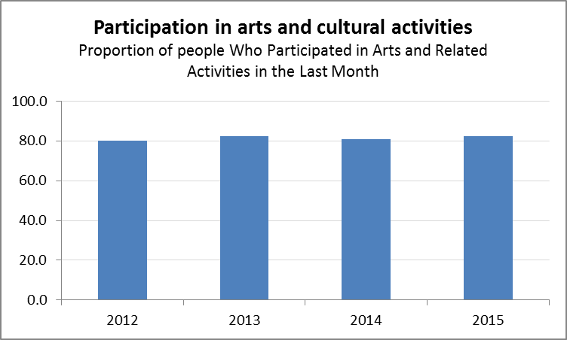

Creative risk taking
Melbourne as a creative city will take risks to break new ground. We will be bold and inspirational in our encouragement of the creative and the enterprising. We will fuel the imagination of all.
Future Melbourne 2008
The arts industry is a major employer of artists and more than 14,000 artists are employed each year through City of Melbourne grant programs. These grant programs also help employ cleaners, designers, promoters, producers, event support staff and countless others.
City of Melbourne actions initiatives that have contributed to creative risk taking include:
- Delivery of major events including Moomba Festival, Melbourne Music Week, Melbourne Spring Fashion Week and New Year's Eve. The City of Melbourne’s role in the events industry is through managing major events and also supporting other event organisers.
- Our Creative Spaces program assists artists and arts organisations to move to, or stay within the municipality, and provides advice to artists, arts organisations and building owners and also manages the Creative Spaces website.
- The Creative Spaces program also manages the Boyd Community Hub in Southbank, which provides 25 studios, along with the River Studios warehouse that provides work space for up to 75 artists and the Meat Market which accommodates 30 arts organisations. Other achievements under the program include the launch of the Carlton Connect LAB14 Studio artist-in-residence space in partnership with the University of Melbourne and the refurbishment of The Dirty Dozen exhibition space in Campbell Arcade beneath Flinders Street. A current focus of the program is providing a new cluster of studio and creative retail spaces at the Guild in Southbank.
- The Creative Spaces program also created a website to connect people to spaces across Australia. Currently there are 897 spaces listed.
- As part of the Victorian Government’s White Night Melbourne event in 2014, around 9000 people walked through the Melbourne City Baths building over 12 hours to witness a spectacular display of synchronised swimming in the lap pool to music and lighting.
- Arts House was established as a national and international centre for contemporary performing arts, and develops and presents risky and experimental practice by emerging and established artists from disciplines including dance, performance, live art, digital and participative practices. Arts House provides opportunities for artists through open call outs for presentation and the development of expressions of interest, and through programming Dance Massive, the Festival of Live Art, Undone and Going Nowhere festivals. Nearly 5000 people visited the Dance Massive festival over 12 days in April 2015, with Arts House selling out six of nine show seasons. Two of Arts House’s sustainability events, Going Nowhere and Reach Out Touch Faith (as part of Going Nowhere) were recognised in Victoria’s respected Green Room Awards for outstanding achievement in the performing arts.

Vibrant, creative community
Artistic and cultural life will be integral to Melbourne as a creative city. In our creative city of the future, ideas-driven industries, groups and individuals will be interwoven: sharing, inspiring and creating together. Local groups and individuals will be drawn to our many creative endeavours, making a vibrant, creative community.
Future Melbourne 2008
“Melbourne is rightly recognised as Australia’s cultural capital. It enjoys a well-recognised international brand...” (The Creative State Global City, Creative Industries Taskforce Report (report to the Victorian Government to inform the development of the state’s first creative industries strategy, November 2015)
City of Melbourne actions and initiatives to create a vibrant, creative community include:
- We encouraged the city community to participate in creativity through a range of programs including the ArtPlay program for children and families, the Signal art studio for people aged 13–25 years, the Arts & Participation program that connects artists with people who do not usually engage with the arts, and the recently refreshed Public Art Melbourne program that supports and encourages artists to contribute to the public space.
- During 2014–15, there were 351,700 visits to the Creative Spaces website and 101,400 people attended Arts Melbourne events. The City of Melbourne’s Annual Report 2014–15 highlighted that nearly half of all participants in the municipality’s arts and cultural programs were engaging with them for the first time.

Celebrating diversity
As a creative city, Melbourne will celebrate its diversity. Melbourne will build communities in which difference is valued and respect and tolerance are paramount. Melbourne will find connections with one another through our differences as well as our similarities. Our diversity will drive innovation and prosperity.
Future Melbourne 2008
Ninety one per cent of residents, workers, visitors and students surveyed agree the City of Melbourne is an artistic and cultural city (City of Melbourne 2014–15 Annual Report).
Forty-eight per cent of the municipality’s residents were born overseas. Residents identify with 207 ancestries that residents in the City of Melbourne affiliated with, along with 138 overseas countries of birth and 121 languages spoken at home other than English (2013 Multicultural Community Demographic Profile, City of Melbourne).
City of Melbourne actions and initiatives to celebrate diversity include:
- The City of Melbourne was the first local government in Australia to register a Reconciliation Action Plan with Reconciliation Australia in 2006.
- We developed our third Reconciliation Action Plan 2015–18. Councillors, executives and senior managers collaborated to identify potential action plan initiatives and explore opportunities for their integration as core organisational priorities.
- Our Aboriginal Heritage Action Plan 2015–18 continues to build on the achievements of the previous Indigenous Heritage Action Plan 2012–2015 and focuses actions into three key themes: conservation, celebration and collaboration.
- We delivered the Indigenous Arts Program encouraging Indigenous participation and contribution to the cultural diversity of the municipality. In 2009–10, Indigenous choreographer Jacob Boehme was awarded the annual Indigenous Arts Mentorship and is currently being mentored by Melbourne’s leading contemporary dance company Chunky Move under the guidance of Artistic Director Gideon Obarzanek. The Blak Nite Cinema, an Indigenous film event held over two nights in the Treasury Gardens, continues to attract a diverse and growing audience.
- ArtPlay further developed its highly popular annual program to enable a wide demographic of children and families to participate in high-quality activities. Over 30,000 adults and children attended ArtPlay’s 336 workshops and performances and 78 days of free exhibitions and schools workshops.
- We partnered with Arts Access and the University of Melbourne to deliver a symposium entitled Beyond Access at the Melbourne Brain Centre. Discussions focused around research investigating the creative case for inclusion of artists with disabilities. Chair of Arts Access Victoria, Margherita Coppolino delivered a strong message advocating inclusion.
- The City of Melbourne Chief Executive Officer is a member of the national program, Male Champions of Change to support gender diversity and equality.

Prosperity through creativity
As a creative city, Melbourne will celebrate its diversity. Melbourne will build communities in which difference is valued and respect and tolerance are paramount. Melbourne will find connections with one another through our differences as well as our similarities. Our diversity will drive innovation and prosperity.
Future Melbourne 2008
Historically, the creative sector makes up about 4 per cent or less of the municipality’s total employment.
City of Melbourne actions and initiatives to facilitate a creative city include:
- In 2010, we launched Melbourne’s first creative arts studio dedicated to people aged 13–25 years. Called ‘Signal’, it provides opportunities for young people to work with professional artists across all art forms and is a place for making, showing, inspiring and developing our city’s new creative talents in every medium. The studio also has a workshop space, a multi-purpose space, a computer and multimedia hub, a plaza for live events and an 18-speaker sound wall for sound-based artworks. Over 5000 young people engaged in the Signal program in its first six months working with a wide range of artists, community and arts organisations.
- We launched our Arts Strategy 2014–17 to encourage a thriving creative economy where artists are supported to contribute to the city through strategies of connection, activation, spaces, funding, recognition and heritage. In the strategy’s first year (2014) over 20,000 artists were supported by Arts Melbourne programs, over 5,000 events were supported or delivered across the municipality and more than 6 million people attended events the City of Melbourne presented or supported.
- In 2014–15, approximately 12,500 artists sought our support, a little down from 14,052 the previous year. Factors that account for this include an unusually large number of applicants coinciding with the triennial arts grants and Indigenous Arts Festival (biennial only), plus the review of the public art program.
- Of the more than 820,000 people surveyed who participated in selected City of Melbourne activities during 2014–15, nearly half reported engaging in these for the first time, up 12 per cent from last year. The 2014–15 survey respondents include a slightly broader range than last year, including those who participated in Melbourne Spring Fashion Week, Melbourne Music Week, New Year’s Eve and Moomba Festival. The 2013–14 survey included participants from ArtPlay, the ArtsHouse program, Organ Program, Arts and Participation Program as well as Melbourne Conversations (which was not included in the 2014–15 survey).

A prosperous city
In a prosperous city, entrepreneurs and businesses thrive and people share their wealth. A prosperous city has a global focus with state of the art infrastructure and services, a highly skilled workforce and affordable business accommodation. A prosperous city shares its knowledge and mentors emerging businesses. It promotes connections and collaborations and attracts global investment and visitors. A prosperous city is stimulating and safe with a vibrant calendar of national and international sporting and cultural events.
Future Melbourne 2008

Overview
The municipality’s economy has experienced steady employment growth, despite the global financial crisis and slowdown of the mining economy in Australia. According to the latest results of the City of Melbourne Census of Land Use and Employment (CLUE), there are just over 450,000 jobs provided in the municipality.
Significantly, the gross local product measured by the City of Melbourne in 2012 showed a 22.5 per cent increase from 2008. This would have contributed to the increase in the number of jobs.
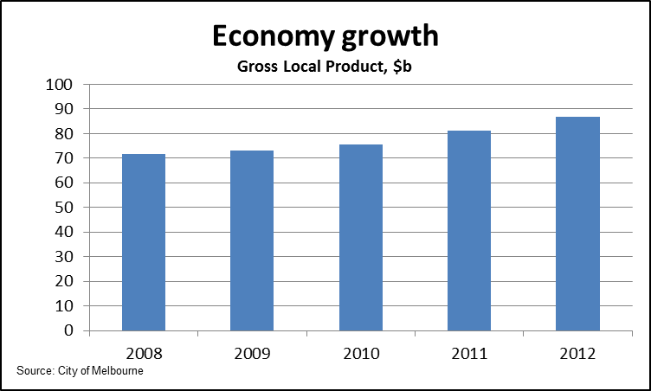
Building prosperity together incorporates all of the City of Melbourne’s business development activities including investment, social integration, multi-purpose infrastructure, sustainable transport, smart technology, recruitment and retention of skills and talent. It includes partnerships with the private sector and a program for growing and evolving our population.
The City of Melbourne was selected from 372 applications around the world to be among the first wave of 33 cities to join the 100 Resilient Cities network. The aim of the network is to help cities around the world become more resilient to present and future physical, social and economic challenges.
Capital cities are usually the economic hub of a state. The City of Melbourne is no different. Continued population growth will impose significant infrastructure demands essential for maintaining the municipality’s prosperity.
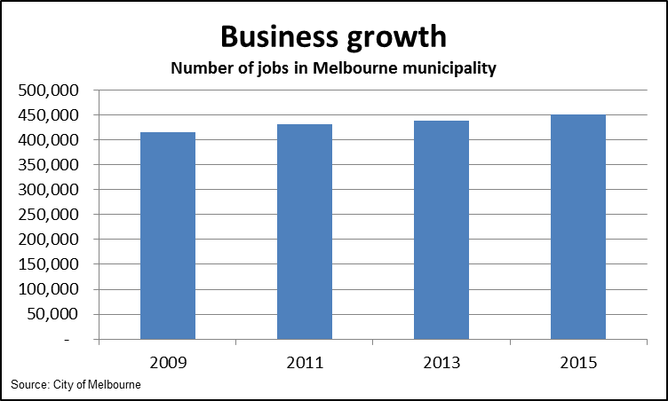
A clear developing trend is the emergence of the sharing economy and introduction of new business models. For exmaple, new corporate social enterprises, start ups and other entrepreneurial businesses are changing the shape of how producers, consumers and society operate. The municipality is being exposed to these forces and will have to adapt if the City of Melbourne is to retain the community’s goal of Melbourne being a bold and inspirational city.
Similarly, connections with other Australian states and territories and with international markets will create enormous opportunities for the City of Melbourne. How should the municipality position itself to harness these opportunities?

A global city
As a prosperous, global city, Melbourne will be influential in the world network of global cities. As a global city, Melbourne will attract global investment, compete in world markets and participate in global issues. Melbourne's knowledge industry will attract a skilled and talented workforce from around the world and support a diverse range of leading international, national and local businesses. Melbourne will connect with the world through state of the art transport and telecommunications infrastructure.
Future Melbourne 2008
In 2013, Melbourne ranked 20th (of 120 cities) in an international assessment of future level of competitiveness by 2025 (Hot Spots 2025, Benchmarking the future competitiveness of cities, Economist Intelligence Unit 2013).
City of Melbourne actions and initiatives to make Melbourne a global city include:
- We worked closely with the Victorian Government through its global network of Victoria Government Business Offices. We also worked with the Australian Government through diplomatic and Austrade posts to establish and build on local and international business relationships and to influence and advocate for new business opportunities for Melbourne.
- We built our connections with international city governments and business organisations through networks such as the Business Partner City Network.
- We commissioned the ASEAN engagement strategy (KPMG-Asialink 2014) to identify opportunities for Melbourne-based businesses in key industry sectors. The study focused on the ASEAN countries, which also have city members of the Business Partner City Network. Three focus cities identified for further investigation include Singapore, Kuala Lumpur in Malaysia and Bandung in Indonesia.
- The Lord Mayor led missions to key international markets of China and Japan once every two years. The enterprise Melbourne Office Tianjin is the only business representative office operated by an Australian capital city in China. It supports Melbourne-based businesses and facilitates inbound business and investment missions from Tianjin to Melbourne. Quarterly high-level consultation hosted by the Lord Mayor and consultation with CEOs from financial services-insurance, business services-consulting, Docklands businesses, life sciences / bio-technology, music industry, retail, mining and resources.
- We targeted in-bound business missions to showcase Melbourne’s capabilities in automotive design (India) and 100 Smart cities (India) urban design and sustainability.
- We established the Enterprise Melbourne high-level advisory board and website business portal.
- The City of Melbourne is a member of the C40 network of the world’s megacities committed to addressing climate change.
- Melbourne was among the first 33 cities selected from 372 global applicants to join the 100RC network.100 Resilient Cities (100RC) aims to help cities around the world build their resilience to the physical, social and economic challenges of today and future.
- We released Resilient Melbourne’s Preliminary Resilience Assessment reports on Phase I of the Resilient Melbourne project, which is part of the Rockefeller Foundation’s 100RC initiative. While the City of Melbourne is the sponsor of Resilient Melbourne and the publisher of this report, the project has involved collaboration across 31 of Melbourne’s local government areas and will continue its work with them.

A stimulating and safe 24 hour city
As a prosperous city, Melbourne will be a stimulating and safe 24-hour city in which people enjoy spending time. The city will enable a mix of activities for all ages and backgrounds including retail, entertainment, business, culture, sport and more as it operates around the clock. These activities will be well-managed, balancing security with the pleasures of exploration and discovery.
Future Melbourne 2008
While the highest proportion of overall offences committed in the municipality relate to property and deception, crimes against the person have remained steady and public order and security offences have fallen. These two categories are important indicators of public safety.
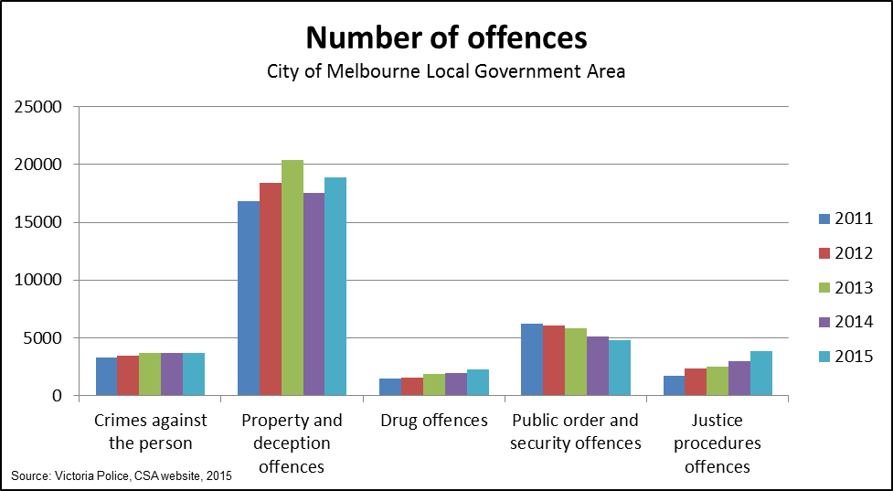
City of Melbourne actions and initiatives to make the city safer include:
- We deployed two security vehicles fitted with 360-degree CCTV surveillance cameras to patrol Melbourne streets during January and February 2010, adding to our 54 safe city cameras. More than 1000 on-the-spot arrests were made based on footage captured and provided to police. All recorded vision is managed in accordance with the City of Melbourne’s safe city camera usage protocols for compliance with privacy provisions.
- Initiatives to improve safety for in the city late at night included installing three enhanced safe city taxi ranks at Queen Street, Flinders Street Station and St Kilda Road in 2015 so that passengers wait in a well-lit, secure area.
- We convened residents, business owners, academics, students, professionals and visitors from across Australia to explore how to go beyond being a safe city to become the most vibrant, safe and welcoming city in the world. Their insights informed the Beyond Safer City Strategy 2014–17.
- Melbourne outbid competitor cities to secure hosting rights for major conferences, including but not limited to the 2016 Conference on Innovative Smart Grid Technologies – Asia; the 15th World Congress of Epidemiology in 2017; the 17th Triennial International Convention of Inner Wheel – Women of Rotary in 2018; and the 2021 Congress of the International Commission on Occupational Health (ICOH). Events like these help support the local economy and reinforce the municipality’s role in global knowledge networks.

Attractive for new businesses
As a prosperous city, Melbourne will be a place for the creation and growth of new businesses. Its affordable accommodation and accessible facilities and services will attract new businesses to operate from the city. The way business is done is changing and as a prosperous city, Melbourne will adapt to accommodate emerging trends and business models.
Future Melbourne 2008
From 2008 to 2012, the municipality’s economy grew over $15 billion and added 30,000 new jobs.
City of Melbourne actions and initiatives to generate and support new business growth include:
- We provided grants to small business to support them with businesses new to Melbourne and to establishing co-working spaces for start-ups as well as incubators such as Open Hub (2007), York Butter Factory (2011), Electron Workshop (2011), The Difference Incubator (2013) and creative small businesses in the Kensington Wool Stores hub.
- We developed our first Social Enterprise Strategy in 2010 to map the City of Melbourne’s role in supporting this emerging sector. The Social Enterprise and Microbusiness Grants were introduced in 2011 with 16 grants provided to date worth approximately $350,000. We also undertook a Social Enterprise Sector Engagement Study in 2015 in the lead up to the development of the next Social Enterprise Strategy. The Council has sponsored the Social Enterprise Conference for the past two years in Melbourne.

Supportive of business
As a prosperous city, Melbourne will help its businesses grow through identifying priority sectors and enterprises and ensuring they receive appropriate information, services and support. Melbourne will also facilitate business connections and access.
Future Melbourne 2008
Melbourne’s CBD attracted the highest ever rates of investment in the nation in 2014 and 2015, with commercial office sales in 2014 totalling almost $3 billion. This is compared with average total commercial office sales in the CBD grid of $1 billion per year over the last decade.
City of Melbourne actions and initiatives to support business and industry growth include:
- We released a new economic development framework, Building Prosperity Together, to support businesses to capitalise on future opportunities in key industry sectors including retail and hospitality.
- We hosted four business breakfast forums, four precinct forums for city traders and four Melbourne Retail and Hospitality Board meetings in accordance with our Melbourne Retail and Hospitality Strategy 2013–17. The strategy is being implemented in partnership with the Victorian Government.
- We launched the Enterprise Melbourne Twitter account in 2013, which now has 1800 followers. The monthly Enterprise Melbourne newsletter has 800 subscribers.

An events city
As a prosperous city, sporting, cultural and business events attract investment, stimulate the economy and contribute to Melbourne's international reputation and brand. Melbourne will use sports, cultural and business events as a platform for economic growth and prosperity.
Future Melbourne 2008
The Melbourne municipality hosts over 8000 festivals, exhibitions and events each year. In 2015, the economic impact generated by City of Melbourne premier events was approximately $46 million. Major events include Moomba Festival, Melbourne Music Week, Melbourne Spring Fashion Week and New Year's Eve.
City of Melbourne actions and initiatives to create an event city include:
- We created and supported a diverse range of activities branded as ‘Uniquely Melbourne’ events to provide a positive profile and social legacies for Melbourne. Fourteen major events received Triennial Sponsorship Program funding of $1.6 million in 2015. Approximately 100 event partnership program (EPP) events received funding of $1.1 million.
- We reviewed our Triennial Sponsorship Program (TSP) and strengthened its focus on economic prosperity and free public events and activities. The EPP is now being refined. We issued over 1000 permits in the municipality including for new events such as White Night and the Night Noodle Market.
- The City of Melbourne’s Event Permit team worked with diverse event organisers and managed public spaces to showcase the city, making it a compelling place for people to visit, live and do business. New major events, new public spaces and new styles of events were introduced. We developed an Event Filming guide adopted by Film Victoria.
- We delivered an annual suite of ‘Uniquely Melbourne’ Premier Events to generate social and economic benefits for Melbourne.

A great place to visit
As a prosperous city, Melbourne will be a great place to visit. We will welcome all international and domestic leisure, business and student visitors. We will be dynamic, engaging, accessible and welcoming. As a great place to visit, we will offer diverse experiences that are easy to find and fun, encourage participation and help people to connect.
Future Melbourne 2008
In the year ending September 2015, the municipality received an estimated 11.3 million visitors. Of this total, around 5.3 million were domestic daytrip visitors, 4.4 million were domestic overnight visitors and 1.5 million were international overnight visitors. They spent an estimated $8.3 billion in the Melbourne municipality for the same time period (International and National Visitor Surveys, Tourism Research Australia, September 2015). Tourism accounts for 4.3 per cent of all economic activity within the municipality (Deloitte Access Economics Analysis 2015).
Melbourne has rated number one by Australians for a variety of attributes including sport, culture, major events, shopping, theatre, restaurants, cafes and bars and interesting and diverse streets and precincts (Tourism Brand Health Survey, Roy Morgan Research 2014).
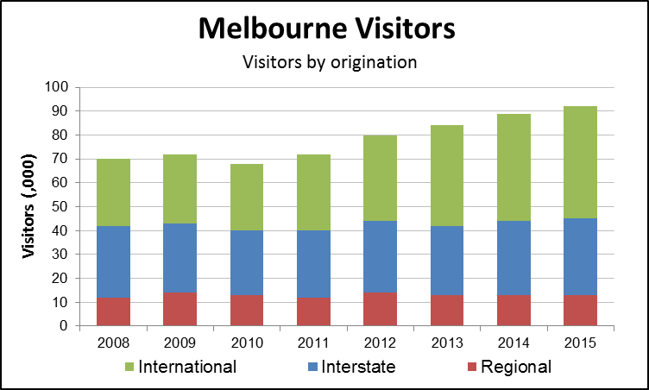
City of Melbourne actions and initiatives to improve the visitor experience include:
- We operate a volunteer workforce of more than 400 individuals, collectively known as the ‘red coats’ to work within our Business and Tourism Melbourne Branch across seven programs: City Ambassador Program; Cooks’ Cottage; Cruise Ship Program; Melbourne Visitor Centre; Melbourne Visitor Booth; and Melbourne Greeter Service. The work of volunteers in encouraging visitors to see more, do more, stay longer and spend more in the municipality is highly valued by our businesses, arts and cultural institutions and attractions.
- We researched how to better identify current and future information preferences of visitors. The research now forms the basis of our draft Tourism Action Plan: 2016–19 that will guide future provision of visitor information.
- We conducted a study into the route, stops, connections and visitor infrastructure needed to support improved water transport services. This has contributed to more efficient and effective delivery of tourism infrastructure, information, planning, supply and communications.

A philanthropic culture
As a prosperous city, Melbourne will have a culture of philanthropy, where businesses invest in building strong, robust and equitable communities. A prosperous Melbourne will invest and participate in community initiatives and supports employee community activities.
Future Melbourne 2008
While there is an absence of data on the total dollar value of philanthropy, around 43 per cent of the municipality’s residents reported they helped out as a volunteer in 2015.
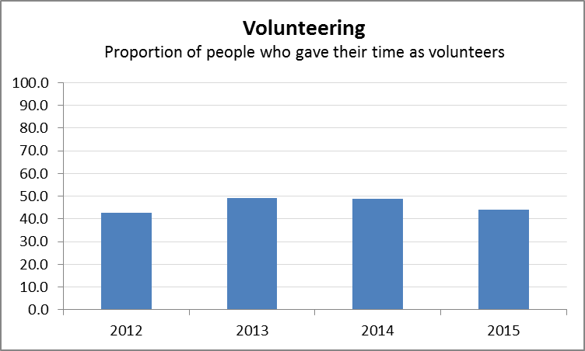

City of Melbourne actions and initiatives to help build a philanthropic culture include:
- In July 2010, the Future Melbourne Committee endorsed the Social Enterprise Strategy to support the development of the emerging social enterprise sector. The Social Enterprise Strategy builds the capacity of partner organisations to contribute to social enterprise in the city. Enhanced social enterprise will assist people to move from dependence and welfare to independence and enterprise. Social enterprises can potentially provide a range of social and cultural benefits in addition to their contribution to economic prosperity.
- We invested in our emerging younger artists with seeding grants of up to $5000 to assist them to create work and activate the city. City of Melbourne is the only local government authority in Australia with a dedicated funding program for young artists. This program supports emerging artists aged up to 26 years who have not previously received arts funding. In 2009–10, a total of 48 young artists were supported. Many of these projects and artists participated in major events including the Next Wave, Fringe and Comedy festivals.
- We facilitated funding partnerships through our Arts House Special Projects such as the Black Arm Band. A combined total of $1.9 million in external funding was secured, primarily from partnerships with the Fred Hollows Foundation, Playing Australia, Major Festivals Initiative, Melbourne International Arts Festival, Vic Health, British Council, Arts Victoria and the Australia Council for the Arts.

A knowledge city
In a knowledge city, the collective power of mind and experience drives the city’s prosperity, its ability to compete globally and the quality of life its people enjoy. It supports a well-resourced education and scientific research system producing a highly skilled and talented workforce and a culture of innovation. It has a vibrant, collaborative and city-based lifelong learning culture. This is supported and amplified by a universal and dynamic online culture connecting its people to each other and to the world.
Future Melbourne 2008

Overview
In 2012, there were 6708 businesses and organisations employing a combined 285,762 jobs in the municipality’s knowledge sector. Its total output was $98.6 billion and it contributed $57.8 billion in Gross Local Product to the municipality’s economy.
Melbourne’s universities are integral to Victoria’s economic, social and community development. The municipality is home to the main campuses of the University of Melbourne, RMIT and the city campuses of another seven universities. Collectively, universities are among the largest employment industries in the municipality.
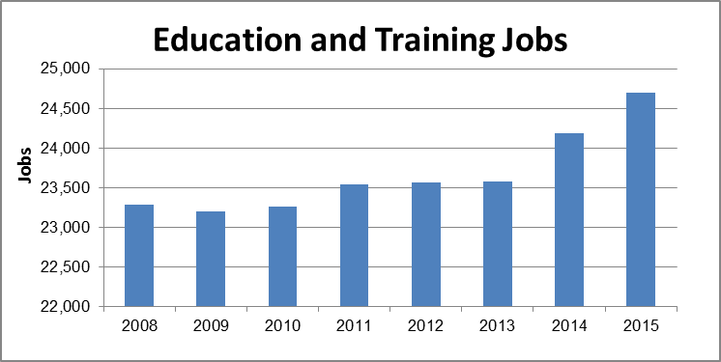
The number of people aged 15–65 years participating in formal learning in inner Melbourne remained fairly constant at around 57,000 people each year from 2011 to 2013.
The development of Melbourne as a knowledge city has long been a priority for the City of Melbourne, which is a recognised early adopter of knowledge-based development strategy.
To support the recognition and expansion of Melbourne as a knowledge city, the City of Melbourne initiated an annual Knowledge Week in 2009. Now entering its seventh year, Melbourne Knowledge Week stimulates and facilitates exchanges between businesses and the research sector to form a vibrant knowledge and innovation ecosystem, leading to new ideas and successful business ventures.
For the third time, Melbourne won the Most Admired Knowledge City Award (MAKCi) at the 2015 Knowledge Cities World Summit.
Melbourne was just the second city to be named a UNESCO City of Literature.
Parkville is the major precinct in Australia for medical and bio-scientific research, education, clinical practice, production of pharmaceuticals and biotechnology products.
The Parkville Biomedical Precinct is without parallel in the southern hemisphere and one of the few such concentrations of research excellence worldwide. The close co-location of major teaching and research hospitals, research centres and universities has created ideal conditions for science and biomedical training, partnership, collaboration and innovation.
A key driver in future will be the increased use of smart technology in mobile devices to drive further innovation in web-based business models. Customers will be closer to the service or product provider regardless of physical distance. How will greater use of smart technology change work patterns in the municipality and the way we enjoy life?

Generating innovation from knowledge
Melbourne will develop a broad-based knowledge culture where learning communities, the knowledge economy and innovation are valued as vital to improving our quality of life. We will draw on the municipality's diversity range of people, institutions and rich cultural assets to generate innovation.
Future Melbourne 2008
The number of enrolments in creative fields of study in the municipality remained high from 2010 to 2012.
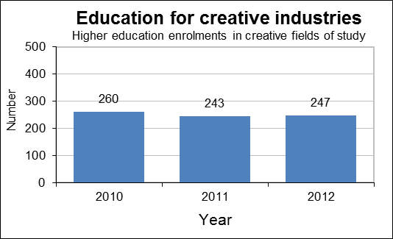
City of Melbourne initiatives that have generated innovation include:
- We launched our Knowledge City Strategy 2014–18 which outlines the City of Melbourne’s contribution to the development of the municipality’s knowledge capacity, culture and reputation.
- We supported seven external partners to deliver knowledge-related activities that attracted more than 133,000 participants.
- Our Melbourne Conversations event saw a full calendar of knowledge-related events in 2015. Around 3190 people attended Melbourne Conversations where public discussion led by knowledgeable national and international speakers was followed by audience questions. Themes ranged widely from personalised medicine to the future of housing, as well as from smart cities to indigenous knowledge.
- The City of Melbourne was awarded an IBM Smarter Cities grant in 2015. This provides access to IBM’s top consultants to improve engagement with communities during and after emergency events. The funding will be used to complement our Knowledge City Strategy and develop a resilience strategy for Melbourne.
- We launched the inaugural Melbourne Knowledge Fellowship in 2014 awarding to it Melbourne-based artist and creative technologist, Brad Hammond. This fellowship aims to enhance local knowledge and skills in the use of creative and innovative technologies by applying learning and best practice from abroad. The fellowship comprises two phases; a learning phase in an international setting and a knowledge-sharing phase at Library at the Dock.

Synergies between the city and universities
As a world class university city, Melbourne values and promotes its universities and the vital role they play in prosperity, cultural development and social life. Melbourne will strive to facilitate collaboration at all levels, promoting cross-fertilisation of ideas and disciplines.
Future Melbourne 2008
With eight universities and numerous post-secondary school institutes, Melbourne is an ideal study destination for domestic and international higher education students. It is estimated that 68,000 higher education students travelled to the city to study or undertake study-related activities on an average weekday in 2014, a growth of 11.1 per cent since 2012.
Just over 85 per cent of international students surveyed believed their involvement in our student programs, either as users and/or as volunteers in helping run events, has increased their positive experience in Melbourne.

Learning city
As a learning city, Melbourne will foster lifelong learning and a collaborative, city-based learning culture in the municipality drawing on the rich resources of the city's education, business, cultural and government sectors.
Future Melbourne 2008
The number of people aged 17–74 years in metropolitan Melbourne who participated in formal learning increased more than 36 per cent over the decade from 2001–10, from almost 296,000 to around 403,000.
City of Melbourne initiatives that have contributed to a learning city include:
- The Office of Knowledge Capital was successful in attracting the third World Knowledge Cities Summit (KCWS), held from 16–19 November 2010 at the Melbourne Convention and Exhibition Centre. KCWS was a three-day conference that saw leading academics and professionals from Melbourne, across Australia, and from other countries, come together in the one place to explore new ideas about creating knowledge cities. The conference showcased how Melbourne has progressed as a successful knowledge city and enhanced Melbourne’s reputation as a leading international knowledge city with world-class learning and research facilities and strong economic and cultural foundations.
- An increase in the number of library visitors from 1,105,276 in 2012–13 to 1,142,025 in 2015.
- We presented the 6th annual Melbourne Knowledge Week in 2015.
- More than 13,000 people participated in Knowledge Week and Melbourne Conversations events in 2014. Since we launched Melbourne Knowledge Week in 2012, events and event partners have increased attracting a combined 7,000 attendees in 2014 and 2015.
- Eighty-five percent of surveyed participants in 2014 and 2015 Knowledge Week events agreed that Melbourne Knowledge Week activities made them feel more informed about the municipality’s knowledge sector.
- In its first year of operation after opening on 31 May 2014, the Library at the Dock hosted 120,000 visitors, attracted 4000 new members, provided 160,000 loans and hosted the activities of 500 groups, organisations and individuals. Library at The Dock has won two Australian Timber Design awards for excellence in public or commercial building design and in sustainability.

Online city
As an online city, Melbourne will have universal and dynamic online culture connecting its people to each other and to the world. A high percentage of people will access the internet via their choice of high -speed broadband providers and all will have access to the municipality's universal wireless internet connection.
Future Melbourne 2008
Eight-eight percent of Melbourne municipality’s households have internet access and 90 per cent use broadband, higher than the Australian average at 77 per cent of households (ABS 2011).
City of Melbourne initiatives that have contributed to an online city include:
- The Melbourne Library Service’s Digital Skills Workshop presented more than 100 free digital skills workshops and events to support digital literacy in our community during 2014–15. More than 1000 people learned new skills including 3D printing, electronics, music, sound editing, animation, gaming and coding.
- In July 2013, Participate Melbourne was launched to provide an additional online way for members of the community to understand and contribute to the decisions that shape Melbourne’s future. From September 2013 to December 2015:
  - 135,000 unique visitors viewed over 440,000 pages
  - visitors contributed over 16,000 pieces of feedback across 52 engagement projects.

An eco-city
An eco-city reduces its ecological footprint to fit within the boundaries of one planet. In an eco-city, people and organisations adapt to a changing climate and gladly act to build a sustainable future.
Future Melbourne 2008

Overview
The City of Melbourne is internationally recognised for its leadership in sustainability and is taking real action on climate change. In responding to growing ecological challenges, the City of Melbourne set the goal of being carbon neutral by 2020.
Importantly, the City of Melbourne has worked together with local residents, businesses and interest groups to develop a range of innovative plans, strategies and programs for a more sustainable Melbourne. A selection of these include our:
- Zero Net Emissions by 2020 Strategy
- 1200 Buildings program, which aims to encourage and support building owners, managers and facility managers to improve energy and water efficiency and reduce waste to landfill of commercial buildings in the municipality
- Urban Forest Strategy
- Urban Landscapes Climate Adaptation Program.
Specific action has been taken on a number of fronts such as planting 15,000 trees plus a further 3,000 trees planted in each future year, as well as helping to increase uptake of renewable energy, protect our biodiversity and improve stormwater harvesting.
City of Melbourne residents have also taken significant steps to reduce the municipality’s ecological footprint. In addition, while the City of Melbourne has led in its own right to reduce greenhouse gases, there has been encouraging growth in corporations located in the municipality seeking to make their buildings energy efficient and reduce their footprint.
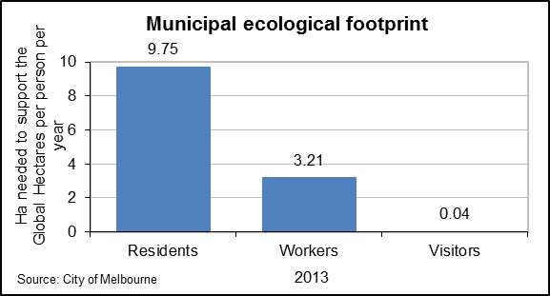
The daily water consumption per resident and per worker has reduced considerably, by around 23.5 per cent for residents and 24.5 per cent for workers from 2006–07 to 2012–13.
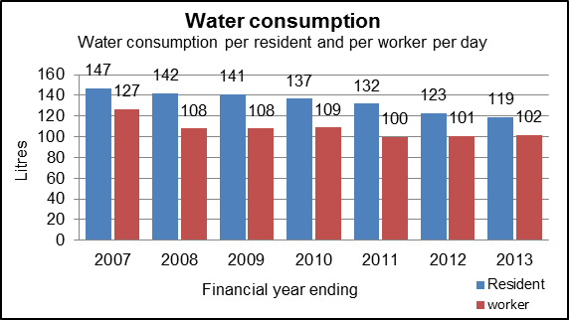

Zero net emissions
To become an eco-city the municipality will need to reduce its emissions of greenhouse gases to zero. We will do this by massively reducing our greenhouse gas emissions and then offsetting those that remain. The interim target for this ambitious goal is to reduce the total emissions across the municipality by 59 per cent per worker and 35 per cent per resident by 2020 (from 2006 levels).
Future Melbourne 2008
The City of Melbourne reduced its greenhouse gas emissions from its operations by 3.85 per cent 2014–15 on the previous year, although its total emissions as a whole continue to grow as a result of overall growth. The challenge is to disconnect this growth from greenhouse gas emissions growth.
City of Melbourne initiatives that have contributed to zero net emissions include:
- We became a carbon neutral organisation in 2012 and have maintained this ever since. For 2013–14, 60,000 tCO2-e of offsets were purchased. The City of Melbourne generally seeks to purchase and retire a 5 per cent surplus of offsets each year.
- We implemented our Zero Net Emissions by 2020 Strategy from 2008 to 2015, including the Greenhouse Action Plan for our operations which transitioned into the Carbon Neutral Strategy. Initiatives included developing and launching energy efficiency programs for private buildings as well as introducing new financial mechanisms to support the retrofitting of commercial buildings through:
  - 1200 Buildings
  - CitySwitch
  - Smart Blocks
  - Environmental Upgrade Finance (EUAs)
  - 541 commercial buildings retrofitted in City of Melbourne 2010–15
  - 35+ events, workshops and seminars, including online videos
  - extensive educational resource hubs for commercial office tenants and owners, facility-building managers and apartment owners and their managers.
- We established funding agreements with the Australian and Victorian Governments, which provided $1.1 million for Smart Blocks and $2.5 million for the CitySwitch program. The outcomes of the CitySwitch program are:
  - total office floor space committed to the program in the municipality = 627,697m²
  - total number of offices committed to the program in the municipality = 137
  - annual growth rate over the last 5 years = 30 per cent +- 4 per cent
  - participants reduced greenhouse gas emissions by 11,980 tonnes in 2014 and saved $3.8 million in operating costs.
- Smart Blocks program outcomes include:
  - 601 buildings are signed up nationally with 125 of them being in the municipality, which represents 10 per cent of its building stock
  - Sixty-seven energy efficiency or renewable energy projects are underway in these 125 buildings and 40 have completed the program using the online tool.
- We launched the Renewable Energy Program in 2014 that has:
  - established the Group Procurement Initiative to drive new investment in upstream large-scale renewable energy generation
  - mapped the municipality’s rooftop solar potential and integrated this with green roof and white roof potential
  - launched a commercial Rooftop Solar program to drive uptake of solar within the municipality.
- To improve City of Melbourne-owned buildings:
  - The new 6-star rated green building Library at the Dock opened in 2014. This building sets new environmental benchmarks, as Australia's first public building constructed primarily from cross-laminated timber and recycled hardwood.

The city as a catchment
Through the adoption of a 'city as a catchment' philosophy, the municipality will conserve water and improve the health of its waterways. By 2020, resident mains water use will be reduced by 40 per cent and worker mains water use will be reduced by 50 per cent (from 2000 levels). Pollution entering our waterway will be reduced by 20 per cent by 2020.
Future Melbourne 2008
Approximately 18,500 million litres of mains water is used in the municipality each year. Of this, 70 per cent is used for commercial purposes, 26 per cent in residential homes and 4 per cent for City of Melbourne operations.
City of Melbourne initiatives that have improved the city as a catchment include:
- In 2008, the City of Melbourne was experiencing the last stages of the Millennium Drought. Melbourne water storages dropped from 97.5 per cent full in October 1996 to just 33 per cent by June 2010 . Stage 3a water restrictions were in place and the City of Melbourne undertook several initiatives to significantly improve its water consumption, such as drought proofing open spaces and altering water use in its buildings.
- In early 2010, the drought broke and a number of restrictions were subsequently lifted. For example, residents were able to water gardens and lawns.
- We have continued our focus on reducing the municipality’s water use. This has involved incorporating water sensitive urban design into many municipality streetscapes, implementing several large stormwater schemes in locations including Fitzroy Gardens, Darling Street East Melbourne, the Docklands development, Birrarung Marr and the Alexandra and Queen Victorian Gardens.
- We updated our Total Watermark-City as a Catchment 2014 strategy in partnership with water authorities and major landholders. With assistance from Australian and Victorian Government funding, four major stormwater harvesting systems were constructed. This has increased our ability to supply irrigation water from alternative water sources, up to 25 per cent of our irrigation demand and on track to source 30 per cent of the City of Melbourne’s operational water needs by 2020.
- We have achieved substantial progress in meeting the Future Melbourne 2008 goal of reducing pollution entering our waterways as set out in the table below:
Future Melbourne 2008 goal (by 2020) | Progress at end 2015
20% reduction in total suspended solids | 16.5% reduction
20% reduction in total phosphorus | 16.1% reduction
35% reduction in total nitrogen | 12.2% reduction

Resource efficient
An eco-city uses only what it needs and produces no waste, creating many environmental and economic benefits that contribute to sustainability.
Future Melbourne 2008
Recycling per household in the municaplity increased 22.4 per cent from 2006 to 2012.
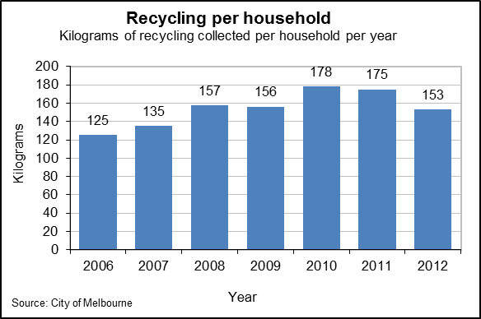
City of Melbourne initiatives that have contributed to a resource-efficient city include:
- We launched the Integrated Waste Management Program (2011) and the Waste and Resource Recovery Plan 2015–18. These include actions that improve residential and commercial waste, reduce waste-to-landfill, improve amenity and reduce the environmental impact of waste management.
- We also supported the Guidelines for Waste Management Plans for New Developments by providing new provisions for energy, water and waste efficiency in the Melbourne Planning Scheme. All new developments, including residential, commercial and mixed-use have a waste management plan that is approved by the City of Melbourne before construction of a development starts.

Adapted for climate change
Every person in the municipality will be aware of— and manage—the risks associated with climate change. We will adapt to ensure long-term benefits for the community and capitalise on opportunities for adaptation.
Future Melbourne 2008
In 2014–15, around three-quarters of the municipality’s residents were aware of climate change risks (City of Melbourne Annual Report 2014–15).
City of Melbourne initiatives that contributed to climate change adaptation included:
- We progressively implemented initiatives to achieve our Urban Forest Strategy target to increase canopy cover in the public realm from 22 per cent to 40 per cent; increase urban forest diversity (no more than 5 per cent of one individual species); improve vegetation health (90 per cent of the City of Melbourne tree population healthy). Since 2011, we have planted more than 15,000 new trees, with 3000 more being planted each subsequent year. If the goals of the Urban Forest Strategy and the Open Space Strategy are achieved, this will achieve a 4⁰C cooling of the city in summertime temperatures by 2040.
- We also implemented activities of our Open Space Strategy to increase public open space by 7.6 per cent. For example, the Errol Street Reserve was opened in 2013 providing 5000 square metres of new open space for North Melbourne residents.
- We commenced research into the adaptation cost curve, heatwave impacts on businesses, cool roofs, drainage infrastructure research in Southbank and an integrated climate adaption model. Our Climate Adaptation Strategy 2009 provided us with a strong understanding of the risks the city faces and actions to mitigate those risks. We will review the Adaptation Strategy in 2016.
- We established the position of Chief Resilience Officer to lead the development of what will be Melbourne’s first resilience strategy, as part of the City of Melbourne’s membership of the global 100 Resilient Cities Network. Research has helped inform the prioritisation of the City of Melbourne’s climate adaptation actions and is shared with cities internationally and other local councils. In 2014–15:
  - we reduced greenhouse gas emissions from City of Melbourne operations 3.85 per cent on the previous year
  - whilst residential waste-to-landfill rose 6.7 per cent the number of households serviced in 2015 increased 8 per cent
  - the number of complaints per capita about waste removal received by the City of Melbourne held steady at 0.02 per cent
  - there was no change in the capacity of our infrastructure to capture and reuse storm water in 2014–15.

Living and working in a dense urban centre
To become an eco-city the living, working, cultural and recreational activities of the municipality will be integrated into a dense and liveable urban ecosystem at the hub of a metropolitan network of similar urban nodes, creating environmental, economic, social and health benefits alike for the metropolitan area and the municipality.
Future Melbourne 2008
Melbourne has been traditionally regarded as Australia's 'garden city', recognised for its network of parks, gardens and streetscapes. Biodiversity is a fundamental driver of human health and wellbeing in cities by providing ‘ecosystem services’ such as pollution and water filtration, shade and nutrient cycling and urban cooling, and indirectly by providing resilience to a changing urban ecosystem.
City of Melbourne initiatives that have contributed to a dense urban centre included:
- We released long-term plans for the municipality’s high-density, high-growth urban renewal areas. Implementation of the plans for Southbank, City North and Arden-Macaulay to integrate the use and development of the land, transport and services and infrastructure provision have progressed to various stages of completion.
- We worked collaboratively with the Victorian Government to integrate the Melbourne Metro Rail transport infrastructure in the City North and Arden Macaulay urban renewal areas with the development of high-quality sustainable and liveable urban nodes.
- We invested heavily in improving the Docklands area adjacent to the Lorimer Precinct of Fishermans Bend. A key issue in determining the community infrastructure required in this precinct is the Victorian Government’s plan for providing community infrastructure in the remainder of the Fishermans Bend area, and also the potential development of pedestrian, cycling and transport links between Docklands and Fishermans Bend. These links may enable and encourage greater access to the recently developed community infrastructure in Docklands.
- In July 2012, the Victorian Minister for Planning identified the Fishermans Bend Urban Renewal Area (FBURA) as a project of State significance and rezoned the area as Capital City Zone (CCZ). Following the announcement, representatives of Places Victoria, the Department of Transport, Planning and Local Infrastructure, the City of Melbourne and the City of Port Phillip worked closely to develop a planning framework for the FBURA. In July 2014, the FBURA Strategic Framework Plan was developed, which articulates key strategic directions and steps needed to transform Fishermans Bend into a thriving inner city environment.

A connected city
In a connected city, all people can move about freely to communicate and trade – locally, regionally and globally – without sacrificing essential social or ecological values. The City of Melbourne manages movement in and around our city to help people trade, meet and move about safely and freely. We know that catering for our growing city and safeguarding its continued prosperity means planning for an efficient and sustainable transport network of the future. Building a ‘connected city’ is about working closely with our partners and advocating for the free movement of people and goods in the city. It is about making it easier for more people to make more sustainable choices as they travel to and around the city, whether by foot, bicycle, tram or train.
Future Melbourne 2008

Overview
With improved conference facilities and Melbourne’s reputation for holding events and conferences, there has been rejuvenation in international visitors to Melbourne for conference and business purposes.
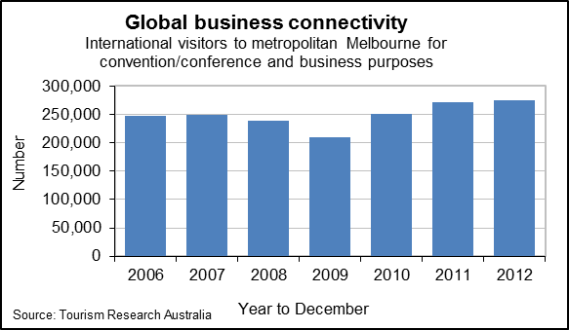

The Education and Training industry contributes almost $3 billion to the municipality’s economy. Since more than 30,000 students are from overseas, this industry is naturally very export dependent. It also reflects the growing interconnectedness of Melbourne with the world.
The number of motor vehicle ownership registered in the municipality per capita has fallen by around 17.5 per cent since 2010.
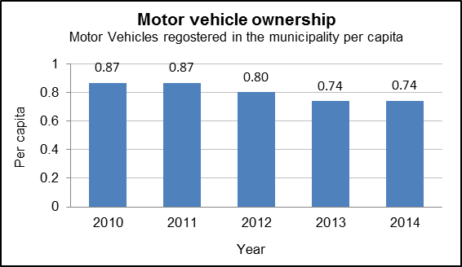

As the City of Melbourne grows, its importance as a global city is also increasing. Endorsed by the City of Melbourne in November 2014, the 'Melbourne – Doing Business Globally' framework guides our international activities, ensures the delivery of opportunities to Melbourne's businesses and seeks to achieve favourable returns on City of Melbourne's financial, program and personnel investment. To achieve this outcome, priority is given to business development activities that increase exports and inward investment in Melbourne's key industry sectors.

Effective and integrated public transport
Melbourne will be the central node of a metropolitan public transport network. Public transport will be the most efficient and attractive way to travel within the municipality and throughout metropolitan Melbourne. This integrated system of rail, tram and bus services will be affordable, responsive to customer needs and fully coordinated with the municipality's cycling and walking paths.
Future Melbourne 2008
More people are travelling to and around the municipality, with alternative forms of transport to the motor vehicle becoming more evident. The Australian Infrastructure Audit Report 2015 forecast that demand for public transport (by passenger hours travelled) that involves the municipality as a destination will increase 121 per cent by 2031.
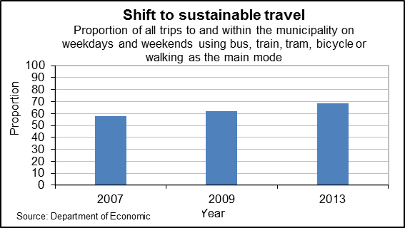
City of Melbourne initiatives that have contributed to effective and integrated public transport include:
- We worked closely with the Victorian Government to support the commitment to and development of the Melbourne Metro Rail project that will add five new rail stations to the municipality to relieve the overloaded Swanston Street tram corridor, significantly boost the capacity of the metropolitan rail network and enable future expansion of the Doncaster, Melbourne Airport and Rowville lines.
- We also worked closely with the Victorian Government and Yarra Trams to upgrade all central city tram stops to improve their safety and comfort and achieve a disability access-compliant level.
- We significantly upgraded the Swanston Street corridor to prioritise public transport, walking and cycling as part of the tram stop upgrade program.
- We worked closely with Public Transport Victoria (PTV) to better integrate pedestrian and public transport way finding signage systems. The aim is to make multi-mode journeys easier and efficiently and effectively use available resources. Integrated sustainable transport modes are encouraging more people to use these modes. More than two thirds (68 per cent) of all trips to and within the municipality were made using sustainable means in 2012–13.

Cycling city
Melbourne will be a cycling city. The municipality's entire road network will be safe and attractive for cyclists of all ages. Bikes will become the mode of choice for private transport trips in the municipality, including for work, school, business and recreation.
Future Melbourne 2008
By December 2015, the City of Melbourne’s bicycle network included over 135 kilometres of on and off road bicycle routes as well as many on-street bicycle hoops.
City of Melbourne initiatives that have contributed to a cycling city include:
- We implemented significant parts of our Bicycle Plan 2012–16 to link comfortable and convenient bicycle routes across Greater Melbourne. From 2012 to 2015 we invested more than $10 million to increase connectivity and safety across the municipality’s bike network.
- We built safer and more connected bicycle routes on William and Spring streets in the central city, Dynon and Flemington roads and Wreckyn Street. The Avenue in the west and north were some of the key bicycle improvement projects implemented. Almost 8 kilometres of new and upgraded bicycle routes and additional bike parking will help people make local cycling trips. Cyclists account for 17 per cent of all vehicles entering the municipality, nearly double the number of 2008.
- We worked with the Victorian Government to procure and deploy the Melbourne Bike Share scheme across inner Melbourne.
- On census day in 2011, significantly more people (1863) rode to work by bicycle compared with 2006 (1092 people), representing a 70.60 per cent increase.

Walking city
Melbourne will be one of the world's great walking cities where residents, workers and tourists have easy access to the many activities available within the municipality. Walking will be easy and attractive and a primary way for anyone and everyone to get around their local area. As well as being a very effective form of mobility, walking will also provide personal and public health, environmental and cultural benefits. A connected city gives top priority to walking, providing a comprehensive, fine grained and good quality pedestrian network.
Future Melbourne 2008
In 2015, the average connections per block and footpath space in the municipality remained unchanged at around 19 per cent since 2013–14. (City of Melbourne Annual Report 2014–15)
City of Melbourne initiatives that have contributed to a walking city include:
- We launched our first Walking Plan in 2014 to improve the pedestrian network and grow the number of walking trips in the central city. The Walking Plan guides infrastructure and other upgrades to the walking network based on the action themes of planning, street management and operation and capital works. Through-block links are planned for in structure plans and development plans to provide greater pedestrian connectivity in urban renewal areas. Key actions in the Walking Plan include:
  - improving the way pedestrians are included in transport planning and management decisions
  - creating an attractive walking environment and connected walking networks
  - addressing pedestrian crowding including around train stations and bus and tram stops
  - reducing pedestrian delays at signalised crossings.
- Our Southbank, City North and Arden-Macaulay Structure Plans have identified improvements to the laneway network. Work is underway to implement this work through the Melbourne Planning Scheme.
- We enhanced the city’s streets and laneways through road and footpath works, landscaping and other improvements. In 2015, the City of Melbourne invested more than $4 million to improve Elizabeth, Lonsdale, Spencer and Little Lonsdale streets as well as Literature Lane, Westwood Place, Brights Place, Healeys Lane and Crombie Lane.

Innovative urban freight logistics
Melbourne will have innovative and efficient freight and logistics infrastructure, optimising the flow of goods locally and globally. Melbourne's freight system will strengthen the municipality's economy. It will be environmentally sustainable, and freight traffic will be designed and managed to enhance the municipality's liveability.
Future Melbourne 2008
Melbourne’s freight task will continue to grow over the medium to long term if current population growth trends continue.
City of Melbourne initiatives and outcomes that contributed to this goal included our development of a Last Kilometre Freight Plan. This aims to involve all participants in the supply chain to help reduce costs and improve efficiency of freight delivery in the central city while improving the city’s amenity. The draft Last Kilometre Freight Plan will be presented to Future Melbourne Committee in March 2016.

Smart city driving
As a connected city, Melbourne will develop a culture of smart city driving in the municipality. This means improving motor vehicle traffic flow and running efficiency and fostering smarter, more efficient motor vehicle use and simplified road management. Smart city driving also means reducing road rage, eliminating pedestrian and cyclist death and serious trauma by collisions and making motoring compatible with these vulnerable road users. This will also reduce the degrading effects of motor vehicle traffic on the general urban amenity.
Future Melbourne 2008
In the 12 months to October 2015, there were six fatalities in Melbourne’s municipality, three more than the previous year. The 5-year average is five fatalities per year. The 5-year average for claims involving acute hospitalisation longer than 14 days is 31 per year. (Transport Accident Commission)
City of Melbourne actions and initiatives to facilitate smarter city driving include:
- We worked with the Victorian Government in strategic network planning to design and manage the road network to optimise the best balance of modes at various locations.
- We also worked with the Victorian Government to extend 40kph speed limits across the municipality to increase road safety and amenity for all users.
- We supported the expansion of car-share services to residents and business by allocating dedicated on-street car parking spaces for car share vehicles.
- We amended the Melbourne planning scheme to allow the provision of zero on-site car parking spaces and place a discretionary limit of one-car parking space per dwelling for developments higher than four levels. The amendment also provides a strategic basis for assessing requests for reductions in required car parking for developments lower than four levels.
- We added electric cars and bikes to the City of Melbourne fleet.

Regional and global transport connections
Melbourne will have fast and direct connections to Australia's network of major cities and global cities in the Asia-Pacific region and around the world. Very high-speed business and tourist passenger transport will connect Melbourne to the eastern seaboards region (including Sydney, Brisbane and Canberra). This connectivity is essential for the future prosperity and global competitiveness of Melbourne, Victoria and Australia.
Future Melbourne 2008
Over 90 per cent of freight to and from the Port of Melbourne is transported by road. Increases in the numbers of vehicles used for freight transport over the next 15 years are expected (Department of Transport, Planning and Local Infrastructure).
The chart below highlights the significant value of trade the port facilitates, totalling over 85 per cent in 2014–15. Identifying and capturing opportunities to improve connectivity between Melbourne and other markets requires partnership between all levels of government.
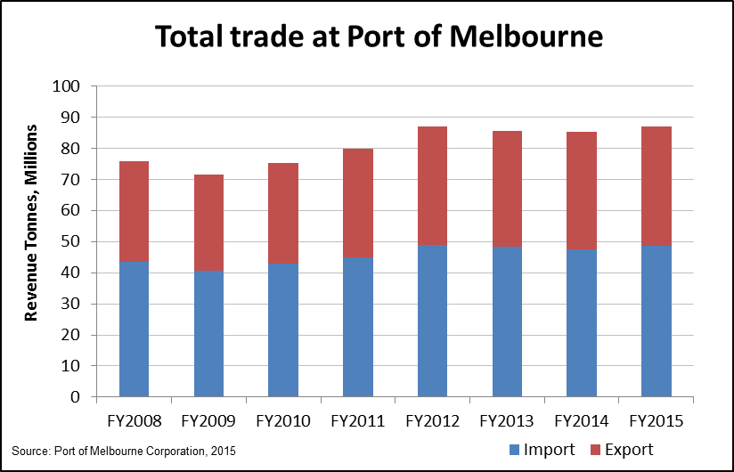
City of Melbourne actions and initiatives to improve regional and global transport connections include:
- We released our Transport Strategy 2012–30.
- We worked with the Victorian Government on the design and development of the Regional Rail Link and to prepare for the increased passenger movement in and around CBD stations.
- We also worked with the Victorian Government and Skybus to improve the public transport connection between the CBD and the Melbourne Airport.
- We worked with the Australian and Victorian Governments on the development of proposals for high-speed intercity rail. The City of Melbourne also made a submission to the Australian Government’s High Speed Rail Study.

10 Headline targets
In Future Melbourne 2008, there were 10 headline targets selected (from the many targets in the community plan) to help measure progress towards these goals for the municipality by 2020.
These targets will show the city’s progress toward achieving its vision of a liveable and sustainable city. Targets may relate to multiple goals and together present an overall indication of our success. This section summarises outcomes against each headline target.

All visitors and residents feel welcome, safe and engaged in the city
This target contains three separate components: welcome, safe and engaged. However, the City of Melbourne did not monitor the welcome target and therefore cannot report against this target.
Perception of safety is a subjective indicator. Neighbourhoods perceived as safe tend to encourage physical activity, community participation and community connectedness and add to the health and wellbeing of local residents and visitors.
In 2015, around 97 per cent of visitors, workers and residents reported feeling safe when alone in public spaces in the municipality during the day. Approximately 62 per cent felt safe during the night. As far as feelings of daytime safety are concerned, the municipality has effectively achieved the target of all visitors and residents feeling safe (Community Indicators Victoria 2007, online).
Data from the Intercept Social Indicators Survey indicates that in 2015, almost all visitors, workers and residents (99 per cent) considered there were sufficient opportunities in the city for them to participate in a range of activities including; arts and culture; sports and leisure; mixing socially; learning; shopping; working or attending to personal business. Effectively, the city has achieved this engagement target.
Target achieved.

All residents, businesses and visitors easily and affordably access the internet
The target of all residents, businesses and visitors easily and affordably being able to access the internet has effectively been achieved. The number of internet connections is internationally accepted as an indicator of information access and internet and communication technology connectivity. Victorian figures on internet connections have been used as a proxy for the City of Melbourne, for reasons of availability of data.
A range of indicators were monitored to report adequately on this target, including home internet access for residents. Library facilities and wireless access is one way the City of Melbourne can directly influence access to electronic information in the municipality. In Victoria in 2013, approximately 55,000 per 100,000 people had an internet connection which indicates good and affordable access for residents, visitors and businesses.
Target achieved.

The municipality is home to at least 140,000 people
The 2014 population estimate for the municipality was approximately 122,200 (ABS 2015). This means the municipality is at least on track to meet, and likely to exceed, the 2020 population target set in Future Melbourne 2008 (Geografia 2014).

In 2008, it was anticipated that Melbourne might eventually aim for a residential density at least comparable to that of Central London, which stood at about 100 people per hectare at the time. At this density, the population of the municipality would be about 350,000, which was less than half as dense as Barcelona but four times the density levels at the time.
Even over 20 years, high population growth rates would have been needed to reach this target. Therefore, a proposed interim target for 2020 was a population of 140,000. This would require a 54,000 increase in the municipality on 2008 population levels.
A population increase of this magnitude will require adding approximately 27,000 additional dwellings on top of 2008 levels (an average 2,250 per year). It would also bring the population density of the municipality to 37 people per hectare. This target also assumes that household size increases from 1.9 to 2 people per dwelling.
Population growth is driven by births, migration and housing construction. A well-planned city focuses on the implications of new growth on its economy, existing communities and the environment. Growth should be concentrated in areas that can accommodate a mix of housing, commerce, industry and recreation to maximise the use of existing infrastructure, minimise travel times to and from work, and minimise servicing costs resulting from new growth. Encouraging mixed use developments combining housing and employment opportunities is essential to achieve these objectives (International Organisation for Standardisation 2014).
Target on-track.

At least 20 per cent of new housing is affordable or social housing
In late 2014, the City of Melbourne released its Housing Strategy, Homes for People 2014–18. The strategy has three key goals:
- Help provide at least 1721 affordable homes (subsidised) for low and moderate income earners.
- Improve the design quality and environmental performance of new apartments.
- Foster a high level of awareness and knowledge around good housing outcomes.

On City of Melbourne-owned land, consideration is being given to including up to 15 per cent of dwellings constructed made available as affordable housing and managed by a registered Affordable Housing Provider.
A key action of the Housing Strategy is the commitment to report annually on success in achieving its goals.
The Housing Strategy is not comparable with the target set in Future Melbourne 2008. Therefore, the annual reporting on implementation of the Housing Strategy will be the relevant measure of success in achieving goals of that strategy only.

City employment exceeds 400,000
The measure of employment in the municipality is based on the Census of Land Use and Employment (CLUE) undertaken biennially by the City of Melbourne. This is the total employment for the municipality and includes full-time, part-time, casual and contract workers (volunteers are not included). In the 2006 CLUE, 365,904 people were employed in the municipality. This measure was chosen for the frequency of its updates.
The municipality has already achieved the target of exceeding 400,000 city workers. In 2012, the CLUE found the municipality had an overall workforce of 439,172. This is the total number of jobs in the Melbourne Local Government Area and includes full-time, part-time, casual and contract employees.
The nature of the municipality as a capital city council and major business centre means businesses and employment benefit from the cumulative benefits of firms employing people in the centre of the Greater Melbourne area. These benefits include maximising the use of existing infrastructure, minimising travel times to and from work, and efficiencies from proximity to competitors, partners, a workforce and contractors.
Target achieved.

Per capita greenhouse gas emissions by 2020 have reduced by 35 per cent per resident and 59 per cent per worker from 2006 levels
Achieving this target requires the municipality to significantly reduce its greenhouse emissions. It also allows for the projected residential and worker growth within the municipality. Details of how the City of Melbourne plans and is working toward achieving these reductions and the methodology for measuring our progress are outlined in our Zero Net Emissions by 2020 strategy. Refer to information in provided in this report on High Level Goal number 4.1 Zero Net Emissions on page 30.
Target off-track.

Per capita drinking water use by 2020 has reduced by 40 per cent per resident and 50 per cent per worker compared to 2000 levels
Achieving this target requires the municipality to significantly reduce its mains water consumption. The target allows for the projected residential and worker growth in the municipality. Implicit in these targets are that alternative water sources will be added and that by 2020 pollution entering our waterways will be reduced by 20 per cent. Details of these targets are outlined in our City of Melbourne Total Watermark - City as a Catchment strategy.
This target effectively means that Future Melbourne aimed to reduce residential mains water use to 178 litres per resident per day and commercial mains water consumption to 91 litres per worker per day by 2020. The Melbourne Local Government Area had already achieved its residential water consumption target in 2006, at the time of publishing Future Melbourne 2008. By contrast, the long-term downward trend in workers’ water consumption, since 2000, appears to have slowed in 2008 and increased again in 2012 and 2013.
Since 2000, total worker and resident water consumption has reduced 40 per cent and 50 per cent respectively. From 2000 to 2013, resident water consumption per person per day declined on average 7 per cent per year from 290 litres per person in 2000 to 119 litres per person in 2013. Melbourne Water’s Target 155 program which aimed to reduce water consumption to 150 litres per person per day may have influenced this result. Similarly, workers’ water consumption declined an average of approximately 5 per cent per year. Workers’ water consumption declined from 187 litres of water per person per day in 2000 to 100 litres in 2011, before rising again to 102 litres per worker per day by 2013. If workers continue to reduce their daily water consumption, the city’s 2020 target for workers’ daily water consumption should easily be achieved.
Total consumption of mains water in the municipality, by residents and non-residents combined in 2013 was 53,536,970 litres. Overall, water use by business remains the largest component of mains water consumption, at 75 per cent of the municipality's water consumption. Residential water consumption accounts for the remaining 25 per cent.
Target on-track

Melbourne will be one of the world's top five university cities
The Global University City Index was developed by RMIT as a contribution to the work of the Committee for Melbourne Higher Education Taskforce. The Global University City Index highlights those cities where there is confluence between their size, liveability and connectedness, the number of excellent universities within their bounds, and their sustained investment in education and research.
The City of Melbourne cannot report against this target because city rankings do not constitute measurable or meaningful targets and are effectively beyond its control. Future Melbourne 2008 also proposed using the Global University City Index. However, the Index is now defunct. It is recommended in future to avoid using city rankings as indicators or targets.

Melbourne will be in the top 10 most innovative global cities
It is recommended to avoid using city rankings as indicators or targets for reasons outlined above.

At least 90 per cent of people walk, cycle or take public transport to work in the municipality
Targets for people walking, cycling or taking public transport to work in the municipality were not achieved. Approximately 60 per cent of the municipality’s workers (193,500 out of 320,500 people) who travelled to work on census day in 2011, did so by various combinations of train, tram, walking only, bicycle or bus. While this is an improvement from about 56 per cent of workers travelling to work on census day 2006, it is unlikely that at this rate the city will achieve the target by 2020. Travelling via train was the most common mode choice of people travelling to work in the municipality (around 39 per cent). If the Melbourne Metro is completed as projected by the mid-2020s it will significantly increase the rail capacity component of this target
Public transport is a key sustainability indicator as it influences employment options, access to services, and health and social connections through physical activity (Community Indicators Victoria 2007, online). Increased public transport patronage has potential to help avoid traffic congestion, injury and air pollution (Austin et al. 2001). Walking is efficient in its use of urban space and energy and it gives streets vitality and contributes to security.
Cycling offers potential to increase physical activity levels, is affordable and can be easily integrated into people’s daily lives as a form of transport (Bauman et al. 2008, p. ii). Pedestrian and cycle paths integrated with public transport systems in the central city area can help the transit network become a viable alternative to the car (The Australia Institute and Newcastle City Council 2000).
Target off-track

Appendix A - Summary of the Future Melbourne 2008 goals.
Since 2008, over the course of two successive councils, the City of Melbourne actions have contributed to achieving 137 (89 per cent) of the 152 tertiary goals of Future Melbourne 2008. This response may have been a strategic or policy initiative or a new program or partnership. These are highlighted below.
1. A city for people
- A great place to live
- Growth of the city
- A sense of community
- Balancing diverse community needs
- Infrastructure and services

- Inclusive community
- Collaborative community
- Caring community
- Social justice
- Supporting and valuing Melbourne's student community.
- Community infrastructure and support programs

- A healthy community
- A healthy city environment
- Healthy communities
- Community involvement and participation
- Physical activity and social interaction

- Designed for people
- Human scale
- Sense of place
- Continuity and change
- Activity and interest on our street edges
- Quality and sustainable urban design and architecture
- Neighbourhoods
- Functional public and private space
- A supportive regulatory framework
- Physical representation of the city

- An affordable place to live
- Affordable housing opportunities
- Access to affordable health care
- Access to affordable and nutritious food
- Chronic homelessness eliminated
- Housing construction
- Site utilisation
- An equitable planning system

- Quality public space
- Variety
- Adaptability
- Accessibility
- Movement and activity
- Connected network of spaces
- Streets, boulevards and laneways
- Parkland
- Waterways
- Private and communal open space

- Facilities and services to meet the needs of our growing community
- Provision of infrastructure
- Sport and recreation infrastructure
- Financing infrastructure provision

2. A creative city
- Creative risk-taking
- Stimulating and inspiring city culture
- Creative risk-taking

- Vibrant, creative community
- Artistic creativity and cultural innovation
- Philanthropy, business and government support the arts
- Grow Melbourne’s creative profile
- Enhanced creative industry, learning and educational
- Affordable and creative spaces for artists

- Celebrating diversity
- Valuing cultural diversity
- Melbourne's uniqueness
- Vibrant Indigenous art and culture

- Prosperity through creativity
- A thriving creative economy
- Global recognition of Melbourne's creativity
- A city community engaged in creativity

3. A prosperous city
- A global city
- A global centre of commerce
- Attract skilled and talented workers
- Infrastructure to support global connectivity
- Leadership in business environment
- Strong international relationships

- A stimulating and safe 24-hour city
- Welcoming, engaging and safe 24-hour city
- Well managed variety of activities
- Safe city
- 24-hour public transport
- Complementary day and night use of space

- Attractive for new businesses
- Affordable space for business
- Utilise long-term, usable vacant property
- Industrial and commercial land supply- accommodation
- Online business
- Leadership and support in business

- Supportive of business
- Grow business and employment
- Business information and support
- Access to information
- Business connections
- Growth in social enterprises
- Collaboration between businesses

- An events city
- Premium events destination
- Economic benefits from events

- A great place to visit
- Preferred global destination
- A welcoming destination
- Well informed visitors
- Effective marketing
- Integrated delivery of tourist needs
- More youth and children visiting

- A philanthropic culture
- Leader in philanthropy
- Philanthropy is embraced
- Effective business and community sector partnerships
- Increased volunteering

4. A knowledge city
- Generating innovation from knowledge
- Culture of innovation
- Creative learning community
- Reputation for knowledge culture

- Synergies between the city and universities
- World class universities
- Leading university city
- Post graduate training centre
- Research and development capacity
- Public sector productivity
- New generation of entrepreneurs
- Foster networks and alliances
- Promote our knowledge capability
- Leader in scientific research
- Increase venture capital investment

- Learning city
- Learning as a value
- Active culture of lifelong learning
- Active collaboration
- Accessible lifelong learning

- Online city
- High-speed, high-capacity Internet
- Universal wireless internet access
- Creative and innovative online urban culture
- Internet access for disadvantaged communities

5. An eco-city
- Zero net emissions city
- Residents reduce emissions
- Workers reduce emissions
- Transport reduces emission
- Report municipal greenhouse gas emissions annually

- The city as a catchment
- Residents’ water consumption reduced
- Workers’ water consumption reduced
- Council’s water consumption reduced
- Reporting on water consumption
- Reduce pollution entering waterways

- Resource efficient
- Reduce household waste in the city
- Reduce commercial waste in the municipality
- Ecological footprint and target
- Recycling and waste collection more economic

- Adapted for climate change
- Climate change
- Leader in climate adaption research
- Innovative climate adaptation solutions

- Living and working in a dense urban centre
- A sustainable mixed use urban centre
- Better population balance
- More locally produced food
6. A connected city
- Effective and integrated public transport
- Improve and expand metro public transport
- New urban growth as transit oriented development
- Integrate public transit with pedestrian and cycling
- Public transit real time user information
- Integrated electronic ticketing and booking

- Cycling city
- The whole network made bike safe
- Develop a culture of slow cycling
- A public bicycle rental system
- Quality end of trip facilities

- Walking city
- A comprehensive, fine grained walking network
- Zero pedestrian deaths-serious injuries
- Connected network of pedestrian places
- Build to universal access standards

- Innovative urban freight logistics
- Increased rail freight and reduce road freight
- Reduce amenity degrading freight
- Low impact and efficient central city last-mile freight
- Low impact and more efficient waste freight

- Smart city driving
- Efficient, flowing inner urban motor vehicle traffic
- Smart and efficient motor vehicle use
- Reduce motorist road rage and frustration
- Eliminate death or serious trauma in the municipality
- Make motoring compatible with vulnerable road users

- Regional and global transport connections
- Maintain international visitations to Melbourne
- Affordable very high speed CBD to CBD inter-city travel
- Integrated central city coach terminal

Appendix B - Council strategies to achieve goals
The Council has implemented a number of initiatives that don’t necessarily align directly with the tertiary level goals. Its actions are best understood as responses to the higher level aspirations as set out in the 33 secondary goals of Future Melbourne 2008.
A city for people
Active Melbourne Strategy (2006–16, currently under review)
Melbourne for All People (2014–17)
Beyond the Safe City Strategy (2014-17)
Docklands Community and Place Plan (2012 ongoing)
Homelessness Strategy (2011-2013; refreshed 2014–17)
Housing Strategy (2014–18)
Municipal Strategic Statement (2013-2053 due for review around 2018)
Open Space Strategy (2012–27)
Preventing Violence Against Women Strategy (2013–16)
Public Health and Wellbeing Plan (2009-13 and 2013–17)
A creative city
Aboriginal Heritage Action Plan (2012–15 and 2015–18)
Arts Strategy (2010-13 and 2014–17)
Heritage Strategy (2013–20)
Music Strategy (2014–17)
A prosperous city
Advancing Melbourne's interests - Business and International Strategy (2008–12)
Retail and Hospitality Strategy (20131–7
Melbourne Marketing Strategy (2011–15)
Tourism Plan (2007–12; new plan currently in development)
A knowledge city
International Student Strategy (2013–17)
Knowledge City Strategy (2014–18)
Library Strategy (2008–18; currently under review)
Smart City Strategy (currently in development)
An eco-city
Climate Change Adaptation Strategy (2009 ongoing and to be updated in 2016)
Resilience Strategy (currently in development)
Total Watermark - City as a Catchment (2008–11 and 2014–30)
Urban Forest Strategy (2012–32)
Urban Ecology and Biodiversity Strategy (currently in development)
Zero Net Emissions by 2020 (2008–11 and 2014–20)
A connected city
Bicycle Plan (2007–11 and 2012–16; new plan currently in development)
Transport Strategy (2012–30)

Appendix C - Example of the nesting of the three tiers of related goals.
The vision | Melbourne will be a bold, inspirational and sustainable city. | One vision epitomising the group of strategic priorities
Primary goal | 4. Make Melbourne a Knowledge City  As a knowledge city, Melbourne will use the collective power of mind and experience to drive the city's prosperity, its ability to compete globally and the quality of life its people enjoy. Melbourne will support a well-resourced education and research system producing a highly skilled and talented workforce. It will celebrate and promote its scientific research institutions and science based businesses as generators of innovation in the city. It will have a vibrant, collaborative, city-based lifelong learning culture. This knowledge culture will be enabled and amplified by a universal and dynamic online culture that connects its people to each other and to the world. | Informed by a suites of related goals
Secondary goal | 19. To generate knowledge from innovation  Melbourne will develop a broad-based knowledge culture where learning communities, the knowledge economy and innovation are valued as vital to improving our quality of life. We will draw on the municipality's diverse range of people, institutions and rich cultural assets to generate innovation. | Synthesised out of the group of related ideas
Tertiary goal | 88. Culture of innovation – Develop a vital culture of innovation in the municipality’s knowledge economy. Melbourne is a centre of innovation and has an international reputation as an innovative environment and economy. Innovation is valued as an important contributor to our culture.  89. Creative learning community  90. Reputation for knowledge culture | The ideas generated by the community in phase one

References
Austin, T., Shoemark, S., Stokes, S., Stone, S., and Terril, A. (2001). Part 1-Developing A Draft Set of Sustainability Indicators for the Shire of Cardinia. Graduate School of Environmental Science, Monash University November 2001.
Australian Bureau of Statistics (1996) Australian Social Trends. Housing – Housing Stock: Home ownership of low income private renters. Canberra
Australian Bureau of Statistics, (Cat. 8158.), 2010, [on-line] Innovation in Australian Business, 2008-09, Canberra, (accessed 24-10-2011).
Australian Bureau of Statistics, 1998, (on-line) 4102.0 - Australian Social Trends, (accessed 31-1-12) http:--www.abs.gov.au-
Australian Bureau of Statistics, 2006 Census of Population and Housing - Reference and Information. Canberra
Australian Bureau of Statistics, 2006 Census Community Profile Series : Melbourne (C) (Local Government Area) Working Population Profile
Australian Bureau of Statistics, 2011, (Cat no.3218.0) Regional Population Growth, Australia, 2009-10, Canberra, http:--www.abs.gov.au-AUSSTATS-abs@.nsf-DetailsPage-3218.02009-10?OpenDocument
Australian Bureau of statistics, 3218.0 - Regional Population Growth, Australia, 2009-10
Australian Bureau of Statistics, 8166.0 , 2011, (on-line) Summary of IT Use and Innovation in Australian Business, 2009-10, http:--www.abs.gov.au-ausstats-abs@.nsf-Products-8166.0~2009-10~Glossary~Glossary?OpenDocument (accessed 31-1-12) Canberra
Australian Bureau of Statistics, Australian and New Zealand Standard Industrial Classification (ANZSIC) 2006 (Revision 2.0) .
Bauman A. Rissel C. Garrard J. Ker I. Speidel R. and Fishman E. (2008) Cycling: Getting Australia Moving: Barriers, facilitators and interventions to get more Australians physically active through cycling Cycling Promotion Fund, Melbourne.
City of Boston, 2006, Wireless in Boston – Wireless Taskforce Report. Broadband for Boston
City of Melbourne Annual Plans 2008 through 204-15.
City of Melbourne, Carbon Inventory (September 2015)
City of Melbourne Census of Land Use and Employment (CLUE) 2008 and 2010 (2010 data by September 2011)
City of Melbourne Population Forecasts 2015-35, [on-line] Geografia 2014 (accessed 15-9-15) http:--melbournepopulation.geografia.com.au-
City of Melbourne, Trends and Melbourne, 2015
City of Melbourne, Total Watermark – City as a Catchment Strategy, http:--www.melbourne.vic.gov.au-Environment-WhatCouncilisDoing-Documents-city_as_catchment.pdf , page 34
Community Indicators Victoria [on-line], (accessed 15 August, 2011), http:--www.communityindicators.net.au-data_framework
Future Melbourne wiki, [on-line], http:--www.futuremelbourne.com.au-wiki-view-FMPlan
Geografia 2015, City of Melbourne population forecast.
ISO-TC268, Sustainable Development of Communities, 2014, ISO 37120 Sustainable Development of Communities Indicators for City Services and Quality of Life, International Organisation for Standardisation,
Roy Morgan Research, Tourism Brand Health Survey, 2014

Savewater 2003 (on-line), www.savewater.com.au-how-to-save-water-in-the-gardenCached - Similar- (accessed 31-1-12)
The Australia Institute and Newcastle City Council, 2000. Indicators of a Sustainable Community, Improving Quality of Life in Newcastle, Discussion Paper Number 28.
The Creative State Global City, Creative Industries Taskforce Report, report to the Victorian Government to inform the development of the state’s first creative industries strategy, November 2015

