SCHEDULE 12 TO THE DEVELOPMENT PLAN OVERLAY
--/--/20--
C221

Shown on the planning scheme map as DPO12

west melbourne Waterfront
Site description
The site is 160 – 232 Kensington Road, West Melbourne.
1.0 Requirement before a permit is granted
--/--/20--
C221

A planning permit may be granted to demolish a building or to carry out site preparation works and related activities before a development plan has been prepared to the satisfaction of the Responsible Authority - provided the Responsible Authority is satisfied that the permit will not prejudice the future use and development of the land in an integrated manner and will contribute to the vision for the site.
2.0 Conditions and requirements for permits
--/--/20--
C221

Permit Application Requirements
Unless otherwise excused by the Responsible Authority in writing, an application for planning permit must include the following:
- A Cultural Heritage Management Plan prepared by a suitably qualified professional.
- A landscape plan prepared by a suitably qualified person(s) to the satisfaction of the City of Melbourne that includes proposed landscape treatments for the interface with the Maribyrnong River.
- A plan which identifies all structures and treatments, including public art, proposed in the public realm to the satisfaction of the City of Melbourne.
- A plan which identifies the affordable housing including the number and location of units to be provided. The plan is to be agreed between the applicant and the registered housing association or provider and to the satisfaction of the Responsible Authority.

Except for a permit issued as provided for under Clause 1.0 of this Schedule a permit must contain the following permit conditions:

Flood mitigation
Prior to commencement of the works authorised by the permit, the owner of the land must enter into an agreement with Melbourne Water and the Responsible Authority pursuant to section 173 of the Planning and Environment Act 1987 whereby the owner covenants that:
- Prior to the occupation of the works authorised by the permit, the owner of the land is to provide for safe pedestrian and vehicular access from the development during a peak flood event (1 in 100 year flood level) to the satisfaction of Melbourne Water and the Responsible Authority.
- The finished floor level of any residential building be constructed to a minimum of 600 mm above the applicable 1 in 100 year flood level of 2.46 metres to AHD.
- No polluted and / or sediment laden runoff is to be discharged directly or indirectly into Melbourne Water's drains or watercourses.

Civil Infrastructure and Community Infrastructure Contribution
Prior to the commencement of the use or works authorised by the permit (excluding any demolition or site preparation works and related activities) on the land, the owner of the land must enter into an agreement with the Responsible Authority pursuant to section 173 of the Planning and Environment Act 1987 whereby the owner covenants that:
- All new roads within the site or altered portions of existing roads (including the provision of footpaths, stormwater drainage, public lighting, street trees, pavement marking and signage) and works to the traffic network, including traffic lights, Kensington Road footpath and bike path, reconstruction of kerb and channels and crossing must be constructed at the owners cost prior to the occupation of the development in accordance with plans and specifications first approved by the City of Melbourne – Engineering Services.
- Provide access to other properties on Kensington Road, at the cost of the developer, in accordance with detailed plans and specifications first approved by the City of Melbourne – Engineering Services.
- All structures and civil infrastructure are to be designed and constructed in accordance with detailed plans and specifications first approved by the City of Melbourne to the City of Melbourne’s standards.
- Payment to the City of Melbourne of a community infrastructure contribution of $1,480.46 (indexed 1 July each year according to the Building Price Index, June Quarter, Melbourne, in Rawlinsons Australian Construction Handbook) per dwelling authorised by the permit, such contribution to be paid prior to a certificate of occupancy being granted.
- The owner of the land must pay all of the Responsible Authority’s reasonable legal costs and expenses of this agreement, including preparation, execution and registration on title.

Noise, odour and dust protection
- All buildings authorised by the permit must be designed to protect themselves from any odour and dust emissions from surrounding uses.
- Prior to occupation of a dwelling authorised by the permit, an acoustic report must be submitted confirming that the development achieves the following:
For Railway noise:
  - Noise intrusion of railway and associated infrastructure noise sources to noise sensitive receivers shall not exceed:
    - 55 dBLAmax (bedrooms)
    - 60 dBLAmax (living room areas)
For other noise:
  - Any new or refurbished development or any conversion of part or all of an existing building that will accommodate new residential or other noise-sensitive uses must:
    - Be designed and constructed to include noise attenuation measures. These noise attenuation measures must achieve a maximum noise level of 35dB(A)Leq in unfurnished and uncarpeted habitable rooms, with all windows and doors closed, unless there is no suitable air conditioning and/or mechanical ventilation, in which case the maximum noise level of 35dB(A)Leq in unfurnished and uncarpeted habitable rooms must be achieved with all the windows half open and the doors closed.
    - Be fitted with suitable air conditioning and /or mechanical ventilation system to the satisfaction of the responsible authority unless the maximum noise level of 35dB(A)Leq in unfurnished and uncarpeted habitable rooms can be achieved with all the windows half open and the doors closed.
    - Have walls, roof, windows, doors and external glazing and the air conditioning or ventilation system designed by a qualified acoustical consultant who must certify that the incorporation of the design features recommended by the consultant will achieve a maximum noise level in unfurnished and uncarpeted habitable rooms of 35dB(A)Leq, based on the external noise levels measured by the consultant as part of a noise level assessment conducted to the satisfaction of the responsible authority.

Wind Assessment
Prior to endorsement of the plans, a Wind Assessment Report must be submitted to the Responsible Authority confirming that the development achieves the following:
- No detrimental change to the wind speed along the public path.
- Ensure the river front public realm and areas designated for outdoor cafes and restaurants is acceptable for short term stationary wind exposure (where peak gust speed during the hourly average with a probability of exceedence of 0.1% in any 22.5o wind direction sector not exceeding 13 ms1).
- All other areas be designed to be acceptable for walking (where peak gust speed during the hourly average with a probability of exceedence of 0.1% in any 22.5o wind direction sector not exceeding 16 ms1).

Staged Planning Permits
If a planning permit authorises a use or development for part of the overall land governed by this overlay, the permit must show (either by words or diagrammatically):
- How the use or development authorised by the permit is consistent with and will facilitate delivery of no less than 7.06% of the land governed by this overlay being set aside and ultimately zoned for public open space generally in accordance with Figure 1- Indicative Framework Plan.
- How the use or development authorised by the permit will integrate with any previously approved and with remaining stages of development of the land.

Permits which authorise a building that exceeds the preferred maximum building height
If a planning permit authorises a building that exceeds the preferred maximum building height of 10 storeys, the permit must show (either by words or diagrammatically), the equivalent of 15% of the gross floor area above ten storeys, authorised by the permit as set aside in the building (or with consent of the Responsible Authority in another part of the land governed by this overlay) for affordable housing. The housing is to be acquired at nil cost by the housing provider.
3.0 Requirements for development plan
--/--/20--
C221

The Development Plan must be consistent with the following vision for the site:
An exemplary mixed use development including a number of visually integrated buildings, which enhance the Maribyrnong River frontage and provide opportunities for riverside activity consistent with the Maribyrnong River Valley Design Guidelines 2010.
The Development Plan must be generally in accordance with the Indicative Framework Plan, as shown in Figure 1, to the satisfaction of the Responsible Authority.
The Development Plan must include the following:
- An urban context and existing conditions analysis showing topography, the top of the Maribyrnong River bank, the surrounding and on site land uses, buildings, noise and odour sources, access points, adjoining roads, cycle and pedestrian paths and public transport.
- Identification of views to be protected and enhanced, including views of and from the site.
- A plan showing proposed demolition.
- A summary of the site’s key land use and development opportunities and constraints.
A Concept Plan which shows:
- The provision of not less than 7.06% of the site frontage along the Maribyrnong River as public open space.
- The mix of land uses.
- Building envelopes including maximum building heights, building setbacks, and building depths.
- Conceptual elevations.
- Cross sections, indicating level changes across the site.
- Orientation and overshadowing demonstrating that the development does not cast a shadow over public open space between 9 am and 3 pm for a minimum of three hours at the solstice and a minimum of five hours at the equinox.
- Street and movement networks, including pedestrian and cycling connections.
- A Public Realm Plan that includes open space and other public realm spaces prepared by a suitably qualified person(s) to the satisfaction of the Responsible Authority.
If it is proposed to develop the land governed by this overlay in stages, a staging plan must be provided to the satisfaction of the Responsible Authority. The staging plan must, unless otherwise excused by the Responsible Authority, identify:
- The proposed sequencing of development, the indicative timing of the provision of infrastructure and services and overall integration with other development stages.
- Vehicular access points, road infrastructure works and traffic management for each stage of the development.
The development plan must also be accompanied by the following reports to the satisfaction of the Responsible Authority:
- An Integrated Transport and Access Plan which includes:
  - Expected traffic generation and the impact on the existing road network.
  - Location of vehicle egress and ingress points.
  - The provision of a movement network to, from and within the site that:
    - connects with and complements the form and structure of the surrounding network;
    - recognises the primacy of pedestrian and bicycle access within the site;
    - provides a high level of amenity and connectivity;
    - allows for appropriate levels of manoeuvrability for emergency and service vehicles; and
    - are of sufficient width to accommodate footpaths, street trees, water sensitive urban design and bicycle lanes.
- A wind analysis to the satisfaction of the Responsible Authority demonstrating that future development will meet the wind requirements in Section 2 of this Schedule.
- A heritage assessment which identifies any heritage places, prepared by a suitably qualified heritage professional.
- An Infrastructure Analysis Report which addresses the following, as appropriate: location of existing infrastructure on the site, drainage and stormwater management.
- An Environmental Sustainable Development Report identifying the environmental initiatives to be included in the development.
- An Acoustic and Vibrations Assessment prepared by a suitably qualified engineer identifying and assessing nearby acoustic emitters including the rail line to the north. The Report must identify and detail how future development will meet the acoustic requirements in Section 2 of this Schedule.
- An odour report which provides details of odour distance thresholds and odour mitigation measures.
- A Stormwater and Flood Management Plan, prepared by a suitably qualified person(s) to the satisfaction of Melbourne Water and the Responsible Authority that identifies and considers:
  - The historical flooding of the site;
  - The unique flooding characteristics of the site, in particular aspects such as flood conveyance, flood storage and accessibility during floods. A model should be prepared demonstrating the ‘base case’, impacts of redevelopment on the land and mitigation options;
  - The control of flows in and around the site for discharges up to and including the 1 in 100 year ARI event;
  - Works required to create safe pedestrian and vehicle access and egress to and from the land;
  - That residential buildings are to attain a finished floor level of a minimum of 600mm above the applicable 1 in 100 year flood level of 2.46 metres to AHD; and
  - Mitigation works in the context of local conditions that do not prejudice potential future regional outcomes.
The development plan must, unless excused by the Responsible Authority, demonstrate how the future use and development of the land responds to the following principles and objectives:

Land Use
- Provide a mix of land uses, focusing commercial uses at the northern end of the site and along Kensington Road.
- Any larger format retail uses (such as a supermarket) should be sleeved with smaller tenancies.
- Activation of the first five levels of buildings at the street edge with residential or commercial uses to achieve a visual relationship between occupants of upper floors and pedestrians.
- Provide varied accommodation typologies suitable for a range of household sizes and types, including the delivery of affordable housing to support the goals of City of Melbourne Homes For People: Housing Strategy (2014).
- Provide floorspace for community services such as child care and creative industries.
- Design buildings that can be adapted to a range of uses over time.
- Ensure that the proposed use does not compromise established land uses on adjoining and nearby land, including the Port of Melbourne.

Urban Design and Public/Private Realm
- The design of the public realm must achieve design excellence and include a high quality palette of materials and finishes.
- Ensure development does not compromise bank stability or result in increased erosion of the Maribyrnong River.
- Protect ongoing public access to and along the Maribyrnong River.
- Public open space along the river should provide for a variety of spaces and experiences and biodiversity values consistent with the City of Melbourne Open Space Strategy 2012.
- Along the river front there is to be no direct access to private dwellings.
- Ensure a clear distinction between private and public realm throughout the site.
- Provide a range and variety of high quality communal and private outdoor spaces.
- Enhance the role of the Maribyrnong River as a pedestrian and cycle route.
- Enhance views and access to the Maribyrnong River from Kensington Road.
- Pedestrian links should be a minimum width of 4 metres, with high quality paving materials and lighting.
- Street interfaces are to be engaging and designed to enable passive surveillance.
- Tree canopy cover of 41% at maturity, should be achieved in the public realm, consistent with the City of Melbourne Urban Forest Strategy 2012-2032.

Built Form
- The bulk of new buildings must provide for a comfortable pedestrian environment and not overwhelm the public domain.
- Development of the site consistent with the Maribyrnong River Valley Design Guidelines 2010.
- The development plan must be consistent with the building envelope specified in Figure 1. The built form must:
  - Be setback a minimum of 15 metres and an average of 25 metres from the top of the Maribyrnong River bank.
  - Be setback at a ratio of 3:5 from the top of the Maribyrnong River bank.
  - Adopt a street edge of 3 to 6 storeys on Kensington Road. Above the street wall, upper floors should be set back within a 45 degree angle.
  - Be setback a minimum of two metres from the existing Kensington Road site boundary with the area to be set aside as a footpath included into the road reserve.
- The preferred maximum building height on the land is 10 storeys. Additional height, up to 14 storeys, may be achieved where it can be demonstrated that it meets the above objectives and will not create additional shadow to the Maribyrnong River, the public open space, the internal street network or the footpath on Kensington Road between 11am and 2pm at the equinox. This will be considered in the context of the delivery of affordable housing.
- Where ground floor residential uses abut the street they should be a maximum height of 1.2 metres above the finished level of the street.
- Minimise over shadowing within the site and on adjoining land.
- Ensure that building heights provide an appropriate transition to site interfaces and do not visually dominate the waterfront.
- Ensure that new development provides a high level of amenity for future occupants, including windows to all bedrooms which are visible from all points in the bedroom and a minimum size of 50 square metres for one bedroom dwellings and 65 square metres for two bedroom dwellings.
- Floorplates are to be designed to maximise opportunities for direct sunlight, natural cross ventilation and passive heating and cooling.
- All habitable rooms must have good natural light.
- All building frontages to Kensington Road, internal streets and to the Maribyrnong River should be modulated and articulated in their presentation.
- The architectural composition of the individual buildings should avoid use of a tower and podium typology.
- Ensure that all development achieves design excellence and that a high quality palette of materials and finishes is selected.
- Car parking visible from the public realm should not occupy more than 20% of the length of frontages at ground level and in the first five levels of the building.
- Car parking should be designed to provide for the opportunity to enable a future change in use.

Pedestrian Permeability, Traffic Management and Bicycle and Car Parking
- Provide a network that:
  - complements and connects with the surrounding network;
  - recognises the primacy of pedestrian and bicycle access within the site and provides a high level of amenity and connectivity;
  - provides safe access for pedestrians and bike users at all times of the day and night;
  - allows for manoeuvrability of emergency and service vehicles; and
  - is of sufficient width to accommodate footpaths, street trees, and water sensitive urban design.
- Manage traffic impacts associated with the new development to ensure safe access to, and egress from the site and to minimise disruption to movement along Kensington Road.
- Ensure the pedestrian network allows for ease of movement within the site:
  - Street or laneway blocks should not exceed 100 metres on any side and secondary streets or laneways included in blocks over 70 metres.
  - The provision of convenient and direct pedestrian movement north south through the site (in addition to Kensington Road and the shared path along the River) is encouraged.
- Ensure direct pedestrian and cycle access is provided from Kensington Road to the Maribyrnong River shared path at intervals of at least every 100 metres.
- Ensure that the ‘shared zone’ as illustrated on the Indicative Framework Plan (Figure 1) is designed so that it is a low speed environment and that priority is afforded to pedestrian movements.
- Ensure service entries, where required, are provided along the northern boundary of the site.

Environmentally Sustainable Design
- Explore opportunities for innovative precinct scale environmentally sustainable initiatives.
3.0 Decision Guidelines
--/--/20--
C221

Before deciding on a request to approve or amend a Development Plan, the Responsible Authority must consider as appropriate:
- Any written comments received in response to the display of the Development Plan.
- The views of Melbourne Water, Environmental Protection Authority, Department of Environment, Land, Water and Planning, Port of Melbourne, VicTrack and the City of Maribyrnong.

Figure 1 – Indicative Framework Plan
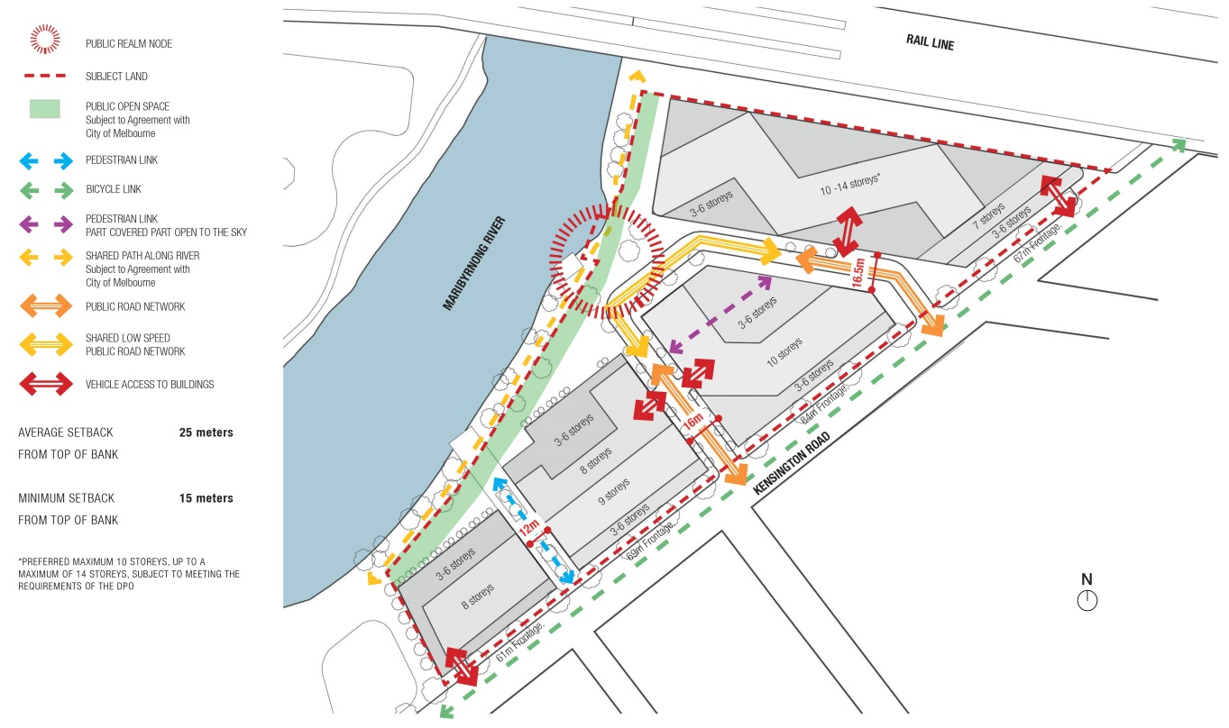
4.0 Reference Documents
--/--/20--
C221

Homes for People: Housing Strategy 2014-18
City of Melbourne Open Space Strategy 2012
Urban Forest Strategy 2012-2032
Kensington Urban Forest Precinct Plan 2014

