PLANNING SCHEME AMENDMENT C221

WEST MELBOURNE WATERFRONT
Dear Sir/Madam
Melbourne Planning Scheme Amendment C221 aims to facilitate a mixed use, residential, commercial and retail development. The amendment applies to land adjoining the Maribyrnong River, at part 156-174 Kensington Road, 176-178 Kensington Road, 180-194 Kensington Road, 196-214 Kensington Road and 216-232 Kensington Road, West Melbourne (please refer to attached site area map).
The Amendment proposes to make the following changes to the Melbourne Planning Scheme:
- Rezone the land from Commercial 2 Zone to the Mixed Use Zone.
- Apply a Development Plan Overlay (DPO) to the land and insert a new Schedule 12 to the Overlay (DPO12). The DPO provides for a staged, development comprising four mixed use buildings ranging in height from three to fourteen storeys, and requires that a development plan be prepared prior to the granting of a planning permit for development (please refer to the attached Indicative Framework Plan for further detail).
- Apply an Environmental Audit Overlay (EAO) to ensure the land is satisfactorily remediated prior to being developed for a sensitive use (such as residential).
From 7 April 2016 to 20 May 2016, the amendment along with the Development Plan will be on public exhibition. Anyone can review these documents and make a submission by Friday 20 May 2016. A copy of the formal Notice of Amendment is attached and provides directions on where you can view the Amendment and how to make a submission.
The outcomes of the exhibition and any proposed revisions to the Amendment and the Development Plan will be reported back to the Future Melbourne Committee.
For more information please contact Sarah Lowcock, Strategic Planner, on 9658 8366 sarah.lowcock@melbourne.vic.gov.au or visit the City of Melbourne’s Participate Melbourne website participate.melbourne.vic.gov.au/C221.
Yours sincerely
Robyn Hellman
Coordinator Planning Scheme

You can comment on Planning Scheme Amendment C221 from 7 April to 20 May.

THE CITY OF MELBOURNE HAS PREPARED PLANNING SCHEME AMENDMENT C221 TO MANAGE THE USE AND DEVELO PMENT OF 160-232 KENSINGTON ROAD, WEST MELBOURNE.

West Melbourne Waterfront – Site Area
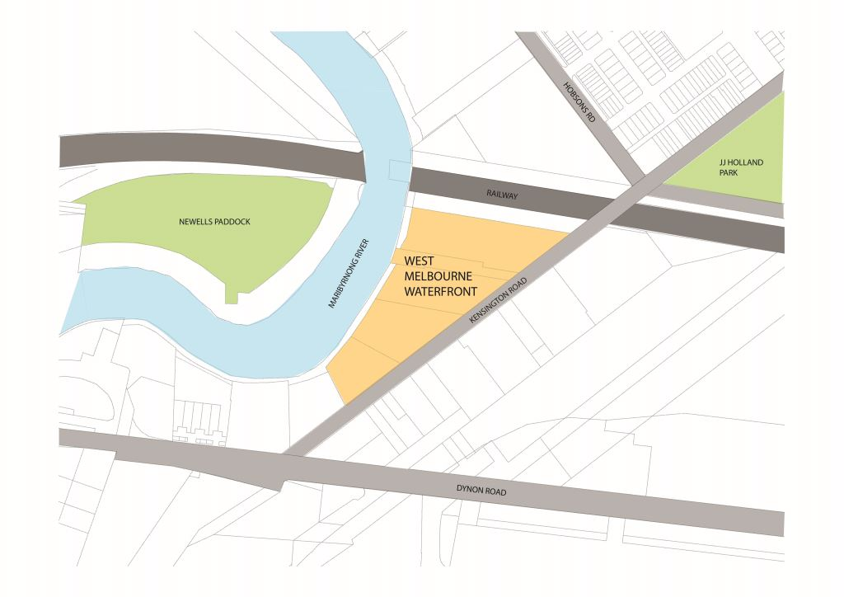

West Melbourne Waterfront – Indicative Framework Plan
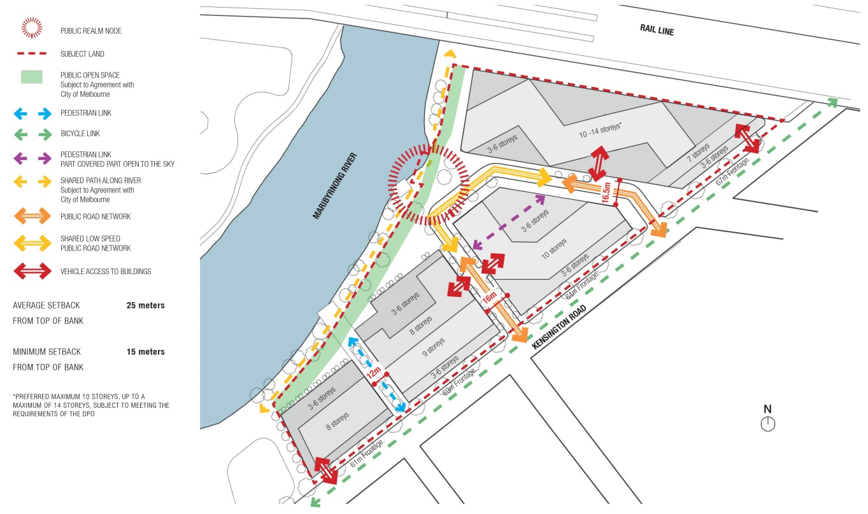

CITY OF MELBOURNE PLANNING SCHEME AMENDMENT ENGAGEMENT TIMELINE
HOW DO I MAKE A SUBMISSION?  For information on where to view the amendment and how to make a submission, see the notice at the back of this letter, or visit the City of Melbourne’s online engagement hub, Participate Melbourne participate.melbourne.vic.gov.au/C221  WHAT IS A PLANNING SCHEME?  A planning scheme is a legal document that sets out planning policies, zones, overlays and other rules affecting how land can be used and developed in the municipality. It sets out what we can and cannot do on different areas of land in the city; for example, whether the land can be used for housing or a shop or business, what the height of a building should be, and how much open space should be provided.  WHAT IS A PLANNING SCHEME AMENDMENT?  As our city grows and changes, planning controls may be changed or updated to reflect the new circumstances. A change to the planning scheme is known as an amendment.  The process for an amendment is set out in the Planning and Environment Act 1987. The amendment process has a number of steps. |  | Proposed Planning Scheme Amendment is considered by Future Melbourne Committee  Minister grants permission to consult on Planning Scheme Amendment.
WE ARE HERE
OPPORTUNITY TO MAKE WRITTEN SUBMISSION
Formal public consultation on Planning Scheme Amendment
OPPORTUNITY FOR VERBAL SUBMISSION TO THE FUTURE MELBOURNE COMMITTEE
Report on public submissions to Future Melbourne Committee
Council requests Minister to appoint independent panel to review and hear submissions.
OPPORTUNITY FOR VERBAL SUBMISSION TO INDEPENDENT PANEL
Independent panel considers written submissions lodged during the statutory consultation period, hears verbal submissions in support of the written submissions and makes recommendations
OPPORTUNITY FOR VERBAL SUBMISSION TO THE FUTURE MELBOURNE COMMITTEE
Future Melbourne Committee considers the panel report and changes to the Planning Scheme Amendment
Council submits final amendment to Minister for approval.
Planning and Environment Act 1987
MELBOURNE PLANNING SCHEME
Notice of the preparation of an amendment
Amendment C221
The Melbourne City Council has prepared Amendment C221 to the Melbourne Planning Scheme.
The land affected by the amendment is part 156-174 Kensington Road, 176-178 Kensington Road, 180-194 Kensington Road, 196-214 Kensington Road and 216-232 Kensington Road, West Melbourne.
The amendment proposes to:
- Rezone the land from Commercial 2 Zone to the Mixed Use Zone (MUZ).
- Apply a Development Plan Overlay (DPO) to the land and insert a new Schedule 12 to the Overlay (DPO12). DPO12 provides for a staged, development comprising four mixed use buildings ranging in height from three to fourteen storeys.
- Apply an Environmental Audit Overlay (EAO) to the land to ensure the land is satisfactorily remediated prior to being developed for a sensitive use.
You may inspect the amendment, any documents that support the amendment and the explanatory report about the amendment, free of charge, at the following locations:
- during office hours, at the office of the planning authority City of Melbourne Level 3, 240 Little Collins Street, Melbourne.
- at Participate Melbourne, the City of Melbourne’s online engagement hub participate.melbourne.vic.gov.au.
- at the Department of Environment, Land, Water and Planning website http://www.delwp.vic.gov.au/public-inspection.
Any person who may be affected by the amendment may make a submission to the planning authority about the amendment. Submissions must be made in writing giving the submitter’s name and contact address, clearly stating the grounds on which the amendment is supported or opposed and indicating what changes (if any) the submitter wishes to make.
Name and contact details of submitters are required for council to consider submissions and to notify such persons of the opportunity to attend council meetings and any public hearing held to consider submissions.
The closing date for submissions is Friday 20 May 2016. A submission must be sent to amendmentC221@melbourne.vic.gov.au or:
Robyn Hellman
Coordinator Planning Scheme and Policy
Urban Strategy
City of Melbourne
PO BOX 1603
MELBOURNE VIC 3001
The planning authority must make a copy of every submission available at its office for any person to inspect free of charge for two months after the amendment comes into operation or lapses.

