Draft plan community engagement summary
Last Kilometre Freight
June 2016

A connected city
We manage movement in and around our growing city to help people trade, meet, participate and move about safely and easily, enabling our community to access all the services and opportunities the municipality offers.

Contents
Background 4
Draft plan community engagement 5
Community engagement findings 8
Response to submissions 10
Changes to the plan 12

Draft Plan Community Engagement Summary
June 2016
Disclaimer
This report is provided for information and it does not purport to be complete. While care has been taken to ensure the content in the report is accurate, we cannot guarantee is without flaw of any kind. There may be errors and omissions or it may not be wholly appropriate for your particular purposes. In addition, the publication is a snapshot in time based on historic information which is liable to change. The City of Melbourne accepts no responsibility and disclaims all liability for any error, loss or other consequence which may arise from you relying on any information contained in this report.

Background
The Draft Last Kilometre Freight Plan was endorsed by the Future Melbourne Committee for community engagement on 13 October 2015. The draft plan established the role of City of Melbourne and others in supporting efficient and resilient central city freight. The draft plan addressed how the municipality could best position its policy, projects and infrastructure to accommodate the evolving needs of freight deliveries whilst balancing city amenity and the transport needs of all modes within the central city.
Community engagement on the draft plan ran from 14 October to 27 November 2015. Pre-draft consultation on the issues and opportunities associated with last kilometre freight was held in March 2015 (see the project timeline).

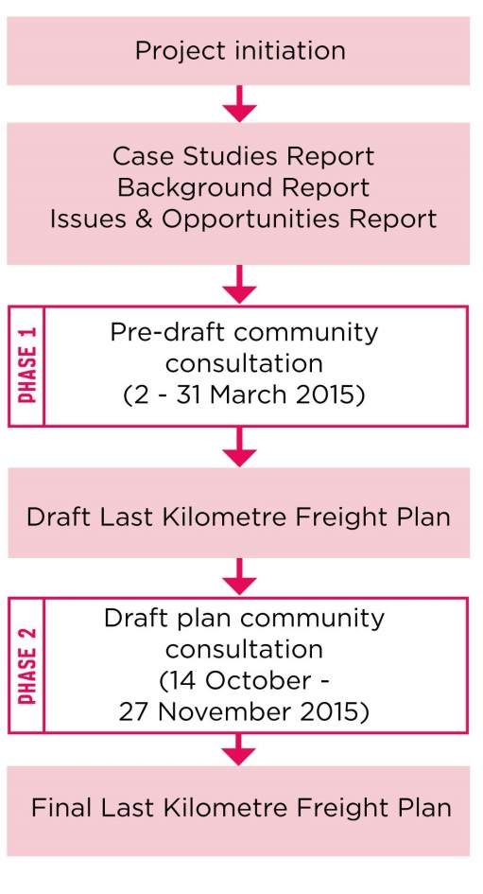
Project timeline

Draft plan community engagement

Aim of engagement
The aim of the community engagement was to ensure the appropriate roles, themes and actions were identified in the draft plan and that these were supported by our community. We also used the engagement to identify any gaps.

Engagement Program

The community engagement program was designed to ensure it was accessible to our diverse freight stakeholders. Engagement opportunities included:
- Participate Melbourne - online engagement hub and survey.
- Freight Open House - face to face engagement and feedback.
- Precinct and Resident Group briefings.
- Offer of meetings and briefings with the project team (all stakeholders).
- Direct feedback to the Project Team via email or telephone.

The feedback received has informed changes to the draft plan to finalise the Last Kilometre Freight Plan. It has also helped identify priorities for implementation.

Communication
Information on the community engagement was circulated through the following channels:
City of Melbourne
Communication opportunities including Enterprise Melbourne newsletter and Melbourne News were used to promote the consultation.
Email
Our stakeholder database (more than 250 individuals and organisations) was contacted throughout the engagement.
Social media
Facebook, Twitter, LinkedIn.
Postcards
More than 10,000 postcards were distributed to central city businesses.

Participate Melbourne
Information on the draft plan was centralised on the City of Melbourne’s ‘Participate Melbourne’ online engagement hub. All communications, including social media posts, online publications, postcards and emails, directed interested parties to the Participate website.
Information available on the website included:
- Draft Last Kilometre Freight Plan.
- Background reports:
  - Case Studies Report;
  - Background Report; and
  - Issues and Opportunities Report.
- Community engagement reports:
  - Breakfast Workshop Report; and
  - Last Kilometre Freight Pre-draft Community Engagement Summary (Issues and Opportunities phase).
A survey was also available through Participate Melbourne. The survey queried participants’ experiences of freight in the central city and their thoughts on the contents of the draft plan. The survey included the option to comment on a specific action or role identified in the draft plan and to raise any perceived gaps or shortcomings. Questions included:
- Has the growth and change in the central city made you think about your freight needs and practices?
- Do you support the roles that have been identified for central city stakeholders? Are there any stakeholders that we’ve missed?
- Would you like to provide feedback on a specific theme or action?
- Is there anything we have missed or anything that needs to be changed?
A total of 16 survey responses were submitted.

Freight Open House
Friday 6 November 2015
7:30am - 11:30am

The Freight Open House provided an opportunity for stakeholders to engage directly as part of the draft plan consultation process. The open house ran as a mini expo on Friday 6 November 2015.

The open house was intended as a platform for networking and sharing freight-related innovation, information, ideas, research and experiences. It also provided an important opportunity for feedback on the draft plan from a target audience.

Large posters offering an overview of the draft plan and its actions were displayed around the open house venue. Each poster offered the opportunity to comment on different themes, actions and roles identified in the draft plan. A total of 19 submissions were received.

Feedback on the open house event was largely positive and the event provided the opportunity for those who wouldn’t usually meet to come together.

The open house featured the following exhibitors:
- Melbourne Metro Rail
- Australian Road Research Board (ARRB) - presenting their research findings on late night delivery
- Suppertime - (now Foodora) app based restaurant service delivered by bicycle
- UrbanFleet - electronic bicycle and cargo bicycle supplier
- Last Mile Solutions - urban consolidation centre
- Bestrane - supply chain technology
- Cargone Couriers - cargo bicycle courier company
- City of Melbourne Bike Plan 2016 - 2020 - information and consultation on the draft bike plan
- Drone video exhibition

Community engagement findings

Overview
During the community consultation 42 individual submissions were received via the Participate Melbourne online survey, email, the Freight Open House and an in-person meeting.

The submission analysis collated all submissions received and broke them down into individual comments for review. A total of 144 comments were recorded. Each submitted comment was individually assessed and commented on.

Breakdown of Comments
The 144 comments derived from the intial 42 submissions were categorised as follows:

General comments
General comments are those which do not take a particular stance on the draft plan or make a recommendation for action. This category includes comments that reference issues with freight in general. For example ‘the value of noise reduction and increased amenity electric cargo bicycles offer to the community is significant but difficult to capture’.

Support for the draft
Support comments are those comments which are consistent with, or support the details of the draft plan. Examples include ‘on your draft strategy we would like to particularly support the actions in regards to the better use of space within the CBD (Action 1.2)’ and ‘useful discussion, not too lengthy and convoluted’.

Issues and gaps
Issues focused on problems respondents saw with the draft plan. Some respondents felt that the plan was too high level and others were sceptical about the likelihood of the actions being implemented. Examples include ‘cargo bikes are manpower wise ineffective - too expensive and low capacity. Cargo trams would be much more cost and time effective.’ and ‘no tangible actions are identified. They are all just “research or investigate” this or that’.
Suggestions
Suggestions centred on ideas people had for making central city freight delivery easier. Many of the suggestions described fine detail actions or initiatives for different parts of the central city, for example ‘building code to mandate ‘safedrop’ areas for carriers supported by security tech’.

A total of 50 suggestions were received, making them most frequent type of response. General comments were a close second with 49.

Primary areas of interest
The draft plan included the following themes:

- Theme 1: Local area planning
- Theme 2: Public transport
- Theme 3: Freight initiatives
- Theme 4: Technology and communication
- Theme 5: Regulation

Theme 3: Freight initiatives was the most popular theme with substantially more comments than any other theme (21 comments).
A number of comments directly responded or related to actions in the draft plan.
The action that received the most attention was Action 3.1: ‘Encourage and support the piloting of new and innovative technologies...’, with a range of responses suggesting freight initiatives to pilot and support for cargo bikes.
A number of comments related to the Queen Victoria Market (QVM) precinct, calling for trials or freight innovations. The draft plan highlighted the opportunities presented by the redevelopment of the QVM. The interest generated through the consultation confirms the need to explore the detailed infrastructure requirements of QVM and build freight requirements into the assessment.
There was support for trialling projects and four submitters expressed an interest in participating in future trials. The draft plan calls for Council to support private sector trialling and innovation.
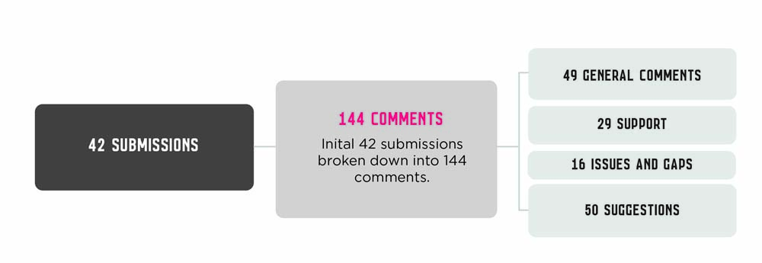
Submission comment breakdown

Response to submissions

Overview
The final plan has been updated to reflect the submissions made during the draft plan consultation. Each submission was broken down into individual comments and each comment was analysed, assessed and responded to. These responses were collated into five groups for action on the draft plan. These action groups are explained below.
Include
Relevant comments for inclusion in the final draft (for example, ideas that fill a gap in the draft). Examples include:
- ‘A significant gap is the absence of any consideration of road safety. Conflict between heavy vehicles and vulnerable road users is a particular concern.’
- ‘Page 19 4.4 Could the freight bulletin also be an App or a newsfeed?’
Support
Comments consistent with, or supportive of, the draft plan.
- ‘Congratulations on the Open House. Great concept.’
- ‘Cargo bikes excellent for city deliveries and bikes with baskets. Do promote.’
Refer
Comments that are not directly relevant to the Last Kilometre Freight Plan but are relevant to other council operations. Examples include:
- ‘Strong support for more bike parking at Rail stations - not just parkiteer cages, but many more bike racks are needed at key stations…….’
- ‘Research customer experience full retail journey at QVM for last kilometre local resident commerce.’
Informative statements
Comments which are informative or unrelated to the plan and not suitable for inclusion in the final draft. Examples include:
- ‘I receive and send a lot of goods from Swanston Street (or at least I try to).’
- ‘Just dodging trucks on my bike, or on foot!!.’
No change
Comments which are too detailed for the scope of the plan, are unrelated to the work or after consideration were not suitable for inclusion in the final plan. Examples include:
- ‘Most taxi ranks are well positioned and well utilised and [we] would not support an increase in freight space/parking at the expense of these.’
- ‘Grocery and produce systems for local transportation.’
Not supported
Comments that are inconsistent with Council policy and were not suitable for inclusion in the final draft. Examples include:
- ‘There needs to be far less access for bicycles and far more access for freight.’
The breakdown of comments outcomes is as follows:
Include - 25
Support - 36
Refer - 12
Informative statements - 28
No change - 39
Not supported – 4
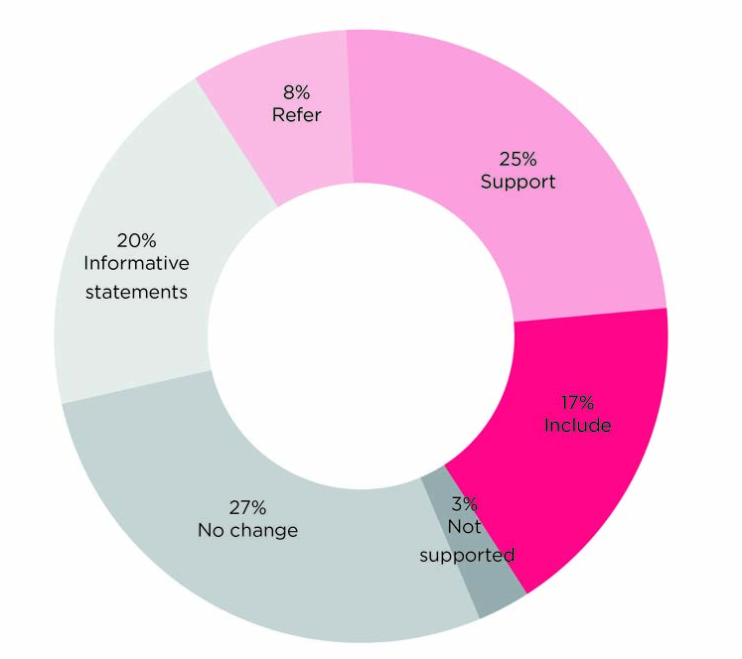
Classification of response to comments

Changes to the plan
Plan section | Changes to plan
General editorial changes | These changes have been made to improve readability. Information and references to other projects have also been updated to ensure the information in the final plan is up to date.
Foreword | Foreword has been incorporated.
Introduction | Text has been reviewed and edited (throughout entire section).  Vision, goals and reference to supporting documents incorporated.  City growth data has been updated.
Who is responsible for what? | Education has been included alongside research. City of Melbourne’s role has been expanded.  Building managers have been identified as having a role alongside business and receivers of freight.  The leadership role of freight deliverers has been expanded to include their role in collaboration.  Universities have been identified as another agency with a role to research and innovate.
Major projects influencing freight | Additional information on the impact of Melbourne Metro has been added.  Further information on the endorsed Bicycle Plan 2016-20 has been incorporated.  Information relating to Elizabeth Street has been updated.
Theme 1: Local area planning | Introductory text has been updated to include ‘specific engagement on last kilometre freight with stakeholders.’  New recommendations have been added:  - ‘Investigate infrastructure to improve the efficiency and safety of goods delivered to and from the QVM.’  - ‘Do last kilometre freight plan as part of local area planning.’  Research recommendation has been moved to Action 4.2.
Theme 2: Public transport | The construction of Melbourne Metro rail has been referenced and the text updated to reflect the scale of impact.  A new recommendation has been added:  - ‘Ensure last kilometre freight is considered in Traffic Management Plans.’
Theme 3: Freight initiatives | Reference to Melbourne as a 24 hour city has been inserted.  The City of Melbourne’s role in facilitating out of hours trials has been incorporated.  New recommendations have been added:  - ‘Encourage and support low emission and low impact vehicles in the central city.’  - ‘Encourage and support the use of alternative vehicles that will increase safety by reducing conflict between heavy vehicles and vulnerable road users.’  - ‘Engage with all stakeholders on the potential use of alternative vehicles (including electric vehicles and cargo-bikes) to perform out of hours deliveries.’
Theme 4: Technology and communication | Additional text to recognise our increased reputation as a connected city as well as a knowledge city.  The role of institutions has been recognised.  The recommendation relating to street management has been moved to Theme 5.  The reference to 50 per cent desired occupancy has been removed from Action 4.1.  New recommendations have been added:  - ‘Work with inner Councils to share data and ensure efficient delivery across municipalities.’  - ‘Research and communicate crash statistics for accidents involving freight vehicles in the central city’ (relocated from Theme 1).  - ‘Investigate the need for a freight education campaign amongst central city users to realise the Last Kilometre Freight Plan and the City of Melbourne Road Safety Plan 2013-17.’  Additional text has been added to the following recommendations, as underlined:  - ‘Investigate changes to the provision and management of on-street loading zones in Elizabeth Street, where strategic opportunities are being investigated.’  - ‘Ensure advancing technology, such as driverless vehicles, drones and robots are considered and appropriately regulated in the central city environment.’  - ‘Investigate the usefulness of a regular multi-agency road freight bulletin and the best way to provide information on changes to central city roads.’ - investigate the best way to provide information.’  - ‘Collaborate with City of Sydney, our sister cities and other governments to identify opportunities to improve our last kilometre freight practices’.
Theme 5: Regulation | Action 5.2 been modified to meet the objectives of the Road Safety Plan 2013-17 and update the reference to the Bicycle Plan 2016-20.  New recommendations have been added:  - ‘Identify alternative ways to manage the street to achieve the most efficient use of on-street parking and loading services’ (relocated from Theme 4).  - Additional text to encourage new buildings to incorporate security protected delivery areas and charging stations.
Implementation | An implementation chapter has been incorporated.

