
Last Kilometre Freight Plan
June 2016
A Connected City
We manage movement in and around our growing city to help people trade, meet, participate and move about safely and easily, enabling our community to access all the services and opportunities the municipality offers.
Contents

Foreword from the Lord Mayor of Melbourne and Councillor Cathy Oke 4
Introduction 6
Why are we doing a last kilometre freight plan? 6
What does this plan address? 8
City growth 9
Who is responsible for what? 10
Major projects influencing freight 12
Theme 1: Local area planning 14
Elizabeth Street 15
Queen Victoria Market 15
Future Projects 15
Theme 2: Public Transport 16
Public transport infrastructure 16
Melbourne Metro 16
Theme 3: Freight Initiatives 18
Cargo bikes 18
Pilot Projects 19
Out of hours deliveries 19
Theme 4: Technology and Communication 21
Technology 21
Communication 21
Theme 5: Regulation 23
Building design 23
Street design 23
Implementation 25
References 34
Supporting documents 35

Last Kilometre Freight Plan
June 2016
Disclaimer
This report is provided for information and it does not purport to be complete. While care has been taken to ensure the content in the report is accurate, we cannot guarantee is without flaw of any kind. There may be errors and omissions or it may not be wholly appropriate for your particular purposes. In addition, the publication is a snapshot in time based on historic information which is liable to change. The City of Melbourne accepts no responsibility and disclaims all liability for any error, loss or other consequence which may arise from you relying on any information contained in this report.
To find out how you can participate in the decision-making process for City of Melbourne’s current and future initiatives, visit melbourne.vic.gov.au/getinvolved

Foreword from the Lord Mayor of Melbourne and Councillor Cathy Oke
Melbourne is the fastest growing city in Australia and we need to be smart about how we accommodate that growth.

We know that 46,000 vehicles and 11,500 bicycles enter the city during the morning peak and 10,300 delivery vehicles enter the city on an average weekday. These figures are set to increase as a growing city will require more deliveries to supply our homes, shops and offices with the things we need.

The City of Melbourne is conscious that an increase in deliveries could result in more trucks and cars on our roads, contributing to congestion on our streets and pathways. We need to investigate, plan for and encourage more innovative ways for deliveries to reach their destination.

Our Last Kilometre Freight Plan focuses on the last leg of a product’s journey into our homes and businesses. The plan is part of an integrated approach to transport, as outlined in the City of Melbourne Transport Strategy 2012.

Our plan links all modes of transport and is coordinated with development in the central city. It also recognises that the City of Melbourne must work with businesses, State Government and the private sector to facilitate innovation in last kilometre freight.

The Last Kilometre Freight Plan includes actions and recommendations that will ensure we keep a strong focus on the vital role that freight plays in the city and that we continue to improve the city’s environment for all users. Work on the plan has already facilitated research and industry connections.

Our vision is for Melbourne to be a connected city: a city that’s linked by a well designed transport system; a city where people can move through our streets safely and easily and a city where people have the things they need, thanks to an efficient and sustainable freight network.


Robert Doyle Cathy Oke
Lord Mayor Councillor (Chair Transport Portfolio)

Introduction

Why are we doing a last kilometre freight plan?
Last kilometre freight is at the heart of how our city works. It is the last leg of the journey of goods into our shops, cafes, restaurants, offices and homes. Efficient freight movement improves liveability, economic prosperity and sustainability.
While there is no evidence of a ‘city-stopping’ freight problem in Melbourne today, there are daily challenges and inefficiencies for freight delivery. These challenges will increase as the central city gets busier and construction of major public transport infrastructure commences.
There are no off-the-shelf solutions when it comes to improving freight movement in a central city. What works in one city may not work in another. An important aspect of this plan is considering the local context and establishing clear roles and expectations about freight so businesses in Melbourne are well positioned to respond to change. This plan makes clear that the City of Melbourne can facilitate change by working with businesses, sharing knowledge and developing partnerships around freight innovation as the city changes. It also establishes that commercial freight initiatives must come from private sector and other players in the supply chain.
The plan has been developed to realise the City of Melbourne’s vision to foster innovative and low-impact freight in central Melbourne, whilst ensuring the central city is designed for people with safe and convivial streets and a prosperous central city for business.
The plan is supported by the following City of Melbourne documents. As well as establishing policy direction, aims, objectives and documenting current practices, these documents illustrate the process to identify the priorities for this plan.
- Last Kilometre Freight Background Report 2015.
- Last Kilometre Freight Case Studies Report 2015.
- Last Kilometre Freight Issues and Opportunities Report 2015.
- Last Kilometre Freight Breakfast Workshop (summary) 2015.
- Last Kilometre Freight Pre-draft Community Consultation (summary) 2015.
- Draft Last Kilometre Freight Plan 2015.
- Draft Plan Community Engagement Summary, Last Kilometre Freight 2016.
This plan identifies actions to ensure last kilometre freight is considered as our city grows and changes. These actions are supported by recommendations and steps to implementation. They have been developed in response to research and engagement undertaken by the City of Melbourne.
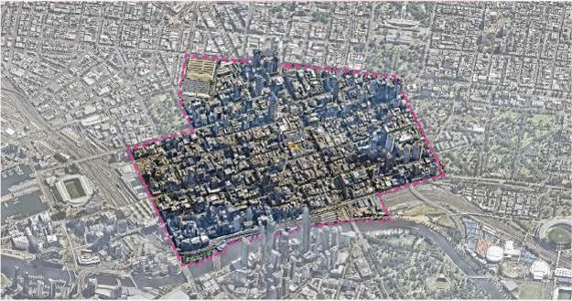
Figure 1: Last Kilometre Freight Plan area
This map highlights the central city area. Itis defined by borders on: Spencer Street from the Yarra River to La Trobe Street, La Trobe Street from Spencer Street to William Street, William Street and Peel Street from La Trobe Street to Victoria Street, Victoria Street from Peel Street to Spring Street, Spring Street from Victoria Street to Flinders Street, Flinders Street from Spring Street to Russell Street, the southern end of Russell Street to the Yarra River and the northern Bank of the Yarra River from Federation Square to Spencer Street.

What does this plan address?
The phrase “last-kilometre freight” covers a vast range of shops, businesses, goods, delivery processes, technologies, locations, industries, people and vehicles.
This plan addresses the last leg of the freight journey in the central city, as this is where most of the freight is delivered and where congestion and pressures on freight delivery are highest (see figure 1). It does not consider the movement of goods from international or interstate locations to distribution centres.
Freight delivery is relevant to everyone. Whether we live or run a business in the central city or visit to work, shop, relax or eat, we have a role in thinking about the future of freight.
People will respond differently to freight challenges and will change practices as appropriate. People will make the decisions that are best for them. They will innovate, adopt technology and change processes to ensure they have the goods they need to be successful in the central city environment.
This plan establishes City of Melbourne policy and action on last kilometre freight and a framework for private and public sector innovation to reduce the impact of freight delivery and ensure that it can get to its destination.
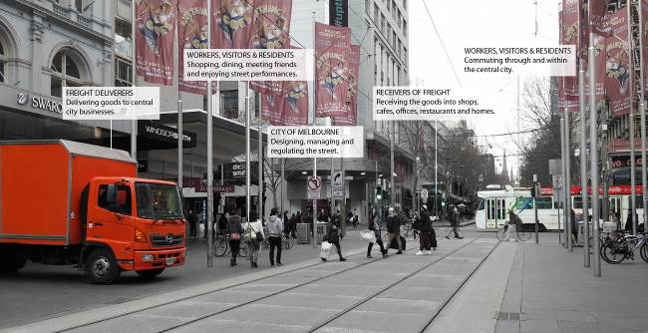
Figure 2: Central city street activities
The above image is an annotated photo taken in Bourke Street Mall, Melbourne. The first annotation points to a truck parked in Bourke Street Mall and reads “freight deliverers: delivering goods to central city businesses”. The second annotation points to a person walking along the street and reads “workers, visitors and residents: shopping, dining, meeting friends and enjoying street performances”. The third annotation points to a street sign and reads “City of Melbourne: designing, managing and regulating the street”. The forth annotation points to central city businesses and reads “receivers of freight: receiving goods into shops, cafes, offices, restaurants and homes. The fifth annotation points to a Swanston Street tram and reads ‘workers, visitors and residents: commuting through and within the central city”.

City growth
The City of Melbourne is growing quickly. In the ten years to 2015, the number of jobs in the central city grew 20 per cent (to 219,000 people) and the number of dwellings increased 113 per cent (to 23,573 dwellings).
Major infrastructure initiatives such as the Melbourne Metro, new tram stops and re-routing trams will continue to transform the central city.
This will trigger changes to the way everyone moves in the central city, including how freight is delivered. Figure 3 illustrates the complexity of daily activity in the central city.
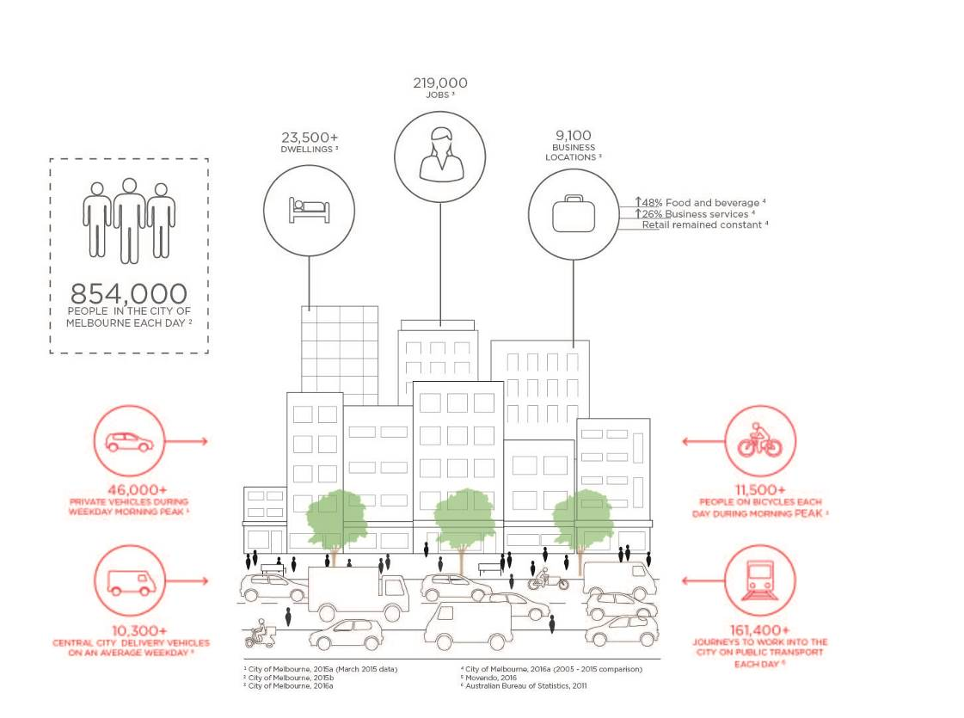
Figure 3: Central city activity
The above diagram is an illustration of a central city scene, skirted by icons and figures that detail available data on the central city. This data is as follows: over 23,500 central city dwellings, over 219,000 central city jobs, over 9,000 central city business locations (18 per cent increase in retail establishments, 65 per cent increase in food and beverage establishments, 30% increase in business services), over 46,000 private vehicles coming into the City of Melbourne each day, over 11,500 people riding bicycles into the City of Melbourne each day, over 850,000 people in the City of Melbourne each day, over 12,100 service delivery vehicles making deliveries in the central city on an average weekday, over 161,400 people coming into the City of Melbourne on public transport each day.

Who is responsible for what?
Freight vehicles form part of a complex and diverse central city transport picture, mixing with people walking, riding bicycles, using public transport and driving.
There are many roles undertaken in the delivery of freight. Much of the movement infrastructure is managed by government, but the task of delivering goods in the city will remain the responsibility of the private sector.
The appropriate roles for the City of Melbourne, building managers, businesses and receivers of freight, freight deliverers, residents and other agencies have informed the development of this plan. Figure 4 provides an overview of the roles different actors fulfil.
Figure 4: Last kilometre freight roles in the central city
 | City of Melbourne | Building managers, business and receivers of freight | Freight deliverers | Residents | Other agencies
Leadership and advocacy | X | X | X |  | X
Facilitate collaboration and partnerships | X |  |  |  | X
Manage and regulate | X | X |  |  | X
Research and educate | X | X | X |  | X
Communicate | X | X |  |  | X
Generate solutions |  | X | X
Support innovation | X | X |  | X | X
Innovate |  | X | X
Collaborate | X | X | X |  | X
Reduce congestion | X |  | X

The role of the City of Melbourne
Support innovation
Supporting private sector efforts to test innovative and efficient freight practices. Raising central city businesses’ awareness of last kilometre freight innovations and best practice.
Leadership and advocacy
Supporting and advocating for changes that will increase the efficiency of the last kilometre freight task and enhance the public realm.
Facilitate collaboration and partnerships
Partnering with and introducing key stakeholders, including community groups, precinct groups, local businesses, industry stakeholders and other government organisations, to achieve the best freight outcomes to meet their needs.
Manage and regulate
Balancing freight needs with the needs of other city users. Designing infrastructure and regulations that support innovative and efficient freight and contribute to convivial and safe streets for all.
Research and educate
Building an evidence base to inform and educate stakeholders and guide action and decision-making.
Communicate
Communicating the right information at the right time to ensure stakeholders possess the knowledge to make the best decisions.

The role of building managers, businesses and receivers of freight
Generate solutions
Building business resilience by identifying the best solutions to freight challenges as early as possible. Identifying the information and support required to inform their decision making and to help realise solutions.
Innovate
Adapting and responding to change with innovation. Ensuring the best and most efficient delivery models are servicing their needs whilst keeping their business costs down and minimising impacts on amenity.
Collaborate and communicate
Collaborating with like and neighbouring businesses to assist innovation and identify appropriate solutions. Sharing information and experiences to inspire innovation.

The role of freight deliverers
Innovate
Maintaining efficiency and responding to the changing central city and the needs of businesses through innovation. Servicing the growing central city by the most efficient and reliable means.
Reduce congestion
Consolidating deliveries and using alternative vehicles and different times of day to manage congestion in the central city through smart works procedures.
Leadership
Leading the way by providing new technologies and innovations that will serve the growing city and enhance the liveability and prosperity of Melbourne, whilst reducing environmental impact. Collaborating with business and residents to achieve these outcomes.

The role of residents
Support innovation
Being adaptable and open to change. Supporting and encouraging business and delivery companies to innovate to establish new ways to deliver freight in the central city.

The role of other agencies
There are multiple government and private agencies operating in the central city managing assets to achieve the best, safest and most efficient results. The actions of these agencies can affect the way last kilometre freight is delivered - for example, timely and efficient communication about road closures or infrastructure changes allows the freight delivery industry to develop contingency plans.
Other agencies and their responsibilities include:
- VicRoads – traffic light signals and arterial roads.
- Public Transport Victoria (PTV) - public transport infrastructure, including level access tram stops.
- Melbourne Metro Rail Authority - design and delivery of Melbourne Metro.
- Yarra Trams, Metro Trains and bus companies – the daily operations of our public transport system.
- Utility companies - the servicing and management of infrastructure. This includes emergency management response (e.g. burst water mains), but also planned maintenance works.
- Universities – undertaking research and seeding innovation.

Major projects influencing freight
The following projects will change how freight is delivered in the central city. In the short term through construction and in the longer term as our city adapts to new transport infrastructure and an enhanced public realm.
Melbourne Metro
Our public transport system will undergo major transformation through the development of Melbourne Metro.
Melbourne Metro is planned to deliver:
- Two nine-kilometre rail tunnels from South Kensington to South Yarra, travelling underneath Swanston Street in the CBD, as part of a new Sunbury to Cranbourne/Pakenham line.
- New stations at Arden, Parkville, CBD North, CBD South and Domain, with surface level changes and improvements.
- Train/tram interchanges at Parkville and Domain.
Major works are expected to commence on the Melbourne Metro Rail project by 2018, these works may include road closures, reduced on-street parking and loading and changes to the public transport network.
In addition to increased rail network capacity, this project will provide new and improved access to inner Melbourne’s urban renewal areas and changes to on-street public transport. This will lead to improved access to the central city, alleviating congestion and providing additional choice for central city mobility.
It will also enable more people to come to the city increasing the number of pedestrians on city footpaths and using other infrastructure.
Tram route changes
To respond to significant population growth and increased patronage of tram services and to support the implementation of Melbourne Metro Rail, changes to Melbourne’s tram routes are required. These changes will ease tram congestion on the Swanston Street Corridor and allow for tram routes to be redistributed to other parts of the central city. This will create additional capacity and improve the level of tram service in other parts of the central city. New tram stops and routes can affect the streetscape and may have short and longer term impacts on freight in the central city.
Level access tram stops
The introduction of level access tram stops throughout the central city will ensure people of all abilities can use our public transport system. These works will be completed to ensure Victoria complies with the Disability Discrimination Act 1982 which stipulates Victoria must achieve 100 per cent compliance by 2032. Some tram stops are currently - or are predicted to be – overcrowded and will need to be expanded. Some may need to be expanded to serve new longer trams. The introduction of new tram stops can affect the layout of parking and loading zones and can change traffic capacity affecting how deliveries can be made.
New bicycle lanes
The City of Melbourne is committed to making Melbourne a cycling city, “with its entire road network safe and attractive for cyclists of all ages”. The City of Melbourne Bike Plan 2016-20 (endorsed March 2016) aims to increase bike use to one in four vehicles entering the city in the morning and eliminating serious crashes from the network. As new bike lanes are implemented throughout the city we need to be aware of the impact these can have on loading zones and of the opportunities new bicycle lanes and infrastructure can provide for cargo bike deliveries over the last kilometre.
Elizabeth Street Strategic Opportunities Plan
An Elizabeth Street Strategic Opportunities Plan is being developed by the City of Melbourne. This will guide future streetscape improvement works to Elizabeth Street in consultation with the community. This plan is being developed with consideration to the impact of major transport infrastructure projects in the central city - the design development of this plan is subject to ongoing consultation with Melbourne Metro Rail Authority, Public Transport Victoria and other key stakeholders.

Theme 1: Local area planning
Last kilometre freight will be a high priority in all local area plans (such as masterplans). This will mean assessing current and future freight needs, engaging stakeholders about freight issues and considering how innovations can help deliver the freight task.
Last kilometre freight must be considered in the context of each project. Different parts of the central city will have different last kilometre freight requirements and therefore different solutions. This is due to a variety of uses (retail, residential, commercial etc.), different access and building types (with some buildings restricted through heritage and other controls) and differing character and amenity.
In order to ensure freight requirements inform future local area plans, the following should be considered:
- Researching and communicating crash statistics for accidents involving freight vehicles in the central city.
- Undertaking freight surveying and analysis and identifying efficient ways of presenting the data.
- Supporting new freight infrastructure, including innovative and low-impact freight solutions.
- Specific engagement on last kilometre freight with stakeholders.

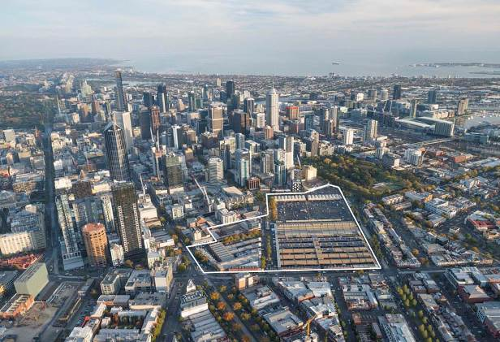
Figure 5: Queen Victoria Market precinct
The above map outlines the area of the Queen Victoria Market redevelopment. The Queen Victoria Market is defined by borders on Elizabeth Street, Franklin Street, Peel Street, and Victoria Street.

Elizabeth Street
The Elizabeth Street Strategic Opportunities Plan is being prepared to accommodate improvements to the public realm and recognise Elizabeth Street’s role as a primary pedestrian spine. There are potential opportunities for freight improvements in Elizabeth Street, including the potential to trial new solutions. Any freight solution for Elizabeth Street will need to be integrated with surrounding areas including the Vehicle Access Permit Scheme operating on Swanston and Bourke streets.

Queen Victoria Market
Redevelopment of the Queen Victoria Market (QVM) provides the opportunity to reinvigorate deliveries to and from this precinct, including the potential to deliver market goods to the increasing number of people living and working near the market and the potential to incorporate infrastructure to support innovative last kilometre freight delivery from the market.
Future Projects
All projects undertaken in the central city (and other areas of the municipality) will consider the role of deliveries and servicing to ensure appropriate infrastructure and design options are identified.
Actions
- Investigate the opportunity for low-impact local delivery opportunities as part of the QVM re-development. This could include the following:
- Pilot low impact vehicles for QVM goods delivery within the central city.
- Determine the feasibility of using QVM as a distribution hub for low impact vehicles.
- Investigate infrastructure to improve the efficiency and safety of goods delivered to and from the QVM.
- Investigate opportunities to reclaim unused or underutilised city space for freight and logistics. This could include the following:
- Refurbishing unused space in central city car parks.
- Undertaking inventory of buildings which have capacity to service surrounding businesses.
- Reassigning on-street space.
- Do last kilometre freight plan as part of local area planning.

Theme 2: Public Transport
Public transport – in combination with walking - has become the mainstay of central city mobility. It ensures we can move a large number of people into, through and around the city each day. Significant changes to public transport infrastructure will affect the way last kilometre freight is delivered in the central city.

Public transport infrastructure
Improvements to Melbourne’s public transport network will increase personal mobility in the central city. Changes to infrastructure can affect the way freight is delivered through changes to loading areas, a reduction in on-street parking and the narrowing of streets.
The City of Melbourne will continue to work with our partners to ensure that changes to the public transport network consider the function of the street and the impact on freight and surrounding businesses.

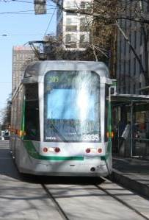
Figure 6: Recent introduction of level access tram stops has affected the loading process in the central city

Melbourne Metro
Melbourne Metro Rail will transform Melbourne. The project will bring up to an additional 20,000 people into the heart of Melbourne in peak hours. Two of the new stations will be in the central city - with busy entrances and connections to the street network.
Building Melbourne Metro Rail provides unique challenges and opportunities. Managing impacts on the delivery supply chain in the central city, particularly in proximity to Melbourne Metro construction sites, will require a variety of responses to ensure freight continues to reach city businesses. It is also an opportunity for the city to innovate in the way it manages freight to improve future amenity and prosperity.
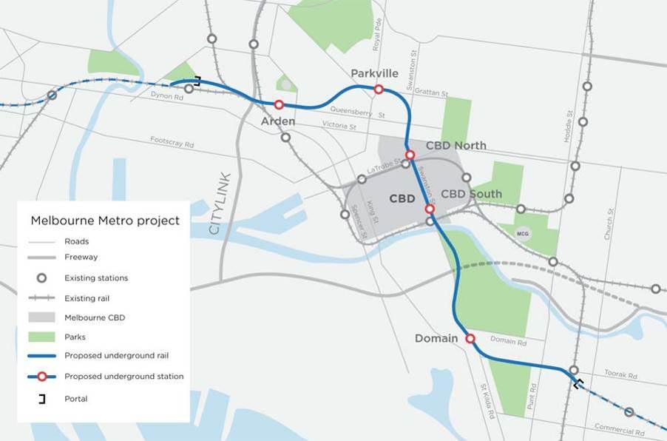
Figure 7: Proposed Melbourne Metro Rail Project alignment
The above map displays the planned route of Melbourne Metro Rail with an underground railway proposed to run from South Kensington to South Yarra via the central city. Five new train stops are proposed: Arden, Parkville, CBD North, CBD South and Domain.

Actions
  - Work with the State Government and our central city partners to promote efficient last kilometre freight in the planning and construction of Melbourne Metro Rail. This could include the following:
- Facilitate improved communication and collaboration between stakeholders around the staging and development of Melbourne Metro Rail and public transport works.
- Facilitate new ways of delivering and receiving freight in response to Melbourne Metro Rail and new public transport infrastructure.
- Ensure last kilometre freight is considered in Traffic Management Plans

Theme 3: Freight Initiatives
Each day, in response to rising city congestion and costs, businesses around the world are working to find cheaper, easier and more efficient ways to move goods. Raising awareness of local and global freight innovations will help local businesses improve central city freight delivery.

Cargo bikes
The City of Melbourne’s Transport Strategy 2012 calls for Melbourne to become a cycling city and a city which supports efficient urban freight through increased innovative and low impact freight.
Cargo bikes are a low impact way to deliver goods. They emit no pollution. They are quieter, smaller and more transparent than trucks and so pose less of a safety threat. They do not block city views and require less space for parking. Cargo bike riders can have a strong connection to other city users because they are travelling at eye level and not inside an enclosed vehicle. Cargo bikes can be electrically assisted to move heavier loads.
There is an emerging cargo bike delivery sector in Melbourne and cargo bike use is growing around the world, especially in the busiest parts of cities. Because of their flexibility and relatively quick delivery times in crowded places, cargo bikes have also helped stimulate and facilitate new ways of doing business.
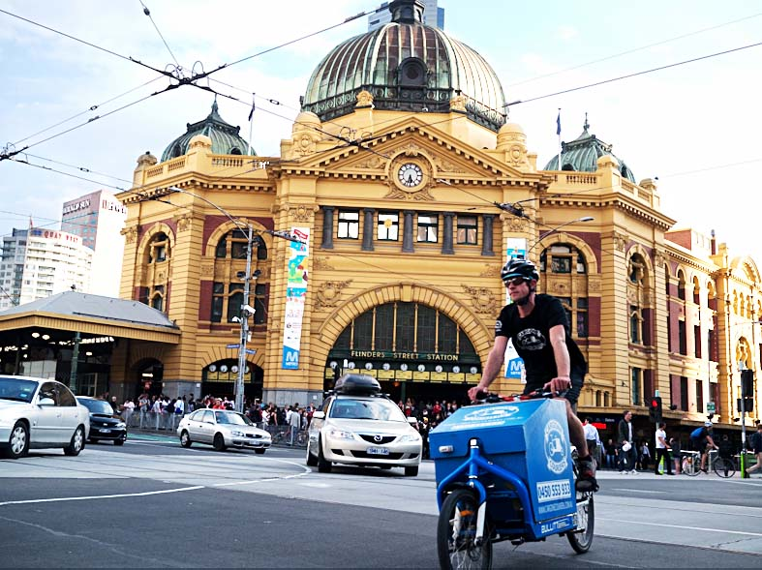
Figure 8: Cargo bike courier, Melbourne

Figure 9: Visual impact of parked freight vehicles
The above diagram shows two identical buildings – one with a cargo bicycle parked in front and the other with a small truck parked in front. The truck obscures the view to the store front whilst the cargo bicycle does not.

Pilot Projects
As part of supporting business growth, development and innovation, the City of Melbourne will provide leadership, advice and support to businesses wishing to innovate.
To build greater resilience amongst the business community and assist business continuity planning, the City of Melbourne can:
- Fund and undertake trials.
- Share lessons learnt from trials.
- Provide support to other agencies interested in piloting projects within the central city.

Out of hours deliveries
The potential benefits of out of hours delivery include reduced congestion, quicker and more efficient delivery, reduced infrastructure requirements, maximising vehicle operational hours and consolidation of larger deliveries - therefore requiring fewer vehicles throughout the day.
Retiming deliveries to off-peak hours has been tried in many places around the world. The costs and benefits of out of hours delivery vary from city to city because every city has different people, traditions, customs, traffic conditions, buildings, street layouts and rules. To be successful, out of hours delivery must work for all players in the supply chain, including the receiver. Having people available to receive freight after hours can be a cost to businesses. Some industries will be better suited to out of hours delivery than others. In many cases, trials of out of hours delivery have not become permanent due to the extra costs involved.
The Department of Economic Development, Jobs, Transport and Resources is working with VicRoads to understand the potential for out of hours delivery in the heart of Melbourne. The challenges are to establish a local rationale for out of hours delivery, to identify the local barriers and enablers and to identify deliverers and receivers interested in leading change.
Melbourne aims to be a 24 hour city. Out of hours deliveries must be managed to support and recognise the range of activities taking place in the central city at all times.
City of Melbourne has a role to play in out of hours delivery by ensuring the liveability of the city is maintained and enhanced where possible but also through the facilitation of out of hours trials and the application of our regulatory procedures such as the designation and timing of loading zones and parking permits, as explored in Theme 4: Technology and communication and Theme 5: Regulation.
Actions
  - Encourage and support the piloting of new and innovative technologies (including vehicles) and processes. Share the outcomes and lessons learnt with all stakeholders to ensure the full impact of new systems are understood and communicated. This could include the following:
- Investigate funding to support central city business and retail precincts (self-formed or other) driving innovation and developing new ways of handling freight over the last kilometre.
- Investigate the potential for the increased use of cargo bikes for goods movement in the central city.
- Promote and raise awareness about the use of cargo bikes and other freight initiatives for delivery in central Melbourne.
- Encourage and support low emission and low impact vehicles in the central city.
- Encourage and support the use of alternative vehicles that will increase safety by reducing conflict between heavy vehicles and vulnerable road users.
  - Work with State Government, industry and the community to overcome barriers (regulatory and other) to quiet out of hours delivery in the central city. This could include the following:
- Identify principles for out of hours deliveries to protect the liveability and amenity of the central city.
- Encourage out of hours infrastructure innovations.
- Support out of hours pilots and ensure the findings are shared with all stakeholders.
- Engage with all stakeholders on the potential use of alternative vehicles (including electric vehicles and cargo bikes) to perform out of hours deliveries.
- Provide input into the EPA Victoria review of State Environment Protection Policy (control of noise from industry, commerce and trade) No. N-1 to achieve the best balance for our residential and commercial stakeholders.

Theme 4: Technology and Communication
Advanced technology and improved communication and collaboration can transform the way we experience the city and increase our reputation as both a connected and knowledge city. It can assist in ensuring central city space is used as efficiently as possible. Improved communication ensures that stakeholders can make the best decisions about deliveries by having all necessary information available to them.

Technology
Rapid technology advancements are changing the way we move, eat, live and socialise. Technology will also have an increasing role in the mobility of cities and the movement of people and goods. Melbourne’s central city freight systems should take advantage of 21st century technology.
Intelligent transport solutions can reduce delays, improve safety, cut noise and allow the efficient sharing of scarce resources including space in the central city.
Technology advancements in freight include systems for booking on and off street loading areas, systems for identifying empty vehicles and connecting them to customers, new low-impact vehicles and systems for combining several deliveries into a single load.

Communication
The central city is a complex environment, with many stakeholders managing, operating and interacting within a limited space. Timely and open communication between stakeholders including institutions, agencies, receivers of freight and freight delivery companies will ensure all parties can be prepared and make the best decisions to meet their freight needs. It will also ensure business continuity and resilience as the central city intensifies and undergoes significant transformation.
Actions
  - Investigate new opportunities for gathering and using freight data to improve freight efficiency. This could include the following:
- Collect data and survey loading zones to evaluate their efficiency and determine if they are achieving the desired occupancy at peak loading times.
- Develop tools to understand the freight generation rates for different land uses.
  - Ensure data which impacts on freight planning and delivery is visible and available. This could include the following:
- Share our information and data to ensure we are adaptive, agile and provide consistent and reliable information to plan ahead and enable solutions – use the right channel at the right time, for the right thing.
- Integrate our technology and information with platforms and systems used by our stakeholders.
- Work with other agencies to share their data with the public.
- Work with inner Councils to share data and ensure efficient delivery across municipalities.
- Research and communicate crash statistics for accidents involving freight vehicles in the central city.
  - Investigate the use of technology to improve the efficiency of deliveries or change the way deliveries are undertaken. This could include the following:
- Investigate changes to the provision and management of on-street loading zones in Elizabeth Street, where strategic opportunities are being investigated.
- Investigate the development of a freight journey planner.
- Publish a freight access map of the central city showing on-street loading zones and the quiet and busy on-street parking times (informed by the parking sensors) to assist freight deliverers to make the best decision on the timing and location of their deliveries.
- Ensure advancing technology, such as driverless vehicles, drones and robots are considered and appropriately regulated in the central city environment.
- Capitalise on Melbourne’s hosting of the 2016 Intelligent Transport Systems (ITS) World Congress to promote the use of technology to improve the efficiency of last kilometre freight.
  - Support and encourage ongoing communication and engagement between all stakeholders to deliver better outcomes. This could include the following:
- Facilitate the early provision of information so businesses have the best opportunity to respond to change.
- Seek the views of stakeholders to identify appropriate freight solutions.
- Develop a platform where all stakeholders can share advice and experiences, to encourage innovation and ensure all stakeholders are aware of freight initiatives.
- Investigate the usefulness of a regular multi-agency road freight bulletin and the best way to provide information on changes to central city roads.
- Collaborate with City of Sydney, our sister cities and other governments to identify opportunities to improve our last kilometre freight practices.
- Collaborate with and connect stakeholders who wish to expand their operations or change their practices to increase the use of cargo bikes.
- Build business engagement and collaboration around the transformation of the public transport network.
- Investigate the need for a freight education campaign amongst central city users to realise the Last Kilometre Freight Plan and the City of Melbourne Road Safety Plan 2013-17.

Theme 5: Regulation
The City of Melbourne regulates the use of streets in many ways to deliver the greatest benefit to the community. Regulating streets can be a complicated balancing act and must respond to the changing demands of users. For example, the desire for a pedestrian mall in Bourke Street required regulation to prevent private vehicle access but to permit freight vehicles at certain times.

Building design

Overview
New buildings in the City of Melbourne should be designed to provide for efficient servicing and delivery. The City of Melbourne can influence building design through:
- Determining planning applications.
- Managing waste.

Street design
Areas of regulation undertaken by the City of Melbourne include:
- Traffic function on City of Melbourne roads.
- Allocating and positioning loading zones and on-street parking areas.
- Operating the Vehicle Access Permit Scheme in Swanston Street and Bourke Street Mall.
- Designing and constructing the public realm including footpaths.
- Issuing permits for the occupation of roads and footpaths to support construction.
The Vehicle Access Permit Scheme, which has operated in Swanston Street since 1978 and Bourke Street since 1991, prevents most vehicles using these streets except some delivery vehicles at specific times. This is to make the streets safer and more enjoyable, provide space for walking, cycling and trams and provide access for deliveries to businesses located on these streets. Some deliverers support the scheme because it makes delivery easier and more efficient. As the city grows and intensifies, the scheme will need to be managed to ensure it provides the greatest benefit to the community.
The City of Melbourne currently aims to have a 50 per cent or lower occupancy of loading zones in peak loading times. This low occupancy rate improves the likelihood of a loading space being available, makes it easier for freight deliverers and reduces vehicles circling and adding to city congestion. It may be possible to improve the efficiency and ‘work rate’ of our loading zones by using technology and improving practices relating to management of loading zones.

Actions
  - Ensure new buildings are equipped to meet the freight requirements for receiving and dispensing goods and services. This could include the following:
- Advocate for the inclusion of loading bays for waste collection and furniture removal in non-commercial buildings, including high rise residential, via the statutory planning process.
- Encourage new buildings to integrate new technologies and infrastructure so deliveries can be made in the most efficient and effective means possible. This may include the use of parcel-lockers, security protected delivery areas, electronic charging stations, consolidation points and quiet loading dock technology.
  - Investigate further opportunities to enhance the operations of central city streets to:
- Meet the objectives of the Transport Strategy 2012, Bicycle Plan 2016-20, the Road Safety Plan 2013-17 and the Walking Plan 2014; and
- Minimise congestion and enhance central city mobility and amenity.
This could include the following:
- Identify alternative means for street management to achieve the most efficient use of on-street parking and loading services.
- Undertake a review of the Vehicle Access Permit Scheme. Assess the performance of the scheme, determine if it is an appropriate tool to expand into other areas of the central city and identify changes to improve the operation of the scheme including opportunities to improve efficiency through technology and training.
- Undertake a review of pricing to discourage lengthy occupancy of city streets for construction purposes to minimise the impact of long-term construction on the street environment.
- Investigate improvements to cycling infrastructure to support cargo bike deliveries in the central city.

Implementation
The following table identifies the implementation process and timeframe for delivery for each of the actions identified in the Last Kilometre Freight Plan to 2020.
The implementation of the Last Kilometre Freight Plan will be subject to future annual budget and service planning priorities. The lead City of Melbourne work area is identified in the following table, as is the delivery mechanism and timeframe.
Delivery mechanisms:
- Business as usual - influencing existing programs, projects and works to incorporate the delivery of the Last Kilometre Freight Plan actions;
- Capital works - part of a separately budgeted capital works or renewal project;
- Future planning - subject to separate approval, budget or business case, to be determined through future annual planning and budgets.
Action in Last Kilometre Freight Plan | Steps to implementation | Lead | Delivery mechanism | Timeframe for delivery
Theme 1: Local Area Planning
Action 1.1 Investigate the opportunity for low-impact local delivery opportunities as part of the QVM re-development. | 1.1.1 Establish and facilitate processes and partnerships which allow for the piloting of innovative low impact freight initiatives for QVM goods delivery.  Also implements Action 3.1. | Queen Victoria Market Renewal | Capital works | 2016 to mid 2017
 | 1.1.2 Investigate infrastructure to improve the efficiency and safety of goods delivered to and from the QVM. Include an assessment of the feasibility of QVM as a distribution hub for low impact vehicles.  Also implements Action 5.1. | Queen Victoria Market Renewal | Capital works | 2016 to mid 2017
Action 1.2 Investigate opportunities to reclaim unused or underutilised space for freight and logistics. | 1.2.1 Reassign on-street space for freight purposes:  - Identify opportunities to prioritise and maintain on-street space for freight.  - Review the allocation of on-street space to ensure the efficient movement of all modes in the central city in response to infrastructure projects and local area opportunities.  - Identify redundant street space and reallocate to achieve a greater return on the operation of the space – this includes a review of former bus zones or where surplus land has been assigned for a use that is no longer required.  Also implements Action 5.2. | Engineering Services | Business as usual | 2016- 2020
 | 1.2.2 Utilise off-street space for efficient freight practices:  - Continue to promote off-street servicing in new buildings to ensure appropriate utilisation of on-street spaces.  - Encourage opportunities to service multiple locations from one area (repurposing of underutilised space).  Also implements Action 3.1, Action 5.1. | Urban Strategy | Business as usual | 2016-2020

Theme 2: Public Transport
Action 2.1 Work with the State Government and our central city partners to promote efficient last kilometre freight in the planning and construction of Melbourne Metro Rail. | 2.1.1 Provide information to the Melbourne Metro Rail Authority to ensure that Traffic Management Plans provide for local freight movements.  Also implements Action 4.2, Action 4.4. | Melbourne Metro Rail Project | Business as usual | 2016 to mid 2017
 | 2.1.2 Support collaboration with business stakeholders around the construction of Melbourne Metro Rail.  Also implements Action 4.4. | Melbourne Metro Rail Project | Business as usual | 2016 to 2020
Theme 3: Freight Initiatives
Action 3.1 Encourage and support the piloting of new and innovative technologies (including vehicles) and processes. Share the outcomes and lessons learnt with all stakeholders to ensure the full impact of new systems are understood and communicated. | 3.1.1 Prepare a report investigating the potential for the increased use of cargo bikes for goods movement in the central city. | Urban Strategy | Business as usual | 2016
 | 3.1.2 Investigate the introduction of special purpose loading zones to support innovative and low impact delivery.  Also implements Action 5.2. | Urban Strategy | Future planning | 2017, 2018
 | 3.1.3 Encourage the use of alternative vehicles to reduce traffic conflict. | Urban Strategy | Business as usual | 2016-2020
Action 3.2 Work with State Government, industry and the community to overcome barriers (regulatory and other) to quiet out of hours delivery in the central city. | 3.2.1 Identify principles for out of hours deliveries to protect the liveability and amenity of the central city. | Urban Strategy | Business as usual | 2016, 2017
 | 3.2.2 Support quiet out of hours pilots that work for all parties in the supply chain and meet the principles identified by the City of Melbourne. | Engineering Services | Business as usual | 2016-2020
 | 3.2.3 Provide input into the EPA Victoria review of State Environment Protection Policy (control of noise from industry, commerce and trade) No. N-1. | Urban Strategy | Business as usual | 2016 to mid 2017
Theme 4: Technology and Communication
Action 4.1 Investigate new opportunities for gathering and using freight data to improve freight efficiency. | 4.1.1 Collect data and survey loading zones to evaluate their efficiency and determine if they are achieving occupancy of 50 per cent at peak loading times. | Engineering Services | Business as usual | 2016, 2017
 | 4.1.2 Use technology to manage on-street parking:  - Increase the number of parking sensors within the central city.  - Work with innovators to deliver new responses to manage on-street space.  Also implements Action 1.2, Action 2.1, Action 3.1. | On-Street Compliance  Smart City Office | Future planning  Future planning | 2017-2020  2017-2020
 | 4.1.3 Develop a tool to understand the freight generation rates for different land uses and apply to the central city. Investigate changes to Census of Land Use and Employment to include questions to gather additional data on freight. | Smart City Office | Business as usual | 2016
Action 4.2 Ensure data which impacts on freight planning and delivery is visible and available. | 4.2.1 Work with research bodies to identify crash statistics in the central city and address through the implementation of the Road Safety Plan 2013-17. | Engineering Services | Business as usual | 2016-2020
Action 4.3 Investigate the use of technology to improve the efficiency of deliveries or change the way deliveries are undertaken. | 4.3.1 Investigate changes to the provision and management of on-street loading zones in Elizabeth Street as part of strategic opportunities. | Urban Strategy | Business as usual | 2016 - 2018
 | 4.3.2 Publish data collected by On-Street Compliance and Engineering Services to inform a freight access map for areas in the central city which have the highest demand for on-street space, showing on-street loading zones and the quiet and busy on-street parking times. | Smart City Office (data)  Urban Strategy | Business as usual  Future planning | 2016-2018
 | 4.3.3 Develop an understanding of disruptive technology and establish policies and regulations guiding their use in the central city in response to any changes in State Legislation. | Smart City Office | Future planning | 2017 - 2020
 | 4.3.4 Promote our data and identify opportunities to capitalise on Melbourne’s hosting of the Intelligent Transport Systems (ITS) World Congress to improve the efficiency of last kilometre freight. | Smart City Office | Business as usual | 2016 to mid 2017
Action 4.4 Support and encourage ongoing communication and engagement between all stakeholders to deliver better outcomes. | 4.4.1 Host engagement activities (for example a Freight Open House) to facilitate the early provision of information to help businesses and industry to respond to change and innovate.  Also implements Action 2.1, Action 3.1. | Urban Strategy  Business and Tourism | Future planning | 2017-2020
 | 4.4.2 Build collaboration and connect stakeholders at engagement events to increase the use of cargo bikes and other low impact freight initiatives.  Also implements Action 3.1. | Urban Strategy  Business and Tourism | Future planning | 2017-2020
 | 4.4.3 Engage stakeholders to identify appropriate freight solutions in response to local area changes or infrastructure.  Also implements Action 1.1, Action 1.2, Action 2.1, Action 3.1, Action 4.3. | Local Area Project Manager | Business as usual | 2016-2020
 | 4.4.4 Communicate with other jurisdictions, agencies, municipalities to share findings of last kilometre freight work.  Also implements Action 2.1, Action 3.2, Action 4.2. | Urban Strategy | Business as usual | 2016-2020
 | 4.4.5 Deliver the ‘Share our Streets’ program and other education and safety campaigns to raise awareness between heavy vehicles and vulnerable road users and realise the Last Kilometre Freight Plan and Road Safety Plan 2013-17.  Also implements Action 5.2. | Engineering Services | Business as usual | 2016-2020
 | 4.4.6 Develop an online freight page to:  - Promote and raise awareness about freight initiatives and innovations, including the use of cargo bikes, out of hours delivery and other freight initiatives in the central city.  - Ensure our data and information is visible and available.  - Enable advice and experiences to be shared amongst the freight industry.  - Link to information relating to central city activities and road closures.  - Communicate grant and project pilot opportunities.  Also implements Action 3.1, Action 3.2, Action 4.2, Action 4.3, Action 5.1, Action 5.2. | Urban Strategy  Smart City Office | Future planning | 2017, 2018

Theme 5 Regulation
Action 5.1 Ensure new buildings are equipped to meet the freight requirements for receiving and dispensing goods and services. | 5.1.1 Write to the Minister for Planning to request review of Victoria Planning Provisions (to be led by State Government) to advocate for the inclusion of loading bays for waste collection and furniture removal in non-commercial buildings, including high rise residential. | Urban Strategy | Business as usual | 2016
 | 5.1.2 Encourage new buildings to integrate technologies and infrastructure. | Urban Strategy | Business as usual | 2016-2020
Action 5.2 Investigate further opportunities to enhance the operations of central city streets to:  - Meet the objectives of the Transport Strategy 2012, Bicycle Plan 2016-20, the Road Safety Plan 2013-17 and the Walking Plan 2014; and  - Minimise congestion and enhance central city mobility and amenity. | 5.2.1 Undertake a review of the Vehicle Access Permit Scheme and make recommendations for the ongoing operation of the scheme. | Urban Strategy | Business as usual | 2016
 | 5.2.2 Review intermittent road closures to ensure cargo bicycles have appropriate access to the central city, in a safe manner. | Engineering Services | Future planning | 2017, 2018
 | 5.2.3 In consultation with established cargo bike companies identify locations for cargo bike parking in the central city. Ensure appropriate infrastructure throughout the central city and at these locations to encourage delivery by bike.  Also implements Action 1.2, Action 3.1. | Engineering Services | Future planning | 2017, 2018

References
Australian Bureau of Statistics (ABS) (2011). Table W22 Method of Travel to Work by Age by Sex, Working Population Profi le (cat. no. 2006.0)(based on place of work, Melbourne (C) (LGA25600)), 2011 Census Community Profi les, 2011 Census of Population and Housing, ABS website, accessed on 12 May 2014: www.censusdata.abs.gov.au/census_services/getproduct/census/2011/communityprofile/LGA24600
City of Melbourne (2008). CBD and Docklands Parking Plan 2008-2013. Accessed: http://www.melbourne.vic.gov.au/AboutCouncil/PlansandPublications/strategies/Pages/CBDandDocklandsparkingplan.asp
City of Melbourne (2012a). Transport Strategy 2012. Accessed: http://www.melbourne.vic.gov.au/AboutCouncil/PlansandPublications/strategies/Pages/transportstrategy.aspx
City of Melbourne (2012b). Bicycle Plan 2012-2016. Accessed: http://www.melbourne.vic.gov.au/AboutCouncil/PlansandPublications/strategies/Pages/Bikeplan.aspx
City of Melbourne (2014). Walking Plan 2014-17. Accessed: https://www.melbourne.vic.gov.au/BuildingandPlanning/FutureGrowth/Documents/Walking_Plan_2014-17.pdf
City of Melbourne (2015a). City of Melbourne Inbound Morning Peak Period Vehicle Survey
City of Melbourne (2015b). Daily Population Estimates and Forecasts. Available: http://www.melbourne.vic.gov.au/SiteCollectionDocuments/daily-population-estimates-and-forecasts-report-2015.pdf
City of Melbourne (2016a). Census of Land Use and Employment 2015.
City of Melbourne (2016b). Bicycle Plan 2016 - 2020.
Melbourne Metro Rail (30 June 2015). Accessed: http://mmrailproject.vic.gov.au/about-the-project
Movendo (2016). Review of the Vehicle Access Permit.
PTV (2015a). “Help plan your future tram services”. Accessed: http://ptv.vic.gov.au/projects/get-involved/have-your-say-on-proposed-changes-to-your-tram-services/
PTV (2015b). “Improving Tram Accessibility”. Accessed: http://ptv.vic.gov.au/projects/trams/improving-tram-accessibility/

Supporting documents
The following documents were prepared in the development of this plan and are available through the City of Melbourne’s website:
City of Melbourne (2015). Last Kilometre Freight Background Report 2015.
City of Melbourne (2015). Last Kilometre Freight Case Studies Report 2015.
City of Melbourne (2015). Last Kilometre Freight Issues and Opportunities Report 2015.
City of Melbourne (2015). Last Kilometre Freight Breakfast Workshop (summary) 2015.
City of Melbourne (2015). Last Kilometre Freight Pre-draft Community Consultation (summary) 2015.
City of Melbourne (2015). Draft Last Kilometre Freight Plan 2015
City of Melbourne (2016). Draft Plan Engagement Summary, last Kilometre Freight 2016.

City of Melbourne (2016a). Census of Land Use and Employment 2014: Small Area Report: Melbourne CBD, 2005 – 2015 comparison
City of Melbourne (2016a). Census of Land Use and Employment 2015: Small Area Report: Melbourne CBD.
Ibid
Ibid, 2005 – 2015 comparison
City of Melbourne (2015).City of Melbourne Inbound morning peak period vehicle survey data (March)
Ibid
City of Melbourne (2013). Daily Population Estimates and Forecasts. http://www.melbourne.vic.gov.au/AboutMelbourne/ Statistics/Documents/Daily_populationmodel_2013_Report.pdf
Movendo (2015). Preliminary research
Australian Bureau of Statistics (2011). Table W22 Method of Travel to Work by Age by Sex, Working Population Profi le (cat. no. 2006.0) (based on place of work, Melbourne (C) (LGA25600)), 2011 Census Community Profi les, 2011 Census of Population and Housing, ABS website, accessed on 12 May 2014: www.censusdata.abs.gov.au/census_services/getproduct/census/2011/communityprofile/LGA24600
Melbourne Metro Rail (30 June 2015). Accessed: http://mmrailproject.vic.gov.au/about-the-project
Melbourne Metro Rail (30 June 2015). Accessed: http://mmrailproject.vic.gov.au/about-the-project
PTV (2015a). “Help plan your future tram services”. Accessed: http://ptv.vic.gov.au/projects/get-involved/have-your-say-on-proposed-changes-to-your-tram-services/
PTV (2015b). “Improving Tram Accessibility”. Accessed: http://ptv.vic.gov.au/projects/trams/improving-tram-accessibility/
City of Melbourne (2012). Accessed: Transport Strategy 2012
Melbourne Metro Rail Authority (2015). Accessed: http://mmrailproject.vic.gov.au/about-the-project
City of Melbourne (2008). CBD and Docklands Parking Plan 2008-2013.

