Climate Change Adaptation – Discussion Paper

[Climate Change Adaptation – Discussion Paper 1](#_Toc457381141)

[The purpose of the discussion paper 2](#_Toc457381142)

[Climate change adaptation context 2](#_Toc457381143)

[Climate affects many things Melbournians value. 2](#_Toc457381144)

[Adaptation responds to the risks of a changing climate 4](#_Toc457381145)

[Building on our previous Climate Change Adaptation Strategy 2009 4](#_Toc457381146)

[Building on what we have heard from you 4](#_Toc457381147)

[Refreshing the Climate Change Adaptation Strategy 4](#_Toc457381148)

[Aims and objectives of the strategy 4](#_Toc457381149)

[Proposed principles to shape our approach and action 5](#_Toc457381150)

[1. Approach Shaping Principles 5](#_Toc457381151)

[2. Action Shaping Principles 6](#_Toc457381152)

[Focus area options 7](#_Toc457381153)

[Focus area one: the natural environment 7](#_Toc457381154)

[1.1 Using the natural environment to build our adaptive capacity 7](#_Toc457381155)

[Focus area two: the built environment 8](#_Toc457381157)

[2.1 Developing a city for the future 8](#_Toc457381158)

[2.2 Managing our existing city for tomorrow 10](#_Toc457381160)

[Streetscapes and open spaces assets 11](#_Toc457381161)

[City of Melbourne building assets 11](#_Toc457381162)

[Commercial building assets 12](#_Toc457381165)

[2.3 Transporting and powering our municipality 12](#_Toc457381167)

[Focus area three: the social environment 13](#_Toc457381169)

[3.1 Growing an adaptive, prosperous economy 13](#_Toc457381170)

[3.2 Enabling our community’s resilience 14](#_Toc457381173)

[3.3 Working with the vulnerable 14](#_Toc457381175)

[Focus area four: our working environment 15](#_Toc457381177)

[4.1 Driving innovation – inside and out 15](#_Toc457381178)

[4.2 Involving our community in responding 15](#_Toc457381180)

[4.3 Governing our response 15](#_Toc457381182)

[Appendix one - background 17](#_Toc457381184)

# The purpose of the discussion paper

The City of Melbourne produced its [*Climate Change Adaptation Strategy*](https://www.melbourne.vic.gov.au/SiteCollectionDocuments/climate-change-adaptation-strategy.pdf) in 2009 (the strategy), which provides a detailed climate change risk assessment for the City of Melbourne and the community. Since 2009, the City of Melbourne has achieved a lot and implemented most of the actions identified in the strategy, while the other actions are ongoing and have been integrated into core business. As we continue to learn from our work and that of others, it’s also crucial that we consider the continually emerging scientific and policy information.

This discussion paper is the first step to update the strategy, to provide direction on how the City of Melbourne will plan, prepare and respond to changes in our climate and ensure that the municipality can survive and thrive. It will build on the work that we have already done to adapt. It will help position us to respond to the goals set by the community through Future Melbourne 2026, as well as support the broader Metropolitan *Resilient Melbourne Strategy* as discussed in Appendix One. Our work in adaptation will be based on a set of principles to help us shape future adaptation actions and provide clarity about how we respond to a changing climate.

This discussion paper provides an overview of what we are seeking to achieve with the strategy refresh. The paper identifies:

* the aim’s and objectives of the strategy refresh
* principles to shape our approach and action
* potential key work focus areas that are based on
* risks that were prioritised in our climate change risk assessment in 2009 and issues that have since been highlighted
* the current context for our municipality
* adaptation practices from around the world.

This phase of community engagement is an opportunity for you to provide input into the strategy refresh by reading this discussion paper and providing your feedback on our focus work areas. Your feedback will help us to understand what you value most so we can prioritise our future climate adaptation work.

You can give us your feedback either online on the City of Melbourne’s Participate Melbourne website or in person at a community workshop.

# Climate change adaptation context

Climate affects many things Melbournians value.

|  |  |
| --- | --- |
| **Lorna, North Melbourne resident**  *“There is a strong walking culture here in North Melbourne, hot weather has an impact on this.*  *The streets are usually busy with pedestrians, which gives us and our neighbours a sense of safety; this changes during a heat wave.*  *The street trees have helped to maintain North Melbourne’s walking culture, they make it comfortable.”* | **Alex Rance, AFL Footballer**  *“During my time playing I’ve seen changes in the extremes that we experience while playing or training in the extreme heat, extreme cold, intense rain or even hail. It makes playing and training harder, but we try to acclimatise with heat chambers, drink more water and monitor ourselves more than ever.*  *In terms of mitigation, Punt Road oval went through some upgrades to raise the height of the oval due to excessive flooding.”* |
| **Caroline Cook, Lost Dogs Home**  *“There have been floods every year or so since I can* *remember, and I have been here 10 years. Usually, it is just up to the ankles, and not really noteworthy. Last year, though, there was a flash flood and the waters rose to knee high levels across the road. Our vet clinic is across the road, and staff need to cross the road multiple times a day, including with animals going to surgery.*  *We are extremely fortunate to have never had an issue with the ambulance access, so we can still bring in dogs and cats in to the facility, including any requiring emergency veterinary attention. This has meant we can live with the flooding.*  *If we got more rainfall however, and our animal pens flooded, we would be in trouble. We would really struggle if we had to find alternate accommodation for 200 dogs. We couldn’t keep them onsite standing in flood waters.”* | **Chris Bence, Public Transport Victoria (PTV)**  *“During the 2009 heatwave in Victoria, there were 1300 train cancellations. This was an exceptionally high number.*  *PTV continually works with public transport operators to build network resilience to improve service delivery and assist in responding to these types of events.”* |

**Climate change will affect the way we work, live and play in the city**

## Adaptation responds to the risks of a changing climate

*Adaptation is the process of planning, preparing, responding and driving changes now, to ensure that we can survive and thrive no matter how the climate changes.*

There are two responses to climate change:

1. mitigation - reducing our emissions, and
2. adaptation - managing the risks of what might happen when the climate changes.

We are strongly committed to both types of action. Our mitigation response is outlined in our [*Zero Net Emissions Strategy*](http://www.melbourne.vic.gov.au/about-council/vision-goals/eco-city/pages/zero-net-emissions-strategy.aspx)*.* This discussion paper focuses on our adaptation response. While we acknowledge that mitigation is necessary to limit the amount of change we might see in our climate, we also acknowledge that there is change already locked into our system – no matter what we do. Therefore adaptation is required as well.

## Building on our previous Climate Change Adaptation Strategy 2009

We have been responding to climate change for a number of years now, with our first strategy published in 2009. Since then we have developed the [Climate Change Adaptation Action Plan 2010](http://www.melbourne.vic.gov.au/about-council/committees-meetings/meeting-archive/meetingagendaitemattachments/509/8512/5.6.pdf) (Action Plan), and then worked to implement a number of actions from the Action Plan. Through this work we have achieved a lot of success. Our achievements include the following:

* Tangible action has been taken to reduce climate risks in our city
* Many actions identified in the strategy are now core business
* Evolved understanding of climate change and decision making
* Productive partnerships built to deliver outcomes

For more information see our background paper in Appendix One.

## Building on what we have heard from you

Future Melbourne 2026 is City of Melbourne’s second Future Melbourne plan, which will provide long-term strategic direction to guide the development of the city and its activities from 2016 until 2026. In 2015-2016 the City of Melbourne undertook considerable community engagement and consultation to inform Future Melbourne 2026.

Through the Future Melbourne 2016 consultation our community told us that climate change was one of the biggest threats to our city. In addition, the City of Melbourne has commissioned surveys over the last two years to understand the perceptions of climate change within the community (both residential and commercial sectors), and this research supports the community feedback that was provided through Future Melbourne.

Increasingly, climate change and urban growth and density are seen as connected. The feedback from Future Melbourne 2016 indicated strong community views that urban density would only increase climate change effects in Melbourne. Feedback has also emphasised that there is a need for City of Melbourne, state and federal government and the community to work together to address climate change.

The first goal of Future Melbourne is *a city that cares for its environment.* A priority under this goal is adapting to climate change.

The *Resilient Melbourne Strategy*, which has been informed by collaboration across the 32 municipalities that make up metropolitan Melbourne, includes actions such as a metropolitan-wide urban forest strategy and the promotion of integrated water management. Both actions build on activity already underway across the City of Melbourne and could achieve notable adaptation outcomes.

# Refreshing the Climate Change Adaptation Strategy

## Aims and objectives of the strategy

Adaptation strengthens our ability to be a bold, inspirational, and sustainable city. By refreshing the Climate Change Adaptation Strategy, we aim to provide direction for how we plan, prepare and respond to ensure that the city can survive and thrive as the climate changes.

|  |
| --- |
| “Adaptation cannot be technology centred. It is about the quality of life.”  *Christiana Figueres, Executive Secretary of the United Nations Framework Convention on Climate Change* |

Through the community engagement for Future Melbourne, we heard that the community values an inclusive, family friendly, culturally diverse city that values and protects its natural environment and provides access to good jobs. The community love events, green spaces and outdoor eating like food trucks and street food markets, and you want more. All these things could be affected by climate change, so our refreshed strategy will be shaped around building the resilience of our municipality so our community can continue to enjoy the things they value.

Therefore we propose the objectives of our strategy refresh to be to:

* strengthen the preparedness of our inclusive, family friendly and culturally diverse community
* cultivate and protect our diverse economy
* continue to grow our events and activities for all residents and visitors
* enhance the natural environment and green spaces of our municipality
* shape our built form and urban renewal areas to support all of the objectives above.

Many of these activities align with the *Resilient Melbourne Strategy,* which is a metropolitan-wide strategy designed to ensure that the city as a whole and its diverse communities are viable, liveable, sustainable and prosperous, today and into the future.

## Proposed principles to shape our approach and action[[1]](#footnote-1)

It is essential to understand how climate change may affect the achievement of each of our objectives in order to effectively respond.

We propose to introduce the below adaptation principles when refreshing the strategy, as these will assist in shaping future adaptation actions at the City of Melbourne. These principles will be applied across our organisation and municipality, and will provide our staff and community with insight about how we can all respond to a changing climate.

#### 1. Approach-shaping principles

The approach-shaping principles describe how we work and include the following.

a. We will act as a leader, championing responses to climate change and seek to act as a catalyst for adaptive change.

b. We will remain open to experimentation and innovation and will continue to push boundaries.

c. We will build partnerships within our community. As we cannot control all facets of climate change risks, we will seek to build partnerships with community members and use participatory processes to co-design and deliver management options.

d. We will freely share knowledge, innovations and lessons learned from current and past experiences.

#### 2. Action-shaping principles

Action-shaping principles describe how we develop and shape our adaptation actions.

a. *We will consider all climate hazards when developing adaptation actions*.

b. *We will build in flexibility, reversibility and maintain future options*. Climate change presents uncertainties and by ensuring a flexible approach enables us to be more responsive as more information comes to hand.

c. *We will shorten time horizons for certain decision making.* The uncertainties associated with climate change become greater the longer the time horizon. Therefore, shortening the time horizon for decision making will enable us to design for the future as we are able to more confidently project for, and then reassess at a later point when more is known about how our climate is changing.

d. *Delivers benefits under multiple futures*. Again to respond to uncertainty, we will seek to deliver solutions that provide us benefits on a range of different potential futures. Our action should deliver benefits under a number of climate impacts, these might include, for example if it floods, or if there is a drought, if it is much hotter, or if temperatures only increase slightly.

e. *The adaptation action should not produce additional greenhouse gas emissions*. Where possible, additional greenhouse gas emission will be avoided. However, the benefits of the adaptation action may outweigh some minimal increase in greenhouse gas emissions.

# Focus area options

There are numerous areas that we propose to focus on, and even more ways we could frame these areas. We have carefully arrived at the following focus areas, which we will use to develop future actions, and we would like your feedback. Please answer the questions under each of the focus areas that are of interest to you.

**Focus area one: the natural environment**

* Using the natural environment to build our adaptive capacity

**Focus area two: the built environment**

* Developing a city for the future
* Managing our existing city for tomorrow
* Transporting and powering our municipality

**Focus area three: the social environment**

* Growing an adaptive, prosperous economy
* Enabling our communities resilience
* Working with the vulnerable

**Focus area four: our working environment**

* Driving innovation – inside and out
* Involving our community in responding
* Governing our response

For each proposed focus area, we have provided general context information, background on how it was dealt with in the strategy, and outlined other relevant actions that have been taken. We have also drawn on examples from the C40 Delta Cities Network, with whom we share our knowledge, and have provided case studies of actions being taken in other cities relevant to each priority work area.

# Focus area one: the natural environment

## 1.1 Using the natural environment to build our adaptive capacity

While at risk itself, the natural environment can also be used to shield us from some of the impacts of climate change. Retaining water in the environment, spreading our green spaces, and increasing our tree canopy can assist us to cool our municipality. Water and greening are two inextricably linked components, vital for us to use our natural environment for adaptation.

The strategy identified this area as key priority for the City of Melbourne. Numerous strategies have been developed since that have progressed work in this space. These include: the [*Urban Forest Strategy 2012-2032*](http://www.melbourne.vic.gov.au/SiteCollectionDocuments/urban-forest-strategy.pdf), [*Open Space Strategy 2012*](http://www.melbourne.vic.gov.au/SiteCollectionDocuments/open-space-strategy.pdf)*,* [*Total Watermark – City as a Catchment update 2014*](https://www.melbourne.vic.gov.au/SiteCollectionDocuments/total-watermark-update-2014.pdf), [*Growing Green Guide 2014*](http://www.growinggreenguide.org/wp-content/uploads/2014/02/growing_green_guide_ebook_130214.pdf), and the [*Elizabeth Street Catchment Integrated Water Cycle Management Plan 2015*.](http://urbanwater.melbourne.vic.gov.au/wp-content/uploads/2015/06/COM_SERVICE_PROD-9175506-v1-FINAL_Elizabeth_St_Catchment_Plan.pdf)

*.*

While we have achieved a lot in this space, others are taking bigger steps. In 2010, City of Copenhagen mandated the use of [green roofs](http://en.klimatilpasning.dk/media/704006/1017_sJ43Q6DDyY.pdf) for most new local developments. These green roofs provide benefits for cooling the city and flood mitigation. Today, it is estimated that Copenhagen is expecting a total of 200.000 m2 of green roofs to be installed over the next few years.

### Question

In order to adapt to climate change, and to build on the work that the City of Melbourne is already doing, what big steps should we take to encourage the use of the natural environment in both the private and public realm?

## Encourage residents to increase tree canopy

## Encourage building owners to green their rooftops

## Focus on public land

## Focus on private land

## Provide incentives for green roofs, walls or facades

## Increase parkland

## More trees and other vegetation

## Capture rainwater and reuse for irrigation of vegetation

## Other ideas

# 

# Focus area two: the built environment

## 2.1 Developing a city for the future

The City of Melbourne has seen a large increase in residential population over recent years. Since 2001 the municipality’s residential population has more than doubled to over 128,000 (2015) people. This is expected to grow to over 262,000 by 2036. Daily users of the city are expected to increase by 23 per cent by 2024.

[Data sources: [2001 to 2015] Australian Bureau of Statistics, Regional Population Growth, 2014-15 (sometimes referred to as "Estimated Resident Population")](http://www.abs.gov.au/AUSSTATS/abs@.nsf/Lookup/3218.0Main+Features12014-15?OpenDocument), [[2036] City of Melbourne Resident Population Forecast, Geografia (last updated March 2016)](http://melbournepopulation.geografia.com.au/)

There are a number of current planning and major infrastructure projects for Melbourne, including Fishermans Bend, Arden-Macaulay, West Melbourne and Melbourne Metro Rail. We don’t have direct responsibility for all of these, but play a large role to influence how they are developed. As these are large, complex projects, it is important to consider their respective responses to climate change so that costly retrofits and other future impacts are avoided.

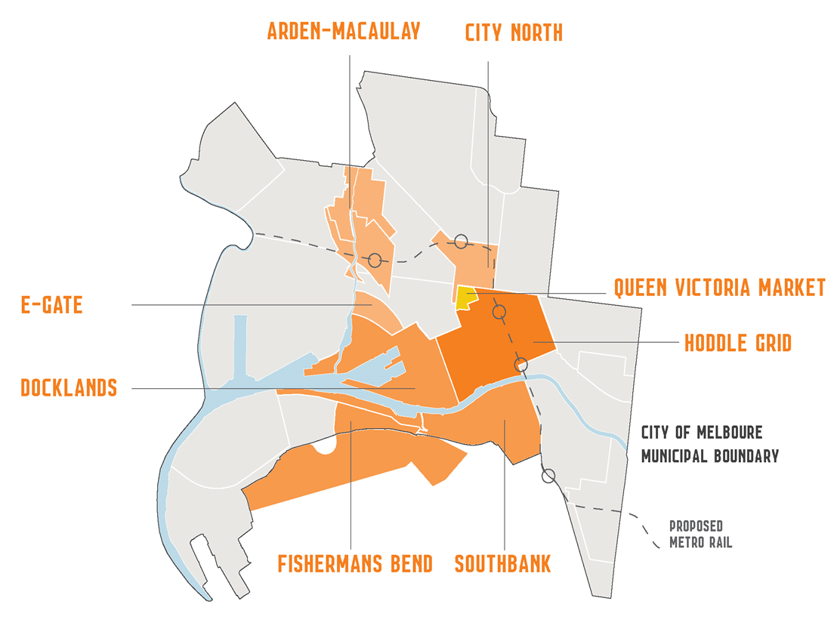

Figure 1: Identifies areas of the City of Melbourne with proposed urban renewal.

Through the Future Melbourne 2016 consultation, urban growth and density was raised by the community as the highest threat to our municipality. Growth may bring many positive benefits, however as the city continues to grow and change, we need to plan ahead to meet the needs of residents, businesses and visitors.

This is an important area for action and we must ensure our new suburbs and infrastructure are resilient to climate change as it is much more cost effective to get it right from the start.

We have recently incorporated enhanced sustainability requirements into our planning scheme – *Melbourne* *Planning Scheme Local Policy 22.19 Energy, water and waste efficiency.* This applies to development applications for all sizes and building types, with varying report requirements and water, energy and waste performance measures depending on the building type and gross floor area. Our Local *Planning policy 22.27 Stormwater Management (Water Sensitive Urban Design*) focuses on stormwater quality, but includes objectives to minimise peak stormwater flows and to reintegrate urban water into the landscape to facilitate a range of benefits including, microclimate cooling, local habitat and provision of attractive spaces for community use and wellbeing.

Adaptation is being integrated into many urban renewal projects across the globe and Melbourne can learn from these. For example, Washington DC’s [Buzzard Point Urban Design Framework](http://planning.dc.gov/page/buzzard-point-urban-design-framework) integrates climate considerations as a key influencer of the urban renewal at Buzzard Point. The City of Copenhagen is working with utility companies and residents to build climate resilient communities. [Klimakvarter](http://klimakvarter.dk/en) is one such community which integrates renewable energy, energy optimisation of buildings, along with innovative mechanisms to manage stormwater.

*“We need to make Copenhagen more resilient to extreme rainfall events. This will require new ideas and solutions, so that we use the rainwater at the same time to create new recreational urban spaces. We need to have less asphalt and more green spaces. That is precisely what is characteristic of the work in the Climate-Resilient Neighbourhood of Østerbro. It can become a great source of inspiration for the rest of the city.*” Mayor for Technical and Environmental Affairs the City of Copenhagen, Morten Kabell

## 2.2 Managing our existing city for tomorrow

### **Questions**

1. What does a climate resilient neighbourhood look like to you?
2. What measures can the City Of Melbourne take to minimise the future impacts of flooding?

City of Melbourne’s diverse services can be grouped under the following six headings: Regulate, Activate city, Advance Melbourne, Design, Build and manage assets, Deliver community services, and Governance and internal support.

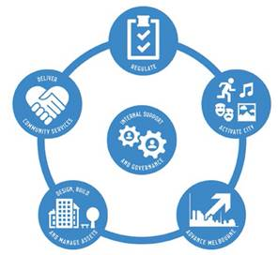

Designing, building and managing these assets is one of the City of Melbourne’s six major service types. Assets also play a critical role in most of the five remaining service types, such as delivering community services, regulating the city and advancing Melbourne.

We want Melbourne to grow and prosper over the next decade without diminishing service levels. Many of the assets we own and manage on behalf of the community provide these services. Our *Asset Management Strategy 2015-25* explains why we need to change the way we manage our assets, what future assets will look like and what we need to do to design, build and manage these assets.

To understand the complexity and range of our assets, we have grouped them into three categories:

* **Streetscapes**: These assets are the things you can see and use on our streets, including bluestone or bitumen footpaths, roads, public seating, waste bins or underground stormwater drains.
* **Open spaces**: These assets are the things you see or use during a lunch break or when you are on your way to a city event. They may include a flower bed, a tree, a sports field or an irrigation system for parks and gardens.
* **Buildings**: These assets are the things you see or use at our many community facilities such as an indoor swimming pool, public seating, childcare centres and books within our libraries.

The remaining assets are those that we do not control – existing commercial buildings and housing are two big categories. Adapting these to climate change is essential for our municipality to continue with high levels of liveability.

### Streetscapes and open spaces assets

Our public realm assets have been a focus of the City of Melbourne work since the strategy’s inception in2009.Assets within this category include bluestone or bitumen footpaths, roads, parks, trees, public seating, waste bins or underground stormwater drains.

Underground stormwater drains in particular have been a focus of our adaptation work in our engineering team. Our drainage system is made up of old infrastructure, with the majority of drainage more than 60-years-old with some that date back to the 1850s. This is a risk as some of our drains struggle to deal with heavier storm flows, which will be exacerbated under climate change. Our roads performed well during the 2009 heatwave, and as such have not yet been a focus for action.[[2]](#footnote-2)

We have made some good gains in this area, however, there are still improvements to be made. Recently, the City of Melbourne updated our *Asset Management Strategy 2015-25*. It notes that key assets are more affected by climate change than others, such as drains, irrigation, park infrastructure, water structures and horticulture are not meeting our high standards for asset condition, capacity and functionality. The *Asset Management Strategy 2015-25* maps out how we will meet these challenges, seize the opportunities that come with them and manage our assets.

We can learn from other cities including Rotterdam in the Netherlands. They have developed and installed [water squares](http://www.publicspace.org/en/works/h034-water-square). These are open, above-ground water tanks that capture stormwater runoff. The tanks are used as basketball courts and public open space when they do not have water in them.

### City of Melbourne building assets

The City of Melbourne has various types of buildings, including corporate, heritage, and community buildings. Currently they are in reasonable condition as assessed in our *Asset Management Strategy 2015-2025*, but some corporate and community buildings are not performing as well on functionality criteria. Heritage buildings present a more complex challenge given their age and condition. However, overall the quality of our buildings is good, making it easier for us to now deal with climate change impacts.

Key climate change impacts on our buildings include the four priority climate change impacts identified in our strategy in 2009. These are:

1. extreme heat
2. drought and water scarcity
3. sea level rise
4. extreme storm and flash flood.

Climate change projections show that the occurrence of these events will increase, as well as the intensity.

To date, the emphasis on council buildings has been to increase their sustainability rather than their resilience. This area represents an opportunity for the refreshed strategy. As noted in our *Asset Management strategy 2015-25*, our buildings are performing reasonably in relation to capacity, condition and functionality. However, each different building type – heritage, corporate and community all have improvements that can be made. Sustainability and adaptation could be considered when renewing these assets.

Currently the Australian Institute of Refrigeration, Air-conditioning and Heating (AIRAH) has a [resilience subcommittee.](http://www.airah.org.au/iMIS15_Prod/AIRAH/Navigation/Resources/SpecialInterestGroups/Resilience_STG/Resilience.aspx) One of the projects they are undertaking is to produce some best practice guidelines for how to build resilience into heating, ventilation, air-conditioning systems in commercial buildings.

### Questions

1. How can the City Of Melbourne ensure that our public buildings are more climate resilient?

### Commercial building assets

Building stock within our municipality is in a constant stage of renewal.

It is important that building owners and managers consider the impacts of climate change on their buildings (see [Increase the climate resilience of your building fact sheet](http://www.melbourne.vic.gov.au/sitecollectiondocuments/increase-climate-resilience-building.pdf) for more information).

Sustainability and climate resilience of our buildings is increasingly important to consumers and governments across Australia. It can help to manage risks, adjust economic activity and reduce vulnerability.

The sustainability features of buildings have a direct impact on the comfort and long-term affordability of a property.

Acknowledging the importance of existing building stock in the municipality, we have focused on trying to encourage increased sustainability across our commercial buildings sector through our [1200 buildings program](http://www.melbourne.vic.gov.au/business/sustainable-business/1200-buildings/Pages/1200-buildings.aspx). The 1200 buildings program focuses on working with building owners in the city to improve their sustainability to deliver reduced running costs and improvements for building users. Since 2010, the owners of over 540 commercial office buildings in Melbourne have retrofitted to improve energy and water efficiency.

Some of the actions advocated through the 1200 buildings program enable buildings to contribute to decreasing water use, thereby generally increasing the resilience of the water systems in Melbourne. To date, the focus of our work with building owners has focused on the sustainability components of their buildings. Some of these works will help to adapt the buildings for a changing climate, however, more work would need to be done to do this.

After Hurricane Sandy in New York, ‘[Rebuild by Design](http://www.rebuildbydesign.org/design-opportunities/)’ was established. This program is a collaboration between the public and private sectors in which interdisciplinary international teams presented ideas and designs to mitigate flood risk in areas of New York. Teams submitted designs that included enabling first floors to be flooded, while protecting vital streets from flooding and at the same time reinvesting in communities and the facilities available.

### Question

1. How can City of Melbourne work more effectively with building owners and managers to improve the climate resilience of commercial buildings?

* Provide incentives, provide information to building owners and managers to understand what they can do to their buildings
* Work with the insurance industry to reduce premiums for climate resilient buildings
* Help building owners obtain finance for retrofit works
* Provide case study examples of other successful projects
* Facilitate connections with other building owners
* Other ideas

## 

## 2.3 Transporting and powering our municipality

We rely on a number of different types of infrastructure to enable and facilitate our lives – infrastructure such as electricity networks, telecommunications, and transport networks. These networks are vital to the liveability of our city as almost 800,000 people pass through our city daily.

Various components of each of these systems will be affected by heatwaves, flooding and sea level rise. Most importantly, these systems can be highly interdependent within and between themselves. Failures at one location can quickly impact the whole network and other systems. For example, electricity blackouts can affect train boom gates, with the boom gates closing if they lose power. Furthermore, our telecommunications sector is dependent on electricity, therefore any loss of power to components or parts of the network could result in loss of service.

Each of the public transport operators has continuously improved their emergency management responses. Protocols led through Public Transport Victoria have been improved based on learnings from the 2009 heatwave. Now Metro and V-Line have hot weather policies, and there is much more communication with customers ahead of heatwaves. Timber sleepers are also being replaced with concrete to increase the resilience of the train network[[3]](#footnote-3). Sydney Trains recently won the Climate Change Adaptation in Government Award from the National Climate Change Adaptation Research Facility. They have undertaken a climate change risk assessment and started to respond to priority risks.

Another influence in this area is the application of the [Infrastructure Sustainability tool](http://isca.org.au/is-rating-scheme/is-overview/is-rating-tool/item/68-is-rating-tool) from the Infrastructure Sustainability Council of Australia - most large infrastructure projects are considering climate change as a step in the tool.

This is a very important area for our municipality and one that is also raised during engagement processes such as Future Melbourne. However, it is a difficult area to respond to due to our lack of control over infrastructure. Working in partnership on this will be necessary to achieve real change for our community.

### Questions

1. What else can the City of Melbourne do to collaborate with and influence infrastructure and transport providers?
2. What else can City of Melbourne do in this space?

# Focus area three: the social environment

## 3.1 Growing an adaptive, prosperous economy

The City of Melbourne is the capital of Victoria, and as such our economy represents a capital’s economy. Our economy totals approximately $90.6 billion of gross local product and accounts for 450,336 jobs. This accounts for approximately 37 per cent of the total metropolitan Melbourne economy, 27 per cent of Victoria’s economy, and 6 per cent of Australia’s economy. The two biggest sectors in our municipality are professional, scientific and technical services and financial and insurance services. Accommodation and food services jobs rank third.

As the capital city, tourism is also a critical part of our economy. Activating the city is a key service City of Melbourne provides by hosting various national and international events. In 2014, the Australian Open was affected by the January heatwave. This led to reduced ticket sales on hot days and very difficult conditions for the players. This is just one example of the potential impacts that could affect our city under climate change.

While there were no direct actions listed in the first Adaptation Action Plan relating to working with our businesses, most of the actions aimed at flood mitigation and heat impacts are partly targeted at reducing the risk to our local businesses and events from climate change. For example, if the transport network fails on a hot day we will see less workers and visitors entering the city. This in turn will mean a loss in productivity in the workplace and lost revenue for the retail sector. We need to reduce extreme weather impacts on the functioning of business in Melbourne.

The City of Melbourne is a member of the national [Business Adaptation Network](https://www.greencrossaustralia.org/our-work/climate-adaptation/business-adaptation-network.aspx), a network that helps share knowledge, build capacity and promote and recognise best practice in climate change adaptation. Resilient Melbourne, also look to make local businesses across Greater Melbourne more adaptive and better prepared.

Increasingly, it is expected that the finance sector will reward and penalise associated risk exposure, valuing adaptive capacity as severe weather and warming trends reinforce 21st century climate realities. Therefore more may need to be done in this space to understand how our local economy is exposed and how they can respond.

This is a priority as continuing the economic prosperity of our municipality is necessary to maintain access to jobs, continue our world leading events, and increase the vibrancy of our community – all things that you have told us you have valued about Melbourne.

## 3.2 Enabling our community’s resilience to climate impacts

Our community is diverse and often transient. In contrast to the rest of the state, the City of Melbourne has a young population and this is expected to remain as such into the future. However, we are projected to experience an increase in our elderly population as well. In 2015, 2.4 per cent of our population was over 75 years old, in 2035 that is expected to rise to 4.4 per cent. This must inform our adaptation planning as the elderly will be more exposed to changes in climate change.

The City of Melbourne experiences a large daily visiting population and a large number of events, which result in very large numbers of people congregating and moving through the city. Our residential population is 116,431 (in 2013), but weekdays this grows to 844,000 people in and around our municipality, and on weekends it is 579,000 people.

Responding to our unique context and building the resilience of our community is vital to deliver on an inclusive, family friendly community. We are currently undertaking an investigation into the relationship between extreme heat and violent behaviour, as this was raised a risk in the first strategy and is now an action of the [*Beyond the Safe City Strategy 2014-17*](http://www.melbourne.vic.gov.au/community/safety-emergency/pages/beyond-the-safe-city-strategy-2014-17.aspx).

Resilient Melbourne highlight as a key objective: empowering communities to take greater responsibility for their own and each other’s well-being, safety and health.

Rio de Janeiro has released a Resilience Strategy, which includes area specific resilience indicators  - seeking to provide a view of the differences between the boroughs of the city and understanding how resilient people and the neighbourhood are in Rio de Janeiro.

## 3.3 Working with the vulnerable

Climate change will disproportionately impact those already most vulnerable in our community such as the homeless, elderly and children. City of Melbourne has started to respond to this through developing the [*Heatwave and Homelessness Action Plan*](https://www.melbourne.vic.gov.au/SiteCollectionDocuments/heatwaves-homelessness.pdf)*.* However, there may be other groups and other risk factors that need to be considered and managed.

There is significant socio-economic disadvantage in the City of Melbourne, specifically parts of North Melbourne, Carlton and Kensington (ABS 2011b). The 2011 Census showed that 18.7 per cent, or over 15,600 residents, were living in poverty; 1164 of whom were children. Approximately 1,232 people are experiencing homelessness in Melbourne according to the ABS Census data for 2011. The City of Melbourne Street Count 2016 found approximately 247 people sleeping rough on the night of the count. People from all sections of the community including families, young people, older people, international students, refugees and those seeking asylum can find themselves facing or experiencing homelessness. Whether it lasts for a very short time, or for a number of months or even years, being without safe, secure and affordable accommodation can have devastating effects on a person’s life. City of Melbourne is committed to addressing the issue of homelessness through the [*Homelessness Strategy 2014–17*](http://www.melbourne.vic.gov.au/community/health-support-services/social-support/pages/homelessness-strategy.aspx) and has developed a number of initiatives to ensure appropriate and inclusive support is provided to people experiencing homelessness in extreme weather.

### Question

1. How can the City of Melbourne work with businesses and the community to increase resilience to extreme weather?

# 

# Focus area four: our working environment

## 4.1 Driving innovation – inside and out

Leadership in innovation is a widely acknowledged attribute of the City of Melbourne with both individual thought leaders and the organisation as a whole providing valuable contributions to the advancement of a range of social, cultural, environmental and planning areas. This is captured through our goal to be a Knowledge City. Our role is to contribute to this is as a promoter, leader, partner and enabler.

Innovation is vital when it comes to responding to climate change. Climate change will exacerbate existing problems and will lead to new problems. We cannot continue with standard practice. As part of our commitment to leadership and innovation, we have participated in a number of collaboration and research partnerships to build our knowledge of climate change and our understanding of the effectiveness of how to respond. Through our partnerships we have been able to lead research projects, implement projects and share our learning’s with stakeholders.

Potentially a driver for action in every other work area, innovation is necessary. Preliminary feedback from stakeholders recently has been that they appreciate our leadership and innovation and see it as a key role of ours.

### Question

To continue as a leader in this space, we are continually looking for positive stories and innovation; do you know of some great examples of innovation in adapting to climate change?

## 4.2 Involving our community in responding

Our current four year Council Plan includes a goal to be an accessible, transparent, and responsive organisation. This commits us to strong community engagement. Through this goal we aim to have a more involved and better informed community. We have established Participate Melbourne to provide an online portal for our community engagement, but we also undertake extensive face to face engagement.

Our strategy came about in part because you asked us to focus on this through our engagement as part of the development of *Future Melbourne 2009*. Since then we have undertaken a number of other events to engage our community on climate change – holding a heatwave hypothetical, and we established The Catchments Project with  [Carlton Connect Initiative’s (CCI)](http://www.energy.unimelb.edu.au/carlton-connect-initiative), LAB-14. Watch The Catchments Project video [here](https://www.youtube.com/watch?v=1CNex52hkw4).

Through Future Melbourne consultation in 2016, we have heard that the community would like to us to involve them in our decision-making. Climate change will require all of us to respond so we see involving the community as a as a priority work area for our strategy refresh.

### Questions

1. After looking through the focus areas, are there any in particular you would like to be further engaged with in shaping? How would you like to contribute?

## 4.3 Governing our response

Governance of our response is necessary as climate change represents risks to our operations. Therefore we are required to track our mitigation of the various risks, so we can understand what risk remains or arises in future.

Through the original strategy, we took a risk management approach to climate change (The project risk management process aligned with the Australian and New Zealand risk standard AS4360). All our work has been informed by the climate change risk assessment completed as part of the strategy process. Since its completion, we have trialled the use of a program called Interplan to manage our reporting against adaptation actions. Through this process we learnt many things including the need for actions that are measurable so we track our progress.

We have also developed an Adaptation Cost Curve to inform how we might prioritise various adaptation actions. The cost curve will help inform priority actions once we start to consider them.

### Question

1. Measuring climate change adaptation outcomes can be difficult; do you have any ideas on how we can measure our progress?

* Using creative arts to communicate outcomes
* Regular reporting
* Accessible data for the public
* Social media tools
* Information in community hubs
* Other ideas

Conclusion

By refreshing the *Climate Change Adaptation Strategy*, the City of Melbourne aims to provide direction for how we plan, prepare and respond to ensure that the municipality can survive and thrive as the climate changes. There is a lot of great work that we and others have done already and need to build on, such as integrated water cycle management, greening our city, emergency management and working with our vulnerable communities.

This discussion paper has presented a summary of what we have already heard through Future Melbourne 2026 consultation, our aims and objectives of the strategy refresh, principles to shape how we work at the City of Melbourne, and focus area options.

There are many areas that we could focus on while refreshing this strategy, and we want to know what you feel are the priorities. Join the discussion forum on our Participate Melbourne website, or attend a community workshop to share your ideas for how we can keep ensuring we can adapt to a changing climate.

# Appendix one - background

City of Melbourne’s response to climate change 18

The climate has already changed and the rate of change is increasing 19

The projections 20

Understanding what climate change might mean for our city 20

We’ve already made adaptation progress 21

Achievement 1 – The *Climate Change Adaptation Strategy* set the priorities, and the priorities then achieved a life of their own 21

Achievement 2 – Tangible action has been taken to reduce climate risks in our city 21

Achievement 3 – Many actions identified in the Strategy are now core business 22

Achievement 4 – Evolved understanding of climate change and decision making 22

Achievement 5 – Productive partnerships built to deliver outcomes 23

Our neighbours and others have also made progress 25

Local businesses and landholders 25

The Northern Alliance for Greenhouse Action 26

City of Port Phillip 26

Resilient Melbourne 26

State Government 27

Federal Government 27

International action 27

# City of Melbourne’s response to climate change

The City of Melbourne has taken many actions to adapt and mitigate climate change and has been recognised for its leadership in responding to both.

The *Climate Change Adaptation Strategy 2009* (the strategy), the first of its kind in Australia, mapped out our approach for adapting to a changing climate. It undertook an in-depth risk assessment and highlighted key priority areas for action. The *Adaptation Action Plan 2010* then outlined more detailed actions we would take to respond to climate change risk assessment. Since then, over 100 actions have been completed and we have clearly demonstrated how a council can adapt to a changing climate.

The City of Melbourne’s *Zero Net Emissions by 2020* *Strategy* was first developed in 2002. It outlined our commitment to mitigate our municipality’s contribution to climate change. In 2014, it was updated to refresh our focus and restate our commitment, and now we will do the same forthe *Climate Change Adaptation Strategy*.

This background paper seeks to provide an overview of our progress since the strategy was released in 2009, as well as to guide your feedback in order to refresh our *Climate Change Adaptation Strategy*. It includes:

* an overview of climate change projections for Melbourne and what this might mean for our city
* the progress that the City of Melbourne has made in adaptation
* examples of progress that others have made since 2009

# The climate is already changing and the rate is increasing

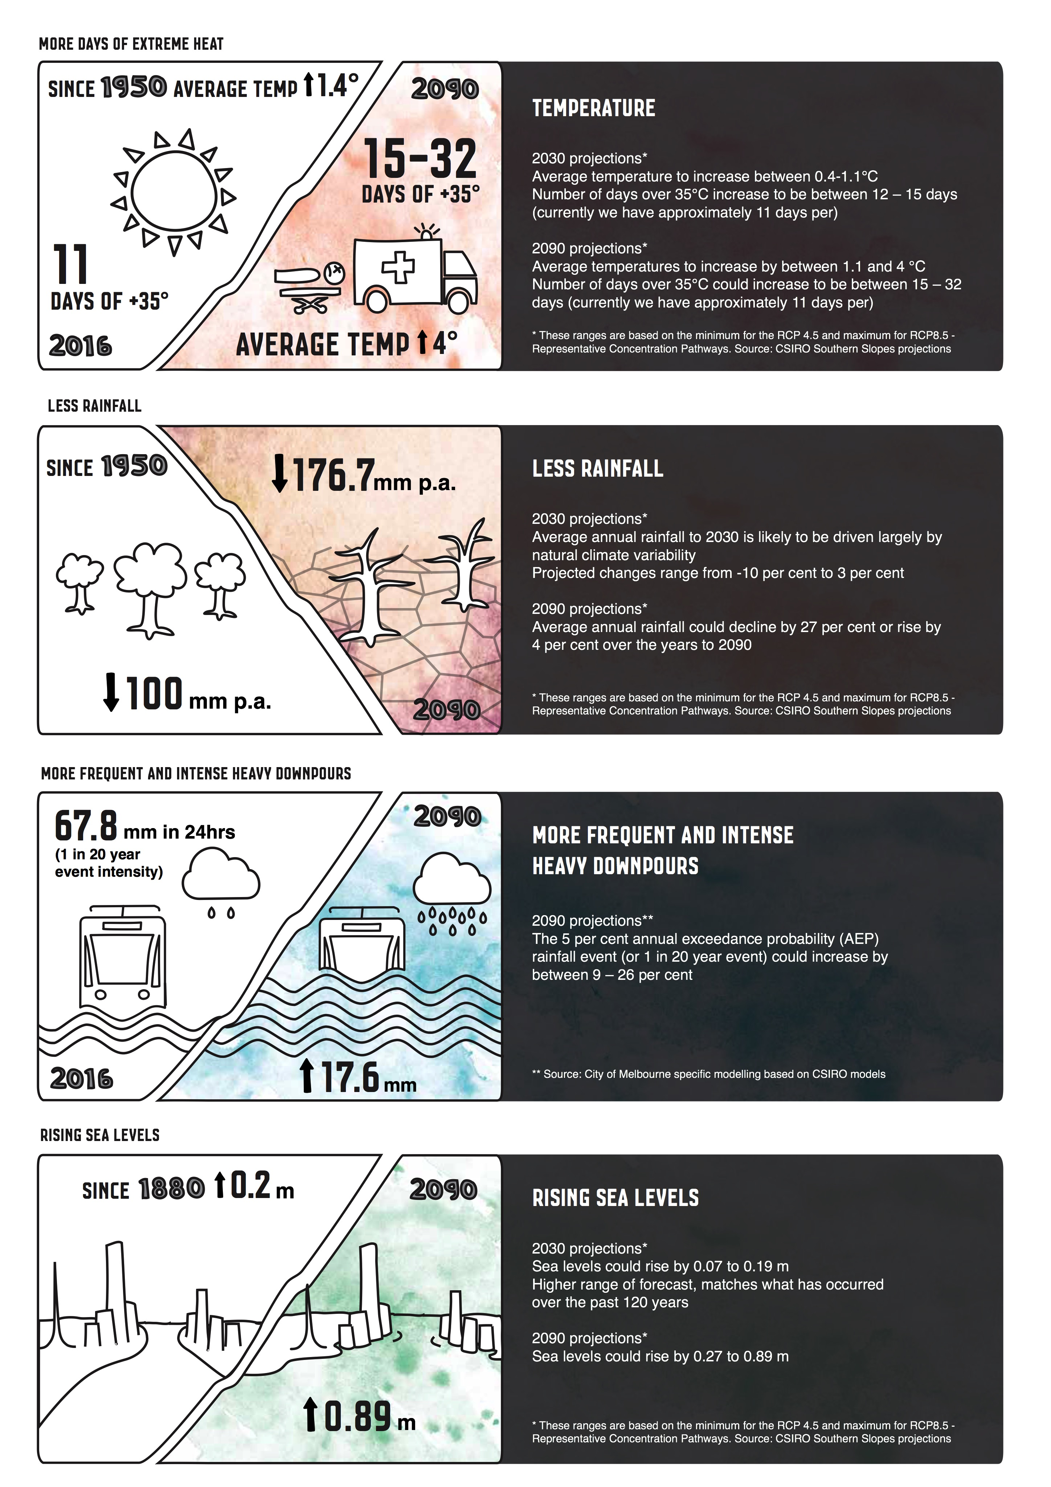

## The projections

While we have already experienced some change, more change is projected to occur and at a faster rate. There is, however, uncertainty about how significant the changes will be, when they might occur, and the direction they will take (for example, for rainfall we might see more or less). Therefore we have to be adept at managing these uncertainties and build in flexibility.

## Understanding what climate change might mean for our city

Over the past 20 years, Melbourne has experienced many climate events that have affected things that the community values. These events provide us an indication of what might be in-store for us in the future.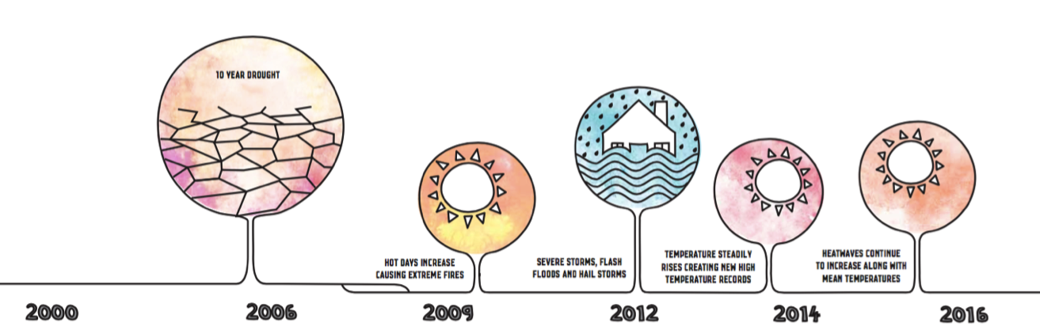

Each of these events has affected different components of our city and our community. Under climate change, it is likely that more of these events will occur with greater intensity or at a greater frequency, or both.

|  |
| --- |
| **The economic and health impacts of heatwaves**  Heatwaves have been shown to dramatically affect patient presentations. The Climate Council’s report 2015, [*The Silent Killer: Climate Change and the Health Impacts of Extreme Heat*](https://www.climatecouncil.org.au/silentkillerreport)*[[4]](#footnote-4)* found that during the heatwave in southeast Australia in January/February 2009, emergency call-outs increased by 46%; cases involving heat-related illness increased 34-fold; and cardiac arrests almost tripled in Victoria. In total, 374 excess deaths were recorded, a 62% increase on the previous year  We undertook some research of business perceptions of the impacts of the 2014 heatwave. Based on this research revenue declines were estimated to be $37 million over the four days of heatwave. Certain sectors such as retail and food and beverage appear to have been harder hit than others. |

## We’ve already made adaptation progress

The focus of the *Climate Change Adaptation Strategy 2009* was to understand our risks and vulnerabilities as a city and to identify actions to address these in the key areas of heat and the increasing intensity of rainfall events as these two risks were considered to be more immediate risks. This emphasis has shaped much of the work we have done since our strategy release in 2009.

### Achievement 1 – The *Climate Change Adaptation Strategy* set the priorities, and the priorities then achieved a life of their own

The *Urban Forest Strategy*, *Total Watermark: City as a Catchment Strategy* and the *Open Space Strategy* are the result of or has reinforced the integration of climate change considerations across a number of key areas within the City of Melbourne.

**

### Achievement 2 – Tangible action has been taken to reduce climate risks in our city

These tangible actions deliver on a number of our priorities. In some instances climate change was the driver of the action, for others climate change adaptation contributed to the business case for their delivery.

|  |
| --- |
| **La Trobe Street green bicycle lane**  As part of works to separate the bike lanes from the road on La Trobe Street, the project also involved actions to add greenery and increase permeable surfaces (so rain can soak into the ground). A key action in our [*Bicycle Plan 2012-16*](https://www.melbourne.vic.gov.au/SiteCollectionDocuments/bicycle-plan-2012-2016.pdf)*[[5]](#endnote-1)*, La Trobe Street was also highlighted as an area that required increased tree canopy as part of the *Urban Forest Strategy* and subsequent precinct planning. This project represented the useful combining of projects, to efficiently achieve the targets in our *Urban Forest Strategy*, *Total Watermark: City as a Catchment 2014*, the *Climate Change Adaptation Strategy* 2009 and the *Bicycle Plan*.  In addition, the *Resilient Melbourne Strategy 2016* has identified an action that will increase the connectedness of bicycle lanes between municipalities which will lead to greater resilience of the community to shocks, including climate resilience. |

|  |
| --- |
| **Stormwater capture and re-use at Fitzroy Gardens**  In response to the millennial drought, a [stormwater harvesting system was installed at Fitzroy Gardens](http://urbanwater.melbourne.vic.gov.au/projects/water-capture-and-reuse/fitzroy-gardens-stormwater-harvesting-project/) December 2013. The system supplies 70 million litres of water every year, and helps us keep the heritage garden healthy in a changing climate.  Through the design, construction and operation of this project, we have grown our knowledge in relation to the operation of these systems. And to give back, we are sharing what we learned from this project on our [Urban Water website.](http://urbanwater.melbourne.vic.gov.au/)  This action delivers on commitments made in our *Climate Change Adaptation Strategy 2009* and *Total Watermark: City as a Catchment 2014*. |

|  |
| --- |
| **Changes to management of our drainage system**  We have investigated various components and locations of our drainage network to inform our drainage maintenance and capital works programs. We have been building a thorough knowledge of our drainage network by video capturing the insides of our drainage network. We have also completed area-specific studies to test how our network might perform in a high rainfall event.  Based on these investigations we are now proactively managing our network to cope with higher intensity rainfall events (where we can we are seeking to take the drainage network to meet a 1:20 year annual return interval (ARI) design standards instead of 1:5 year ARI). These actions are now completed and were committed to in the strategy and *Total Watermark: City as a Catchment 2014*. We now have more in-depth knowledge of our drainage network and the network is more resilient. |

### Achievement 3 – Many actions identified in the strategy are now core business

Over the past seven years, our emergency managers have been busy working with many stakeholders to improve how we work together to respond to emergency events. This work has covered off on a number actions identified through the *Climate Change* *Adaptation Action Plan 2010*, and now have become business as usual for our emergency management team. Work in this space is now influencing work by other councils.

|  |
| --- |
| **Brokerage program**  In 2014-15, the City of Melbourne established the *Heatwave and Homelessness Action Plan*, as the homeless were identified as especially vulnerable to heatwaves within the city. The brokerage program was developed in response to this, and provides free swimming and locker passes, movie passes (limited in number), and maps of cool spaces and drinking fountains to homeless service providers to provide to their clients.  “*Having these positive engagement mechanisms can help us build stronger relationships with our clients quickly*.” **Launch Housing – Daniel Sedgely** |

### Achievement 4 – Evolved understanding of climate change and decision making

Understanding in more detail what climate change may mean for the city was a critical action from the 2009 strategy. We have completed a number of research projects since the strategy’s release, working with specialists from universities in Melbourne, consultants, our neighbouring councils – such as the City of Port Phillip – and international cities like Rotterdam, Copenhagen, New York and Jakarta. We have built our knowledge of the different climate variables and how they might change under climate change.

|  |
| --- |
| **Adaptation Cost Curve**  In 2015, the City of Melbourne built an Adaptation Cost Curve. The Cost Curve ranks adaptation actions based on their ability to mitigate risk (quantified in dollars) and build our resilience (quantified in lives saved, as well as other criteria). This tool will assist us to prioritise the actions for our next action plan. |

|  |
| --- |
| **Integrated Climate Adaptation Model**  Since the release of the strategy, we have collected more in-depth information about urban heat in our municipality (case study above) and drought tolerance of our trees, and we’ve completed flood modelling across the entire municipality.  To bring this together, we are currently finalising the Integrated Climate Adaptation Model (ICAM). This tool uses our enhanced knowledge of climate change, and provides analysis of the different benefits that various adaptation options bring when seeking to manage the risk of flooding and urban heat.  This tool was developed with input from some of Australia’s leading climate scientists, hydrologists, IT specialists, spatial scientists and engineers, and will provide us valuable information for responding to climate change during the implementation of the refreshed *Climate Change Adaptation Strategy*.  “*We have improved the way we think about and manage water in the local environment. We now need to understand how we can manage our soils better. We need to ensure our streetscapes, parks and the private realm are as absorbent as possible to deliver the flood mitigation benefits we are looking for*.” Ralf Pfleiderer, City of Melbourne, Water Sensitive Urban Design coordinator. |

### Achievement 5 – Productive partnerships built to deliver outcomes

These achievements were highly dependent on information sharing, collaboration and successful partnerships. Here are just a few:

|  |
| --- |
| **Emergency management planning**  Emergency management requires a collaborative effort between government agencies such as Emergency Management Victoria, the Victorian State Emergencies Services, Public Transport Victoria, community service organisations such as Red Cross, Launch Housing, and large operators in our municipality like the Port of Melbourne Corporation. Over the past seven years, we have focused on growing our networks for responding to emergencies. Now our networks mean we have a broader reach with our work, and more generally the response is more coordinated and effective.  “*Since 2009 we have reviewed the membership of our Municipal Emergency Management Committee and as a result added several stakeholders who are outside the emergency services sector, such as public transport providers, hospitals, Port of Melbourne Corporation, and Melbourne Assessment Prison. This helped us build new relationships with the new committee members, improving our ability to manage emergency events in Melbourne*.” Christine Drummond, Municipal Emergency Recovery Officer, City of Melbourne |

|  |
| --- |
| **C40 Connecting Delta Cities Network**  The City of Melbourne is a member of the C40 Connecting Delta Cities Network (CDC Network). This network connects people working in delta cities (cities that are situated where rivers meet larger bodies of water) around the world who are tackling similar challenges and opportunities for climate action. The CDC network is a growing network, currently made up of a 16 delta cities from around the world. These cities are the world's front runners, sharing knowledge and experience to keep their cities safe and liveable.  This network has assisted us to build trusted relationships with a number of international cities – which has in turn ensured that we have been able to learn from their ideas, solutions, lessons, and questions. These lessons learned are informing this update of the strategy, and provide us with innovative ways to manage climate change.  C:\Users\vicbar\AppData\Local\Microsoft\Windows\Temporary Internet Files\Content.Word\worldmap sept'14_20x15cm.jpg |

|  |
| --- |
| **Inner Melbourne Climate Adaptation Network**  Through our *Climate Change Adaptation Strategy 2009*, we recognised that while we are actively working to reduce the risk of a number of the key impacts identified, we have limited direct control over many climate change risks. In response, we set up the Inner Melbourne Climate Adaptation Network, which brings together a range of government, business and community stakeholders who play vital and sometimes interlinking roles in addressing climate change risks in Melbourne. Through hosting Melbourne’s adaptation network we have enhanced the level that climate change risks are being addressed through developing relationships, sharing information and forming collaborative partnerships. |

Our neighbours and others have also made progress

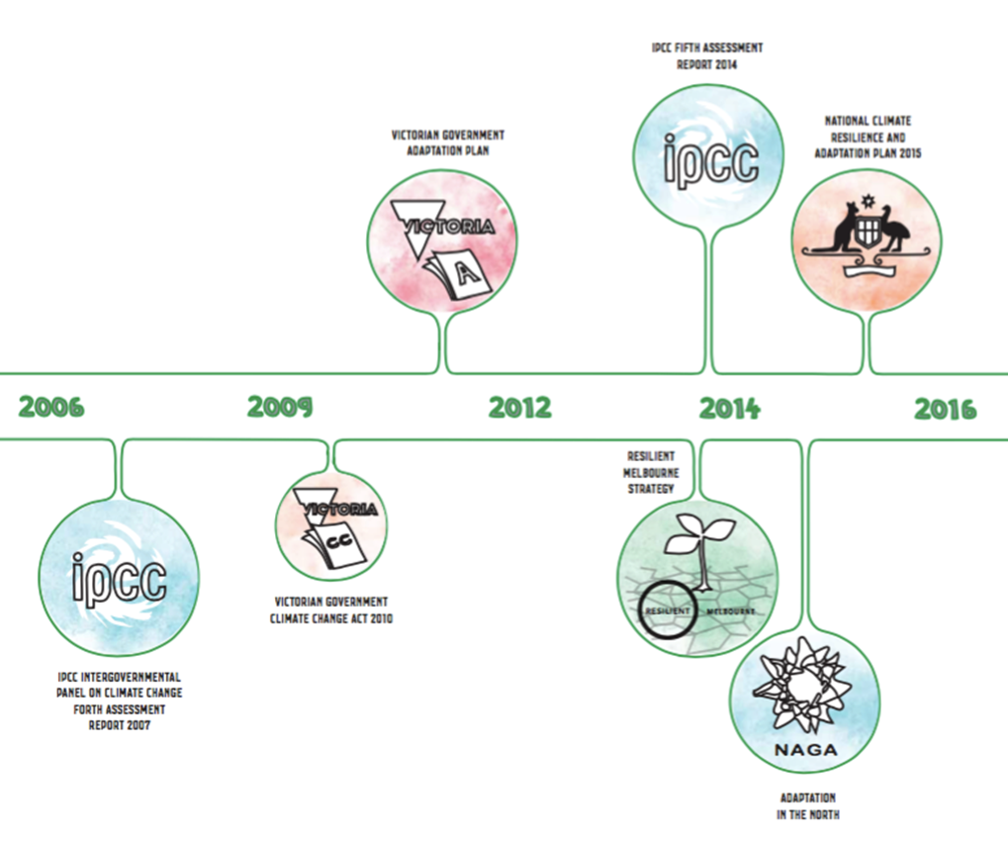Everyone has a role to play in preparing for a changing climate, and many of our residents, local businesses, neighbours, State and Federal Government, along with international players have all taken action.

## Local businesses and landholders

Many of the City of Melbourne’s local businesses and landholders are already responding to climate change.

|  |
| --- |
| “*Punt Road oval even went through some upgrades to raise the height of the oval due to excessive flooding*.”  Alex Rance, AFL footballer |

We are working with our universities to assist us to manage the Elizabeth Street catchment. They are also responding themselves as they are aware of the potential for climate impacts on their students.

|  |
| --- |
| *“We have four different initiatives to address the heat issue in our precinct: greening laneways and intersections, cool walking tours, cool pop-up spaces, underground spaces. Each includes different activities to ensure that our precinct is active, engaged and safe despite increasing heat stress in the city.”*  Michael Nolan, RMIT |

## The Northern Alliance for Greenhouse Action

Melbourne’s northern councils are also seeking to adapt. In 2014, the Northern Alliance for Greenhouse Action (NAGA) – a group of nine councils including City of Banyule, City of Darebin, Hume City Council, City of Manningham, City of Melbourne, City of Moreland, Shire of Nillumbik, City of Whittlesea, and City of Yarra – conducted an integrated regional vulnerability assessment, [Adaptation in the North](http://www.naga.org.au/uploads/9/0/5/3/9053945/adaptation_in_the_north_volume_1.pdf), to identify populations, infrastructure and assets at particular risk from climate change in northern metropolitan Melbourne. Priority areas were identified and councils are taking action on these within their own municipalities. Priority areas included health, emergency management, infrastructure, industry, natural ecosystems and planning. Work on cross sector impacts and building capacity of the councils were also highlighted as important actions.

### City of Port Phillip

The City of Melbourne has also worked extensively with the City of Port Phillip to understand the costs and benefits associated with rising sea levels, as well as developing a framework to understand the economic benefits of green infrastructure.

|  |
| --- |
| *"The impacts of climate change are felt across municipal boundaries, and working together to develop adaptation options is imperative to creating resilience. Working with the City of Melbourne and other IMAP [Inner Melbourne Action Plan] councils to develop the Growing Green Guide for green roofs and walls is an example of how we can successfully develop a consistent approach to climate adaptation planning."*  Mayor Bernadene Voss, City of Port Phillip |

### Resilient Melbourne

One great example of collaboration has been the work of Resilient Melbourne. This project has brought Melbourne’s 32 metropolitan councils together to work in partnership to build the resilience of our city. Melbourne was funded to be part of the Rockefeller Foundation’s 100 Resilient Cities (100RC) – one of the first 32 cities to join the 100RC network. As part of this, the 32 councils developed the [*Resilient Melbourne Strategy.*](https://www.melbourne.vic.gov.au/SiteCollectionDocuments/resilient-melbourne-strategy.pdfhttp:/resilientmelbourne.com.au/wp-content/uploads/2016/05/COM_SERVICE_PROD-9860726-v1-Final_Resilient_Melbourne_strategy_for_web_180516.pdf)*[[6]](#footnote-5)* The *Resilient Melbourne Strategy* sets out actions to build the resilience of Melbourne to a wide range of shocks and stressors – of which climate change is one. It represents a starting point that brings together various representatives to develop new ways to deal with chronic stresses and acute shocks of which climate change is one. The *Resilient Melbourne Strategy* sets out four areas for action. Each area for action includes a flagship action alongside other actions to be progressed by all 32 councils.

The areas and flagship actions include:

* **Adapt** – Metropolitan urban forest strategy. This action will grow our own urban forest, cooling more of Melbourne, mitigating the urban heat island effect but also contributing to the expansion of biodiversity across our city
* **Survive** – An emergency management community resilience framework for Victoria. Looking beyond Melbourne, this action is aimed at establishing a plan to empower communities to take active responsibility for their own and each other’s wellbeing, safety and health, further building the partnerships between our community and emergency service agencies
* **Thrive** – The metropolitan cycling network. Targeted at many facets of resilience – reducing our reliance on car transportation, promoting social cohesion and improving the health of our community. These objectives all have benefits for our own municipality
* **Embed** –Build resilience thinking and planning into existing organisations and ways of working.

The *Resilient Melbourne Strategy* represents a big leap forward in terms of councils coming together to build Melbourne’s resilience.

|  |
| --- |
| “*Resilient Melbourne marks an important point in Melbourne’s development. It presents the first of our city’s resilience strategies: a starting point that brings together individuals and organisations critical to the resilience of Melbourne and our diverse communities. It offers a new way to deal with the chronic stresses and acute shocks we are likely to experience, and to achieve our vision of a city that is viable, sustainable, liveable and prosperous*.”  Toby Kent, Chief Resilience Officer, Melbourne |

### State Government

In 2010, the Victorian Government passed the *Climate Change Act 2010*. The Climate Change Act committed the Victorian Government to consider climate change in a range of key pieces of legislation, to provide an update of climate projections for Victoria and the development of an *Adaptation Plan.*

The Victorian Government is currently reviewing its climate change action. A key output will be the development of the *Climate Change Framework*. It will outline the goals and actions that the Victorian Government will take to both mitigate and adapt to climate change. The Victorian Government is also currently working to update its *Climate Change Adaptation Plan*. This new plan will seek to continue Victoria’s strong adaptation action.

|  |
| --- |
| “*We [the Victorian Government] are taking decisive action because we know that climate change is real and we ignore it at our peril*.”  Minister for Energy, Environment and Climate Change Lily D’Ambrosio |

### Federal Government

In December 2015, the Federal Government released the *National Climate Resilience and Adaptation Strategy*. This strategy outlines how Australia is managing climate risks, sets a vision for the future and principles to shape adaptation practice.

### International action

Resilience and adaptation are becoming a greater focus within the international negotiation process as global actors realise the importance of helping countries adapt to problems we are experiencing now. The Paris Agreement acknowledged adaptation as needed, and for the first time, the temperature and adaptation goals were linked. This agreement was also the first time that included and recognised subnational governments – with subnational governments offering funding for the United Nations Framework Convention on Climate change (UNFCCC) Least Developed Countries Fund.

|  |
| --- |
| *“The Paris Agreement ties the adaptation goal to the temperature goal. It is finally acknowledged that there is a relationship between the concentrations in the atmosphere and the adaptive actions that are needed.”*  Christiana Figueres, Executive Secretary of the United Nations Framework Convention on Climate Change |

Adaptation and resilience are also key parts of *Goal 13 – Take urgent action to combat climate change and its impacts* – from the *UN Sustainable Development Goals*. Under this goal there are targets associated with strengthening resilience and adaptive capacity to climate-related hazards and natural disasters in all countries and to integrate climate change measures into national policies, strategies and planning.

1. Our principles are based on various principles proposed by others within the adaptation space, including the Great Barrier Reef Marine Park Authority (<http://www.gbrmpa.gov.au/__data/assets/pdf_file/0020/12539/Bringing-adaptation-to-life.pdf>) [↑](#footnote-ref-1)
2. [QUT Historical Case Studies of Extreme Events, 2010](https://www.nccarf.edu.au/business/sites/www.nccarf.edu.au.business/files/attached_files_publications/Pub%2013_10%20Southern%20Cities%20Heatwaves%20-%20Complete%20Findings.pdf) [↑](#footnote-ref-2)
3. [QUT Historical Case Studies of Extreme Events, 2010](https://www.nccarf.edu.au/business/sites/www.nccarf.edu.au.business/files/attached_files_publications/Pub%2013_10%20Southern%20Cities%20Heatwaves%20-%20Complete%20Findings.pdf) [↑](#footnote-ref-3)
4. <https://www.climatecouncil.org.au/silentkillerreport> [↑](#footnote-ref-4)
5. <https://www.melbourne.vic.gov.au/SiteCollectionDocuments/bicycle-plan-2012-2016.pdf> [↑](#endnote-ref-1)
6. <https://www.melbourne.vic.gov.au/SiteCollectionDocuments/resilient-melbourne-strategy.pdf> [↑](#footnote-ref-5)