Attachment 3
Agenda item [ ]
Future Melbourne Committee
September 2016

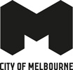
Skate Melbourne Framework

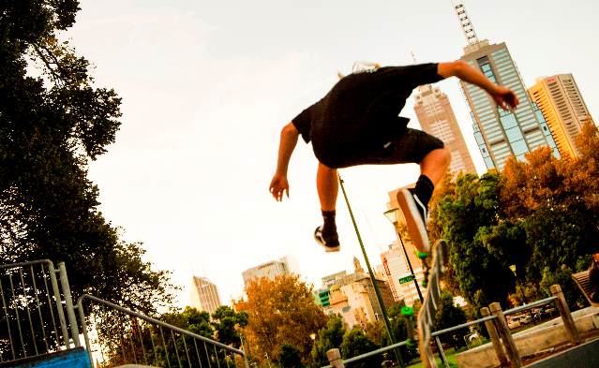

Community engagement phase one summary

March to April 2016

Disclaimer

This report is provided for information and it does not purport to be complete. While care has been taken to ensure the content in the report is accurate, we cannot guarantee it is without flaw of any kind. There may be errors and omissions or it may not be wholly appropriate for your particular purposes. In addition, the publication is a snapshot in time based on historic information which is liable to change. The City of Melbourne accepts no responsibility and disclaims all liability for any error, loss or other consequence which may arise from you relying on any information contained in this report.

Executive summary

Project background

The City of Melbourne is creating a strategic framework that will guide the management, provision and location of skate activity in the future development of the municipality.

The City of Melbourne ‘Skatesafe’ Skating Management Plan 1998 was developed in response to increased skate activity in the City of Melbourne. The plan employed six major components to better manage skate activity in the city. These components included: provision of a venue, code of conduct, preferred routes and areas, education and awareness programs, physical measures and legislation through local law.

The plan was considered a success and forward thinking for its time, with some elements of the plan still existing today. However, since the plan’s inception skating has grown in popularity, the city has transformed, demographics have changed and styles of skating have evolved. To date, the plan has not been reviewed in great detail, nor have the existing facilities, programmes and management methods.

In late 2014, consultation around the popular street skating location Lincoln Square Plaza highlighted that a strategic plan needs to be developed for the future of skating in the City of Melbourne. Additional face-to-face surveys have also been conducted, including surveys with skaters to better understand demographics and their desired spaces and needs in the city. This research was conducted by YMCA and City of Melbourne in July 2015 and a summary of findings can be found in the appendix.
Community engagement

Community engagement on the City of Melbourne Skate Framework occurred from Monday 21 March to Monday 18 April 2016. The key goal of this round of engagement was to enable a diverse range of people who use open space to provide input that guides the development of the City of Melbourne’s Skate Framework. Furthermore, there was opportunity to better understand the skate community itself and how the broader general public feels we can better manage, provide for and locate skate activity in the City of Melbourne. Melbourne City Council was directed by the Council’s Parks and Gardens Advisory Committee and the Council Project Steering Committee to incorporate existing research conducted by the City of Melbourne into the engagement process, especially in the areas of key challenges and complaints, skating participation rates, benefits, popularity and other current trends in skating locally and internationally.

The community was invited to share their ideas by:

- Completing a survey which was available online at Participate Melbourne.
- Attending three face-to-face pop-up engagement sessions in different locations within the central city.
- Discussing their ideas in-person at a workshop held on Sunday 3 April.
- Becoming involved in the Skate Melbourne Advisory Group. This group would then help to formulate the draft Skate Framework, after the initial phase of engagement.

This report amalgamates feedback from all of the above engagement methods, including feedback from the Skate Melbourne Advisory Group and the survey summary report compiled by consultants Micromex. Micromex were engaged to assist with quantifying and analysing the data compiled from the online survey only and the full report is available in the appendix section of this document.

Overview

In total, 505 online surveys were received along with various other contributions through the workshop, pop-ups and skate advisory group meetings.

The survey also collected demographic data about respondents. Responses were received from people aged under 15 to over 60 years, with almost 50 per cent of respondents aged 25 and under. Over 80 per cent of respondents were male and a large majority (77 per cent) of respondents were individuals who participate in skate activity. Social media was the most effective method utilised to reach the skate community and direct them to the survey. More information on social media responses and feedback can be found in the appendix.

Micromex’s qualitative analysis of open ended comments determined that of 505 respondents, 11 were classified as having an anti-skate stance, 27 were neutral and 467 were pro-skate (including 389 skaters).

Almost 40 per cent of respondents stated they were residents of the City of Melbourne when their postcodes highlighted otherwise. This is thought to be caused by a general misunderstanding that the City of Melbourne’s municipal boundaries are not the same as the greater Melbourne area.
Key concerns for respondents were:
- Noise and disturbance such as skating near residential areas late into the night.
- Personal safety concerns, for example potential collisions and runaway boards.
- Damage of private and public property and amenity.
- Unclear lines of movement by skaters.
- And other public space issues (not only related to skate) including;
  - Poor behaviour in public and public consumption of alcohol by some skate participants.
  - Overcrowding of public space by one user group (in this case, skaters).

Key unifying themes for respondents included:
- The sense of community and diverse demographics.
- Social inclusion for all city users in public space is important.
- Dedicated skate areas are necessary.
- Signage and/or information is required about areas/times that skating is allowed.
- Access to street-scapes is important.
- Melbourne is seen as a great city for skating. For some this goes beyond just skate-able assets and also includes the beauty, atmosphere and culture of the city.
- Self-expression/creativity/adventure derived from skating.

For skate participants, additional questions were asked to gain insights into their skating requirements. The key unifying themes were:
- A lack of quality spatial provisions, fit for the desired end users.
- They seek a variety of surfaces/obstacles/challenges/spaces.
- A lack of public spaces where skaters are welcome to skate (routes and open spaces)
- A lack of sheltered and night time skating options.
- The over use of skate stopping methods and exclusion of skaters from public space.
- A lack of opportunity to participate in different styles of skating within the municipality.
- Negative public perception and harassment, such as the public thinking it’s a crime or vandalism.
What we asked

There were a series of questions on the survey, focusing around the key themes of location, provision and managing skating in public spaces. Through our pop-ups we asked the general public’s perception of skating and their thoughts around the activity. We anticipated engaging with a lot of skaters and through the workshop and the survey, we provided more detailed questions around what types of facilities they would like to see into the future and the characteristics they enjoyed in favourite spaces that already exist. The survey itself is in the appendix of this document.
How it was communicated

Community engagement was promoted by the City of Melbourne through a range of mediums to reach as many residents, workers, students and visitors as possible. This included:

- The City of Melbourne website directed visitors to the Participate Melbourne page.
- Postcards and posters were placed at multiple City of Melbourne venues including libraries, and community hubs and around the central city to encourage people to fill in the survey.
- Through central city pop-ups information panels on the framework were displayed and prompted questions for visitors to engage with.
- Social media posts on City of Melbourne Facebook and Twitter accounts.
- Emails were sent to key stakeholders and resident groups.
- Corporate ads and the Melbourne Magazine.
- Well known skaters were encouraged to share the Participate Melbourne page within the skating community.

Constraints

Over 75 per cent of survey respondents were skaters which meant the overall data was skewed toward a skater’s perspective. Whilst this was a large proportion, due to high response rates, there were still 116 respondents who were not skaters.

Lincoln Square Plaza’s modifications to deter skate activity were happening at the same time of the engagement period. This proved a substantial constraint in engaging with the skate community itself. Due to the contention of the topic, council officers were unable to engage at popular and known skate spots, such as Lincoln Square. The heightened media coverage around Lincoln Square’s upcoming modifications meant that many responses to the framework via social media posts were oriented toward Lincoln Square’s modifications which were mostly negative. Some common responses indicated the community felt that the Council appeared disingenuous with its engagement around the framework and were sending the community mixed messages about council’s stance around skate activity.

Key desires

Looking to the future at a strategic/framework level, both the survey respondents and the Skate Advisory Group highlighted that there is a desire for ‘integration’ of skating into the city and the ‘inclusion’ of the skate community in the process. The key unifying themes were:

Key desires | Description
An increase in provision of a mix of facility scales and types, especially dedicated and clearly identifiable skate-friendly areas which enable multiple users to interact with skating.  “As key contributors to the culture of Melbourne, it is important they are not marginalised or excluded from the use of a public space.” – non-skater male 50-59  “Skate spaces should be dedicated spaces and/or at designated times.” – non-skater female 60-69 | - Enhanced skate facilities - better designs, renovations, seating, lighting, indoor/undercover areas.  - These spaces should be clearly indicated for skaters and non-skaters alike.  - The space caters for a diverse range of demographics and skill levels.  - Mixed and shared use facilities/spaces were highlighted as an effective typology to enable this.  - Non-skaters tend to be concerned with skaters in public spaces, with some feeling they are not allowed in these spaces, whilst skaters feel they are. Further clarity around where skating is encouraged is required.
Strategically locating and designing suitable and safe spaces for skating to take place, avoiding conflict with other uses and users.  “The noise, the risk of collision… is not conducive to a pleasant public space.” – non-skater female 70-79  “Safety is obviously a great concern. Generally I have noticed that skaters are very aware and very considerate of other members of the public. I am sure that clever design features can allow for skating to occur amidst busy places.” – non-skater 50-59 | Many of the challenges raised by non-skaters related to:  - Issues around noise near residential areas.  - Skate activity taking place in dangerous locations where people are trying to walk through or utilise a space for other activities.  - Damage to infrastructure that is not seen as designed for skating activity.  - Congregation of too many skaters and not feeling able to use the space.  The Skate Advisory Group also highlighted that these concerns need to considered in any future space that may encourage skating.
A safe and inclusive environment for all (particularly for female skaters). | This was important for all respondents as well as the safety of other city users.
Central city, accessible locations and ‘Street style’ spaces were important. Large plazas were a key desire as they act as a community hub; they should have communal spatial qualities such as the room and ability to socialise with the broader public.  “I love watching people using public spaces for all sorts of reasons, I want our cities to be welcoming and safe spaces for people of all ages and cultures and skating is a part of that.” - non-skater female 60-69 | - Central and accessible locations were important for skaters, as the city is seen as a meeting point. This was especially important for youth skaters who need public transport to get around.  - Spaces for all ages, city users and abilities.  - Street skating style in particular has a high demand and participation rate. Public plazas can also act as community hubs for these skaters.  - Suitably found public areas where skaters can be free to skate without the use of stoppers/capped ledges, or being asked to move on by residents, security or police.  - Spaces to sit, socialise and spectate are integral for medium to larger scale spaces.
Spaces that have multiple uses and activities were highlighted as a key desire for non-skaters and skaters alike.  “The variety of activity that brings together people of different ages and interests is most important and helps to bond the community at large.” – non-skater female 80+ | - Multi-use recreational spaces like Neill Street Reserve and other precedents were highlighted multiple times as great spaces for all users.  - These spaces are seen as hubs of activity which are safe and offer an array of services to the community. They promote social and communal spaces and enable people to engage in physical activity.  - Having skate-able spaces near other complementary activities that are also loud (e.g. basketball, soccer, volleyball, etc.) and active (e.g. rock climbing walls, free running, personal training, etc.) and that require hard surfaces would be ideal.
It is important that the City of Melbourne cater for a diverse range of skate styles, devices and users. | - There are many different styles and devices used in skating and all need to be adequately catered for. This also applies to different skill levels, ages and demographics.  - It’s important that spaces cater for non-skating city users to spectate and interact with skating also.
Increased respect and tolerance of skate activity and the skate community from the broader community, enforcement officers and the Council.  “The greatest power in improving the skating community in Melbourne is education.” – youth skater | The Skate Advisory Group highlighted that increased education and clear communication on skating activity in the city is needed for skaters and non-skaters alike, with key a focus on:  - Businesses and other enforcement officers such as security.  - Promoting positive and inclusive skating and enforcement culture through City of Melbourne run events and programs.  - Clearer and more easily accessed communication from the Council as to where and when skating is allowed.
Youth in general need to be better catered for in public spaces in the City of Melbourne. | A lot of feedback from skaters and those with a relationship to skate commented on the fact that youth are not catered for enough in the city.

SUMMARY OF ENGAGEMENT ACTIVITIES
What the survey respondents told us
Online survey responses (505 respondents)

Survey respondent demographics

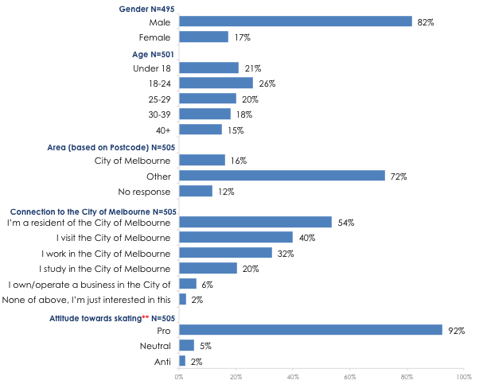

Survey respondent types
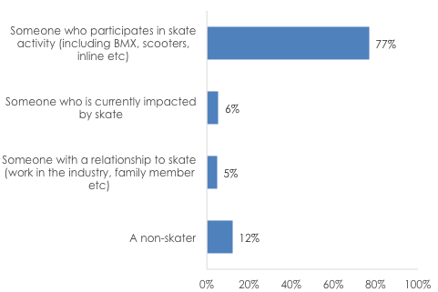

Source: MicroMex Survey Response Report

Questions | Description
Preferred public spaces for skate activity. | The most popular preferred public spaces from all respondents were forecourts, plazas and squares, dedicated skate spaces and streets and laneways. However those with a neutral/anti-skate perspective were less supportive of forecourts, plazas and squares and streets and laneways and more supportive of dedicated spaces and temporary spaces.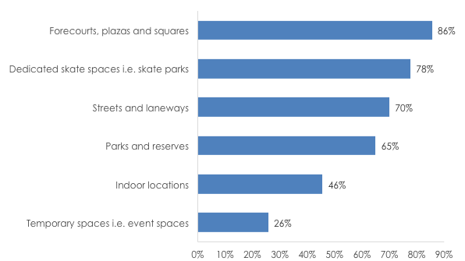
The elements enjoyed in these public spaces. | - Sense of community  - Social inclusion – spaces to engage with broader community  - The activity  - Fun  - Creativity  - Atmosphere and aesthetic of the space itself – different environments from typical skate park.
Sharing and managing use of public spaces. | - Designated skate spaces should aim to avoid close proximity to conflicting land use and users, for example key thoroughfares (especially during peak traffic times), residential buildings, culturally sensitive or sacred spaces and spaces of tranquillity.  - Promoting mutual respect by skaters and non-skaters alike.  - Dedicated spaces and designated areas and times for skating should have appropriate signage or similar to indicate this activity happens in the space. This is not just important for skaters but also the general public.  - Clear urban design elements and legible public spaces.  - These spaces need to feel safe and are safely accessible at all times of the day and night. This is particularly important to female and youth skaters.  - Better design of skate parks themselves.
Important principles that may guide the future of skate development. | Integration and inclusiveness were key themes selected by participants. All key principles were of almost equal weighting, not including ‘exploring partnerships’, however, some comments regarding this question stated that all four were important. Further work with the Skate Melbourne Advisory Group has highlighted that building partnerships and relationships with the private sector is of high priority.  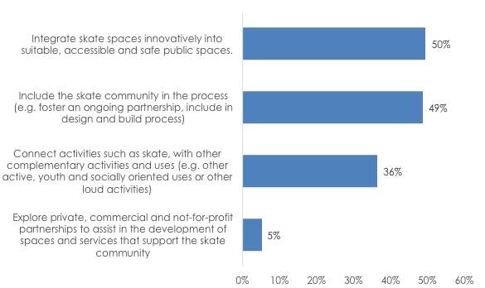
Suggested improvements | A clear indication was that more and better skate facilities for the desired end users were sought after, especially skate friendly areas. Those with a pro-skate stance wished to promote a more positive and inclusive attitude of skating from the Council and general public.
Other comments | Melbourne was praised as a great city for skating – and the Council was praised for undertaking community engagement. However, the removal of Lincoln Square was negative for around 10 per cent of participants.
Skate respondents segment (389 respondents)
Summary
The survey incorporated a specific section where skaters were asked to respond to additional questions. Over 80 per cent of skate respondents were skateboarders that participate in street style skating. Most skateboard respondents were very experienced with over 70 per cent skating for more than five years.
The main drivers for skating in the City of Melbourne is the sense of community, belonging, a good mix of spots, the great surfaces, the central location and the aesthetic and atmosphere of the city.
The main issues with skating in the city are the negative perceptions from other city users and being harassed by security. City of Melbourne has been said to be one of the most skate-stopped cities in the world, with a lack of quality and diverse spaces being allowed to be skated.

Questions | Description
Key devices used | The majority of respondents use skateboards as their preferred device.  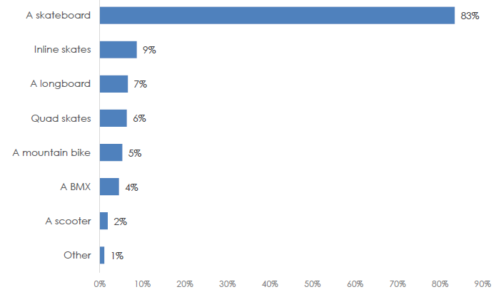
Key styles participated in | Many of the respondents participate in multiple styles of skating, with the main three being; street style skating (88 per cent) which takes place in public spaces, park (46 per cent) and transitional (32 per cent) which take place in dedicated skate parks and facilities.
Experience levels of skaters | Many of the respondents were heavily experienced in skating with over 70 per cent having over five years of skating experience.
Frequency of skating in City of Melbourne | Many skaters frequently visit the City of Melbourne to skate with over sixty per cent visiting the municipality a few times a week or daily. Only 11 per cent skated in the City of Melbourne rarely or never.
What’s enjoyable about skating in City of Melbourne | The main drivers of enjoyment include ‘sense of belonging/community’, ‘good mix of skate areas/proximity of skate areas’, and the ‘atmosphere/beauty of Melbourne’. The comments suggest that for some skaters, there is a connection with Melbourne that goes beyond the simple availability of skate-worthy assets.
What’s not enjoyable about skating in the City of Melbourne | Skaters don’t enjoy being harassed by security and negativity from others for being skaters. They also don’t enjoy the ‘skate stoppers/caps’ designed to stop skating. A lack of physical assets and spaces where they’re allowed to skate (including the re-design of Lincoln Square Plaza) were also key themes.
Important characteristics of skate spaces | The central city location and being close to food and services were important, along with a space to hang out’, which supports the earlier key points on the appeal of feeling a part of a community and having a space to be around others.  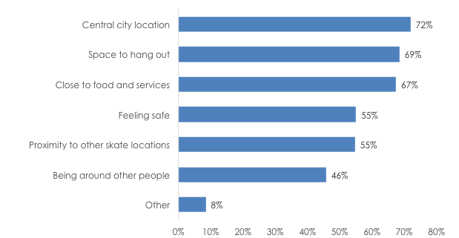
Spaces that best support the skate community | There is a clear desire for street styled facilities and spaces, and more integration and inclusion into the city’s public realm. Sheltered spaces were also highlighted as desirable, as at present there are no sheltered spaces to skate year round in the City of Melbourne.  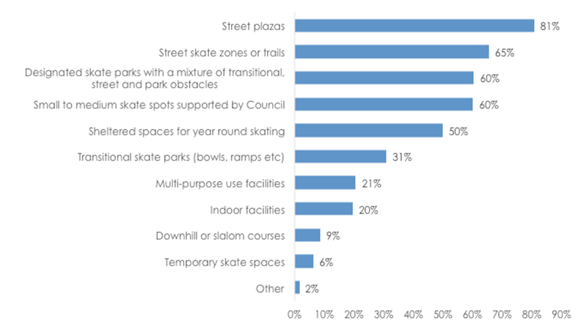

Pop-up engagement findings
Once a week throughout the engagement period on-street pop-ups were held to promote the framework and engage with the general public and asked them their thoughts around skating. Across three pop-ups, approximately 100 individuals spoke briefly with council officers on the street, with many more reading and reacting to the signs promoting the framework. General responses were positive or neutral. Little to no respondents had serious issues with skating, nor were they bothered by it, ‘as long as it wasn’t hurting anyone’ stated one community member. Some common responses were that skating brought vibrancy and performance to the city, that it was better individuals (especially youth) participate in active recreation rather than being behind a screen, and that skaters shouldn’t be victimised for participating in a healthy activity.

Quotes from general public at the pop-ups:
“As long as they’re not hurting anyone, what’s the problem?” – mother of two children
“Skating brings life to the city, they’re fun to watch when I’m on my lunch break.” – female city worker
“The new skate park in St Kilda was highly contested by local residents; those same residents now love it!”
– St Kilda resident and city businessman

Skate framework workshop
- Eight skaters attended the workshop. These included a pro street skater, some intermediate skaters, a beginner, the manager of Riverslide Skate Park and a skater who also works as a skate park designer.
- Despite the small numbers, some detailed focus areas, challenges and opportunities came out of the workshop.
- All skaters in attendance associated themselves with park and street skating styles.
- The small numbers enabled a more detailed and open conversation based session, which allowed the process to be more inclusive and engaging.

Key findings:

- Educate the public: it’s a sport, a lifestyle, an art form – it’s unstructured. Improve the general public’s understanding and perception of the activity and community.
  - Instead of skate stopping, enable it by designing skate ability into new spaces (considering skate in new projects is important).
- Getting the right location for skating is important.
- DIY skate parks – a sense of ownership is a great way to build in acceptance and use of the space into the future.
- Map of where and when people can skate would help people understand where to skate.
- Melbourne can be seen as a leader in skating culture and provision.
- Share the process with other councils and advocate for inclusion.
- Putting other complementary activities and having multiple activities and uses in and around a skate space will make the space more interesting and well utilised. This will also seemingly make the spaces seem less like skate specific, which is what street skaters want.
- Skate parks were seen as important for beginners and families, however they are sometimes seen as a day care where parents just drop their kids off. This is not attractive to teens and young adults in these peak times as it can be dangerous for professionals and beginners alike.
- Street skate plazas were seen as important for the skateboarding community – it’s a very different type of skate space as it doesn’t look like a skate park. There are also no unattended small children, nor are there scooters or bikes. These spaces also allow filming and photos. Lincoln Square was popular because it was accessible, had space to hang out, it was in a public space which was aesthetically pleasing, a very visible space by other city users and the elements catered to beginner, intermediate and experienced skaters. The amalgamation of all of these factors allow for skaters to skate safely and connect with their community.

Feedback on the workshop and engagement process included:

- The word ‘framework’ isn’t very clear and is hard to understand right away.
- A lot of the skaters found out about the project through various means, however it wasn’t easily found if you were not in the street skating scene.
- No Facebook event or Instagram presence made it difficult to share with everyone.
- Difficult to engage with skaters without a clear indication of the overall plan. Suggestions to improve engagement include:
  - Involvement of role models.
  - Rather than sitting around a room talking, something interesting and tangible to do such as a demonstration, game of SKATE, a competition or a DIY building workshop.
  - Make sure it works with a lot of people - time and place are important. Docklands was a bit difficult to get to and not central. Important to be at or close to where people skate already.
- Case studies were a good tool to help explain but need Australian ones so that it’s local and relatable such as St Kilda, Geelong and Reservoir.

Social media
Social media was an effective method of reaching the skate community on the topic. It was also helpful for the general public and youth demographics. The Facebook posts had over 800 reactions, 120 comments and 60 shares collectively. The framework was also shared on Facebook and Instagram by popular skate culture magazines and websites. However, as highlighted in the constraints section, there was heightened media awareness due to Lincoln Square Plaza’s modifications, which may have impacted on the Skate Melbourne framework’s response rate, messaging and the types of responses received.

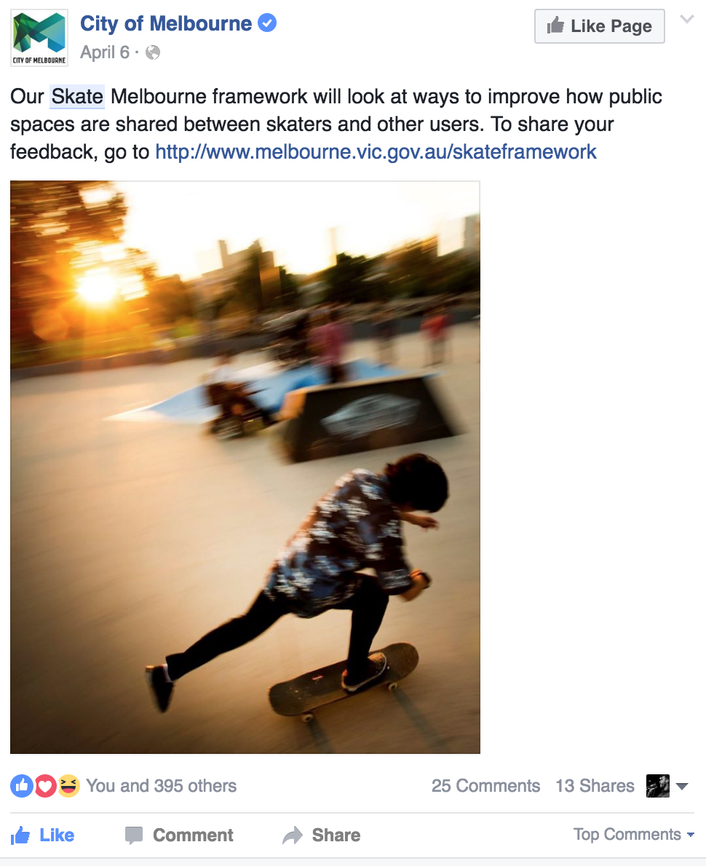 | 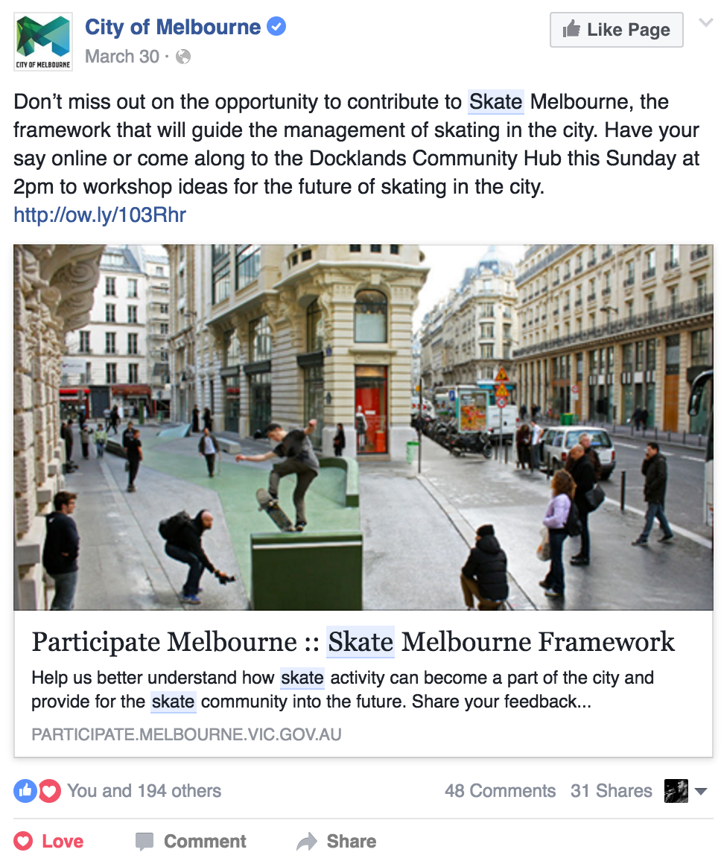
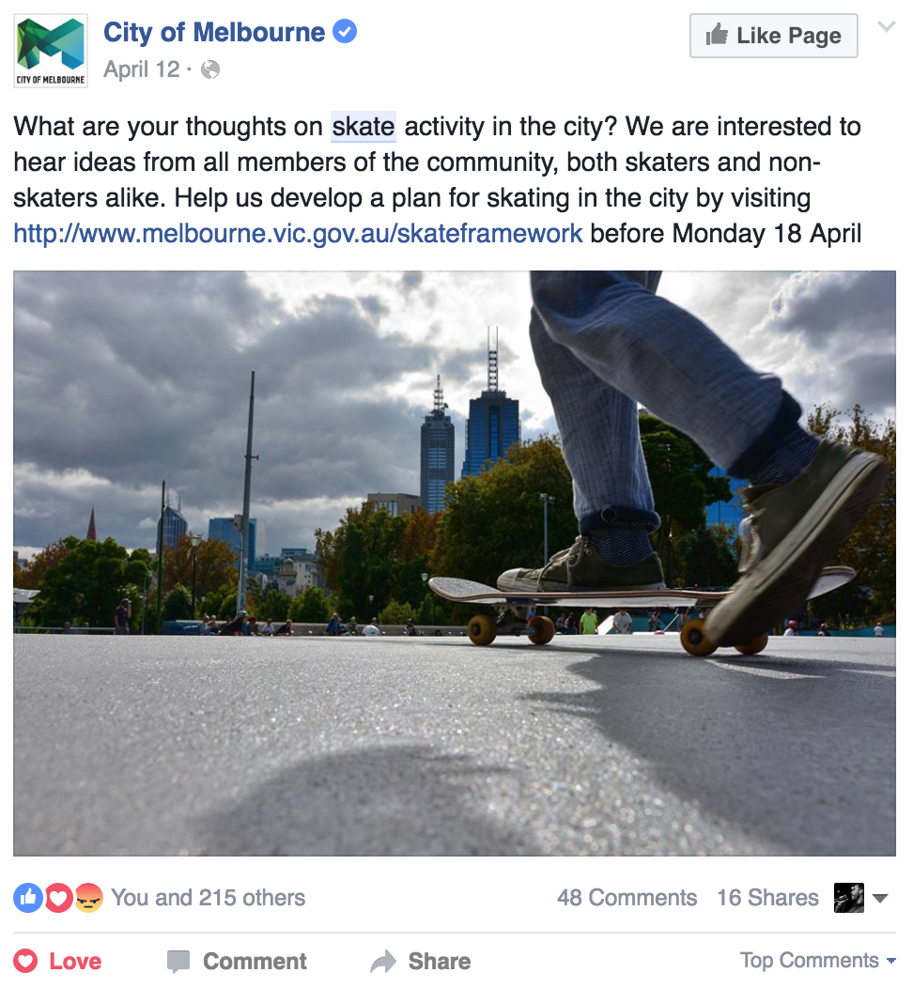 | 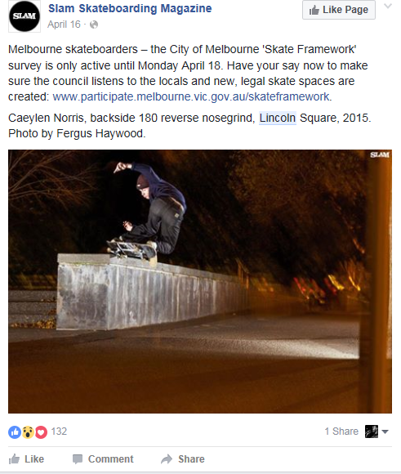
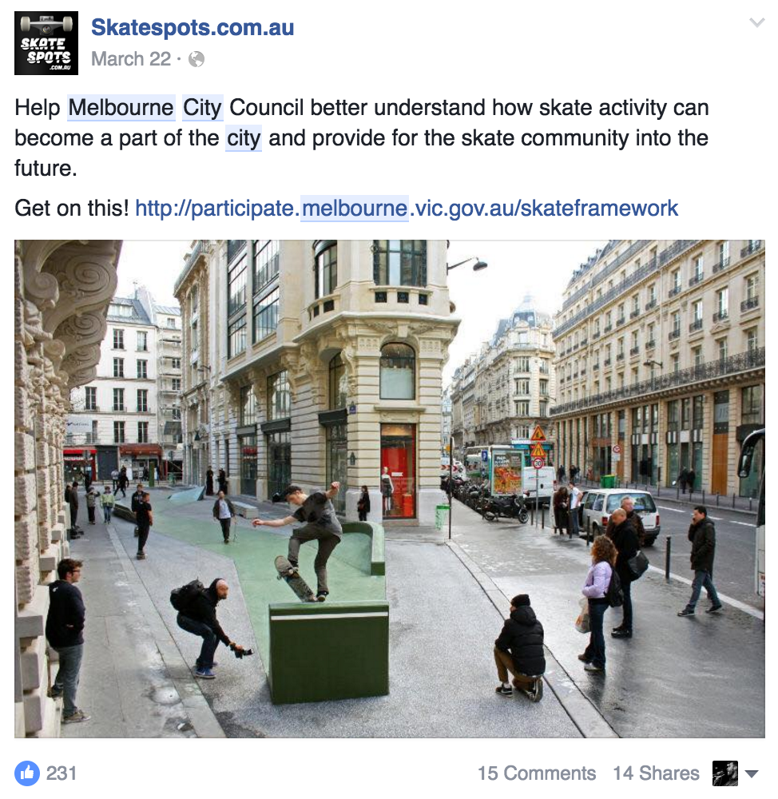 | 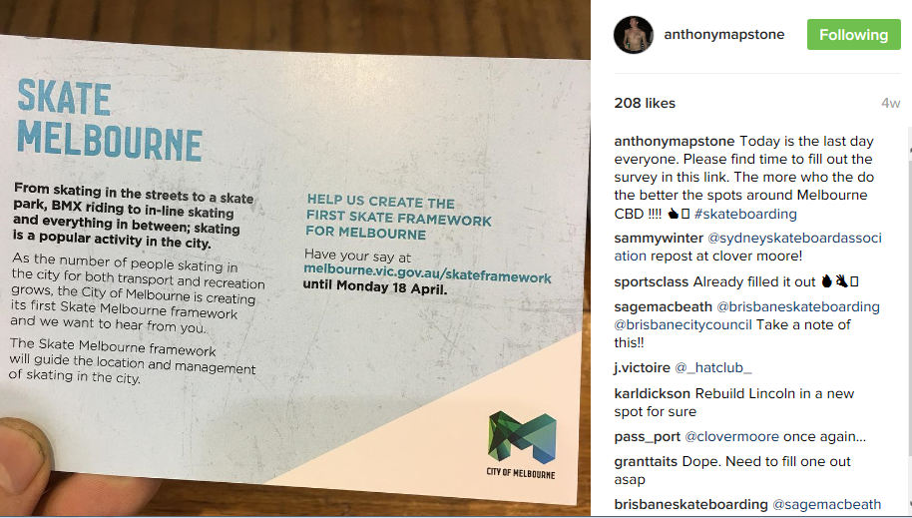  Prolific and well known skaters shared the survey on their personal Instagram and Facebook pages which resulted in peaks in response rates.  Sydney Skateboarding Association and Brisbane skate communities then went onto share the engagement process as a flagship of progressive and inclusive government procedure.
Skate Melbourne Advisory Group
Through the community engagement phase, the Council asked for expressions of interest in being a part of an advisory group. It was highlighted by many that a community group was required to help develop the framework in more detail. The Skate Melbourne Advisory Group consists of 12 members covering a mix of residents, skaters, police, security, youth and university representatives. The Council aimed to have a good mix of genders (five females, seven men), ages (16-50 years) and skate styles (street, transitional and park styles are represented) and devices (quad skates, skateboards and longboards are represented) represented in the group.
The group collaborated with the Council on the key topics of skate provision, management (especially within shared public spaces) and location through workshop sessions and provided constant feedback on content being produced by the Council. They will also provide feedback and guidance on the first draft of the strategic framework.
Survey responses were shared with the newly formed Skate Melbourne Advisory Group and the group was asked, “Considering the heavy response from street skaters to the survey, how much weight should we put on the survey results and findings?” It was highlighted that the high response from street skaters shows that this is an important and popular style in the City of Melbourne, and is unique for the City of Melbourne as a central location and a capital city renowned for its skating and street culture. Street skating should therefore be a key focus in the development of the final framework, however, it should not be the only focus and should incorporate other styles and devices used within skating in its development. These styles and devices include transitional and park styles, long boarding, quad skating, rollerblades, scooters, BMX and more.
It was highlighted that in the next round of engagement, more work is required to engage with the business and residential sectors to get them more involved and have their input to balance the responses and we will work with the Skate Melbourne Advisory Group in developing the next stage of engagement.
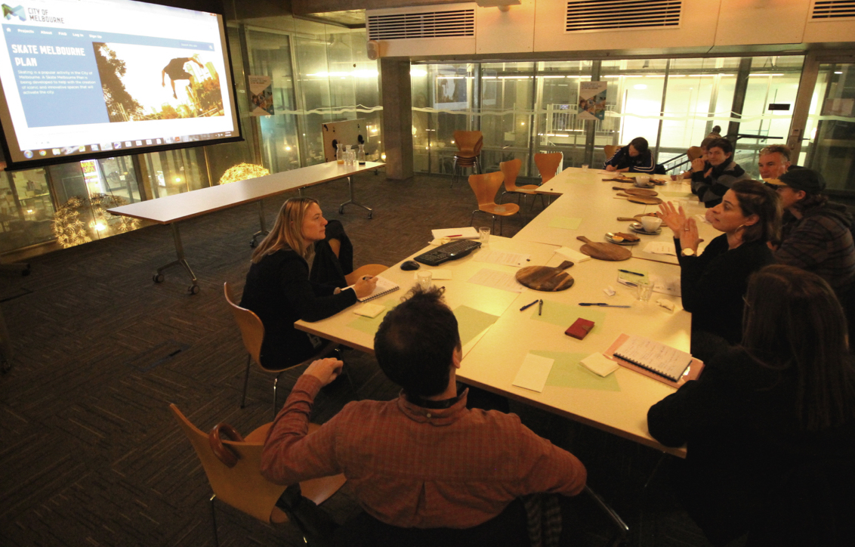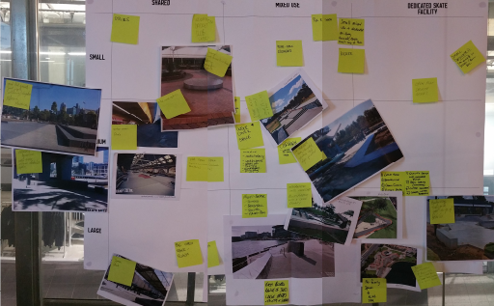
Above: an example of the process undertaken in workshopping ideas for the draft framework with the Skate Melbourne Advisory Group.
Next steps

Information captured through the first phase of community engagement will inform the development of the draft framework which will then be shared with the public for consultation by the end of 2016.

Visit http://www.melbourne.vic.gov.au/skate for more information.

APPENDIX

Appendix item one - Summary of community engagement phase one

Method | Number of interactions | Comments
Participate Melbourne site | 3605 sessions  505 contributions  18 applications for advisory group  59 people downloaded the skate framework background paper | - 89% skate participant respondents.  - 92% positive response toward skate.  - 83% of skate respondents utilise skateboards.  - 66% of skate respondents participate in street style skateboarding.
3 x central city face-to-face pop-ups | 100 interactions (approximate)  promoted skate framework with general city users passing by | - Located in central city public spaces during peak hours of usage.  - No cases of heavily opposed attitudes toward skate activity.
1 x workshop | 8 participants | - Feedback on low attendance rates was highlighted as:  - Lack of awareness of framework and workshop itself.  - Poor location and timing.  - Unsure of what a ‘framework’ is.  - Unsure of what they would be doing in the workshop.  - Low numbers allowed for more detailed conversation and involvement.
3 x boosted Facebook posts | 800 reactions  120 comments  60 shares | - Some comments were negatively geared around the modifications being made to Lincoln Square Plaza.
Other major parties sharing the Participate survey | 2 x Facebook shares from major skateboarding social media sites with 350 reactions  2 x Instagram shares from major skateboarding social media sites with 300+ interactions  Plus more shared posts from many individuals | - Some prolific skate magazines and skaters took it upon themselves to share the framework consultation.  - Other skate community groups from Brisbane and Sydney both shared the Participate survey. The Sydney Skateboarding Association stated: “it’s not hard to see why Melbourne is considered Australia’s cultural hub”.
Major news articles on Lincoln Square’s modifications to discourage skate activity. | Major news articles from The Age, The Herald Sun and ABC. All of these contained different perspectives on the topic. | - This had a significant impact on the community engagement process both negatively and positively.  - Negatives:  - Skate community felt council’s process was disingenuous.  - May have deterred some skaters from participating.  - Other community members felt youth in general were being negatively represented and impacted.  - Limited face-to-face engagement opportunities.  - Positives:  - Highlighted the topic of skating in the municipality.  - May have caused more skaters to provide feedback.

Appendix Item 2

Skate Framework Survey Form

I am answering this survey as... Required

- Someone who participates in skate activity (includes BMX, scooters, inline etc)
- Someone with a relationship to skate (work in the industry, family member etc)
- Someone who is currently impacted by skate
- A non-skater
- Other: _______________________________________________________________________

Choose four of the following types of public spaces that you think are most suitable for skate activity

- Parks and reserves
- Forecourts, plazas and squares
- Streets and laneways
- Temporary spaces i.e. event spaces
- Indoor locations
- Dedicated skate spaces i.e. skate parks
What elements do you enjoy most about those public spaces? Are there any other areas of the municipality that you think could be suitable for skate activity?
__________________________________________________________________________________________________________________________________________________________________________________________________________

Some of the public spaces listed above can be spaces shared with pedestrians, businesses, vehicles and other uses or activities in the same place, at the same time. How can we improve the way these spaces are shared and managed?
____________________________________________________________________________________________________________________________________________________________________________________________________________________________________________________________________________________________________________________________________

Using past research and case studies we have identified some key principles that may guide the future of skate in the City of Melbourne. Choose which ones you think are important.

- Connect activities such as skate, with other complementary activities and uses (e.g. other active, youth and socially oriented uses or other loud activities)

- Include the skate community in the process (e.g. foster an ongoing partnership, include in design and build process)

- Integrate skate spaces innovatively into suitable, accessible and safe public spaces.

- Explore private, commercial and not-for-profit partnerships to assist in the development of spaces and services that support the skate community

Please explain your answers. Is there anything we've missed?
_____________________________________________________________________________________________________

What is the one thing you would do to improve skating in Melbourne?
_____________________________________________________________________________________________________

Do you have any further comments to make about skate in the City of Melbourne?
_____________________________________________________________________________________________________

Age Group

- Under 10
- 10-14
- 15-17
- 18-24
- 25-29
- 30-39
- 40-49
- 50-59
- 60-69
- 70-79
- 80 or over

Gender identity

- Female
- Male
- Indeterminate/Intersex/Undisclosed

What is your connection to the City of Melbourne?

- I’m a resident of the City of
- I work in the City of Melbourne
- I own / operate a business in the City of Melbourne
- I study in the City of Melbourne
- I visit the City of Melbourne
- None of above, I’m just interested in this subject
Residential postcode: _ _ _ _

How would you like to be updated?
For this project only
New projects and monthly newsletter

SKATE SPECIFIC QUESTIONS

I ride/use...

- A skateboard
- A longboard
- A scooter
- A BMX
- A mountain bike
- Inline skates
- Other: ________________________________________________________________________

My favourite styles of skate/BMX/inline are:

- Transitional
- Street
- Park
- Downhill skating
- Transport only
- Other: ________________________________________________________________________

How many years have you been skating for

- Less than one year
- Less than 4 years
- 5-10 years
- More than 10 years
How often do you skate within the City of Melbourne?

- Daily
- A few times a week
- A few times a month
- Rarely
- Never

What do you enjoy about skating in the City of Melbourne?
__________________________________________________________________________________________________________________________________________________________________________________________________________

What do you not enjoy about skating in the City of Melbourne?
__________________________________________________________________________________________________________________________________________________________________________________________________________

What characteristics do you think are important in a skate space

- Central city location
- Close to food and services
- Being around other people
- Proximity to other skate locations
- Feeling safe
- Space to hang out
- Other: _______________________________________________________________________

Which of the following spaces and facilities do you think would best support the skate community

- Designated skate parks with a mixture of transitional, street and park obstacles
- Transitional skate parks (bowls, ramps etc)
- Small to medium skate spots supported by Council
- Street skate zones or trails
- Street plazas
- Sheltered spaces for year round skating
- Downhill or slalom courses
- Indoor facilities
- Temporary skate spaces
- Multi-purpose use facilities
- Other: ________________________________________________________________________

Other surveys conducted in the past – July School Holidays 2015 (YMCA and City of Melbourne)
Leading up to and also during the peak time of the July School holidays 2015 City of Melbourne in partnership with YMCA conducted limited on street surveys of street skaters and park skaters’ alike. These surveys were formulated by the City of Melbourne Skate Framework Working Group and YMCA. They were conducted during daylight hours, on site and face-to-face by the YMCA Skate Ambassadors and compiled by City of Melbourne.
Skateboarding surveys formulated and conducted by YMCA Skate Ambassadors and City of Melbourne
Date and occasion | Frequency | Location | Data acquired | Number of respondents
30/05/2015 – 01/07/2015 | Weekends | Lincoln Square | Post code and age only | 146
21/06/2015  Go Skateboarding Day | One day | Riverslide Skate Park | Detailed survey / questionnaire | 37
02/07/2015 – 11/07/2015  School Holidays | Daily | Popular skate spots and parks | Detailed survey / questionnaire | 141
 |  |  | TOTAL | 324

The total (324) data results show that:
- 59% were under the age of 18
- 27% were aged between 18 and 25 and
- 14% were older than 25 years
- 12% were City of Melbourne residents
- 50% lived in inner Melbourne suburbs
- 19% lived in greater Melbourne
- 16% were from rural areas.

A more detailed survey to find out more about the skating community was undertaken (178 responses).

This survey showed:

- 96% of interviewees were male

- 31% were employed, 24% worked and studied, 39% were full time students, and 6% neither worked nor studied.
- Occupations included; Youth Workers, Web Developers, Aircraft Mechanics, Graphic Designers, Architects, Chefs, Landscapers, Teachers, IT workers, Retail, Carpenters, Hospitality and more.
- 81% of the most favoured spaces to skate were informal “street” rather than skate park locations (see Figure 8)
- 70% skateboarded on weekends and during school holidays, with 30% skated during business hours.

In the second survey additional questions were asked about the motivation to skate.

From 141 responses:

- 37% said skateboarding was their only form of physical activity and/or hobby.
- The primary reasons for skating were: enjoyment (88%), social interaction and community (65%), stress relief / mental health benefits (55%)

Figure 4: A break down of the age groups of skaters

Figure 5: A break down of the postal code of skaters

Figure 6: A break down of the occupation of skaters

Figure 7: A break down of the main themes when responding to “What does Skateboarding mean to you?”

Figure 8: A break down of the favoured skate spots for 178 of respondents

