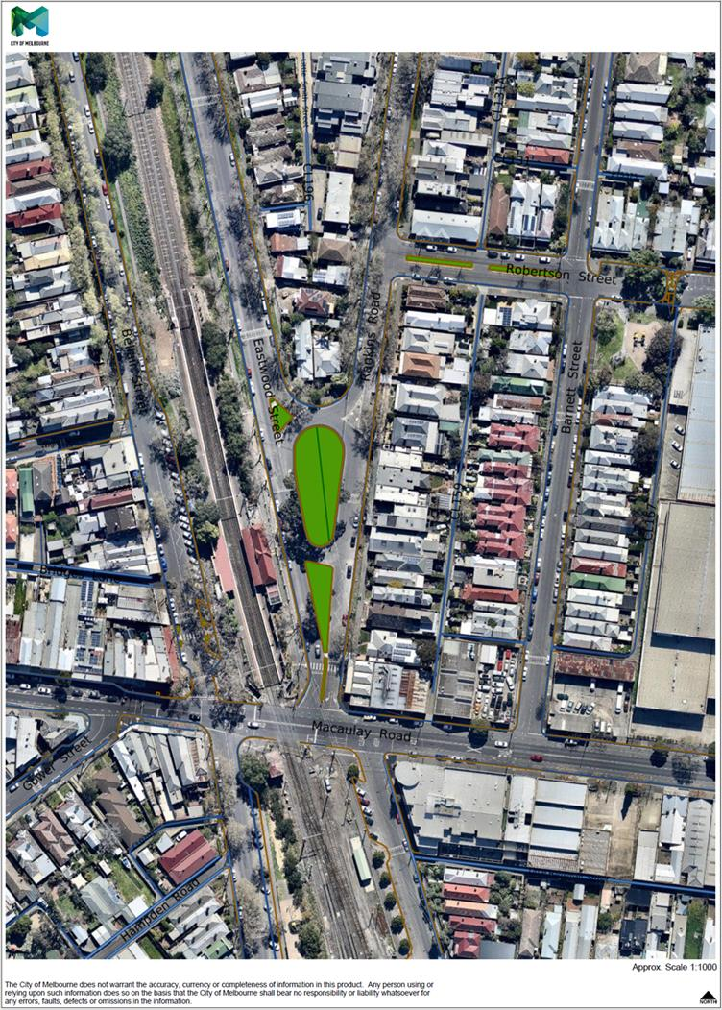

**Traffic Data Summary and Location of Traffic Counters – April 2016**

**(During Construction of Eastwood and Rankins Road Park)**

4

19

19

189

136

182

One-way Traffic Volume Week Day Average = 604

Speed: 85th Percentile = 29

Average Speed = 24.8

Two-way Traffic Volume Week Day Average = 551

Speed: 85th Percentile = 25

Average Speed = 22.5

Two-way Traffic Volume Week Day Average = 307

Speed: 85th Percentile = 34

Average Speed = 26.4

0



224

600

217

219

**Total Traffic Volume at Macaulay/Rankins Intersection (7am-7pm), One-Off Week Day Count = 549**

South bound traffic only (12hrs) = 507

North bound traffic only (12hrs) = 42

**Total Traffic Volume at Macaulay/Barnett Intersection (7am-7pm), One-Off Week Day Count = 1,260**

South bound traffic only (12hrs) = 436

North bound traffic only (12hrs) = 824