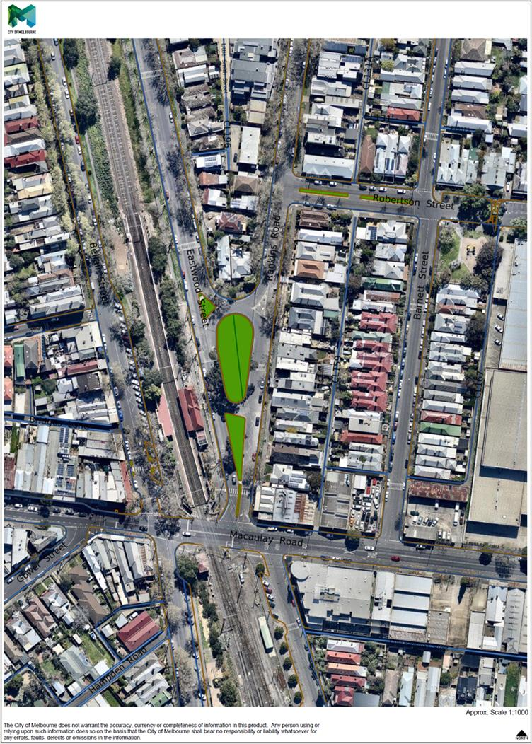

**Traffic Data Summary and Location of Traffic Counters – June 2017**

**(12 Months Post-Construction of Eastwood and Rankins Road Park)**

579

39

55

353

222

234

One-way Traffic Volume Week Day Average = 994

Speed: 85th Percentile = 25

Average Speed = 22.0

0

Two-way Traffic Volume Week Day Average = 710

Speed: 85th Percentile = 26

Average Speed = 22.1

Two-way Traffic Volume Week Day Average = 1,365

Speed: 85th Percentile = 40

Average Speed = 33.0

0



203

132

129

172

**Total Traffic Volume at Macaulay/Rankins Intersection (7am-7pm), One-Off Week Day Count =1,482**

South bound traffic only (12hrs) = 809

North bound traffic only (12hrs) = 673

**Total Traffic Volume at Macaulay/Barnett Intersection (7am-7pm), One-Off Week Day Count = 636**

South bound traffic only (12hrs) = 301

North bound traffic only (12hrs) = 335