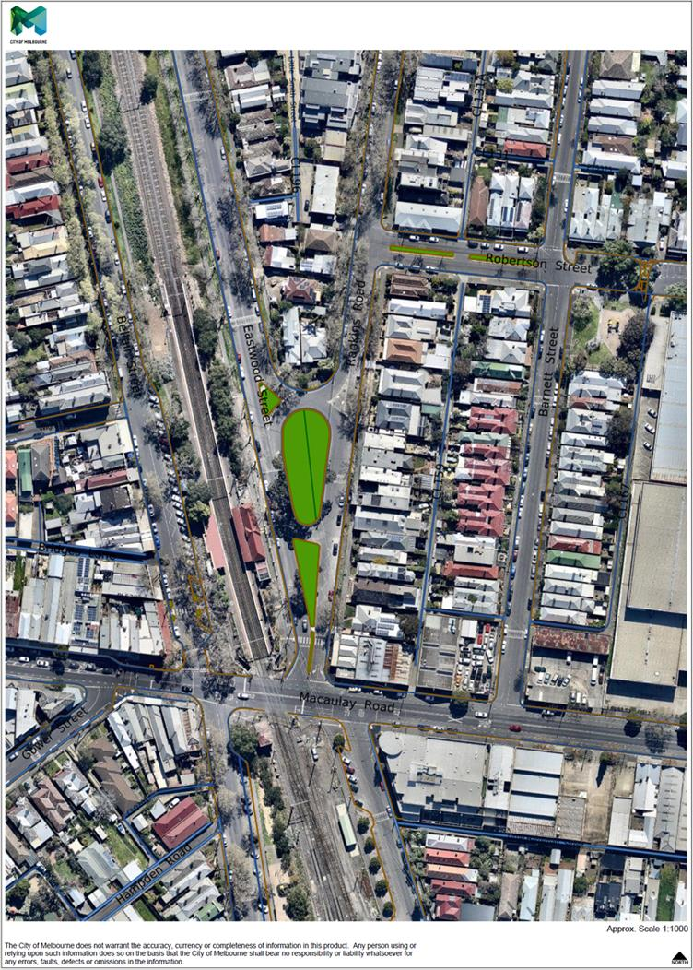

**Traffic Data Summary and Location of Traffic Counters – December 2014**

**(Prior to Construction of Eastwood and Rankins Road Park)**

564

33

252

407

213

243

**Total Traffic Volume at Macaulay/Rankins Intersection (7am-7pm), One-Off Week Day Count = 1,716**

South bound traffic only (12hrs) = 867

North bound traffic only (12hrs) = 849

One-way Traffic Volume Week Day Average = 1041

Speed: 85th Percentile = 35

Average Speed = 29.4

Two-way Traffic Volume Week Day Average = 638

Speed: 85th Percentile = 24

Average Speed = 20.4

Two-way Traffic Volume Week Day Average = 2389

Speed: 85th Percentile = 33

Average Speed = 28.7

4



149

99

161

185

**Total Traffic Volume at Macaulay/Barnett Intersection (7am-7pm), One-Off Week Day Count = 594**

South bound traffic only (12hrs) = 346

North bound traffic only (12hrs) = 248