341-345 Elizabeth Street, MELBOURNE (HO1204)
Grading: Significant
Date(s): 1924
Survey Date: April 2016
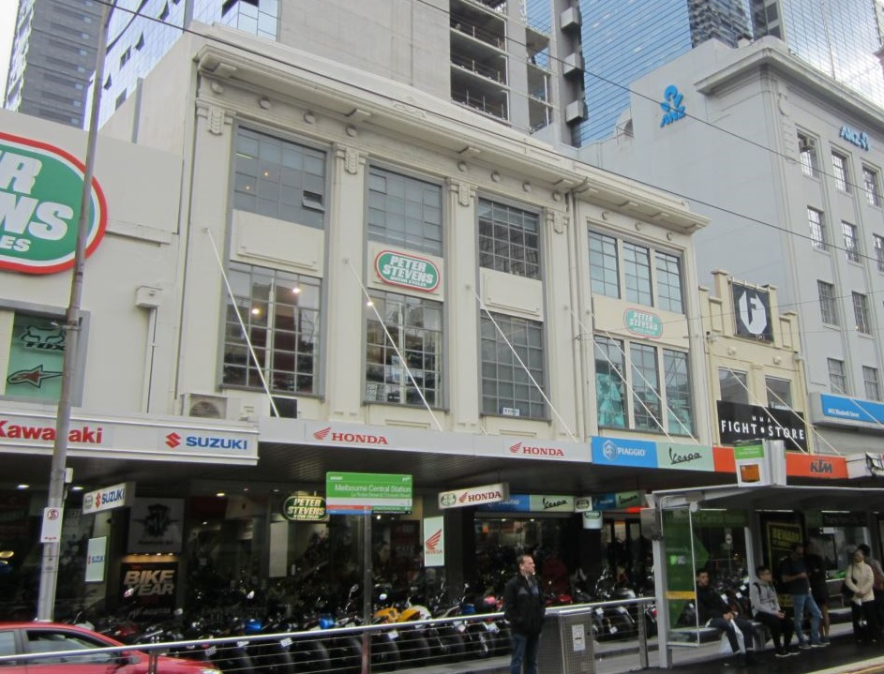

Statement of Significance

What is Significant?
The warehouse building at nos 341-345 Elizabeth Street was constructed in 1924, replacing two Victorian shops. The 1890 rate books list five-room brick shops at nos 341-3 and 345 Elizabeth Street, which were occupied by a restaurant and tailor. By 1922, the row of shops from no 341 to 357, at the corner of La Trobe Street, was owned by warehousing firm the Connibere Brothers. The following year, these properties had been sold to a number of different owners, with nos 341-345 acquired by Cassells Tailors. The latter appear to have been established in c. 1907, with a shop in the Eastern Arcade in Bourke Street; and by 1913, Cassells and Co had relocated to 271 Swanston Street.
In March 1923, a permit application was made to the City of Melbourne for the construction of a reinforced concrete warehouse to a value of £8000. The new building was completed by 1924, and was described in the rate books of 1925 as a concrete warehouse.
The whole of the new building was owned by Cassells, but had two street addresses: the larger nos 341-343, known variously as no 341 or no 343, and the other at no 345 Elizabeth Street. These two addresses can be discerned in the building façade today. The building also had rear access from an unnamed right-of-way, accessed in turn from Sutherland Street. In 1924, Cassells advertised to lease a factory with workroom, ‘excellent light [and] central position. In 1925, the tailors occupied no 343 and Eustace Raftopoulos operated the IXL Cafe from no 345. It is possible that Eustace Raftopoulos was related to Arthur and Conis Raftopoulos, who operated the oyster saloon at 195 Elizabeth Street in the early twentieth century, a club in Lonsdale Street and a cafe in Russell Street in the 1920s. In 1950, the subject building was sold to the National Bank of Australia for £46,000.
The design of the former warehouse/factory, relies on innovations made in Chicago through the late nineteenth and early twentieth centuries. Chicagoan architects developed a new form of fireproof building in which steel frames supported the upper levels, eliminating the need for thick, load-bearing brick walls. The resulting form of expression flouted precedent and convention allowing glazing rather than (rendered) brickwork to dominate building facades. In essence, these buildings comprised an expressed structural system of concrete (or concrete clad steel) columns and floor plates. The effect of this, somewhat brutish, form was typically attenuated by an applique of understated classical detailing in the form of dentils to parapets, capitals to columns or moldings to spandrel panels. This general approach is seen in the subject building. However, Australian commercial buildings clung to their Victorian, red brick heritage into the twentieth century and Chicagoan influences did not begin to emerge until the Edwardian period, and did not become commonplace until c. 1930.
The three-storey former warehouse building at nos 341-345 Elizabeth Street is typical of the above form of expression as it emerged through the 1920s in Australia with fashionable embellishments to a Chicagoan frame. On the subject property, substantial columns, suggesting giant order classical pilasters, ascend through the upper levels to a low, stylised parapet. These elegant devices incorporate stepped chamfering to their edges and rise to simple, abstracted capitals suggesting contemporary Art Deco designs. The parapet is similarly sleek with faux dentillation and simplified brackets. Spandrel panels reiterate the stepped detailing of the columns.
The building is currently used as motorcycle showrooms. This has required some alteration at ground floor level. However, the upper levels and the expression of the building more broadly are largely intact to their 1924 state. Original detailing and simple, albeit large steel-framed windows survive. An original canopy has been reclad but retains its early form. The building has been overpainted.

How is it Significant?
The three-storey warehouse building at nos 341-345 Elizabeth Street, constructed in 1924, is of local aesthetic/architectural significance.

Why is it Significant?
The building is of local aesthetic/architectural significance. It is substantially externally intact, particularly to the façade levels above the ground floor shopfronts. It is also a fine example of a concrete framed building, with large expanses of glazing, which illustrates developments in building technology increasingly seen in commercial buildings in the interwar period. The design can be attributed to earlier innovations in Chicago, where architects developed a new form of fireproof building in which steel and concrete frames supported the upper levels, eliminating the need for thick, load-bearing brick walls. Of note with the subject building are the substantial columns with simple, abstracted capitals; low parapet and stylised detailing; and the large steel-framed windows which allowed the original owners to promote the new factory/workroom as having ‘excellent light’. The overall effect is of a stripped, architectural expression incorporating classical form and proportion which, despite its utilitarian underpinnings, achieves a formal interwar expression that refers equally to American Art Deco sources and the classical world.

32-34 Guildford Lane, MELBOURNE (HO1205)
Grading: Significant
Date(s): 1908, c1920
Survey Date: April 2016
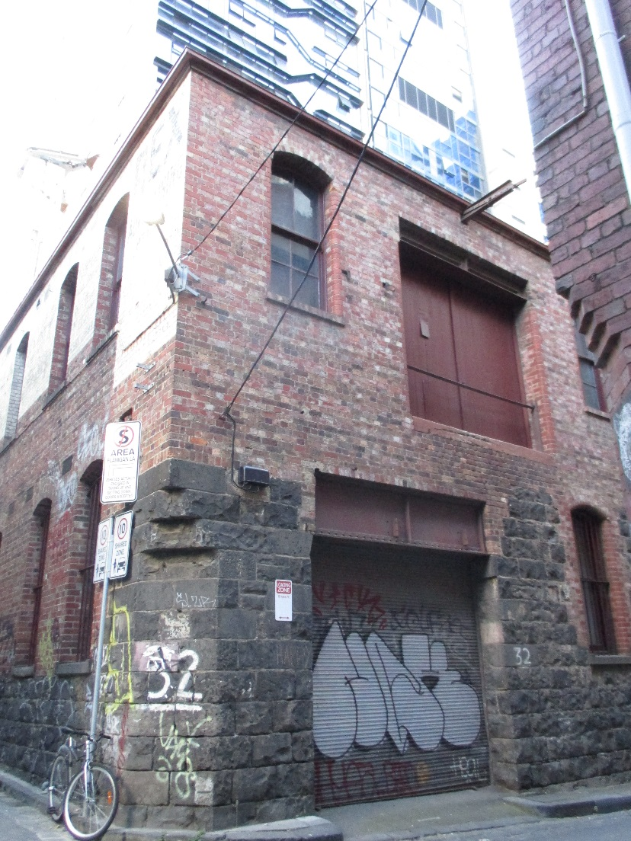

Statement of Significance

What is Significant?
The 1894 MMBW detail plan no 1017 shows this corner site as being no 44 Guildford Lane, and occupied by a small brick building, described as a brick house occupied by James Marsh in the 1896 municipal rate books. Within ten years, this building had been demolished, and the rate books record the then unnumbered property as ‘land’. In 1908, a permit was obtained by prominent builder Clements Langford for the construction of a ‘stone factory’ at the site. Langford was the builder of a number of significant buildings in Melbourne, including the former Gollin & Company Building in Bourke Street, of 1902; the former E S & A Bank in Swanston Street, of 1928; and the final stages of St Patricks Cathedral, including the towers and spire, in 1926-33.
The 1910 municipal rate books list this stone factory building, with Langford also the owner of the brick house at no 30 and the occupier of the stone house at no 33. Both properties at nos 30 and 32 were valued at a NAV of £16. In 1915, the property was described as a brick workshop and store at no 30-34 Guildford Lane, valued at NAV of £20. Five years later, the brick workshop was valued at a NAV of £100, indicating that improvements had been undertaken at the site. These works likely include the construction of the brick second level to what appears to have been a single-storey stone building. Although Langford is listed as the owner and occupier of the building in 1920, by 1924, electrical engineers Nilsen Cromie were at the site.
The two building programmes – 1908 construction and c.1920 second floor addition - remain legible in the factory building. The ground floor façade and lower sections of the side and rear elevations to Flanigans Lane, survive from the original construction. These are of random dressed bluestone laid in courses. An original ground floor window to Guildford Lane, incorporating red brick quoins and segmental-arched head windows, also survives. The adjacent entry has been altered, largely through the introduction of a deep steel lintel to support the upper level. Bluestone walls to the corner of Guildford and Flanigan Lanes incorporate a canted corner with a corbel detail above, intended to reduce the damage from vehicle impacts. Above these original elements, face brick walls in English bond were constructed in c.1920. Early features, including upper level windows and landing doors to Guildford Lane, survive. Windows from the second programme of works also survive along the Flanigan Lane elevation. Segmental-arched ground floor windows, retain c.1920 cast iron bars and joinery over bluestone sills from 1908. Windows to the upper level addition are similar but incorporate brick sills. The upper level of the side elevation has been painted and some early signage survives but the building is largely intact and legible to its c.1920 state.

How is it Significant?
No 32 Guildford Lane is of local historical and aesthetic/architectural significance.

Why is it Significant?
The building is historically significant for its association with prominent builder Clements Langford. He constructed the building in 1908 as a factory, undertook later improvements, and owned it and an adjoining property until at least 1920. This was in the period when Langford was a sought-after Melbourne builder, and it is assumed that the subject building supported his construction activities, as a workshop or store. Aesthetically, while the building has been modified and extended, albeit at an early period, it is a robust and prominent corner building in the precinct, marking the western entry to the historic part of Guildford Lane. Its corner position is emphasised by the chamfered detail to the stonework at ground floor level in the south-west corner of the building. The ad hoc combination of materials and details, including the unusual coming together of face stonework and brick walling is another distinguishing feature of the building. The resulting character and architectural expression is evolved, rather than designed, but nevertheless has resulted in a distinctive building in the precinct.

Cyclone House (HO1205)
17-19 Hardware Lane, MELBOURNE
Grading: Significant
Date(s): 1930
Survey Date: April 2016
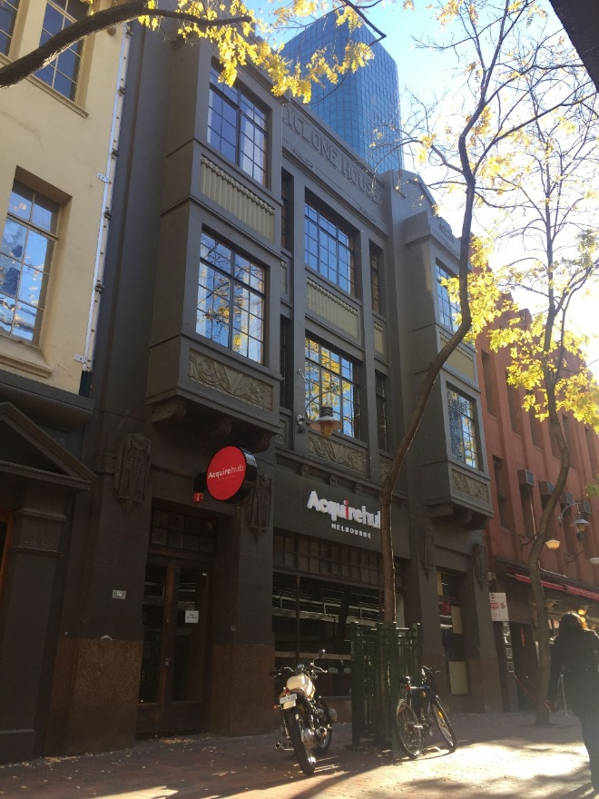

Statement of Significance

What is Significant
Cyclone House was constructed for the Cyclone Fence and Gate Co. in 1930 after the sale and subdivision of the former Kirk’s Bazaar land and creation of the extension of Hardware Lane in the mid-1920s. The company relocated to the new offices and showrooms, along with Chambers and Bennetts. The Cyclone Woven Wire Fence Company was established in 1898 by Leonard Tasman Chambers and William Eastwood Thompson, who had obtained the rights to manufacture American ‘cyclone’ fencing. In addition to manufacturing the American designs, the company also designed products for Australian customers. Such was the growth of the company, that by the 1920s it had established factories in Melbourne, Adelaide, Sydney and Perth. The company was known for woven wire and wrought iron gates, which became common in Australian suburbs in the mid-twentieth century.
The company’s occupation of its building, however, was short-lived, with the company putting it up for auction in 1935. It appears that the building was not sold at this time, but the Australian Broadcasting Corporation (ABC) took up a lease for part of the building for use as temporary studios ‘for the broadcasting of plays and other entertainments.’ Cyclone House was again put up for sale in 1946, and was described in the auction notice as ‘a modern, three-storey reinforced concrete office building’. The building sold for £11,000. The ABC continued to occupy Cyclone House into the 1970s, and the building housed its concert and production departments.
Description
Cyclone House is a formal three-storey building which is remarkably intact to its 1930 state, and combines a range of, occasionally diverse, features into a single, substantial whole. The building has a symmetrical, rendered façade, flanked by jettied bays rising through the upper levels to produce a tripartite expression. Each bay is capped by a stylised triangular pediment rising above a simple parapet. The name ‘Cyclone House’ is realised in rendered lettering to the parapet. Windows are largely original and multi-paned, with decorative panels to spandrels incorporating novel geometric devices. At its roof level, the building retains an early water tower, again featuring the ‘Cyclone’ name, and flagpole which would have formed a local landmark prior to taller and more intensive development east of Elizabeth Street during the later twentieth century. Overall, it displays an unusual composition with understated references to Scottish Baronial and Collegiate Gothic forms, overlaid with an applique of classical and Moderne motifs.

How is it Significant

Cyclone House, constructed in 1930 at 17-19 Hardware Lane, is of local historical and aesthetic/architectural significance.

Why is it Significant

The building is significant for its initial association with the highly successful Cyclone Fence and Gate Co, which had been established in 1898. The company produced the much sought after ‘cyclone’ wire fencing, a product which had been invented in America. The Cyclone Fence and Gate Co also manufactured the then popular woven wire and wrought iron gates. Despite its success, the company did not occupy the building for long, with the Australian Broadcasting Commission moving into the premises in the pre-WWII period and maintaining its association until the 1970s. Aesthetically, the scale and quality of the building is testament to the then success of the Cyclone Fence and Gate Co. It has an unusual architectural expression, with a composition drawing from a range of sources, including English, classical and Moderne antecedents. The building is also highly intact externally, and unusually retains an early named water tower at roof level.

Former Penman & Dalziel warehouse (HO665)
55-57 Hardware Lane, MELBOURNE
Grading: Significant
Place type: Warehouse
Date(s): 1887-8
Survey Date: April 2016
Intactness: Fair
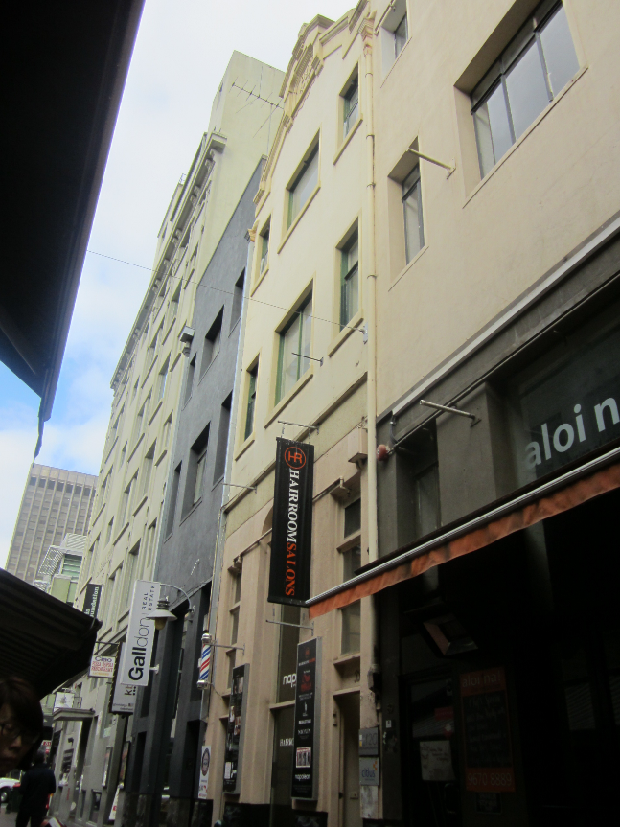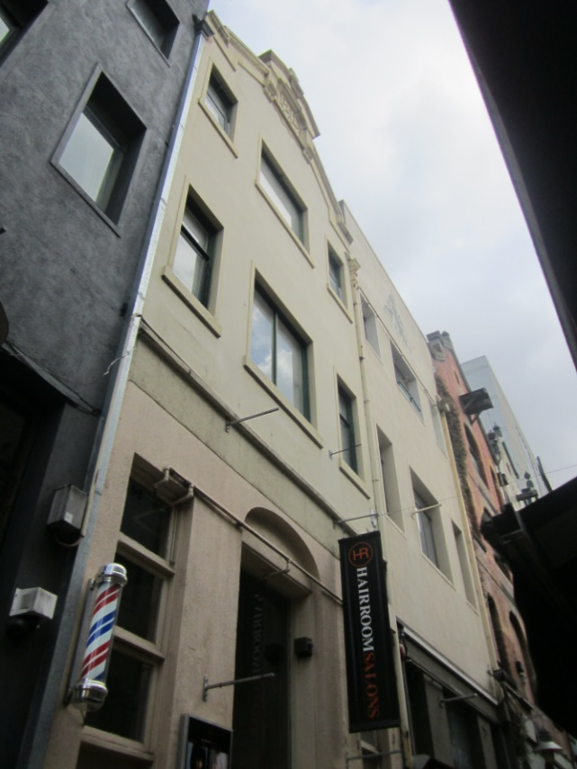

Statement of Significance

What is Significant
The building at 55-57 Hardware Lane was built as part of a group of three warehouses in 1887-8, for furniture manufacturer Penman and Dalziel. It is a four-storey rendered masonry former warehouse, with a tall narrow massing on a long rectilinear plan, and a basement level. The façade has been modified, including through the application of render over original face brickwork, however the building retains its distinctive gabled and parapeted form, and rough face bluestone plinth at ground level. While the ground floor level has been altered, the original arrangement of lower floors with ground floor elevated to facilitate loading remains legible. Fenestration at the upper levels also remains broadly intact to its early state with large central landing doors to each level flanked by sliding sash windows. The rear of the building as seen from Goldie Place, is more intact and retains its face brick exterior and original windows.

How is it Significant
No 55-57 Hardware Lane, Melbourne, is of historical and aesthetic/architectural significance to the City of Melbourne.

Why is it Significant
The building at 55-57 Hardware Lane is of local historical significance. It is one of an important collection of nineteenth century warehouse and mercantile buildings in Hardware Lane. Constructed in 1887-8, to a design by noted architect Alfred Dunn, the building was one of five warehouses built in Hardware Lane and the adjoining Goldie Place, for the furniture making company of Penman and Dalziel. The company remained associated with the warehouses until 1910, and in 1937 were noted as one of Melbourne’s early ‘skilled craftsmen’ and ‘leading names’ in fine furniture manufacture. (Criterion A) The subject building is also of local aesthetic/architectural significance. While it has been altered, the building retains its distinctive gabled and parapeted form, rough face bluestone plinth, broadly original arrangement of lower floors with elevated ground floor to facilitate loading, and broadly intact fenestration and openings to the upper levels. It is also one of a more extensive row of tall and gabled nineteenth century warehouse forms in Hardware Lane, and makes a significant contribution to the warehouse character of the lane. (Criterion E)

Dynon’s Buildings (HO667)
63-77 Hardware Lane, MELBOURNE
Grading: Significant
Place type: Warehouse
Date(s): 1889
Survey Date: April 2016
Intactness: Good
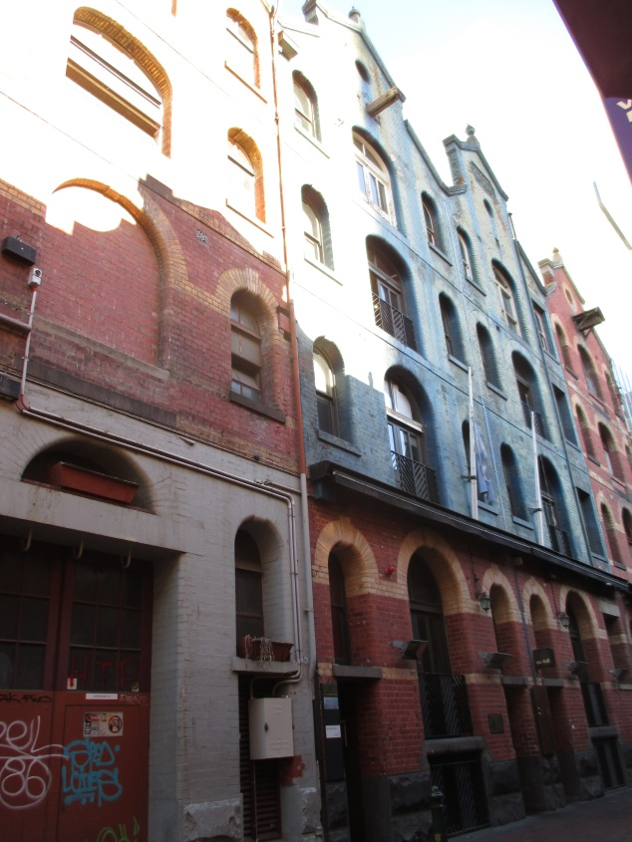

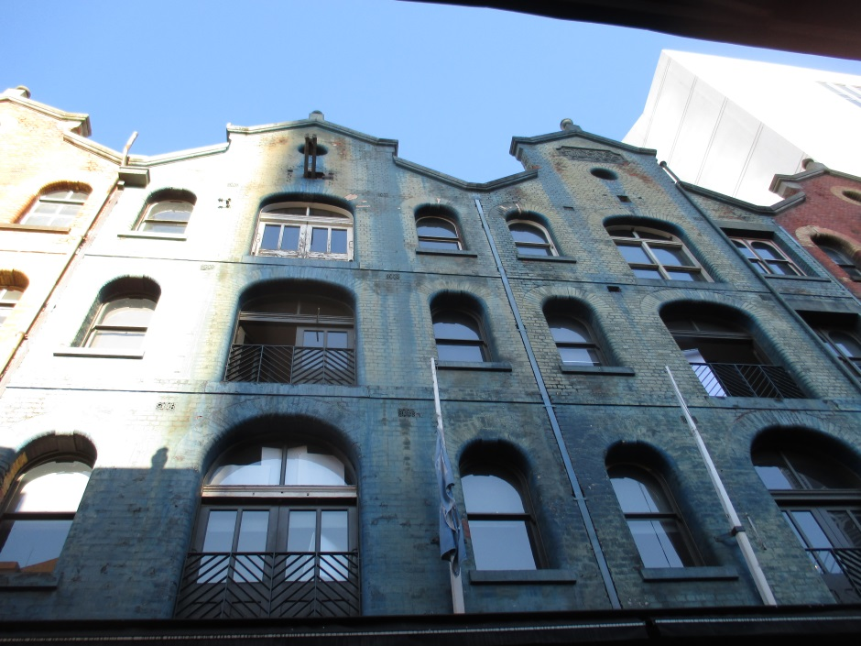

Statement of Significance

What is Significant
The buildings at 63-77 Hardware Lane represent four out of the original five warehouses, which were designed by William Pitt for china and glass merchant, John Dynon, and constructed in 1889. The group of four, known as Dynon’s Buildings, are tall and narrow bichrome brick warehouses, notable for their arcuated facades and striking parapets, the latter with raised pedimental devices and oriels. The architectural detailing to the arched window heads and stringcourses is accentuated in cream face brick against a red brick base; and original bluestone plinths and the majority of window and door openings also survive.

How is it Significant
The buildings at 63-77 Hardware Lane, Melbourne, are of historical and aesthetic/architectural significance to the City of Melbourne.

Why is it Significant
The buildings at 63-77 Hardware Lane, Melbourne, known as Dynon’s Buildings, are of local historical significance. The buildings, constructed in 1889 to a design by William Pitt, are part of an important collection of nineteenth century warehouse and mercantile buildings in Hardware Lane. In replacing earlier and smaller buildings on the site, they are demonstrative of the late nineteenth century growth in warehousing activity in this part of Melbourne. Hardware Lane also assumed much of its current historic character during Melbourne’s Boom of the late 1880s. (Criterion A). Dynon’s Buildings are significant for their association with renowned architect, William Pitt. They were designed by Pitt at the height of his architectural output and influence, when he was responsible for some of the exemplars of the 1880s Boom Style in Melbourne. Pitt was known for eclectic designs and compositional flamboyance, and his industrial and mercantile commissions while typically more subdued were also very capably handled, as with the subject buildings. (Criterion H) Nos 63-77 Hardware Lane are also of local aesthetic/architectural significance. The buildings are substantially externally intact, and retain their original tall and narrow warehouse form and detailing, including arched window heads and stringcourses accentuated in cream face brick against a red brick base, heavy bluestone plinths, striking parapets with raised pedimental devices and oriels, and the majority of the original window and door openings. The groups also form part of a more extensive row of tall and gabled nineteenth century brick warehouses in Hardware Lane, and make a significant contribution to the warehouse character of the lane. (Criterion E)

Former John Dickinson & Co warehouse (HO1208)
337-339 La Trobe Street, MELBOURNE
Grading: Significant
Place type: Warehouse
Date(s): 1923-24
Survey Date: April 2016
Intactness: Good
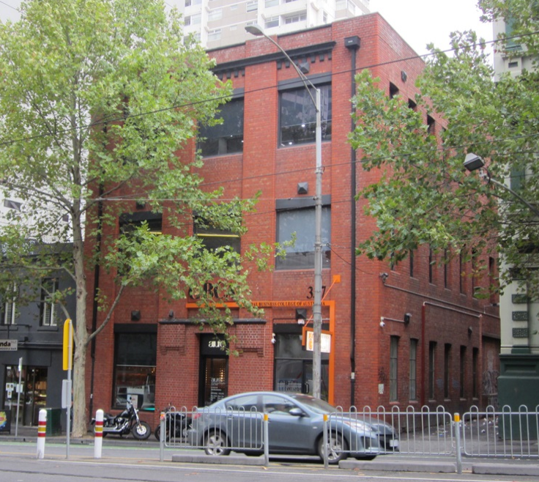

Statement of Significance

What is Significant
The building at 337-339 La Trobe Street, Melbourne, was built in 1923-4, and is the former warehouse of stationers, John Dickinson & Co. It is a substantially externally intact three storey red brick building on a rectilinear plan, with a gablet roof in galvanised steel. While its character is largely utilitarian, and the La Trobe Street facade has understated detailing, the building retains key elements of its design including its face brick expression; broad pilasters with bull-nosed bricks to corners which rise the full height of the building to a simple parapet; a projecting cornice and dentils realised in overpainted concrete; and above the principle entry a shallow awning in painted concrete with broad corbelled brick brackets. The window frames and glazing to the principle façade have been modified, but the original pattern of large openings with concrete lintels and brick sills survives. The west elevation to Flanigan Lane has segmental arched window openings which largely retain original frames and sashes and brickwork details.

How is it Significant
The building at 337-339 La Trobe Street, Melbourne, is of historical and aesthetic/architectural significance to the City of Melbourne.

Why is it Significant
The building at 337-339 La Trobe Street, Melbourne, is of local historical significance. It was purpose built by the renowned stationary company, John Dickinson & Co. The company was a leading international paper and stationery brand, established in Britain in 1803 by John Dickinson, who made many pioneering discoveries in papermaking. The building provides evidence of the expansion of the company in the early twentieth century, into Australia and New Zealand, whereby they built warehouses and factories in Sydney, Melbourne, Wellington and Auckland. The building continued its association with the firm until 1958. (Criterion A) The subject building is also of aesthetic/architectural significance. While it is of largely utilitarian interwar character, the building is enhanced by its high level of external intactness, unpainted brick walled expression, understated architectural details and overall scale. The wide pilasters which rise through the principal façade, dentilated cornice to the top level, and unusual awning device above the principle albeit somewhat narrow entrance at ground floor level, enliven its appearance. It is also a mature example of late Edwardian warehouse design constructed in the period immediately before reinforced concrete would replace red brick as the preferred material for warehouse construction. (Criterion E) The building is additionally a good representative example of a warehouse, and a rare red brick building of this age in this area of La Trobe Street. (Criterion D)

Hardware House (HO1205)
386-392 Little Bourke Street, MELBOURNE
Grading: Significant
Date(s): c1926
Survey Date: April 2016
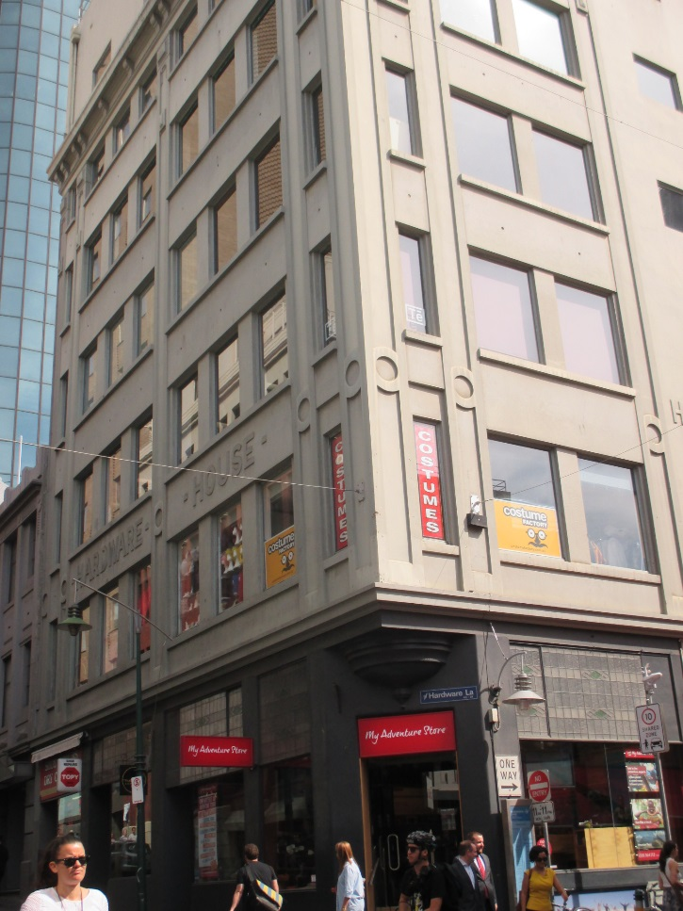

Statement of Significance

What is Significant?
In August 1924, the Hardware Club purchased the site of the Governor Arthur Hotel at 386-392 Little Bourke Street for £17,750. The hotel had been unlicensed since 1916. The Hardware Club was originally formed in the mid-1890s as a social club for members of the hardware trade. Within a year it had 148 members, and within ten years, it boasted over 1,000 members.
The new club premises, known as Hardware House, was designed by architect J V Ward and constructed by the Concrete Building Company. During excavations of the site, the adjoining building at 394 Little Bourke Street collapsed. The resulting demolition of what was known as Endicott’s Building saw textile workers in the adjoining White’s knitting and white work factory in Goldie Place temporarily out of work due to the risk of brick walls collapsing on the warehouse. The new club building was opened in October 1926 at a ceremony performed by the Lord Mayor, Sir William Brunton, a member of the Hardware Club. The six-storied Hardware House comprised ‘dining, card and reading rooms, bathrooms, billiard room, library, lounge and a suite of offices’, with ‘sample rooms’ on the sixth floor for use by members. In the mid-1980s, Hardware House became an exclusive and popular nightclub named, somewhat ironically, the Hardware Club.
Hardware Lane took its name from Hardware House. The lane was created as an extension of Wrights Lane, following subdivision of the former Kirks Horse Bazaar property. Hardware Lane was also at the forefront of contemporary laneway renewal in the central city, being a popular nightspot from the 1970s, with restaurants, bistros and clubs moving into its buildings.
Hardware House occupies a prominent corner in the precinct. Externally, the reinforced concrete building adopts a straightforward multi-storey composition with glazed shopfronts at ground floor level and five more massive floors above, capped by an overhanging bracketed cornice. The ground floor retains the broad form of its two original shopfronts with original leadlight glazing to highlight windows. Lower lights have been altered. The corner to the intersection is notable for a decorative canted corner and corbelled first floor designed to reduce vehicle impacts. The upper floors are largely without ornament, apart from rendered signage spelling ‘Hardware House’ to the Little Bourke Street façade accompanied by simple circular decorative devices to pilasters along to both frontages. Window joinery to the upper levels has been altered although the original pattern of fenestration and the broad character of the building survives. An additional level has been added to the building in the relatively recent past.

How is it Significant?
Hardware House at 386-392 Little Bourke Street is of local historical and aesthetic/architectural significance.

Why is it Significant?
The building, which dates from 1926, is historically significant as a purpose-built former club house associated with members of the hardware trade. Its scale is demonstrative of the importance of hardware traders to the City of Melbourne. Hardware House, together with Farrant’s Building across Little Bourke Street, also illustrates the redevelopment of this area of the precinct after the closure of Kirk’s Horse Bazaar, and is significant for bestowing its name on the adjacent Hardware Lane, an early and popular example of laneway renewal in central Melbourne. Aesthetically, the building is a large and prominent corner building in the precinct; it is also substantially externally intact. While a simple but well-resolved design, it provides evidence of the widespread adoption of concrete as the material of choice for multi-storey buildings during the interwar period. The ground floor façade retains original leaded highlight windows to the shopfronts, and a chamfered corner entrance.

Farrant’s Building (HO1205)
387 Little Bourke Street, MELBOURNE
Grading: Significant
Date(s): 1926
Survey Date: April 2016
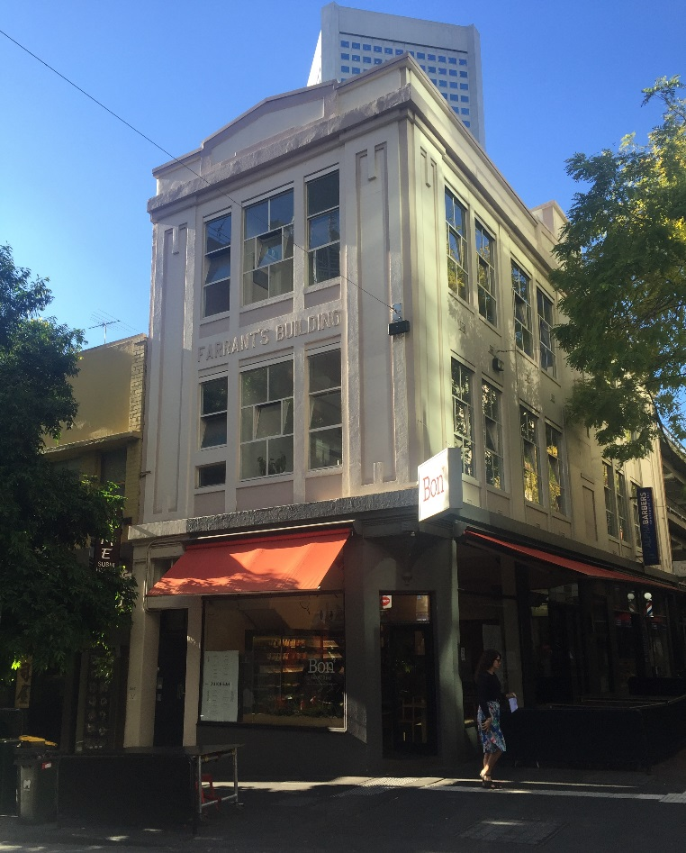

Statement of Significance

What is Significant?
Farrant’s Building was constructed in 1926 for saddle manufacturer Farrant’s, a firm which had been in operation since the late 1880s. The building was constructed after the closure and demolition of Kirks Horse Bazaar, although the company had occupied a small shop on the site from the mid-1890s. The business was one of many selling horse-related products and providing horse-related services, which were associated with this area of Melbourne and its proximity to the horse bazaars. The company advertised that it sold ‘riding saddles, bridles, harness [and] collars’, with ‘no factory made goods’.
With the subdivision and sale of land after the closure of the horse bazaar in 1925-1926, Farrant’s applied to the City of Melbourne to construct a three-storey building at the Little Bourke Street site, to the corner of Hardware Lane, to a value of £3,700. The building incorporated two ground floor shops fronting the newly created extension to Hardware Lane. Farrant’s remained at the site at least until the early 1950s, although parts of the building were variously occupied by other businesses including a leather goods merchant, manufacturers’ agents and embroiders.
Constructed in 1926, the three-storey Farrant’s Building comprises three-storey retail and manufacturing premises. Presumed to be of masonry construction, it is rendered to produce an understated interwar classical expression with corners realised as stylised columns rising to abstracted capitals below a shallow parapet and triangular pediment. The name, Farrant’s Building, is in realised rendered lettering at second floor level. At ground floor level, the forms of a canted corner entry (with the upper storeys forming a short cantilever) and of early shopfronts survive. However, original window joinery has typically been lost at ground floor level. At the upper levels, original window arrangements survive throughout and incorporate unusual and decorative arrangements of fixed and casement windows providing light and air to the manufacturing spaces. Despite alterations at ground floor level and overpainting more broadly, the form and character of Farrant’s Building survives.

How is it Significant?
Farrant’s Building at 387 Little Bourke Street, was constructed in 1926 for saddle manufacturer Farrant’s, and is of local historical and aesthetic/architectural significance.

Why is it Significant?
The building is historically significant for its association with the commercial horse-related products and services businesses which were concentrated in this area of the precinct. These businesses evolved in connection with the local horse bazaars, particularly in the nineteenth century. Unusually, Farrant’s opted to construct this building towards the end of that period, and subsequently maintained their operation into the 1950s. Together with Hardware House across Little Bourke Street, Farrant’s Building also illustrates the redevelopment of this area of the precinct after the closure of Kirk’s Horse Bazaar. Aesthetically, the building is a substantially externally intact and well-resolved corner commercial building. Its large original windows to the upper levels, with unusual and decorative arrangements of fixed and casement windows, were designed to provide light and air into the original manufacturing spaces. While it has an understated interwar classical expression, details of note include corners realised as stylised columns rising to abstracted capitals below a shallow parapet and triangular pediment, the rendering of the name ‘Farrant’s Building’ at second floor level, and the canted corner entry.

Former Day & Sons warehouse (HO1205)
401-405 Little Bourke Street, MELBOURNE
Grading: Significant
Place type: Warehouse
Date(s): 1911, 1936 modifications
Survey Date: April 2016
Intactness: Good
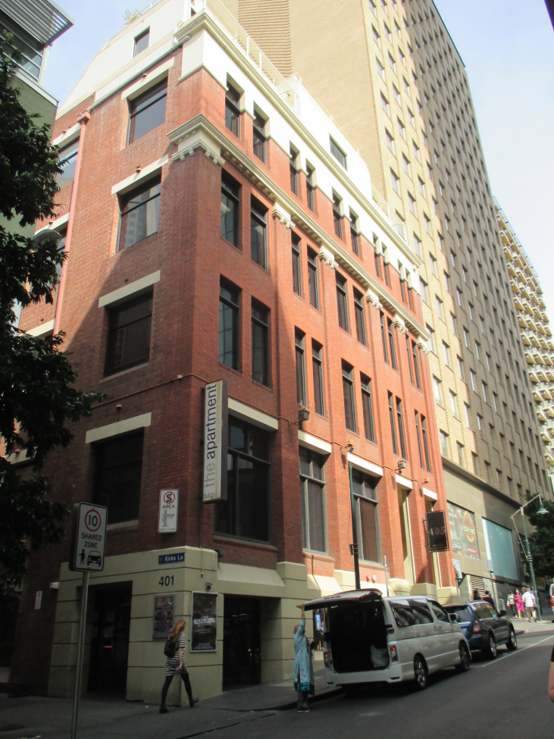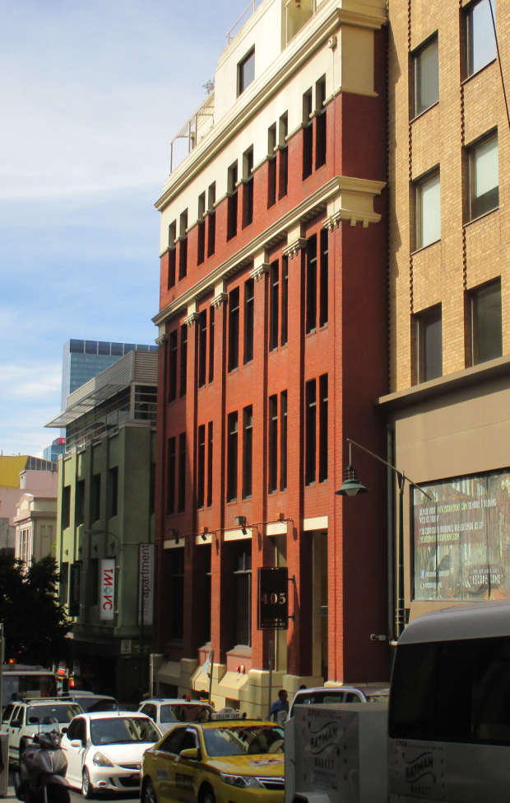

Statement of Significance

What is Significant
The former Day & Sons warehouse at 401-405 Little Bourke Street, was constructed in 1911 and extended in 1936. It is located on the south side of Little Bourke Street, with the east elevation to Kirks Lane. The face brick building has a rectilinear plan, and is of four storeys with a semi-basement, and rooftop elements at a small setback. It presents an asymmetrical façade to Little Bourke Street reflecting the different structural arrangements of the two building components.
Consistent with commercial design of the period, the building is expressed as a tripartite arrangement, broadly modelled on fifteenth or sixteenth century palazzi with unornamented intermediate floors about a heavy base floor and below an overhanging cornice or ‘capital’ level. In Australia, buildings of this form are occasionally described as Commercial Palazzi, however the subject building is devoid of classical detailing and references to buildings of the Italian Renaissance largely derive from its tripartite form rather than its ornamentation.
The semi-basement level is rendered in a rusticated manner to produce a heavy base to the composition. Brick pilasters, broadly recalling classical columns rise to abstracted, dentilated capitals. The upper level sits over a rendered string course and is capped by an ornamental parapet. The cornice, parapet (and a section of the facade below the parapet) are rendered, providing the upper level with a contrast to the brick intermediate floors below, and giving emphasis to the building’s crown. Rooftop elements appear to date from the 1936 works (they are visible in 1940) but do not affect the façade composition. The eastern elevation is without ornament, presenting simple, punched window openings to the laneway. Original steel framed windows to this elevation have been replaced.
The current entry arrangement on the western side of the north façade appears to date from c.1980s, albeit the altered arrangements continue to utilise existing openings and the works have not affected the rhythm of the original fenestration. External rendered elements have been overpainted and timber windows to the façade have been altered,. The external expression of the façade otherwise survives with face brickwork and rendered detailing intact.

How is it Significant
The warehouse at 401-405 Little Bourke Street, is of historical and aesthetic/architectural significance to the City of Melbourne.

Why is it Significant
The warehouse at 401-405 Little Bourke Street, constructed in 1911 for saddlery merchants and ironmongers, William Day and Sons, with significant modifications undertaken in 1936, is of local historical significance. The building is significant for its historical association with the commercial horse-related products and services businesses which were concentrated in this area of the central city. The businesses were in historical proximity to the renowned horse bazaars, including the long running Kirk’s Bazaar, after which the adjoining lane is named. Day and Sons were one of a number of like-minded businesses in the area, which flourished from the nineteenth century, although unusually the company continued to operate from at least part of the building into the 1970s. The warehouse is also of aesthetic/architectural significance. While the original 1911 building was extended and modified in 1936, the works were relatively early in the history of the building, and undertaken by Day and Sons. The works were well resolved architecturally and in execution, with regard to the building’s form and understated stripped classical expression. The building balances a classical sense of composition with the use of limited and particularly stylised classical detailing. The face brickwork of the building also stands out in the Little Bourke Street context. Buildings of this type additionally demonstrate an affinity with the emergent Modern School while continuing to offer the familiarity of classically-based architecture.

