Planning and Environment Act 1987

Melbourne PLANNING SCHEME

AMENDMENT C320

EXPLANATORY REPORT

Who is the planning authority?
This amendment has been prepared by the Melbourne City Council which is the planning authority for this amendment.

Land affected by the Amendment
The Amendment applies to 154-160 Leicester Street, Carlton (Former Carlton Inn, also known as the Corkman Irish Pub).
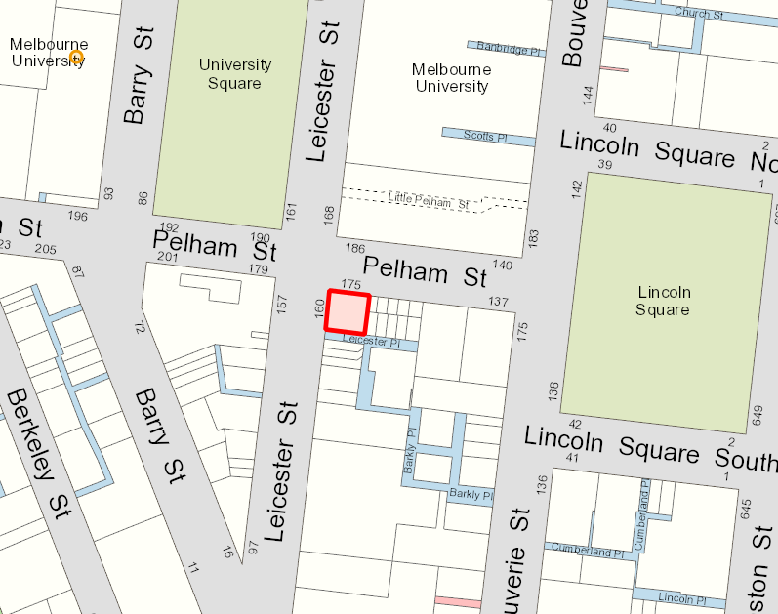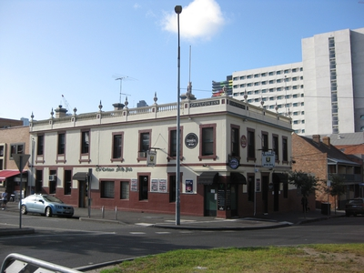

What the amendment does

The Amendment proposes the following changes to the Melbourne Planning Scheme:

Deletes the interim Design and Development Overlay 68 (DDO68 – 160 Leicester Place, Carlton); and

Amends the existing Design and Development Overlay Schedule (DDO61 – City North) to introduce permanent built form controls including requiring the reconstruction of the significant heritage building at 154-160 Leicester Place, Carlton.

Strategic assessment of the Amendment

Why is the Amendment required?
This Amendment is required to introduce appropriate permanent built form controls for the site. This will ensure the significant heritage building is reconstructed so that its heritage significance can be recognised and protected and will ensure a good long term planning outcome is achieved.
The Carlton Inn was a two storey rendered brick hotel constructed in the mid 1880’s. The property is covered by Heritage Overlay (HO85 – Carlton Inn 154-160 Leicester Street, Carlton).
On 15-16 October 2016 the building was demolished without planning approval.
On 27 October 2016 the Minister for Planning introduced interim planning controls over the site via Melbourne Planning Scheme Amendment C299. The amendment applied a new Schedule 68 to the Design and Development Overlay (DDO68 - 160 Leicester Place, Carlton) to the land, which introduced interim built form controls requiring the reconstruction of the significant heritage building.
DDO68 (160 Leicester Place, Carlton) is set to expire and will cease to have effect on 31 October 2018.

How does the Amendment implement the objectives of planning in Victoria?
Under section 4(1) of the Planning and Environment Act 1987, the proposed amendment will implement the following objectives of planning in Victoria:
(a) to provide for the fair, orderly, economic and sustainable use, and development of land;
(c) to secure a pleasant, efficient and safe working, living and recreational environment for all Victorians and visitors to Victoria;
(d) to conserve and enhance those buildings, areas or other places which are of scientific, aesthetic, architectural or historical interest, or otherwise of special cultural value;
(f) to facilitate development in accordance with the objectives set out in paragraphs (a), (b), (c), (d) and (e);
(g) to balance the present and future interests of all Victorians.

How does the Amendment address any environmental, social and economic effects?
The changes proposed by this amendment are not relevant to environmental effects.
The changes proposed by this amendment seek to address social and economic effects to achieve a net community benefit.
Due to the heritage significance of the former building and the illegal demolition which occurred in October 2016, reconstruction of the former building will ensure significant historic, architectural, aesthetic, social and cultural values are upheld with regard to the site. This will be to the benefit of the site, the immediate and local area and to the people of Victoria.
The amendment will contribute to an understanding of Melbourne’s local history, particularly social, architectural and economic history.

Does the Amendment address relevant bushfire risk?
The amendment affects land within inner metropolitan Melbourne which is not a bushfire prone area.

Does the Amendment comply with the requirements of any Minister’s Direction applicable to the amendment?
The amendment is consistent with the Ministerial Direction on the Form and Content of Planning Schemes under Section 7(5) of the Planning and Environment Act 1987 and Ministerial Direction No.11 Strategic Assessment of Amendments.
The Amendment complies with Direction No. 9 Metropolitan Planning Strategy and specifically supports Direction No.4, Policy 4.4 - “Respect Melbourne’s heritage as we build for the future”.

How does the Amendment support or implement the State Planning Policy Framework and any adopted State policy?
The Amendment supports the following objectives of the State Planning Policy Framework:
Clause 11.06-4 (Place and identity)
- To create a distinctive and liveable city with quality design and amenity.
Clause 15 (Built Environment and Heritage):
- To create urban environments that are safe, functional and provide good quality environments with a sense of place and cultural identity.
- To achieve architectural and urban design outcomes that contribute positively to local urban character and enhance the public realm while minimising detrimental impact on neighbouring properties.
- To recognise and protect cultural identity, neighbourhood character and sense of place.
- To ensure the conservation of places of heritage significance.

How does the Amendment support or implement the Local Planning Policy Framework, and specifically the Municipal Strategic Statement?
The Amendment supports and implements the MSS which includes the following:
- Clause 21.03 which states, among other things:
Protecting existing built form character and heritage, in addition to providing an attractive and liveable built environment in parts of the City where development will intensify is essential. Also important is minimizing the ecological footprint of the City and managing the City so that it is responsive to climate change.
- Clause 21.04–1.2 which states, among other things:
City North is identified for proposed renewal given its existing role as a specialised activity centre, the proposed Parkville Station as part of the Melbourne Metro project and its proximity as an extension of the Central City. The City North Structure Plan 2012 has been adopted by the City of Melbourne and has been implemented into the planning scheme via a planning scheme amendment.
- Clause 21.06 which states, among other things:
Melbourne’s character is defined by its distinctive urban structure, historic street pattern, boulevards and parks, heritage precincts, and individually significant heritage buildings. Heritage buildings, precincts and streetscapes are a large part of Melbourne’s attraction and the conservation of identified heritage places from the impact of development is crucial.
The buildings in the private realm should be coordinated with the development of the streets, paths, parks and places in the public realm. Development must add positively to Melbourne’s public realm and contribute to making it safe and engaging for users.

Does the Amendment make proper use of the Victoria Planning Provisions?
The Amendment makes proper use of the Victoria Planning Provisions. The Schedule to the Design and Development Overlay is the proper Victorian Planning Provision tool for the introduction of built form controls.
The Amendment also addresses the requirements of the following Planning Practice Notes:
PPN10: Writing Schedules
PPN23: Applying the Incorporated Plan and Development Plan Overlays
PPN59: The Role of Mandatory Provisions in Planning Schemes

How does the Amendment address the views of any relevant agency?
The views of any relevant agencies have not been sought. Council will engage with relevant agencies, affected property owners and relevant principal community groups during the public exhibition phase of the Amendment.

Does the Amendment address relevant requirements of the Transport Integration Act 2010?
This planning scheme amendment is not likely to have a significant impact on the transport system as defined by Section 3 of the Transport Integration Act 2010.

Resource and administrative costs

What impact will the new planning provisions have on the resource and administrative costs of the responsible authority?
It is not expected that the amendment will give rise to any unreasonable resource or administrative costs for the responsible authority. The amendment will provide the appropriate planning framework for the responsible authority to efficiently plan for this site.

Where you may inspect this Amendment
The amendment can be viewed on the City of Melbourne’s Participate Website at:
https://participate.melbourne.vic.gov.au/amendmentc320
The Amendment is available for public inspection, free of charge, during office hours at the following places:
City of Melbourne
Council House 2, Planning and Building Reception Counter
Level 3, 240 Little Collins Street
MELBOURNE VIC 3000
The Amendment can also be inspected free of charge at the Department of Environment, Land, Water and Planning website at www.delwp.vic.gov.au/public-inspection.

Submissions
Any person who may be affected by the Amendment may make a submission to the planning authority. Submissions about the Amendment [and/or planning permit] must be received by 5pm on Friday 27 April 2018.
A submission must be sent to: planningpolicy@melbourne.vic.gov.au
Or
Team leader – Planning Policy
City of Melbourne
PO Box 1603
MELBOURNE VIC 3001

Panel hearing dates
In accordance with clause 4(2) of Ministerial Direction No.15 the following panel hearing dates have been set for this amendment:
- directions hearing: the week commencing 25 June 2018.
- panel hearing: the week commencing 30 July 2018.

