Transport Strategy Refresh
City Space Discussion Paper

This discussion paper is to inform a new City of Melbourne Transport Strategy to 2050. A draft strategy will be released for consultation in 2018. We are seeking your views on these issues and ideas.
Melbourne is renowned for its high quality public places, spaces and streets. The way that people use, interact with and experience our streets and spaces is linked to the city’s reputation as a desirable place to live, work and visit.
A key principle of the Transport Integration Act 2010 relates to enhancing the transport system from a user perspective. The city’s streets and spaces form a critical component of people’s transport journeys and poor experiences affect their perceptions of the city and of the transport system.
The City of Melbourne plays an important role in the allocation, design, management and use of public space in the city. Given the pressure of population and job growth, a faster and bolder approach to the reallocation of city space will be required over the next 30 years.
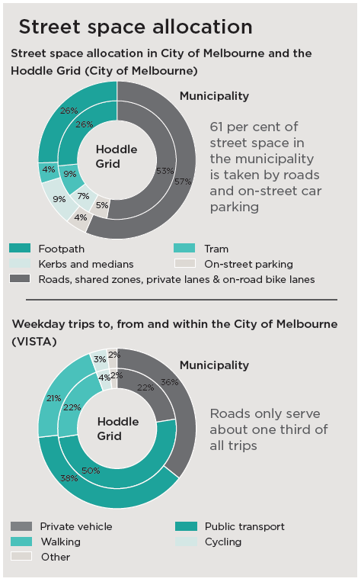
What are the current issues?
Space for people
Space in the city is limited and under increasing pressure. A disproportionate amount of space is allocated for private vehicles in the central city, relative to the transport role these vehicles serve. Residential, worker and visitor populations in the central city continue to grow and are placing increasing pressure on public space. Pedestrian overcrowding leads to poor experiences of our city and particularly affects more vulnerable users. Negotiating crowds in a wheelchair or with a pram can be especially difficult.

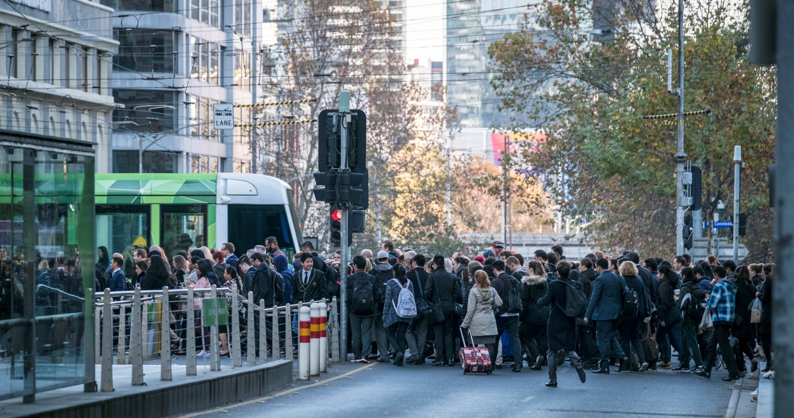
Pedestrians squeeze across Collins Street pedestrian crossing
Competing demands
There is frequent conflict between the different functions of our footpath space (movement functions such as walking and place functions such as cafe seating). Different users of footpath space may also come into conflict, as their needs and desires vary (for example residents, tourists, parents with prams, people with disabilities). Road space is also contested between different modes including private motor vehicles, delivery trucks, trams, buses, cyclists, motorbikes and pedestrians.
Prioritising the allocation of city space
Space in the city is limited and we can’t create more space to separate modes everywhere. Traditionally the approach to allocating transport space has been fragmented, with a focus on the individual modes of transport rather than an integrated approach which maximises access and mobility for people.

Most of the street space in the city is allocated to private vehicles, yet cars are the most inefficient way to transport the large numbers of people present in busy city centres. Efficient modes need to be prioritised to enable the creation of high quality city streets and places for people to enjoy the city. The economic contribution of different uses must be considered to increase street level productivity.
What are other cities doing?
Cities around the world are facing challenges similar to Melbourne. These global best practice ideas can help to inform the right approach for Melbourne.
Car-free Oslo
- Oslo has the fastest rate of population growth in Europe and this has been identified as the biggest threat to quality of life in the city.
- To mitigate this pressure, the city plans to make its central area car-free by 2019.
- Access for important motor vehicles such as emergency vehicles critical to the function of the city will be maintained as well as for deliveries, people with disabilities and taxis.
- Access to and within the central area will be primarily by walking, cycling and public transport.

New car-free areas would help to maintain the amenity and liveability of the central city
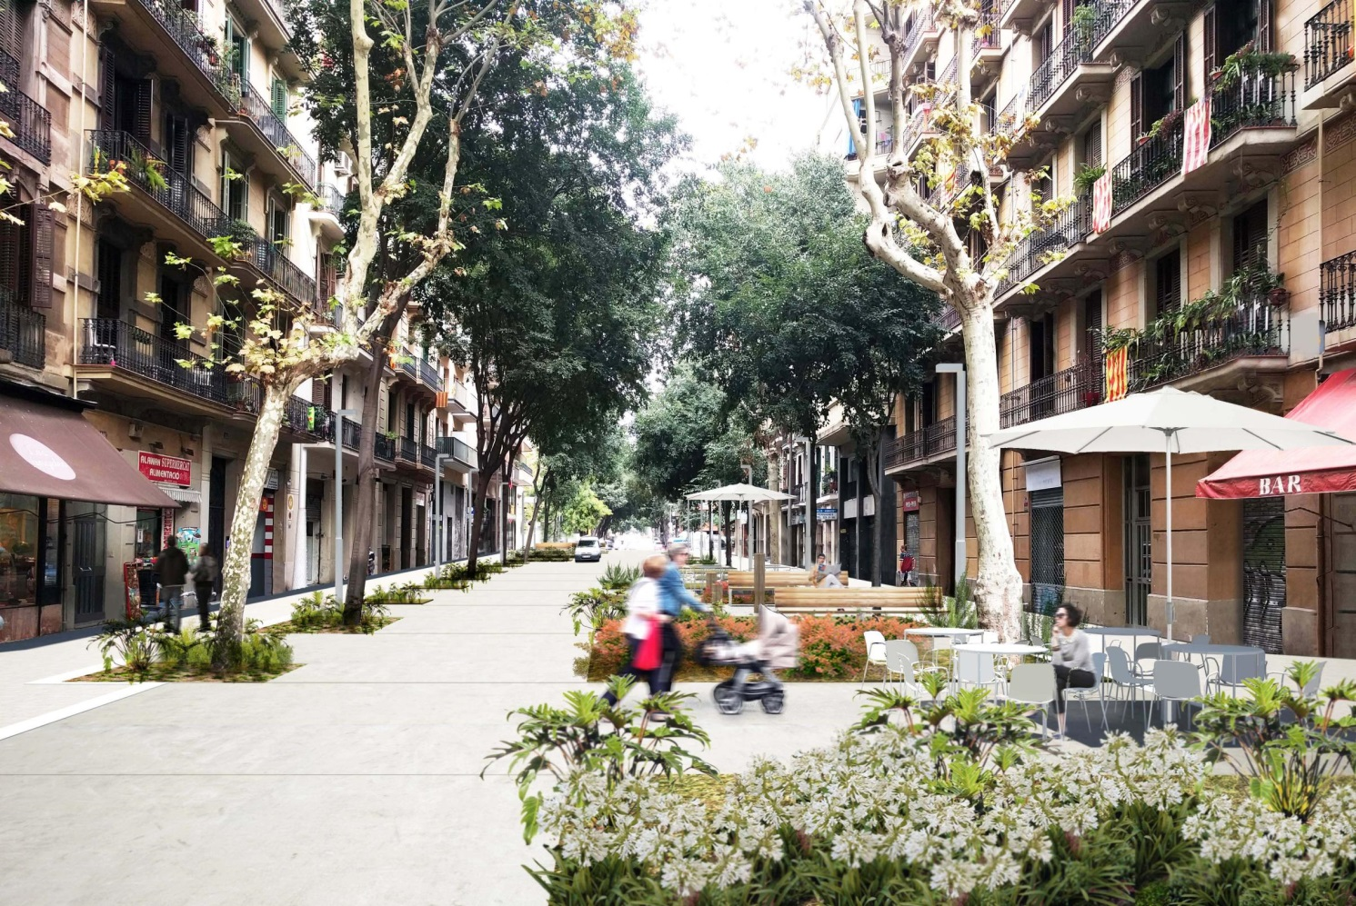
Street treatments in Barcelona create more space for people
Barcelona Superblocks
- Barcelona has a uniform street grid similar to Melbourne’s Hoddle Grid. The city has recently introduced the concept of ‘Superblocks’ where streets which form a 3 x 3 group of nine city blocks are being redesigned to prioritise people over cars.
- The streets within each Superblock are transformed to shared spaces and prioritised for walking, cycling, residents’ cars and deliveries. The streets which form the perimeter of each Superblock are designated for cars and public transport.
- Speed limits are reduced to 10 km/h to create people-friendly environments where children can play freely.
- In the areas where previously almost 75 per cent of all space was allocated for cars, 75 per cent is now given to pedestrians.

‘Superblocks’ could be applied in Melbourne to make streets in the central city safer, greener, more inclusive and more vibrant.

What should be done to address these issues in Melbourne?
Declutter pedestrian spaces
Remove unnecessary objects from the footpath to improve pedestrian conditions, particularly for those with a disability and parents with prams. This includes considering how bicycle and motorcycle parking is accommodated, and where objects such as street furniture are positioned.
Reallocate inefficient transport space to more productive uses
Remove on-street parking and traffic lanes for more economically, socially and environmentally productive uses. Build wider footpaths to accommodate pedestrian movements and activities such as outdoor dining, street trading, seating and spaces for civic activities, tree planting and rain water management.
Create more shared spaces
Designate new areas to be shared by different modes of transport. In the short term this involves classification of identified streets as ‘shared zones’. Medium term design changes to streets into ‘shared spaces’ could include level surfaces from building to building to change behaviour on the street. Long-term, precinct wide changes similar to a ‘superblocks’ model transform our streets.
Improve our understanding of ‘user experience’ in the city
Regular user experience research helps to understand how different people experience the transport system and better inform policy and the design of spaces. Transport services need to be user centred in their design, rather than simply complying with minimum service standards. An example includes the management of traffic lights, where people with mobility impairments need to be provided more time to cross safely and comfortably.
What if?
- We removed clutter from footpaths to improve disability access and public safety.
- We removed on-street parking spaces and built wider footpaths for pedestrians and provided more space for outdoor dining, street life and more trees.
- We applied the Barcelona ‘Superblocks’ model to sections of the Hoddle grid, with 10km/h shared spaces for walking, cycling, deliveries and residential access on Flinders Lane and Little Collins Street.

We want your thoughts!

participate.melbourne.vic.gov.au/transportstrategy
Phone: 9658 9658
Email: transport@melbourne.vic.gov.au

