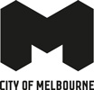
Transport Strategy Refresh
City Growth and the Transport Challenge

Introduction
Melbourne is vital to the prosperity and liveability of all Victorians and Australians. It is the location of Victoria’s most important economic and cultural infrastructure. As the centre of the state’s transport system, the central city is the most accessible location for all Victorians.

Our achievements
Over the last 30 years, the City of Melbourne has improved the quality of our streets creating vibrant, productive, inclusive and enjoyable places. Our streets are critical to the city’s liveability, environmental sustainability, economic prosperity and international reputation. We have created more places for walking, shopping, sitting, connections for business and dining by repurposing excess road space.
These improvements to our city have not happened by accident - the City of Melbourne has taken a number of deliberate actions to enhance the quality of our streets, including:
- Introducing a consistent design palette of high quality bluestone paving, street furniture and landscape in our pedestrian spaces
- Activating our laneways and building frontages via the introduction of exemplary policies, transforming our city into a wonderful place to live, work, do business and visit.
- Prioritising walking as the number one mode of transport, supported by public transport and cycling. Improvements have seen these modes grow strongly while the importance of cars has declined.
Key strategies include Transport Strategy 2012, Walking Plan 2014, Places for People 2015 and Bicycle Plan 2016. This will continue to be our focus as we refresh the Transport Strategy in 2018.

A changing city
While much has been achieved, Melbourne is facing significant change over the next 30 years including substantial population growth. In the next three years the number of people in our municipality on an average weekday will exceed 1 million and is forecast to grow to approximately 1.4 million by 2036. By 2051, Greater Melbourne’s population is expected to grow by almost 80 per cent, from today’s 4.5 million to eight million people.
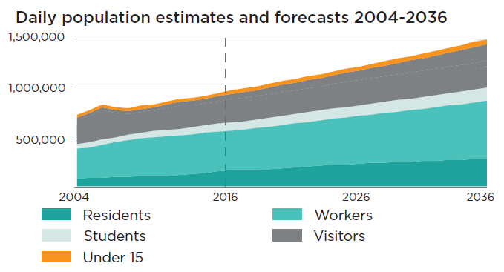
The city’s growing population presents unprecedented pressure on our public spaces, streets and transport system, including:
- Overcrowding of footpaths, particularly at major traffic intersections. People struggle to fit on the footpath in a number of places. This presents a major safety risk and negatively impacts the city’s liveability, reputation and economic prosperity. More time waiting at intersections means less time in shops, cafés and restaurants and doing business.
- Escalating pressure on our public transport system, which is already under strain. Whilst the Melbourne Metro project will play a critical role in unlocking capacity in the city’s rail system, the network will be overcrowded again shortly after its completion.
- Traffic congestion continues to increase in the inner city and middle ring neighbourhoods surrounding the central city.
- The city’s urban renewal areas are developing quickly and quality public transport connections have not yet been committed.
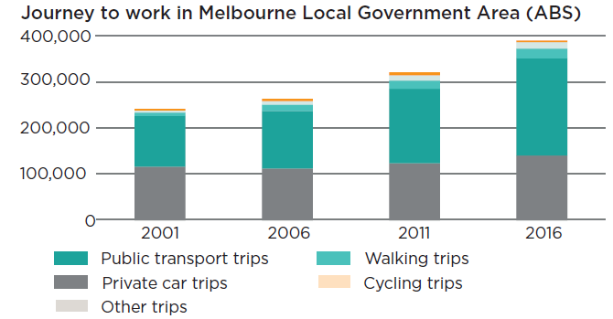

Emerging issues and new ideas
Other issues the Transport Strategy refresh will provide new insight into:
- Under-representation of bicycles in the city. Cycling to Melbourne grew strongly from 2008 but growth has since stalled.
- Low occupancy of some on-street car parks, excessive provision of off-street parking and competing demands for city space e.g. public spaces, trees, landscaping etc.
- The opportunities and challenges presented by emerging technologies including automated vehicles and drones.
- Responding to disruption from major infrastructure projects to ensure that when infrastructure is reinstated we take the opportunity to plan for future transport and public space needs.
- Adapting the transport system to increase resilience in response to climate change and reduce emissions.
- Ways to reduce the risk of attacks on pedestrians by hostile vehicles.
- Ensuring that our future streets remove barriers to inclusion so our city is comfortable, accessible and attractive for people of all abilities and ages.
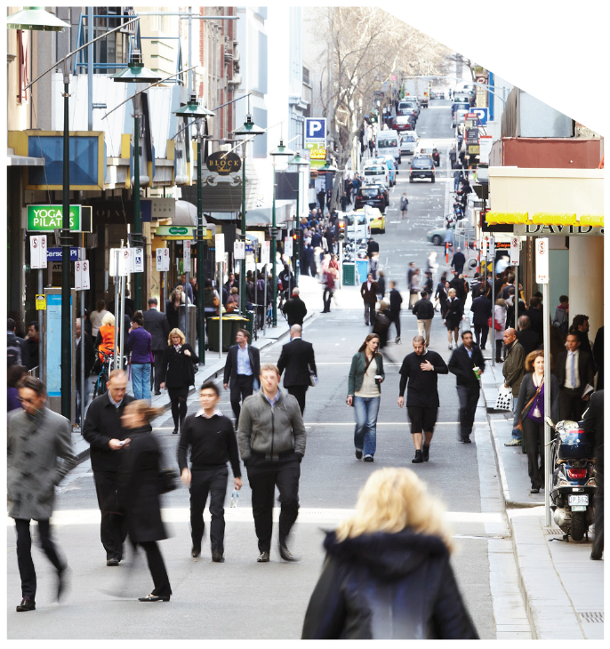

Where to from here?
Our city’s transport system is at a critical juncture. We face a once-in-a-generation opportunity to make bold decisions that will ensure our city is easy, safe and attractive to move around with almost twice as many people as we have today.
Based on what you told us in 2016 during the Future Melbourne consultation, we have commenced work to refresh the Transport Strategy. Now we need your input to explore the issues and ideas identified so far.

Transport Strategy refresh
The Transport Strategy seeks to respond to new challenges and changes being faced by the city over the next 30 years.

Discussion papers
A number of discussion papers have been prepared to start a conversation on the major topics we want to address in the Transport Strategy. These will be released over the coming months. Each paper outlines key issues the city is facing, considers what other cities are doing and presents policy options, opportunities or projects we could consider for Melbourne. The topics include:
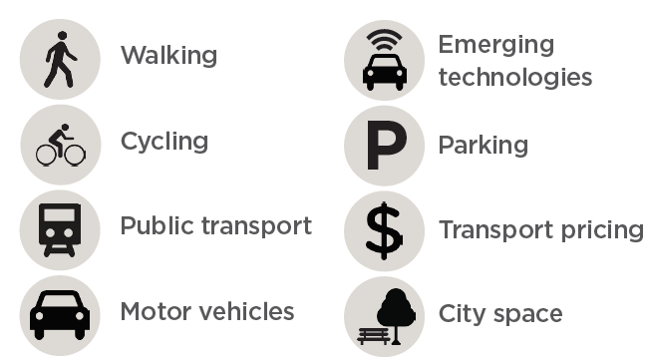
We want to know your views on these issues and ideas along with any other points we should consider. This research and your feedback will help to inform the draft Transport Strategy.

Draft Transport Strategy
Later this year we will publish a draft Transport Strategy. Further consultation with community and stakeholders will take place at that time and inform the Final Transport Strategy.

Final Transport Strategy
The new Transport Strategy will be a 10 year document with a 30 year vision which guides City of Melbourne decision making around transport, includes ambitious targets and aligns with council goals.
The new Transport Strategy will be delivered to council for endorsement in the new financial year.
To stay up-to-date and find out more head to Participate Melbourne.

We want your thoughts!
participate.melbourne.vic.gov.au/transportstrategy
Phone: 9658 9658
Email: transport@melbourne.vic.gov.au

