Planning and Environment Act 1987 Melbourne Planning Scheme
Amendment C323
Explanatory Report
Contents
Who is the planning authority? 3
Land affected by the Amendment 3
What the Amendment does 3
Strategic assessment of the amendment 4
Why is the amendment required? 4
How does the amendment implement the objectives of planning in Victoria? 4
How does the amendment address any environmental, social, and economic effects? 5
Does the amendment address relevant bushfire risk? 5
Does the amendment comply with the requirements of any Minister’s Direction applicable to the amendment? 5
Direction 1.1 – Create a city structure that strengthens Melbourne’s competitiveness for jobs and investment 5
Direction 4.2 – Build on Melbourne’s cultural leadership and sporting legacy 5
How does the amendment support or implement the State Planning Policy Framework and any adopted State policy? 6
Clause 11.02-1 Supply of urban land 6
Clause 11.06-1 Jobs and investment 6
Clause 11.06-4 Place and identity 6
Clause 15.01-1 Urban design 6
Clause 15.01-2 Urban design principles 6
Clause 17.01-1 Business 6
Clause 17.02-4 Innovation and Research 6
Clause 17.03-1 Facilitating tourism 7
Clause 17.03-2 Tourism in Metropolitan Melbourne 7
Clause 19.02-3 Cultural facilities 7
How does the amendment support or implement the Local Planning Policy Framework, and specifically the Municipal Strategic Statement? 7
Does the Amendment make proper use of the Victoria Planning Provisions? 8
How does the Amendment address the views of any relevant agency? 9
Does the Amendment address relevant requirements of the Transport Integration Act 2010? 9
Resource and administrative costs 9
Where you may inspect this Amendment 9
Submissions 9
Panel hearing dates 9

Who is the planning authority?
This amendment has been prepared by the Melbourne City Council, who is the planning authority for this amendment.
The amendment has been made at the request of Creative Victoria, part of the Department of Economic Development, Jobs, Transport and Resources.

Land affected by the Amendment
The amendment applies to land generally within the Melbourne Arts Centre Precinct in Southbank (‘the Arts Precinct’) as shown on the map below:
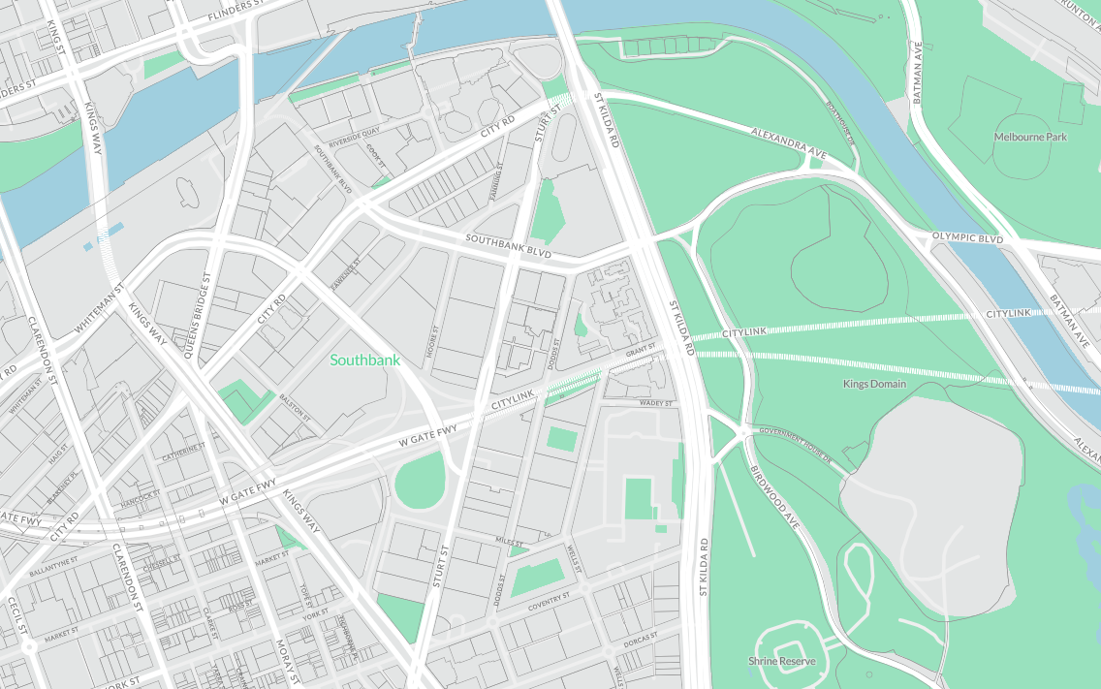
Figure 1 Land affected by the Amendment

What the Amendment does
The amendment proposes to introduce permanent planning controls for the Melbourne Arts Precinct in Southbank and make consequential changes to the Melbourne Planning Scheme.
Specifically, the amendment proposes to:
- Insert Schedule 7 to Clause 37.04 (Capital City Zone) on a permanent basis;
- Amend Clause 22.01 (Urban Design in the Capital City) to include reference to Schedule 7 to the Capital City Zone;
- Amend Schedule 1 to Clause 43.02 (Design and Development Overlay) to include reference to Schedule 7 to the Capital City Zone; and
- Delete Schedule 12 to the Parking Overlay and apply Schedule 1 to the Parking Overlay to land rezoned from General Residential Zone – Schedule 1 as part of Amendment C330 to the Melbourne Planning Scheme.

Strategic assessment of the amendment

Why is the amendment required?
A recent increase in residential and commercial development within the Arts Precinct has signalled the need for revised the planning controls to promote uses which support the role of the Arts Precinct which is of State significance.
The Melbourne Planning Scheme identifies the primary importance of the Arts Precinct as an arts and cultural spine which contributes to Melbourne’s role as a national and international leader in creative endeavours. Melbourne City Council prepared the Southbank Structure Plan in 2010 which examined key challenges in the delivery of this vision for the Arts Precinct. It recommended that the land use zoning be modified to provide a coherent planning framework for the Arts Precinct.
On 7 March 2018, Melbourne Planning Scheme Amendment C330 introduced interim planning controls for the Arts Precinct and rezoned land from Capital City Zone – Schedule 3 and General Residential Zone – Schedule 1 to the Capital City Zone – Schedule 7 to ensure that creative industry outcomes and complementary uses could be immediately considered in decision making. The interim controls will expire on 31 March 2019.
The permanent controls are required to safeguard the Arts Precinct and to ensure that it continues to foster art, cultural and creative outcomes. Specifically, Schedule 7 to the Capital City Zone proposes:
- A purpose that maintains and enhances the Melbourne Arts Precinct as a significant arts and cultural precinct.
- A mix of ‘as of right’ and ‘permissible’ uses which are specifically tailored to the future needs of the Melbourne Arts Precinct and seek to encourage the provision of arts and creative industry uses within the first four storeys of buildings, together with the provision of active street frontages and integration with the public realm.
- Application requirements and decision guidelines in respect of the use of land which further the purposes of the zone.
The amendment will implement key recommendations of the Southbank Structure Plan 2010 and is consistent with key directives of the Metropolitan Planning Strategy, Plan Melbourne 2010-2050. It is also supported by Victoria’s first creative industries strategy, Creative State 2016-2020, which seeks to put Victoria’s creative industries at the forefront of the State’s future growth, prosperity and liveability.
The consequential changes to Clause 22.01 (Urban Design in the Capital City) and Schedule 1 to Clause 43.02 (Design and Development Overlay) are required to ensure the continued application of the urban design policy contained in Clause 22.01 and the active street frontage requirements contained in Schedule 1 to Clause 43.02.
The application of Schedule 1 to the Parking Overlay is required to ensure that the correct car parking requirements are applied to land within the Capital City Zone. The current Schedule 12 to the Parking Overlay is only applicable to land located within a residential zone.

How does the amendment implement the objectives of planning in Victoria?
The amendment implements the objectives in section 4 of the Planning and Environment Act 1987 (the Act), in particular:
(a) to provide for the fair, orderly, economic and sustainable use, and development of land;
(b) to secure a pleasant, efficient and safe working, living and recreational environment; and
(d) to conserve and enhance those buildings, areas or other places which are of scientific, aesthetic, architectural or historical interest, or otherwise of special cultural value;
(g) to balance the present and future interests of all Victorians.
The amendment facilitates the delivery of creative industries and will provide for increased cultural and creative activity in the Arts Precinct. This initiative has economic and cultural benefits for the local area and the State.

How does the amendment address any environmental, social, and economic effects?
The amendment will have positive economic and social effects by providing for the equitable use and development of land in the Arts Precinct. The amendment also facilitates development which would allow for a greater diversity of uses in the Arts Precinct consistent with the outcomes sought in the Southbank Structure Plan 2010.
The amendment will not have any significant impacts on the environment.

Does the amendment address relevant bushfire risk?
The land affected by the amendment is not located within an area of identified bushfire risk.

Does the amendment comply with the requirements of any Minister’s Direction applicable to the amendment?
The amendment is consistent with the Ministerial Direction on the Form and Content of Planning Schemes under section 7(5) of the Act and Ministerial Direction 11: Strategic Assessment Guidelines under Section 12(2) of the Act
The amendment has also been prepared with regard to Ministerial Direction 9: Metropolitan Planning Strategy, which refers to Plan Melbourne 2017-2050.
Plan Melbourne 2017-2050 identifies a vision for the future of Melbourne and objectives and outcomes sought for the city, with directions identified to achieve the desired outcomes and objectives. Providing opportunities to establish and expand creative industries in the Melbourne Arts Precinct is consistent with Plan Melbourne 2017-2050.
The amendment is consistent with the following Directions in Plan Melbourne 2017-2050:

Direction 1.1 – Create a city structure that strengthens Melbourne’s competitiveness for jobs and investment
This Direction promotes a whole-of-government approach to planning for the central city.
Action 2 of the Plan Melbourne 2017-2050 Implementation Plan is to:
- Identify opportunities to establish and expand creative industries, small businesses and tourism; and
- Identify opportunities to improve the public realm, open space, social, cultural and recreational facilities that support the central city’s economic functions.

Direction 4.2 – Build on Melbourne’s cultural leadership and sporting legacy
Policy 4.2.2 seeks to support the growth and development of Melbourne’s cultural precincts and creative industries. It provides that:
The city’s dynamic arts culture will be supported and facilitated – ensuring spaces and facilities are created that encourage cultural innovation and new forms of artistic expression throughout the metropolitan area. This policy will help Victoria’s cultural precincts and creative industries remain sustainable and attract investment, reinforcing Melbourne’s multicultural diversity through a commitment to cultural events and programs and associated infrastructure and creative business opportunities.
Action 64 in the Plan Melbourne 2017 – 2050 Implementation Plan is to:
- Identify opportunities for emerging creative industries to access affordable spaces to pursue cultural production and expression by removing regulatory barriers, and brokering and facilitating cultural development programs.
According to the Plan Melbourne 2017 – 2050 Implementation Plan, DEDJTR is the lead agency in consultation with the City of Melbourne for these actions in the medium term. The amendment represents direct action by DEDJTR to fulfil these objectives and actions of the Metropolitan Planning Strategy.

How does the amendment support or implement the State Planning Policy Framework and any adopted State policy?
The amendment supports and implements State Planning Policy Framework in responding to the following clauses:

Clause 11.02-1 Supply of urban land
To ensure a sufficient supply of land is available for residential, commercial, retail, industrial, recreational, institutional and other community uses.

Clause 11.06-1 Jobs and investment
To create a city structure that drives productivity, attracts investment, supports innovation and creates jobs.

Clause 11.06-4 Place and identity
To create a distinctive and liveable city with quality design and amenity.

Clause 15.01-1 Urban design
To create urban environments that are safe, functional and provide good quality environments with a sense of place and cultural identity.

Clause 15.01-2 Urban design principles
To achieve architectural and urban design outcomes that contribute positively to local urban character and enhance the public realm while minimising detrimental impact on neighbouring properties.

Clause 17.01-1 Business
To encourage development which meet the communities’ needs for retail, entertainment, office and other commercial services and provides net community benefit in relation to accessibility, efficient infrastructure use and the aggregation and sustainability of commercial facilities.

Clause 17.02-4 Innovation and Research
To create opportunities for innovation and the knowledge economy within existing and emerging industries, research and education.

Clause 17.03-1 Facilitating tourism
To encourage tourism development to maximise the employment and long-term economic, social and cultural benefits of developing the State as a competitive domestic and international tourist destination.

Clause 17.03-2 Tourism in Metropolitan Melbourne
To maintain and develop Metropolitan Melbourne as a desirable tourist destination.

Clause 19.02-3 Cultural facilities
To develop a strong cultural environment and increase access to arts, recreation and other cultural facilities’.

How does the amendment support or implement the Local Planning Policy Framework, and specifically the Municipal Strategic Statement?
The Municipal Strategic Statement acknowledges that the central city has a highly diverse economic base, with strengths in health and medical research, education, retail, creative industries, tourism and port-related activities. The Arts Precinct is a core component of the central city.
The amendment is consistent with and facilitates the following clauses of the Local Planning Policy Framework:
Clause 21.02-4 Creative City, which recognises Melbourne is a national and international leader in creative endeavours and specifically acknowledges the premier cultural institutions along the Sturt Street spine.
Clause 21.03 Vision, which notes that the City of Melbourne makes an important contribution to the economic prosperity of the state through the provision of its local, corporate and global businesses, its strong retail, major cultural, sporting and tourism industry, and its significant industrial uses.
Clause 21.04-1.2 Urban renewal areas, which recognises Southbank as home to the State’s major arts facilities as part of its internationally recognised Melbourne Arts Precinct and other major activity areas.
Clause 21.06-1 Urban design
To improve public realm permeability, legibility, and flexibility.
Strategy 6.2 Ensure the design of buildings and public spaces enhances the public realm and the pedestrian environment.
Strategy 6.3 Ensure that new developments in the Capital City, Docklands, Business and Mixed Use zoned areas provide active street frontages and minimise pedestrian disruption from car access.
Clause 21.08-2 Business
To encourage employment opportunities for local residents.
Strategy 2.1 Encourage a diversity of small to medium enterprises in the Capital City, Docklands, Commercial and Mixed Use Zones.
Strategy 2.2 Support the development of home based businesses, consistent with maintaining amenity in Residential and Mixed Use Zones.
Clause 21.10-6 Cultural / Arts and Entertainment Facilities
Objective 1 To provide a diverse range of leisure, arts, cultural and entertainment facilities.
Strategy 1.2 Support quality public institutions, including art galleries, libraries and museums, throughout the municipality, where consistent with the local amenity.
Strategy 1.3 Support entertainment, music and cultural attractions in Commercial and Mixed Use Zones, where consistent with the local amenity.
Objective 2 Enhance the City as Victoria’s pre-eminent cultural and entertainment location.
Strategy 2.1 Support and encourage the growth of a vibrant cultural environment in the Hoddle Grid, Southbank and Docklands, by supporting entertainment uses, music and the arts.
Clause 21.13-1 Urban Renewal Areas - Southbank
Built Environment and Heritage
- Ensure all new development creates a high quality pedestrian environment and positively enhances the area’s public realm.
- Encourage a mix of public and commercial uses at ground level in new developments to support street life and provide pedestrian interest.
Transport
- Improve the public environment of Southbank by providing public spaces, improving pedestrian facilities and upgrading streetscapes.
- Improve streetscapes as a priority along major pedestrian routes.
- Encourage a continuous network of through block links to increase permeability, amenity and safety and to improve access to the Yarra River and Arts Precinct.
- Give greater priority to pedestrian, cyclist and public transport amenity and access ahead of private motor vehicle use.
- Create a connected and permeable neighbourhood.
Infrastructure
- Support arts and education uses and facilities at Southbank.
- Support arts, entertainment, cultural, educational attractions in Southbank, especially in the Arts Precinct.
The amendment also supports the vision for Southbank included in the Southbank Structure Plan 2010, which seeks to create ‘an inclusive, diverse and resilient place that exemplifies the ecological, community and commercial prosperity of a sustainable urban district, while enhancing its presence as a world class cultural and arts precinct in the heart of Melbourne’s parkland and riverfront’.
The Structure Plan identifies that the current fragmented zoning as a key challenge to the delivery of this vision and makes recommendations to ensure that Sturt Street provides for broader spectrum of creative industry activity that complements the existing regional arts facilities and reinforces Southbank as the arts and cultural centre of Victoria.

Does the Amendment make proper use of the Victoria Planning Provisions?
The amendment makes proper use of the Victoria Planning Provisions (VPP). The Capital City Zone is considered appropriate to achieve the intended future land use and development outcomes for the central city and specifically for the Melbourne Arts Precinct. The application of Schedule 7 to the Capital City Zone will allow a mix of uses, including creative uses, and provide for development which maximises pedestrian access, active street frontages and integration with the public realm.

How does the Amendment address the views of any relevant agency?
The views of relevant agencies will be sought during the public exhibition of the amendment.

Does the Amendment address relevant requirements of the Transport Integration Act 2010?
The amendment will not have any direct impact on the transport system.

Resource and administrative costs
- What impact will the new planning provisions have on the resource and administrative costs of the responsible authority?
The amendment is unlikely to have an adverse impact on resource and administrative costs to the responsible authority.

Where you may inspect this Amendment
The amendment is available for public inspection, free of charge, during office hours at the following places:
Melbourne City Council
Level 3, 240 Little Collins Street
MELBOURNE VIC 3000
The amendment can also be inspected free of charge at the Department of Environment, Land, Water and Planning website .

Submissions
Any person who may be affected by the amendment may make a submission to the planning authority. Submissions about the amendment must be received by Monday 21 May 2018.
A submission must be sent to: Robyn Hellman, Coordinator Planning Policy, City of Melbourne, PO BOX 1603, MELBOURNE VIC 3001.

Panel hearing dates
In accordance with clause 4(2) of Ministerial Direction No.15 the following panel hearing dates have been set for this amendment:
- directions hearing: Monday 5 September 2018
- panel hearing: Monday 15 October 2018

http://www.planning.vic.gov.au/public-inspection.

