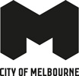
Transport Strategy Refresh
Background paper: City Space
April 2018

Author
This paper was prepared by UB-LAB on behalf of the City of Melbourne. UB-LAB is an urban design research practice focused on the relationship between people and the built environment. The paper was written by Jonathan Daly; founder and managing director of UB-LAB. Jonathan is an urbanist and environmental psychologist. He has more than 18 years of experience working in the fields of architecture, urban design and transportation across Europe, North America and Australasia.

Contributions from the following organisations are gratefully acknowledged, who attended a workshop at Melbourne Town Hall on 22 November 2018:

- Victoria Walks
- Bicycle Network Victoria
- Transport for Victoria
- Motorcycle Riders Association of Victoria
- Victorian Motorcycle Council
- RACV
- MRCagney
- COTA Victoria
- Council to Homeless Persons
- Women’s Health Victoria
- XYX Lab
- Victoria Police
- Metropolitan Fire Brigade
- University of Melbourne
- City of Melbourne staff

Additionally, thanks to the participants who contributed their time and knowledge of the city during the walking interviews undertaken to inform this paper.
Contents

1 Introduction 1
1.1 Background 1
1.2 How this Paper was Prepared 1
1.3 How this Paper is Structured 2
2 Allocating City Space in the Hoddle Grid 3
2.1 How Space is Currently Allocated 3
2.2 The Growing Pressure on City Space 7
2.3 Key Issues in Allocating City Space 20
3 How Other Global Cities are Reallocating Space 31
3.1 At the City Level 31
3.2 At the Block Level 33
3.3 At the Street Level 37
4 How Other Global Cities are Thinking About the Future 40
4.1 The Future of City Precincts 40
4.2 The Future of City Streets 41
4.3 The Future of City Parking 44
5 How City Space Could Be Reallocated in the Hoddle Grid 47
5.1 Strategy 1: More Inclusive Use of Space 47
5.2 Strategy 2: More Efficient Use of Space 48
5.3 Strategy 3: More Intelligent Use of Space 49
6 Have Your Say 51
References 52

List of Figures
Figure 1: General allocation of space in the Hoddle Grid by mode 4
Figure 2: Breakdown of the allocation of street space in the LGA and CBD 5
Figure 3: Transport trips within the Hoddle Grid by mode 6
Figure 4: Concentration of job growth in the City of Melbourne 8
Figure 5: Overcrowding at tram stops in the Hoddle Grid 9
Figure 6: Person with mobility impairment crossing Swanston Street between Federation Square and Flinders Street Station 10
Figure 7: Mapping the female experience of the city – results from the ‘Free To Be’ project 11
Figure 8: Estimated number of people in Australia with dementia (2005 – 2050) 12
Figure 9: Construction impacts on streets in the CBD 13
Figure 10: Construction works for the Metro Tunnel at City Square in the CBD 14
Figure 11: Emerging technologies in the Hoddle Grid 15
Figure 12: Concrete bollards installed across Hoddle Grid to prevent hostile vehicle attacks (photo taken at the corner of Flinders Street and Swanston Street, outside Flinders Street Station) 17
Figure 13: Wider benefits of urban trees 18
Figure 14: Urban greening project by the City of Melbourne (Godfrey Street in the CBD) 20
Figure 15: The 24-hour rhythms of the City of Melbourne 21
Figure 16: Conditions at the tram stop on Swanston Street, adjacent to Flinders Station 22
Figure 17: Overcrowding on footpaths outside Parliament Station (on Lonsdale Street) 23
Figure 18: Competing uses for space on the footpaths of Swanston Street 24
Figure 19: Competing demands for footpath space on Spring Street 25
Figure 20: Shared spaces in the Hoddle Grid (Hardware Street, between Lonsdale Street and Little Lonsdale Street) 26
Figure 21: Shared space before and after, New Road, Brighton, UK 27
Figure 22: Proposed design for the closure of the southern end of Elizabeth Street 28
Figure 23: Limited space for cyclists on Swanston Street 29
Figure 24: Temporary weekday closure of Little Collins Street 30
Figure 25: Oslo’s central city 32
Figure 26: Reallocating space in Oslo's central city 33
Figure 27: Barcelona’s Superblock concept 35
Figure 28: Reallocating space within the Superblocks 36
Figure 29: Potential Superblocks in the Hoddle Grid 38
Figure 30: Climate Alley – plan view 39
Figure 31: Climate Alley – reallocating space 40
Figure 32: Waterfront Toronto's urban design and technology concept 41
Figure 33: The potential for reallocating space with autonomous vehicles 44
Figure 34: The POP-UP concept 45
Figure 35: Pop Up operation 46

List of Tables
Table 1: The conditions increasing demand for space 7

Introduction

Background
This paper focuses on the space between the buildings of Melbourne’s Hoddle Grid; the streets, laneways, plazas, including the footpaths, tram stops and the roadway. It sets out the key issues facing the City of Melbourne in how best to allocate the use of this space, to enable people to travel to and within the Hoddle Grid, and to spend time in these spaces for business, social and cultural purposes.
This paper considers how people experience city space, particularly those who may feel more vulnerable in the city, such as older people, LGBQTI people, people with disabilities, women, people of minority ethnic backgrounds, and children (Mandanipour 2010). These users are considered to be more vulnerable because of the different challenges they face being in city space and moving around the city. Some of these challenges are physical while others are psychological; both create barriers and/or reduce the experience of the city for these users. Taking the needs of all users into consideration, along with other important issues such as climate change, security and emerging technologies, broadens the often-narrow emphasis of transport planning.
There are often competing and conflicting demands for limited space in the city. This is particularly the case in the Hoddle Grid, where due to the intensity of population and business activity, the many demands for space (e.g. for transport and outdoor dining) and the limited availability of space creates a significant challenge for the City of Melbourne.
This paper explores how other cities are addressing, or planning to address, the same challenges facing Melbourne, to help inform a series of strategies and polices for consideration in the development of the City of Melbourne’s Transport Strategy refresh. These proposals are presented for your consideration and feedback. These strategies and polices represent the starting point for a broader discussion about how the City of Melbourne can meet the many demands on city space. The paper aims to make the case for reallocating space in the Hoddle Grid in order to maximise its utility, to provide improved access and mobility that is safe, comfortable, inclusive, equitable, and resilient, for all users of the city.

How this Paper was Prepared
This paper was prepared using a combination of methods, including ethnographic fieldwork that engaged with the people who use city space in Melbourne through direct observation and a series of ‘walking interviews’. These methods helped to develop an understanding of the ‘user experience’, and how it relates to the physical environment of public space.
The complete list of methods used includes:
- An analysis of the volume of land area allocated to different uses and users, across the municipality;
- A review of the current Transport Strategy, as well as other relevant plans, strategies, research reports and polices;
- A workshop with transport providers, advocates and experts representing a range of users of the city, to map the key issues affecting mobility and access;
- Walking interviews with a range of users of the city (including residents, shoppers, workers, students and tourists/visitors), covering a range of important characteristics (including people with disabilities, the aged, parents with young children, people of minority ethnic background, and women), to better understand how they experience city space;
- Observations of how people use different spaces in the city to better understand some of the issues raised in the workshop and by the interviewees;
- A review of examples of international best practice; how different cities are responding to the same challenges being faced by Melbourne, and what can be learned from these approaches;
- A review of cutting-edge research exploring how city space might be allocated in the future; and
- The development of a set of strategic directions to inform the refreshed Transport Strategy.

How this Paper is Structured
Following this introduction, the paper is structured in five further sections:
- The main issues facing the use and allocation of urban space in the city.
- Several cases of how other cities are exploring and meeting the same challenges.
- Several cases of forward-thinking research that provide some insights for how space could be allocated in the future.
- A series of strategies and policies are presented for discussion to inform the development of the Transport Strategy refresh.
- Several questions are posed for consideration, to help respond to this paper, and to contribute to the Transport Strategy refresh.

Allocating City Space in the Hoddle Grid
This section explores how space is currently allocated in the Hoddle Grid, the increasing demand for this space, and the key issues that need to be considered when determining how best to allocate it for different uses and users.
The central city is the economic hub of Melbourne and an attractive location for many businesses and workers, contributing significantly to the city’s economic growth and prosperity. The city’s strong hospitality and retail sector supports the evolution of the central city as an attractive place to live, work and visit. As the city grows, so too does investment in important social and cultural services and facilities. However, as the success of the city grows, so do the demands for space within it.
It’s unbelievable how busy the city has got since we moved here 16 years ago…everyone wants to live here! It’s so multicultural, it reminds me of European cities.
Retired and disabled couple living in the Hoddle Grid
As the residential and visiting population of the city grows, demand grows for more and better public spaces – more footpaths, safer streets, and better access and mobility. The imperative to make these spaces more inclusive, more efficient and smarter also grows. As city spaces become busier, pedestrian overcrowding occurs more frequently and streets become more congested which can impact negatively on the experience of the city for different users. Travelling to and within the city can become more challenging, especially for people with mobility impairments, the elderly and parents with young children. Some women may also feel more vulnerable in certain spaces in the city or during certain times of day. The City of Melbourne must be proactive in understanding the experiences of the city from all user perspectives and address the challenges associated with spatial pressure in the city, or risk damaging its highly regarded reputation. The City of Melbourne has been reallocating space (e.g. through footpath widening and the creation of shared zones), particularly within the Hoddle Grid, for more than a decade in response to the changing city form, land use and demographics. In 2016, it was estimated that 903,000 people are in the central city each weekday, which is estimated to grow to 1.4 million by 2036 (City of Melbourne 2017a). This rate of change requires faster and more ambitious thinking about how space is allocated for different uses and users.

How Space is Currently Allocated
This section presents the results of an analysis of how city space is currently allocated in the Hoddle Grid.

Results of GIS Analysis of Space Allocation
Figure 1 and Figure 2 present a summary of the main results of the GIS analysis of how space is currently allocated by transport mode. A more detailed analysis has been prepared separately to this paper, which will inform the Transport Strategy refresh. The main omission from this data is the space allocated to cycling, which is included within ‘Roads/vehicles’. However, it should be noted that this represents a relatively insignificant proportion of the overall road-space allocation. Furthermore, space allocated for buses is also included in Roads/vehicles but there are very limited number of dedicated bus lanes in the municipality. This analysis will be further refined with more complete data in the future.
Figure 1: General allocation of street space in the Hoddle Grid by mode

Source: City of Melbourne, 2018.
Currently, 57 per cent of the street space within the Hoddle Grid is allocated to roads/vehicles, which excludes on-street parking provision. Less than one third is dedicated to pedestrians and just 10% for public transport which consists almost entirely tram right of way. Figure 2 (overleaf) presents a breakdown of space allocation by streets in the LGA and the CBD/Hoddle Grid.
Figure 2: Breakdown of the allocation of street space in the LGA and CBD
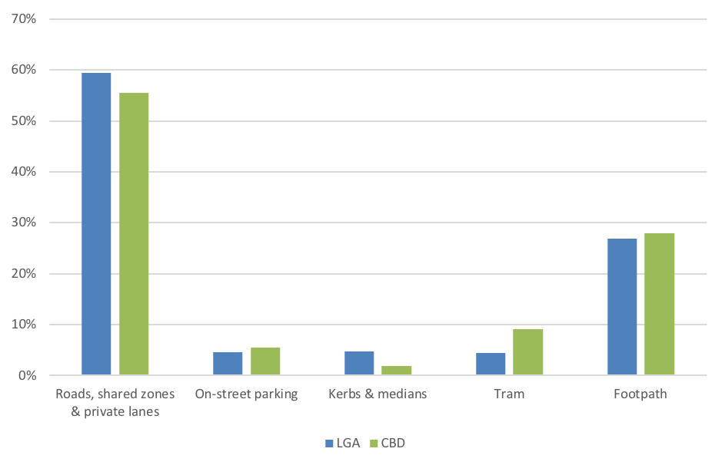
Source: City of Melbourne, 2018.
The primary component among the first category is roads (41.8 per cent), with Shared Zones (1.6 per cent) and private lanes (2.4 per cent) comprising only a small fraction of this space. On-street car parking represents just under five per cent of the total space allocation.

Proportion of Trips by Mode Within the Hoddle Grid
Having established how much space is allocated to different modes of transport within the Hoddle Grid, it is then useful to consider how this relates to the proportion of trips made by these modes. Figure 3 overleaf, presents a breakdown of all trips within the Hoddle Grid by mode.
Figure 3: Transport trips within the Hoddle Grid by mode
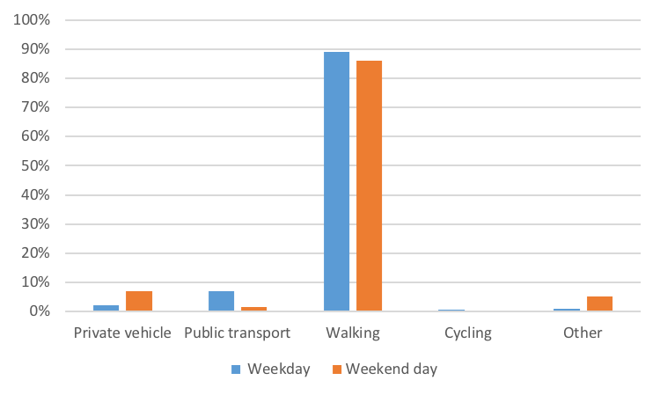
Source: Ipsos, 2018.
Approximately 89 per cent of all trips within the Hoddle Grid are undertaken on foot (Ipos 2018), and pressure on footpath space is likely to increase as the estimated daily population increases by almost 50 per cent in the next 20 years (City of Melbourne 2017a). Overcrowding already occurs on footpaths across the Hoddle Grid, particularly at some train stations and tram stops during the peak periods. Public transport use has also been increasing as population growth has risen. There has been a noticeable shift in how people travel to and within the Hoddle Grid (City of Melbourne 2012a). The proportion of trips to and within the Hoddle Grid made by public transport are expected to continue to increase on completion of major projects such as the Metro Tunnel, which is expected to increase capacity by 39,000 passengers during the peak period (Victorian Government 2017).

Conclusion
The data shows that there is a large discrepancy between the proportion of space allocated to motor vehicles within the Hoddle Grid and the proportion of trips undertaken by this mode. Currently, 89 per cent of trips within the Hoddle Grid are on foot but just 26% of space is allocated to pedestrians. Whereas, just two per cent of trips are undertaken by car but 61 per cent of space is allocated for roads/vehicles (Ipsos 2018).
Clearly, motor vehicles require significantly more space and carry significantly fewer people than other modes, such as public transport, walking, cycling and rideshare modes (i.e. car sharing and bike sharing). In other words, trips by private motor vehicles (excluding those for deliveries, people with mobility impairments, and taxis) are relatively inefficient compared to other modes. The additional space required to support the use of private motor vehicles comes at the expense of space for pedestrians and to mitigate climate change and increases security risk. There is also a potential opportunity cost associated with not allocating this space to higher value uses. Furthermore, private motor vehicles contribute to air and noise pollution in the city, and impact negatively on the general safety and comfort of all city users. This inefficient use of city space is exacerbated by several emerging conditions, which are increasing pressure for, and on, space in the city, particularly the growth in the population of residents and visitors.

The Growing Pressure on City Space
There are several important changes taking place that are increasing pressure on the demand for space in the City of Melbourne, particularly in the Hoddle Grid - as summarised in Table 1 below.
Table 1: The conditions increasing demand for space
Conditions | What this means for city space
(1) Population Growth | More residents and visitors in the Hoddle Grid on a daily basis, of which approximately 90 per cent will be moving around on foot
(2) Equity and Inclusion | More vulnerable users of the city require more space because of the additional challenges they face in using the city
(3) Major Transport Projects | Reduces space during construction and increases demand for space afterwards with increase in people walking
(4) Terrorism & Security | Requires more space to prevent hostile vehicle attacks
(5) Emerging Technologies | Could require more space if access for autonomous vehicles is not managed properly
(6) Climate Change | Requires more space to provide for water capture and retention, and for urban greening (e.g. urban tree planting)
These conditions are discussed further in the following sections.

Population Growth
Population growth presents one of the biggest challenges facing the City of Melbourne in terms of how best to allocate space in the Hoddle Grid. According to the City of Melbourne’s Daily Population Estimates and Forecasts Report (2017a), the residential population of the Hoddle Grid has grown 14.8 per cent from 37,989 to 42,589 between 2014 and 2016 and is expected to exceed 76,000 by 2036 – making it one the fastest growing in a local government area in Australia. The daily visitor population grew 6 per cent, from 851,000 to 903,000, during the same period, and is expected to exceed one million by 2036 (Ibid).
The daily visitor population comprises workers, students, people undertaking non-work and study trips (e.g. shopping, cultural and other social trips), and people from regional Victoria, interstate and overseas. As the daily population increases, more delivery and other trips (e.g. emergency services) are generated to support this growth. These trips highlight the importance of the city, and the Hoddle Grid in particular, as the economic hub of Victoria. In the last two years, based on CLUE data, there has been a 7.3 per cent growth in jobs in the professional sector and a 6.2 per cent growth in jobs in healthcare (City of Melbourne 2017a). Over two thirds (70.5 per cent) of all new jobs are concentrated in the central city area, of which the majority (48.4 per cent) was within the Hoddle Grid (Ibid) – see Figure 4.
Figure 4: Concentration of job growth in the City of Melbourne
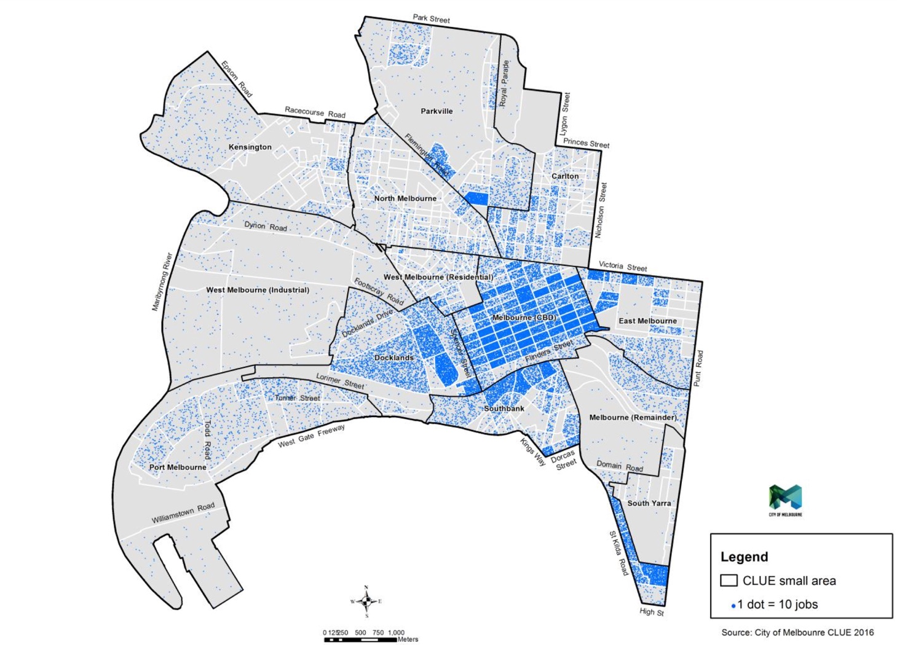
Source: City of Melbourne, 2017a.
The increasing residential and visitor populations also influence other areas of the local economy, with a reported 52.1 per cent increase in cafes and restaurants between 2006 and 2016 (Ibid). There are now 37,000 outdoor dining seats in the city, for which demand will continue to grow as the population grows (Ibid).
With 89 per cent of all trips within the Hoddle Grid undertaken on foot (Ipsos 2018), the demand for space for pedestrians to move around the city is increasing. These impacts are further exacerbated when public transport trips are taken into account. All public transport trips begin and end with walking, which significantly contributes to the high proportion of walking trips in the Hoddle Grid. Many train users connect with tram services to complete their journeys. These factors contribute to the increasing overcrowding at certain tram stops and at major train stations in the central city, as shown in Figure 5 overleaf.
Figure 5: Overcrowding at tram stops in the Hoddle Grid
Collins Street and Spencer Street (Wong, 2018) | Flinders Street and Swanston Street (Wong, 2016)
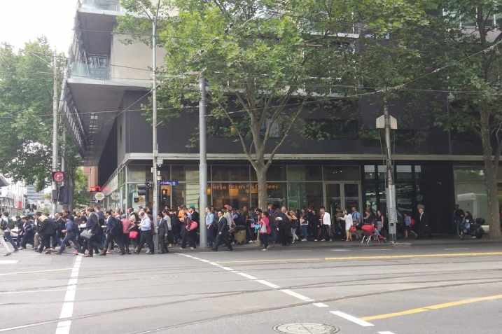 | 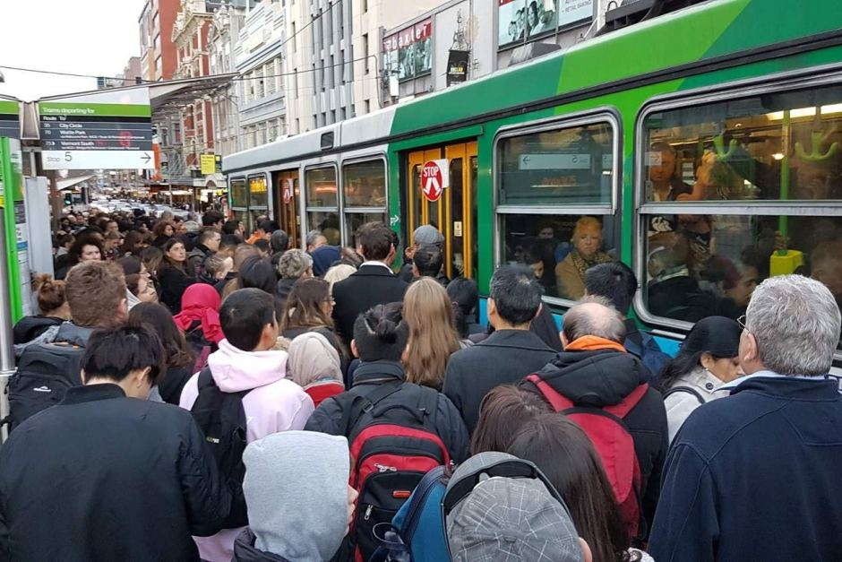
The relationship between population growth and increasing travel by non-car modes, such as public transport and walking, requires an integrated approach to planning a mobility system, rather than planning for any one particular mode.
I returned to Melbourne in 2011 after 10 years away and I can't believe the population explosion. It is becoming uncomfortable because the roads and trams can't cope.
Respondent, Future Melbourne 2026 (City of Melbourne 2017b)
Providing the space within the Hoddle Grid to meet the travel demands of the city’s growing residential, worker and visitor population (and several other important needs outlined in sections 2.2.2 to 2.2.6) and ensure the safety of people within the city, will require a significant reconsideration of how city space is currently allocated and designated for other uses. The challenge is in determining which uses should be prioritised to best meet the needs of the city and the people who experience it.

Equity & Inclusion
The experience of moving around the Hoddle Grid is very different for different people, particularly for the more vulnerable users of the city, which includes people with physical and visual impairments, the elderly, people with dementia, females, LGBTQI people, and families with young children.
This area with Federation Square, the cathedral, the bridge and the station was my favourite place in the city but now, as a parent, I do my very best to bypass this area…I try to walk up and catch a tram down Collins street when I go to Coles…I feel unsafe…at night-time I would definitely not go down here…because I have a young child and because I am a woman
Minority ethnic female parent and resident in the Hoddle Grid
These users are more vulnerable because they face a range of challenges in moving around the city. These challenges can take the form of physical impediments, such as steps, steep inclines, reflective and wet surfaces, obstructed footpaths, and excessively wide pedestrian crossings (See Figure 6, overleaf).
Figure 6: Person with mobility impairment crossing Swanston Street between Federation Square and Flinders Street Station
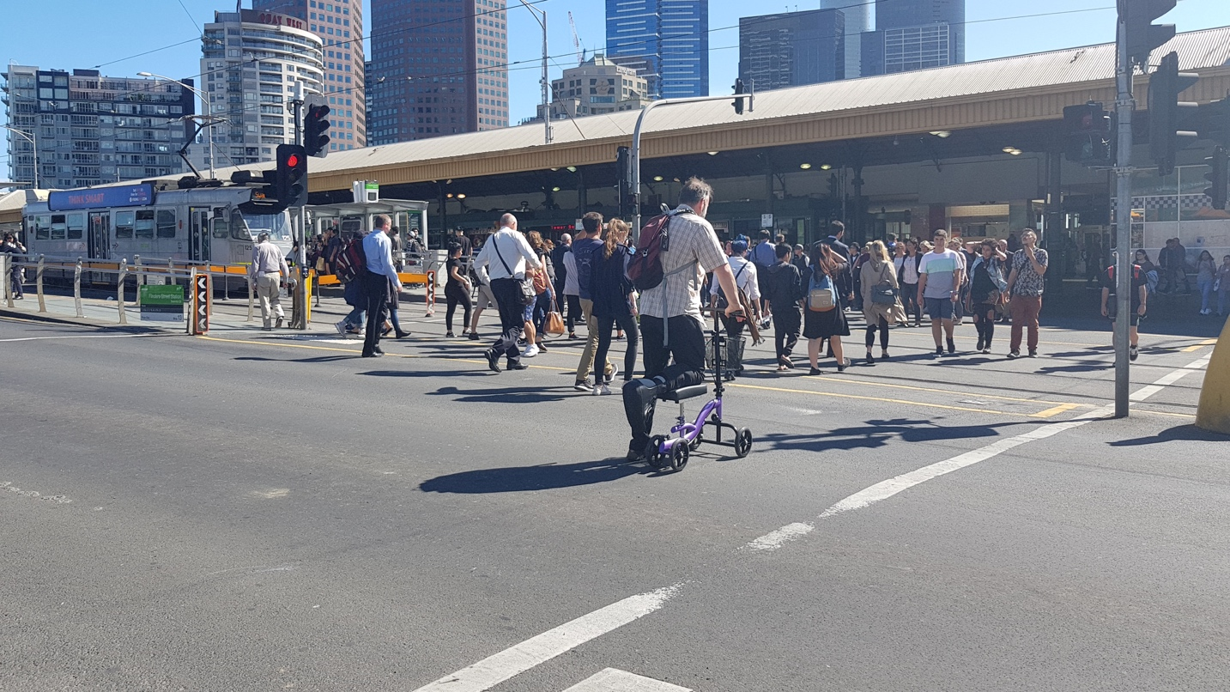
Source: Author (2017).
However, in other cases, the challenges can be more complex, particularly for people from minority ethnic backgrounds (Mandanipour, 2010), females (Kalms et al, 2017), and LGBTQI people (Goh, 2017).
I have at many times been called one or another name for being brown just being on Flinders Street…I find it unsafe, particularly when sporting events are on.
Minority ethnic female resident and mother of young child
These users generally feel less safe in public spaces as they are more likely to experience harassment, assault and discrimination (Ibid and Nadimpalli 2018). Kalms et al (2017) notes that “…spaces that were crowded seemed to provide a cover for unpleasant incidents such as pushing and groping.”
If I didn’t have to constantly think about my safety my life would be a lot easier. I would go to a lot more things. It’s not a matter of getting to places, it’s getting home. I’d save a lot of money because I Uber so much trying to get home.
Respondent, ‘Free to Be’ Project (Free to Be 2017)
The actual design of public spaces, such as poor lighting or the presence of highly sexualised advertising, can also negatively affect these users. Thanks to recent research (Free to Be 2017), we are now starting to better understand the experience of city space for women (see Figure 7), children and people of minority ethnic backgrounds. This research is helping to address the gap in data about women’s experience of cities. The City of Melbourne would also benefit from more user research to better understand the experience of the city for everyone, particularly these more vulnerable users.
Figure 7: Mapping the female experience of the city – results from the ‘Free To Be’ project
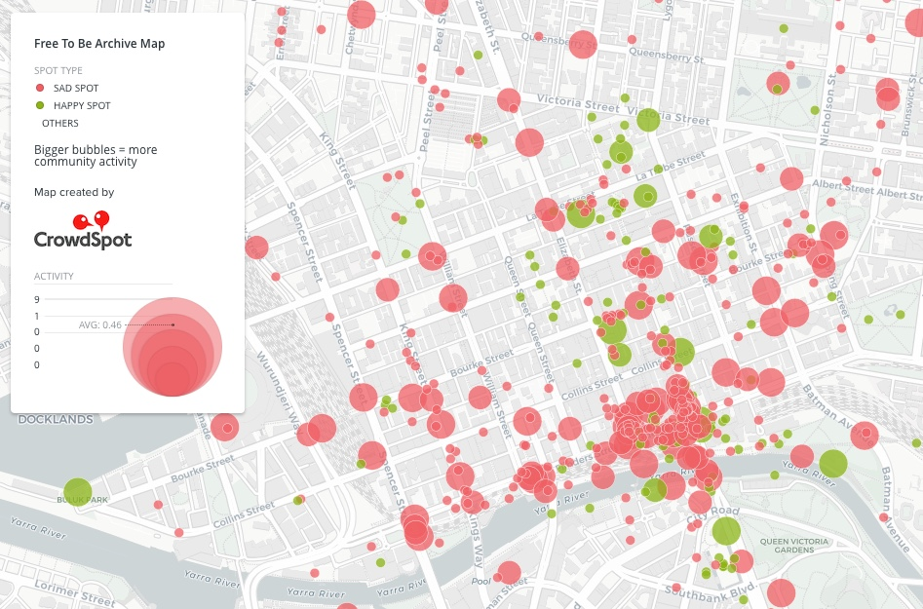
Source: Crowdspot (n.d). Description: The map presents the locations identified by female respondents in which they experienced happy (green) and sad (red) encounters in city space. Sad encounters include sexual harassment, intimidation, fear and assault.
Under the Federal Disability Discrimination Act 1992, the City of Melbourne is required to provide an environment that is accessible for all users of the city. While provisions for some users, such as people with physical impairments, has, and continues to, be addressed (e.g. through the construction of accessible tram stops), other users need more consideration. For example, the rate of growth in people with dementia is particularly significant, with the number of Australians with dementia expected to reach almost 400,000 by 2020, and then more than double this figure by 2050 (See Figure 8).
Figure 8: Estimated number of people in Australia with dementia (2005 – 2050)
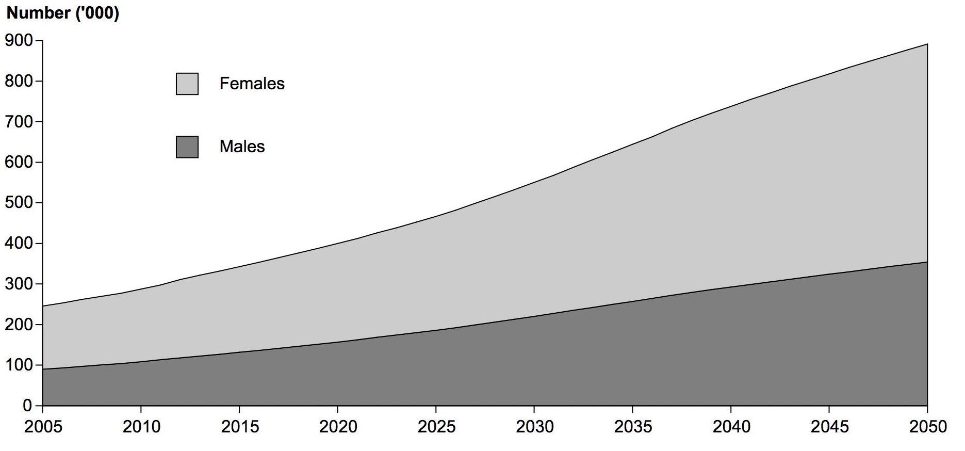
Source: Australian Institute of Health and Welfare (2012): Description: The chart presents the growth in dementia across Australia between 2005 and 2050, for females (light grey) and males (dark grey).
According to the Australian Institute of Health and Welfare (2012), dementia is now the main form of disability among older Australians and is also starting to affect younger people too. However, to date, relatively little consideration has been given to dementia sufferers needs in the design of city spaces, with “many outdoor environments [being] inhospitable…because they are disorientating, difficult to interpret and navigate, threatening or distressing.” (Blackman et al 2003). Finding a balance between the many competing demands for these spaces is challenging but there is a strong and ethical argument to place a higher priority on the needs of more vulnerable city users.
When considering the problems associated with overcrowding, more consideration needs to be given to how different users experience these conditions, particularly in terms of personal safety, security and comfort. Focusing only on the efficient movement of people and transport fails to acknowledge important issues about how more vulnerable people experience the city. This represents a significant threat to the reputation of the city. The different experiences of the wide range of users of the city demonstrates the need to design a mobility system that is inclusive and equitable in terms of the safety and comfort of all users, regardless of age, gender, ethnicity and ability. These provisions are key requirements of both the Disability Discrimination Act 1992 and the Transport Integration Act 2010. It is therefore incumbent upon the City of Melbourne, and other relevant agencies, to provide such a system and environment in the central city.

Major Transport Projects
The Victorian Government is responsible for major transport projects in Victoria, some of which are delivered within the Hoddle Grid, affecting the user experience of the city. These projects represent significant investment and often result in unavoidable disruptions, often for extended periods of time, even over several years. These works often require the full or partial closure of streets and changes to public transport services that affect the day-to-day experience of the city.
We avoid streets with construction works because there are too many obstacles and we have to cross the street back and forth, it’s just too hard.
Retired and disabled couple living in the Hoddle Grid
This can have a disproportionate impact on some users more than others. For example, the closure of footpaths can increase the challenges facing people with mobility impairments and people with young children.
Figure 9: Construction impacts on streets in the CBD
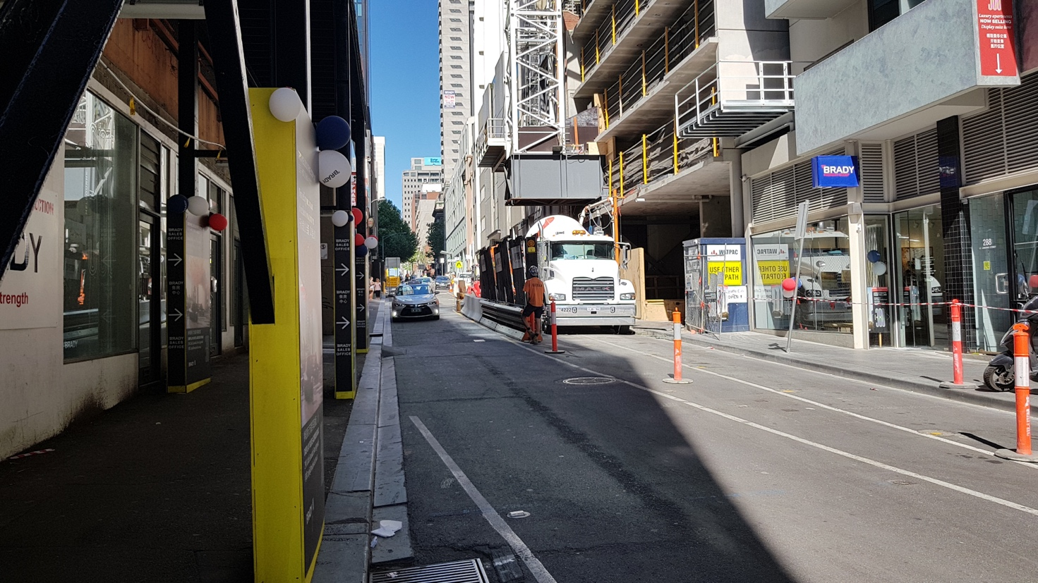
Source: Author (2017)
Notwithstanding these adverse impacts, such projects deliver important longer-term benefits for city users. Improvements to the public transport system, such as the $11 billion Metro tunnel project, will deliver more capacity, services and reliability for train services to and within the Hoddle Grid.
Figure 10: Construction works for the Metro Tunnel at City Square in the CBD
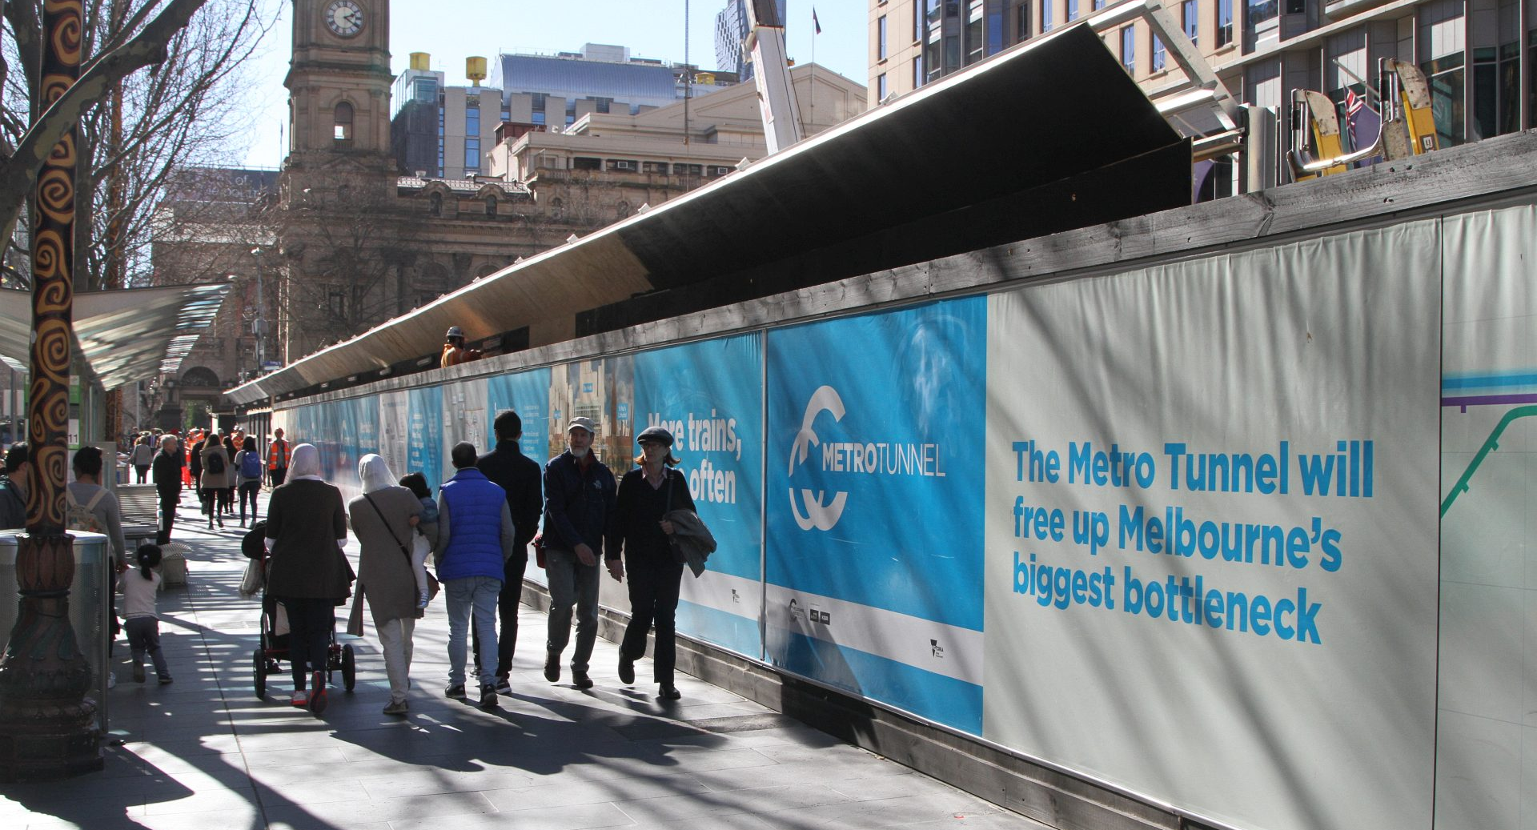
Source: Wong (2017).
However, these improvements will further increase demand for space in the Hoddle Grid, with the additional train passengers resulting in an increase in people on foot, which could increase the potential for overcrowding on footpaths, at station entries and at certain tram stops.

Emerging Technologies
There are several emerging technologies in transportation and mobility that are increasing demand for space, particularly in the Hoddle Grid (See Figure 11). They range from relatively low-technological developments, such as rideshare transport services like dockless share bikes (e.g. O-Bike), Melbourne Bike Share, and car-sharing (e.g. GoGet and GreenShareCar), to more high-technological developments, such as autonomous vehicles and drones.
Figure 11: Emerging technologies in the Hoddle Grid
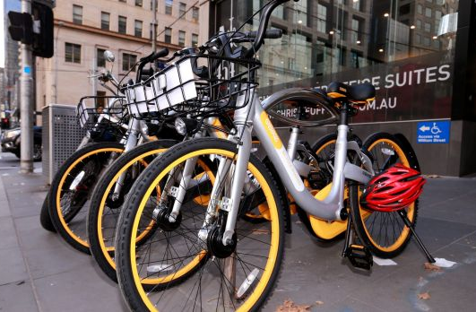 | 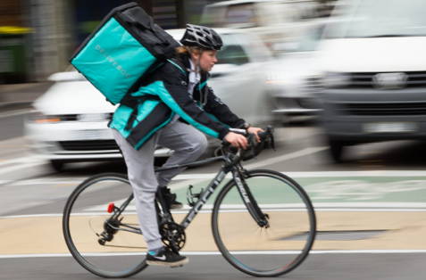 | 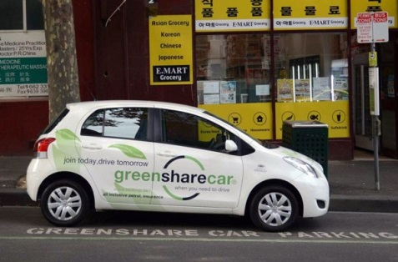
O-Bikes (Taylor 2017) | Deliveroo (South 2018) | GreenCarShare (The Fifth Estate 2015)
Rideshare services have road and kerbside space requirements but also reduce reliance on private motor vehicles, which have relatively higher space needs. They also include new taxi-like services such as Uber, which has significantly disrupted traditional taxi services in the Melbourne and cities around the world. Further disruptions have also been experienced in how goods are being delivered in and the around the city through the development of App-based technologies. Services such as UberEATS, Foodora and Deliveroo are changing some trips in the city, with restaurant and takeaway food delivered door-to-door. All of these technological developments represent some form of disruption, challenging traditional understandings of transport modes as either private or publically provided services.
How these technologies will develop, what form they will take, and what impact they will have on our cities and our lives are less well understood. While they may offer many potential benefits, they are not guaranteed.
Automated vehicle technology holds many promises for cities, but the potential benefits of automation are not guaranteed. City policies must proactively guide the technology to prioritize people-centric design.
NACTO (2017, p. 3)
They have significant potential to reshape our cities, both for better and for worse. For example, autonomous vehicles have the potential to eventually eliminate the need for car parking, particularly kerbside parking, in the Hoddle Grid, which could free up valuable space for other more productive purposes, such as outdoor dining that has economic benefits; tree planting that helps mitigate climate change impacts; and more space for people to walk, sit and enjoy the city. However, autonomous vehicles also have the potential to create demand for more travel, which could in turn require the reallocation of more space to support this demand.
The cost of traveling a mile might drop so substantially that people would abandon public transportation in favor of autonomous cars. That, in turn, could lead to an increase in the number of vehicles in a city — and with that increase, surreal gridlock.
Carlo Ratti, MIT (In an interview with Martijn Gerritsen on the impact of autonomous vehicles, Pop Up City, February 2018)
Adapting the central city to facilitate additional vehicle use and accommodating the needs of autonomous vehicles would mean sacrificing space for people, such as reducing footpath widths. In other words, we risk repeating the mistakes of the past when we allowed private car-use free and unfettered access to the city at the expense of the city itself, creating congestion, pollution, urban sprawl and consuming the space used for everyday urban life, which serves important economic, social and environmental purposes.
Whether vehicles are autonomous or driver-operated, managing access for private vehicles in the central city will continue to be an issue for the City of Melbourne. This raises important questions about where and how much access should be given to vehicles, especially in the Hoddle Grid.

Terrorism & Security
The Australian Government warns that crowded places are attractive targets for terrorists using vehicles as a weapon (Australian Government 2017). They define crowded places as “locations which are easily accessible by large numbers of people on a predictable basis”, including pedestrian malls and civic spaces. They further warn that “[t]errorists have plotted … attacks [in Australian cities], … and we expect more will occur”. Victoria Police has previously confirmed they prevented several vehicle attacks in Melbourne. However, not all hostile vehicle attacks are terror-related. The three hostile vehicle attacks that have taken place in the central city over the last 12 months were not deemed acts of terror (Colangelo 2017). The common factor in each of these incidents was the history of mental illness of the perpetrator. All major cities in Australia are taking precautionary measures to protect against the threats posed by hostile vehicle attacks, whether terror-related or otherwise. Some of these measures are more visible than others, such as the concrete bollards installed at key locations in the Hoddle Grid in the aftermath of the Bourke Street Mall attack (see Figure 12 overleaf). This measure demonstrated for the first time the potential impacts of physical mitigation of hostile vehicles on city space. These impacts include the reallocation of space from other uses and the potential psychological impacts on how people experience the city, which can be both positive and negative. For example, for some people the presence of measures such as bollards and more police officers create a sense of safety, whereas for others it creates the sense of concern.
Figure 12: Concrete bollards installed across Hoddle Grid to prevent hostile vehicle attacks (photo taken at the corner of Flinders Street and Swanston Street, outside Flinders Street Station)
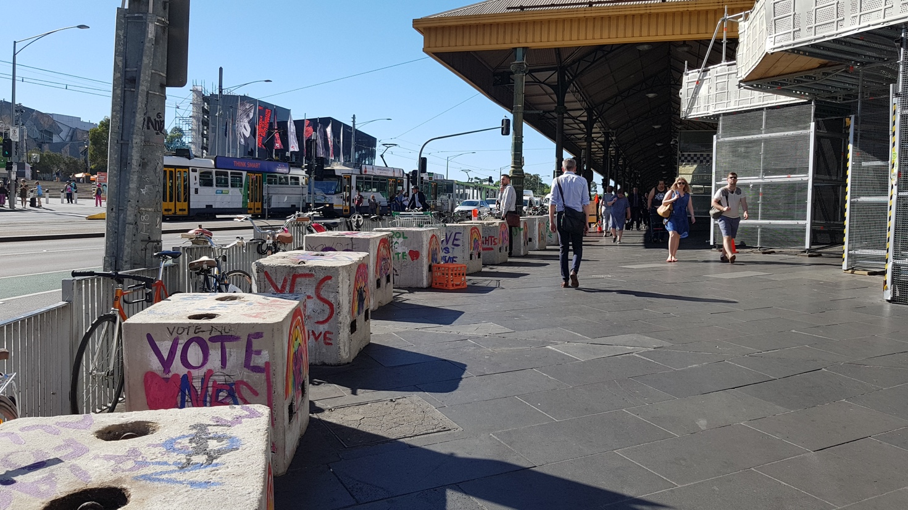
Source: Author (2017): Description: The concrete bollards shown on the left against the pedestrian guard rail, where installed to prevent hostile vehicle attacks.
The growing population of residents, workers and visitors in the Hoddle Grid will increase overcrowding in certain places, which may make this area more attractive for hostile vehicle attacks, especially during peak periods of travel and other periods of high-intensity people activity, such as on weekends and during big events. Managing overcrowding is an important issue for the City of Melbourne, particularly in terms of the safety and comfort of all city users. However, it may now also be an important issue for reducing the attractiveness of the Hoddle Grid to hostile vehicle attacks. The installation of measures to prevent hostile vehicle attacks, in the form of reinforced street furniture or steel bollards, will require the reallocation of space. However, in some locations, particularly those with heavy flows of pedestrians, steel bollards will be the only appropriate option. Reducing overcrowding will also require wider footpaths and greater priority for pedestrians at intersections. This can only be achieved by reallocating space from other uses through prioritisation.
While the threats posed by hostile vehicle attacks are an alarming development, they also present an opportunity to create safer, more inclusive, equitable, people-friendly urban spaces that better support the economy and resilience of the city. Reallocating space to prevent hostile vehicle attacks could be an opportunity to reduce overcrowding, while also creating more space for outdoor dining and trading, for social and civic activities, for tree planting, for street furniture, for public art, and more space for the 90% of trips undertaken by foot in the Hoddle Grid.
A further potential measure to prevent hostile vehicle attacks and reduce overcrowding could include significant limitations on access for private cars/vehicles within the Hoddle Grid. A number of cities around the world are already implementing such restrictions, including New Orleans, Montpellier, Oslo, Paris and Madrid. This has the potential to free up valuable space that could then be reallocated to a range of other more productive uses, such as wider footpaths, bicycle lanes, and larger tram stops.

Climate Change
The City of Melbourne’s Climate Change Adaptation Strategy (2009) notes that:
The two most significant extreme weather events for Melbourne likely to be exacerbated by climate change are extreme heatwaves and intense rainfall events. While drought and sea level rise also have critical risks, these two priority events are likely to happen sooner, potentially more frequently, and can have significant and devastating effects for Melbourne, its visitors and residents.”
City of Melbourne (2009, p.8)
Extreme weather events are not the only environmental issues facing the City of Melbourne, particularly the Hoddle Grid. The city itself also contributes to certain conditions, which, if not managed, can have a detrimental impact on the experience of the city for all users but particularly children and older populations. For example, cities are significant generators of heat, which exacerbates the impact of heatwaves. In addition, they also create air and noise pollution, which can have detrimental health impacts. This can lead to stress, anxiety and various psychological disorders, and in extreme cases, even death (Peen et al 2010).
Figure 13: Wider benefits of urban trees
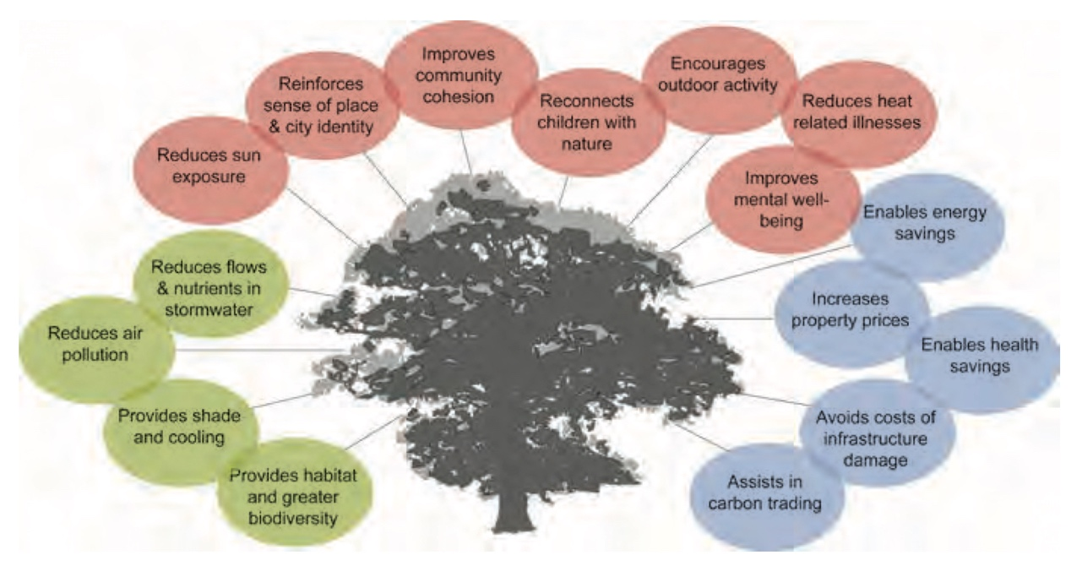
Source: City of Melbourne (2012b, p.11).
Many of these issues and impacts can be mitigated by urban greening in the form of trees, shrubs, green walls and green roofs (Richardson et al 2013) - see Figure 13 above for wider benefits of urban trees. Not only does greening reduce heat in the city, access to greening has proven to reduce stress in people.
Trees that are planted in good soil with plenty of room to grow big and healthy can really help to clear the air. They also provide shade for pedestrians and encourage walking.
Respondent, Future Melbourne 2026 (City of Melbourne 2017b)
The City of Melbourne’s award-winning Urban Forest Strategy sets out a range of actions to green the city, including the goal of 40% tree canopy cover across the entire municipality, which will have significant city space requirements. Many urban greening projects will have requirements for space that will be part of, or adjacent to, footpaths in the central city (see Figure 14 overleaf as an example).
Figure 14: Urban greening project by the City of Melbourne (Godfrey Street in the CBD)
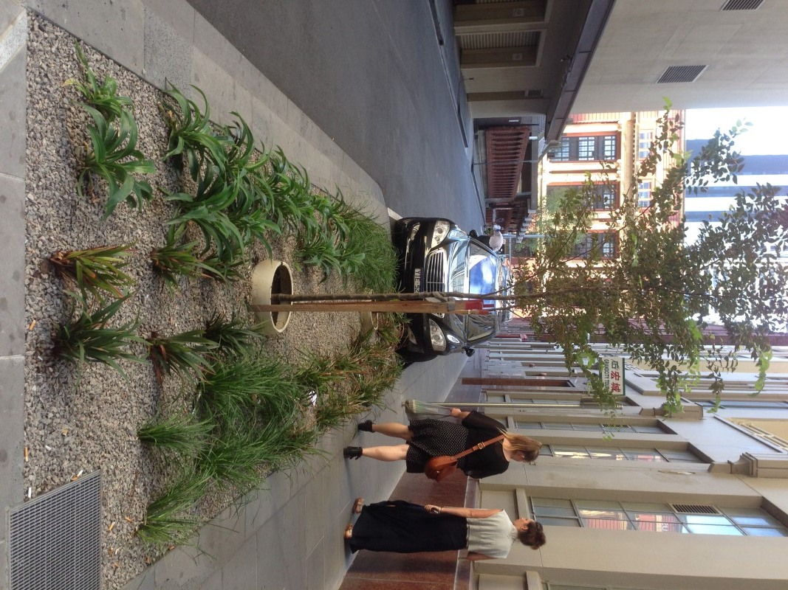
Source: City of Melbourne, n.d.
Furthermore, meeting and sustaining this goal will require a resilient water capture and retention system to reduce the impact of droughts and heatwaves on vegetation. To achieve this, and to manage extreme rainfall events, integrating drainage and water capture into public realm infrastructure will be required, which also places further demands on city space.

Key Issues in Allocating City Space
The City of Melbourne faces several important overlapping issues when deciding how to allocate the use of space to meet the changing conditions in the Hoddle Grid. This section discusses the key challenges in addressing each of these issues.

Managing the Rhythms of Activity in City Space
The spaces in the Hoddle Grid pulse with the ebb and flow of people, as they move through and around it, interacting with the buildings, the public spaces and each other (See Figure 15). There is an intensity to this pulse that rises and falls depending on the time of the day, day of the week, and the time of year. These intensities are largely a function of the volumes of people and the area of space they occupy.
Figure 15: The 24-hour rhythms of the City of Melbourne
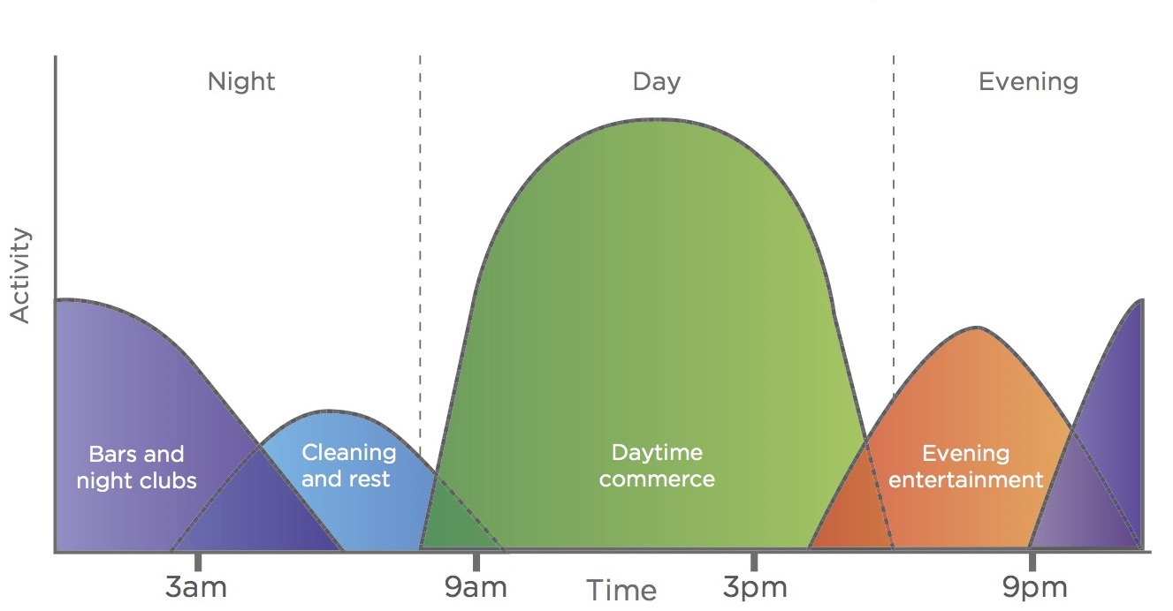
Source: City of Melbourne (2012a, p.24). Description: The chart shows the peaks and troughs for the volume of users in the city across the day.
These fluctuations play a very important role in how the city operates and how it is experienced by different users. The intensity of activity in a space can have both positive and negative impacts on different users. Large volumes of people can create vibrancy and provide a strong base of customers for retail trade, but at the same time produce overcrowding in some locations, making some people feel stressed or unsafe. The experience of the city also changes after dark, with some users less inclined to use city space at certain times of the day.
We don’t go out much at night. If we do, we make sure we get home before 9pm. You’ve heard the news, Elizabeth Street is like skid row, we don’t feel safe.
Retired and disabled couple living in the Hoddle Grid
Lower volumes of people can reduce stress for some people, while making others feel less safe, depending on the location and time of the day.
I feel less safe, less comfortable in the evening when the activity dies down and there are not a lot of people on the road…that’s when you have good spaces and not so good spaces
Minority ethnic female and daily visitor to Hoddle Grid
Nowhere is this more evident than at the major transport interchanges in the Hoddle Grid. Flinders Street, Southern Cross and Parliament stations all experience high volumes of passengers during the morning and evening peak periods, as well as on weekends, which in turn creates very high volumes of pedestrians when passengers exit the stations onto the adjoining footpaths.
Figure 16: Conditions at the tram stop on Swanston Street, adjacent to Flinders Station
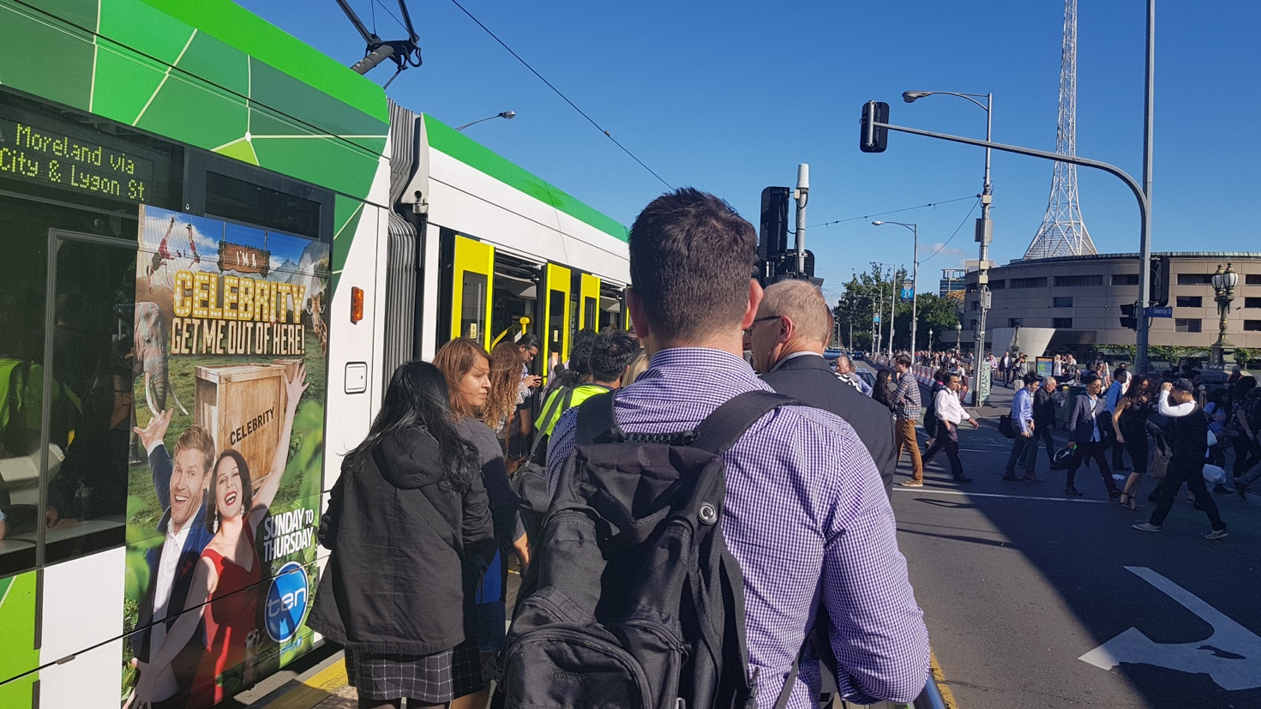
Source: Author (2018).
The tram stop [at Flinders Street Station] is the most difficult when you are trying to get off and get across the street because of the crowding… sometimes I get off one stop earlier to avoid these stops.
Minority ethnic female and daily visitor to Hoddle Grid
This often leads to overcrowding at nearby intersections, with pedestrians spilling out onto the roadway – see Figure 17 for example, showing footpath crowding of passengers from Parliament Station during a weekday morning peak period.
Figure 17: Overcrowding on footpaths outside Parliament Station (on Lonsdale Street)
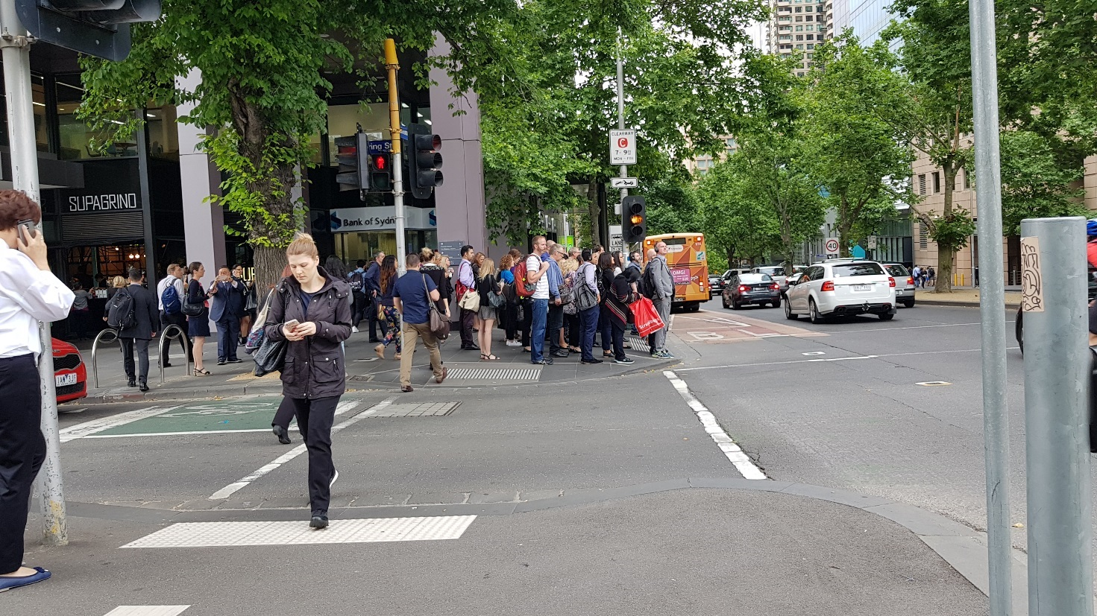
Source: Author (2017).
Furthermore, many train users connect with tram services. This puts significant pressure on the capacity of adjacent tram stops. This raises safety concerns for pedestrians and public transport users alike, which is exacerbated for the elderly, people with disabilities, young children, women, and people with prams.
Currently most passengers alighting at Parliament station have to cross at least one road to get to their destination - including every single passenger exiting at Lonsdale St. The intersection at the corner of Spring and Collins St is particularly congested, without reducing space allocated to roads there are few other options to increase space for pedestrians at this congested intersection.
Respondent, Future Melbourne 2026 (City of Melbourne 2017b)
The changing conditions in the city will increase the intensity of the use of city space in two significant ways. Firstly, the increasing population of residents, workers and visitors, most of whom will move around the city on foot, will significantly increase demand for pedestrian space. Secondly, providing for climate change adaptation and preventing hostile vehicle attacks, together with major public transport construction projects, will reduce available space for pedestrians and cyclists. In other words, more people will compete for less space. The potential for overcrowding could rise significantly, particularly during the peak travel periods; during the middle of the day during lunch, and at weekends when many people travel into the city from across metropolitan Melbourne and Victoria.
These factors will also place significant pressure on the public transport system, particularly in the vicinity of station entrances and tram stops. The connection between public transport and the volume of pedestrian movements is fundamental to how the city operates. Greater priority for the transition between trains, trams and the pedestrian network will be required. Public transport is critical to how people travel to and from the city, whereas walking is more important to how people move around within the city. Reallocating space to manage the intensity of peaks in population and activity, across the day and week, will be critical to managing the changing conditions in the city.

Managing Conflict Between the Uses and Users of City Space
Cities have always been, and will continue to be, places where space is contested (Hou 2010). Our streets serve many functions and many different users with different needs. Our footpaths support movement, outdoor dining, seating, bicycle and motorbike parking, advertising, busking, street art, utilities, signage, trading etc. At the same time, they also support different users, such as shoppers, residents, workers, and tourists. Many of these users, such as older people, those with mobility impairments, people with prams and young children, and people with medical conditions like dementia, have specific needs. How these spaces are allocated in terms of use and users, including what priority is assigned to different modes of transport, will determine how much conflict is created and how different users experience city space.
Swanston Street and Elizabeth Street are two of the most crowded spaces in the Hoddle Grid, where in some sections people compete for footpath space with many of the aforementioned uses. It could be argued that this assemblage of uses and users, while essential to the livability of the city, can also create clutter and conflict.
Figure 18: Competing uses for space on the footpaths of Swanston Street
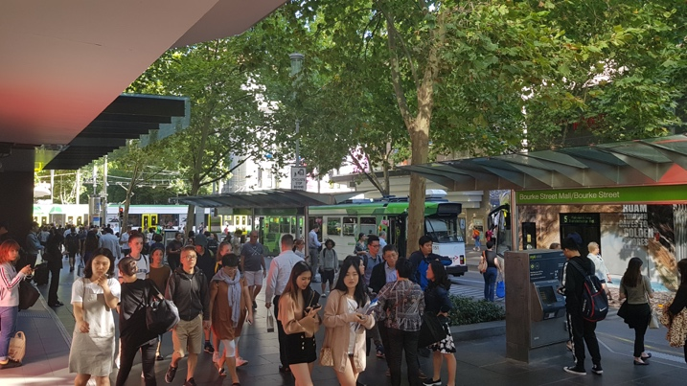 | 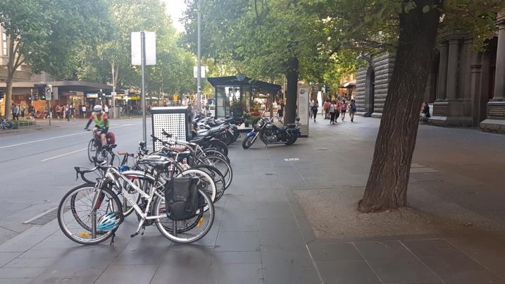
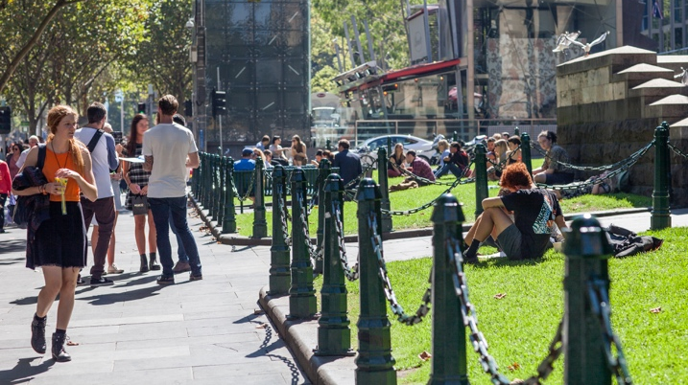 | 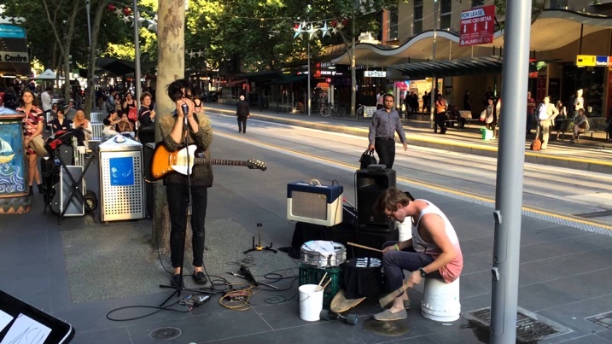
Source: Author 2018.
Striking the right balance between these competing uses and users is challenging but there is a strong ethical and operational argument to allocate this space in a more inclusive and equitable way. The obvious starting point is to consider what uses can be accommodated elsewhere or at different times. This would help to improve conditions for all users.
Figure 19, , presents a case in point, where an elderly man with a walking aid was observed seeking the assistance of others (in this case nearby police officers) to navigate a section of footpath that had become overcrowded due to the outdoor dining area, the queue of customers at the coffee hatch and passing pedestrians. All of these uses are important functions of the street but, nonetheless, create different experiences for different users.
Figure 19: Competing demands for footpath space on Spring Street
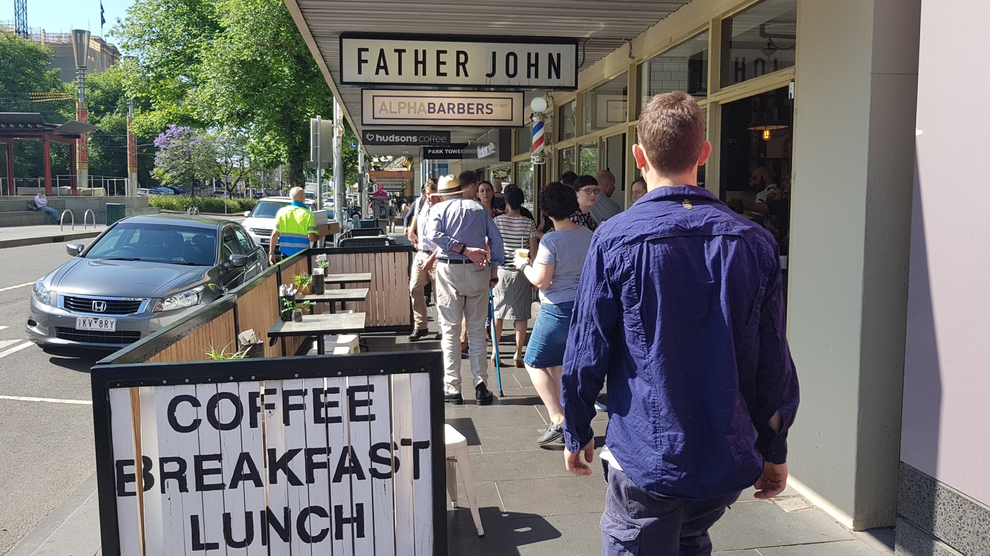
Source: Author (2017).
Our roadways are also contested spaces, as motor vehicles, delivery trucks, buses, trams, motorbikes, cyclists and even pedestrians compete for the same space. The traditional approach has been to separate different modes for safety and efficiency. However, it is not always possible to provide such separation, and it can also be an inefficient use of space if too much priority is assigned to modes that require significant space but support the movement of relatively small volumes of people. In some situations, it is more appropriate to separate modes. For example, there is a strong case for separating trams and motor vehicles. Trams carry high volumes of people and require relatively less space, compared to private cars which require more space (traffic lanes and parking) and carry relatively few people; on average 1.2 persons per car (VicRoads 2015). Furthermore, some streets have a stronger transport or movement function, such as St Kilda Road, City Road and Royal Parade. It makes sense to provide separation here between trams, cars, and bicycles.
However, there are also situations where it makes sense for different modes to share the same space, such as the little streets and laneways, because of the limited space available in these locations. Sharing space would enable more utility to be gained in the Hoddle Grid, as demonstrated in a study by the City of Melbourne (2012c, p.5), which noted that “…shared space works harder for the local economy and the local community because more activity and economic product can be generated in each square metre of space”. In economic terms alone, it is estimated that outdoor dining generates up to $25,000 in revenue per square metre per annum (City of Melbourne 2012d). Shared spaces prioritise vulnerable road users, requiring vehicular traffic to drive slowly, cautiously and give way first and foremost to pedestrians.
Figure 20: Shared spaces in the Hoddle Grid (Hardware Street, between Lonsdale Street and Little Lonsdale Street)
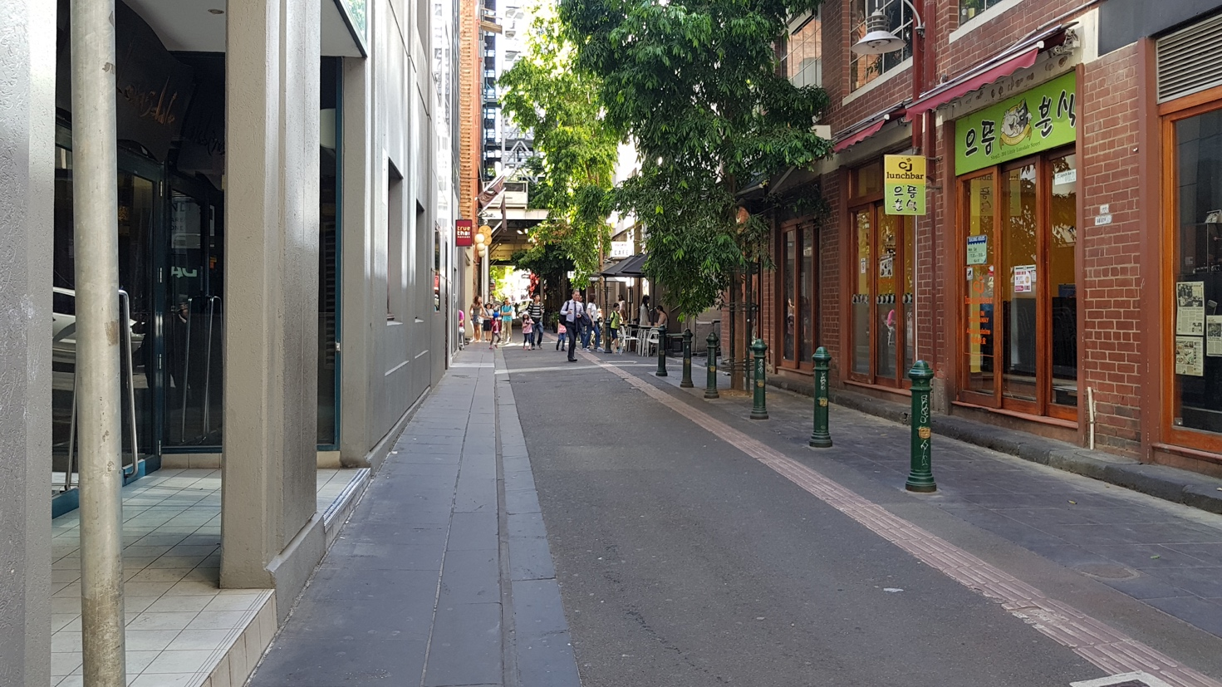
Source: Author (2017).
Sharing the same space can also help different road users learn to coexist in the city (Ruiz-Apilanez 2017). One of the problems with separation, particularly between cyclists and motorists, is the limitations to where it can be provided. There are many streets were the provision of dedicated space for different modes is not possible. Even in Copenhagen where almost two thirds of all trips are by bicycle and which has one of the most extensive networks of separated bike lanes, two thirds of the total network are shared with motor vehicles. Therefore, there will always be situations where cyclists and motorists come into contact with each other. Providing dedicated space for different modes can create territories, which may lead to conflict when they are deemed to have been encroached upon by another mode of transport. For example, when a cyclist leaves a separated bike lane and enters a standard traffic lane. These issues are already evident in the city (City of Melbourne 2012e). If more of the Hoddle Grid was shared space, then it may provide an environment that reduces conflict. However, and importantly, the provision of shared space must be accompanied by other measures, including motor vehicle speed reductions, priority for vulnerable road users, particularly pedestrians, and greater enforcement of these protections.
The potential for conflict between uses and users of city space will continue to grow given the changing conditions in the Hoddle Grid. The growing population of residents and visitors, together with the increasing demands from construction, security, climate change and so forth, are placing significant pressures on the limited available space. New directions are required that use smarter ways to allocate and use this space, to limit conflicts and protect the experience of the city that is so valued by all its users.
Figure 21: Shared space before and after, New Road, Brighton, UK
Before | After
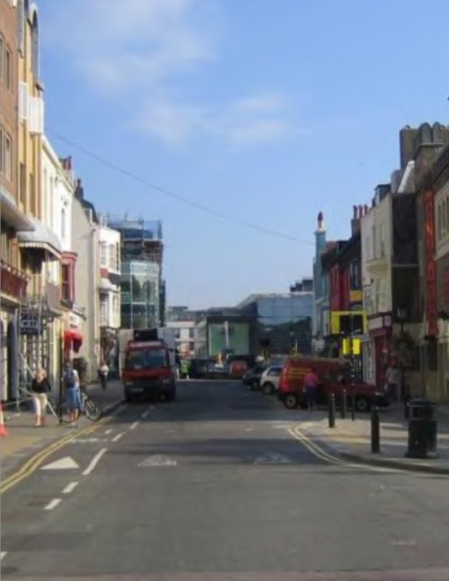 | 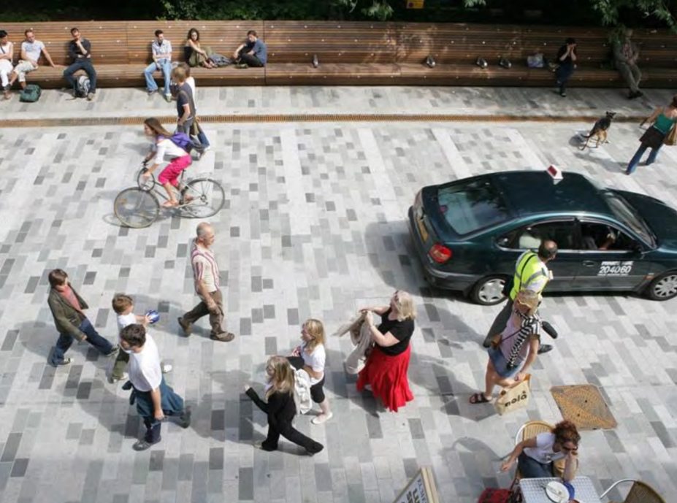
Source: Jeff Risom, n.d.
Shared space has proven to reduce conflict between different users by forcing motorists to drive slowly and carefully, giving way to pedestrians. It also provides public realm improvements in terms of the quality of space for people, whether walking, shopping, dining or socialising, as shown in Figure 21.

Prioritising the Allocation of City Space
Deciding the most appropriate basis for allocating space, to enable travel to and within the city, must consider how best to manage the intensities of activity, as well as minimising the conflicts between uses and users. At the same time, such decisions must also consider the needs of the most vulnerable, as well as safety and security issues, and the psychological and physiological comfort of all users. Furthermore, such decisions must respond proactively to the challenges of population growth and climate change. This has not always been reflected in how the allocation of space has been prioritised in the Hoddle Grid. Traditionally the approach has been quite fragmented, as the best possible outcome has been sought for each mode of transport, rather than considering an integrated approach focused on maximising access and mobility for everyone, in a safe and efficient manner.
It is crucial to tackle the inequality of road space…[by] this I mean fair allocation of road space to more vulnerable and more sustainable users - namely the pedestrian and the cyclist
Respondent, Future Melbourne 2026 (City of Melbourne 2017b)
There is a growing consensus among the users of the city for a different approach. In a report commissioned by the City of Melbourne analysing feedback on transport issues during the Future Melbourne 2026 consultation process, the main issue noted by respondents was road congestion, which they attributed to population growth and insufficient alternatives to private car use. Proposals from respondents to address congestion emphasised public transport, new technology and putting people first. While improving traffic flow for cars was also proposed, these suggestions mainly related to travel to the city, not within it. In fact, respondents overwhelmingly supported significantly reducing car use within the Hoddle Grid.
We would like to see a lot less cars in the CBD, a lot less, like with the closure of Elizabeth Street.
Retired and disabled couple, residents in the Hoddle Grid
These findings are not new. The City of Melbourne has been supporting a reduction in motor vehicle dependency from as far back as the Postcode 3000 project in 1992. The current Transport Strategy, and associated plans for walking and cycling, among others, all strongly demonstrate a consensus for a city that does not overly rely on private car use.
Figure 22: Proposed design for the closure of the southern end of Elizabeth Street
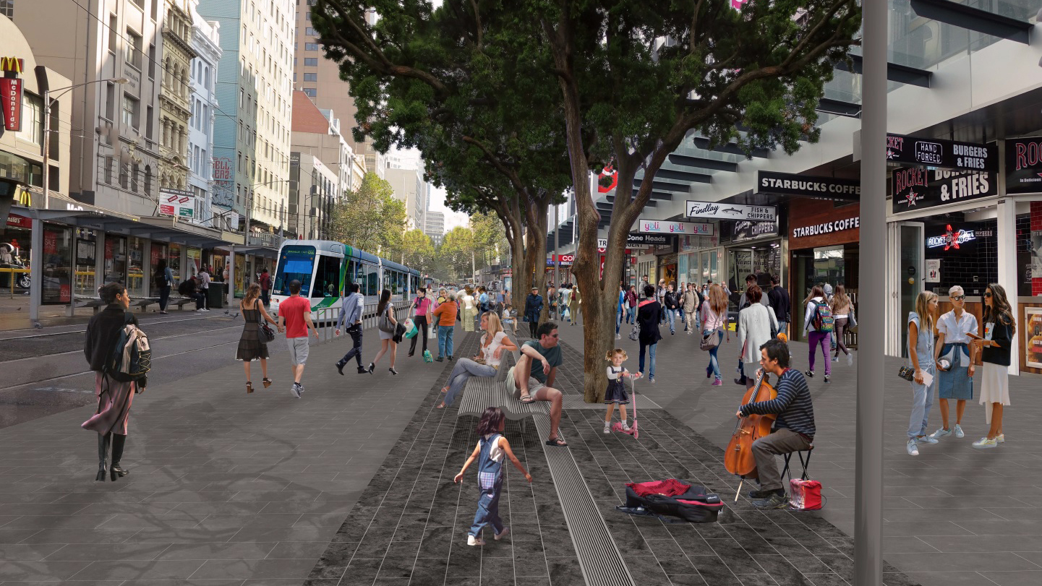
Source: City of Melbourne, n.d.
Community feedback gathered in the preparation of these plans demonstrated a strong level of support for reducing car dependence, as well as a reduction in the presence of motor vehicles in the city. The necessity to move from prioritising private car-use to an integrated mobility system is strengthened by the increasing demands on the limited space available in the Hoddle Grid. Such demands are well beyond the traditional scope of planning for transportation, as they encompass the wider context of public space, including the provision of safe, comfortable, active streets, laneways and plazas. They also include the integration of measures to reduce the effects of heatwaves, heavy rainfall and air and noise pollution.
The critical question is how these needs should be provided for within the constraints of limited space in the city, or, in other words, how do we maximise the utility of city space. The starting point for this discussion must be the minimisation or elimination of inefficient uses of space.
Currently, there are 22 streets within the Hoddle Grid that are closed to vehicular traffic for certain period of the day. A further five streets have been closed to vehicular traffic permanently. In addition, there is limited access for vehicular traffic on Swanston Street, and Bourke Street Mall is limited to trams and pedestrians. While some streets currently carry a large number of vehicles, such as King Street, Victoria Street and Lonsdale Street, others, such as Swanston Street and the little streets, have a stronger place value, catering to civic and social functions, as well as shopping and other activities. Swanston Street is one of the busiest spaces in the Hoddle Grid, with significant volumes of people throughout the day and across the week. It is also the busiest tram route and caters to relatively high volumes of bicycles, deliveries, taxis and emergency service movements.
In 2012, the City of Melbourne completed a new streetscape project to introduce fully accessible tram stops and remove most private car use. This project has changed the operation and feel of the street to one where priority is mainly provided for trams. Although on-street car parking has been reduced, there is still significant kerbside use by emergency service and delivery vehicles. While this has reduced vehicular traffic to the benefit of cyclists, they still have to compete with trams and parked vehicles for road space. In some cases, cyclists find themselves with no space when trams pass by parked vehicles – see Figure 23.
Figure 23: Limited space for cyclists on Swanston Street
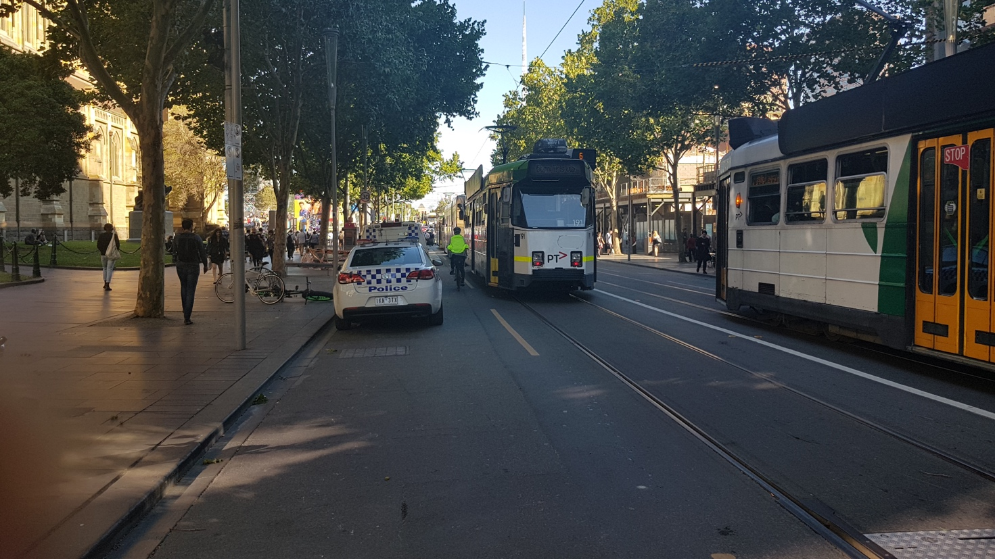Source: Author (2018).
While there have been improvements for pedestrians in the form of footpath widening, more can be done to increase crossing times at signalised crossings and reduce intersection cycle times to minimise pedestrian overcrowding at intersections. This can be achieved at low cost and without delay.
The City of Melbourne has gradually created more people-friendly environments on the little streets, including Flinders Lane, Little Collins, Little Bourke and Little Lonsdale (between Swanston Street and Elizabeth Street), through high quality wider footpaths and priority crossings. These changes have helped to create bustling, vibrant spaces in the city, filled with residents, shoppers, workers and visitors. However, they still cater for car parking and private car use, which creates conflict with pedestrians, cyclists and deliveries. The City of Melbourne has also successfully implemented a temporary closure of Little Collins Street between Russell Street and Elizabeth Street for a two-hour period each working day between noon and 2pm, which gives pedestrians and cyclists priority access during this period.
Figure 24: Temporary weekday closure of Little Collins Street
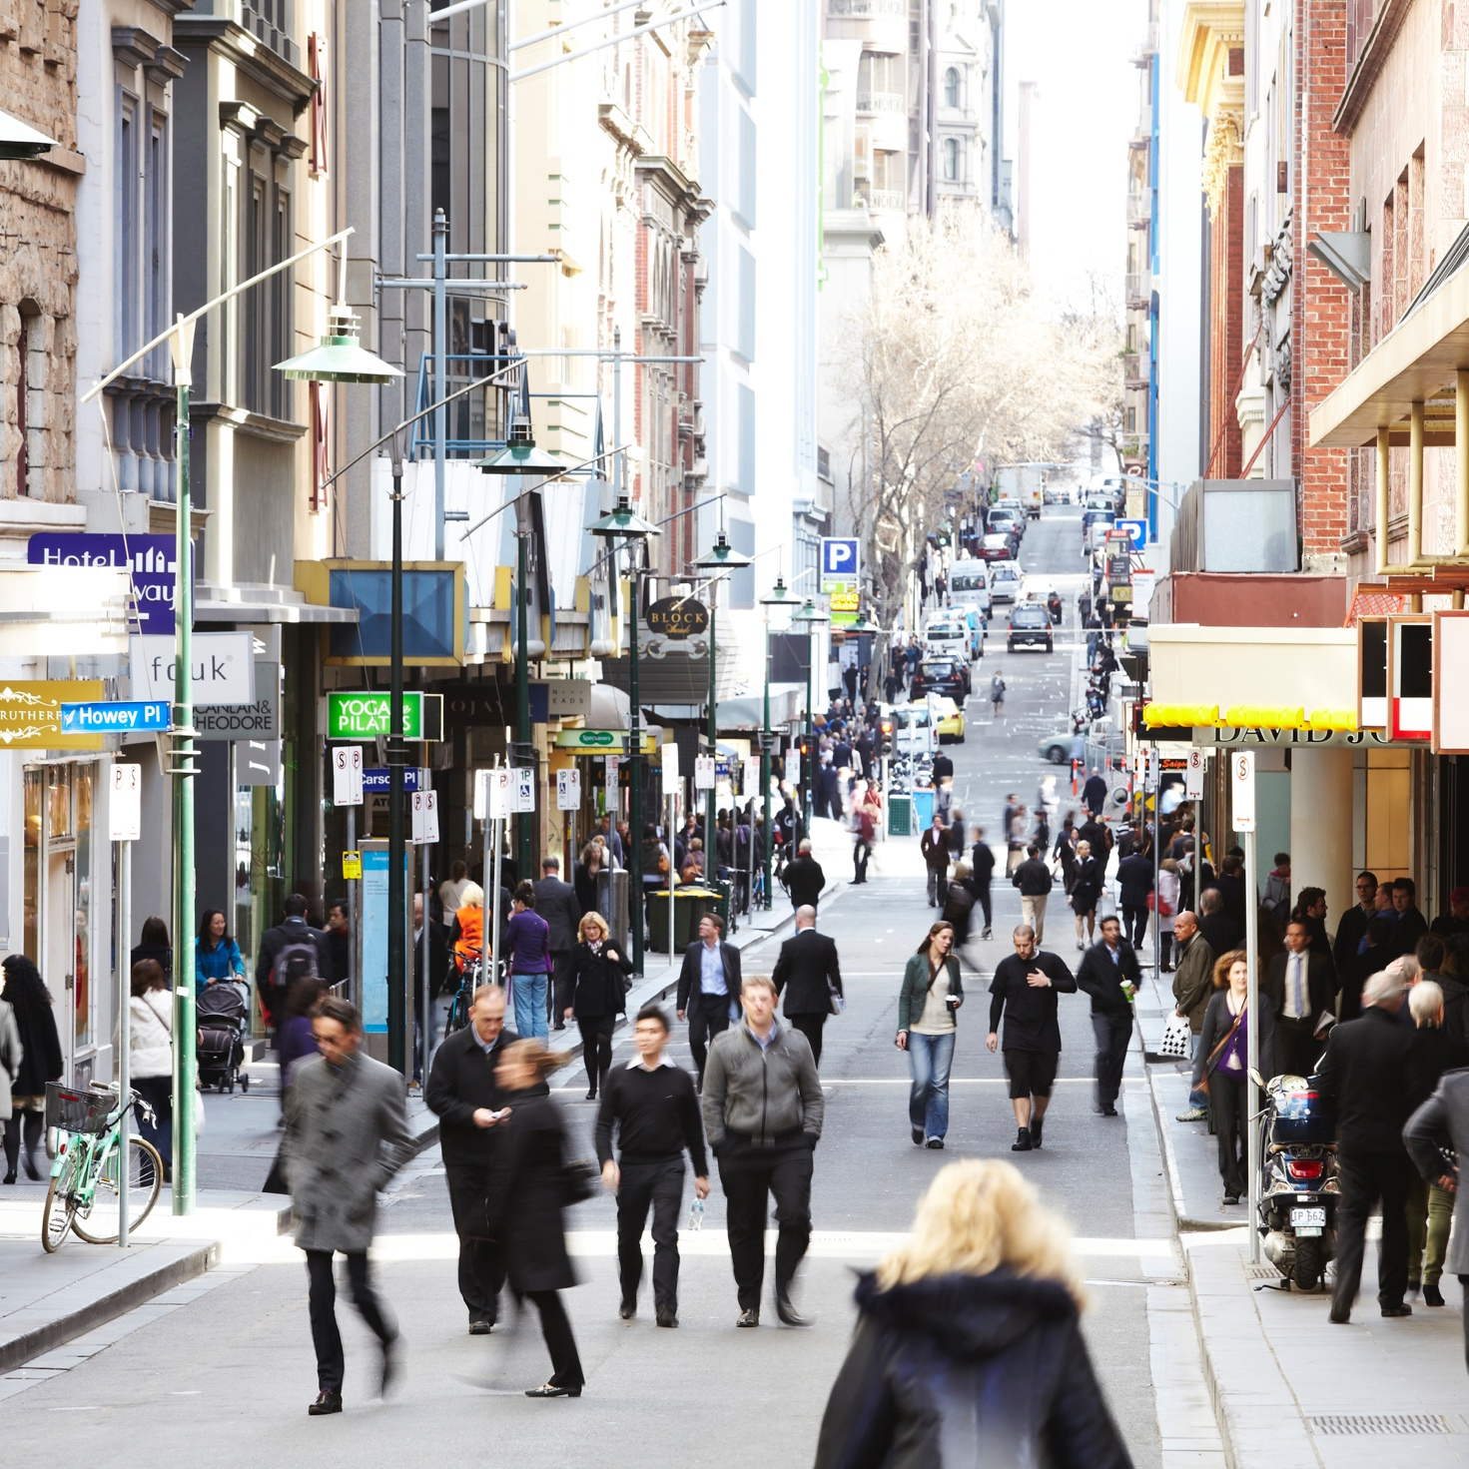
Source: City of Melbourne (n.d).
However, outside of these times, priority for pedestrians is often reduced, with narrow footpaths a common feature and car parking provided on both sides of the street. There is an argument that vehicular access should be limited within these areas to residents, deliveries and emergency services. Such a place-based approach would reallocate space based on function and efficiency, to create more people-friendly environments, such as shared spaces/zones.
It would be nice to have more shared spaces…I like exploring these streets…it’s nice because there are more people and it has a kind of European feel.
Minority ethnic female student and daily visitor to Hoddle Grid
According to a review of Shared Zones (City of Melbourne 2012c), there are currently 71 locations in the Hoddle Grid that are designated as ‘shared zones’, where pedestrians share the same space as vehicular traffic, but the former have priority. This review (Ibid) highlights Hardware Street, Degraves Street, Bank Place and Ridgeway Lane as some of the more successful schemes. The review also notes that there are a further 31 locations awaiting VicRoads approval, an additional 13 are in the process of being submitted for approval, and another 49 are currently being designed. The benefits of prioritising, non-car modes, particularly pedestrians, include improved safety, more vibrant spaces, more space for other uses such as outdoor dining, reduce pedestrian crowding, improved access to public transport, and improved access for cyclists.

Summary
Given the increasing demand for space in the Hoddle Grid, it is argued that the City of Melbourne must prioritise more efficient forms of transport, including public transport, walking, cycling and rideshare. This will enable the reallocation of space to support the increasing daily population, while also improving the experience of living in and visiting the city for everyone.

How Other Global Cities are Reallocating Space
Most cities around the world face the same challenges as Melbourne in terms of how to best allocate city space. Many are now taking the brave steps to ensure the liveability and future economic, social and environmental sustainability of their cities. The following section presents a selection of cases that demonstrate how these initiatives could be applied in the Hoddle Grid.

At the City Level

Oslo is Going Car-free
Oslo has one of the highest quality of life rankings in Europe, and the fastest rate of population growth, which the City of Oslo has identified as its biggest threat. To address this threat, the City of Oslo launched an ambitious plan in 2015 to make its central area car-free by 2019. Car-free does not mean completely eliminating all access for vehicles in the central city, rather the aim is to prohibit unnecessary use of motor vehicles. Where required, access is maintained for deliveries, people with mobility impairments and taxis. However, access within the central area will be primarily by walking, cycling, rideshare and public transport.
Figure 25: Oslo’s central city
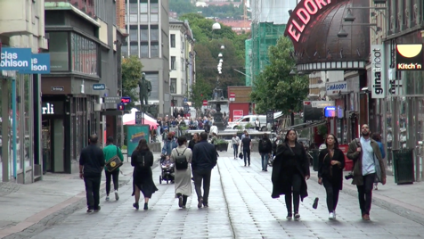 | 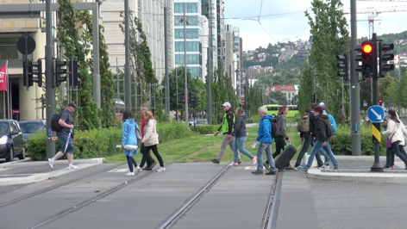 | 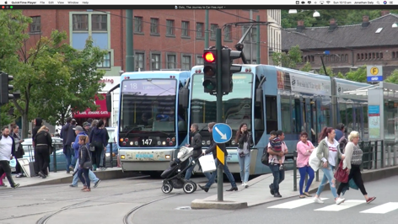
Source: Street Films (2018).

Why Oslo is Going Car-free
Oslo’s main reason for going car-free in the central city are primarily because of population growth, but also because of the need to adapt for climate change, to create a more equitable city, and to prevent hostile vehicle attacks.
“The primary focus is to improve city life and reducing traffic from private cars is used as means to achieve this. Freed areas previously occupied by cars can be used by the municipality, organizations, businesses and inhabitants to everything from outside dining, culture activities, art, bicycle stands or playgrounds.”
City of Oslo (2017)
These are the same challenges facing most global cities, including Melbourne. Madrid (Spain), Paris (France), Hamburg (Germany), Chengdu (China), Brussels (Belgium), Mexico City (Mexico), Helsinki (Finland), Dublin (Ireland) and Milan (Italy) are also undertaking a significant reallocation of space away from private cars to more efficient modes of transport, all for the same reasons.

How Oslo is Going Car-free
Oslo is reallocating space away from private motor vehicles to create more space for other uses. To achieve this, they are incrementally removing 700 on-street car parking spaces and reallocating this space for:
- Bike share scheme, 60 kilometres of bicycle lanes, bicycle parking and subsidy scheme for purchase of cargo bicycles;
- New tram routes, complete upgrade of existing network and purchase of 87 new trams;
- Upgrading the bus system;
- New public spaces, including playgrounds, shared zones and pedestrian-only zones;
- Footpath widening; and
- New one-stop-shop app for all public transport, for journey planning and the purchase of tickets.
Figure 26: Reallocating space in Oslo's central city
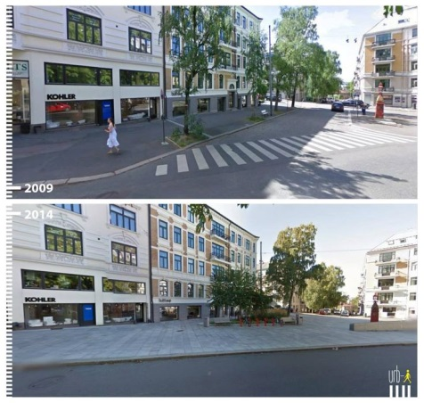 | 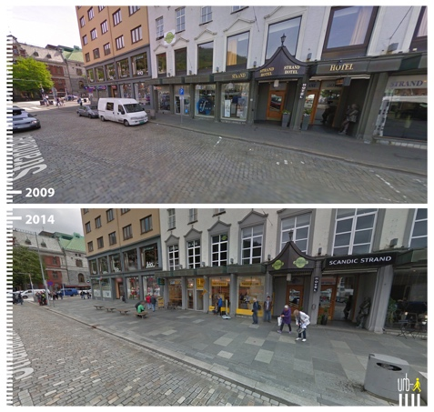 | 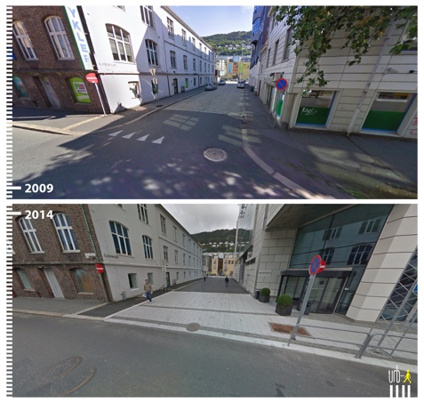
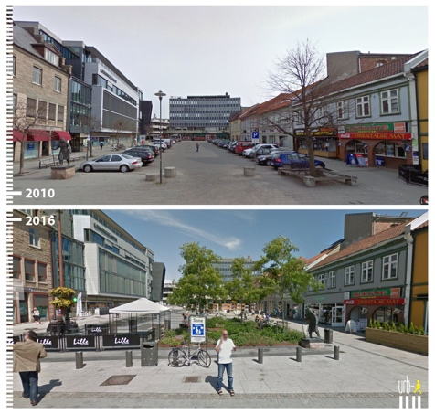 | 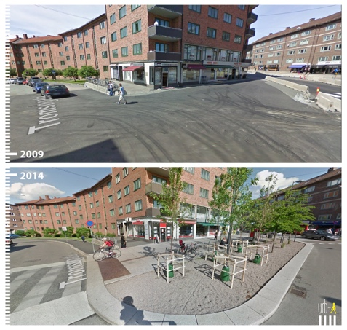 | 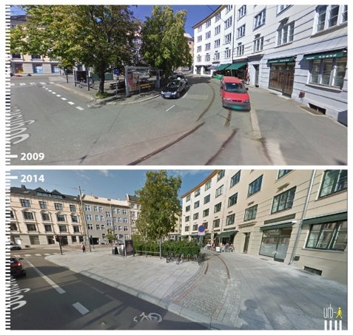
Source: Urb-i / Google Streetview (2018).

How could this be Applied in Melbourne?
Oslo’s central area (1.3 km²) is significantly smaller than the Hoddle Grid (6.2 km²), with a significantly smaller population (1,150 compared to 136,000). Therefore, it may be more practical to identify areas within the Hoddle Grid – comprising a number of blocks – that could become (mostly) car-free. This could then be incrementally expanded across the Hoddle Grid as the population continues to grow.
While Oslo plans to remove 700 car parking spaces, the City of Melbourne has (since 1999) removed 1520 on-street car parking spaces. However, in relative terms, Oslo is removing three times more on-street car parking than Melbourne. As on-street car parking is one of the least efficient uses of city space, the City of Melbourne could consider a strategic approach to reallocating this space for more productive uses, such as space for pedestrians, cyclists, public transport, outdoor dining, and climate change adaptation.
The City of Melbourne should be a city for people to explore and enjoy the city easily and comfortably. To realise this, the city should transition from a car-based city to a people-based city. This can only be achieved by actively discouraging cars entering the city.
Respondent, Future Melbourne 2026 (City of Melbourne 2017b)
Like most global cities, Melbourne is unlikely to become completely car-free. However, given the pressures for space in the Hoddle Grid, it is conceivable that heavily restricted access for private motor vehicles will be an appropriate policy option in the future. This does not mean preventing people from travelling to the Hoddle Grid by private motor vehicle, rather, like Oslo, travel through the Hoddle Grid would be mainly by more efficient modes that consume less space, like public transport, walking and cycling. As an immediate priority, trips through the Hoddle Grid to destinations beyond should be restricted.

At the Block Level

Barcelona is Creating People-friendly Areas
In Barcelona, an area of 7.5 square kilometres called Eixample, comprises a grid layout and is home to approximately 267,000 residents. The grid is framed by blocks, containing mainly residential apartments on the upper levels and retail / commercial on the ground floor. In 2014, the City of Barcelona released a 4-year Urban Mobility Plan proposing the creation of 500 ‘Superblocks’, with each Superblock comprising nine (3x3) regular blocks (400x400m) – See Figure 27. The aim is to eliminate unnecessary vehicular traffic and free up valuable space to improve conditions for people. Within the Superblocks vehicular access is limited to resident’s cars, deliveries, walking and cycling. Other vehicles can only use the roads outside the Superblocks. The Superblock concept was first suggested in 1987 and tested in 2003.
Figure 27: Barcelona’s Superblock concept
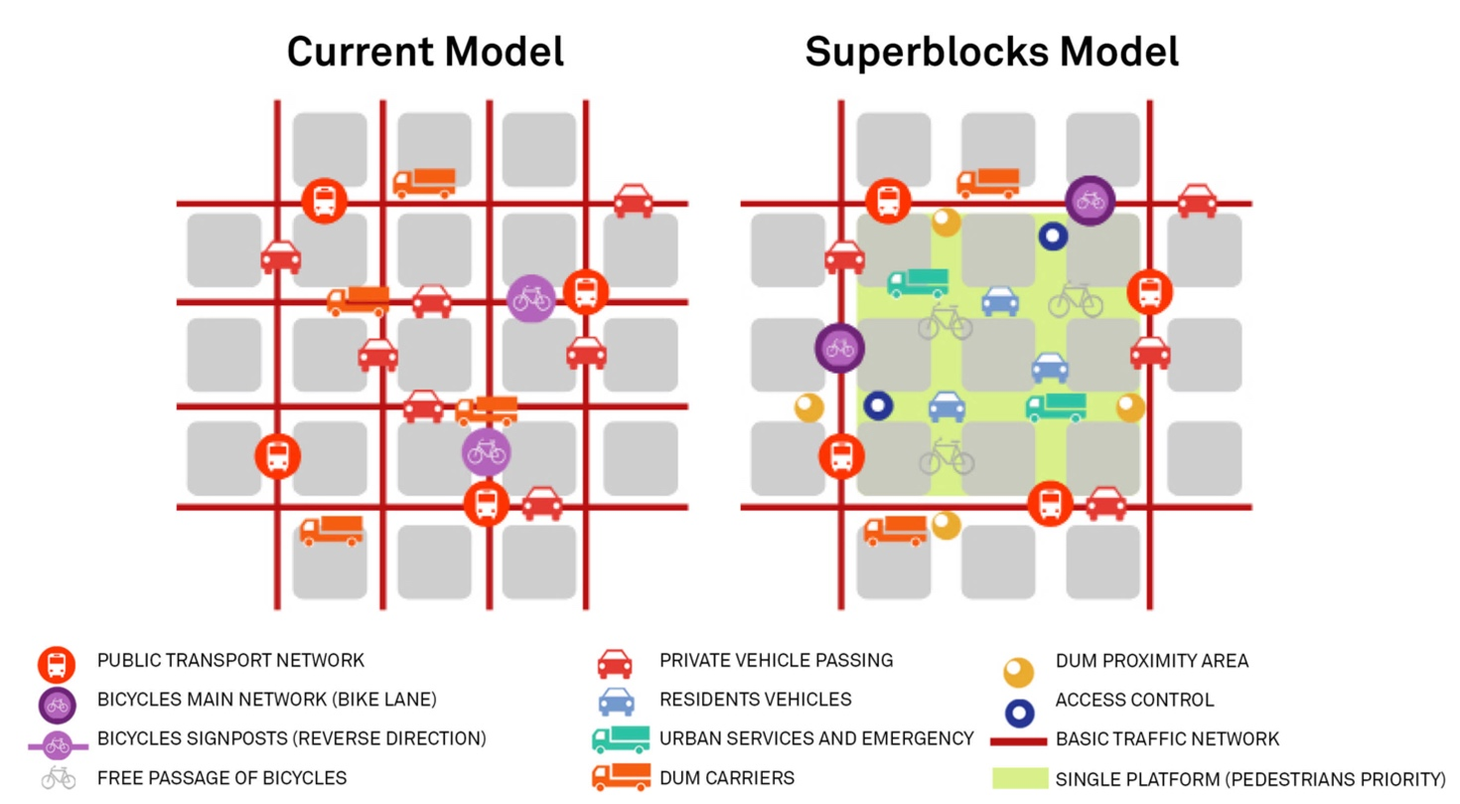
Source: City of Barcelona (2013).
The Superblock concept has already been successfully tested in the town of Vitoria-Gasteiz, which lies to the north of Barcelona (Civitas 2015). They have implemented 77 Superblocks since 2008, with positive economic, social and environmental outcomes. Pedestrian space within the central city increased from 45 per cent to 74 per cent, with a 40 per cent increase in walking trips. Noise pollution decreased from 66.5 to 61 decibels, while air pollution improved significantly with a 42 per cent reduction in nitrogen oxide emissions and a 38 per cent reduction in particle pollution. Overall, travel by private motor vehicles has decreased by 66 per cent within the Superblocks.

Why is Barcelona Creating Superblocks?
Barcelona faces significant issues in terms of providing sufficient space for their citizens, combating climate change, reducing air and noise pollution, and mitigating the safety risks of motor vehicles. For Barcelona, it is primarily a question of equity, with only 20% of total movements undertaken in private motor vehicles but 60% of all road space used by cars.
We want these public spaces to be areas where one can exercise all citizen rights: exchange, expression and participation, culture and knowledge, the right to leisure.
Salvador Rueda, Director of the Barcelona Urban Ecology Agency (Bausells 2016)
In reallocating urban space this way, significant benefits are provided to the community. For example, where almost 75% of all space was allocated for cars, 75% is now given to pedestrians. Furthermore, a significant health benefit is achieved with a 28% reduction in air pollution. Overall, the liveability rating for these spaces increasing from 25% to almost 75%.

How is Barcelona Achieving This?
Within the Superblocks, vehicular access is restricted to residents, business owners, deliveries, public transport, walking and cycling.
Figure 28: Reallocating space within the Superblocks
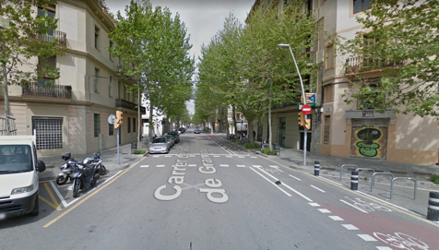 |  | 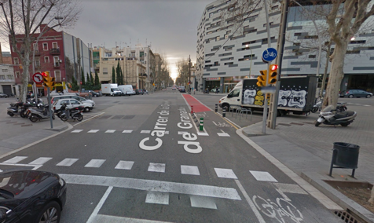 | 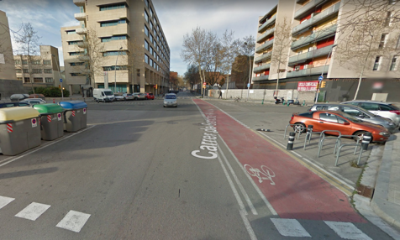
 | Before | Before | Before
 | 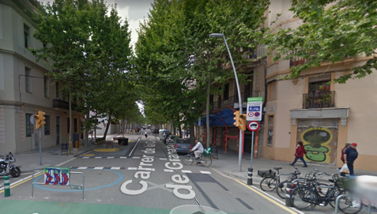 | 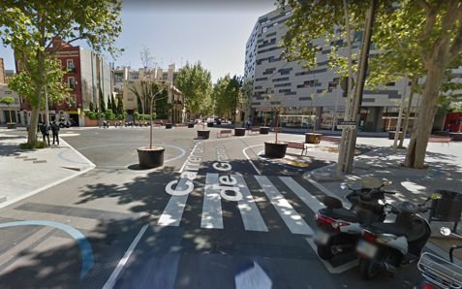 | 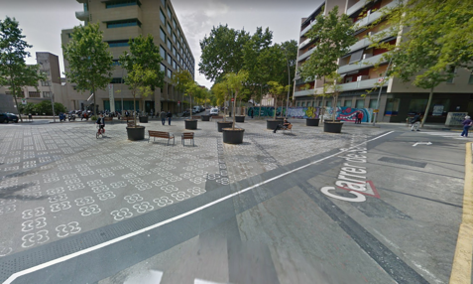
 | After | After | After
Source: Google Street View (2018).
Speed limits are reduced to 10 km/h to create people-friendly environments, where children can play freely. The restrictions on vehicular access are achieved via the installation of bollards and signage. Within the superblocks, new spaces are created for people and improvements are made for public transport, walking and cycling.

How Could this be Applied in Melbourne?
The land area of Eixample is comparable to that of the Hoddle Grid (7.5 km^{2,} compared to 6.2 km²), whereas Eixample’s residential population is larger than that of the Hoddle Grid (287,000 compared to 42,250). However, given the relative populations, there are likely to be more visitors to the Hoddle Grid compared with Eixample. Both Eixample and the Hoddle Grid are the busiest areas of Barcelona and Melbourne respectively during the working week. In both places about the same proportion of space is allocated to vehicular traffic (60 per cent in Eixample compared to 62 per cent in the Hoddle Grid), whereas in Eixample four times more trips are undertaken by car than in the Hoddle Grid (20 per cent compared to 5 per cent). On this basis, there is arguably an overprovision of space for cars in the Hoddle Grid.
Places like Degraves Street are such a success, we need more of this in our city. If these laneways were resurfaced as one flat surface (without curbs) then it is obvious that the whole space is for pedestrians. In terms of vehicle access, there could be an agreement that delivery vehicles can still drive here to make deliveries, but the pedestrian always has right of way. For example, a van could enter Little Bourke Street from Elizabeth street, quickly make a delivery and then promptly exit the pedestrian zone at Queen Street. This is something that is successfully managed in many European cities, so why not replicate it here in our great city?
Respondent, Future Melbourne 2026 (City of Melbourne 2017b)
Eixample’s regular blocks are smaller than those in the Hoddle Grid (133x133m compared to 215x200m), which provide greater permeability and creates more space when combined into Superblocks, than would be possible in the Hoddle Grid. However, this does make the creation of Superblocks in the Hoddle Grid relatively simpler, by simply restricting access for vehicles on the little streets between the blocks. An incremental approach could be applied, starting with the blocks that currently experience the highest levels of people-activity.
Figure 29 (overleaf) presents a sample of potential Superblocks in the Hoddle Grid. The larger Superblocks take advantage of the existing restrictions on Swanston Street. Restricting access for motor vehicles across the day and week would increase space for pedestrians, cyclists, outdoor dining, tree planting and other productive uses.
Figure 29: Potential Superblocks in the Hoddle Grid
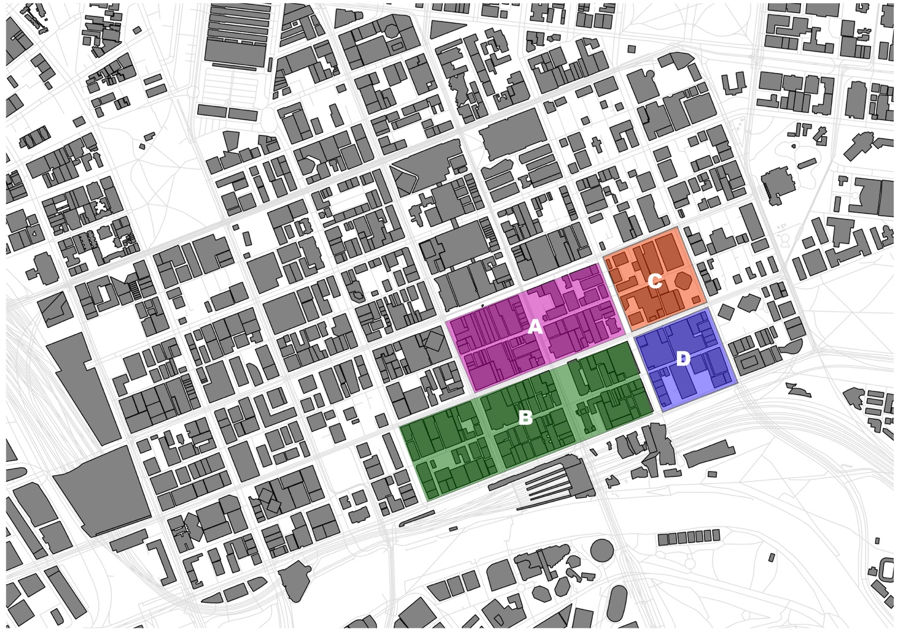
Source: Author, 2018.
This does not mean replicating the approach taken in Barcelona, rather it would mean adjusting the approach to suit the local context. For example, access to private off-street car parking is arguably one of the main barriers to delivering this in the Hoddle Grid, which would require more detailed investigation. Managing vehicular access to the Superblocks could be achieved by allocating permits, similar to the existing residential parking permit scheme.

At the Street Level

Copenhagen is Designing Multifunctional Spaces
Copenhagen has been gradually reallocating urban space away from private cars, since the first major oil crisis in the 1970’s, to create people-friendly environments. This has resulted in almost two thirds of all trips now undertaken by bicycle. However, like most global cities, Copenhagen faces increasing demands on limited city space from population growth, climate change adaptation, and for security. Their approach is to maximise the utility of the limited space available by creating spaces that serve several functions at the same time. The creation of multifunctional spaces is achieved by reallocating space away from inefficient uses, such as overprovision for private cars, to space for people, trees, and water management.

Why is Copenhagen Designing Multifunctional Spaces?
Multifunctional urban spaces enable the city to get more from what they already have. Urban spaces that serve a single purpose or function are a legacy of an era in planning when it seemed rational to divide the city into different functions. However, it has long been established that this approach is inefficient and that mixed-use planning is a much more efficient and effective form of planning (Jacobs 2002). Copenhagen is now applying this thinking to their urban public spaces.
It is easier to prepare Denmark for tomorrow’s climate than to clean up one cloudburst after another. This is why a project like [this] … is a big step in the right direction.
Environment Minister Ida Auken (Third Nature 2017a)
Instead of looking at streets purely for the movement of people and goods, they are integrating initiatives to create new public spaces and measures to mitigate climate change impacts.

How are Copenhagen Achieving This?
One example of how Copenhagen is creating multifunctional spaces is the Climate Alley streetscape project in the St. Kjelds neighbourhood of Østerbro – See Figure 30 and Figure 31. One of the main objectives of this project was to integrate measures to mitigate the impacts of climate change, extreme rainfall events or ‘cloudbursts’, with the provision of more and better space for people.
Figure 30: Climate Alley – plan view
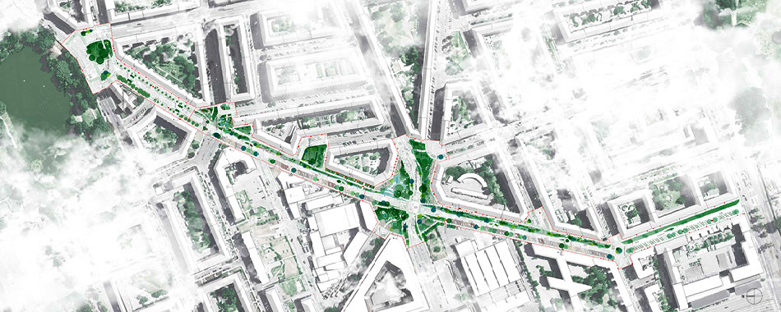
Source: Third Nature (2017b).
Climate Alley reallocates space to create more room for more efficient modes of transport such as walking, cycling and public transport. New public spaces are created for outdoor dining, exercise, play, and social interaction. Within these space, measures for rainwater capture and drainage have been integrated to provide more trees, vegetation and water features.
Figure 31: Climate Alley – reallocating space
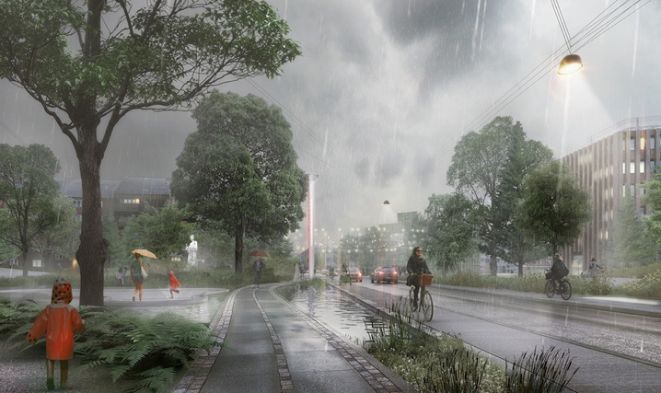 | 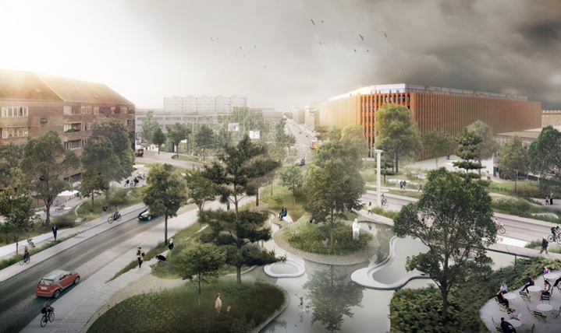
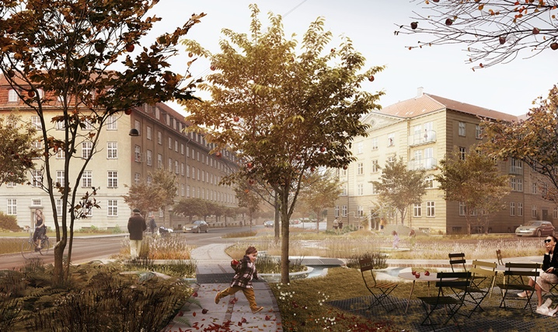 | 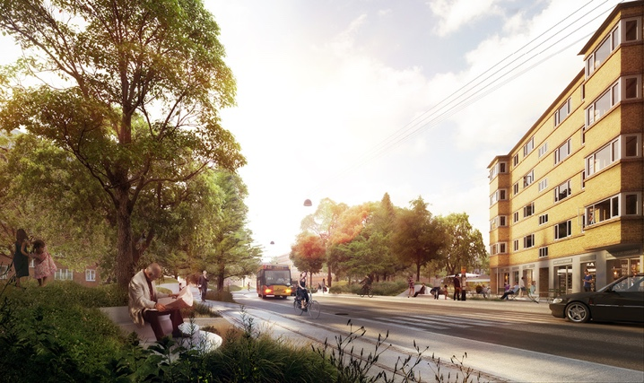
Source: Third Nature (2017c).

How Could this be Applied in Melbourne
While the design of streets in Copenhagen differs significantly to those in the Hoddle Grid, particularly in terms of the priority assigned to more efficient modes of transport, and the location of the Climate Alley project is outside the central city, there are still useful lessons for Melbourne. The designers behind this project set out to create a new standard typology for streetscape design, one which reallocates space to serve several important functions at the same time. The key lesson for Melbourne is the integrated, multifunctional approach to streetscape design. An approach that helps to address several pressing issues facing Melbourne, and all global cities; how to create more space for a growing population, provide for climate change adaptation, and provide for more efficient modes of transport. Such an approach would integrate the city’s transport requirements with those of climate change adaptation, such as the measures proposed in the City of Melbourne’s Climate Change Adaptation Strategy and Urban Forest Strategy.

How Other Global Cities are Thinking About the Future
Given the refresh of the Transport Strategy will have a 30-year timeframe, it is important to look beyond current best practice because this is what is happening today, not in 4, 10 or 30 years’ time. To determine what city space might look like in the future, we can consider the work being carried out by urban researchers in universities, think tanks, advocacy groups and other forward-thinking organisations around the world. The following are some examples of new ideas and thinking about how cities might allocate space in the future. While the direct application of these examples may not be possible in the Hoddle Grid, each case offers ideas and lessons for the Transport Strategy.

The Future of City Precincts

Waterfront Toronto’s Smart City
The planning and design of entirely new precincts is a common aspect of many of the world’s major cities. Melbourne has or is delivering several such projects, including Fisherman’s Bend in the west and Arden in the north. Sydney is currently finishing the construction of Barangaroo on its waterfront. However, a new proposed development in Toronto, Canada, offers a glimpse of what the future might hold for the use of urban space at a precinct level. Waterfront Toronto is a renewal project to transform 800 acres of the city’s waterfront into “… a world-class archetype of post-industrial innovative urban development.” (Sidewalk Labs 2017a).
Figure 32: Waterfront Toronto's urban design and technology concept
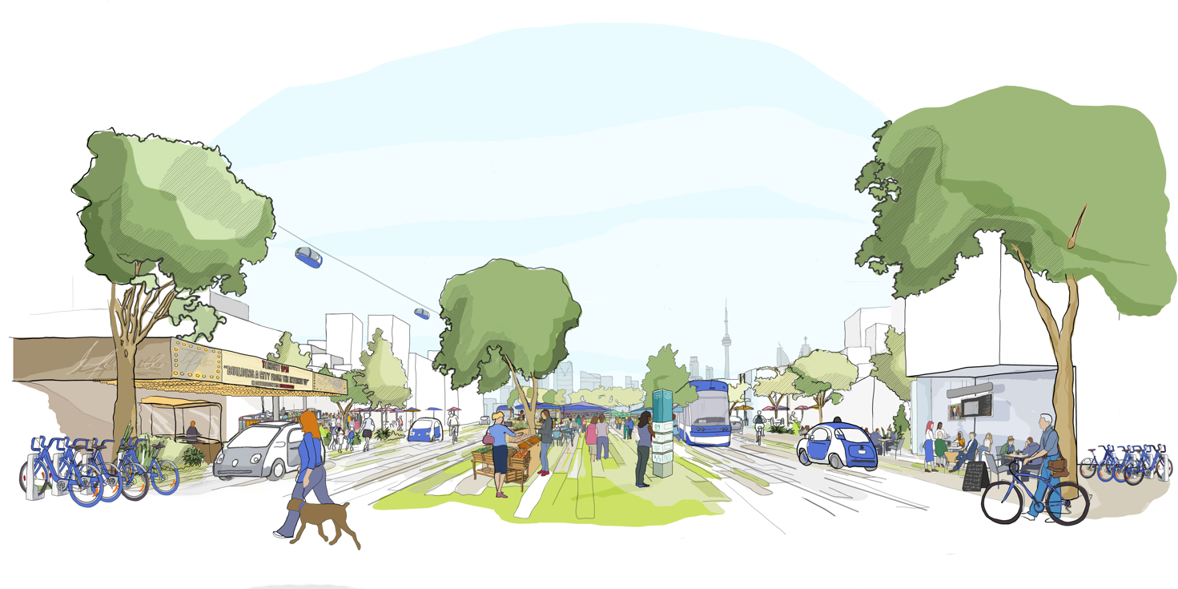
Source: Sidewalk Labs (2017b).
Waterfront Toronto is envisioned as a “smart city” concept, combining best practice in urban design and digital technology “…to address some of the biggest challenges facing cities, including energy use, housing affordability, and transportation.” (Sidewalk Labs 2017a). What is also vastly different about this project, is that it is being designed by Sidewalk Labs, which is part of Google. In its agreement with the city, Google will invest $50 million (Canadian Dollars) in testing new technologies and will also relocate their Canadian headquarters to the precinct.
Waterfront Toronto aim to embed technologies in all aspects of the precinct, including how it is constructed and how it operates on a day-to-day basis. Sensors will track everything from the movement and behaviour of people, to the operations of buildings and transport. Sidewalk Labs note that the use of sensor technology is also intended to improve the efficient use of urban space, ie. to create “a place where people-centred street designs and a range of transportation options make getting around more affordable, safe, and convenient than the private car.” (Sidewalk Labs 2017a)

Lessons for Melbourne
There are several lessons that could be relevant for Melbourne. First, the proposed integration of good urban design principles with new technologies represents a more grounded approach for what could be termed ‘the smart city’, rather than adopting a technology-led strategy. The value of this approach is captured in Sidewalk’s proposed reallocation of space for people.
Sidewalk’s approach to the public realm centres on returning it to pedestrians and making it more usable more often.
Sidewalk Labs (2017a, p. 19)
Secondly, this example also presents a warning about the continuing privatisation or, an encroachment of big corporations into, urban public space. Google’s role in the Waterfront Toronto development has raised many concerns among the public, particularly about privacy issues related to data collection. More recently (December 2017), in Melbourne, the State Government controversially announced that Apple would open a new flagship store in Federation Square, raising concerns about the ownership and control of public space.
As with all emerging technologies, such as autonomous vehicles, there are both potential benefits and drawbacks. What is important for the City of Melbourne is taking a proactive approach to ensure that emerging technologies work in the interests of the public. In other words, to ensure that new technologies and the emerging role of big corporations in urban planning, benefits everyone economically, without compromising the social and environmental quality of the city.

The Future of City Streets

NACTO’s Blueprint for Autonomous Urbanism
The National Association of City Transportation Officials (“NACTO”) is a non-for-profit association of some of the largest cities across North America, dealing with transportation issues of local, regional and national significance. In October 2017, NACTO released a Blueprint for Autonomous Urbanism, setting out “…a future where cities benefit from new transportation technologies to improve the public realm and build streets that work for people, rather than merely redesigning streets to accommodate emerging technologies.” At the heart of this document is a warning that the benefits of autonomous vehicles are not guaranteed, and that if we do not act now to ensure that people, and not technology, are the focus of automation, we risk repeating the mistakes of yesteryear, when as Janette Sadik-Khan (former commissioner of the New York City Department of Transportation) states:
One century ago, as the automotive age swept across the nation, cities responded not by adapting cars and trucks to the varied uses of the street, but with a relentless clear cutting of urban roads, removing all obstacles from curb to curb - including pedestrians - and all but eliminating street life. Subsequent generations of urban planners built upon this, hollowing out downtown urban cores with congestion and traffic danger, replacing housing with parking lots, and eviscerating urban economies.
NACTO (2017, p.3)
This document argues that we need to heed these mistakes and ensure that we use the benefits of automation to create people-friendly urban spaces, “…one in which automation can serve the goals of safety, equity, public health, and sustainability” (NACTO 2017, p.8). They illustrate the potential space saving benefits in Figure 33 overleaf. However, they stress that this is only possible with a balanced and integrated mobility system in which autonomous cars are not prioritized above public transport, walking and cycling.
Figure 33: The potential for reallocating space with autonomous vehicles
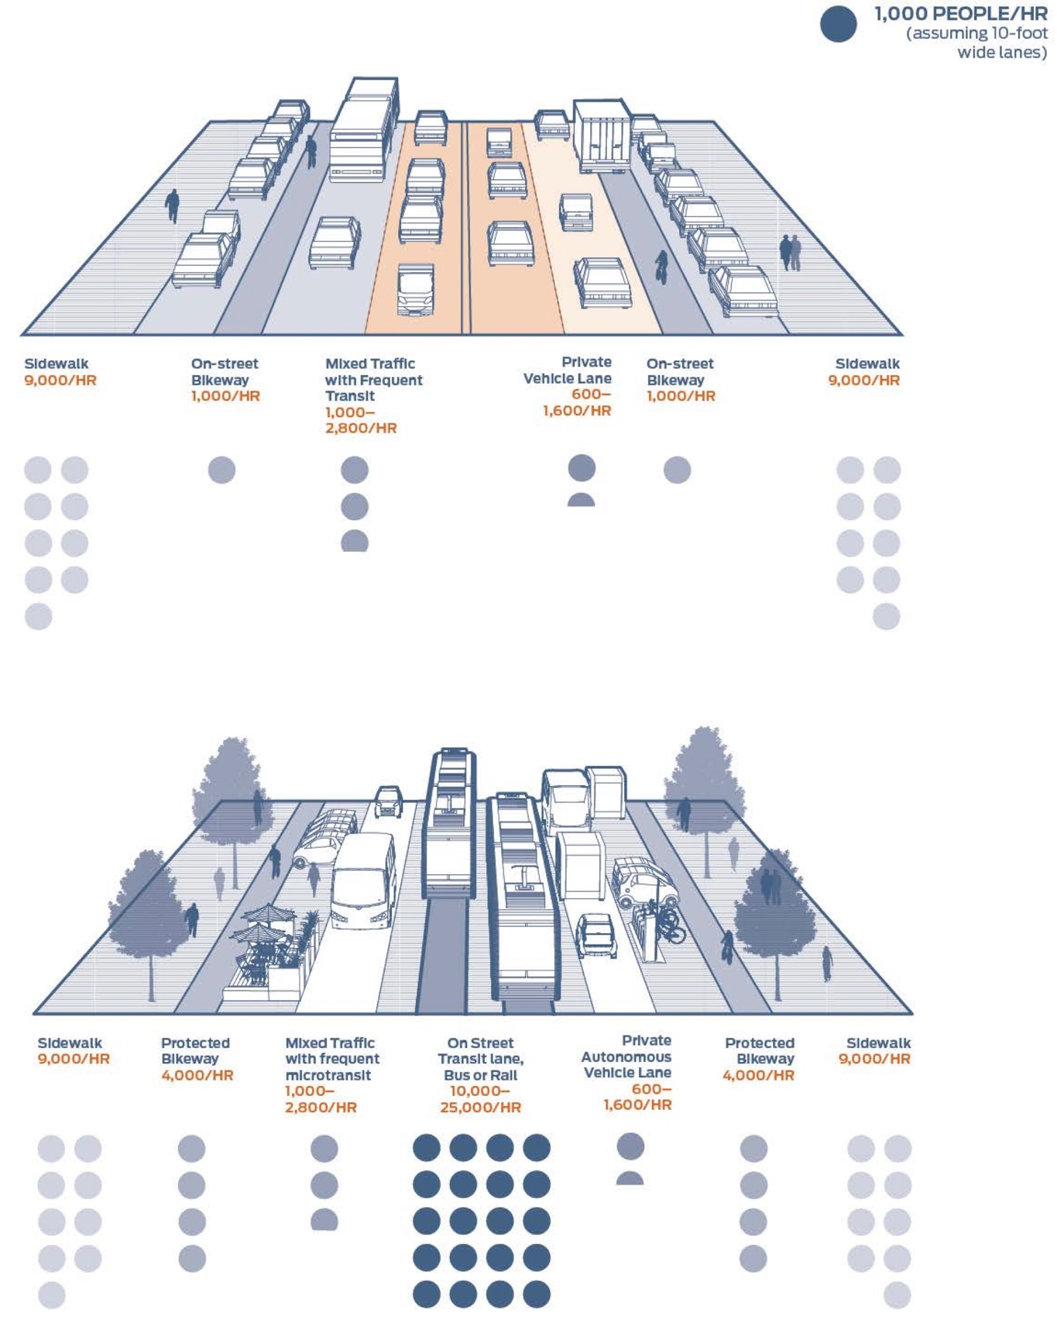
Source: NACTO (2017, p.50).
NACTO propose that we use the benefits of automation to reallocate space away from private motor vehicles, to create space for more efficient transport modes like walking, cycling and public transport, and to create more public space for people. They argue that this approach will deliver benefits for the whole city, social, environmental and economic.

Lessons for Melbourne
The key lesson here for Melbourne is that the benefits of autonomous vehicles are not guaranteed. The City of Melbourne, like all global cities, must be proactive to ensure that these emerging technologies benefit the public interest. This will mean ensuring that any space created by autonomous vehicles through the elimination of parking and narrower vehicle widths, are reallocated to create more space to accommodate population growth, climate change adaptation and other more pressing issues (see Section 2). It will also mean managing autonomous vehicle demand to prevent the consumption of city space to meet this demand, especially within the Hoddle Grid.

The Future of City Parking

POP-UP in New York and Copenhagen
POP-UP (see Figure 34 below) is an idea developed by the Danish architecture firm Third Nature, which attempts to address three key urban issues simultaneously, namely the increasing occurrence of heavy rain weather events that produce flooding; the inefficient use of space as surface car parking which results in congestion as cars circulate searching for spaces; and the lack of green open space in cities.
Figure 34: The POP-UP concept
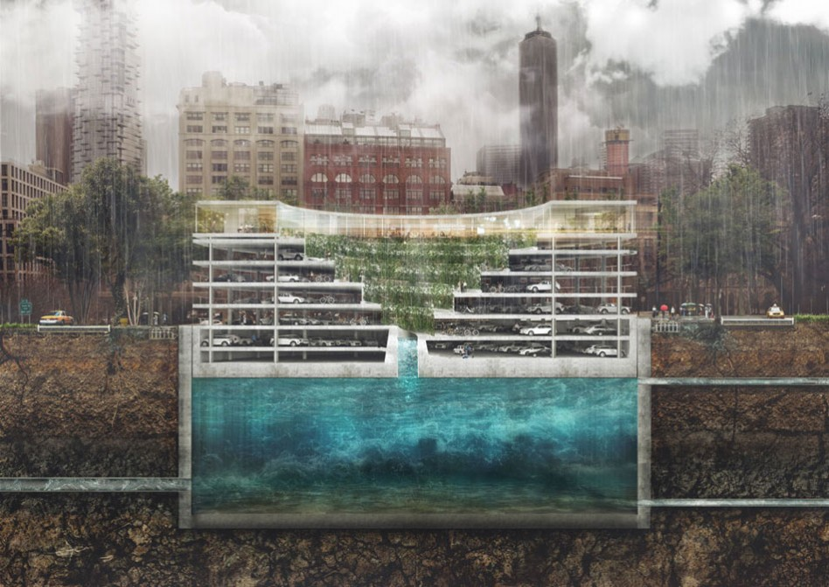
Source: Third Nature (2017d).

Figure 35: Pop Up operation
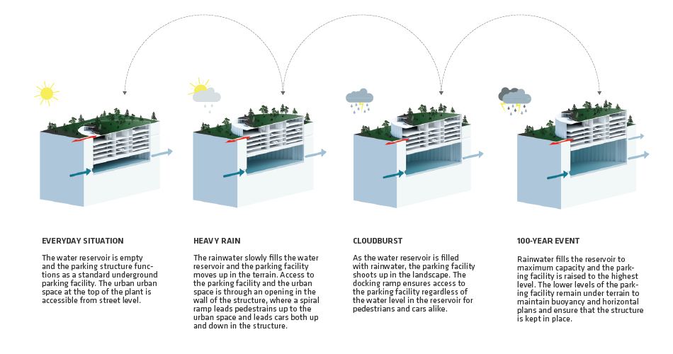
Source: Third Nature (2017d).
This idea creates new green open space by moving surface car parking into a stacked parking structure that is submerged in the ground. During a major rain weather event, the reservoir in which the car park is submerged collects the excess rainwater forcing the car parking structure to rise out of the ground, above the surface – see Figure 35 above, for details of how this concept operates.
There is a battle for urban space. Often the choice comes down to financials and open spaces loose to developments. By combining several solutions into one, the POP-UP enables cities to ensure the economic vitality of the city whilst becoming resilient. They can maximize the economic return by creating dense and vibrant neighbourhoods and ensure resilient and liveable urban spaces for the local population.
Jonathan Asbjørn Leonardsen, Rambøll (Third Nature, 2017e)
The idea has been considered in different cities around the world, including Copenhagen, London, Singapore, Mexico, Tokyo and New York. What is most important about this idea is the approach that seeks to address multiple pressing problems with one initiative, which produces multiple benefits for a city and its inhabitants.

Lessons for Melbourne
POP UP is another example, albeit highly conceptual, about how to take a multifunctional approach to the use of city space. This is important because of the many demands for city space, particularly those created by population growth and climate change. The approach is more important here than the actual proposal, as the feasibility of POP UP in or around the Hoddle Grid is unknown. The idea behind POP UP may offer the City of Melbourne a source of inspiration to remove all surface car parking in the Hoddle Grid, while also implementing important climate change adaptation measures.

How City Space Could Be Reallocated in the Hoddle Grid
This section presents a series of directions for the Transport Strategy refresh. They are based on the six key conditions, discussed in Section 2, that are increasing pressure on the use of space in the Hoddle Grid, the impact this has for how people travel to and within the city, and effects on how different users experience the city. Under each strategic direction, a series of potential policies are proposed that have been closely based on international best practice but within the context of the City of Melbourne.
The directions provided here seek to:
- Maximise access and mobility to and within the Hoddle Grid for everyone, including deliveries and emergency services;
- Maximise the utility of the limited urban space available in the Hoddle Grid;
- Provide an inclusive and equitable environment that is safe and comfortable for everyone, particularly the most vulnerable;
- Create an environment resilient to the threats of terrorism and climate change; and
- Enhance the vibrancy and attractiveness of urban space to support the economic and cultural well-being of the Hoddle Grid.
These strategic directions, and associated policies, are provided here as a starting point for a discussion among the wider community about how best to allocate space in the city. Benefit-cost analysis tools will help identify the options which are most likely to generate the best value outcomes for the City of Melbourne.

Strategy 1: More Inclusive Use of Space
The provision of more inclusive space is both a regulatory and moral responsibility for the City of Melbourne. Different users of the city experience it in different ways. For some, such as people with mobility impairments, the elderly, families with young children, women, LGBTQI people, and people from minority ethnic backgrounds, using city space can prove more challenging physically and mentally (see Section 2.2.2). Some of the changes taking place in the city, particularly the overcrowding caused by population growth, have a disproportionate impact on these groups. The reputation of the city relies heavily on how it is experienced by the more vulnerable members of society, as such it is critical that city space is inclusive and equitable for all users.
Policies for more inclusive use of space
- Undertake ‘user experience’ research on an annual basis to better understand how different users experience city spaces. This is particularly important for LGBTQI people, people from minority ethnic backgrounds and female users of the city, whose experience of city space is relatively under-researched. This research can be used to benchmark progress and to inform the development of City of Melbourne policies, plans and strategies. Such information can also be used to inform the design and management of city spaces.
- Declutter pedestrian spaces by removing or relocating uses and objects, to remove barriers and obstacles for people who require the use of mobility aids and families with young children and prams:
  - Consider relocating all bicycle parking (privately-owned and shared services) and motorbike parking to the kerbside. This may require removal of some footpath parking in the Hoddle Grid and providing alternative parking kerbside by using space currently assigned to car parking. It is also proposed that this opportunity is used to increase provision for bicycle and motorbike parking across the Hoddle Grid.
  - Further limiting the use of footpath space for portable advertising boards, particularly on heavily pedestrian trafficked streets and on footpaths of limited width.
  - Consider further limiting busking on heavily pedestrian trafficked footpaths, such as Swanston Street, across the day, during the week and on weekends.
  - Remove and/or rationalise redundant street furniture, signage and other objects on footpaths and in public spaces. This would require an audit of all streets within the Hoddle Grid to map all objects and determine those that are redundant, and those that can be rationalised (eg. Signage).
  - Consider further limiting the use of ‘counter-style’ food and beverage shop frontages on heavily pedestrian trafficked footpaths, which create queues and crowding limiting access for other city users. Address on a case-by-case basis.
- Provide more time for pedestrians to cross streets to and within the Hoddle Grid, particularly for people with mobility impairments who are less able to cross safely and comfortably (See also Strategy 2, Policy 3).
- Reduce traffic signal cycle times at intersections to reduce waiting times and pedestrian crowding, and also provide more time for people with physical impairments to cross safely and comfortably.
- Investigate the provision of a consistent and coherent wayfinding system that provides for the needs of people with visual impairments and people with dementia.
- Ban the use of sexist and highly-sexualised advertising and imagery in city spaces, including on tram stops, which negatively affects the experience of the city for females of all ages, and contributes to cultural problems of sexual harassment.

Strategy 2: More Efficient Use of Space
Making more efficient use of city space means the reallocation of physical space and the reassignment of priority to different uses and users. The purpose of reallocating city space is to maximise the utility of the limited space available in the Hoddle Grid. By doing so, better use can be made of this space to address the challenges of population growth, climate change, and security threats.
Policies for more efficient use of space
- Reclaim city space within the Hoddle Grid by:
  - Reduce the provision of on-street parking for private car use (Short to Long-term); and
  - Where possible, reduce the number and/or narrow the width of traffic lanes (Short to Long-term);
- Reallocate this reclaimed space for:
  - The provision of wider footpaths to support pedestrian movements and activities, including outdoor dining, trading, seating and the creation of pocket-sized public spaces for civic purposes;
  - The integration of climate change adaptation measures, such as tree planting and rain water management, which will also help to create a more attractive and comfortable environment for all people, but particularly the young and the elderly;
  - The integration of measures to prevent hostile vehicle attacks;
  - The provision of public transport services and a network of separated bicycle lanes; and
  - Loading zones, disabled parking, taxi ranks, rideshare vehicle parking, and motorbike and bicycle parking.
- Increase priority for pedestrians at signalised crossings to reduce overcrowding on footpaths and create a safer and more comfortable environment for more vulnerable users of the city, such as people with young children, the elderly and people with disabilities.
  - Implement starting with the crossings at major train stations, King Street and along Swanston Street, on the little streets and to cross over Swanston Street (Short-term); and
  - Then roll out across the whole Hoddle Grid (Medium-term).
- Increase the provision of spaces in the Hoddle Grid that are shared by different modes of transport, increase space for economic, social and environmental needs:
  - Immediately designate the spaces proposed in the City of Melbourne (2012c) study as ‘Shared Zones,’ with appropriate signage (short term).
  - Reduce speed limits to 20 km per hour in these zones and limit car parking (short term).
  - Gradually evolve Shared Zones (designated mainly by signage) into Shared Spaces through design changes, including the provision of a level surface (from building to building) and the removal of more traditional traffic engineering features such as signs, traffic lights, pedestrian barriers, road markings and kerbs (City of Melbourne, 2012c) (short to medium-term).
  - Develop place-based, people-friendly ‘Superblocks’ or areas that combine several shared spaces, which will increase the priority for people walking by expanding the concept of shared space to incorporate several streets and laneways – similar concept to Barcelona’s Superblocks (Medium to long-term).

Strategy 3: More Intelligent Use of Space
The concept of the ‘Smart City’, including the development of ‘Autonomous Vehicles’ or ‘driverless cars’, is now relatively familiar. The idea that technology can solve many, if not all, of our problems is not new, nor is has it proven so. The benefits these emerging technologies offer are not guaranteed (NACTO 2017). In fact, we run the risk of repeating history and allowing vehicles (this time driverless) to dictate how our cities are designed, and therefore how they are experienced. History has taught us that this approach was unsuccessful and unless we heed these lessons, it is possible that the advent of AVs will result in the reshaping of our city to meet the needs of an evolution of the private car, rather than using the benefits of AVs and other emerging technologies to meet the needs of our cities and its users. After all, we do not design our homes to fit our furniture, so why would we design our cities to fit a specific mode of transport. Rather, we must use emerging technologies to benefit the public interest.
Policies for more intelligent use of space
- Support emerging technologies that enable the reallocation of city space to better support the economic, social and environmental needs of the city.
  - Such technologies might include autonomous vehicles provided the space created by the elimination of car parking is reallocated to better support the city economically, socially and environmentally (see Policy 2, under Strategy 1).
- Support emerging technologies that benefit public transport services, particularly those that enable the provision of an integrated mobility service, helping to connect different forms of public transport into a seamless, 24-hour, door-to-door service.
  - This would involve the integration of train stations, bus and tram stops, airports, and car and bike share services into a connected communications network where information is shared in real-time with city users.
  - This will provide users with relevant information on all transport options based on their location via mobile devices.
- Support emerging technologies that enable access for important vehicular traffic, such as deliveries, emergency services, taxis and transport for people with disabilities.
  - This includes technologies that enable the design of smaller, space efficient, flexible and adaptable delivery and emergency service vehicles, to reduce space requirements in the Hoddle Grid. This could include cargo bicycles and drones for deliveries.
      - Technologies to support the fast response of emergency services are already in use, such as Emergency Vehicle Priority (EVP) that provide a passage of green lights. Drones are now being used by fire services around the world, enabling emergency services to deliver medical supplies and locate victims more quickly.
      - It is also possible that emerging technologies will enable the design of smaller emergency service vehicles that can better navigate constrained urban spaces. Such developments would be very beneficial given the relatively large vehicles currently in use, many of which rely on the use of tram tracks for access within the Hoddle Grid.

Have Your Say
This discussion paper is only the start of the process of creating a new Integrated Transport Strategy. However, it is a perfect opportunity to start thinking about the challenges facing our Hoddle Grid and how we can meet them.
To help you get involved in this discussion, we have proposed several questions below for you to consider and respond to:
- If you live in the Hoddle Grid, what kind of public spaces do you / would you like to experience?
- If you live outside the Hoddle Grid, including outside Inner Melbourne, do you need to drive to your destinations in the Hoddle Grid or do you need access to these places?
- If almost 90% of all trips within the Hoddle Grid are made by walking, should we prioritise pedestrian movement above all other modes?
- Should we reshape the Hoddle Grid for autonomous vehicles or should people-friendly environments take priority?
- How would you prioritise the allocation of space in the Hoddle Grid given the limited space available and the many demands for it?

References

Australian Government 2017, ‘Australia’s Strategy for Protecting Crowded Places from Terrorism’, Commonwealth of Australia, Canberra, accessed 14 January 2018: https://www.nationalsecurity.gov.au/Media-and-publications/Publications/Documents/Australias-Strategy-Protecting-Crowded-Places-Terrorism.pdf
Australian Institute of Health and Welfare, 2012. ‘Dementia in Australia’, Canberra: AIHW. accessed 14 January 2018: https://www.aihw.gov.au/getmedia/199796bc-34bf-4c49-a046-7e83c24968f1/13995.pdf.aspx?inline=true
Blackman, T, Mitchell, L, Burton, E, Jenks, M, Parsons, M, Raman, S, & Williams, K 2003, ‘The accessibility of public spaces for people with dementia: a new priority for the 'open city’, Disability & Society, 18, 3, pp. 357-371
Bausells, M 2016, ‘Superblocks to the rescue: Barcelona’s plan to give streets back to residents’, The Guardian, London, accessed 14 January 2018: www.theguardian.com/cities/2016/may/17/superblocks-rescue-barcelona-spain-plan-give-streets-back-residents
City of Barcelona 2013, ‘Urban Mobility Plan of Barcelona 2013-2018’, accessed 14 January 2018: www.mobilitat.ajuntament.barcelona.cat/sites/default/files/docs/PMU_Sintesi_Angles.pdf
City of Melbourne 2009, ‘Climate Change Adaptation Strategy’, accessed 14 January 2018: www.melbourne.vic.gov.au/sitecollectiondocuments/climate-change-adaptation-strategy-refresh-2017.pdf
City of Melbourne 2012a, ‘Transport Strategy: Planning for Future Growth’, City of Melbourne, accessed 14 January 2018: www.melbourne.vic.gov.au/SiteCollectionDocuments/transport-strategy-2012.pdf
City of Melbourne 2012b, ‘Urban Forest Strategy: Making a Great City Greener 2012-2032’, accessed 14 January 2018: www.melbourne.vic.gov.au/SiteCollectionDocuments/urban-forest-strategy.pdf
City of Melbourne 2012c, ‘CBD Shared Zones’, accessed 14 January 2018: www.participate.melbourne.vic.gov.au/application/files/7714/1222/4710/COM_SERVICE_PROD-_7989222-v3-Walking_Plan_Technical_Report_-_Shared_Zones.pdf
City of Melbourne 2012d, ‘Walking Plan 2014-17’, accessed 14 January 2018: www.melbourne.vic.gov.au/SiteCollectionDocuments/walking-plan-2014-17.pdf
City of Melbourne 2012e, ‘Cycling Plan 2016-20’, accessed 14 January 2018: www.melbourne.vic.gov.au/SiteCollectionDocuments/city-of-melbourne-bicycle-plan-2016-2020.pdf
City of Melbourne 2017a, ‘Daily Population Estimates and Forecasts, City of Melbourne’, accessed 14 January 2018: www.melbourne.vic.gov.au/SiteCollectionDocuments/daily-population-estimates-and-forecasts-report-2017.pdf
City of Melbourne 2017b, ‘Future Melbourne 2026: Transport Reinvestigation Addendum’, accessed 14 January 2018: www.participate.melbourne.vic.gov.au/future
City of Oslo 2017, ‘Car free city life in Oslo’ accessed 14 January 2018: www.oslo.kommune.no/english/politics-and-administration/green-oslo/best-practices/car-free-city/#gref.
Civitas 2015, ‘Superblocks model’, accessed 14 January 2018: www.civitas.eu/measure/superblocks-model
Colangelo, A 2017, ‘Man arrested over alleged Melbourne New Year's Eve terror plot for Federation Square’, The Age, Melbourne, accessed 14 January 2018: www.theage.com.au/victoria/man-arrested-over-alleged-melbourne-new-years-eve-terror-plot-20171127-gztznw.html
Free to Be 2017, ‘Girls have the right to feel safe in the city’, accessed 14 January 2018: https://www.plan.org.au/free-to-be/idil
Goh, K. (2017). Safe Cities and Queer Spaces: The Urban Politics of Radical LGBT Activism. Annals of the American Association of Geographers, pp.1-15.
Hou, J 2010, ‘Insurgent Public Space: Guerrilla Urbanism And The Remaking Of Contemporary Cities’, n.p.: Hoboken : Taylor and Francis, 2010.
Ipos 2018, ‘City of Melbourne: Update of the Strategic Transport Evidence Base’. Melbourne
Jacobs, J 2002, ‘The Death And Life Of Great American Cities’, n.p.: New York : Random House, 2002.
Madanipour, A 2010, ‘Whose Public Space? : International Case Studies In Urban Design And Development’, n.p.: London : Routledge, 2010.
Marcus Wong 2017, ‘Site clearance works continue at City Square’, accessed 14 January 2018: www.railgallery.wongm.com/melbourne-metro-rail-tunnel-prework/F121_1027.jpg.html
NACTO 2017, ‘The Promises and Perils of Automation’, accessed 14 January 2018: www.nacto.org/publication/bau/blueprint-for-autonomous-urbanism
Nadimpalli, S. Mateo-Babiano, I. Das, J. 2018. Putting the pieces together to create safe public spaces for all. [ONLINE] Available at: https://theconversation.com/putting-the-pieces-together-to-create-safe-public-spaces-for-all-89961. [Accessed 8 February 2018].
Kalms, N, Matthewson, G, Salen, P 2017, ‘Safe in the City? Girls tell it like it is’, accessed 14 January 2018: www.theconversation.com/safe-in-the-city-girls-tell-it-like-it-is-72975
Peen, J, Schoevers, R, Beekman, A, & Dekker, J, 2010, ‘The current status of urban-rural differences in psychiatric disorders’, Acta Psychiatrica Scandinavica, 121, 2, pp. 84-93
Richardson, E, Pearce, J, Mitchell, R, & Kingham, S 2013, 'Original Research: Role of physical activity in the relationship between urban green space and health', Public Health, 127, pp. 318-324, ScienceDirect
Ruiz-Apilanez, B, Karimi, K, Garcia-Camacha, I, & Martin, R 2017, 'Shared space streets: design, user perception and performance', Urban Design International, 22, 3, pp. 267-284, Arts & Humanities.
Sidewalk Labs 2017a, ‘Waterfront Toronto: Request for Proposal 2017-13’, accessed 14 January 2018: www.sidewalktoronto.ca/wp-content/uploads/2017/10/Sidewalk-Labs-Vision-Sections-of-RFP-Submission.pdf
Sidewalk Labs 2017b, ‘Sidewalk Labs - Mobility Vision’, accessed 14 January 2018: www.sidewalktoronto.ca/wp-content/uploads/2017/10/Sidewalk-Toronto-Image-Gallery.zip
South, J 2018, ‘A Deliveroo rider on the move’, accessed 14 January 2018: www.smh.com.au/content/dam/images/g/n/t/e/0/x/image.imgtype.articleLeadwide.620x349.png/1459292897915.png
Street Films 2018, ‘Oslo: The Journey to Car-free, accessed 14 January 2018: www.vimeo.com/212846367
Taylor, W 2017, ‘Ranks of the orange bikes have been seen on Melbourne streets’, accessed 14 January 2018: www.fairfaxstatic.com.au/content/dam/images/g/w/r/w/3/x/image.related.articleLeadwide.620x349.gwmz3u.png/1498009377955.jpg
The Fifth Estate 2015, ‘A GreenShareCar car in inner-city Melbourne’, accessed 14 January 2018: www.thefifthestate.com.au/wp-content/uploads/2015/07/car-share.jpg?fit=600%2C395&ssl=1
Third Nature 2017a, ‘City Center Cloudburst strategy’, accessed 14 January 2018: www.tredjenatur.dk/en/portfolio/city-center-cloudburst-strategy
Third Nature 2017b, ‘Climate Alley oversight plan’, accessed 14 January 2018: www.tredjenatur.dk/wp-content/uploads/2015/05/Oversigtsplan.jpg
Third Nature 2017c, ‘Climate Alley oversight plan, viewed 14 January 2018: www.tredjenatur.dk/wp-content/uploads/2015/05/Skt-Kjelds-Plads.jpg
Third Nature 2017d, ‘Pop Up Climate Change Adaptation’, accessed 14 January 2018: www.tredjenatur.dk/wp-content/uploads/2017/08/ILLUSTRATIVT-SNIT-TEST-948x671.jpg
Third Nature 2017e, ‘Pop Up Climate Change Adaptation’, accessed 14 January 2018: www.tredjenatur.dk/en/portfolio/pop-up
Urb-i / Google Streetview 2018, ‘Oslo before and after’, accessed 14 January 2018: www.urb-i.com/norway
VicRoads 2015, ‘Traffic Monitor 2012-13’, accessed 14 January 2018: www.vicroads.vic.gov.au/~/media/files/documents/traffic-and-road-use/trafficmonitorreport2012130315a.pdf?la=en
Victorian Government 2017, ‘What is the Metro Tunnel?’, accessed 14 January 2018: www.metrotunnel.vic.gov.au/about-the-project/faq

All references to Short, Medium and Long term refer the timeframe of the Transport Strategy refresh

