

Transport Strategy Discussion Paper

Emerging Technology

This discussion paper is to inform a new City of Melbourne Transport Strategy to 2050. A draft strategy will be released for consultation in 2018. We are seeking views on these issues and ideas.

New and emerging technologies provide both opportunities and challenges for our future city. The City of Melbourne will be a leader in innovating and piloting transport technology which supports a smart, global, connected city, while ensuring our city remains a place that prioritises people. Equally, the City of Melbourne expects that new regulations will be needed to optimise emerging technologies to capture the benefits while mitigating negative outcomes.

Population growth means we need to move more people on our streets as well as provide more public space and respond to climate change. Ongoing prioritisation of the most space-efficient transport modes will enhance our central city.

There is much interest in the development of cars that can operate without a driver. In the compact central city there is little evidence to suggest this technology will have much benefit. However beyond the central city, improved feeder services to connect people to fixed public transport in the middle and outer suburbs, and improved road safety are possible benefits.

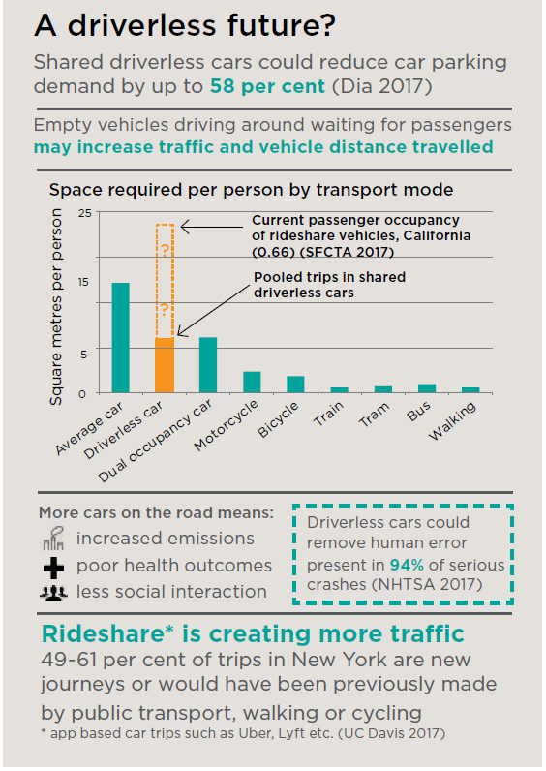

# What are the issues?

## More cars on the road

If driverless cars were privately owned the number of car trips on our streets would significantly increase, worsening congestion. New types of trips might include:

• empty cars circulating streets instead of parking

• empty cars driving ‘home’ after dropping someone off

• increased freight and home deliveries, if costs reduce

• trips by people currently unable to drive, including children, older people, vision impaired and others.

These new trips may have positive or negative social, environmental and economic impacts. The degree of uncertainty makes it challenging to foresee the outcomes. Automation will impact the entire economy and generate changes to the types of employment opportunities available in transport industries.

## Shared mobility

If driverless cars result in more car sharing and pooled trips, benefits such as reduced traffic and lower cost transport are possible. Cities may need to provide less transport infrastructure.

However, operators of driverless fleets may want to maximise the distance their vehicles travel and compete

with public transport. Shared driverless services might also use advertising in vehicles to provide more competitive user costs. This would result in providers trying to capture more of passenger’s time and attention, rather than providing efficient transport. Competition between public and private transport providers needs to be minimised to ensure an efficient, integrated transport system.

## Mobility as a service

Communications technologies (such as mobile phones and app-based platforms) continue to develop and could affect our future travel behaviours. Technology is offering people travel choices tailored to individual needs as well as real-time information about travel options, conditions, time and cost. There are opportunities to integrate additional information about emerging mobility services like car share and ridesourcing in the future.

## Data security

Driverless cars will require large amounts of data to operate, and will also generate new data linked to location, safety, destinations and habits. This data will be of value to different parties and will raise significant privacy issues if linked to identities of passengers.

## New freight systems and vehicles

A variety of new technologies are being developed to support growing freight demand. These include delivery robots on footpaths and airborne parcel drones. These devices need to be managed to ensure they integrate safely on our streets and footpaths, ensure privacy and preserve the amenity of our city.

## Smart sensors for better decisions

Pedestrian counters and on-street parking sensors are used to monitor the performance of the city. Sensors can support the efficient movement of people and enable better decision making in the future.

## What are other cities doing?

Cities around the world are facing challenges similar to Melbourne. These global best practice ideas can help to inform the right approach for Melbourne.

### Mobility as a Service (MaaS) platform, Finland

• Finland is pioneering an integrated platform to bring together multiple mobilty services. For a monthly fee,

subscribers can access public transport, car share, ride share and bike share.

• Participating services provide data so it can be centrally managed to provide visibility for users and improve transport planning. New regulations discourage competition between public and private modes.

• Studies have suggested a well managed MaaS platform with shared services supporting public transport can deliver a reduction in vehicle kilometres travelled, comparable to a congestion charge (ITF 2017).

**MaaS regulatory reform could enable better integration of a growing number of mobility services. Leadership from government, working closely with service providers, is required for this to be achieved.**

A community member using a shared bike and looking at phone.

A MaaS digital platform can improve integration of public

transport, car share, bike share and other services

## Shared streets data platform, U.S.A.

• Kerbsides are becoming increasingly contested city spaces for pick-ups, drop-offs, deliveries, service vehicles, disability access and emergency services.

• With information available about parking availability, demand and vehicle arrival time there are new ways to manage these spaces.

• A shared streets data platform acts as a 3rd party between government and private companies, enabling more cooperation.

Melbourne could benefit from more efficient and dynamic kerbside management and booking services, and more open data may enable greater efficiency.

# What should be done to address these issues in Melbourne?

## Integrate driverless cars with public transport

To maintain a prosperous and liveable city into the future, clear regulatory signals are required now to ensure driverless cars support public transport rather than compete with it. New regulation needs to be consistent with the objectives of the *Transport* *Integration Act 2010* to achieve socio-economic inclusion, economic prosperity, environmental sustainability, integration of transport and land use, efficiency and reliability, and enhance safety, health and wellbeing. It is clear that having more privately-owned cars in the city will not achieve these objectives.

## Support a shift towards Mobility as a Service

Support and enable partnerships with mobility providers, and promote the consolidation and integration of services. Only through the integration of public transport, active transport and shared mobility options can benefits of increased automation be captured.

## Investigate future data security risks

To prepare for new technology, new mechanisms for data protection are required. Robust and secure sensor network technologies need to protect the community against possible data/sensor tampering. Additionally, secure data practices must include users having full control of how their data is used.

## Safe streets and a city for people

Lower speeds will remain the primary safety objective for walkable streets. Technology advancements and innovation are important and will be supported and enabled. However, our priortity must be a city for people. Pedestrian safety and priority will remain critical in our people focused city which must look, feel and be safe.

## Trial and pilot innovative freight

The opportunities presented by smaller driverless delivery vehicles are of greater potential than driverless passenger cars in the central city. Testing new delivery vehicles in the air or on the ground will help to understand if this technology can benefit the city. Delivery routes and vehicles should be consolidated where possible to improve efficiency.

# What if?

• Empty driverless cars paid a fee to use the road, preventing increased congestion.

• Driverless cars were regulated to move out of the way for buses and trams.

• Smart sensors halved time that buses and trams spent waiting for cars at traffic lights.

• Deliveries were made by robots on the ground and in the air, reducing congestion.

• For a monthly fee, people could access public transport, ride hailing, bike and car share via an app.

## We want your thoughts!

participate.melbourne.vic.gov.au/transportstrategy

9658 9658

[transport@melbourne.vic.gov.au](mailto:transport@melbourne.vic.gov.au)

# Which future do we want for our city?

The following two scenarios are described to test different possible outcomes, depending on different changes in technology, policy and social trends.

## Scenario 1: Government action and private sector cooperation lead to:

The movement of people is prioritised over the movement of vehicles and public transport investment is increased. Private vehicle use is minimised in the central city and data more freely available. This results in reduced congestion, cheaper user friendly transport, reduced emissions, re-purposed car parking and efficient management of street space. More people choose to walk and cycle in the central city to the benefit of the retail and knowledge economies and the healthcare system.

This image of ‘Scenario 1: Government action and private sector cooperation lead to’, shows more street space for pedestrians and cyclists. Drones flying safely, improved tram stop space for people to access trams. The tram tracks containing grass, increased green walls and garden beds. 

## Scenario 2: Government inertia and aggressive private sector competition, lead to:

To allow driverless cars to serve more people safely, pedestrian movement is restricted and footpaths separated from roads. Driverless cars compete for passengers with public transport and vehicle occupancy declines. There is limited sharing and access to movement data resulting in poor efficiency. Electric cars become popular but require lots of space and power for battery charging. Parking demand, emissions, congestion and freight costs increase while productivity falls.

This image ‘Scenario 2: Government inertia and aggressive private sector competition, lead to:’ shows drones flying unsafely, traffic congestion and a car standing over a pedestrian crossing. In addition to this there are fences along the street restricting pedestrian movement. The lack of protected cycling infrastructure increases risk factor for community members who are riding a bike.   