Transport Strategy Refresh
Background paper: impacts of emerging transport technology on the City of Melbourne
May 2018
Publication details
City of Melbourne
GPO Box 1603
Melbourne VIC 3001

ViSpoke Consulting
Collaborative, bespoke strategic solutions
ABN: 66 112 032 431
This discussion paper prepared by for, and on behalf of the City of Melbourne, by ViSpoke Consulting.
ViSpoke is a boutique strategy consulting group with a unique skillset to meet unique challenges. ViSpoke provides tailored business solutions and broader information products that support better decision making, effective and efficient project delivery, and greater overall impact.

Contents
1. EXECUTIVE SUMMARY 3
2. DEFINING THE CONTEXT 6
2.1.1 Purpose of this paper 6
2.1.2 Current strategic context 6
2.1.3 Previous Emerging Transport Technologies research 7
2.2 Current social trends and implications 7
3. KEY ISSUES AND IMPLICATIONS FOR THE CITY OF MELBOURNE 14
3.1 Automated vehicles 14
3.1.1 Key issues with vehicle automation technology 14
3.1.2 Implications of automated vehicles? 16
3.2 Communications technology 23
3.2.1 Key issues with communications technology 23
3.2.2 Implications of communications technology developments 25
3.3 Shared transport technology 29
3.3.1 Key issues with shared transport technology 29
3.3.2 Implications of shared mobility developments 31
3.4 Energy for transport 33
3.4.1 Key issues with energy for transport 33
3.4.2 Implications of changes in transport fuels 35
3.5 Other new technologies 37
3.5.2 Implications of drones and other vehicles 38
4. EXPERIENCE FROM OTHER CITIES 40
4.1 New York Connected Vehicle Pilot 40
4.2 Shared electric cars - Grenoble, France 41
4.3 The city of Columbus, U.S – Smart Columbus 41
4.4 Melbourne is already a hub of transport innovation 43
5. POLICY OPTIONS FOR MELBOURNE 45
5.1 Future development scenarios 45
5.1.1 Scenario 1 Convergence of technology and policy 45
5.1.2 Scenario 2 Divergence of policy and technology 49
5.1.3 Scenario 3 Mixed pathways 51
5.2 Policy options 53
6. RECOMMENDATIONS 57
6.1 Specific recommendations: 57
7. REFERENCES AND FURTHER READING 60

EXECUTIVE SUMMARY
There are a range of new and emerging technologies and business models that may dramatically transform the transport system in Melbourne, and either support the City of Melbourne vision for the future, or potentially create barriers to achieving it.
This discussion paper explores four key technologies and briefly discusses a range of other emerging technologies. The paper then discusses the potential impacts of these technologies and provides suggestions for where the organisation could be proactive in preparing for, and mitigating the risks of these technologies to capture future benefits.
The City of Melbourne has a Vision for the City that outlines a series of key goals. The organisation recognises that new technologies and business models have the potential to both support the ability to achieve those goals and also challenge the development of a sustainable, inventive and inclusive city, that is also vibrant and flourishing.
In today’s society, there is demand for faster, better and smarter ways to do things. Technology and business models are continuously evolving, advancing rapidly and creating challenges and opportunities on many levels, to meet consumer and market needs.
Twenty years ago, few could have imagined the technologies on which we now depend - the internet, mobile phones, smart phones, smart phone applications, portable computers, smart televisions and wireless connectivity to name a few. Planning for a 30-year horizon requires consideration and examination of unknown future outcomes.
A new wave of transport technology is rapidly emerging. This relates to automated features in vehicles, including automatic braking, lane correction, speed control and notifying emergency services in the event of an incident. Further than this, there is the emergence of vehicles which are essentially self-driving under certain conditions.
Emergence of Automated Vehicles
Automated vehicles (AVs) are already being manufactured and used around the world, including Australia. They are currently being tested and will include all forms of transportation that have up to now relied on direct human manual interaction - cars, buses, trams, trucks, trains, aeroplanes, ferries and maintenance machines.
Automated vehicles have the potential to create a range of benefits and equally, their introduction also brings about significant challenges and potential adverse impacts upon the city and the community.
While an individual consumer might find advantages in acquiring and adopting the new technology, the overall impacts on the wider community could easily be negative. The consequences of these new technologies and business models on equity in the community is a challenging issue. There are also stages of automation and many vehicles will be partially automated long before fully driverless vehicles are common.

Communications technology and connectivity
The advances in communications technology during the last few decades have driven enormous changes in consumer behaviour and are expected to continue to drive changes in transport. The increase in sensing technology will mean road managers and travellers can get real time information on congestion, weather, arrival times and where the nearest shared bike or car might be.
Smart phones, tablets and secure payment systems have allowed the growth to a new mobility eco-system, where consumers (connected travellers) directly interact and influence travel behaviours by using their connected devices to customise their travel, monitor and improve services. The connected traveller concept is one that brings together vehicles, physical infrastructure and cyberinfrastructure and goes beyond just mere transportation by broadening accessibility to services and improvements in lifestyle (Yang, Ozbay and Ban 2017).
Artificial intelligence (AI) is another technology with the potential to change the way transport functions - flexible and continuously learning, AI makes the decisions in automated vehicles rather than relying on fixed algorithms. Traffic signalisation and routing of traffic around incidents or hazards could also be provided more efficiently by connected AI systems. (PK Agarwal et al, 2015)
The first trials of highly connected systems are already taking place in Melbourne, in other Australian cities and around the world, with some technologies being partially automated and others fully automated. Given the way our society, urban spaces and transport system are currently set up to function, the challenges and opportunities that these changes represent are significant. The City of Melbourne is already placing itself at the forefront of researching these technologies and continues to be proactive in understanding any potential local impacts
Increase in shared mobility
Facilitated by new technologies, there has been an upswing in the range of services offered that could replace or augment private vehicle ownership. It is now possible to reliably and easily use a single app to check different transport options, select the preferred travel time and price, book and pre-pay for some services.
Vehicles can be easily hired using another app, reducing private vehicle ownership and reducing demand for parking. Flexible pricing options in some locations have increased the use of shared trips (for example Uber Pool) which can significantly reduce the number of trips on our roads, improving safety, congestion and emissions from transport.
While there is debate about what has caused the change, Australia and most western nations are all experiencing declines in personal travel demand. Individually, people are travelling less and this has the potential to have benefits for transport and our community if the trend continues.
Changes in transport fuels and energy
The transport system in Australia has largely been fossil fuelled since the arrival of motorised transport, but new options are emerging to change that. Electric vehicles, either petrol electric hybrids or plug in battery vehicles, have been rising in popularity internationally and many countries have made significant investments (both public and private) to support or incentivise their rollout.
In Australia, however, the uptake of electric vehicles has been low - declining during 2015-16. Electric vehicles offer the opportunity to cut carbon dioxide emissions, reduce transport noise and other health impacts. Research from overseas indicates that shifting towards more renewable sources of electricity, increased education and the provision of more accessible recharging, is likely to improve uptake. Likely, the key factor in uptake will be the continued reduction in the price of electrically charged vehicles.
Other technologies and cumulative impacts
Other technologies are also emerging which will combine with these key technologies to change the way in which transport is used. For example, land, aquatic and aerial drones could replace many of the unpleasant or unsafe maintenance and surveillance tasks in the transport system. Land and aerial drones could improve the delivery of freight. But drones will take up public space and are likely to interact with other transport users such as pedestrians and cyclists.
Government and industry play a primary role in the mobility eco-system. Their collaboration and ability to recognise impacts (both positive and adverse) and risks of these technologies is essential to find ways to maximise the benefits and minimise the overall negatives of transitioning the current transportation culture into an intelligent transportation system.
The City of Melbourne will play a key role in influencing the way these technologies are taken up by consumers. It is critical to have a debate about how these technologies could help to achieve the organisation’s strategic goals.
Key areas of focus
International and local experience have identified the following key areas of focus to help shape the City of Melbourne transport strategy:
- integration of information, planning, policy, procurement and solutions
- collaboration across government and the private sector to co-create the vision for Melbourne and ensure the city’s liveability, prosperity and productivity is enhanced
- building resilience and flexibility into plans, policy, infrastructure, engagement and services
- engaging with uncertainty - use foresight, forecasting, modelling, trials and engagement with experts and the community to minimise surprises and share relevant information.

DEFINING THE CONTEXT

2.1.1 Purpose of this paper
If we don’t prepare for the future, we can’t expect to meet its needs.
Preparing for the future is increasingly important as the world is rapidly shifting from relative stability to a state of fast technological, cultural and environmental change, and economic transition as the 21st century progresses.
For example, many Australian industries and sectors have been fundamentally affected by the rise of the peer-to-peer economy. Businesses such as Uber and Airbnb have disrupted traditional business models and challenged current regulatory systems. In 2015, Australian data showed that Uber recorded over 15 million rides and Airbnb had over 66,000 property listings. These figures are predicted to grow significantly (Minifie and Wiltshire, 2016).
No one can predict the future. However, by looking at it critically - by engaging with the change drivers and considering what possible futures they might create - we can better plan for it.
The purpose of this paper is to stimulate critical discussion of the many ways that new and emerging technology, business models and social trends might impact the plans and strategies of the City of Melbourne to create a vibrant, people-centric city over the coming decades.

2.1.2 Current strategic context
By 2026, Melbourne’s population will increase significantly with more people living alone. The most significant growth areas, in terms of relative population growth, are Docklands and Southbank, with more than 100 per cent growth forecast in each location (174 per cent in Southbank) (City of Melbourne, 2018). The central city has the largest absolute growth, but significant areas of this are forecast to have high population density compared to the Australian average, as illustrated in the image below. Compounded with changing demographic trends across the region, this will impact travel patterns and mobility needs.
Figure 1: Forecast population density in the City of Melbourne in 2027
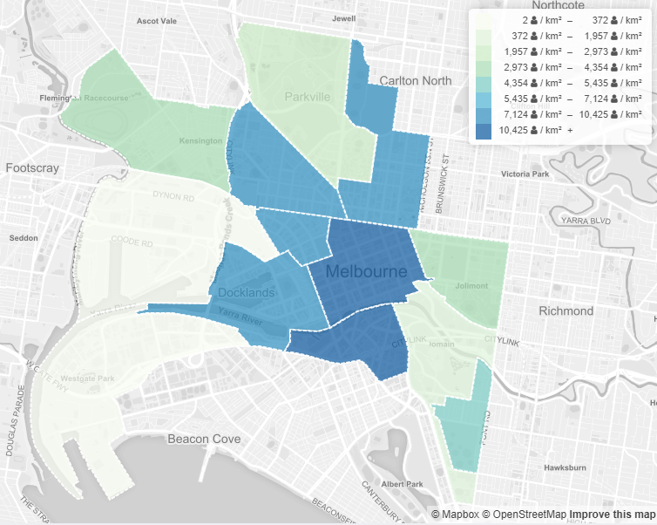
(City of Melbourne, http://melbournepopulation.geografia.com.au/maps/popdensity#2027, 2018)
The City of Melbourne and the metropolitan area as a whole are experiencing rapid economic, residential, employment and visitation growth. Between 2004 and 2016, the following growth has occurred and is forecast by the City of Melbourne:
- Gross Local Product (GLP) has grown from $59.9 billion to $92.12 billion in 2016.
- The residential population has risen from 72,000 to 136,000 and is forecast to reach 218,000 in 2026.
- Jobs have grown from 327,000 to 455,000 and are forecast to reach 453,000 in 2026.
- Daily visitors to the central city have risen from 254,000 to 273,000 and are forecast to reach 415,000.
- Total daily population has risen from 681,000 to 903,000 and is forecast to reach 1.14 million by 2026.
A key strategic challenge is uncertainty for the future, particularly in terms of emerging technologies - their impact on transport, mobility provision and demand. Better understanding the range of plausible futures and building more resilient and flexible approaches is critical, as is making use of tools like scenario planning and foresight to try and make more sense of the complex way some of the new technologies and trends might interact - and the options the City of Melbourne has for managing impacts.

2.1.3 Previous Emerging Transport Technologies research
A recent ground-breaking City of Melbourne report identified potential impacts of emerging transport technologies including greater use of ride sourcing services, significantly lower demand for car parking and increasing congestion in the absence of additional congestion management measures.
Key areas of policy reform identified by the report include car parking availability and pricing, along with off-street parking design to allow greater flexibility of use. Further research into car sharing longitudinal demand, disruptive freight technologies and development of future scenario traffic modelling was also recommended by the report (Fishman, 2016).
Many of these same issues are identified in this discussion paper, but with a focus on the possible long and short-term policy responses for the City of Melbourne.

2.2 Current social trends and implications
Transport systems give the community access to economic opportunities, social activities and services such as health and education. People expect to be able to travel safely, at a reasonable cost and without too much time or effort.
Each of these key factors is personal, so the choices of individual travelers vary widely.
New technologies are being developed all the time. In the context of our transport system the development of innovative technologies is generally adopted by business or individual consumers in the first instance. Technologies that address a market need (or that create a new market need) see more rapid adoption.

Recent examples of new technologies and business models impacting on the transport system include:
- ride sourcing and ride sharing services including Uber, Car sharing services for example RACV car share, GoGet, GreenShareCar
- use of digital marketplaces, phone applications and the internet to access information, services and transactions. Examples include Rome to Rio, TramTracker, Public Transport Victoria app, 13CABS, Spotcycle.

Safety
Safety is a major consideration in both travel choices and the adoption of technologies. Travelers expect to be able to use the transport system without significant risks of serious injury or fatalities. Transport agencies, vehicle manufacturers and community groups, have worked towards reducing the number and severity of crashes and these figures have decreased over the years. The declining trend in crashes on roads in the City of Melbourne in the last decade is depicted below:
Figure 2: Declining overall trend in fatal and serious injury crashes over the last five years
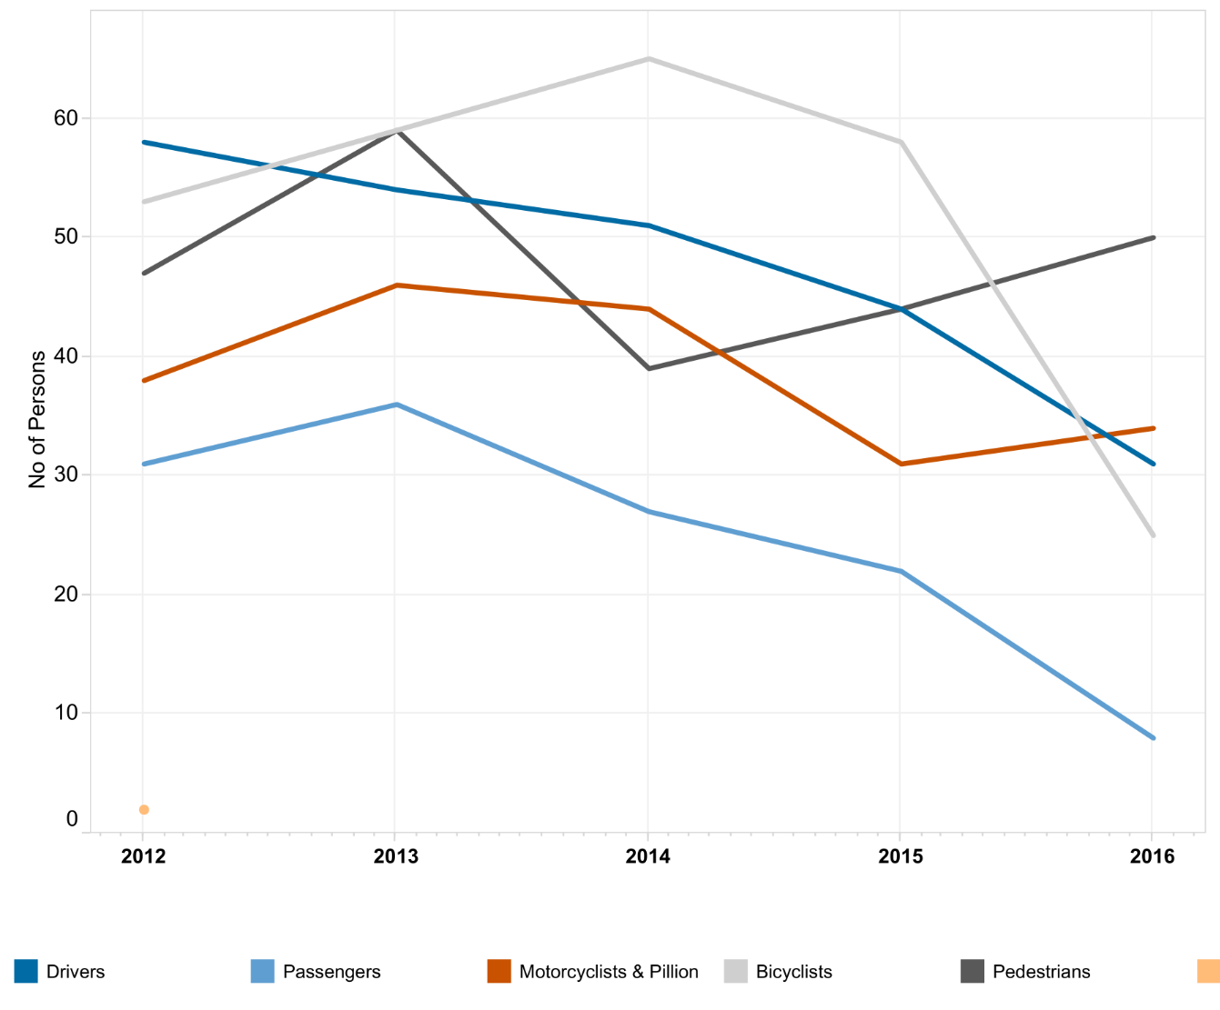
(Crash statistics public tableau VicRoads, 2017)

Changing demographics
Population changes across Australia will be a key driver of transport demand into the future. Within the overall population growth and demographic trends that have been estimated by the Australian Treasury in the 2015 Intergenerational Report (Australian Treasury, 2015), there are specific sub-trends which may impact upon transport differently:
- growth in dense urban centers is likely to have a disproportionate impact on economic productivity
- regional and remote populations may continue to experience decline or stagnant populations
- the proportion of older people will increase significantly.
An ageing population will reshape how we think about workforce engagement, wellness and active transportation. It will also affect government revenues and priorities for expenditure, with a decreasing tax base expected over the coming decades.

Personal travel has peaked
After decades of rapid and consistent growth, personal travel now appears to have plateaued across western nations. In 2005, Australia reached its personal travel saturation point, after which average travel per person (average kilometres travelled per capita) first flattened, and since declined (see figure 3) (BITRE, 2015). Contributing key factors may include:
- economic factors - unemployment, fuel prices and increasing costs of traditional suburban house ownership (leading to increasing housing densification and living in proximity to public transport)
- social issues - changing consumer demands
- saturation of people’s ‘time budget’ for travel each day
- generational changes in travelling habits and modes.
A number of studies have observed that millennials and younger generations are not acquiring a driver licence until later in life and often prefer ride sourcing or other methods of transport, contributing to the decline in personal travel (BITRE, 2015, and http://infrastructurevictoria.com.au/managing-transport-demand).
Figure 3. Australian urban passenger travel demand per capita
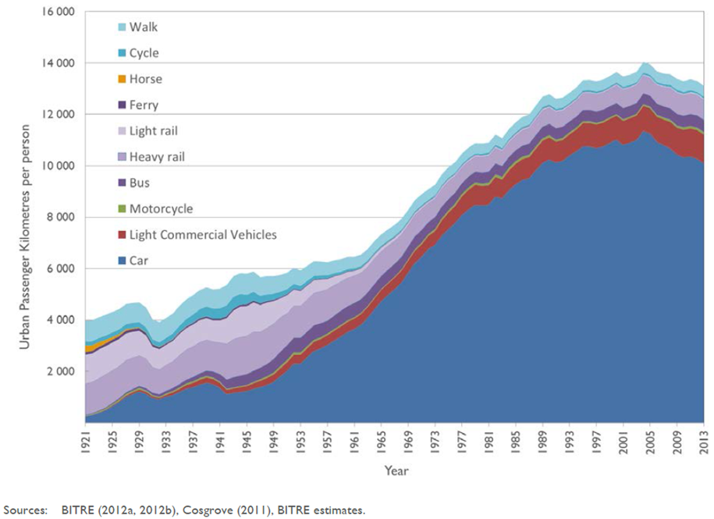

The ‘household travel budget’
Households can only afford to devote a certain amount of time each day and money to transport as part of the household financial budget. In 2015-16, compared to housing and food, household transport expenditure was approximately 14.5 per cent. ([ABS] 2017).
Figure 4: Average weekly transport expenditure as proportion of total household budget
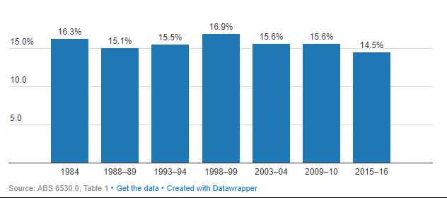
(Jericho, 2017)
As the third highest single expenditure class, it was made up of:
- vehicle acquisition
- vehicle running costs
- public transport
- taxi and ride sourcing fares
What is a travel time budget?
A travel time budget (the average amount of travel time spent commuting – often called Marchetti’s constant) places an upper bound on the length of time most individuals are willing to spend travelling. People are generally willing to travel on average, about one hour and ten minutes in total per day, despite technology allowing us to travel much further in our travel time budgets.
Studies show that once travel time exceeds around 35 minutes (one way), the costs (both financial and time) of travel perceived by commuters rises sharply (BITRE 2016, Newman 2016, Marchetti 1994).
There are several key influences on people’s choices about where to live and work, and the amount of time they are personally willing to spend commuting:
- the urban form (particularly the distance one must travel to a destination)
- the time spent travelling and (even more importantly) the reliability of travel time
- the quality of transport infrastructure, and
- services constraints during peak hour (infrastructure Victoria, Managing Transport Demand).
It is also noteworthy that data shows commuters are more willing to spend longer time in a public transport vehicle than in a car as a driver. This may be related to the ability of commuters in public transport to use their time for other purposes.
Average commute times for Melbourne by mode show that public transport commutes are significantly longer, with public transport commutes from outer Melbourne being more than double the commuting time for cars (Vista BITRE 2013).

The demand for teleworking
With the shift towards flexible work options and a knowledge economy that increasingly relies upon workers’ creating value without necessarily having to travel, teleworking is well positioned to grow. However, unlike historical predictions teleworking has not grown to replace face-to-face interaction, but rather to complement and supplement it.
What is a knowledge economy?
Most advanced economies are increasingly based on knowledge and information. Knowledge is increasingly seen as a major driver of productivity and economic growth. The term knowledge economy stems from this understanding of the importance of knowledge and technology in modern economies (OECD, 1996).
The City of Melbourne, for example, has an economy that is dominated by knowledge industries including professional Scientific and technical services (17 per cent of jobs), Finance and insurance services (14 per cent), Information media and telecommunications (6 per cent of jobs) and Education and training (5 per cent of jobs) (Population Geographia, 2018).
The Australian Media and Communications Authority reports (2015) that that in 2014, 49 per cent of employed Australians used digital communications to work away from the office, equating to approximately 5.7 million workers.
Figure 5. People can work from anywhere they can connect
At home
Hired office space
Shared business co-location
Café’s, eateries and restaurants
Public squares and open spaces
Shopping centres
Libraries
Educational Institutions

Image adapted from ACMA 2015.
Often referred to as a “third spaces” these facilities are increasingly becoming part of the urban landscape and commercial providers are stepping in to provide the services that knowledge-workers need.
Given that ‘knowledge economy’ workers make up the bulk of employees within major Australian cities, urban design and transportation systems may see telecommuting as an opportunity to maintain and better utilise existing infrastructure.

Access, mobility and social inclusion
The advent of the internet has spawned entirely new forms of social interaction that have come to diversify the traditional forms of communication and information sharing. Despite wanting more virtual connectivity, however, consumers still have a high expectation of personal face-to-face services and interactions. (Common Sense Media, 2012).
If personal travel growth continues at its lower level, then overall travel demand may only rise as a factor of population growth. As we have seen with the increasing urbanisation in Australia – this likely concentrates the need for transport investments for additional transport capacity in urban areas and raises the question of how best to support declining population areas.

The sharing economy
Consumers choosing to not directly own something, but instead share its use (either with or without a fee) are participating in the sharing economy. This form of commerce, supported by new technology and consumption trends has massively increased the reach and convenience of such models – particularly into transport.
Car sharing clubs and businesses are well established, as are peer-to-peer sharing of accommodation, finance, travel experiences and employment. They allow people to increase the value of their vehicles and other transport assets by creating an income stream from unused possessions. For the transport system, car sharing and bike sharing offers an important opportunity to reduce total car ownership and dependency and reduce car parking requirements.
Uber and many similar companies allow users to book and pay for a ride using a phone application. The transaction is electronic, the trip is electronically mapped and monitored, and both driver and passenger can rate one another for service and other features of the trip. Uber, and other companies offering similar services, have spread around the world – offering transport but owning no vehicles or physical infrastructure.
Uber, active in 58 countries and valued over $US50 billion, poses a challenge to existing commercial passenger transport services, and regulators. By allowing customers to review drivers through the rating system, and using technology to remove most of the risk (removing the need for cash, and adding tracking and tracing features to each trip), this sidesteps government requirements for commercial passenger services.
Innovation and disruption in freight transport services is on the rise with Uber and others moving towards freight deliveries, offering car owners opportunities to use their vehicle as an income-producing asset as well as a means of transport. Essentially a commercialisation of the original government policy of ridesourcing, this allows people to pay to carpool, using the phone application to pay and rate both customers and drivers.

Increasing freight demand
The freight task in Australia is forecast to continue to grow rapidly, with much of the growth in major cities including Melbourne. The graph depicts that by 2016, the domestic national freight task had increased by 50 per cent (over a period of 10 years) and that by 2026 is predicted to increase by another 26 per cent. (NTC, 2016)
With the City of Melbourne’s proximity to one the Port of Melbourne, there will be pressure to ensure the smooth flow of goods to, from and within the municipality.
Figure 6. Forecast growth in the national freight task (Tonne-kilometres) by mode
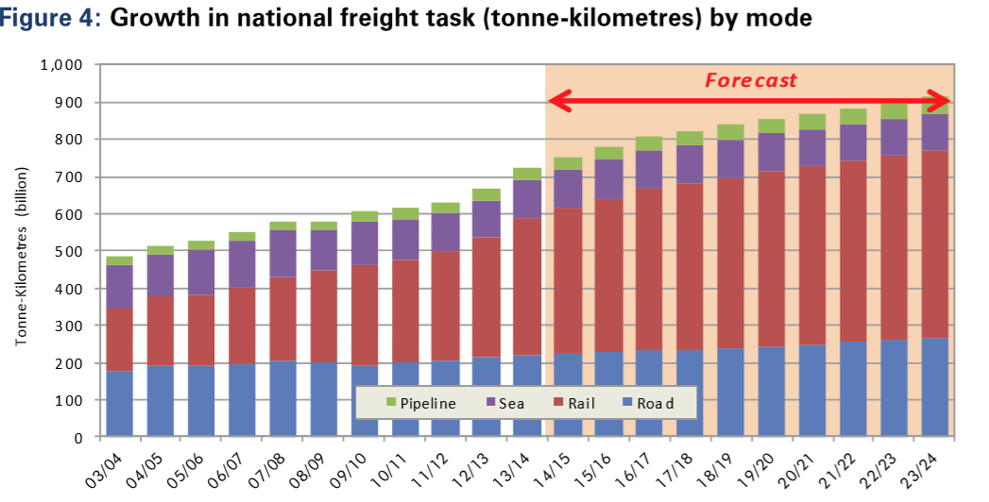
(NTC, 2016)

KEY ISSUES AND IMPLICATIONS FOR THE CITY OF MELBOURNE
The key technologies’ that are likely to drive change in mobility demand and the transport system over the coming decades to 2050 include:
- Increasing automation of vehicles and mobility services, including the development of fully driverless vehicles
- communication technology improvements and the connectivity of vehicles, people, businesses, infrastructure and data
- increase of shared mobility / mobility-as-a-service, facilitated by improvements in connectivity and telecommunications
- potential shifts in energy availability and cost as new technologies become more viable
In addition, there are a range of other potential technologies that might impact on the urban form, mobility needs, and transport system in Melbourne, including drones and other new types of vehicles and devices that are likely to provide additional mobility and freight services.
The next section summarises these new technologies, while the final section of this chapter explores the potential for them to impact on the City of Melbourne’s services and strategic goals

3.1 Automated vehicles

3.1.1 Key issues with vehicle automation technology
One of the most significant emerging technologies to impact on the transport system (and society in Australia more generally) will be automated vehicles. Already active and used in many parts of the world, automated vehicles will fundamentally change the way transport is used and accessed.
Australia is moving forward with automated trains. Sydney Metro is providing a fully-automated rail system operating on a closed network, running trains every four minutes during peak times.
In Western Australia, Rio Tinto is in the operational phase of their ‘AutoHaul’ rail system, pioneering one of the first automated heavy haul rail systems in the world.
Most vehicles manufactured today have some automated features – including simple features like ‘cruise control’ for holding a set speed, through more complex features like automatic lane correction and driverless parking. At the higher end of this spectrum sit vehicles capable of driving themselves under certain circumstances.
Automated, autonomous or connected?
Different terms have been used to describe the new wave of technologies, and there is emerging a consensus on how to describe different types of automation and connectivity.
An autonomous vehicle, as described above, is a vehicle that can control certain aspects of the driving task. Some vehicles only have autonomous features (like lane correction or automatic braking) while others might one day be fully automated.
An automated vehicle can, however, either be connected or autonomous. A connected automated vehicle (commonly referred to as a CAV) can wirelessly share information with vehicles around it, with infrastructure, and with traffic management systems to support the development of an entire connected transport ecosystem.
An autonomous automated vehicle is designed to operate in isolation, or with input from Global Positioning Satellite input for guidance. They generally have entirely internal learning and guidance systems, operate from a databank of detailed maps, and do not rely on the infrastructure or vehicles around them to be connected, in order to operate.
Different AV technology pathways are being followed, but it seems most likely that the most common eventual form of the technology might be a combination of both – vehicles able to operate in isolation in some locations, but with enhanced efficiency and safety when connected.
Currently, the most common potential areas for automation in vehicles is on freeways for private cars and trucks, or on quiet, well mapped routes like university campuses or between public transport nodes for automated mini-buses.
The National Transport Commission is currently examining regulatory barriers to the introduction of automated vehicles in Australia’s transport system, and there are a wide variety of issues that will need to be considered. Partially automated vehicles are already available overseas and many vehicles on Australian roads today have automated features and the software and technology to control the vehicle in certain circumstances.
In the early stages, lower ‘levels’ of automated vehicles will likely be the most common. The table below describes the kinds of automation a consumer would find at each levels of technology.
Table 1. Levels of automation in vehicles
Levels of automation |  | Example
No automation | Full time human driven. | 1976 Holden Commodore
Driver assistance | Full time human driver. Advisory features warn or assist the driver to make decisions. | Vehicle with a basic speed warning feature or reversing camera
Partial automation | Full time human driver. Vehicle can take control of steering, acceleration and braking under certain circumstances (e.g. collision avoidance). | Vehicles with cruise control, lane keeping assistance or collision avoidance (automatic braking)
Conditional automation | An automated driver system controls the entire driving task in certain circumstances and specific locations.  The driver need not remain vigilant during this time, but must be prepared to take over again if the vehicle alerts them to.  Vehicle probably cannot operate empty. | Many new vehicles are manufactured with the ability to effectively drive themselves on freeways, or with self-parking features.  Vehicle manufacturers have not provided a warranty to purchasers that they will not be liable for crashes so technically the driver is still ‘in control’ and these vehicles would be classified as partially automated, with ‘driver assistance’
High automation | The automated driving system controls the entire driving task in some situations, or all the time in defined locations. No driver monitoring is required, and the vehicle can safely bring itself to a stop.  Vehicle may operate empty | Currently being trialed in Melbourne and other locations, these would include an automated bus or tram able to operate on a defined route or network or cars able to drive themselves on a freeway
Full automation | The vehicle can operate in automated mode all the time, without restrictions on locations. No need for a human driver to control aspects of the vehicle task unless they choose to.  Vehicle may operate empty. | Fully automated vehicles that can operate anywhere - without restrictions on location or without defined route limitations - are not currently operational.
Dedicated automated vehicle | A fully or highly automated vehicle that has no manual controls for a human driver. The vehicle may operate empty and is never under human control (expect by a remote controller). | No examples of this exist now at present.
Adapted from NTC, 2017.

3.1.2 Implications of automated vehicles?
Automation has many implications for Melbourne. Some of these implications, be they opportunities or challenges, will depend on how the technology is deployed. For example, forecasts indicate that private automation is likely to increase the number of trips on the road, leading to rising congestion and urban sprawl (MRCagney 2017).
Some of these issues, however, might play out in unknown ways. Access and equity issues are a particular area of uncertainty, and researchers have made widely differing predictions about whether automation will reduce or increase the cost of transport for those vulnerable to economic and other changes (Parliament of Australia).
Table 2 summarises many of the potential opportunities and challenges identified in the literature.

Table 2: Potential opportunities and challenges of automated vehicle technology
Potential Opportunities | Potential Challenges
Social:  - improved safety for both vehicle occupants and other road users  - reduced number and severity of crashes  - improved efficiency  - reduced travel costs  - reduced environmental impacts  - improved access to mobility for the mobility-disadvantaged  - cheaper mobility  - enhanced human-independent mobility, improved social inclusion  - real time data updates for travel customization  - AV’s can alert emergency services in the event of a crash (first responder access)  - Smoother flowing traffic and reduced travel time variability | Social:  - increased number of trips and congestion (induced demand)  - slower travel speeds  - competing space for walking and cycling  - less space for cultural and social interaction  - ‘privatisation of the public right of way’ (delivery drones competing with pedestrians and cyclists for footpath space)  - delivery drones considered an obstructive hazard to older walkers and people with disabilities  - driver education (vehicle control and operation still required in some technologies)  - pedestrian behaviour education (around AV capacities, right of way, safe crossing and interaction of pedestrians with AV’s)  - social exclusion (mobility disadvantages if the cost of using AV’s is too high)
Economic:  - lower insurance and health care costs (fewer motor vehicle incidents)  - increased health benefits (lower morbidity rates from transport fewer emissions, and more active transportation)  - less fuel consumption and travel time (cost-time saving benefits)  - reduced human power (less drivers and law enforcers)  - more efficient allocation for government resources (e.g.law enforcement)  - decreased wear and tear of major traffic routes, bridges and road infrastructures  - increased job creation in areas of digital development, design and infrastructure  - increase consumer demand for interactive inbuilt gadgets and services (infotainment)  - potential increase in advertising and subscription revenue opportunities  - potential for new taxation models (consumption-based dynamic taxation)  - potential increase in productivity (in so far as these reduce the cost of travel and unnecessary travel) | Economic:  - high initial vehicle costs (cost of implementing and maintaining technologies)  - public transport impacts (changes to commuter preferences leading to reduced fare-box revenue)  - potentially decreased government revenues (reduced infringements, licensing, parking)  - reduction of fuel excise (electrification of AV’s)  - changing employment and business (need for transport workers and drivers could decline)  - less demand for vehicle repairs due to reduced crash rates  - high maintenance cost of digital infrastructure  - greater energy consumption (non-fuel based)  - increased demand for additional bandwidth requirements  - potential negative impacts on the community due regulatory framework that is incomplete, or the regulatory framework not being in place in time

Potential Opportunities | Potential Challenges
Collective:  - reduced congestion from smoother travel and reduced trips (if higher vehicle occupancy)  - road use efficiency (expanded roadway capacity, rerouting of vehicles through traffic jams, vehicle platooning adjusts heavy vehicle routing patterns)  - smarter city planning (smarter spending on infrastructure and community services)  - decreased need for roadside and public parking  - land availability for more productive spaces and residences  - creation of social corridors for use by local businesses, pedestrians and cyclists  - potential reduction in real estate costs  - potential to support the first-mile-to-last-mile transportation of goods and people  - user data and analytics to drive improvement in services  - opportunities for collaboration of all government tiers with industry groups  - decrease in car ownership and running costs. | Collective:  - increased number of trips and congestion (if occupancy remains same or lower and from new demand for mobility)  - potential reduced demand for public transport services  - decreased amenity, leading to reduced walking cycling and public space use  - potential security risks (potential for hacking)  - potential system failures (due to inclement weather or extreme temperatures)  - equipment glitches leading to potential expensive litigation  - lack of education and awareness for road users interacting in a mixed environment of non-autonomous cars and AV’s  - lack of clarity of the environmental impacts of AV manufacturing components  - potential injury to animals and wildlife  - increased urban sprawl (willingness to commute longer because value of time changes) potential.
Information adapted from: KPMG, 2017; Wong, JC, 2017; ITF 2015, Allesandrini et al 2015 and Dia et al 2016b.

While most of these potential negative impacts are ‘network wide’, they combine to pose a particular challenge to the City of Melbourne. Melbourne is a hub of the knowledge economy, and is proudly one of the world’s most livable cities. It is an economic powerhouse for Victoria and Australia, with employment for hundreds of thousands of people – most of which depends on those employers in the City being able to attract good workers. Technology and travel patterns have an enormous impact on the livability of the city.
Many analysts believe the impact of AV’s will vary widely and may depend on factors such as:
- the most common way AV’s may be deployed:
- a ‘privately owned and used’ model, or
- the ‘shared mobility’ model, which might either be provided by a private sector or public sector fleet owner (or even on a not-for-profit/public good/cost recovery basis)
- the types of AV’s and the complementary services sought out by consumers (NTC, 2016b).
It is likely that the reality will be a mix of the two most common deployment pathways. Each model can be expected to have radically different impacts on the transport network (ITF 2015, Dia 2015, Dia et al 2016a) – and the City of Melbourne may wish to influence the deployment model to achieve its strategic goals. Given the difficulty of anticipating and planning for these different impacts, a flexible, proactive approach, is likely to be necessary.

3.1.2.1 Privately owned automation
Many vehicles rolling off production lines today have some automated features – and the sophistication of these functions is improving all the time. Targeted at private owners, traditional vehicle manufacturers are aiming to retain their current market share by making the vehicles attractive to personally own (rather than lease or hire).
Private vehicles with automated features, or fully automated in specific locations (like freeways) are likely to be the most common early deployments of AVs in Australia, since the technology will probably not allow fully driverless functionality outside of trials.
As described earlier in the discussion paper, the benefits of these vehicles may:
- improve safety → significant reductions in crashes
- free up drivers → to do other things on long freeway commutes
- fundamentally change the value of time for commuters → potentially breaking the current link between travel time and willingness to commute
Much of the literature about automated vehicles also predict certain challenges associated with privately deployed automated vehicles:
- increased average vehicle commuting distances and time → as people purchase homes further from the city
- increased congestion → as people opt for their private automated car and single occupancy vehicle use increases
- increased demand for parking in or around the city → as these vehicles may not be able to make the entire return trip in driverless mode
The side effects of this would likely include increased traffic through the City of Melbourne – both on arterial roads and inner-city streets. Further consequences would likely include increased urban sprawl, reduced amenity for walking and cycling and reduced amenity of public places for other uses. The following chapters explore policy options being explored elsewhere in the world, or which the City of Melbourne may wish to implement.
Once the vehicles become capable of making entire trips in driverless mode, the broader range of benefits from automation might be more available. For example, a single car could drive family members to various locations (work-places or school) and then return to take on other trips according to the needs of the family.
The individual economic benefits of a single AV might be enough to replace most of the family’s mobility needs – the downside may be a collective impact on public transport use and increase in the number of trips on the road.
Many of those trips are likely to be empty as the vehicle drives itself between picks-ups and deliveries, or drives itself off to a parking and recharging station. It is estimated that this will significantly reduce the amenity of roads for walking and cycling and would likely decrease the use of road-based public transport. (reference needed here).
In terms of freight, automated trucks, vans and trains are likely to be adopted because of the incremental improvements they offer in safety, environmental, fuel and scheduling, rather than with the intention of replacing the driver. Integration of privately owned fleets of vehicles and drones with existing on-line shopping and delivery systems such as Amazon, Ocado and Peapod will likely result in another wave of efficiency and service improvements for customers.
Commercial fleets will probably be early adopters of vehicles with automated technologies (partial and conditional automation) to improve the safety of their employees and drive down maintenance and other costs associated with fleet management.
Other references: Dia & Javanshour 2017, Muoio 2017, Ho 2017, Dia 2016a, Dia 2015.

3.1.2.2 Shared automated mobility
Almost by definition, a shared automated vehicle is either highly or fully automated (or even a dedicated AV) as defined above as it will have no driver for at least short parts of the journey. Shared automated vehicles don’t necessarily mean that there is more than one person in the vehicle at the same time (ride pooling), but that the vehicle is available for the use of more than one person or family. There are a number of separate business models for ownership of shared automated vehicles.

Table 3: Business models for shared automated vehicles
Business model | Description
Business-to-consumer | A fleet owner hires out the vehicles like a fleet of automated cars or shared automated bikes that are booked and paid for using a digital app. The direct provision of pooled trips on microtransit (mini-bus) vehicles for commercial routes or areas is also possible.  The fleet owner is likely to optimise travel (and profit) by using AI or complex algorithms to optimise travel. There may not be any inherent commercial incentive to support pooled trips
Peer-to-Peer | Individuals that own automated vehicles can allow others to book and pay for the use of these vehicles through a digital app. Various ownership models exist including direct ownership (and leasing) of the vehicle, fractional ownership (partial ownership of one or more vehicles that are shared)  The vehicles function much like a commercial fleet vehicle, assuming they have access to the algorithms and systems that allow them to optimize route, pick-ups and drop-offs
Business-to-business and Business-to-government | Businesses that own one or more automated vehicles that are hired out to other businesses, or to government, either on an ad-hoc or a longer term contractual basis. Examples of this include:  - the leasing of automated freight vehicles to transport companies on a contractual basis  - leasing of space on an automated freight vehicle through a digital marketplace or freight broker on a one-off basis  - leasing of fleets of mini-buses, cars, trains or other vehicles to governments as part of contractual arrangements for the provision of public transport services
Adapted from ITF 2017.
Regardless of the ownership of the vehicle, it is expected that these vehicles would generally allow both individual and pooled journeys. One of the earliest deployments of this technology is the current trials of small mini-bus type vehicles in Melbourne and other cities. Google and other companies in the USA and Europe are trialing the feasibility of automated ridesourced vehicles (like a taxi or Uber) that begin to take on the features of a public transport service.
Image 1: Automated mini-bus
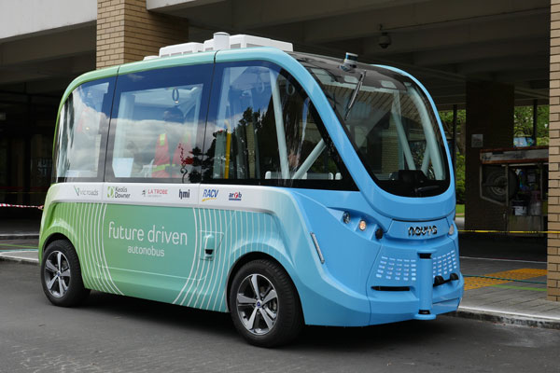
RACV 2017.
It is likely that shared AVs will work best during their early introduction in well-mapped, closely monitored zones. Current trials of automated buses in Melbourne, Perth and other locations, rely on low speed mini-bus type vehicles travelling along a single route, and interacting with other road users only on that route. This is ideal for situations such as the inner city, slow traffic activity hubs, university campuses and hospital precincts.
Shared automated mobility models may later extend to provide other benefits:
- an on-demand easily accessible ‘mobility service’ to large segments of the population in the City of Melbourne
- households could potentially dispense with the expenses of owning a car and instead call up a vehicle
- vehicle usage efficiency – increased passenger carrying and decreased empty circulating vehicles on the network
- decreased need for recharging frequency as vehicle travel capacity is maximized.
Such vehicles are being looked at in other jurisdictions for the benefits of connecting more people with public transport hubs such as rail stations and major tram hubs (NSW Government 2017, pp45-53). Entirely new vehicle types are being developed – leading to a blurring of the lines between cars, buses and trains. Some of these have the potential to complement existing public transport services, while having additional flexibility. The so-called tram-bus looks like a tram, operates like a bus, and doesn’t need rails or a driver.
Image 2: Driverless train/tram runs on virtual rails
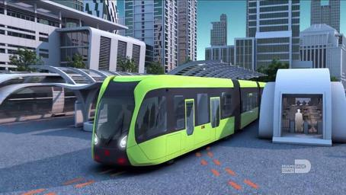
Williams, 2017.
Fully automated taxi-type services will likely follow, but are likely to be constrained to well-mapped and connected areas initially. Given that the vehicles are more likely to be electric (to reduce refueling issues), they will also be constrained by proximity to charging stations and may be limited to certain metropolitan regions until charging networks expand.
Evidence from a Swinburne University study suggests that a fleet of fully automated shared vehicles could deliver the same level of mobility services to Melbourne city to meet today’s travel patterns, but with significantly fewer cars. Commuters travelling in groups and being transported by self-driving cars could lead to a 40 per cent reduction in the number of vehicles in the city. Under a fully automated shared vehicle transport model, parking space requirements could drop by almost 58 per cent (Dia, 2015).
Reduced numbers of vehicles providing highly automated mobility may allow the reclaiming of road space for walking, cycling and other purposes, and could reduce the need for parking in areas that are serviced by these vehicles.
Economics is likely to be a massive driver of consumer adoption. Cities have been generally built around the use of the car. In the future, with parking costs and vehicle running costs all escalating, it is possible that privately owned cars will come to be seen by many as inconvenient, rather than essential.
This trend has already started, with many younger people making the choice to prioritise saving for a home purchase or some other activity over owning a car. A potential economic incentive for the adoption of shared automated mobility could be that the cost of using a shared AV may be similar to the cost of a public transport fare (LEK 2016) or even lower.
Shared freight transport is also likely to develop further through the use of automated vehicles. Many freight companies may continue to own their own vehicles. It is likely that ‘for-hire’ automated trucks will allow companies to add additional temporary capacity, or even build an entire business model on leasing space in automated trucks for specific journeys. Uber, Volvo and other companies are currently seeking to deploy partially or fully automated freight vehicles, and digital marketplaces (apps) already exist, and will likely grow to support the collaborative use of freight trips (Meketon M, Rennicke B 2016).
Though beneficial to the consumer, this may have a significant impact on government regulated public transport services unless they are encouraged to integrate with and not compete against existing mass transit services. There is great uncertainty around what the impact of automated vehicles – either privately owned or shared, on public transport might be.

3.2 Communications technology

3.2.1 Key issues with communications technology
The last decade has seen a shift in business and government service delivery with significant growth in online service delivery, including services that replace, increase, or otherwise change transport demand.
A range of applications of communications technologies are detailed below. These technologies are based on connectivity – which relies upon interoperable data and information, usually through the internet.

3.2.1.1 The internet – people and things
As an indispensable mode of communication, the internet creates limitless potential for the creation of newer, better, cheaper and smarter connected technologies. The ‘internet of things’ is basically a network of computerised and networked ‘things’- that enable objects to connect and exchange information (Lindqvist & Neumann, 2017).
With micro-processor and sensor technology becoming smaller and cheaper, chips and sensors are increasingly being wired into everyday items. For transport systems, these chips and sensors may evolve to travel pattern monitoring, providing real time schedule updates, customisable travel, service maintenance information and warnings - all of which support improved service delivery and planning. As outlined further below, connected infrastructure (or cyber-infrastructure) allows the deployment of new systems and apps that both government and the private sector can use to improve transport in various ways.

3.2.1.2 Blockchain
Blockchain is an evolution of the internet, a technology that allows people to share decentralised digital records (a decentralised ledger) across a network of computers, without the need for a central storage point or authority. Some nations are looking at using blockchain to turn property records into a digital ledger (they call smart contracts) that is searchable by anyone, rather than controlled by government departments.
Blockchain can also protect your privacy, by being able to accurately and securely confirm that you are who you say you are (for example that you are the owner of a particular bank account and that you have booked a ride), without revealing who you are or any private information about you. The sophistication of blockchains means that no single entity can tamper with records, ensuring data integrity and transaction authenticity.
One of the earliest uses of blockchain has been digital currencies like Bitcoin – money that is not issued by or backed by any government. Digital currencies allow individuals another layer of financial privacy, and could be an important stepping stone in creating a secure, private transport payment platform (see MaaS below).
According to experts here in Melbourne and around the world, it is only a matter of time, before blockchain technology is used in peer-to-peer and machine-to-machine transaction, such as transport system safety technologies, where high levels of trust and verifiability is required.
References: Dia 2016, Aecom, McKinsey 2016.

3.2.1.3 Artificial intelligence
Many new vehicles come with many obvious new enhancements like cameras and RADAR sensors to sense the road environment and other vehicles and people around them. Researchers are working around the world to enhance the less obvious systems that control these new vehicles with computing systems that approximate human decision-making. Called artificial intelligence (AI), these systems are capable of learning in much the same way people are, and don’t simply follow a set of rules like older computers.
The most obvious use for AI is in automated vehicles – allowing them to drive safely around the network, avoid collisions and hazards and finding their own routes based on the data they receive from their sensors and from being connected to data from the rest of the network. It isn’t possible to hard-code for every possible situation that a driverless vehicle will encounter, so AI of some kind is almost essential for automated vehicles to function.
Artificial intelligence is also being examined for traffic management and signalisation to improve the efficiency of the network, and supporting the deep learning between automated vehicles and other transport systems – so that every vehicle system can learn from errors or mistakes made by one vehicle. Integrating traffic guidance with consumer needs is another area that could benefit from AI, with real-time routing of people around hazards or delays, proactively identifying the most efficient place to stop and refuel, suggesting restaurants that match the driver’s previous purchases, or sending reminders to do the shopping when the fridge at home is running low on milk.
References: Agarwal et al 2015, Sakar 2017, Executive Office of the President of the USA 2016, Giarratana 2016, Novosilska 2018.

3.2.2 Implications of communications technology developments
Current and future developments in improved data sharing, wireless connectivity and communication technology will support improvements in transport safety, efficiency, information sharing and services provision.
Connected vehicles (also called Cooperative Intelligent Transport Systems or C-ITS) allow a vehicle to communicate with other vehicles (V2V), roadside infrastructure (V2I) and other devices, such as mobile phones (V2P).
Improved transport system connectivity and data sharing could improve specific areas of transport including:
- improved connectivity between vehicles, infrastructure, pedestrians and other travelers can also improve safety. Demonstrated in several cities around the world (including New York, an example we highlight in a later chapter), improved connectivity is improving the safety of road users by providing direct alerts to pedestrians, drivers and, eventually, directly to automated driving systems
- real time travel prediction to support traffic light synchronization and other road management systems, resulting in smoother traffic flow and improved network efficiency
- providing real time schedule updates and weather or dangerous conditions notifications to travelers based on their predicted origin and destination
- linking with guidance apps to seamlessly reroute traffic around incidents
- service maintenance information and warnings for travelers to be aware of prior to or during travel
- sensor technologies and the connected infrastructure will allow infrastructure managers to monitor road and rail networks in real time and better predict usage patterns, maintenance needs and damage to the network, resulting in improved service delivery and planning by road and public transport agencies. The next section on intelligent transport systems explores this in more detail
- independent transport service providers are (and will increasingly) be able to provide personalised service updates to users, and travelers will be able to purchase the transport services they need for each trip based on their service preferences (similar to Finland’s MaaS reforms)
- augmented and virtual reality applications can support the efficiency and safety of the network. Augmented and virtual reality systems range from very simple to extremely complex, and can be used for many transport and mobility related uses. These include driver competency assessments, new and existing driver training, on-screen or heads up display safety information such as speed and proximity to approaching vehicles and providing navigation assistance to both vehicle users and pedestrians or cyclists.

3.2.2.1 Intelligent Transport Systems
Within a transport context, connected technology is spurring the creation of systems that will optimise the efficiency of services and safety of people and goods transportation, boost economic growth and potentially decrease environmental impacts. The automation of roads, rail, air and freight provides a complete end-to-end intelligent transportation solution.
Australia is well established in the development, trial and deployment of intelligent and connected transport systems. There are a wide range of initiatives currently underway, including here in Victoria (ITS Australia 2017). Some of these initiatives include:
Victoria
- Bosch Highly Automated Driving Vehicle partnership with Transport Accident Commission (TAC) and VicRoads.
- Eastlink Driver Assisted Technology – partnership with Victorian Government, Australian Road Research Board and La Trobe University to test network and driver assisted vehicles
- ITS Grants Program includes project trialing CAVs in highway scenarios, C-ITS to support tram priority, and in-vehicle connected vehicle services using cellular communications.
- Road Safety Action Plan includes $10M action to trial connected and automated vehicle technologies.
- Transurban CityLink automated vehicles – trial of how automated vehicles interact with road infrastructure
- University of Melbourne – world first urban test bed for multimodal connected transport on a large scale in a complex urban environment
New South Wales
- Cooperative Intelligent Transport Initiative (CITI) trial of heavy vehicle safety applications using Cooperative ITS.
- Heavy Vehicle Priority Project trial of applications to provide heavy vehicle priority at signalised intersections.
- Smart Innovation Centre announced in 2016, planned to be a R&D hub for emerging transport technologies, including CAVs.
Queensland
- Cooperative and Automated Vehicle Initiative (CAVI) incorporates two main projects – a large scale pilot of Cooperative ITS in Ipswich, and a smaller pilot of cooperative and highly automated vehicles driven on selected roads.
Northern Territory
- Autonomous Passenger Vehicle trial commenced 2016, transporting people at Darwin Waterfront, Australia’s first fully operational autonomous vehicle transport trial.
South Australia
- Future Mobility Lab Fund a $10M program over three years for development, testing and demonstrations of CAV technology, connected V2V and V2I pilots and demonstrations, and research and development. Western Australia
Western Australia
- Autonomous Heavy Vehicle Platooning Trial Main Roads WA is partnering with industry to launch a trial of autonomous heavy vehicle platooning.
- RAC Intellibus with the support of the WA Government, RAC is trialing a fully driverless, fully electric shuttle bus in South Perth.
With microprocessor and sensor technology becoming smaller and cheaper, chips and sensors are increasingly being wired into everyday items. Once data from connected and automated vehicles is joined into a virtual network, the transport system efficiency and safety can be better managed in real time, and efficiency and safety improved.
The increase of data projected to be created may also create opportunities for business and improved public outcomes.
This data will enable improved transport decisions such as traffic and incident management, and asset condition monitoring (e.g. the vehicle’s sensors detect potholes or low skid resistance areas). There will be new and innovative ways ‘big data’ will be used and that could have major impacts on providers and users of the transport system.
Every day, more transport information becomes available and in user-friendly formats. There are now apps that allow the planning of journeys not just across the city, but across the world, integrating train, plane, bus, walk, ride, drive and ferry options and the estimated time and costs. Governments can contribute to the public good by making transport information (e.g. timetables, vehicle positions of trains, buses, trams and ferries) available to third parties. One of the notable obstacles to these systems has been government reluctance to allow third parties to use their ticketing and charging systems.

3.2.2.2 Connectivity and blockchain in transport pricing
A specific application for improved connectivity (and blockchain technology in particular) is in the realm of pricing. Existing sources of government revenues from transport are forecast to shift significantly and become more uncertain with vehicles that do not rely on a currently taxed fuel (electricity), do not speed or break road rules, may not park in metered areas, and may be re-charged at home from battery packs via solar or other renewable energy sources.
The new technology that is increasingly embedded in our vehicles offers the possibility of real time pricing of transport and parking in a way that preserves the personal privacy of the individual, while also allowing rigorous assurance around the validity of the charging data (journey length, time of day, congestion surcharges etc.).
When governments inevitably move towards reforming the current road user price charging arrangements, interoperable, secure, and distributed data transfer offers a way to perform these functions without the fear of governments holding or accessing private data for enforcement or other purposes.
This business model and technology already exists, with Melbourne’s own Transport Certification Australia (TCA) providing assurance services to on the location of trucks, taxis, buses and other vehicles (https://tca.gov.au/tca/our-services). Effectively, data is collected from certified GPS telematics devices, and transmitted to the assuring organisation, which collates information and sends reports of activity to the governing organization or regulator.
There are many barriers to implementing road user pricing, which will be further explored in the City of Melbourne discussion paper on transport pricing. In terms of the technology, however, several key barriers or factors will include:
- consumer trust in the security of their data, and privacy concerns about governments tracking vehicle location
- supporting consumer-centric pathways to pay the charge – including both higher and ‘lower’ technology options
- government assurance over the revenue arrangements
- identifying options to set a price that does not create a disincentive to adopting a new payment model. For example, a new road user charge should not exceed the current road user charges for a similar activity
- technical issues such as the security and reliability of charging technology is an issue, but Australia has led the way in supporting the development of international standards for telematics that could allow reliable charging.
References: HVCI 2013, Howard 2015, Fletcher 2015, ITS International 2013.

3.2.2.3 Mobility as a Service (MaaS)
Mobility as a Service (MaaS) is an emerging system that reorganises personal transport. Using a single mobile app, MaaS brings together different transport providers under one banner giving users access to all the available transport options in one place like a mobile phone plan. MaaS is a mechanism by which travellers use their smart devices to find, plan, book and pay for trips on all forms of transport, creating customisable, personalised door to door travel planning solutions to meet their individual needs, using a single mobile application.
MaaS could rapidly be adopted as a tangible streamlined transportation solution and an alternative to car ownership, as it converges every type of transport including public transport (buses, trams, trains), car sharing, ride sourcing (including taxis) and bike share schemes, into a single intuitive platform. Transport options, route mapping, payment and ticketing options, travel update information and communications technology, potentially make MaaS a leading commercial product within the mobility ecosystem (TTF 2017).
There are significant barriers to establishing a MaaS ecosystem, including:
- physical barriers and hard payment methods such as cards at public transport stations and other key points
- having a single platform for the exchange of data between private sector and public transport authorities – interoperable information technology systems are essential for a MaaS ecosystem
- branding of services and allowing specific service providers to continue to compete with one another on both price and service quality
- demographic and geographic challenges (MaaS tends to be more attractive to younger, wealthier, inner city dwellers rather than families living in outer regional areas)
- creating a single market for transport (eliminating exclusivity and lock-ins that may exist such as current contractual arrangements)
- building the collaborative partnerships between government and private sector, in what is commonly a competitive environment (MaaS Alliance 2017).

3.2.2.4 Regulatory technology (RegTec)
RegTech is a term that means the use of technology and data to automate some functions of a compliance system – ensuring the honest and lawfully compliant actions of those governed by the system. In transport, we could see the increased use of technology to improve compliance. Applications like the Intelligent Access Program (IAP) run by the Melbourne based quasi-government company Transport Certification Australia (TCA) are already a useful tool in ensuring trucks and other restricted access vehicles remain on approved routes. The same technology could potentially be used to monitor conditions such as time of day access restrictions to certain precincts or streets, as part of a parking compliance regime for certain types of vehicles or even for pricing of access to certain roads for particular vehicles.
We might also see new pathways emerge such as self-monitoring vehicles that are not only programmed not to speed or break the road rules, but which also monitor other road users around them and report infringements. This will allow authorities to identify vehicles that are speeding past sensor points (and as sensors become cheaper and vehicles become ‘connected’ this could be just about everywhere), running red lights, or carrying too heavy a load.

3.3 Shared transport technology

3.3.1 Key issues with shared transport technology
The shared mobility concept has always existed. Public transport services such as trains, buses, taxis, ferries, ships, airplanes are all shared mobility systems, as is catching a ride with a friend to university. Within the private sector, commercial freight transport and shipping also use this concept to consolidate loads and improve efficiency.
However, with the emergence of new technologies, the concept of shared mobility is expanding further, to include privately owned vehicles as a new commercial market opportunity, where ‘sharing’ of mobility services no longer belongs to one segment of the transport industry. It is important to distinguish between the different types of shared transport, because each can have significant impacts on the transport network, as illustrated in Table 4.

Table 4: Varying types of vehicle sharing and their implications
Lower vehicle Higher vehicle
occupancy occupancy
(passengers) (passengers)
Commercial transport service (single passenger) | Vehicles for hire (car and bike sharing, traditional vehicle hire) | Shared private trips | Pooled commercial transport (either traditional taxis or Uber/Lyft services) | Mass transit services – trains, trams and buses
Taxis, Uber, Lyft and other services offer commercial transport. This can reduce car dependence and offer cheaper mobility | Car share schemes (of various kinds), bike-hire schemes such as O-Bike, and traditional vehicle hiring can offer new transport options | Sharing trips with friends, family or colleagues can save money and reduce the number of trips on the network | Commercially provided. Multiple passengers reduces the per-passenger cost of transport and increases vehicle occupancy | Provided on scheduled routes and with cost of operation usually supported by government
Cheaper mobility can actually increase trips. Also vehicles circulate with only a driver | Reduced parking requirements and reduced member costs of vehicle ownership | Current vehicle occupancy is 1.07 – and every shared trip improves this | From 2 up to 8 passengers for a full maxi-taxi | Occupancy can be very high (~800 passengers per train)

Car sharing allows people to rent a vehicle for only a few hours in a day, or to lease their own vehicle to reduce private ownership and ease pressure on car parking:
- Targeted at high density urban areas, it provides a cheaper, faster, easy access and return, short term car hire option.
- Using allocated on-street parking bays, users book on their smart phones, walk to and collect vehicles from any number of on street locations, and return it to the same or different designated car space.
- GoGet, Flexicar, Hertz 24/7, Green Car Share and PopCar are some companies offering these sharing services.
Car sharing is a shared transport business model, reducing the need for car ownership, the costs of car hire and petrol and the number of cars on the road in general.
Car sharing of privately owned vehicles is also a popular business model:
- private car owners register their own vehicles on-line to rent out on an hourly basis to other registered users
- facilitated by peer-to-peer online apps, companies like RACV DriveMyCar and Car Next Door are offering these services in Australia.
The ‘Ride sourcing’ business model uses smart phones to pre-book rides:
- Uber are booked and paid via the use of a mobile phone application
- bookings, trips and fares are electronically mapped and monitored allowing for passengers and drivers to rate one another on service and other factors
- Lyft, Via, ArcadeCity and Haxi are companies running overseas, whilst Uber is now firmly placed within the Australian transport market.

An extension to the ‘ride sourcing’ model (or private sharing of trips) is the ‘pooling’ of rides:
- these services allow a passenger to split the trip fare with another individual travelling in the same direction
- significantly reduces the cost of transportation for consumers and offers the potential for significant increases in vehicle occupancy, which can significantly reduce the number of trips on the network
- media reports suggest this type of transport capability will soon be functional in Australian markets.

3.3.2 Implications of shared mobility developments
Several cities (London and New York in particular) have reported that the introduction of ridesourcing services like Uber and Lyft have been associated with reduced levels of public transport ridership and increases in traffic congestion. (Powley et al 2017, Bliss 2017)
The introduction of ridesourcing services in seven major metropolitan regions resulted in some significant changes in transport by those who used the services, as shown in the figure below. One of the key findings of the study is that between 49 and 61 per cent of trips that were made by ridesourcing would not have been made at all or would have been undertaken by public transport, walking or cycling.
Figure 7: Changes in public transport, biking and walking after adoption of ridesourcing services
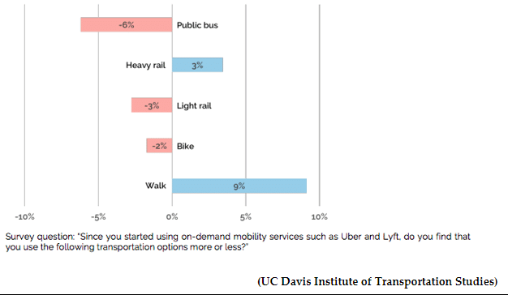
Bliss 2017
Pooled transport, however, should be distinguished from most ridesourced trips, which are often single-occupant. In 2016, Uber, San Francisco, reported that 40 per cent of their bookings were pooled trips. Within the first three months of operations, they estimated to have eliminated approximately 34 million kilometers in car trips, corresponding to 3800 tonnes of carbon dioxide emissions (CO₂).
The overall impact of shared mobility on other travel patterns has been analysed in a recent research report funded by the United States Transport Research Board (TRB). This study identified five key findings in relation to shared mobility:
- among survey respondents, greater use of shared modes is associated with greater likelihood to use transit frequently, own fewer cars, and have reduced transportation spending
- shared modes largely complement public transit, enhancing urban mobility
- because shared modes are expected to continue growing in significance, public entities should identify opportunities to engage with them to ensure that benefits are widely and equitably shared
- the public sector and private mobility operators are eager to collaborate to improve paratransit using emerging approaches and technology
- a number of business models are emerging that include new forms of public-private partnership for provision of mobility and related information services (Feigon & Murphy 2017).
Technological advancement within the freight transport sector is similarly gaining pace. Emerging technologies will increase the efficiency of freight transport by streamlining currently fragmented and time-consuming processes. ‘Smart logistics’ apps aim to better match freight shippers and carriers (Forbes 2016) and companies such as TugForce, Convey and Cargomatic are developing ‘smart logistics’ apps. Shared mobility in the freight transport sector improves vehicle utilisation, increasing productivity with fewer vehicles, decreasing vehicle turnover and environmental impacts. Improved productivity and efficiency may reduce the cost of passenger and goods transportation with improved convenience and service for consumers.

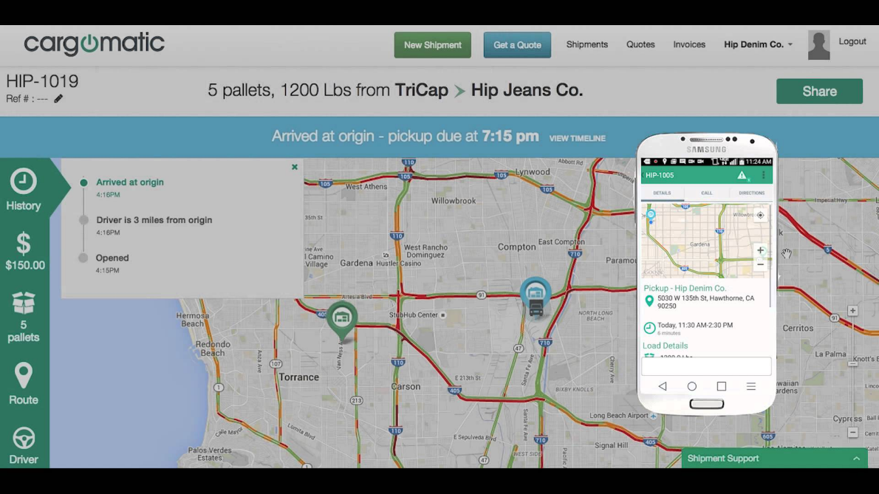
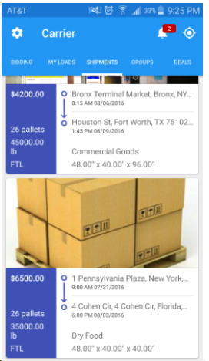
Image 3: Freight apps for customer and freight companies alike

Cargomatic 2015, Tugforce 2017.

It is estimated that car sharing can reduce car parking demand by up to nine car spaces for every shared car (Goldstein 2015, City of Melbourne research) and the actual cost of car ownership can be significantly lower than private ownership, depending on how much you use your vehicle. Australia’s Choice magazine estimated that using a shared vehicle (and not owning a private vehicle) is likely to be more cost effective that owning and using a private vehicle if use of the car is under about 5,000 km per year (Castle 2015).
There is a great deal of research currently being conducted into this area, and the City of Melbourne could benefit from close collaboration with existing researchers both within Australia, and internationally. Working with local researchers to test the applicability of these findings in Melbourne would be critical.

3.4 Energy for transport

3.4.1 Key issues with energy for transport

3.4.1.1 Current and forecast energy usage
The most recent statistics from the Australian Chief Economist indicates that transport remains the second largest sector in terms of energy use in Australia (at 27.2 per cent of total energy usage in Australia), growing steadily at an average of 1.7 per cent per year, as illustrated below (Office of the Chief Economist 2016).
Figure 8: Growth in energy consumption in Australia, by sector
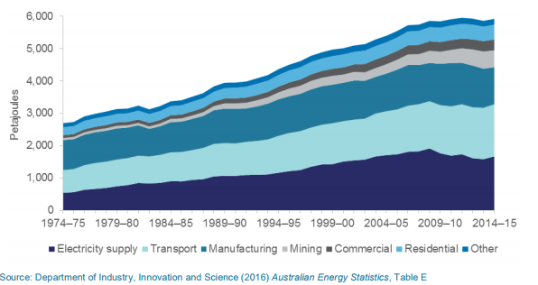
Office of the Chief Economist 2016.
Despite the advances for renewable energies as major players in future energy supply, coal and oil are predicted to continue to supply the bulk of Australia’s energy requirements. Additionally, transport emissions in Australia are significantly higher than Europe (NTC 2016c), with Australian average CO₂ emissions at an equivalent point to Europe a decade ago.

3.4.1.2 Electric vehicles
Electric vehicles were first developed in the 1830s, and included both small cars and electric powered bicycles (Miligan).
Electric vehicles have made a resurgence in recent years, beginning with hybrid petrol-electric vehicles, and moving into purely battery powered vehicles (IEA 2017). The graph below indicates the rapid uptake of electric powered vehicles globally.
Figure 9: Rapid growth of global electric vehicle sales 2010-2016
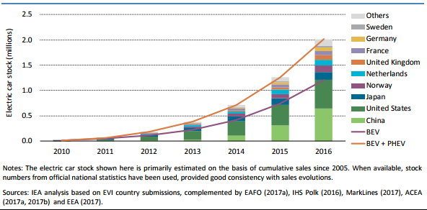
While the numbers are low compared to vehicles with combustion engines, the following factors may support an increase in electric vehicle numbers:
- cost of petrol and diesel increasingly absorbing household budgets (AAA 2017). Electric power is comparatively cheap as a fuel source
- the range of electric vehicles (particularly hybrids) increasing and becoming less of a consideration in the purchase of a vehicle (Degirmenci, K & Breitner)
- the infrastructure for cars and electric bicycles and devices is improving to support increased use of these vehicles in commuting or daily travel
- charging infrastructure is becoming more common – including home charging and fast charging systems
- the production of lower cost electric vehicles (including through reduced costs of battery production) (https://about.bnef.com/electric-vehicle-outlook/)
- the community is becoming increasingly concerned about transport emissions, and the use of renewable energy to fuel electric vehicles has been identified as a barrier to uptake in Australia.
Despite this, adoption of electric vehicles in Australia is amongst the lowest in the world (IEA, 2017). Electric vehicle purchases declined by 83 per cent in 2016, as shown in the diagram below from the NTC’s report Carbon Dioxide Emissions Intensity for New Australian Light Vehicles 2016 (NTC 2016c).
Figure 10: Sales of electric vehicles in 2016 in Australia
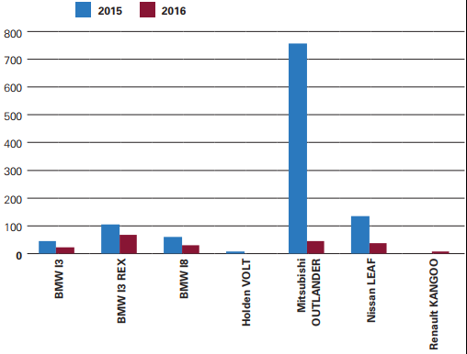
NTC 2016c.
Plug-in electric vehicle sales stalled in Australia during 2016, but some in the industry believe this was due to consumers delaying investments for the arrival of a range of new 2018 models. Only time will tell if the adoption of these new vehicles will become significant in the vehicle fleet.
Electric trucks are believed to be only months away from market, and are believed to have a range that would allow them to almost undertake the Melbourne to Sydney journey with ease. Rapid charging allows them to get back up to a 600 kilometre range again in only 30 minutes (Vorrath 2017).
Smaller electric freight vehicles would be very feasible in and around an urban area, returning to base or rapid charging stations between deliveries.
One of the complexities of battery charging is the perennial issue of varying standards. Electric vehicles currently are being designed and produced with different charging ports. This is likely to be a significantly limiting factor in an international charging market unless resolved at the national level. Energy for electric vehicles or batteries in Melbourne is generally sourced from the mainstream grid, which is primarily sourced from fossil fuels.
Finally, availability of the minerals needed to manufacture batteries (particularly Lithium and Cobalt) is being raised as a potential limiting factor. Deutsche Bank in 2016 identified that rapid growth in electric vehicles and e-bikes are likely to outpace demands for these rare minerals from other sources (Deutsche Bank 2016). E-bikes alone are forecast to utilize 14 per cent of global lithium demand by 2025 (Shunmugasundaram 2017).

3.4.2 Implications of changes in transport fuels
Our transport system requires significant amounts of energy – and this energy usage is likely to increase despite improvements in vehicle efficiency. By its nature, energy for transport must be portable, and so high-yield fossil fuels like mineral oil and bio-fuels will continue to be essential until battery technology and other forms of combustible fuel, such as hydrogen become easily available, economically viable, and have the necessary distribution networks.
The security of energy for transport will likely become increasingly important as global energy demand increases. Until alternative technologies become economically viable for mass-distribution, oil is likely to remain the primary source of transport energy world-wide. If demand outstrips supply for transport energy, it is likely that a smooth transition to alternative energy sources may be managed – maintaining the reliability of transport.
Should demand outstrip supply, even for short periods due to global conflicts affecting supply, temporary shortages, or rapid increases in demand, the likely result will be price spikes, fuel competition, and increases in the cost of transport.
Conversely, instability in fuel supply could also stimulate increases in efficiency of supply chains and the move towards alternate energy sources.
While Australian EV uptake has been lower than global trends, the City of Melbourne has a population of early adopters of new technologies, and a demographic profile that would support faster than average adoption (Gardner et al 2011).
The following graph indicates the relative emissions intensity of new vehicles released in 2016, by fuel type. Note that vehicles with a zero emission are not included on this table, which would further reduce the average electric vehicle intensity.
Figure 11: Average emissions intensity of new cars by fuel type, 2016
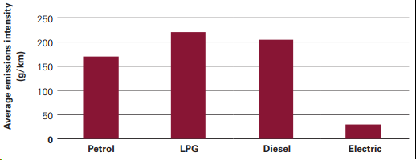
NTC 2016c.
One additional barrier to rapid adoption of electric vehicles is the uncertainty and complexity of having different vehicle plugs. The need for public or commercial recharging stations to have multiple charging plugs, or to only service particular vehicles will add costs and reduce attractiveness of these vehicles to consumers.
A final factor to consider, is that the emergence of automated vehicles and electric vehicles at the same time is likely to see the convergence of the two technologies. It seems obvious that fully autonomous vehicles would need a refueling system that doesn’t involve significant human involvement – and electric recharging at base stations seems an obvious answer.

3.5 Other new technologies
Technology is moving rapidly in a wide variety of fields and many of these are disrupting the traditional approaches to producing goods and delivering services, and may have the potential to have a significant impact on the transport system.

3.5.1.1 Small automated vehicles – drones on land, sea and air
Much of the focus internationally has been on driverless cars, yet drones are also part of the autonomous vehicle transformation. Aerial drones have been making deliveries on a trial basis in several locations around Australia, and have the potential to significantly reduce the cost of parcel deliveries in remote locations.
Australia Post has recently begun trialing small land drones for the delivery of parcels in the Brisbane suburb of New Farm, and Dominos’ pizza has planned deliveries using these vehicles. This technology is moving ahead in many ways faster than passenger and large freight vehicles, because they are largely free of issues such as size constraints, human carrying safety or operation in complex road environments.
Drones can operate in small clusters to carry small or large loads and their design specifications can vary:
- recreational toys to commercial drones
- controlled by a human controller or fully automated in guidance and function
- unmanned used for small deliveries to reduce transport costs and drive productivity in ‘last mile’ deliveries.
Australia Post is currently utilizing drones to improve efficiency and keep costs low.
Image 4: Robot ‘posties’ currently being trialled in New Farm, Queensland
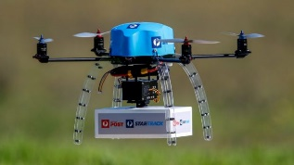

McLeay 2017.
The use of drones in last mile deliveries is extremely feasible and offers opportunities to eliminate the ‘empty space’ in delivery vans, as well as the waiting time or lost time from making multiple trips for a single parcel.
Drones may also be useful in maintenance and replacing the work of humans that is dangerous, dull or dirty. Water drones could also be valuable in helping the city to reduce pollution in the riverways or to support the protection and monitoring of the environment.

3.5.2.2 New types of vehicles and devices
Technology has been driving innovation in vehicle design over the last few decades, and this has seen the development of many interesting, and potentially challenging new vehicle designs. Some of these devices and vehicles do not easily fit within the existing vehicle classification and regulatory framework, and the City of Melbourne will likely need to work with VicRoads and Transport for Victoria to identify how to best manage them.
Some of the new vehicles and devices include:
- small electric motor-driven and human propelled versions of existing devices such as skateboards, bicycles and scooters
- connected bicycles – paid for and unlocked through a mobile phone app
- new electric motor-driven vehicles that are very light and only take up a small amount of road space, but do not have most of the protective features of a car
- bicycles with some of the automated features of cars, including collision avoidance, automatic braking and network connectivity
- larger vehicles such as the rail-less tram-bus, which has the capacity and design of a tram, but the flexibility of a bus.

3.5.2 Implications of drones and other vehicles
Drones (also referred to as small automated vehicles) can be used to improve the productivity of transport by reducing costs of ‘last mile’ delivery. Drones are being promoted and designed to assist with many tasks such as maintenance of transport infrastructure – replacing humans that are doing tasks that are dull, dirty or dangerous. This might include cleaning windows or solar panels, replacing light globes, or removing rubbish from streets, gutters and rivers.
Drones raise questions, however, about access to public space, and what impact a significant number of them might have on footpath amenity and the safety of pedestrians with mobility issues.
The City of Melbourne will need to grapple with these vehicles as they appear on our roads and paths. Some may in fact be valuable to improve mobility and reduce vehicle-dependence, but the safety implications of new vehicles, and the best way to manage interactions with existing transport users will need to be managed. It is likely that there will be a complex balance between benefits and negative impacts to the community, and private benefits and impacts that cannot easily be predicted.
The safety, amenity and nuisance impact of some of these new devices and vehicles may need to be managed outside of the usual set of powers available to the City of Melbourne.

Case study of bike hire schemes –O-bike is a Singaporean company offering shared bike rental in Melbourne and Sydney, based on a smart phone app that locates, unlocks and allows payment for trips on the company’s bikes. The scheme began operating in Melbourne in mid-2017, with over a thousand brightly yellow painted bikes seen across the City of Melbourne and surrounding suburbs. While for some, this scheme appears to offer significant positives, in the form of cheap, easy access to sustainable mobility, there have been significant issues associated with the scheme, including:
- vandalism of the bikes, with bikes being hung in trees, thrown in rivers, or knocked over and left as a hazard for others
- the bikes being left scattered around public places creating a public nuisance for pedestrians, cyclists, joggers and businesses – often utilizing footpath space and narrowing space available for pedestrians
- lack of any pricing or charging regime (or public contribution) to recover or offset costs associated with the company utilizing public space to park bikes (or removal of vandalized or nuisance bikes).
What is the right balance between providing access to public space for the private sector to sell services to the public, and protecting public access to public space? Does the City of Melbourne need additional powers or the support of the Victorian Government to better control the use of public space by private organisations operating on a for-profit basis? (Sheng Ha 2017)
Some regulators currently have the power to ask a Court to issue commercial prohibitions that are used to manage the danger that uncooperative private sector organisations might pose to the public interest by restricting their business practices or preventing their operation.

EXPERIENCE FROM OTHER CITIES
Around the world, governments are working in collaboration with technology developers and car manufacturers towards improving the future of transportation. Several large-scale projects in the United States, Europe and Asia are being developed, tested and deployed (Yang et al 2017). Cities have already implemented innovative and quantifiable trials to test the technologies and business models that will transform mobility, transportation and urban infrastructure over the next few decades. Some examples include:

4.1 New York Connected Vehicle Pilot
The Federal Automated Vehicles Policy developed by the National Highway Transportation Safety Administration (NHTSA) outlines best practices and industry standards for the design, development, deployment and testing of highly automated vehicles (HAVs). This policy guideline applies to all entities that sell or operate automated vehicles including suppliers, outfitters, commercial sale and entities intending to use AV’s on public roadways, transit companies, automated fleet operators, “driverless taxi companies” and any fleet vehicles (NHTSA 2016).
To date the U.S. Department of Transportation has leveraged approximately $350 million for the creation of smart city and advanced transportation technologies, granting funds under several nationwide programs. One of the three national deployment trials, the New York City Connected Vehicle Pilot, aims to reduce the number of fatalities and injuries from traffic crashes. The city has undertaken a pilot of connected vehicles, infrastructure and pedestrians.
While still underway, the NYC pilot has already shown some valuable learnings for other cities looking to utilise connected communications technologies to improve public safety. In a high-density city, where on average a person is killed or seriously injured every two hours by a vehicle, a major focus of the pilot is on the safety applications of AV’s, integrating V2V (vehicle-to-vehicle), vehicle-to-infrastructure (V2I) and infrastructure-to-pedestrian (IVP) communications into this project.
Some of the key learnings so far from the pilot (which is in its second phase (Deploy/Design/Test technology) include:
- Taking a whole of system approach. Good program management is essential and requires collaboration between all levels of government and across the city, integration between modes, data and technology, sharing information, stakeholder engagement and education and addressing commercial partner’s risk and issues.
- Having a clear concept of operations for the road, area or precinct – and using flexible standards (or flexibly used standards) as the base for helping to achieve the concept of operations (US ODT 2017).
- Using international expertise, and adapting it locally. Adapting technology to a dense urban environment requires tailoring and work, but there are a wide range of existing service providers and technologies to use as a basis for testing and trials.
What does this mean for Melbourne?
The City of Melbourne is already working with researchers and technology providers to test the applicability and impacts of new technologies such as automated buses in the metropolitan areas. The city may wish to consider trialling some complementary infrastructure to vehicle technologies such as red light violation warnings, speed compliance and emergency communications, and infrastructure to pedestrian technologies such as signalised crosswalk warning systems.
The value of this testing would be to assess the benefits, costs, and optimal functionality for broader rollout across the metropolitan area over future decades.

4.2 Shared electric cars - Grenoble, France
Three years ago, Grenoble in partnership with Toyota introduced an electric car sharing project. A fleet of shared electric vehicles for rent was provided, and they collected from pick up stations around the city, driven and dropped off at recharging stations (close to bus and tram stops). Evaluation of the trial which ran until August 2017, found that higher rental periods occurred during the week than on the weekend, around peak commuting hours (morning, lunch time and late afternoon). Trips were an average of 5 kilometres (well below the maximum range of 35 to 50kms for these cars), rented for approximately 45 minutes and 75 per cent of users booked a single one-way travel option (pick up from one location and drop off at another). The purpose was to encourage a multimodal mobility system where travellers could opt to use several mobility forms (electric car, bicycle, public transport) to reach their destinations (Ayre 2017).
What does this mean for Melbourne?
Other cities are forming partnerships to deploy automated vehicle testbeds, and interest in trialling automated vehicles is very high in Australia. The City of Melbourne may seek to partner with a service provider to establish a not-for-profit automated electric vehicle fleet, planned and delivered to complement the existing public transport system and active transport network. An example of such a ‘public good’ automated vehicle fleet is explored further in the next chapter, as one of the scenarios.

4.3 The city of Columbus, U.S – Smart Columbus
In 2016, the city of Columbus won the $40 million funding grant as part of the national Smart City Challenge, a major government initiative funded by the U.S Department of Transportation (U.S. DOT).
Columbus was one of 78 cities that competed for this funding, which was supplemented by private sector contributor (Vulcan Inc) with another $10 million.
The SMART Columbus city vision uses a holistic approach to reinvent mobility and how people will access opportunities and essential services (City of Columbus 2017).
Image 5: Smart Columbus Vision
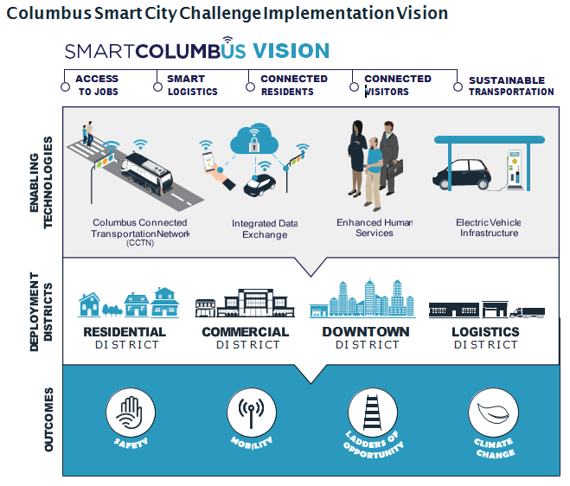
City of Columbus 2017.
Already underway, Columbus is using a cohesive system to target challenges in residential, commercial, freight logistics and downtown districts. The project incorporates integrated data exchange, connected vehicles, common travel payment, multimodal trip planning, smart mobility hubs, street lighting, collision avoidance, mobility assistance, enhanced permit parking, event parking management, delivery zone availability, connected electric autonomous vehicles, truck platooning, oversize vehicle routing, and interstate truck parking.
Some specific projects being undertaken as part of this program include:
- creating an integrated data exchange
- installing connected devices in vehicles to support improved vehicle and pedestrian safety
- working towards a single transport payment method across all modes of public and private transport
- establishing more convenient mobility hubs that provide access to public transport (train and bus stops) clustered with bike hire and car share options
- implementing a digital permit parking scheme to better identify resident vehicles and make parking payment easier
- collaborating with providers to deliver connected, electric autonomous vehicles that will operate on set routes to connect between key hubs and complement public transport.
A similar suite of proposals, implemented and deployed in various ways, was common across many of the competing 78 cities. The most commonly proposed strategies across the spectrum of submissions included:
- integrated digital mobility marketplaces to allow travelers to easily plan multimodal trips, compare trip costs and purchase mobility services.
- expanding bikeshare, carshare, and rideshare options.
- improving transit service reliability by establishing bus rapid transit corridors, installing signal systems that prioritize buses, and getting real time transit information into the hands of riders.
- ensuring the safety of pedestrians and cyclists with pedestrian detection and warning systems on trucks and buses and at busy intersections.
What does this mean for Melbourne?
As suggested above, trial deployments would be a valuable area of research and investment for the City of Melbourne. With significant investment and projected population growth flowing into Fisherman’s Bend this is an area of the city that could be an ideal location for the testing of new safety and mobility technologies. Some areas for consideration could include:
- improved connectivity and integration between vehicles and infrastructure (such as signalised lights, pedestrian crossings, public transport stops, and mobile phones)
- improved integration between modes and information provided to customers, including utilisation of customer travel preferences to improve public transport timing and connectivity
- exploring opportunities with the Victorian government to implement a single transport payment method
- trialling a digital permit parking scheme.

4.4 Melbourne is already a hub of transport innovation
The Melbourne metropolitan region, and Melbourne City in particular, is a hub of innovation. Transport innovation pioneers and researchers have made the city home to:
- ITS Australia hosted the 2016 Intelligent Transport Systems World Congress in Melbourne, which showcased a variety of new technologies and demonstrated the functionality of several automated vehicles here on the streets of Melbourne. https://www.its-australia.com.au/events-archive/2016-its-world-congress-melbourne/
- VicRoads, the University of Melbourne, RMIT and City of Melbourne are creating the world’s first urban laboratory for implementing and testing of emerging connected multi-modal transport technologies at a large scale and in a complex urban environment. The Australian Integrated Multimodal EcoSystem (AIMES) is based in and around Carlton, has already seen the testing of an automated bus in late 2017. https://imovecrc.com/australia-national-connected-multimodal-transport-test-bed/
- LaTrobe University is hosting an automated bus trial, in partnership with Melbourne’s ARRB, VicRoads, the RACV and international leader in public transport provision Keolis Downer. Trials of the automated bus in a university transport environment commenced in late 2017, with the intent to move to public passenger transport in mid-2018. http://www.latrobe.edu.au/technology-infusion/autonobus
- The Urban Mobility Program of the Smart City Institute is undertaking groundbreaking research into the benefits of shared, automated vehicle fleets in Melbourne. http://www.swinburne.edu.au/research/our-research/institutes/smart-cities/
- ARRB and the Australian Driverless Vehicles Initiative (ADVI) are leading or collaborating on several national initiatives to support the trial, and deployment of connected and automated vehicles. http://advi.org.au/
- Transport Certification Australia (TCA) has played a global leadership role in shaping international telematics and communications technology interoperability standards. https://tca.gov.au/tca

POLICY OPTIONS FOR MELBOURNE
Emerging technology provides many opportunities, but also provides challenges to achieving the Vision for the City of Melbourne. The decision-making environment for the City of Melbourne over the next few decades is likely to become more complex and the expectations of the community are increasing, which will exacerbate many of the complexities City of Melbourne will have to manage.
Given the uncertainty in how different technologies might be adopted by consumers, there is great divergence of opinion about the best way to proceed in planning and managing the City of Melbourne’s transport system over the coming decades to achieve the vision for Melbourne.
Scenario planning is a world recognised tool for helping to engage with the uncertainty of future growth and social change patterns (Bradfield 2005, Leigh 2003). This paper explores three potential future scenarios, focusing on the way the emerging technologies described earlier in this paper might impact on the mobility needs of the city, as well as the experiences of citizens and visitors to the city.

5.1 Future development scenarios
As we have highlighted so far, technology might be adopted in many different ways, depending on the preferences of consumers, changing business models and different government and market influences – all of which create a unique set of circumstances in each city. As a result, it is worth exploring some different scenarios for the future – since it is impossible to predict which particular future will evolve.
These three scenarios describe plausible futures which consider:
- degrees of automation
- willingness by the community to share transport
- energy types
- connectivity and integration of systems, and
- data sharing.
In each case, the scenario explores specific implications for the City of Melbourne, but also needs to be considered in the context of the broader metropolitan, regional and national context. In each case, the scenario is set around the mid-2030s and attempts to explore the impacts of the technologies on road use and demand, walking, cycling, urban form and parking, amongst other things.

5.1.1 Scenario 1 Convergence of technology and policy
Settings
- High automation - technology reaches full automation (including dedicated automated vehicles) across all of the City of Melbourne and is deployed as part of a low cost ‘public good’ model
- High sharing - consumer demand for shared (pooled rides and shared vehicles of various kinds) mobility is significantly higher than current levels (average vehicle occupancy increases to 1.8 passengers per trip)
- High electrification - majority of new vehicles are electric (60 per cent of new vehicle sales within the City of Melbourne are electric)
- High data sharing - communications technology allows for private, secure, but personalised information to be shared in an interoperable way across the transport cyberinfrastructure.
One possible future might see the acceleration of several existing trends around automation, sharing of transport, electrification of vehicles and connectivity. Within this scenario, automated vehicle manufacturers and road managers collaborate to deploy small fleets of electric, automated vehicles in the City of Melbourne and surrounding metropolitan region. These vehicles range from four-seater sedans to 12-seater people-movers with the ability to platoon into small groups. Controlled by artificial intelligence systems, and operating on a purely cost-recovery basis with charges that encourage pooled trips, the vehicles come to be a core part of the transport system in Melbourne, complementing heavy rail, trams, and buses.
Although restricted to particular speeds, the vehicles generally have access to all arterial and local roads that allow through traffic. The vehicles accept single riders, but the pricing structure strongly promotes sharing of rides, and they are integrated with the existing tram and train network to avoid competition and provide additional mobility to and from public transport stops, and across the radial network.
Algorithms and near-artificial intelligence optimise the routes of the vehicles to minimise trips and maximise the utility of each vehicle. De-identified data from the use of the vehicles is shared to allow optimisation of travel. Some vehicles also offer premium services such as entertainment, or discounts with associated businesses.
A series of roadside inductive charging stations scattered around the inner metro region allows the vehicles to rapidly charge between hires, and a number of automated and human-driven, carbon fuelled share cars are available for temporary hire to provide the flexibility to connect with areas outside the range of the electric fleet. Many people take advantage of the new AV’s, and live in outer metropolitan regions further from the city, relying on their automated cars to get them safely to work while they sleep their commute away or watch their favourite on-line show.
The City has reclaimed some road space, eliminating on-street parking from sections of the city and slowing speeds to support dedicated space for pedestrians and cyclists, as well as new footpath delivery drones that have replaced most delivery vans. These explicit choices have channelled through traffic to key arterial routes, and maintained strong public transport patronage. The City of Melbourne’s advocacy and collaboration with the Victorian Government has improved ongoing investment in public transport across urban renewal areas and to support improved uptake of shared mobility options, to minimise car dependence.
A collaboration between the City, the Port, the transport industry and innovators has seen the development of a digital interface to optimise pick-up and delivery times and transport routes through the city – minimising movements of containers and other large freight, particularly during the day.
Implications
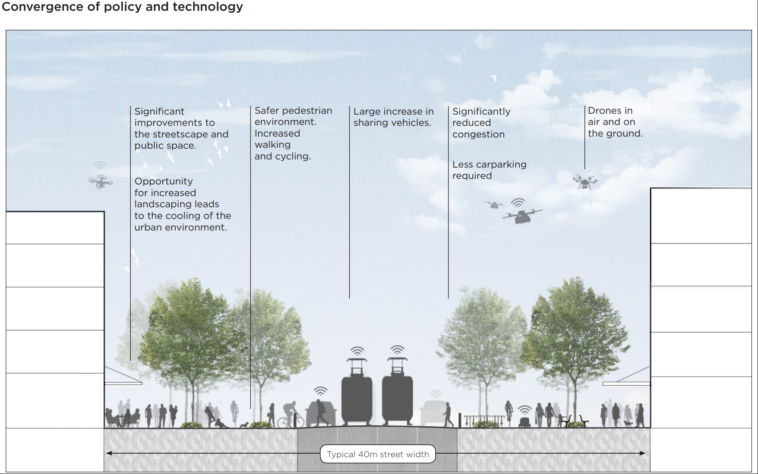
It is plausible that the following might be likely implications from this scenario:
- reduced car reliance and ownership in the City of Melbourne, with more people being connected to public transport, or utilizing the shared AVs to reach destinations not easily accessed by public transport (Dia 2017). This also requires less parking and other space for vehicles
- there is some increase in actual personal travel because of the low cost of the shared automated vehicles, but this is largely offset by the rise in pooled trips
- improved livability in general for residents and visitors to the City because traffic is smoother and travel times are more reliable, as well as less circulation as fewer vehicles are hunting for parking. This allows the reclamation of space required for cars, parking space required on-road and in buildings. Increased traffic on the arterial and ring-road networks partially offsets this in certain locations
- better traffic management, as vehicles and the traffic management system are ‘aware’ of the origin and destination of each trip as it is undertaken and can prioritise signals and route vehicles to effectively stream and platoon cars or avoid hazards and obstacles
- significantly improved safety because of several factors
  - automated vehicles being up to 94 per cent safer than human driven vehicles (NHTSA, 2017)
  - connected devices such as smart phones offer improved safety for pedestrians and cyclists by allowing automated vehicles to detect and avoid them, for example, when people step out between parked cars
  - reduced overall number of cars on most local roads because of more shared transport
  - average speed limits on most local roads decreases to 30 to 40 km/h and becomes smoother and more predictable
  - reduced car parking required, allowing increased space dedicated to walking, cycling and public transport
  - fewer breaches of road safety laws (such as speeding) because the authorities are notified every time a significant alleged breach of the road rules occurs within detecting distance of one of the automated vehicle fleet
- people also receive notifications of more efficient ways to reach their destinations when traffic and weather conditions change
- human driven cars benefit from the improved connectivity and shared data as well, receiving ‘push’ notifications to change routes to save time and fuel
- reduced transport emissions – both CO₂ and other noxious emissions
- increase in walking and cycling results in improved community amenity in, and around the city
- unfortunately, some of these benefits are offset by increased congestion on the arterial and ring-road network and seeking to access the city because of:
  - population growth in the City of Melbourne (though most new trips are in shared AVs) and outside the City of Melbourne
  - people from outer metropolitan regions (where shared, electric vehicles are much less popular due to less opportunity for sharing due to lower density living and fewer charging opportunities) still drive through the city and often use privately owned AV’s
  - vehicle occupancy actually drops below one on certain trips (for example, private AV’s travel around empty to park after dropping off their rider from a long commute) which could push up demand for parking
  - urban sprawl is compounded because travelers are willing to live further from their workplaces and commute because they can sleep or otherwise entertain themselves during the lengthy (and sometimes slow) commute in their privately owned automated vehicle
  - induced demand, as certain streets become calmer and more smooth flowing, some people have chosen to drive rather than use public transport or other modes
- walking remains the dominant mode for trips within the central city and short journeys across the City of Melbourne, and public transport is still the dominant mode for central city commuters. Many people who work outside the central city travelling by train or tram, and use the automated shared vehicles and buses for their ‘last mile’
- private car parking for privately owned and business fleet vehicles in the city is still in high demand but most on-street parking has been reclaimed for public space as one of the measures to encourage public transport ridership and other forms of shared transport. Parking is also managed through a digital pricing platform to optimise the availability and supply of parking
- large scale freight deliveries to the city and major hubs are often split up or consolidated in warehouses on the rim of major shopping districts, and delivered at night by small fleets of battery-powered drones. Consolidation of loads has been another big win, though the city is looking to further optimise freight and looks for ways to help the industry improve productivity by supporting fast charging facilities for larger electric trucks.
- Meanwhile, the City has invested in prioritising freight vehicles on key freight routes to and from the Port of Melbourne to ensure that the life-blood of the Port can through the city efficiently, and with minimum interaction with vulnerable travellers.

5.1.2 Scenario 2 Divergence of policy and technology
Settings
- Low automation - Because of liability entanglements and technical complications, automated vehicle providers do not progress beyond current levels of conditional automation on freeways, certain private carparks and some other locations (meaning vehicles are generally not driverless at all)
- Low sharing - consumer demand for shared (ride sourcing and pooled) mobility returns to historical levels (average vehicle occupancy remains static from the present, at approximately 1.07 occupants per vehicle)
- Low electrification - a significant, but small proportion of the vehicle fleet is electric, but does not become the majority due to confusion and customer dissatisfaction with different charging plugs and the dependence of the electricity grid on fossil fuel (approximately 30 per cent of new vehicles purchased in Melbourne per year are electric)
- Poor data sharing - communications technology remains fragmented, with private companies unwilling to share data for commercial reasons, and standards not being adopted, or being too open to support full interoperability.
A very plausible alternate scenario sees automated technology delivered, but only in certain locations such as freeways, parking structures and certain commercial premises. These vehicles are not adopted as shared fleets, but rather purchased as privately-owned vehicles. Most vehicles only operate in automated mode on freeways, but commuters who are living further from the city centre enjoy the ability to relax or even sleep during the long and often slow journey home.
Because electric charging facilities are not widely enough spread, most of these vehicles are hybrid vehicles that run partially off an electric charge but are supplemented with carbon fuel. Finally, while many of the car companies are willing to share their data, there is no convergence on international standards and commercial pressures push companies to only share basic safety data. Without the free exchange of information other than simple location, the advanced hyperconnectivity of the first scenario does not evolve.
Traffic applications for drivers and pedestrians focus on the individual, seeking to optimise each person’s individual journey and safety.
The Council’s new digital parking platform has been welcomed at last, though the introduction was controversial – allowing people and companies to book and pay for parking in the city central and key hubs to streamline vehicle movements as they search for parking. The third-party blockchain platform on people’s mobile phones also allows Council to continue to raise revenue from parking, while avoiding major infrastructure investments. While drone compliance of parking is being trialled, human inspectors are still walking the streets.
Implications
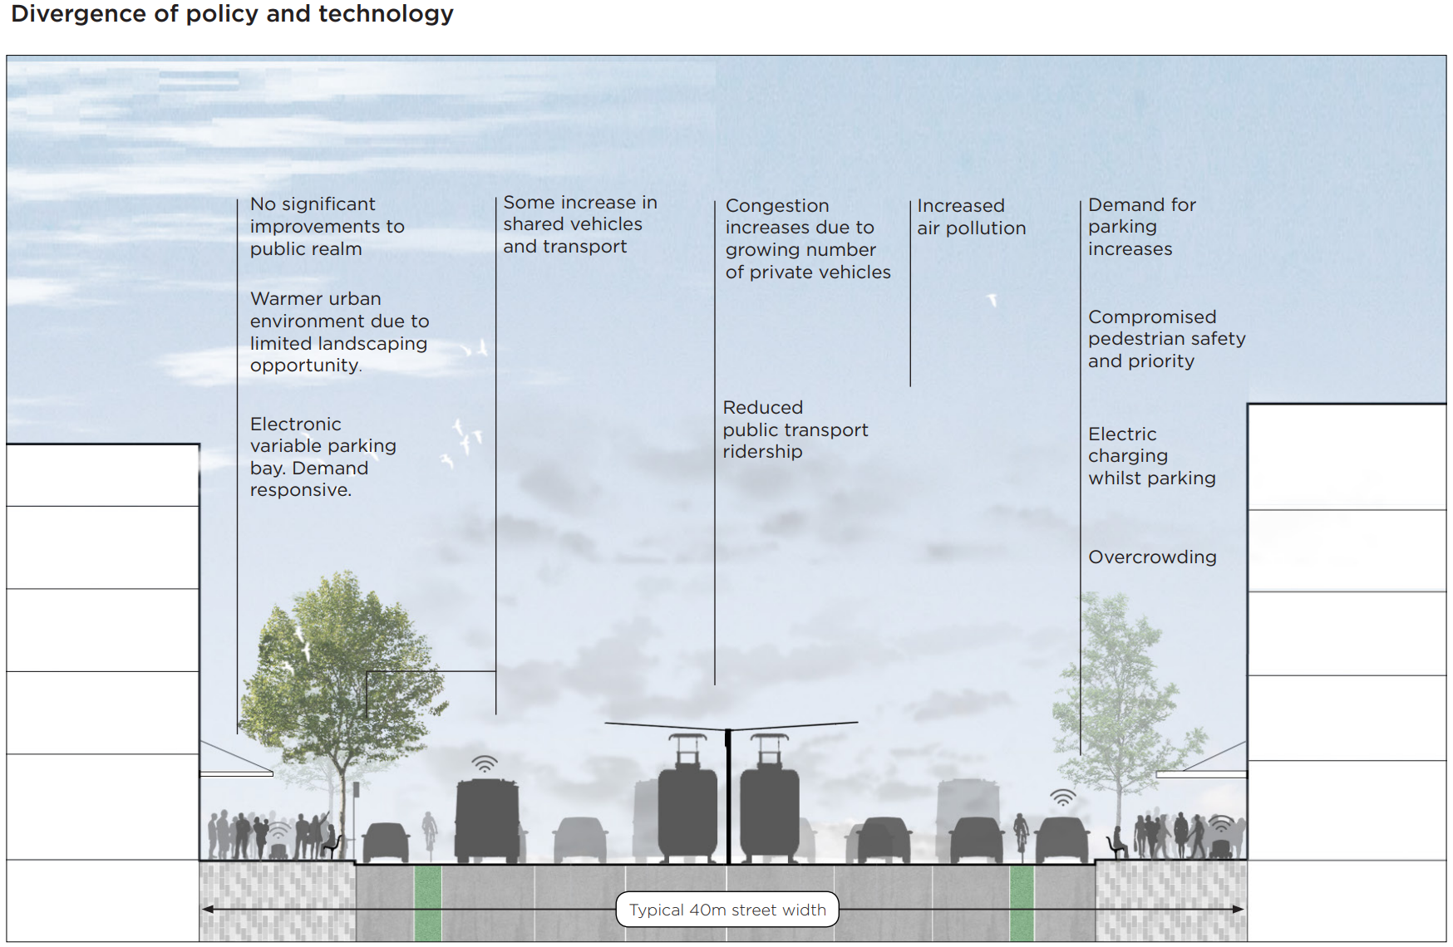
It is plausible that the following might be likely implications from this scenario:
- road safety for vehicle occupants improves significantly, as advanced safety features such as lane correction and collision avoidance become standard across the vehicle fleet and reduce the number and severity of crashes
- vehicle travel on all roads in the City of Melbourne and the city’s ring-roads increases significantly due to:
  - natural population growth in the City of Melbourne and outside the City of Melbourne (people travelling to or through City of Melbourne)
  - urban sprawl has increased as people sleep through their long inter-regional journeys, or watch movies, or occasionally finish some urgent work from the office
  - because of the increasing distance of many commutes and a lack of convenient access to public transport on the urban fringes, public transport usage as a proportion of travel to the city declines
  - in a feedback loop from increased traffic on both arterial and suburban roads, fewer people are willing to cycle or walk, and road space for parking and commuting becomes increasingly in demand
  - a lack of investment in public transport in new housing developments at the fringe of the metropolitan region, locking in car dependence and often multi-car families
- due to increased private and commercial fleet usage, parking demand in the City of Melbourne increases
- freight increases as the Port of Melbourne continues to grow in prominence as a major international hub, but congestion and a lack of collaboration hampers the efficiency of the industry. Some companies invest in portable drones to aid in the unloading and delivery of trucks to customers in major hubs, but the absence of easy access to fast charging technology means only the big players can afford them
- equity of mobility is negatively impacted, as the overall cost (financial and time) of mobility increases. Families that can’t afford private AVs spend more money on petrol due to longer commute times, and they have to be in control of their vehicle for the entire journey. Road based public transport suffers from the same delays making trams and buses less attractive options
- more cars on the road make streetscapes less attractive and increases the perception of risk, and community amenity becomes a hot topic – freeways some to have separate lanes for vehicles operating in automated mode
- another hot topic is the increase in transport emissions – with CO₂ emissions continuing to rise as engines remain generally fossil fueled. Other particulates also continue to grow, and deaths and morbidity due to air quality becomes a significant community health concern.

5.1.3 Scenario 3 Mixed pathways
Settings
- Automation for shared vehicles only - most automated vehicle providers do not progress beyond current levels of conditional automation, but collaboration with certain manufacturers allows the deployment of automated mini-buses on specific routes or specific areas
- Improved sharing - willingness to share journeys continues to increase from today’s levels, but many people still prefer a private journey if they have the choice (average vehicle occupancy increases to 1.2 per trip)
- Improved electrification - electric charging technology is deployed around the City of Melbourne, and private charging systems are provided in many private carparks, which supports strong adoption of electric vehicles in the City of Melbourne, but with much lower adoption in surrounding and outer urban areas (up to 60 per cent of new vehicles purchases in the City of Melbourne are electric, but in outer regions the proportion is much lower)
- Improved data sharing - communications technology interoperability standards ensure that all connected vehicles and devices can share basic safety information
Within the City of Melbourne, collaborations between the city, public transport authority, private vehicle developers and the community see the deployment of a fleet of small, automated mini-buses that better connects across (and integrates with) the existing public transport network, and supplements the public transport system when needed.
Between the shared autonobuses and a new parking booking and payment app that better rations parking space, the city can reclaim some road space and dedicate it to better cycling infrastructure on key commuter routes across the city. Space for walking, green space and drones is reclaimed in major activity precincts such as high street shopping districts.
City of Melbourne establishes a data sharing platform to support improved secure third-party access to transport data, and to enable the new parking booking and payment app to function properly. Licensed sale and use of non-personal data becomes a new revenue source for the city, and supports improved research and planning.
Commuters from outside the city continue to be car dependant, and their vehicles remain largely human controlled. There are no fleets of autonomous or shared taxis, and the ‘mobility as a service’ future is only partially realised. City of Melbourne remains a highly valued destination, keeping housing prices high and driving up pressure to protect local community amenity.
Implications
Some plausible implications from this scenario are:
- traffic on major through routes and arterial roads increases as a result of population growth, but average commute times do not increase significantly on major highways because people continue choose to live and work within approximately 35 minutes of one another (urban sprawl slows)
- traffic on local streets and in major shopping/activity areas decreases slightly and is smoother flowing due to slower speeds, reduced on-street carparking (which reduces cars ‘circulating’ looking for parking spaces), increased space dedicated to walking and cycling, and improved traffic signalization
- walking and cycling increases in certain locations (not on major arterial roads across the city, but to and from major activity centres within the City of Melbourne, particularly the city centre)
- safety improves dramatically, as a result of:
  - new advanced safety features becoming standard in all new vehicles over the intervening two decades. This reduces the number and severity of vehicle crashes
  - the City of Melbourne’s platform for sharing data enables third party app developers and government to roll out connected pedestrian and cyclist cyberinfrastructure – apps that warn drivers of approaching pedestrians, that help guide cyclists away from busy hot spots, and that allow traffic signals to better prioritise pedestrians and cyclists
  - slower speeds and more pedestrian friendly streetscapes (with less on-street parking) in certain locations
- public transport usage to, and within the City of Melbourne retains its mode share and increases in absolute terms due to restrictions on parking, speed limits and other factors prioritizing non-car modes in the city centre and other City of Melbourne activity centres, as well as because of the better integration with the automated buses
- decreased vehicle emissions within the City of Melbourne in general but increased emissions near arterial through roads, and much lower emissions on quieter City of Melbourne roads.

5.2 Policy options
Policy assumptions
There are several assumptions that have been made in the development of this paper, which lead to general themes of focus, and potential policy options for the city to explore. The assumptions we have made include:
- stability in the system of government – Victoria will remain a largely free market, democracy with three levels of government administering the current range of policy areas.
- the City of Melbourne will remain in its current geographical form and with the current responsibilities
- population growth will occur in accordance with the forecasts of the City of Melbourne, and other agencies, including forecasts for an ageing population
- the global, national and state economy will return to a more long-term cyclical trend and will likely undergo significant disruptions in specific industries, but the City of Melbourne will remain a major economic driver in the Victorian economy
- technology will continue to be developed to meet new market niches, to support new business models, and these will challenge and potentially disrupt some existing industries and markets.
Some of the implications of these assumptions include:
- the Victorian government will remain largely responsible for public transport (mass transit) planning, integration and provision
- the Victorian and Australian governments will retain responsibility for the overarching regulatory regime (state and federal laws) and therefore technology will operate within a national and state framework
- the City of Melbourne, within the context of state planning and approval legislation, will retain control over local planning approvals and requirements, parking management, local laws and the delivery, management, maintenance and operations of the local network of roads, paths and public spaces in the City of Melbourne
- consumers will be the key driver of technology adoption – choosing which new services they want, trust and are willing to pay for.
The City of Melbourne has a range of policy levers and options available to shape the future development of Melbourne transport system and mobility patterns and choices.
Some policy options will be more valuable in managing the impact and opportunities of emerging technologies than others. International and interstate practices may guide the choice of policy options, but Melbourne has unique characteristics that need to be considered in decisions – most important being the goals and objectives of the vision for Melbourne.
In general, it is likely that the City of Melbourne does not have the mandate or power to outright prohibit or ban most new technologies. Given that the deployment and adoption of technologies will usually be through consumer choice –one of the most effective ways of influencing the impacts of new technologies is likely to be through policies that support consumer choices that align with the Vision.
Proactive shaping of the market settings is complex, but international and local practice in allocating space and prioritising access and convenience of different modes is likely to also be effective in shaping the uptake of new technologies.
As outlined in the next chapter, collaboration and integration (and occasionally advocacy) between all levels of government, and with the private sector, researchers and the community will be essential to achieve the full benefits of new technology and minimise the negative impacts.
Table 5: Some of the direct policy options available to (or being implemented by) the City of Melbourne
Policy option | Examples and suggestions
Education | Sponsoring events  Prioritising the use and access to public transport at major events  Using apps and other digital technology to support the adoption of shared vehicles, public transport, walking and cycling,  Working with corporations and fleet owners to optimise the efficiency of their fleet usage in terms of the broader network outcomes  Direct education of travellers through workplace TravelSmart type behavioural change programs
Research and trials | Examining new technologies, including:  - safe design and use  - the most viable business models and deployment patterns  - adoption trends by users  - implications for urban growth, travel behavior and public space allocation  Developing and exploring scenarios to improve the robustness of policy and planning
Planning and construction controls | Exploring setting requirements for dedicated parking spaces for shared vehicles, and recharging facilities for electric vehicles
Procurement policies and processes | Ensure new services, activities and infrastructure is resilient to change, free from technology or data monopolies and is interoperable into the future.  Procurement (particularly when coordinated with other major market players such as metro regional councils or other major Australian cities) can be a powerful tool in setting standards for data interoperability, carbon footprint, adaptability of services, and other criteria
Revised parking policies | Parking policy including restrictions, charging, prioritisation and resumptions and may be a valuable trigger to incentivise or support shared vehicle use, shared automated vehicle use, and to increase walking and cycling and improve community amenity.
Advocacy | Bringing well-reasoned, proposals to the Victorian and federal governments to support issues that directly or indirectly influence the vision for Melbourne will be essential to improving coordination between levels of government.  Automated vehicle regulation and policies, vehicle electrification and standards for electric vehicles, and the planning and supply of public transport are areas of key interest.
Collaboration and partnerships | Collaboration with other Councils in the metropolitan region is critical to achieving sustainable, long-lasting change in behaviour towards more efficient use of road and other public space, and more intensive use (higher occupancy) of private vehicles and public transport  Partnerships and collaborative arrangements with other cities such as Sydney and Brisbane can be valuable to share information, plan for single solutions and improve the efficiency of procurement  Collaboration with other levels of government and the private sector is essential to shape the policy settings for the future  Proactively working with the private sector to test, evaluate and adjust policy settings in relation to the deployment of new technologies
Road management policies | There are many forms of road management policies, including various forms of prioritising different modes/users, or allocating space. These include:  - allocation of space between cyclists, buses, trams, cars and pedestrians (and other uses such as commercial footpath access, drones etc.)  - signalisation and traffic management system operation,  - restricting access to some road users,  - using speed limits and street design to discourage or encourage certain types of road use in certain locations.
Direct investment | Investment can take many forms, including both physical infrastructure, tangible services, and less tangible cyber infrastructure.  Physical infrastructure is usually very expensive, and includes:  - new road space, traffic lanes, foot and cycle paths, tram—only lanes, parking space transport (road, cycling, walking, public transport) infrastructure  New services often have a significant recurring cost to government, and include:  - new or expanded bus, tram and train services, subsidized taxi or other ride sourcing/sharing services for particular community segments  New cyberinfrastructure, including both tangible, and intangible elements:  - connecting existing infrastructure such as installing Bluetooth or other sensors in signalised intersections to detect pedestrians  - new data sharing platforms, a new enhanced traffic signal management system, or a new digital parking management and payment system

Many of these policy options are, of course, combined, so education would usually accompany a new type of public transport service. Similarly, Melbourne might follow the lead of some overseas cities and work with the Port to implement a ‘Low Emissions Zone’, in collaboration with the Port of Melbourne (Port of Antwerp 2017) potentially by restricting access to the port to vehicles certified as having emissions below a certain threshold, with accompanying education and public awareness by the City of Melbourne.
All of these options present different benefits at different cost levels, and different levels of implementation complexity. Each policy option would need to be assessed in order to ensure informed decision making and to ensure that the City of Melbourne delivers the best value for money solution. In terms of a public policy debate, often policy options can be framed as ‘trade offs’ – since there is certainly not enough room or money to make all the changes individuals might want to see.
The key trade off that community will be involved with and will experience directly will be the allocation of space in the road corridor, literally, a trade-off between which mode receives the most space, and prioritisation in design. Some of the other obvious policy trade-offs might include:

Increasing vehicle occupancy of vehicles (including increasing PT use) | Vs | Providing road capacity for single-occupant vehicles (and potentially empty vehicles if full AV capability is achieved)
Increasing density of urban areas, along with mixed use and available mass transit | Vs | Allowing continued growth of the urban footprint to provide freestanding housing and private open space/backyards
Restricting access to certain roads or reducing parking, or reducing speed (for example, pedestrian shared zones) | Vs | Allowing increased free use of motorised transport

As can be seen from the scenarios earlier in this chapter, technology can play a significant role in achieving the optimal outcomes in terms of safety, affordable mobility, community amenity and other factors. The largest key factor, however, was how the technology affected vehicle occupancy.
Trade offs and policy choices that increase the average number of occupants of vehicles (whether private vehicles, public transport or automated vehicles) will be critical to protecting the amenity, safety, environmental outcomes and liveability of the City of Melbourne and its streets.

RECOMMENDATIONS
In looking at Melbourne’s history and at comparable cities in Australia and around the world, we can see several consistent themes in policy, planning and operational activities. To achieve the City of Melbourne’s vision, the following key areas of focus are identified to help shape the Transport Strategy:
- integration of information, planning, policy, procurement and solutions
- collaboration across government and the private sector to co-create the vision for Melbourne and ensure the city’s liveability, prosperity and productivity is enhanced
- building resilience and flexibility into plans, policy, infrastructure, engagement and services
- engaging with uncertainty – use foresight, forecasting, modelling, trials and engagement with experts and the community to minimise surprises and share relevant information.

6.1 Specific recommendations:
- Take a stronger advocacy role and increase collaboration with the Victorian and Australian governments to ensure future regulatory and policy settings and new investments align with the City of Melbourne’s vision, including:
  - road user pricing is an area where strong advocacy by local government in general, and Australia’s major international cities in particular is essential
  - explore opportunities for trials around incentives and pricing options for congestion management
  - public transport investment – both in the City of Melbourne but also in the outer regions to ensure new developments are well serviced with more sustainable transport options to reduce the need for private car commuting to the metropolitan area
  - working directly with the Australian Government’s Chief Scientist, CSIRO, Infrastructure Australia and Infrastructure Victoria to build the evidence-base for more rapid adoption of shared (pooled) transport and electric vehicles for major infrastructure business cases
  - incentives and national policies and standards that support the increase of sustainability-promoting electric vehicles, potentially including reduced vehicle taxes, registration fees and standardization of charging infrastructure standards
  - ensuring the local community and amenity impacts from the introduction of new technologies is more strongly factored into Victorian and national policy and regulatory settings.
- Investigate opportunities for improved data sharing and integration with the Victorian Government and with the private sector and community. Consideration of a data sharing protocol that enables secure, access to non-personal data that is useful to the private sector and the community (and potentially a charging system for third party and council services in the future) including:
  - current usage and status of the traffic network
  - real time location and timeliness of public transport vehicles (trams, buses and trains)
  - network disruptions including both planned (roadworks, special events etc) and unplanned events (such as vehicle breakdowns, crashes and debris on the road/tracks)
- Undertake ongoing engagement with key industry stakeholders to improve the flow of information on likely new technologies and commercial models, and to identify potential issues and possible solutions earlier.
- Review procurement policies and systems to ensure new acquisitions of infrastructure, services and other activities are technology neutral and open market. This includes specifying outcomes and desired measures rather than methods of compliance or technical requirements insofar as this is possible. Ensuring data integration and exchange is a part of future contracts where possible is increasingly important
- Enhance the Council’s strategic focus on and operational support for increased vehicle occupancy (and freight utilisation) – including consideration of:
  - increasing the availability and ease of access for car parking for existing and future car-sharing and car-pooling organisations (such as higher priority or lower cost space for pick-ups and drop offs for vehicles with three or more occupants at special events)
  - direct and indirect incentives for car sharing enterprises (such as a short to medium term pricing plan that encourages deployment in areas of the city with higher housing density)
  - enhanced industry engagement specifically on the impact and opportunity of new services such as car sharing, ridesharing, automation and new forms of ‘public transport’
  - incentives (such as restricting parking, road access etc.) to encourage the use of shared vehicles and bikes for first and last mile journeys to public transport nodes
  - trialing the more intensive use of freight vehicles and hubs, including consolidation centres to reduced freight trips and therefore improve productivity, safety and other outcomes
- Continue to pilot new technologies, and encourage and support the private sector and researchers to undertake trials and demonstrations to test the safety, useability, commercial viability and other aspects of new services and systems. Consider the following priority areas for trials:
  - working with the owners of digital maps such as Google, to include additional valuable information layers, that would enable some of the following suggestions
  - connected technology (particularly at signalized intersections, pedestrian crossings, public transport stops and safety black spots) for improved pedestrian and cyclist safety
  - third-party digital platform for booking slots for freight pick-ups and deliveries that supports both efficiency and competition (is not owned by a major freight operator or manager)
  - the use of drones in maintenance and operations activities, and supporting research into the use of other new technologies such as energy efficient (or energy generating) paints and surfaces for road and structures, self-healing designs for critical infrastructure, and permeable surfaces to replace water impervious pavements as part of more water sensitive urban design
- working with the Victorian government, the freight sector and Port of Melbourne to identify areas for new technology to improve freight efficiency and to ensure the Victorian Freight Strategy supports the prioritisation of freight movements over passenger transport in key corridors
- working with the Victorian Government to investigate more efficient methods of traffic management and signal control, that also support improved transport connectivity
- Explore opportunities to undertake a trial deployment or incentivise a fleet of ‘public good’ automated micro-transit vehicles and cars, on a purely cost recovery basis to supplement and complement the public transport system within the City of Melbourne.
- Explore the deployment of a Finland-style digital marketplace for Mobility-as-a-Service in cooperation with the Victorian government and public transport operators as well as private sector mobility providers.

REFERENCES AND FURTHER READING
Adriano Alessandrini, Andrea Campagna, Paolo Delle Site, Francesco Filippi*, Luca Persia, Automated Vehicles and the Rethinking of Mobility and Cities, Centre for Transport and Logistics (CTL) – Sapienza University of Rome, 2015
AECOM, Blockchain: redefining the future of real estate?, viewed 16 December 2017, http://www.aecom.com/ca/cornerstone-issue-03/blockchain/
Agarwal PK, Gurjar J, Agarwal A, Birla K 2015, ‘Application of artificial intelligence for development of intelligent transport system in smart cities’, International Journal of Transportation Engineering and Traffic System, vol. 1, no. 1, pp. 20–30.
Australian Automobile Association 2017, Transport Affordability Index Report – December 2017, viewed 2 January 2018, http://aaa.asn.au/storage/aaa-affordability-index-q4-2017.pdf
Australian Bureau of Statistics (ABS) 2017, June Quarter 2017, ‘Australian demographic statistics’, cat. No. 3101.0, Australian Bureau of Statistics, Canberra.
Australian Bureau of Statistics (ABS) 2017, 6530.0 ‘Household Expenditure Survey, Australia: Summary of Results, 2015-16’, viewed 28 November 2017, https://www.abs.gov.au/ausstats/abs@.nsf/lookup/6530.0Media%20Release12015-16
Australian Communications and Media Authority (ACMA) March 2015, Communications report 2013-14 series, Report 1 – Australians’ digital lives, viewed 11 November 2017, https://www.acma.gov.au/-/media/Research-and-Analysis/Research/pdf/Australians-digital-livesFinal-pdf.pdf?la=en
Ayre, J 2016, First results from Toyota’s Electric Carsharing Project in Grenoble, EVObsession, 30 May 2016, viewed 12 November 2017, https://evobsession.com/first-results-toyotas-electric-car-sharing-project-grenoble/
Bliss, L 2017, The Ride-Hailing Effect: More Cars, More Trips, More Miles, CityLab, 12 October 2017, https://www.citylab.com/transportation/2017/10/the-ride-hailing-effect-more-cars-more-trips-more-miles/542592/
Bradfield, R. Wright, G, Burt, G, Cairns, G, Van Der Heijden, K “The Origins and Evolution of Scenario Techniques in Long Range Business Planning,” Futures, 37, 2005, pp. 795-812.
Cargomatic 2015, Cargomatic Trucking App Demo, Youtube, 15 October 2015, viewed 16 November 2017, https://www.youtube.com/watch?v=3q9kymaQ01c
Castle J 2015, Car share services – Should you jump on the car-sharing bandwagon?, Choice, 21 April 2015, viewed 16 November 2017, https://www.choice.com.au/transport/cars/general/articles/car-sharing-vs-car-buying
City of Columbus 2017, Smart Columbus, viewed 12 November 2017, https://www.columbus.gov/smartcity/
Crash statistics public tableau, VicRoads, viewed 10.16.2017, https://public.tableau.com/views/Injurystatfacts/Injurytrend?%3Aembed=y&%3Adisplay_count=yes&%3AshowTabs=y&%3AshowVizHome=no#1&%3Adisplay_count=yes&%3Atoolbar=no&%3Arender=false
Degirmenci, K & Breitner M 2017, Consumer purchase intentions for electric vehicles: Is green more important than price and range?, Transportation Research Part D: Transport and Environment, Volume 51, March 2017, Pages 250-260, viewed 17 December 2017, https://www.sciencedirect.com/science/article/pii/S1361920916302978
Department of Infrastructure and Regional Development, Bureau of Infrastructure, Transport and Regional Economics, Saturating Daily Travel, Information Sheet 61, https://bitre.gov.au/publications/2014/files/is_061.pdf
Department of Infrastructure and Regional Development, Bureau of Infrastructure, Transport and Regional Economics, Five facts about commuting in Australia, Information Sheet 77, https://bitre.gov.au/publications/2016/files/is_077.pdf
Deutsche Bank 2016, Welcome to the Lithium-ion Age: Global lithium S&D analysis highlights opportunity for high quality assets, Deutsche Bank Market Research, 9 May 2016, viewed 16 November 2017, https://www.slideshare.net/stockshaman/deutsche-bank-lithium-report-may-2016
Dia, H 2015, Driverless cars will change the way we think of car ownership, The Conversation, 6 November 2015, viewed 26 November 2017, https://theconversation.com/driverless-cars-will-change-the-way-we-think-of-car-ownership-50125
Dia, H 2016, How blockchain will transform our cities, Swinburne University, 14 December 2016, viewed 26 November 2017, http://www.swinburne.edu.au/news/latest-news/2016/12/how-blockchain-will-transform-our-cities.php
Dia, H, Hill, J, Javanshour, F 2016a, Autonomous mobility on demand – Review of recent literature and insights for shaping policy directions: 23rd ITS World Congress, Melbourne, Australia, 10–14 October 2016
Dia, H, Javanshour, F, Hill, J 2016b, Modelling the Impacts of Autonomous Shared Mobility Systems: 23rd ITS World Congress, Melbourne, Australia, 10–14 October 2016
Dia, H, Javanshour, F 2017, Autonomous Shared Mobility-On-Demand: Melbourne Pilot Simulation Study: 19th EURO Working Group on Transportation Meeting, EWGT2016, 5-7 September 2016, Istanbul, Turkey
Executive Office of the President of the United States of America, December 2016, Artificial Intelligence, Automation and the Economy, viewed 11 December 2017, https://obamawhitehouse.archives.gov/sites/whitehouse.gov/files/documents/Artificial-Intelligence-Automation-Economy.PDF
Feigon, S & Murphy C 2017, Shared Mobility and the Transformation of Public Transit, Transit Cooperative Research Program; Transportation Research Board, The National Academies Press, Washington
Fishman, E 2016, ‘Emerging Transport Technologies: Assessing Impacts and implications for the City of Melbourne’, Institute for Sensible Transport report to the City of Melbourne February 2016, City of Melbourne.
Fletcher, P 2015, Address to Transport Reform Network road pricing forum, transcript, 29 October 2015, http://minister.infrastructure.gov.au/pf/speeches/2015/pfs001_2015.aspx
Gardner, J., Quezada, G., Paevere, P., 2011. Social Study on Attitudes, Drivers and Barriers to the Uptake of Electric Vehicles. (An Electric Driveway Project Report). Commonwealth Scientific and Industrial Research Organisation (CSIRO), Australia.
Giarratana, C 2016, How AI is driving the future of autonomous cars, ReadWrite, 20 December 2016, viewed 15 December 2017, https://readwrite.com/2016/12/20/ai-driving-future-autonomous-cars-tl4/
Goldstein, D 2015, Does Every Car Need 8 Parking Spaces? Ride-Sharing Can Save Emissions by Reducing Parking, Too, NRDC, 9 March 2015, https://www.nrdc.org/experts/david-b-goldstein/does-every-car-need-8-parking-spaces-ride-sharing-can-save-emissions
Heavy Vehicle Charging and Investment Reform (HVCI) 2013, Heavy Vehicle Charging and Investment Options Development Discussion Paper, June 2013, viewed 7 November 2017, https://www.ntc.gov.au/Media/Reports/(DEA17955-F356-4634-8313-305E2F427FF9).pdf
Howard, R 2015, The Customer is Always Right: Putting consumers back at the heart of UK energy policy, Policy Exchange, https://policyexchange.org.uk/wp-content/uploads/2016/09/the-customer-is-always-right-1.pdf
Infrastructure Victoria, Managing Transport Demand, accessed 25 January 2018, http://infrastructurevictoria.com.au/managing-transport-demand
Intelligent Transport Systems (ITS) Australia 2017, Report on Australia’s future in Intelligent Transport Systems – Levaeraging the 2016 IS World Congress in Melbourne Australia, March 2017, https://www.its-australia.com.au/wp-content/uploads/Smart-Transport-for-Australia.pdf
International Energy Agency 2017, Global EV Outlook 2017, Two Million and counting, viewed 16 November, https://www.iea.org/publications/freepublications/publication/GlobalEVOutlook2017.pdf
International Transport Forum 2015, Automated and Autonomous Driving, Regulation under uncertainty, viewed 16 December 2017, https://www.itf-oecd.org/sites/default/files/docs/15cpb_autonomousdriving.pdf
International Transport Forum 2017, Shared automated vehicles review, viewed 16 December 2017, https://www.itf-oecd.org/sites/default/files/docs/15cpb_autonomousdriving.pdf
ITS International 2013, Oregon tests new mileage-base charging scheme, July 2013, viewed 13 December 2017, http://www.itsinternational.com/categories/charging-tolling/features/oregon-tests-new-mileage-base-charging-scheme/
Ho, C 2017, Self-driving cars could make traffic congestion worse - media release, 25 September 2017, viewed 15 December 2017, http://sydney.edu.au/business/__data/assets/pdf_file/0006/330189/MEDIA-RELEASE-Self-driving-cars-could-worsen-traffic-congestion-FINAL1.pdf
Jericho, G 2017, Households forced to abandon luxuries and spend more of the budget on basics, The Guardian, 14 September 2017, viewed 11 November 2017, https://www.theguardian.com/business/grogonomics/2017/sep/14/flat-household-incomes-means-more-of-the-budget-goes-on-basics
KPMG February 2017, Impact of autonomous vehicles on public transport sector, viewed 14 December 2017, https://assets.kpmg.com/content/dam/kpmg/ie/pdf/2017/07/ie-impact-av-vehicles-public-transport-2017.pdf
Leigh, Andrew, “Thinking Ahead: Strategic Foresight and Government” Australian Journal of Public Administration, 62 (2) June 2003, pp. 3-10.
LEK 2016, Driverless Cars: Why it’s Time to Consider Their Disruptive Power, Executive Insights, Vol 17, Issue 37, http://www.lek.com/sites/default/files/Driverless-Cars_Why-Its-Time-To-Consider-Their-Disruptive-Power_ExecutiveInsights_1737.pdf
Lindqvist & Neumann, Future of internet of things, Communications of the ACM, February 2017, vol. 60, no. 2, https://cacm.acm.org/magazines/2017/2/212425-the-future-of-the-internet-of-things/abstract
MaaS Alliance 2017, Guidelines and Recommendations to create the foundations for a thriving MaaS Ecosystem: White Paper, 4 September 2017, https://maas-alliance.eu/wp-content/uploads/sites/7/2017/09/MaaS-WhitePaper_final_040917-2.pdf
Marchetti, C 1994, ‘Anthropological invariants in Travel Behaviour’, Technological Forecasting and Social Change, vol 47, P75-88
McKinsey 2016, How blockchains could change the world, May 2016, viewed 17 December 2017, https://www.mckinsey.com/industries/high-tech/our-insights/how-blockchains-could-change-the-world
McLeay, B 2017, Auspost is introducing a robot so that it too can not deliver your parcels, Pedestrian, 13 November 2017, viewed 20 November 2017, https://www.pedestrian.tv/tech/australia-post-trials-robot-postie/
Meketon M, Rennicke B 2016, Make way for uber-trucking with smart trucking apps, Forbes, 13 July 2016, viewed 23 August 2016, https://www.forbes.com/sites/oliverwyman/2016/07/13/make-way-for-uber-trucking-with-smart-trucking-apps/#237fdbb81a2a
Miligan, G, A brief History of Electric Vehicles, viewed 16 November 2017, https://electrichighway.net.au/ev-life/a-brief-history-of-electric-vehicles/
Minifie,J,Wiltshire, Trent 2016, ‘Peer-to-peer pressure: policy for the sharing economy, Grattan Institute Report No. 2016-7, April 2016, Grattan Institute, viewed 28 November 2017, https://grattan.edu.au/wp-content/uploads/2016/04/871-Peer-to-peer-pressure.pdf
MR Cagney December 2017, Autonomous Vehicles research report, viewed 19 December 2017, http://mrcagney.com/uploads/case-studies/MRCAutonomousVehicles.pdf
Muoio, D 2017, Why self-driving cars could be terrible for traffic, Business Insider Australia, 5 June 2017, viewed 16 December 2017, https://www.businessinsider.com.au/self-driving-cars-traffic-congestion-2017-6?r=US&IR=T
National Transport Commission August 2016, Who Moves What Where: Freight and Passenger Transport in Australia, viewed 15 November 2017, https://www.ntc.gov.au/Media/Reports/(D62E6EFC-36C7-48B1-66A7-DDEF3B04CCAE).pdf
National Transport Commission October 2016b, Land Transport Regulation 2040: Technology, trends and other factors of change. Foundation paper, viewed 21 November 2017, http://www.ntc.gov.au/Media/Reports/(5DC20551-A325-68C1-486E-D10212E19A15).pdf
https://www.ntc.gov.au/Media/Reports/(C19AD85F-32EC-4605-886F-8448F1CB00A2).pdf
National Transport Commission 2016c, Carbon Dioxide Emissions Intensity for New Australian Light Vehicles 2015, March 2016, viewed 21 November 2017, https://www.ntc.gov.au/Media/Reports/(C19AD85F-32EC-4605-886F-8448F1CB00A2).pdf
Newman, P 2015, Defying the ‘one-hour rule’ for city travel, traffic modelling drives policy madness, The Conversation, 15 January 2016, viewed 11 November 2017, https://theconversation.com/defying-the-one-hour-rule-for-city-travel-traffic-modelling-drives-policy-madness-53099
New South Wales Government October 2017, Future Transport 2056: Draft Future Transport Strategy 2056, viewed December 17 2017, file:///C:/Users/jlego/Downloads/Future-Transport-Strategy-2056%20(1).pdf
National Highway Traffic Safety Administration (NHTSA) US Department of Transportation 2017, Automated Vehicles for Safety, viewed 11 November 2017, https://www.nhtsa.gov/technology-innovation/automated-vehicles-safety
National Highway Traffic Safety Administration (NHTSA) US Department of Transportation 2016, Federal Automated Vehicles Policy: Accelerating the Next Revolution In Roadway Safety, September 2016, viewed 17 November 2017, https://www.nhtsa.gov/sites/nhtsa.dot.gov/files/documents/av_policy_guidance_pdf.pdf
Novosilska, L 2018, 5 Ways Artificial Intelligence is Impacting the Automotive Industry, Ignite, https://igniteoutsourcing.com/publications/artificial-intelligence-in-automotive-industry/
Office of the Chief Economist, Australian Government Department of Industry, Innovation and Science 2016, Australian Energy Update 2016, viewed 18 November 2018, https://www.industry.gov.au/Office-of-the-Chief-Economist/Publications/Documents/aes/2016-australian-energy-statistics.pdf
Organisation for Economic Co-Operation and Development, The Knowledge-Based Economy, 1996, viewed 11 November 2017, https://www.oecd.org/sti/sci-tech/1913021.pdf
Parliament of Australia, Social Issues relating to land-based automated vehicles in Australia, 6. Access and equity, viewed 11 January 2018, https://www.aph.gov.au/Parliamentary_Business/Committees/House/Industry_Innovation_Science_and_Resources/Driverless_vehicles/Report/section?id=committees%2freportrep%2f024056%2f24941
Population Geographia, City of Melbourne, viewed 25 January 2018 http://melbournepopulation.geografia.com.au/
Port of Antwerp 2017, Sustainability: Air quality, viewed 10 November 2017, http://www.portofantwerp.com/en/air-quality
Powley, T, Murgia, M, Wright, R, Hook, L 2017, How Uber and London ended up in a taxi war, Financial Times, 28 September 2017, viewed 16 November 2017, https://www.ft.com/content/41a0ff40-a383-11e7-9e4f-7f5e6a7c98a2
Royal Automotive Club of Victoria (RACV) 2017, All aboard the driverless bus, viewed on 16 January 2018, https://www.racv.com.au/membership/member-benefits/royalauto/motoring/public-transport/racv-driverless-bus-trial-starts-at-la-trobe-university.html
Sarkar, S 2017, How AI will transform our cities in the near future, Analytics Insight, 5 December 2017, viewed 6 December 2017, https://www.analyticsinsight.net/how-ai-will-transform-our-cities-in-near-future/
Sheng Ha, S 2017, Bike share schemes may seem a waste of space but the economics makes sense, ABC News 19 September 2017, viewed 22 November 017, http://www.abc.net.au/news/2017-09-19/bike-share-schemes-economics-makes-sense-the-conversation/8957404
Shunmugasundaram, R, Lagadec, MF, Degnarain, N, Wood, V 2017, The future is battery-powered. But are we overcharging the planet?, World Economic Forum (WEF) 2017, viewed 4 February 2018, https://medium.com/world-economic-forum/the-future-is-battery-powered-but-are-we-overcharging-the-planet-a2272ca172c3
Transport and Tourism Forum (TTF) Australia, August 2017, The Future of Mobility, viewed 7 December 2017, http://www.ttf.org.au/wp-content/uploads/2017/08/TTF-The-Future-of-Mobility-August-2017.pdf
Tugforce 2017, viewed 16 November 2017, https://tugforce.com/
Vorrath, S 2017, Elon Musk unveils the long range Tesla Semi electric truck, ReNewEconomy, 17 November 2017, viewed 18 November 2017, http://reneweconomy.com.au/elon-musk-unveils-the-long-range-tesla-semi-electric-truck-19790/
U.S Department of Transportation 2017, NYC DOT Connected Vehicle Pilot - Part 1, online video, 17 July 2017, viewed 15 November 2017, https://www.youtube.com/watch?v=Bxu29Qbs-zI&feature=youtu.be&list=PL48fn16R8Rdy6aRkSEA328ZgXtYPRntW
Williams, S, Is this the future of urban transport? China unveils track-less train that runs on virtual railways, Daily Mail, 2 June 2017, viewed 16 November 3017, http://www.dailymail.co.uk/news/peoplesdaily/article-4565992/China-unveils-track-train-runs-virtual-rails.html
Wong, JC 2017, Delivery robots: a revolutionary step or sidewalk-clogging nightmare?, The Guardian, 12 April 2017, viewed 6 December 2017, https://www.theguardian.com/technology/2017/apr/12/delivery-robots-doordash-yelp-sidewalk-problems
Yang, C. Y. D, Ozbay, Ban, X (J) 2017, ‘Developments in connected and automated vehicles’, Journal of Intelligent Transportation Systems, vol.21, no.4, pp.251254, doiI: 10.1080/15472450.2017.1337974

