**MELBOURNE PLANNING SCHEME**

**Incorporated Document**

**(Am C305)**

**Authorisation**

**Southbank**

**Statements of Significance**

**2 October 2017**

This document is an incorporated document in the Melbourne Planning Scheme pursuant to Section 6(2)(j) of the Planning and Environment Act 1987

TABLE OF CONTENTS

|  |  |
| --- | --- |
| Southbank and Fishermans Bend | 4 |
| Summary | 4 |
| What is significant? | 8 |
| How is it significant? | 9 |
| Why is it significant? | 9 |
| City Road Industrial and Warehouse Precinct | 11 |
| Bluestone pitched laneways thematic group - various locations Southbank | 13 |
| Electricity substation thematic group - various locations, Southbank | 15 |
| New St John’s Lutheran Church, 20 City Road, Southbank | 17 |
| G.P. Motors, Pty Ltd (Dunlop Australia/Opera Australia), 35-41 City Road, Southbank | 17 |
| Crown Chemical Co. warehouse, 63-65 City Road, Southbank | 20 |
| Kosky Bros, Pty Ltd furriers, 67-69 City Road, Southbank | 22 |
| Maurice Artaud & Co, 71-75 City Road, Southbank | 24 |
| James Moore's Timber Yards and Sawmills complex façade, 135 & 151 City Road, 68-82 Southbank Boulevard, Southbank, HO366 | 26 |
| Sharps & Sons Timber, General Motors (Australia), International Harvester façade, 171-193, 195-205 City and 1 Balston Street Southbank, HO368 | 28 |
| Boyd Community Hub, formerly State School No. 2686, later J.H. Boyd Domestic College, 207-227 City Road Southbank, HO369 | 30 |
| Main Point Hotel, 235-239 City Road, Southbank HO370 | 32 |
| Bank of New South Wales, 269-283 City Road, Southbank HO371 | 34 |
| Edward Murphy's warehouse and workshop, 272 City Road, Southbank, HO374 | 36 |
| Murphy's Buildings, formerly Australian Chemicals/ Scott Paint Works, 276-282 City Road, Southbank HO375 | 38 |
| White & Hancock's warehouse, later White, Hancock and Mills Pty. Ltd., 300 City Road, Southbank, HO376 | 40 |
| Spencer Street Bridge, Clarendon and Spencer Streets Southbank | 42 |
| Fergus and Mitchell, later Robur Tea warehouse, 28 Clarendon Street Southbank, HO765 | 44 |
| Eckersley & Sons soda fountain works, 93-103 Clarendon Street Southbank | 46 |
| Melbourne and Metropolitan Tramways Board Electricity Substation 'S’, 67-69 Clarke Street Southbank | 47 |
| Thornycroft (Aust) Ltd later Herald Sun Television studio, 49-61 Coventry Street and 50 Dorcas street, Southbank | 49 |
| Vault sculpture, Grant Street (corner Dodds Street) Southbank | 50 |
| Kings Way Bridge, Kings Way Southbank | 51 |
| Austral Otis engineering works, later Regent House, 63 Kings Way, Southbank | 54 |
| Queen's Bridge, Queens Bridge Street Southbank, HO791 | 56 |
| Sandridge Rail Bridge, 1 Queens Bridge Street Southbank, HO762 | 58 |
| Queens Bridge Hotel, 1-7 Queens Bridge Street Southbank | 60 |
| Robur Tea Company factory‐warehouse, 107-127 Queens Bridge Street Southbank | 62 |
| Castlemaine Brewery, 107-127 (Part), 129-131 and 133 Queens Bridge Street, Southbank | 64 |
| Jones Bond Store, later Riverside Apartments, 1 Riverside Quay Southbank | 67 |
| Duke & Orr’s Dry Dock, South Wharf and Cargo Sheds, 1-27 & 29-65 South Wharf Promenade, 2 Clarendon Street, South Wharf, HO764 | 69 |
| Cargo Sheds, berths 4,5,6,7,8,9, 1-27 & 29-65 South Wharf Promenade and 2 Clarendon Street, South Wharf | 71 |
| Hamer Hall and part of Arts Centre Melbourne, 100 St Kilda Road, Southbank | 73 |
| Arts Centre, 100 St Kilda Road Southbank HO760 | 76 |
| National Gallery of Victoria, 180 St Kilda Road, Southbank | 79 |
| Victoria Police Barracks, later part Victorian College of The Arts, 234 St Kilda Road, Southbank | 82 |
| Victoria Police Mounted Branch stables, part Victoria Police Depot complex, 234 St Kilda Road (13 Dodds Street), Southbank | 85 |
| Police Hospital, part Victorian Mounted Police Depot complex, 234 St Kilda Road, Southbank | 88 |
| Castlemaine Brewery Malthouse, 113 Sturt Street, Southbank | 93 |
| Commonwealth Artificial Limb Factory, 242-246 Sturt Street Southbank | 95 |

# 

# Electricity substation thematic group - various locations, Southbank

|  |  |
| --- | --- |
| 99A Sturt Street | 79 Fawkner Street |
| 33 Hancock Street | 7 Moray Street |
| 175 Sturt Street |  |

Statement of Significance

What is significant?

The Southbank Electrical Substations are located at 99A Sturt Street, 79 Fawkner Street, 33 Hancock Street, 7 Moray Street and 175 Sturt Street, Southbank.

 Contributory elements include:

* rectangular plans and parapeted forms
* brick  finishes with rendered lintels and brick drip moulds
* fittings including rain goods, terracotta vents and timber doors
* wide eaves and gambrel roof forms

How is it significant?

The Southbank electricity substations are significant historically to Southbank and the City of Melbourne.

 Why is it significant?

The Southbank electricity substations are historically significant as representative of the provision of reticulated electricity into the Southbank area in the early 20th century as local engineering firms created a much increased demand for electricity and former crown land reserves were sold for new development. The individual substations were generally connected to specific industrial developments in their local area, such as the 99 Sturt Street substation being establishment adjacent to the PMG workshops in the 1920s.

 The substations are of aesthetic interest for their utilitarian brick interwar style which was typical of both the period and function.

# New St John’s Lutheran Church, 20 City Road, Southbank

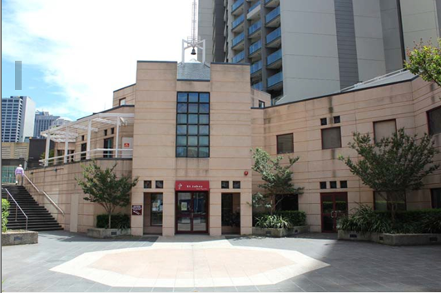

Statement of Significance

What is significant?

Emanating from a congregation established in Melbourne in 1861, St John's Lutheran Church was built in 1989 as a replacement of an earlier 1928 church, which was demolished as part of the sweeping changes brought by the development of Southbank.

Contributory elements include:

* octagonal and colonnaded Post‐Modern form;
* artificial stone finishes.

How is it significant?

St John’s Lutheran Church is socially and historically significant to Southgate and the City of Melbourne and of architectural interest.

Why is it significant?

St John’s Lutheran Church is historically significant as being symbolic of a small but pioneering Lutheran congregation church which reflects both a long tradition in Melbourne since the 1860s and previous occupation of the nearby site from the 1920s, as well as the modern context of its setting in the Southgate development.

It is of architectural interest as a Post‐Modern reinterpretation by David Cole of Buchan, Laird and Bawden, of the austere tradition of the original church near this site in a style which also reflects the larger Southgate shopping mall development of that time.

It is of social significance for its continuing contribution to the spiritual and cultural life of the Southbank area and the community of parishioners and congregation, as well as an established recital venue for chamber musicians.

# G.P. Motors, Pty Ltd (Dunlop Australia/Opera Australia), 35-41 City Road, Southbank

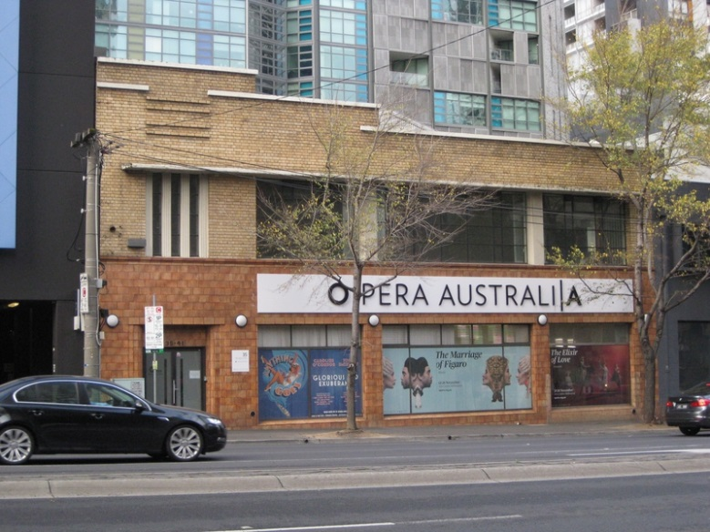

Statement of Significance

What is Significant?

G.P. Motors, Pty Ltd. is a mid-twentieth century motor garage built for the owners and operated in the 1930s to early 1950s. The building comprises a brick masonry and iron framed structure, formerly with car ramps to the upper level, and an elaborate Streamlined Moderne façade.

Contributory elements include:

* parapeted two storey form, built to the street alignment with pitched roof behind;
* Streamlined Moderne styling, promoting the modern imagery of the firm;
* cream face brick upper level façade cladding set against distinctive terracotta faïence on the ground level;
* cemented streamlining on the façade, at parapet and storey levels;
* multi-pane glazing to upper level;
* counter-posing of vertical and dominant horizontal elements, as seen in the stair window ribbing, set under the upper level window hood;
* oyster light fittings either side of the door;
* faceted terra-cotta door reveals to entry;
* transom lights to show windows; and
* the rear elevation is plain but well-preserved with some changes to openings.

Added panel sign is removable and is not contributory.

How is it Significant?

G.P. Motors, Pty Ltd. is significant historically and aesthetically to Southbank and the City of Melbourne.

Why is it Significant?

G.P. Motors, Pty Ltd. is significant historically as expressive of the continuing industrial expansion in the Southbank area into the Interwar period, with associated motor trade buildings nearby, such as Brooklands (since demolished) and the Melbourne Towing Service. It is a rare survivor of a representative of the motor trade, for which the Southbank area was once highly characteristic. Aesthetically, it is a good example of the Moderne style as applied to retail imagery to promote a modern industry, motor car retailing and service.

# Crown Chemical Co. warehouse, 63-65 City Road, Southbank

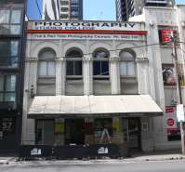

Statement of Significance

What is Significant?

Crown Chemical Company warehouse built for George Buckley by c1915 and occupied over a long period by Anderson's Printing and Publishing Co., Pty., Ltd.

Contributory elements include:

* parapeted two-storey form, with pitched roof behind;
* face brick and cemented detailing to façade (painted over);
* tall-arched façade fenestration;
* Romanesque revival styling typical of Edwardian-era warehouses.
* rear elevation red brickwork (partially over-painted) with a timber upper-level vertical board loading door and largely intact timber-framed windows.

A skillion awning and other joinery elements have been added to the City Road facade.

How is it Significant?

Anderson's Printing and Publishing Co., Pty., Ltd.is significant historically and aesthetically to Southbank and the City of Melbourne.

Why is it Significant?

Anderson's Printing and Publishing Co., Pty., Ltd. warehouse is significant Historically as representative of the major industrial development that occurred along the south bank of the Yarra River from the Victorian-era through to the Interwar periods. Aesthetically, it is significant for the tall-arched fenestration of the façade that exhibits the interest in medieval architectural sources and Arts & Crafts detailing in the Edwardian-era warehouse design.

# Kosky Bros, Pty Ltd furriers, 67-69 City Road, Southbank

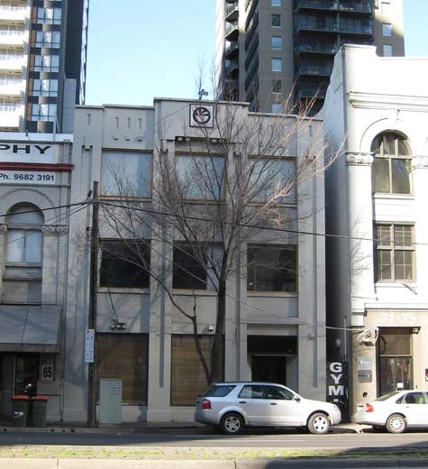

Statement of Significance

What is significant?

Kosky Bros, Pty Ltd furriers, 67‐69 City Road Southbank

Contributory elements include:

* parapeted three‐storey form, with pitched roof behind;
* cement rendered façade (since painted over);
* Modelled parapet detail
* recessed side light wells and rows of windows (for lighting the sales and production areas)
* Austere modernist styling typical of interwar‐era warehouses;
* rear elevation with barred steel frame windows.

How is it significant?

Kosky Bros, Pty Ltd furriers is significant historically and aesthetically to Southbank and the City of Melbourne.

Why is it significant?

Kosky Bros, Pty Ltd furriers is of historical significance as characteristic of the interwar warehouses which typified the architectural style and function of City Road in most of the twentieth century. It was one of a number of fabric and clothing companies in the area (c.f Maurice Artaud next door) with international origins, reflecting the role of European immigrants in the import and rag trades in Melbourne.

It is also significant as an example of early reinforced-concrete construction in a design that recognises the modernity of the material.

The place is also indirectly related to the Petrov affair though Kosky's selling furs to Petrov's wife and other embassy officials and being accused in the Petrov papers of being an MVD spy.

The building is also of historical significance for demonstrating the style of prominent architect Gordon John Sunderland, in one of his rare commercial/industrial commissions.

It is of aesthetic significance as a distinctive modernist treatment of the standard warehouse form, hinting at the Egyptian revival employed by the architect at the Sandringham Masonic Centre.

# Maurice Artaud & Co, 71-75 City Road, Southbank

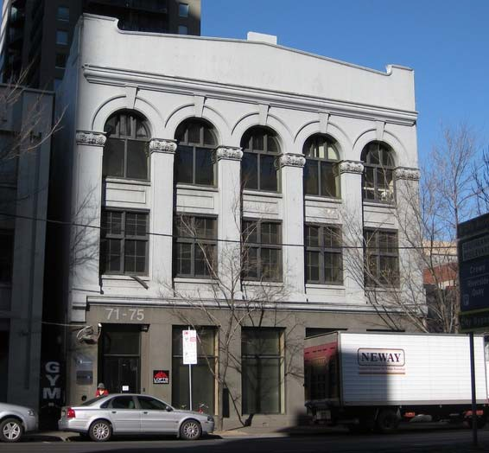

Statement of Significance

What is significant?

Maurice Artaud and Co 71‐75 City Road Southbank

Contributory elements include:

* parapeted three‐storey form, with pitched roof behind;
* face brick and cemented detailing to façade (since painted over);
* tall‐arched façade fenestration;
* Romanesque revival styling typical of Edwardian‐era warehouses;
* rear elevation red brickwork (part overpainted), a timber upper level vertical boarded loading door and largely intact timber framed windows.

How is it significant?

Maurice Artaud and Co. warehouse is significant historically and aesthetically to Southbank.

Why is it significant?

Maurice Artaud and Co, is significant historically as a representative example of the factory and warehouse buildings that were characteristic of the Southbank area in the late nineteenth and early twentieth century. Artaud was an importer of fancy goods and hat manufacturer, and one of a number of clothing businesses that concentrated in Flinders Lane and inner suburbs of Melbourne as an important part of the city’s business prosperity. As such it represents an important phase in the history of Melbourne and Southbank.

The building is of aesthetic significance for its tall, arched fenestration of the facade that signals an interest in medieval architectural sources and arts & crafts detailing during the Edwardian era of warehouse design.

# James Moore's Timber Yards and Sawmills complex façade, 135 & 151 City Road, 68-82 Southbank Boulevard, Southbank, HO366

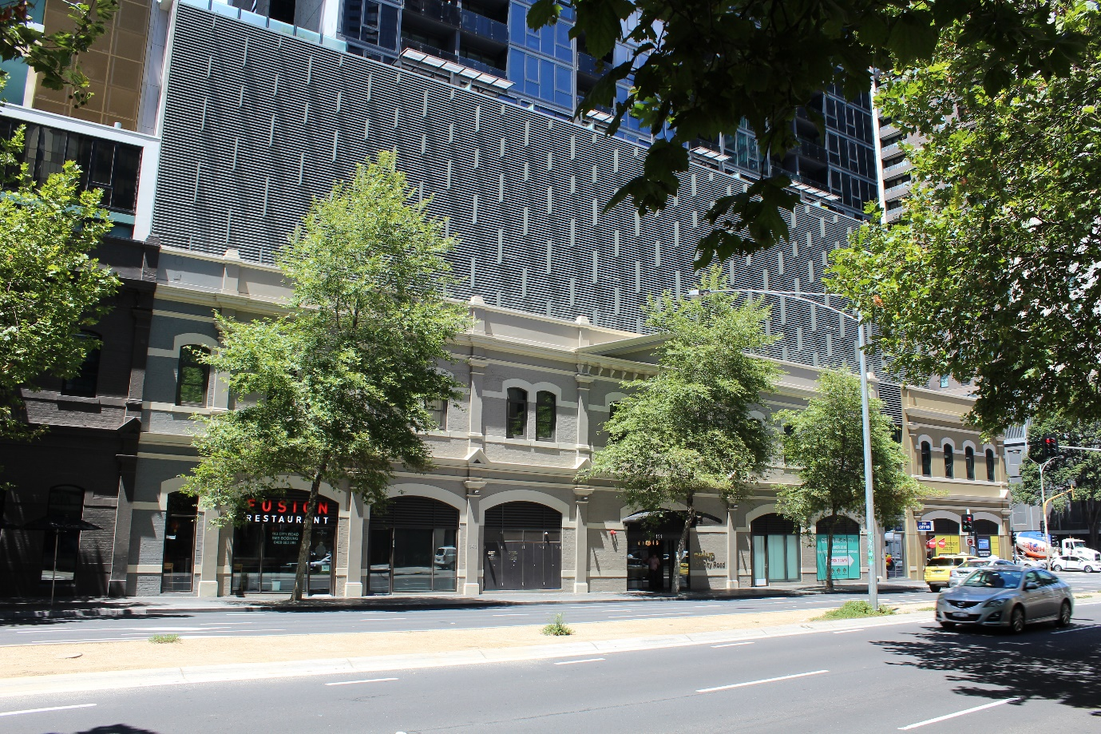

Statement of Significance

What is significant?

James Moore's Timber Yards and Sawmills complex street façade and supporting structure at 115‐143 City Road, built up for the important timber merchant firm of James Moore in the period 1899‐1903 and occupied by the firm into the mid-1930s.

Contributory elements include:

* Two storey Italian Renaissance revival face brick (overpainted) and rendered façade to City Road and approximately 10m return onto Southbank Boulevard (formerly Ireland St) ;
* symmetrical City Road façade with minor pedimented bays at both ends of the elevation, and a central large pediment that once contained the name of the company within its tympanum, as the focus of the façade;
* stuccoed pilasters defining the bays, with miniature pediments at the intermediate string course;
* parapet entablature linking the three pedimented bays, set above the main cornice, once, with cement orbs on the parapet piers.
* stuccoed impost and sill courses as further horizontal elements;
* timber framed double‐hung sash windows, once had multi‐pane glazing; and
* typically segmental archways at ground level.

Ground level openings have been changed, the brickwork painted over, some joinery renewed but the integrity as a large Edwardian‐era commercial facade is relatively good. A replica bay has been added to the west end of the façade, separated by a glass link.

How is it significant?

James Moore's Timber Yards and Sawmills complex street façade is significant historically and aesthetically to Southbank, South Melbourne and the City of Melbourne.

Why is it significant?

James Moore's Timber Yards and Sawmills complex street façade is significant.

Historically:

As a large and relatively well‐preserved commercial façade that symbolises the extensive development created by the hardware, timber supplier and saw miller James Moore in the Victorian and Edwardian‐eras. Moore was also one of the colony's foremost contractors and served prominently in local government. The façade is also symbolic of a time when this part of South Melbourne, well served by the wharves and railways, was a major industrial centre within the Colony of Victoria.

Aesthetically:

A well designed and extensive commercial elevation in the prevailing Italian Renaissance revival manner that was far grander than equivalent timber yards within Victoria at that time. Also contributory to the larger role of City Road as one of the major commercial and industrial strips, in this case linking Melbourne with the waterfront of Port Melbourne.

# Sharps & Sons Timber, General Motors (Australia), International Harvester façade, 171-193, 195-205 City and 1 Balston Street Southbank, HO368

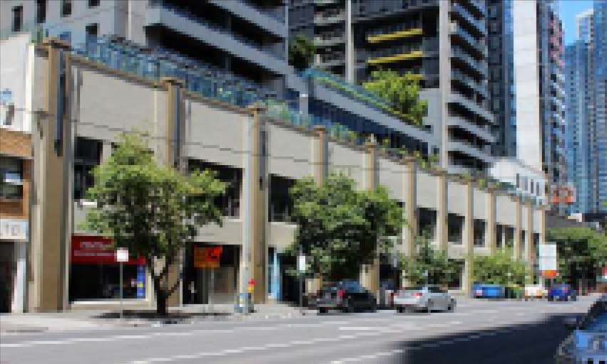

Statement of Significance

What is significant?

The Sharps & Sons Timber warehouse, General Motors (Australia), and later International House façade built in 1926‐7 and modified in 1939 is all that remains of a once vast industrial complex.

Contributory elements include:

* Two‐storey parapeted and rendered masonry form;
* divided by capped and ribbed pilasters into 17 bays along City Road and 4 (once 7) bays along Balston Street with a wider central bay in City Road bearing the firm's name;
* regular punched fenestration set in the spandrels between piers, typically glazed in 8 panels;
* large ground floor display window openings but refitted with new glazing (once with multi‐pane glazing to transoms and 2 pane plate glass below); and
* contribution to the former industrial character of the City Road Industrial precinct.

How is it significant?

The Sharps & Sons Timber warehouse, General Motors (Australia), and later International House façade is significant historically and aesthetically to Southbank.

Why is it significant

The Sharps & Sons Timber warehouse, General Motors (Australia), and later International House façade is significant historically to Southbank, South Melbourne and the City of Melbourne.

General Motors (Australia) Pty Ltd complex, later International Harvester façade is significant.

Historically:

* as symbolic of a once vast industrial complex built up in the Interwar period to serve the growing motorisation of community transport and large scale farming in Australia;
* as the Australian headquarters of the International Harvester company, part what was described as `the largest and most modern motor truck and farm implement display In the southern hemisphere'
* also symbolic of the move of industry to major assembly plants needing more and cheaper land located out of the central city to localities such as City Road that still had good shipping and rail access
* as a contributory part of the City Road Industrial precinct and hence symbolic of the key role this area one played in the nation's industrial development.

# Boyd Community Hub, formerly State School No. 2686, later J.H. Boyd Domestic College, 207-227 City Road Southbank, HO369

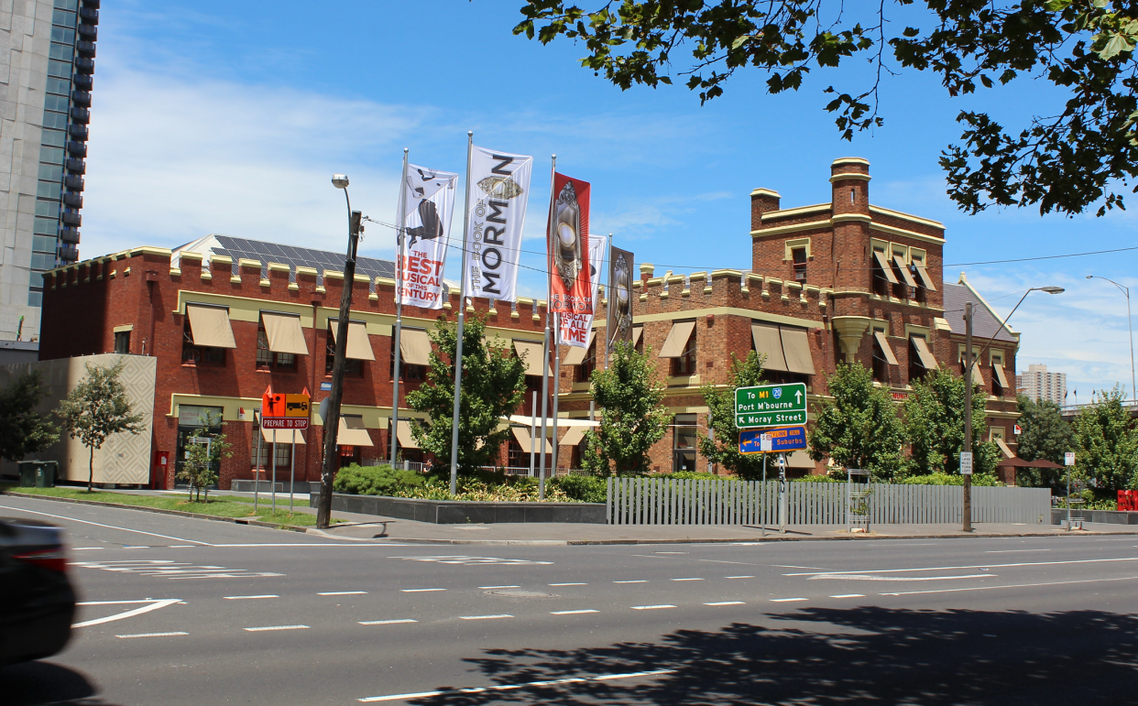

Statement of Significance (as listed in the Victorian Heritage Register 2017)

What is significant?

The J.H. Boyd Girls High School was constructed in 1884‐1885 to the design of the Education Department's Chief Architect Henry Bastow. It opened as State School No. 2686, replacing No. 222 St Luke's South Melbourne Church of England School in Clarendon Street, Emerald Hill. In 1929 it was amalgamated with the Eastern Road State School No. 1852. The building was reconstructed in 1930 byW.H. Bolger to become the South Melbourne Girls' School devoted to the training of girls in domestic arts. In 1932 it was renamed the J.H. Boyd Domestic College after its patron, a successful grazier, who bequeathed a large sum of money to establish a school of domestic science so 'that women should be taught to manage a home correctly'. The school occupies a prominent corner site on City Road, and is a two storey brick building with a third storey of one room and entry to a tower. It was closed as a school in 1985 after 100 years of operation. The extant section of the original school is a commanding Tudor Revival design executed in Hawthorn bricks, embellished with bands of cream brick and render mouldings. The Tudor influence is repeated in a castellated parapet and octagonal turret.

How is it significant?

The J.H. Boyd Girls High School is of architectural and historical significance to the State of Victoria.

Why is it significant?

The J.H. Boyd Girls High School is of architectural significance as one of the most ornamental and distinctive of the Education Department schools of the 19th century. It was the only 19th century State School to have a three storey central block, reflecting its prominent location in full view of the railway line from Port Melbourne to Flinders Street. The school's size and style are evidence of the rapid growth in population and wealth in Melbourne's suburbs as a result of post‐gold rush consolidation and prosperity.

The J.H. Boyd Girls High School is of historical significance as a reminder of earlier philosophies of educational provision, especially for girls. Domestic Arts schools developed in the years during and after WWI, at a time when there was a wider concerted push for 'scientific' mothering education. It was considered that mothering skills were not innate and needed to be taught, in the same way that domestic skills needed to be inculcated at school. The school's emphasis on the domestic arts demonstrates the different approach to girls' and boys' education that characterised the school system for much of the 19th and 20th centuries. Less emphasis was placed on academic achievement than on domestication, to produce young women who would find their place in private rather than public life. Nevertheless, these domestic arts schools were the predecessors of the Girls High Schools and, despite the emphasis on domestic skills, they were a means of expanding secondary education to girls at a time when State Governments were reluctant to provide post‐primary education education.

# Main Point Hotel, 235-239 City Road, Southbank HO370

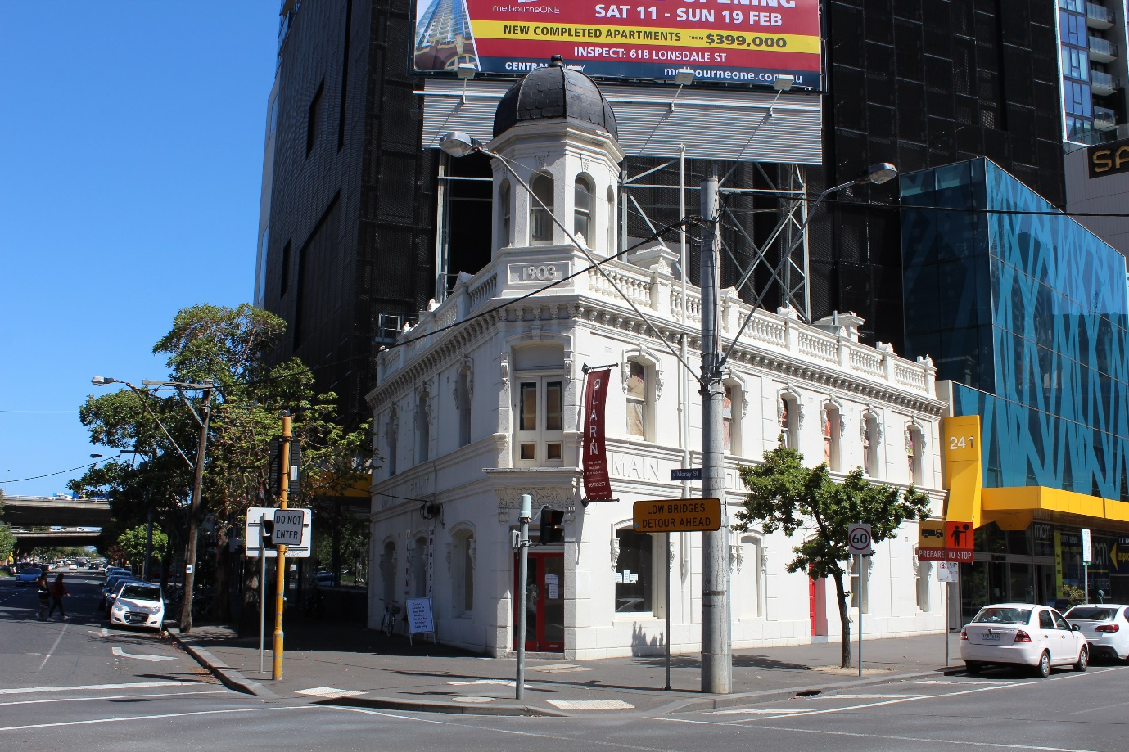

Statement of Significance

What is significant?

The Main Point Hotel is an Italian Renaissance derived design, executed in stuccoed brick, with some rich decorative elements including the distinctive corner tower. It was built for Emily Rubira to the design of Joseph Parer, the Spanish Rubira and Parer families being linked by marriage. Both families were long‐term hotel and café operators in Melbourne, The London, Hosies and Albion hotels being some of the more prominent examples.

Contributory elements include:

* Two storey stuccoed Italian Renaissance revival form set on two street alignments;
* a balustraded and piered parapet;
* parapet piers‐surmounted by acroteria;
* a deeply bracketed cornice;
* rusticated pilasters and moulded strings;
* unusual upper level doorway at the corner presumably leading to a wrought‐iron balconette;
* brackets supporting hood moulds over the segment‐arched window openings;
* double‐hung timber‐framed sash windows;
* a corner entry covered by a richly foliated bracketed hood;
* gas bracket base remnant under the foliated panel, over the entry;
* two major bar windows are at the corner;
* an octagonal corner tower capped by a fish‐scale pattern, metal sheeted dome; and
* construction date (1903) and building name set in cemented parapet panels.

Signs placed in windows and set within façade panels are not contributory; the roof sign is intrusive. The glazed entry doors are new and unrelated; the upper level door panels have been glazed. The finial is missing from the dome.

The hotel is contributory to the City Road industrial precinct as a major part of the Edwardian‐era phase of the area's growth.

How is it significant?

The Main Point Hotel is significant socially, historically and aesthetically to Southbank, South Melbourne and the City of Melbourne.

Why is it significant?

The Main Point Hotel is significant.

Socially and historically, as a long‐term gathering place within the community since 1903 and as the site of a hotel since the 1860s also for the link with the well-known hotelier Parer family; and aesthetically, for its distinctive tower and as a well‐preserved Italian Renaissance revival design.

# Bank of New South Wales, 269-283 City Road, Southbank HO371

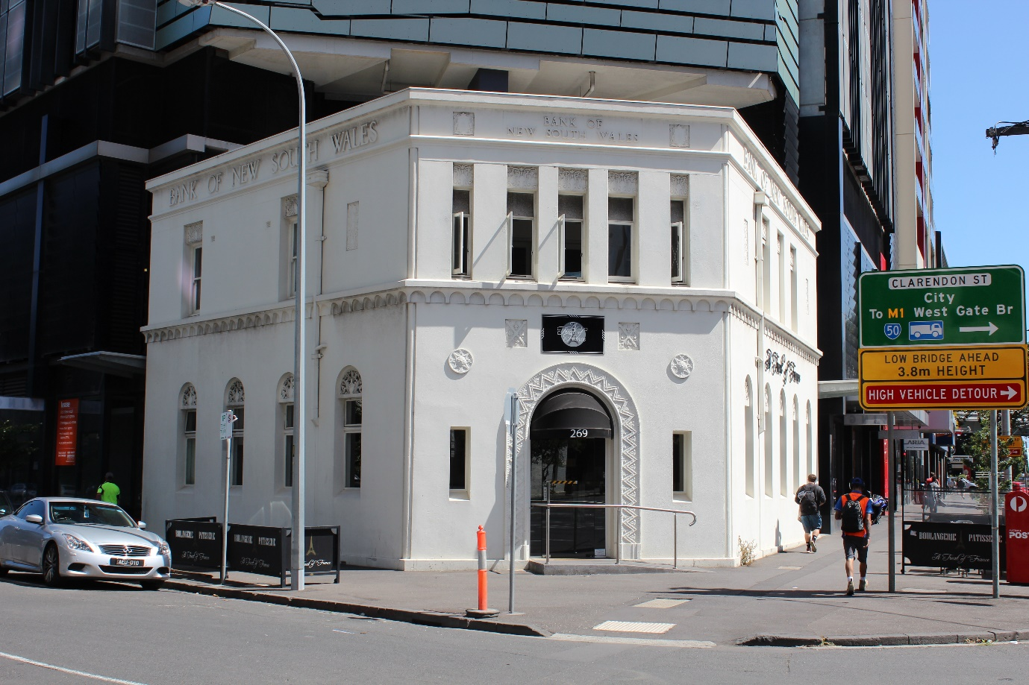

Statement of Significance

What is significant?

The South Melbourne branch of the Bank of New South Wales opened its premises in City Rd in 1932 and its designers, Godfrey and Spowers.

Contributory elements include:

* Jazz Moderne styling,
* parapeted two‐story corner form;
* stylised cornice, entablature and string mould, in a simple classical manner
* detailing reflecting both Aztec and Egyptian influences, typical of the Moderne style;
* scalloped string frieze are stylised papyrus capitals or lotus borders,
* bas‐relief chevrons to the architrave to the entrance door;
* punched slit‐like fenestration, with casement sashes to City Road and timber double‐hung sash windows to the side street;
* bas‐relief ornament as foliation, arabesques and shields in pressed cement at the tympanums of window openings and as isolated panels in the stucco, reflecting a medieval character;
* building name in bas‐relief in the parapet entablature; and
* Modernistic pressed sheet metal rain‐water heads.

The entrance doors and vestibule have been changed and a ramp added. A major development is adjoining.

How is it significant?

The South Melbourne branch of the Bank of New South Wale is significant socially, historically and aesthetically to Southbank and the City of Melbourne.

Why is it significant?

The South Melbourne branch of the Bank of New South Wale is significant. Historically and socially, as a long‐term and well‐preserved commercial site in Southbank's main thoroughfare, and a publicly accessible banking destination in South Melbourne over time; and

Aesthetically, as a good example of Jazz‐Moderne style commercial architecture by a well-known architectural firm and bank specialist, as enhanced by its corner siting. The design is unusual and shows the influence of exotic styles on design in parallel with the move to Modernism. The former bank remains as one of the few key commercial buildings built during the 1930s in the South Melbourne area.

# Edward Murphy's warehouse and workshop, 272 City Road, Southbank, HO374

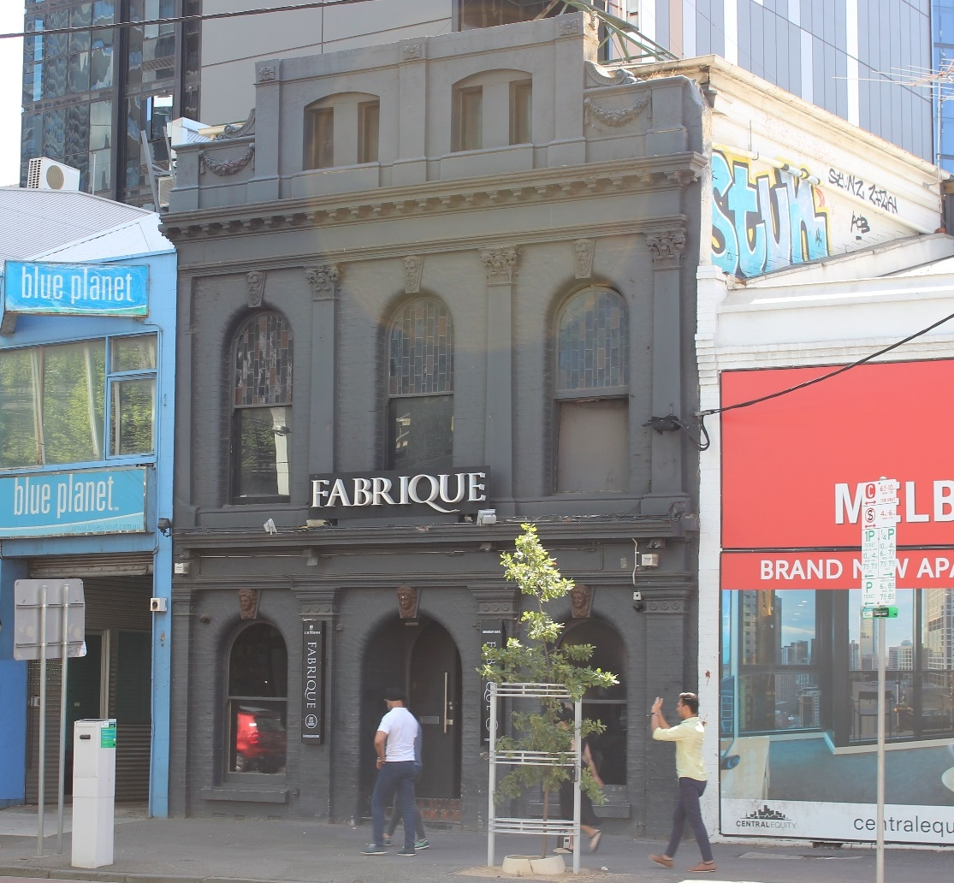

Statement of Significance

What is significant?

Edward Murphy, old Colonist, ventilator manufacturer and plaster modeller, had this brick warehouse erected in the late 1880s after a long tenure in this part of South Melbourne as a manufacturer. His firm remained there until around World War One after a successful enterprise that gained a number of awards and commissions.

Contributory elements include:

* Two storey brick parapeted form;
* an arcuated façade of face brick with a cemented detailing;
* a cemented trabeated system laid across the façade;
* Doric Order and Corinthian Order pilasters
* large arched window openings with prominent cement masks set onto their keystones, befitting the trade within;
* cemented mouldings including a parapet cornice and string mould at the first floor level;
* timber framed double‐hung sash windows;
* an attic level with Victory garlands adorning the parapet panels; and
* contribution to the adjacent Victorian‐era commercial streetscape, also built up by Murphy.

How is it significant?

Edward Murphy's warehouse is significant historically and aesthetically to South Melbourne and the City of Melbourne.

Why is it significant?

Edward Murphy's warehouse is significant.

Historically as a well‐preserved warehouse associated with the plaster modelling and architectural ornament trade which evokes its purpose by the application of cement ornament to the façade also for the long association with the locally prominent pioneering Murphy family that had been linked with industrial development on Southbank since the 1860s; and aesthetically, for the relative sophistication as both an arcuated and trabeated workshop façade and one of the few Victorian‐era commercial buildings remaining in Southbank as an indicator of the former key role of the locality in manufacturing and warehousing.

# Murphy's Buildings, formerly Australian Chemicals/ Scott Paint Works, 276-282 City Road, Southbank HO375

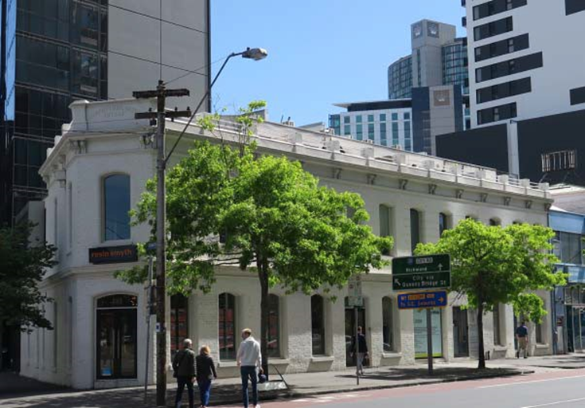

Statement of Significance

What is significant?

Edward Murphy, old Colonist, ventilator manufacturer and plaster modeller, had this brick warehouse row erected in 1885 after a long tenure in this part of South Melbourne as a manufacturer. His firm remained there until around World War One after a successful enterprise that gained a number of awards and commissions. Murphy leased this row to a number of engineering and manufacturing tenants.

Contributory elements include:

* two storey brick parapeted form;
* an arcuated façade of face brick with a cemented detailing;
* cemented mouldings including a parapet cornice and string mould at the first floor level;
* formerly timber framed double‐hung sash windows; and
* contribution to the Victorian‐era commercial streetscape, built up by Murphy.

How is it significant?

Murphy's Buildings, Edward Murphy's warehouse row is significant historically and aesthetically to South Melbourne and the City of Melbourne.

Why is it significant?

Murphy's Buildings, Edward Murphy's warehouse row is significant.

Historically as a well‐preserved warehouse row associated with the locally prominent pioneering Murphy family that had been linked with industrial development on Southbank since the 1860s; and aesthetically, relatively well‐preserved and one of the few Victorian‐era commercial buildings remaining in Southbank as an indicator of the former key role of the locality in manufacturing and warehousing.

# White & Hancock's warehouse, later White, Hancock and Mills Pty. Ltd., 300 City Road, Southbank, HO376

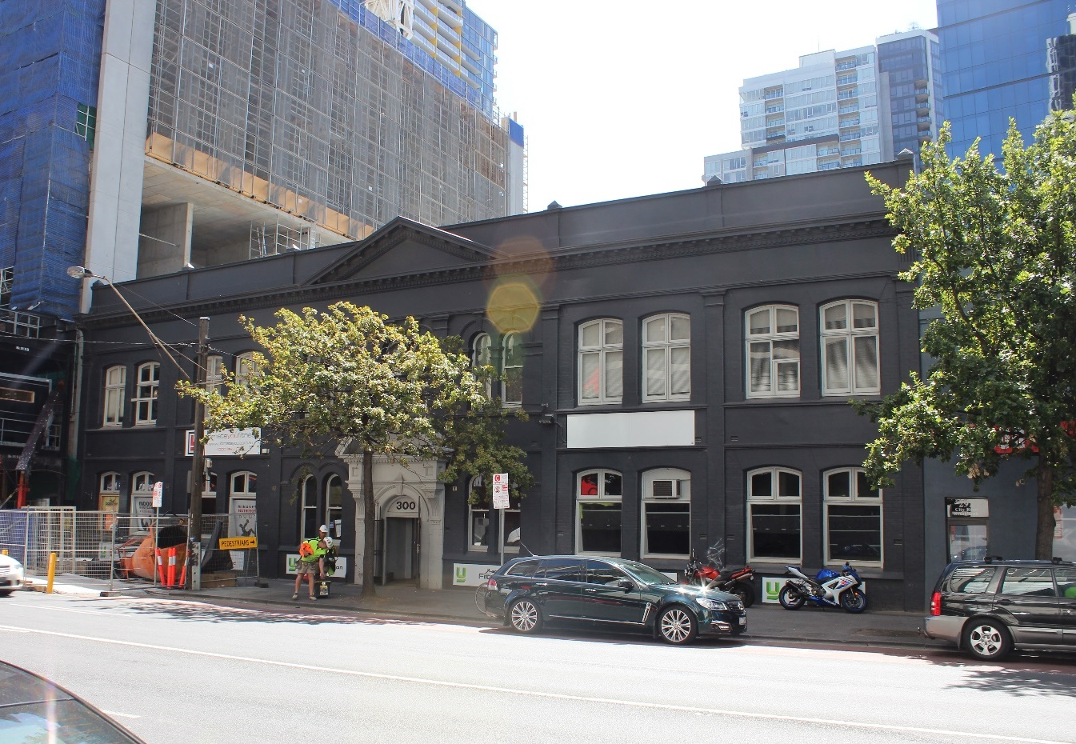

Statement of Significance

What is significant?

Poultry and bird foods supplier and filter manufacturers, White & Hancock, had this warehouse, built by 1916 and occupied it for a long period. They were part of the extensive industrial and distribution development that existed at Southbank over a long period, aided by good railway and shipping access.

Contributory elements include:

* two storey parapeted brick warehouse form of approximately 10m depth;
* Edwardian‐era Classical revival styling
* six façade bays arranged either side of an ornate cemented entry;
* large parapet pediment above the entry;
* paired arcuated fenestration with hood moulds set above and below a cemented panel in the central three bays;
* a boldly modelled bracketed tympanum set over another segmental archway at the doorway at the entry;
* double‐hung sash windows used throughout the central bays;
* casement sashes typical of the Edwardian‐era, with paired top lights set in segmentally arched openings for the rest of the street elevation;
* contribution to nearby commercial streetscape of the Murphy buildings, as enhanced by the stone paved Haig Lane backing onto the site.

How is it significant?

White & Hancock's warehouse is significant historically and aesthetically to Southbank.

Why is it significant?

White & Hancock's warehouse is significant.

* historically for its representation of the extensive industrial and distribution development that existed at Southbank over a long period, aided by good railway and shipping access, and its long association with the firm White & Hancock, who were well‐known in the poultry industry; and
* aesthetically for the ornate Edwardian classicism of the façade, particularly the entry bays, judged within Edwardian‐era warehouse and manufacturing structures.

# Spencer Street Bridge, Clarendon and Spencer Streets Southbank

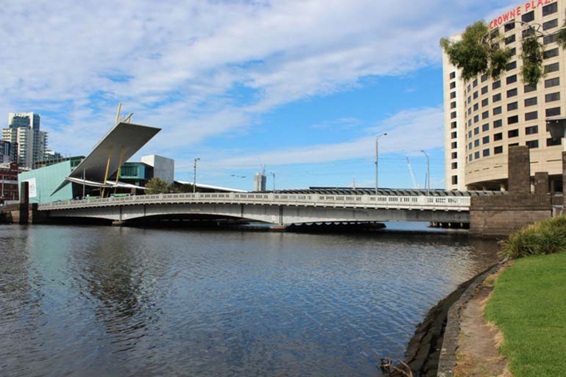

Statement of Significance

What is significant?

The Spencer Street Bridge built by the Victorian Railways Construction Branch in 1929‐30 is significant as a major new crossing of the Yarra River reflecting engineering and design standards intended to enhance the Yarra River as an aesthetic and recreational adjunct to the City of Melbourne.

Contributory elements include:

* low triple arched form;
* cantilevered and suspended riveted girder design;
* cast iron balustrade and handrails; and
* bluestone Newell post pillars, wingwalls and commemorative plaques

How is it significant?

The Spencer Street Bridge is significant for aesthetic/architectural, historic, and technical reasons at a State level.

Why is it significant?

Spencer Street Bridge was constructed after a long period of stagnation in road and bridge development in Victoria in a climate of controversy and rivalry between public authorities, local councils and politicians.

The Spencer Street Bridge is of historical significance as the first major new crossing (as opposed to replacement of older bridges on existing crossings such as the 1924 Church Street Bridge) to be created over the lower Yarra in Melbourne after a considerable lull in such projects, since the Morell Bridge of 1899-1900 to the 1920s. Its construction demonstrates the political difficulties of the time and the growing importance of motor vehicle traffic to Melbourne’s commerce. The Spencer Street Bridge was the first permanent structure over the Yarra built below “the falls” (a natural rock barrier that formed the upstream limit of practical river navigation) and as such is historically important because it was the first bridge to effectively cut the city off from direct contact with its port. For five decades Spencer Street was the furthest downstream bridge on the Yarra River and today still forms a principal gateway to the central business district and one of the most significant Yarra crossings.

The bridge is also of historical significance as the largest and most prominent road bridge built by the Victorian Railways Construction Branch during a decade in which the influence and importance of this railways design office reached a peak, undertaking several major bridge and railway construction projects in New South Wales and Malaya, in addition to the construction of some 700 km of new railway and several major railway bridges within Victoria.

The Spencer Street Bridge is also of historical significance for its role in the political and local infighting, which hindered cooperation between the various authorities with a stake in the crossing, preventing the bridge being built for many years. It is also noteworthy for the social changes it created in Melbourne by altering travel and communication patterns between suburbs, industrial areas and the city following its construction.

The bridge is of technical significance as the earliest known variable depth steel plate girder bridge in Victoria and one of the earliest examples of composite road bridge design in which plate girders were “keyed” to a cast in-situ reinforced concrete deck by shear connectors to form an integral structure with enhanced stiffness. While this was not part of structural design for increasing bearing capacity of the bridge it predicts design trends which became standard in the 1930s.

The riveted steel girders were fabricated by Kelly & Lewis Pty. Ltd., one of Victoria’s most prominent engineering firms in the early 20th century, and are a rare and early example of both variable-depth plate girders and the combination of cantilevered and suspended spans. The 33.66 m centre span of the Spencer Street Bridge is the second-longest extant riveted metal plate girder road bridge span in Victoria (after the 42.7 m Keilor Bridge over the Maribyrnong) and the ninth-longest span amongst all plate girder road bridges in the State. The unusual length and innovative design of the Spencer Street Bridge girders and their application in a composite structural form with a shear connected reinforced concrete deck, is of importance in the development of bridge engineering technology in Victoria during the interwar years, a period when standardisation in bridge design was becoming the norm under the CRB, but experimentation and innovation was also apparent.

The bridge is of aesthetic significance as a representative example of the nature of large civic construction of the interwar period with its subdued Art Deco design. The aesthetic design qualities of the bridge are apparent in its understated and somewhat austere parapets and pylons utilising the standard Melbourne building material of bluestone, as well as the combination of a humped or arched overall deck profile over the three individual arches of each variable depth girder span. .

The alterations to the bridge in recent years have been unsympathetic due to the lack of appreciation of the significance of the bridge. However, its historical and technical values are still intact and can be appreciated despite changes in the vicinity, such as the addition of a modern footbridge on the downstream side.