Transport Strategy Discussion Paper
Bicycles for Everyday Transport

This discussion paper is to inform a new City of Melbourne Transport Strategy to 2050. A draft strategy will be released for consultation in 2018. We are seeking your views on these issues and ideas.
The City of Melbourne has delivered an extensive program of improving and extending bike infrastructure over many years. The refreshed Transport Strategy will build on the progress already made by successive City of Melbourne Bicycle Plans. To boost cycling participation for transport improved facilities are required.
When people choose to ride they reduce emissions, noise, congestion and free up public transport capacity. Cycling provides mental and physical health benefits and, with the right infrastructure, it can be great fun. People riding save everyone money by reducing health costs and the need for investment in public transport and roads. It is in everyone’s interest that people ride (and walk) as much as possible.
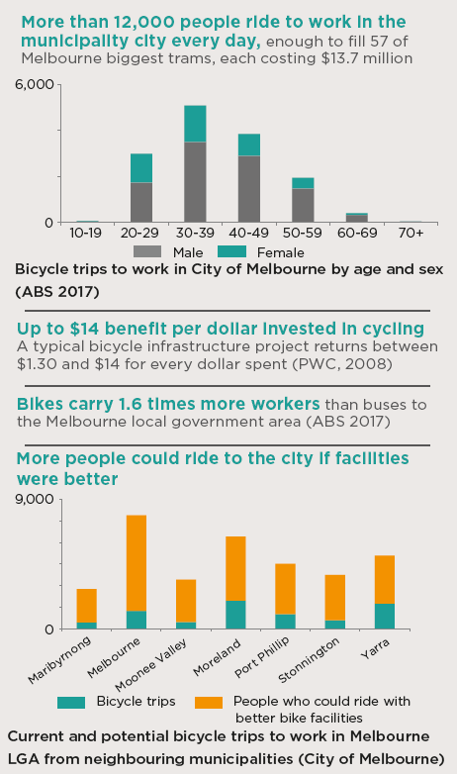

What are the current issues?

People don’t feel confident cycling in Melbourne
Concern for safety remains the primary barrier preventing more people riding. City of Melbourne research found that potential bike riders would feel much more confident using physically separated infrastructure than painted lanes.
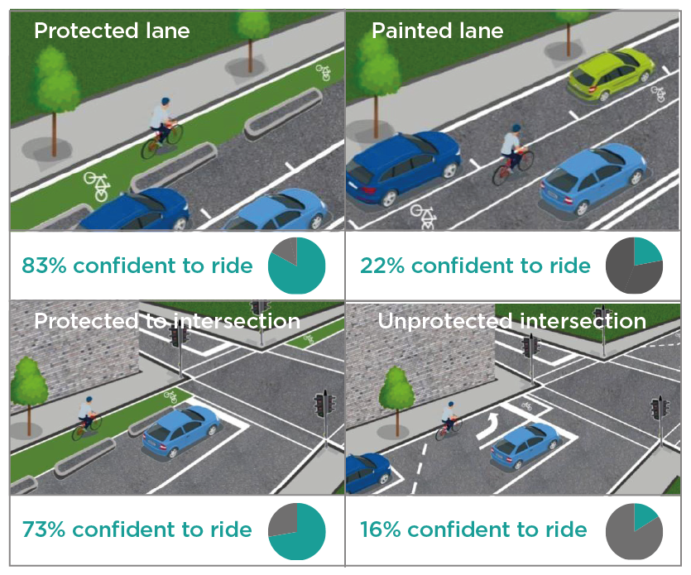

Providing for local bicycle trips
Riding a bike can be a faster option for many local trips. To enable more local cycling, facilities need to be connected and protected from traffic. Where there is not enough space for protection, traffic should be calmed to allow more people to feel safe and comfortable. Bike share can also support these trips but has not yet succeeded in Melbourne.

Conflict and behaviour
People walking, riding bikes and driving can come into conflict when sharing space. Poor behaviour can be observed across all forms of transport. Melbourne needs a stronger culture of sharing and courtesy when moving around the city. Bike facilities which minimise conflict can make riding an everyday activity for all ages and abilities.

Road rules
Bikes are different from motor vehicles, yet the road rules treat them the same. Bikes are more space efficient, slower, quieter and allow for better peripheral vision. In the event of a crash, bikes cause much less harm to the surrounding environment. The law needs to recognise these differences to increase the competitiveness of bikes. For example, Paris has recognised that riding is much faster and easier without stopping unnecessarily and allows riders to turn right at certain red lights and stop signs when it is safe to do so.

Other barriers which prevent more people riding bikes
A lack of access to showers or lockers in workplaces or not having access to convenient bicycle parking can prevent people riding. Blocked bike lanes due to construction or illegally parked cars can also make it less attractive to cycle.

What are other cities doing?
Cities around the world are facing similar challenges. These global best practice ideas can help to inform the right approach for Melbourne.

Increasing cycling capacity in Copenhagen, Denmark
The already popular Nørrobrogade separated cycling route in Copenhagen was widened for bicycles. Bicycle trips increased by 35 per cent, from 36,000 to 48,400.
- This shows the value of continuous improvement of facilities for cyclists.
- In the same way that building more roads attracts more traffic, building high quality cycle routes will increase the number of people who choose to ride.
- Bike lanes move more people in less space. Improving cycling capacity is one of the most productive transport investments that busy cities can make.
Upgrades to existing cycling infrastructure can enable more people to ride bikes.

Business support for protected cycle lanes, London
A network of 180 London employers came together through the Cycling Works campaign to support plans for protected cycle lanes in central London. This overwhelming support helped convince government agencies to push ahead with improved cycling facilities and deliver the plans in full.
- CEOs from finance, technology, law, media, education and healthcare supported cycling and protected lanes as good for employees, businesses and London.
- Businesses recognised that there was demand for better cycling infrastructure from their employees and recognised the health and environment benefits, the opportunity for reduced congestion and economic benefit to business.
- Some of the new protected cycle lanes are moving five times as many people as the adjacent traffic lanes (Transport for London).
Businesses in Melbourne could provide incentives and support for new riders. Is your workplace supportive of cycling?

What should be done to address these issues?

Physical protection to intersections
Providing protected lanes up to the intersection will significantly increase the number of people who choose to cycle. Separated lanes should include trunk routes running north-south and east-west at appropriate intervals, with cycle-specific traffic lights. If we want better bike infrastructure, we need to accept some impacts to cars like reduced on street parking, fewer turning lanes and reduced traffic capacity. This may increase congestion until people switch to another mode.

Increase investment in cycling improvements
Victorian Government investment in cycling is at its lowest point this decade, around $3 per person in 2015-16 (AustRoads 2016; ABS 2016). The City of Melbourne spent $2.67m on its bicycle improvement program in 2016-17, equating to around an additional $3 for every person visiting the municipality on an average weekday. To achieve the City of Melbourne’s current cycling target, the number of people riding needs to double by 2020. This will require a much larger, targeted investment in bike infrastructure from all levels of government.

Provide more bicycle parking in more places
Space underground and in buildings is needed to ensure enough bicycle parking is provided and to free up footpath space for other uses. The Victorian Government’s Victorian Infrastructure Plan includes a commitment to changing the planning scheme to require more bike parking in new buildings.

Reduce motor vehicle use in the municipality
Fewer cars on the road will make cycling more attractive for local trips and provide more space for public transport, which is a more efficient mode of transport. This requires policies to reduce motor vehicle ownership, use and road space allocation.

Electric bikes
Electric bicycles now outsell standard bicycles in the Netherlands and are becoming popular in Melbourne. They significantly increase the range of cycling trips and can reduce the need for riders to shower at their destination. Electric bikes can also make cycling an option for older people. Mechanisms to promote and encourage e-bike use should be explored.

Dockless share bikes
Dockless share bike schemes have now entered the Melbourne market. These bikes support short trips within the city but require space in the public realm and can create risks for people walking. The City of Melbourne has asked the State Government for new regulations to maximise the benefits and minimise the negatives of this new type of bike access.

What if?
- Everyone who wanted to ride a bike felt safe to do so at any time of day and for any type of trip.
- Protected bike lanes radiated out in each direction from the city, removing some traffic lanes to move more people.
- Bike lanes continued to and through intersections.
- We trialled fully separated bike lanes along Flinders Street linking the MCG to Docklands.

We want your thoughts!
participate.melbourne.vic.gov.au/transportstrategy
9658 9658
transport@melbourne.vic.gov.au

