3.6 Include ‘movement’ in the design of places and open spaces
The City of Melbourne can increase the use of the bicycle by allowing low-key ‘extended walking trips’ by bicycle through ‘places’ and open space.
There is currently no general City of Melbourne policy banning bicycle use from ‘places’ and open space. Indeed, some of the current policies, such as the City of Melbourne’s Open Space Technical Report of 2012, make positive statements.
Nonetheless in some locations the City of Melbourne’s actions, suggest that the administration considers bicycle use in ‘places’ and ‘spaces’ as detrimental. The expression of this approach can be seen in some of the bicycle bans and infrastructure downgrades that have been implemented as well as the unintentional oversights (or perhaps intentional exclusion) of bicycles from some spaces and places.
Some of these unfortunate and unnecessary measures have probably been put in place to regulate, prevent or pre-empt inappropriate behaviour by bicycle riders. There is no doubt that people on bicycles can and do perform antisocial and thoughtless acts that put themselves and others at risk and inconvenience. Similarly, people who travel by car, transit and on foot act in foolish and inconsiderate ways.
Rather than manage behaviour (which is a difficult and continual task) the City of Melbourne has in some places preferred to implement bicycle bans and barriers. This approach is unsound. It leads to contradictory outcomes and, perhaps most importantly, these actions by their arbitrary and unreasonable nature undermine the development of ‘good behaviour’ by people when they are pedalling.
Examples of bans, downgrading of bicycle routes and overlooking bicycle use include bans on riding in the Bourke Street mall and Carlton Gardens, positive and negative interventions along the riverbanks and the lack of access for people on bicycles in the recent ‘pop up’ place at the intersection of Elizabeth and Flinders Streets.
In the Bourke Street mall ‘place making’ has excluded bicycle use. Permitted vehicle access is allowed for 8.5 hours each day. The ban on bicycle use is for 24-hours a day, 7 days a week. This bears no relation to the activity in the mall. The bans are visually contradicted by the placement of bicycle parking rails in the centre of the mall. One contradictory consequence of the bans is that the City of Melbourne issues penalties to people making deliveries in the mall on bicycles while permitting deliveries by car.
In the Carlton Gardens open space management has ‘removed’ bicycle use. Long standing bicycle access through the Carlton Gardens was first restricted to families with children under 12. This partial ban was then extended in 2010 to a full ban on any bicycle riding. Meanwhile on Museum land in the centre of the Carlton Gardens, riders filter across the forecourt of the Museum through the crowds of school children and adults visiting the Museum. A consequence of the ban in the Gardens is that riders have been moved off the 5m wide paths through the gardens and channelled onto a heavily used 2.5m wide two-way shared bicycle pedestrian footpath. The pedestrians could use the 5m paths through the park but do not because they are longer. The riders would use them but are fined if they do. As a result, the park paths lie idle and conflict builds along the kerb.
Similar mixed messages can be observed along the riverbanks of the Yarra. Paths are being developed and improved upstream and downstream on the Yarra. The remarkable Jim Stynes Bridge west of the Spencer Street bridge is one example. As a result, an increasing number of riders flow into the CBD section of the Yarra River on the north and south banks. It can be expected that these flows will increase.
In a contradictory move, on the north bank, when Batman Avenue was removed to establish Birrarung Marr, the riverside bicycle path was also removed and the alignment blocked. People still ride bicycles through Birrarung Marr Park but now, rather than being channelled predictably on one alignment, they scatter unpredictably across the whole area creating bottlenecks and multiplying potential conflict points. Downstream from Princes Bridge on the north bank a ‘Dismount’ sign has been installed. The rationale for this sign is unclear.
Along the southern bank of the Yarra River, incremental development has produced a riverbank space in which trees, seats, structures and flow paths for pedestrians and bicycle riders are all jumbled together. It is difficult for a responsible rider to know where to place themselves in this environment. Nor is it reasonable to expect people to ride predictably in a straight line at a speed below 10km/h.
The recent ‘pop-up’ park at the end of Elizabeth Street created a barrier for cyclists. Riders have always been permitted in this block but, while the park allowed for tram movements and walking, it included a bicycle ban along with the motor vehicle ban. Nor were any bicycle parking arrangements included. The number of bicycles parked at the State Library suggests that bicycle parking is part of what people want in these places.
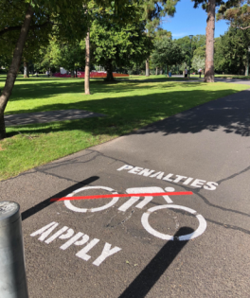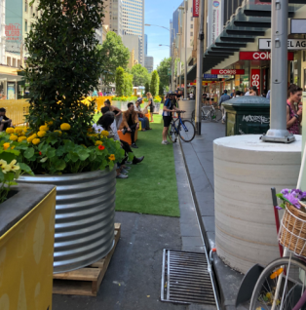

Figure 25: (Left) The City of Melbourne bans bicycle use in some areas including the Carlton Gardens. (Right) Bicycle use has not been included within or alongside the pop-up park at the intersection of Elizabeth and Flinders Streets.
Source: PBA

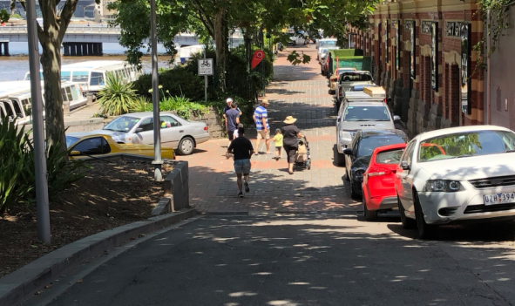

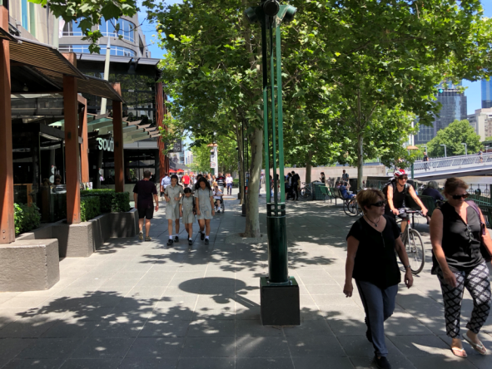

Figure 26: (Top) Halfway along this section of the north bank of the Yarra River (which functions as a road) there is a ‘Dismount’ sign. It is not clear why this instruction is appropriate and why it is in this location. (Bottom) It is not clear where someone riding a bicycle should travel along this section of the south bank of the Yarra River. A sign in the distance sets a speed limit of 10kph. It is extremely difficult to ride for any distance at 10kph.
Source: PBA
What approach should the City of Melbourne take?
The answer along the river bank can be found in Vancouver. This city is also suffering the consequences of the success and popularity of its river and waterfront paths. Alongside False Creek on a summer’s day around 4,000 people use the path – half riding bicycles and half on foot. The current path is not fit for this purpose (although, like the paths along the Yarra it has been good enough to generate a high level of activity). To cope with success, the False Creek path in Vancouver is being replaced with two 3m separated paths one for people on foot and the other for people on wheels. Faster riders will be encouraged to use a bypass.
Figure 27: The False Creek path in Vancouver is being replaced with two 3m separated paths. Faster riders will be encouraged to use a bypass.
Source: City of Vancouver
A similar approach can be found in past City policies and initiatives along the riverbank that have, for whatever reason, failed to be implemented. It is recommended that the City of Melbourne return to a leadership role for the river bank and develop concepts and a public consensus on a redevelopment that will make it a great place for people to flow through as well as to pause and enjoy. The rethinking will need to include bypasses where possible and methods to express the change from higher speed ‘congestion cutter’ type of riding along the river corridor into the lower key ‘extended walking’ style of riding that is appropriate in a busy space. An up-to-date and relevant path system along the Yarra River can be a goal identified in the new Transport Strategy.
The answer in the other locations – whether urban places or open spaces – is to relax the bans and allow low key ‘extended walking’ type bicycle trips to flow with pedestrian flows.
Examples of this more open approach can be found in other cities where riders flow through special places without degrading them. The photos below show pedestrians and bicycle riders travelling through the State Museum (Rijksmuseum) in Amsterdam and the Meadows in Edinburgh. Another area where riders and pedestrians mingle is on the river side of the Railway Station in Amsterdam where the ferry passengers, bicycle riders and train passengers flow through and across the space. The formal recognition of these flows of bicycle riders was controversial in some cases but time has proven that coexistence is possible.

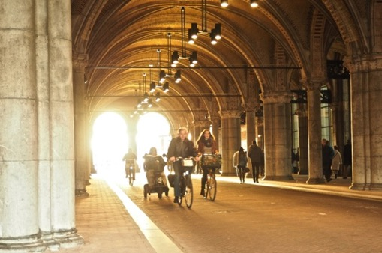
Figure 28: Pedestrians and bicycle riders travel through the State Museum (Rijksmuseum) Amsterdam.
Photo: https://ilovebikingsf.com/tag/amsterdam/ 25 November 2014
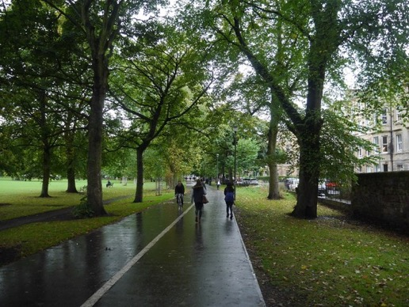

Figure 29: Riders and walkers on one of the paths through the Meadows Edinburgh
Photo: Richard Webb North Meadow Walk Edinburgh http://www.geograph.org.uk/photo/4720690
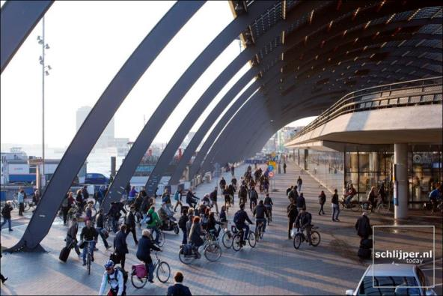
Figure 30: The photos show the space between the railway station in Amsterdam and the ferry. This space is crossed by a bicycle route (top photo) which merges with a cross flow of people (some on bikes) moving between the station (on the right of the right-hand photo) and the ferry terminal (on the left of the right-hand photo). Photos: Acitymadebypeople.com (top) Schlijper.nl (bottom)

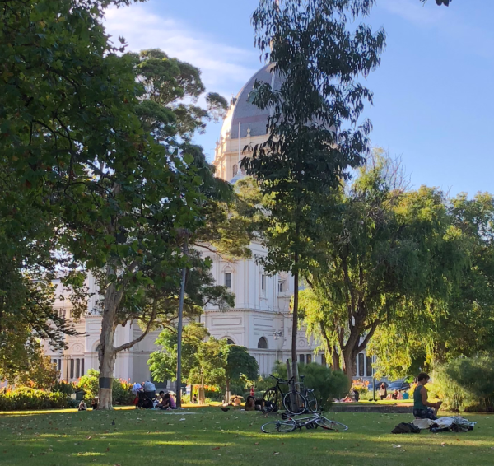]
Figure 31: Signs that people have pedalled to the Carlton Gardens
Source: PBA
Looking beyond the ban signs in Melbourne, peaceful coexistence can be found in many places. The photo above shows people in the Carlton Gardens who arrived by bicycle without causing any negative impact to the place or space or other users. The new approach would need to include the aim of strengthening the culture of respectful mingling that already exists. A strong culture would not emerge overnight but, judging by approaches used overseas, it is a realistic goal. Penalties, including social disapproval, would target poor behaviour – just as we target littering and other inappropriate behaviours – and not be applied to people just because they are on a bicycle.
It is appropriate that there is an effort to resolve the issue of behaviour and bans in the directions in the new Transport Strategy. A table is provided below that suggests a framework that could apply.

Table 4 – Bicycles in places and open space
Type and speed of bicycle trip | Lightly used open space | Heavily used open space | Heavily used places
Low speed ‘extended walking’ bicycle trips | Acceptable | Acceptable  The Yarra River banks are an example | Acceptable  Bourke Street Mall is an example
Higher speed ‘congestion cutter’ bicycle trips | Acceptable  Fawkner Park and Yarra Park are examples | Not acceptable | Not acceptable
PBA

3.7 Require more bicycle parking in the planning scheme
The City of Melbourne can increase the use of the bicycle by changing the planning scheme so that more bicycle parking spaces are required in new developments.
The current planning scheme provides strong support for car ownership and use but its support for bicycle ownership and use is weak. This unequal treatment occurs because the requirements for the construction of off-street car parking bays are strong and the requirements for bicycle storage and parking are weak. The requirement for car parking spaces is usually one per dwelling – roughly one bay for two people. The requirement for bicycle parking is one bicycle space for every five dwellings – roughly one bicycle storage space for ten people. Similar unequal rules apply for offices and commercial developments such as supermarkets.
These settings are back to front. The bicycle spaces in housing need to be guaranteed by the planning scheme at the rate of one per person. As discussed above, car spaces should be an option that an owner or renter can avoid if they do not have a car or find that they no longer need one.
The rate of bicycle storage and parking provision in the planning scheme needs to be generous. In one building in Brunswick, 60 bicycle parking spaces were provided for 24 apartments. This proved not be enough and there are now over 70 bicycles owned by residents of the building (almost 3 bicycles per dwelling).
It is important that the planning scheme requires the bicycle storage to be provided in convenient locations so the bicycle is ready to go. You are unlikely to ‘jump on your bike’ to go somewhere if you need to fetch your bicycle from the balcony, carry it through the bedroom, down in the lift and out through the foyer. On the other hand, two ‘plips’ – one to get in the car and one to exit the building – are all that is required to initiate a car trip.
There is little that can be done about the buildings that do not have adequate bicycle parking spaces. It would be appropriate for the City of Melbourne to offer people who find themselves in an apartment without bicycle parking, a subsidy or zero interest loan for a folding bicycle. A similar subsidy or loan could be provided to people who choose an apartment without a car space to enable the household to purchase an e-bike.
Bicycle parking at large scale destinations needs to be guaranteed by the planning scheme. If destinations are providing off-street parking, then a significant proportion of that space should be available for staff and visitors who arrive by bicycle. Hospitals and universities in the municipality, to a greater or lesser extent, outsource their bicycle parking to the City of Melbourne to put aside public space at the kerb or on the nature strip space and install parking rails. This is not necessarily the best outcome for the street and the community. As well as minimum provision for bicycle parking the planning scheme should require provision for ‘overflow’ bicycle parking. One solution might be contributions to, or leasing of, off-site facilities. This is how ‘overflow’ staff parking car parking is often handled.
Smaller destinations also need to look after people who arrive by bicycle. The planning scheme only requires a shop to provide bicycle parking for its customers if it is larger than 1,000 square metres (Clause 52.34) whereas a shop of that size is required to provide 40 car spaces (Clause 52.06). Research in Lygon Street suggests that retail destinations are likely to benefit more from bicycle riders than people who arrive by car (Lee; 2010). Some of these spaces can be provided on kerb outstands which replace kerbside car parking bays. These ‘corrals’ were endorsed in the current Transport Strategy and the implementation could be expanded in the new Strategy.
Investigations by the City of Melbourne suggest that in Melbourne office building owners are going beyond the minimum requirements in the planning scheme for employee bicycle parking. Office refurbishments including end-of-lease refits often include significant upgrades in the quantity and quality of bicycle parking. Some end of trip facilities – the showers and lockers – are of ‘hotel’ quality. Many employers regularly expand their bicycle parking area to keep up with the level of use. It has been claimed that in the Sydney CBD between 2015 – 2017 more than $35m was spent by Sydney businesses on 35 bicycle end of trip facilities. However, the investigation in the City of Melbourne found that some building managers have not provided the facilities required by their permit, and the facility design in most buildings is poor when compared with best practice.
It is time to raise the base level of provision in the planning scheme to a higher minimum standard of quantity and quality. Upgrades to on-site bicycle storage and parking could be supported by access to financial arrangements similar to Energy Upgrade Agreements.
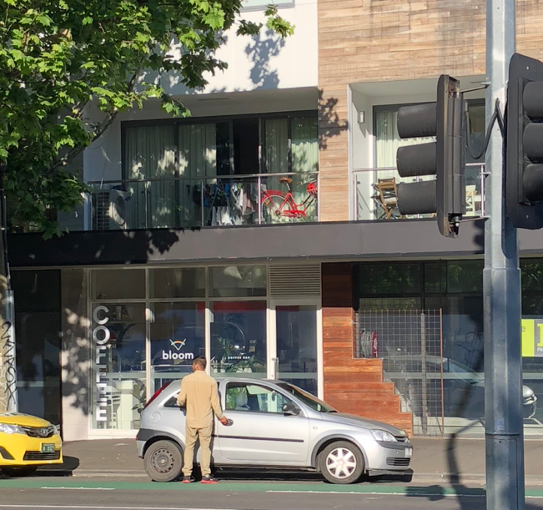

Figure 32: The person in this apartment in the City of Melbourne keeps their bicycle on the balcony. This is an inconvenient location for regular or spontaneous use.
Source: PBA

3.8 Move bicycle parking from the footpath to kerb-extensions to underground
The City of Melbourne needs to take steps to ensure that areas of bicycle parking do not reduce the width of busy footpaths or occupy valuable open space. If bicycle use continues to grow, it will be necessary to consider moving large areas of bicycle parking underground.
Today bicycles are locked up to formal parking rails and other street furniture along many footpaths. Low levels of bicycle parking on footpaths are usually unproblematic. However high levels of footpath bicycle (and motorcycle) parking create clutter on the path, impede pedestrian flow and can create safety hazards.
Where bicycles are beginning to reduce footpath capacity and amenity it is appropriate to move them from the ‘footpath furniture zone’ to kerb outstands. A kerb outstand that replaces a couple of car parks can accommodate a couple of dozen bicycles. The kerb outstand solution was endorsed in the 2012 Transport Strategy. The Strategy indicated that there was a ‘good opportunity’ to replace kerbside car parking with kerbside bicycle parking. The success of the bicycle parking kerb extension in Lygon Street mentioned above was referenced. This type of facility has been replicated in a few locations (Pelham Street Carlton is an example) but is yet to become the norm.
The shift from footpath to kerb outstands will need to accelerate as bicycle parking threatens high use footpaths (such as Flinders Lane) and is overflowing in popular places (such as around the State Library).
In Europe, municipalities are recovering scarce and valuable public space from the bicycle by providing underground parking. The cost of underground structures illustrates the value that these cities place on the contribution of the bicycle and the value of the public space that is recovered.
Münster, Germany, has been building underground parking for bicycles for nearly twenty years. The largest underground bicycle park in the world (12,500 bays) is being developed in Utrecht, Netherlands as part of the railway station redevelopment. The Utrecht bike station includes a bike share service and a bike shop. (Many bicycle trips in the Netherlands are to the train or on an onward journey from the train.)
Figure 33: Underground bicycle parking station in Münster was built to ‘recover’ the public space above which had become occupied by bicycle parking.
Source: City of Münster https://www.radstation.de/de/360-ansicht/4_18.html
Many train passengers in Melbourne use bicycles to reach railway stations. As a result, bicycle parking is building up around Flinders Street Station for example. More people would probably ride to the stations, but the informal parking areas are constrained by the limited space and lack of facilities. The Flinders Street station precinct is likely to become more attractive to people on bicycles when the Melbourne Metro Station opens. Rather than continuing to expand bicycle parking on the surface, the space under the City Square – when it becomes available again – could be repurposed as underground bicycle parking for the central area.
Bicycle parking is even more limited for people riding to (or from) Southern Cross Station. Inbound commuters have nowhere to store a bicycle at the station overnight so that it is available for their onward journey in the morning. One solution could be to provide underground parking in the Station precinct. A Utrecht-style bicycle area near Southern Cross Station could offer to store private bikes and rent share bikes. Such a facility would enable Southern Cross Station to serve all the western end of the central area out to the edges of Docklands through ‘extended walking trips’.
Underground facilities should also be considered in the Parkville Biomedical and Melbourne University precincts as well as in the area around the RMIT University and the State Library of Victoria.

3.9 Increase investment in bicycle infrastructure and provide incentives
The City of Melbourne can increase the use of the bicycle by increasing its investment in the mode.
The Council has net assets of $4 billion and spends nearly $200 million on capital works each year. This financial power has enabled the City of Melbourne to shape the transport system in several ways. In the case of Swanston Street, it was able to achieve significant improvements to the transport network including supporting bicycle use. Investments such as these are how the intentions and directions expressed in Strategies are realised.
The City of Melbourne’s intentions for bicycle use are positive and unambiguous. The 2012 Transport Strategy spoke of a 400% increase in bicycle use including ‘reinforcing it as a mode of choice for moving around the central city’ for trips within and to the City, noting that ‘a shift of public transport passengers onto bicycles would help alleviate overcrowding.’
The strategy was reflected in the 2012-16 Bicycle Plan which aimed to deliver ‘a 50 per cent increase in bicycle trips to, from and within the municipality on weekdays’ and raise the bicycle share of trips from 4% to 6%. The 2016 – 2020 Bicycle Plan established a target of ‘7% total trips to, within and from the City by bike, and a 10% target by 2030.’
The 2012 Transport Strategy did not identify annual financial commitments to increasing bicycle use. These decisions are made each year by the Council in the context of the Strategy. It is possible however to look back at the published City of Melbourne budget allocations over the period of the current Transport Strategy to see what has been spent.
On average the annual budget allocation for the bicycle improvement program has been $2.5m and $154,000 for bicycle lane maintenance. Between 2004 and 2013 the capital works allocation fluctuated between zero and $5m (2012-2013). The data on bicycle trips provided above reveals the return on this investment. Over the period the number of bicycle trips has grown by 7.5% or three thousand riders a day. However, the share of trips has fallen from 3.8% in 2009 -10 to 3.6% in 2015-16. The data suggests that to reach the 2020 strategic target of 7% of trips, the current level of riding in the City will have to more than double.
On this basis, we can say that the successive annual investments achieved positive outcomes. The investments showed that improved facilities appear to increase the number of bicycle trips and the total number of trips has gone up. However, the scale of the investment appears not to have been large enough to secure strategic success as the bicycle lost share in ‘extended walking’ trips and only gained slightly in ‘congestion cutting’ trips. To lift the share of bicycle trips enough to meet its strategic goals, the City of Melbourne will have to increase its investment. A doubling of the capital works budget would be, on average, $5m a year, a fourfold increase would be in the order of $10m a year.
Another way to use the City’s financial power is through incentives that seek to establish new behaviours. Transport behaviour has been influenced in other places through financial mechanisms such as feebates, hypothecated revenue, subsidies and loans. These are discussed below.
Feebates & hypothecated revenue
Feebates are fees charged to one person and rebated to another. In France, Germany and Ontario (Canada) feebates have been used to influence new motor vehicle purchases. The fee applies to the low efficiency vehicle and the rebate is received by the purchaser of a high efficiency vehicle. In the City of Perth, parking revenue is used to fund mode shift initiatives including facilities for cyclists and pedestrians. Some of the funds raised by the Victorian Government’s Congestion Levy on certain off-street parking bays are used in this way.
Feebates could be introduced in the areas of the municipality where households are permitted to store a second vehicle at the kerb. This second kerbside permit fee could be raised and revenue returned to residents who purchase an e-bike. Such a feebate would tip the balance away from motor vehicle ownership and use and towards use of alternatives including bicycle riding.
It is recognised that the City of Melbourne treats revenue from parking meters as general revenue and spends the revenue on needs and opportunities beyond the transport sector. Within this overall approach it would be possible to follow the Perth model and set aside a proportion of parking revenue and direct it to strengthening alternative modes of travel including bicycle infrastructure. It would make sense to people that a portion of the parking fees were allocated to initiatives that helped people switch away from car trips as that will reduce traffic congestion and competition for car parking spaces.
Other Incentives
In the early days of solar panels financial incentives played a key role in building the scale of production and widening the group of people with direct experience of solar power. Today, for solar panels, these incentives are not as necessary and other financial mechanisms are being used to drive renewable energy, including the environmental upgrade finance provide through the City of Melbourne.
Similar incentives are rarely applied in the transport sector in Australia. However, in other countries there are subsidies for electric motor vehicles and electric cargo bikes (Norway). Disincentives for car ownership and use have also being introduced.
The City of Melbourne has the capacity to provide purchase incentives for e-bikes and folding bicycles (for apartment dwellers without bicycle parking space). These vehicles can cost around $3,000 – around ten times the cost of a basic bike. The City of Melbourne could provide the interest payments on these bicycles allowing people to pay them off over a couple of years at the rate of a public transport ticket. This would enable people to get a loan (personal loans are not usually issued below $4,000) and avoid credit card interest. The RACV has just introduced such a loan but it is only available for some models through some retailers.
Eligibility or priority access to the available funds could be linked to households that do not own a car or have reduced the number of kerbside permits that they use or who live some way out of the centre such as in Fishermans Bend or Kensington.
The quality and quantity of bicycle parking provided in housing, offices and commercial destinations can be improved and increased through financing partnerships and incentives for building owners and managers. The City of Adelaide currently provides a $5,000 financial incentive to building managers who install electric car charging infrastructure. Similar ‘transport upgrade agreements’ could also be used to stimulate retrofitting of facilities that increase the use of alternative modes, including bicycle riding.

Summary of the discussion
This section summarises the issues and recommendations made in this paper.
- The City of Melbourne’s next transport strategy should emphasise and prioritise space efficient transport modes so that more people can flow along the roads in the municipality.
- A space-efficient transport system will also release space for purposes outside the transport system.
- Bicycle trips are important because they complement trips made on foot and by transit.
- Bicycle trips also provide valuable benefits outside the transport system.
- There are two main types of bicycle trips: short trips that complement walking trips – ‘extended walking’ and longer trips that complement transit – ‘congestion cutting’.
- In recent times the shorter trips have fallen in number while the longer trips have grown, but only as fast as the growth in population.
- There are people who are ‘ready to ride’ but they are cautious about traffic and need bicycle facilities that are separate in the mid-block and at intersections.
The City of Melbourne can increase the number and proportion of bicycle trips by:
- Neutralising the measures in the planning scheme that support car ownership and use
- Reducing access and priority for motor vehicles
- Increasing the number of high-mobility streets where walking, transit and bicycle trips are strengthened
- Extending high-mobility streets into high mobility corridors that reach to the boundary of the municipality
- Improving bicycle facilities by:
  - A regular investment program that continually upgrades popular routes
  - Strengthening popular bicycle routes with Dutch-style separated intersections
  - Allowing low-impact bicycle flows through open space and ‘places’ across the municipality.
  - Moving high levels of bicycle parking from the footpath to kerb outstands and eventually underground
  - Changing the planning scheme so that there is always space for people to park their bicycle and that the space is in a convenient location where the bicycle is ready for use
  - Increasing the level of investment in bicycle infrastructure.

References

‘In Melbourne, some of the existing major gardens exclude cycling access to encourage walking and strolling in these contemplative spaces. The community via the surveys identified this as a key issue, with comments that the gardens should be made accessible for cyclists in the future. This strategy supports unstructured recreational use, however resolving the issue of cycling access in the major historical gardens needs to be considered at the master plan level to ensure all issue are carefully considered. City of Melbourne Open Space Strategy Technical Report June 2012
Recognising the economic role of bikes: sharing parking in Lygon Street, Carlton Lee, March June 2010 Australian Planner
Investment in end of trip facilities in Sydney. PFL Spaces Press release 30 May 2017

